Name of Journal: World Journal of Diabetes
Manuscript NO: 54624
Manuscript Type: EDITORIAL

Cystic fibrosis-related diabetes: The unmet need

Pozo L et al. CF-related diabetes

Leonardo Pozo, Fatimah Bello, Yamely Mendez, Salim Surani

Leonardo Pozo, Fatimah Bello, Family Medicine, University of Texas Rio Grande Valley, Edinburgh, TX 78539, United States

Yamely Mendez, Faculty of Medicine “Dr. Alberto Romo Caballero”, Universidad Autonoma de Tamaulipas, Houston, TX 77058, United States

Salim Surani, Medical Critical Care Services, Corpus Christi Medical Center, Corpus Christi, TX 78404, United States

Author contributions: All authors equally contributed to this paper with conception and design of the study, literature review and analysis, drafting and critical revision and editing, and final approval of the final version.

Corresponding author: Salim Surani, BSc, FACC, FACP, FCCP, MD, Professor, Medical Critical Care Services, Corpus Christi Medical Center, 701 Ayers street, Corpus Christi, TX 78413, United States. srsurani@hotmail.com

Received: February 9, 2020
Revised: April 14, 2020
Accepted: April 24, 2020
Published online: June 15, 2020

Abstract
Cystic fibrosis (CF) is a common autosomal recessive disease. Life expectancy of patients with CF continues to improve mainly driven by the evolving therapies for CF-related organ dysfunction. The prevalence of CF-related diabetes (CFRD) increases exponentially as patients’ age. Clinical care guidelines for CFRD from 2010, recommend insulin as the mainstay of treatment. Many patients with CFRD may not require exogenous insulin due to the heterogeneity of this clinical entity. Maintenance of euglycemia by enhancing endogenous insulin production, secretion and degradation with novel pharmacological therapies like glucagon-like peptide-1 agonist is an option that remains to be fully explored. As such, the scope of this article will focus on our perspective of glucagon-like peptide-1 receptor agonist in the context of CFRD. Other potential options such as sodium-glucose cotransporter-2 and dipeptidyl peptidase 4 inhibitors and their impact on this patient population is limited and further studies are required.

Key words: Cystic fibrosis; Cystic fibrosis-related diabetes; Cystic fibrosis transmembrane conductance regulator; Gastric inhibitory polypeptide; Glucagon-like peptide 1; Glucagon-like peptide-1 receptor agonist; Dipeptidyl peptidase 4 inhibitors

Pozo L, Bello F, Mendez Y, Surani S. Cystic fibrosis-related diabetes: The unmet need. World J Diabetes 2020; 11(6): 213-217
URL: https://www.wjgnet.com/1948-9358/full/v11/i6/213.htm
DOI: https://dx.doi.org/10.4239/wjd.v11.i6.213

Core tip: Cystic fibrosis-related diabetes is a heterogeneous entity. Currently, insulin is the agent of choice to maintain euglycemia on this patient population. Novel therapies like glucagon-like peptide-1 agonist offer an opportunity to reevaluate the way we approach this disease.

INTRODUCTION
Cystic fibrosis (CF) is a common autosomal recessive disease that has been described to affect Caucasians and, to a lesser extent, other populations, affecting up to 1 person per every 3000 live births^{[1]} in the United States. Its pathogenesis is secondary to a defect in the CF transmembrane conductance regulator (CFTR) gene that encodes for a homonymous membrane protein that conducts chloride ions across epithelial cell membranes, resulting in dysregulation of the normal pH and ionic balance of physiologic secretions and subsequent multiorgan dysfunction^{[2]}.
Despite discrepancies in the median age at death between different patient populations^{[3]}, the life expectancy of patients with CF continues to improve mainly driven by the evolving therapies for CF-related organ dysfunction. However, new challenges in the form of chronic-degenerative diseases arise from this increased life expectancy. The prevalence of CF-related diabetes (CFRD) increases exponentially when patients reach adulthood^{[4,5]}.

PATHOPHYSIOLOGY OF CYSTIC FIBROSIS-RELATED DIABETES
CFRD is a unique disease that combines features of patients with type 1 and type 2 diabetes mellitus (T1DM and T2DM) such as impaired insulin secretion and peripheral insulin resistance^{[6]}. Due to the heterogeneity of CF, it is difficult to predict which patients will go on to develop CFRD. Some mutations, however, have a higher prevalence and predisposition to develop the disease and are associated with pancreatic exocrine dysfunction^{[7]}.
CFTR plays a dual role in insulin/glucagon hemostasis. Abnormal intracellular accumulation of chloride in β cells impairs their ability to depolarize in response to glucose, diminishing insulin release. In α cells, normal glucagon suppression is impaired by the inability of the cells to hyperpolarize in presence of high intracellular chloride, resulting in uncontrolled secretion of glucagon by potentiating adenosine triphosphate-sensitive K+ channels^{[8-10]} (Figure 1).
Exocrine pancreatic insufficiency is an independent factor that must be accounted for. The low bicarbonate to chloride transport ratio, which reduces secretory volume, creates a protein gradient at the lumen, resulting in obstruction and interstitial edema^{[11]}. Evidence suggests that, overtime, the resulting histopathological changes correlate with progression of the disease, damaging islet cells. Furthermore, CFRD patients have low levels of gastric inhibitory polypeptide (GIP) and glucagon-like peptide-1 (GLP-1), which contributes to postprandial glycemic excursions and lower secretion of insulin^{[12,13]}.
Insulin resistance is associated with the fluctuant systemic inflammatory process associated with the counterregulatory response of growth hormone, cortisol and catecholamines that are released as a response to frequent pulmonary exacerbations and their treatment with steroids that these patients are typically exposed to.

THE ROLE OF INCRETINS AND GLUCAGON-LIKE PEPTIDE-1 RECEPTOR AGONIST
The most recent version of the clinical care guidelines for CFRD from 2010 recommend insulin as the mainstay of treatment^{[14]}. With the advent of GLP-1 receptor agonists (GLP-1 RA) this could change in the future for certain subtypes of the disease in which β cell structure remains preserved, but function is impaired, similar to patients with T2DM^{[15]}.
GLP-1 RA ameliorate the pathophysiology that has been previously explained (see above) by improving insulin release and slowing gastric emptying, improving glycemia^{[16]}. Interestingly, these effects have been reproduced in the past, when GLP-1 RA were not available in the market by using pancreatic enzymes as a replacement of the exocrine function of the pancreas^{[17]}. However, approximately 20% of the patients had refractory disease due to the diminishing bicarbonate levels secreted by the pancreas to the intestine, delaying and impairing the effectiveness of fat absorption while worsening prandial glycemic excursions as a result^{[18]}.
Currently, very few studies have been published and even less are underway to address the use of GLP-1 RA, dipeptidyl peptidase 4 inhibitors or sodium-glucose cotransporter-2 inhibitors based therapies in the treatment of CFRD. One of the limitations when designing these studies is the target population. As demonstrated by Geyer et al^{[19]}, exenatide demonstrated to be an effective treatment option for patients with early-onset CFRD. However, it is important to note this study was done in the pediatric population, which is arguably less affected by CFRD. Another point to consider is how heterogeneous the patient population can be due to differences in mutations and residual function of the CFTR protein in individuals that would be treated with this novel therapy.
One of the issues with GLP-1 RA in this patient population is weight loss, which is not desirable in this context. Classically, diabetic patients must limit their carbohydrate and caloric intake to limit glycemic excursions^{[5]}. This conflicts with the current recommendations that seek to maintain a good nutritional status with high fat diets, frequent snacking and weight gain, which is associated with good prognosis^{[20]}, although this is a more important marker for early stages of the disease, which might not be applicable to CFRD since these patients usually present when they are older than 18 years of age.
With the advent of newer, novel CFTR modulating therapies such as Lumacaftor/Ivacaftor, attempts have been made to determine if these novel treatments have an impact in CFRD and related conditions^{[21-23]} despite lack of a direct mechanism of action since β cells do not express CFTR^{[24]}. It has been proposed that increased levels of GLP-1 and GIP with preservation of exocrine and endocrine pancreatic functions are the main drivers of these positive effects. Large randomized controlled trials are needed to verify and validate these findings^{[25]}, which also go in favor towards a broader utilization of novel therapies for CFRD.

CONCLUSION
Many patients with CFRD may not require exogenous insulin despite this being the approved therapy for all forms of CFRD despite the heterogeneity of CF as a clinical entity. Maintenance of euglycemia by enhancing endogenous insulin production, secretion and degradation via improved incretin (GLP-1 and GIP) stabilization and/or exogenous administration might play a central role that is currently not fully exploited.

REFERENCES
1 Cystic Fibrosis Foundation. Annual data report 2018 Cystic Fibrosis Foundation Patient Registry. [assessed 24 Jan 2020]. Available from: https://www.cff.org/Research/Researcher-Resources/Patient-Registry/2018-Patient-Registry-Annual-Data-Report.pdf
2 Haq IJ, Gray MA, Garnett JP, Ward C, Brodlie M. Airway surface liquid homeostasis in cystic fibrosis: pathophysiology and therapeutic targets. Thorax 2016; 71: 284-287 [PMID: 26719229 DOI: 10.1136/thoraxjnl-2015-207588]
3 Stephenson AL, Sykes J, Stanojevic S, Quon BS, Marshall BC, Petren K, Ostrenga J, Fink AK, Elbert A, Goss CH. Survival Comparison of Patients With Cystic Fibrosis in Canada and the United States: A Population-Based Cohort Study. Ann Intern Med 2017; 166: 537-546 [PMID: 28288488 DOI: 10.7326/M16-0858]
4 Moran A, Dunitz J, Nathan B, Saeed A, Holme B, Thomas W. Cystic fibrosis-related diabetes: current trends in prevalence, incidence, and mortality. Diabetes Care 2009; 32: 1626-1631 [PMID: 19542209 DOI: 10.2337/dc09-0586]
5 Brennan AL, Beynon J. Clinical updates in cystic fibrosis-related diabetes. Semin Respir Crit Care Med 2015; 36: 236-250 [PMID: 25826591 DOI: 10.1055/s-0035-1547319]
6 Barrio R. Management of endocrine disease: Cystic fibrosis-related diabetes: novel pathogenic insights opening new therapeutic avenues. Eur J Endocrinol 2015; 172: R131-R141 [PMID: 25336504 DOI: 10.1530/EJE-14-0644]
7 Bridges N. Diabetes in cystic fibrosis. Paediatr Respir Rev 2013; 14 Suppl 1: 16-18 [PMID: 23522600 DOI: 10.1016/j.prrv.2013.02.002]
8 Best L. Glucose-induced electrical activity in rat pancreatic beta-cells: dependence on intracellular chloride concentration. J Physiol 2005; 568: 137-144 [PMID: 16024506 DOI: 10.1113/jphysiol.2005.093740]
9 Boom A, Lybaert P, Pollet JF, Jacobs P, Jijakli H, Golstein PE, Sener A, Malaisse WJ, Beauwens R. Expression and localization of cystic fibrosis transmembrane conductance regulator in the rat endocrine pancreas. Endocrine 2007; 32: 197-205 [PMID: 18040894 DOI: 10.1007/s12020-007-9026-x]
10 Lanng S, Thorsteinsson B, Røder ME, Orskov C, Holst JJ, Nerup J, Koch C. Pancreas and gut hormone responses to oral glucose and intravenous glucagon in cystic fibrosis patients with normal, impaired, and diabetic glucose tolerance. Acta Endocrinol (Copenh) 1993; 128: 207-214 [PMID: 8480468 DOI: 10.1530/acta.0.1280207]
11 Meyerholz DK, Stoltz DA, Pezzulo AA, Welsh MJ. Pathology of gastrointestinal organs in a porcine model of cystic fibrosis. Am J Pathol 2010; 176: 1377-1389 [PMID: 20110417 DOI: 10.2353/ajpath.2010.090849]
12 Kuo P, Stevens JE, Russo A, Maddox A, Wishart JM, Jones KL, Greville H, Hetzel D, Chapman I, Horowitz M, Rayner CK. Gastric emptying, incretin hormone secretion, and postprandial glycemia in cystic fibrosis--effects of pancreatic enzyme supplementation. J Clin Endocrinol Metab 2011; 96: E851-E855 [PMID: 21389144 DOI: 10.1210/jc.2010-2460]
13 Hillman M, Eriksson L, Mared L, Helgesson K, Landin-Olsson M. Reduced levels of active GLP-1 in patients with cystic fibrosis with and without diabetes mellitus. J Cyst Fibros 2012; 11: 144-149 [PMID: 22138561 DOI: 10.1016/j.jcf.2011.11.001]
14 Moran A, Brunzell C, Cohen RC, Katz M, Marshall BC, Onady G, Robinson KA, Sabadosa KA, Stecenko A, Slovis B; CFRD Guidelines Committee. Clinical care guidelines for cystic fibrosis-related diabetes: a position statement of the American Diabetes Association and a clinical practice guideline of the Cystic Fibrosis Foundation, endorsed by the Pediatric Endocrine Society. Diabetes Care 2010; 33: 2697-2708 [PMID: 21115772 DOI: 10.2337/dc10-1768]
15 Inzucchi SE, Bergenstal RM, Buse JB, Diamant M, Ferrannini E, Nauck M, Peters AL, Tsapas A, Wender R, Matthews DR; American Diabetes Association (ADA); European Association for the Study of Diabetes (EASD). Management of hyperglycemia in type 2 diabetes: a patient-centered approach: position statement of the American Diabetes Association (ADA) and the European Association for the Study of Diabetes (EASD). Diabetes Care 2012; 35: 1364-1379 [PMID: 22517736 DOI: 10.2337/dc12-0413]
16 Doyle ME, Egan JM. Mechanisms of action of glucagon-like peptide 1 in the pancreas. Pharmacol Ther 2007; 113: 546-593 [PMID: 17306374 DOI: 10.1016/j.pharmthera.2006.11.007]
17 Symonds EL, Omari TI, Webster JM, Davidson GP, Butler RN. Relation between pancreatic lipase activity and gastric emptying rate in children with cystic fibrosis. J Pediatr 2003; 143: 772-775 [PMID: 14657826 DOI: 10.1067/S0022-3476(03)00581-X]
18 Guarner L, Rodríguez R, Guarner F, Malagelada JR. Fate of oral enzymes in pancreatic insufficiency. Gut 1993; 34: 708-712 [PMID: 8504976 DOI: 10.1136/gut.34.5.708]
19 Geyer MC, Sullivan T, Tai A, Morton JM, Edwards S, Martin AJ, Perano SJ, Gagliardi L, Rayner CK, Horowitz M, Couper JJ. Exenatide corrects postprandial hyperglycaemia in young people with cystic fibrosis and impaired glucose tolerance: A randomized crossover trial. Diabetes Obes Metab 2019; 21: 700-704 [PMID: 30259623 DOI: 10.1111/dom.13544]
20 Kerem E, Reisman J, Corey M, Canny GJ, Levison H. Prediction of mortality in patients with cystic fibrosis. N Engl J Med 1992; 326: 1187-1191 [PMID: 1285737 DOI: 10.1056/NEJM199204303261804]
21 Kutney K, Donnola SB, Flask CA, Gubitosi-Klug R, O'Riordan M, McBennett K, Sferra TJ, Kaminski B. Lumacaftor/ivacaftor therapy is associated with reduced hepatic steatosis in cystic fibrosis patients. World J Hepatol 2019; 11: 761-772 [PMID: 31966908 DOI: 10.4254/wjh.v11.i12.761]
22 Kapoor H, Koolwal A, Singh A. Ivacaftor: a novel mutation modulating drug. J Clin Diagn Res 2014; 8: SE01-SE05 [PMID: 25584290 DOI: 10.7860/JCDR/2014/6486.5158]
23 Bellin MD, Laguna T, Leschyshyn J, Regelmann W, Dunitz J, Billings J, Moran A. Insulin secretion improves in cystic fibrosis following ivacaftor correction of CFTR: a small pilot study. Pediatr Diabetes 2013; 14: 417-421 [PMID: 23952705 DOI: 10.1111/pedi.12026]
24 Hart NJ, Aramandla R, Poffenberger G, Fayolle C, Thames AH, Bautista A, Spigelman AF, Babon JAB, DeNicola ME, Dadi PK, Bush WS, Balamurugan AN, Brissova M, Dai C, Prasad N, Bottino R, Jacobson DA, Drumm ML, Kent SC, MacDonald PE, Powers AC. Cystic fibrosis-related diabetes is caused by islet loss and inflammation. JCI Insight 2018; 3 [PMID: 29669939 DOI: 10.1172/jci.insight.98240]
25 Christian F, Thierman A, Shirley E, Allen K, Cross C, Jones K. Sustained Glycemic Control With Ivacaftor in Cystic Fibrosis-Related Diabetes. J Investig Med High Impact Case Rep 2019; 7: 2324709619842898 [PMID: 31010313 DOI: 10.1177/2324709619842898]

Footnotes
Conflict-of-interest statement: No potential conflicts of interest.

Open-Access: This article is an open-access article that was selected by an in-house editor and fully peer-reviewed by external reviewers. It is distributed in accordance with the Creative Commons Attribution NonCommercial (CC BY-NC 4.0) license, which permits others to distribute, remix, adapt, build upon this work non-commercially, and license their derivative works on different terms, provided the original work is properly cited and the use is non-commercial. See: http://creativecommons.org/licenses/by-nc/4.0/

Manuscript source: Invited manuscript

Peer-review started: February 9, 2020
First decision: April 3, 2020
Article in press: April 24, 2020

Specialty type: Endocrinology and metabolism
Country of origin: United States
Peer-review report classification
Grade A (Excellent): 0
Grade B (Very good): B
Grade C (Good): 0
Grade D (Fair): D
Grade E (Poor): 0

P-Reviewer: Papazafiropoulou A, Saisho Y S-Editor: Dou Y L-Editor: A E-Editor: Liu MY

Figure Legends
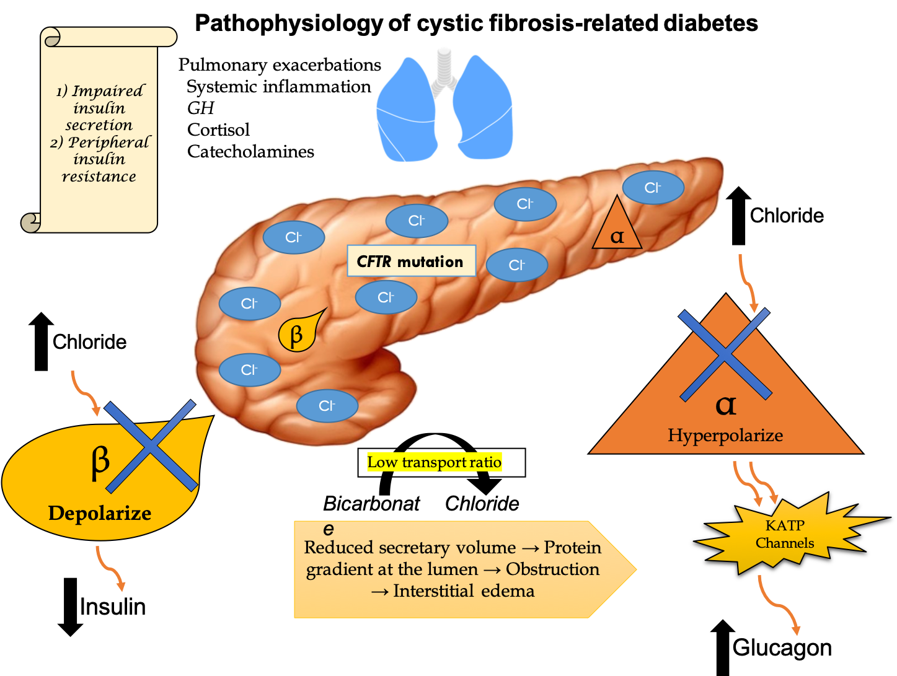
Figure 1 Pathophysiology of cystic fibrosis-related diabetes.

