Name of Journal: World Journal of Clinical Cases
Manuscript NO: 59796
Manuscript Type: CASE REPORT

Thoracic pyogenic infectious spondylitis presented as pneumothorax: A case report

Cho MK et al. Thoracic pyogenic infectious spondylitis

Mi-Kyung Cho, Byeong-Ju Lee, Jae-Hyeok Chang, Young-Mo Kim

Mi-Kyung Cho, Byeong-Ju Lee, Jae-Hyeok Chang, Young-Mo Kim, Department of Rehabilitation Medicine, Pusan National University Hospital, Busan 49241, South Korea

Author contributions: Lee BJ and Cho MK conceived the report; Cho MK wrote the first draft with input from all authors; Kim YM, Lee BJ analyzed and interpreted the patient data regarding the disease; Chang JH and Lee BJ examined and approved the manuscript; all authors critically reviewed and issued final approval for the version to be submitted.

Supported by a Clinical Research Grant from Pusan National University Hospital in 2020.

Corresponding author: Byeong-Ju Lee, MD, Assistant Professor, Department of Rehabilitation Medicine, Pusan National University Hospital, 179 Gudeok-ro, Seo-gu, Busan 49241, South Korea. lbjinishs@gmail.com

Received: October 20, 2020
Revised: December 27, 2020
Accepted: January 12, 2021
Published online: February 26, 2021

Abstract
BACKGROUND
Pyogenic infectious spondylitis (PIS) is a rare condition, with an incidence between 0.2 and 2 cases per 100000 per annum. It’s most common symptom—back or neck pain—occurs in more than 90% of cases. Herein, we reported a case of thoracic PIS accompanied by pneumothorax in a 65-year-old male patient.

CASE SUMMARY
A 65-year-old man presented with right chest pain and dyspnea. The initial erect posteroanterior chest radiography revealed pneumothorax, which was further evaluated by chest computed tomography, revealing pleural effusion in the right lung and a paravertebral abscess with bony destruction of vertebral body. Based on magnetic resonance imaging, the patient was diagnosed with thoracic infectious spondylitis with an anterior paravertebral abscess. He was prescribed antibiotics and underwent neurosurgery due to aggravated symptoms and neurologic deficit. Tissue examination revealed that the cause of pleural effusion and pneumothorax was Staphylococcus aureus infection contiguously spread to lung pleura. After several surgical treatments with intravenous antibiotic therapy for two months and transition to oral antibiotics (rifampin 600 mg qd and ciprofloxacin 500 mg bid), the patient received physical therapy to recover balance. One month after discharge, the patient had no chest pain or dyspnea, and exhibited no elevation in inflammatory markers or new thoracic lesions.

CONCLUSION
To our knowledge, this is the very first report of a case of thoracic PIS with pneumothorax.

Key Words: Chest pain; Pneumothorax; Pleural effusion; Neurologic deficits; Spondylitis; Case report

©The Author(s) 2021. Published by Baishideng Publishing Group Inc. All rights reserved.

Citation: Cho MK, Lee BJ, Chang JH, Kim YM. Thoracic pyogenic infectious spondylitis presented as pneumothorax: A case report. World J Clin Cases 2021; 9(6): 1402-1407
URL: https://www.wjgnet.com/2307-8960/full/v9/i6/1402.htm
DOI: https://dx.doi.org/10.12998/wjcc.v9.i6.1402

Core Tip: Back or neck pain is the most common symptom in over 90% of pyogenic infectious spondylitis (PIS) cases. Anatomically, abscesses occur most often in the spine posterior region because lesions are more likely to develop in larger epidural spaces that contain infection-prone fat. However, in the case presented herein, the spinal abscess initially found in the anterior area of the T8–9 disc and anterior epidural space, spreading contiguously to the lung pleura and causing pleural effusion and pneumothorax. This difference in abscess location may explain the PIS presentation with nonspecific symptoms, such as chest pain and dyspnea.

INTRODUCTION
Pyogenic infectious spondylitis (PIS) is a rare infectious disorder, with an annual number of incident cases between 0.2 and 2 cases per 100000 people^{[1-3]}. This disorder is defined as an inflammatory process of the spine and disc that may extend into the epidural space and paraspinal soft tissues. Spontaneous PIS manifests as a wide range of symptoms and a usually insidious progression. Back or neck pain is the most common symptom in more than 90% of PIS cases. Neurologic deficits and fever — two other major symptoms — are observed in 30% and less than 20% of cases, respectively. Other symptoms of PIS include nausea, vomiting, anorexia, weight loss, lethargy, and confusion^{[4-8]}. Herein, we report a rare case of PIS that accompanied pneumothorax in a 65-year-old patient who complained of chest pain and dyspnea.

CASE PRESENTATION
Chief complaints
A 65-year-old man presented to a primary health care institution complaining of right chest pain and dyspnea.

History of present illness
The patient’s symptoms manifested approximately two months ago and had worsened within the last 24 h.

History of past illness
The patient had a medical history of type 2 diabetes, the most predisposing risk factor for PIS, and his glycated hemoglobin level was 9.4%.

Personal and family history
He had no remarkable family medical history. He smoked 10 cigarettes a day for 20 years. He drank 180 mL of 17 % alcohol three times a week. The amount of alcohol he drank per day was 13.1 g.

Physical examination
The patient complained of right chest pain with a rate of 7 in the visual analog scale and mild dyspnea. The patient’s temperature was 36.5 °C, heart rate was 84 bpm, respiratory rate was 16 breaths per minute, blood pressure was 100/60 mmHg, and oxygen saturation in room air was 97%. Neurological examination revealed no abnormalities.

Laboratory examinations
Blood analysis revealed no leukocytosis (white blood cell: 5080/µL) with mildly elevated serum C-reactive protein (1.6 mg/dL, normal range: < 0.5 mg/dL). Blood biochemistry parameters and urinalysis were normal.

Imaging examinations
An initial erect posteroanterior chest radiography (CXR) performed at a previous primary health care institution revealed pneumothorax (Figure 1). When the CXR was repeated at our hospital, however, it revealed no abnormalities. On chest computed tomography (CT) scan, we observed pleural effusion in the right lung and a paravertebral abscess with bony destruction of the T9 vertebral body (Figure 2).

FINAL DIAGNOSIS
The final diagnosis is thoracic PIS due to Staphylococcus aureus.

TREATMENT
After several surgical procedures and intravenous antibiotic therapy for about two months, the patient’s treatment was transitioned to oral antibiotic therapy (rifampin 600 mg once and ciprofloxacin 500 mg twice daily). One month after the last surgery, he was transferred to the Department of Rehabilitation Medicine. A manual muscle test was conducted (scale: 0-5), and his upper extremities received a grade of 5 and lower extremities received a grade of 4. His feet exhibited severely impaired proprioception (2 successes in 10 trials), and he received a score of 8/56 on the Berg balance scale (BBS). He was provided physical therapy for balance and gait training for 2 wk.

OUTCOME AND FOLLOW-UP
At follow-up visit one month after discharge, the patient had no chest pain or dyspnea. Laboratory examination revealed no elevation in inflammatory markers and chest radiograph showed no new lesions. Additionally, the patient was able to walk independently with an assistive monocane. Over a 4-mo period, his proprioception improved from 2 to 4 successes, and his BBS score increased to 20.

DISCUSSION
PIS is a relatively rare condition. The predisposing factors of PIS included diabetes mellitus, long-term steroid therapy, malignancy, liver cirrhosis, chronic renal failure, malnutrition, substance abuse, human immunodeficiency virus infection, and septicemia. Excessive alcohol ingestion may also be counted among the major predisposing factor^{[4]}. Regular alcohol intake and diabetes mellitus might had been predisposing factor. This disease predominantly affects people aged 50 years or older, and the incidence increases with every 10 years thereafter. Men are more susceptible than women to PIS, with a case ratio of 1.5–3:1. The most common symptoms include pain, fever, limited range of motion, and localized tenderness near the affected area, whereas neurological complications are rarely found. A diagnosis of suspected PIS is based on clinical symptoms.
PIS could result in potentially systemic (e.g., endocarditis, liver abscess, and peritonitis) or local infectious complications (e.g., psoas muscle abscess, and esophageal involvement) in rare cases^{[9-12]}. Rushworth et al^{[13]} reported an infant that was first diagnosed with pneumonia caused by a spinal epidural abscess with Staphylococcus aureus infection. Except for this pediatric case, no other cases of pulmonary complications accompanied by PIS have been reported to the best of our knowledge.
Anatomically, abscesses usually occur in the posterior region of the spine because lesions are more likely to develop in larger epidural spaces that contain infection-prone fat^{[14,15]}. However, in this case anterior paravertebral abscess was connected with the pleural effusion with extension to T8/9 disc, right rib and anterior epidural space(Figure 3). It might have spread contiguously to the lung pleura to cause pleural effusion and pneumothorax. This would explain why the patient complained of the nonspecific symptoms of PIS, chest pain and dyspnea.
Pneumothorax can be divided into three categories: primary spontaneous pneumothorax (PSP), secondary spontaneous pneumothorax (SSP), and traumatic pneumothorax. PSP tends to occur in young adult patients without underlying lung problems and usually causes limited symptoms of chest pain and mild breathlessness. In contrast, SSP can be assumed in a patient with a history of lung disease or an age of 45 years or older with a habit of smoking (Table 1).
The clinical categorization of pneumothorax into PSP and SSP is of great importance, as the treatment of SSP differs from that of PSP. Schnell et al^{[16]} suggested that chest CT scans should be performed in cases where findings are unclear or if the patients are suspected to suffer from SSP. According to the algorithm^{[16]}, the patient underwent a CT scanning, was given a final diagnosis of PIS, and received proper surgical treatment. To our knowledge, this is the very first report of a case of thoracic PIS with pneumothorax.

CONCLUSION
PIS is a rare infectious disorder. Back or neck pain is the most common symptom in over 90% of cases along with two other major symptoms, neurologic deficits and fever. We reported a rare case of throracic PIS accompanied by pneumothorax with a chief complaint of chest pain and dyspnea. To our knowledge, this is the very first report of a case of PIS with pneumothorax.

REFERENCES
1 Govender S. Spinal infections. J Bone Joint Surg Br 2005; 87: 1454-1458 [PMID: 16260656 DOI: 10.1302/0301-620X.87B11.16294]
2 Stäbler A, Reiser MF. Imaging of spinal infection. Radiol Clin North Am 2001; 39: 115-135 [PMID: 11221503 DOI: 10.1016/s0033-8389(05)70266-9]
3 Hopkinson N, Stevenson J, Benjamin S. A case ascertainment study of septic discitis: clinical, microbiological and radiological features. QJM 2001; 94: 465-470 [PMID: 11528009 DOI: 10.1093/qjmed/94.9.465]
4 Tali ET. Spinal infections. Eur J Radiol 2004; 50: 120-133 [PMID: 15081128 DOI: 10.1016/j.ejrad.2003.10.022]
5 Rigamonti D, Liem L, Sampath P, Knoller N, Namaguchi Y, Schreibman DL, Sloan MA, Wolf A, Zeidman S. Spinal epidural abscess: contemporary trends in etiology, evaluation, and management. Surg Neurol 1999; 52: 189-96; discussion 197 [PMID: 10447289 DOI: 10.1016/s0090-3019(99)00055-5]
6 Weinstein MA, McCabe JP, Cammisa FP Jr. Postoperative spinal wound infection: a review of 2,391 consecutive index procedures. J Spinal Disord 2000; 13: 422-426 [PMID: 11052352 DOI: 10.1097/00002517-200010000-00009]
7 Kasliwal MK, Tan LA, Traynelis VC. Infection with spinal instrumentation: Review of pathogenesis, diagnosis, prevention, and management. Surg Neurol Int 2013; 4: S392-S403 [PMID: 24340238 DOI: 10.4103/2152-7806.120783]
8 Mylona E, Samarkos M, Kakalou E, Fanourgiakis P, Skoutelis A. Pyogenic vertebral osteomyelitis: a systematic review of clinical characteristics. Semin Arthritis Rheum 2009; 39: 10-17 [PMID: 18550153 DOI: 10.1016/j.semarthrit.2008.03.002]
9 Darouiche RO. Spinal epidural abscess. N Engl J Med 2006; 355: 2012-2020 [PMID: 17093252 DOI: 10.1056/NEJMra055111]
10 Shetty SM, Mohan K, Dilip KS, Shetty JB. Cervical spondylodiscitis presenting with dysphagia and dysphonia. Int J Health Allied Sci 2014; 3: 263 [DOI: 10.4103/2278-344X.143069]
11 May T, Amiel C, Lion C, Weber M, Gerald A, Canton P. Meningitis due to Gemella haemolysans. Eur J Clin Microbiol Infect Dis 1993; 12: 644–645 [DOI: 10.1007/BF01973650]
12 Makaritsis KP, Liaskos C, Papadamou G, Dalekos GN. Spontaneous bacterial peritonitis: an unusual manifestation of brucellosis in a previous healthy male patient. BMJ Case Rep 2015; 2015 [PMID: 25903208 DOI: 10.1136/bcr-2015-209387]
13 Rushworth RG, Martin PB. Acute spinal epidural abscess: a case in an infant with recovery. Arch Dis Child 1958; 33: 261-264 [PMID: 13545879 DOI: 10.1136/adc.33.169.261]
14 Darouiche RO, Hamill RJ, Greenberg SB, Weathers SW, Musher DM. Bacterial spinal epidural abscess. Review of 43 cases and literature survey. Medicine (Baltimore) 1992; 71: 369-385 [PMID: 1359381]
15 Akalan N, Ozgen T. Infection as a cause of spinal cord compression: a review of 36 spinal epidural abscess cases. Acta Neurochir (Wien) 2000; 142: 17-23 [PMID: 10664371 DOI: 10.1007/s007010050002]
16 Schnell J, Beer M, Eggeling S, Gesierich W, Gottlieb J, Herth FJF, Hofmann HS, Jany B, Kreuter M, Ley-Zaporozhan J, Scheubel R, Walles T, Wiesemann S, Worth H, Stoelben E. Management of Spontaneous Pneumothorax and Post-Interventional Pneumothorax: German S3 Guideline. Respiration 2019; 97: 370-402 [PMID: 30041191 DOI: 10.1159/000490179]
17 Bobbio A, Dechartres A, Bouam S, Damotte D, Rabbat A, Regnard J, Roche N, Alifano M. Epidemiology of spontaneous pneumothorax: gender-related differences. Thorax 2015; 70: 653-658 [PMID: 25918121 DOI: 10.1136/thoraxjnl-2014-206577]
Footnotes
Informed consent statement: Informed written consent was obtained from the patient for publication of this report.

Conflict-of-interest statement: The authors declare that they have no conflict of interest.

CARE Checklist (2016) statement: The authors had read the CARE Checklist (2016), and the manuscript was prepared and revised according to the CARE Checklist (2016)

Open-Access: This article is an open-access article that was selected by an in-house editor and fully peer-reviewed by external reviewers. It is distributed in accordance with the Creative Commons Attribution NonCommercial (CC BY-NC 4.0) license, which permits others to distribute, remix, adapt, build upon this work non-commercially, and license their derivative works on different terms, provided the original work is properly cited and the use is non-commercial. See: http://creativecommons.org/Licenses/by-nc/4.0/

Manuscript source: Unsolicited manuscript

Peer-review started: October 20, 2020
First decision: December 13, 2020
Article in press: January 12, 2021

Specialty type: Medicine, general and internal
Country/Territory of origin: South Korea
Peer-review report’s scientific quality classification
Grade A (Excellent): 0
Grade B (Very good): B, B
Grade C (Good): C, C
Grade D (Fair): 0
Grade E (Poor): 0

P-Reviewer: Ding H, Wong Y, Zhuo ZQ S-Editor: Zhang H L-Editor: A P-Editor: Xing YX

Figure Legends
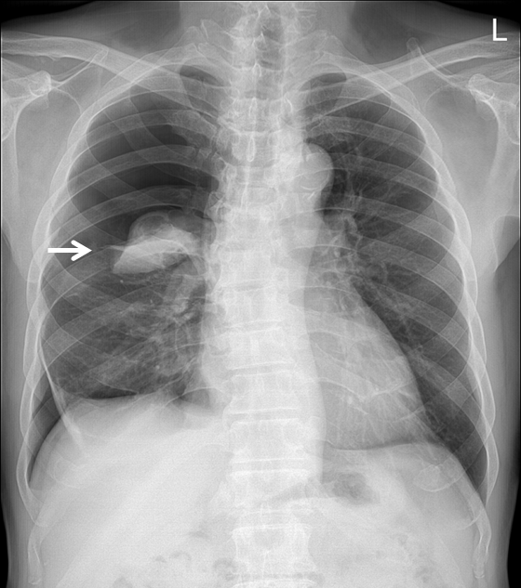
Figure 1 Visible pneumothorax (arrow) on an initial erect posteroanterior chest radiograph.

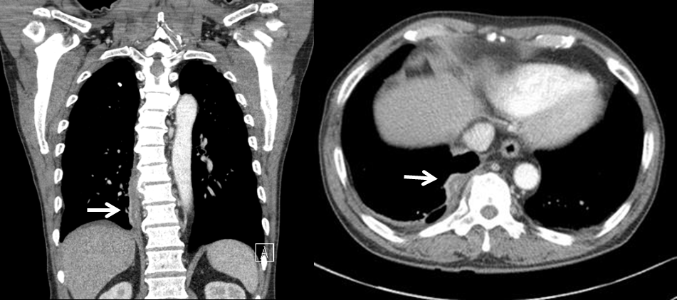
Figure 2 Initial chest computed tomography showing a paravertebral abscess (arrow) connected with the pleural effusion.

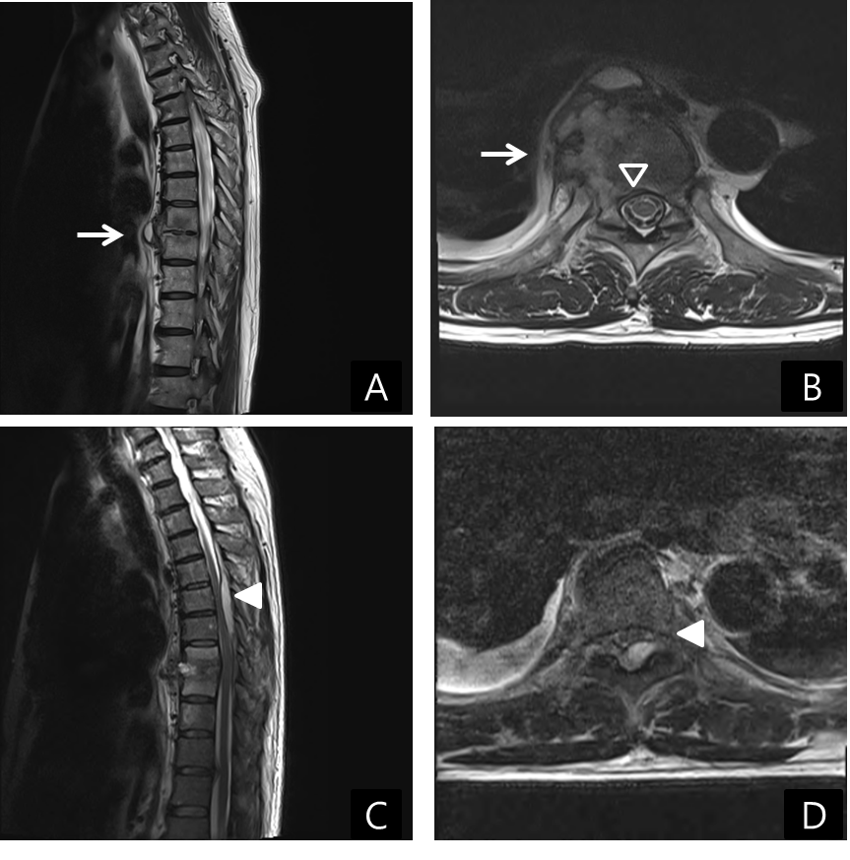
Figure 3 Magnetic resonance imaging of the thoracic spine. A and B: Initial magnetic resonance imaging (MRI) scan showing a paravertebral abscess with extension to T8/9 disc, right rib (arrow), and anterior epidural space (empty arrowhead); C and D: Follow-up MRI scan showing an epidural abscess (arrowhead) at the T4-7 Level with spinal cord compression at T6-7.
Table 1 Characteristics of primary and secondary pneumothorax (according to Bobbio et al^{[17]})
 | Primary spontaneous pneumothorax | Secondary spontaneous pneumothorax
Proportion of all spontaneous pneumothorax, % | 85 | 15
Patient age, yr | 35 ± 18 | 53 ± 20
Sex, male: female | 76: 24 | 80: 20
Underlying lung disease | No | Yes
Clinical picture | Often complaint-free | Depending on severity of the underlying lung disease
Concurrent diseases | Rare | Frequent

Published by Baishideng Publishing Group Inc
7041 Koll Center Parkway, Suite 160, Pleasanton, CA 94566, USA
Telephone: +1-925-3991568
E-mail: bpgoffice@wjgnet.com
Help Desk: https://www.f6publishing.com/helpdesk
https://www.wjgnet.com

© 2021 Baishideng Publishing Group Inc. All rights reserved.

