Name of Journal: World Journal of Clinical Cases
Manuscript NO: 41453
Manuscript Type: ORIGINAL ARTICLE

Retrospective Study
New metastatic lymph node classification for early gastric cancer should differ from those for advanced gastric adenocarcinoma: Results based on the SEER database

Lin JX et al. A new N category for early gastric cancer

Jian-Xian Lin, Jun-Peng Lin, Ping Li, Jian-Wei Xie, Jia-Bin Wang, Jun Lu, Qi-Yue Chen, Long-Long Cao, Mi Lin, Ru-Hong Tu, Chao-Hui Zheng, Chang-Ming Huang

Jian-Xian Lin, Jun-Peng Lin, Ping Li, Jian-Wei Xie, Jia-Bin Wang, Jun Lu, Qi-Yue Chen, Long-Long Cao, Mi Lin, Ru-Hong Tu, Chao-Hui Zheng, Chang-Ming Huang, Department of Gastric Surgery, Fujian Medical University Union Hospital, Fuzhou 350001, Fujian Province, China

Jian-Xian Lin, Jun-Peng Lin, Ping Li, Jian-Wei Xie, Jia-Bin Wang, Jun Lu, Qi-Yue Chen, Long-Long Cao, Mi Lin, Ru-Hong Tu, Chao-Hui Zheng, Chang-Ming Huang, Department of General Surgery, Fujian Medical University Union Hospital, Fuzhou 350001, Fujian Province, China

Jian-Xian Lin, Ping Li, Jia-bin Wang, Chang-Ming Huang, Key Laboratory of Ministry of Education of Gastrointestinal Cancer, Fujian Medical University, Fuzhou 350108, Fujian Province, China

ORCID number: Jian-Xian Lin (0000-0002-5006-4454); Jun-Peng Lin (0000-0002-4376-6730); Ping Li (0000-0002-9418-9339); Jian-Wei Xie (0000-0001-9000-5638); Jia-Bin Wang (0000-0002-2023-0183); Jun Lu (0000-0002-8459-4867); Qi-Yue Chen (0000-0001-6391-4043); Long-Long Cao (0000-0003-3144-3050); Mi Lin (0000-0001-7299-6159); Ru-Hong Tu (0000-0002-7491-3879); Chao-Hui Zheng (0000-0003-0157-5167); Chang-Ming Huang (0000-0002-0019-885X).

Author contributions: Lin JX, Lin JP, and Huang CM conceived of the study, analyzed the data, and drafted the manuscript; Zheng CH, Li P, Xie JW, and Wang JB helped revise the manuscript critically for important intellectual content; Lu J, Chen QY, Cao LL, Lin M, and Tu RH helped collect the data and design the study; all authors read and approved the final manuscript.

Supported by Scientific and Technological Innovation Joint Capital Projects of Fujian Province, China, No. 2016Y9031; and Construction Project of Fujian Province Minimally Invasive Medical Center, No. [2017]171.

Institutional review board statement: This study was reviewed and approved by the Ethics Committee of the Fujian Medical University Union Hospital (No. 2018KY039).

Informed consent statement: Participants were not required to give informed consent to this retrospective study since the analysis of baseline characteristics used anonymized clinical data.

Conflict-of-interest statement: There is no conflict of interest associated with publication of this manuscript.

Open-Access: This article is an open-access article which was selected by an in-house editor and fully peer-reviewed by external reviewers. It is distributed in accordance with the Creative Commons Attribution Non Commercial (CC BY-NC 4.0) license, which permits others to distribute, remix, adapt, build upon this work non-commercially, and license their derivative works on different terms, provided the original work is properly cited and the use is non-commercial. See: http://creativecommons.org/licenses/by-nc/4.0/

Manuscript source: Unsolicited manuscript

Corresponding author: Chang-Ming Huang, MD, Doctor, Professor, Department of Gastric Surgery, Fujian Medical University Union Hospital, No. 29, Xinquan Road, Fuzhou 350001, Fujian Province, China. hcmlr2002@163.com
Telephone: +86-591-83363366
Fax: +86-591-83363366

Received: August 14, 2018
Peer-review started: August 14, 2018
First decision: October 5, 2018
Revised: November 13, 2018
Accepted: November 23, 2018
Article in press: November 24, 2018
Published online: January 26, 2019

Abstract
AIM
To establish an appropriate N classification system for early gastric cancer (EGC).

METHODS
Data from 10714 patients who underwent radical gastrectomy between 1988 and 2011 were retrieved from the National Cancer Institute’s Surveillance, Epidemiology, and End Result database. The overall survival (OS) based on the eighth edition and new tumor lymph node metastasis (TNM) staging systems were compared, and the analysis was repeated in an external validation set from the Fujian Medical University Union Hospital database.

RESULTS
There were no significant differences in OS between N1 and N2 cancers or between N3a and N3b cancers in cases of EGC. The X-tile program identified that the new staging system for EGC consisted of T1N0, T1N1’ [1-6 metastatic lymph nodes (LNs)], and T1N2’ (≥ 7 metastatic LNs). Compared with the eighth edition of the TNM staging system, the OS of patients in T1N1’ stage was similar to that of patients with stage IIA disease, whereas the OS of patients in T1N2’ stage was similar to that of patients with stage IIB disease. The new TNM staging system exhibited a slightly lower Akaike Information Criterion value and higher χ² and c-statistic compared with the eighth edition of the TNM classification system. Similar results were found in the external validation dataset from the external validation set.

CONCLUSION
We have developed an optional new TNM staging system with a better predictive ability that can be used to accurately predict the 5-year OS of patients with EGC.

Key words: Early gastric cancer; Gastrectomy; Tumor lymph node metastasis classification; N classification; Lymph node; Prognosis

© The Author(s) 2019. Published by Baishideng Publishing Group Inc. All rights reserved.

Core tip: The overall survival (OS) was not significantly different between N1 and N2 cancers or between N3a and N3b cancers in cases of early gastric cancer (EGC). We identified a new metastatic lymph node classification for EGC which consisted of T1N1’ (1-6 metastatic LNs) and T1N2’ (≥7 metastatic LNs). The OS of patients in T1N1’ stage was similar to that of the 8th edition American Joint Committee on Cancer stage IIA disease, while the OS of patients in T1N2’ stage was not significantly different from that of patients with stage IIB disease. The new TNM staging system has a better predictive ability of OS for EGC.

Citation: Lin JX, Lin JP, Li P, Xie JW, Wang JB, Lu J, Chen QY, Cao LL, Lin M, Tu RH, Zheng CH, Huang CM. New metastatic lymph node classification for early gastric cancer should differ from those for advanced gastric adenocarcinoma: Results based on the SEER database. World J Clin Cases 2019; 7(2): 145-155
URL: https://www.wjgnet.com/2307-8960/full/v7/i2/145.htm
DOI: https://dx.doi.org/10.12998/wjcc.v7.i2.145
INTRODUCTION
Gastric cancer (GC) is still the fifth common malignant tumor with a high incidence of cancer-related death in the world^{[1,2]}. In 2015, there were an estimated 24590 people who will be diagnosed with GC and more than 10000 patients will eventually die in the United States^{[3]}. Radical gastrectomy with radical systemic lymphadenectomy is the only proven and potentially curative treatment for resectable GC^{[4-6]}. Since the first American Joint Committee on Cancer (AJCC) staging of cancer was published in 1977, there have been eighth editions which have been changed a lot based on the treatment strategies and big database. However, as the founding editors adroitly noted that: “Staging of cancer is not an exact science. As new information becomes available about etiology and various methods of diagnosis and treatment, the classification and staging of cancer will change”^{[7]}. Recently, the eighth edition of the AJCC tumor lymph node metastasis (TNM) staging system for gastric carcinoma was published^{[8]}. This edition retains the same T, N, and M classifications as the seventh edition. However, early gastric cancer (EGC), which comprises of T1 tumors irrespective of lymph node metastasis, is a special type of cancer^{[9]}. Although GC is often diagnosed at an advanced stage, the incidence of EGC may be increasing, especially in Japan and South Korea^{[10,11]}. Variable rates of recurrence of EGC, which range from 2.1% to 12.4%, have been reported in several studies^{[11-14]}. Al-Refaie et al^{[15]} found that the AJCC TNM staging system was inadequate for EGC. Additionally, some studies showed that the survival of patients with EGC was more affected by the metastatic lymph nodes (LNs) than the depth of tumor spread into the stomach wall or its size^{[16,17]}. Therefore, the current research was aimed to re-evaluate the long-term overall survival (OS) of EGC patients from the Surveillance, Epidemiology, and End Results (SEER) database who underwent radical gastrectomy between 1988 and 2011 in the context of the eighth edition of the AJCC staging system, and identify a better TNM classification to improve the prognostic prediction of patients with EGC after curative surgery. We also compared the discriminatory value of the new TNM classification with that of the eighth edition of the AJCC TNM staging system.

MATERIALS AND METHODS
Patients
The SEER program of the National Cancer Institute is an authoritative source of information on cancer incidence and survival data which cover approximately 26 percent of the United States population^{[18]}. Its registries routinely collect data on patient demographics, primary tumor site, tumor morphology and stage at diagnosis, treatment, and survival. The inclusion criteria included: (1) patients in the SEER database who were at least 20 years of age with gastric adenocarcinoma confirmed by histology (ICD-0-3M-8140/3, M-8142/3 through M-8145/3, M-8210/3, M-8211/3, M-8255/3, M-8260/3 through M-8263/3, M-8310/3, M-8323/3, M-8480/3, M-8481/3, and M-8490/3) and who underwent radical gastrectomy between 1988 and 2011 were eligible for this study; (2) only patients with at least 15 LNs examined were included; (3) we then obtained data from the following categories: “Race recode (White, Black, and Other)”, “Age at diagnosis”, “Grade”, “ICD-O-3 Hist/behav”, “Primary Site - labeled”, “Derived AJCC Stage Group, 6th ed (2004+)”, “Derived AJCC Stage Group, 7th ed (2010+)”, “EOD 10 - extent (1988-2003)”, “CS extension (2004+)”, “Derived AJCC T, 6th ed (2004+)”, “Derived AJCC T, 7th ed (2010+)”, “EOD 10 - nodes (1988-2003)”, “CS lymph nodes (2004+)”, “Derived AJCC N, 6th ed (2004+)”, “Derived AJCC N, 7th ed (2010+)”, “CS mets at dx (2004+)”, “Derived AJCC M, 6th ed (2004+)”, “Derived AJCC M, 7th ed (2010+)”, “Site specific surgery (1973-1997 varying detail by year and site)”, “RX Summ--Surg Prim Site (1998+)”, “Regional nodes examined (1988+)”, and “Regional nodes positive (1988+)”. Patients were excluded due to: (1) pT4b stage; (2) when distant metastasis was apparent (M1); (3) unknown T and/or N category; (4) patients with previous malignancies; and (5) patients received radiotherapy or chemotherapy prior to surgery. Patients with tumors located in the esophagogastric junction (sit code 160) were also excluded, as these may be classified as either GC or esophageal cancer, depending on the extent of the disease^{[19]}. The tumor stage was reclassified according to the eighth edition of the AJCC/UICC TNM classification^{[8]}. All patients with incomplete medical records or whose records lacked certain information were eliminated from the dataset. For the re-classification of the TNM stages for early GC, the T1 patients were excluded from stage IIA and IIB. The median follow-up for SEER data sets was 121 mo.
Additional external validation was performed using the dataset from Fujian Medical University Union Hospital (FMUUH), China. Patients with GC in the FMUUH database who were older than 18 years of age and who underwent radical gastrectomy between January 1997 and December 2014 were eligible for this study. The inclusion criteria were defined as: (1) histologically confirmed primary gastric adenocarcinoma; (2) at least 15 LNs examined; (3) no distant metastasis; and (4) radical gastrectomy with R0 resection and regional lymphadenectomy. Patients in the validation data set were excluded if they had fewer than 15 examined LNs, T4b stage, and if the T stage, number of positive LNs, or status of distant metastases were unknown. The final FMUUH cohort included in this study comprised 4407 patients. The adjuvant chemotherapy generally consisted of 5-fluorouracil (5-FU)-based regimens (commonly Oxaliplatin with either Xeloda or S1) for advanced GC in the FMUUH data sets^{[20,21]}. The follow-up data were obtained from the follow-up office established by the Department of Gastric Surgery, FMUUH or from the National Statistical Office data. The survival time was calculated from the date of operation to the date of last follow-up or death. All patients were followed until death or date of December 2016, whichever occurred first. The median follow-up period was 66.0 mo. This project was approved by the local ethics committee of the FMUUH, China.

Methods
Statistical analyses were performed with SPSS statistics software (version 18.0, SPSS Inc, Chicago, IL, United States) and STATA version 12.0 (StataCorp, College Station, TX, United States). OS was analyzed using the Kaplan-Meier method, and log-rank tests were used for statistical comparisons of the survival curves. X-tile program (http:www.tissuearray.org/rimmlab/) was used to produce the LN cutoff points with the minimum P-values from log-rank χ² statistics for the categorical metastatic LNs in terms of survival. The Akaike Information Criterion (AIC) and the Harrell’s concordance index (c-statistic) were used to assess the relative discriminatory abilities of the different TNM staging systems. In general, a predictive model with a low AIC indicates a better model fit, and a high c-statistic represents a better discriminatory ability^{[22-24]}. Statistical significant differences were assumed as a two-side P < 0.05.

RESULTS
Clinicopathological characteristics of patients
In all, 10714 patients in the SEER database fulfilled the selection criteria (Table 1). There were 6497 (60.6%) males and 4217 (39.4%) females aged between 20 and 101 years (67.1 ± 13.1 years). The median number of nodes examined was 22, and the 25% and 75% interquartile ranges were 18.0 and 29.0, respectively. Based on the eighth edition of the TNM classification^{[7]}, 1814 (16.9%) patients had stage pT1 (T1N0, 1353 patients; T1N1, 235 patients; T1N2, 139 patients; and T1N3, 87 patients), 1167 (10.9%) had pT2, 4417 (41.2%) had pT3, and 3316 (30.9%) had pT4a disease. A total of 3169 (29.6%) patients showed no LN metastasis, whereas 1530 (14.3%) had pN1, 1820 (17.0%) had pN2, 2596 (24.2%) had pN3a, and 1599 (14.9%) had pN3b disease. According to the TNM classification, there were 1353 (12.6%) patients in stage IA, 754 (7.0%) in stage IB, 1323 (12.3%) in stage IIA, 1213 (11.3%) in stage IIB, 1328 (12.4%) in stage IIIA, 2569 (24.0%) in stage IIIB, and 2174 (20.3%) in stage IIIC.

Comparison of the survival for each N classification in the same T category
The 5-year OS rate of the entire cohort was 39.3%. The OS was compared with each N classification in the same T category (Figure 1 and Supplemental Table 1). For advanced GC (pT2-4a) patients, the survival curves of different N classifications demonstrated significant differences in the same T classification (P < 0.05). However, the OS between N1 and N2 cancers and between N3a and N3b cancers in cases of EGC did not differ significantly (P > 0.05), although a marked difference was seen in survival between the N0 and N1, and between the N2 and N3a cancer groups (P < 0.05).

Identification of the optimal cut-off points of N classification for EGC
We applied X-tile analysis to determine the optimal cut-off N classification in order to predict the OS according to the different numbers of metastatic LNs. The result showed that 6 was the optimal cut-off for the number of metastatic LNs in patients with EGC (P < 0.05, Figure 2). Therefore, this value was used to divide the patients with EGC with LN metastasis into two subsets as follow: N1’, 1-6 LNs and N2’, ≥7 LNs.

Re-classification of the TNM stages for EGC
According to the eighth edition of the TNM staging system, T1N1 is stage IB, T1N2 is stage IIA, T1N3a is stage IIB, and T1N3b is stage IIIB. To identify the proposed new TNM staging system for EGC, we calculated T1N1’ and T1N2’ as new stages and compared the OS of patients with those stages to the stages according to the eighth edition of the TNM staging system which has excluded the T1N1-3 patients. The results are showed in Figure 3 and Supplemental Table 2. No significant differences were observed in patients with T1N1’ vs stage IIA or in patients with T1N2’ vs stage IIB (P > 0.05), but a significant difference was observed in patients with other stages. In addition, we found that the survival curves were comparable between T1N1’ and subgroups of stage IIA (T2N1 and T3N0), and between T1N2’ and subgroups of stage IIB (T2N2, T3N1, and T4aN0) (Supplemental Figure 1). Therefore, the proposed new stages T1N1’ and T1N2’ were considered equivalent to stage IIA and stage IIB, respectively.

Prognostic value of the eighth edition and the proposed new TNM staging system
The proposed new TNM (nTNM) staging system is shown in Figure 4. We retained the same stages as in the eighth edition classification for advanced GC. The nTNM staging system revealed no crossing of the survival curves among the individual stage subgroups with statistically significant differences (Figure 5). A statistical assessment of the predictive performance of the two staging systems revealed that the nTNM staging system had a smaller AIC value (310672.4 vs 310674.3 for the eighth), a higher χ² (6522.172 vs 6503.622 for the eighth), and a little higher Harrell’s C-index (0.6685 vs 0.6674 for the eighth). Although these values are not so much different between the eighth edition of the AJCC TNM staging classification and nTNM, the new N classification for EGC seems to have an optimal prognostic stratification.

Validation using the FMUUH data sets
An external validation of the new staging system was performed using the FMUUH data set (n = 4407). For patients in the FMUUH dataset, the 5-year OS was significantly different for patients at each stage between the eighth edition of the AJCC TNM staging system and the nTNM (P < 0.05; Supplemental Figure 2). The nTNM staging also showed a slightly smaller AIC value (24796.1 vs 24798.5 for the eighth edition), a higher χ² (1293.584 vs 1290.275 for the eighth), and a higher Harrell’s C-index (0.7498 vs 0.7491 for the eighth).

DISCUSSION
EGC is a special type of tumor that comprises of T1 (invading the mucosa or submucosa) tumors irrespective of lymph node metastasis. Currently, given that health and endoscopic examinations are more commonly performed in clinical practice, the frequency of the diagnosis of EGC among all cases of GC has increased^{[25]}. The 5-year survival rate of patients with EGC usually exceeds 90% in some Asian and Western countries. However, nearly 10% of patients still experience recurrence or death^{[26-28]}. An accurate staging system for malignancy is useful to make the postoperative treatment decisions and follow-up plans^{[29]}. Although the AJCC system is a worldwide used staging system, the N staging system is still occasionally questionable^{[30-32]}. The eighth edition of the TNM staging system stratifies GC without distant metastasis into seven risk groups according to the pathological T and N categories. However, the classification scheme of the AJCC staging system is primarily based on the advanced GC. In EGC, lymph node metastasis is less severe than that in advanced GC^{[33]}. Whether the AJCC TNM staging system is also appropriate for T1 cancer remains to be decided, but few studies have focused on this topic. Therefore, we investigated the survival of patients with EGC on the basis of a large sample and long-term follow-up results from the SEER database. Several highly influential studies also used the SEER database as a large-scale of multicenter database^{[18,34,35]}. Although the SEER database may have some missing information, a part of patients have detailed primary tumor and lymph node characteristics, and survival, which were the main information we needed in our study.
The LN metastasis is one of the most significant prognostic factors for EGC. As reported in previous studies, LN metastasis usually occurs in less than 6% of intramucosal GCs, but when the tumor invades the sub-mucosal layer where lymphatic vessels are abundant, the rate of LN metastasis increases significantly to above 10%^{[36]}. However, the N classification is still doubtful for EGC. A study from South Korea^{[37]} showed that the sixth and seventh editions of the AJCC staging system were not well distributed with respect to the survival curve for patients with EGC; as a result, they developed a new N category as follows: N1 (1-5 metastatic LNs), N2 (6-10 metastatic LNs), and N3 (>10 metastatic LNs). They found that this classification system resulted in satisfactory survival curves. In the current study, we found that the OS between N1 and N2, or between N3a and N3b cancers were not significantly different in cases of EGC (P > 0.05). We used the X-tile method and the bootstrap procedure to confirm the stability of the cut off of 6 metastatic LNs, which showed a significant difference. Then, we proposed to classify EGC with LN metastasis into two subsets: T1N1’ and T1N2’ stages, which were determined to be stage IIA and stage IIB, respectively. The T1N3b classified into category IIB instead of IIIB is benefit for more actually predicting the survival. However, adjuvant chemotherapy still should be chose according to the treatment guideline. Moreover, this nTNM staging system shows a similar predictive ability (with a slightly lower AIC value and higher χ² and c-statistic) for patients compared to the 8th edition of the AJCC TNM staging system. Although the new classification applies different N classifications between T1 and T2-4, it is meaningful of providing more accurate prognosis of N stages for EGC patients.
This study is significant, as a large cohort of patients who underwent radical gastrectomy and had a verified diagnosis based on the latest revision of the AJCC TNM classification were used to develop the nTNM staging system. An external validation is essential to ensure external applicability, although the predictive accuracy may decrease within an external validation set. It is more stringent for an external validation involving a dataset from another country than that involving using a dataset from a different institution or a validation set from the same institution based on a data-splitting method^{[22]}. Since GC in American or European patients may differ biologically from GC in Asian patients, due to the significant variability in the extent of LN dissection and the average number of nodes retrieved^{[38-40]}, an Eastern-based population should also be used to evaluate the prognostic value of the new nTNM classification. Therefore, the additional external validation in this study was performed using an Asian dataset from the FMUUH database. Although the extent of LN dissection has changed over time, there is still without a standard extent of lymph node dissection for GC worldwide until now. In Japanese GC treatment guidelines^{[9]}, a D1 or D1 + lymphadenectomy is acceptable for EGC. Additionally, the NCCN guideline for GC indicates that gastric resection should include a systemic lymphadenectomy and remove at least 15 LNs as an adequate number of nodes for staging^{[8]}. Therefore, in order to have a more actual estimation of N status of EGC, we only included patients with 15 or greater LNs retrieved in the current study according to the NCCN guidelines. In accordance with our results, the external validation of the nTNM classification system with the FMUUH dataset revealed similar results of AIC value, χ², and Harrell’s C-index as the training set. Nowadays, there are no studies on how many differences between AIC, χ², and c-statistics will be significant or clinically meaningful. Most studies mention that a smaller AIC value or a larger χ² and c-statistics indicated a better model for predicting outcome^{[29,41-43]}. At least, these parameters in this study were similar between the 8th edition TNM and new classification.
Although this study had a large cohort of patients from the SEER database, and had an external validation performed using the FMUUH database, there were still some limitations. First, the power of our conclusions may be somewhat limited by the retrospective nature of the study. The new classification in this study still needs more available data to confirm. Second, there are some shortcomings with the SEER data, including some incomplete information and the treatment may with some variable including quality of surgery. Third, the differences of AIC and c-index between the eighth edition and new TNM classification may be a little small. This may be because the eighth edition of the AJCC TNM staging system was revised based on the seventh edition and a large international sample size. It actually has a quite homogeneity, discriminatory, and monotonicity ability. What’s more, the data collecting periods were a little long in this study, and there were some epoch events, such as chemotherapy and endoscopic excision. Prior to 2002, adjuvant regimens were not widely used outside of Asia. In the United States now, adjuvant chemoradiotherapy is frequently employed. In Europe and Australia, adjuvant chemotherapy is usually platinum based with 5-FU or Xeloda, and S1 is more used in Asia. These variations in adjuvant therapies may affect the outcomes. However, this study focused on EGC, and most of the patients did not need chemotherapy. Additionally, we only included patients with at least 15 LNs examined in our study who might have sufficient LNs to check the LN status for EGC. As a result, there were still some meaningful findings from this study.
In summary, the LN metastasis classification of the eighth edition of the AJCC TNM staging system has variation in survival for AGC patients but is still associated with some stage migration in EGC. We have developed an optional new TNM staging system that can be used to accurately predict the 5-year OS of patients with EGC. However, more prospective studies with different populations are needed in the future.

ARTICLE HIGHLIGHTS
Research background
Gastric cancer (GC) is a common type of cancer with a high incidence of cancer-related death. Early gastric cancer (EGC), which comprises of T1 tumors irrespective of lymph node metastasis, is a special type of cancer. Although GC is often diagnosed at an advanced stage, the incidence of EGC is increasing. Recently, the eighth edition of the American Joint Committee on Cancer (AJCC) tumor lymph node metastasis (TNM) staging system for stomach carcinoma was published. This edition retains the same T, N, and M classifications as the seventh edition. However, several studies found that the AJCC TNM staging system was inadequate for EGC.

Research motivation
An accurate staging system for malignancy is useful to make the postoperative treatment decisions and follow-up plans. Although the AJCC system is a worldwide used staging system, the N staging system is still occasionally questionable. The eighth edition of the TNM staging system stratifies GC without distal metastasis into seven risk groups according to the pathological T and N categories. However, the classification scheme of the AJCC staging system is primarily based on the advanced GC. In EGC, lymph node metastasis is less severe than that in advanced GC. Whether the AJCC TNM staging system is also appropriate for T1 cancer remains to be decided, but few studies have focused on this topic.

Research objective
The aim of this study was to identify a better TNM classification to improve the prognostic prediction of patients with EGC after curative surgery.

Research methods
We re-evaluated the long-term survival of patients with EGC who underwent radical gastrectomy from the SEER database between 1988 and 2011 in the context of the eighth edition of the AJCC staging system, and identify a better TNM classification to improve the prognostic prediction of patients with EGC after curative surgery. We also compared the discriminatory value of the new TNM classification with that of the eighth edition of the AJCC TNM staging system. Additional external validation was performed using the dataset from Fujian Medical University Union Hospital, China with similar inclusion and exclusion criteria. Overall survival was analyzed using the Kaplan-Meier method, and log-rank tests were used for statistical comparisons of the survival curves. X-tile program (http:www.tissuearray.org/rimmlab/) was used to produce the LN cutoff points with the minimum P-values from log-rank χ² statistics for the categorical metastatic LNs in terms of survival. The Akaike Information Criterion and the Harrell’s concordance index (c-statistic) were used to assess the relative discriminatory abilities of different TNM staging systems.

Research results
The OS between N1 and N2, or between N3a and N3b cancers did not differ significantly in cases of EGC. We identified a new metastatic lymph node classification for EGC consisting of T1N0, T1N1’ (1-6 metastatic LNs), and T1N2’ (≥7 metastatic LNs) using X tile program. The OS of patients in T1N1’ stage was similar to the 8th edition AJCC stage IIA disease, while the OS of patients in T1N2’ stage was not significantly different from that of stage IIB disease. The new TNM staging system exhibited a slightly better predictive ability of OS for EGC in the training set and an external validation set.

Research conclusions
The LN metastasis classification of the eighth edition of the AJCC TNM staging system has variation in survival for AGC patients but is still associated with some stage migration in EGC. We have developed an optional new TNM staging system that can be used to accurately predict the 5-year OS of patients with EGC. However, more prospective studies with different populations are needed in the future.

Research perspectives
EGC is a special type of tumor that comprises of T1 (invading the mucosa or submucosa) tumors irrespective of lymph node metastasis. The 5-year survival rate of patients with EGC usually exceeds 90% in some Asian and Western countries. However, nearly 10% of patients still experience recurrence or death. An accurate staging system for malignancy is useful for making the postoperative treatment decisions and follow-up plans. We have developed an optional new TNM staging system with a better predictive ability of overall survival for EGC. This topic requires further analysis in a larger patient subset and in randomized studies in the future.
REFERENCES
1 Jemal A, Bray F, Center MM, Ferlay J, Ward E, Forman D. Global cancer statistics. CA Cancer J Clin 2011; 61: 69-90 [PMID: 21296855 DOI: 10.3322/caac.20107]
2 Hartgrink HH, Jansen EP, van Grieken NC, van de Velde CJ. Gastric cancer. Lancet 2009; 374: 477-490 [PMID: 19625077 DOI: 10.1016/S0140-6736(09)60617-6]
3 Siegel RL, Miller KD, Jemal A. Cancer statistics, 2015. CA Cancer J Clin 2015; 65: 5-29 [PMID: 25559415 DOI: 10.3322/caac.21254]
4 Songun I, Putter H, Kranenbarg EM, Sasako M, van de Velde CJ. Surgical treatment of gastric cancer: 15-year follow-up results of the randomised nationwide Dutch D1D2 trial. Lancet Oncol 2010; 11: 439-449 [PMID: 20409751 DOI: 10.1016/S1470-2045(10)70070-X]
5 Isobe Y, Nashimoto A, Akazawa K, Oda I, Hayashi K, Miyashiro I, Katai H, Tsujitani S, Kodera Y, Seto Y, Kaminishi M. Gastric cancer treatment in Japan: 2008 annual report of the JGCA nationwide registry. Gastric Cancer 2011; 14: 301-316 [PMID: 21894577 DOI: 10.1007/s10120-011-0085-6]
6 Baiocchi GL, Tiberio GA, Minicozzi AM, Morgagni P, Marrelli D, Bruno L, Rosa F, Marchet A, Coniglio A, Saragoni L, Veltri M, Pacelli F, Roviello F, Nitti D, Giulini SM, De Manzoni G. A multicentric Western analysis of prognostic factors in advanced, node-negative gastric cancer patients. Ann Surg 2010; 252: 70-73 [PMID: 20562605 DOI: 10.1097/SLA.0b013e3181e4585e]
7 Amin MB, Greene FL, Edge SB, Compton CC, Gershenwald JE, Brookland RK, Meyer L, Gress DM, Byrd DR, Winchester DP. The Eighth Edition AJCC Cancer Staging Manual: Continuing to build a bridge from a population-based to a more "personalized" approach to cancer staging. CA Cancer J Clin 2017; 67: 93-99 [PMID: 28094848 DOI: 10.3322/caac.21388]
8 Amin MB, Greene FL, Edge SB, Compton CC, Gershenwald JE, Brookland RK, Meyer L, Gress DM, Byrd DR, Winchester DP. AJCC Cancer Staging Manual. 8th ed. New York: Springer, 2016
9 Japanese Gastric Cancer Association.. Japanese classification of gastric carcinoma: 3rd English edition. Gastric Cancer 2011; 14: 101-112 [PMID: 21573743 DOI: 10.1007/s10120-011-0041-5]
10 Lee JH, Chang KK, Yoon C, Tang LH, Strong VE, Yoon SS. Lauren Histologic Type Is the Most Important Factor Associated With Pattern of Recurrence Following Resection of Gastric Adenocarcinoma. Ann Surg 2018; 267: 105-113 [PMID: 27759618 DOI: 10.1097/SLA.0000000000002040]
11 Pyo JH, Lee H, Min BH, Lee JH, Choi MG, Lee JH, Sohn TS, Bae JM, Kim KM, Ahn JH, Carriere KC, Kim JJ, Kim S. Long-Term Outcome of Endoscopic Resection vs. Surgery for Early Gastric Cancer: A Non-inferiority-Matched Cohort Study. Am J Gastroenterol 2016; 111: 240-249 [PMID: 26782817 DOI: 10.1038/ajg.2015.427]
12 Wu B, Wu D, Wang M, Wang G. Recurrence in patients following curative resection of early gastric carcinoma. J Surg Oncol 2008; 98: 411-414 [PMID: 18767119 DOI: 10.1002/jso.21133]
13 Yamamoto M, Yamanaka T, Baba H, Kakeji Y, Maehara Y. The postoperative recurrence and the occurrence of second primary carcinomas in patients with early gastric carcinoma. J Surg Oncol 2008; 97: 231-235 [PMID: 18095298 DOI: 10.1002/jso.20946]
14 Takizawa K, Ono H, Kakushima N, Tanaka M, Hasuike N, Matsubayashi H, Yamagichi Y, Bando E, Terashima M, Kusafuka K, Nakajima T. Risk of lymph node metastases from intramucosal gastric cancer in relation to histological types: how to manage the mixed histological type for endoscopic submucosal dissection. Gastric Cancer 2013; 16: 531-536 [PMID: 23192620 DOI: 10.1007/s10120-012-0220-z]
15 Al-Refaie WB, Tseng JF, Gay G, Patel-Parekh L, Mansfield PF, Pisters PW, Yao JC, Feig BW. The impact of ethnicity on the presentation and prognosis of patients with gastric adenocarcinoma. Results from the National Cancer Data Base. Cancer 2008; 113: 461-469 [PMID: 18553367 DOI: 10.1002/cncr.23572]
16 Nogueira C, Silva AS, Santos JN, Silva AG, Ferreira J, Matos E, Vilaça H. Early gastric cancer: ten years of experience. World J Surg 2002; 26: 330-334 [PMID: 11865370 DOI: 10.1007/s00268-001-0228-8]
17 Zhao X, Cai A, Xi H, Chen L, Peng Z, Li P, Liu N, Cui J, Li H. Predictive Factors for Lymph Node Metastasis in Undifferentiated Early Gastric Cancer: a Systematic Review and Meta-analysis. J Gastrointest Surg 2017; 21: 700-711 [PMID: 28120275 DOI: 10.1007/s11605-017-3364-7]
18 Wang J, Dang P, Raut CP, Pandalai PK, Maduekwe UN, Rattner DW, Lauwers GY, Yoon SS. Comparison of a lymph node ratio-based staging system with the 7th AJCC system for gastric cancer: analysis of 18,043 patients from the SEER database. Ann Surg 2012; 255: 478-485 [PMID: 22330040 DOI: 10.1097/SLA.0b013e31824857e2]
19 Washington K. 7th edition of the AJCC cancer staging manual: stomach. Ann Surg Oncol 2010; 17: 3077-3079 [PMID: 20882416 DOI: 10.1245/s10434-010-1362-z]
20 Sasako M, Sakuramoto S, Katai H, Kinoshita T, Furukawa H, Yamaguchi T, Nashimoto A, Fujii M, Nakajima T, Ohashi Y. Five-year outcomes of a randomized phase III trial comparing adjuvant chemotherapy with S-1 versus surgery alone in stage II or III gastric cancer. J Clin Oncol 2011; 29: 4387-4393 [PMID: 22010012 DOI: 10.1200/JCO.2011.36.5908]
21 Bang YJ, Kim YW, Yang HK, Chung HC, Park YK, Lee KH, Lee KW, Kim YH, Noh SI, Cho JY, Mok YJ, Kim YH, Ji J, Yeh TS, Button P, Sirzén F, Noh SH; CLASSIC trial investigators. Adjuvant capecitabine and oxaliplatin for gastric cancer after D2 gastrectomy (CLASSIC): a phase 3 open-label, randomised controlled trial. Lancet 2012; 379: 315-321 [PMID: 22226517 DOI: 10.1016/S0140-6736(11)61873-4]
22 Han DS, Suh YS, Kong SH, Lee HJ, Choi Y, Aikou S, Sano T, Park BJ, Kim WH, Yang HK. Nomogram predicting long-term survival after d2 gastrectomy for gastric cancer. J Clin Oncol 2012; 30: 3834-3840 [PMID: 23008291 DOI: 10.1200/JCO.2012.41.8343]
23 Harrell FE Jr. Regression Modeling Strategies with Application to Linear Models, Logistic Regression, and Survival Analysis. New York, NY, Springer Verlag, 2001
24 Harrell FE Jr, Lee KL, Mark DB. Multivariable prognostic models: issues in developing models, evaluating assumptions and adequacy, and measuring and reducing errors. Stat Med 1996; 15: 361-387 [PMID: 8668867 DOI: 10.1002/(SICI)1097-0258(19960229)15:43.0.CO;2-4]
25 Hwang JJ, Lee DH, Yoon H, Shin CM, Park YS, Kim N. Clinicopathological characteristics of patients who underwent additional gastrectomy after incomplete endoscopic resection for early gastric cancer. Medicine (Baltimore) 2017; 96: e6172 [PMID: 28207556 DOI: 10.1097/MD.0000000000006172]
26 Hanyu T, Matsuki A, Kosugi S, Ishikawa T, Nashimoto A, Yabusaki H, Aizawa M, Ichikawa H, Shimada Y, Hirose Y, Wakai T. Prognostic analysis of submucosa-invasive gastric cancer with lymph node metastasis. Surgery 2015; 157: 716-722 [PMID: 25433728 DOI: 10.1016/j.surg.2014.10.009]
27 Kubota H, Kotoh T, Masunaga R, Dhar DK, Shibakita M, Tachibana M, Kohno H, Nagasue N. Impact of screening survey of gastric cancer on clinicopathological features and survival: retrospective study at a single institution. Surgery 2000; 128: 41-47 [PMID: 10876184 DOI: 10.1067/msy.2000.106812]
28 Lee JH, Choi IJ, Han HS, Kim YW, Ryu KW, Yoon HM, Eom BW, Kim CG, Lee JY, Cho SJ, Kim YI, Nam BH, Kook MC. Risk of lymph node metastasis in differentiated type mucosal early gastric cancer mixed with minor undifferentiated type histology. Ann Surg Oncol 2015; 22: 1813-1819 [PMID: 25344305 DOI: 10.1245/s10434-014-4167-7]
29 Spolverato G, Ejaz A, Kim Y, Squires MH, Poultsides G, Fields RC, Bloomston M, Weber SM, Votanopoulos K, Acher AW, Jin LX, Hawkins WG, Schmidt C, Kooby DA, Worhunsky D, Saunders N, Cho CS, Levine EA, Maithel SK, Pawlik TM. Prognostic Performance of Different Lymph Node Staging Systems After Curative Intent Resection for Gastric Adenocarcinoma. Ann Surg 2015; 262: 991-998 [PMID: 25563867 DOI: 10.1097/SLA.0000000000001040]
30 Wang W, Sun XW, Li CF, Lv L, Li YF, Chen YB, Xu DZ, Kesari R, Huang CY, Li W, Zhan YQ, Zhou ZW. Comparison of the 6th and 7th editions of the UICC TNM staging system for gastric cancer: results of a Chinese single-institution study of 1,503 patients. Ann Surg Oncol 2011; 18: 1060-1067 [PMID: 21107742 DOI: 10.1245/s10434-010-1424-2]
31 Chae S, Lee A, Lee JH. The effectiveness of the new (7th) UICC N classification in the prognosis evaluation of gastric cancer patients: a comparative study between the 5th/6th and 7th UICC N classification. Gastric Cancer 2011; 14: 166-171 [PMID: 21360132 DOI: 10.1007/s10120-011-0024-6]
32 Warneke VS, Behrens HM, Hartmann JT, Held H, Becker T, Schwarz NT, Röcken C. Cohort study based on the seventh edition of the TNM classification for gastric cancer: proposal of a new staging system. J Clin Oncol 2011; 29: 2364-2371 [PMID: 21537040 DOI: 10.1200/JCO.2010.34.4358]
33 Sekiguchi M, Oda I, Taniguchi H, Suzuki H, Morita S, Fukagawa T, Sekine S, Kushima R, Katai H. Risk stratification and predictive risk-scoring model for lymph node metastasis in early gastric cancer. J Gastroenterol 2016; 51: 961-970 [PMID: 26884381 DOI: 10.1007/s00535-016-1180-6]
34 Anderson WF, Camargo MC, Fraumeni JF Jr, Correa P, Rosenberg PS, Rabkin CS. Age-specific trends in incidence of noncardia gastric cancer in US adults. JAMA 2010; 303: 1723-1728 [PMID: 20442388 DOI: 10.1001/jama.2010.496]
35 Wang J, Sun Y, Bertagnolli MM. Comparison of gastric cancer survival between Caucasian and Asian patients treated in the United States: results from the Surveillance Epidemiology and End Results (SEER) database. Ann Surg Oncol 2015; 22: 2965-2971 [PMID: 25631065 DOI: 10.1245/s10434-015-4388-4]
36 Namieno T, Koito K, Higashi T, Sato N, Uchino J. General pattern of lymph node metastasis in early gastric carcinoma. World J Surg 1996; 20: 996-1000 [PMID: 8798355 DOI: 10.1007/s002689900151]
37 Choi KH, Kim BS, Oh ST, Yook JH, Kim BS. Comparison the sixth and seventh editions of the AJCC staging system for T1 gastric cancer: a long-term follow-up study of 2124 patients. Gastric Cancer 2017; 20: 43-48 [PMID: 26732877 DOI: 10.1007/s10120-015-0590-0]
38 Woo Y, Son T, Song K, Okumura N, Hu Y, Cho GS, Kim JW, Choi SH, Noh SH, Hyung WJ. A Novel Prediction Model of Prognosis After Gastrectomy for Gastric Carcinoma: Development and Validation Using Asian Databases. Ann Surg 2016; 264: 114-120 [PMID: 26945155 DOI: 10.1097/SLA.0000000000001523]
39 Naylor GM, Gotoda T, Dixon M, Shimoda T, Gatta L, Owen R, Tompkins D, Axon A. Why does Japan have a high incidence of gastric cancer? Comparison of gastritis between UK and Japanese patients. Gut 2006; 55: 1545-1552 [PMID: 16603635 DOI: 10.1136/gut.2005.080358]
40 Theuer CP, Campbell BS, Peel DJ, Lin F, Carpenter P, Ziogas A, Butler JA. Microsatellite instability in Japanese vs European American patients with gastric cancer. Arch Surg 2002; 137: 960-5; discussion 965-6 [PMID: 12146999 DOI: 10.1001/archsurg.137.8.960]
41 Lu J, Wang W, Zheng CH, Fang C, Li P, Xie JW, Wang JB, Lin JX, Chen QY, Cao LL, Lin M, Huang CM, Zhou ZW. Influence of Total Lymph Node Count on Staging and Survival After Gastrectomy for Gastric Cancer: An Analysis From a Two-Institution Database in China. Ann Surg Oncol 2017; 24: 486-493 [PMID: 27619942 DOI: 10.1245/s10434-016-5494-7]
42 Wang X, Appleby DH, Zhang X, Gan L, Wang JJ, Wan F. Comparison of three lymph node staging schemes for predicting outcome in patients with gastric cancer. Br J Surg 2013; 100: 505-514 [PMID: 23319421 DOI: 10.1002/bjs.9014]
43 Hsu PK, Wu YC, Chou TY, Huang CS, Hsu WH. Comparison of the 6th and 7th editions of the American Joint Committee on Cancer tumor-node-metastasis staging system in patients with resected esophageal carcinoma. Ann Thorac Surg 2010; 89: 1024-1031 [PMID: 20338302 DOI: 10.1016/j.athoracsur.2010.01.017]

P-Reviewer: Chiu CC, Muguruma N, Noshiro H, Tsunoda S S-Editor: Ji FF L-Editor: Wang TQ E-Editor: Wu YXJ

Specialty type: Medicine, research and experimental
Country of origin: China
Peer-review report classification
Grade A (Excellent): 0
Grade B (Very good): B, B
Grade C (Good): C
Grade D (Fair): 0
Grade E (Poor): E

Table 1 Patient and tumor characteristic
Characteristic | SEER set  (10714 patients) |  |  | FMUUH set  (4407 patients) |  | P
 | mean or n | SD or % |  | mean or n | SD or %
Age (SD) | 67.1 | 13.1 |  | 59.8 | 11.3 | 0.000
Sex |  |  |  |  |  | 0.000
Male | 6497 | 60.6 |  | 3321 | 75.4
Female | 4217 | 39.4 |  | 1086 | 24.6
Race |  |  |  |  |  | -
White | 6539 | 61.0 |  | - | -
Black | 1297 | 12.1 |  | - | -
Other | 2848 | 26.6 |  | - | -
Unknown | 30 | 0.3 |  | - | -
No. of examined nodes (SD) | 24.99 | 10.7 |  | 30.9 | 13.0 | 0.000
pT category |  |  |  |  |  | 0.000
pT1 | 1814 | 16.9 |  | 899 | 20.4
pT2 | 1167 | 10.9 |  | 534 | 12.1
pT3 | 4417 | 41.2 |  | 954 | 21.6
pT4a | 3316 | 30.9 |  | 2020 | 45.8
pN category |  |  |  |  |  | 0.000
pN0 | 3169 | 29.6 |  | 1485 | 33.7
pN1 | 1530 | 14.3 |  | 630 | 14.3
pN2 | 1820 | 17.0 |  | 781 | 17.7
pN3a | 2596 | 24.2 |  | 928 | 21.1
pN3b | 1599 | 14.9 |  | 583 | 13.2
TNM stage |  |  |  |  |  | 0.000
IA | 1353 | 12.6 |  | 738 | 16.7
IB | 754 | 7.0 |  | 372 | 8.4
IIA | 1323 | 12.3 |  | 387 | 8.8
IIB | 1213 | 11.3 |  | 537 | 12.2
IIIA | 1328 | 12.4 |  | 921 | 20.9
IIIB | 2569 | 24.0 |  | 882 | 20.0
IIIC | 2174 | 20.3 |  | 570 | 12.9

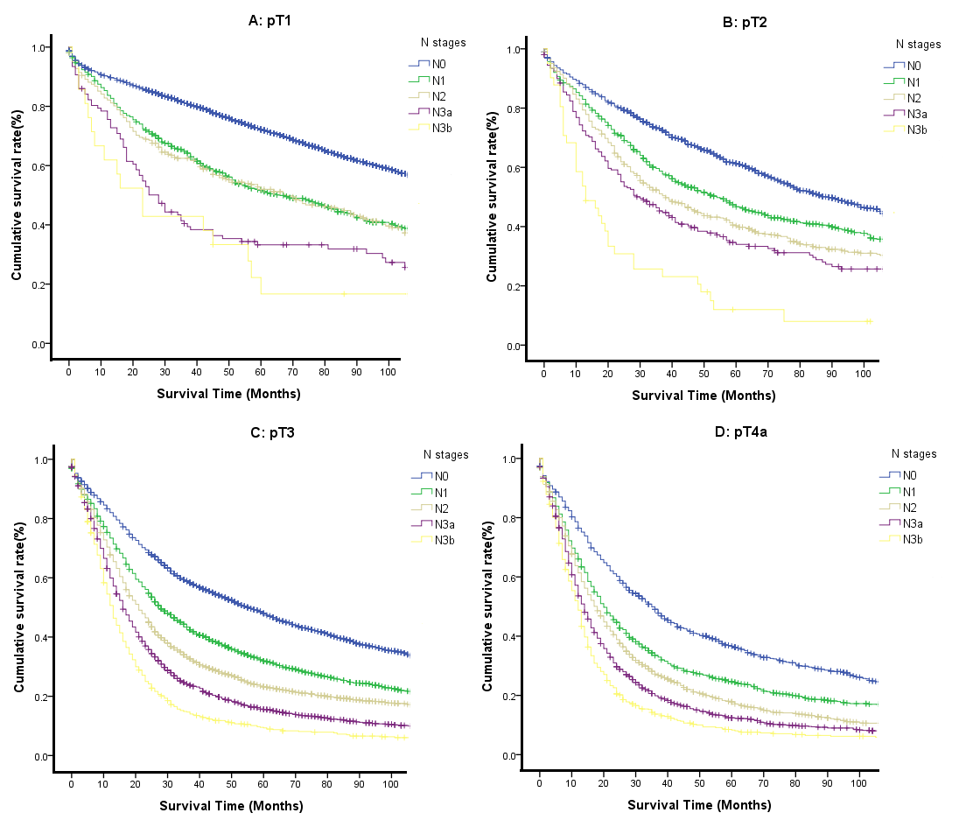
Figure 1 Comparison of the survival for each N classification in the same T category of gastric cancer. A: pT1 patients; B: pT2 patients; C: pT3 patients; D: pT4a patients.

A B C
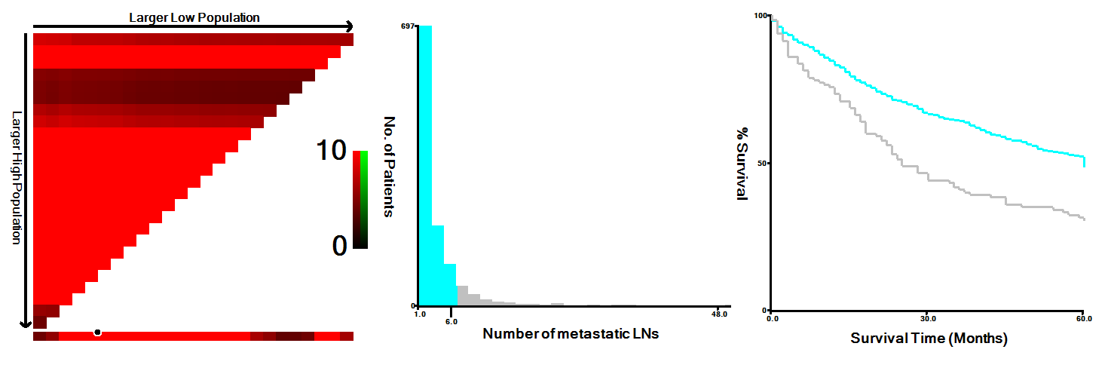
Figure 2 X-tile analysis of survival data from the Surveillance, Epidemiology, and End Results registry reveals a continuous distribution based on the number of metastatic lymph nodes. A-C: The optimal cut-point highlighted by the black circle (C) is shown on a histogram of the entire cohort (B), and a Kaplan-Meier plot (A). P-values were determined by using the cut-point. It shows that the optimal cutoff point of the N category is 6 (χ² = 165.38, P < 0.001). LNs: Lymph nodes.

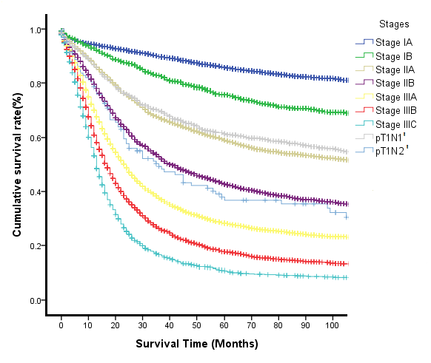
Figure 3 Comparison of the overall survival of patients with T1N1’ and T1N2’ stages to the stages according to the eighth edition of the tumor lymph node metastasis staging system for gastric cancer.
A B
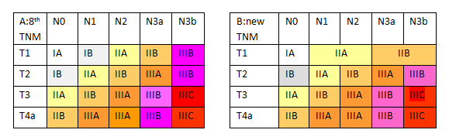
Figure 4 Difference in the two classifications for gastric cancer patients. A: The eighth edition tumor lymph node metastasis (TNM) staging system; B: The new TNM staging system.

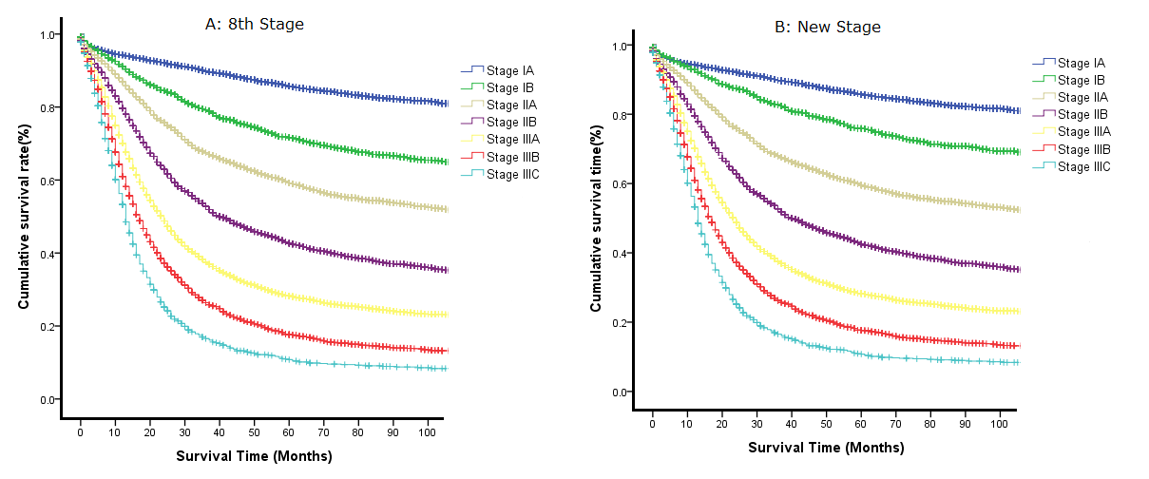
Figure 5 Survival curves of the Surveillance, Epidemiology, and End Results data set for gastric cancer patients. A: The eighth edition tumor lymph node metastasis (TNM) staging system; B: The new TNM staging system.

