Name of Journal: World Journal of Gastroenterology
Manuscript NO: 60914
Manuscript Type: SCIENTOMETRICS

Global research trends in the microbiome related to irritable bowel syndrome: A bibliometric and visualized study

Zyoud SH et al. Microbiome-related irritable bowel syndrome

Sa'ed H Zyoud, Simon Smale, W Stephen Waring, Waleed Sweileh, Samah W Al-Jabi

Sa'ed H Zyoud, Poison Control and Drug Information Center (PCDIC), College of Medicine and Health Sciences, An-Najah National University, Nablus 44839, West Bank, Palestine

Sa'ed H Zyoud, Samah W Al-Jabi, Department of Clinical and Community Pharmacy, College of Medicine and Health Sciences, An-Najah National University, Nablus 44839, West Bank, Palestine

Sa'ed H Zyoud, Department of Clinical Research Centre, An-Najah National University Hospital, Nablus 44839, West Bank, Palestine

Simon Smale, Department of Gastroenterology, York Hospital, York Teaching Hospital NHS Foundation Trust, York YO31 8HE, United Kingdom

W Stephen Waring, Acute Medical Unit, York Teaching Hospitals NHS Foundation Trust, York YO31 8HE, United Kingdom

Waleed Sweileh, Department of Pharmacology and Toxicology, College of Medicine and Health Sciences, An-Najah National University, Nablus 44839, West Bank, Palestine

Author contributions: Zyoud SH designed the study, collected the data, analyzed the data, made major contributions to the manuscript’s existing literature search and interpretation, and drafted the manuscript; Al-Jabi SW, and Sweileh W participated in the study design; Smale S and Waring WS contributed towards the conception, wrote part of the article; Al-Jabi SW, Sweileh W, Smale S and Waring WS were involved in interpretation of the data, and made revisions to the initial draft; all authors provided critical review and approved the final manuscript before submission.

Corresponding author: Sa'ed H Zyoud, PhD, Associate Professor, Director, Poison Control and Drug Information Center (PCDIC), College of Medicine and Health Sciences, An-Najah National University, Academic Street, Nablus 44839, West Bank, Palestine. saedzyoud@yahoo.com

Received: November 18, 2020
Revised: January 11, 2021
Accepted: March 16, 2021
Published online: April 7, 2021

Abstract
BACKGROUND
Irritable bowel syndrome (IBS) is a common functional gastrointestinal disorder. Dysregulation of the gut–brain axis plays a central role in the pathophysiology of IBS. It is increasingly clear that the microbiome plays a key role in the development and normal functioning of the gut–brain axis.

AIM
To facilitate the identification of specific areas of focus that may be of relevance to future research. This study represents a bibliometric analysis of the literature pertaining to the microbiome in IBS to understand the development of this field.

METHODS
The data used in our bibliometric analysis were retrieved from the Scopus database. The terms related to IBS and microbiome were searched in titles or abstracts within the period of 2000–2019. VOSviewer software was used for data visualization.

RESULTS
A total of 13055 documents related to IBS were retrieved at the global level. There were 1872 scientific publications focused on the microbiome in IBS. There was a strong positive correlation between publication productivity related to IBS in all fields and productivity related to the microbiome in IBS (r = 0.951, P < 0.001). The United States was the most prolific country with 449 (24%) publications, followed by the United Kingdom (n = 176, 9.4%), China (n = 154, 8.2%), and Italy (n = 151, 8.1%). The h-index for all retrieved publications related to the microbiome in IBS was 138. The hot topics were stratified into four clusters: (1) The gut–brain axis related to IBS; (2) Clinical trials related to IBS and the microbiome; (3) Drug-mediated manipulation of the gut microbiome; and (4) The role of the altered composition of intestinal microbiota in IBS prevention.

CONCLUSION
This is the first study to evaluate and quantify global research productivity pertaining to the microbiome in IBS. The number of publications regarding the gut microbiota in IBS has continuously grown since 2013. This finding suggests that the future outlook for interventions targeting the gut microbiota in IBS remains promising.

Key Words: Irritable bowel syndrome; Bibliometric; Microbiota; Microbiome; Scopus; Brain gut axis

©The Author(s) 2021. Published by Baishideng Publishing Group Inc. All rights reserved.

Citation: Zyoud SH, Smale S, Waring WS, Sweileh W, Al-Jabi SW. Global research trends in the microbiome related to irritable bowel syndrome: A bibliometric and visualized study. World J Gastroenterol 2021; 27(13): 1341-1353
URL: https://www.wjgnet.com/1007-9327/full/v27/i13/1341.htm
DOI: https://dx.doi.org/10.3748/wjg.v27.i13.1341

Core Tip: This is the first study to evaluate and quantify the global research productivity pertaining to the microbiome in irritable bowel syndrome (IBS). We present a holistic picture of this emerging topic and explore future research directions. A number of abnormalities have been described within the microbiome of patients with IBS. The relationships of these abnormalities to the causality of dysfunction and associated symptomatology have not been clearly elucidated. Our finding, while preliminary, suggests that the future outlook for interventions targeting the gut microbiota in IBS remains promising.

INTRODUCTION
Irritable bowel syndrome (IBS) is a term used to describe a group of symptoms, including abdominal pain and altered bowel habits, that arises because of disturbances of the interactions between the diet, the brain, the gut, and the microbiome. IBS poses a significant disease burden, with 20% of adults estimated to develop IBS symptoms in any given year. Symptoms arise as a consequence of abnormal visceral sensation and or motility as a result of abnormalities within the enteric or central nervous systems, or both^{[1]}. This usually occurs in the absence of ‘organic’ disease, but the association with other gastrointestinal diseases is common. Many patients experiencing gastrointestinal inflammation due to infection or inflammatory bowel disease develop IBS symptoms^{[2]}. Nearly a quarter of patients with IBS without identifiable ‘organic’ disease appear to have low-grade intestinal inflammation as judged by faecal inflammatory markers (calprotectin)^{[3]}. Inflammation may lead to sensitization of peripheral nerves. Most inflammation within the gastrointestinal tract settles, but in susceptible individuals sensitization of peripheral afferents may persist. Such sensitization may be driven by ongoing mast cell activation and increased epithelial permeability associated with low-level inflammation^{[4]}.
The onset of symptoms in IBS is often associated with psychological stressors. A high proportion of people with IBS have psychological comorbidities. Chronic stress is associated with stress-induced hyperalgesia. This hyperalgesia is mediated via corticotrophin-releasing hormone and the hypothalamic–pituitary axis (HPA)^{[5]}. Dysfunction within these systems is well documented in patients with functional gastrointestinal disorders and other chronic pain syndromes. Furthermore, many patients have histories of traumatic events in early life. These events may result in changes that profoundly affect the microbiome and brain development, predisposing patients to visceral pain syndromes^{[6–8]}. In addition to direct effects on neurons proximal to the bowel, bacteria and their products have a profound effect on the development and activity of the central nervous system and, consequently, upon the psychological state and behaviors^{[9]}. Within the enteric nervous system, certain bacterial strains may directly promote sensitization or downregulation of peripheral afferents. Of note, low-grade inflammation seen in a proportion of patients with IBS may result from the ability of specific bacteria to enhance the production and the effects of proinflammatory cytokines. Bacteria may also be able to transmit signals via the enteric nervous and immune systems to the central nervous system^{[10]}.
Although several bibliometric studies have been conducted to evaluate research productivity regarding various research aspects in the medical field^{[11–18]}, and some bibliometric studies have focused on microbiota science^{[19–25]}, there has not been an assessment of the research output regarding the microbiome in IBS. This study undertakes a bibliometric analysis of the literature within this field to understand the development of the literature pertaining to the microbiome in IBS and to facilitate the identification of specific areas of focus that may be of relevance to future research. This study evaluates data that will help to address the research gaps in this field. The current bibliometric study plays a significant role for researchers interested in the relationship between the microbiome and IBS, because it offers a quick reference guide for interdisciplinary researchers to know how this field has been assessed by scientific experts in previous years.

MATERIALS AND METHODS
The data used in our bibliometric analysis were retrieved from Scopus, which is a multidisciplinary database owned by Elsevier and is considered the largest and most widely used database^{[26–28]}. Most of the publications in this field were published between 2000 and 2019. The following term combinations were searched in the title or abstract within this period: Terms related to IBS, i.e., ‘adaptive colitis’ OR ‘colon spasm’ OR ‘functional bowel disease’ OR ‘irritable bowel’ OR ‘irritable colon’ OR ‘membranous colitis’ OR ‘mucous colitis’ OR ‘spastic colitis’ OR ‘spastic colon’ OR ‘spastic bowel’ OR ‘functional colonic disease’ OR ‘colon irritable’ OR ‘colon neurosis’ OR ‘bowel neurosis’ OR ‘functional colopathy’ OR ‘functional colonopathy’ OR ‘chronic catarrhal colitis’ OR ‘colica mucosa’ OR ‘colonic enterospasm’ OR ‘dyskinesia of the colon’ OR ‘dyssynergia of the colon’ OR ‘functional enterocolonopathy’ OR ‘functional diarrhea’ OR ‘Glarry enteritis’ OR ‘glutinous diarrhea’ OR ‘intestinal croup’ OR ‘irritable gut syndrome’ OR ‘lienteric diarrhea’ OR ‘Membranous catarrh of the intestine’ OR ‘mucomembranous colic’ OR ‘myxoneurosis’ OR ‘nervous diarrhea’ OR ‘neurogenic mucous’ OR ‘nonspecific diarrhea’ OR ‘tubular diarrhea’ OR ‘unhappy colon’ OR ‘unstable colon’, and terms related to microbiome, i.e., ‘microbiome’ OR ‘microflora’ OR ‘microbiota’ OR ‘flora’ OR ‘probiotic’ OR ‘Saccharomyces’ OR ‘Lactobacillus’ OR ‘Bifidobacterium’ OR ‘Escherichia coli’. The terms were selected from related reviews on IBS^{[29,30]} and the microbiome^{[19,20,31–33]}.

Data analysis
Microsoft Excel was used to analyze the retrieved data to calculate frequencies and percentages. The current bibliometric study included quantitative data about document types, language, country of the publications with their h-index and collaboration pattern, authors of the publications, journals that published papers on IBS, microbiome documents, and citation reports. In addition, we used the Statistical Package for the Social Sciences 16.0 software for Windows to assess the correlation between yearly quantitative distributions of publications related to IBS in all fields and publications related to the microbiome in IBS by using the Pearson correlation test. Analysis with P < 0.05 is considered statistically significant. In addition, the VOSviewer program^{[34,35]} was used for mapping and clustering terms according to their occurrence in both titles and abstracts to determine hot topics in this field. Furthermore, network visualization maps for collaboration among the most productive countries and the most prolific authors in this field were prepared using VOSviewer.

RESULTS
A total of 13055 documents related to IBS in titles and abstracts were retrieved over the period of 2000–2019 at the global level. There were 1872 scientific publications focused on the microbiome in IBS. The research findings showed that English was the main research language of documents indexed in Scopus, accounting for 48.8% of the documents, followed by German (3.9%) and Chinese (2.9%). Articles were the main type of document for publications related to the microbiome and IBS, accounting for 51.9% of documents, followed by reviews (35.3%).
The number of publications related to the microbiome in IBS has increased year by year. The quantity of documents has increased each year, from 9 documents in 2000, to 84 documents in 2009, to 219 documents in 2019 (Figure 1). Published papers during the last 5 years (2015 to 2019) accounted for 47.0% of the total publications. There was a strong positive correlation between the publication productivity related to IBS in all fields and the productivity related to the microbiome in IBS (r = 0.951, P < 0.001).
In total, authors from 105 countries published their work on the microbiome and IBS topics. Table 1 lists the top 10 most prolific countries. The United States was the most prolific country with 449 (24%) publications, followed by the United Kingdom (n = 176, 9.4%), China (n = 154, 8.2%), and Italy (n = 151, 8.1%). The h-index for all retrieved publications related to the microbiome in IBS was 138. Figure 2 shows the network visualization map for the collaboration among the 40 most productive countries. This includes countries that published more than 5 papers on microbiome and IBS research according to the number of publications in the last two decades (2000–2019). The United States and the United Kingdom can be referred to as central countries for this network because they published research in collaboration with 40 and 31 countries, respectively. In total, 5960 authors published their work on the microbiome and IBS topics. Figure 3 shows the network visualization map for the collaboration among the 32 most productive authors (authors who published more than 10 papers) on the microbiome in IBS research according to the number of publications in the last two decades (2000–2019). EMM Quigley (United States), G Barbara (Italy), JF Cryan (Ireland), and TG Dinan (Ireland) can be considered the prolific authors of this network due to the fact that they published 61, 25, 25, and 23 documents, respectively.
Terms were extracted from the titles and abstracts of all retrieved publications related to the microbiome in IBS and analyzed by the VOSviewer software to identify the current state and hot topics in this field. Terms appearing more than 10 times were included in the map (Figure 4) and were stratified into four clusters: IBS related to the gut–brain axis (yellow cluster), clinical trials related to IBS and the microbiome (red cluster), drug-mediated manipulation of the gut microbiome (blue cluster), and the role of the altered composition of intestinal microbiota in IBS prevention (green cluster).
The top 10 journals accounted for 19.98% of all articles (Table 2). The four journals that published the most studies related to microbiome and IBS were World Journal of Gastroenterology (n = 70), Alimentary Pharmacology and Therapeutics (n = 54), Neurogastroenterology and Motility (n = 52), and the Journal of Clinical Gastroenterology (n = 39).
The sample presents an average citation rate of 42 citations per publication. However, 16.6% of the publications have never been cited. Table 3 lists the information on the top ranking of publications in terms of the highest number of citations^{[36–55]}. The article ‘Prebiotic Effects: Metabolic and Health Benefits” is the most cited article with 1147 citations; it was authored by Roberfroid et al^{[49]} and published in the British Journal of Nutrition in 2010. This study reported that a substantial number of studies about human intervention have shown that dietary intake of food products/ingredients/supplements results in statistically important improvements in the faecal gut microbiota composition. The second most highly cited article is ‘Lactobacillus and Bifidobacterium in IBS: Symptom Responses and Relationship to Cytokine Profiles’ by O'Mahony et al^{[44]} and published in Gastroenterology in 2005. This study showed that intake of Bifidobacterium infantis over 8 wk was associated with symptomatic improvement in IBS.
Table 4 presents the top 10 most productive institutions on the microbiome in IBS research, ranked by the total number of publications. The four institutions that have published the most studies related to microbiome and IBS are the University College Cork (n = 87), APC Microbiome Ireland (n = 84), McMaster University (n = 45), the Mayo Clinic (n = 32), and Alma Mater Studiorum Università di Bologna (n = 38) (Table 4).

DISCUSSION
This bibliometric study was carried out using data from Scopus for the period of 2000–2019. It presents a comprehensive review of research progress on the microbiome and IBS, identifies hot topics within this field, and indicates potential directions for future research. It is apparent that the research productivity in this field has progressively increased due to the increasing recognition of the role of the gut microbiota^{[56,57]}. In addition, this increase is probably linked to the growing number of researchers who are interested in the fields of neurology and gastroenterology [e.g., EMM Quigley (the United States), JF Cryan (Ireland), TG Dinan (Ireland), G Barbara (Italy), Y Ringel (the United States), M Simrén (Sweden), M Camilleri (the United States), A Palva (Finland), M Pimentel (Canada), NJ Talley (Australia), and others]. Over the last two decades, advances in our understanding of the enteric and central nervous systems have led to an evolving understanding of their interactions and how the gastrointestinal microbiome influences their function. Disturbances in the gastrointestinal microbiome have been identified in patients with functional gastrointestinal disease, like IBS, and it is often the case that symptoms may be triggered by events that lead to changes in the microbiome, where the emotional context and the enteric nervous system function in tandem^{[1]}.
The results of this study indicate that the United States has been the most prolific country in this field. These findings are consistent with many previous bibliometric studies^{[12,58]}. Research productivity in the United States is likely associated with overwhelming support in terms of research, the wide range of researchers with an interest within this field, several well-resourced research environments, and greater availability of a well-trained workforce. In addition, the economic strength of the United States has led to a substantial amount of financial support for researchers and has enhanced the mobility of researchers^{[59,60]}. Furthermore, in 2013, the United States launched an exceptional research project on the gut microbiota–brain axis^{[61]}, thus contributing to the increasing number of publications regarding the microbiome in IBS.
Our study demonstrates that the gut–brain axis has become the most prolific area for research within IBS and the microbiome globally, and several studies in a range of journals are proof of this emerging trend. According to these data, we can infer that central pain amplification occurs through a wide variety of mechanisms within the central nervous system and mediates the effects of mood, emotional context, and environmental circumstances upon our central pain perception. Functional magnetic resonance imaging (fMRI) studies have demonstrated that patients with IBS often display an exaggerated response of arousal circuits associated with the HPA and activation of endogenous pain pathways in response to visceral stimulation. Similarly, studies have shown enhanced anticipation of pain in response to conditioning stimuli in patients with functional gastrointestinal disease^{[62]}. Neuro-immune activation within the central nervous system is associated with altered astrocyte and microglial activity that further enhances central sensitisation.
Early deprivation in patients with IBS can have profound effects on the microbiome, and researchers recognise that these factors may predispose susceptible individuals to more severe IBS^{[8,63–66]}. Changes in central nervous system function arise as a result of microbial products, which then influence astrocyte, microglial, and central nervous system inflammatory responses^{[67]}. Certain bacterial strains, possibly as a result of being able to modulate these effects, may influence behaviour. Offspring of mice fed a high-fat diet display disordered behaviour and socialisation. These behavioural changes appear to be manifested by alterations in the microbiome. Correction of ‘bacterial deficits’ or their metabolic sequelae leads to improvements in behaviour. Specific bacterial strains have been demonstrated to increase resilience in individuals with anxiety, and these behavioural changes have neurological correlates in fMRI studies. Those factors known to provoke IBS have profound effects on the microbiome function; gastroenteritis can deplete the microbiome, and psychological stress can lead to significant changes in the representation of different phyla within the microbial flora. These potentially detrimental changes may facilitate feedback from the gut and, consequently, permit the gut to have effects on mood, behaviour, and cognitive functions.

Limitations
There are some limitations in our study that are similar to previous bibliometric studies. First, although Scopus is the most recognized and the largest database for peer-reviewed literature, our study is restricted to only the Scopus database as a source of data collection. Second, some authors or institutions have different name formats in the Scopus database, and their research count might be scattered; therefore, their names might not show in the active list. Despite these limitations, we still consider that the findings of our analysis were adequate to characterize accurately the state of IBS and microbiome research at the global level.

CONCLUSION
This is the first study to evaluate and quantify the global research productivity pertaining to the microbiome in IBS to present a holistic picture of this emerging topic and explore future research directions. The number of publications regarding the gut microbiota in IBS has continuously grown since 2013. The United States, the United Kingdom, Italy, and Ireland have been the most productive regions. Currently, the main hot topics regarding the gut microbiota in IBS are the gut–brain axis related to IBS, clinical trials related to IBS and the microbiome, drug-mediated manipulation of the gut microbiome, and the role of the altered composition of intestinal microbiota in IBS prevention. A number of abnormalities have been described within the microbiome of patients with IBS. The relationship between these abnormalities and the causality of dysfunction and associated symptomatology have yet to be clearly elucidated. Our findings, while preliminary, suggest that the future outlook for interventions targeting the gut microbiota in IBS remains promising.

ARTICLE HIGHLIGHTS
Research background
The ability of specific bacteria to boost the development and the effects of proinflammatory cytokines can result in low-grade inflammation seen in a proportion of patients with irritable bowel syndrome (IBS).

Research motivation
The current bibliometric analysis plays an important role for researchers interested in the relationship between the microbiome and IBS. It provides a simple reference guide for interdisciplinary researchers to learn how scientific experts have examined this area in previous years.

Research objectives
This study aimed to carry out a bibliometric review of the IBS and the microbiome literature to explain the growth of this field and assist the identification of unique focus areas that may be important for future research.

Research methods
The information used in our bibliometric research was derived from the Scopus database. Terms related to IBS and the microbiome were searched in titles or abstracts during the period of 2000–2019. For data visualization, VOSviewer software was used.

Research results
Since 2013, the number of publications on gut microbiota in IBS has continuously increased. This result indicates that the future outlook remains optimistic for treatments targeting the gut microbiota in IBS.

Research conclusions
This is the first study to analyze and measure the global research productivity of IBS and microbiome research to provide a holistic view of this evolving subject and explore future research directions. It is evident that, due to the growing understanding of the role of the gut microbiota, research productivity in this area has steadily increased. Currently, the key hot topics are the gut–brain axis related to IBS, clinical trials related to IBS and the microbiome, drug-mediated modulation of the gut microbiome, and the role of the altered composition of the intestinal microbiome in the prevention of IBS.

Research perspectives
Our results indicate that the future outlook for IBS therapies targeting the intestinal microbiota remains promising.

REFERENCES
1 Foster JA, Rinaman L, Cryan JF. Stress &amp; the gut-brain axis: Regulation by the microbiome. Neurobiol Stress 2017; 7: 124-136 [PMID: 29276734 DOI: 10.1016/j.ynstr.2017.03.001]
2 Hoekman DR, Zeevenhooven J, D'Haens GR, Benninga MA. The prevalence of irritable bowel syndrome-type symptoms in inflammatory bowel disease patients in remission. Eur J Gastroenterol Hepatol 2017; 29: 1086-1090 [PMID: 28639969 DOI: 10.1097/MEG.0000000000000921]
3 Holtmann GJ, Ford AC, Talley NJ. Pathophysiology of irritable bowel syndrome. Lancet Gastroenterol Hepatol 2016; 1: 133-146 [PMID: 28404070 DOI: 10.1016/S2468-1253(16)30023-1]
4 Boeckxstaens GE, Wouters MM. Neuroimmune factors in functional gastrointestinal disorders: A focus on irritable bowel syndrome. Neurogastroenterol Motil 2017; 29 [PMID: 28027594 DOI: 10.1111/nmo.13007]
5 Park SH, Naliboff BD, Shih W, Presson AP, Videlock EJ, Ju T, Kilpatrick L, Gupta A, Mayer EA, Chang L. Resilience is decreased in irritable bowel syndrome and associated with symptoms and cortisol response. Neurogastroenterol Motil 2018; 30 [PMID: 28718999 DOI: 10.1111/nmo.13155]
6 Stern EK, Brenner DM. Gut Microbiota-Based Therapies for Irritable Bowel Syndrome. Clin Transl Gastroenterol 2018; 9: e134 [PMID: 29446765 DOI: 10.1038/ctg.2018.2]
7 Rodiño-Janeiro BK, Vicario M, Alonso-Cotoner C, Pascua-García R, Santos J. A Review of Microbiota and Irritable Bowel Syndrome: Future in Therapies. Adv Ther 2018; 35: 289-310 [PMID: 29498019 DOI: 10.1007/s12325-018-0673-5]
8 Salem AE, Singh R, Ayoub YK, Khairy AM, Mullin GE. The gut microbiome and irritable bowel syndrome: State of art review. Arab J Gastroenterol 2018; 19: 136-141 [PMID: 29935865 DOI: 10.1016/j.ajg.2018.02.008]
9 Dinan TG, Cryan JF. Mood by microbe: towards clinical translation. Genome Med 2016; 8: 36 [PMID: 27048547 DOI: 10.1186/s13073-016-0292-1]
10 Menees S, Chey W. The gut microbiome and irritable bowel syndrome. F1000Res 2018; 7 [PMID: 30026921 DOI: 10.12688/f1000research.14592.1]
11 Hernández-Vásquez A, Alarcon-Ruiz CA, Bendezu-Quispe G, Comandé D, Rosselli D. A bibliometric analysis of the global research on biosimilars. J Pharm Policy Pract 2018; 11: 6 [PMID: 29599984 DOI: 10.1186/s40545-018-0133-2]
12 Liu H, Yu Z, Chen C, Hong R, Jin K, Yang C. Visualization and Bibliometric Analysis of Research Trends on Human Fatigue Assessment. J Med Syst 2018; 42: 179 [PMID: 30116894 DOI: 10.1007/s10916-018-1033-3]
13 Ozsoy Z, Demir E. The Evolution of Bariatric Surgery Publications and Global Productivity: A Bibliometric Analysis. Obes Surg 2018; 28: 1117-1129 [PMID: 29086169 DOI: 10.1007/s11695-017-2982-1]
14 Schwimmer MH, Sawh MC, Heskett KM, Goyal NP, Newton KP, Schwimmer JB. A Bibliometric Analysis of Clinical and Translational Research in Pediatric Gastroenterology from 1970 to 2017. J Pediatr Gastroenterol Nutr 2018; 67: 564-569 [PMID: 29901549 DOI: 10.1097/MPG.0000000000002056]
15 Wang B, Zhao P. Worldwide research productivity in the field of back pain: A bibliometric analysis. Medicine (Baltimore) 2018; 97: e11566 [PMID: 30290588 DOI: 10.1097/MD.0000000000011566]
16 Yeung AWK, Heinrich M, Atanasov AG. Ethnopharmacology-A Bibliometric Analysis of a Field of Research Meandering Between Medicine and Food Science? Front Pharmacol 2018; 9: 215 [PMID: 29599720 DOI: 10.3389/fphar.2018.00215]
17 Zyoud SH, Waring WS, Al-Jabi SW, Sweileh WM. Global cocaine intoxication research trends during 1975-2015: a bibliometric analysis of Web of Science publications. Subst Abuse Treat Prev Policy 2017; 12: 6 [PMID: 28153037 DOI: 10.1186/s13011-017-0090-9]
18 Zyoud SH, Waring WS, Sweileh WM, Al-Jabi SW. Global Research Trends in Lithium Toxicity from 1913 to 2015: A Bibliometric Analysis. Basic Clin Pharmacol Toxicol 2017; 121: 67-73 [PMID: 28064463 DOI: 10.1111/bcpt.12755]
19 Tian J, Li M, Lian F, Tong X. The hundred most-cited publications in microbiota of diabetes research: A bibliometric analysis. Medicine (Baltimore) 2017; 96: e7338 [PMID: 28906350 DOI: 10.1097/MD.0000000000007338]
20 Yao H, Wan JY, Wang CZ, Li L, Wang J, Li Y, Huang WH, Zeng J, Wang Q, Yuan CS. Bibliometric analysis of research on the role of intestinal microbiota in obesity. PeerJ 2018; 6: e5091 [PMID: 29967745 DOI: 10.7717/peerj.5091]
21 Zyoud SH, Smale S, Waring WS, Sweileh WM, Al-Jabi SW. Global research trends in microbiome-gut-brain axis during 2009-2018: a bibliometric and visualized study. BMC Gastroenterol 2019; 19: 158 [PMID: 31470803 DOI: 10.1186/s12876-019-1076-z]
22 Ejtahed HS, Tabatabaei-Malazy O, Soroush AR, Hasani-Ranjbar S, Siadat SD, Raes J, Larijani B. Worldwide trends in scientific publications on association of gut microbiota with obesity. Iran J Basic Med Sci 2019; 22: 65-71 [PMID: 30944710 DOI: 10.22038/ijbms.2018.30203.7281]
23 Huang X, Fan X, Ying J, Chen S. Emerging trends and research foci in gastrointestinal microbiome. J Transl Med 2019; 17: 67 [PMID: 30819194 DOI: 10.1186/s12967-019-1810-x]
24 Li Y, Zou Z, Bian X, Huang Y, Wang Y, Yang C, Zhao J, Xie L. Fecal microbiota transplantation research output from 2004 to 2017: a bibliometric analysis. PeerJ 2019; 7: e6411 [PMID: 30809438 DOI: 10.7717/peerj.6411]
25 Ding-Qi B, Hui-Bo C, Xin-Yang L, Yi Z, Lan-Hua L, Yun-Hai G. [Analysis of research status and hotspots of snail intestinal flora based on bibliometrics]. Zhongguo Xue Xi Chong Bing Fang Zhi Za Zhi 2018; 30: 571-574 [PMID: 30567035 DOI: 10.16250/j.32.1374.2018189]
26 Padilla FM, Gallardo M, Manzano-Agugliaro F. Global trends in nitrate leaching research in the 1960-2017 period. Sci Total Environ 2018; 643: 400-413 [PMID: 29940451 DOI: 10.1016/j.scitotenv.2018.06.215]
27 Teles RHG, Moralles HF, Cominetti MR. Global trends in nanomedicine research on triple negative breast cancer: a bibliometric analysis. Int J Nanomedicine 2018; 13: 2321-2336 [PMID: 29713164 DOI: 10.2147/IJN.S164355]
28 Cash-Gibson L, Rojas-Gualdrón DF, Pericàs JM, Benach J. Inequalities in global health inequalities research: A 50-year bibliometric analysis (1966-2015). PLoS One 2018; 13: e0191901 [PMID: 29385197 DOI: 10.1371/journal.pone.0191901]
29 Ford AC, Quigley EM, Lacy BE, Lembo AJ, Saito YA, Schiller LR, Soffer EE, Spiegel BM, Moayyedi P. Effect of antidepressants and psychological therapies, including hypnotherapy, in irritable bowel syndrome: systematic review and meta-analysis. Am J Gastroenterol 2014; 109: 1350-65; quiz 1366 [PMID: 24935275 DOI: 10.1038/ajg.2014.148]
30 Latimer PR. Irritable bowel syndrome. Psychosomatics 1983; 24: 205-218 [PMID: 6844534 DOI: 10.1016/S0033-3182(83)73223-8]
31 John GK, Wang L, Nanavati J, Twose C, Singh R, Mullin G. Dietary Alteration of the Gut Microbiome and Its Impact on Weight and Fat Mass: A Systematic Review and Meta-Analysis. Genes (Basel) 2018; 9 [PMID: 29547587 DOI: 10.3390/genes9030167]
32 Memba R, Duggan SN, Ni Chonchubhair HM, Griffin OM, Bashir Y, O'Connor DB, Murphy A, McMahon J, Volcov Y, Ryan BM, Conlon KC. The potential role of gut microbiota in pancreatic disease: A systematic review. Pancreatology 2017; 17: 867-874 [PMID: 28935288 DOI: 10.1016/j.pan.2017.09.002]
33 Linares DM, Ross P, Stanton C. Beneficial Microbes: The pharmacy in the gut. Bioengineered 2016; 7: 11-20 [PMID: 26709457 DOI: 10.1080/21655979.2015.1126015]
34 van Eck NJ, Waltman L. Software survey: VOSviewer, a computer program for bibliometric mapping. Scientometrics 2010; 84: 523-538 [PMID: 20585380 DOI: 10.1007/s11192-009-0146-3]
35 van Eck NJ, Waltman L. Citation-based clustering of publications using CitNetExplorer and VOSviewer. Scientometrics 2017; 111: 1053-1070 [PMID: 28490825 DOI: 10.1007/s11192-017-2300-7]
36 Carabotti M, Scirocco A, Maselli MA, Severi C. The gut-brain axis: interactions between enteric microbiota, central and enteric nervous systems. Ann Gastroenterol 2015; 28: 203-209 [PMID: 25830558]
37 Claesson MJ, Cusack S, O'Sullivan O, Greene-Diniz R, de Weerd H, Flannery E, Marchesi JR, Falush D, Dinan T, Fitzgerald G, Stanton C, van Sinderen D, O'Connor M, Harnedy N, O'Connor K, Henry C, O'Mahony D, Fitzgerald AP, Shanahan F, Twomey C, Hill C, Ross RP, O'Toole PW. Composition, variability, and temporal stability of the intestinal microbiota of the elderly. Proc Natl Acad Sci U S A 2011; 108 Suppl 1: 4586-4591 [PMID: 20571116 DOI: 10.1073/pnas.1000097107]
38 Collins SM, Surette M, Bercik P. The interplay between the intestinal microbiota and the brain. Nat Rev Microbiol 2012; 10: 735-742 [PMID: 23000955 DOI: 10.1038/nrmicro2876]
39 de Vrese M, Schrezenmeir J. Probiotics, prebiotics, and synbiotics. Adv Biochem Eng Biotechnol 2008; 111: 1-66 [PMID: 18461293 DOI: 10.1007/10_2008_097]
40 Kassinen A, Krogius-Kurikka L, Mäkivuokko H, Rinttilä T, Paulin L, Corander J, Malinen E, Apajalahti J, Palva A. The fecal microbiota of irritable bowel syndrome patients differs significantly from that of healthy subjects. Gastroenterology 2007; 133: 24-33 [PMID: 17631127 DOI: 10.1053/j.gastro.2007.04.005]
41 Malinen E, Rinttilä T, Kajander K, Mättö J, Kassinen A, Krogius L, Saarela M, Korpela R, Palva A. Analysis of the fecal microbiota of irritable bowel syndrome patients and healthy controls with real-time PCR. Am J Gastroenterol 2005; 100: 373-382 [PMID: 15667495 DOI: 10.1111/j.1572-0241.2005.40312.x]
42 Mayer EA, Tillisch K, Gupta A. Gut/brain axis and the microbiota. J Clin Invest 2015; 125: 926-938 [PMID: 25689247 DOI: 10.1172/JCI76304]
43 Nobaek S, Johansson ML, Molin G, Ahrné S, Jeppsson B. Alteration of intestinal microflora is associated with reduction in abdominal bloating and pain in patients with irritable bowel syndrome. Am J Gastroenterol 2000; 95: 1231-1238 [PMID: 10811333 DOI: 10.1111/j.1572-0241.2000.02015.x]
44 O'Mahony L, McCarthy J, Kelly P, Hurley G, Luo F, Chen K, O'Sullivan GC, Kiely B, Collins JK, Shanahan F, Quigley EM. Lactobacillus and bifidobacterium in irritable bowel syndrome: symptom responses and relationship to cytokine profiles. Gastroenterology 2005; 128: 541-551 [PMID: 15765388 DOI: 10.1053/j.gastro.2004.11.050]
45 O'Mahony SM, Marchesi JR, Scully P, Codling C, Ceolho AM, Quigley EM, Cryan JF, Dinan TG. Early life stress alters behavior, immunity, and microbiota in rats: implications for irritable bowel syndrome and psychiatric illnesses. Biol Psychiatry 2009; 65: 263-267 [PMID: 18723164 DOI: 10.1016/j.biopsych.2008.06.026]
46 Pimentel M, Lembo A, Chey WD, Zakko S, Ringel Y, Yu J, Mareya SM, Shaw AL, Bortey E, Forbes WP; TARGET Study Group. Rifaximin therapy for patients with irritable bowel syndrome without constipation. N Engl J Med 2011; 364: 22-32 [PMID: 21208106 DOI: 10.1056/NEJMoa1004409]
47 Rajilić-Stojanović M, Biagi E, Heilig HG, Kajander K, Kekkonen RA, Tims S, de Vos WM. Global and deep molecular analysis of microbiota signatures in fecal samples from patients with irritable bowel syndrome. Gastroenterology 2011; 141: 1792-1801 [PMID: 21820992 DOI: 10.1053/j.gastro.2011.07.043]
48 Rinttilä T, Kassinen A, Malinen E, Krogius L, Palva A. Development of an extensive set of 16S rDNA-targeted primers for quantification of pathogenic and indigenous bacteria in faecal samples by real-time PCR. J Appl Microbiol 2004; 97: 1166-1177 [PMID: 15546407 DOI: 10.1111/j.1365-2672.2004.02409.x]
49 Roberfroid M, Gibson GR, Hoyles L, McCartney AL, Rastall R, Rowland I, Wolvers D, Watzl B, Szajewska H, Stahl B, Guarner F, Respondek F, Whelan K, Coxam V, Davicco MJ, Léotoing L, Wittrant Y, Delzenne NM, Cani PD, Neyrinck AM, Meheust A. Prebiotic effects: metabolic and health benefits. Br J Nutr 2010; 104 Suppl 2: S1-63 [PMID: 20920376 DOI: 10.1017/S0007114510003363]
50 Rolfe RD. The role of probiotic cultures in the control of gastrointestinal health. J Nutr 2000; 130: 396S-402S [PMID: 10721914 DOI: 10.1093/jn/130.2.396S]
51 Rousseaux C, Thuru X, Gelot A, Barnich N, Neut C, Dubuquoy L, Dubuquoy C, Merour E, Geboes K, Chamaillard M, Ouwehand A, Leyer G, Carcano D, Colombel JF, Ardid D, Desreumaux P. Lactobacillus acidophilus modulates intestinal pain and induces opioid and cannabinoid receptors. Nat Med 2007; 13: 35-37 [PMID: 17159985 DOI: 10.1038/nm1521]
52 Simrén M, Barbara G, Flint HJ, Spiegel BM, Spiller RC, Vanner S, Verdu EF, Whorwell PJ, Zoetendal EG; Rome Foundation Committee. Intestinal microbiota in functional bowel disorders: a Rome foundation report. Gut 2013; 62: 159-176 [PMID: 22730468 DOI: 10.1136/gutjnl-2012-302167]
53 Spiller R, Garsed K. Postinfectious irritable bowel syndrome. Gastroenterology 2009; 136: 1979-1988 [PMID: 19457422 DOI: 10.1053/j.gastro.2009.02.074]
54 Swidsinski A, Weber J, Loening-Baucke V, Hale LP, Lochs H. Spatial organization and composition of the mucosal flora in patients with inflammatory bowel disease. J Clin Microbiol 2005; 43: 3380-3389 [PMID: 16000463 DOI: 10.1128/jcm.43.7.3380-3389.2005]
55 Whorwell PJ, Altringer L, Morel J, Bond Y, Charbonneau D, O'Mahony L, Kiely B, Shanahan F, Quigley EM. Efficacy of an encapsulated probiotic Bifidobacterium infantis 35624 in women with irritable bowel syndrome. Am J Gastroenterol 2006; 101: 1581-1590 [PMID: 16863564 DOI: 10.1111/j.1572-0241.2006.00734.x]
56 Distrutti E, Monaldi L, Ricci P, Fiorucci S. Gut microbiota role in irritable bowel syndrome: New therapeutic strategies. World J Gastroenterol 2016; 22: 2219-2241 [PMID: 26900286 DOI: 10.3748/wjg.v22.i7.2219]
57 König J, Brummer RJ. Alteration of the intestinal microbiota as a cause of and a potential therapeutic option in irritable bowel syndrome. Benef Microbes 2014; 5: 247-261 [PMID: 24583610 DOI: 10.3920/BM2013.0033]
58 Mo Z, Fu HZ, Ho YS. Global development and trend of wind tunnel research from 1991 to 2014: a bibliometric analysis. Environ Sci Pollut Res Int 2018; 25: 30257-30270 [PMID: 30155635 DOI: 10.1007/s11356-018-3019-6]
59 Philipson L. Medical research activities, funding, and creativity in Europe: comparison with research in the United States. JAMA 2005; 294: 1394-1398 [PMID: 16174700 DOI: 10.1001/jama.294.11.1394]
60 Fontanarosa PB, DeAngelis CD, Hunt N. Medical research--state of the science. JAMA 2005; 294: 1424-1425 [PMID: 16174710 DOI: 10.1001/jama.294.11.1424]
61 Wang HX, Wang YP. Gut Microbiota-brain Axis. Chin Med J (Engl) 2016; 129: 2373-2380 [PMID: 27647198 DOI: 10.4103/0366-6999.190667]
62 Kano M, Dupont P, Aziz Q, Fukudo S. Understanding Neurogastroenterology From Neuroimaging Perspective: A Comprehensive Review of Functional and Structural Brain Imaging in Functional Gastrointestinal Disorders. J Neurogastroenterol Motil 2018; 24: 512-527 [PMID: 30041284 DOI: 10.5056/jnm18072]
63 Tanaka Y, Kanazawa M, Fukudo S, Drossman DA. Biopsychosocial model of irritable bowel syndrome. J Neurogastroenterol Motil 2011; 17: 131-139 [PMID: 21602989 DOI: 10.5056/jnm.2011.17.2.131]
64 Vuong HE, Yano JM, Fung TC, Hsiao EY. The Microbiome and Host Behavior. Annu Rev Neurosci 2017; 40: 21-49 [PMID: 28301775 DOI: 10.1146/annurev-neuro-072116-031347]
65 Dinan TG, Cryan JF. The Microbiome-Gut-Brain Axis in Health and Disease. Gastroenterol Clin North Am 2017; 46: 77-89 [PMID: 28164854 DOI: 10.1016/j.gtc.2016.09.007]
66 Chong PP, Chin VK, Looi CY, Wong WF, Madhavan P, Yong VC. The Microbiome and Irritable Bowel Syndrome - A Review on the Pathophysiology, Current Research and Future Therapy. Front Microbiol 2019; 10: 1136 [PMID: 31244784 DOI: 10.3389/fmicb.2019.01136]
67 Fung TC, Olson CA, Hsiao EY. Interactions between the microbiota, immune and nervous systems in health and disease. Nat Neurosci 2017; 20: 145-155 [PMID: 28092661 DOI: 10.1038/nn.4476]
Footnotes
Conflict-of-interest statement: The authors have no financial disclosures or conflicts of interest to declare.

PRISMA 2009 Checklist statement: The authors have read the PRISMA 2009 Checklist, and the manuscript was prepared and revised according to the PRISMA 2009 Checklist.

Open-Access: This article is an open-access article that was selected by an in-house editor and fully peer-reviewed by external reviewers. It is distributed in accordance with the Creative Commons Attribution NonCommercial (CC BY-NC 4.0) license, which permits others to distribute, remix, adapt, build upon this work non-commercially, and license their derivative works on different terms, provided the original work is properly cited and the use is non-commercial. See: http://creativecommons.org/Licenses/by-nc/4.0/

Manuscript source: Invited manuscript

Peer-review started: November 18, 2020
First decision: December 27, 2020
Article in press: March 16, 2021

Specialty type: Gastroenterology and hepatology
Country/Territory of origin: Palestine
Peer-review report’s scientific quality classification
Grade A (Excellent): 0
Grade B (Very good): B
Grade C (Good): 0
Grade D (Fair): 0
Grade E (Poor): 0

P-Reviewer: Gazouli M S-Editor: Fan JR L-Editor: A P-Editor: Li JH

Figure Legends
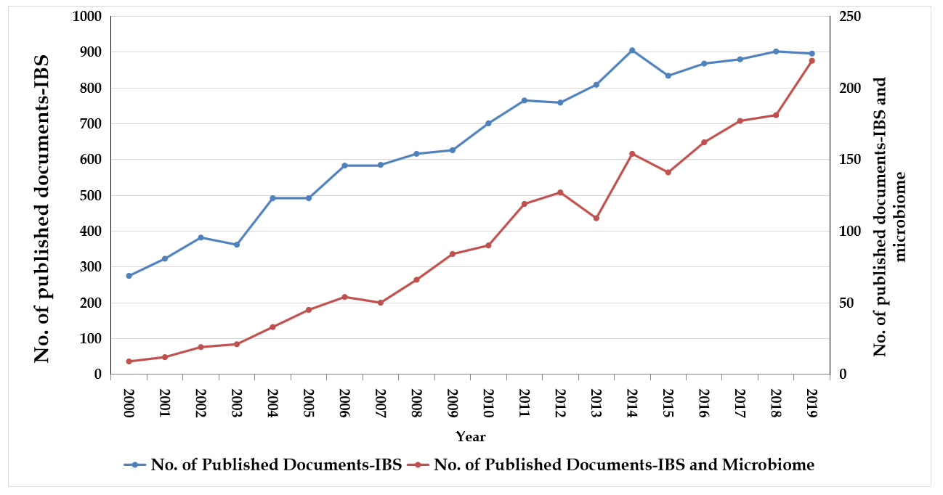
Figure 1 The annual number of publications related to irritable bowel syndrome and the microbiome from 2000 to 2019. IBS: Irritable bowel syndrome.

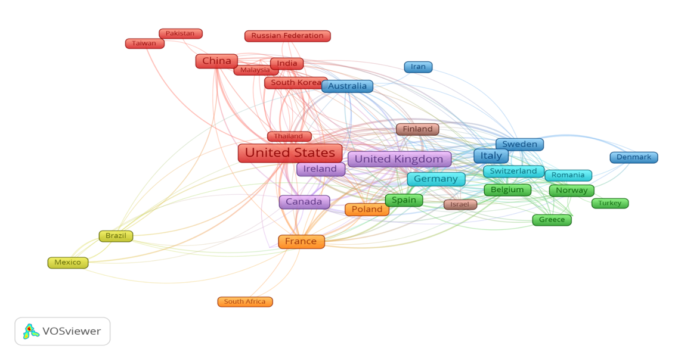
Figure 2 Network visualization map for the collaboration among the 40 most productive countries on the microbiome in irritable bowel syndrome research according to the number of publications in the last two decades (2000–2019).

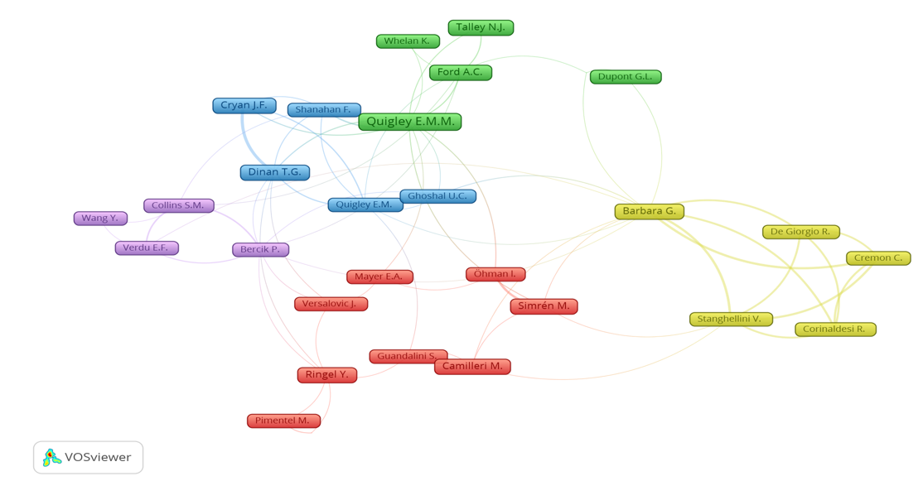
Figure 3 Network visualization map for the collaboration among the 32 most productive authors on the microbiome in irritable bowel syndrome research according to the number of publications in the last two decades (2000–2019).

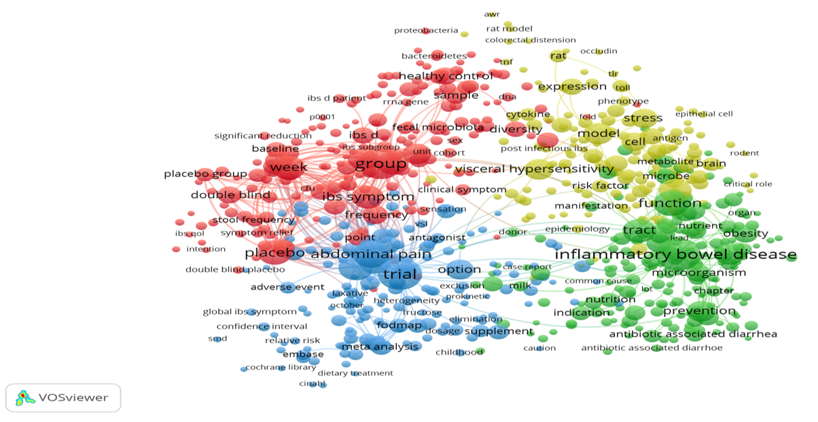
Figure 4 Network visualization map for the terms with high co-occurrence frequencies, based on the titles and abstracts of documents related to the microbiome in irritable bowel syndrome research published in the last two decades (2000–2019).

Table 1 Top 10 most productive countries on the microbiome in irritable bowel syndrome research, ranked by the total number of publications in the last two decades (2000-2019)
SCR | Country | Number of documents | %
1st | United States | 449 | 24.0
2nd | United Kingdom | 176 | 9.4
3rd | China | 154 | 8.2
4th | Italy | 151 | 8.1
5th | France | 116 | 6.2
6th | Germany | 107 | 5.7
7th | Canada | 103 | 5.5
8th | Ireland | 102 | 5.4
9th | Australia | 72 | 3.8
10th | Spain | 69 | 3.7
SCR: Standard competition ranking.

Table 2 Top 10 most productive journals on the microbiome in irritable bowel syndrome research, ranked by the total number of publications in the last two decades (2000-2019)
SCR¹ | Journal | Frequency | % | IF²
1st | World Journal of Gastroenterology | 70 | 3.74 | 3.665
2nd | Alimentary Pharmacology and Therapeutics | 54 | 2.88 | 7.515
3rd | Neurogastroenterology and Motility | 52 | 2.78 | 2.946
4th | Journal of Clinical Gastroenterology | 39 | 2.08 | 2.973
5th | American Journal of Gastroenterology | 34 | 1.82 | 10.171
6th | Gastroenterology | 33 | 1.76 | 17.373
7th | Current Opinion in Gastroenterology | 27 | 1.44 | 3.225
8th | Plos One | 24 | 1.28 | 2.740
9th | Nutrients | 21 | 1.12 | 4.546
10th | Gut Microbes | 20 | 1.07 | 7.740
¹Equal journals have the same ranking number, and then a gap is left in the ranking numbers.
²Impact factors based on Journal Citation Reports 2019 from Clarivate Analytics.
SCR: Standard competition ranking; IF: Impact factor.

Table 3 Top 20 most cited articles on the microbiome in irritable bowel syndrome research in the last two decades (2000-2019)
SCR | Ref. | Title | Year | Source title | Cited by
1st | Roberfroid et al^{[49]} | "Prebiotic effects: Metabolic and health benefits" | 2010 | British Journal of Nutrition | 1147
2nd | O'Mahony et al^{[44]} | "Lactobacillus and Bifidobacterium in irritable bowel syndrome: Symptom responses and relationship to cytokine profiles" | 2005 | Gastroenterology | 1042
3rd | Claesson et al^{[37]} | "Composition, variability, and temporal stability of the intestinal microbiota of the elderly" | 2011 | Proceedings of the National Academy of Sciences of the United States of America | 836
4th | Collins et al^{[38]} | "The interplay between the intestinal microbiota and the brain” | 2012 | Nature Reviews Microbiology | 735
5th | Kassinen et al^{[40]} | "The fecal microbiota of irritable bowel syndrome patients differs significantly from that of healthy subjects” | 2007 | Gastroenterology | 684
6th | Pimentel et al^{[46]} | "Rifaximin therapy for patients with irritable bowel syndrome without constipation" | 2011 | New England Journal of Medicine | 659
7th | Rinttilä et al^{[48]} | "Development of an extensive set of 16S rDNA-targeted primers for quantification of pathogenic and indigenous bacteria in faecal samples by real-time PCR" | 2004 | Journal of Applied Microbiology | 658
8th | O'Mahony et al^{[45]} | "Early life stress alters behavior, immunity, and microbiota in rats: implications for irritable bowel syndrome and psychiatric illnesses " | 2009 | Biological Psychiatry | 634
9th | Rolfe^{[50]} | “The role of probiotic cultures in the control of gastrointestinal health” | 2000 | Journal of Nutrition | 584
10^{h} | Carabotti et al^{[36]} | “The gut-brain axis: Interactions between enteric microbiota, central and enteric nervous systems" | 2015 | Annals of Gastroenterology | 580
11th | De Vrese and Schrezenmeir^{[39]} | "Probiotics, prebiotics, and synbiotics" | 2008 | Advances in Biochemical Engineering/Biotechnology | 575
12th | Rajilić-Stojanović et al^{[47]} | "Global and deep molecular analysis of microbiota signatures in fecal samples from patients with irritable bowel syndrome" | 2011 | Gastroenterology | 545
13th | Whorwell et al^{[55]} | "Efficacy of an encapsulated probiotic Bifidobacterium infantis 35624 in women with irritable bowel syndrome" | 2006 | American Journal of Gastroenterology | 541
13th | Swidsinski et al^{[54]} | "Spatial organization and composition of the mucosal flora in patients with inflammatory bowel disease" | 2005 | Journal of Clinical Microbiology | 541
15th | Malinen et al^{[41]} | "Analysis of the fecal microbiota of irritable bowel syndrome patients and healthy controls with real-time PCR" | 2005 | American Journal of Gastroenterology | 523
16th | Mayer et al^{[42]} | "Gut/brain axis and the microbiota" | 2015 | Journal of Clinical Investigation | 519
17th | Simrén et al^{[52]} | "Intestinal microbiota in functional bowel disorders: A Rome foundation report" | 2013 | Gut | 510
18th | Spiller and Garsed^{[53]} | "Postinfectious irritable bowel syndrome " | 2009 | Gastroenterology | 508
19th | Rousseaux et al^{[51]} | "Lactobacillus acidophilus modulates intestinal pain and induces opioid and cannabinoid receptors" | 2007 | Nature Medicine | 500
20th | Nobaek et al^{[43]} | "Alteration of intestinal microflora is associated with reduction in abdominal bloating and pain in patients with irritable bowel syndrome" | 2000 | American Journal of Gastroenterology | 498

Table 4 Top 10 most productive institutions on the microbiome in irritable bowel syndrome research, ranked by the total number of publications in the last two decades (2000-2019)
SCR¹ | Institute | Country | n | %
1st | University College Cork | Ireland | 87 | 4.65
2nd | APC Microbiome Ireland | Ireland | 84 | 4.49
3rd | McMaster University | Canada | 45 | 2.40
4th | Alma Mater Studiorum Università di Bologna | Italy | 38 | 2.03
5th | Helsingin Yliopisto | Finland | 36 | 1.92
5th | Mayo Clinic | United States | 36 | 1.92
7th | Inserm (Institut national de la santé et de la recherche médicale) | France | 30 | 1.60
8th | Baylor College of Medicine | United States | 27 | 1.44
9th | Göteborgs Universitet | Sweden | 27 | 1.44
10th | The University of North Carolina at Chapel Hill | United States | 27 | 1.44
¹Equal institutes have the same ranking number, and then a gap is left in the ranking numbers.
SCR: Standard competition ranking.

Published by Baishideng Publishing Group Inc
7041 Koll Center Parkway, Suite 160, Pleasanton, CA 94566, USA
Telephone: +1-925-3991568
E-mail: bpgoffice@wjgnet.com
Help Desk: https://www.f6publishing.com/helpdesk
https://www.wjgnet.com

© 2021 Baishideng Publishing Group Inc. All rights reserved.

