Name of Journal: World Journal of Clinical Cases
Manuscript NO: 78875
Manuscript Type: CASE REPORT

Segmental artery injury during transforaminal percutaneous endoscopic lumbar discectomy: Two case reports

Cho WJ et al. Segmental artery injury during transforaminal PELD

Wan-Jae Cho, Ki-Won Kim, Hyung-Youl Park, Bo-Hyoung Kim, Jun-Seok Lee

Wan-Jae Cho, Ki-Won Kim, Bo-Hyoung Kim, Department of Orthopedic Surgery, Yeouido St. Mary’s Hospital, College of Medicine, Catholic University of Korea, Seoul 07345, South Korea

Hyung-Youl Park, Jun-Seok Lee, Department of Orthopedic Surgery, Eunpyeong St. Mary’s Hospital, College of Medicine, Catholic University of Korea, Seoul 03312, South Korea

Author contributions: Lee JS conceived the idea of the case report; Kim KW, Park HY, and Kim BH prepared the figures and collected the data; Cho WJ wrote the manuscript; All authors read and approved the final manuscript.

Corresponding author: Jun-Seok Lee, MD, PhD, Professor, Department of Orthopedic Surgery, Eunpyeong St. Mary’s Hospital, College of Medicine, Catholic University of Korea, No. 1021 Tongil-Ro, Eunpyeong-gu, Seoul 03312, South Korea. junband@naver.com

Received: July 23, 2022
Revised: October 19, 2022
Accepted: November 2, 2022
Published online: November 26, 2022

Abstract
BACKGROUND
Since Kambin experimentally induced arthroscopy to treat herniated nucleus pulposus, percutaneous endoscopic lumbar discectomy (PELD) has been developed. The branch of the segmental artery around the neural foramen may be damaged during PELD using the transforaminal approach. We report 2 rare cases in which segmental artery injury that occurred during PELD was treated with emergency embolization.

CASE SUMMARY
In case 1, a 31-year-old man was transferred to our emergency department with left lower quadrant abdominal pain after PELD at a local hospital. Lumbar spine magnetic resonance imaging after the surgery showed a hematoma of the left retroperitoneal area and the psoas muscle area. Under suspicion of vascular injury, arteriography was performed. Pseudoaneurysm and blood leakage from the left 4th lumbar segmental artery into the abdominal cavity were identified. Emergency transarterial embolization was performed using fibered microcoils for bleeding of the segmental artery. In case 2, a 75-year-old woman was transferred to our emergency department with low blood pressure, right flank pain, and drowsy mental status after PELD at a local hospital. When the patient arrived at the emergency room, the blood pressure decreased from 107/55 mmHg to 72/47 mmHg. Low blood pressure persisted. Under suspicion of vessel injury, arteriography was performed, and the right 4th lumbar segmental artery rupture was confirmed. Emergency transarterial embolization was performed for bleeding of segmental artery.

CONCLUSION
We were able to find the bleeding focus by angiography and treat the injury of the segmental artery successfully through emergency transarterial embolization.

Key Words: Percutaneous endoscopic lumbar discectomy; Segmental artery injury; Transarterial embolization; Angiography; Case report

©The Author(s) 2022. Published by Baishideng Publishing Group Inc. All rights reserved.

Citation: Cho WJ, Kim KW, Park HY, Kim BH, Lee JS. Segmental artery injury during transforaminal percutaneous endoscopic lumbar discectomy: Two cases reports. World J Clin Cases 2022; 10(33): 12345-12351
URL: https://www.wjgnet.com/2307-8960/full/v10/i33/12345.htm
DOI: https://dx.doi.org/10.12998/wjcc.v10.i33.12345

Core Tip: The branch of the segmental artery around the neural foramen may be damaged during percutaneous endoscopic lumbar discectomy using the transforaminal approach. When segmental artery rupture is suspected, angiography is helpful in finding the bleeding focus, and emergency embolization is considered an effective treatment method. In our 2 cases, clear bleeding focus was found by angiography, and the bleeding was controlled successfully through emergency transarterial embolization.

INTRODUCTION
After the endoscope was developed, it began to be actively used in the field of spinal surgery. Since Pan et al^{[1]} experimentally induced arthroscopy to treat herniated nucleus pulposus, percutaneous endoscopic lumbar discectomy (PELD) has been developed. PELD has several advantages, including less paravertebral muscle injury, preservation of bony structure, and rapid recovery^{[2]}. On the other hand, surgery-related complications of PELD including dural tear, intervertebral infection, hypoesthesia, bleeding, and recurrence are common^{[1]}. Lumbar segmental arteries originate from the aorta and primarily distribute on the lateral surface of the vertebrae, forming an extensive arterial network that feeds the nerve root, vertebral body, and associated muscles or extradural structures^{[3]}. The segmental artery branches into the intercostal branch, muscular branch, and spinal artery near the neural foramen^{[4]}. Of these, spinal arteries enter the vertebral canal and divide into postcentral, prelaminar, and radicular branches^{[5]}. The branch of the segmental artery around the neural foramen may be damaged during PELD using a transforaminal approach. Here we report 2 rare cases of segmental artery injury during PELD.

CASE PRESENTATION
Chief complaints
Case 1: A 31-year-old man presented with left lower quadrant abdominal pain after PELD at a local hospital.
Case 2: A 75-year-old woman presented with low blood pressure, right flank pain, and drowsy mental status after PELD at a local hospital.

History of present illness
Case 1: He was transferred to the emergency department at our hospital 17 h after surgery. When the patient arrived at the emergency room, the abdominal pain worsened.
Case 2: She was transferred to the emergency department of our hospital 8 h after surgery. When the patient arrived at the emergency room, her blood pressure decreased from 107/55 mmHg to 72/47 mmHg. Her low blood pressure persisted.

History of past illness
Case 1: The patient was medically healthy without taking any medications.
Case 2: The patient had diabetes mellitus, hypertension, and hyperlipidemia as comorbidities.

Personal and family history
Cases 1 and 2: There were no specific family health histories.

Physical examination
Case 1: Tenderness in the left lower quadrant area was observed. He had no neurologic deficit.
Case 2: There was no neurologic deficit other than the right flank pain.

Laboratory examinations
Case 1: When the patient arrived at the emergency room, laboratory investigations revealed low levels of hemoglobin (11.9 g/dL, normal range: 14.0-18.0 g/dL) with low levels of hematocrit (35.0%, normal range: 42.0%-52.0%). White blood cell count was 10.65 × 10⁹/L (normal range: 4.0-10.0 × 10⁹/L), and platelet count was 170 × 10⁹/L (normal range: 150-450 × 10⁹/L). At 2 h after arrival, follow-up laboratory investigations showed rapidly decreasing hemoglobin (10.0 g/dL) and hematocrit (29.2%).
Coagulation function test revealed: prothrombin time (PT), 10.3 s (normal range: 9.7-13.3 s); PT%, 106.1% (normal range: 77%-120%); international normalized ratio, 0.97 (normal range: 0.88-1.20); and activated partial thromboplastin time, 24.9 s (normal range: 23.1-37.3 s). These results were all within normal ranges.

Case 2: When the patient arrived at the emergency room, laboratory investigations revealed low levels of hemoglobin (9.4 g/dL, normal range: 12.0-16.0 g/dL) with low levels of hematocrit (27.5%, normal range: 37.0%-47.0%). White blood cell count was 15.52 × 10⁹/L (normal range: 4.0-10.0 × 10⁹/L), and platelet count was 170 × 10⁹/L (normal range: 150 - 450 × 10⁹/L).
Coagulation function test revealed: PT, 10.7 s (normal range: 9.7-13.3s); PT%, 93.4% (normal range: 77%-120%); international normalized ratio, 1.03 (normal range: 0.88-1.20); and activated partial thromboplastin time: 20.4 s (normal range: 23.1-37.3 s). These results were all within normal ranges.

Imaging examinations
Case 1: Lumbar spine magnetic resonance imaging after the surgery showed hematoma of the left retroperitoneal area and the psoas muscle area (Figures 1 and 2).
Case 2: Computed tomography scan of the abdomen aorta showed hemorrhage in the right retroperitoneal area without a clear bleeding focus (Figure 3A and B).

FINAL DIAGNOSIS
Case 1
Pseudoaneurysm and blood leakage from the left 4th lumbar segmental artery into the abdominal cavity were identified by arteriography (Figure 2A).

Case 2
The right 4th lumbar segmental artery rupture was confirmed by arteriography (Figure 4).

TREATMENT
Cases 1 and 2
Emergency transarterial embolization was performed using fibered microcoils for bleeding of the segmental artery (Figure 2B).

OUTCOME AND FOLLOW-UP
Case 1
After the embolization, the pain improved. The patient was discharged in a tolerable state in the 1st wk after the procedure.

Case 2
After the procedure, the patient’s flank pain improved. Her vital signs were stable. The patient was discharged in a tolerable state on the 4th d after the procedure.

DISCUSSION
PELD can be broadly divided into percutaneous endoscopic transforaminal discectomy and percutaneous endoscopic interlaminar discectomy, which have different characteristics and indications depending on the surgical approach^{[6]}. Huang et al^{[6]} revealed that percutaneous endoscopic interlaminar discectomy had a shorter operation time, decreased intraoperative blood loss, and lower fluoroscopy times compared with percutaneous endoscopic transforaminal discectomy for treating herniation of nucleus pulposus. The percutaneous endoscopic interlaminar discectomy approach is familiar to surgeons because its anatomical orientations are similar to open surgery. Microscopic vision is also easier. However, since the transforaminal approach has different anatomical similarities to open surgery, it may be difficult to perform the technique.
We found a total of 7 cases of vessel injury that occurred during PELD^{[7-10]}. In 6 of the 7 cases, vessel injury occurred during a transforaminal approach. Our 2 cases also had a segmental artery injury during transforaminal PELD. The segmental artery branches into the intercostal branch, muscular branch, and spinal artery near the neural foramen. Accordingly, during a transforaminal approach, the guide wire may come close to the branch of the segmental artery, causing injury. During guide wire insertion before reaching the disc, the guide tip should be placed behind the posterior vertebral line to avoid damage to the segmental artery terminal branch^{[7]}. In the extraforaminal area, the arterial branches are complex, and care must be taken because vascular damage may occur during exploration^{[7]}. If blood vessel damage is found, hemostasis can be attempted by electrocautery or compressing a gelatin sponge. If bleeding persists even after trying the above method, an artery injury is suspected, and transarterial embolization can be performed as in our cases. Complications of transarterial embolization include contrast reaction, vascular injury, and coil migration, but the incidence is known to be low^{[11]}.
In the literature, patients have complained of flank pain and inguinal pain as symptoms of vessel injury. However, in our cases 1 patient complained of abdominal pain and 1 patient complained of flank pain. Of the 7 cases reported so far, only 2 cases on which angiography was performed could detect an accurate bleeding focus in a segmental artery. For the other 5 cases, both computed tomography and magnetic resonance imaging were performed. However, no bleeding focus was found because angiography was not performed. Of the 5 cases where no bleeding focus was found, 3 cases received conservative treatment and 2 cases underwent abdominal exploration (Table 1). In our 2 cases, a clear bleeding focus was found by angiography, and the bleeding was controlled successfully through emergency transarterial embolization. Therefore, when segmental artery rupture is suspected, angiography is helpful in finding the bleeding focus, and emergency embolization is considered an effective treatment method.

CONCLUSION
We report 2 rare cases of segmental artery injury during transforaminal PELD. We were able to find the bleeding focus by angiography and treat the injury of the segmental artery successfully through emergency transarterial embolization.

REFERENCES
1 Pan M, Li Q, Li S, Mao H, Meng B, Zhou F, Yang H. Percutaneous Endoscopic Lumbar Discectomy: Indications and Complications. Pain Physician 2020; 23: 49-56 [PMID: 32013278]
2 Choi KC, Lee JH, Kim JS, Sabal LA, Lee S, Kim H, Lee SH. Unsuccessful percutaneous endoscopic lumbar discectomy: a single-center experience of 10,228 cases. Neurosurgery 2015; 76: 372-80; discussion 380-1; quiz 381 [PMID: 25599214 DOI: 10.1227/NEU.0000000000000628]
3 Beckman JM, Vincent B, Park MS, Billys JB, Isaacs RE, Pimenta L, Uribe JS. Contralateral psoas hematoma after minimally invasive, lateral retroperitoneal transpsoas lumbar interbody fusion: a multicenter review of 3950 lumbar levels. J Neurosurg Spine 2017; 26: 50-54 [PMID: 27494784 DOI: 10.3171/2016.4.SPINE151040]
4 Shimizu S, Tanaka R, Kan S, Suzuki S, Kurata A, Fujii K. Origins of the segmental arteries in the aorta: an anatomic study for selective catheterization with spinal arteriography. AJNR Am J Neuroradiol 2005; 26: 922-928 [PMID: 15814947]
5 Zhao Q, Zhong E, Shi B, Ding Z, Jin D, Li Q. Clinical Anatomy and Possible Clinical Significance of the Postcentral Branches of Spinal Arteries in the L1-L5 Levels. Clin Spine Surg 2020; 33: 328-332 [PMID: 31169617 DOI: 10.1097/BSD.0000000000000831]
6 Huang Y, Yin J, Sun Z, Song S, Zhuang Y, Liu X, Du S, Rui Y. Percutaneous endoscopic lumbar discectomy for LDH via a transforaminal approach versus an interlaminar approach: a meta-analysis. Orthopade 2020; 49: 338-349 [PMID: 30989258 DOI: 10.1007/s00132-019-03710-z]
7 Ahn Y, Kim JU, Lee BH, Lee SH, Park JD, Hong DH, Lee JH. Postoperative retroperitoneal hematoma following transforaminal percutaneous endoscopic lumbar discectomy. J Neurosurg Spine 2009; 10: 595-602 [PMID: 19558294 DOI: 10.3171/2009.2.SPINE08227]
8 Kim HS, Ju CI, Kim SW, Kim JG. Huge Psoas Muscle Hematoma due to Lumbar Segmental Vessel Injury Following Percutaneous Endoscopic Lumbar Discectomy. J Korean Neurosurg Soc 2009; 45: 192-195 [PMID: 19352485 DOI: 10.3340/jkns.2009.45.3.192]
9 Panagiotopoulos K, Gazzeri R, Bruni A, Agrillo U. Pseudoaneurysm of a segmental lumbar artery following a full-endoscopic transforaminal lumbar discectomy: a rare approach-related complication. Acta Neurochir (Wien) 2019; 161: 907-910 [PMID: 30879131 DOI: 10.1007/s00701-019-03876-7]
10 Wang Y, Ai P, Zhan G, Shen B. Lumbar Artery Injury during Transforaminal Percutaneous Endoscopic Lumbar Discectomy: Successful Treatment by Emergent Transcatheter Arterial Embolization. Ann Vasc Surg 2018; 53: 267.e11-267.e14 [PMID: 30012447 DOI: 10.1016/j.avsg.2018.05.032]
11 Bauer JR, Ray CE. Transcatheter arterial embolization in the trauma patient: a review. Semin Intervent Radiol 2004; 21: 11-22 [PMID: 21331105 DOI: 10.1055/s-2004-831401]

Footnotes
Informed consent statement: Both patients included in the present case series gave their consent prior to study inclusion.

Conflict-of-interest statement: All authors have no conflicts of interest to declare.

CARE Checklist (2016) statement: The authors have read the CARE Checklist (2016), and the manuscript was prepared and revised according to the CARE Checklist (2016).

Open-Access: This article is an open-access article that was selected by an in-house editor and fully peer-reviewed by external reviewers. It is distributed in accordance with the Creative Commons Attribution NonCommercial (CC BY-NC 4.0) license, which permits others to distribute, remix, adapt, build upon this work non-commercially, and license their derivative works on different terms, provided the original work is properly cited and the use is non-commercial. See: https://creativecommons.org/Licenses/by-nc/4.0/

Provenance and peer review: Unsolicited article; Externally peer reviewed.
Peer-review model: Single blind

Peer-review started: July 23, 2022
First decision: October 12, 2022
Article in press: November 2, 2022

Specialty type: Medicine, research and experimental
Country/Territory of origin: South Korea
Peer-review report’s scientific quality classification
Grade A (Excellent): 0
Grade B (Very good): 0
Grade C (Good): C
Grade D (Fair): D
Grade E (Poor): 0

P-Reviewer: Zhang JW, China; Yuan HJ, China S-Editor: Wang LL L-Editor: Filipodia P-Editor: Wang LL

Figure Legends
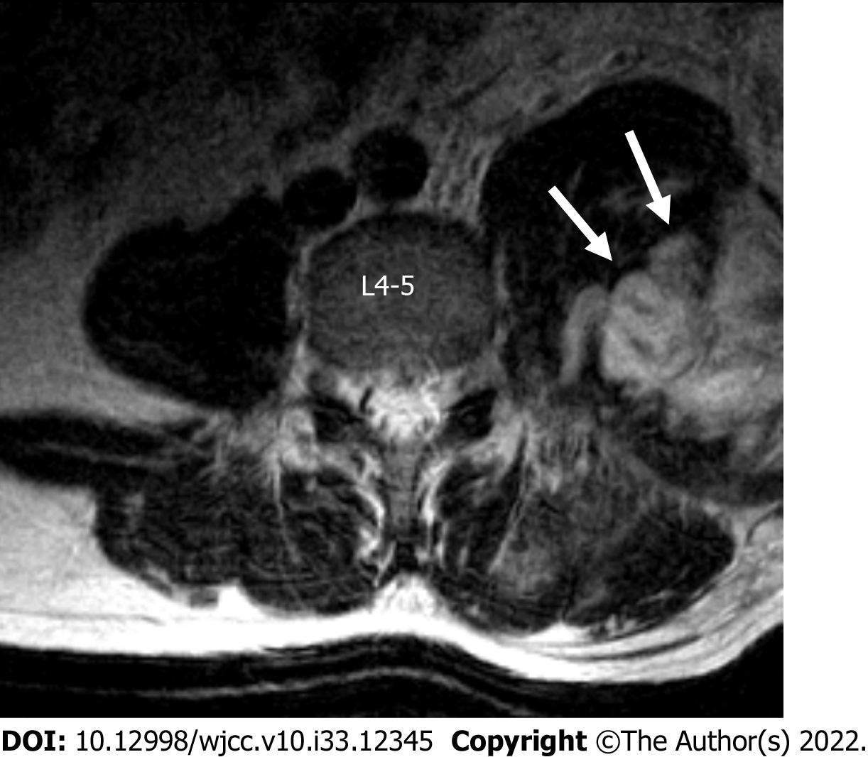
Figure 1 Axial T2-weighted magnetic resonance image scan of the lumbar spine showed left psoas muscle hematoma (arrows).

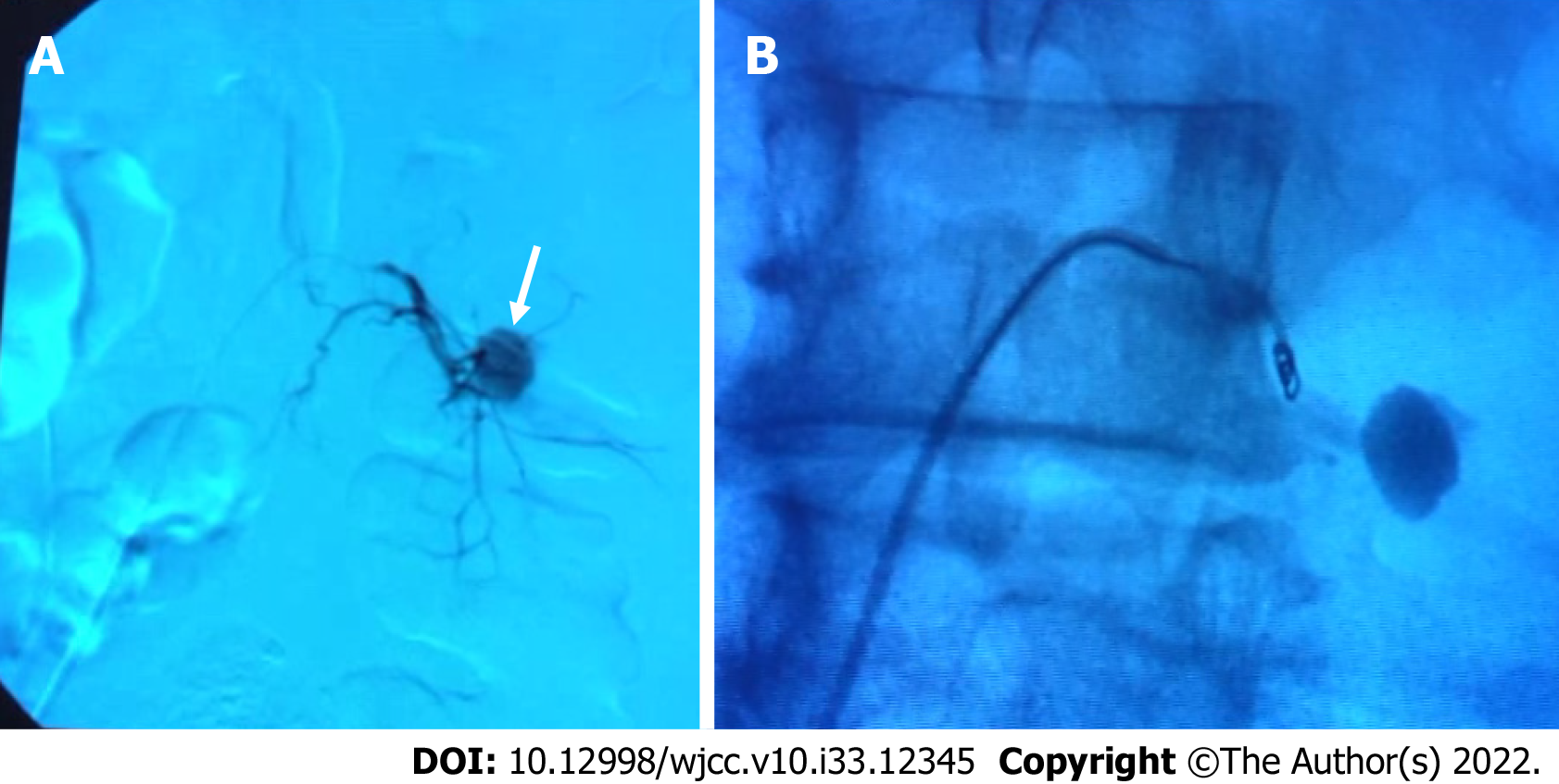
Figure 2 Arteriography. A: Arteriography showed pseudoaneurysm (arrow) of the left 4th lumbar segmental artery; B: Arteriography of embolization using microcoils.

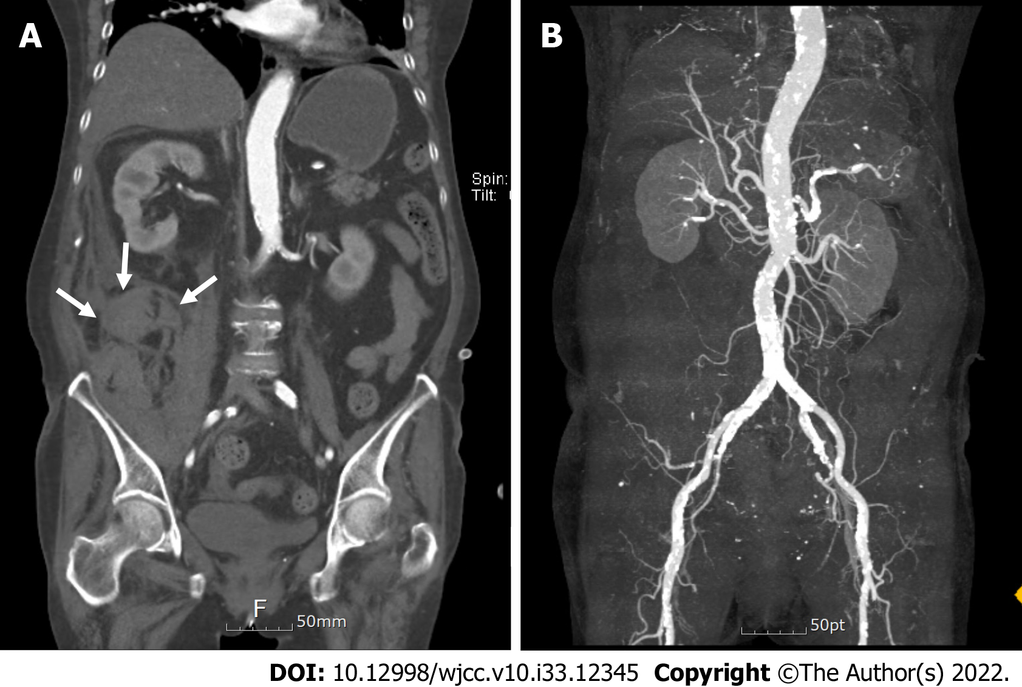
Figure 3 Computed tomography scans of the abdomen aorta. A: Coronal image of the right retroperitoneal hemorrhage (arrows); B: Vascular reconstruction image showed no detected bleeding focus.

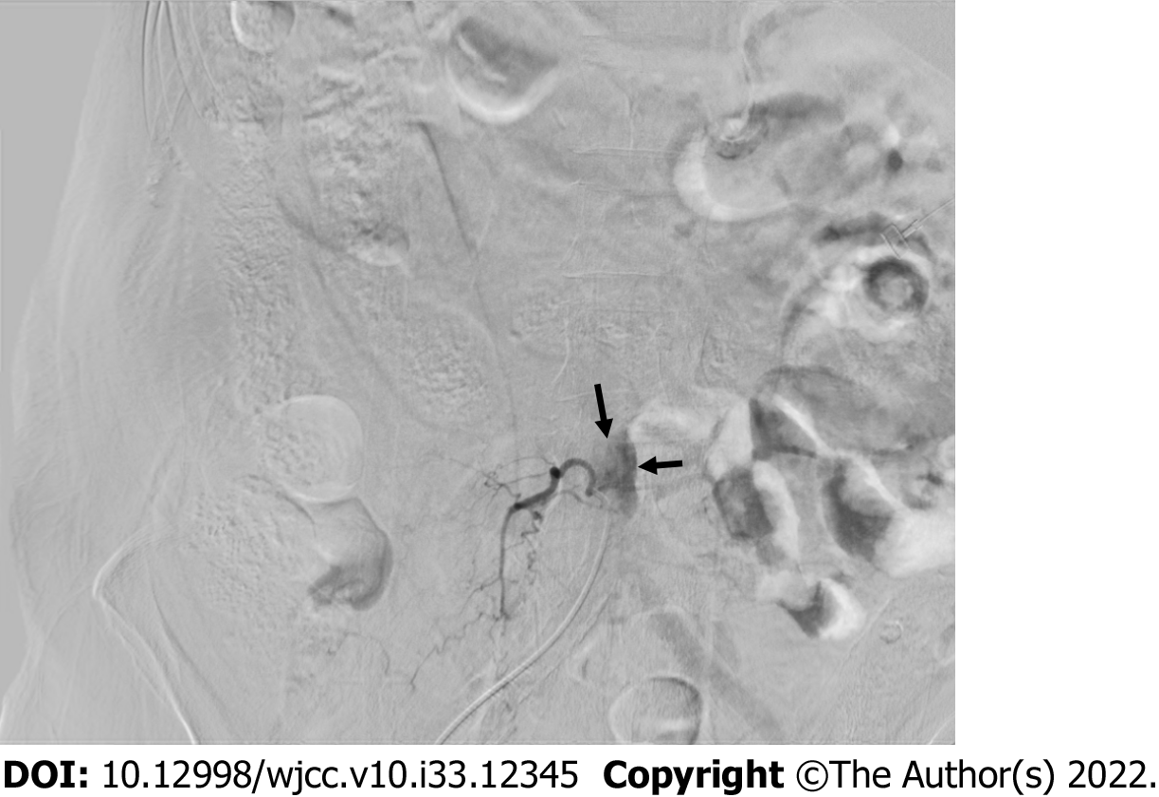
Figure 4 Arteriography showed the right 4th lumbar segmental artery rupture. Arrows indicate blood leakage.

Table 1 Segmental artery injury during percutaneous endoscopic lumbar discectomy reported in the literature
Ref. | Age | Sex | HNP level | HNP operation | Symptom | Diagnosis | Treatment
Kim et al^{[8]}, 2009 | 60 | F | L4-5 | PELD | Flank and leg pain, hip flexion weakness, low BP | Psoas hematoma | Transfusion
Ahn et al^{[7]}, 2009 | 64 | M | L4-5 | Trans foraminal PELD | Inguinal and flank pain | Retroperitoneal hematoma | Retroperitoneal exploration
Ahn et al^{[7]}, 2009 | 31 | F | L4-5 | Trans foraminal PELD | Inguinal and thigh pain | Retroperitoneal hematoma | Paraspinal and retroperitoneal exploration
Ahn et al^{[7]}, 2009 | 34 | M | L4-5 | Trans foraminal PELD | Inguinal and thigh pain | Psoas hematoma | Conservative
Ahn et al^{[7]}, 2009 | 41 | F | L3-4, 4-5 | Trans foraminal PELD | Inguinal pain, hip flexion weakness | Retroperitoneal hematoma | Conservative
Wang et al^{[10]}, 2018 | 64 | F | L3-4 | Trans foraminal PELD | Intraoperative bleeding | Lumbar artery injury | Coil embolization
Panagiotopoulos et al^{[9]}, 2019 | 39 | M | L4-5 | Trans foraminal PELD | Flank pain | Segmental artery pseudoaneurysm | Coil embolization
BP: Blood pressure; F: Female; M: Male; HNP: Herniation of nucleus pulposus; PELD: Percutaneous endoscopic lumbar discectomy.

Published by Baishideng Publishing Group Inc
7041 Koll Center Parkway, Suite 160, Pleasanton, CA 94566, USA
Telephone: +1-925-3991568
E-mail: bpgoffice@wjgnet.com
Help Desk: https://www.f6publishing.com/helpdesk
https://www.wjgnet.com

© 2022 Baishideng Publishing Group Inc. All rights reserved.

