Name of Journal: World Journal of Clinical Cases
Manuscript No: 48249
Manuscript Type: CASE REPORT

Characteristics of multiple nodules in a patient with pulmonary Langerhans cell histiocytosis: A case report

Kanaji N et al. Pulmonary Langerhans cell histiocytosis with multiple nodules

Nobuhiro Kanaji, Yoshimasa Tokunaga, Ryou Ishikawa, Naoki Watanabe, Norimitsu Kadowaki

Nobuhiro Kanaji, Naoki Watanabe, Norimitsu Kadowaki, Department of Internal Medicine, Division of Hematology, Rheumatology and Respiratory Medicine, Faculty of Medicine, Kagawa University, Kagawa 761-0793, Japan

Yoshimasa Tokunaga, Department of General Thoracic Surgery, Breast and Endocrinological Surgery, Faculty of Medicine, Kagawa University, Kagawa 761-0793, Japan

Ryou Ishikawa, Department of Diagnostic Pathology, Faculty of Medicine, Kagawa University, Kagawa 761-0793, Japan

ORCID number: Nobuhiro Kanaji (0000-0001-7365-4927); Yoshimasa Tokunaga (0000-0003-0754-373X); Ryou Ishikawa (0000-0001-5625-3259); Naoki Watanabe (0000-0002-6418-991X); Norimitsu Kadowaki (0000-0002-6473-800X).

Author contributions: Kanaji N carried out the diagnosis and followed up the patient, designed and drafted the manuscript; Tokunaga Y carried out the diagnosis; Ishikawa R collected pathological sections; Watanabe N and Kadowaki N revised the manuscript; all authors read and approved the final manuscript.

Informed consent statement: Written informed consent was obtained from the patient for publication of this report and any accompanying images.

Conflict-of-interest statement: No potential conflicts of interest relevant to this article were reported.

CARE Checklist (2016) statement: The authors have read the CARE Checklist (2016), and the manuscript was prepared and revised according to the CARE Checklist (2016).

Open-Access: This article is an open-access article which was selected by an in-house editor and fully peer-reviewed by external reviewers. It is distributed in accordance with the Creative Commons Attribution Non Commercial (CC BY-NC 4.0) license, which permits others to distribute, remix, adapt, build upon this work non-commercially, and license their derivative works on different terms, provided the original work is properly cited and the use is non-commercial. See: http://creativecommons.org/licenses/by-nc/4.0/

Manuscript source: Unsolicited Manuscript

Corresponding author: Nobuhiro Kanaji, MD, PhD, Assistant Professor, Department of Internal Medicine, Division of Hematology, Rheumatology and Respiratory Medicine, Faculty of Medicine, Kagawa University, 1750-1 Ikenobe, Kagawa 761-0793, Japan. kanaji@med.kagawa-u.ac.jp
Telephone:+81-87-8912145
Fax: +81-87-8912147

Received: April 17, 2019
Peer-review started: April 18, 2019
First decision: June 19, 2019
Revised: July 5, 2019
Accepted: July 20, 2019
Article in press: July 20, 2019
Published online: September 6, 2019

Abstract
BACKGROUND
The common computed tomography findings of pulmonary Langerhans cell histiocytosis (PLCH) are multiple cysts and micronodules predominantly in middle to upper lung lobes. Non-cystic nodules and large nodules are atypical findings of PLCH.

CASE SUMMARY
The patient was a 48-year-old Japanese man with a smoking history (20 cigarettes/d, 28 years) and no symptoms. Multiple nodules existed in all lung lobes, predominantly in the right lower lobe. Some nodules seemed to be distributed randomly, and others were adjacent to bronchus. Most nodules were solid; some small ones were cystic. The largest nodule was 22 mm in diameter. Although metastatic lung tumors were suspected, thoracoscopic lung biopsy led to the diagnosis of PLCH. At 6 months after he quit smoking, all nodules had almost disappeared. We investigated the characteristics of nodules at diagnosis in detail. Of 349 nodules in total, 116 were in upper and 199 were in lower lobes. Ninety-six (27.5%) were cystic; the remaining 253 (72.5%) were non-cystic. The prevalence of cystic nodules was higher in upper lobes than in lower lobes (right upper 37.5% vs lower 18.2%, P = 0.0068; left upper 48.1% vs lower 24.4%, P = 0.0078). The average size (dia.) of cystic nodules was smaller than that of non-cystic nodules (5.03 mm vs 7.40 mm, respectively, P < 0.0001).

CONCLUSION
Although multiple non-cystic nodules including large nodules (over 20 mm) are atypical, PLCH should be included in differential diagnoses. The presence of small cystic nodules predominantly in upper lobes and asymptomatic situation are also important for differential diagnoses to distinguish from metastatic cancers.

Key words: Langerhans cell histiocytosis; Multiple; Non-cystic; Nodule; Distribution; Size; Case report

© The Author(s) 2019. Published by Baishideng Publishing Group Inc. All rights reserved.

Core tip: The common computed tomography findings of pulmonary Langerhans cell histiocytosis (PLCH) are multiple cysts and micronodules predominantly in middle-to-upper lung lobes. We present herein a rare case of PLCH with non-cystic multiple large nodules. Of 349 nodules in total, 116 were in upper and 199 were in lower lobes. The prevalence of cystic nodules was higher in upper lobes than in lower lobes. The average size (dia.) of cystic nodules was smaller than that of non-cystic nodules. Knowledge of such characteristics of nodules may help the pulmonologists consider PLCH in differential diagnoses of multiple nodules.

Kanaji N, Tokunaga Y, Ishikawa R, Watanabe N, Kadowaki N. Characteristics of multiple nodules in a patient with pulmonary Langerhans cell histiocytosis: A case report. World J Clin Cases 2019; 7(17):2519-2525
URL: https://www.wjgnet.com/2307-8960/full/v7/i17/2519.htm
DOI: https://dx.doi.org/10.12998/wjcc.v7.i17.2519

INTRODUCTION
Langerhans cell histiocytosis (LCH) is characterized by accumulations of large mononuclear cells named Langerhans cells that form granulomas in various organs such as bone, skin and lung^{[1–3]}. LCH can be clinically classified into three groups: single-system, low-risk multisystem, and multisystem with risk-organ involvement^{[4,5]}. Pulmonary Langerhans cell histiocytosis (PLCH) is a diffuse lung disease whose clinical manifestations may involve a single organ or multisystem^{[4]}. The common findings of PLCH on chest computed tomography (CT) scan are multiple cysts predominantly in upper lung zones and a micronodular pattern of the middle-upper lobes^{[4]}. Non-cystic nodules and large nodules are rare in PLCH. Such characteristics of multiple nodules are common in metastatic cancers.
We here present a case of PLCH with multiple nodules including the non-cystic nodules > 20 mm in dia. We assessed the characteristics of multiple nodules including the number, distribution and sizes of cystic and non-cystic nodules.

CASE PRESENTATION
Chief complaints
A medical examination revealed an abnormal shadow on the chest radiograph of a 48-year-old Japanese man with no symptoms.

History of present illness
He visited to our hospital immediately after an abnormal shadow was pointed out.

History of past illness
He had been diagnosed with primary aldosterone disease and hypertension and had continued with treatment with tablets of potassium chloride, spironolactone, telmisartan and amlodipine besilate. He had no other notable medical history.

Personal and family history
He was a care assistant in a hospital and a current smoker (20 cigarettes/d for the past 28 years). He had no serious family history.

Physical examination
The physical examination revealed no remarkable abnormalities. Normal breath sounds and no adventitious sounds were auscultated.

Laboratory examinations
Laboratory examinations revealed a low concentration of serum potassium (3.0 mmol/L). The C-reactive protein level was 0.58 mg/dL. There were no other abnormal findings, including circulating blood cell counts, blood biochemistry and routine urine tests.

Imaging examinations
The chest radiograph and CT showed multiple nodules in both lung fields (Figure 1). Although the nodules seemed to be distributed randomly, fewer nodules were adjacent to the pleura, and some were adjacent to bronchus (Figure 1B and C). Nodules existed from upper to lower lobes, dominantly in the right lower lobes (Figure 1B and C). Most of the nodules were non-cystic, and the small nodules were cystic (Figure 1C). The largest nodule was 22 mm in dia., in the right middle lobe (Figure 1D). Mediastinal lymph nodes were approx. 10 mm in size (not shown). The differential diagnosis included metastatic lung tumors, lymph proliferative disorder, granulomatous polyangiitis, and PLCH.

FINAL DIAGNOSIS
Transbronchial biopsy specimens showed non-specific features; only inflammatory cells (not shown). Several nodules in the right lower lobe were resected under thoracoscopic surgery, and tissue specimens showed abnormal cells with notched nuclei with the infiltration of many eosinophils (Figure 2A and B). Abnormal cells were positive for CD1a and S-100 (Figure 2C and D) and negative for CD68 and CD21 (not shown). Based on these findings, we made the diagnosis of PLCH.

TREATMENT
The patient began to quit smoking after we encountered him. He received no additional medical treatment.

OUTCOME AND FOLLOW-UP
He continued the smoking cessation, and 6 months later, all nodules had almost disappeared (Figure 3).

INVESTIGATION OF CHARACTERISTICS OF MULTIPLE NODULES
To investigate the patient's CT findings at the diagnosis in detail, we counted the number of nodules in all lung lobes and classified the nodules into cystic and non-cystic nodules (Figure 4). Of the total of 349 nodules, 116 were in upper lobes and 199 were in lower lobes (right plus left lobes). Ninety-six (27.5%) were cystic, and the remaining 253 (72.5%) were non-cystic. The prevalence of cystic nodules was higher in upper lobes than in lower lobes (Figure 4A; right upper 37.5% vs lower 18.2%, P = 0.0068; left upper 48.1% vs lower 24.4%, P = 0.0078). The average size (dia.) of cystic nodules was smaller than that of non-cystic nodules (5.03 mm vs 7.40 mm, respectively; P < 0.0001, Figure 4B).

DISCUSSION
Our patient was diagnosed with PLCH and exhibited the following rare patterns on CT scans: (1) Multiple nodules dominantly in lower lobes; (2) nodules > 20 mm in dia. Our investigation of the CT findings in detail revealed that (3) the prevalence of cystic nodules was higher in upper lobes than in lower lobes; and (4) the cystic nodules were smaller than the non-cystic nodules.
The two common CT findings of PLCH are multiple cysts and micronodules predominantly in middle-to-upper lung zones^{[4]}. Either one or both of the findings were recognized in all 40 of the reported cases^{[4]}. Other abnormal findings include patchy or cord shadows, pleural thickening, pleural effusion, and mediastinal lymph node enlargement^{[5]}. PLCH cases with multiple nodules without cystic formation have also been reported^{[6–8]}. However, the sizes of the nodules in those cases were usually < 10 mm^{[6–8]}. Thus, the non-cystic large nodules observed our patient are rare in PLCH. In addition, a greater number of nodules were found in lower lobes than in upper lobes. Such characteristics are common in metastatic lung tumors (cancers) because they usually develop via a hematogenous route and the bloodstream is more abundant in lower lobes, although transbronchial dissemination in lung cancer was also occasionally reported^{[9]}.
Many studies have shown that a subset of LCH has genetic mutations including V-Raf murine sarcoma vial homolog B1 (BRAF)^{[3,10]}. BRAF V600E was detected in approximately one-half of patients with LCH^{[10]}. MAPKK1 mutations were detected in 6 of 13 (46%) BRAF-negative cases^{[3]}. These findings suggest that LCH has some genetic monoclonality, which was considered to be a type of tumor.
Langerhans cells can develop in organs such as bone, skin, brain, liver and lung^{[1–3]}, suggesting that they can spread to the whole body hematogenously. It is possible that some of the nodules observed in the present case developed as a result of hematogenous metastases. Consistent with this, the CT findings in several prior cases with multiple nodules showed a distribution pattern mimicking hematogenous pulmonary metastases^{[7,8]}. We speculate that the distribution pattern as hematogenous lung metastases is consistent with PLCH as well as metastatic cancers.
There are several notable points for the differential diagnosis of PLCH from metastatic cancers in the present case. First, the distribution pattern of multiple nodules was not a completely hematogenous pattern, and some nodules were distributed around or adjacent to bronchi. It was reported that many small nodules were distributed in the centers of secondary lobules around small airways in PLCH^{[11]}. It is quite unusual for a plurality of primary tumors to occur simultaneously. However, the existence/non-existence of a transbronchial dissemination of Langerhans' cells remains unclear.
Second, there were small cystic nodules. In cases of metastatic cancers, cystic changes tend to appear in larger nodules rather than in smaller nodules. Based on the follow-ups of PLCH cases, it was reported that nodular lesions transform into cysts^{[6]}. In progressed cases, cystic changes fuse and develop emphysema-like lesions. However, in our patient's case, the cystic nodules were smaller than the non-cystic nodules, and there were no fused cystic nodules. On the other hand, some non-cystic nodules fused and formed a snowman-like shape. In the present case, cystic changes inside nodules might appear at an early phase and disappear at a late phase at which Langerhans' cells proliferate and form a large, filled nodule.
Third, another important finding concerning the differential diagnosis between PLCH and metastatic malignant tumors is the patient's symptoms. Patients with advanced cancer often present subjective symptoms such as anorexia, body weight loss, fever, and fatigue. Our patient had no symptoms. PLCH as well as pulmonary alveolar proteinosis^{[12]} and sarcoidosis^{[13]} is a disease by which a symptom may relatively lack even though the evidence of the extensive radiological findings.
We counted the number of nodules and evaluated the ratio of cystic to non-cystic nodules visually. However, the computer-aided automatic evaluation of radiological findings may bring the diagnosis that is more exact than a human evaluation. Recently, trials of deep learning-based diagnosis of pulmonary nodules have been reported^{[14,15]}. The introduction of such artificial intelligence in the medical settings will be realized in the near future.

CONCLUSION
Multiple non-cystic nodules including large nodules (> 20 mm) can occur in PLCH. Knowledge of atypical findings in PLCH, taken together with other findings (e.g., cystic formation in small nodules dominantly in upper lobes and no symptom) may help pulmonologists consider PLCH in differential diagnoses.
REFERENCES
1 Vassallo R, Ryu JH, Colby TV, Hartman T, Limper AH. Pulmonary Langerhans'-cell histiocytosis. N Engl J Med 2000; 342: 1969-1978 [PMID: 10877650]
2 Watanabe R, Tatsumi K, Hashimoto S, Tamakoshi A, Kuriyama T; Respiratory Failure Research Group of Japan. Clinico-epidemiological features of pulmonary histiocytosis X. Intern Med 2001; 40: 998-1003 [PMID: 11688843]
3 Alayed K, Medeiros LJ, Patel KP, Zuo Z, Li S, Verma S, Galbincea J, Cason RC, Luthra R, Yin CC. BRAF and MAP2K1 mutations in Langerhans cell histiocytosis: a study of 50 cases. Hum Pathol 2016; 52: 61-67 [PMID: 26980021 DOI: 10.1016/j.humpath.2015.12.029]
4 Elia D, Torre O, Cassandro R, Caminati A, Harari S. Pulmonary Langerhans cell histiocytosis: a comprehensive analysis of 40 patients and literature review. Eur J Intern Med 2015; 26: 351-356 [PMID: 25899682 DOI: 10.1016/j.ejim.2015.04.001]
5 Li CW, Li MH, Li JX, Tao RJ, Xu JF, Cao WJ. Pulmonary Langerhans cell histiocytosis: analysis of 14 patients and literature review. J Thorac Dis 2016; 8: 1283-1289 [PMID: 27293848 DOI: 10.21037/jtd.2016.04.64]
6 Brauner MW, Grenier P, Tijani K, Battesti JP, Valeyre D. Pulmonary Langerhans cell histiocytosis: evolution of lesions on CT scans. Radiology 1997; 204: 497-502 [PMID: 9240543]
7 Niksarlioglu YO, Gurel B, Tezel GG, Firat P, Dogan R, Kars A, Coplu L. Langerhans' cell histiocytosis mimicking metastatic carcinoma of the lung. Respirology 2009; 14: 456-458 [PMID: 19192223 DOI: 10.1111/j.1440-1843.2008.01474.x]
8 Chon S, Kyung SY, Lee SP, Park JW, Jeong SH, Choi SJ, Ha SY. A case of pulmonary langerhans' cell histiocytosis mimicking hematogenous pulmonary metastases. Korean J Intern Med 2009; 24: 393-396 [PMID: 19949741 DOI: 10.3904/kjim.2009.24.4.393]
9 Tadokoro A, Kanaji N, Ishii T, Watanabe N, Inoue T, Kadowaki N, Bandoh S. Transbronchial Dissemination of Squamous Cell Lung Cancer. Clin Med Insights Oncol 2015; 9: 129-133 [PMID: 26672760 DOI: 10.4137/CMO.S32707]
10 Selway JL, Harikumar PE, Chu A, Langlands K. Genetic homogeneity of adult Langerhans cell histiocytosis lesions: Insights from BRAF V600E mutations in adult populations. Oncol Lett 2017; 14: 4449-4454 [PMID: 29085441 DOI: 10.3892/ol.2017.6774]
11 Moore AD, Godwin JD, Müller NL, Naidich DP, Hammar SP, Buschman DL, Takasugi JE, de Carvalho CR. Pulmonary histiocytosis X: comparison of radiographic and CT findings. Radiology 1989; 172: 249-254 [PMID: 2787035]
12 Inoue Y, Trapnell BC, Tazawa R, Arai T, Takada T, Hizawa N, Kasahara Y, Tatsumi K, Hojo M, Ichiwata T, Tanaka N, Yamaguchi E, Eda R, Oishi K, Tsuchihashi Y, Kaneko C, Nukiwa T, Sakatani M, Krischer JP, Nakata K; Japanese Center of the Rare Lung Diseases Consortium. Characteristics of a large cohort of patients with autoimmune pulmonary alveolar proteinosis in Japan. Am J Respir Crit Care Med 2008; 177: 752-762 [PMID: 18202348 DOI: 10.1164/rccm.200708-1271OC]
13 Judson MA. The Clinical Features of Sarcoidosis: A Comprehensive Review. Clin Rev Allergy Immunol 2015; 49: 63-78 [PMID: 25274450 DOI: 10.1007/s12016-014-8450-y]
14 Shaffie A, Soliman A, Fraiwan L, Ghazal M, Taher F, Dunlap N, Wang B, van Berkel V, Keynton R, Elmaghraby A, El-Baz A. A Generalized Deep Learning-Based Diagnostic System for Early Diagnosis of Various Types of Pulmonary Nodules. Technol Cancer Res Treat 2018; 17: 1533033818798800 [DOI: 10.1177/1533033818798800]
15 Schwyzer M, Ferraro DA, Muehlematter UJ, Curioni-Fontecedro A, Huellner MW, von Schulthess GK, Kaufmann PA, Burger IA, Messerli M. Automated detection of lung cancer at ultralow dose PET/CT by deep neural networks - Initial results. Lung Cancer 2018; 126: 170-173 [PMID: 30527183 DOI: 10.1016/j.lungcan.2018.11.001]

P-Reviewer: Turner AM S-Editor: Cui LJ L-Editor: A E-Editor: Xing YX

Specialty type: Medicine, research and experimental
Country of origin: Japan
Peer-review report classification
Grade A (Excellent): 0
Grade B (Very good): B
Grade C (Good): 0
Grade D (Fair): 0
Grade E (Poor): 0

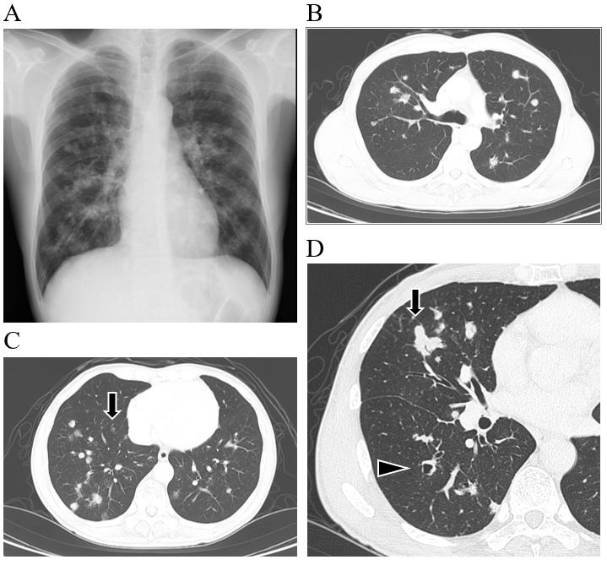
Figure 1 Radiological findings at the initial diagnosis. A: Chest X-ray at the diagnosis showed multiple nodules in bilateral lung fields; B and C: Chest computed tomography showed multiple nodules, adjacent to the pleura or bronchus, predominantly in the right lower lobe. Some small nodules showed cystic formation (arrow); D: Largest nodule was in the right middle lobe; 22 mm dia. (arrow). Arrowhead: A dilated bronchus, but not a cystic nodule.
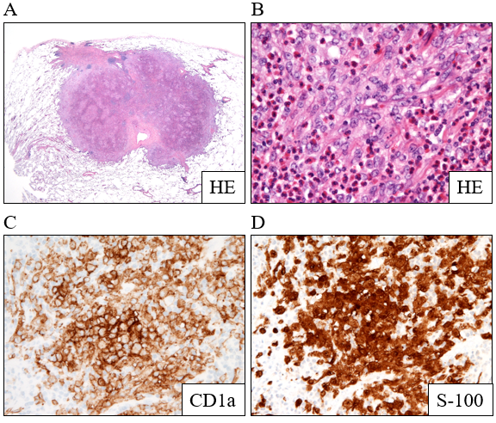
Figure 2 Histopathological findings obtained from a nodule in right lower field. A and B: Hematoxylin-eosin staining showing abnormal cells with notched nuclei with the infiltration of many eosinophils; C and D: Abnormal cells were positive for CD1a and S-100.S

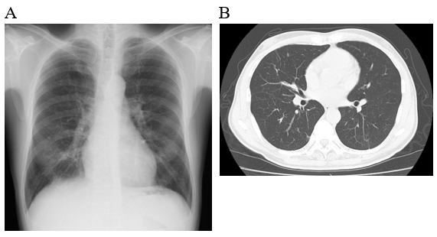Figure 3 Radiological findings at 6 mo after the patient quit smoking. A: Chest X-ray; B: Computed tomography scan.
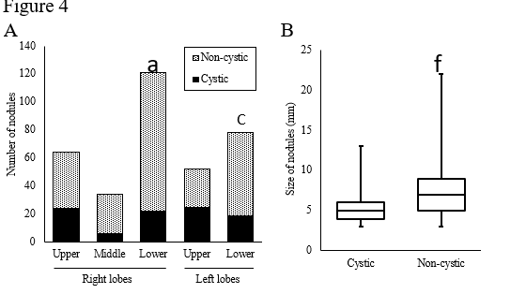
Figure 4 Numbers and sizes of cystic and non-cystic nodules. A: Number of nodules in each lobe. The prevalence of cystic nodules is compared. ªP<0.01 vs the right upper lobe, ^{c}P < 0.01 vs the left upper lobe; B: Sizes of the nodules. The data summarize the results of all lung lobes. ^{f}P < 0.0001 vs the cystic nodules.

