Name of Journal: World Journal of Gastrointestinal Pathophysiology
Manuscript NO: 64336
Manuscript Type: FRONTIER

Molecular and genetic markers in hepatocellular carcinoma: in silico analysis to clinical validation (current limitations and future promises)

El-Nakeep s. Bioinformatics and HCC: hopes and limitations

Sarah El-Nakeep

Sarah El-Nakeep, Gastroenterology and Hepatology Unit, Department of Internal Medicine, Faculty of Medicine, Ain Shams University, Cairo 11591, Egypt

Author contributions: El-Nakeep S wrote the manuscript, collected the data, and draw the figures using powerpoint.

Corresponding author: Sarah El-Nakeep, MD, Associate Professor, Gastroenterology and Hepatology Unit, Department of Internal Medicine, Faculty of Medicine, Ain Shams University, Ramsees street, Cairo 11591, Egypt. sarahnakeep@gmail.com

Received: March 21, 2021
Revised: May 15, 2021
Accepted: December 22, 2021
Published online: January 22, 2022

Abstract
Hepatocellular carcinoma (HCC) is the second cause of cancer-related mortality. The diagnosis of HCC depends mainly on α-fetoprotein, which is limited in its diagnostic and screening capabilities. There is an urgent need for a biomarker that detects early HCC to give the patients a chance for curative treatment. New targets of therapy could enhance survival and create future alternative curative methods. In silico analysis provides both; discovery of biomarkers, and understanding of the molecular pathways, to pave the way for treatment development. This review discusses the role of in silico analysis in the discovery of biomarkers, molecular pathways, and the role the author has contributed to this area of research. It also discusses future aspirations and current limitations. A literature review was conducted on the topic using various databases (PubMed, Science Direct, and Wiley Online Library), searching in various reviews, and editorials on the topic, with overviewing the author’s own published and unpublished work. This review discussed the steps of the validation process from in silico analysis to in vivo validation, to incorporation into clinical practice guidelines. In addition, reviewing the recent lines of research of bioinformatic studies related to HCC. In conclusion, the genetic, molecular and epigenetic markers discoveries are hot areas for HCC research. Bioinformatics will enhance our ability to accomplish this understanding in the near future. We face certain limitations that we need to overcome.

Key Words: Hepatocellular carcinoma; In silico analysis; bioinformatics; biomarkers; molecular pathways; genetics; epigenetics

©The Author(s) 2022. Published by Baishideng Publishing Group Inc. All rights reserved.

Citation: El-Nakeep S. Molecular and genetic markers in hepatocellular carcinoma: in silico analysis to clinical validation (current limitations and future promises). World J Gastrointest Pathophysiol 2022; 13(1): 1-14
URL: https://www.wjgnet.com/2150-5330/full/v13/i1/1.htm
DOI: https://dx.doi.org/10.4291/wjgp.v13.i1.1

Core tip: Hepatocellular carcinoma (HCC) is the second cause of cancer-related mortality. The importance of having an early detecting biomarker is to allow for curative measures to be applicable, and prognostic biomarkers to detect survival, in dealing with the disease. In silico analyses allow us to discover new genetic and epigenetic biomarkers, along with establishing the coexpression patterns, which impact HCC survival. Also, it allows for understanding the molecular pathways for HCC pathogenesis, and the discovery of potential therapeutic options. In this article, I review the current discoveries and limitations that face researchers to reach their ultimate goal of establishing clinical practice guidelines. I give an overview of the future potential that could benefit integrated research on HCC and discuss my own research related to the topic.
INTRODUCTION
Hepatocellular carcinoma (HCC) is the most common primary liver cancer. HCC is the sixth most prevalent cancer, and the second leading cause of cancer mortality^{[1]}. The incidence of HCC in different countries is related mostly to the geographic prevalence of certain risk factors such as chronic hepatitis B and C, aflatoxins, and alcoholism^{[2,3]}. HCC causes annual mortality exceeding 700000 cases^{[4]}, and high recurrence rate after treatment, with overall 5-year survival (< 50% of cases)^{[5]}, and even lower numbers reach the endpoint of 10-year survival (< 10% of cases), despite aggressive treatment^{[6]}.
Cirrhosis can proceed to HCC in 5%–30% of patients after an average duration of 5 years^{[7]}. Most HCC cases arguably occur on top of cirrhosis, but we cannot ignore the 20% of cases that occur without any preceding cirrhosis. Thus, cirrhotic and noncirrhotic causes of HCC are explained by different pathogenic mechanisms^{[8,9]}.
A debate has arisen about the relation of increased incidence of HCC among patients receiving new direct-acting antivirals (DAAs) for hepatitis C treatment, but recent studies have shown that the risk of de novo and recurrent HCC with DAAs is actually lower than without, although not completely abolished^{[10,11]}.
Many HCC studies use bioinformatics as a method to determine the molecular pathways affected by HCC, along with the genetic and epigenetic control of those pathways. These proteomic and genomic studies are the future of personalized medicine, where precision therapy could offer patients a management plan specified for their individual mutations, with high curative capabilities. We have visualized how intercepting a molecular pathway as in sorafenib, a multikinase inhibitor that enhances apoptosis, could increase the survival of advanced HCC by several months, but unfortunately, recent studies have shown that resistance to the drug is evolving^{[12,13]}.
The Cancer Genome Atlas Research Network has conducted a study project on 33 cancers with poor prognosis, provided that there were suitable available tissue samples for experimental validation through antibodies’ multiplex analysis, and they included HCC among other cancers. The HCC study included 363 cases for whole-exome sequencing and 196 for further proteomic, epigenetic and DNA-methylation analyses. They found that the molecular pathways most affected in HCC are those that deal with the following: cell proliferation, differentiation, growth, apoptosis, and immortalization (through telomerase)^{[14]}.
In this review, I explore the steps for validation of molecular markers, with the limitations encountered to validate a novel biomarker, the research in molecular pathways related biomarkers, the role of bioinformatics in the discovery of those pathways, and future aspirations.

Important Qualities In Diagnostic And Prognostic Markers That Have To Be Met
The early diagnosis of HCC is a crucial issue, as all of the available curative measures are only effective in early stages of cancer (liver resection, liver transplantation, radiofrequency ablation). They are curative in early the Barcelona Clinic Liver Cancer stages (0 and A), where the size of the tumor does not exceed 5 cm in its largest diameter in one nodule, or the size does not exceed 3 cm in three nodules (Stage A)^{[15]}. Thus, early screening of HCC is an effective tool for both early detection and treatment, which increases overall survival and yields better prognosis. Unfortunately, the screening process of HCC suffers a huge limitation, which is the low sensitivity of its most accepted biomarker, α-fetoprotein (AFP).
So, the current European Association for the Study of the Liver (EASL), and the American Association of Study of Liver Disease (AASLD) guidelines recommend the following; due to cost-effectiveness, abdominal ultrasound should only be used in the screening process, while AFP is limited to the diagnosis or screening of at high-risk populations. Where we find AFP sensitivity reaching as low as 20% positivity in early stages of cancer, with fluctuating levels of the biomarker in cirrhotic patients due to other reasons, causing further confusion in reaching the diagnosis^{[16-18]}, AFP is removed from the screening assessment guidelines altogether, as mentioned above.
It is important to note that, in Japan, the at-risk populations for HCC are still screened by 3-mo abdominal ultrasound, and AFP, in addition to another two biomarkers, Lens culinaris-agglutinin-reactive fraction of AFP, and PIVKA-II (protein-induced by vitamin K absence or antagonist-II). All these are included in the Japanese insurance plan of at-risk populations^{[19]}. Other markers considered for HCC diagnosis are: Dickkopf-1, which is a good biomarker for HCC with negative AFP^{[20]}, and des-γ-carboxy prothrombin, which is directly correlated with tumor size and has higher sensitivity than AFP, so can be used in screening more effectively^{[21]}. Unfortunately, none of the aforementioned biomarkers reaches the final acceptance to be added to any of the clinical practice guidelines for HCC due to cost-effectiveness, difficult availability, or high variability across studies.
I shared in the research work of determining some of the cost-effective biomarkers that are both cheap and effective, for establishing the diagnosis and staging of HCC, including a study on Golgi protein (GP)73, where the combined sensitivity of both AFP and GP73 was 84.4% and specificity of 95.6%^{[22]}. Our results were similar to the meta-analysis of the diagnostic accuracy of GP73 in HCC, where combined GP73 and AFP had pooled sensitivity of 87% and pooled specificity of 85%^{[23]}.
AFP is the only widely validated biomarker for HCC diagnosis, and prognosis in most clinical guidelines despite its limitations. To overcome its limitations we are still searching for a new biomarker. This is an ongoing process, requiring computational, experimental, and clinical validation. Figure 1 shows the most important factors that are required in an effective diagnostic and prognostic biomarker.

Steps For Validation For A New Biomarker
The only approved biomarker for diagnosis by both the American and European guidelines is AFP. Other biomarkers are approved in Japanese and Korean guidelines as mentioned earlier. AFP, the biomarker that stood the test of time, has its own problems as low sensitivity making it weak as a surveillance method, which caused the ASLD and EASL to remove it from the screening of HCC except for high-risk populations^{[24,25]}. Searching for a new biomarker is an ongoing process, which needs computational, experimental, and clinical validation, as shown in figure 2.
The novel biomarkers discovered through bioinformatics analysis usually pass through different steps of validation. First, computational validation (in silico validation), through assessing correlated genes, then by statistical analysis of different genetic expressions^{[26]}. Hence, the most statistically significant biomarkers, with a plausible molecular pathogenic background, will pass to the next stage. Experimental validation on the HCC tissues on resected tumor from patients or experimental laboratory cells as HeLa cells (in vitro studies). Later, clinical validation in the sera of patients with established diagnosis to determine the actual in vivo predictive diagnostic and prognostic capabilities of the biomarker. In this stage, we calculate the diagnostic test accuracy of the biomarker through identifying its specificity, sensitivity, and area under the curve (AUC), along with other important related parameters.
Diagnostic biomarkers should have a correlation with a clinical endpoint to be used in clinical trials, whether to help assessing this clinical endpoint or relate to it, as a surrogate marker. Then, external validation is examined through wide-scale studies, for the most acceptable biomarker in sensitivity and specificity. These studies must be done on variable and random populations (different ethnicity, gender, age groups, stages of the disease, etc.). When the biomarker reaches this stage of diagnostic accuracy validation, and proves to be cost-effective, then it can be added to clinical practice according to the level of evidence provided (the type of studies conducted i.e., cohort, randomized controlled trial, case–control, etc., and the size of the population examined)^{[27-29]}.
The steps for validation of a miRNA biomarker are^{[30]}: (1) data processing and screening of differentially expressed miRNAs; (2) construction of the miRNA signature; (3) confirmation of the miRNA signature; (4) miRNA signature validation using the OncomiR database and Gene Expression Omnibus (GEO) dataset; (5) functional analysis; (6) in vitro analysis; (7) testing on patients sera for diagnostic test accuracy; (8) wide-scale clinical validation; and (9) adding as a biomarker to the HCC diagnosis guidelines according to the level of evidence.

Discovering New Biomarkers: Molecular Pathways Discovery and Determining of the Genetic–epigenetic–phenotypic linkage through clinical studies
HCC is a cancer of poor prognosis, especially when discovered in late stage, which is usually the case, due to lack of early detection by biomarkers, lack of effective chemotherapeutic treatment, and limited molecular target treatment. Understanding the molecular and genetic pathways is vital to overcome these obstacles, and reach better prognostic outcomes. Recently, an accumulation of data regarding genetic and epigenetic biomarkers became available, for both in vitro laboratory analysis and in silico analysis^{[31]}.
Many pathways have been critically assessed as the key element of early diagnosis of HCC or as the key predictive outcome (whether metastasis, relapse or complete recovery) after curative interventions. These pathways include cellular effects, such as: cell proliferation, growth, differentiation and immortality. Moreover, disturbance or mutation affects functions such as: vascular angiogenesis, inflammatory response, programmed cell death and autophagy. Formulation of drugs that could intercept these molecular pathways to establish a treatment plan with good prognostic capabilities is under investigation^{[32]}.

Autophagy pathway in HCC: published and unpublished work of the author
Autophagy is defined as the degradation of cellular components by lysosomal fusing with autophagosomes, and forming autolysosomes, as a homeostatic regulation for aging, stress, immunological response, or anticancer response. The role of autophagy in HCC is a complicated one. Whereas basal autophagy is responsible for anticancer protection of the organ, as carcinoma progress to a late stage, autophagy helps the cancerous tissues’ survival and growth. Autophagy genes and their regulatory proteins linked to HCC include, Beclin-1, ATG5 and ATG7. They control many molecular pathways such as: phosphatidylinositol-4,5-bisphosphate 3-kinase PI3K/AKT/mTOR, ERK/mitogen-activated protein kinase (MAPK), and apoptosis p53 pathways among others^{[33-36]}.
Our research on this pathway, linking the autophagy control of ATG-4B mRNA expression through noncoding miRNA-661 through bioinformatics methods proved to be of a clinical value after clinical validation. We found that combination of both biomarkers had specificity of 82.1% and sensitivity of 100%, especially in early HCC. The prognosis in the form of tumor-free survival was improved with the decline in the serum level of the two biomarkers as proved by multivariate analysis^{[37]}.

Hepatitis B and C associated HCC and the molecular pathways discovered: published work
Hepatitis C virus (HCV) and hepatitis B virus (HBV) are the most common risk factors associated with HCC^{[38]}. HBV is responsible for about half of HCC cases worldwide, in addition to most of the childhood associated HCC^{[7]}.
In a recent study, the researchers performed bioinformatics analyses using data from GEO database, to show the possible molecular pathways, which cause HBV to induce HCC. They formed heatmaps of the top 50 downregulated genes, and the top 50 upregulated genes associated with HCC occurrence. They found that there are six genes most significantly controlling the following pathways: carbon, certain amino acids, and retinol metabolism. They presented the molecular and cellular cycle pathways through the protein–protein interaction networks^{[39]}. Furthermore, HBV-related HCC is linked to mutation of the TP53 gene, along with viral genetic integration with the host DNA^{[14]}.
As for HCC associated with HCV, while using hierarchical clustering of the hub genes^{[40]}, the authors found overexpression of three genes: cyclin B1 coding gene, kinesin family member 20A coding gene, and hyaluronan mediated motility receptor coding gene. These were associated with decreased survival in patients with HCV-associated HCC^{[41]}.
Similarly, our team conducted a study about the relation of IL-28 genetic polymorphism and HCC associated with HCV, in the era of interferon treatment of HCV infection. We found that the T allele was higher in both chronic liver disease (CLD) and HCC groups, with prevalence of 50% and 70%, respectively. As compared to the C allele, where the prevalence in CLD versus HCC groups was 30% and 50%, respectively, but the differences between the groups were not significant^{[42]}. Our results were similar to a recent study conducted on the Chinese population, which found that the T allele was associated with a higher risk of HCV-related HCC^{[43]}. A recent meta-analysis found a strong correlation between IL-28B genetic polymorphism and HCC association with HBV or HCV infection, where CC and TT genotypes of certain single nucleotide polymorphisms (SNPs) of IL-28B were protective against HCC occurrence^{[44]}.
In addition, a bioinformatics study found that the IL-28B gene has a relation to HCC recurrence through gene expression profiles on 20 HCC versus 91 CLD samples, further researched in silico by gene set enrichment analysis and one-way hierarchical clustering for microarray analysis. They found on subsequent clinical validation in 183 HCC patients that certain IL-28B locus SNPs are associated with HCC recurrence ^{[45]}.

Role of noncoding RNAs as epigenetic biomarkers for HCC: including published work
Both long noncoding RNAs and miRNAs are considered noncoding chromosomal regions, originating in the introns of the chromosomal DNA. They are responsible mainly for the control of the exons’ stimulation–inhibition process^{[46]}. Exons are the chromosomal blocks of DNA responsible for encoding proteins. The noncoding RNAs have many functions including: controlling protein metabolism, and maintaining chromosomal structure, besides segregation through telomerase generation^{[46,47]}.
As an example, the role of miRNA-20a in controlling the mRNA of CyclinD1 (a proto-oncogene) was studied using bioinformatics prediction methods through matching the seed region of the miRNA with the chosen sequence, to predict related miRNA targets. This oncogene is responsible for controlling progression of G1 to S phase, and hepatocellular growth, through regulation of the Wnt signaling pathway. Later, this was confirmed by experimental validation in HepG2 cells^{[48]}. table 1 shows the molecular pathways.
Also, miR-1180-3p is upregulated in HCC and associated with increased tumor proliferation, resulting in poor survival. Functional computational analysis and KEGG pathways maps showed that this epigenetic marker is linked to MAPK pathway regulation, in addition to control of cellular proliferation, apoptosis and differentiation^{[49]}. table 1 shows the molecular pathways.
Our team has published work on the relation between different miRNAs and oncogenes and HCC, especially those associated with HCV, and comparing their diagnostic efficacy to that of the established marker AFP. For example, autophagy genetic markers are correlated with miRNA-661, as mentioned earlier. lncRNA-UCA1 (urothelial carcinoma associated 1), c-JUN (cellular jun proto-oncogene), miR-143 and miR-550a were studied in the serum of HCV-infected HCC patients^{[37,50,51]}. lncRNA-UCA1 had a sensitivity of 91.4% and specificity of 88.6%, while c-JUN had a sensitivity of 91.4% and specificity of 91.4% with AUC of 91%^{[51]}. Also, miR-550a had an inverse relation with miR-550a with sensitivity of 91.89% and specificity of 90.24%, while miR-143 did not show any relation to HCC occurrence^{[50]}.

Role of telomeres in HCC initiation and prognosis: work in progress
Telomeres function mainly in capping the chromosomal end to protect it from damage. They consist of nucleoprotein repeats. Telomeres can be transcribed into long noncoding RNAs, thus having an epigenetic control on the telomere homeostasis and telomerase enzymatic activity. Telomeres that bear such functions are called telomeric repeat-containing RNA (TERRA)^{[52,53]}. The role of TERRA in HCC prognosis has been recently studied; it is downregulated in HCC and causes poor prognosis due to metastasis and cell growth, as studied in vivo and in vitro^{[54]}. Through bioinformatics analyses, several regulatory protein motifs (regulating TERRA) at the end of chromosomes were identified and confirmed through experimental siRNA transcription on HeLa cells, when transfected^{[55]}. Determination of the mechanisms of control of telomere homeostasis and telomerase enzyme will enable researchers to discover drugs that could modify this pathway, in order to cure cancer proliferation, and metastasis (figure 3). I am involved in ongoing research in this area.

Other important molecular pathways
Other important molecular pathways that are studied in HCC are shown in table 1. (1) proliferation pathway is enhanced through the inhibition of various transcription factors (TFs). TFs present a form of differentiation therapy, which decreases cancer growth^{[56]}. (2) Cellular growth in HCC: growth factor dysregulation causes disturbance in hepatocyte growth, and is considered as a treatment option for HCC^{[57]}. (3) Angiogenesis in HCC: diagnosis and prognosis of HCC have different associations with various growth factors, including vascular endothelial growth factor (VEGF), epidermal growth factor, transforming growth factor, etc. (4) Inflammatory response: for example, the effect of the interleukin pathway, and chronic inflammatory response in chronic hepatitis or steatohepatitis could result in activation of this pathway. (5) Cell cycle progression: as mentioned earlier in control of cyclin D1, this could also form a suitable drug target.

Computational Methods Used In Molecular Pathway Discovery
Interactive networks formed by data mining
Genetic networks formed through data mining are formed of two types: supervised learning, which mainly investigates data through statistical analysis of the patterns of coexpression presented in different genes; and unsupervised learning, which mainly deals with the discovery of genetic signatures to predict occurrence of certain diseases^{[58]}. Both are considered methods of artificial intelligence and machine learning. Identifying the coexpression of genetic patterns for diagnosis and prognosis, through machine learning, could help formulate personalized therapeutic targets and advance precision medicine^{[59]}. Figure 4 shows the pathways of bioinformatics analysis, and the general directions aimed in using in silico analysis.

Forming a miRNA signature
miRNA signature is a group of miRNAs that act collectively as one diagnostic or prognostic biomarker for a certain disease. By using the most relevant and lowest number of miRNAs to achieve the highest possible sensitivity and specificity of this biomarker in diagnosis or prognosis, we can create a relevant signature. Recently a group of scientists used support-vector-machine-based technology to assess the relation of miRNA signatures with clinical staging of HCC. The results showed 23 miRNAs with collective high sensitivity and specificity in differentiating early from late HCC, while seven miRNAs helped to determine the prognosis and survival in HCC patients^{[60]}.

Forming of prognostic biomarker coexpression signatures in HCC
Genetic or protein signatures formed by alignment of different sequences, preferably through multiple sequence alignment, could provide information about the mostconserved" sequence in a protein or gene or miRNA, through comparison between genes inherited by different species with a common ancestor (homologs), including similar genes in different species (orthologs), or different genes in the same species (paralogs). Coexpression signatures might help to categorize proteins or genes in different familial sets to predict their prognostic effect. There are different types of coexpression signatures including patterns, fingerprints and profiles^{[61-63]}.
A group of researchers collected different known HCC prognostic genes from various genetic and oncological databases, then through Lasso-Cox modeling a single prognostic signature, composed of the five genes CCNB2, DYNC1LI1, KIF11, SPC25 and KIF18A, was tested in HCC tissues from patients by immunohistochemistry against HCC survival^{[64]}. Another group of researchers found a single 14-gene signature for the prediction of HCC outcome^{[65]}.
A recent proteomic study used data mining to examine a new prognostic predictor protein signature. They found that four proteins, proliferating cell nuclear antigen, MutS homolog, cyclin-dependent kinase 1 and asparagine synthetase, were expressed in HCC tissue, and formed a single protein signature that predicted HCC survival. Most studies have used clinical proteomic databases including Clinical Proteomic Tumor Analysis Consortium (CPTAC) and Cancer Proteome Atlas (TCPA) as the source for genetic data collection^{[66]}.

Forming a gene coexpression network
A research group used 389 differentially expressed genes (retrieved from the GEO database) to build a gene coexpression network using the Robust Rank Aggregation method to aggregate ranked genes, and found that 40 hub genes (i.e., functionally significant in the module formed) were linked to HCC diagnosis, including 30 hub genes that were linked to HCC prognosis. Subsequent clinical validation of those most significant (only three novel biomarkers), was done on 32 HCC patients, showing upregulation in all three biomarkers, and their upregulation was associated with advanced tumor staging and worse prognosis. Those three novel biomarkers had not been assessed before in HCC, and all were linked to the regulation of cellular methylation process^{[67]}.

Bioinformatic analysis for hcc-therapy drug candidates (through molecular pathways or drug docking)
An important area in the discovery of novel drug candidates is drug-docking analysis. This is the first line of drug discovery in the era of bioinformatics, and has provided us with research on new applications of existing drugs and discovery of novel ones. This area, despite being interesting, is strictly used by pharmacology and biology specialists, and it is only during clinical validation that clinicians become aware of it during assessment of new drugs in clinical trials.
Following in silico validation, the first step is in vitro validation on hepatocellular culture, and later in vivo through animal or preclinical trials.
The first human trial is considered Phase 0 and is conducted only on healthy humans, as an exploratory phase prior to examining the treatment on affected patients. Later in Phase I/II, we establish primarily the safety and secondarily the efficacy, while Phase III concentrates mainly on establishing the efficacy of the drug. Finally, the post-marketing phase (Phase IV) determines the effectiveness of the drug in real life settings. Both Phase III and IV also ascertain the occurrence of adverse events (i.e., safety) in real life settings^{[68]}. In case of known and established drugs already in use for other illnesses, drugs discovered through molecular docking can bypass the animal trials and Phase 0, and go straight to phase I/II clinical trials (figure 5).
In HCC, many studies considered molecular docking as a way to discover new drug targets. Different pharmacological compounds were considered as drug targets, for example, berberine, which affects the PI3K/AKT signaling pathway^{[69]}, or phytoconstituents of Cocculus hirsutus (coclaurine, haiderine and lirioresinol), which affects the VEGF receptor pathway^{[70]}. A recent study used both molecular docking and genetic networks to design anti-HCC drugs from an ancient traditional Chinese medicine SiNiSan (SNS). SNS affects primarily the p53 pathway, thus regulating apoptosis^{[71]}.
Drug docking requires knowledge and experience in computational programs and algorithms. An easier and more approachable way to search for drug candidates is through selecting pharmacogenic compounds achieved by bioinformatic analysis of different molecular pathways, then proceed to in vitro analysis in cellular culture, followed by in vivo analysis in animal trials, then all through the aforementioned steps of validation. Our team has just published a paper on this topic, where cyan was used as an antioxidant for the inhibition of HCC proliferation, through modulation of the cell cycle in Wistar rats. The drug effect resulted in lower levels of expression of long noncoding RNA MALAT1, and tubulin γ1 mRNA, and higher levels of expression of miR-125b. We chose this drug target through a priori bioinformatic analysis, followed by laboratory confirmation, and later by in vivo animal trials^{[72]}.
Other areas of bioinformatics research include whole-exome sequencing, transcriptome sequencing, and cistrome analysis^{[73]}.

Limitations To Using In silico Analysis And Clinical Validation
Cost-effectiveness
Data mining is an option to examine the association between genetic material and clinical diseases. Meanwhile, the data collection cost is high. Moreover, most genetic and epigenetic biomarkers incur a high cost for laboratory assessment, mostly supplemented by grants or national or international funding.
Cost-effectiveness of applying those novel biomarkers for general clinical practice has yet to be determined. This needs large-scale population studies, and specifically designed cost-effective models^{[74-76]}.
Generally speaking, a novel biomarker should be cost-effective to be applicable in clinical practice guidelines after its wide-scale validation. Ultrasound has proven to be cost-effective in screening, with or without the addition of afp, as a part of the two-stage biomarker–ultrasound screening^{[77]}. This is a critical issue, not only in developing and low-income countries but also in developed countries, while designing their clinical guidelines by healthcare system authorities.
Another problem faced is that laboratory analyses mostly require highly specialized researchers to handle the genetically fragile materials efficiently and without contamination or destruction. Preferably, this kind of research is conducted in highly specialized research laboratories for genetic analysis. Bioinformatics laboratories should always be constructed as a part of these physical laboratories.

CONCLUSION
The future holds out hope for personalized medicine, where we can treat HCC on an individual level, through assessing the genetic and epigenetic background of the patient, and then planning a specified management, considering the highest benefit and the lowest risk to the patient. The future also offers the promise of early detection of HCC, which has been the main obstacle in achieving our goal of cure, as most of the cases are diagnosed beyond the reach of curative methods, in late clinical stages.
Moreover, we can offer the chance for prognostic prediction of overall survival and tumor recurrence in HCC patients.
Proteomics, genomic, epigenomic and transcriptomic analyses provide massive data on the expression profiles of HCC; however, we are still unclear of their exact role or underlying mechanisms of action. Future studies are needed to integrate these data to provide a clear picture of the disease^{[66]}. For example, S100A9 and granulin protein affect the progression of tumor and metastasis^{[78]}, and the inclusion complex of curcumin/β-cyclodextrin polymer prohibitsgrowth of HepG2 cell line^{[79]}. These examples provide diagnostic and prognostic biomarkers for HCC severity and clinical progression, and further research on the affected molecular pathways as possible therapeutic targets specific to each patient, i.e., precision medicine.^{[80,81]}.
Personalized medicine and individual planning for the management of patients with HCC are the future of medicine. To achieve this we need a multidisciplinary team of hepatologists, oncologists, clinical pharmacists, hepatic surgeons, interventional radiologists, nursing teams, psychiatrists, and social workers. All this should take place in specialized facilities, such as tertiary or specialized hospitals, which deal with these special types of cases. These facilities must include data storage access to a genetic bank, a blood and tissue bank, along with the required bioinformatics specialists to enter, retrieve and analyze data when needed. Finally, supportive teams of social workers, supporting family members and friends, while having effective communication with the medical team, are all essential in procuring the best possible outcome for the patient.

REFERENCES
1 Holvoet T, Raevens S, Vandewynckel YP, Van Biesen W, Geboes K, Van Vlierberghe H. Systematic review of guidelines for management of intermediate hepatocellular carcinoma using the Appraisal of Guidelines Research and Evaluation II instrument. Dig Liver Dis 2015; 47: 877-883 [PMID: 26250948 DOI: 10.1016/j.dld.2015.07.005]
2 Yapali S, Tozun N. Epidemiology and viral risk factors for hepatocellular carcinoma in the Eastern Mediterranean countries. Hepatoma Res 2018; 4: 24 [DOI: 10.20517/2394-5079.2018.57]
3 Omar A, Abou-Alfa GK, Khairy A, Omar H. Risk factors for developing hepatocellular carcinoma in Egypt. Chin Clin Oncol 2013; 2: 43 [PMID: 25841922 DOI: 10.3978/j.issn.2304-3865.2013.11.07]
4 Ferlay J, Soerjomataram I, Dikshit R, Eser S, Mathers C, Rebelo M, Parkin DM, Forman D, Bray F. Cancer incidence and mortality worldwide: sources, methods and major patterns in GLOBOCAN 2012. Int J Cancer 2015; 136: E359-E386 [PMID: 25220842 DOI: 10.1002/ijc.29210]
5 Hanazaki K, Kajikawa S, Shimozawa N, Mihara M, Shimada K, Hiraguri M, Koide N, Adachi W, Amano J. Survival and recurrence after hepatic resection of 386 consecutive patients with hepatocellular carcinoma. J Am Coll Surg 2000; 191: 381-388 [PMID: 11030243 DOI: 10.1016/s1072-7515(00)00700-6]
6 Sempokuya T, Wong LL. Ten-year survival and recurrence of hepatocellular cancer. Hepatoma Res 2019; 5 [PMID: 31701016 DOI: 10.20517/2394-5079.2019.013]
7 El-Serag HB. Hepatocellular carcinoma. N Engl J Med 2011; 365: 1118-1127 [PMID: 21992124 DOI: 10.1056/NEJMra1001683]
8 Ding B, Lou W, Liu J, Li R, Chen J, Fan W. In silico analysis excavates potential biomarkers by constructing miRNA-mRNA networks between non-cirrhotic HCC and cirrhotic HCC. Cancer Cell Int 2019; 19: 186 [PMID: 31346321 DOI: 10.1186/s12935-019-0901-3]
9 Desai A, Sandhu S, Lai JP, Sandhu DS. Hepatocellular carcinoma in non-cirrhotic liver: A comprehensive review. World J Hepatol 2019; 11: 1-18 [PMID: 30705715 DOI: 10.4254/wjh.v11.i1.1]
10 Musa NI, Mohamed IE, Abohalima AS. Impact of treating chronic hepatitis C infection with direct-acting antivirals on the risk of hepatocellular carcinoma recurrence. Egyptian Liver J 2020; 10: 26 [DOI: 10.1186/s43066-020-00035-x]
11 Muzica CM, Stanciu C, Huiban L, Singeap AM, Sfarti C, Zenovia S, Cojocariu C, Trifan A. Hepatocellular carcinoma after direct-acting antiviral hepatitis C virus therapy: A debate near the end. World J Gastroenterol 2020; 26: 6770-6781 [PMID: 33268960 DOI: 10.3748/wjg.v26.i43.6770]
12 Siegel AB, Olsen SK, Magun A, Brown RS Jr. Sorafenib: where do we go from here? Hepatology 2010; 52: 360-369 [PMID: 20578152 DOI: 10.1002/hep.23633]
13 Tang W, Chen Z, Zhang W, Cheng Y, Zhang B, Wu F, Wang Q, Wang S, Rong D, Reiter FP, De Toni EN, Wang X. The mechanisms of sorafenib resistance in hepatocellular carcinoma: theoretical basis and therapeutic aspects. Signal Transduct Target Ther 2020; 5: 87 [PMID: 32532960 DOI: 10.1038/s41392-020-0187-x]
14 Cancer Genome Atlas Research Network. Electronic address: wheeler@bcm.edu.; Cancer Genome Atlas Research Network. Comprehensive and Integrative Genomic Characterization of Hepatocellular Carcinoma. Cell 2017; 169: 1327-1341.e23 [PMID: 28622513 DOI: 10.1016/j.cell.2017.05.046]
15 Richani M, Kolly P, Knoepfli M, Herrmann E, Zweifel M, von Tengg-Kobligk H, Candinas D, Dufour JF. Treatment allocation in hepatocellular carcinoma: Assessment of the BCLC algorithm. Ann Hepatol 2016; 15: 82-90 [PMID: 26626644 DOI: 10.5604/16652681.1184233]
16 Yilmaz N, Yilmaz UE, Suer K, Goral V, Cakir N. Screening for hepatocellular carcinoma: summary of current guidelines up to 2018. Hepatoma Res 2018; 4: 46 [DOI: 10.20517/2394-5079.2018.49]
17 European Association for the Study of the Liver. European Association for the Study of the Liver. EASL Clinical Practice Guidelines: Management of hepatocellular carcinoma. J Hepatol 2018; 69: 182-236 [PMID: 29628281 DOI: 10.1016/j.jhep.2018.03.019]
18 Heimbach JK, Kulik LM, Finn RS, Sirlin CB, Abecassis MM, Roberts LR, Zhu AX, Murad MH, Marrero JA. AASLD guidelines for the treatment of hepatocellular carcinoma. Hepatology 2018; 67: 358-380 [PMID: 28130846 DOI: 10.1002/hep.29086]
19 Kudo M. Management of Hepatocellular Carcinoma in Japan as a World-Leading Model. Liver Cancer 2018; 7: 134-147 [PMID: 29888204 DOI: 10.1159/000484619]
20 Shen Q, Fan J, Yang XR, Tan Y, Zhao W, Xu Y, Wang N, Niu Y, Wu Z, Zhou J, Qiu SJ, Shi YH, Yu B, Tang N, Chu W, Wang M, Wu J, Zhang Z, Yang S, Gu J, Wang H, Qin W. Serum DKK1 as a protein biomarker for the diagnosis of hepatocellular carcinoma: a large-scale, multicentre study. Lancet Oncol 2012; 13: 817-826 [PMID: 22738799 DOI: 10.1016/S1470-2045(12)70233-4]
21 Durazo FA, Blatt LM, Corey WG, Lin JH, Han S, Saab S, Busuttil RW, Tong MJ. Des-gamma-carboxyprothrombin, alpha-fetoprotein and AFP-L3 in patients with chronic hepatitis, cirrhosis and hepatocellular carcinoma. J Gastroenterol Hepatol 2008; 23: 1541-1548 [PMID: 18422961 DOI: 10.1111/j.1440-1746.2008.05395.x]
22 Makhlouf M, Mabood M, Saleh S, El Nakeep S, Abdelhakam S, Rushdy M, Abd-Al Hafez EM, Abbas A. Serum Golgi protein-73 in combination with Alpha-fetoprotein for diagnosing hepatocellular carcinoma in Egyptian patients. Egypt J Intern Med 2017; 29: 40-46 [DOI: 10.4103/ejim.ejim_4_17]
23 Dai M, Chen X, Liu X, Peng Z, Meng J, Dai S. Diagnostic Value of the Combination of Golgi Protein 73 and Alpha-Fetoprotein in Hepatocellular Carcinoma: A Meta-Analysis. PLoS One 2015; 10: e0140067 [PMID: 26441340 DOI: 10.1371/journal.pone.0140067]
24 Ryder SD; British Society of Gastroenterology. Guidelines for the diagnosis and treatment of hepatocellular carcinoma (HCC) in adults. Gut 2003; 52 Suppl 3: iii1-iii8 [PMID: 12692148 DOI: 10.1136/gut.52.suppl_3.iii1]
25 Ahmed Mohammed HF, Roberts LR. Should AFP (or any biomarkers) be used for HCC surveillance? Curr Hepatol Rep 2017; 16: 137-145 [PMID: 29085770 DOI: 10.1007/s11901-017-0349-7]
26 Viceconti M, Pappalardo F, Rodriguez B, Horner M, Bischoff J, Musuamba Tshinanu F. In silico trials: Verification, validation and uncertainty quantification of predictive models used in the regulatory evaluation of biomedical products. Methods 2021; 185: 120-127 [PMID: 31991193 DOI: 10.1016/j.ymeth.2020.01.011]
27 Doust J. Qualification vs validation of biomarkers. Scand J Clin Lab Invest Suppl 2010; 242: 40-43 [PMID: 20515275 DOI: 10.3109/00365513.2010.493380]
28 Roy S, Coldren C, Karunamurthy A, Kip NS, Klee EW, Lincoln SE, Leon A, Pullambhatla M, Temple-Smolkin RL, Voelkerding KV, Wang C, Carter AB. Standards and Guidelines for Validating Next-Generation Sequencing Bioinformatics Pipelines: A Joint Recommendation of the Association for Molecular Pathology and the College of American Pathologists. J Mol Diagn 2018; 20: 4-27 [PMID: 29154853 DOI: 10.1016/j.jmoldx.2017.11.003]
29 Dobbin KK, Cesano A, Alvarez J, Hawtin R, Janetzki S, Kirsch I, Masucci GV, Robbins PB, Selvan SR, Streicher HZ, Zhang J, Butterfield LH, Thurin M. Validation of biomarkers to predict response to immunotherapy in cancer: Volume II - clinical validation and regulatory considerations. J Immunother Cancer 2016; 4: 77 [PMID: 27891226 DOI: 10.1186/s40425-016-0179-0]
30 Li W, Kong X, Huang T, Shen L, Wu P, Chen QF. Bioinformatic analysis and in vitro validation of a five-microRNA signature as a prognostic biomarker of hepatocellular carcinoma. Ann Transl Med 2020; 8: 1422 [PMID: 33313167 DOI: 10.21037/atm-20-2509]
31 Piñero F, Dirchwolf M, Pessôa MG. Biomarkers in Hepatocellular Carcinoma: Diagnosis, Prognosis and Treatment Response Assessment. Cells 2020; 9 [PMID: 32492896 DOI: 10.3390/cells9061370]
32 Alqahtani A, Khan Z, Alloghbi A, Said Ahmed TS, Ashraf M, Hammouda DM. Hepatocellular Carcinoma: Molecular Mechanisms and Targeted Therapies. Medicina (Kaunas) 2019; 55 [PMID: 31450841 DOI: 10.3390/medicina55090526]
33 Yang S, Yang L, Li X, Li B, Li Y, Zhang X, Ma Y, Peng X, Jin H, Li H. New insights into autophagy in hepatocellular carcinoma: mechanisms and therapeutic strategies. Am J Cancer Res 2019; 9: 1329-1353 [PMID: 31392073]
34 Levy DE, Lee CK. What does Stat3 do? J Clin Invest 2002; 109: 1143-1148 [PMID: 11994402 DOI: 10.1172/JCI15650]
35 KEGG Database. Kyoto Encyclopedia of Genes and Genomes (KEGG Pathways). 2021. Available from: https://www.genome.jp/kegg/kegg1.html
36 Liu L, Liao JZ, He XX, Li PY. The role of autophagy in hepatocellular carcinoma: friend or foe. Oncotarget 2017; 8: 57707-57722 [PMID: 28915706 DOI: 10.18632/oncotarget.17202]
37 Ali MA, Matboli M, El-Khazragy N, Saber O, El-Nakeep S, Abdelzaher HM, Shafei AE, Mostafa R. Investigating miRNA-661 and ATG4-B mRNA expression as potential biomarkers for hepatocellular carcinoma. Biomark Med 2018; 12: 245-256 [PMID: 29441798 DOI: 10.2217/bmm-2017-0273]
38 Kumar M, Kumar R, Hissar SS, Saraswat MK, Sharma BC, Sakhuja P, Sarin SK. Risk factors analysis for hepatocellular carcinoma in patients with and without cirrhosis: a case-control study of 213 hepatocellular carcinoma patients from India. J Gastroenterol Hepatol 2007; 22: 1104-1111 [PMID: 17559381 DOI: 10.1111/j.1440-1746.2007.04908.x]
39 de Wit MC. Re: Detection of submicroscopic chromosomal aberrations by array-based comparative genomic hybridization in fetuses with congenital heart disease. Y. Yan, Q. Wu, L. Zhang, X. Wang, S. Dan, D. Deng, L. Sun, L. Yao, Y. Ma and L. Wang. Ultrasound Obstet Gynecol 2014; 43: 404-412. Ultrasound Obstet Gynecol 2014; 43: 363 [PMID: 24692221 DOI: 10.1002/uog.13355]
40 Dong J, Horvath S. Understanding network concepts in modules. BMC Syst Biol 2007; 1: 24 [PMID: 17547772 DOI: 10.1186/1752-0509-1-24]
41 Liu J, Ma Z, Liu Y, Wu L, Hou Z, Li W. Screening of potential biomarkers in hepatitis C virus-induced hepatocellular carcinoma using bioinformatic analysis. Oncol Lett 2019; 18: 2500-2508 [PMID: 31452738 DOI: 10.3892/ol.2019.10578]
42 Teama S, Agwa S, El Sayed O, Sayed M, Abd El Samee A, El Nakeep S. Assessment of interleukin-28B (interferon λ3) rs12979860 C/T gene polymorphism and the risk for hepatocellular carcinoma in chronic hepatitis C cirrhotic patients. Egyptian Liver J 2016; 6: 48–53 [DOI: 10.1097/01.ELX.0000515930.52529.6c]
43 Hou W, Qiao K, Huo Z, Du Y, Wang C, Syn WK. Association of IFNL3 rs12979860 polymorphism with HCV-related hepatocellular carcinoma susceptibility in a Chinese population. Clin Exp Gastroenterol 2019; 12: 433-439 [PMID: 31807049 DOI: 10.2147/CEG.S206194]
44 Qin S, Wang J, Zhou C, Xu Y, Zhang Y, Wang X, Wang S. The influence of interleukin 28B polymorphisms on the risk of hepatocellular carcinoma among patients with HBV or HCV infection: An updated meta-analysis. Medicine (Baltimore) 2019; 98: e17275 [PMID: 31568008 DOI: 10.1097/MD.0000000000017275]
45 Hodo Y, Honda M, Tanaka A, Nomura Y, Arai K, Yamashita T, Sakai Y, Yamashita T, Mizukoshi E, Sakai A, Sasaki M, Nakanuma Y, Moriyama M, Kaneko S. Association of interleukin-28B genotype and hepatocellular carcinoma recurrence in patients with chronic hepatitis C. Clin Cancer Res 2013; 19: 1827-1837 [PMID: 23426277 DOI: 10.1158/1078-0432.CCR-12-1641]
46 Lin SL, Miller JD, Ying SY. Intronic microRNA (miRNA). J Biomed Biotechnol 2006; 2006: 26818 [PMID: 17057362 DOI: 10.1155/JBB/2006/26818]
47 Blake CC. Exons and the evolution of proteins. Int Rev Cytol 1985; 93: 149-185 [PMID: 2409042 DOI: 10.1016/s0074-7696(08)61374-1]
48 Karimkhanloo H, Mohammadi-Yeganeh S, Ahsani Z, Paryan M. Bioinformatics prediction and experimental validation of microRNA-20a targeting Cyclin D1 in hepatocellular carcinoma. Tumour Biol 2017; 39: 1010428317698361 [PMID: 28378640 DOI: 10.1177/1010428317698361]
49 Zhou Z, Zhou X, Jiang Y, Qiu M, Liang X, Lin Q, Guo Q, Nong C, Huo R, Chen Q, Liu H, Liu Y, Zhu S, Wang M, Yu H. Clinical significance of miR-1180-3p in hepatocellular carcinoma: a study based on bioinformatics analysis and RT-qPCR validation. Sci Rep 2020; 10: 11573 [PMID: 32665670 DOI: 10.1038/s41598-020-68450-z]
50 Fathy S, Emam M, Agwa S, Soliman C, El-Nakeep S. Efficacy of Plasma microRNA-143 and microRNA-550a as Potential Diagnostic and Prognostic Biomarkers for Chronic Hepatitis and Hepatocellular Carcinoma in Egyptian Patients. Biomed J Sci Tech Res 2018; 2 [DOI: 10.26717/BJSTR.2018.02.000652]
51 El-Tawdi AH, Matboli M, El-Nakeep S, Azazy AE, Abdel-Rahman O. Association of long noncoding RNA and c-JUN expression in hepatocellular carcinoma. Expert Rev Gastroenterol Hepatol 2016; 10: 869-877 [PMID: 27215316 DOI: 10.1080/17474124.2016.1193003]
52 Cusanelli E, Chartrand P. Telomeric noncoding RNA: telomeric repeat-containing RNA in telomere biology. Wiley Interdiscip Rev RNA 2014; 5: 407-419 [PMID: 24523222 DOI: 10.1002/wrna.1220]
53 Cusanelli E, Chartrand P. Telomeric repeat-containing RNA TERRA: a noncoding RNA connecting telomere biology to genome integrity. Front Genet 2015; 6: 143 [PMID: 25926849 DOI: 10.3389/fgene.2015.00143]
54 Cao H, Zhai Y, Ji X, Wang Y, Zhao J, Xing J, An J, Ren T. Noncoding telomeric repeat-containing RNA inhibits the progression of hepatocellular carcinoma by regulating telomerase-mediated telomere length. Cancer Sci 2020; 111: 2789-2802 [PMID: 32357278 DOI: 10.1111/cas.14442]
55 Feretzaki M, Renck Nunes P, Lingner J. Expression and differential regulation of human TERRA at several chromosome ends. RNA 2019; 25: 1470-1480 [PMID: 31350341 DOI: 10.1261/rna.072322.119]
56 Takashima Y, Horisawa K, Udono M, Ohkawa Y, Suzuki A. Prolonged inhibition of hepatocellular carcinoma cell proliferation by combinatorial expression of defined transcription factors. Cancer Sci 2018; 109: 3543-3553 [PMID: 30220099 DOI: 10.1111/cas.13798]
57 Wang X, Ding J, Feng Y, Weng L, Zhao G, Xiang J, Zhang M, Xing D. Targeting of growth factors in the treatment of hepatocellular carcinoma: The potentials of polysaccharides. Oncol Lett 2017; 13: 1509-1517 [PMID: 28454283 DOI: 10.3892/ol.2017.5602]
58 Lee JK, Williams PD, Cheon S. Data mining in genomics. Clin Lab Med 2008; 28: 145-166, viii [PMID: 18194724 DOI: 10.1016/j.cll.2007.10.010]
59 van IJzendoorn DGP, Szuhai K, Briaire-de Bruijn IH, Kostine M, Kuijjer ML, Bovée JVMG. Machine learning analysis of gene expression data reveals novel diagnostic and prognostic biomarkers and identifies therapeutic targets for soft tissue sarcomas. PLoS Comput Biol 2019; 15: e1006826 [PMID: 30785874 DOI: 10.1371/journal.pcbi.1006826]
60 Yerukala Sathipati S, Ho SY. Novel miRNA signature for predicting the stage of hepatocellular carcinoma. Sci Rep 2020; 10: 14452 [PMID: 32879391 DOI: 10.1038/s41598-020-71324-z]
61 Sheridan RP, Venkataraghavan R. A systematic search for protein signature sequences. Proteins 1992; 14: 16-28 [PMID: 1409561 DOI: 10.1002/prot.340140105]
62 Marchler-Bauer A, Derbyshire MK, Gonzales NR, Lu S, Chitsaz F, Geer LY, Geer RC, He J, Gwadz M, Hurwitz DI, Lanczycki CJ, Lu F, Marchler GH, Song JS, Thanki N, Wang Z, Yamashita RA, Zhang D, Zheng C, Bryant SH. CDD: NCBI's conserved domain database. Nucleic Acids Res 2015; 43: D222-D226 [PMID: 25414356 DOI: 10.1093/nar/gku1221]
63 Sigrist CJ, Cerutti L, de Castro E, Langendijk-Genevaux PS, Bulliard V, Bairoch A, Hulo N. PROSITE, a protein domain database for functional characterization and annotation. Nucleic Acids Res 2010; 38: D161-D166 [PMID: 19858104 DOI: 10.1093/nar/gkp885]
64 Wang X, Qiao J, Wang R. Exploration and validation of a novel prognostic signature based on comprehensive bioinformatics analysis in hepatocellular carcinoma. Biosci Rep 2020; 40 [PMID: 33111935 DOI: 10.1042/BSR20203263]
65 Zhang BH, Yang J, Jiang L, Lyu T, Kong LX, Tan YF, Li B, Zhu YF, Xi AY, Xu X, Yan LN, Yang JY. Development and validation of a 14-gene signature for prognosis prediction in hepatocellular carcinoma. Genomics 2020; 112: 2763-2771 [PMID: 32198063 DOI: 10.1016/j.ygeno.2020.03.013]
66 Wu ZH, Yang DL. Identification of a protein signature for predicting overall survival of hepatocellular carcinoma: a study based on data mining. BMC Cancer 2020; 20: 720 [PMID: 32746792 DOI: 10.1186/s12885-020-07229-x]
67 Hu X, Bao M, Huang J, Zhou L, Zheng S. Identification and Validation of Novel Biomarkers for Diagnosis and Prognosis of Hepatocellular Carcinoma. Front Oncol 2020; 10: 541479 [PMID: 33102213 DOI: 10.3389/fonc.2020.541479]
68 Akhondzadeh S. The Importance of Clinical Trials in Drug Development. Avicenna J Med Biotechnol 2016; 8: 151 [PMID: 27920881]
69 Song L, Luo Y, Wang X, Almutairi MM, Pan H, Li W, Liu Y, Wang Q, Hong M. Exploring the active mechanism of berberine against HCC by systematic pharmacology and experimental validation. Mol Med Rep 2019; 20: 4654-4664 [PMID: 31545468 DOI: 10.3892/mmr.2019.10698]
70 Thavamani BS, Mathew M, Dhanabal SP. Cocculus hirsutus: Molecular Docking to Identify Suitable Targets for Hepatocellular Carcinoma by In silico Technique. Pharmacogn Mag 2016; 12: S350-S352 [PMID: 27563224 DOI: 10.4103/0973-1296.185769]
71 Zhang Q, Feng Z, Gao M, Guo L. Determining novel candidate anti-hepatocellular carcinoma drugs using interaction networks and molecular docking between drug targets and natural compounds of SiNiSan. PeerJ 2021; 9: e10745 [PMID: 33628636 DOI: 10.7717/peerj.10745]
72 Matboli M, Hasanin AH, Hussein R, El-Nakeep S, Habib EK, Ellackany R, Saleh LA. Cyanidin 3-glucoside modulated cell cycle progression in liver precancerous lesion, in vivo study. World J Gastroenterol 2021; 27: 1435-1450 [PMID: 33911466 DOI: 10.3748/wjg.v27.i14.1435]
73 Xia X. Bioinformatics and Drug Discovery. Curr Top Med Chem 2017; 17: 1709-1726 [PMID: 27848897 DOI: 10.2174/1568026617666161116143440]
74 Romanus D, Cardarella S, Cutler D, Landrum MB, Lindeman NI, Gazelle GS. Cost-effectiveness of multiplexed predictive biomarker screening in non-small-cell lung cancer. J Thorac Oncol 2015; 10: 586-594 [PMID: 25590606 DOI: 10.1097/JTO.0000000000000474]
75 Seo MK, Cairns J. Do cancer biomarkers make targeted therapies cost-effective? A systematic review in metastatic colorectal cancer. PLoS One 2018; 13: e0204496 [PMID: 30256829 DOI: 10.1371/journal.pone.0204496]
76 Thariani R, Veenstra DL, Carlson JJ, Garrison LP, Ramsey S. Paying for personalized care: cancer biomarkers and comparative effectiveness. Mol Oncol 2012; 6: 260-266 [PMID: 22429896 DOI: 10.1016/j.molonc.2012.02.006]
77 Ruggeri M. Hepatocellular carcinoma: cost-effectiveness of screening. A systematic review. Risk Manag Healthc Policy 2012; 5: 49-54 [PMID: 22826645 DOI: 10.2147/RMHP.S18677]
78 Chiou SH, Lee KT. Proteomic analysis and translational perspective of hepatocellular carcinoma: Identification of diagnostic protein biomarkers by an onco-proteogenomics approach. Kaohsiung J Med Sci 2016; 32: 535-544 [PMID: 27847095 DOI: 10.1016/j.kjms.2016.09.002]
79 Chen J, Cao X, Qin X, Liu H, Chen S, Zhong S, Li Y. Proteomic analysis of the molecular mechanism of curcumin/β-cyclodextrin polymer inclusion complex inhibiting HepG2 cells growth. J Food Biochem 2020; 44: e13119 [PMID: 31868930 DOI: 10.1111/jfbc.13119]
80 Duarte TT, Spencer CT. Personalized Proteomics: The Future of Precision Medicine. Proteomes 2016; 4 [PMID: 27882306 DOI: 10.3390/proteomes4040029]
81 Zhou L, Wang K, Li Q, Nice EC, Zhang H, Huang C. Clinical proteomics-driven precision medicine for targeted cancer therapy: current overview and future perspectives. Expert Rev Proteomics 2016; 13: 367-381 [PMID: 26923776 DOI: 10.1586/14789450.2016.1159959]

Footnotes
Conflict-of-interest statement: Sarah El-Nakeep declares that she has no conflict of interest.

Open-Access: This article is an open-access article that was selected by an in-house editor and fully peer-reviewed by external reviewers. It is distributed in accordance with the Creative Commons Attribution NonCommercial (CC BY-NC 4.0) license, which permits others to distribute, remix, adapt, build upon this work non-commercially, and license their derivative works on different terms, provided the original work is properly cited and the use is non-commercial. See: https://creativecommons.org/Licenses/by-nc/4.0/

Provenance and peer review: Invited article; Externally peer reviewed.
Peer-review model: Single blind

Peer-review started: March 21, 2021
First decision: May 1, 2021
Article in press: December 22, 2021

Specialty type: Gastroenterology and hepatology
Country/Territory of origin: Egypt
Peer-review report’s scientific quality classification
Grade A (Excellent): 0
Grade B (Very good): 0
Grade C (Good): C, C
Grade D (Fair): 0
Grade E (Poor): 0

P-Reviewer: Jin C, Liu X S-Editor: Ma YJ L-Editor: Kerr C P-Editor: Ma YJ

Figure Legends
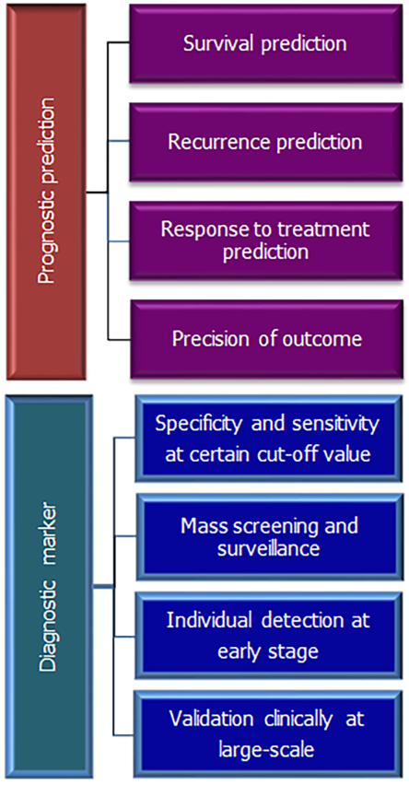
Figure 1 Showing important features of prognostic and diagnostic markers.
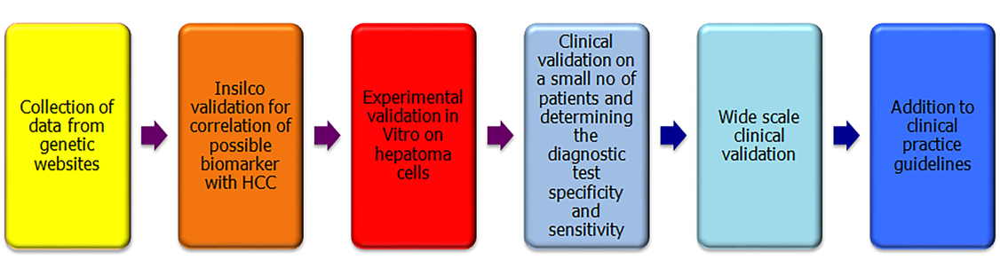
Figure 2 Pathway for validation of the biomarkers in hepatocellular carcinoma.
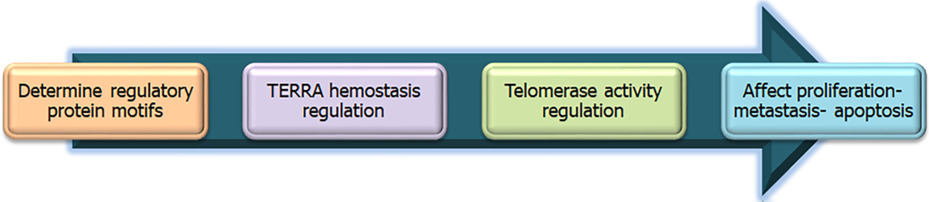
Figure 3 Proposed mechanism of drug development using bioinformatics and molecular knowledge about telomere homeostasis.
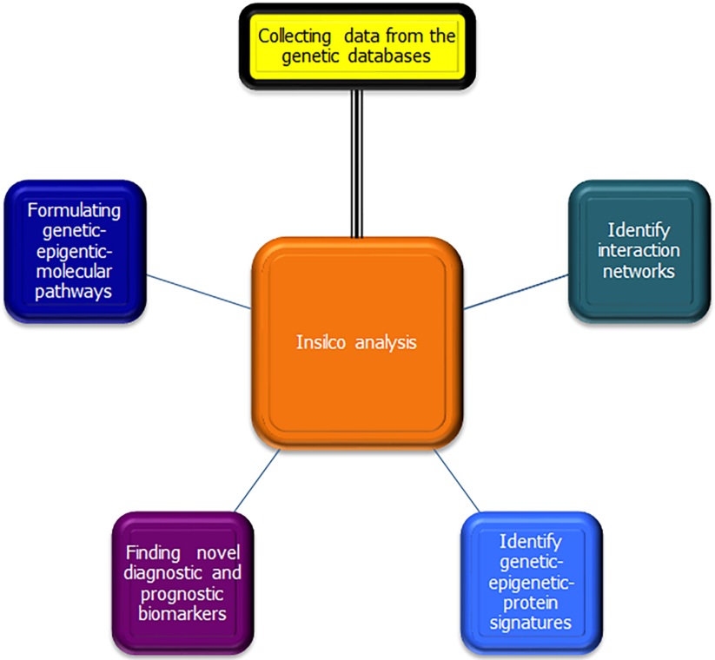
Figure 4 Pathways and aims of bioinformatics analysis.
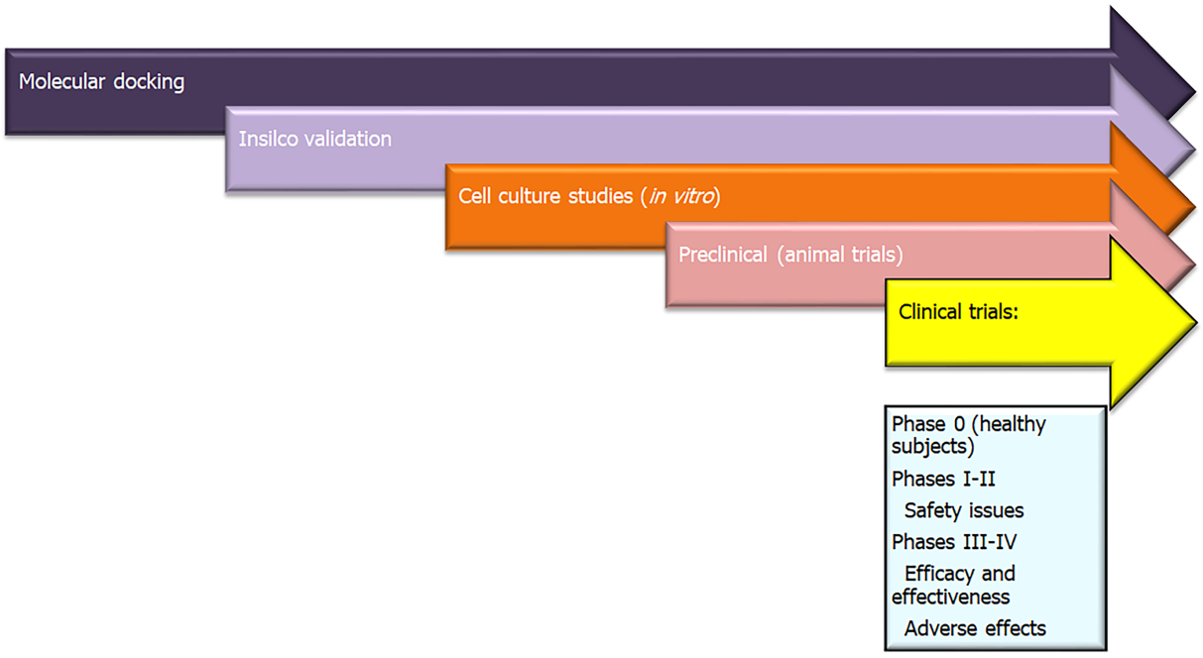
Figure 5 Role of molecular docking from drug discovery to clinical use.
Table 1 Molecular pathways affected in hepatocellular carcinoma and their related protein-coding genes^{[14,33,34]} and KEGG pathways database^{[35]}
Function | Pathways and genetic regulators
Proliferation | Wnt pathway: MYC, FGF19, APC, AXIN  MAPK/ERK signaling pathway: mTOR, ERK 1/2
Cell growth and angiogenesis | RTK/RAS/PI(3)K pathway: PIK3CA, VEGF, EGF, MET, KRAS, PTEN, AKT1/2, FGFR1, NF1, TSC1/2, TGF-β pathway: SMAD2/3, SMAD4
Apoptosis | TP53 signaling pathway: MDM4, MDM2, CDKN2A, RPS6KA3
Cell immortality | Telomerase production: TERT
Cell cycle progression | RB1, CCND1, CDK4, CCNE1
Cell differentiation | HNF1A
Autophagy | RAS/RAF/MEK/ERK pathway, PI3K-AKT (AKT kinase)-mTOR pathway, and Wnt/β-catenin signaling pathway: Becilin-1, ATG3, ATG5, ATG7
Inflammatory response | IL-6 stimulation: STAT3, HNF1, IL6ST, GNAS
Chromatin modifiers | BAP1, ARID1A/B, IDH1/2, SMACA4, KMT2D
Wnt: Wingless and Int-1 (combined word); FGF19: Fibroblast growth factor 19 coding gene; MAPK: Mitogen-activated protein kinase; ERK: Extracellular signal-regulated kinase; mTOR: The mechanistic target of rapamycin; VEGF: Vascular endothelial growth factor; EGF: Epidermal growth factor; KRAS: K-Ras coding gene; PTEN: Phosphatase and tensin homolog coding gene; FGFR1: Fibroblast growth factor receptor 1 coding gene; SMAD family: signal transducers for receptors of the transforming growth factor beta coding genes; Tp53: Tumor protein P53; MDM2: E3 ubiquitin ligase to degrade p53 coding gene; RPS6KA3: Ribosomal Protein S6 Kinase A3 coding gene; TERT: Telomerase reverse transcriptase coding gene; CCND1: Cyclin D1 Coding gene; CDK4: Cyclin-dependent kinase 4; CCNE1: Cyclin E1 coding gene; HNF1A: HNF1 Homeobox A coding gene; IL: Interleukin; ATG: Autophagy Related coding gene; STAT3: Signal transducer and activator of transcription 3; GNAS: guanine nucleotide binding protein; BAP1: BRCA1 associated protein-1; ARID1A/B: AT-rich interactive domain-containing protein 1A/B; IDH1/2: Isocitrate dehydrogenase 1/2; KMT2D: Lysine Methyltransferase 2D coding gene.

Published by Baishideng Publishing Group Inc
7041 Koll Center Parkway, Suite 160, Pleasanton, CA 94566, USA
Telephone: +1-925-3991568
E-mail: bpgoffice@wjgnet.com
Help Desk: https://www.f6publishing.com/helpdesk
https://www.wjgnet.com

© 2022 Baishideng Publishing Group Inc. All rights reserved.

