Name of Journal: World Journal of Clinical Cases
Manuscript NO: 44561
Manuscript Type: CASE REPORT

Melanotic Xp11-associated tumor of the sigmoid colon: A case report

Wang G et al. Melanotic Xp11-associated tumor of the sigmoid colon

Gang Wang, Gang-Gang Li, Sheng-Mao Zhu, Bao-Jia Cai, Peng-Jie Yu, Cheng-Wu Zhang

Gang Wang, the Graduate School of Qinghai University, Xining 810016, Qinghai Province, China

Gang-Gang Li, Sheng-Mao Zhu, Bao-Jia Cai, Peng-Jie Yu, Cheng-Wu Zhang, Department of Gastrointestinal Surgery, Affiliated Hospital of Qinghai University, Xining 810000, Qinghai Province, China

ORCID number: Gang Wang (0000-0002-8111-0118); Gang-Gang Li (0000-0001-5465-7284); Sheng-Mao Zhu (0000-0002-1329-5026); Bao-Jia Cai (0000-0002-7970-2667); Peng-Jie Yu (0000-0001-7372-6919); Cheng-Wu Zhang (0000-0003-4078-2767).

Author contributions: Li GG and Zhu SM designed the study; Zhang CW, Bao JC, and Peng JY performed the operation; Wang G wrote the paper; all authors read and approved the final manuscript.

Supported by The Key Research & Development and Transformation Project of Qinghai Province for 2018 (No. 2018-SF-113).

Informed consent statement: Informed consent was obtained from the patient for this publication.

Conflict-of-interest statement: The authors declare that they have no competing interests.

CARE Checklist (2016) statement: The guidelines of the “CARE Checklist - 2016: Information for writing a case report” have been adopted.

Open-Access: This article is an open-access article which was selected by an in-house editor and fully peer-reviewed by external reviewers. It is distributed in accordance with the Creative Commons Attribution Non Commercial (CC BY-NC 4.0) license, which permits others to distribute, remix, adapt, build upon this work non-commercially, and license their derivative works on different terms, provided the original work is properly cited and the use is non-commercial. See: http://creativecommons.org/licenses/by-nc/4.0/

Manuscript source: Unsolicited manuscript

Corresponding author: Cheng-Wu Zhang, MD, Chief Doctor, Professor, Department of Gastrointestinal Surgery, Affiliated Hospital of Qinghai University, No. 29, Tongren Road, Xining 810000, Qinghai Province, China. 861072284@qq.com
Telephone: +86-153-4973630

Received: November 16, 2018
Peer-review started: November 16, 2018
First decision: December 9, 2018
Revised: December 30, 2018
Accepted: January 30, 2019
Article in press: January 30, 2019
Published online: March 6, 2019

Abstract
BACKGROUND
Melanotic Xp11-associated tumors are rare mesenchymal-derived tumors. So far, most primary melanotic Xp11-associated tumors have been reported in the kidney, and reports of this tumor in the gastrointestinal tract are rare.

CASE SUMMARY
Here we describe the case of a 25-year-old woman who presented with a melanotic Xp11-associated tumor in the sigmoid colon. Colonoscopy revealed a large mucosal bulge in the sigmoid colon, approximately 32 cm inside the anus. The surface was rough with local erosion. The tumor was brittle on biopsy and bled easily. Computed tomography revealed thickening of the rectal wall with edema. Postoperative pathology indicated the likelihood of a perivascular epithelioid cell tumor. Histologically, the tumor comprised plump epithelioid cells with abundant clear to lightly eosinophilic cytoplasm and round nuclei arranged in an alveolar or trabecular pattern. The tumor cells were strongly positive for HMB-45, Melan-A, Cathepsin K, and TFE3 but negative for vimentin, smooth muscle actin, S100 protein, CD10, CK20, and desmin. The tumor cells had a low Ki-67 labeling index (approximately 2%). Fluorescence in situ hybridization revealed TFE3 fracture. Based on these histologic and immunohistochemical features, a diagnosis of melanotic Xp11-associated tumor of the sigmoid colon was made.

CONCLUSION
In summary, we report the clinicopathological features of a primary tumor that is extremely rare in the sigmoid colon and review the clinicopathological characteristics of melanotic Xp11-associated tumors, compatible with the very rare tumor termed “melanotic Xp11 translocation renal cancer” in all aspects.

Key words: Melanotic Xp11-associated tumor; Perivascular epithelioid cell tumor; Melan-A; Sigmoid colon; Case report

© The Author(s) 2019. Published by Baishideng Publishing Group Inc. All rights reserved.

Core tip: Melanotic Xp11-associated tumors can occur at all ages; children and young adults are particularly prone whereas it is rare in middle-aged and elderly individuals. So far, most primary melanotic Xp11-associated tumors have been reported in the kidney, and reports of this tumor in the gastrointestinal tract are rare. Therefore, data regarding the clinical features and biologic behavior of melanotic Xp11-associated tumors are limited.

Citaiton: Wang G, Li GG, Zhu SM, Cai BJ, Yu PJ, Zhang CW. Melanotic Xp11-associated tumor of the sigmoid colon: A case report. World J Clin Cases 2019; 7(5): 684-690
URL: https://www.wjgnet.com/2307-8960/full/v7/i5/684.htm
DOI: https://dx.doi.org/10.12998/wjcc.v7.i5.684
INTRODUCTION
Melanotic Xp11-associated tumors are rare mesenchymal-derived tumors. In 2009, Argani et al^{[1]} reported the clinicopathological features of a distinctive renal cell cancer (RCC) termed “melanotic Xp11 translocation renal cancer”. In 2012, LeGallo et al^{[2]} reported the first case of primary melanotic Xp11-associated tumor in the ovary, for which the immunohistochemical markers were very similar to those of RCC. Melanotic Xp11-associated tumors can occur at all ages; children and young adults are particularly prone whereas it is rare in middle-aged and elderly individuals. The common pathological features are: (1) the pigments are visible; (2) the tumor cells are nested, have highly developed capillary vessels, are rich in cytoplasm, and can coexpress melanocyte markers HMB45 and Melan-A but not epithelial markers; and (3) there are TFE3 gene rearrangement and Xp11 translocation. So far, most primary melanotic Xp11-associated tumors have been reported in the kidney, and reports of this tumor in the gastrointestinal tract are rare. Therefore, data regarding the clinical features and biologic behavior of melanotic Xp11-associated tumors are limited. Here we report the clinicopathologic features of a sigmoid colon tumor in a 25-year-old woman showing morphologic, immunohistochemical, and molecular genetic features identical to those of melanotic Xp11 translocation renal cancer, and performed a review of the published literature.

CASE PRESENTATION
Chief complaints
A 25-year-old woman presented with a 4-d history of abdominal pain, melena, and nausea that were aggravated 1 d prior to admission. She had diarrhea approximately four times a day.

History of present illness
The patient presented to a local Chinese Medicine Hospital and was diagnosed with hemorrhoids. Her condition did not improve after the medical treatment, so she presented to our hospital for further evaluation.

History of past illness
There was no obvious abnormality in the past illness.

Personal and family history
She denied any family history of related diseases.

Physical examination upon admission
No obvious positive signs were found in the abdomen.

Laboratory examinations
The laboratory findings revealed normal routine blood parameters, coagulation function, tumor markers, and biochemistry results. Blood pressure was 90/70 mmHg, heart rate was 90 beats/min, and the heart rhythm was normal. Immunohistochemically, the tumor cells were strongly positive for HMB45, CD34 (vascular+), CD117, CD163, CD68, and Melan-A and negative for CK, Vimentin, S100, CK7, CK20, CD10, Dog-1, Des, CgA, SYN, LCA, EMA, smooth muscle actin (SMA), and SOX-10. Mitotic figures were approximately ≥ 2/5 per high power field, Ki-67 labeling index was approximately 2%, and there was a partially invasive boundary. The initial diagnosis was a gastrointestinal tract malignancy with perivascular epithelioid cell tumor (PEComa). However, we excluded primary melanoma and primary clear-cell sarcoma of the gastrointestinal tract. The patient was advised to have a genetic test or pathological consultation. Pathological consultation and a fluorescence in situ hybridization (FISH) test were subsequently performed at Xijing Hospital, Fourth Military Medical University; immunohistochemistry showed that the tumor cells expressed a melanin marker and TFE3, accompanied by TFE3 gene translocation (Figure 1). FISH for TFE3 rearrangement showed that the TFE3 gene was fractured (Figure 1). The tumor showed an abnormal signal pattern consistent with rearrangement of the TFE3 locus in 52% of the cells. Taking into account all these immunohistochemistry and FISH tests, the final diagnosis was a melanotic Xp11-associated tumor. There was no intraoperative evidence of metastasis or involvement of other abdominal organs. Moreover, subsequent staging studies showed no evidence of metastatic disease.

Imaging examinations
Colonoscopy revealed a large mucosal bulge in the sigmoid colon, approximately 32 cm inside the anus. The surface was rough with local erosion. The tumor was brittle on biopsy and bled easily. Computed tomography revealed thickening of the rectal wall with edema. Gastroenterography revealed a filling defect at the junction of the sigmoid and the descending colon. Sputum passed through, the local wall was stiff, and the mucosal destruction was interrupted. Barium sulfate passed through, the local wall was stiff, and the mucosal destruction was interrupted. A malignant tumor was suspected after we completed the relevant examinations. Laparoscopic-assisted resection of the large sigmoid colon mass (about 10 cm × 2.1 cm) was performed. Postoperative pathology indicated the likelihood of a PEComa.

FINAL DIAGNOSIS
Melanotic Xp11-associated tumor of the sigmoid colon.

TREATMENT
Laparoscopic-assisted resection of the large sigmoid colon.

OUTCOME AND FOLLOW-UP
She was followed by imaging studies of the chest, abdomen, and pelvis as well as colonoscopy every 3 mo. At 6 mo after the initial diagnosis, she was disease-free.

DISCUSSION
Since Argan et al^{[1]} first reported Xp11 translocation RCC in 2009, increasing numbers of melanotic tumors have been reported. In 2012, LeGallo et al^{[2]} first reported melanotic Xp11-associated tumor originating in the ovary. The common pathological feature are that the tumor cells are nested, have highly developed capillary vessels, and are rich in cytoplasm, and the pigments are visible, which makes it very similar to PEComa, and tumor cells can coexpress melanocyte markers HMB45 and Melan-A^{[3,4]}. Melanotic Xp11-associated tumors originating in the digestive system are rare. Therefore, most previous reports on this disease misdiagnosed it as a PEComa. So far, no relevant clinical data can predict the prognosis of these rare postoperative melanotic Xp11-associated tumors^{[2]}. Due to the fact that melanotic Xp11-associated tumors are extremely rare and their histologic features vary, a differential diagnosis to exclude other tumors is important. The differential diagnosis of melanotic Xp11-associated tumors includes various types of epithelial and mesenchymal tumors, including PEComa, malignant melanoma, clear-cell sarcoma, gastrointestinal stromal tumor (GIST), metastatic RCC, and epithelioid leiomyosarcoma. It is well known that the morphology and immunohistochemical features of these unique melanotic Xp11-associated tumors overlap with the morphologic and immunohistochemical features of PEComa. Although the distinction of melanotic Xp11-associated tumors from PEComas is difficult, we believe that the overall morphologic features of the current tumor, particularly the presence of large amounts of melanin, the absence of SMA expression, the lack of the tuberous sclerosis complex gene mutation, and the presence of SFPQ/TFE3 fusion^{[3,5-8]}, encouraged us to interpret this lesion as a melanotic Xp11-associated tumor (Table 1), thereby making it less difficult to differentiate. The detailed differences are shown in Table 1. FISH is the most commonly used method for gene detection^{[9]}. Malignant melanoma and clear-cell sarcoma have a high positive rate of S100 protein and TFE3 recombination but a lack of expression of myogenic markers^{[10,11]}. Therefore, the melanin and myogenic immune markers can be used for identification. GIST is the most common tumor of the gastrointestinal mesenchymal tissue, which has a morphology very similar to that of gastrointestinal PEComa, and can also coexpress the CD117 tumor marker, which increases the difficulty in differentiation of this disease. However, GIST does not have the characteristic of expressing the melanin marker; hence, we can use the melanin marker to distinguish it^{[12-15]}.

CONCLUSION
In summary, we report the clinicopathological features of a primary tumor that is extremely rare in the sigmoid colon and review the clinicopathological characteristics of melanotic Xp11-associated tumors, compatible with the very rare tumor termed “melanotic Xp11 translocation renal cancer” in all aspects. Xp11 melanoma should be considered in the differential diagnosis of abnormal melanomas, particularly in cases involving PEComas or unusual primary melanoma tumors. Melanotic Xp11-associated tumors are a special type of tumor with a low incidence, especially for tumors originating in the gastrointestinal tract. The etiology, pathogenesis, and related biological behaviors of this disease remain unclear. Postoperative management, including adjuvant chemotherapy, has not been established yet. A further study of these particularly rare tumors is necessary to understand their biological behavior and pathogenesis. Therefore, patients with postoperative melanotic Xp11-associated tumors should be carefully followed.

REFERENCES
1 Argani P, Aulmann S, Karanjawala Z, Fraser RB, Ladanyi M, Rodriguez MM. Melanotic Xp11 translocation renal cancers: a distinctive neoplasm with overlapping features of PEComa, carcinoma, and melanoma. Am J Surg Pathol 2009; 33: 609-619 [PMID: 19065101 DOI: 10.1097/PAS.0b013e31818fbdff]
2 LeGallo RD, Stelow EB, Sukov WR, Duska LR, Alisanski SB, Folpe AL. Melanotic xp11.2 neoplasm of the ovary: report of a unique case. Am J Surg Pathol 2012; 36: 1410-1414 [PMID: 22895274 DOI: 10.1097/PAS.0b013e31826277a9]
3 Wang XT, Xia QY, Ni H, Ye SB, Li R, Wang X, Shi SS, Zhou XJ, Rao Q. SFPQ/PSF-TFE3 renal cell carcinoma: a clinicopathologic study emphasizing extended morphology and reviewing the differences between SFPQ-TFE3 RCC and the corresponding mesenchymal neoplasm despite an identical gene fusion. Hum Pathol 2017; 63: 190-200 [PMID: 28315422 DOI: 10.1016/j.humpath.2017.02.022]
4 Saleeb RM, Srigley JR, Sweet J, Doucet C, Royal V, Chen YB, Brimo F, Evans A. Melanotic MiT family translocation neoplasms: Expanding the clinical and molecular spectrum of this unique entity of tumors. Pathol Res Pract 2017; 213: 1412-1418 [PMID: 28969862 DOI: 10.1016/j.prp.2017.08.004]
5 Rao Q, Shen Q, Xia QY, Wang ZY, Liu B, Shi SS, Shi QL, Yin HL, Wu B, Ye SB, Li L, Chen JY, Pan MH, Li Q, Li R, Wang X, Zhang RS, Yu B, Ma HH, Lu ZF, Zhou XJ. PSF/SFPQ is a very common gene fusion partner in TFE3 rearrangement-associated perivascular epithelioid cell tumors (PEComas) and melanotic Xp11 translocation renal cancers: clinicopathologic, immunohistochemical, and molecular characteristics suggesting classification as a distinct entity. Am J Surg Pathol 2015; 39: 1181-1196 [PMID: 26274027 DOI: 10.1097/PAS.0000000000000502]
6 Argani P, Zhong M, Reuter VE, Fallon JT, Epstein JI, Netto GJ, Antonescu CR. TFE3-Fusion Variant Analysis Defines Specific Clinicopathologic Associations Among Xp11 Translocation Cancers. Am J Surg Pathol 2016; 40: 723-737 [PMID: 26975036 DOI: 10.1097/PAS.0000000000000631]
7 Zhan HQ, Chen H, Wang CF, Zhu XZ. A case of PSF-TFE3 gene fusion in Xp11.2 renal cell carcinoma with melanotic features. Hum Pathol 2015; 46: 476-481 [PMID: 25582502 DOI: 10.1016/j.humpath.2014.11.013]
8 Rao Q, Williamson SR, Zhang S, Eble JN, Grignon DJ, Wang M, Zhou XJ, Huang W, Tan PH, Maclennan GT, Cheng L. TFE3 break-apart FISH has a higher sensitivity for Xp11.2 translocation-associated renal cell carcinoma compared with TFE3 or cathepsin K immunohistochemical staining alone: expanding the morphologic spectrum. Am J Surg Pathol 2013; 37: 804-815 [PMID: 23598965 DOI: 10.1097/PAS.0b013e31827e17cb]
9 Manucha V, Sessums MT, Lewin J, Akhtar I. Cyto-histological correlation of Xp11.2 translocation/TFE3 gene fusion associated renal cell carcinoma: Report of a case with review of literature. Diagn Cytopathol 2018; 46: 267-270 [PMID: 29024535 DOI: 10.1002/dc.23839]
10 Wang XT, Xia QY, Ni H, Wang ZY, Ye SB, Li R, Wang X, Lv JH, Shi SS, Ma HH, Lu ZF, Shen Q, Zhou XJ, Rao Q. Xp11 neoplasm with melanocytic differentiation of the prostate harbouring the novel NONO-TFE3 gene fusion: report of a unique case expanding the gene fusion spectrum. Histopathology 2016; 69: 450-458 [PMID: 26844676 DOI: 10.1111/his.12949]
11 Dickson BC, Brooks JS, Pasha TL, Zhang PJ. TFE3 expression in tumors of the microphthalmia-associated transcription factor (MiTF) family. Int J Surg Pathol 2011; 19: 26-30 [PMID: 20164056 DOI: 10.1177/1066896909352861]
12 Kanazawa A, Fujii S, Godai TI, Ishibe A, Oshima T, Fukushima T, Ota M, Yukawa N, Rino Y, Imada T, Ito J, Nozawa A, Masuda M, Kunisaki C. Perivascular epithelioid cell tumor of the rectum: report of a case and review of the literature. World J Surg Oncol 2014; 12: 12 [PMID: 24410788 DOI: 10.1186/1477-7819-12-12]
13 Alvarado-Cabrero I, Vázquez G, Sierra Santiesteban FI, Hernández-Hernández DM, Pompa AZ. Clinicopathologic study of 275 cases of gastrointestinal stromal tumors: the experience at 3 large medical centers in Mexico. Ann Diagn Pathol 2007; 11: 39-45 [PMID: 17240306 DOI: 10.1016/j.anndiagpath.2006.03.014]
14 Torii I, Kondo N, Takuwa T, Matsumoto S, Okumura Y, Sato A, Tanaka F, Nishigami T, Hasegawa S, Tsujimura T. Perivascular epithelioid cell tumor of the rib. Virchows Arch 2008; 452: 697-702 [PMID: 18437415 DOI: 10.1007/s00428-008-0612-y]
15 Lee M, Cho KJ, Yu C, Park Y, Kim JC, Kim J, Yu E, Kim MJ. Perivascular epithelioid cell tumor of the sigmoid colon with transcription factor E3 expression. Ann Diagn Pathol 2012; 16: 306-311 [PMID: 21546294 DOI: 10.1016/j.anndiagpath.2011.01.007]

P-Reviewer: Parellada CM, Rubbini M, Fukuda S S-Editor: Dou Y
L-Editor: Wang TQ E-Editor: Bian YN

Specialty type: Medicine, Research and Experimental
Country of origin: China
Peer-review report classification
Grade A (Excellent): A
Grade B (Very good): 0
Grade C (Good): C, C
Grade D (Fair): 0
Grade E (Poor): 0

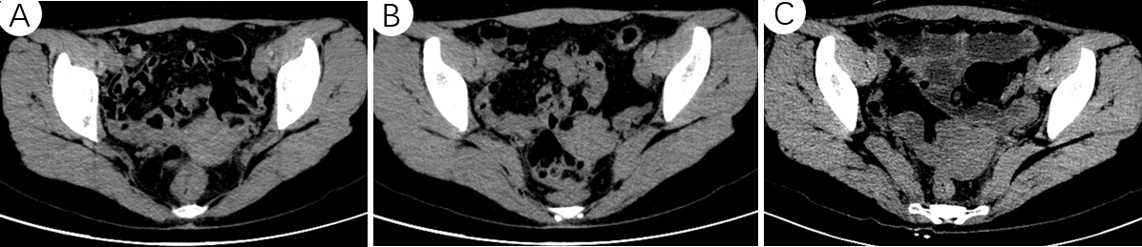

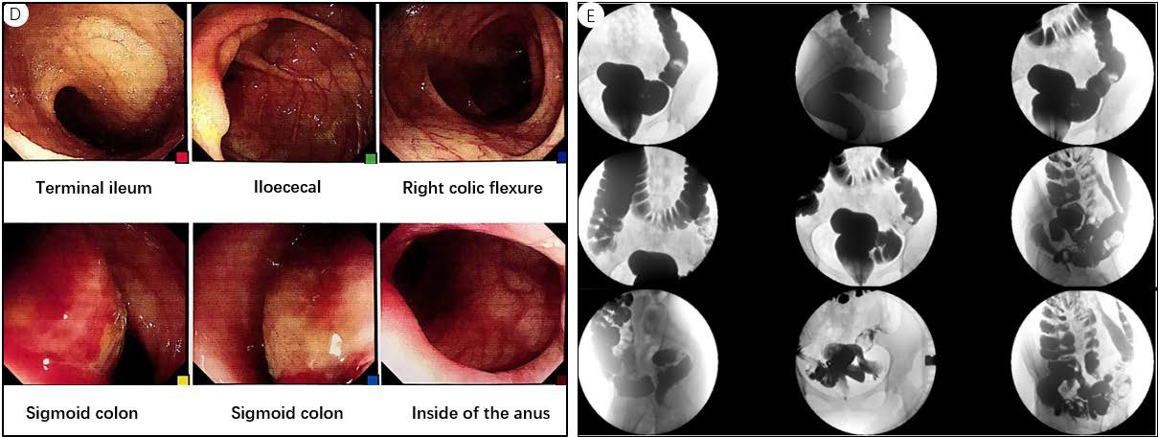

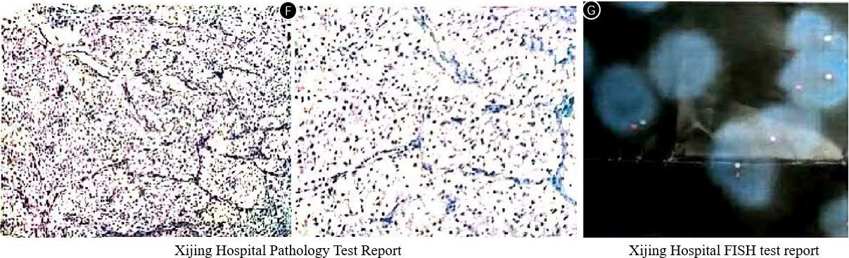

Figure 1 The examination results of the patient. A and B: Preoperative computed tomography (CT) showing thickening of the rectal wall with edema; C: Postoperative CT showing a high-density suture shadow in the operation area; D: Approximately 32 cm inside the anus, a large mucosal bulge can be seen in the sigmoid colon. The surface was rough with local erosion. The tumor was brittle on biopsy and bled easily; E: Preoperative gastrointestinal angiography showing a filling defect at the junction of the sigmoid and the descending colon. The barium sulfate passed through, the local wall was stiff, and the mucosal destruction was interrupted; F: Pathological consultation at Xijing Hospital. The tumor cells in the muscle layer of the sigmoid colon were scattered in the nest, and capillaries were separated. The cytoplasm of tumor cells was rich and lightly stained. The nucleus was medium-sized and round or oval (note the nucleolus). The nuclear division was rare, and a small amount of pigment was visible. Immunohistochemistry showed that the tumor cells expressed a melanin marker and TFE3, accompanied by TFE3 gene translocation, consistent with pigmented Xp11-related tumors. Tumor cells were positive for TFE3 and Cathepsin, and fluorescence in situ hybridization (FISH) results showed TFE3 gene fragmentation (see the FISH report). Original immunohistochemistry results showed HMB45 (+), Melan-A (+), Ki-67 (+, approximately 5%), smooth muscle actin (−), CK (−), and EMA (−); G: Results of FISH test at Xijing Hospital shown that the TFE3 is fractured.

Table 1 Comparative features of melanotic Xp11 tumors and perivascular epithelioid cell tumors
 | Melanotic Xp11 tumors | PEComas
Sex predilection | Females > males | Females > males
Age | Children and young adults, but may affect older adults | Middle age, but may affect children and older adults
Family history |  | Tuberous sclerosis
Site | Kidneys, uterus, ovaries, cervix, colon, pancreas, bladder, and pelvis | Genitourinary tract, viscera, skin, soft tissue, and bone
Histology | Epithelioid with clear cytoplasm | Spindled, epithelioid, or sclerosing
Melanin pigment | Usually present | Usually absent
Muscle marker expression | Usually absent | Usually present
Melanocytic marker expression | Present | Present
Epithelial marker expression | Absent | Absent
Molecular genetic alteration | Xp11 translocation; PSF-TFE3 fusion | Loss of TSC1 (9q34) or TSC2 (16p13.3) gene
PEComa: Perivascular epithelioid cell tumor.

