Name of Journal: World Journal of Clinical Cases
Manuscript NO: 76889
Manuscript Type: CASE REPORT

Incidental accumulation of Technetium-99m pertechnetate in subacute cerebral infarction: A case report

Han YH et al. Incidental accumulation of Technetium-99m pertechnetate

Yeon-Hee Han, Hwan-Jeong Jeong, Hyun Goo Kang, Seok Tae Lim

Yeon-Hee Han, Hwan-Jeong Jeong, Seok Tae Lim, Department of Nuclear Medicine, Research Institute of Clinical Medicine of Jeonbuk National University-Biomedical Research Institute of Jeonbuk National University Hospital, Jounbuk National University Medical School and Hospital, Jeonju 54907, Jeonbuk, South Korea

Hyun Goo Kang, Department of Neurology, Jeonbuk National University Medical School and Hospital, Jeonju 54907, Jeonbuk, South Korea

Author contributions: Han YH and Lim ST were nuclear physicians, performed the conceptualization, investigation, and contributed to manuscipt drafting; Jeong HJ reviewed the literature and contributed to manuscript editing; Kang HG was a neurophysician and performed the disease consultation and manuscript drafting; Han YH and Lim ST were responsible for the revision of the manuscript for important intellectual content; all authors issued final approval for the version to be submitted.

Corresponding author: Seok Tae Lim, PhD, Professor, Department of Nuclear Medicine, Research Institute of Clinical Medicine of Jeonbuk National University-Biomedical Research Institute of Jeonbuk National University Hospital, Jounbuk National University Medical School and Hospital, 20 Geonjiro Deokjin-gu, Jeonju 54907, Jeonbuk, South Korea. stlim@jbnu.ac.kr

Received: April 5, 2022
Revised: June 17, 2022
Accepted: July 5, 2022
Published online: August 16, 2022

Abstract
BACKGROUND
When interpreting nuclear medicine images, unexpected findings are sometimes encountered. Recognizing these findings and determining the mechanism of their occurrence could have a significant impact on early diagnosis of critical diseases and the appropriate management of patients.

CASE SUMMARY
A 59-year-old man was admitted to the emergency room due to left hemiparesis, left hemifacial palsy, and mild dysarthria. After 2 wk of hospitalization, the patient complained of dry eyes and mouth. Thus, salivary scintigraphy was performed to evaluate the functional status of his salivary glands. Incidental accumulation in the right frontoparietal area was found on salivary scintigraphy. Fluid-attenuated inversion recovery phase magnetic resonance (FLAIR phase MR) image showed diffuse high signal intensity in the same area. Anterior and posterior horns of the right lateral ventricle were obliterated and the midline was slightly shifted to the left side due to right frontoparietal swelling. On salivary scintigraphy, Tc-99m pertechnetate was incidentally accumulated in a subacute cerebral infarction lesion. Two years after the diagnosis of acute infarction, the second series of salivary scintigraphy showed no abnormal activity in the brain. FLAIR phase MR image also demonstrated markedly decreased high signal intensity in the previous infarction lesion without evidence of swelling indicating chronic cerebral infarction.

CONCLUSION
This case highlights that Tc-99m pertechnetate could accumulate in a subacute cerebral infarction lesion. The mechanism of an unexpected uptake of Tc-99m pertechnetate in unusual sites should be evaluated and kept in mind for better interpretation.

Key Words: Cerebral infarction; Tc-99m pertechnetate; Salivary scintigraphy; Case report

©The Author(s) 2022. Published by Baishideng Publishing Group Inc. All rights reserved.

Citation: Han YH, Jeong HJ, Kang HG, Lim ST. Incidental accumulation of Technetium-99m pertechnetate in subacute cerebral infarction. World J Clin Cases 2022; 10(23): 8400-8405
URL: https://www.wjgnet.com/2307-8960/full/v10/i23/8400.htm
DOI: https://dx.doi.org/10.12998/wjcc.v10.i23.8400

Core Tip: Tc-99m pertechnetate is a truly carrier-free radiotracer transported by sodium iodide symporter. Salivary scintigraphy using Tc-99m pertechnetate is frequently performed for diagnosing salivary gland diseases such Sjogren's syndrome. Here, we present a rare case of Tc-99m pertechnetate accumulation in the subacute cerebral infarction lesion. The reason for Tc-99m pertechnetate accumulation is thought to be due to ingrowth and proliferation of new capillaries with enhanced permeability in the subacute cerebral infarction lesion. The present case highlights that Tc-99m pertechnetate could accumulate in a subacute cerebral infarction lesion. The mechanisms of an unexpected uptake of Tc-99m pertechnetate in unusual sites should be evaluated and kept in mind for better interpretation.

INTRODUCTION
When interpreting nuclear medicine images, unexpected findings are sometimes encountered. Recognizing these findings and determining the mechanism of their occurrence could have a great impact on early diagnosis of critical disease and appropriate management of patients. Tc-99m pertechnetate is one of the most common and widely used radiotracers in the nuclear medicine department. Although it is mostly used in combination with other pharmaceuticals, free Tc-99m pertechnetate itself is also used to evaluate thyroid and salivary gland function and to detect ectopic gastric mucosa in Meckel’s diverticulum. Salivary scintigraphy using Tc-99m pertechnetate provides a series of processes in which saliva is produced and excreted. Therefore, it can evaluate saliva production and excretory functions of major salivary glands such as the parotid and submandibular glands in various salivary gland diseases such as radiation sialoadenitis and Sjogren's syndrome. Here, we present the first case of a subacute cerebral infarction demonstrating an unexpected uptake of Tc-99m pertechnetate on salivary scintigraphy.

CASE PRESENTATION
Chief complaints
A 59-year-old man was admitted to the emergency room because of left hemiparesis, left hemifacial palsy, and mild dysarthria.

History of present illness
After 2 wk of hospitalization, the patient's symptoms of dry eyes and mouth started and worsened as time went by.

History of past illness
The patient had no previous medical history.

Personal and family history
There was no specific family history.

Physical examination
The patient had a body temperature of 36.1 °C, a heart rate of 54 bpm, a respiratory rate of 18 breaths per minute, a blood pressure of 101/61 mmHg, and oxygen saturation in room air of 97%. His mental status was light drowsy. Clinical neurological examination revealed left hemiparesis, left hemifacial palsy, mild dysarthria, and asomatognosia. Our first clinical consideration was an acute cerebral infarction.

Laboratory examinations
Blood analysis revealed a normal leukocyte count of 7.7 × 10⁹ /L with normal hematocrit and platelet count. Prothrombin time and partial thromboplastin time were normal and d-dimers were increased at 2.38 μg/mL. Serum C-reactive protein was within normal range and erythrocyte sedimentation rate was 10 mm/h. Blood biochemistries and urine analysis results were normal. Electrocardiogram, chest X-ray, and arterial blood gas analysis were also normal. After 2 wk of hospitalization, the patient complained of dry eyes and mouth Thus further studies were performed. Anti-Ro and anti-La antibodies known to be associated with Sjogren's syndrome, were positive and his Schirmer's test showed a possible shortage of tears.

Imaging examinations
On computed tomography angiography, total obstruction of the right common carotid artery and the M1 portion of the right middle cerebral artery was noted. There was a large acute infarction in the right frontoparietal area on the MR image. Salivary scintigraphy was performed at 2 wk after hospitalization to evaluate functional status of his salivary glands. It demonstrated markedly decreased excretory function of bilateral parotid and submandibular glands, while the uptake ability was relatively preserved. On salivary scintigraphy, an unexpected accumulation of Tc-99m pertechnetate in the right frontoparietal area was also noted (Figure 1). We correlated it with brain magnetic resonance (MR) image. Fluid-attenuated inversion recovery phase MR (FLAIR phase MR) image showed diffuse high signal intensity in the same area (Figure 1). Anterior and posterior horns of the right lateral ventricle were obliterated and the midline was slightly shifted to the left side due to right frontoparietal swelling.

MULTIDISCIPLINARY EXPERT CONSULTATION
Kang HG, MD, PhD, Associate Professor, Department of Neurology, Jeonbuk National University Medical School and Hospital
The patient should undergo immediate transcarotid endovascular thrombectomy of the right common carotid artery with thrombolytic agent as a treatment for acute cerebral infarction.

Han YH, MD, PhD, Fund Professor, Department of Nuclear Medicine, Research Institute of Clinical Medicine of Jeonbuk National University-Biomedical Research Institute of Jeonbuk National University Hospital, Jeonbuk National University Medical School and Hospital
To evaluate his dry eyes and mouth, anti-Ro and anti-La antibodies, Schirmer's test, and salivary scintigraphy using Tc-99m pertechnetate are necessary.

Jeong HJ, Seok Tae Lim, MD, PhD, Professor, Department of Nuclear Medicine, Research Institute of Clinical Medicine of Jeonbuk National University-Biomedical Research Institute of Jeonbuk National University Hospital, Jeonbuk National University Medical School and Hospital
An unexpected accumulation of Tc-99m pertechnetate in the right frontoparietal area was detected. Markedly decreased excretory function of the bilateral parotid and submandibular glands was also noticed suggesting Sjogren's syndrome.

FINAL DIAGNOSIS
The final diagnosis of the presented case was cerebral infarction with unexpected accumulation of Tc-99m pertechnetate in the subacute phase.

TREATMENT
Immediate transcarotid endovascular thrombectomy of the right common carotid artery was performed and a thrombolytic agent was started. The National Institutes of Health stroke scale score was improved from 12 points before thrombectomy to 6 points after thrombectomy and decreased to 3 points after 8 d. After proper management for acute infarction using aspirin, clopidogrel, and mannitol, the patient could walk without assistance of other people. He was independent for most basic activities of daily living, although he might need help with more complex tasks (modified Rankin scale, 3). His eye and mouth dryness also gradually improved after taking pilocarpine, a muscarinic cholinergic agonist. He was discharged after 15 d of hospitalization and regular check-ups were performed in the Departments of Neurology and Rheumatology.

OUTCOME AND FOLLOW-UP
Two years after the diagnosis of acute infarction, the second series of salivary scintigraphy and brain MR were performed for follow-up evaluation. On salivary scintigraphy, there was no abnormal radioactivity in the brain (Figure 2). FLAIR phase MR image also demonstrated markedly decreased high signal intensity in the previous infarction lesion without evidence of swelling (Figure 2). Informed consent for publication of clinical data was obtained from the patient.

DISCUSSION
Tc-99m pertechnetate is a truly carrier-free radiotracer and transported by the sodium iodide symporter. Therefore, Tc-99m pertechnetate scintigraphy is a powerful imaging modality for assessing sodium iodide symporter activity in various organs^{[1]}. It is widely used to evaluate the function of the thyroid and salivary glands and to detect ectopic gastric mucosa in Meckel’s diverticulum^{[2]}.
Salivary scintigraphy using Tc-99m pertechnetate provides a series of processes in which saliva is produced and excreted. Therefore, it is used for salivary gland diseases such as radiation sialoadenitis and Sjogren's syndrome to evaluate saliva production and excretory functions of major salivary glands such as the parotid and submandibular glands.
Attempts have been made to localize brain tumors using Tc-99m pertechnetate and Tc-99m labeled phosphate compound from the 1960s to the 1980s^{[3-4]}. However, currently there is no case of using them for such purpose. There are some reports of an unusual uptake of Tc-99m pertechnetate in pediatric Burkitt's lymphoma and in an unilateral breast used predominantly during breastfeeding^{[5-6]}. Uptake mechanisms are thought to be an increased blood pool and a functional overexpression of sodium iodide symporter, respectively.
The mechanism of radiotracer localization in a brain lesion can be related to a variety of factors, including increased vascularity, abnormal vascular permeability, edema, and selective cellular metabolism. The underlying mechanism may differ among chemical compounds of the radiotracer and pathologic types of lesions. In our case, the ingrowth and proliferation of new capillaries with enhanced permeability in a subacute cerebral infarction might be the main reason for the accumulation of Tc-99m pertechnetate.
Not many nuclear physicians know that Tc-99m pertechnetate can be taken up by subacute cerebral infarctions. To the best of our knowledge, this is the first report to demonstrate Tc-99m pertechnetate uptake in a subacute cerebral infarction on salivary scintigraphy.
Recognizing these findings and determining the mechanism of their occurrence could make a great impact on early diagnosis of critical disease and appropriate management of patients.

CONCLUSION
This case highlights that Tc-99m pertechnetate could accumulate in a subacute cerebral infarction lesion. The mechanisms of an unexpected uptake of Tc-99m pertechnetate in unusual sites should be evaluated and kept in mind for better interpretation.

REFERENCES
1 Hingorani M, Spitzweg C, Vassaux G, Newbold K, Melcher A, Pandha H, Vile R, Harrington K. The biology of the sodium iodide symporter and its potential for targeted gene delivery. Curr Cancer Drug Targets 2010; 10: 242-267 [PMID: 20201784 DOI: 10.2174/156800910791054194]
2 Franken PR, Guglielmi J, Vanhove C, Koulibaly M, Defrise M, Darcourt J, Pourcher T. Distribution and dynamics of (99m)Tc-pertechnetate uptake in the thyroid and other organs assessed by single-photon emission computed tomography in living mice. Thyroid 2010; 20: 519-526 [PMID: 20384490 DOI: 10.1089/thy.2009.0213]
3 Mori H, Maeda T, Hisada K, Kobayashi S. Cerebral infarction: a disparity between Tc-99m-pertechnetate and Tc-99m-EHDP images. Clin Nucl Med 1980; 5: 310-312 [PMID: 6771082 DOI: 10.1097/00003072-198007000-00006]
4 McAfee JG, Fueger CF, Stern HS, Wagner HN Jr, Migita T. Tc99m pertechnetate for brain scanning. J Nucl Med 1984; 25: 385-401 [PMID: 6321702]
5 Cherng SC, Fan YM, Yu CY, Chu CC, Cheng SN. Incidental accumulation of technetium-99m pertechnetate in pediatric Burkitt's lymphoma with tumor-induced intussusception. Clin Nucl Med 2004; 29: 264-265 [PMID: 15096976 DOI: 10.1097/01.rlu.0000117887.51760.05]
6 Gayana S, Bhattacharya A, Kamaleshwaran KK, Mittal BR. Unilateral breast uptake of tc-99m pertechnetate in a patient with cold nodule of the thyroid. World J Nucl Med 2012; 11: 79-80 [PMID: 23372442 DOI: 10.4103/1450-1147.103423]

Footnotes
Informed consent statement: Informed written consent was obtained from the patient for publication of this report and any accompanying images.

Conflict-of-interest statement: All authors declare that they have no conflict of interest.

CARE Checklist (2016) statement: The authors have read the CARE Checklist (2016), and the manuscript was prepared and revised according to the CARE Checklist (2016).

Open-Access: This article is an open-access article that was selected by an in-house editor and fully peer-reviewed by external reviewers. It is distributed in accordance with the Creative Commons Attribution NonCommercial (CC BY-NC 4.0) license, which permits others to distribute, remix, adapt, build upon this work non-commercially, and license their derivative works on different terms, provided the original work is properly cited and the use is non-commercial. See: https://creativecommons.org/Licenses/by-nc/4.0/

Provenance and peer review: Unsolicited article; Externally peer reviewed.
Peer-review model: Single blind

Peer-review started: April 5, 2022
First decision: June 16, 2022
Article in press: July 5, 2022

Specialty type: Medicine, research and experimental
Country/Territory of origin: South Korea
Peer-review report’s scientific quality classification
Grade A (Excellent): 0
Grade B (Very good): B, B
Grade C (Good): 0
Grade D (Fair): 0
Grade E (Poor): 0

P-Reviewer: Luo WL, China; Zhang LH, China S-Editor: Wang LL L-Editor: A P-Editor: Wang LL

Figure Legends
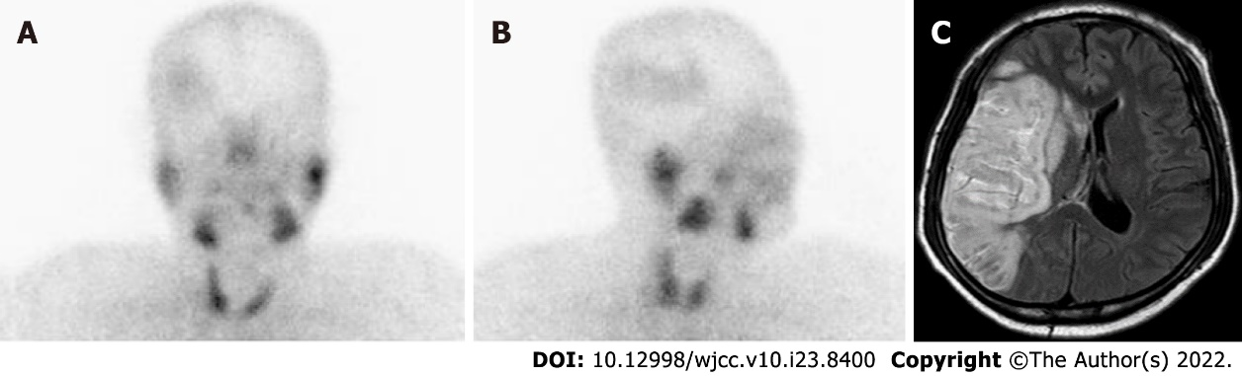
Figure 1 Salivary scintigraphy and fluid-attenuated inversion recovery phase magnetic resonance image at 2 wk after diagnosis of acute cerebral infarction. A and B: Anterior and right oblique images of salivary scintigraphy show an unexpected accumulation of Tc-99m pertechnetate in the right frontoparietal area; C: Fluid-attenuated inversion recovery phase magnetic resonance image demonstrates diffuse high signal intensity in the same area. Anterior and posterior horns of the right lateral ventricle were obliterated and the midline was slightly shifted to the left side due to right frontoparietal swelling.
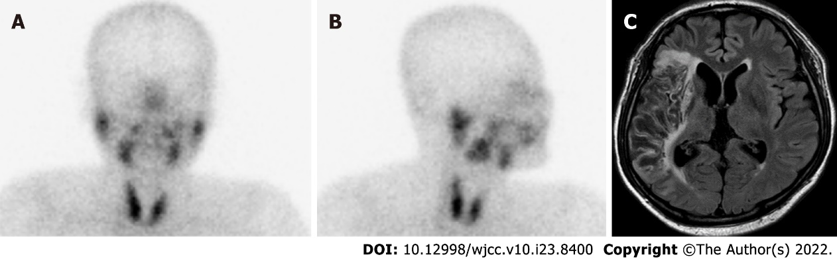
Figure 2 Follow-up salivary scintigraphy and fluid-attenuated inversion recovery phase magnetic resonance image after 2 years. A and B: The second series of salivary scintigraphy shows no abnormal radioactivity in the brain; C: Fluid-attenuated inversion recovery phase magnetic resonance image also demonstrates markedly decreased high signal intensity without evidence of swelling in the previous lesion suggesting chronic infarction.

Published by Baishideng Publishing Group Inc
7041 Koll Center Parkway, Suite 160, Pleasanton, CA 94566, USA
Telephone: +1-925-3991568
E-mail: bpgoffice@wjgnet.com
Help Desk: https://www.f6publishing.com/helpdesk
https://www.wjgnet.com

© 2022 Baishideng Publishing Group Inc. All rights reserved.

