Name of Journal: World Journal of Clinical Cases
Manuscript NO: 72418
Manuscript Type: ORIGINAL ARTICLE

Retrospective Study
Longitudinal changes in personalized platelet count metrics are good indicators of initial 3-year outcome in colorectal cancer

Herold Z et al. Longitudinal platelet changes in colorectal cancer

Zoltan Herold, Magdolna Herold, Julia Lohinszky, Attila Marcell Szasz, Magdolna Dank, Aniko Somogyi

Zoltan Herold, Attila Marcell Szasz, Magdolna Dank, Division of Oncology, Department of Internal Medicine and Oncology, Semmelweis University, Budapest 1083, Hungary

Zoltan Herold, Magdolna Herold, Julia Lohinszky, Aniko Somogyi, Department of Internal Medicine and Hematology, Semmelweis University, Budapest 1088, Hungary

Author contributions: Herold Z, Somogyi A, and Dank M built the study design; Herold Z and Herold M were involved in the collection of patient data; Herold Z performed the statistical analysis of data; Herold Z, Herold M, and Szasz AM interpreted the data; Lohinszky J and Dank M were involved in patient selection; Herold Z prepared the draft of the manuscript; all authors were involved in manuscript editing and reviewing; Herold Z and Dank M received funding; Somogyi A supervised the study; all authors have read and agreed to the published version of the manuscript.

Supported by the New National Excellence Program of the Hungarian Ministry for Innovation and Technology from the source of the National Research, Development and Innovation Fund, No. UNKP-20-4-I; and the Hungarian National Research, Development and Innovation Office, No. NVKP_16-1-2016-0042.

Corresponding author: Zoltan Herold, MSc, PhD, Research Scientist, Division of Oncology, Department of Internal Medicine and Oncology, Semmelweis University, Tomo u. 25-29, Budapest 1083, Hungary. herold.zoltan@med.semmelweis-univ.hu

Received: October 15, 2021
Revised: December 23, 2021
Accepted: May 22, 2022
Published online: July 16, 2022

Abstract
BACKGROUND
Platelet count or complete blood count (CBC)-based ratios including lymphocyte-to-monocyte (LMR), neutrophil-to-lymphocyte (NLR), hemoglobin-to-platelet (HPR), red blood cell count distribution width-to-platelet (RPR), and platelet-to-lymphocyte (PLR) ratio are good predictors of colorectal cancer (CRC) survival. Their change in time is not well documented, however.

AIM
To investigate the effect of longitudinal CBC ratio changes on CRC survival and their possible associations with clinicopathological properties, comorbidities, and anamnestic data.

METHODS
A retrospective longitudinal observational study was conducted with the inclusion of 835 CRC patients, who attended at Semmelweis University, Budapest. CBC ratios and two additional newly defined personalized platelet count metrics (pPLT_{D} and pPLT_{S}, the platelet counts relative to the measurement at the time of CRC diagnosis and to the one 4-6 wk after tumor removal surgery, respectively) were recorded.

RESULTS
The 835 CRC patients had a total of 4608 measurements (5.52 visits/patient, in average). Longitudinal survival models revealed that the increases/decreases in LMR [hazard ratio (HR): 0.4989, P < 0.0001], NLR (HR: 1.0819, P < 0.0001), HPR (HR: 0.0533, P = 0.0038), pPLT_{D} (HR: 4.9229, P < 0.0001), and pPLT_{S} (HR: 4.7568, P < 0.0001) values were poor prognostic signs of disease-specific survival. The same was obtained for all-cause mortality. Most abnormal changes occurred within the first 3 years after the diagnosis of CRC. RPR and PLR had an only marginal effect on disease-specific (P = 0.0675) and all-cause mortality (Bayesian 95% credible interval: 0.90–186.05), respectively.

CONCLUSION
LMR, NLR, and HPR are good metrics to follow the prognosis of the disease. pPLT_{D} and pPLT_{S} perform just as well as the former, while the use of RPR and PLR with the course of the disease is not recommended. Early detection of the abnormal changes in pPLT_{D}, pPLT_{S}, LMR, NLR, or HPR may alert the practicing oncologist for further therapy decisions in a timely manner.

Key Words: Personalized platelet count; Lymphocyte-to-monocyte ratio; Neutrophil-to-lymphocyte ratio; Hemoglobin-to-platelet ratio; Platelet-to-lymphocyte ratio; Colorectal neoplasms

©The Author(s) 2022. Published by Baishideng Publishing Group Inc. All rights reserved.

Citation: Herold Z, Herold M, Lohinszky J, Szasz AM, Dank M, Somogyi A. Longitudinal changes in personalized platelet count metrics are good indicators of initial 3-year outcome in colorectal cancer. World J Clin Cases 2022; 10(20): 6825-6845
URL: https://www.wjgnet.com/2307-8960/full/v10/i20/6825.htm
DOI: https://dx.doi.org/10.12998/wjcc.v10.i20.6825

Core Tip: While the ability of various pre- and post-operative parameters of ratios from complete blood count to predict colorectal cancer (CRC) patient survival is known, their longitudinal changes with the course of the disease are not well documented. Temporal changes of complete blood count ratios of 835 CRC patients were investigated in this retrospective analysis. Two newly defined personalized platelet count metrics were introduced, and two distinct patterns were identified within the parameters examined. Most abnormal changes of the parameters occurred within the first 3 years after the diagnosis of CRC, which coincided with most of the CRC-related deaths.

INTRODUCTION
Colorectal cancer (CRC) is the third most commonly diagnosed cancer type with almost 1.9 million new cases and 916000 deaths worldwide annually, being the second leading cause of cancer deaths, according to the GLOBOCAN 2020 data^{[1]}. In the last decades, a large variety of molecular and routinely used biomarkers have been proposed as prognostic signs of the disease, including ratios created from the parameters of complete blood count (CBC). The following ratios have been developed and their abnormal values have been associated with shorter survival times and worse prognosis in CRC: Lymphocyte-to-monocyte ratio (LMR)^{[2-5]}, neutrophil-to-lymphocyte ratio (NLR)^{[6-13]}, hemoglobin-to-platelet ratio (HPR)^{[14]}, platelet-to-lymphocyte ratio (PLR)^{[9,10,14-16]}, mean platelet volume-to-platelet ratio (MPV/PC)^{[17]}, red blood cell distribution width-to-platelet ratio (RPR)^{[18]}, and personalized platelet counts relative to a platelet count measured at a particular time point^{[19,20]}. It has to be mentioned though, that almost all previous studies, except Sylman et al^{[19]}, investigated the effect of these ratios on CRC in only one of the following ways: (1) Only at a specific timepoint (e.g., pre- or post-operatively, or after the first set of chemotherapy, etc.)^{[2-4,6-10,13-18]}; or (2) Their change over time was investigated by the difference between two timepoints^{[11,12,20]}. In contrast, Sylman et al^{[19]} used a time-dependent statistical model-based approach and concluded that platelet changes over the course of the disease are strongly associated with the prognosis of CRC.
A retrospective longitudinal observational study was created to investigate the effect of CBC-related ratio-changes on CRC survival. The possible associations between the CBC ratios and various clinicopathological properties, comorbidities, and anamnestic data were further objectives of the investigations.

MATERIALS AND METHODS
This study was conducted in concordance with the WMA Declaration of Helsinki. It was approved by the Regional and Institutional Committee of Science and Research Ethics, Semmelweis University (SE TUKEB 21-14/1994, approval date of latest modification: February 23, 2021). Handling of patient data was in accordance with the General Data Protection Regulation issued by the European Union.

Patients and study design
A retrospective longitudinal observational study was conducted with the data available from the medical database of Semmelweis University, Budapest. List of possibly eligible patients was downloaded based on the International Statistical Classification of Diseases and Related Health Problems (ICD-10) codes C18 (malignant neoplasm of the colon), C19 (malignant neoplasm of the rectosigmoid junction), and C20 (malignant neoplasm of the rectum). A total of 2150 CRC patients’ anonymous and de-identified data was retrieved, who attended at the outpatient clinics of the Department of Internal Medicine and Hematology, Semmelweis University, Budapest and at the Department of Internal and Medicine and Oncology, Semmelweis University, Budapest, between 2006 and 2018. The exclusion criteria included age < 18 years, any previous malignancies, known hematologic disease, inflammatory bowel disease, systemic autoimmune disease, mental disease, and/or inadequately controlled thyroid diseases, the usage of systemic corticosteroids 90 d prior to baseline visit date, erythropoiesis-stimulating agents, and patients with an Eastern Cooperative Oncology Group (ECOG) performance status > 2. The criteria for inclusion in the study required laboratory results performed at Semmelweis University at least at the time of CRC diagnosis. After verification of the inclusion and exclusion criteria, 835 of the 2150 patients remained as the initial study population (Figure 1).
Of the 835 patients, a total of 4608 visits (5.52 visits/patient in average) had been processed as follows. Laboratory measurements of patients with a resectable tumor (n = 743, 88.98%) were recorded at the time of CRC diagnosis prior to any oncological procedures, 4-6 wk after but at least within 6 mo after the tumor removal surgery, and every 4-6 mo after the postoperative visit. Measurements of patients with an irresectable tumor (n = 92, 11.02%) were recorded every 4-6 mo after the initial laboratory measurements performed at the time of CRC diagnosis (Figure 1). If a patient had no visit within the optimal window, the next measurement was recorded as close as possible. If a recent blood transfusion was administered around the selected visit, another random visit was selected.

Clinicopathological and laboratory data measurements
Anamnestic data including co-morbidities and recent medications were collected for the baseline measurements, while fasting blood samples were recorded for every visit. CBC was measured at the laboratories of Semmelweis University, Budapest. Staging was given by histopathological examination of surgical specimens and imaging studies; the American Joint Committee on Cancer staging was used^{[21]}. Location of colon tumor was described as rectal cancer; right-sided^{[22]} if the tumor was originating from the cecum, ascending colon, and proximal two-third of the transverse colon; left-sided^{[22]} if originating from the distal one-third of the transverse colon, descending colon, sigmoid colon; and multiplex if tumor growth was found at more than one site. Chemotherapy was recorded as “adjuvant” if no distant metastasis by imaging was detected; and “metastatic“ if metastasis was present. Furthermore, a “chemotherapy 2” grouping was also created, where the previous group “metastatic” was further divided into “First-line”, “Second-line”, and “Third-line and above”. The usage of biological agents and regorafenib / trifluridine-tipiracil was recorded as dummy variables. Survival times were calculated from the time of CRC diagnosis until patient's death or until the termination of data collection (June 30, 2021). Tumor related and unrelated deaths were recorded as separate events, while patients alive were right-censored.
LMR, NLR, PLR, HPR, and RPR were calculated as described previously^{[5,14,18,23]} and data was 88.15% (n = 4062), 69.73% (n = 3213), 70.05% (n = 3228), 100% (n = 4608), and 78.97% (n = 3639) available for every patient visit, respectively. In addition to the above, two newly developed personalized platelet measures were calculated: (1) The personalized platelet measure relative to the platelet count observed at the time of CRC diagnosis (pPLT_{D}) was defined as the quotient of “the platelet count(s) at (a) later visit(s)” divided by “the platelet count at the time of CRC diagnosis”; while (2) “The platelet count after the primary tumor removal surgery” was used as the divisor for the other newly defined personalized platelet measure (pPLT_{S}). The first could be determined for every, while pPLT_{S} was only available for 3633 (78.84%) patient visits.

Statistical analysis
Statistical analyses were performed within the R for Windows version 4.1.0 environment (R Foundation for Statistical Computing, 2021, Vienna, Austria). Welch’s two sample t-test, one-way ANOVA with Tukey’s all-pair post-hoc test, and Fisher’s exact test were used for comparisons between groups. Receiver operating characteristic (ROC) analysis was performed with the R package “pROC” (Robin et al, version 1.17.0.1). Natural cubic spline adjusted random intercept linear mixed effect model was used to determine parameter changes with the course of the disease (R package “nlme”, developed by Pinheiro, Bates DebRoy, Sarkar and the R Core Team, version 3.1-152). Survival models were calculated both for single-time-point and longitudinal data. Pre- and post-operative survival was determined with cause-specific competing risk survival model (R package “survival”, developed by Therneau and Grambsch, version 3.2-11), while longitudinal survival was analyzed using competing risk survival model with a time-dependent covariate and with Bayesian joint modeling (R package rstanarm, developed by Goodrich, Gabry, Ali and Brilleman, version 2.21.1). P < 0.05 was considered statistically significant for frequentist methods, while Bayesian survival models were evaluated by the following method. If the 95% credible interval (CrI) – the equivalent to the frequentist confidence interval (CI) – contained the hazard ratio (HR) 1, the model was considered not significant. However, if the 95%CrI was under or over HR = 1, the effect of the parameter was considered clinically significant. Continuous data are reported as the mean ± SD, while the number of occurrences and their percentage in parentheses characterize frequency data. Longitudinal joint-model results were drawn using the built-in methods of “rstanarm” and forest plots with the ‘forestplot’ R package (Gordon Lumley, version 1.10.1).

RESULTS
Baseline results and pre- and post-operative survival of CRC patients
A total of 4608 CBC measurements of 835 patients were analyzed in this retrospective study, 5.52 ± 3.94 visits/patient (min: 1, max: 28) in average. Average age of patients was 65.31 ± 11.00 years at the time of CRC diagnosis, and 367 of the 835 study subjects (43.95%) were female. Detailed preoperative CBC measurements, anamnestic data, clinicopathological data, and medical history data are summarized in Table 1. The secondary chemotherapy grouping was not used during the longitudinal data analysis, as further breakdown of groups did not provide additional information.
The relationship between the various CBC ratios and anamnestic/clinicopathological data was analyzed. Higher preoperative LMR values were associated with female sex (P = 0.0001), more advanced stage (P = 0.0036), the presence of distant metastases (P = 0.0231), postoperative radiotherapy (P = 0.0483), the need for chemotherapy (P = 0.0323) and cholecystectomy in patient’s medical history (P = 0.0483). Similar to LMR, lower NLR values were associated with female sex (P = 0.0214), stage (P < 0.0001), distant metastases (P < 0.0001), postoperative radiotherapy (P = 0.0207), chemotherapy (P = 0.0028), and cholecystectomy in patient’s medical history (P = 0.0217). Furthermore, marginally different preoperative NLR values were found if a patient needed any biological agents at any point within the course of the disease (P = 0.0673). Basically, the same could have been found in the HPR, RPR, and PLR (Table 2) with the following additions. Lower HPR (P = 0.0046) and RPR (P = 0.0352) values were found in those patients with regional lymph-node metastases. Preoperative radiotherapy was associated with higher HPR (P = 0.0129). HPR (P < 0.0001) and PLR (P = 0.0148) were significantly different in right-sided and rectal tumors, respectively. Lower RPR and PLR values indicated the need for using regorafenib/trifluridine-tipiracil (RPR: P = 0.0106; PLR: P = 0.0617). Major cardiovascular (CV) event (P = 0.0295) and type 2 diabetes (T2DM, P = 0.0695) in a patient’s medical history was associated with higher RPR values (Table 2).
Approximately 73.17% of (611/835) the study participants had postoperative laboratory measurement (at least 4-6 wk, but max. 6 mo after the primary tumor removal surgery). Postoperative CBC ratios are summarized in Table 3. In previous findings^{[3,4,8-10,13-16,24]}, both pre- and post-operative CBC ratios have been associated with a worse survival of patients. Similar to those results^{[3,4,8-10,13-16,24]}, we could also confirm that more abnormal pre- and post-operative LMR, NLR, HPR, and PLR values predicted a shorter disease-specific survival of CRC patients; however, the previously reported significant effect of RPR on survival^{[18]} could not be confirmed. In addition, higher postoperative pPLT_{D} values also predicted shorter survival times of study subjects (Figure 2).
In several previous studies, CRC ratios have been dichotomized based on ROC analysis results. ROC analyses investigating the relationship between all-cause mortality and CBC ratios had been performed and optimal thresholds were determined via Youden's J statistic (Figure 3F). The cut-off values of 3.2214 [sensitivity (Se): 59.46%; specificity (Sp): 57.23%], 2.9383 (Se: 68.29%; Sp: 50.65%), 0.3190 (Se: 39.47%; Sp: 74.74%), 0.0438 (Se: 47.37%; Sp: 62.82%), and 67.2163 (Se: 70.17%; Sp: 40.45%) were determined for LMR, NLR, HPR, RPR, and PLR, respectively. Survival results of these dichotomized variables had been drawn (Figure 3A-E).

Changes of complete blood count ratios with the course of the disease
To determine whether the CBC ratio values change with respect to the course of CRC and how these affect patient survival, we chose two approaches. First, random intercept linear mixed effect models were constructed, where all 4608 measurements from all the 835 study participants were used. To gather information on whether survivors and patients who died during the study had different changes within the parameters, censoring data was included in all models as an explanatory variable. A total of 451 patients (54.01%) died until the termination date of our data collection, of which 367 (43.95%) and 84 (10.06%) were related to CRC and other non-cancer related causes, respectively. The data obtained from the model predictions can be summarized in general as follows. Change in CBC ratios of survivors and patients who died due to non-cancer related causes did not differ: pPLT_{D}, pPLT_{S}, NLR, and PLR slowly, but constantly decreased, LMR was basically constant, and HPR and RPR increased (Figure 4C). In contrast, the observed parameters moved in the opposite directions in those patients who died of CRC. The most significant change in pPLT_{D}, pPLT_{S}, LMR, and NLR values occurred within the first 36 mo after the diagnosis of the tumor, which coincided with the observation that the highest proportion of deceased patients (262/367, 71.39%) died within this period. A generalizable pattern that a slow decrease was followed by a sudden, fast increase was observable (Figure 4A and B). In contrast to the former four ratios, the different change-directions in HPR, RPR, and PLR values were observed in later periods of the disease (> 36 mo observation time), meaning that the abnormal change in these parameters was more common in those patients who died after a long illness. Data was further stratified by clinicopathological and anamnestic parameters, and a significant effect of tumor stage (pPLT_{D}, pPLT_{S}, LMR, HPR, and RPR: P < 0.0001; Figure 5 and Supplementary Figure 1), tumor location (pPLT_{D} and LMR: P < 0.0001; NLR: P = 0.0056; Supplementary Figure 2), presence of distant (NLR: P = 0.0354; HPR: P = 0.0380; Supplementary Figure 3) or lymph-node metastasis (pPLT_{D}: P = 0.0019; pPLT_{S}: P = 0.0421; Supplementary Figure 4), used oncological therapy (pPLT_{D}, pPLT_{S}, HPR, and PLR: P < 0.05; LMR and NLR: P ≤ 0.0013; Supplementary Figure 5-9), sex (LMR, HPR, and PLR: P < 0.0001; NLR: P = 0.0186; RPR: P = 0.0043; Supplementary Figure 10), cholecystectomy (pPLT_{D}: P = 0.0434; HPR: P = 0.0479; PLR: P = 0.0455; Supplementary Figure 11), hypertension (pPLT_{S}: P = 0.0454; LMR: P = 0.0378; Supplementary Figure 12), and T2DM (pPLT_{D}: P = 0.0643; LMR: P = 0.0229; PLR: P = 0.0244; Supplementary Figure 13) on the parameter changes was observed. Although we found more abnormal values in those patients with any comorbidities and clinically more advanced CRC cases, in general, the presence of comorbidities was associated with less abnormal values of CBC ratios.
Second, specific survival models were constructed, with which the effect of longitudinal changes in CBC ratios on patient survival could also be analyzed. Univariate Bayesian joint-models and univariate and multivariate competing risk models with a time-dependent covariate (CR_{TD}) were used to analyze all-cause and disease specific mortality, respectively. Based on the results of joint models, all CBC ratios, except RPR, had a clinically significant effect on all-cause mortality. Higher pPLT_{D}, pPLT_{S,} and NLR, and lower LMR, HPR, and PLR values predicted a shorter survival of the study subjects (Figure 6 and Supplementary Figure 14). Similar to the results obtained from joint models, disease-specific results of CR_{TD} models strengthened the observations on pPLT_{D}, pPLT_{S}, LMR, NLR, and HPR; however, here it was not RPR, but PLR, that was not significant (Figure 7). In all the multivariate CR_{TD} models, all CBC ratios, except PLR, had significant effect, while PLR had only marginal effect (P values between 0.0664 and 0.0766). Study subjects with more advanced disease stages had more abnormal pPLT_{S} (Figure 8B), LMR, and RPR values, which were associated with a higher risk of earlier disease-specific death. Furthermore, a marginal effect of tumor stage on pPLT_{D} (Figure 8A), tumor location on pPLT_{D} and HPR (Supplementary Figure 15A and B), previous major CV event on pPLT_{D} (Supplementary Figure 15C), sex on LMR, T2DM on NLR, the use of anti-hypertensive agents on NLR and HPR (Supplementary Figure 15D), and previous cholelithiasis on NLR was observed.

DISCUSSION
CRC has been associated with several risk factors in recent years, including various genetic factors, routine laboratory parameters, co-morbidities, etc. Abnormal values of CBC indices and ratios calculated from those are associated with a shorter survival of CRC patients^{[2-4,6-20]}. These changes are thought to be caused by tumor-specific background mechanisms like paraneoplastic thrombocytosis^{[25]} or the interaction between the microenvironment of the tumor and the immune system leading to various systemic effects^{[26]}. Clinically, hemoglobin and hematocrit values, platelet count, white blood cell count, and red blood cell counts decrease with age^{[27-29]}, while in various forms of cancer, including CRC, the opposite has been observed^{[19,20,30]}. Without going into too much detail, the following observations are known within the literature regarding the relationship between CRC and platelets and CBC-based ratios. Qualitative and quantitative changes in platelets in gastrointestinal cancers are known for more than 100 years^{[31]}, and a significant platelet increase can be observed within the last 1-4 years prior to the diagnosis of CRC^{[19]}. Platelet count over the upper normal range (known as thrombocytosis) at the time of CRC diagnosis or postoperatively is associated with an increased risk for shorter survival times^{[25]}. It must be mentioned though that the definition of elevated platelet counts varies within publications^{[25]}; some authors have defined thrombocytosis cut-off values even within the normal range^{[32,33]}, while others set higher values than the upper normal range^{[34]}. It has been suggested that using hard cut-off points of single-time-point measurements may introduce erroneous findings and personalized/relative platelet counts may more accurately describe the true risk of patients^{[19,20,35]}. Furthermore, the following problem can also introduce significant bias not finding high risk patients using the single-time threshold methods. If hypothetical “Patient 1” and “Patient 2” have a baseline platelet count of 180 × 10⁹/L increasing to 386 × 10⁹/L due to CRC and 390 × 10⁹/L to 405 × 10⁹/L, respectively, using the single-time-point thrombocytosis cut-offs, the true higher risk of “Patient 1” would be probably unnoticed, even if his/her relative increase is much higher (114% vs 4%). A higher increase is usually accompanied with an elevated risk of shorter survival times^{[19,20]}. Previous findings of relative platelet ratios have shown that the higher the increase in the platelet counts, the worse the expected survival, and higher values are possibly good indicators of more advanced stages with the presence of regional lymph node or distant metastases^{[19,20]}. In the current study, we defined two new personalized relative platelet measures, pPLT_{D} and pPLT_{S}, which could show us how a patient’s platelet count changed in relation to two specific timepoints. With these, the following patterns could have been observed: Survivors were basically the patients who are in complete remission, in whom pPLT_{D} and pPLT_{S} values decreased slowly, like those observed within the healthy population^{[27-29]}, while a sudden, fast increase within the last months prior to cancer-related death could be observed. Both parameters could be associated with various oncological parameters, including the location of the tumor, tumor stage, the presence of lymph-node metastasis, and the usage of radiotherapy, biological therapy, and various chemotherapies. As an expected result from previous reports^{[19,20,25]} and the current study’s observed pattern-changes, the increase in pPLT_{D} and pPLT_{S} values was accompanied with a higher risk for a shorter survival.
Adjustment of platelet counts with other CBC indices (MPV/PC, HPR, and PLR)^{[9,10,14-18]} can further increase its potential predictive power on finding CRC patients^{[17,36]} and the abnormally increased/decreased values of these ratios are usually related to more advanced clinicopathological factors and are poor prognostic signs^{[9,10,14-16,18,24,37]}. We found that higher HPR values predicted a better survival of patients and its lower values were usually found more likely in those patients with more advanced disease, inversely proportional to those of personalized platelet ratios. The longitudinal analysis of HPR revealed that its decrease was more prominent in patients with a longer illness. The relationship between the clinicopathological parameters and PLR and RPR was also verifiable, but the effect of their changes on survival with the course of the disease was somewhat controversial. The effect of PLR and RPR changes on disease-specific and all-cause mortality was found to be only marginal, respectively, which suggests that therapy-decisions based on these two parameters should be avoided, compared to the other CBC ratios. Partial longitudinal data – pre-chemotherapy and 3-mo after chemotherapy – on PLR has been described in the paper of Nemoto et al^{[11]}, where, similarly to our results, no significant effect of delta-PLR changes on survival has been found. Single time-point analysis of pre- and post-operative HPR, RPR, and PLR data did not differ from those previously reported^{[3,4,8-10,13-16,24]}. Due to the low number of available measurements, longitudinal modeling of MPV/PC was unfeasible.
The relationship between CRC and white blood cell type ratios is also a popular research area. Most studies have investigated NLR and just like with platelets and platelet-related ratios, abnormal NLR has been associated with a poorer progression-free and overall survival of patients^{[3,8,13,24,37]}, higher clinical stages, tumor location, and regional lymph-node and distant metastases^{[3,8,10,24]}. Several studies have found NLR of ~3.0 as a good threshold to distinguish patient with possibly good and bad life expectancies^{[8-10]}. A few studies have evaluated NLR changes over time and it has been found that patients with a lower or no decrease in NLR were at a greater risk^{[11,12,38]}. We could also confirm and strengthen this relationship between NLR changes and patient survival, and higher NLR levels throughout the course of the disease increased the risk of a shorter disease-specific and all-cause mortality. Most NLR increase occurred within the first 36 mo of our observation, like that of pPLT_{D} and pPLT_{S}. LMR , also a much studied white blood cell ratio, is considered a poor prognostic sign if its value is low^{[2,3]}. Low LMR occurs if the monocyte count is greater than lymphocyte count. Longitudinal LMR changes were good indicators of disease progression and like in the case of NLR, the majority of significant LMR decrease were observed within the first 3 years after the diagnosis of CRC. The similarities in the patterns of platelet- and lymphocyte-related ratios suggest that the changes in these two CBC parameters are most likely related to more advanced CRC and disease progression may be well-characterized using pPLT_{D}, pPLT_{S}, LMR, or NLR, while in longer-lasting disease, the late decrease in hemoglobin levels may predict the worsening of a patients’ condition and HPR will be the better marker to be used.
The strong relationship between CRC and other comorbidities in a patient’s medical history, such as T2DM^{[39]}, hypertension^{[40]}, major CV events^{[41-43]}, appendectomy^{[44,45]}, and cholecystectomy^{[46]}, is well known. The population suffering from these conditions are at a greater risk of developing CRC than healthy people, and several common risk factors between CRC and the other conditions have been found^{[39,42,47]}. Studies investigating CBC ratios in non-cancer populations having the comorbidities listed above have found similar results to those reported in CRC-related studies that the abnormal values of the various CBC ratios are associated with an increased risk of more advanced illness and faster disease progression^{[48-52]}. Despite the large number of studies examining the relationship between CBC ratios and CRC, there are only a few that have investigated the combined effect of CBC ratios and comorbidities in CRC. One of the reasons behind this tendency might be that most observational studies were designed in a similar way to randomized clinical trials, and the various comorbidities will increase the heterogenicity of patients, and to avoid bias, comorbidities are very often included in exclusion criteria (e.g., including, but not limited to^{[14,36]}). The following is known about the combined relationship of CRC, CBC ratios, and comorbidities. Lower body mass index and marginally less obese patients can be found with a preoperative PLR > 160^{[53]}, NLR of patients with T2DM or hypertension do not differ from those without the two conditions^{[54]}, LMR combined with carbohydrate antigen 19-9 has good predictive value on postoperative recurrence in CRC + T2DM patients^{[55]}, and PLR is significantly higher in CRC patients with metabolic syndrome^{[56]}. Furthermore, colorectal adenoma, which has a high risk to develop into CRC^{[57]}, has an increased prevalence in metabolic syndrome patients with higher NLR values^{[23]}, and higher NLR at the diagnosis of CRC may be a sign of stroke within 2 years after cancer diagnosis^{[58]}. We found that preoperative RPR was marginally and significantly higher in those CRC patients with T2DM and previous major CV event in their medical history, respectively. Cholecystectomy in medical history was associated with significantly higher LMR, significantly lower NLR, and marginally higher PLR. Some of the longitudinal changes in CBC ratios were affected by cholecystectomy (pPLT_{D}, HPR, and PLR), hypertension (pPLT_{S} and LMR), and T2DM (pPLT_{D}, LMR and PLR); furthermore, marginally lower hazard ratios within the longitudinal survival models were observed for pPLT_{D} with CV events, for NLR with T2DM, and for NLR and HPR with medically treated hypertension. Platelet aggregation inhibition had no effect neither on single-time-point nor on longitudinal survival. These observations suggest that the known and well-managed comorbidities as well as the regular medical supervision can decrease the increased risk for this subset of patients, which ultimately leads to a conclusion that the appropriate treatment for any known or emerging comorbidities observed during routine oncology care should be resolved with proper patient education and by finding the appropriate specialist if necessary. In addition to the above, the subset of CRC patients with any controlled thyroid diseases (in euthyroid state) did not show differentiation in any of the CBC ratios, which might be in connection with the lower risk of developing CRC in thyroid illnesses^{[59]}, despite the known relationship between non-cancer and cancer originated thyroid disorders and NLR^{[60]}.
Routine follow-up of CRC patients is currently done according to the scheme, recommended, e.g., by the European Society for Medical Oncology^{[61,62]} or by others^{[63]}. In general, the current gold standards are the measurement of the tumor marker carcinoembryonic antigen (CEA) and imaging studies, which are recommended to be performed every 3-6 mo and 3-6-12 mo depending on the stage, presence of metastases, current treatment, etc., of the disease, respectively. Although the superiority of tumor markers and imaging studies is not questioned, our results suggest that frequent CBC measurements may extend the current routine follow-up arsenal of medical tests. The application of CBC metrics is easy and cost-effective; however, a prospective clinical trial – similar to that of the COLOFOL randomized clinical trial^{[64]} and its retrospective counterpart^{[65]} – is required to properly address its everyday usefulness in routine CRC follow-up. The two aforementioned studies^{[64,65]} have found that there is no connection between CEA/imaging surveillance intensity and overall survival or frequency of tumor recurrence for stages II and III CRC.

Limitations
A major limitation of the current research was its retrospective design, which, e.g., prevented testing whether any intervention in the case of an observable CBC metric increase/decrease could change the outcome of the disease. A prospective, randomized clinical trial may give proper answers for this question. An additional limitations was that due to the structure and operation of the database, not every single, but only the selected CBC measurements could have been manually downloaded. To avoid selection bias, within the visit ranges, the actual measurements were selected completely at random. Further limitation of the study was that some CBC indices were not available for every visit. LMR, NLR, PLR, HPR, RPR, pPLT_{D,} and pPLT_{S} were available for 88.15% (n = 4062), 69.73% (n = 3213), 70.05% (n = 3228), 100% (n = 4608), 78.97% (n = 3639), 100% (n = 4608), and 78.84% (n = 3633) of all patient visits, respectively. To reduce the resulting biases, we chose statistical methods that can robustly address the problem of missing values. Both mixed effect models and Bayesian methods, including joint models, can perform better and give more proper results with sufficient strength when missing values are present^{[66]}.

CONCLUSION
Summarizing the results of our study, our results strengthened the previous observations that LMR, NLR, and HPR are good indicators of disease progression, but the usefulness of RPR and PLR is in question as they had only marginal effect on all-cause and disease specific mortality, respectively. We had introduced two additional platelet-related personalized metrics, pPLT_{D} and pPLT_{S,} and our result suggested that their usage is equivalent to that of LMR, NLR, and HPR. Most abnormal changes in pPLT_{D}, pPLT_{S}, LMR, and NLR suggestive of progressive disease are expected within the first 3 years after CRC diagnosis, whereas those of HPR are in the subsequent interval.
Most important message of our results is that the early detection of the described patterns above, as auxiliary indicators accompanying tumor markers and imaging studies, may ultimately bring the attention of the practicing oncologist for further therapy decisions in a timely manner. However, to properly address these questions, a prospective randomized clinical trial is required.

ARTICLE HIGHLIGHTS
Research background
Abnormal pre- and/or post-operative platelet count, lymphocyte-to-monocyte ratio (LMR), neutrophil-to-lymphocyte ratio (NLR), hemoglobin-to-platelet ratio (HPR), red blood cell count distribution width-to-platelet ratio (RPR), and platelet-to-lymphocyte ratio (PLR) values are associated with shorter overall and progression free survival times of colorectal cancer (CRC) patients. However, only a limited number of former studies have investigated how these parameters change during disease progression.

Research motivation
It was hypothesized that platelet count, LMR, NLR, HPR, RPR, and PLR of CRC patients with shorter or longer survival times do change differently.

Research objectives
The aim of the study was to identify tendencies within the longitudinal changes of platelet count, LMR, NLR, HPR, RPR, and PLR of CRC patients with different disease outcomes and clinicopathological properties.

Research methods
A retrospective observational study was conducted with the inclusion of 835 CRC patients. Platelet counts, LMR, NLR, HPR, RPR, and PLR were recorded as follows: (1) At the time of CRC diagnosis; (2) After primary tumor removal surgery; and (3) Every 6 mo postoperatively. In addition to LMR, NLR, HPR, RPR, and PLR, two newly defined personalized platelet count metrics was also introduced: pPLT_{D} and pPLT_{S}, which were defined as the platelet count ratio relative to the one measured at the time of CRC diagnosis and the one measured after tumor removal surgery, respectively.

Research results
Although the single time-point measurement of all complete blood count metrics had been associated with a worse survival of CRC patients, only the longitudinal changes of LMR, NLR, HPR, and the personalized platelet metrics showed a significant effect on patient survival. Most abnormal changes were observed in the first 3-year period after the diagnosis of CRC, which coincided with most of the CRC-related deaths. Different patterns in the investigated metrics could have been identified in those patients who died or survived.

Research conclusions
pPLT_{D}, pPLT_{S}, LMR, NLR, and HPR are good markers for patient survival, and their change to abnormal values are effective markers of disease progression. Therefore, their use in the routine oncology care may alert the practicing oncologist for further therapy decisions in a timely manner.

Research perspectives
The current study provided enough evidence for a future prospective study, which should investigate the usefulness of pPLT_{D}, pPLT_{S}, LMR, NLR, and HPR in routine oncology care, as potential markers for disease progression.

ACKNOWLEDGEMENTS
We are grateful to Viktor Madar-Dank, research assistant of the Department of the Institute for Dispute Resolution of New Jersey City University, for English proofreading.

REFERENCES
1 Sung H, Ferlay J, Siegel RL, Laversanne M, Soerjomataram I, Jemal A, Bray F. Global Cancer Statistics 2020: GLOBOCAN Estimates of Incidence and Mortality Worldwide for 36 Cancers in 185 Countries. CA Cancer J Clin 2021; 71: 209-249 [PMID: 33538338 DOI: 10.3322/caac.21660]
2 Tan D, Fu Y, Tong W, Li F. Prognostic significance of lymphocyte to monocyte ratio in colorectal cancer: A meta-analysis. Int J Surg 2018; 55: 128-138 [PMID: 29807167 DOI: 10.1016/j.ijsu.2018.05.030]
3 Chen XQ, Xue CR, Hou P, Lin BQ, Zhang JR. Lymphocyte-to-monocyte ratio effectively predicts survival outcome of patients with obstructive colorectal cancer. World J Gastroenterol 2019; 25: 4970-4984 [PMID: 31543687 DOI: 10.3748/wjg.v25.i33.4970]
4 Jakubowska K, Koda M, Grudzińska M, Kańczuga-Koda L, Famulski W. Monocyte-to-lymphocyte ratio as a prognostic factor in peripheral whole blood samples of colorectal cancer patients. World J Gastroenterol 2020; 26: 4639-4655 [PMID: 32884222 DOI: 10.3748/wjg.v26.i31.4639]
5 Wu Q, Hu T, Zheng E, Deng X, Wang Z. Prognostic role of the lymphocyte-to-monocyte ratio in colorectal cancer: An up-to-date meta-analysis. Medicine (Baltimore) 2017; 96: e7051 [PMID: 28562566 DOI: 10.1097/MD.0000000000007051]
6 Dimitriou N, Felekouras E, Karavokyros I, Alexandrou A, Pikoulis E, Griniatsos J. Neutrophils to lymphocytes ratio as a useful prognosticator for stage II colorectal cancer patients. BMC Cancer 2018; 18: 1202 [PMID: 30509242 DOI: 10.1186/s12885-018-5042-x]
7 Jakubowska K, Koda M, Kisielewski W, Kańczuga-Koda L, Grudzińska M, Famulski W. Pre- and postoperative neutrophil and lymphocyte count and neutrophil-to-lymphocyte ratio in patients with colorectal cancer. Mol Clin Oncol 2020; 13: 56 [PMID: 32905328 DOI: 10.3892/mco.2020.2126]
8 Mazaki J, Katsumata K, Kasahara K, Tago T, Wada T, Kuwabara H, Enomoto M, Ishizaki T, Nagakawa Y, Tsuchida A. Neutrophil-to-lymphocyte ratio is a prognostic factor for colon cancer: a propensity score analysis. BMC Cancer 2020; 20: 922 [PMID: 32977767 DOI: 10.1186/s12885-020-07429-5]
9 Ke TM, Lin LC, Huang CC, Chien YW, Ting WC, Yang CC. High neutrophil-to-lymphocyte ratio and platelet-to-lymphocyte ratio predict poor survival in rectal cancer patients receiving neoadjuvant concurrent chemoradiotherapy. Medicine (Baltimore) 2020; 99: e19877 [PMID: 32332656 DOI: 10.1097/MD.0000000000019877]
10 Jia W, Yuan L, Ni H, Xu B, Zhao P. Prognostic Value of Platelet-to-Lymphocyte Ratio, Neutrophil-to-Lymphocyte Ratio, and Lymphocyte-to-White Blood Cell Ratio in Colorectal Cancer Patients Who Received Neoadjuvant Chemotherapy. Technol Cancer Res Treat 2021; 20: 15330338211034291 [PMID: 34308689 DOI: 10.1177/15330338211034291]
11 Nemoto T, Endo S, Isohata N, Takayanagi D, Nemoto D, Aizawa M, Utano K, Togashi K. Change in the neutrophil-to-lymphocyte ratio during chemotherapy may predict prognosis in patients with advanced or metastatic colorectal cancer. Mol Clin Oncol 2021; 14: 107 [PMID: 33815795 DOI: 10.3892/mco.2021.2269]
12 Ashizawa N, Furuya S, Katsutoshi S, Sudo M, Akaike H, Hosomura N, Kawaguchi Y, Amemiya H, Kawaida H, Inoue S, Kono H, Ichikawa D. Clinical Significance of Dynamic Neutrophil-lymphocyte Ratio Changes in Patients With Colorectal Cancer. Anticancer Res 2020; 40: 2311-2317 [PMID: 32234931 DOI: 10.21873/anticanres.14197]
13 Dell'Aquila E, Cremolini C, Zeppola T, Lonardi S, Bergamo F, Masi G, Stellato M, Marmorino F, Schirripa M, Urbano F, Ronzoni M, Tomasello G, Zaniboni A, Racca P, Buonadonna A, Allegrini G, Fea E, Di Donato S, Chiara S, Tonini G, Tomcikova D, Boni L, Falcone A, Santini D. Prognostic and predictive role of neutrophil/Lymphocytes ratio in metastatic colorectal cancer: a retrospective analysis of the TRIBE study by GONO. Ann Oncol 2018; 29: 924-930 [PMID: 29324972 DOI: 10.1093/annonc/mdy004]
14 Mo CJ, Hu ZJ, Qin SZ, Chen HP, Huang L, Li S, Cao Z. Diagnostic value of platelet-lymphocyte ratio and hemoglobin-platelet ratio in patients with rectal cancer. J Clin Lab Anal 2020; 34: e23153 [PMID: 31960471 DOI: 10.1002/jcla.23153]
15 Tan D, Fu Y, Su Q, Wang H. Prognostic role of platelet-lymphocyte ratio in colorectal cancer: A systematic review and meta-analysis. Medicine (Baltimore) 2016; 95: e3837 [PMID: 27310960 DOI: 10.1097/MD.0000000000003837]
16 Lu C, Gao P, Yang Y, Chen X, Wang L, Yu D, Song Y, Xu Q, Wang Z. Prognostic evaluation of platelet to lymphocyte ratio in patients with colorectal cancer. Oncotarget 2017; 8: 86287-86295 [PMID: 29156795 DOI: 10.18632/oncotarget.21141]
17 Wu YY, Zhang X, Qin YY, Qin JQ, Lin FQ. Mean platelet volume/platelet count ratio in colorectal cancer: a retrospective clinical study. BMC Cancer 2019; 19: 314 [PMID: 30947696 DOI: 10.1186/s12885-019-5504-9]
18 Bilgin B, Sendur MAN, Hizal M, Dede DS, Akinci MB, Kandil SU, Yaman S, Yalçin A, Kiliç M, Yalçin B. Prognostic effect of red cell distribution width-to-platelet ratio in colorectal cancer according to tumor stage and localization. J Cancer Res Ther 2019; 15: 54-60 [PMID: 30880755 DOI: 10.4103/jcrt.JCRT_624_17]
19 Sylman JL, Boyce HB, Mitrugno A, Tormoen GW, Thomas IC, Wagner TH, Lee JS, Leppert JT, McCarty OJT, Mallick P. A Temporal Examination of Platelet Counts as a Predictor of Prognosis in Lung, Prostate, and Colon Cancer Patients. Sci Rep 2018; 8: 6564 [PMID: 29700384 DOI: 10.1038/s41598-018-25019-1]
20 Herold Z, Herold M, Lohinszky J, Dank M, Somogyi A. Personalized Indicator Thrombocytosis Shows Connection to Staging and Indicates Shorter Survival in Colorectal Cancer Patients with or without Type 2 Diabetes. Cancers (Basel) 2020; 12 [PMID: 32121060 DOI: 10.3390/cancers12030556]
21 Jessup J, Goldberg R, Asare E, Benson A, Brierley J, Chang G, Chen V, Compton C, De Nardi P, Goodman K, Gress D, Guinney J, Gunderson L, Hamilton S, Hanna N, Kakar S, Kosinski L, Negoita S, Ogino S, Overman M, Quirke P, Rohren E, Sargent D, Schumacher-Penberthy L, Shibata D, Sinicrope F, Steele S, Stojadinovic A, Tejpar S, Weiser M, Welton M, Washington M. Colon and Rectum. In: Amin M, Edge S, Greene F, Byrd D, Brookland R, Washington M, Gershenwald J, Compton C, Hess K, Sullivan D, Jessup J, Brierley J, Gaspar L, Schilsky R, Balch C, Winchester D, Asare E, Madera M, Gress D, Meyer L. AJCC Cancer Staging Manual (8th Edition). Chicago, IL, USA: Springer International Publishing, 2018: 251-274
22 Shen H, Yang J, Huang Q, Jiang MJ, Tan YN, Fu JF, Zhu LZ, Fang XF, Yuan Y. Different treatment strategies and molecular features between right-sided and left-sided colon cancers. World J Gastroenterol 2015; 21: 6470-6478 [PMID: 26074686 DOI: 10.3748/wjg.v21.i21.6470]
23 Kim JH, Cho KI, Kim YA, Park SJ. Elevated Neutrophil-to-Lymphocyte Ratio in Metabolic Syndrome Is Associated with Increased Risk of Colorectal Adenoma. Metab Syndr Relat Disord 2017; 15: 393-399 [PMID: 28910195 DOI: 10.1089/met.2017.0041]
24 Li Y, Wu H, Xing C, Hu X, Zhang F, Peng Y, Li Z, Lu T. Prognostic evaluation of colorectal cancer using three new comprehensive indexes related to infection, anemia and coagulation derived from peripheral blood. J Cancer 2020; 11: 3834-3845 [PMID: 32328188 DOI: 10.7150/jca.42409]
25 Baranyai Z, Jósa V, Tóth A, Szilasi Z, Tihanyi B, Zaránd A, Harsanyi L, Szállási Z. Paraneoplastic thrombocytosis in gastrointestinal cancer. Platelets 2016; 27: 269-275 [PMID: 27136385 DOI: 10.3109/09537104.2016.1170112]
26 Chan JC, Chan DL, Diakos CI, Engel A, Pavlakis N, Gill A, Clarke SJ. The Lymphocyte-to-Monocyte Ratio is a Superior Predictor of Overall Survival in Comparison to Established Biomarkers of Resectable Colorectal Cancer. Ann Surg 2017; 265: 539-546 [PMID: 27070934 DOI: 10.1097/SLA.0000000000001743]
27 Nah EH, Kim S, Cho S, Cho HI. Complete Blood Count Reference Intervals and Patterns of Changes Across Pediatric, Adult, and Geriatric Ages in Korea. Ann Lab Med 2018; 38: 503-511 [PMID: 30027692 DOI: 10.3343/alm.2018.38.6.503]
28 Zierk J, Krebs A, Rauh M, Metzler M, Löscher A, Strasser E, Krause SW. Blood counts in adult and elderly individuals: defining the norms over eight decades of life. Br J Haematol 2020; 189: 777-789 [PMID: 32030733 DOI: 10.1111/bjh.16430]
29 Balduini CL, Noris P. Platelet count and aging. Haematologica 2014; 99: 953-955 [PMID: 24881040 DOI: 10.3324/haematol.2014.106260]
30 Chmielewski PP, Strzelec B. Elevated leukocyte count as a harbinger of systemic inflammation, disease progression, and poor prognosis: a review. Folia Morphol (Warsz) 2018; 77: 171-178 [PMID: 29064542 DOI: 10.5603/FM.a2017.0101]
31 Trousseau A. Phlegmasia alba dolens. Lecutres on clinical medicine 1865; 5: 281-333
32 Ishizuka M, Nagata H, Takagi K, Iwasaki Y, Kubota K. Preoperative thrombocytosis is associated with survival after surgery for colorectal cancer. J Surg Oncol 2012; 106: 887-891 [PMID: 22623286 DOI: 10.1002/jso.23163]
33 Cravioto-Villanueva A, Luna-Perez P, Gutierrez-de la Barrera M, Martinez-Gómez H, Maffuz A, Rojas-Garcia P, Perez-Alvarez C, Rodriguez-Ramirez S, Rodriguez-Antezana E, Ramirez-Ramirez L. Thrombocytosis as a predictor of distant recurrence in patients with rectal cancer. Arch Med Res 2012; 43: 305-311 [PMID: 22727694 DOI: 10.1016/j.arcmed.2012.06.008]
34 Nyasavajjala SM, Runau F, Datta S, Annette H, Shaw AG, Lund JN. Is there a role for pre-operative thrombocytosis in the management of colorectal cancer? Int J Surg 2010; 8: 436-438 [PMID: 20685408 DOI: 10.1016/j.ijsu.2010.05.005]
35 Zaninetti C, Biino G, Noris P, Melazzini F, Civaschi E, Balduini CL. Personalized reference intervals for platelet count reduce the number of subjects with unexplained thrombocytopenia. Haematologica 2015; 100: e338-e340 [PMID: 25957395 DOI: 10.3324/haematol.2015.127597]
36 Zhu X, Cao Y, Lu P, Kang Y, Lin Z, Hao T, Song Y. Evaluation of platelet indices as diagnostic biomarkers for colorectal cancer. Sci Rep 2018; 8: 11814 [PMID: 30087357 DOI: 10.1038/s41598-018-29293-x]
37 Toiyama Y, Inoue Y, Kawamura M, Kawamoto A, Okugawa Y, Hiro J, Saigusa S, Tanaka K, Mohri Y, Kusunoki M. Elevated platelet count as predictor of recurrence in rectal cancer patients undergoing preoperative chemoradiotherapy followed by surgery. Int Surg 2015; 100: 199-207 [PMID: 25692418 DOI: 10.9738/INTSURG-D-13-00178.1]
38 Li Z, Zhao R, Cui Y, Zhou Y, Wu X. The dynamic change of neutrophil to lymphocyte ratio can predict clinical outcome in stage I-III colon cancer. Sci Rep 2018; 8: 9453 [PMID: 29930287 DOI: 10.1038/s41598-018-27896-y]
39 González N, Prieto I, Del Puerto-Nevado L, Portal-Nuñez S, Ardura JA, Corton M, Fernández-Fernández B, Aguilera O, Gomez-Guerrero C, Mas S, Moreno JA, Ruiz-Ortega M, Sanz AB, Sanchez-Niño MD, Rojo F, Vivanco F, Esbrit P, Ayuso C, Alvarez-Llamas G, Egido J, García-Foncillas J, Ortiz A; DiabetesCancerConnect Consortium. 2017 update on the relationship between diabetes and colorectal cancer: epidemiology, potential molecular mechanisms and therapeutic implications. Oncotarget 2017; 8: 18456-18485 [PMID: 28060743 DOI: 10.18632/oncotarget.14472]
40 Xuan K, Zhao T, Sun C, Patel AS, Liu H, Chen X, Qu G, Sun Y. The association between hypertension and colorectal cancer: a meta-analysis of observational studies. Eur J Cancer Prev 2021; 30: 84-96 [PMID: 32039929 DOI: 10.1097/CEJ.0000000000000578]
41 Erichsen R, Sværke C, Sørensen HT, Sandler RS, Baron JA. Risk of colorectal cancer in patients with acute myocardial infarction and stroke: a nationwide cohort study. Cancer Epidemiol Biomarkers Prev 2013; 22: 1994-1999 [PMID: 24049127 DOI: 10.1158/1055-9965.EPI-13-0444]
42 Koene RJ, Prizment AE, Blaes A, Konety SH. Shared Risk Factors in Cardiovascular Disease and Cancer. Circulation 2016; 133: 1104-1114 [PMID: 26976915 DOI: 10.1161/CIRCULATIONAHA.115.020406]
43 Strongman H, Gadd S, Matthews A, Mansfield KE, Stanway S, Lyon AR, Dos-Santos-Silva I, Smeeth L, Bhaskaran K. Medium and long-term risks of specific cardiovascular diseases in survivors of 20 adult cancers: a population-based cohort study using multiple linked UK electronic health records databases. Lancet 2019; 394: 1041-1054 [PMID: 31443926 DOI: 10.1016/S0140-6736(19)31674-5]
44 Shine RJ, Zarifeh A, Frampton C, Rossaak J. Appendicitis presenting as the first manifestation of colorectal carcinoma: a 13-year retrospective study. N Z Med J 2017; 130: 25-32 [PMID: 28727691]
45 Wu SC, Chen WT, Muo CH, Ke TW, Fang CW, Sung FC. Association between appendectomy and subsequent colorectal cancer development: an Asian population study. PLoS One 2015; 10: e0118411 [PMID: 25710790 DOI: 10.1371/journal.pone.0118411]
46 Zhang Y, Liu H, Li L, Ai M, Gong Z, He Y, Dong Y, Xu S, Wang J, Jin B, Liu J, Teng Z. Cholecystectomy can increase the risk of colorectal cancer: A meta-analysis of 10 cohort studies. PLoS One 2017; 12: e0181852 [PMID: 28771518 DOI: 10.1371/journal.pone.0181852]
47 Giovannucci E, Harlan DM, Archer MC, Bergenstal RM, Gapstur SM, Habel LA, Pollak M, Regensteiner JG, Yee D. Diabetes and cancer: a consensus report. Diabetes Care 2010; 33: 1674-1685 [PMID: 20587728 DOI: 10.2337/dc10-0666]
48 Bi Y, Shen J, Chen SC, Chen JX, Xia YP. Prognostic value of neutrophil to lymphocyte ratio in acute ischemic stroke after reperfusion therapy. Sci Rep 2021; 11: 6177 [PMID: 33731740 DOI: 10.1038/s41598-021-85373-5]
49 Ishizuka M, Shimizu T, Kubota K. Neutrophil-to-lymphocyte ratio has a close association with gangrenous appendicitis in patients undergoing appendectomy. Int Surg 2012; 97: 299-304 [PMID: 23294069 DOI: 10.9738/CC161.1]
50 Duman TT, Aktas G, Atak BM, Kocak MZ, Erkus E, Savli H. Neutrophil to lymphocyte ratio as an indicative of diabetic control level in type 2 diabetes mellitus. Afr Health Sci 2019; 19: 1602-1606 [PMID: 31148989 DOI: 10.4314/ahs.v19i1.35]
51 Angkananard T, Anothaisintawee T, McEvoy M, Attia J, Thakkinstian A. Neutrophil Lymphocyte Ratio and Cardiovascular Disease Risk: A Systematic Review and Meta-Analysis. Biomed Res Int 2018; 2018: 2703518 [PMID: 30534554 DOI: 10.1155/2018/2703518]
52 Jhuang YH, Kao TW, Peng TC, Chen WL, Li YW, Chang PK, Wu LW. Neutrophil to lymphocyte ratio as predictor for incident hypertension: a 9-year cohort study in Taiwan. Hypertens Res 2019; 42: 1209-1214 [PMID: 30850753 DOI: 10.1038/s41440-019-0245-3]
53 You J, Zhu GQ, Xie L, Liu WY, Shi L, Wang OC, Huang ZH, Braddock M, Guo GL, Zheng MH. Preoperative platelet to lymphocyte ratio is a valuable prognostic biomarker in patients with colorectal cancer. Oncotarget 2016; 7: 25516-25527 [PMID: 27027440 DOI: 10.18632/oncotarget.8334]
54 He WZ, Hu WM, Kong PF, Yang L, Yang YZ, Xie QK, Jiang C, Yin CX, Qiu HJ, Zhang B, Zhang HZ, Xia LP. Systemic neutrophil lymphocyte ratio and mismatch repair status in colorectal cancer patients: correlation and prognostic value. J Cancer 2018; 9: 3093-3100 [PMID: 30210632 DOI: 10.7150/jca.26669]
55 Yu D, An G, Yao J. Lymphocyte-to-monocyte ratio combined with CA19-9 for predicting postoperative recurrence of colorectal cancer in patients with diabetes. J Clin Lab Anal 2021; 35: e23944 [PMID: 34418175 DOI: 10.1002/jcla.23944]
56 You J, Zhang H, Shen Y, Chen C, Liu W, Zheng M, Van Poucke S, Guo G, Huang Z. Impact of platelet to lymphocyte ratio and metabolic syndrome on the prognosis of colorectal cancer patients. Onco Targets Ther 2017; 10: 2199-2208 [PMID: 28458563 DOI: 10.2147/OTT.S132621]
57 Lang BM, Kuipers J, Misselwitz B, Beerenwinkel N. Predicting colorectal cancer risk from adenoma detection via a two-type branching process model. PLoS Comput Biol 2020; 16: e1007552 [PMID: 32023238 DOI: 10.1371/journal.pcbi.1007552]
58 Kawano T, Sasaki T, Gon Y, Kitano T, Kanki H, Todo K, Shimamura M, Matsumura Y, Huang A, Hattori S, Mochizuki H. High neutrophil/Lymphocyte ratio at cancer diagnosis predicts incidence of stroke in cancer patients. Brain Commun 2021; 3: fcab071 [PMID: 33928250 DOI: 10.1093/braincomms/fcab071]
59 L'Heureux A, Wieland DR, Weng CH, Chen YH, Lin CH, Lin TH, Weng CH. Association Between Thyroid Disorders and Colorectal Cancer Risk in Adult Patients in Taiwan. JAMA Netw Open 2019; 2: e193755 [PMID: 31099862 DOI: 10.1001/jamanetworkopen.2019.3755]
60 Ari A, Gunver F. Comparison of neutrophil-lymphocyte ratio and platelet-lymphocyte ratio in patients with thyroiditis and papillary tumors. J Int Med Res 2019; 47: 2077-2083 [PMID: 30909773 DOI: 10.1177/0300060519838392]
61 Van Cutsem E, Cervantes A, Adam R, Sobrero A, Van Krieken JH, Aderka D, Aranda Aguilar E, Bardelli A, Benson A, Bodoky G, Ciardiello F, D'Hoore A, Diaz-Rubio E, Douillard JY, Ducreux M, Falcone A, Grothey A, Gruenberger T, Haustermans K, Heinemann V, Hoff P, Köhne CH, Labianca R, Laurent-Puig P, Ma B, Maughan T, Muro K, Normanno N, Österlund P, Oyen WJG, Papamichael D, Pentheroudakis G, Pfeiffer P, Price TJ, Punt C, Ricke J, Roth A, Salazar R, Scheithauer W, Schmoll HJ, Tabernero J, Taïeb J, Tejpar S, Wasan H, Yoshino T, Zaanan T, Arnold D. ESMO consensus guidelines for the management of patients with metastatic colorectal cancer. Ann Oncol 2016; 27: 1386-1422 [PMID: 27380959 DOI: 10.1093/annonc/mdw235]
62 ESMO Clinical practice guidelines: Gastrointestinal Cancers. Available from [cited 2021 Dec 18]: https://www.esmo.org/guidelines/gastrointestinal-cancers. Cited: 18 Dec 2021.
63 Vera R, Aparicio J, Carballo F, Esteva M, González-Flores E, Santianes J, Santolaya F, Fernández-Cebrián JM. Recommendations for follow-up of colorectal cancer survivors. Clin Transl Oncol 2019; 21: 1302-1311 [PMID: 30762206 DOI: 10.1007/s12094-019-02059-1]
64 Wille-Jørgensen P, Syk I, Smedh K, Laurberg S, Nielsen DT, Petersen SH, Renehan AG, Horváth-Puhó E, Påhlman L, Sørensen HT; COLOFOL Study Group. Effect of More vs Less Frequent Follow-up Testing on Overall and Colorectal Cancer-Specific Mortality in Patients With Stage II or III Colorectal Cancer: The COLOFOL Randomized Clinical Trial. JAMA 2018; 319: 2095-2103 [PMID: 29800179 DOI: 10.1001/jama.2018.5623]
65 Snyder RA, Hu CY, Cuddy A, Francescatti AB, Schumacher JR, Van Loon K, You YN, Kozower BD, Greenberg CC, Schrag D, Venook A, McKellar D, Winchester DP, Chang GJ; Alliance for Clinical Trials in Oncology Network Cancer Surveillance Optimization Working Group. Association Between Intensity of Posttreatment Surveillance Testing and Detection of Recurrence in Patients With Colorectal Cancer. JAMA 2018; 319: 2104-2115 [PMID: 29800181 DOI: 10.1001/jama.2018.5816]
66 Ibrahim JG, Molenberghs G. Missing data methods in longitudinal studies: a review. Test (Madr) 2009; 18: 1-43 [PMID: 21218187 DOI: 10.1007/s11749-009-0138-x]

Footnotes
Institutional review board statement: The study was approved by the Regional and Institutional Committee of Science and Research Ethics, Semmelweis University (SE TUKEB 21-14/1994, approval date of latest modification: February 23, 2021).

Informed consent statement: Patient data was retrieved anonymously from the medical database of Semmelweis University in a retrospective manner. A general consent form for academic assessment studies of all admitted patients was signed upon their treatment back in those years. Signed patient informed consent for further research at that time was not required given the anonymized, de-identified data.

Conflict-of-interest statement: All the authors report no relevant conflicts of interest for this article.

Data sharing statement: The datasets used and/or analyzed during the current study are available from the corresponding author on reasonable request.

Open-Access: This article is an open-access article that was selected by an in-house editor and fully peer-reviewed by external reviewers. It is distributed in accordance with the Creative Commons Attribution NonCommercial (CC BY-NC 4.0) license, which permits others to distribute, remix, adapt, build upon this work non-commercially, and license their derivative works on different terms, provided the original work is properly cited and the use is non-commercial. See: https://creativecommons.org/Licenses/by-nc/4.0/

Provenance and peer review: Invited article; Externally peer reviewed.
Peer-review model: Single blind

Peer-review started: October 15, 2021
First decision: December 12, 2021
Article in press: May 22, 2022

Specialty type: Oncology
Country/Territory of origin: Hungary
Peer-review report’s scientific quality classification
Grade A (Excellent): 0
Grade B (Very good): B
Grade C (Good): 0
Grade D (Fair): D
Grade E (Poor): 0

P-Reviewer: Luo ZW, China; Tajiri K, Japan A-Editor: Yang YZ, China S-Editor: Xing YX L-Editor: Wang TQ P-Editor: Xing YX
Figure Legends
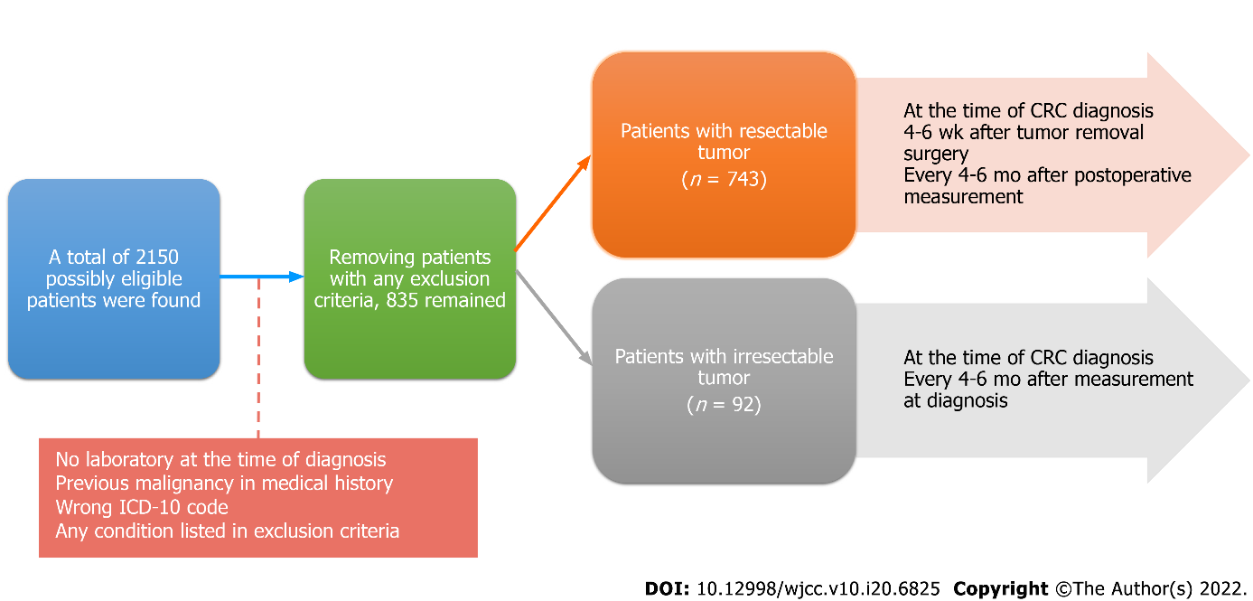
Figure 1 Schematic structure of the study. ICD-10: International Statistical Classification of Diseases and Related Health Problems.
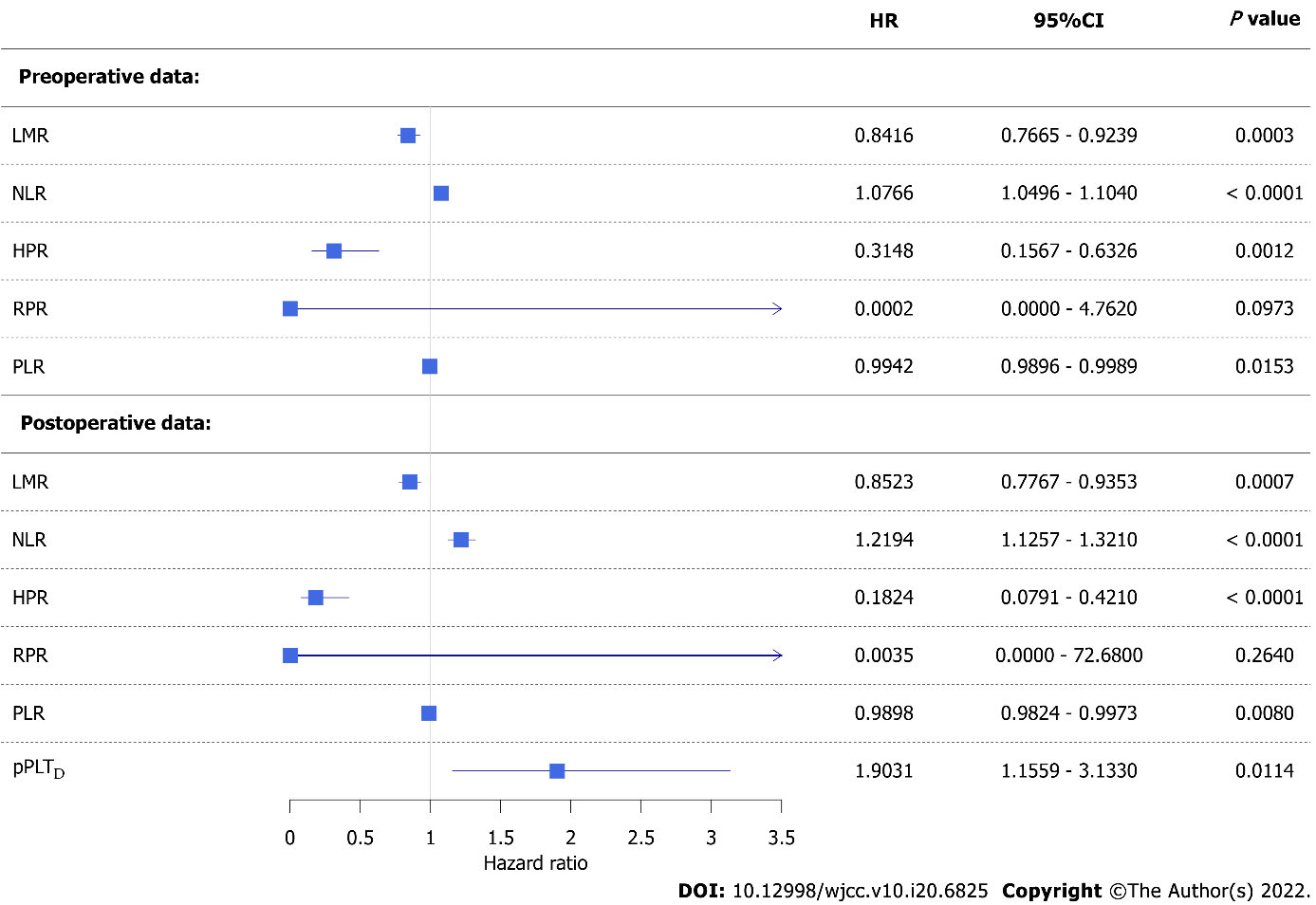
Figure 2 Forest plot of univariate competing risk survival models. Colorectal cancer-specific hazard was higher if a patient had a lower lymphocyte-to-monocyte ratio, hemoglobin-to-platelet ratio, or platelet-to-lymphocyte ratio and higher neutrophil-to-lymphocyte ratio or personalized platelet count relative to “at-diagnosis”. Red blood cell distribution width-to-platelet ratio did not affect neither pre- nor post-operative survival. CI: Confidence interval; HR: Hazard ratio; LMR: Lymphocyte-to-monocyte ratio; PLR: Platelet-to-lymphocyte ratio; NLR: Neutrophil-to-lymphocyte ratio; HPR: hemoglobin-to-platelet ratio; RPR: red blood cell distribution width-to-platelet ratio; pPLT_{D}: Personalized platelet count relative to “at-diagnosis”.
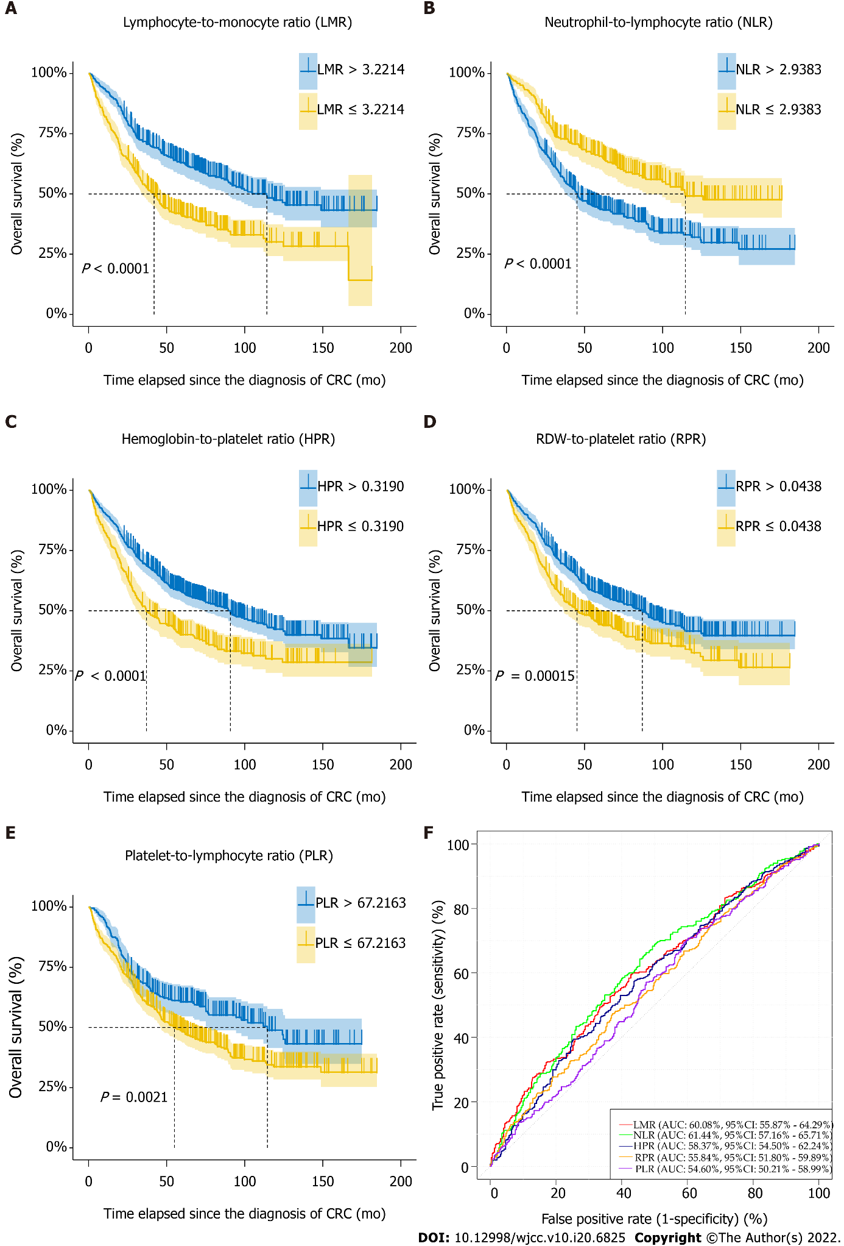
Figure 3 Naïve Kaplan-Meier survival curves of preoperative complete blood count ratios of colorectal cancer patients, which were dichotomized based on optimal thresholds available from receiver operating characteristic models. AUC: Area under curve; CI: Confidence interval; RDW: Red blood cell distribution width.
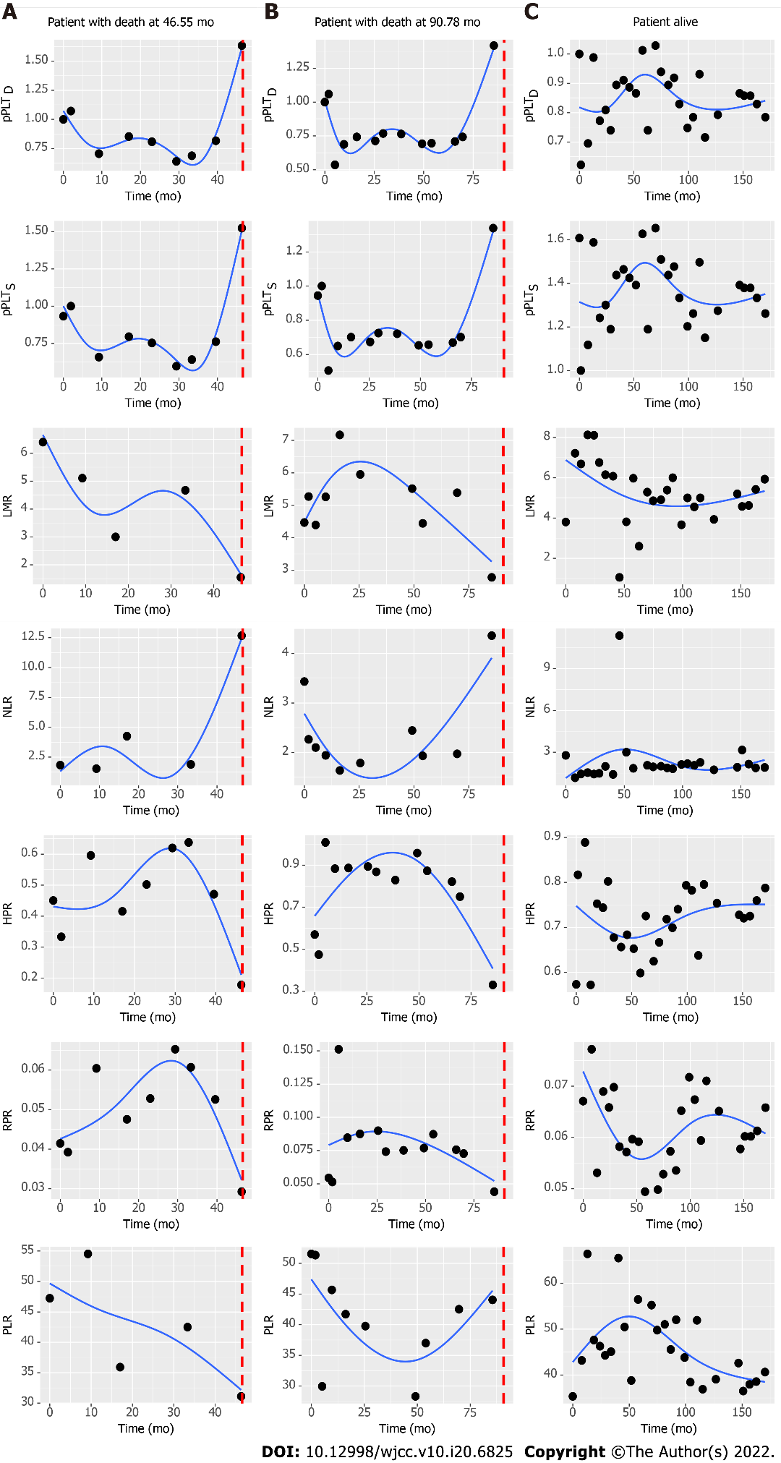
Figure 4 Characteristic changes of complete blood count ratios in patients who died or were alive at the end of our observation. Dotted vertical line represents time of death. pPLT_{D}: Personalized platelet count relative to “at-diagnosis”; pPLT_{S}: Personalized platelet count relative to “after-surgery”; LMR: Lymphocyte-to-monocyte ratio; NLR: Neutrophil-to-lymphocyte ratio; HPR: Hemoglobin-to-platelet ratio; RPR: Red blood cell distribution width-to-platelet ratio; PLR: Platelet-to-lymphocyte ratio.
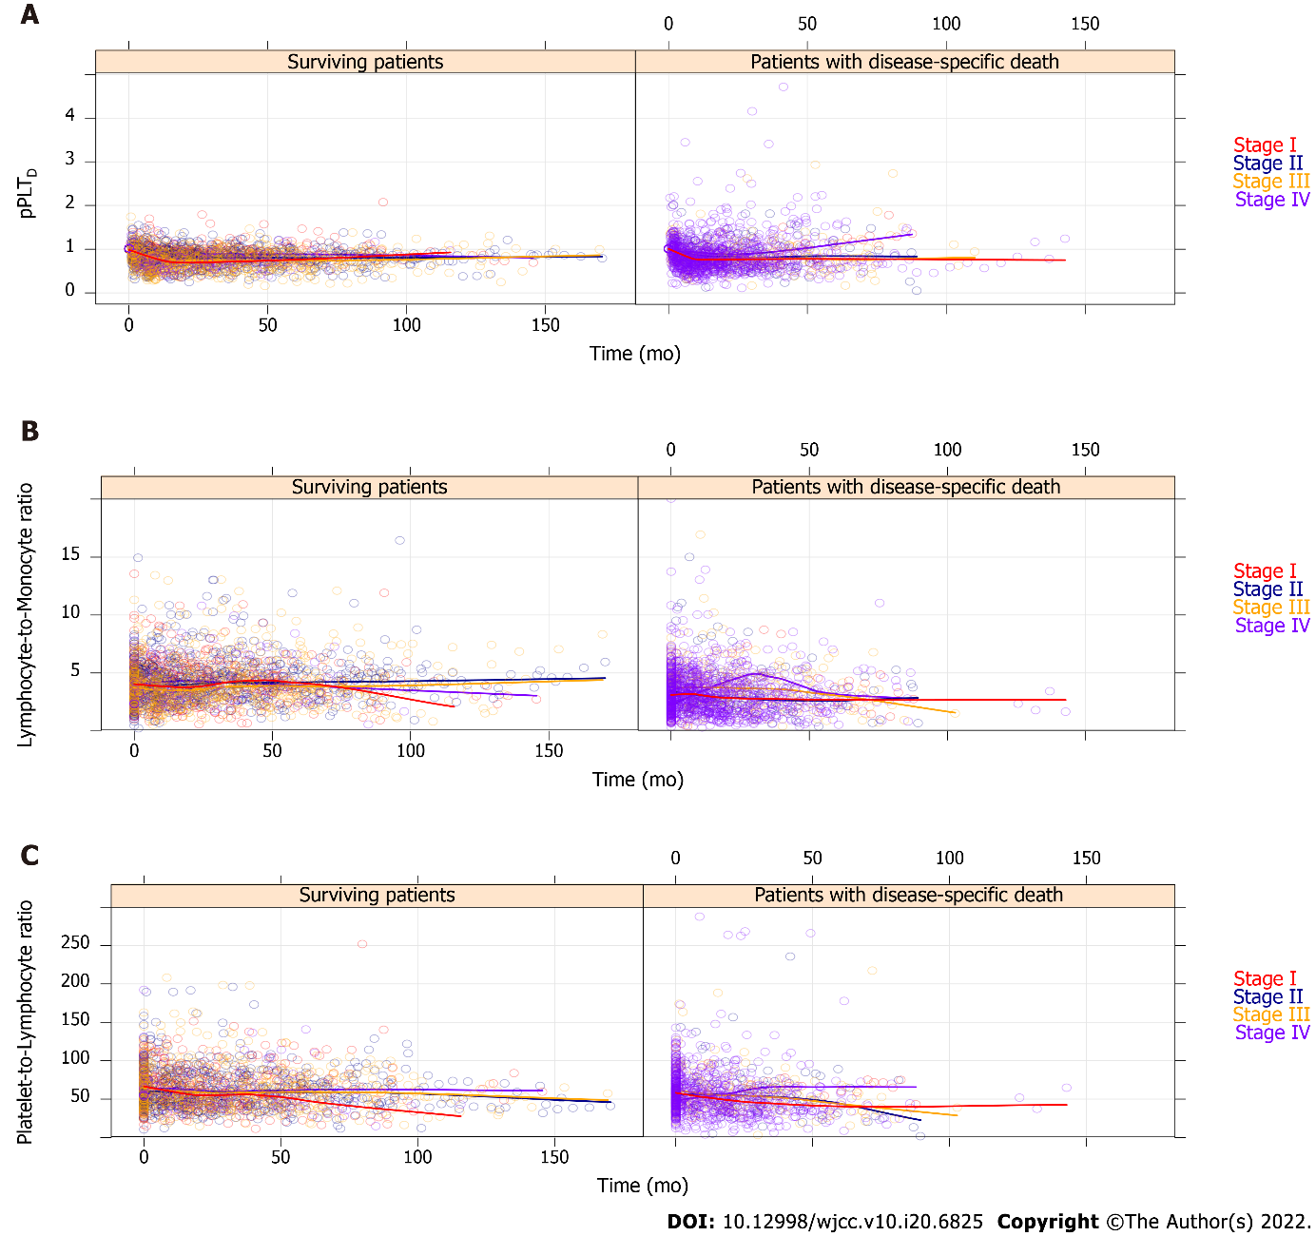
Figure 5 All recorded personalized platelet count relative to “at-diagnosis” (pPLT_{D}), lymphocyte-to-monocyte ratio, and platelet-to-lymphocyte ratio values of the 835 study participants, which have been stratified by American Joint Committee on Cancer staging^{[21]}. For better view, the remaining complete blood count ratios are drawn on Supplementary Figure 1. Regression curves are not drawn from the actual spline adjusted mixed effect model, but the automatic smoothing curve of the plotting process.
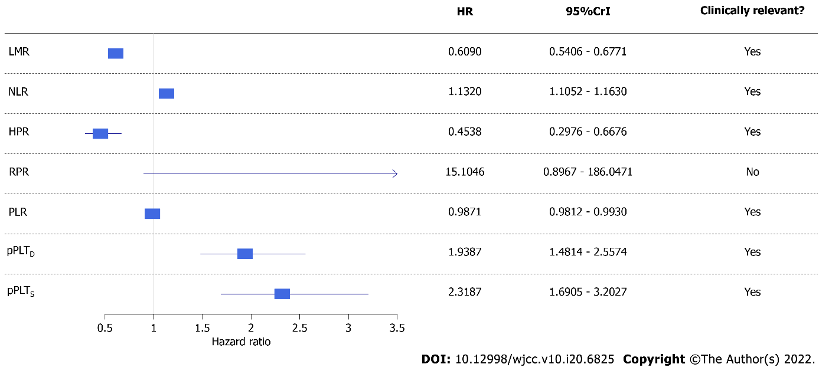
Figure 6 Forest plot of univariate Bayesian joint-models. Higher risk of all-cause mortality was associated with a lower lymphocyte-to-monocyte ratio, hemoglobin-to-platelet ratio, and platelet-to-lymphocyte ratio and higher neutrophil-to-lymphocyte ratio, personalized platelet count relative to “at-diagnosis”, and personalized platelet count relative to “after-surgery”. Red blood cell distribution width-to-platelet ratio did not affect all-cause mortality of study participants. CrI: Credible interval; HR: Hazard ratio; LMR: Lymphocyte-to-monocyte ratio; PLR: Platelet-to-lymphocyte ratio; NLR: Neutrophil-to-lymphocyte ratio; HPR: hemoglobin-to-platelet ratio; RPR: red blood cell distribution width-to-platelet ratio; pPLT_{D}: Personalized platelet count relative to “at-diagnosis”; pPLT_{S}: Personalized platelet count relative to “after-surgery”. Bayesian statistical methods do not give P values, and evaluation of results was detailed in methods.
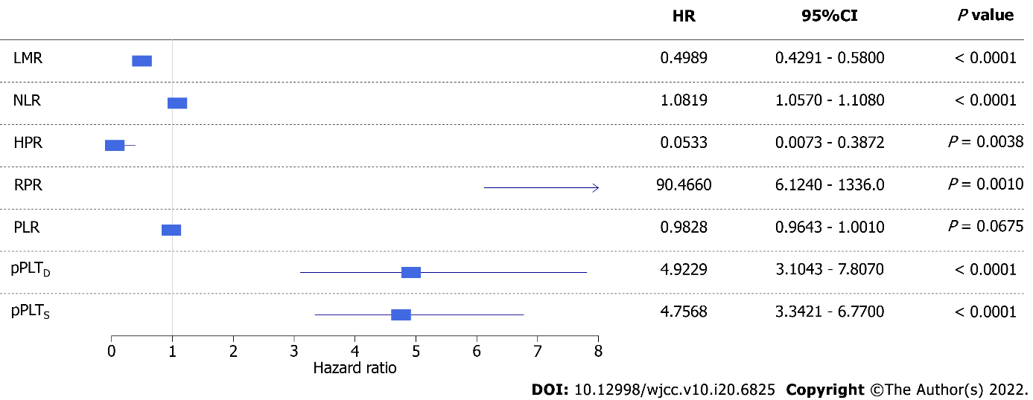
Figure 7 Forest plot of univariate competing risk models with time-dependent covariate. Higher risk of disease-specific mortality was associated with a lower lymphocyte-to-monocyte ratio, hemoglobin-to-platelet ratio, and platelet-to-lymphocyte ratio, and higher red blood cell distribution width-to-platelet ratio, personalized platelet count relative to “at-diagnosis”, and personalized platelet count relative to “after-surgery”. Neutrophil-to-lymphocyte ratio did not affect disease-specific mortality of study participants. CI: Confidence interval; HR: Hazard ratio. LMR: Lymphocyte-to-monocyte ratio; PLR: Platelet-to-lymphocyte ratio; NLR: Neutrophil-to-lymphocyte ratio; HPR: hemoglobin-to-platelet ratio; RPR: red blood cell distribution width-to-platelet ratio; pPLT_{D}: Personalized platelet count relative to “at-diagnosis”; pPLT_{S}: Personalized platelet count relative to “after-surgery”.
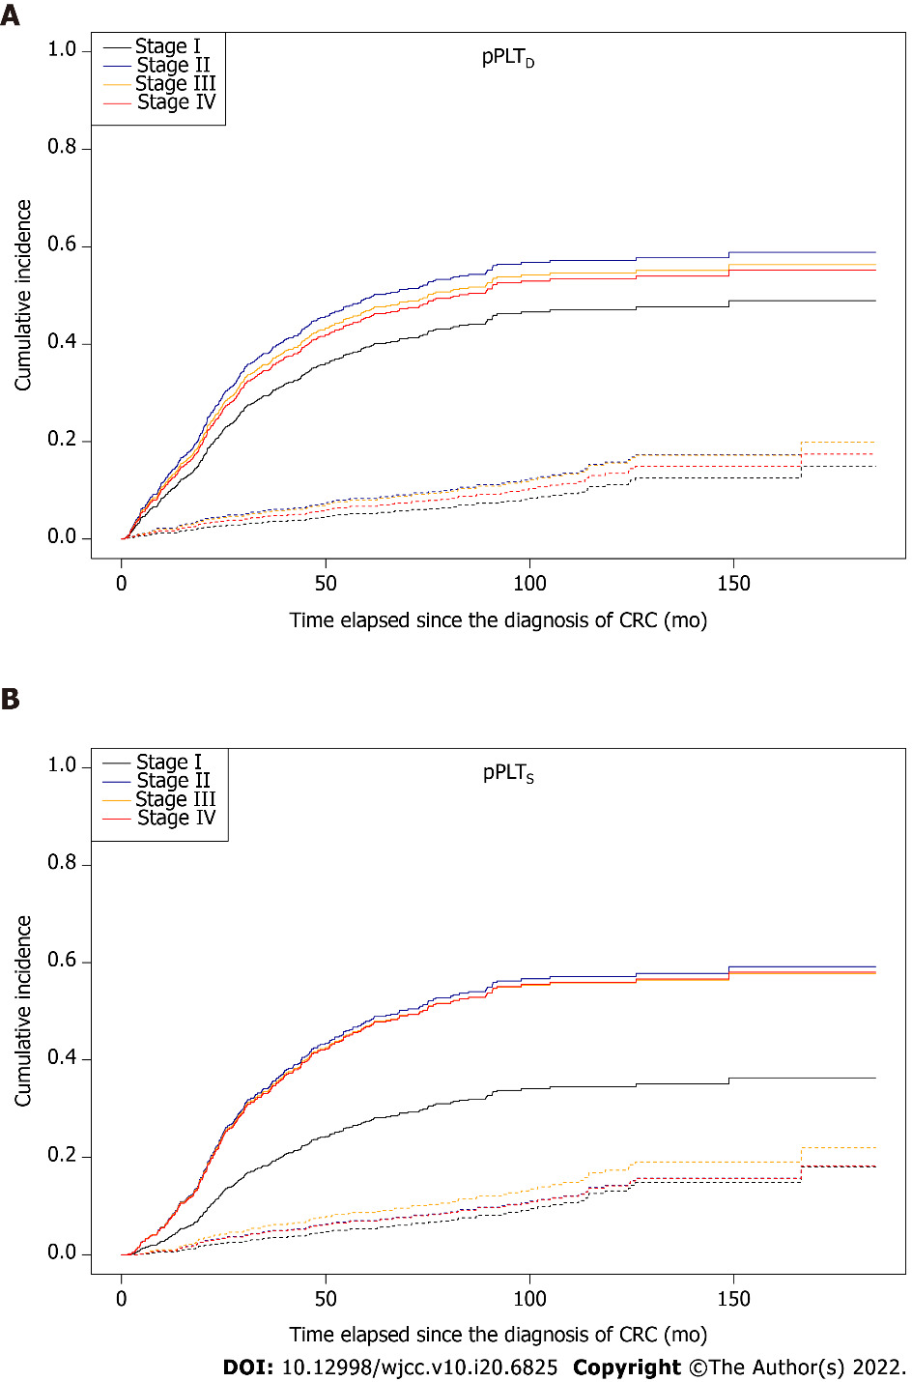
Figure 8 Survival curves for two competing events, stratified by American Joint Committee on Cancer staging^{[21]}, in colorectal cancer patients. Solid and dashed lines represent disease-specific death and non-cancer related death, respectively. A: The effect of the stage on patient survival was marginal in the case of personalized platelet count relative to “at-diagnosis” (pPLT_{D}, Stage I vs Stage II: P = 0.0847); B: A significant difference was found in personalized platelet count relative to “after-surgery” (pPLT_{S}, Stage I vs Stage II: P = 0.0314; Stage I vs Stage III: P = 0.0594; Stage I vs Stage IV: P = 0.0335). pPLT_{D}: Personalized platelet count relative to “at-diagnosis”; pPLT_{S}: Personalized platelet count relative to “after-surgery”.
Table 1 Baseline complete blood count measurements and anamnestic data of the 835 colorectal cancer patients
Parameter | mean ± SD  or number of observations | Number of missing | Available
Age (yr) | 65.31 ± 11.00 | 0 | 100%
Male: Female | 468: 367  (56.05%: 43.95%) | 0 | 100%
White blood cell count (10⁹/L) | 8.74 ± 3.55 | 0 | 100%
Neutrophil count (10⁹/L) | 6.25 ± 3.37 | 169 | 79.76%
Eosinophil count (10⁹/L) | 0.18 ± 0.37 | 173 | 79.28%
Basophil count (10⁹/L) | 0.04 ± 0.03 | 173 | 79.28%
Monocyte count (10⁹/L) | 0.56 ± 0.29 | 147 | 82.40%
Lymphocyte count (10⁹/L) | 1.69 ± 0.78 | 147 | 82.40%
Red blood cell count (10¹²/L) | 4.50 ± 0.58 | 0 | 100%
Hemoglobin (g/L) | 122.34 ± 23.97 | 0 | 100%
Hematocrit (L/L) | 0.38 ± 0.06 | 0 | 100%
Mean corpuscular volume (fL) | 83.45 ± 9.71 | 0 | 100%
Mean corpuscular hemoglobin (pg) | 27.15 ± 4.12 | 0 | 100%
Mean corpuscular hemoglobin concentration (g/L) | 324.25 ± 24.05 | 0 | 100%
Red blood cell distribution width (%) | 14.95 ± 2.86 | 62 | 92.57%
Platelet count (10⁹/L) | 341.19 ± 131.66 | 0 | 100%
AJCC stage^{[21]} |  | 0 | 100%
I | 107 (12.81%)
II | 214 (25.63%)
III | 187 (22.40%)
IV | 327 (39.16%)
Regional lymph node metastasis | 445 (%) | 0 | 100%
Distant metastasis |  | 0 | 100%
At the time of diagnosis | 326 (39.04%)
Later with the course of the disease | 102 (12.22%)
Location of the tumor^{[22]} |  | 0 | 100%
Left-sided | 273 (32.69%)
Right-sided | 246 (29.46%)
Rectum | 297 (35.57%)
Multiplex | 19 (2.28%)
Chemotherapy |  | 0 | 100%
Adjuvant | 248 (29.70%)
Metastatic | 331 (39.64%)
First line | 126 (15.09%)
Second line | 98 (11.74%)
Third line or above | 104 (12.46%)
Radiotherapy |  | 0 | 100%
Preoperative | 63 (7.54%)
Postoperative | 64 (7.66%)
Both | 5 (0.60%)
Usage of |  | 0 | 100%
Biological agents | 229 (27.43%)
Regorafenib/trifluridine-tipiracil | 55 (6.59%)
Medical history |  | 0 | 100%
Diabetes mellitus | 210 (25.15%)
Hypertension | 568 (68.02%)
Major cardiovascular event(s) prior to CRC | 156 (18.68%)
Thyroid disease (in euthyroid state) | 84 (10.06%)
Appendicitis/appendectomy | 145 (17.36%)
Cholelithiasis/cholecystectomy | 194/123 (23.23%)/(14.73%)
Concomitant therapy |  | 0 | 100%
Platelet aggregation inhibition | 158 (18.92%)
Statin | 155 (18.56%)
Antihypertensive agents | 530 (63.47%)

Table 2 Comparison of the different baseline complete blood count ratios by anamnestic and clinicopathological data
Grouping factor | LMR | NLR | HPR | RPR | PLR
Sex
Male | 3.30 ± 2.22^{c} | 4.69 ± 3.94ª | 0.45 ± 0.21^{d} | 0.051 ± 0.020ª | 58.96 ± 30.01^{c}
Female | 3.90 ± 1.88 | 4.05 ± 3.14 | 0.38 ± 0.18 | 0.047 ± 0.025 | 66.87 ± 25.68
Location of the tumor^{[22]}
Left-sided | 3.64 ± 2.50 | 4.55 ± 3.48 | 0.43 ± 0.21^{d,1} | 0.049 ± 0.027 | 61.06 ± 32.31
Right-sided | 3.34 ± 1.96 | 4.54 ± 3.09 | 0.35 ± 0.19 | 0.048 ± 0.020 | 67.49 ± 28.98
Rectum | 3.64 ± 1.81 | 4.24 ± 4.21 | 0.47 ± 0.19^{d,2} | 0.050 ± 0.019 | 59.19 ± 22.49^{a,2}
Multiplex | 4.03 ± 1.42 | 2.69 ± 1.05 | 0.45 ± 0.17 | 0.056 ± 0.014 | 68.17 ± 32.28
AJCC stage^{[21]}
I | 4.12 ± 2.10^{b,3} | 3.42 ± 2.99 | 0.49 ± 0.22^{a,4} | 0.054 ± 0.026^{a,3} | 63.22 ± 26.54
II | 3.47 ± 1.55 | 4.23 ± 3.13 | 0.43 ± 0.17 | 0.051 ± 0.018 | 61.18 ± 23.52
III | 3.82 ± 2.53 | 3.82 ± 2.29 | 0.42 ± 0.18 | 0.049 ± 0.015 | 63.47 ± 25.45
IV | 3.29 ± 2.11 | 5.21 ± 4.50 | 0.39 ± 0.22^{d,3} | 0.047 ± 0.027 | 62.60 ± 33.47
Regional lymph node metastasis
No | 3.59 ± 1.78 | 4.17 ± 3.64 | 0.44 ± 0.20^{b} | 0.051 ± 0.021ª | 62.58 ± 25.96
Yes | 3.52 ± 2.35 | 4.59 ± 3.57 | 0.40 ± 0.20 | 0.048 ± 0.023 | 62.38 ± 30.47
Distant metastasis
None | 3.76 ± 2.14^{a,5} | 3.83 ± 2.71^{d,5} | 0.45 ± 0.19^{c,5} | 0.051 ± 0.020^{a,5} | 62.38 ± 24.59
At the time of diagnosis | 3.29 ± 2.11 | 5.21 ± 4.51 | 0.39 ± 0.22 | 0.047 ± 0.027 | 62.69 ± 33.51
Later with the course of the disease | 3.62 ± 1.80 | 4.23 ± 3.27 | 0.42 ± 0.17 | 0.049 ± 0.016 | 62.51 ± 26.06
Radiotherapy
None | 3.48 ± 2.15^{a,6} | 4.55 ± 3.72^{a,6} | 0.40 ± 0.20^{a,6} | 0.048 ± 0.022 | 62.94 ± 29.18
Preoperative | 3.73 ± 2.06 | 4.11 ± 3.67 | 0.53 ± 0.24^{d,7} | 0.055 ± 0.033 | 56.41 ± 23.60
Postoperative | 4.29 ± 1.38 | 3.00 ± 1.43 | 0.48 ± 0.16 | 0.051 ± 0.015 | 61.32 ± 22.12
Both | 4.17 ± 1.55 | 2.53 ± 0.94 | 0.52 ± 0.10 | 0.049 ± 0.010 | 87.02 ± 18.13
Chemotherapy
None | 3.29 ± 1.89^{a,8} | 5.06 ± 5.01^{b,8} | 0.42 ± 0.23 | 0.050 ± 0.023 | 60.61 ± 33.77
Adjuvant | 3.82 ± 2.30 | 3.86 ± 2.57 | 0.44 ± 0.18 | 0.050 ± 0.017 | 63.73 ± 24.96
Metastatic | 3.57 ± 1.89 | 4.29 ± 2.77 | 0.40 ± 0.20 | 0.047 ± 0.026 | 63.14 ± 25.95
Usage of biological agents
No | 3.52 ± 2.16 | 4.53 ± 3.87 | 0.42 ± 0.21 | 0.050 ± 0.025ª | 61.96 ± 28.46
Yes | 3.67 ± 1.93 | 4.03 ± 2.66 | 0.41 ± 0.17 | 0.046 ± 0.014 | 64.16 ± 28.26
Usage of regorafenib/trifluridine-tipiracil
No | 3.58 ± 2.12 | 4.38 ± 3.66 | 0.42 ± 0.21 | 0.049 ± 0.023ª | 62.96 ± 28.66
Yes | 3.21 ± 1.66 | 4.67 ± 2.85 | 0.41 ± 0.17 | 0.045 ± 0.012 | 55.65 ± 23.33
Type 2 diabetes mellitus
No | 3.58 ± 2.09 | 4.41 ± 3.70 | 0.42 ± 0.20 | 0.048 ± 0.019 | 63.62 ± 29.85
Yes | 3.47 ± 2.13 | 4.41 ± 3.38 | 0.43 ± 0.21 | 0.052 ± 0.031 | 58.87 ± 23.31
History of major CV event
No | 3.60 ± 2.19 | 4.44 ± 3.78 | 0.42 ± 0.20 | 0.048 ± 0.023ª | 62.68 ± 29.21
Yes | 3.38 ± 1.67 | 4.24 ± 2.82 | 0.43 ± 0.23 | 0.053 ± 0.022 | 61.80 ± 24.86
History of cholecystectomy
No | 3.49 ± 2.03ª | 4.50 ± 3.75ª | 0.42 ± 0.20 | 0.049 ± 0.020 | 61.81 ± 29.09
Yes | 4.02 ± 2.47 | 3.78 ± 2.55 | 0.42 ± 0.21 | 0.052 ± 0.035 | 66.61 ± 23.76
ªP < 0.05.
^{b}P < 0.01.
^{c}P < 0.001.
^{d}P < 0.0001.
¹Right-sided vs left-sided tumors.
²Right-sided tumors vs rectal cancer.
³Stage I vs Stage IV.
⁴Stage I vs Stage III.
⁵None vs at the time of diagnosis.
⁶None vs postoperative radiotherapy.
⁷None vs preoperative radiotherapy.
⁸None vs adjuvant chemotherapy.
LMR: Lymphocyte-to-monocyte ratio; NLR: neutrophil-to-lymphocyte ratio; HPR: Hemoglobin-to-platelet ratio; RPR: Red blood cell distribution width (RDW)-to-platelet ratio; PLR: Platelet-to-lymphocyte ratio; AJCC: American Joint Committee on Cancer; CV: Cardiovascular. Of the total 835 study subjects, 82.40%, 79.04%, 92.57%, and 79.76% of LMR, NLR, RPR, and PLR were only available for statistical analysis, respectively.

Table 3 Complete blood count ratios at least 4-6 weeks after primary tumor removal surgery (n = 644)
Parameter | mean ± SD | Number of missing | Available %
Time since tumor removal surgery (mo) | 2.21 ± 1.88 | – | –
Lymphocyte-to-monocyte ratio | 4.01 ± 1.95 | 107 | 82.49%
Neutrophil-to-lymphocyte ratio | 3.59 ± 2.82 | 273 | 55.32%
Hemoglobin-to-platelet ratio | 0.48 ± 0.19 | 0 | 100%
Red blood cell distribution width-to-platelet ratio | 0.058 ± 0.023 | 212 | 65.30%
Platelet-to-lymphocyte ratio | 67.60 ± 28.82 | 266 | 56.46%
Personalized platelet count, relative to “at-diagnosis” | 0.91 ± 0.27 | 0 | 100%

Published by Baishideng Publishing Group Inc
7041 Koll Center Parkway, Suite 160, Pleasanton, CA 94566, USA
Telephone: +1-925-3991568
E-mail: bpgoffice@wjgnet.com
Help Desk: https://www.f6publishing.com/helpdesk
https://www.wjgnet.com

© 2022 Baishideng Publishing Group Inc. All rights reserved.

