Name of Journal: World Journal of Gastroenterology
Manuscript NO: 45590
Manuscript Type: ORIGINAL ARTICLE

Basic Study
Seven-senescence-associated gene signature predicts overall survival for Asian patients with hepatocellular carcinoma

Xiang XH et al. Seven-gene signature predicts HCC patients’ OS

Xiao-Hong Xiang, Li Yang, Xing Zhang, Xiao-Hua Ma, Run-Chen Miao, Jing-Xian Gu, Yu-Nong Fu, Qing Yao, Jing-Yao Zhang, Chang Liu, Ting Lin, Kai Qu

Xiao-Hong Xiang, Xing Zhang, Xiao-Hua Ma, Run-Chen Miao, Jing-Xian Gu, Yu-Nong Fu, Qing Yao, Jing-Yao Zhang, Chang Liu, Ting Lin, Kai Qu, Department of Hepatobiliary Surgery, the First Affiliated Hospital of Xi’an Jiaotong University, Xi’an 710061, Shaanxi Province, China

Li Yang, Department of Clinical Laboratory, Liaocheng People’s Hospital, Taishan Medical College, Liaocheng 252000, Shandong Province, China

ORCID number: Xiao-Hong Xiang (0000-0002-9020-9187); Li Yang (0000-0002-8325-8335); Xing Zhang (0000-0001-9568-8124); Xiao-Hua Ma (0000-0002-5546-8458); Run-Chen Miao (0000-0003-1651-3970); Jing-Xian Gu (0000-0002-6183-4004); Yu-Nong Fu (0000-0001-8324-0613); Qing Yao (0000-0002-4904-9214); Jing-Yao Zhang (0000-0002-1177-0401); Chang Liu (0000-0001-7916-4670); Ting Lin (0000-0003-3825-6178); Kai Qu (0000-0002-1138-3727).

Author contributions: Qu K, Lin T, Liu C, and Xiang XH designed the research; Yang L, Zhang X, Ma XH, Miao RC, and Gu JX collected and analyzed the data; Qu K, Xiang XH, Fu YN, and Yao Q prepared the figures; Zhang JY, Lin T, Qu K, and Liu C drafted and revised the manuscript.

Supported by the National Natural Science Foundation of China, No. 81773128 and No. 81871998; the Natural Science Basic Research Plan in Shaanxi Province of China, No. 2018JM7013 and No. 2017JM8039; the Research Fund for Young Star of Science and Technology in Shaanxi Province, No. 2018KJXX-022; and China Postdoctoral Science Foundation, No. 2018M641000.

Institutional review board statement: The study was reviewed and approved by the First Affiliated Hospital of Xi’an Jiaotong University Institutional Review Board.

Conflict-of-interest statement: None.

Open-Access: This article is an open-access article which was selected by an in-house editor and fully peer-reviewed by external reviewers. It is distributed in accordance with the Creative Commons Attribution Non Commercial (CC BY-NC 4.0) license, which permits others to distribute, remix, adapt, build upon this work non-commercially, and license their derivative works on different terms, provided the original work is properly cited and the use is non-commercial. See: http://creativecommons.org/licenses/by-nc/4.0/

Manuscript source: Unsolicited manuscript

Corresponding author: Kai Qu, MD, PhD, Professor, Research Assistant Professor, Department of Hepatobiliary Surgery, the First Affiliated Hospital of Xi’an Jiaotong University, 277 West Yanta Road, Xi’an 710061, Shaanxi Province, China. qukai@xjtu.edu.cn
Telephone: +86-29-85323900
Fax: +86-29-85324695

Received: January 6, 2019
Peer-review started: January 7, 2019
First decision: February 13, 2019
Revised: March 6, 2019
Accepted: March 15, 2019
Article in press: March 16, 2019
Published online: April 14, 2019

Abstract
BACKGROUND
Cellular senescence is a recognized barrier for progression of chronic liver diseases to hepatocellular carcinoma (HCC). The expression of a cluster of genes is altered in response to environmental factors during senescence. However, it is questionable whether these genes could serve as biomarkers for HCC patients.

AIM
To develop a signature of senescence-associated genes (SAGs) that predicts patients’ overall survival (OS) to improve prognosis prediction of HCC.

METHODS
SAGs were identified using two senescent cell models. Univariate COX regression analysis was performed to screen the candidate genes significantly associated with OS of HCC in a discovery cohort (GSE14520) for the least absolute shrinkage and selection operator modelling. Prognostic value of this seven-gene signature was evaluated using two independent cohorts retrieved from the GEO (GSE14520) and the Cancer Genome Atlas datasets, respectively. Time-dependent receiver operating characteristic (ROC) curve analysis was conducted to compare the predictive accuracy of the seven-SAG signature and serum α-fetoprotein (AFP).

RESULTS
A total of 42 SAGs were screened and seven of them, including KIF18B, CEP55, CIT, MCM7, CDC45, EZH2, and MCM5, were used to construct a prognostic formula. All seven genes were significantly downregulated genes in senescent cells and upregulated in HCC tissues. Survival analysis indicated that our seven-SAG signature was strongly associated with OS, especially in Asian populations, both in discovery and validation cohorts. Moreover, time-dependent ROC curve analysis suggested the seven-gene signature had a better predictive accuracy than serum AFP in predicting HCC patients’ 1-, 3-, and 5-year OS.

CONCLUSION
We developed a seven-SAG signature, which could predict OS of Asian HCC patients. This risk model provides new clinical evidence for the accurate diagnosis and targeted treatment of HCC.

Key words: Senescence-associated genes; Hepatocellular carcinoma; Overall survival; Risk model; Asian patients

© The Author(s) 2019. Published by Baishideng Publishing Group Inc. All rights reserved.

Core tip: In the present study, we identified a total of 42 senescence-associated genes (SAGs) and found seven of them were significantly downregulated genes in senescent cells and upregulated in HCC tissues. By using the least absolute shrinkage and selection operator, we constructed a seven-SAG signature that could predict the overall survival (OS) of hepatocellular carcinoma. This seven-SAG signature was further validated and developed in another independent dataset from The Cancer Genome Atlas project. Moreover, our risk score system showed better utility in predicting the OS than classic serum biomarker α-fetoprotein.

Citation: Xiang XH, Yang L, Zhang X, Ma XH, Miao RC, Gu JX, Fu YN, Yao Q, Zhang JY, Liu C, Lin T, Qu K. Seven-senescence-associated gene signature predicts overall survival for Asian patients with hepatocellular carcinoma. World J Gastroenterol 2019; 25(14): 1715-1728
URL: https://www.wjgnet.com/1007-9327/full/v25/i14/1715.htm
DOI: https://dx.doi.org/10.3748/wjg.v25.i14.1715

INTRODUCTION
Hepatocellular carcinoma (HCC) becomes the third leading cause of cancer deaths worldwide, with approximately 80% of mortalities occurring within 5 years^{[1,2]}. During the past decades, great effects have been made to improve the management of HCC. As more and more HCCs are diagnosed at an early stage, treatment efficacy is greatly improved^{[3]}. Whereas, deaths caused by HCC always occur when patients undergo treatment and the clinical outcome of HCC patients is still poor^{[4]}. Moreover, HCC is an extremely heterogeneous disease, which must be monitored for high-risk patients with poor clinical outcomes and adopt effective treatments to improve patient survival^{[5]}. Traditional serum markers, especially alpha-fetoprotein (AFP), have been the most common prognostic indicators in clinic. However, they significantly depend on tumor burden, which limits their value in diagnosing early stage tumors. Therefore, identifying novel prognostic biomarkers contributes to early diagnosis and reducing HCC mortality.
Cellular senescence is considered to be a response of a proliferating somatic cell to stress and damage derived from both exogenous and endogenous sources, and persistent DNA damage is the most common cause^{[6]}. It is characterized as a permanent cell cycle arrest^{[7]}. Cellular senescence has been deemed as a mechanism of limited cell division due to progressive telomere shortening^{[8]}. In cancer cells, there exists telomere-independent senescence due to their activation of telomerase. For instance, numerous studies found that RAS activation could induce cellular senescence in many cancer cell types. Both telomere-dependent and -independent pathways induced senescence by inducing a DNA damage response. Recently, it has been demonstrated that hepatocytes escaping from senescence played a key role in hepatic carcinogenesis and HCC progression^{[9,10]}. During the senescence process, a large number of genes are expressed differentially. Hence, it is reliable to focus on senescence associated genes (SAGs) as a novel approach in cancer diagnosis and monitor.
Bearing this in mind, we first identified the SAGs by analyzing the genome profiling data derived from two types of senescent cells, replicative senescence (RS) and oncogene-induced senescence (OIS). Next, we investigated the prognostic value of several candidate SAGs in predicting survival of HCC by multistep comparisons. Finally, we validated that the candidate SAGs were superior to classic serum biomarker AFP in predicting the OS in HCC cohort retrieved from the Cancer Genome Atlas (TCGA). As far as we know, the study is the first to investigate the expression patterns of SAGs between senescence and HCC and their association with clinical prognosis of Asian patients with HCC.

MATERIALS AND METHODS
Data sources and processing
Two genomic profiling datasets of RS cells (GSE19018 and GSE36640), three datasets of OIS cells (GSE19864, GSE40349, and GSE60652), and one HCC dataset (GSE14520) were obtained from the Gene Expression Omnibus (GEO) database (http://www.ncbi.nlm.nih.gov/geo/). RMA algorithm was performed to normalize and transform all the selected data from GEO to expression values in the R environment (v3.5.1). Among them, GSE14520 (based on GPL3921 platform) enrolled 209 HCC patients with survival data. An independent HCC cohort derived from TCGA database (TCGA-LIHC) was used as a validation group. The level 3 RNAseqv2 data and clinical data were derived from the TCGA data portal. A total of 370 HCC samples were included.

Diﬀerential gene expression analysis
Diﬀerentially expressed genes (DEGs) were calculated in RS and OIS cell models, respectively. Only fold change (FC) ≥ 1.5 and q-value < 0.05 were considered statistically significant. Then, we picked up the overlapped significantly expressed genes in the two senescent models. Venn diagram was carried out using Venny 2.1.0. Moreover, the expression levels of candidate genes were plotted and analyzed by the t-test in GSE14520 and TCGA-LIHC cohorts.

Prognostic model development
A prognostic model was created by the seven-SAG signature according to least absolute shrinkage and selection operator (LASSO) analysis. LASSO is one of the most popular approaches for sparse linear regression^{[11]}. ‘Almnet’ package was carried out based on a series of λ in the R environment (v3.5.1)^{[12]} and the coefficients of each gene in the risk score system were generated. We got a risk score for every patient based on their own expression levels of the seven genes after the LASSO regression analysis.

Survival analysis
Univariate and multivariate survival analyses were carried out and further multivariate Cox regression analysis only included variables with P < 0.05. All tests were carried out using SPSS (version 22.0; Chicago, United States). Kaplan-Meier curves were generated using GraphPad Prism 7.0. Comparisons between different subgroups were performed by the Log-Rank test. Patients are divided into high- and low- risk groups by the median.

Time-dependent receiver operating characteristic curve (ROC) analysis
ROC curve is extended to evaluate biomarker’s accuracy of discriminating binary outcomes^{[13]}. Individuals with a high risk of developing the disease later may be disease-free in earlier life and their markers’ value may change from baseline during follow-up. Therefore, time-dependent ROC curve analysis is more appropriate and outperforms the conventional method adopted for handling censored biomarker data. In this study, the time-dependent ROC curve analysis was performed with “survival ROC” package (R version 3.5.1). The prognostic performance was evaluated at 1, 3, and 5 years to compare the predictive accuracy and sensitivity of different prognostic models.

Statistical analysis
The chi-square test was carried out to discover the relationship between gene expression and clinical parameters. Unpaired student’s t-test was used to analyze the difference of gene expression in HCC patients of different features. P < 0.05 was considered statistically different. Statistical analyses were performed using IBM SPSS Statistics software program version 24.0 (IBM Corp, NY, United States).

RESULTS
Identification of SAGs using different senescent models
The overall workflow of the data processing is presented in Figure 1A. To identify SAGs, we first integrated five different microarray profiles (GSE19018, GSE36640, GSE19864, GSE40349, and GSE60652). All datasets used in the present study were normalized before analysis. The relative expression of all samples pre- and post-normalization is shown in Figure 1B. Next, we screened the DEGs, which were identified as FC ≥ 1.5 and q-value < 0.05 (senescent vs proliferating cells), in RS and OIS models, respectively. A total of 781 up-regulated and 739 down-regulated genes were selected in the RS model, and 103 up-regulated and 288 down-regulated genes in the OIS model (Figure 2A). By overlapping the two DEG lists, 42 common differentially expressed genes (35 downregulated and only 7 upregulated genes) were selected as SAGs (Figure 2B) and the expression levels of these genes in RS and OIS models are presented as a heat map in Figure 2C.

Construction of a risk score system
To obtain a prognostic SAG signature for HCC survival prediction, we first screened the expression pattern of the above 42 candidate genes in HCC cohorts. Eventually, seven downregulated genes in senescent cells, KIF18B, CEP55, CIT, MCM7, CDC45, EZH2, and MCM5, were significantly upregulated in HCC tissues in both discovery and validation groups, with a P-value < 0.0001 (Figure 3). Next, we performed univariate survival analysis with Cox proportional hazards models to evaluate the prognostic value of each candidate gene. We found that all seven genes (CEP55, MCM7, CDC45, MCM5, KIF18B, CIT, and EZH2) were proved to be risk factors for HCC patients. We then developed a risk score formula based on these seven SAGs using the LASSO method: Risk score = (0.243 × relative expression value of KIF18B) + (0.274 × relative expression value of CEP55) + (0.282 × relative expression value of CIT) + (0.266 × relative expression value of MCM7) + (0.678 × relative expression value of CDC45) + (0.175 × relative expression value of EZH2) + (0.536 × relative expression value of MCM5). In this risk score system, the contribution of every gene to the risk score model was weighted by absolute value of coefficients. Every patient would get a risk score based on the expression of the seven SAGs of themselves.

Validation of the seven-SAG signature for prognosis
To confirm the potentiality of the seven-SAG prognostic model, Kaplan-Meier curve was carried out to evaluate the association between the overall survival (OS) and our gene signature in discovery (GSE14520) and validation (TCGA-LIHC) cohorts. The whole group was divided into the high- and low-risk subgroups according to the median of all patients’ risk scores. In the discovery cohort, with the increase in the risk score, the expression of all the seven genes was increasing, and the death events accumulated (Figure 4A). The patients in the high-risk subgroup had a 1.92-fold higher death risk than the low subgroup [hazard ratio (HR), 95% confidence interval (CI) = 1.92, 1.16-3.19; log-rank P value = 0.011] (Figure 4B). We then tempted to test these findings in the validation cohort (TCGA-LIHC) (Figure 4C). Similar to the findings obtained from the discovery cohort, patients in the high-risk group [median survival time (MST) = 46.6 m] had significantly shorter OS time than patients with a low-risk score (MST = 70.5 m) [HR (95%CI) = 1.80 (1.27-2.54), log-rank P value = 0.001] (Figure 4D). Interestingly, when we analyzed the data in the Asian population, we observed a highly significant association between the seven-SAG signature and OS. The majority of death events occurred in the high-risk group (Figure 4E). Asian HCC patients with a high-risk score were shown to have a > 5-fold increased death risk than low-risk patients [HR (95%CI) = 5.81 (3.20-10.54), log-rank P value < 0.0001]. The MST of the high-risk subgroup was only 60% of that of the low-risk group (MST = 21.6 m vs 91.7 m) (Figure 4F). In order to investigate the prognostic value of the risk score system in different patient groups with different characteristics, we performed univariate/multivariate Cox regression analysis of clinicopathologic factors associated with OS in the discovery and validation cohorts. From the Cox regression results, both the seven-SAG signature and serum AFP level were confirmed to be independent risk factors of OS in the two cohorts (Table 1).

Comparison of the seven-SAG signature and serum AFP in predicting OS
To assess the prognostic accuracy of the seven-SAG signature, we performed time-dependent ROC analysis of 1-, 3-, and 5-year OS of the validation cohort. The area under the curve (AUC) of the seven-SAG signature model indicated an acceptable predictive accuracy, which is superior to AFP, a widely used traditional serum marker, at 1 year (our seven-gene model AUC = 0.708, serum AFP level AUC = 0.606) (Figure 5A), 3 years (our seven-gene model AUC = 0.699, serum AFP level AUC = 0.568) (Figure 5B) as well as 5 years (our seven-gene model AUC = 0.678, serum AFP level AUC = 0.604) (Figure 5C). These results indicated the validation of the prognostic signature.

Stratified analysis of the seven-SAG signature for prognosis prediction
Stratified analyses based on the clinical characteristics were carried out to identify the suitable Asian patient groups for the seven-SAG signature (Table 2). In the elderly population, patients with a high-risk score had a more than 3-fold increased risk of death than the low-risk group (Figure 6A-C). These results suggested that our seven-SAG signature was more applicable to the HCC patients with older age in predicting OS.

DISCUSSION
In this study, we first identified 42 overlapped DEGs using the RS and OIS models. Among them, seven downregulated genes in senescent cells, KIF18B, CEP55, CIT, MCM7, CDC45, EZH2, and MCM5, were shown to be upregulated in HCC tissues and selected to construct a prognostic model. The seven-SAG signature was shown to be associated with OS in both discovery and validation cohorts. Stratified analysis showed that our seven-SAG signature was significantly associated with OS in elderly Asian patients. Moreover, time-dependent ROC analysis showed a favorable prognostic value of our seven-SAG signature when compared with serum AFP.
The cellular senescence is considered an aging hallmark. With the increase in age, the number of senescent cells is increasing. Cellular senescence is widely considered to be an anti-tumor mechanism. Studies have shown that a source of stress that triggers liver senescence is chronic inflammation, which causes damage to liver cell regeneration. Importantly, abrogation of senescence leads to aggressive HCC development^{[14]}. In the present study, we found that the HCC patients carrying high expression of seven SAGs had a shorter OS time. Stratified results further suggested the seven-SAG signature was more applicable to the elderly HCC patients. The potential explanation might be that due to the increasing number of senescent cells, the expression of the seven-SAG signature is decreased, while its high expression indicates a higher proliferation rate and poorer OS.
It has been widely accepted that senescence pathways are collectively at the level of activation of CDKIs, which play pivotal roles in regulating the expression of cell cycle progression. Of the seven genes, KIF18B, a member of the kinesin-8 subfamily, is involved in a cell cycle process^{[15]} and acts as an oncogene in cervical cancer^{[16]}. CEP55, also known as c10orf3 and FLJ10540, promotes tumorigenesis and regulates stemness in various cancers, such as lung adenocarcinoma^{[17-19]}. CIT (Serine/threonine kinase 21) encoding a serine/threonine protein kinase, is a downstream effector of Rho family GTPases and participates in cell cycle regulation. Liu et al^{[20]} and Xu et al^{[21]} have demonstrated that CIT is up-regulated in HCC and regulates the G2/M transition in rat hepatocytes. EZH2 is a subunit of polycomb repressive complex 2 (PRC2), a protein complex that induces epigenetically silencing genes^{[22]}. And it has been reported that several lncRNAs are able to regulate gene transcription by binding to PRC2^{[23,24]}.
In most eukaryotes, the MCM complex consists of six highly conserved MCM proteins, namely MCM2–7, which functions as a replicative DNA helicase to unwind the DNA duplex template during DNA replication^{[25]}. Recent evidence has demonstrated that several MCM proteins are tightly associated with tumorigenesis^{[26-28]}. The MCM2-7 hexamer complexes with CDC45 and the hetero-tetrameric GINS complex, the Cdc45-Mcm2-7-GINS (CMG) complex, function as a potential target for cancer treatment and CDC45 interacts with MCM2^{[29]}. Furthermore, our previous study showed that MCM7 promotes cancer progression through cyclin D1-dependent signaling in HCC^{[30]}. Three members of CMG complex, MCM5, MCM7, and CDC45, were selected to construct the risk formula. This evidence indicated that more attention should be focused on the pro-oncogenic mechanisms of senescence escape of HCC cells.
Our study showed that AFP was an independent risk factor for HCC patients. AFP is often expressed at high levels in most HCC patients and is considered a reliable clinical tumor biomarker. As a classic serum biomarker, AFP was found to be associated with prognosis in HCC patients^{[31,32]}. Park et al^{[33]} reported that AFP combined with PIVKA-II were useful in predicting survival in the radiological treatment of locally advanced HCC. Jiang et al^{[34]} also found that preoperative AFP and fibrinogen showed a predictive power for recurrence of HCC after liver transplantation. Here, our study demonstrated that the seven-SAG signature model was superior to serum AFP level and more applicable in predicting OS of HCC patients with older age. The above findings suggested a potential clinical application of the seven-SAG signature in HCC patients.
However, there are some limitations in our study. First, the samples for screening SAG were small, which might cause false positive results. Second, we constructed the risk score system merely based on the gene expression levels, rather than the other genetic events that probably have an effect on the initiation and progression of cancer. Third, patients in the discovery cohort were from Asia, thus, the risk score system was established based on an Asian background. And further stratified analysis in the validation cohort also showed that this model was more suitable for Asian patients. Hence, our HCC prognostic signature still needs to be validated in a larger group of patients from various populations.
In conclusion, we constructed and confirmed a prognostic risk score system comprised of seven SAGs. The seven-SAG signature could be a potential predictor for OS, particularly in elderly Asian HCC patients. Our data provide new promising evidence on prediction biomarkers and targeted therapy for HCC.

ARTICLE HIGHLIGHTS
Research background
Hepatocellular carcinoma (HCC) is a common malignancy that remains a serious cause of death worldwide. Recently, molecular markers and prognostic models have been used to improve the diagnosis and treatment of HCC, but few can be applied clinically. Currently, bioinformatics technology has been used for data mining in large public databases. The abundant sample size in the public database can make up for the shortcomings of small samples in real hospitals and help to seek for a more accurate and applicable prognostic model for HCC.

Research motivation
Researchers have been making efforts to find molecular markers or prognostic models that can effectively predict the prognosis of HCC. Senescence is a cell cycle arrest caused by stress in cells, but the cells are still alive. Studies have shown that the proportion of senescent cells in tissues of patients with cirrhosis increases, but a considerable number of patients with cirrhosis can develop liver cancer, and its specific molecular mechanism has rarely been reported.

Research objectives
By analyzing the database of two cellular senescence models from Gene Expression Omnibus, we screened for senescence-associated genes and validated these genes in the liver cancer databases (GSE14520 and TCGA-LIHC). Then, we constructed an HCC prognostic model and evaluate its prognostic accuracy.

Research methods
Senescence-associated genes (SAGs) were identified using R package ’limma’. The latest statistical algorithm-the least absolute shrinkage and selection operator (LASSO) was applied to create our prognostic model. Time-dependent receiver operating characteristic (ROC) curves were used to compare the prognostic accuracy between the seven-SAG signature and serum α-fetoprotein.

Research results
The prognostic model for predicting the overall survival (OS) of HCC was constructed by LASSO, consisting of the seven senescence-associated genes (SAGs) (KIF18B, CEP55, CIT, MCM7, CDC45, EZH2, and MCM5). All seven SAGs were highly expressed in HCC and proliferating cells, while lowly expressed in normal tissues and senescent cells. Survival analysis showed that our seven-SAG characteristics are closely related to OS, especially in Asian populations, both in the discovery and validation cohorts. In addition, the time-dependent ROC curve analysis indicated that the seven-gene marker is better than serum alpha-fetoprotein in predicting 1-, 3-, and 5-year OS of HCC patients.

Research conclusions
The seven-SAG signature was more applicable to evaluate OS of Asian HCC patients, which may provide new clinical evidence for the diagnosis and treatment of HCC transformed from cirrhosis.

Research perspectives
The current study provides clues that the expression changes of senescence-associated gene are the molecular basis for the progression of cirrhosis to liver cancer. Finding effective senescence-associated molecular biomarkers and predictive features of HCC prognosis is necessary.
REFERENCES
1 Chen W, Zheng R, Baade PD, Zhang S, Zeng H, Bray F, Jemal A, Yu XQ, He J. Cancer statistics in China, 2015. CA Cancer J Clin 2016; 66: 115-132 [PMID: 26808342 DOI: 10.3322/caac.21338]
2 Reddy SK, Steel JL, Chen HW, DeMateo DJ, Cardinal J, Behari J, Humar A, Marsh JW, Geller DA, Tsung A. Outcomes of curative treatment for hepatocellular cancer in nonalcoholic steatohepatitis versus hepatitis C and alcoholic liver disease. Hepatology 2012; 55: 1809-1819 [PMID: 22183968 DOI: 10.1002/hep.25536]
3 Bruix J, Gores GJ, Mazzaferro V. Hepatocellular carcinoma: Clinical frontiers and perspectives. Gut 2014; 63: 844-855 [PMID: 24531850 DOI: 10.1136/gutjnl-2013-306627]
4 Dutkowski P, Linecker M, DeOliveira ML, Müllhaupt B, Clavien PA. Challenges to liver transplantation and strategies to improve outcomes. Gastroenterology 2015; 148: 307-323 [PMID: 25224524 DOI: 10.1053/j.gastro.2014.08.045]
5 Llovet JM, Villanueva A, Lachenmayer A, Finn RS. Advances in targeted therapies for hepatocellular carcinoma in the genomic era. Nat Rev Clin Oncol 2015; 12: 408-424 [PMID: 26054909 DOI: 10.1038/nrclinonc.2015.103]
6 Kuilman T, Michaloglou C, Mooi WJ, Peeper DS. The essence of senescence. Genes Dev 2010; 24: 2463-2479 [PMID: 21078816 DOI: 10.1101/gad.1971610]
7 Demidenko ZN, Korotchkina LG, Gudkov AV, Blagosklonny MV. Paradoxical suppression of cellular senescence by p53. Proc Natl Acad Sci U S A 2010; 107: 9660-9664 [PMID: 20457898 DOI: 10.1073/pnas.1002298107]
8 Wiemann SU, Satyanarayana A, Tsahuridu M, Tillmann HL, Zender L, Klempnauer J, Flemming P, Franco S, Blasco MA, Manns MP, Rudolph KL. Hepatocyte telomere shortening and senescence are general markers of human liver cirrhosis. FASEB J 2002; 16: 935-942 [PMID: 12087054 DOI: 10.1096/fj.01-0977com]
9 Wei W, Ji S. Cellular senescence: Molecular mechanisms and pathogenicity. J Cell Physiol 2018; 233: 9121-9135 [PMID: 30078211 DOI: 10.1002/jcp.26956]
10 Guo M. Cellular senescence and liver disease: Mechanisms and therapeutic strategies. Biomed Pharmacother 2017; 96: 1527-1537 [PMID: 29174037 DOI: 10.1016/j.biopha.2017.11.075]
11 Arbet J, McGue M, Chatterjee S, Basu S. Resampling-based tests for Lasso in genome-wide association studies. BMC Genet 2017; 18: 70 [PMID: 28738830 DOI: 10.1186/s12863-017-0533-3]
12 Friedman J, Hastie T, Tibshirani R. Regularization Paths for Generalized Linear Models via Coordinate Descent. J Stat Softw 2010; 33: 1-22 [PMID: 20808728 DOI: 10.1163/ej.9789004178922.i-328.7]
13 Kim Y, Kong L. Time-dependent ROC analysis for censored biomarker data due to limit of detection. J Biopharm Stat 2018; 28: 612-621 [PMID: 28862526 DOI: 10.1080/10543406.2017.1372768]
14 Zeng S, Shen WH, Liu L. Senescence and Cancer. Cancer Transl Med 2018; 4: 70-74 [PMID: 30766922 DOI: 10.4103/ctm.ctm_22_18]
15 Lee YM, Kim E, Park M, Moon E, Ahn SM, Kim W, Hwang KB, Kim YK, Choi W, Kim W. Cell cycle-regulated expression and subcellular localization of a kinesin-8 member human KIF18B. Gene 2010; 466: 16-25 [PMID: 20600703 DOI: 10.1016/j.gene.2010.06.007]
16 Wu Y, Wang A, Zhu B, Huang J, Lu E, Xu H, Xia W, Dong G, Jiang F, Xu L. KIF18B promotes tumor progression through activating the Wnt/β-catenin pathway in cervical cancer. Onco Targets Ther 2018; 11: 1707-1720 [PMID: 29636620 DOI: 10.2147/OTT.S157440]
17 Tao J, Zhi X, Tian Y, Li Z, Zhu Y, Wang W, Xie K, Tang J, Zhang X, Wang L, Xu Z. CEP55 contributes to human gastric carcinoma by regulating cell proliferation. Tumour Biol 2014; 35: 4389-4399 [PMID: 24390615 DOI: 10.1007/s13277-013-1578-1]
18 Chen CH, Lu PJ, Chen YC, Fu SL, Wu KJ, Tsou AP, Lee YC, Lin TC, Hsu SL, Lin WJ, Huang CY, Chou CK. FLJ10540-elicited cell transformation is through the activation of PI3-kinase/AKT pathway. Oncogene 2007; 26: 4272-4283 [PMID: 17237822 DOI: 10.1038/sj.onc.1210207]
19 Martinez-Garay I, Rustom A, Gerdes HH, Kutsche K. The novel centrosomal associated protein CEP55 is present in the spindle midzone and the midbody. Genomics 2006; 87: 243-253 [PMID: 16406728 DOI: 10.1016/j.ygeno.2005.11.006]
20 Liu H, Di Cunto F, Imarisio S, Reid LM. Citron kinase is a cell cycle-dependent, nuclear protein required for G2/M transition of hepatocytes. J Biol Chem 2003; 278: 2541-2548 [PMID: 12411428 DOI: 10.1074/jbc.M210391200]
21 Xu XR, Huang J, Xu ZG, Qian BZ, Zhu ZD, Yan Q, Cai T, Zhang X, Xiao HS, Qu J, Liu F, Huang QH, Cheng ZH, Li NG, Du JJ, Hu W, Shen KT, Lu G, Fu G, Zhong M, Xu SH, Gu WY, Huang W, Zhao XT, Hu GX, Gu JR, Chen Z, Han ZG. Insight into hepatocellular carcinogenesis at transcriptome level by comparing gene expression profiles of hepatocellular carcinoma with those of corresponding noncancerous liver. Proc Natl Acad Sci U S A 2001; 98: 15089-15094 [PMID: 11752456 DOI: 10.1073/pnas.241522398]
22 Kim KH, Roberts CW. Targeting EZH2 in cancer. Nat Med 2016; 22: 128-134 [PMID: 26845405 DOI: 10.1038/nm.4036]
23 Su M, Xiao Y, Tang J, Wu J, Ma J, Tian B, Zhou Y, Wang H, Yang D, Liao QJ, Wang W. Role of lncRNA and EZH2 Interaction/Regulatory Network in Lung Cancer. J Cancer 2018; 9: 4156-4165 [PMID: 30519315 DOI: 10.7150/jca.27098]
24 Dong P, Xiong Y, Yue J, Hanley SJB, Kobayashi N, Todo Y, Watari H. Long Non-coding RNA NEAT1: A Novel Target for Diagnosis and Therapy in Human Tumors. Front Genet 2018; 9: 471 [PMID: 30374364 DOI: 10.3389/fgene.2018.00471]
25 Ishimi Y. Regulation of MCM2-7 function. Genes Genet Syst 2018; 93: 125-133 [PMID: 30369561 DOI: 10.1266/ggs.18-00026]
26 Zhou YM, Zhang XF, Cao L, Li B, Sui CJ, Li YM, Yin ZF. MCM7 expression predicts post-operative prognosis for hepatocellular carcinoma. Liver Int 2012; 32: 1505-1509 [PMID: 22784096 DOI: 10.1111/j.1478-3231.2012.02846.x]
27 Toyokawa G, Masuda K, Daigo Y, Cho HS, Yoshimatsu M, Takawa M, Hayami S, Maejima K, Chino M, Field HI, Neal DE, Tsuchiya E, Ponder BA, Maehara Y, Nakamura Y, Hamamoto R. Minichromosome Maintenance Protein 7 is a potential therapeutic target in human cancer and a novel prognostic marker of non-small cell lung cancer. Mol Cancer 2011; 10: 65 [PMID: 21619671 DOI: 10.1186/1476-4598-10-65]
28 You Z, Ishimi Y, Masai H, Hanaoka F. Roles of Mcm7 and Mcm4 subunits in the DNA helicase activity of the mouse Mcm4/6/7 complex. J Biol Chem 2002; 277: 42471-42479 [PMID: 12207017 DOI: 10.1074/jbc.M205769200]
29 Abid Ali F, Renault L, Gannon J, Gahlon HL, Kotecha A, Zhou JC, Rueda D, Costa A. Cryo-EM structures of the eukaryotic replicative helicase bound to a translocation substrate. Nat Commun 2016; 7: 10708 [PMID: 26888060 DOI: 10.1038/ncomms10708]
30 Qu K, Wang Z, Fan H, Li J, Liu J, Li P, Liang Z, An H, Jiang Y, Lin Q, Dong X, Liu P, Liu C. MCM7 promotes cancer progression through cyclin D1-dependent signaling and serves as a prognostic marker for patients with hepatocellular carcinoma. Cell Death Dis 2017; 8: e2603 [PMID: 28182015 DOI: 10.1038/cddis.2016.352]
31 Lee SH, Lee JS, Na GH, You YK, Kim DG. Immunohistochemical markers for hepatocellular carcinoma prognosis after liver resection and liver transplantation. Clin Transplant 2017; 31 [PMID: 27653235 DOI: 10.1111/ctr.12852]
32 Liu G, Wang K, Li J, Xia Y, Lu L, Wan X, Yan Z, Shi L, Lau WY, Wu M, Shen F. Changes in serum alpha fetoprotein in patients with recurrent hepatocellular carcinoma following hepatectomy. J Gastroenterol Hepatol 2015; 30: 1405-1411 [PMID: 25801981 DOI: 10.1111/jgh.12953]
33 Park H, Kim SU, Park JY, Kim DY, Ahn SH, Chon CY, Han KH, Seong J. Clinical usefulness of double biomarkers AFP and PIVKA-II for subdividing prognostic groups in locally advanced hepatocellular carcinoma. Liver Int 2014; 34: 313-321 [PMID: 23895043 DOI: 10.1111/liv.12274]
34 Jiang N, Zeng KN, Dou KF, Lv Y, Zhou J, Li HB, Tang JX, Li JJ, Wang GY, Yi SH, Yi HM, Li H, Chen GH, Yang Y. Preoperative Alfa-Fetoprotein and Fibrinogen Predict Hepatocellular Carcinoma Recurrence After Liver Transplantation Regardless of the Milan Criteria: Model Development with External Validation. Cell Physiol Biochem 2018; 48: 317-327 [PMID: 30016765 DOI: 10.1159/000491731]
P-Reviewer: El Eneen Khattab MA, Kamimura K, Toriguchi K
S-Editor: Yan JP
L-Editor: Wang TQ E-Editor: Song H
Specialty type: Gastroenterology and hepatology
Country of origin: China
Peer-review report classification
Grade A (Excellent): 0
Grade B (Very good): 0
Grade C (Good): C, C, C
Grade D (Fair): 0
Grade E (Poor): 0

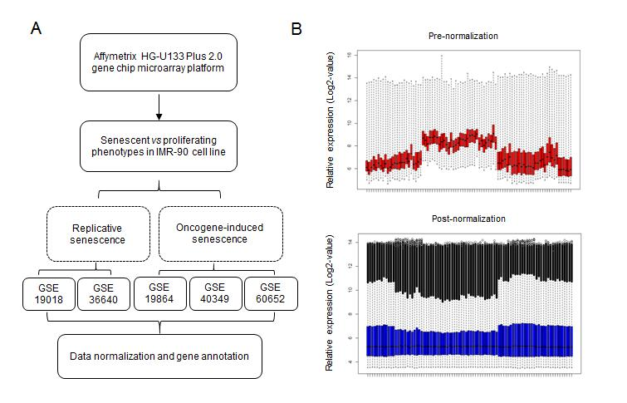
Figure 1 Data sources and processing. A: Flowchart describing the process used to generate differentially expressed senescence-associated genes; B: The relative expression in all samples pre- and post-normalization.
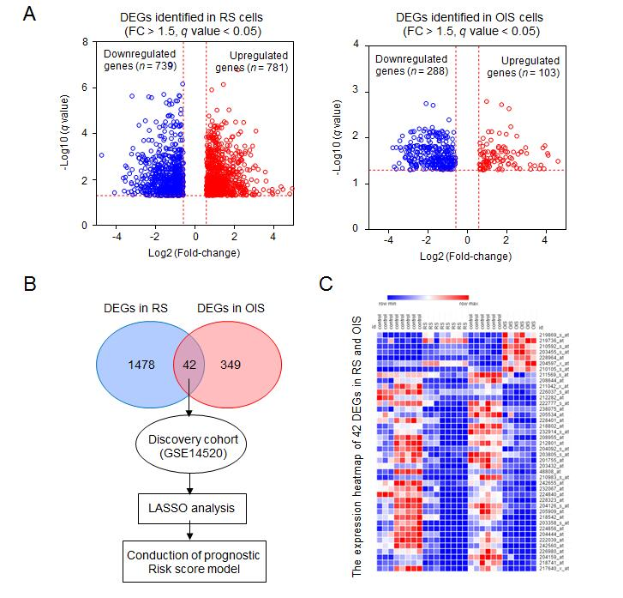
Figure 2 Expression of differentially expressed genes in senescent cells. A: The differentially expressed genes were identified in replicative senescence (RS) and oncogene-induced senescence (OIS) models. There were 781 up-regulated and 739 down-regulated genes selected using the RS model, and 103 up-regulated and 288 down-regulated genes selected using the OIS model; B: Overlapping the two lists, 42 common differentially expressed genes were selected as senescence associated genes; C: The expression levels of 42 genes are presented as a heat map in RS and OIS models. DEGs: Differentially expressed genes; RS: Replicative senescence; OIS: Oncogene-induced senescence; SAGs: Senescence associated genes; FC: Fold change; LASSO: Least absolute shrinkage and selection operator.
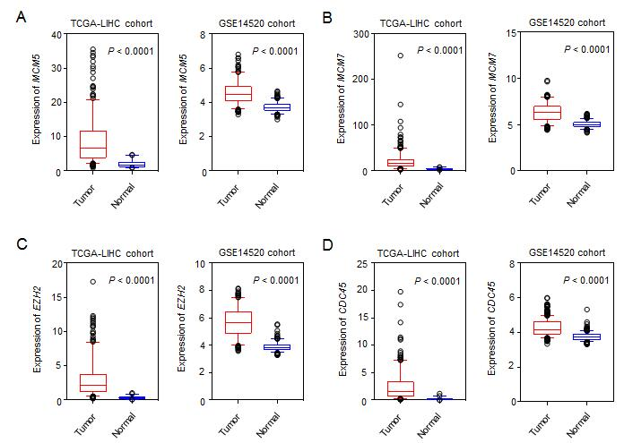
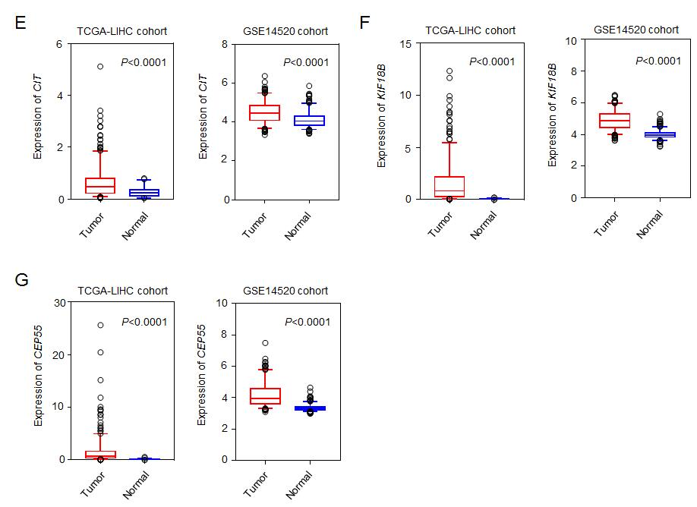
Figure 3 Expression of the seven candidate genes in hepatocellular carcinoma and normal liver tissues. A: MCM5; B: MCM7; C: EZH2; D: CDC45; E: CIT; F: KIF18B; G: CEP55. Seven senescence associated genes, which were downregulated in senescent cells, were shown to be upregulated in hepatocellular carcinoma tissues in both discovery and validation cohorts. P < 0.0001 for all.
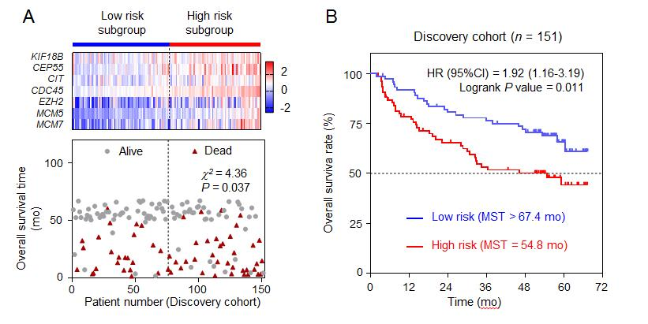
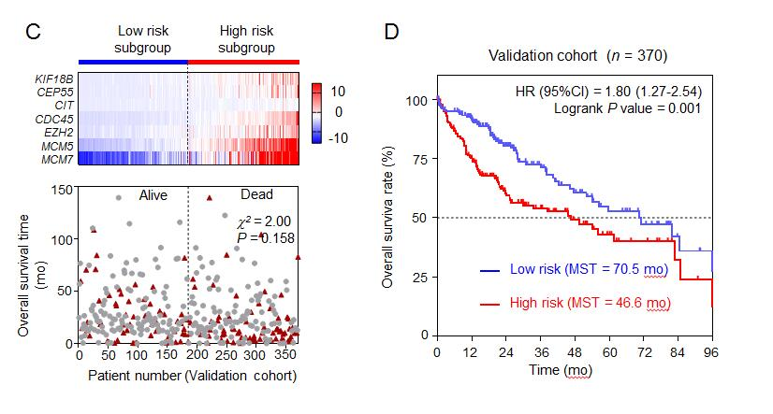
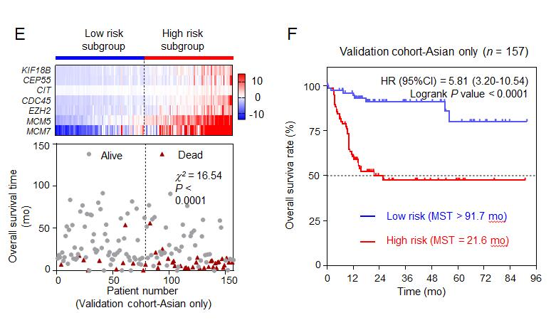
Figure 4 The seven-senescence associated gene signature is associated with overall survival in the discovery and validation cohorts. A: The heat map of the expression of three genes and patients’ death status in the discovery cohort; B: Kaplan-Meier survival curves plotted to estimate the overall survival probabilities for the low-risk vs high-risk group in the discovery cohort; C: The heat map of the expression of three genes and patients’ death status in the validation cohort; D: Kaplan-Meier survival curves plotted to estimate the overall survival probabilities for the low-risk vs high-risk group in the validation cohort; E: The heat map of the expression of three genes and patients’ death status in the validation cohort-Asian only subgroup; F: Kaplan-Meier survival curves plotted to estimate the overall survival probabilities for the low-risk vs high-risk group in the validation cohort-Asian only subgroup. HR: Hazard ratio; CI: Confidence interval.

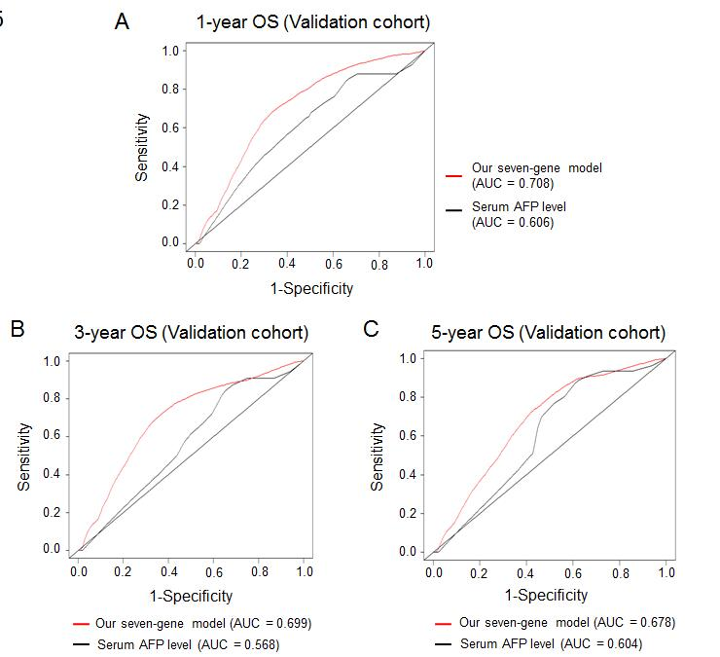
Figure 5 Comparison of the seven-senescence associated gene signature and α-fetoprotein in predicting overall survival of hepatocellular carcinoma patients. To assess the prognostic accuracy of the seven-senescence associated gene signature and serumα-fetoprotein level, time-dependent receiver operating characteristic curve analysis was conducted for 1-, 3-, and 5-year overall survival (OS). A: 1-year OS; B: 3-year OS; C: 5-year OS. AUC: Area under the curve; AFP: Alpha-fetoprotein; OS: Overall survival.

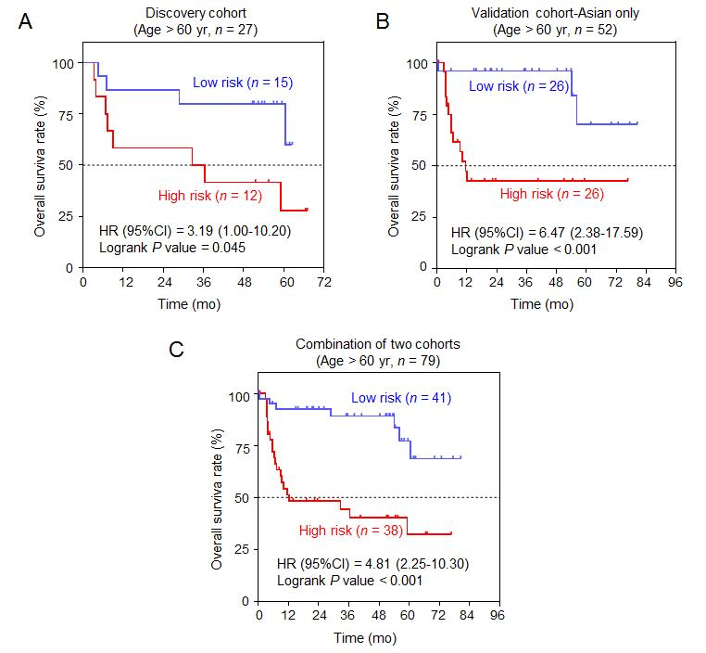
Figure 6 Association between the seven-senescence associated gene signature and overall survival in the elderly age subgroup. Kaplan-Meier survival curves were plotted to estimate the overall survival probabilities for the low-risk vs high-risk group. A: Discovery group; B: Validation group; C: Combination of discovery group and validation group. HR: Hazard ratio; CI: Confidence interval.

Table 1 Univariate/multivariate Cox regression analysis of clinicopathologic factors associated with overall survival in GSE14520 and The Cancer Genome Atlas cohorts
Variable | Discovery cohort |  |  |  |  | Validation cohort-Asian only
 | Univariate analysis |  | Multivariate analysis |  |  | Univariate analysis |  | Multivariate analysis
 | HR (95%CI) | P-value | HR (95%CI) | P-value |  | HR (95%CI) | P-value | HR (95%CI) | P-value
Gender (male/female) | 1.36 (0.55-3.40) | 0.507 | — | — |  | 0.89 (0.43-1.86) | 0.755 | — | —
Age (>60/≤60 yr) | 1.06 (0.57-2.00) | 0.851 | — | — |  | 1.21 (0.66-2.24) | 0.541 | — | —
Cirrhosis (yes/no) | 3.09 (0.76-12.65) | 0.117 | — | — |  | 0.41 (0.26-0.64) | <0.001ª | 0.60 (0.37-0.96) | 0.034ª
AFP (>300/≤300 ng/mL) | 2.30 (1.37-3.86) | 0.002ª | 2.26 (1.38-3.69) | 0.001ª |  | 0.27 (0.16-0.47) | <0.001ª | 0.47 (0.28-0.77) | 0.003ª
Risk score (low/high) | 1.93 (1.15-3.23) | 0.012ª | 1.99 (1.19-3.34) | 0.009ª |  | 5.91 (2.74-12.76) | <0.001ª | 4.22 (1.89-9.41) | <0.001ª
ªStatistically significant. HR: Hazard ratio; CI: Confidence interval; AFP: Alpha-fetoprotein.

Table 2 Stratified analysis of overall survival in GSE14520 and The Cancer Genome Atlas cohorts
Variable | Discovery cohort |  |  |  | Validation cohort-Asian only
 | High-risk/low-risk | HR (95% CI) | P-value |  | High-risk/low-risk | HR (95%CI) | P-value
Overall | 76/75 | 1.92 (1.16-3.19) | 0.011ª |  | 79/78 | 5.81 (3.20-10.54) | <0.001ª
Gender
Male | 69/67 | 2.15 (1.27-3.64) | 0.004ª |  | 62/61 | 5.18 (2.66-10.10) | <0.001ª
Female | 7/8 | 0.60 (0.10-3.47) | 0.569 |  | 17/17 | 9.63 (2.59-35.77) | 0.009ª
Age (yr)
≤60 | 64/60 | 1.70 (0.97-2.98) | 0.064 |  | 53/52 | 5.22 (2.49-10.97) | <0.001ª
>60 | 12/15 | 3.19 (1.00-10.20) | 0.045ª |  | 26/26 | 6.47 (2.38-17.59) | <0.001ª
Cirrhosis
Yes | 70/69 | 1.93 (1.15-3.22) | 0.012ª |  | 17/24 | 3.50 (0.66-18.47) | 0.122
No | 6/6 | 1.73 (0.10-30.65) | 0.695 |  | 11/28 | 0.98 (0.19-5.00) | 0.979
AFP (ng/mL)
≤300 | 40/39 | 1.73 (0.77-3.87) | 0.179 |  | 34/55 | 2.94 (1.01-8.57) | 0.036ª
>300 | 34/34 | 2.11 (1.09-4.08) | 0.025ª |  | 16/16 | 2.65 (0.60-11.66) | 0.226
ªStatistically significant. HR: Hazard ratio; CI: Confidence interval; AFP: Alpha-fetoprotein.

