Name of Journal: World Journal of Gastroenterology
Manuscript NO: 62348
Manuscript Type: CORRECTION

Helicobacter pylori promotes invasion and metastasis of gastric cancer by enhancing heparanase expression

Liu LP et al. HPA in H. pylori positive GC

Li-Ping Liu, Xi-Ping Sheng, Tian-Kui Shuai, Yong-Xun Zhao, Bin Li, Yu-Min Li

Li-Ping Liu, The Second Clinical Medical School of Lanzhou University, Lanzhou University, Lanzhou 730000, Gansu Province, China

Li-Ping Liu, Bin Li, Department of Critical Care Medicine, The First Hospital of Lanzhou University, Lanzhou 730000, Gansu Province, China

Li-Ping Liu, Tian-Kui Shuai, Department of Critical Care Medicine, The Donggang District of First Hospital of Lanzhou University, Lanzhou 730030, Gansu Province, China

Xi-Ping Sheng, Institute of Epidemiology and Health Statistics, School of Public Health, Lanzhou University, Lanzhou 730000, Gansu Province, China

Yong-Xun Zhao, Department of Surgical Oncology, The First Hospital of Lanzhou University, Lanzhou 730000, Gansu Province, China

Yu-Min Li, Key Laboratory of Digestive System Tumors of Gansu Province, The Second Clinical Medical School of Lanzhou University, Lanzhou 730000, Gansu Province, China

Author contributions: Liu LP and Li YM designed the experiments; Sheng XP and Li B contributed to the statistical analyses; Zhao YX performed the experiments; Liu LP prepared the manuscript; Shuai TK and Li B conducted data collection.

Corresponding author: Yu-Min Li, MD, PhD, Chief Doctor, Professor, Key Laboratory of Digestive System Tumors of Gansu Province, The Second Clinical Medical School of Lanzhou University, No. 82 Cuiyingmen, Chengguan District, Lanzhou 730000, Gansu Province, China. liym@lzu.edu.cn

Received: January 6, 2021
Revised: February 19, 2021
Accepted: May 17, 2021
Published online: June 14, 2021

Abstract
Correction to "Liu LP, Sheng XP, Shuai TK, Zhao YX, Li B, Li YM. Helicobacter pylori promotes invasion and metastasis of gastric cancer by enhancing heparanase expression. World J Gastroenterol 2018; 24: 4565-4577 [PMID: 30386106 DOI: 10.3748/wjg.v24.i40.4565]." In this article, we have identified some of the images in Figure 2A, C, E, G, and I are identical to the images in Figures 1B, 2A, 3B, 3E, and 3G of another paper entitled "Liu L, Zhao Y, Fan G, Shuai T, Li B, Li Y. Helicobacter pylori infection enhances heparanase leading to cell proliferation via mitogen-activated protein kinase signalling in human gastric cancer cells.", which was published by us in the Molecular Medicine Reports in December, 2018 [PMID: 30320396 DOI: 10.3892/mmr.2018.9558]. The reason why we asked to replace the pictures was that when we were simultaneously preparing to submit our two different articles to the World Journal of Gastroenterology (WJG) and Molecular Medicine reports, we uploaded the wrong pictures to the WJG, which were same as those submitted to the Molecular Medicine Reports. We apologize for this negligence and any inconvenience that this may cause. We would be grateful if you could replace the wrong pictures with the correct ones attached.

Key Words: Correction; Replace the wrong pictures; Gastric cancer; Helicobacter pylori

©The Author(s) 2021. Published by Baishideng Publishing Group Inc. All rights reserved.

Citation: Liu LP, Sheng XP, Shuai TK, Zhao YX, Li B, Li YM. Helicobacter pylori promotes invasion and metastasis of gastric cancer by enhancing heparanase expression. World J Gastroenterol 2021; 27(22): 3138-3141
URL: https://www.wjgnet.com/1007-9327/full/v27/i22/3138.htm
DOI: https://dx.doi.org/10.3748/wjg.v27.i22.3138

Core Tip: This manuscript is to correct the images in Figure 2A, C, E, G, and I of "Liu LP, Sheng XP, Shuai TK, Zhao YX, Li B, Li YM. Helicobacter pylori promotes invasion and metastasis of gastric cancer by enhancing heparanase expression. World J Gastroenterol 2018; 24: 4565-4577 [PMID: 30386106 DOI: 10.3748/wjg.v24.i40.4565]."
TO THE EDITOR
Correction
Correction to: Figure 2A, C, E, G and I. Liu LP, Sheng XP, Shuai TK, Zhao YX, Li B, Li YM. Helicobacter pylori promotes invasion and metastasis of gastric cancer by enhancing heparanase expression. World J Gastroenterol 2018; 24: 4565-4577 [PMID: 30386106 DOI: 10.3748/wjg.v24.i40.4565].
In this article^{[1]}, we have identified some of the images in Figure 2A, C, E, G, and I are identical to the images in Figures 1B, 2A, 3B, 3E, and 3G of another paper entitled "Liu L, Zhao Y, Fan G, Shuai T, Li B, Li Y. Helicobacter pylori infection enhances heparanase leading to cell proliferation via mitogen-activated protein kinase signalling in human gastric cancer cells"^{[2]}, which was published by us in the Molecular Medicine Reports in December, 2018.
The reason why we asked to replace the pictures was that when we were simultaneously preparing to submit our two different articles to the World Journal of Gastroenterology (WJG) and Molecular Medicine reports, we uploaded the wrong pictures to the WJG, which were same as those submitted to the Molecular Medicine Reports.
We apologize for this negligence and any inconvenience that this may cause.
We would be grateful if you could replace the wrong pictures with the correct ones attached (Figure 1).

ACKNOWLEDGEMENTS
We thank Dr. Zhong-Tian Bai for his critical reading of this manuscript. The authors appreciate Wen-Ting He for technical assistance.

REFERENCES
1 Liu LP, Sheng XP, Shuai TK, Zhao YX, Li B, Li YM. Helicobacter pylori promotes invasion and metastasis of gastric cancer by enhancing heparanase expression. World J Gastroenterol 2018; 24: 4565-4577 [PMID: 30386106 DOI: 10.3748/wjg.v24.i40.4565]

2 Liu L, Zhao Y, Fan G, Shuai T, Li B, Li Y. Helicobacter pylori infection enhances heparanase leading to cell proliferation via mitogen-activated protein kinase signalling in human gastric cancer cells. Mol Med Rep 2018; 18: 5733-5741 [PMID: 30320396 DOI: 10.3892/mmr.2018.9558]
Footnotes
Conflict-of-interest statement: The authors declare that they have no competing interests to disclose.

Open-Access: This article is an open-access article that was selected by an in-house editor and fully peer-reviewed by external reviewers. It is distributed in accordance with the Creative Commons Attribution NonCommercial (CC BY-NC 4.0) license, which permits others to distribute, remix, adapt, build upon this work non-commercially, and license their derivative works on different terms, provided the original work is properly cited and the use is non-commercial. See: http://creativecommons.org/Licenses/by-nc/4.0/

Manuscript source: Unsolicited manuscript

Peer-review started: January 6, 2021
First decision: February 11, 2021
Article in press: May 17, 2021

Specialty type: Gastroenterology and hepatology
Country/Territory of origin: China
Peer-review report’s scientific quality classification
Grade A (Excellent): 0
Grade B (Very good): 0
Grade C (Good): C
Grade D (Fair): 0
Grade E (Poor): 0

P-Reviewer: Shimada S S-Editor: Fan JR L-Editor: Wang TQ P-Editor: Liu JH
Figure Legends
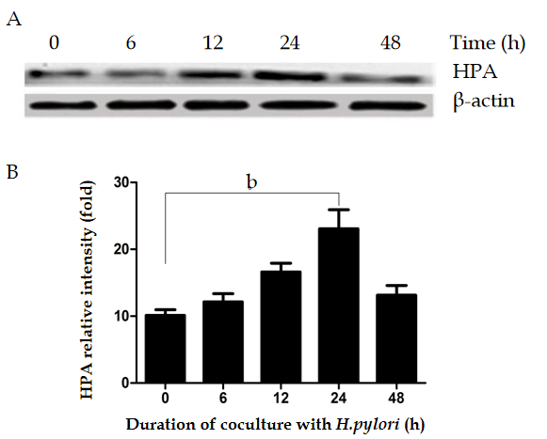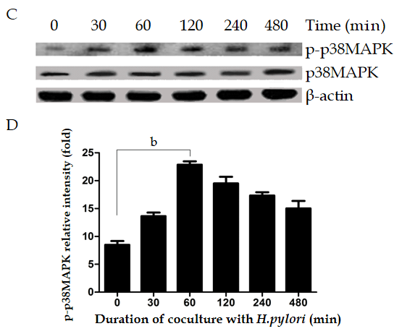
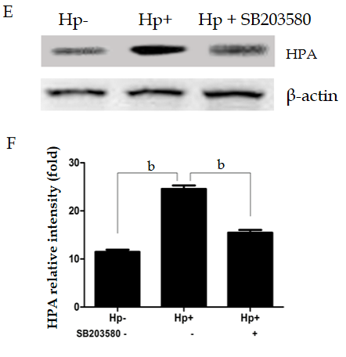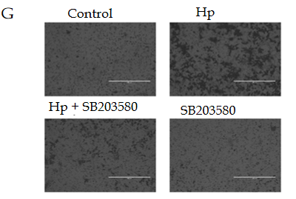
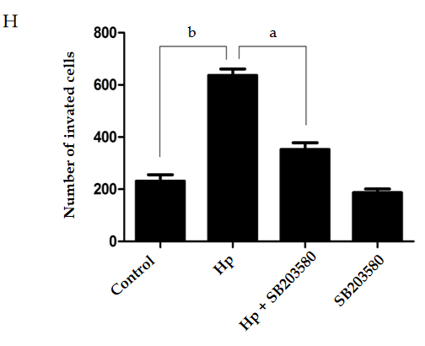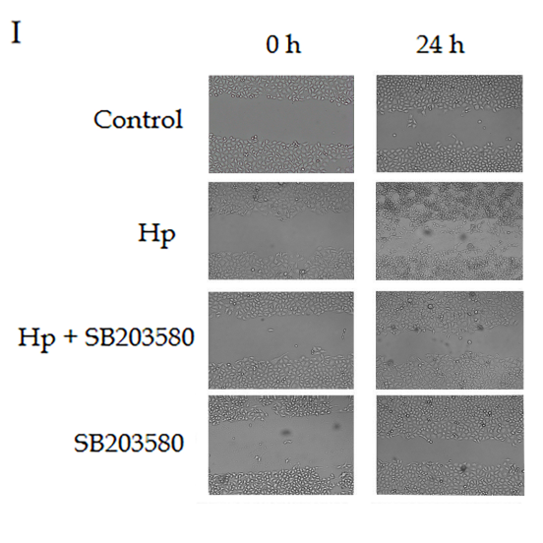

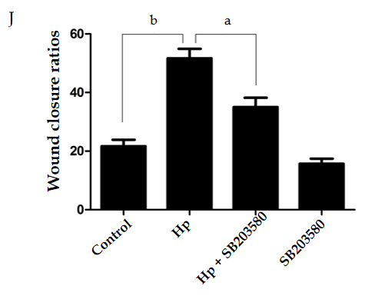
Figure 1 Heparanase protein expression following Helicobacter pylori infection in MKN-45 gastric cancer cells via the mitogen-activated protein kinase signaling pathway. A: Heparanase (HPA) expression was determined by Western blot at 0, 6, 12, 24, and 48 h after Helicobacter pylori (H. pylori) infection; B: Quantitative Western blot results of HPA; C: p-p38 mitogen-activated protein kinase (MAPK) expression was determined by Western blot at 0, 30, 60, 120, and 480 min after H. pylori infection; D: Quantitative Western blot results of p-p38MAPK; E: HPA expression when the MAPK inhibitor SB203580 was given to MKN-45 cells before H. pylori infection; F: Quantitative Western blot results of HPA when the MAPK inhibitor SB203580 was given. ^{b}P < 0.01 compared with the value at 0 h; G and H: Cell invasion rates in the three groups detected using a Transwell invasion assay; I and J: Migration rates in the three groups detected using a scratch migration assay. ªP < 0.05, ^{b}P < 0.01. HPA: Heparanase; MAPK: Mitogen-activated protein kinase; H. pylori: Helicobacter pylori. Figure 2 in the original manuscript: Liu LP, Sheng XP, Shuai TK, Zhao YX, Li B, Li YM. Helicobacter pylori promotes invasion and metastasis of gastric cancer by enhancing heparanase expression. World J Gastroenterol 2018; 24: 4565-4577 [PMID: 30386106 DOI: 10.3748/wjg.v24.i40.4565].

Published by Baishideng Publishing Group Inc
7041 Koll Center Parkway, Suite 160, Pleasanton, CA 94566, USA
Telephone: +1-925-3991568
E-mail: bpgoffice@wjgnet.com
Help Desk: https://www.f6publishing.com/helpdesk
https://www.wjgnet.com

© 2021 Baishideng Publishing Group Inc. All rights reserved.

