Name of Journal: World Journal of Clinical Cases
Manuscript NO: 70222
Manuscript Type: CASE REPORT

Obturator hernia - a rare etiology of lateral thigh pain: A case report

Kim JY et al. Obturator hernia

Jun Young Kim, Min Cheol Chang

Jun Young Kim, Min Cheol Chang, Department of Physical Medicine and Rehabilitation, College of Medicine, Yeungnam University, Taegu 705-717, South Korea

Author contributions: Kim JY and Chang MC contributed equally to this work. Kim JY and Chang MC both designed the research study, performed the research, analyzed the data, and wrote the manuscript; all authors have read and approve the final manuscript.

Supported by the National Research Foundation of Korea Grant funded by the Korean Government, No. NRF-2021R1A2C1013073.

Corresponding author: Min Cheol Chang, MD, Associate Professor, Department of Physical Medicine and Rehabilitation, College of Medicine, Yeungnam University, 317-1 Daemyungdong, Namku, Taegu 705-717, South Korea. wheel633@gmail.com

Received: July 27, 2021
Revised: September 2, 2021
Accepted: October 18, 2021
Published online: December 6, 2021

Abstract
BACKGROUND
Lateral thigh pain is a common complaint in patients visiting a pain clinic. Herein, we describe the case of a patient with lateral thigh pain caused by an obturator hernia.

CASE SUMMARY
An 83-year-old woman visited the emergency room with suddenly aggravated right lateral thigh pain. Magnetic resonance imaging of the thigh revealed no abnormal findings in the lateral thigh area. However, an obturator hernia between the pectineus and obturator externus muscles was observed by chance. Retroperitoneal computed tomography revealed a herniated small bowel with an incarceration point at the right obturator canal and a dilated loop of the small bowel upstream. Ultrasonography of the right inguinal region revealed a distended bowel loop in the right pectineus muscle.

CONCLUSION
Our report provides clinicians with information that an obturator hernia can cause lateral thigh pain.

Key Words: Obturator hernia; Pain; Magnetic resonance image; Computed tomography; Ultrasonography; Case report

©The Author(s) 2021. Published by Baishideng Publishing Group Inc. All rights reserved.

Citation: Kim JY, Chang MC. Obturator hernia - a rare etiology of lateral thigh pain: A case report. World J Clin Cases 2021; 9(34): 10728-10732
URL: https://www.wjgnet.com/2307-8960/full/v9/i34/10728.htm
DOI: https://dx.doi.org/10.12998/wjcc.v9.i34.10728

Core Tip: The causes of thigh pain are diverse. Although it is a rare disorder, an obturator hernia should be suspected, and imaging studies should be performed when musculoskeletal disorders causing thigh pain are not found in patients with medial, anterior, or lateral thigh pain. Additionally, our report provides clinicians with information that an obturator hernia can cause lateral thigh pain.

INTRODUCTION
In pain practice, lateral thigh pain is a common complaint of patients. It is caused by several pathologies, such as radiculopathy due to a herniated lumbar disc or spinal stenosis, femoral cutaneous neuropathy, myofascial pain syndrome, and sprain or strain^{[1]}. Because therapeutic methods differ according to the etiology, accurate diagnosis is important.
Currently, there is insufficient knowledge on pain caused by an obturator hernia. In this regard, we present the case of a patient with lateral thigh pain caused by an obturator hernia and describe the findings of imaging studies.

CASE PRESENTATION
Chief complaints
An 83-year-old woman (height: 147 cm; weight: 42 kg) visited our emergency room owing to suddenly aggravated right lateral thigh pain. The pain intensity assessed using the numeric rating scale (NRS) was 9.

History of present illness
This right lateral thigh pain had persisted for several years and had suddenly worsened on the day of the visit to the emergency room. It was aggravated while standing and walking and was relieved upon sitting or lying. She did not have nausea, vomiting, or abdominal pain.

History of past illness
The patient had no specific history of past illnesses.

Personal and family histories
The patient had no specific personal or family history of illnesses.

Physical examination
Physical examination revealed no tenderness of the right lateral thigh and no motor or sensory deficits. Furthermore, the patient did not exhibit any signs of obturator nerve irritation, such as sensory deficit or pain in the medial thigh area. Deep tendon reflexes in relation to the bilateral knees and ankles were normoactive. The straight leg raise test yielded normal findings for both legs. The patient did not have a specific medical history but had mild chronic back pain (NRS score, 1), which had persisted for > 10 years.

Imaging examinations
Magnetic resonance imaging (MRI) of the right thigh revealed no abnormal findings in the lateral thigh. The right lateral femoral cutaneous nerve was intact. However, an obturator hernia between the pectineus and obturator externus muscles was observed by chance (Figure 1). Retroperitoneal computed tomography (CT) revealed a herniated small bowel with an incarceration point at the right obturator canal and a dilated loop of the small bowel upstream (Figure 1). Ultrasonography (USG) of the right inguinal region revealed a distended bowel loop in the right pectineus muscle (Figure 1).
Because the patient had chronic lower back pain, we suspected that her lateral thigh pain might have been caused by lumbar radicular pain due to spinal disorders. Therefore, we conducted imaging studies of the lumbar spine. Lumbar radiography revealed multilevel degenerative lumbar spondylosis. Moreover, central stenosis at L4-5 was observed on lumbar spine CT. Because the patient’s pain was aggravated while standing and walking, we suspected that her pain was caused by right L5 radiculopathy due to lumbar stenosis at L4-5. We performed selective nerve root injection on the right L5 with dexamethasone 40 mg (1 mL), 2% lidocaine (0.3 mL), and normal saline (0.7 mL). However, no pain was provoked during the injection. Additionally, at 30 min after the selective nerve root injection, no pain relief was achieved. Further, at the 1-week follow-up, no pain reduction was observed.

FINAL DIAGNOSIS
The patient was diagnosed with lateral thigh pain caused by a right obturator hernia.

TREATMENT
She underwent surgical reduction of the obturator hernia with subsequent mesh repair of the defect.

OUTCOME AND FOLLOW-UP
At the 1-wk follow-up after the surgery, her lateral thigh pain had completely subsided. The study was approved by the Institutional Review Board of Yeungnam University Hospital.

DISCUSSION
An obturator hernia is a protrusion of both intraperitoneal and extraperitoneal contents through the obturator canal, adjacent to the obturator vessels and nerves^{[2]}. It is a rare disorder, accounting for approximately 0.7% of all hernias^{[3]}. This type of hernia is neither palpable nor externally visible, and its representative symptoms are not specific. Therefore, it often goes unsuspected, undiagnosed, or misdiagnosed^{[4]}. It has been reported that only 20%-30% of obturator hernia cases are correctly diagnosed before surgery^{[5]}. The diagnosis of an obturator hernia is very important because focal strangulation or entrapment of the bowel (lower portion of the ileum) in the hernial orifice can progress to gangrene^{[4]}. Because an obturator hernia is unlikely to be reducible, it is typically treated via open or laparoscopic hernia repair.
The most common symptoms of an obturator hernia are pain and paresthesia along the anterior or medial aspect of the thigh, possibly extending down to the knee^{[2]}. However, these symptoms are not always present. Sometimes, thigh pain may not occur. Furthermore, in a previous study, the pain due to obturator hernia occurred in the lateral thigh area, similar to that in our patient^{[6]}. We suspect that our patient’s lateral thigh pain was a referred pain, that is, pain perceived in an area other than the site of the noxious stimulus. The human brain cannot clearly discriminate the site of an irritated or diseased visceral organ and frequently perceives the associated pain as originating from a remote musculoskeletal area^{[7]}.
The diagnosis of an obturator hernia is based on high suspicion and imaging study findings^{[8]}. On CT or MRI, a herniating bowel loop with a defect in the inguinal region is observed^{[4]}. Obturator hernias are typically observed in emaciated and multiparous elderly women^{[9]}. Therefore, when thin elderly women present with unexplained thigh pain (anterior, medial, or lateral areas), CT or MRI scans for evaluating obturator hernias are recommended.
USG of the inguinal area is a useful tool that can be rapidly and easily applied at the bedside of patients who are suspected to have an obturator hernia. Moreover, USG is useful for diagnosing other musculoskeletal disorders, such as muscle tears, nerve entrapment, or bursitis, which can cause thigh pain^{[10,11]}.

CONCLUSION
In conclusion, the causes of thigh pain are diverse. Although it is a rare disorder, an obturator hernia should be suspected, and the appropriate imaging studies should be performed when musculoskeletal disorders causing thigh pain are not found in patients with medial, anterior, or lateral thigh pain. Furthermore, our report provides clinicians with information that an obturator hernia can cause lateral thigh pain.

REFERENCES
1 DeFroda SF, Daniels AH, Deren ME. Differentiating Radiculopathy from Lower Extremity Arthropathy. Am J Med 2016; 129: 1124.e1-1124.e7 [PMID: 27401953 DOI: 10.1016/j.amjmed.2016.06.019]
2 Igari K, Ochiai T, Aihara A, Kumagai Y, Iida M, Yamazaki S. Clinical presentation of obturator hernia and review of the literature. Hernia 2010; 14: 409-413 [PMID: 20422238 DOI: 10.1007/s10029-010-0658-z]
3 Susmallian S, Ponomarenko O, Barnea R, Paran H. Obturator hernia as a frequent finding during laparoscopic pelvic exploration: A retrospective observational study. Medicine (Baltimore) 2016; 95: e4102 [PMID: 27399109 DOI: 10.1097/MD.0000000000004102]
4 Chitrambalam TG, Christopher PJ, Sundaraj J, Selvamuthukumaran S. Diagnostic difficulties in obturator hernia: a rare case presentation and review of literature. BMJ Case Rep 2020; 13 [PMID: 32933908 DOI: 10.1136/bcr-2020-235644]
5 Maharaj D, Maharaj S, Young L, Ramdass MJ, Naraynsingh V. Obturator hernia repair--a new technique. Hernia 2002; 6: 45-47 [PMID: 12090583 DOI: 10.1007/s10029-002-0042-8]
6 Kontoyannis A, Sweetland H. Crach Course: Surgery. 3rd ed. Mosby Ltd, 2008: 282
7 Sikandar S, Dickenson AH. Visceral pain: the ins and outs, the ups and downs. Curr Opin Support Palliat Care 2012; 6: 17-26 [PMID: 22246042 DOI: 10.1097/SPC.0b013e32834f6ec9]
8 Durgakeri P, Strauss P, Jones B. Obturator hernia: the 'little old lady's hernia'. ANZ J Surg 2017; 87: 412-414 [PMID: 25366514 DOI: 10.1111/ans.12903]
9 Arif A, Abideen ZU, Zia N, Khan MA. Perforated obturator Littr hernia in an elderly woman. Ann Saudi Med 2015; 35: 324-326 [PMID: 26497715 DOI: 10.5144/0256-4947.2015.324]
10 Chang MC, Chang KV, Wu WT, Özçakar L. Ultrasound Imaging for Painful Lipomatosis: Cutaneous Nerves Really Matter!. Am J Phys Med Rehabil 2020; 99: e88-e89 [PMID: 31361622 DOI: 10.1097/PHM.0000000000001280]
11 Kim JB, Lee W, Chang MC. Ultrasonographic and magnetic resonance images of a gluteus maximus tear. Yeungnam Univ J Med 2021; 38: 157-159 [PMID: 32891077 DOI: 10.12701/yujm.2020.00500]

Footnotes
Informed consent statement: The need for informed consent was waived by the Institutional Review Board of Yeungnam University Hospital because of the retrospective nature of this case report.

Conflict-of-interest statement: The authors declare that they have no conflict of interest.

CARE Checklist (2016) statement: The authors have read the CARE Checklist (2016), and the manuscript was prepared and revised according to this checklist.

Open-Access: This article is an open-access article that was selected by an in-house editor and fully peer-reviewed by external reviewers. It is distributed in accordance with the Creative Commons Attribution NonCommercial (CC BY-NC 4.0) license, which permits others to distribute, remix, adapt, build upon this work non-commercially, and license their derivative works on different terms, provided the original work is properly cited and the use is non-commercial. See: http://creativecommons.org/Licenses/by-nc/4.0/

Provenance and peer review: Unsolicited article; Externally peer reviewed

Peer-review started: July 27, 2021
First decision: September 1, 2021
Article in press: October 18, 2021

Specialty type: Rehabilitation
Country/Territory of origin: South Korea
Peer-review report’s scientific quality classification
Grade A (Excellent): 0
Grade B (Very good): 0
Grade C (Good): 0
Grade D (Fair): D
Grade E (Poor): 0

P-Reviewer: Yoshizawa T S-Editor: Yan JP L-Editor: A P-Editor: Yan JP

Figure Legends
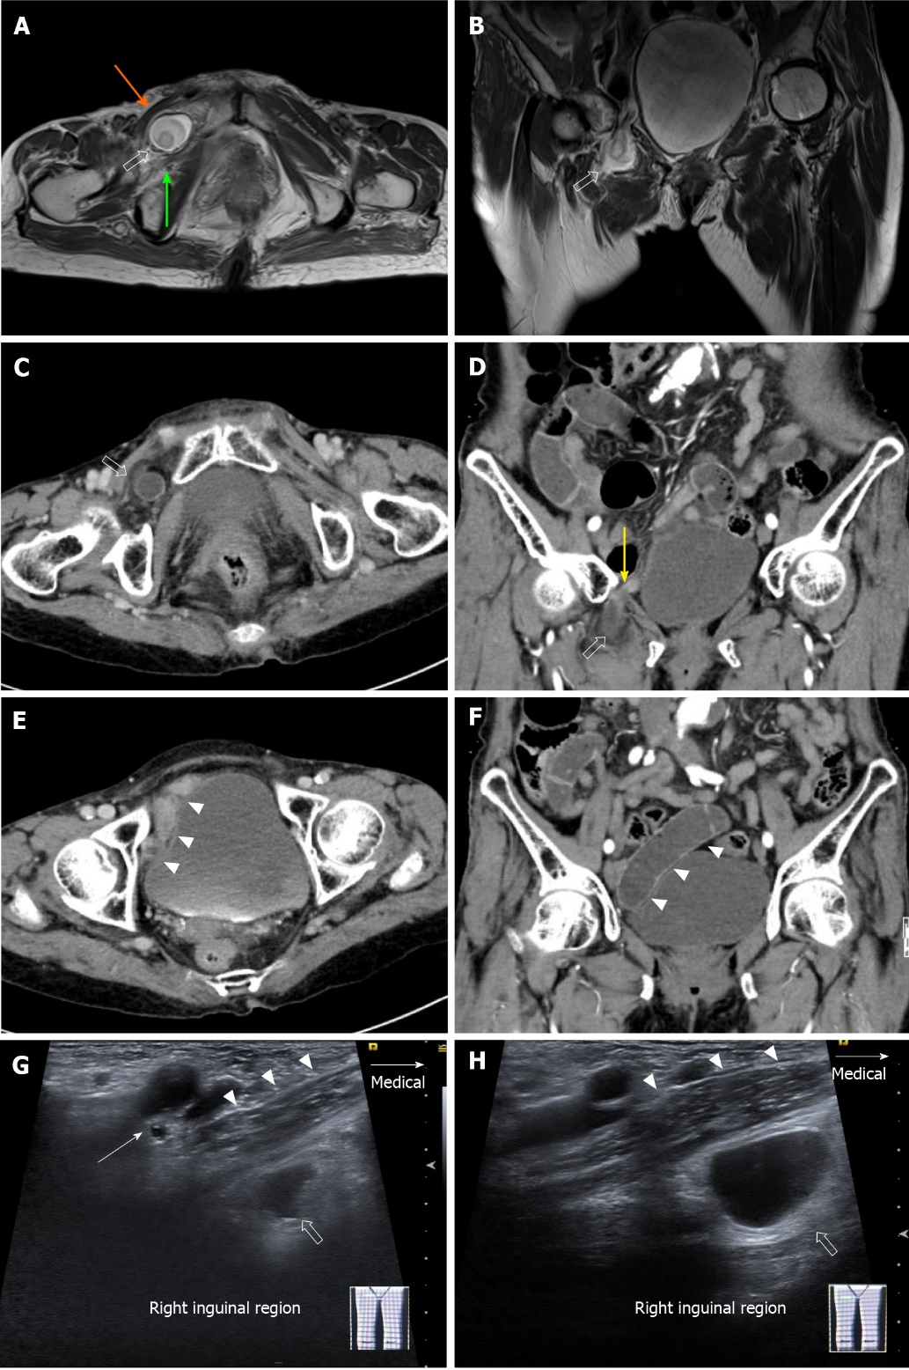
Figure 1 Imaging study of an 83-year-old woman with right lateral thigh pain. A: Axial T2-weighted thigh magnetic resonance (MR) image shows the small bowel (open arrow) located between the right pectineus muscle (orange arrow) and right obturator externus muscle (green arrow); B: Coronal T2-weighted thigh MR image shows the small bowel (open arrow) herniating through the right obturator canal; C and D: Axial (C) and (D) coronal contrast-enhanced retroperitoneal computed tomography (CT) images show the right obturator hernia (open arrow) and strangulation point (yellow arrow) at the right obturator canal; E and F: Axial (E) and (F) coronal contrast-enhanced retroperitoneal CT images show a dilated loop of the small bowel upstream (arrowheads); G and H: Ultrasonographic images of the right inguinal region (G and H) shows a herniated bowel loop (open arrow) below the pectineus muscle (arrowheads) (arrow in G, femoral vessels.

Published by Baishideng Publishing Group Inc
7041 Koll Center Parkway, Suite 160, Pleasanton, CA 94566, USA
Telephone: +1-925-3991568
E-mail: bpgoffice@wjgnet.com
Help Desk: https://www.f6publishing.com/helpdesk
https://www.wjgnet.com

© 2021 Baishideng Publishing Group Inc. All rights reserved.

