Name of Journal: World Journal of Clinical Oncology
Manuscript NO: 68415
Manuscript Type: CASE REPORT

Foreign body granulomas mimic peritoneal dissemination caused by incarcerated femoral hernia perforation: A case report

Ogino S et al. IFBGs mimicking peritoneal dissemination

Shinpei Ogino, Tatsuya Matsumoto, Yosuke Kamada, Noriaki Koizumi, Hiroshi Fujiki, Kenji Nakamura, Takeshi Yamano, Chouhei Sakakura

Shinpei Ogino, Tatsuya Matsumoto, Yosuke Kamada, Noriaki Koizumi, Hiroshi Fujiki, Kenji Nakamura, Chouhei Sakakura, Department of Surgery, Akashi City Hospital, Akashi 673-8501, Hyogo, Japan

Takeshi Yamano, Department of Pathology, Akashi City Hospital, Akashi 673-8501, Hyogo, Japan

Author contributions: Ogino S was a major contributor; Matsumoto T, Yamano T and Sakakura C supervised in writing the manuscript; Ogino S, Kamada Y, Koizumi N, Fujiki H and Nakamura K performed patient treatment; Yamano T performed the pathological diagnosis; all authors read and approved the final manuscript.

Corresponding author: Shinpei Ogino, MD, PhD, Doctor, Surgeon, Department of Surgery, Akashi City Hospital, 1-33 Takasho-machi, Akashi 673-8501, Hyogo, Japan. s-ogino@koto.kpu-m.ac.jp

Received: May 22, 2021
Revised: August 20, 2021
Accepted: September 30, 2021
Published online: November 24, 2021

Abstract
BACKGROUND
Foreign body granuloma (FBG) is a well-known type of granulomatous formation, and intraabdominal FBG (IFBG) is primarily caused by surgical residues. Multifocal IFBGs caused by gastrointestinal perforation is an extremely rare and interesting clinicopathological condition that resembles peritoneal dissemination. Here, we present a case of IFBGs mimicking peritoneal dissemination caused by bowel perforation and describe the value of intraoperative pathological examinations for rapid IFBG diagnosis.

CASE SUMMARY
An 86-year-old woman with an incarcerated femoral hernia was admitted to the hospital and underwent operation. During the operation, the incarcerated ileum was perforated during repair due to hemorrhage necrosis, and a small volume of enteric fluid leaked from the perforation. The incarcerated ileum was resected, and the femoral hernia was repaired without mesh. Four months later, a second operation was performed for an umbilical incisional hernia. During the second operation, multiple small, white nodules were observed throughout the abdominal cavity, resembling peritoneal dissemination. The results of peritoneal washing cytology in Douglas’ pouch and the examination of frozen nodule sections were compatible with IFBG diagnosis, and incisional hernia repair was performed.

CONCLUSION
IFBGs can mimic malignancy. Intraoperative pathological examinations and operation history are valuable for the rapid diagnosis to avoid excessive treatments.

Key Words: Foreign body granuloma; Peritoneal dissemination; Peritoneal seeding; Perforation; Operation; Case report

©The Author(s) 2021. Published by Baishideng Publishing Group Inc. All rights reserved.

Citation: Ogino S, Matsumoto T, Kamada Y, Koizumi N, Fujiki H, Nakamura K, Yamano T, Sakakura C. Foreign body granulomas mimic peritoneal dissemination caused by incarcerated femoral hernia perforation: A case report. World J Clin Oncol 2021; 12(11): 1083-1088
URL: https://www.wjgnet.com/2218-4333/full/v12/i11/1083.htm
DOI: https://dx.doi.org/10.5306/wjco.v12.i11.1083

Core Tip: Multifocal intraabdominal foreign body granulomas (IFBGs) caused by gastrointestinal perforation are clinically rare and mimic peritoneal dissemination. An 86-year-old woman underwent an operation to treat an incarcerated femoral hernia; however, the incarcerated ileum was perforated due to hemorrhage necrosis, resulting in incarcerated ileum resection. After 4 mo, a second laparoscopic operation was conducted for an umbilical incisional hernia; however, small, white nodules were identified throughout the entire abdominal cavity, mimicking peritoneal dissemination. Using intraoperative cytology and frozen sections, the nodules were diagnosed as IFBGs. IFBGs sometimes mimic peritoneal dissemination, and intraoperative pathological examinations are effective for rapid diagnosis.
INTRODUCTION
A foreign body granuloma (FBG) is a tissue reaction caused by retained foreign bodies, and intraabdominal FBGs (IFBGs) are typically caused by materials used in a previous operation, such as surgical sutures, gauze, and sponges^{[1-3]}. However, in rare cases, bowel perforation, bile or gallstone spillage, and foreign bodies unrelated to operations, such as fish bones, can result in IFBGs^{[4-6]}. Furthermore, IFBGs sometimes occur multifocally and can closely resemble peritoneal dissemination, leading to misdiagnosis^{[5,7]}. Here, we present a case of IFBGs mimicking peritoneal dissemination 4 mo after an operation to treat an incarcerated and perforated femoral hernia.

CASE PRESENTATION
Chief complaints
An 86-year-old woman presented to our hospital with anorexia and vomiting for 3 d.

History of present illness
Her medical history was unremarkable.

History of past illness
Past appendectomy.

Personal and family history
No special in personal and family history.

Physical examination
Severe pain with redness and a palpable bulge was observed in the right inguinal area.

Laboratory examinations
The laboratory workup showed a white blood cell count of 17.1 × 10⁹/L and C-reactive protein levels at 6.13 mg/dL.

Imaging examinations
Abdominal computed tomography (CT) showed a right incarcerated femoral hernia with small bowel obstruction.

FINAL DIAGNOSIS
FBG (see TREATMENT section).

TREATMENT
The laparoscopic repair of an incarcerated femoral hernia was attempted; however, the incarcerated ileum was perforated during the repair because it had become necrotic. The necrotic ileum was resected, and the right femoral hernia was repaired using the McVay procedure (Figure 1). Although postoperative intensive care for septic shock and disseminated intravascular coagulation was necessary, the patient was discharged one month after the operation. The patient revisited our hospital 3 mo later due to an umbilical incisional hernia, and laparoscopic incisional hernia repair was performed. During the operation, the hernia orifice, 11 cm in diameter, was identified at the umbilical wound, and multiple small white nodules expanded throughout the entire abdominal cavity (Figure 2). We suspected the peritoneal dissemination of some tumors. Because no observable tumor could be located in the abdominal cavity, peritoneal wash cytology of Douglas’s pouch was performed, and frozen sections of the nodules were examined. The cytology was negative for malignancy (Figure 3), and the frozen sections showed a multinucleated giant cell containing a foreign body, surrounded by inflammatory cells, fibrosis, and granulomatous formations (Figure 4), which was compatible with an FBG reaction. Therefore, laparoscopic intraperitoneal onlay mesh repair with hernia orifice closure (IPOM-plus) was performed.

OUTCOME AND FOLLOW-UP
The postoperative clinical course was uneventful, and no malignant findings were observed on chest-to-abdominal enhanced CT or gastrointestinal and colon endoscopy. No malignancy was detected, and no recurrence of hernia was observed during 7 mo of follow-up.

DISCUSSION
FBG is a chronic immune reaction induced by the presence of a foreign body. IFBG is typically caused by retained surgical residues, bowel perforation, bile spillage, gallstones, or fish bones^{[1,2,4-6,8]}. Suture granulomas are the most common type associated with surgical residuals, although gauze and sponges have also been reported^{[1-3]}. IFBGs occasionally resemble tumorous nodules and sometimes occur multifocally, which can mimic peritoneal dissemination^{[2,8]}. IFBG is also well-known to be caused by glove powder used in operations. IFBGs associated with lycopodium, talcum, and starch powders from surgical gloves have previously been reported, and these IFBGs can be quite difficult to differentiate from cancerous nodules^{[7,9,10]}. Akita et al^{[5]} reported that food starch released from gastrointestinal perforations could cause multiple IFBGs, mimicking peritoneal dissemination; they reported a case in which tenderness and guarding over the entire abdomen was observed due to a gastric cancer perforation, which was treated surgically. Two months later, many small, white granulomas mimicking peritoneal dissemination were observed, particularly in the upper abdominal cavity, which were diagnosed as IFBGs based on frozen sections during the second operation. In the pathological findings, saburra was observed at the center of the granuloma.
In the present case, multiple small, white nodules that expanded throughout the entire abdominal cavity were observed during the second operation, which were extremely difficult to differentiate from peritoneal dissemination. A multinucleated giant cell containing a foreign body similar to saburra and surrounded by inflammatory cells and granuloma formation was observed pathologically; thus, these nodules were diagnosed as IFBGs and were thought to be caused by food starch, similar to the previously reported case^{[5]}, particularly as no evidence of malignancy was identified either during or after the operations.
FBG is one type of non-infectious granulomatous reaction, characterized by the presence of a foreign body surrounded by granuloma formations in foreign body giant cells. FBGs have also been associated with granuloma formation due to an excessive immune response to foreign bodies, potentially related to allergic reactions and microbiological factors^{[11]}. Intriguingly, in the present case, the IFBG expanded to the entire abdominal cavity at the time of the second operation, although the amount of enteric fluid that leaked from the perforation was limited to a small range and was localized within the lower abdominal cavity during the first operation. Because the lower abdominal cavity was rinsed after the resection of the incarcerated ileum during the first operation, the remaining food particles released from the small enteric fluid leak should have been minimized and at low concentrations, which suggested that each IFBG was either caused by an extremely minute food starch quantity or represented an allergic response, resulting in the accumulation of microbiological factors. Furthermore, the characteristic histological findings of FBG were very supportive of an IFBG diagnosis, especially during the operation. The misdiagnosis of IFBGs as malignancies can potentially lead to ineffective or unnecessary treatments. A previous case reported IFBGs mimicking peritoneal dissemination 3 mo after laparoscopic cholecystectomy, resulting in the wedge resection of the liver and transverse colon and omentectomy, and IFBGs were later diagnosed pathologically as likely due to bile or gallstone spillage^{[6]}. As reported by Akita et al^{[5]}, intraoperative cytology and frozen sections are valuable for the rapid diagnosis of IFBGs. In the current case, these quick pathological examinations performed during the operation provided an important and powerful method for differentiating IFBGs from peritoneal dissemination.
The physiologic activation of histiocytes generally occurs within 24-48 h^{[12]}; however, the time required for granulomatous formation resembling nodules remains unclear. In the current case, 4 mo was sufficient for the observed granulomatous formation. The percentage of granulomas observed during operations decreases gradually, from 37% if the previous operation was performed within 6 mo to 18% when the previous operation occurred more than 2 years prior^{[1]}. Granulomas that resemble peritoneal dissemination can form within 2 mo, according to Akita et al^{[5]}, and this occurred within 4 mo in the current patient. Therefore, the interval between first and second operations also supports the diagnosis of IFBG.

CONCLUSION
In conclusion, multiple IFBGs caused by bowel perforations are associated with a very rare clinicopathological condition and can mimic peritoneal dissemination. A history of past operations and the interval between the current and past operations can be helpful for distinguishing between IFBGs and peritoneal dissemination, and intraoperative cytology and frozen sections are extremely valuable methods for the rapid diagnosis of IFBG, which can prevent misdiagnosis and avoid the use of ineffective or excessive treatments.

REFERENCES
1 Luijendijk RW, de Lange DC, Wauters CC, Hop WC, Duron JJ, Pailler JL, Camprodon BR, Holmdahl L, van Geldorp HJ, Jeekel J. Foreign material in postoperative adhesions. Ann Surg 1996; 223: 242-248 [PMID: 8604903 DOI: 10.1097/00000658-199603000-00003]
2 Wang H, Chen P. Surgicel® (oxidized regenerated cellulose) granuloma mimicking local recurrent gastrointestinal stromal tumor: A case report. Oncol Lett 2013; 5: 1497-1500 [PMID: 23759739 DOI: 10.3892/ol.2013.1218]
3 Ezaki T, Okamura T, Yoshida Y, Kodate M, Shirakusa T, Tanimoto A, Hiratsuka R. Foreign-body granuloma mimicking an extrahepatically growing liver tumor: report of a case. Surg Today 1994; 24: 829-832 [PMID: 7865961 DOI: 10.1007/bf01636316]
4 Yamamoto T, Hirohashi K, Iwasaki H, Kubo S, Tanaka Y, Yamasaki K, Koh M, Uenishi T, Ogawa M, Sakabe K, Tanaka S, Shuto T, Tanaka H. Pseudotumor of the omentum with a fishbone nucleus. J Gastroenterol Hepatol 2007; 22: 597-600 [PMID: 17376061 DOI: 10.1111/j.1440-1746.2006.03353.x]
5 Akita H, Watanabe Y, Ishida H, Nakaguchi K, Okino T, Kabuto T. A foreign body granuloma after gastric perforation mimicking peritoneal dissemination of gastric cancer: report of a case. Surg Today 2009; 39: 795-799 [PMID: 19779777 DOI: 10.1007/s00595-008-3937-x]
6 Jeong H, Lee HW, Jung HR, Hwang I, Kwon SY, Kang YN, Kim SP, Choe M. Bile Granuloma Mimicking Peritoneal Seeding: A Case Report. J Pathol Transl Med 2018; 52: 339-343 [PMID: 30008197 DOI: 10.4132/jptm.2018.06.02]
7 Giercksky KE, Qvist H, Giercksky TC, Warloe T, Nesland JM. Multiple glove powder granulomas masquerading as peritoneal carcinomatosis. J Am Coll Surg 1994; 179: 299-304 [PMID: 8069426]
8 Shan GD, Chen ZP, Xu YS, Liu XQ, Gao Y, Hu FL, Fang Y, Xu CF, Xu GQ. Gastric foreign body granuloma caused by an embedded fishbone: a case report. World J Gastroenterol 2014; 20: 3388-3390 [PMID: 24696619 DOI: 10.3748/wjg.v20.i12.3388]
9 LEE CM Jr, LEHMAN EP. Experiments with nonirritating glove powder. Surg Gynecol Obstet 1947; 84: 689-695 [PMID: 20292162]
10 Ellis H. The hazards of surgical glove dusting powders. Surg Gynecol Obstet 1990; 171: 521-527 [PMID: 2244289]
11 Schmitt A, Volz A. Non-infectious granulomatous dermatoses. J Dtsch Dermatol Ges 2019; 17: 518-533 [PMID: 31115996 DOI: 10.1111/ddg.13848]
12 Shah KK, Pritt BS, Alexander MP. Histopathologic review of granulomatous inflammation. J Clin Tuberc Other Mycobact Dis 2017; 7: 1-12 [PMID: 31723695 DOI: 10.1016/j.jctube.2017.02.001]

Footnotes
Informed consent statement: The study participant provided informed written consent prior to their treatments and study enrollment.

Conflict-of-interest statement: All authors declare no conflict of interest related to this study or its publication.

CARE Checklist (2016) statement: The authors have read the CARE Checklist (2016), and the manuscript was prepared and revised according to the CARE Checklist (2016).

Open-Access: This article is an open-access article that was selected by an in-house editor and fully peer-reviewed by external reviewers. It is distributed in accordance with the Creative Commons Attribution NonCommercial (CC BY-NC 4.0) license, which permits others to distribute, remix, adapt, build upon this work non-commercially, and license their derivative works on different terms, provided the original work is properly cited and the use is non-commercial. See: http://creativecommons.org/Licenses/by-nc/4.0/

Provenance and peer review: Unsolicited article; Externally peer reviewed.

Peer-review started: May 22, 2021
First decision: August 18, 2021
Article in press: September 30, 2021

Specialty type: Oncology
Country/Territory of origin: Japan
Peer-review report’s scientific quality classification
Grade A (Excellent): 0
Grade B (Very good): B
Grade C (Good): 0
Grade D (Fair): 0
Grade E (Poor): 0

P-Reviewer: Liu YC S-Editor: Gao CC L-Editor: A P-Editor: Gao CC

Figure Legends
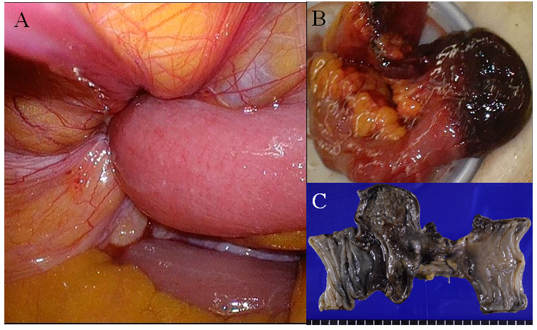
Figure 1 The necrotic ileum was resected, and the right femoral hernia was repaired using the McVay procedure. A: The ileum was incarcerated into the right femoral hernia; B: The incarcerated ileum became necrotic; C: The resected ileum showed hemorrhage necrosis over a 10 cm length.
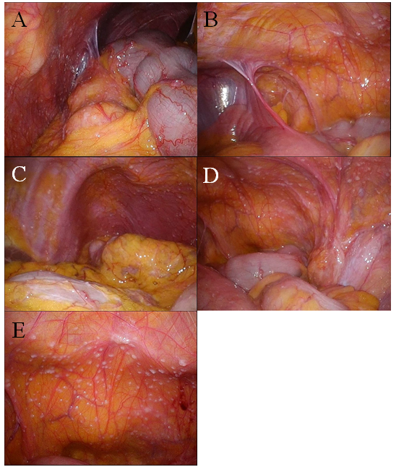
Figure 2 Multiple small white nodules mimicking peritoneal dissemination were observed throughout the entire abdominal cavity during the second operation. A: Right upper abdominal cavity; B: Right lower abdominal cavity; C: Left upper abdominal cavity; D: Left lower abdominal cavity; E: Back side of the bladder.
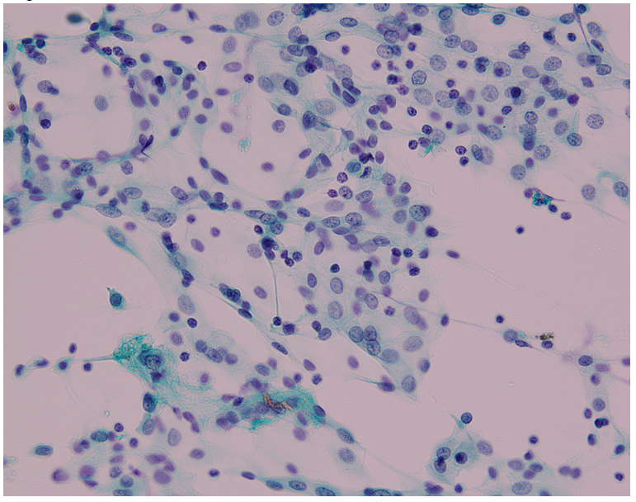
Figure 3 Papanicolaou stain of the peritoneal washing cytology of Douglas’ pouch showed only inflammatory cells (× 40).
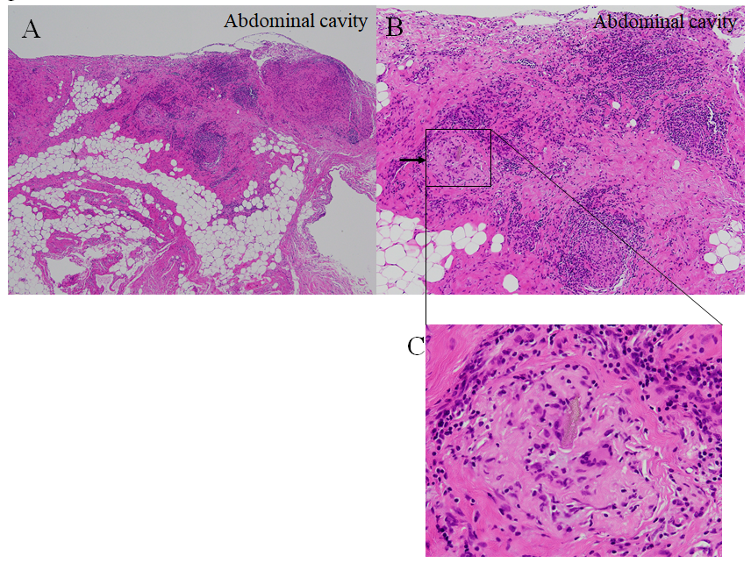
Figure 4 Pathological findings of the small white nodule. Hematoxylin and eosin stain of the nodule. A multinucleated giant cell with a foreign body (arrow) surrounded by monocytes, lymphocytes, and granuloma formations. A: × 40; B: × 100; C: × 200.

Published by Baishideng Publishing Group Inc
7041 Koll Center Parkway, Suite 160, Pleasanton, CA 94566, USA
Telephone: +1-925-3991568
E-mail: bpgoffice@wjgnet.com
Help Desk: https://www.f6publishing.com/helpdesk
https://www.wjgnet.com

© 2021 Baishideng Publishing Group Inc. All rights reserved.

