Name of Journal: World Journal of Gastroenterology
Manuscript NO: 66216
Manuscript Type: CORRECTION

Correction to “Downregulation of FoxM1 inhibits the viability and invasion of gallbladder carcinoma cells, partially dependent on the induction of cellular senescence”

Tao J et al. Correction of the mistakes

Jie Tao, Xin-Sen Xu, Yan-Zhou Song, Chang Liu

Jie Tao, Xin-Sen Xu, Chang Liu, Department of Hepatobiliary Surgery, the First Affiliated Hospital of Medical College, Xi’an Jiaotong University, Xi'an 710061, Shaanxi Province, China

Yan-Zhou Song, Department of General Surgery, Lianyungang First People’s Hospital, Lianyungang 222002, Jiangsu Province, China

Author contributions: Tao J and Xu XS revised the manuscript; Song YZ provided the raw data; Liu C designed the study.

Corresponding author: Chang Liu, MD, Chief Doctor, Department of Hepatobiliary Surgery, the First Affiliated Hospital of Medical College, Xi’an Jiaotong University, No. 277 West Yanta Road, Xi'an 710061, Shaanxi Province, China. liuchangdoctor@163.com

Received: March 30, 2021
Revised: June 2, 2021
Accepted: June 16, 2021
Published online: July 14, 2021

Abstract
We corrected the mistake of Figure 3, and replaced the incorrect images with the correct ones. The “adenovirus” was a typographical error in writing, and should be revised to “lentivirus.”

Key Words: Correction; Unintentional; Mistake; Error; Sorting; Figure

©The Author(s) 2021. Published by Baishideng Publishing Group Inc. All rights reserved.

Citation: Tao J, Xu XS, Song YZ, Liu C. Correction to “Downregulation of FoxM1 inhibits the viability and invasion of gallbladder carcinoma cells, partially dependent on the induction of cellular senescence”. World J Gastroenterol 2021; 27(26): 4246-4247
URL: https://www.wjgnet.com/1007-9327/full/v27/i26/4246.htm
DOI: https://dx.doi.org/10.3748/wjg.v27.i26.4246

Core Tip: We corrected the mistake of Figure 3 and manuscript text.

TO THE EDITOR
We found a mistake in Figure 3^{[1]}. This is an unintentional error that occurred when sorting through the images. We have replaced the incorrect images with the correct Figure 1. This technical error does not change the meaning of the picture or the conclusion of the manuscript. On the other hand, we only used lentivirus in the experiment. The “adenovirus” was a typographical error in writing. We mostly used “lentivirus” in the manuscript. “Adenovirus” should be revised to “lentivirus” in P9497 right column, line 11 and line 27; P9498 right column, line 26; P9499 right column, line 47; Figure 3 and Figure 4 captions. We apologize for our unintentional mistakes, which caused great inconvenience.

REFERENCES
1 Tao J, Xu XS, Song YZ, Qu K, Wu QF, Wang RT, Meng FD, Wei JC, Dong SB, Zhang YL, Tai MH, Dong YF, Wang L, Liu C. Down-regulation of FoxM1 inhibits viability and invasion of gallbladder carcinoma cells, partially dependent on inducement of cellular senescence. World J Gastroenterol 2014; 20: 9497-9505 [PMID: 25071344 DOI: 10.3748/wjg.v20.i28.9497]

Footnotes
Conflict-of-interest statement: There's no conflict of interest.

Open-Access: This article is an open-access article that was selected by an in-house editor and fully peer-reviewed by external reviewers. It is distributed in accordance with the Creative Commons Attribution NonCommercial (CC BY-NC 4.0) license, which permits others to distribute, remix, adapt, build upon this work non-commercially, and license their derivative works on different terms, provided the original work is properly cited and the use is non-commercial. See: http://creativecommons.org/Licenses/by-nc/4.0/

Manuscript source: Unsolicited manuscript

Peer-review started: March 30, 2021
First decision: May 28, 2021
Article in press: June 16, 2021

Specialty type: Oncology
Country/Territory of origin: China
Peer-review report’s scientific quality classification
Grade A (Excellent): 0
Grade B (Very good): B
Grade C (Good): C
Grade D (Fair): 0
Grade E (Poor): 0

P-Reviewer: Chou YC, Fujita-Yoshigaki J S-Editor: Ma YJ L-Editor: Filipodia P-Editor: Liu JH

Figure Legends
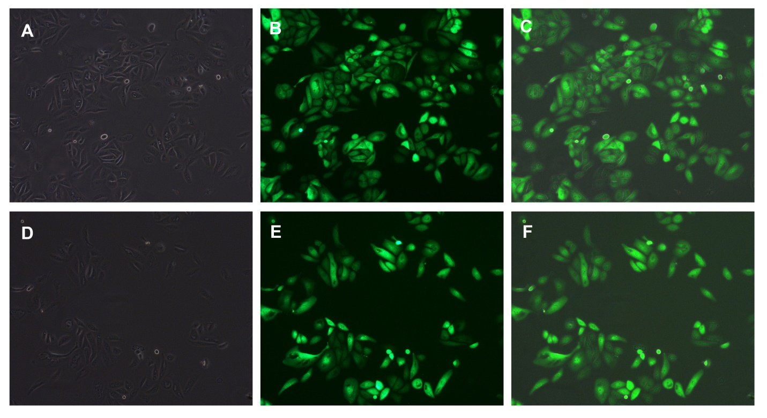
Figure 1 Representative photograph (100 ×) showing recombinant lentivirus transfection efficiency evaluated by fluorescence microscopy (transfected with the negative control, top; transfected with the shF1822, bottom). A and D: Light microscopy; B and E: Fluorescence microscopy; C and F: Superimposed image of the two images.

Published by Baishideng Publishing Group Inc
7041 Koll Center Parkway, Suite 160, Pleasanton, CA 94566, USA
Telephone: +1-925-3991568
E-mail: bpgoffice@wjgnet.com
Help Desk: https://www.f6publishing.com/helpdesk
https://www.wjgnet.com

© 2021 Baishideng Publishing Group Inc. All rights reserved.

