Name of Journal: World Journal of Clinical Cases
Manuscript NO: 48438
Manuscript Type: MINIREVIEWS

Multifocal G1-G2 gastric neuroendocrine tumors: Differentiating between Type I, II and III, a clinicopathologic review

Algashaamy K et al. Multifocal G1-G2 gastric neuroendocrine tumors

Khaled Algashaamy, Monica Garcia-Buitrago

Khaled Algashaamy, Monica Garcia-Buitrago, Department of Pathology and Laboratory Medicine, Jackson Memorial Hospital, University of Miami, Miller School of Medicine, Miami, FL 33136, United States

ORCID number: Khaled Algashaamy (0000-0002-4339-4404); Monica Garcia-Buitrago (0000-0003-1146-4284).

Author contributions: Algashaamy K and Garcia-Buitrago M wrote this review.

Conflict-of-interest statement: The authors have nothing to disclose.

Open-Access: This article is an open-access article which was selected by an in house editor and fully peer-reviewed by external reviewers. It is distributed in accordance with the Creative Commons Attribution Non Commercial (CC BYNC 4.0) license, which permits others to distribute, remix, adapt, build upon this work non-commercially, and license their derivative works on different terms, provided the original work is properly cited and the use is noncommercial. See: http://creativecommons.org/licenses/by-nc/4.0/

Manuscript source: Invited manuscript

Corresponding author: Khaled Algashaamy, MBBS, MD, Doctor, Department of Pathology and Laboratory Medicine, Jackson Memorial Hospital, University of Miami, Miller School of Medicine, Holtz Center, 1611 NW 12th Avenue, Suite 2044, Miami, FL 33136, United States. khaled.algashaamy@jhsmiami.org

Received: April 23, 2019
Peer-review started: May 8, 2019
First decision: May 31, 2019
Revised: July 26, 2019
Accepted: August 20, 2019
Article in press: August 20, 2019
Published online: September 6, 2019

Abstract

Gastric neuroendocrine tumors (gNETs) are a rare entity that is increasing in incidence. Different pathophysiological processes can lead to the development of these tumors, appropriate histological analysis is necessary to differentiate between grade 1 (G1) and grade 2 (G2) tumors as this will impact the management of these patients based on their increased risk of lymph node and distant metastases. To provide a comprehensive clinicopathologic review of multifocal gastric neuroendocrine tumors, with particular emphasis on G1 and G2 tumors and differentiating between types I, II and II and risk stratification based upon immunohistochemical profile. This review is based on peer-reviewed literature and the authors’ experience. gNETs are a heterogenous group of tumors that is rising in incidence. These lesions while arise from the same cell type, they have different etiologies. Identifying the type of gNETs is a collective effort of clinical and pathologic correlation. The correct grading and staging of these lesions are of paramount significance, due its impact on patient management and prognosis.

Key words: Gastric neuroendocrine tumors; Enterochromaffin like cells; Histopathological features; Immunohistochemistry; Diagnosis; Treatment

© The Author(s) 2019. Published by Baishideng Publishing Group Inc. All rights reserved.

Core tip: Gastric neuroendocrine tumors are a rare entity with increasing incidence. Different pathophysiological processes can lead to the development of these tumors, appropriate histological analysis is necessary to differentiate between grade 1 (G1) and grade 2 (G2) tumors as this will impact the management of these patients based on their increased risk of lymph node and distant metastases. In this mini-review article, we aim to provide a comprehensive clinicopathologic review of multifocal gastric neuroendocrine tumors, with particular emphasis on G1 and G2 tumors and differentiating between types I, II and II and risk stratification based upon immunohistochemical profile. We have based this review on peer-reviewed literature and the authors’ experience.

Citation: Algashaamy K, Garcia-Buitrago M. Multifocal G1-G2 gastric neuroendocrine tumors: Differentiating between Type I, II and III, a clinicopathologic review. World J Clin Cases 2019; 7(17):2413-2419
URL: https://www.wjgnet.com/2307-8960/full/v7/i17/2413.htm
DOI: https://dx.doi.org/10.12998/wjcc.v7.i17.2413

INTRODUCTION
Neuroendocrine tumors (NETs) of the gastrointestinal (GI) and pancreaticobiliary tracts are a heterogeneous group of tumors that have a diverse biologic and clinical profile that varies according to the primary tumor site of origin, and its histopathologic features^{[1-4]}. Gastric neuroendocrine tumors (gNETs), which are the product of the neoplastic transformation of the enterochromaffin like cells (ECL) of the gastric mucosa, are a rare and indolent category of neuroendocrine tumors that has witnessed a rise in incidence due to the widespread use of upper digestive endoscopy and the technical refinement of endoscopists^{[5]}. In this article we will review the histopathological features, immunohistochemistry, differential diagnosis, treatment, prognosis and outcome of these lesions.

HISTOPATHOLOGICAL FEATURES
The ECL cells play a fundamental role in the regulation of acid secretion, which is essential to understand the gNET classification into subtypes, each with distinct management and prognosis. Following food intake, the G cells of the antrum secrete gastrin which in turn stimulates the ECL cells along with the histamine-producing parietal cells to secrete hydrochloric acid (HCL), this phase is inhibited through a negative feedback mechanism that comes from the D cells, which through HCL acid stimulation secrete somatostatin reducing the secretion of gastrin^{[6]}.
Gastric neuroendocrine tumors are classified based on their location, syndromic association, clinical behavior and demographic profile, as follows.

Type I
These lesions correspond to the majority of gNETs found in the stomach (70%-80%), they are usually multiple small nodules/polyps in the gastric body and are limited to the mucosa and submucosa. These lesions are usually found in association with autoimmune chronic atrophic gastritis. The presence of anti-parietal cell or anti-intrinsic factor antibodies leads to the destruction of the parietal cells reducing the level of hydrochloric acid (achlorhydria), which in turn eliminates the negative feedback inhibition of gastrin production by G cells leading to hypergastrinemia, this excess hormone production favors the appearance of multiple small lesions that are generally indolent and may regress. Lymph node metastases are very rare and occur only when the tumors are large (greater than 2 cm) and infiltrate the muscularis propria. These characteristics give these tumors a little aggressive behavior; however, they have an overall good prognosis^{[7]}. They are clinically associated with pernicious or megaloblastic anemia due to the body’s inability to absorb vitamin B12 secondary to a decrease in intrinsic factor^{[8]}. The findings on upper GI endoscopy include soft yellowish and transparent vasculature seen in the antral mucosa, contrasting with the smooth, erythematous looking mucosa of normal areas. The neuroendocrine tumors are seen as minute (less than 1-2 cm) and frequently multiple polyps (Figure 1). Histologic examination shows atrophied gastric oxyntic mucosa with occasional intestinal, pseudopyloric or pancreatic acinar metaplasia with nodules that are composed of sheets or nests of neuroendocrine cells. When these nodules measure less than 5 mm in greatest linear dimension, they should be named neuroendocrine microadenomas, rather than neuroendocrine tumors. These tumors usually exhibit nil mitotic activity and a low Ki67 proliferation index of less than 3%, compatible with well differentiated neuroendocrine tumors, grade 1 (G1) (Figure 1 and Figure 2).

Type II
These lesions account for 7% of gNETS, they are usually small, multiple tumors and have a bimodal age distribution affecting young adults with multiple endocrine neoplasia type 1 (MEN1), Zollinger-Ellison syndrome and older adults. MEN1 is a tumor suppressor gene present at 11q13 locus, the transcription product of MEN1 gene is the Menin protein^{[9-13]}. Biallelic inactivation through a mutation in 1 allele of MEN1, coupled with the loss of the remaining wild type allele is identified in about 90% of gNETS of this type^{[14]}. Upper GI endoscopy reveals multiple tumors measuring less than 2 cm noted in the body or fundus of the stomach and an adjacent normal or hypertrophic gastric mucosa with clinical findings of hypergastrinemia and low gastric PH (hyperchlorhydria)^{[15]}. Serial measurements of serum gastrin levels following intravenous administration of secretin can be performed and show an increase in gastrin levels for patients with gastrinoma, while a decrease in gastrin levels is seen in healthy individuals. Histopathologic examination demonstrates a gastric oxyntic mucosa with increased oxyntic cell mass due to uninhibited gastrin stimulation along with nodules of neuroendocrine tumor nests that have negligible mitotic activity, absent necrosis and typically a low Ki67 proliferation index (less than 3%) compatible with a well differentiated neuroendocrine tumor, G1 and rarely a G2 in the advent of a Ki67proliferation index between 3% to 20%. In contrast to type I tumors, 10%-30% metastasize. Neuroendocrine microadenomatosis is a common feature of MEN1.Tumors greater than 2 cm that invade the muscularis propria and exhibit vascular invasion are more likely to metastasize.

Type III
These lesions are sporadic tumors and are the second most common gNET. They occur in the absence of ECL cell hyperplasia and are not associated with hypergastrinemia, chronic atrophic gastritis, MEN1 or Zollinger- Ellison syndrome. Upper endoscopy reveals a single solitary lesion, greater than 2 cm, that can be located in any part of the stomach. Histopathologic examination shows cords and nests of tumor cells. Many cases show intermediate cytological atypia characterized by abundant amphophilic cytoplasm, enlarged nuclei with open chromatin and prominent nucleoli, single cell apoptosis or extensive necrosis can be identified along with a Ki67 proliferation index in excess of 3%, thereby making these tumors G2 or in rare occasions G3 when the Ki67 index exceeds the 20% threshold. Metastases are common and are associated with larger size, angioinvasion, and invasion of the muscularis propria.

IMMUNOHISTOCHEMISTRY
Endocrine cells of the GI and pancreaticobiliary tracts and NETs are labelled by neuroendocrine markers, including CD56/NCAM1, leu7/B3GAT1, protein gene product 9.5 (PGP9.5), neuron specific enolase, synaptophysin and chromogranin A. It is considered that synaptophysin is the most sensitive, and chromogranin A is the most specific of the neuroendocrine markers. Therefore, in the majority of practices those two markers are used to determine neuroendocrine differentiation. The other stains mentioned are not commonly used, due to their low sensitivity and specificity^{[16]}. Grading of NETs is done using the Ki67 proliferation index, as recommended by the World Health Organization (WHO) classification of neuroendocrine tumors (2010 and most recently in 2017), the labelling index should be measured in 500-2000 cells in the most proliferative “hot spot” areas^{[17]}. Indices that are less than 3% are considered a G1 tumor, indices that are between 3% and 20% are considered G2 tumors and those that have a Ki67 proliferation index higher than 20% are considered to be G3 lesions, based on the latest (2017) WHO recommendation. The mitotic count is also used in the grading of these tumors, grade 1 tumors have less than 2/10 HPF, grade 2 tumors have 2-20/10 HPF, and grade 3 tumors have more than 20/10 HPF (based on 2017 WHO recommendation). Cases with discrepancies between the Ki67 proliferation index and the mitotic count comprise one third of the cases; and in these cases, the higher grade should be selected^{[18]}. Combined, these two features have been shown to reflect the clinical behavior and prognosis of these tumors^{[19,20]}.

PROGNOSIS AND PREDICTIVE FACTORS
The prognosis of patients with gNETs is highly variable. According to the WHO, these neoplasms are classified into different grades with distinct prognosis. Histologic features that correlate with a favorable prognosis include the following: (a) growth within the mucosa-submucosa interface; (b) absence of angioinvasion; (c) lesion size less than 1 cm; (d) absence of endocrine syndrome on clinical evaluation; and (e) low mitotic activity^{[21,22]}. Tumor related deaths in Type I lesions are only observed in exceptional situations, while 1 out of 10 patients have died from Type II lesions. On the other hand, type III lesions carried a mortality rate of 27% with a mean survival of 28 mo^{[23]}.

STAGING AND TREATMENT
CT scan is recommended for type I and type II lesions that are larger than 2 cm and for all type III lesions. The use of magnetic resonance imaging of the abdomen, octreotide scintigraphy and PET-CT is limited for specific cases^{[24]}. According to the AJCC (8th edition), lymph node metastases (N1) are detected in about 5% of type I, 30% of type II and 71% of type III, while distant (liver) metastases (M1) are found in 2.5%, 10% and 69% of cases of type I, II and III, respectively^{[25]}. Therefore, the majority of ECL cell NETs of type I and II are considered to be stage I, i.e., T1 N0 M0, and only a selected few would be stage IIa or T2 N0 M0. On the other hand, most type III lesions fit stages IIa, IIb (T3 N0 M0), IIIa (T4 N0 M0), IIIb (T1 N1 M0) or even IV (any T, any N, M0)^{[26]}.
Treatment of gNETs is a multifaceted approach, depending on the clinical type, disease extent, degree of differentiation of the lesion and the presence or absence of poor prognostic indicators. Type I lesions are treated by endoscopic mucosal resection as most of these lesions are small, well differentiated and exhibits excellent prognosis^{[27]}. Supplementing Vit B12 is also recommended. Surgical treatment of type I gNETs is reserved for cases in which endoscopic resection is not feasible or when poor prognostic indicators are present. The choice of the best surgery (i.e., antrectomy, subtotal or total gastrectomy) for these lesions is also controversial^{[28]}. Antrectomy has been proposed to remove the gastrin producing G cells; however, failure may occur due to improper removal of those cells or because the ECL cells have become autonomous. This led to the suggestion of subtotal gastrectomy to allow adequate removal of the G cells while reserving total gastrectomy for those cases with substantial disease in the gastric fundus^{[29]}. Clinical management for type I gNETs while available, is hardly an effective option for long term management. The use of somatostatin analogue (octreotide) has been attempted by some authors; however, following discontinuation of the treatment it was noted that follow-up serum gastrin levels increased, and the tumor progressed^{[30,31]}. Type II lesions are usually treated by localizing and resecting the gastrinoma. Type III lesions are treated more aggressively with treatments including but not limited to subtotal, or total gastrectomies (depending on the location) with associated lymphadenectomy. The presence of metastatic disease in the liver is treated by resection if present in a resectable location otherwise arterial embolization or radioablation have a success rate of 50%^{[32]}. In cases of type III lesions with extrahepatic metastasis or recurrent disease, systemic cytotoxic chemotherapy or molecular targeted agents can be introduced.

CONCLUSION
gNETs are a group of tumors that are witnessing a rise in incidence of diagnosis due to an increase in upper GI endoscopy, and refinement of the endoscopic techniques. Those lesions while arise from the same group of cells, are different in etiology and therefore differ in the natural disease progression. Identifying the type of gNETs is a collective effort of clinical and pathologic correlation, the correct grading and staging of these lesions is of paramount significance, due its impact on patient management and prognosis. Finally, it is worth noting that this area of digestive pathology is an active area of research and studies that will clarify the disease biology and improve its management.

REFERENCES
1 Gastrointestinal Pathology Study Group of Korean Society of Pathologists, Cho MY, Kim JM, Sohn JH, Kim MJ, Kim KM, Kim WH, Kim H, Kook MC, Park DY, Lee JH, Chang H, Jung ES, Kim HK, Jin SY, Choi JH, Gu MJ, Kim S, Kang MS, Cho CH, Park MI, Kang YK, Kim YW, Yoon SO, Bae HI, Joo M, Moon WS, Kang DY, Chang SJ. Current Trends of the Incidence and Pathological Diagnosis of Gastroenteropancreatic Neuroendocrine Tumors (GEP-NETs) in Korea 2000-2009: Multicenter Study. Cancer Res Treat 2012; 44: 157-165 [PMID: 23091441 DOI: 10.4143/crt.2012.44.3.157]
2 Klimstra DS, Modlin IR, Coppola D, Lloyd RV, Suster S. The pathologic classification of neuroendocrine tumors: a review of nomenclature, grading, and staging systems. Pancreas 2010; 39: 707-712 [PMID: 20664470 DOI: 10.1097/MPA.0b013e3181ec124e]
3 Klöppel G, Couvelard A, Perren A, Komminoth P, McNicol AM, Nilsson O, Scarpa A, Scoazec JY, Wiedenmann B, Papotti M, Rindi G, Plöckinger U; Mallorca Consensus Conference participants; European Neuroendocrine Tumor Society. ENETS Consensus Guidelines for the Standards of Care in Neuroendocrine Tumors: towards a standardized approach to the diagnosis of gastroenteropancreatic neuroendocrine tumors and their prognostic stratification. Neuroendocrinology 2009; 90: 162-166 [PMID: 19060454 DOI: 10.1159/000182196]
4 Klöppel G, Perren A, Heitz PU. The gastroenteropancreatic neuroendocrine cell system and its tumors: the WHO classification. Ann N Y Acad Sci 2004; 1014: 13-27 [PMID: 15153416 DOI: 10.1196/annals.1294.002]
5 Burkitt MD, Pritchard DM. Review article: Pathogenesis and management of gastric carcinoid tumours. Aliment Pharmacol Ther 2006; 24: 1305-1320 [PMID: 17059512 DOI: 10.1111/j.1365-2036.2006.03130.x]
6 Dias AR, Azevedo BC, Alban LBV, Yagi OK, Ramos MFKP, Jacob CE, Barchi LC, Cecconello I, Ribeiro U Jr, Zilberstein B. Gastric Neuroendocrine Tumor: Review and Update. Arq Bras Cir Dig 2017; 30: 150-154 [PMID: 29257854 DOI: 10.1590/0102-6720201700020016]
7 Modlin IM, Kidd M, Latich I, Zikusoka MN, Shapiro MD. Current status of gastrointestinal carcinoids. Gastroenterology 2005; 128: 1717-1751 [PMID: 15887161 DOI: 10.1053/j.gastro.2005.03.038]
8 Hung OY, Maithel SK, Willingham FF, Farris AB 3rd, Kauh JS. Hypergastrinemia, type 1 gastric carcinoid tumors: diagnosis and management. J Clin Oncol 2011; 29: e713-e715 [PMID: 21747088 DOI: 10.1200/JCO.2011.35.3235]
9 Bale SJ, Bale AE, Stewart K, Dachowski L, McBride OW, Glaser T, Green JE 3rd, Mulvihill JJ, Brandi ML, Sakaguchi K. Linkage analysis of multiple endocrine neoplasia type 1 with INT2 and other markers on chromosome 11. Genomics 1989; 4: 320-322 [PMID: 2565877 DOI: 10.1016/0888-7543(89)90336-4]
10 Chandrasekharappa SC, Guru SC, Manickam P, Olufemi SE, Collins FS, Emmert-Buck MR, Debelenko LV, Zhuang Z, Lubensky IA, Liotta LA, Crabtree JS, Wang Y, Roe BA, Weisemann J, Boguski MS, Agarwal SK, Kester MB, Kim YS, Heppner C, Dong Q, Spiegel AM, Burns AL, Marx SJ. Positional cloning of the gene for multiple endocrine neoplasia-type 1. Science 1997; 276: 404-407 [PMID: 9103196 DOI: 10.1126/science.276.5311.404]
11 Debelenko LV, Emmert-Buck MR, Zhuang Z, Epshteyn E, Moskaluk CA, Jensen RT, Liotta LA, Lubensky IA. The multiple endocrine neoplasia type I gene locus is involved in the pathogenesis of type II gastric carcinoids. Gastroenterology 1997; 113: 773-781 [PMID: 9287968 DOI: 10.1016/S0016-5085(97)70171-9]
12 Larsson C, Skogseid B, Oberg K, Nakamura Y, Nordenskjöld M. Multiple endocrine neoplasia type 1 gene maps to chromosome 11 and is lost in insulinoma. Nature 1988; 332: 85-87 [PMID: 2894610 DOI: 10.1038/332085a0]
13 Agarwal SK, Guru SC, Heppner C, Erdos MR, Collins RM, Park SY, Saggar S, Chandrasekharappa SC, Collins FS, Spiegel AM, Marx SJ, Burns AL. Menin interacts with the AP1 transcription factor JunD and represses JunD-activated transcription. Cell 1999; 96: 143-152 [PMID: 9989505 DOI: 10.1016/S0092-8674(00)80967-8]
14 Kim JY, Hong SM. Recent Updates on Neuroendocrine Tumors From the Gastrointestinal and Pancreatobiliary Tracts. Arch Pathol Lab Med 2016; 140: 437-448 [PMID: 27128301 DOI: 10.5858/arpa.2015-0314-RA]
15 Pritchard DM. Zollinger-Ellison syndrome: still a diagnostic challenge in the 21st century? Gastroenterology 2011; 140: 1380-1383 [PMID: 21443889 DOI: 10.1053/j.gastro.2011.03.026]
16 Cockburn AN, Morgan CJ, Genta RM. Neuroendocrine proliferations of the stomach: a pragmatic approach for the perplexed pathologist. Adv Anat Pathol 2013; 20: 148-157 [PMID: 23574771 DOI: 10.1097/PAP.0b013e31828d185d]
17 Klimstra DS, Modlin IR, Adsay NV, Chetty R, Deshpande V, Gönen M, Jensen RT, Kidd M, Kulke MH, Lloyd RV, Moran C, Moss SF, Oberg K, O'Toole D, Rindi G, Robert ME, Suster S, Tang LH, Tzen CY, Washington MK, Wiedenmann B, Yao J. Pathology reporting of neuroendocrine tumors: application of the Delphic consensus process to the development of a minimum pathology data set. Am J Surg Pathol 2010; 34: 300-313 [PMID: 20118772 DOI: 10.1097/PAS.0b013e3181ce1447]
18 Rindi G, Klöppel G, Couvelard A, Komminoth P, Körner M, Lopes JM, McNicol AM, Nilsson O, Perren A, Scarpa A, Scoazec JY, Wiedenmann B. TNM staging of midgut and hindgut (neuro) endocrine tumors: a consensus proposal including a grading system. Virchows Arch 2007; 451: 757-762 [PMID: 17674042 DOI: 10.1007/s00428-007-0452-1]
19 McCall CM, Shi C, Cornish TC, Klimstra DS, Tang LH, Basturk O, Mun LJ, Ellison TA, Wolfgang CL, Choti MA, Schulick RD, Edil BH, Hruban RH. Grading of well-differentiated pancreatic neuroendocrine tumors is improved by the inclusion of both Ki67 proliferative index and mitotic rate. Am J Surg Pathol 2013; 37: 1671-1677 [PMID: 24121170 DOI: 10.1097/PAS.0000000000000089]
20 Hochwald SN, Zee S, Conlon KC, Colleoni R, Louie O, Brennan MF, Klimstra DS. Prognostic factors in pancreatic endocrine neoplasms: an analysis of 136 cases with a proposal for low-grade and intermediate-grade groups. J Clin Oncol 2002; 20: 2633-2642 [PMID: 12039924 DOI: 10.1200/JCO.2002.10.030]
21 Pape UF, Jann H, Müller-Nordhorn J, Bockelbrink A, Berndt U, Willich SN, Koch M, Röcken C, Rindi G, Wiedenmann B. Prognostic relevance of a novel TNM classification system for upper gastroenteropancreatic neuroendocrine tumors. Cancer 2008; 113: 256-265 [PMID: 18506737 DOI: 10.1002/cncr.23549]
22 Norton JA, Melcher ML, Gibril F, Jensen RT. Gastric carcinoid tumors in multiple endocrine neoplasia-1 patients with Zollinger-Ellison syndrome can be symptomatic, demonstrate aggressive growth, and require surgical treatment. Surgery 2004; 136: 1267-1274 [PMID: 15657586 DOI: 10.1016/j.surg.2004.06.057]
23 Rindi G, Azzoni C, La Rosa S, Klersy C, Paolotti D, Rappel S, Stolte M, Capella C, Bordi C, Solcia E. ECL cell tumor and poorly differentiated endocrine carcinoma of the stomach: prognostic evaluation by pathological analysis. Gastroenterology 1999; 116: 532-542 [PMID: 10029611 DOI: 10.1016/S0016-5085(99)70174-5]
24 Rindi G, Bordi C, Rappel S, La Rosa S, Stolte M, Solcia E. Gastric carcinoids and neuroendocrine carcinomas: pathogenesis, pathology, and behavior. World J Surg 1996; 20: 168-172 [PMID: 8661813 DOI: 10.1007/s002689900026]
25 Rindi G, Luinetti O, Cornaggia M, Capella C, Solcia E. Three subtypes of gastric argyrophil carcinoid and the gastric neuroendocrine carcinoma: a clinicopathologic study. Gastroenterology 1993; 104: 994-1006 [PMID: 7681798 DOI: 10.1016/0016-5085(93)90266-F]
26 Borch K, Ahrén B, Ahlman H, Falkmer S, Granérus G, Grimelius L. Gastric carcinoids: biologic behavior and prognosis after differentiated treatment in relation to type. Ann Surg 2005; 242: 64-73 [PMID: 15973103 DOI: 10.1097/01.sla.0000167862.52309.7d]
27 Sundin A, Vullierme MP, Kaltsas G, Plöckinger U; Mallorca Consensus Conference participants; European Neuroendocrine Tumor Society. ENETS Consensus Guidelines for the Standards of Care in Neuroendocrine Tumors: radiological examinations. Neuroendocrinology 2009; 90: 167-183 [PMID: 19077417 DOI: 10.1159/000184855]
28 Rindi G, Klöppel G, Alhman H, Caplin M, Couvelard A, de Herder WW, Erikssson B, Falchetti A, Falconi M, Komminoth P, Körner M, Lopes JM, McNicol AM, Nilsson O, Perren A, Scarpa A, Scoazec JY, Wiedenmann B; all other Frascati Consensus Conference participants; European Neuroendocrine Tumor Society (ENETS). TNM staging of foregut (neuro)endocrine tumors: a consensus proposal including a grading system. Virchows Arch 2006; 449: 395-401 [PMID: 16967267 DOI: 10.1007/s00428-006-0250-1]
29 Gladdy RA, Strong VE, Coit D, Allen PJ, Gerdes H, Shia J, Klimstra DS, Brennan MF, Tang LH. Defining surgical indications for type I gastric carcinoid tumor. Ann Surg Oncol 2009; 16: 3154-3160 [PMID: 19727959 DOI: 10.1245/s10434-009-0687-y]
30 Zilberstein B, Malheiros C, Lourenço LG, Kassab P, Jacob CE, Weston AC, Bresciani CJ, Castro O, Gama-Rodrigues J; Grupo do Consenso, Borin AA, Buchpiegel C, Montagnini A, Leite CV, Deutsch CR, Kruel CD, Mucerino D, Wohnrath D, Ilias E, Mrué F, Maluf-Filho F, Rocha F, de Souza F, Tomasich FS, Ishak G, Laporte G, de Souza HP, Cecconello I, Eisig J, Ohana J, Sabagga J, del Grande JC, de Jesus JP, Soares J, Dias LA, Moreira LF, Correa M, Carvalho M, Andreollo NA, Áquila ND, Czeczko NG, Kruel N, Forones NM, da Motta OM, Malafaia O, Assumpção P, Leonardi P, Sakai P, Rocha PR, Colleoni R, Gurgel R, Coral RP, Chalub S, Ribeiro- Junior U, Alves VA, Vasquez Vde L, Nadalin V; Brazilian Association of Gastric Cancer. Brazilian consensus in gastric cancer: guidelines for gastric cancer in Brazil. Arq Bras Cir Dig 2013; 26: 2-6 [PMID: 23702862 DOI: 10.1590/S0102-67202013000100002]
31 Dakin GF, Warner RR, Pomp A, Salky B, Inabnet WB. Presentation, treatment, and outcome of type 1 gastric carcinoid tumors. J Surg Oncol 2006; 93: 368-372 [PMID: 16550587 DOI: 10.1002/jso.20468]
32 Grozinsky-Glasberg S, Kaltsas G, Gur C, Gal E, Thomas D, Fichman S, Alexandraki K, Barak D, Glaser B, Shimon I, Gross DJ. Long-acting somatostatin analogues are an effective treatment for type 1 gastric carcinoid tumours. Eur J Endocrinol 2008; 159: 475-482 [PMID: 18662970 DOI: 10.1530/EJE-08-0420]
P-Reviewer: Aoyagi K, Goral V S-Editor: Wang JL L-Editor: A E-Editor: Qi LL

Specialty type: Medicine, research and experimental
Country of origin: United States
Peer-review report classification
Grade A (Excellent): 0
Grade B (Very good): 0
Grade C (Good): C
Grade D (Fair): D
Grade E (Poor): 0

Table 1 Features of Types I, II and III gastric neuroendocrine tumors
 | Location | Clinical association | Metastasis | Ki67 proliferation index | Prognosis | Size
Type I | Body | Pernicious anemia; Atrophic Gastritis | Rare | < 3% | Good | Variable < 1-2 cm
Type II | Body | Multiple Endocrine Neoplasia type 1, Zollinger-Ellison syndrome | 10%-30% metastasize | < 3%; Rarely 3%-20% | Variable prognosis but overall benign behavior | < 2cm
Type III | Any part of stomach | No clinical association | Very common | 3%-20%; Rarely >20% | Aggressive behavior | > 2cm

Table 2 Grading system of well-differentiated neuroendocrine tumors according to the 2017 World Health Organization classification
Neuroendocrine tumor | Mitotic index | Ki67 proliferation index
Neuroendocrine tumor (G1) (well differentiated) | < 2 | < 3%
Neuroendocrine tumor (G2) (well differentiated) | 2-20 | 3%-20%
Neuroendocrine tumor (G3) (well | > 20 | > 20%

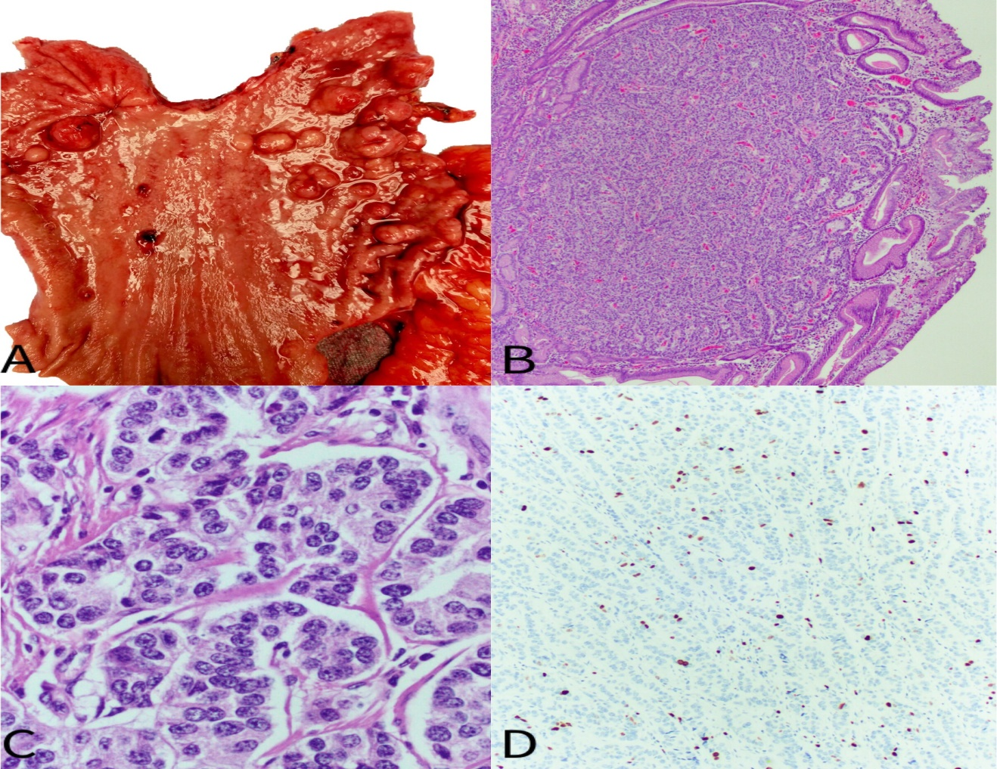

Figure 1 The neuroendocrine tumors are seen as minute (less than 1-2 cm) and frequently multiple polyps. A: Gastrectomy specimen with multiple nodules/polyps, ranging in size from 0.5 mm to 2 cm; B: Gastric mucosa showing a neuroendocrine tumor (HE, 40×); C: Nested groups of cells with nuclei showing “salt and pepper” chromatin and no mitotic activity (HE, 400×); D: Ki67 proliferation index of less than 3%, consistent with a well differentiated neuroendocrine tumor G1 (Ki67 immunostain, 200×).

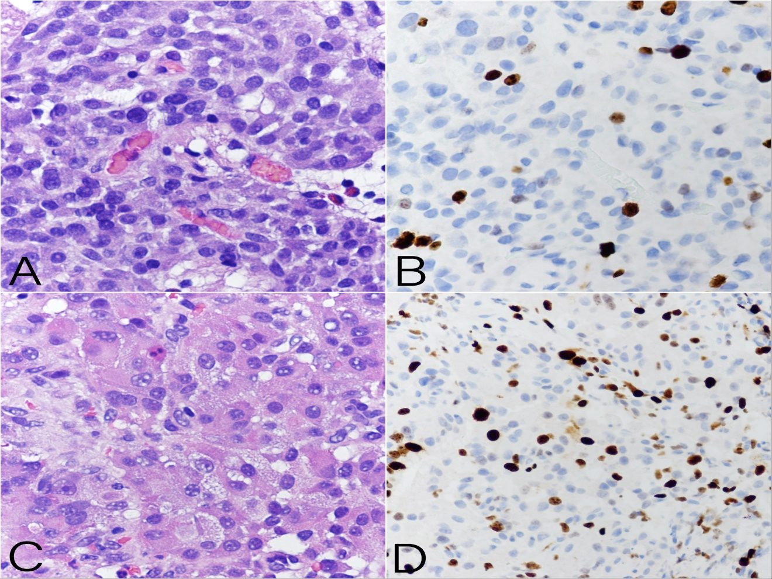
Figure 2 Tumors usually exhibit nil mitotic activity and a low Ki67 proliferation index of less than 3%, compatible with well differentiated neuroendocrine tumors, grade 1. A: A nodule of neuroendocrine tumor nest of cells with nuclei showing “salt and pepper” chromatin with negligible mitotic activity and absent necrosis (HE, 400×); B: Ki67 proliferation index of 5%, consistent with a well differentiated neuroendocrine tumor G2 (Ki67 immunostain, 400×); C: Nest of tumors cells, arranged in nodules, showing intermediate grade cytological atypia characterized by abundant amphophilic cytoplasm, enlarged nuclei with open chromatin and nucleoli; D: Ki67 proliferation index of more than 20%, consistent with a well differentiated neuroendocrine tumor G3 (Ki67 immunostain, 400×).

