Name of Journal: World Journal of Clinical Cases
Manuscript NO: 64089
Manuscript Type: CASE REPORT

Adult rhabdomyosarcoma originating in the temporal muscle, invading the skull and meninges: a case report

Wang GH et al. Adult temporal muscle rhabdomyosarcoma

Geng-Huan Wang, He-Ping Shen, Zheng-Min Chu, Jian Shen

Geng-Huan Wang, Zheng-Min Chu, Jian Shen, Department of neurosurgery, the second affiliated hospital of jiaxing university, jiaxing 314000, Zhejiang Province, China

He-Ping Shen, Department of neurology, the second affiliated hospital of jiaxing university, jiaxing 314000, Zhejiang Province, China

Author contributions: Wang GH and Chu ZM designed the research; Shen J and Chu ZM performed the research; Shen HP analyzed the data; Wang GH and Shen HP contributed to manuscript drafting; all authors approved the submission of the final version.

Corresponding author: Zheng-Min Chu, MD, Dean, Doctor, Senior Researcher, Department of neurosurgery, the second affiliated hospital of jiaxing university, No. 1518 North part of the ring road, jiaxing 314000, Zhejiang Province, China. chuzhengmin@163.com

Received: February 8, 2021
Revised: March 13, 2021
Accepted: May 7, 2021
Published online: June 26, 2021

Abstract
BACKGROUND
Rhabdomyosarcoma (RMS) is a rare malignant tumor of mesenchymal origin that mainly affects children. Spindle cell/sclerosing RMS (SSRMS) is even rarer. It is a new subtype that was added to the World Health Organization disease classification in 2013. To the best of our knowledge, this is the first reported case of adult SSRMS disease classification originating in the temporal muscle.

CASE SUMMARY
SSRMS originating in the temporal muscle of a male adult enlarged rapidly, destroyed the skull, and invaded the meninges. The tumor was completely removed, and the postoperative pathological diagnosis was SSRMS. Postoperative recovery was good and chemotherapy and radiotherapy were given after the operation. Followed up for 3 mo, no tumor recurred.

CONCLUSION
RMS is one of the differential diagnoses for head soft tissue tumors with short-term enlargement and skull infiltration. Preoperative computed tomography or magnetic resonance imaging is necessary for early detection of tumor invasion of the skull and brain tissue.

Key Words: Rhabdomyosarcoma; Temporal Muscle; Skull; Dura Mater; Adult; case report

©The Author(s) 2021. Published by Baishideng Publishing Group Inc. All rights reserved.

Citation: Wang GH, Shen HP, Chu ZM, Shen J. Adult rhabdomyosarcoma originating in the temporal muscle, invading the skull and meninges: a case report. World J Clin Cases 2021; 9(18): 4866-4872
URL: https://www.wjgnet.com/2307-8960/full/v9/i18/4866.htm
DOI: https://dx.doi.org/10.12998/wjcc.v9.i18.4866

Core Tip: Rhabdomyosarcoma (RMS) is a rare malignant tumor of mesenchymal origin that mainly affects children. Spindle cell/sclerosing RMS (SSRMS) is even rarer. We describe an adult case of SSRMS originating in the temporal muscle. The tumor rapidly enlarged, destroyed the skull, and invaded the meninges. The tumor was completely removed. The postoperative pathological diagnosis was SSRMS. This case report provides complete imaging data of tumor progression. To our knowledge, this case is the first reported adult SSRMS originating from the temporal muscle.

INTRODUCTION
Rhabdomyosarcoma (RMS) is a rare, highly aggressive, rapidly growing mesenchymal malignancy that is more common in children^{[1]}. Spindle cell/sclerosing RMS (SSRMS) is even rarer. It is a new subtype that was added to the disease classification of the World Health Organization (WHO) in 2013. RMS mainly occurs in the head and neck area^{[2]}. It is very rare that RMS originates from the temporal muscle. We report a case of adult SSRMS that originated from the temporal muscle, destroyed the skull, and invaded the dura mater. As far as we know, there have been no previous reports of a case like this one.

CASE PRESENTATION
Chief complaints
A 55-year-old male patient was admitted to our hospital with a lump in the left temporal region.

History of present illness
Two months prior to admission, the patient noticed a lump in his left temporal scalp. The patient had no headaches or nausea and vomiting. The patient came to the outpatient department. A computed tomography (CT) scan was done and surgery was recommended, but the patient refused. The tumor grew slowly.

History of past illness
The patient had a 2-year history of hypertension.

Personal and family history
The patient had a 10-year history of smoking. He denied any family history.

Physical examination
Physical examination revealed a 6 cm × 7 cm hard, painless mass in the left temporal region. There was no redness or swelling on the surface of the mass.

Laboratory examinations
Laboratory examination, including liver and renal functions, blood counts, electrolytes, and coagulation function were normal. Serum tumor markers, HIV antibody, tuberculosis, and syphilis were negative.

Imaging examinations
The first CT showed a subcutaneous mass in the left temporal region (Figure 1). The second CT revealed that the mass was enlarged and the adjacent skull was destroyed (Figure 2). Magnetic resonance imaging (MRI) revealed a mass in the left temporal muscle, with obvious enhancement around the tumor, but no enhancement in the center of the tumor (Figure 3).

FINAL DIAGNOSIS
The patient was admitted to our hospital with a diagnosis of left temporal soft tissue sarcoma, and metastatic tumor could not be ruled out. The pathology finding was SSRMS.

TREATMENT
The tumor was resected. During the operation, it was found that the tumor originated from the temporal muscle and had destroyed the skull and invaded the meninges. The tumor was completely removed with negative margins, and part of the skull and meninges were removed. Pathological evaluation of intraoperative frozen sections revealed malignant tumors, so cranioplasty was not performed. Chemotherapy and radiotherapy were given after the operation. Eight cycles of vincristine, ifosfamide, and etoposide were planned. A total of 50.4 Gy of radiation was administered.

OUTCOME AND FOLLOW-UP
The postoperative recovery was good. Tumor recurrence was not seen at the 3 mo follow-up. Pathological examination revealed that the tumor was composed of mildly atypical spindle cells arranged in a crossed bundle or spiral. A few rhabdomyoblasts were scattered among the spindle cells (Figure 4). Immunohistochemistry showed desmin (+), MyoD1 (+), Ki-67 (+) 60%, CD10 (+), SMA (-), GFAP (-), myosin (-), S-100 (-), GFAP (-), TLE (-), and s (-) cells (Figure 5). The diagnosis was SSRMS.

DISCUSSION
Weber first reported RMS in 1854^{[3]}. RMS is one of the most common tumors of children, about 250 new cases in children each year^{[1]}. The age of onset has two peaks. The first is at 2 to 6 years of age and the second is at 14 to 18 years of age^{[2,4]}. The median age is about 7 years^{[4]}. Seventy percent of patients are younger than 10 years of age^{[5]}. RMS has a very low incidence, and a high mortality rate, in adults^{[6]}.
RMS can originate from primitive mesenchymal cells anywhere in the body. Interestingly, most RMS tumors do not occur in muscles, but in areas where there is no muscle^{[2]}. About 40% of RMSs occur in the head and neck region^{[2]}, followed by the urogenital tract, retroperitoneum, and limbs. The most common origins of head RMS are the orbits, nasopharynx, paranasal sinuses, middle ear, and external auditory canal^{[2,7]}. The orbit is the most common single primary site^{[8]}. This case originated from the temporal muscle, destroyed the skull, and invaded the meninges. Adult RMS is very rare in clinical practice. As far as we know, no similar case has been reported in the literature.
Traditionally, three main RMS subtypes, embryonic, alveolar, and polymorphic, are recognized. However, other variants have been described, including SSRMS^{[9]}. SSRMS was added to the WHO disease classification in 2013. This case was diagnosed as SSRMS based on pathological findings and immunohistochemistry. RMS mostly manifests as a rapidly increasing mass that can invade nearby tissues and metastasize to distant sites. The main clinical features of this case of RMS were a fast-growing painless temporal muscle mass, destruction of the skull, invasion of meninges, and normal skin. The imaging findings of SSRMS have definitive characteristics. In this case, enhanced MRI showed obvious enhancement around the tumor, but the tumor center had an extremely low signal, and no enhancement, similar to the characteristics described by Freling et al^{[10]}.
RMS usually requires a variety of treatment modalities, depending on the tumor location, size, and metastasis^{[11]}. It is usually recommended to completely remove the tumor if surgery will not cause significant loss of function^{[12]}. Survival is better if a definite negative surgical margin is achieved^{[13]}, but in many cases, the tumor cannot be completely removed, and only biopsy is possible. The prognosis of RMS is related to age, site of origin, tumor size, and metastasis^{[14,15]}. Chemotherapy can shrink tumors and reduce large tumors that cannot be completely resected to the extent that they are easier to remove^{[11]}. RMS can easily metastasize to the bone marrow, and some small tumors that cannot be detected by imaging examinations may have spread to other parts of the body, which is why chemotherapy is needed^{[16]}. Positive margins after MRS surgery will result in a higher local failure rate^{[17]}. Radiotherapy can reduce the local failure rate after MRS surgery. Studies found that in patients receiving radiotherapy, there was no correlation between positive margins and local recurrence^{[17]}.
The prognosis of RMS is significantly improved by more aggressive comprehensive treatment. The 5-year disease-free survival rates of early and late localized tumors are 81%^{[18]} and 41%^{[19]} respectively. Maurer et al^{[20]} reported that the 5-year survival rates were 92% for orbital tumors, 81% FOR non-parameningeal tumors, and 69% FOR parameningeal tumors. If RMS invades the meninges, brain, and cranial nerves, the prognosis is extremely poor, often with rapid recurrence after surgical resection^{[21]} and a median survival of 5-9 mon^{[22]}. Among the reported cases, there was no 5-year survival^{[23,24]}. In this case, chemotherapy and radiotherapy were still given even though although the tumor was completely resected because the tumor had invaded the meninges. Some authors recommend radical resection supplemented with radiation and chemotherapy^{[25]}.

CONCLUSION
Adult SSRMS originating in the soft tissues of the scalp is very rare. To our knowledge, this is the first reported case of SSRMS originating from the temporal muscle in an adult. It destroyed the skull and invaded the meninges. RMS is one of the differential diagnoses for head soft tissue tumors with short-term enlargement and skull infiltration. Preoperative CT or MRI is necessary for early detection of invasion of the skull and brain tissue.

REFERENCES
1 Dasgupta R, Fuchs J, Rodeberg D. Rhabdomyosarcoma. Semin Pediatr Surg 2016; 25: 276-283 [PMID: 27955730 DOI: 10.1053/j.sempedsurg.2016.09.011]
2 Cunningham MJ, Myers EN, Bluestone CD. Malignant tumors of the head and neck in children: a twenty-year review. Int J Pediatr Otorhinolaryngol 1987; 13: 279-292 [PMID: 3679684 DOI: 10.1016/0165-5876(87)90109-1]
3 Weber CO. Anatomische Untersuchung einer hypertrophische Zunge nebst Besnerkungen uber die Neubildung quergestreifter Muskelfasern. Virchows Arch Pathol Anat 1854; 7: 115-118
4 Maurer HM, Beltangady M, Gehan EA, Crist W, Hammond D, Hays DM, Heyn R, Lawrence W, Newton W, Ortega J. The Intergroup Rhabdomyosarcoma Study-I. A final report. Cancer 1988; 61: 209-220 [PMID: 3275486 DOI: 10.1002/1097-0142(19880115)61:2<209::aid-cncr2820610202>3.0.co;2-l]
5 Maurer HM. Rhabdomyosarcoma in childhood and adolescence. Curr Probl Cancer 1978; 2: 1-36 [PMID: 109248 DOI: 10.1016/s0147-0272(78)80004-x]
6 Slemmons KK, Crose LE, Rudzinski E, Bentley RC, Linardic CM. Role of the YAP Oncoprotein in Priming Ras-Driven Rhabdomyosarcoma. PLoS One 2015; 10: e0140781 [PMID: 26496700 DOI: 10.1371/journal.pone.0140781]
7 Sohaib SA, Moseley I, Wright JE. Orbital rhabdomyosarcoma--the radiological characteristics. Clin Radiol 1998; 53: 357-362 [PMID: 9630275 DOI: 10.1016/s0009-9260(98)80009-3]
8 Wharam MD Jr, Foulkes MA, Lawrence W Jr, Lindberg RD, Maurer HM, Newton WA Jr, Ragab AH, Raney RB Jr, Tefft M. Soft tissue sarcoma of the head and neck in childhood: nonorbital and nonparameningeal sites. A report of the Intergroup Rhabdomyosarcoma Study (IRS)-I. Cancer 1984; 53: 1016-1019 [PMID: 6692285 DOI: 10.1002/1097-0142(19840215)53:4<1016::aid-cncr2820530432>3.0.co;2-2]
9 Mentzel T, Katenkamp D. Sclerosing, pseudovascular rhabdomyosarcoma in adults. Clinicopathological and immunohistochemical analysis of three cases. Virchows Arch 2000; 436: 305-311 [PMID: 10834531 DOI: 10.1007/s004280050451]
10 Freling NJ, Merks JH, Saeed P, Balm AJ, Bras J, Pieters BR, Adam JA, van Rijn RR. Imaging findings in craniofacial childhood rhabdomyosarcoma. Pediatr Radiol 2010; 40: 1723-38; quiz 1855 [PMID: 20725831 DOI: 10.1007/s00247-010-1787-3]
11 Green LB, Reese DA, Gidvani-Diaz V, Hivnor C. Scalp metastasis of paraspinal alveolar rhabdomyosarcoma. Cutis 2011; 87: 186-188 [PMID: 21644492]
12 Puri PL, Sartorelli V, Yang XJ, Hamamori Y, Ogryzko VV, Howard BH, Kedes L, Wang JY, Graessmann A, Nakatani Y, Levrero M. Differential roles of p300 and PCAF acetyltransferases in muscle differentiation. Mol Cell 1997; 1: 35-45 [PMID: 9659901 DOI: 10.1016/s1097-2765(00)80005-2]
13 Yeung P, Bridger A, Smee R, Baldwin M, Bridger GP. Malignancies of the external auditory canal and temporal bone: a review. ANZ J Surg 2002; 72: 114-120 [PMID: 12074062 DOI: 10.1046/j.1445-2197.2002.02313.x]
14 Van Rijn RR, Wilde JC, Bras J, Oldenburger F, McHugh KM, Merks JH. Imaging findings in noncraniofacial childhood rhabdomyosarcoma. Pediatr Radiol 2008; 38: 617-634 [PMID: 18324394 DOI: 10.1007/s00247-008-0751-y]
15 Skapek SX, Ferrari A, Gupta AA, Lupo PJ, Butler E, Shipley J, Barr FG, Hawkins DS. Rhabdomyosarcoma. Nat Rev Dis Primers 2019; 5: 1 [PMID: 30617281 DOI: 10.1038/s41572-018-0051-2]
16 Andrade CR, Trento GDS, Jeremias F, Giro EMA, Gabrielli MAC, Gabrielli MFR, Almeida OP, Pereira-Filho VA. Rabdomyosarcoma of the Mandible: An Uncommon Clinical Presentation. J Craniofac Surg 2018; 29: e221-e224 [PMID: 29283939 DOI: 10.1097/SCS.0000000000004154]
17 Sharma N, George NA, Singh R, Iype EM, Varghese BT, Thomas S. Surgical Management of Head and Neck Soft Tissue Sarcoma: 11-Year Experience at a Tertiary Care Centre in South India. Indian J Surg Oncol 2018; 9: 187-191 [PMID: 29887699 DOI: 10.1007/s13193-018-0755-5]
18 Durve DV, Kanegaonkar RG, Albert D, Levitt G. Paediatric rhabdomyosarcoma of the ear and temporal bone. Clin Otolaryngol Allied Sci 2004; 29: 32-37 [PMID: 14961849 DOI: 10.1111/j.1365-2273.2004.00764.x]
19 Raney RB Jr, Lawrence W Jr, Maurer HM, Lindberg RD, Newton WA Jr, Ragab AH, Tefft M, Foulkes MA. Rhabdomyosarcoma of the ear in childhood. A report from the Intergroup Rhabdomyosarcoma Study-I. Cancer 1983; 51: 2356-2361 [PMID: 6342748 DOI: 10.1002/1097-0142(19830615)51:12<2356::aid-cncr2820511232>3.0.co;2-l]
20 Maurer HM, Gehan EA, Beltangady M, Crist W, Dickman PS, Donaldson SS, Fryer C, Hammond D, Hays DM, Herrmann J. The Intergroup Rhabdomyosarcoma Study-II. Cancer 1993; 71: 1904-1922 [PMID: 8448756 DOI: 10.1002/1097-0142(19930301)71:5<1904::aid-cncr2820710530>3.0.co;2-x]
21 Hayashi K, Ohtsuki Y, Ikehara I, Akagi T, Murakami M, Date I, Bukeo T, Yagyu Y. Primary rhabdomyosarcoma combined with chronic paragonimiasis in the cerebrum: a necropsy case and review of the literature. Acta Neuropathol 1986; 72: 170-177 [PMID: 3825517 DOI: 10.1007/BF00685980]
22 Tefft M, Fernandez C, Donaldson M, Newton W, Moon TE. Incidence of meningeal involvement by rhabdomyosarcoma of the head and neck in children: a report of the Intergroup Rhabdomyosarcoma Study (IRS). Cancer 1978; 42: 253-258 [PMID: 667796 DOI: 10.1002/1097-0142(197807)42:1<253::aid-cncr2820420139>3.0.co;2-j]
23 Bradford R, Crockard HA, Isaacson PG. Primary rhabdomyosarcoma of the central nervous system: case report. Neurosurgery 1985; 17: 101-104 [PMID: 3895025 DOI: 10.1227/00006123-198507000-00019]
24 Taratuto AL, Molina HA, Diez B, Zúccaro G, Monges J. Primary rhabdomyosarcoma of brain and cerebellum. Report of four cases in infants: an immunohistochemical study. Acta Neuropathol 1985; 66: 98-104 [PMID: 4013672 DOI: 10.1007/BF00688683]
25 Chen Q, Lu W, Li B. Primary sclerosing rhabdomyosarcoma of the scalp and skull: report of a case and review of literature. Int J Clin Exp Pathol 2015; 8: 2205-2207 [PMID: 25973130]

Footnotes
Informed consent statement: Informed written consent was obtained from the patient for publication of this report and any accompanying images.

Conflict-of-interest statement: The authors have no conflicts of interest to declare.

CARE Checklist (2016) statement: The authors have read the CARE Checklist (2016), and the manuscript was prepared and revised according to the CARE Checklist (2016).

Open-Access: This article is an open-access article that was selected by an in-house editor and fully peer-reviewed by external reviewers. It is distributed in accordance with the Creative Commons Attribution NonCommercial (CC BY-NC 4.0) license, which permits others to distribute, remix, adapt, build upon this work non-commercially, and license their derivative works on different terms, provided the original work is properly cited and the use is non-commercial. See: http://creativecommons.org/Licenses/by-nc/4.0/

Manuscript source: Unsolicited manuscript

Peer-review started: February 8, 2021
First decision: March 7, 2021
Article in press: May 7, 2021

Specialty type: Oncology
Country/Territory of origin: China
Peer-review report’s scientific quality classification
Grade A (Excellent): 0
Grade B (Very good): 0
Grade C (Good): C
Grade D (Fair): 0
Grade E (Poor): 0

P-Reviewer: Gupta R S-Editor: Gong ZM L-Editor: Filipodia P-Editor: Wang LL

Figure Legends
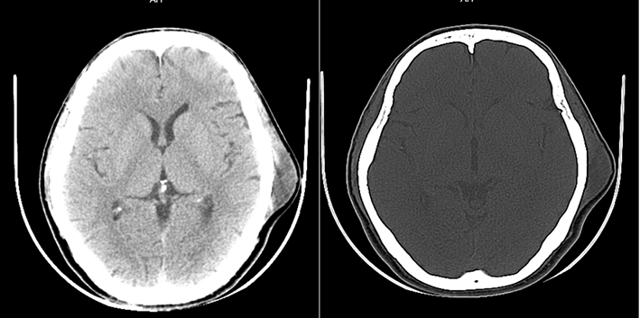
Figure 1 Computed tomography shows a subcutaneous mass in the left temporal region without skull destruction.
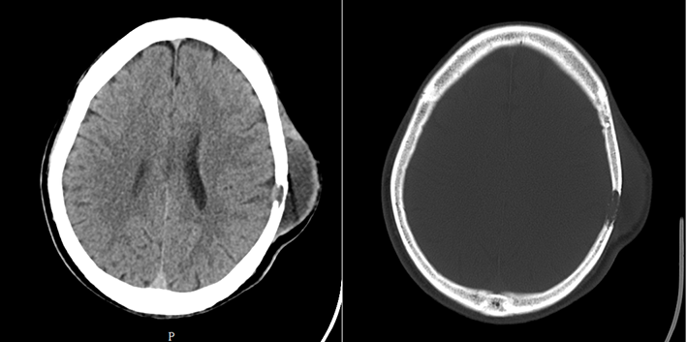
Figure 2 Computed tomography shows a soft tissue mass in the left temporal region and destruction of the adjacent skull.
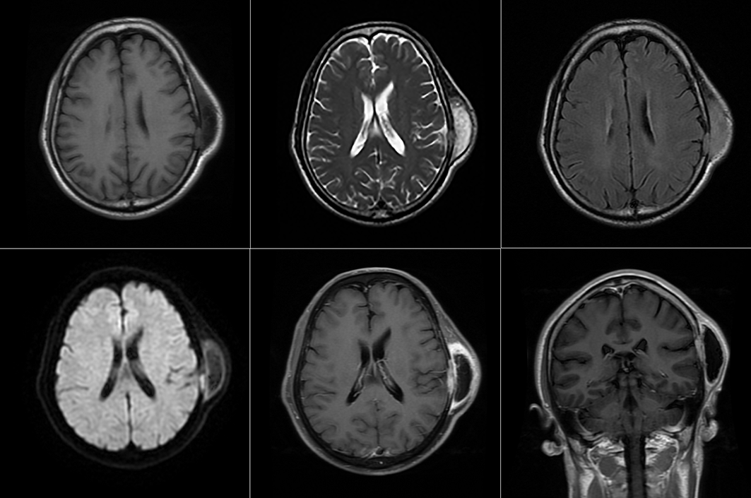
Figure 3 Magnetic resonance imaging shows a mass in the left temporal muscle, with obvious enhancement around the tumor, but no enhancement in the center of the tumor.
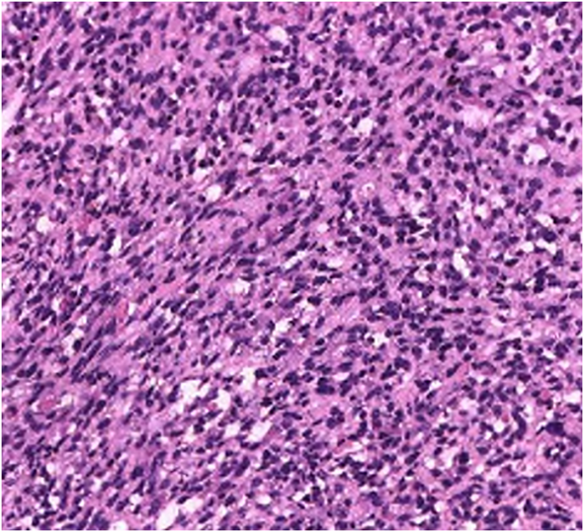
Figure 4 Pathological examination revealed a tumor composed of mildly atypical spindle cells arranged in a crossed bundle or spiral, and with a few rhabdomyoblasts scattered among the spindle cells (hematoxylin and eosin, × 200).
A B
Figure 5 Immunohistochemical staining of tumor tissue. A: Desmin is strongly positive in the cytoplasm of tumor cells (× 200); B: MyoD1 is strongly positive in the nucleus of tumor cells (× 200).

Published by Baishideng Publishing Group Inc
7041 Koll Center Parkway, Suite 160, Pleasanton, CA 94566, USA
Telephone: +1-925-3991568
E-mail: bpgoffice@wjgnet.com
Help Desk: https://www.f6publishing.com/helpdesk
https://www.wjgnet.com

© 2021 Baishideng Publishing Group Inc. All rights reserved.

