Name of Journal: World Journal of Clinical Oncology
Manuscript NO: 63860
Manuscript Type: REVIEW

Proteoglycans and their functions in esophageal squamous cell carcinoma

Zhu Y et al. Proteoglycans and their functions in ESCC

Yun Zhu, Annie Lai Man Cheung

Yun Zhu, Annie Lai Man Cheung, School of Biomedical Sciences, The University of Hong Kong, Hong Kong, China

Author contributions: Zhu Y and Cheung ALM contributed to the writing, literature review, and/or critical revision of the manuscript; Zhu Y is specially credited with design and preparation of the figures.

Supported by Research Grants Council of the Hong Kong SAR, China, No. 17111016 and No. 17100819.

Corresponding author: Annie Lai Man Cheung, BSc, PhD, Associate Professor, School of Biomedical Sciences, The University of Hong Kong, Laboratory Block, No. 21 Sassoon Road, Hong Kong, China. lmcheung@hku.hk

Received: February 5, 2021
Revised: April 13, 2021
Accepted: June 2, 2021
Published online: July 24, 2021

Abstract
Esophageal squamous cell carcinoma (ESCC) is a highly malignant disease that has a poor prognosis. Its high lethality is mainly due to the lack of symptoms at early stages, which culminates in diagnosis at a late stage when the tumor has already metastasized. Unfortunately, the common cancer biomarkers have low sensitivity and specificity in esophageal cancer. Therefore, a better understanding of the molecular mechanisms underlying ESCC progression is needed to identify novel diagnostic markers and therapeutic targets for intervention. The invasion of cancer cells into the surrounding tissue is a crucial step for metastasis. During metastasis, tumor cells can interact with extracellular components and secrete proteolytic enzymes to remodel the surrounding tumor microenvironment. Proteoglycans are one of the major components of extracellular matrix. They are involved in multiple processes of cancer cell invasion and metastasis by interacting with soluble bioactive molecules, surrounding matrix, cell surface receptors, and enzymes. Apart from having diverse functions in tumor cells and their surrounding microenvironment, proteoglycans also have diagnostic and prognostic significance in cancer patients. However, the functional significance and underlying mechanisms of proteoglycans in ESCC are not well understood. This review summarizes the proteoglycans that have been studied in ESCC in order to provide a comprehensive view of the role of proteoglycans in the progression of this cancer type. A long term goal would be to exploit these molecules to provide new strategies for therapeutic intervention.

Key Words: Esophageal squamous cell carcinoma; Proteoglycan; Glycosaminoglycan; Serglycin; Extracellular matrix; Biomarker

©The Author(s) 2021. Published by Baishideng Publishing Group Inc. All rights reserved.

Citation: Zhu Y, Cheung ALM. Proteoglycans and their functions in esophageal squamous cell carcinoma. World J Clin Oncol 2021; 12(7): 507-521
URL: https://www.wjgnet.com/2218-4333/full/v12/i7/507.htm
DOI: https://dx.doi.org/10.5306/wjco.v12.i7.507

Core Tip: Esophageal squamous cell carcinoma (ESCC) is a highly malignant human cancer because of its early metastasis and late diagnosis. Cancer metastasis involves multiple steps that involve cell-cell and cell-matrix interactions in the tumor microenvironment. Proteoglycans are one of the components of the extracellular matrix that play an important role in cell-matrix interactions. We herein summarize the proteoglycans that have been studied in ESCC to provide a comprehensive view of the role of proteoglycans in ESCC.
INTRODUCTION
Esophageal cancer is the 7th most common cancer in the world and the sixth highest ranking cancer in terms of mortality rate^{[1]}. The two major subtypes of esophageal cancer are esophageal squamous cell carcinoma (ESCC) and esophageal adenocarcinoma (EAC). People who develop esophageal cancer usually have no specific symptoms at the early stage. The onset of symptoms is often accompanied by difficulty and pain in swallowing (dysphagia), loss of body weight, and heartburn, by which time the tumor is likely already in the advanced stage. Late diagnosis of esophageal cancer is the primary reason for its high lethality. Tobacco use and alcohol consumption are the two main risk factors of ESCC. In addition, genetic susceptibility also plays a role in ESCC. It has been reported that TP53 has the highest frequency of mutation in ESCC patients^{[2]}. Other frequently mutated genes in ESCC are RB1, CDKN2A, PIK3CA, CCND1, ZNF750, NOTCH1, NFE2L2, FAT1, and FAT2^{[3-6]}. It is widely accepted that tumor progression not only depends on accumulation of genetic alterations but also on changes within the surrounding microenvironment^{[7]}. The contribution of tumor microenvironment and extracellular matrix (ECM) components to cancer development and progression is increasingly being recognized^{[7-9]}. The ECM in the tumor microenvironment consists of proteoglycans, collagens, fibronectin, and laminins^{[10]}. Interaction of these molecules with growth factors, chemokines, cytokines, and matrix metalloproteinases facilitate tumor cell survival, invasion, and metastasis^{[11,12]}. It is a highly dynamic and complex interaction network. In this review, the characteristics of proteoglycans and their functions in ESCC are summarized.

STRUCTURE and classification OF PROTEOGLYCANS
Proteoglycans typically consist of polysaccharide chains termed glycosaminoglycan (GAG) and a core protein. The GAGs are covalently attached to the serine residues on the core protein. Proteoglycans differ from glycoproteins in several aspects. For example, the carbohydrate content in proteoglycans is 50%-60%, which is much higher than that in glycoproteins. The GAGs in proteoglycans are linear, negatively-charged long chains, whereas the oligosaccharides in glycoproteins are branched short chains that may or may not be negatively-charged. The GAGs of proteoglycans are composed of repeating disaccharide units of hexuronic acid and hexosamine. They may be modified with sulfate groups at various positions to achieve multiple biological functions^{[13]}. The major categories of GAGs are chondroitin sulfate (CS), dermatan sulfate (DS), keratan sulfate (KS), heparan sulfate (HS), heparin, and hyaluronan (HA).
CSs consist of repeating disaccharide units of N-acetylgalactosamine (GalNAc) and D-glucuronic acid (GlcA), and can be sulfated at C4 and/or C6 position of the GalNAc unit. The CS chains that contain sulfate group modification at both C4 and C6 positions of the GalNAc unit are named CS-E, whereas those modified exclusively at C4 position of GalNAc are known as CS-A. CS-C contains sulfate group only at C6 position of the GalNAc. CS-D chains have sulfate groups at C6 position of the GalNAc and C2 position of the GlcA. DS chains, also named CS-B, are derived from CS, of which the GlcA residues are epimerized into L-iduronic acid (IdoA). DS chains are sulfated at C2 position of IdoA and C4/C6 position of the GalNAc. KS chains contain repeating disaccharide units of galactose (Gal) and N-acetylglucosamine (GlcNAc). HS chains consist of GlcA and GlcNAc repeats, while heparins consist of repeating disaccharide units of IdoA and GlcNAc. The sulfate modifications in HS and heparins are in clusters. HA, a linear, protein-free, non-sulfated GAG consists of GlcNAc and GlcA repeating units. The structures of GAG chains are shown in Figure 1.
Proteoglycans can be classified according to their predominant GAG types into CS proteoglycans and HS proteoglycans or according to their cellular and subcellular location, overall gene/protein homology, and the presence of specific protein modules within their respective protein cores into intracellular, cell-surface, pericellular, and extracellular proteoglycans^{[14]}. In this review, the functions of proteoglycans in ESCC will be discussed according to this classification. These proteoglycans are classified and summarized in Table 1.

INTRACELLULAR PROTEOGLYCANS IN ESCC
Serglycin is the only known intracellular proteoglycan. It was first isolated from rat yolk carcinoma cell line L2 (named as pPG1) in 1985^{[15]}. Human SRGN (serglycin) was isolated from promyelocytic leukemia HL-60 cells in 1990^{[16]} and from hematopoietic cells in 1992^{[17]}. Its amino acid sequence was later found to be identical to that of human platelet proteoglycan protein, which was isolated and characterized in 1986^{[18]}, and the complete amino acid sequence determined in 1988^{[19,20]}.
The human SRGN gene is located on chromosome 10 and spans about 16.7 kb with 7% of the gene comprising of exons^{[16,17,21]}. Nicodemus et al^{[16]} showed that human SRGN gene contains three exons, with exon 1 encoding signal peptide (amino acids 1-27), exon 2 encoding amino acids 28-77, and exon 3 encoding amino acids 77-158, which includes the serine/glycine repeat region (amino acids 94-111). The serine/glycine repeat region is the GAG attachment region that allows the clustering of GAG chains close to the center of the core protein. This structure is unique to serglycin^{[22]}.
Serglycin was initially characterized as a hematopoietic proteoglycan^{[23]} and was subsequently found to be present in many other non-hematopoietic cells such as endothelial cells^{[24]}, immune cells^{[25]}, chondrocytes^{[26-28]}, and cancer cells^{[29,30]}. The type and size of the GAG chains of serglycin vary among different cell types and can affect the functions of serglycin. Serglycin synthesized by rat serosal mast cells is mainly modified with heparin or HS, while CS chains are predominant in rat mucosal-like mast cells^{[31]}. HS/CS hybrid GAG chains are found in mouse mastocytoma cells and human erythroleukemia cells^{[32]}. In human umbilical vein endothelial cells, serglycin is modified with CS-GAG chains and has smaller GAG chains than that expressed in platelets^{[24,33]}. In human platelets, the predominant type of GAG chain is CS-4^{[18]}.
The enzymes involved in the synthesis of GAG chains have different functions in the particular physiological process of cells. Two enzymes that synthesize CS, namely chondroitin 4-sulfotransferase-1 and GalNAc(4S)-6-O-sulfotansferase, and N-deacetylase/N-sulfotransferase-2, which is essential for heparin synthesis, are positively associated with mast cell maturation, whereas chondroitin 6-sulfotransferase is negatively correlated with mast cell maturation^{[34]}. Serglycin core protein, chondroitin 4-sulfotransferase-1, and GalNAc(4S)-6-O-sulfotansferase are upregulated during mast cell activation and accompanied by downregulation of N-deacetylase/N-sulfotransferase-2^{[34]}. A recent study showed that hyaluronidase-4 can cleave the CS chains of serglycin in human mast cells^{[35]}. These reports suggest that enzymes responsible for GAG synthesis are important in determining the functions of serglycin.
In the past two decades, an ever-increasing number of studies have shown that serglycin plays a significant role in human cancers. It has been reported that serglycin is increased in many human cancers including breast cancer^{[36-40]}, multiple myeloma^{[41-44]}, acute myeloid leukemia^{[45]}, nasopharyngeal carcinoma^{[46-48]}, hepatocellular carcinoma (HCC)^{[49-51]}, colon cancer^{[52,53]}, non-small cell lung cancer^{[54,55]}, and glioblastoma^{[56]}. The reported functions of serglycin in promoting cancer progression include regulation of cell adhesion, promoting migration/invasion, inducing angiogenesis, and avoiding immune destruction (Figure 2).
Our recent study showed for the first time that serum serglycin could be a potential non-invasive biomarker with prognostic significance in ESCC^{[57]}. We found that serglycin and its binding partners (including matrix metalloproteinases) could promote ESCC cell invasion, migration, and metastasis. We also identified midkine as a novel GAG-dependent binding partner of serglycin, which contributes to ESCC progression by upregulating mitogen-activated protein kinase/extracellular signal-regulated protein kinase signaling and c-Myc expression in an autocrine manner^{[57]}. This study also highlighted the significance of CS-GAGs of serglycin in ESCC cell invasion. Strategies that target serglycin, its binding partners, or its GAG chains where most of the protein interactions take place may be a new direction in ESCC therapy.

CELL-SURFACE PROTEOGLYCANS IN ESCC
Syndecan
The syndecan family is a group of transmembrane proteoglycans consisting of syndecan-1, -2, -3, and -4. They generally carry HS-GAG chains. In normal esophageal epithelium, syndecan-1 is strongly expressed in cell membrane, and the expression of syndecan-1 core protein and HS-GAG chains are significantly decreased in T2 and T3 stage specimens compared with lower grade specimens^{[58]}. Although the study by Conejo et al^{[59]} found that syndecan-1 messenger RNA level in esophageal malignancies was not significantly different from that in the corresponding normal samples, a histochemical study by Szumilo et al^{[60]} showed that well- and moderately-differentiated carcinomas are more frequently syndecan-1-positive compared with poorly differentiated carcinomas. Loss of syndecan-1 was found to be associated with the incidence of lymphatic invasion, and malignant phenotype of ESCC^{[58]}. Notably, the reduction of HS-GAGs on syndecan-1 was more important than that of core protein for tumor cell invasion; other pathological parameters such as nodal and distant organ metastasis were negatively correlated with HS-GAG expression but not with syndecan-1 core protein expression^{[58]}. Unlike syndecan-1, which acts as a tumor suppressor in ESCC, syndecan-2 is positively correlated with tumor size in ESCC^{[61]}. Multivariate analysis showed that syndecan-2 is an independent prognostic factor for survival rate of ESCC patients after surgery^{[61]}.

Glypican
Glypican family includes six members, which are glypican-1 to -6. They also carry HS-GAG chains. Glypican-1 was found to be upregulated in ESCC cell lines compared with normal epithelial cells, and its expression in ESCC tissue is negatively correlated with survival rate of patients^{[62]}. Another study confirmed that ESCC tumor samples have higher expression of glypican-1 than that in para-tumor tissues^{[63]}. Functionally, glypican-1 promotes cell motility and induces epithelial-mesenchymal transition (EMT) in ESCC, possibly through activation of AKT/β-catenin pathway^{[63]}. Knockdown of glypican-1 (GPC1) significantly inhibited ESCC cell growth by inhibiting epidermal growth factor receptor pathway and inducing cell apoptosis^{[64]}. Systemic administration of anti-GPC1 antibody significantly inhibited growth of tumor xenografts and tumor angiogenesis^{[64]}. Based on these findings, glypican-1 was described as a promising therapeutic target in ESCC^{[65]}.
Unlike glypican-1, glypican-3 did not show significant correlation with histological type, tumor stage, tumor grade, or patient survival in ESCC^{[66,67]}, although it was reported to be a diagnostic molecule and a therapeutic target in HCC^{[68,69]}.

PERICELLULAR PROTEOGLYCANS
Pericellular proteoglycans include perlecan, agrin, collagen XVIII, and collagen XV (Table 1). The functions of perlecan, agrin, and collagen XV in ESCC have not been elucidated. Endostatin, which is a 20 kDa C-terminal fragment of collagen XVIII, was found to have anti-angiogenic activity^{[70]}. It was later shown to have inhibitory effect on formation of ESCC-related lymphatic vessels^{[71]}. The application of recombinant endostatin protein combined with chemoradiotherapy in ESCC treatment increased the overall survival rate of patients^{[72]}. Recombinant endostatin combined with radiotherapy could significantly inhibit proliferation and migration/invasion of ESCC cells as well as reduce angiogenesis, but there was no effect on cell apoptosis^{[73]}.

EXTRACELLULAR PROTEOGLYCANS IN ESCC
Decorin
Decorin, also called PG40, belongs to the small leucine-rich proteoglycan (SLRP) family^{[74]}. The core protein of decorin is about 42 kDa. There is a single GAG chain attached to the N-terminus of the core protein^{[75]}. Proteoglycans belonging to SLRP family contain a region with leucine-rich tandem repeats (LRR). The LRR region is modified by N-glycosylation. N-glycosylation and the O-linked GAG side chains are crucial for the interactions of decorin with other molecules. Studies have shown that the DS-GAGs are essential in fibrillar network formation through bridging collagen fibers^{[76,77]}. The GAG chains and LRR region of SLRPs are both involved in ECM assembly.
Decorin was found to be necessary for appropriate fibrillogenesis due to its ability to bind to collagen^{[74]}. The significance of decorin, as well as other SLRPs, in ECM assembly has been intensively investigated and reviewed^{[78]}. Of note, same classes of SLRPs have the same function of binding to collagen and therefore compete with each other. For example, two other class I SLRPs, namely biglycan and asporin, are able to compensate for the loss of decorin^{[79]}. Asporin can compensate for both decorin and biglycan loss^{[80]}. Lumican, a class II SLRP, can compete with fibromodulin, which belongs to the same class^{[81,82]}.
The concentration of plasma decorin in 275 ESCC patients was found to be significantly lower than that in normal controls^{[83]}. The expression of decorin in malignant ESCC tissue samples is also lower compared with normal tissue^{[84,85]}. The study by Ji et al^{[84]} showed that decorin expression in ESCC is negatively correlated with histological grade, lymph node metastasis, tumor stage, and clinical stage. Low expression of decorin is associated with poor survival rate and is an independent prognostic marker in patients with ESCC^{[84]}. The tumor suppressive property of decorin, as revealed from studies in other types of cancer such as skin squamous cell carcinoma^{[86]} and breast cancer^{[87,88]}, is predominantly due to its ability to trap transforming growth factor β (TGF-β) in the ECM. The binding of decorin to TGF-β prevents the latter from binding to its receptors. Interestingly, this decorin-TGF-β interaction is dependent on decorin-collagen binding^{[89]}. In addition, decorin also acts as a receptor tyrosine kinase inhibitor^{[90]}. It can inhibit the activity of epidermal growth factor receptor^{[91]}, insulin-like growth factor receptor 1, and platelet-derived growth factor receptor α/β^{[92]}, thereby suppressing their downstream signaling cascades, and finally inhibiting cancer cell proliferation, migration, and invasion^{[93]}. Systemic administration of recombinant decorin protein can inhibit tumor growth and reduce metastasis of squamous cell carcinoma^{[86]}. Based on these characteristics of decorin, it is regarded as a promising anti-tumor molecule and a potential neoadjuvant therapy for human cancers^{[94,95]}.

Biglycan
Biglycan, a SLRP protein coded by the BGN gene, is structurally related to decorin but holds two GAG chains rather than one at the N-terminus of the core protein. The molecular weight of biglycan core protein is about 42 kDa. Although biglycan shares similar structure with decorin, the functions of biglycan in human cancers differ from that of decorin. In ESCC, the gene expression of BGN is upregulated in tumor samples compared with non-tumor tissues^{[96,97]}, although there is no significant association with patient survival^{[98]}. High expression of biglycan in tumor tissue is positively correlated with tumor invasion, lymph node metastasis, and advanced clinical stage^{[96,97]} and is an independent prognostic marker of ESCC^{[97]}. In addition, higher serum biglycan was found in patients with EAC^{[99]}, suggesting that biglycan has diagnostic significance in esophageal cancer. Functionally, biglycan has anti-apoptotic effects on mesangial cells and pro-angiogenesis effects on tumor endothelial cells^{[100]}, which contribute to cancer cell survival and metastasis. These studies suggest that targeting biglycan may be a novel approach in anti-angiogenic and anti-tumor therapy for ESCC patients^{[97,100]}.

Lumican
Lumican is a class II SLRP that has up to three KS-GAG chains. There are contradictory reports on the roles of lumican in human cancers. In pancreatic cancer, patients with high expression of stromal lumican have favorable survival after surgery^{[101]}. However, the gene expression of LUM was found to be 7-fold higher in ESCC than in normal epithelia^{[102,103]}. Strong positive lumican immunostaining was found in the stromal and epithelial compartments of ESCC specimens but was almost negative in normal epithelium^{[103]}. The concentration of lumican in plasma was identified as a potential biomarker of ESCC via a proteomic screen^{[104]}. Nevertheless, a previous study by our group comparing a highly invasive ESCC subline with its parental cells showed that LUM decreased 8-fold in the highly invasive subline and was accompanied by activation of AKT pathway^{[105]}. Li et al^{[101]} reported that overexpression of LUM suppressed AKT activation in pancreatic cancer cells. These findings infer that lumican might be negatively correlated with AKT activation.

Testican-1
Testican-1, also known as proteoglycan 1, belongs to the SPOCK family and is encoded by the SPOCK1 gene. It has been reported to be able to induce EMT in gastric cancer^{[106]}. In colorectal cancer, knockdown of SPOCK1 could significantly reduce cell proliferation and invasion through the inhibition of phosphatidylinositol-3-kinase/AKT pathway^{[107]}. In ESCC, upregulation of SPOCK1 also induces EMT and promotes cancer cell migration and invasion^{[108]}.

CONCLUSION
This article reviews the classification and structure of proteoglycans (Table 1 and Figure 1) and the functions of proteoglycans related to ESCC (Figure 3). As one of the components of the ECM, proteoglycans have been studied in several kinds of human cancers due to their roles in matrix organization and regulation of tumor cell-matrix interactions. Proteoglycans have diagnostic and prognostic significance in ESCC and can modulate ESCC cell migration/invasion and EMT. The secreted serglycin can also activate cell signaling in an autocrine manner (Figure 2). In addition, the significance of GAGs attached to the core protein of proteoglycans (e.g., serglycin and syndecan-1) and the expression level of GAGs regulated by multiple enzymes are increasingly gaining attention. Proteoglycans can enhance or inhibit the activity of soluble factors through interacting with them, and such interactions depend largely on the GAG chains. To date, most studies on proteoglycans in ESCC have focused primarily on their diagnostic and/or prognostic significance. In order to utilize or target these dynamic molecules in designing new strategies for treatment of this cancer, more in-depth research is needed to decipher the complex roles of proteoglycans in ESCC, especially their interactions with other ECM components, receptors, and soluble factors.

REFERENCES
1 Bray F, Ferlay J, Soerjomataram I, Siegel RL, Torre LA, Jemal A. Global cancer statistics 2018: GLOBOCAN estimates of incidence and mortality worldwide for 36 cancers in 185 countries. CA Cancer J Clin 2018; 68: 394-424 [PMID: 30207593 DOI: 10.3322/caac.21492]
2 Song Y, Li L, Ou Y, Gao Z, Li E, Li X, Zhang W, Wang J, Xu L, Zhou Y, Ma X, Liu L, Zhao Z, Huang X, Fan J, Dong L, Chen G, Ma L, Yang J, Chen L, He M, Li M, Zhuang X, Huang K, Qiu K, Yin G, Guo G, Feng Q, Chen P, Wu Z, Wu J, Ma L, Zhao J, Luo L, Fu M, Xu B, Chen B, Li Y, Tong T, Wang M, Liu Z, Lin D, Zhang X, Yang H, Wang J, Zhan Q. Identification of genomic alterations in oesophageal squamous cell cancer. Nature 2014; 509: 91-95 [PMID: 24670651 DOI: 10.1038/nature13176]
3 Gao YB, Chen ZL, Li JG, Hu XD, Shi XJ, Sun ZM, Zhang F, Zhao ZR, Li ZT, Liu ZY, Zhao YD, Sun J, Zhou CC, Yao R, Wang SY, Wang P, Sun N, Zhang BH, Dong JS, Yu Y, Luo M, Feng XL, Shi SS, Zhou F, Tan FW, Qiu B, Li N, Shao K, Zhang LJ, Zhang LJ, Xue Q, Gao SG, He J. Genetic landscape of esophageal squamous cell carcinoma. Nat Genet 2014; 46: 1097-1102 [PMID: 25151357 DOI: 10.1038/ng.3076]
4 Zhang L, Zhou Y, Cheng C, Cui H, Cheng L, Kong P, Wang J, Li Y, Chen W, Song B, Wang F, Jia Z, Li L, Li Y, Yang B, Liu J, Shi R, Bi Y, Zhang Y, Wang J, Zhao Z, Hu X, Yang J, Li H, Gao Z, Chen G, Huang X, Yang X, Wan S, Chen C, Li B, Tan Y, Chen L, He M, Xie S, Li X, Zhuang X, Wang M, Xia Z, Luo L, Ma J, Dong B, Zhao J, Song Y, Ou Y, Li E, Xu L, Wang J, Xi Y, Li G, Xu E, Liang J, Yang X, Guo J, Chen X, Zhang Y, Li Q, Liu L, Li Y, Zhang X, Yang H, Lin D, Cheng X, Guo Y, Wang J, Zhan Q, Cui Y. Genomic analyses reveal mutational signatures and frequently altered genes in esophageal squamous cell carcinoma. Am J Hum Genet 2015; 96: 597-611 [PMID: 25839328 DOI: 10.1016/j.ajhg.2015.02.017]
5 Lin DC, Hao JJ, Nagata Y, Xu L, Shang L, Meng X, Sato Y, Okuno Y, Varela AM, Ding LW, Garg M, Liu LZ, Yang H, Yin D, Shi ZZ, Jiang YY, Gu WY, Gong T, Zhang Y, Xu X, Kalid O, Shacham S, Ogawa S, Wang MR, Koeffler HP. Genomic and molecular characterization of esophageal squamous cell carcinoma. Nat Genet 2014; 46: 467-473 [PMID: 24686850 DOI: 10.1038/ng.2935]
6 Cui Y, Chen H, Xi R, Cui H, Zhao Y, Xu E, Yan T, Lu X, Huang F, Kong P, Li Y, Zhu X, Wang J, Zhu W, Wang J, Ma Y, Zhou Y, Guo S, Zhang L, Liu Y, Wang B, Xi Y, Sun R, Yu X, Zhai Y, Wang F, Yang J, Yang B, Cheng C, Liu J, Song B, Li H, Wang Y, Zhang Y, Cheng X, Zhan Q, Li Y, Liu Z. Whole-genome sequencing of 508 patients identifies key molecular features associated with poor prognosis in esophageal squamous cell carcinoma. Cell Res 2020; 30: 902-913 [PMID: 32398863 DOI: 10.1038/s41422-020-0333-6]
7 Hanahan D, Weinberg RA. Hallmarks of cancer: the next generation. Cell 2011; 144: 646-674 [PMID: 21376230 DOI: 10.1016/j.cell.2011.02.013]
8 Multhaupt HA, Leitinger B, Gullberg D, Couchman JR. Extracellular matrix component signaling in cancer. Adv Drug Deliv Rev 2016; 97: 28-40 [PMID: 26519775 DOI: 10.1016/j.addr.2015.10.013]
9 Palumbo A Jr, Meireles Da Costa N, Pontes B, Leite de Oliveira F, Lohan Codeço M, Ribeiro Pinto LF, Nasciutti LE. Esophageal Cancer Development: Crucial Clues Arising from the Extracellular Matrix. Cells 2020; 9 [PMID: 32079295 DOI: 10.3390/cells9020455]
10 Theocharis AD, Skandalis SS, Gialeli C, Karamanos NK. Extracellular matrix structure. Adv Drug Deliv Rev 2016; 97: 4-27 [PMID: 26562801 DOI: 10.1016/j.addr.2015.11.001]
11 Theocharis AD, Manou D, Karamanos NK. The extracellular matrix as a multitasking player in disease. FEBS J 2019; 286: 2830-2869 [PMID: 30908868 DOI: 10.1111/febs.14818]
12 Theocharis AD, Karamanos NK. Proteoglycans remodeling in cancer: Underlying molecular mechanisms. Matrix Biol 2019; 75-76: 220-259 [PMID: 29128506 DOI: 10.1016/j.matbio.2017.10.008]
13 Soares da Costa D, Reis RL, Pashkuleva I. Sulfation of Glycosaminoglycans and Its Implications in Human Health and Disorders. Annu Rev Biomed Eng 2017; 19: 1-26 [PMID: 28226217 DOI: 10.1146/annurev-bioeng-071516-044610]
14 Iozzo RV, Schaefer L. Proteoglycan form and function: A comprehensive nomenclature of proteoglycans. Matrix Biol 2015; 42: 11-55 [PMID: 25701227 DOI: 10.1016/j.matbio.2015.02.003]
15 Bourdon MA, Oldberg A, Pierschbacher M, Ruoslahti E. Molecular cloning and sequence analysis of a chondroitin sulfate proteoglycan cDNA. Proc Natl Acad Sci USA 1985; 82: 1321-1325 [PMID: 3919394 DOI: 10.1073/pnas.82.5.1321]
16 Nicodemus CF, Avraham S, Austen KF, Purdy S, Jablonski J, Stevens RL. Characterization of the human gene that encodes the peptide core of secretory granule proteoglycans in promyelocytic leukemia HL-60 cells and analysis of the translated product. J Biol Chem 1990; 265: 5889-5896 [PMID: 2180935 DOI: 10.1016/S0021-9258(19)39446-3]
17 Humphries DE, Nicodemus CF, Schiller V, Stevens RL. The human serglycin gene. Nucleotide sequence and methylation pattern in human promyelocytic leukemia HL-60 cells and T-lymphoblast Molt-4 cells. J Biol Chem 1992; 267: 13558-13563 [PMID: 1377686 DOI: 10.1016/S0021-9258(18)42248-X]
18 Okayama M, Oguri K, Fujiwara Y, Nakanishi H, Yonekura H, Kondo T, Ui N. Purification and characterization of human platelet proteoglycan. Biochem J 1986; 233: 73-81 [PMID: 3954736 DOI: 10.1042/bj2330073]
19 Périn JP, Bonnet F, Maillet P, Jollès P. Characterization and N-terminal sequence of human platelet proteoglycan. Biochem J 1988; 255: 1007-1013 [PMID: 3214420 DOI: 10.1042/bj2551007]
20 Alliel PM, Périn JP, Maillet P, Bonnet F, Rosa JP, Jollès P. Complete amino acid sequence of a human platelet proteoglycan. FEBS Lett 1988; 236: 123-126 [PMID: 3402609 DOI: 10.1016/0014-5793(88)80298-9]
21 Stevens RL, Avraham S, Gartner MC, Bruns GA, Austen KF, Weis JH. Isolation and characterization of a cDNA that encodes the peptide core of the secretory granule proteoglycan of human promyelocytic leukemia HL-60 cells. J Biol Chem 1988; 263: 7287-7291 [PMID: 2835370 DOI: 10.1016/S0021-9258(18)68639-9]
22 Kolset SO, Tveit H. Serglycin--structure and biology. Cell Mol Life Sci 2008; 65: 1073-1085 [PMID: 18066495 DOI: 10.1007/s00018-007-7455-6]
23 Matsumoto R, Sali A, Ghildyal N, Karplus M, Stevens RL. Packaging of proteases and proteoglycans in the granules of mast cells and other hematopoietic cells. A cluster of histidines on mouse mast cell protease 7 regulates its binding to heparin serglycin proteoglycans. J Biol Chem 1995; 270: 19524-19531 [PMID: 7642636 DOI: 10.1074/jbc.270.33.19524]
24 Schick BP, Gradowski JF, San Antonio JD. Synthesis, secretion, and subcellular localization of serglycin proteoglycan in human endothelial cells. Blood 2001; 97: 449-458 [PMID: 11154222 DOI: 10.1182/blood.v97.2.449]
25 Kolset SO, Pejler G. Serglycin: a structural and functional chameleon with wide impact on immune cells. J Immunol 2011; 187: 4927-4933 [PMID: 22049227 DOI: 10.4049/jimmunol.1100806]
26 Zhang L, Yang M, Yang D, Cavey G, Davidson P, Gibson G. Molecular interactions of MMP-13 C-terminal domain with chondrocyte proteins. Connect Tissue Res 2010; 51: 230-239 [PMID: 20073988 DOI: 10.3109/03008200903288902]
27 Scuruchi M, D'Ascola A, Avenoso A, Mandraffino G G, Campo S S, Campo GM. Serglycin as part of IL-1β induced inflammation in human chondrocytes. Arch Biochem Biophys 2019; 669: 80-86 [PMID: 31145901 DOI: 10.1016/j.abb.2019.05.021]
28 D'Ascola A, Scuruchi M, Avenoso A, Bruschetta G, Campo S, Mandraffino G, Campo GM. Serglycin is involved in inflammatory response in articular mouse chondrocytes. Biochem Biophys Res Commun 2018; 499: 506-512 [PMID: 29588174 DOI: 10.1016/j.bbrc.2018.03.178]
29 Korpetinou A, Skandalis SS, Labropoulou VT, Smirlaki G, Noulas A, Karamanos NK, Theocharis AD. Serglycin: at the crossroad of inflammation and malignancy. Front Oncol 2014; 3: 327 [PMID: 24455486 DOI: 10.3389/fonc.2013.00327]
30 Manou D, Karamanos NK, Theocharis AD. Tumorigenic functions of serglycin: Regulatory roles in epithelial to mesenchymal transition and oncogenic signaling. Semin Cancer Biol 2020; 62: 108-115 [PMID: 31279836 DOI: 10.1016/j.semcancer.2019.07.004]
31 Tantravahi RV, Stevens RL, Austen KF, Weis JH. A single gene in mast cells encodes the core peptides of heparin and chondroitin sulfate proteoglycans. Proc Natl Acad Sci USA 1986; 83: 9207-9210 [PMID: 2947243 DOI: 10.1073/pnas.83.23.9207]
32 Lidholt K, Eriksson I, Kjellén L. Heparin proteoglycans synthesized by mouse mastocytoma contain chondroitin sulphate. Biochem J 1995; 311 ( Pt 1): 233-238 [PMID: 7575459 DOI: 10.1042/bj3110233]
33 Schick BP, Pestina TI, San Antonio JD, Stenberg PE, Jackson CW. Decreased serglycin proteoglycan size is associated with the platelet alpha granule storage defect in Wistar Furth hereditary macrothrombocytopenic rats. Serglycin binding affinity to type I collagen is unaltered. J Cell Physiol 1997; 172: 87-93 [PMID: 9207929 DOI: 10.1002/(SICI)1097-4652(199707)172:1<87::AID-JCP10>3.0.CO;2-L]
34 Duelli A, Rönnberg E, Waern I, Ringvall M, Kolset SO, Pejler G. Mast cell differentiation and activation is closely linked to expression of genes coding for the serglycin proteoglycan core protein and a distinct set of chondroitin sulfate and heparin sulfotransferases. J Immunol 2009; 183: 7073-7083 [PMID: 19915053 DOI: 10.4049/jimmunol.0900309]
35 Farrugia BL, Mizumoto S, Lord MS, O'Grady RL, Kuchel RP, Yamada S, Whitelock JM. Hyaluronidase-4 is produced by mast cells and can cleave serglycin chondroitin sulfate chains into lower molecular weight forms. J Biol Chem 2019; 294: 11458-11472 [PMID: 31175155 DOI: 10.1074/jbc.RA119.008647]
36 Kang Y, Siegel PM, Shu W, Drobnjak M, Kakonen SM, Cordón-Cardo C, Guise TA, Massagué J. A multigenic program mediating breast cancer metastasis to bone. Cancer Cell 2003; 3: 537-549 [PMID: 12842083 DOI: 10.1016/s1535-6108(03)00132-6]
37 Iida J, Dorchak J, Clancy R, Slavik J, Ellsworth R, Katagiri Y, Pugacheva EN, van Kuppevelt TH, Mural RJ, Cutler ML, Shriver CD. Role for chondroitin sulfate glycosaminoglycan in NEDD9-mediated breast cancer cell growth. Exp Cell Res 2015; 330: 358-370 [PMID: 25445787 DOI: 10.1016/j.yexcr.2014.11.002]
38 Korpetinou A, Skandalis SS, Moustakas A, Happonen KE, Tveit H, Prydz K, Labropoulou VT, Giannopoulou E, Kalofonos HP, Blom AM, Karamanos NK, Theocharis AD. Serglycin is implicated in the promotion of aggressive phenotype of breast cancer cells. PLoS One 2013; 8: e78157 [PMID: 24205138 DOI: 10.1371/journal.pone.0078157]
39 Bouris P, Manou D, Sopaki-Valalaki A, Kolokotroni A, Moustakas A, Kapoor A, Iozzo RV, Karamanos NK, Theocharis AD. Serglycin promotes breast cancer cell aggressiveness: Induction of epithelial to mesenchymal transition, proteolytic activity and IL-8 signaling. Matrix Biol 2018; 74: 35-51 [PMID: 29842969 DOI: 10.1016/j.matbio.2018.05.011]
40 Zhang Z, Deng Y, Zheng G, Jia X, Xiong Y, Luo K, Qiu Q, Qiu N, Yin J, Lu M, Liu H, Gu Y, He Z. SRGN-TGFβ2 regulatory loop confers invasion and metastasis in triple-negative breast cancer. Oncogenesis 2017; 6: e360 [PMID: 28692037 DOI: 10.1038/oncsis.2017.53]
41 Skliris A, Labropoulou VT, Papachristou DJ, Aletras A, Karamanos NK, Theocharis AD. Cell-surface serglycin promotes adhesion of myeloma cells to collagen type I and affects the expression of matrix metalloproteinases. FEBS J 2013; 280: 2342-2352 [PMID: 23387827 DOI: 10.1111/febs.12179]
42 Theocharis AD, Seidel C, Borset M, Dobra K, Baykov V, Labropoulou V, Kanakis I, Dalas E, Karamanos NK, Sundan A, Hjerpe A. Serglycin constitutively secreted by myeloma plasma cells is a potent inhibitor of bone mineralization in vitro. J Biol Chem 2006; 281: 35116-35128 [PMID: 16870619 DOI: 10.1074/jbc.M601061200]
43 Skliris A, Happonen KE, Terpos E, Labropoulou V, Børset M, Heinegård D, Blom AM, Theocharis AD. Serglycin inhibits the classical and lectin pathways of complement via its glycosaminoglycan chains: implications for multiple myeloma. Eur J Immunol 2011; 41: 437-449 [PMID: 21268013 DOI: 10.1002/eji.201040429]
44 Purushothaman A, Toole BP. Serglycin proteoglycan is required for multiple myeloma cell adhesion, in vivo growth, and vascularization. J Biol Chem 2014; 289: 5499-5509 [PMID: 24403068 DOI: 10.1074/jbc.M113.532143]
45 Niemann CU, Kjeldsen L, Ralfkiaer E, Jensen MK, Borregaard N. Serglycin proteoglycan in hematologic malignancies: a marker of acute myeloid leukemia. Leukemia 2007; 21: 2406-2410 [PMID: 17928883 DOI: 10.1038/sj.leu.2404975]
46 Chu Q, Huang H, Huang T, Cao L, Peng L, Shi S, Zheng L, Xu L, Zhang S, Huang J, Li X, Qian C, Huang B. Extracellular serglycin upregulates the CD44 receptor in an autocrine manner to maintain self-renewal in nasopharyngeal carcinoma cells by reciprocally activating the MAPK/β-catenin axis. Cell Death Dis 2016; 7: e2456 [PMID: 27809309 DOI: 10.1038/cddis.2016.287]
47 Chia CS, Ong WS, Li XJ, Soong YL, Chong FT, Tan HK, Soo KC, Qian CN, Teh BT, Iyer NG. Serglycin expression: An independent marker of distant metastases in nasopharyngeal carcinoma. Head Neck 2016; 38: 21-28 [PMID: 24995621 DOI: 10.1002/hed.23841]
48 Li XJ, Ong CK, Cao Y, Xiang YQ, Shao JY, Ooi A, Peng LX, Lu WH, Zhang Z, Petillo D, Qin L, Bao YN, Zheng FJ, Chia CS, Iyer NG, Kang TB, Zeng YX, Soo KC, Trent JM, Teh BT, Qian CN. Serglycin is a theranostic target in nasopharyngeal carcinoma that promotes metastasis. Cancer Res 2011; 71: 3162-3172 [PMID: 21289131 DOI: 10.1158/0008-5472.CAN-10-3557]
49 He J, Zeng ZC, Xiang ZL, Yang P. Mass spectrometry-based serum peptide profiling in hepatocellular carcinoma with bone metastasis. World J Gastroenterol 2014; 20: 3025-3032 [PMID: 24659894 DOI: 10.3748/wjg.v20.i11.3025]
50 He L, Zhou X, Qu C, Tang Y, Zhang Q, Hong J. Serglycin (SRGN) overexpression predicts poor prognosis in hepatocellular carcinoma patients. Med Oncol 2013; 30: 707 [PMID: 23996242 DOI: 10.1007/s12032-013-0707-4]
51 Chen H, Li Y, Chen Y, Li Y, McGowan E, Lin Y. Serglycin level in peripheral circulating blood cells has prognostic significance in patients with hepatocellular carcinoma. Ann Oncol 2019; 30 Suppl 4: iv8-iv9 [DOI: 10.1093/annonc/mdz155.029]
52 Korpetinou A, Papachristou DJ, Lampropoulou A, Bouris P, Labropoulou VT, Noulas A, Karamanos NK, Theocharis AD. Increased Expression of Serglycin in Specific Carcinomas and Aggressive Cancer Cell Lines. Biomed Res Int 2015; 2015: 690721 [PMID: 26581653 DOI: 10.1155/2015/690721]
53 Suhovskih AV, Aidagulova SV, Kashuba VI, Grigorieva EV. Proteoglycans as potential microenvironmental biomarkers for colon cancer. Cell Tissue Res 2015; 361: 833-844 [PMID: 25715761 DOI: 10.1007/s00441-015-2141-8]
54 Guo JY, Chiu CH, Wang MJ, Li FA, Chen JY. Proteoglycan serglycin promotes non-small cell lung cancer cell migration through the interaction of its glycosaminoglycans with CD44. J Biomed Sci 2020; 27: 2 [PMID: 31898491 DOI: 10.1186/s12929-019-0600-3]
55 Guo JY, Hsu HS, Tyan SW, Li FY, Shew JY, Lee WH, Chen JY. Serglycin in tumor microenvironment promotes non-small cell lung cancer aggressiveness in a CD44-dependent manner. Oncogene 2017; 36: 2457-2471 [PMID: 27819672 DOI: 10.1038/onc.2016.404]
56 Roy A, Attarha S, Weishaupt H, Edqvist PH, Swartling FJ, Bergqvist M, Siebzehnrubl FA, Smits A, Pontén F, Tchougounova E. Serglycin as a potential biomarker for glioma: association of serglycin expression, extent of mast cell recruitment and glioblastoma progression. Oncotarget 2017; 8: 24815-24827 [PMID: 28445977 DOI: 10.18632/oncotarget.15820]
57 Zhu Y, Lam AKY, Shum DKY, Cui D, Zhang J, Yan DD, Li B, Xu WW, Lee NPY, Chan KT, Law S, Tsao SW, Cheung ALM. Significance of serglycin and its binding partners in autocrine promotion of metastasis in esophageal cancer. Theranostics 2021; 11: 2722-2741 [PMID: 33456569 DOI: 10.7150/thno.49547]
58 Mikami S, Ohashi K, Usui Y, Nemoto T, Katsube K, Yanagishita M, Nakajima M, Nakamura K, Koike M. Loss of syndecan-1 and increased expression of heparanase in invasive esophageal carcinomas. Jpn J Cancer Res 2001; 92: 1062-1073 [PMID: 11676857 DOI: 10.1111/j.1349-7006.2001.tb01061.x]
59 Conejo JR, Kleeff J, Koliopanos A, Matsuda K, Zhu ZW, Goecke H, Bicheng N, Zimmermann A, Korc M, Friess H, Büchler MW. Syndecan-1 expression is up-regulated in pancreatic but not in other gastrointestinal cancers. Int J Cancer 2000; 88: 12-20 [PMID: 10962434 DOI: 10.1002/1097-0215(20001001)88:1<12::AID-IJC3>3.0.CO;2-T]
60 Szumilo J, Burdan F, Zinkiewicz K, Dudka J, Klepacz R, Dabrowski A, Korobowicz E. Expression of syndecan-1 and cathepsins D and K in advanced esophageal squamous cell carcinoma. Folia Histochem Cytobiol 2009; 47: 571-578 [PMID: 20430722 DOI: 10.2478/v10042-008-0012-8]
61 Huang X, Xiao DW, Xu LY, Zhong HJ, Liao LD, Xie ZF, Li EM. Prognostic significance of altered expression of SDC2 and CYR61 in esophageal squamous cell carcinoma. Oncol Rep 2009; 21: 1123-1129 [PMID: 19288017 DOI: 10.3892/or_00000332]
62 Hara H, Takahashi T, Serada S, Fujimoto M, Ohkawara T, Nakatsuka R, Harada E, Nishigaki T, Takahashi Y, Nojima S, Miyazaki Y, Makino T, Kurokawa Y, Yamasaki M, Miyata H, Nakajima K, Takiguchi S, Morii E, Mori M, Doki Y, Naka T. Overexpression of glypican-1 implicates poor prognosis and their chemoresistance in oesophageal squamous cell carcinoma. Br J Cancer 2016; 115: 66-75 [PMID: 27310703 DOI: 10.1038/bjc.2016.183]
63 Li J, Chen Y, Zhan C, Zhu J, Weng S, Dong L, Liu T, Shen X. Glypican-1 Promotes Tumorigenesis by Regulating the PTEN/Akt/β-Catenin Signaling Pathway in Esophageal Squamous Cell Carcinoma. Dig Dis Sci 2019; 64: 1493-1502 [PMID: 30730015 DOI: 10.1007/s10620-019-5461-9]
64 Harada E, Serada S, Fujimoto M, Takahashi Y, Takahashi T, Hara H, Nakatsuka R, Sugase T, Nishigaki T, Saito Y, Hiramatsu K, Nojima S, Mitsuo R, Ohkawara T, Morii E, Mori M, Doki Y, Kaneda Y, Naka T. Glypican-1 targeted antibody-based therapy induces preclinical antitumor activity against esophageal squamous cell carcinoma. Oncotarget 2017; 8: 24741-24752 [PMID: 28445969 DOI: 10.18632/oncotarget.15799]
65 Song Q. Glypican-1 as a Therapy Target in Esophageal Squamous Cell Carcinoma. Dig Dis Sci 2019; 64: 3355-3356 [PMID: 31559549 DOI: 10.1007/s10620-019-05852-8]
66 Mounajjed T, Zhang L, Wu TT. Glypican-3 expression in gastrointestinal and pancreatic epithelial neoplasms. Hum Pathol 2013; 44: 542-550 [PMID: 23079207 DOI: 10.1016/j.humpath.2012.06.016]
67 Zhu Z, Friess H, Kleeff J, Wang L, Wirtz M, Zimmermann A, Korc M, Büchler MW. Glypican-3 expression is markedly decreased in human gastric cancer but not in esophageal cancer. Am J Surg 2002; 184: 78-83 [PMID: 12135726 DOI: 10.1016/s0002-9610(02)00884-x]
68 Chen JJ, Xie CM, Wang CR, Wan Y, Dong ZN, Li M, Xu WW. Development of a Time-Resolved Fluorescence Immunoassay for the Diagnosis of Hepatocellular Carcinoma Based on the Detection of Glypican-3. J Fluoresc 2017; 27: 1479-1485 [PMID: 28429175 DOI: 10.1007/s10895-017-2087-1]
69 Zhou F, Shang W, Yu X, Tian J. Glypican-3: A promising biomarker for hepatocellular carcinoma diagnosis and treatment. Med Res Rev 2018; 38: 741-767 [PMID: 28621802 DOI: 10.1002/med.21455]
70 O'Reilly MS, Boehm T, Shing Y, Fukai N, Vasios G, Lane WS, Flynn E, Birkhead JR, Olsen BR, Folkman J. Endostatin: an endogenous inhibitor of angiogenesis and tumor growth. Cell 1997; 88: 277-285 [PMID: 9008168 DOI: 10.1016/s0092-8674(00)81848-6]
71 Zheng Y, Sun M, Chen J, He L, Zhao N, Chen K. Effect of VEGF-C siRNA and endostatin on ring formation and proliferation of esophageal squamous cell carcinoma lymphatic endothelial cells. Onco Targets Ther 2016; 9: 6727-6732 [PMID: 27826199 DOI: 10.2147/OTT.S108340]
72 Zhong Z, Gu X, Zhang Z, Wang D, Qing Y, Li M, Dai N. Recombinant human endostatin combined with definitive chemoradiotherapy as primary treatment for patients with unresectable but without systemic metastatic squamous cell carcinoma of the oesophagus. Br J Radiol 2012; 85: e1104-e1109 [PMID: 22898155 DOI: 10.1259/bjr/15321801]
73 Chen X, Zhang H, Zhu H, Yang X, Yang Y, Yang Y, Min H, Chen G, Liu J, Lu J, Cheng H, Sun X. Endostatin combined with radiotherapy suppresses vasculogenic mimicry formation through inhibition of epithelial-mesenchymal transition in esophageal cancer. Tumour Biol 2016; 37: 4679-4688 [PMID: 26511968 DOI: 10.1007/s13277-015-4284-3]
74 Danielson KG, Baribault H, Holmes DF, Graham H, Kadler KE, Iozzo RV. Targeted disruption of decorin leads to abnormal collagen fibril morphology and skin fragility. J Cell Biol 1997; 136: 729-743 [PMID: 9024701 DOI: 10.1083/jcb.136.3.729]
75 Krusius T, Ruoslahti E. Primary structure of an extracellular matrix proteoglycan core protein deduced from cloned cDNA. Proc Natl Acad Sci USA 1986; 83: 7683-7687 [PMID: 3484330 DOI: 10.1073/pnas.83.20.7683]
76 Henninger HB, Maas SA, Underwood CJ, Whitaker RT, Weiss JA. Spatial distribution and orientation of dermatan sulfate in human medial collateral ligament. J Struct Biol 2007; 158: 33-45 [PMID: 17150374 DOI: 10.1016/j.jsb.2006.10.008]
77 Lewis PN, Pinali C, Young RD, Meek KM, Quantock AJ, Knupp C. Structural interactions between collagen and proteoglycans are elucidated by three-dimensional electron tomography of bovine cornea. Structure 2010; 18: 239-245 [PMID: 20159468 DOI: 10.1016/j.str.2009.11.013]
78 Chen S, Birk DE. The regulatory roles of small leucine-rich proteoglycans in extracellular matrix assembly. FEBS J 2013; 280: 2120-2137 [PMID: 23331954 DOI: 10.1111/febs.12136]
79 Kalamajski S, Aspberg A, Lindblom K, Heinegård D, Oldberg A. Asporin competes with decorin for collagen binding, binds calcium and promotes osteoblast collagen mineralization. Biochem J 2009; 423: 53-59 [PMID: 19589127 DOI: 10.1042/BJ20090542]
80 Corsi A, Xu T, Chen XD, Boyde A, Liang J, Mankani M, Sommer B, Iozzo RV, Eichstetter I, Robey PG, Bianco P, Young MF. Phenotypic effects of biglycan deficiency are linked to collagen fibril abnormalities, are synergized by decorin deficiency, and mimic Ehlers-Danlos-like changes in bone and other connective tissues. J Bone Miner Res 2002; 17: 1180-1189 [PMID: 12102052 DOI: 10.1359/jbmr.2002.17.7.1180]
81 Svensson L, Närlid I, Oldberg A. Fibromodulin and lumican bind to the same region on collagen type I fibrils. FEBS Lett 2000; 470: 178-182 [PMID: 10734230 DOI: 10.1016/s0014-5793(00)01314-4]
82 Kalamajski S, Oldberg Å. Homologous sequence in lumican and fibromodulin leucine-rich repeat 5-7 competes for collagen binding. J Biol Chem 2009; 284: 534-539 [PMID: 19008226 DOI: 10.1074/jbc.M805721200]
83 Wu IC, Wu DC, Huang CC, Lin HS, Chen YK, Tsai HJ, Lu CY, Chou SH, Chou YP, Li LH, Tai SY, Wu MT. Plasma decorin predicts the presence of esophageal squamous cell carcinoma. Int J Cancer 2010; 127: 2138-2146 [PMID: 20143390 DOI: 10.1002/ijc.25239]
84 Ji C, Liu H, Xiang M, Liu J, Yue F, Wang W, Chu X. Deregulation of decorin and FHL1 are associated with esophageal squamous cell carcinoma progression and poor prognosis. Int J Clin Exp Med 2015; 8: 20965-20970 [PMID: 26885026]
85 Augoff K, Grabowski K, Rabczynski J, Kolondra A, Tabola R, Sikorski AF. Expression of decorin in esophageal cancer in relation to the expression of three isoforms of transforming growth factor-beta (TGF-beta1, -beta2, and -beta3) and matrix metalloproteinase-2 activity. Cancer Invest 2009; 27: 443-452 [PMID: 19212830 DOI: 10.1080/07357900802527221]
86 Seidler DG, Goldoni S, Agnew C, Cardi C, Thakur ML, Owens RT, McQuillan DJ, Iozzo RV. Decorin protein core inhibits in vivo cancer growth and metabolism by hindering epidermal growth factor receptor function and triggering apoptosis via caspase-3 activation. J Biol Chem 2006; 281: 26408-26418 [PMID: 16835231 DOI: 10.1074/jbc.M602853200]
87 Santra M, Eichstetter I, Iozzo RV. An anti-oncogenic role for decorin. Down-regulation of ErbB2 leads to growth suppression and cytodifferentiation of mammary carcinoma cells. J Biol Chem 2000; 275: 35153-35161 [PMID: 10942781 DOI: 10.1074/jbc.M006821200]
88 Reed CC, Waterhouse A, Kirby S, Kay P, Owens RT, McQuillan DJ, Iozzo RV. Decorin prevents metastatic spreading of breast cancer. Oncogene 2005; 24: 1104-1110 [PMID: 15690056 DOI: 10.1038/sj.onc.1208329]
89 Markmann A, Hausser H, Schönherr E, Kresse H. Influence of decorin expression on transforming growth factor-beta-mediated collagen gel retraction and biglycan induction. Matrix Biol 2000; 19: 631-636 [PMID: 11102752 DOI: 10.1016/s0945-053x(00)00097-4]
90 Neill T, Schaefer L, Iozzo RV. Decorin as a multivalent therapeutic agent against cancer. Adv Drug Deliv Rev 2016; 97: 174-185 [PMID: 26522384 DOI: 10.1016/j.addr.2015.10.016]
91 Neill T, Schaefer L, Iozzo RV. Oncosuppressive functions of decorin. Mol Cell Oncol 2015; 2: e975645 [PMID: 27308453 DOI: 10.4161/23723556.2014.975645]
92 Neill T, Schaefer L, Iozzo RV. Decoding the Matrix: Instructive Roles of Proteoglycan Receptors. Biochemistry 2015; 54: 4583-4598 [PMID: 26177309 DOI: 10.1021/acs.biochem.5b00653]
93 Morrione A, Neill T, Iozzo RV. Dichotomy of decorin activity on the insulin-like growth factor-I system. FEBS J 2013; 280: 2138-2149 [PMID: 23351020 DOI: 10.1111/febs.12149]
94 Sainio AO, Järveläinen HT. Decorin-mediated oncosuppression - a potential future adjuvant therapy for human epithelial cancers. Br J Pharmacol 2019; 176: 5-15 [PMID: 29488209 DOI: 10.1111/bph.14180]
95 Järvinen TAH, Ruoslahti E. Generation of a multi-functional, target organ-specific, anti-fibrotic molecule by molecular engineering of the extracellular matrix protein, decorin. Br J Pharmacol 2019; 176: 16-25 [PMID: 29847688 DOI: 10.1111/bph.14374]
96 Wong FH, Huang CY, Su LJ, Wu YC, Lin YS, Hsia JY, Tsai HT, Lee SA, Lin CH, Tzeng CH, Chen PM, Chen YJ, Liang SC, Lai JM, Yen CC. Combination of microarray profiling and protein-protein interaction databases delineates the minimal discriminators as a metastasis network for esophageal squamous cell carcinoma. Int J Oncol 2009; 34: 117-128 [PMID: 19082484]
97 Zhu YH, Yang F, Zhang SS, Zeng TT, Xie X, Guan XY. High expression of biglycan is associated with poor prognosis in patients with esophageal squamous cell carcinoma. Int J Clin Exp Pathol 2013; 6: 2497-2505 [PMID: 24228112]
98 Zhao SF, Yin XJ, Zhao WJ, Liu LC, Wang ZP. Biglycan as a potential diagnostic and prognostic biomarker in multiple human cancers. Oncol Lett 2020; 19: 1673-1682 [PMID: 32194659 DOI: 10.3892/ol.2020.11266]
99 Zaidi AH, Gopalakrishnan V, Kasi PM, Zeng X, Malhotra U, Balasubramanian J, Visweswaran S, Sun M, Flint MS, Davison JM, Hood BL, Conrads TP, Bergman JJ, Bigbee WL, Jobe BA. Evaluation of a 4-protein serum biomarker panel-biglycan, annexin-A6, myeloperoxidase, and protein S100-A9 (B-AMP)-for the detection of esophageal adenocarcinoma. Cancer 2014; 120: 3902-3913 [PMID: 25100294 DOI: 10.1002/cncr.28963]
100 Yamamoto K, Ohga N, Hida Y, Maishi N, Kawamoto T, Kitayama K, Akiyama K, Osawa T, Kondoh M, Matsuda K, Onodera Y, Fujie M, Kaga K, Hirano S, Shinohara N, Shindoh M, Hida K. Biglycan is a specific marker and an autocrine angiogenic factor of tumour endothelial cells. Br J Cancer 2012; 106: 1214-1223 [PMID: 22374465 DOI: 10.1038/bjc.2012.59]
101 Li X, Truty MA, Kang Y, Chopin-Laly X, Zhang R, Roife D, Chatterjee D, Lin E, Thomas RM, Wang H, Katz MH, Fleming JB. Extracellular lumican inhibits pancreatic cancer cell growth and is associated with prolonged survival after surgery. Clin Cancer Res 2014; 20: 6529-6540 [PMID: 25336691 DOI: 10.1158/1078-0432.CCR-14-0970]
102 Kashyap MK, Marimuthu A, Kishore CJ, Peri S, Keerthikumar S, Prasad TS, Mahmood R, Rao S, Ranganathan P, Sanjeeviah RC, Vijayakumar M, Kumar KV, Montgomery EA, Kumar RV, Pandey A. Genomewide mRNA profiling of esophageal squamous cell carcinoma for identification of cancer biomarkers. Cancer Biol Ther 2009; 8: 36-46 [PMID: 18981721 DOI: 10.4161/cbt.8.1.7090]
103 Kashyap MK, Marimuthu A, Peri S, Kumar GS, Jacob HK, Prasad TS, Mahmood R, Kumar KV, Kumar MV, Meltzer SJ, Montgomery EA, Kumar RV, Pandey A. Overexpression of periostin and lumican in esophageal squamous cell carcinoma. Cancers (Basel) 2010; 2: 133-142 [PMID: 24281036 DOI: 10.3390/cancers2010133]
104 Wang X, Peng Y, Xie M, Gao Z, Yin L, Pu Y, Liu R. Identification of extracellular matrix protein 1 as a potential plasma biomarker of ESCC by proteomic analysis using iTRAQ and 2D-LC-MS/MS. Proteomics Clin Appl 2017; 11 [PMID: 28493612 DOI: 10.1002/prca.201600163]
105 Li B, Xu WW, Lam AKY, Wang Y, Hu HF, Guan XY, Qin YR, Saremi N, Tsao SW, He QY, Cheung ALM. Significance of PI3K/AKT signaling pathway in metastasis of esophageal squamous cell carcinoma and its potential as a target for anti-metastasis therapy. Oncotarget 2017; 8: 38755-38766 [PMID: 28418888 DOI: 10.18632/oncotarget.16333]
106 Kim HP, Han SW, Song SH, Jeong EG, Lee MY, Hwang D, Im SA, Bang YJ, Kim TY. Testican-1-mediated epithelial-mesenchymal transition signaling confers acquired resistance to lapatinib in HER2-positive gastric cancer. Oncogene 2014; 33: 3334-3341 [PMID: 23873022 DOI: 10.1038/onc.2013.285]
107 Zhao P, Guan HT, Dai ZJ, Ma YG, Liu XX, Wang XJ. Knockdown of SPOCK1 Inhibits the Proliferation and Invasion in Colorectal Cancer Cells by Suppressing the PI3K/Akt Pathway. Oncol Res 2016; 24: 437-445 [PMID: 28281964 DOI: 10.3727/096504016X14685034103554]
108 Song X, Han P, Liu J, Wang Y, Li D, He J, Gong J, Li M, Tu W, Yan W, Liu M, Huang H, Tian D, Liao J. Up-regulation of SPOCK1 induces epithelial-mesenchymal transition and promotes migration and invasion in esophageal squamous cell carcinoma. J Mol Histol 2015; 46: 347-356 [PMID: 26077618 DOI: 10.1007/s10735-015-9627-2]

Footnotes
Conflict-of-interest statement: The authors report no conflict of interest and no financial disclosures.

Open-Access: This article is an open-access article that was selected by an in-house editor and fully peer-reviewed by external reviewers. It is distributed in accordance with the Creative Commons Attribution NonCommercial (CC BY-NC 4.0) license, which permits others to distribute, remix, adapt, build upon this work non-commercially, and license their derivative works on different terms, provided the original work is properly cited and the use is non-commercial. See: http://creativecommons.org/Licenses/by-nc/4.0/

Manuscript source: Invited manuscript

Peer-review started: February 5, 2021
First decision: March 31, 2021
Article in press: June 2, 2021

Specialty type: Oncology
Country/Territory of origin: China
Peer-review report’s scientific quality classification
Grade A (Excellent): 0
Grade B (Very good): B
Grade C (Good): 0
Grade D (Fair): 0
Grade E (Poor): 0

P-Reviewer: Li JC S-Editor: Gao CC L-Editor: Filipodia P-Editor: Yuan YY

Figure Legends
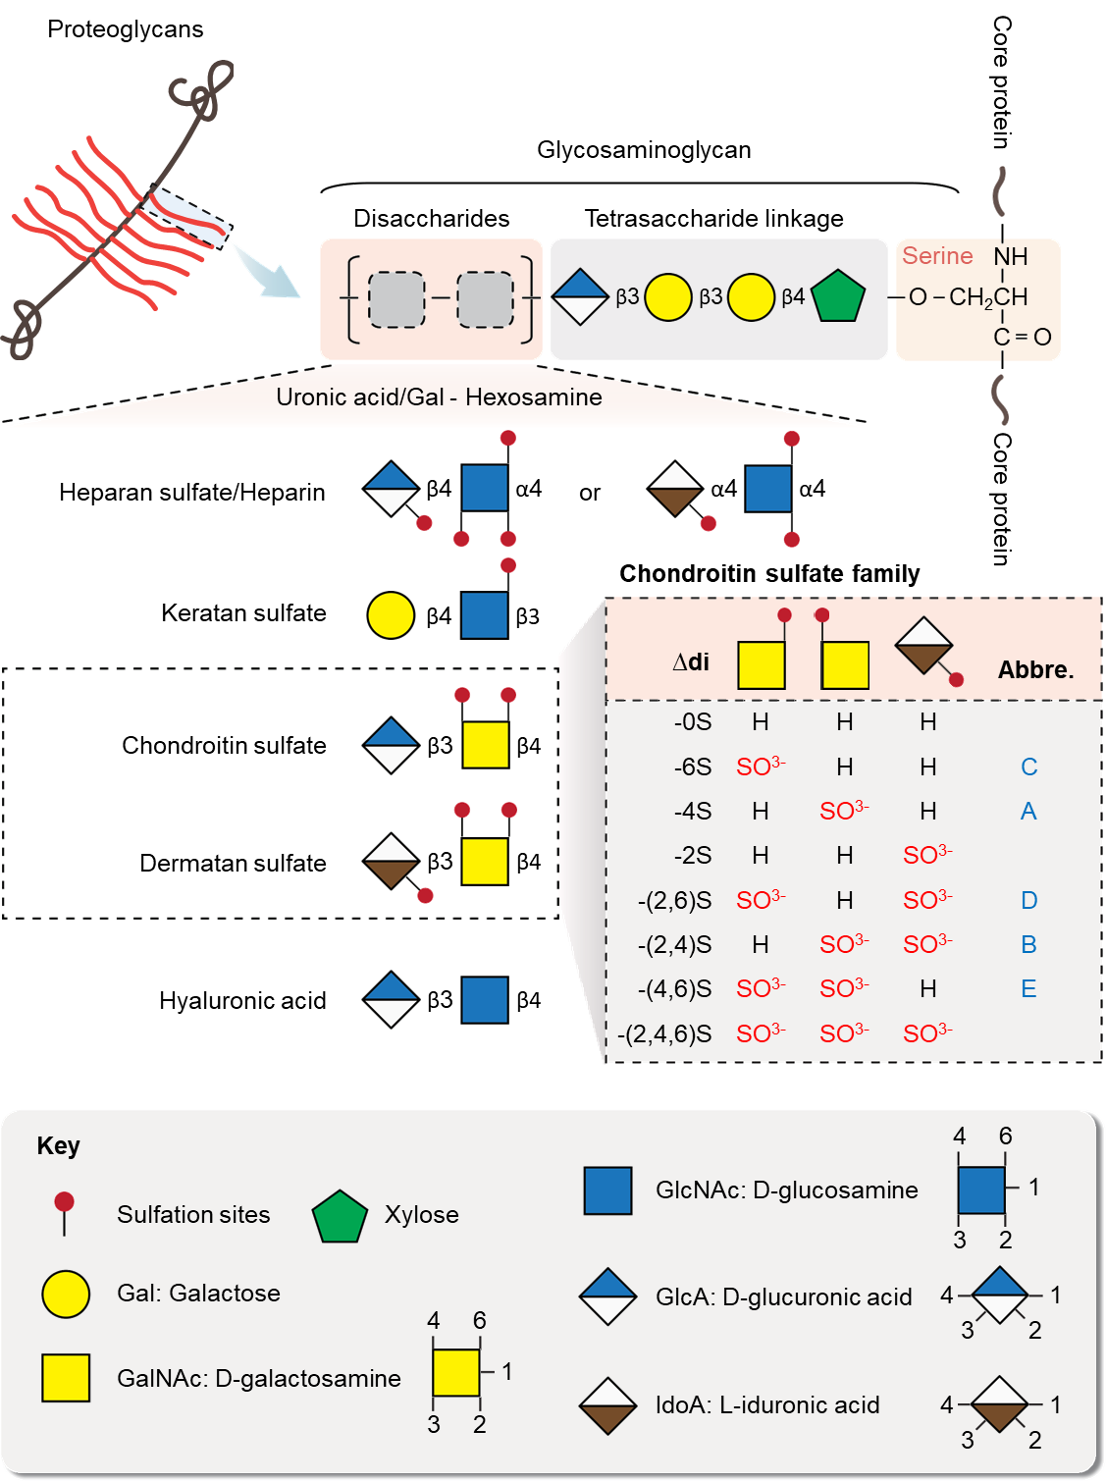
Figure 1 Structure and components of glycosaminoglycan chains of proteoglycans. The disaccharide unit of glycosaminoglycan consists of epimers of uronic acid (GlcA, IdoA) or galactose and hexosamine (GlcNAc, GalNAc). The repeating disaccharide units in different types of glycosaminoglycan are shown with the potential sulfation positions. The different disaccharides types (∆di) of chondroitin sulfate family have abbreviated names, which are based on their different sulfation positions.
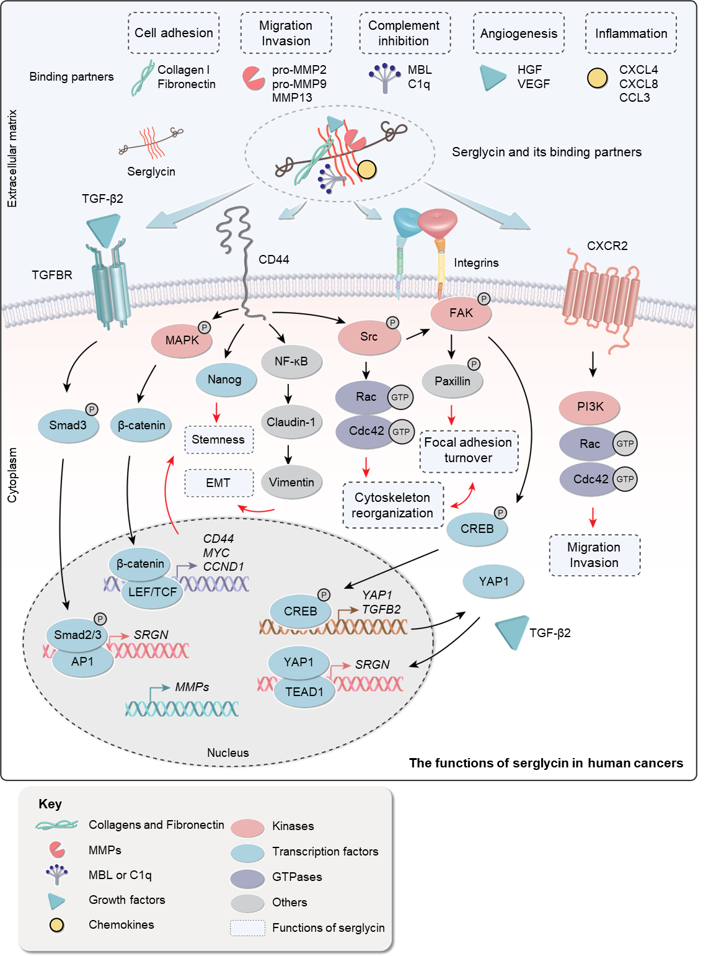
Figure 2 Overview of serglycin functions in human cancers. The various binding partners of serglycin contribute to the multiple functions of serglycin in human cancers. Serglycin, with or without binding partner, can bind to receptors on cancer cells and activate the downstream signaling pathways, including β-catenin, Nanog, phosphatidylinositol-3-kinase (PI3K) and transforming growth factor (TGF) β pathways. MMP: Matrix metalloproteinase; NF-κβ: Nuclear factor-kappa B.
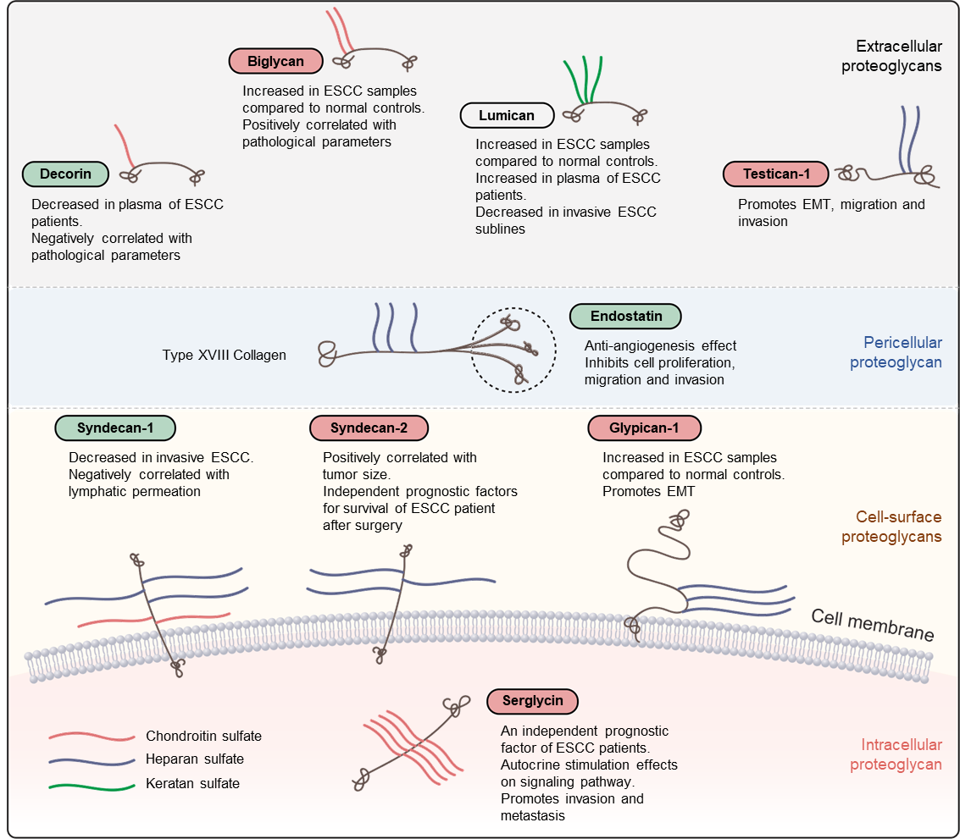
Figure 3 Classification and schematic representation of proteoglycans studied in esophageal squamous cell carcinoma. Proteoglycans are classified as extracellular, pericellular, cell-surface, and intracellular according to their cellular and subcellular localization. The ones that have pro-invasive function in esophageal squamous cell carcinoma (ESCC) are highlighted in red bubbles, and the ones that act as the tumor suppressors are highlighted in green bubbles. Lumican is in the transparent bubble because its function in ESCC is still controversial. EMT: Epithelial-mesenchymal transition.
Table 1 Classification of proteoglycans with clinicopathological and/or functional significance in esophageal squamous cell carcinoma^{[14]}
Location | Classification | Gene symbol | Eponym | Predominant GAG | Studied in ESCC | Ref.
Intracellular | Secretory granules | SRGN | Serglycin | Heparin/CS | Serglycin | Zhu et al^{[57]}
Cell-surface | Transmembrane | SDC | Syndecan 1-4 | HS/CS | Syndecan-1, -2 | Mikami et al^{[58]}, Szumilo et al^{[60]} and Huang et al^{[61]}
 |  | CSPG4 | NG2 | CS/DS
 |  | TGFBR3 | Betaglycan | HS/CS
 |  | PTPRZ1 | Phosphacan | CS/DS
 | GPI-anchored | GPC | Glypican 1-6 | HS | Glypican-1, -3 | Hara et al^{[62]}, Li et al^{[63]}, Harada et al^{[64]} and Song^{[65]}
Pericellular | Basement membrane zone | HSPG2 | Perlecan | HS/CS
 |  | AGRN | Agrin | HS
 |  | COL18A1 | Collagen XVIII | HS | Endostatin | Zheng et al^{[71]}, Zhong et al^{[72]} and Chen et al^{[73]}
 |  | COL15A1 | Collagen XV | CS/HS
Extracellular | Hyalectans | ACAN | Aggrecan | CS/KS
 |  | VCAN | Versican | CS/DS
 |  | NCAN | Neurocan | CS/DS
 |  | BCAN | Brevican | CS/DS
 | SLRPs, Canonical Class I | DCN | Decorin | CS/DS | Decorin | Wu et al^{[83]}, Ji et al^{[84]} and Augoff et al^{[85]}
 |  | BGN | Biglycan | CS/DS | Biglycan | Zhu et al^{[97]}
 |  | ASPN | Asporin
 |  | ECM2 | ECM2
 |  | ECMX | ECMX
 | SLRPs, Canonical Class II | FMOD | Fibromodulin | KS
 |  | LUM | Lumican | KS | Lumican | Kashyap et al^{[102,103]}
 |  | PRELP | PRELP
 |  | KERA | Keratocan | KS
 |  | OMD | Osteoadherin | KS
 | SLRPs, Canonical Class III | EPYC | Epiphycan | CS/DS
 |  | OPTC | Opticin
 |  | OGN | Osteoglycin
 | SLRPs, Non-Canonical Class IV | CHAD | Chondroadherin
 |  | NYX | Nyctalopin
 |  | TSKU | Tsukushi
 | SLRPs, Non-Canonical Class V | PODN | Podocan
 |  | PODNL1 | Podocan-Like 1
 | SPOCK | SPOCK | Testican 1-3 | HS | Testican-1 | Song et al^{[108]}
CS: Chondroitin sulfate; DS: Dermatan sulfate; ESCC: Esophageal squamous cell carcinoma; GAG: Glycosaminoglycan; GPI: Glycosylphosphatidylinositol; HS: Heparan sulfate; KS: Keratan sulfate; NG2: Nerve/glial antigen 2; SLRP: Small leucine-rich proteoglycan.

Published by Baishideng Publishing Group Inc
7041 Koll Center Parkway, Suite 160, Pleasanton, CA 94566, USA
Telephone: +1-925-3991568
E-mail: bpgoffice@wjgnet.com
Help Desk: https://www.f6publishing.com/helpdesk
https://www.wjgnet.com

© 2021 Baishideng Publishing Group Inc. All rights reserved.

