Name of Journal: World Journal of Gastroenterology
Manuscript NO: 78969
Manuscript Type: CASE REPORT

Pulmonary cryptococcosis after immunomodulator treatment in patients with Crohn’s disease: Three case reports

Fang YF et al. Pulmonary cryptococcosis in Crohn’s disease

Yan-Fei Fang, Xiang-Han Cao, Ling-Ya Yao, Qian Cao

Yan-Fei Fang, Xiang-Han Cao, Ling-Ya Yao, Qian Cao, Department of Gastroenterology, Inflammatory Bowel Disease Center, Sir Run Shaw Hospital, College of Medicine Zhejiang University, Hangzhou 310016, Zhejiang Province, China

Author contributions: Fang YF and Cao Q contributed to conceptualization; Fang YF and Cao XH contributed to data collection and manuscript drafting; Fang YF, Cao XH and Yao LY contributed to manuscript revision; All authors have approved the final manuscript.

Corresponding author: Qian Cao, PhD, Chief Doctor, Chief Physician, Department of Gastroenterology, Inflammatory Bowel Disease Center, Sir Run Shaw Hospital, College of Medicine Zhejiang University, No. 3 East Qingchun Road, Hangzhou 310016, Zhejiang Province, China. caoq@zju.edu.cn

Received: August 3, 2022
Revised: December 1, 2022
Accepted: January 3, 2023
Published online: January 28, 2023
Abstract
BACKGROUND
Corticosteroids and anti-tumor necrosis factor α mAbs are widely used to treat Crohn's disease (CD). However, one disadvantage of this treatment is impairment of normal immune function, leading to an increased risk of infection. Cryptococcus infection is an opportunistic infection that occurs mainly in immunocompromised patients and poses a significant diagnostic challenge in patients with CD.

CASE SUMMARY
Here, we report three cases of pulmonary cryptococcosis in patients with CD after receiving immunomodulatory treatment. The patients presented with no or mild respiratory symptoms. Chest computed tomography scans revealed pulmonary nodules in the unilateral or bilateral lobes. Diagnoses were made using pathological examination and metagenomic sequencing. The patients were treated with fluconazole 400 mg once daily for 1 to 6 mo, and symptoms were resolved. Literature searches were conducted in PubMed, Web of Science, and Embase to retrieve previously reported cases and summarize patient characteristics.

CONCLUSION
The incidence of cryptococcus infection has increased along with immunomodulator use. Clinical vigilance is required for early identification and standardized treatment.

Key Words: Crohn’s disease; Immunomodulator; Infliximab; Opportunistic infections; Pulmonary cryptococcosis; Case report

©The Author(s) 2023. Published by Baishideng Publishing Group Inc. All rights reserved.

Citation: Fang YF, Cao XH, Yao LY, Cao Q. Pulmonary cryptococcosis after immunomodulator treatment in patients with Crohn’s disease: Three case reports. World J Gastroenterol 2023; 29(4): 758-765
URL: https://www.wjgnet.com/1007-9327/full/v29/i4/758.htm
DOI: https://dx.doi.org/10.3748/wjg.v29.i4.758

Core Tip: Corticosteroids and anti-tumor necrosis factor α mAbs are commonly used to treat Crohn's disease (CD). However, they may also contribute to an increased risk of opportunistic infections. In this article, we report three cases of pulmonary cryptococcosis in patients with CD after receiving immunomodulatory treatment. Pathogen identification mainly depends on pathological examination findings, but metagenomics can serve as an alternative tool. Patients with timely diagnosis generally have a good prognosis, but clinical alerts should be raised in those who are elderly and have comorbidities and dissemination phenotype.

INTRODUCTION
Crohn's disease (CD), a chronic inflammatory disease that may involve any part of the digestive tract, is characterized by periodic clinical relapse and remission^{[1]}. Treatment medications include mesalamine, corticosteroids, small-molecule immunosuppressants, and biologics such as mAbs^{[2]}. However, these drugs also affect normal immune function and may contribute to an increased risk of opportunistic infections.
Pulmonary cryptococcosis is a type of subacute or chronic fungal infection caused by the genus Cryptococcus, and is found mostly in immunocompromised patients. It usually presents with isolated pulmonary granulomatous lesions but can also disseminate to other organ systems^{[3]}. Here, we report three cases of pulmonary cryptococcosis in patients with CD who received immunomodulatory treatment, and review previously reported cases. Literature searches were conducted in PubMed, Web of Science and Embase databases using the keywords “Crohn's disease”, “pulmonary cryptococcosis”, and “cryptococcus”. The search was restricted to full-text journal articles and conference abstracts published in English between January 1980 and May 2022. The bibliographies of the included articles were manually reviewed.

CASE PRESENTATION
Chief complaints
Case 1: A 65-year-old man was admitted to a local hospital for recurrent abdominal distension and pain 10 years ago.

Case 2: A 20-year-old man was admitted to our hospital for perianal pain with fever 5 years ago.

Case 3: A 59-year-old man was admitted to a local hospital for recurrent abdominal pain and diarrhea 13 years ago.

History of present illness
Case 1: The patient was referred to our hospital and diagnosed with CD. Before treatment initiation, chest computed tomography (CT) showed small nodules in the bilateral upper lobes with a benign tendency, pulmonary sac in the right upper lobe, and fibrous foci in the right middle lobe and bilateral lower lobes. The patient received four doses of infliximab (IFX; 300 mg) and achieved clinical remission.

Case 2: The patient was diagnosed with CD and was treated with IFX for 2 years (22 doses; 300 mg), which was discontinued due to secondary loss of response. He complained of night sweats and right-sided chest pain during deep breathing.

Case 3: The patient was diagnosed with CD 5 years ago and had been treated with methylprednisolone (MP; 0.75 mg/kg) for 3 years. He complained of productive cough for 1 mo.

Laboratory examinations
Case 2: The carbohydrate antigen 125 (CA-125) level was 54.2 U/mL. The G test, galactomannan (GM) test, and sputum fungal test results were negative.

Case 3: Vitamin B12 and folic acid levels were normal. Hepatitis B virus surface, core and E antibodies, antinuclear antibodies, vasculitis antibodies, sputum acid-fast (AF) staining, bronchoscopic brush cytology, and bronchoalveolar lavage fluid (BALF) cytopathology showed negative findings.

Other laboratory examination results are summarized in Table 1.

Imaging examinations
Case 1: A repeat CT scan after the fourth dose of IFX revealed an increased number of bilateral nodules and a large nodule in the left upper lobe with possible inflammation (Fig. 1A). Electromagnetic navigation bronchoscopy revealed a clear trachea and no neoplasm in the principal and segmental bronchi. A biopsy was performed in the anterior segment of the left upper lobe. Fibrinobronchoscopic AF staining, fungus, culture, brush cytology, BALF Gram staining, exfoliative cytology, and X-PERT assay (simultaneous detection of Mycobacterium tuberculosis and resistance to rifampin) results were negative. Biopsy revealed focal granuloma formation in the alveolar tissues (Figure 1B). Periodic acid-Schiff (PAS) staining and AF staining were negative; however, periodic acid-silver methenamine (PASM) staining revealed suspicious positive bodies (Figure 1C).

Case 2: Chest CT revealed patchy lesions in the right upper lobe and right interlobar fissure, and multiple bilateral nodules with inflammatory propensity (Figure 2A). Bronchoscopy revealed clear segmental bronchi with no apparent stenosis or neoplasm in the lumen. Fibrinobronchoscopy was performed, and the BALF Aspergillus GM level was 0.840 μg/L. AF staining, fungus, brush cytology, and culture results were negative. BALF was sent for metagenomic sequencing and Cryptococcus was detected.

Case 3: Chest CT tomography revealed nodules in the posterior segment of the right upper lobe (Figure 3A). Tumor presence could not be ruled out. Bronchoscopy revealed no neoplasm in bilateral bronchi. Considering the difficulty of bronchoscopic biopsy, thoracoscopic lobectomy of the posterior segment of the right upper lobe was performed. Postoperative pathology revealed negative AF staining results but positive PAS and PASM staining results (Figure 3B, C). Tuberculosis- DNA (TB-DNA) test was negative.

FINAL DIAGNOSIS
Case 1-3: A diagnosis of CD combined with pulmonary cryptococcosis was confirmed.

TREATMENT
Case 1: IFX was discontinued, and the patient was administered fluconazole (FLCZ) 400 mg once daily for 6 mo.

Case 2: Medications for CD were discontinued. The patient was given FLCZ 400 mg once daily for 5 mo.

Case 3: MP was switched to pan-enteral nutrition therapy. The patient was administered FLCZ 400 mg once daily for 1 mo.

OUTCOME AND FOLLOW-UP
Case 1: A chest CT upon completion of anti-fungal therapy showed reduced size of the pulmonary nodule in the left upper lobe.

Case 2: During anti-fungal therapy, the patient was started on thalidomide for CD treatment and reported no apparent abdominal pain. One month after anti-fungal therapy, he achieved symptom resolution, and a repeat chest CT scan showed lesion absorption (Figure 2B).

Case 3: IFX was initiated 7 years later because of the progression of CD. Regular follow-ups have revealed no recurrence so far.

The clinical courses of the three cases are summarized in Figure 4.

DISCUSSION
Cryptococcus infection is an opportunistic fungal infection caused by Cryptococcus neoformans or Cryptococcus gattii. These pathogens are ubiquitously distributed, with the respiratory tract being the primary portal of entry. Cryptococcosis often occurs in immunocompromised individuals, such as human immunodeficiency virus-infected patients, organ transplant recipients, and those with indications for immunosuppressants^{[3]}. However, it has also been reported in immunocompetent patients^{[4]}.
A total of 21 studies reporting CD cases complicated by Cryptococcus infection were identified (Table 2)^{[4-24]}. Among them, one was a retrospective analysis^{[21]} (197 males and 69 females) and another reported relapse of a previously reported case^{[13]}. The remaining 19 patients comprised 13 males and 6 females; 9 of the cases were disseminated cryptococcosis^{[4,5,8,12,15-19]}. Infection sites included lungs (15 cases), central nervous system (CNS; 5 cases), gastrointestinal tract (GI; 3 cases), skin (1 case), omentum (1 case), and pleural fluid and ascites (1 case).
Infected patients had been treated with different combinations of CD drugs, including anti-tumor necrosis factor α (TNF-α) agents, such as IFX, adalimumab and certolizumab pegol, corticosteroids, and other immunosuppressants. Symptoms ranged from asymptomatic lung granulomas to severe pneumonia. Patients with disseminated cryptococcosis may also present with symptoms of other organ systems, such as colitis^{[8]}, meningitis^{[12]}, or skin ulcers^{[5]}. Chest imaging typically revealed single or multiple pulmonary nodules. Diagnosis mainly relies on pathological examination, with accessory methods including fungal culture and the cryptococcal polysaccharide capsular antigen test. The most commonly used anti-fungal medications are amphotericin B (AmB), liposomal AmB (LAmB), 5-flucytosine (5FC), FLCZ, itraconazole, and voriconazole. Patients with mild symptoms generally recovered after treatment with triazole, while AmB and 5FC were intended for deep fungal infections; however, AmB and LAmB may cause serious adverse events^{[4,8]}. Patients with disseminated cryptococcosis have a relatively poor prognosis, particularly when the CNS is involved.
Anti-TNF-α antibodies have been widely administered among CD patients with high efficacy, but concerns remain regarding their immunogenicity, skin toxicity, and increased risk of infection, such as the possible activation of latent TB. Therefore, current guidelines suggest that TB screening should be conducted before medication infusion^{[25]}. TNF-α also plays a role in clearing pulmonary Cryptococcus infections by inducing interleukin-12 and interferon γ to promote a T1-cell-mediated immune response^{[26]}. Anti-TNF-α agents, among other immunomodulators, may interfere with this process and increase the risk of Cryptococcus infection.
In this paper, we report three male patients diagnosed with CD, aged 20–65 years, who developed pulmonary cryptococcosis after being treated with anti-TNF-α agents or corticosteroids. The patients presented with asymptomatic or mild pneumonia with pulmonary nodules. One patient (case 2) showed elevated CA-125 level, which might be due to intestinal inflammation. G test and GM test were both negative, possibly because of low sensitivity of the tests for Cryptococcus. One patient (case 3) underwent surgery because of difficulty in biopsy. Diagnosis depended on postoperative pathological examinations since BALF might fail to detect Cryptococcus. All patients achieved symptom resolution after FLCZ treatment, consistent with other studies^{[6,10,23]}.
CD complicated with pulmonary cryptococcosis is relatively rare, but its incidence has increased in recent years with the use of various immunomodulators, particularly biologics, in CD management. Diagnosis is challenging because clinical symptoms and chest imaging both lack specificity, and GI manifestations can resemble CD progression, leading to misdiagnosis. Therefore, high clinical vigilance is required for early identification of infection, discontinuation of immunomodulators, and standardized treatment.

CONCLUSION
Our three case reports and literature review suggest that patients with timely diagnosis generally have a good prognosis. However, comorbidities, advanced age, and dissemination phenotype should raise clinical alerts. Metagenomic sequencing can be an alternative approach for pathogen diagnosis when biopsy is unfeasible.

REFERENCES
1 Lichtenstein GR, Loftus EV, Isaacs KL, Regueiro MD, Gerson LB, Sands BE. ACG Clinical Guideline: Management of Crohn's Disease in Adults. Am J Gastroenterol 2018; 113: 481-517 [PMID: 29610508 DOI: 10.1038/ajg.2018.27]
2 Adamina M, Bonovas S, Raine T, Spinelli A, Warusavitarne J, Armuzzi A, Bachmann O, Bager P, Biancone L, Bokemeyer B, Bossuyt P, Burisch J, Collins P, Doherty G, El-Hussuna A, Ellul P, Fiorino G, Frei-Lanter C, Furfaro F, Gingert C, Gionchetti P, Gisbert JP, Gomollon F, González Lorenzo M, Gordon H, Hlavaty T, Juillerat P, Katsanos K, Kopylov U, Krustins E, Kucharzik T, Lytras T, Maaser C, Magro F, Marshall JK, Myrelid P, Pellino G, Rosa I, Sabino J, Savarino E, Stassen L, Torres J, Uzzan M, Vavricka S, Verstockt B, Zmora O. ECCO Guidelines on Therapeutics in Crohn's Disease: Surgical Treatment. J Crohns Colitis 2020; 14: 155-168 [PMID: 31742338 DOI: 10.1093/ecco-jcc/jjz187]
3 Maziarz EK, Perfect JR. Cryptococcosis. Infect Dis Clin North Am 2016; 30: 179-206 [PMID: 26897067 DOI: 10.1016/j.idc.2015.10.006]
4 Sciaudone G, Pellino G, Guadagni I, Somma A, D'Armiento FP, Selvaggi F. Disseminated Cryptococcus neoformans infection and Crohn's disease in an immunocompetent patient. J Crohns Colitis 2011; 5: 60-63 [PMID: 21272807 DOI: 10.1016/j.crohns.2010.08.003]
5 Lerner EA, Kibbi AG, Haas A. Calf ulcer in an immunocompromised host. Cryptococcosis. Arch Dermatol 1988; 124: 430-431, 433-434 [PMID: 3345094 DOI: 10.1001/archderm.124.3.430]
6 Hrnicek M J, Young R L. Immunomodulatory therapy in Crohn's disease as a cause of Cryptococcus neoformans pneumonia. Am J Gastroenterol 2003; 98: S162 [DOI:10.1016/s0002-9270(03)01251-6]
7 Rehman T, Ali J, Lopez FA. A 61-year-old man with asymptomatic, bilateral lung masses. J La State Med Soc 2008; 160: 309-349 [PMID: 19283977]
8 Osawa R, Singh N. Colitis as a manifestation of infliximab-associated disseminated cryptococcosis. Int J Infect Dis 2010; 14: e436-e440 [PMID: 19660974 DOI: 10.1016/j.ijid.2009.05.019]
9 Hirai F, Matsui T, Ishibashi Y, Higashi D, Futami K, Haraoka S, Iwashita A. Asymptomatic pulmonary cryptococcosis in a patient with Crohn's disease on infliximab: case report. Inflamm Bowel Dis 2011; 17: 1637-1638 [PMID: 21674724 DOI: 10.1002/ibd.21564]
10 Takazono T, Izumikawa K, Yoshioka S, Matsuo N, Yamakawa M, Suyama N, Kohno S. Possible pulmonary cryptococcosis in a patient with Crohn's disease during anti-tumor necrosis factor-alpha treatment: a case report and literature review. Jpn J Infect Dis 2012; 65: 461-464 [PMID: 22996229 DOI: 10.7883/yoken.65.461]
11 Fraison JB, Guilpain P, Schiffmann A, Veyrac M, Le Moing V, Rispail P, Le Quellec A. Pulmonary cryptococcosis in a patient with Crohn's disease treated with prednisone, azathioprine and adalimumab: exposure to chicken manure as a source of contamination. J Crohns Colitis 2013; 7: e11-e14 [PMID: 22647638 DOI: 10.1016/j.crohns.2012.04.016]
12 Wysocki JD, Said SM, Papadakis KA. An uncommon cause of abdominal pain and fever in a patient with Crohn's disease. Gastroenterology 2015; 148: e12-e13 [PMID: 25824348 DOI: 10.1053/j.gastro.2014.10.044]
13 Takazono T, Sawai T, Tashiro M, Saijo T, Yamamoto K, Imamura Y, Miyazaki T, Suyama N, Izumikawa K, Kakeya H, Yanagihara K, Mukae H, Kohno S. Relapsed Pulmonary Cryptococcosis during Tumor Necrosis Factor α Inhibitor Treatment. Intern Med 2016; 55: 2877-2880 [PMID: 27725552 DOI: 10.2169/internalmedicine.55.6969]
14 Zhou L, Ouyang R, Peng Y. Cryptogenic organizing pneumonia and asymptomatic pulmonary cryptococosis coexisting in a patient with crohn's disease. Chest 2016; 149: A189 [DOI:10.1016/j.chest.2016.02.196]
15 Saad AM, Czul F, Sakuraba A, Rubin DT, Cohen RD. Age of Diagnosis is Associated with Disease Presentation and Therapeutic Complications in Patients with Crohn's Disease. Inflamm Bowel Dis 2016; 22: 1027-1031 [PMID: 26919459 DOI: 10.1097/MIB.0000000000000732]
16 Vasant DH, Limdi JK, Borg-Bartolo SP, Bonington A, George R. Posterior Reversible Encephalopathy Syndrome and Fatal Cryptococcal Meningitis After Immunosuppression in a Patient With Elderly Onset Inflammatory Bowel Disease. ACG Case Rep J 2016; 3: e98 [PMID: 27807560 DOI: 10.14309/crj.2016.71]
17 Lee WS, Azmi N, Ng RT, Ong SY, Ponnampalavanar SS, Mahadeva S, Hilmi I. Fatal infections in older patients with inflammatory bowel disease on anti-tumor necrosis factor therapy. Intest Res 2017; 15: 524-528 [PMID: 29142521 DOI: 10.5217/ir.2017.15.4.524]
18 Chavapradit N, Angkasekwinai N. Disseminated cryptococcosis in Crohn's disease: a case report. BMC Infect Dis 2018; 18: 620 [PMID: 30514241 DOI: 10.1186/s12879-018-3553-3]
19 Maleb A, Hami A, Lahlou Y B, Lamrabat S, Rifai S, Rahmani N, Bensalah M, Frikh M, Lemnouer A, Elouennass M. Disseminated Cryptococcosis Incorrectly Managed: a Case Report. Journal of Mycology and Infection 2019; 24: 28-31 [DOI:10.17966/jmi.2019.24.1.28]
20 Santo P, Zaltman C, Santos P, Valente F, Costa M, Silveira M, Barroso P. Association of Cryptococcosis and Tuberculosis in a Patient With Crohn's Disease - A Challenging Diagnosis. Am J Gastroenterol 2019; 1141: S29 [DOI:10.14309/01.ajg.0000613416.21476.f5]
21 Mushtaq K, Khan Z, Aziz M, Alyousif ZA, Siddiqui N, Khan MA, Nawras A. Trends and outcomes of fungal infections in hospitalized patients of inflammatory bowel disease: a nationwide analysis. Transl Gastroenterol Hepatol 2020; 5: 35 [PMID: 32632386 DOI: 10.21037/tgh.2019.10.14]
22 Yeh H, Wu RC, Tsai WS, Kuo CJ, Su MY, Chiu CT, Le PH. Systemic lupus erythematosus complicated by Crohn's disease with rectovaginal fistula. BMC Gastroenterol 2021; 21: 206 [PMID: 33964869 DOI: 10.1186/s12876-021-01801-w]
23 Hussein M, Haq IU, Hameed M, Alabbas A, Hadi HA, Elarabi A, Al-Bozom I. Isolated pulmonary cryptococcosis in a patient with Crohn's disease treated with infliximab: A case report and literature review. Respir Med Case Rep 2021; 33: 101459 [PMID: 34401295 DOI: 10.1016/j.rmcr.2021.101459]
24 Yeoh K, McGregor A. Persistent Dyspnea in a Patient with Altered Immune Status. Infectious Diseases in Clinical Practice 2022; 30 [DOI:10.1097/ipc.0000000000001116]
25 D'Haens GR, van Deventer S. 25 years of anti-TNF treatment for inflammatory bowel disease: lessons from the past and a look to the future. Gut 2021; 70: 1396-1405 [PMID: 33431575 DOI: 10.1136/gutjnl-2019-320022]
26 Herring AC, Lee J, McDonald RA, Toews GB, Huffnagle GB. Induction of interleukin-12 and gamma interferon requires tumor necrosis factor alpha for protective T1-cell-mediated immunity to pulmonary Cryptococcus neoformans infection. Infect Immun 2002; 70: 2959-2964 [PMID: 12010985 DOI: 10.1128/IAI.70.6.2959-2964.2002]

Footnotes
Informed consent statement: All study participants or their legal guardian provided informed written consent about personal and medical data collection prior to study enrolment.

Conflict-of-interest statement: All the authors report no relevant conflicts of interest for this article.

CARE Checklist (2016) statement: The authors have read the CARE Checklist (2016), and the manuscript was prepared and revised according to the CARE Checklist (2016).

Open-Access: This article is an open-access article that was selected by an in-house editor and fully peer-reviewed by external reviewers. It is distributed in accordance with the Creative Commons Attribution NonCommercial (CC BY-NC 4.0) license, which permits others to distribute, remix, adapt, build upon this work non-commercially, and license their derivative works on different terms, provided the original work is properly cited and the use is non-commercial. See: https://creativecommons.org/Licenses/by-nc/4.0/

Provenance and peer review: Unsolicited article; Externally peer reviewed.

Peer-review model: Single blind

Peer-review started: August 3, 2022
First decision: November 17, 2022
Article in press: January 3, 2023

Specialty type: Gastroenterology and hepatology
Country/Territory of origin: China
Peer-review report’s scientific quality classification
Grade A (Excellent): 0
Grade B (Very good): B, B
Grade C (Good): 0
Grade D (Fair): 0
Grade E (Poor): 0

P-Reviewer: Said ZNA, Egypt; Wang P, China S-Editor: Liu GL L-Editor: A P-Editor: Liu GL
Figure Legends
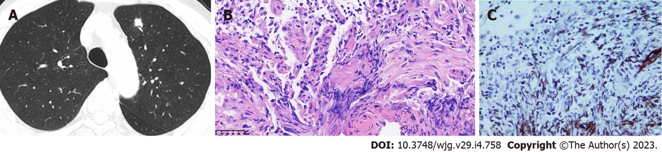
Figure 1 Imaging and pathologic findings of case 1. A: Chest computed tomography scan showing multiple nodules in bilateral lobes and a large one in the left upper lobe; B: Hematoxylin-eosin staining showing focal granuloma formation in alveolar tissues; C: Periodic acid-silver methenamine staining showing suspicious positive organisms.
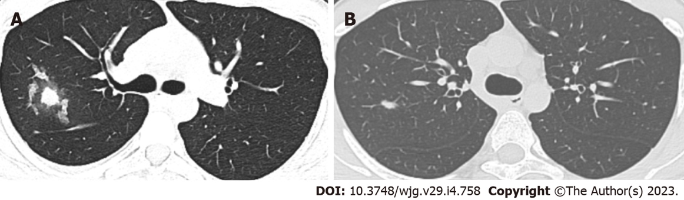
Figure 2 Imaging findings of case 2. A: Chest computed tomography (CT) scan before fluconazole treatment showing patchy lesions in the right upper lobe and right interlobar fissure and multiple nodules in bilateral lobes; B: Chest CT scan showing lesion absorption 6 mo after initiation of anti-fungal therapy.
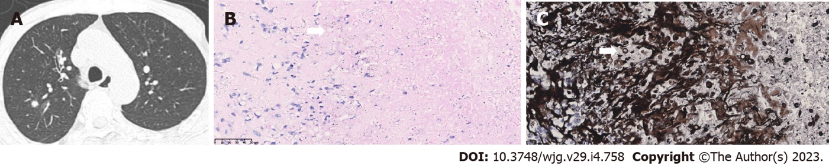
Figure 3 Imaging and pathologic findings of case 3. A: Chest computed tomography scan showing nodules in the posterior segment of right upper lobe; B and C: Periodic acid-Schiff and periodic acid-silver methenamine staining showing positive organisms (white arrows).
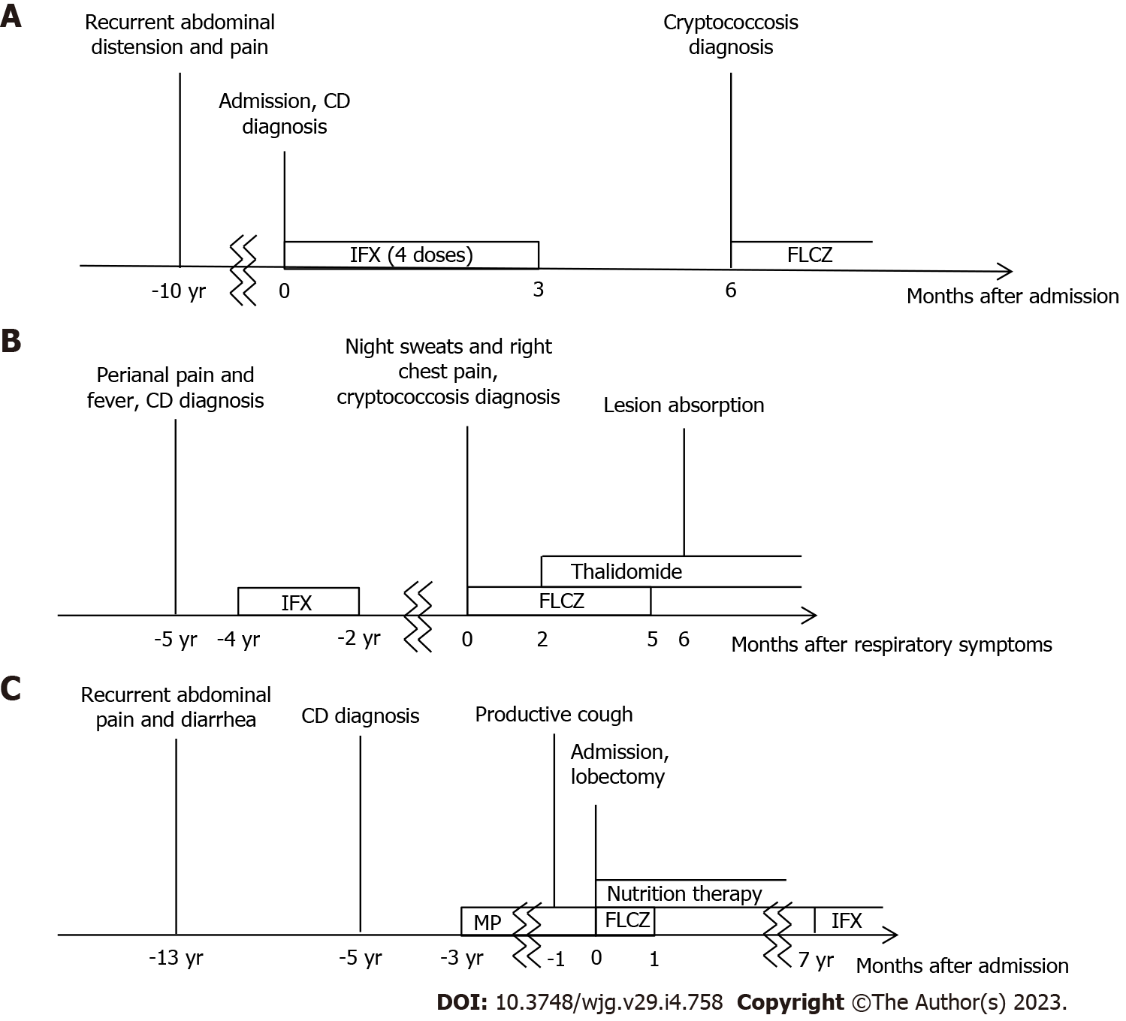
Figure 4 Clinical courses of the three cases. A: Case 1; B: Case 2; C: Case 3. CD: Crohn’s disease; IFX: Infliximab; FLCZ: Fluconazole; MP: Methylprednisolone.

Table 1 Laboratory examination
Case | 1 | 2 | 3
WBC count (×10⁹/L) | 10.0 | 9.4 | 2.5
Neutrophil count (×10⁹/L) | 8.13 | 8.0 | 1.6
Platelet count (×10⁹/L) | 305 | 282 | 220
Hemoglobin (g/L) | 120 | 139 | 97
Albumin (g/L) | 34.3 | 42.8 | 12.0
CRP (mg/L) | 23.3 | 17.4 | 34.9
ESR (mm/hr) | 19 | 16 | 14
Tumor markers | Negative | Negative | Negative
T-SPOT.TB | Negative | Negative | Weak positive
EBV IgM | Negative | Negative | -
Cytomegalovirus IgM | Negative | Negative | Negative
HIV | Negative | Negative | Negative
TPPA test | Negative | Negative | Negative
WBC: White blood cell; CRP: C reactive protein; ESR: Erythrocyte sedimentation rate; T-SPOT.TB: T-cell spot of tuberculosis test; EBV: Epstein-Barr virus; IgM: Immunoglobulin M; HIV: Human immunodeficiency virus; TPPA: Treponema pallidum particle agglutination.

Table 2 Clinical characteristics of cryptococcus infection in patients with Crohn’s disease
Ref. | Age/sex | Comorbidity | CD medication | Symptom | Infection site | Treatment | Outcome
Lerner et al^{[5]}, 1988 | 65/M | Ankylosing spondylitis | Prednisone | Calf ulcer | Lungs, skin | AmB, 5FC | Died
Hrnicek et al^{[6]}, 2003 | 51/M | None | IFX, prednisone, MTX, ciprofloxacin | Cough, fatigue, headache, fever, chills | Lungs | Surgery, FLCZ | Recovered
Rehman et al^{[7]}, 2008 | 61/M | None | IFX, prednisone, budesonide, AZA | None | Lungs | AmB, 5FC → FLCZ | Recovered
Osawa et al, 2010^{[8]} | 53/M | Silicosis | IFX, prednisone, AZA | Abdominal pain, diarrhea, fever, night sweats, headache | Lungs, GI, CNS | AmB → LAmB, 5FC → FLCZ | Recovered
Sciaudone et al^{[4]}, 2011 | 26/F | None | None | Diarrhea, abdominal pain, weight-loss, headache, cough | Lungs, GI | Surgery, LAmB → FLCZ | Recovered
Hirai et al^{[9]}, 2011 | 39/M | None | IFX | None | Lungs | Surgery | Recovered
Takazono et al^{[10]}, 2012 | 35/M | None | IFX, prednisolone, mesalazine | Fever | Lungs | FLCZ | Recovered
Fraison et al^{[11]}, 2013 | 54/M | Ankylosing spondylitis | ADM, AZA | Fever, anorexia, cough, chest pain, dyspnea, arthralgia, myalgia | Lungs | LAmB, 5FC → FLCZ | Recovered
Wysocki et al^{[12]}, 2015 | 46/M | None | IFX, AZA →ADM →CZP | Abdominal and back pain, fever, headache | Omentum, CNS | LAmB, 5FC | Recovered
Takazono et al^{[13]}, 2016 | 35/M | None | IFX, prednisolone | Fever, fatigue, night sweats | Lungs | FLCZ → ITCZ | Recovered
Zhou et al^{[14]}, 2016 | 66/M | Cryptogenic organizing pneumonia | Prednisone | Dyspnea, cough | Lungs | FLCZ | Recovered
Saad et al^{[15]}, 2016 | 71/M | None | IFX, AZA | Meningitis | CNS | - | -
Vasant et al^{[16]}, 2016 | 74/F | Posterior reversible encephalopathy syndrome | IFX, prednisolone | Headache, confusion, fever, rigor, body ache | CNS | LAmB, 5FC → VRCZ | Died
Lee et al^{[17]}, 2017 | 70/F | Klebsiella pneumoniae and Pneumocystis jiroveci infections | IFX | Pyrexia | CNS | AmB → VRCZ | Died
Chavapradit et al^{[18]}, 2018 | 64/F | None | Prednisolone, AZA, mesalazine | Abdominal pain, diarrhea | Lungs, GI | AmB → FLCZ | Recovered
Maleb et al^{[19]}, 2019 | 45/M | None | Steroid, AZA | Shock, abundance of ascites, fever | Pleural fluid, ascites | FLCZ | Died
Santo et al^{[20]}, 2019 | 23/M | Tuberculosis | IFX, AZA | Fever, headache | Lungs | FLCZ | Recovered
Yeh et al^{[22]}, 2021 | 57/F | Systemic lupus erythematosus | ADM, prednisolone, mesalazine | Pneumonia | Lungs | AmB, 5FC | Recovered
Hussein et al^{[23]}, 2021 | 54/M | None | IFX, prednisolone, MTX | Fever, fatigue, cough | Lungs | FLCZ | Recovered
Yeoh et al^{[24]}, 2022 | 52/F | Autoimmune hepatitis | Prednisolone | Dyspnea, chest pain, cough, lethargy | Lungs | Surgery | Recovered
M: Male; F: Female; IFX: Infliximab; MTX: Methotrexate; AZA: Azathioprine; ADM: Adalimumab; CZP: Certolizumab pegol; GI: Gastrointestinal tract; CNS: Central nervous system; AmB: Aamphotericin B; LAmB: Liposomal amphotericin B; 5FC: 5-fluorocytosine; FLCZ: Fluconazole; ITCZ: Itraconazole; VRCZ: Voriconazole; -: Not reported.

Published by Baishideng Publishing Group Inc
7041 Koll Center Parkway, Suite 160, Pleasanton, CA 94566, USA
Telephone: +19253991568
Email: bpgoffice@wjgnet.com
Help Desk: https://www.f6publishing.com/helpdesk
https://www.wjgnet.com

© 2023 Baishideng Publishing Group Inc. All rights reserved.

