Name of Journal: World Journal of Gastrointestinal Endoscopy
Manuscript NO: 44867
Manuscript Type: REVIEW

Difficult biliary cannulation: historical perspective, practical updates, and guide for the endoscopist

Berry R et al. Difficult biliary cannulation

Rani Berry, James Y Han, James H Tabibian

Rani Berry, Department of Internal Medicine, Ronald Reagan UCLA Medical Center, Los Angeles, CA 90095, United States

James Han, Department of Internal Medicine, University of California, Irvine, CA 92868, United States

James H Tabibian, Division of Gastroenterology, Department of Medicine, Olive View-UCLA Medical Center, Sylmar, CA 91342, United States

ORCID number: Rani Berry (0000-0002-5510-0338); James Han (0000-0003-3210-8473); James H Tabibian (0000-0001-9104-1702)

Author contributions: Berry R, Han J and Tabibian JH acquired and selected the figures and drafted the manuscript; Tabibian JH provided supervision and critical revision of the manuscript.

Conflict-of-interest statement: No potential conflicts of interest, no financial support.

Open-Access: This article is an open-access article which was selected by an in-house editor and fully peer-reviewed by external reviewers. It is distributed in accordance with the Creative Commons Attribution Non Commercial (CC BY-NC 4.0) license, which permits others to distribute, remix, adapt, build upon this work non-commercially, and license their derivative works on different terms, provided the original work is properly cited and the use is non-commercial. See: http://creativecommons.org/licenses/by-nc/4.0/

Manuscript source: Invited manuscript

Corresponding author: James H Tabibian, MD, PhD, Associate Professor, Division of Gastroenterology, Department of Medicine, Olive View-UCLA Medical Center, 14445 Olive View Dr., 2B-182, Sylmar, CA 91342, United States. jtabibian@dhs.lacounty.gov
Telephone: +1-747-2104627
Fax: +1-747-2104573
Received: November 30, 2018
Peer-review started: November 30, 2018
First decision: December 10, 2018
Revised: December 18, 2018
Accepted: January 3, 2019
Article in press: January 3, 2019
Published online: January 16, 2019

Abstract
Despite improvements in endoscopic technologies and accessories, development of advanced endoscopy fellowship programs, and advances in ancillary imaging techniques, biliary cannulation in endoscopic retrograde cholangiopancreatography (ERCP) can still be unsuccessful in up to 20% of patients, even in referral centers. Once cannulation has been deemed to be difficult, the risk of post-ERCP pancreatitis and technical failure inherently increases. A number of factors, including endoscopist experience and patient anatomy, have been associated with difficult biliary cannulation, but predicting a case of difficult cannulation a priori is often not possible. Numerous techniques such as pancreatic guidewire and stenting, early pre-cut, and rendezvous may be employed when standard approaches fail. Data regarding the rate of success and adverse events of these techniques have been variable, though most studies suggest that pancreatic duct stenting generally reduces the rate of post-ERCP pancreatitis in instances of difficult biliary cannulation. Here we provide a review on difficult biliary cannulation and discuss how the choice of which techniques to employ and how to best employ them should be individualized and take into account the skill of the endoscopist, the disorder being treated, the anatomy of the patient, and the available biomedical literature.

Key words: Selective biliary cannulation; Post-endoscopic retrograde cholangiopancreatography pancreatitis; Periampullary diverticulum; Precut technique; Endoscopic ultrasound; Rendezvous endoscopic retrograde cholangiopancreatography

© The Author(s) 2019. Published by Baishideng Publishing Group Inc. All rights reserved.

Core tip: Endoscopic retrograde cholangiopancreatography (ERCP) serves an important role in the treatment of biliary obstruction, gastrointestinal malignancies, therapeutic ductal stenting and more. Successful ERCP hinges on efficient biliary cannulation. In this review, we provide an overview on the standard methods for selective biliary cannulation, factors that can cause difficult cannulation, and an in-depth summary of techniques used to facilitate cannulation after repeat attempts.

Citation: Berry R, Han JY, Tabibian JH. Difficult biliary cannulation: historical perspective, practical updates, and guide for the endoscopist. World J Gastrointest Endosc 2019; 11(1): 5-21
URL: https://www.wjgnet.com/1948-5190/full/v11/i1/5.htm
DOI: https://dx.doi.org/10.4253/wjge.v11.i1.5

INTRODUCTION
Successful biliary cannulation was first achieved by the obstetrician William McCune and the surgical team at George Washington University, using an Eder fiberoptic duodenoscope equipped with a forward and side lens. At that time, McCune recorded a 50% success rate, and wrote, “Anyone who looks through one of these instruments has to have 2 personality characteristics. First, he has to be honest, and second, must have an undying, blind, day and night, uncompromising persistence.” Rapid improvement in success rates came one year later in Japan, when Oi^{[1]} developed a side-viewing fiberoptic duodenoscope with the ability to manipulate the cannula. The investigators reported a 77% success rate, without significant morbidity. Five years later, the improvement in ERCP methodologies led to additional techniques; some researcher in Erlangen, Germany and Kawai^{[2]} in Japan were independently working on therapeutic uses of ERCP, documenting the first cases of biliary sphincterotomy. The “Demling-Classen” probe allowed for success sphincterotomy (i.e., “Erlangen”sphincterotomy) and the ability to inject contrast dye while the catheter was held in place. Meanwhile, Kawai^{[2]} developed a technique similar to modern-day needle knife sphincterotomy. These early breakthroughs were inspired by many sources, including the already ubiquitous use of baskets, stents, catheters and guidewires in the fields of cardiology, urology, and interventional radiology, and have undoubtedly laid the foundation for modern day ERCP.
The evolution of ERCP has similarly been influenced heavily by radiologic advances such as magnetic resonance cholangiopancreatopgraphy (MRCP), surgical advances such as laproscopic cholecystectomy, and endoscopic ultrasound (EUS). Today, the indications for ERCP are numerous, including but not limited to: biliary obstruction in the setting of stones, malignancy, infection, and parasites, types 1 and 2 sphincter of Oddi dysfunction, palliative and therapeutic ductal stenting, therapies for biliary tract malignancies (e.g., photodynamic therapy (PDT), radiofrequency ablation (RFA), etc. for cholangicarcinoma), and many more. Regardless of the indication, ERCP has been and remains an invasive procedure that requires advanced training and finesse to safely achieve success.

STANDARD METHODS FOR SELECTIVE BILIARY CANNULATION
Since the advent of ERCP, selective biliary cannulation (SBC) has remained not only the first and rate-limiting step of the procedure, but also one of the most technically challenging portions. The incidence of complications while trying to achieve SBC ranges from 4%-30% depending on various research studies^{[3,4]}. Failed biliary cannulation occurs in up to 20% of cases and itself is associated with a higher risk of complications including post-ERCP pancreatitis (PEP), bleeding, delayed therapy, and others^{[4]}. The standard endoscopic approach to uncomplicated SBC can be conceptualized chronologically as presented below.

Papillary assessment and positioning
Successful ERCP hinges on proper scope placement and adequate visualization of the papilla. Most commonly, a side-viewing duodenoscope with a channel of 3.7-4.2 mm is used (except in rare situations such as duodenal stenosis, in which a small scope is necessary)^{[5]}. Good visualization of the major duodenal papilla for biliary cannulation is achieved by placing the duodenoscope below the papilla (Figure 1). Shifting the patient into a left lateral decubitus or supine position can help improve the orientation of the scope and prevent it from falling back into the stomach. If a long scope position is required, the scope tip should be placed below the level of the papilla while applying gentle (counterclockwise) torque, thus allowing for appropriate infrapapillary orientation while maintaining visualization^{[6]}. This view can facilitate better visualization of the major duodenal papilla and a more stable scope position in patients with a very proximal papilla, among other potential indications (Table 1). Note, this differs greatly from attempting main pancreatic duct (MPD) cannulation, in which the duodenoscope tip is usually positioned perpendicular to the duodenal wall^{[7]}. Importantly, when pursuing ERCP limit insufflation as overdistention of the gastric tract can make duodenal visualization more difficult. Occasionally, passing the duodenoscope into the stomach and aspirating gas, can prevent this. Once in position, with a steady hold on the duodenoscopy, the endoscopist is ready to choose a preferential technique for initial attempt of biliary cannulation.

Technique: contrast cannulation vs wire guided cannulation
Standard methods of biliary cannulation include contrast-assisted cannulation and guide-wire assisted cannulation. In these methods, the majority of endoscopists use a sphincterotome (ST) since it can be adjusted into the direction of the biliary duct by pulling or relaxing the cutting wire and allows for sphincterotomy if necessary. Triple-lumen STs are especially used to cannulate never previously proceduralized papilla^{[8,9]}. The ST is inserted past the papilla, into the bile duct, with focus on minimizing papilla trauma and MPD cannulation or opacification. PD opacification (i.e., injection with contrast) is directly related to increased risk of PEP. Cannulation technique varies by hospital, physician comfort and available devices, we will review herein the most widely used techniques, in particular contrast vs wire guided cannulation.
Contrast cannulation (CC) was first demonstrated with the Deming-Classen probe but is associated with a higher rate of PEP as compared with wire-guided cannulation (WGC), a technique first described by Bassi et al^{[10]} in 1987. In contrast-assisted cannulation, the tip of the ST or other cannula is inserted into the papillary orifice followed by injection of contrast under fluoroscopy to visualize the ampulla and distal common bile duct and subsequent advancement of the catheter into the bile duct. . This technique often requires repetitive probing and multiple attempts of injecting contrast; factors that contribute to its association with high rates of PEP.
In WGC, a soft, hydrophilic guidewire serves as a tract that achieves desired duct selection without injection of contrast^{[11]}. The most common guidewire used is a 0.035 inch diameter hydrophilic tip guidewire^{[12]}. Hydrophilic tip guidewires are commonly used because of their reduced friction and ease of pushing. Guidewires with angled tips have been shown to lead to shorter cannulation times, likely because the angled tips are better able to follow the “S” shape of the intraduodenal segment of the bile duct and/or turn cephalad into the biliary system^{[13]}. Once an endoscopist has decided on GWC, the next step is deciding between the touch (T) technique and the no-touch (NT) technique. In the former, the catheter is inserted into papillary orifice and then a guidewire is advanced under fluoroscopic guidance into the common bile duct (CBD). In the latter, the guidewire is advanced just beyond the tip of the catheter, and then the catheter with guidewire tip protruding is advanced directly into the papillary orifice under fluoroscopy and onward into the bile duct.
Variations of WGC and the touch vs no-touch technique are commonly seen. The most common variations include: initial bile duct access with ST, followed by wire advancement (touch) vs ST advancement to the level of the papilla, after which the wire is used to achieve SBC (no-touch) or initial wire advancement past the tip of the ST, followed by “wire ST complex” advancement into the papilla (no-touch). These techniques are used respectively: in papilla of normal size, position and SBC challenge vs with floppy or mobile papilla vs in scenarios where the papilla is small (if the ST tip is larger than the papillary opening). Besides these techniques, the endoscopist can also decide between assistant-controlled wire-guided, using the wire to access the duct, the endoscopist to control the ST and the assistant to control the wire vs physician-controlled wire-guided cannulation, in which, the physician controls both the ST and the wire. During particularly challenging ERCPs with variant patient anatomy, contrast can opacify the intraduodenal portion of the CBD to better determine the direction of catheter advancement^{[14,15]}. Every time the ST comes in contact with the ampulla, contrast is injected, therefore, every cannulation attempt is also associated with risk of injecting contrast into the MPD and risk of PEP. Therefore, despite its procedural flexibility, WGC still carries a risk of PEP, intramural dissection, perforation of MPD side branches and creation of false passages^{[10]}.

DIFFICULT CANNULATION
Even in the hands of experienced endoscopists, selective biliary cannulation (SBC) can fail in up to 20% of cases^{[11]}. Multiple attempts at SBC increases the time patients spend on anesthesia, increase the risk of PEP, and delay therapeutic options^{[4]}. When difficult SBC is encountered, the endoscopist must decide to either persist with standard cannulation techniques, switch to more advanced techniques such as pancreatic guidewire or precut techniques, or abort the procedure. The safety of the patient, urgency of the procedure, time spent on cannulation, and cost of the tools are all important factors in this decision. Studies have shown that increased time spent on cannulation and a greater number of attempts can leads to increased rates of PEP and using advanced instruments such as various needle knife tools and additional guidewires can incur greater cost to both the patient and endoscopist.
PEP is the most common and serious complication of ERCP. Defined as the development of pancreatitis (clinical presentation, amylase over three times the upper limit of normal, or imaging findings) post-ERCP, that requires unplanned hospital admission for at least 1 day and is a significant source of cost of care in ERCP^{[16,17]}. A systematic review of 21 prospective studies that included 16,885 patients undergoing ERCP found that the overall rate of PEP was 3.5% and a mortality rate of 0.8%^{[18]}. Risk factors for PEP include suspected sphincter of Oddi dysfunction, female gender, a previous history of pancreatitis^{[19]}.
Difficult cannulation however is an independent risk factor for PEP^{[20]}. The risk of PEP was increased with precut sphincterotomy (RR = 2.71, 95%CI: 2.02-3.63; P < 0.001) and pancreatic injection of contrast (RR = 2.2, 95%CI: 1.6-3.01; P < 0.001)^{[19]}. The risk is also increased in centers that perform low overall ERCP volume (< 200 ERCPs/year) and low ERCP frequency per endoscopist (< 40 per year), and is additive to other patient-related risk factors such as younger age or female sex^{[12,21,22]}. In the quest to improve cannulation rates, many techniques and tools were designed to not only facilitate biliary cannulation but also to reduce the risk of PEP.

Factors that make SBC difficult
ERCP is an advanced technique that not all endoscopists perform routinely. Multiple studies have shown that technical success increases with experience, with competency in SBC usually achieve only after performing 350-400 ERCPs^{[23–25]}. Besides endoscopist practice and expertise, a multitude of additional factors can make biliary cannulation difficult, even for the practiced endoscopist. Correct duodenal positioning, and adequate visualization of the papilla are vital for success, however, size of the papilla, and variant patient anatomy can also affect the degree of difficult in cannulation.
Although the hepatopancreatic (also termed biliopancreatic) ampulla usually enters the duodenum in the second portion, it is sometimes further distal in the third portion, making it more difficult to reach (Figure 2). The size of the papilla is another important factor (Figure 3). A small papilla can be difficult to identify, especially when there are excessive mucosal folds or other architectural distortions, and the tip of the ST may be larger than the papilla itself. A small papilla is also associated with initial contact of the ST with the septum instead of smooth insertion into the bile duct. If a wire lead cannulation technique is used, a small papilla makes it more difficult to redirect the ST without losing contact with the papilla. An extra-large papilla can also be problematic, as it can be more relaxed and unstable, making initial ST entry more troublesome. Also, the larger the papilla the more difficult further cannulation is, even with successful initial ST-papilla contact.
Another common problem that arises is parallel tracts of the pancreatic and biliary ducts (Figure 4), this makes it difficult to identify if the guidewire has passed through the correct tract. In these circumstances it is sometimes beneficial to inject contrast to better visualize the anatomy^{[6]}.
In normal anatomy, the papilla is on the inside (medial aspect) of the mid-second portion of the duodenum; however, it is occasionally found more proximally (near the superior duodenal angle) or more distally (bordering the third portion of the duodenum). In these cases as well as others of altered papillary location or morphology, locating the frenulum of the longitudinal duodenal fold or the papillary “beard” can help localize the major papilla, and a catheter or ST can lift duodenal folds to permit better visualization^{[27]}. A periampullary diverticulum (PAD), alternatively termed juxtapapillary diverticulum, can also make SBC difficult (Figure 5). For example, PAD can obscure the papilla or distort its orientation. In cases of PAD, the biliary direction is not angulated superiorly, but instead runs horizontally, therefore there is no need to angulate the ST upward. If using an ST is unsuccessful, a standard catheter may be more beneficial for cannulation^{[6]}.
Once PAD is suspected, it can be exposed by using the ERCP catheter to move the duodenal mucosa from the outer rim of the diverticular ring, exposing the papilla. Another method includes injecting the inferior section of the diverticulum to move the papillary tip into view. However, this technique is associated with higher risks of needle perforation, retroperitoneal leaks, and causing papillary edema with subsequent obscuration of the papillary orifice^{[27]}. Precut techniques and pancreatic duct stent placement are recommended to better expose the papilla for cannulation. When these methods are used, the rate of successful SBC in patients with PAD approaches those without^{[12,28,29]}. Once the papilla is identified, SBC is usually achieved easily. Notably, and as alluded to above, anatomic distortion from PAD can cause deviation in the location of the orifice of the CBD and MPD from their most common positions at 11 and 2 o’clock, respectively^{[6]}. When this occurs, simply clipping redundant or obscured folds can help with visualization (Table 1).
Patients with a Billroth II gastrectomy or Roux-en-Y surgery are considered to have complex post-surgical anatomy and SBC should be attempted at referral centers by endoscopists who have experience with such anatomy. Patient’s with these surgeries typically have the papilla in a portion of the duodenum retrograde from the gastrojejunotomy site. Because of this increased distance, push or balloon enteroscopy retrograde from the jejunum to the duodenum is frequently needed to reach the papilla. A meta-analysis of 43 studies that looked at single balloon, double balloon, spiral enteroscopy and short scope double balloon found 83% biliary cannulation success rates for spiral and single balloon methods and 95% success rates for long scope and short scope double balloon, with adverse events ranging from 0%-3%^{[30]}. Gastroscopes are now less commonly used, predominantly only in older patients, without entero-enteric anastomosis. However, they are still used for initial inspection and for primary visualization of anastomose-type. Patient anatomy with long afferent loops or post Roux-en-Y anastomosis who require subsequent ERCP, may require an enteroscope longer than 170 cm for forward-viewing endoscopic techniques^{[27]}.
Besides papilla size, location, duodenal positioning, PAD, and iatrogenic patient varied anatomy, other factors that lead to swelling of the papilla also contribute to difficult cannulation. In the case of biliary malignancies, tumor infiltration of the papilla or duodenum can make the papilla difficult to find. In addition, malignancy makes the cystic tracts and vasculature more friable; this leads to more papillary edema, trauma and bleeding, with fewer cannulation attempts. Last, even in patients with normal anatomy and easily visualized papilla, multiple attempts of SBC can traumatize the papilla and extensively opacify the pancreas, these factors in themselves can distort visualization of the papilla and can make further attempts even more difficult.

Defining difficult biliary cannulation
When SBC using the techniques described is not easily achieved, it is considered a difficult cannulation. Over the years, there have been several attempts to objectively define difficult cannulation. Most definitions use a combination of a minimum number of cannulation attempts, typically 5 to 15, and a minimum time spent on standard cannulation techniques, typically greater than 5 to 20 min^{[15,31–34]}. The number of inadvertent MPD injections or cannulations may also be considered part of the definition of difficult cannulation, with some studies suggesting > 4 MPD cannulations as the limit^{[35]}.
Recently, the European Society of Gastrointestinal Endoscopy (ESGE) guidelines defined difficult biliary cannulation in an intact papilla as any procedure in which the duration of cannulation attempt exceeded 5 min or 5 attempts, or a procedure with more than one unintentional MPD cannulation or opacification^{[12,35]}. However, there is no uniform definition of what comprises a cannulation attempt. Friedland et al^{[36]} defined a cannulation attempt as any repositioning or wedging of the cannulation device while attempt SBC, while Bailey et al^{[37]} defined an attempt as sustained contact between the cannulation device and the papilla for five seconds or more. A 2013 study that compared the accuracy of cannulation time versus cannulation attempts as determined by two third party observers in 14 patients found that there was significant disagreement between observers in terms of observed number of attempts, illustrating the difficulty and variation in defining a cannulation attempt and thus difficult biliary cannulation when using number of attempts^{[38]}. Regardless of which definition is used, it is generally accepted that once difficult cannulation is encountered, the risk of PEP or complete failure of the procedure is dramatically increased.

It is important to note that when the purpose of SBC is for pancreatic intervention only, cannulation of the minor papilla can be pursued as an alternative to the methods discussed below. Although SBC of the major papilla the most common and effective method used for management of pancreatic diseases, when access to the major papilla is difficult or impossible due to severe duct distortion or obstructive mass, cannulation of the minor papilla may be easier and safer than persistent attempts at major duct cannulation. The minor papilla is the papilla of the accessory pancreatic duct, or sometimes, a variant duct anatomy in pancreas divisum (Figure 2). Access to the minor papilla enables therapeutic options for pancreatic diseases such as chronic or recurrent acute pancreatitis and pseudocysts, but not for biliary disease as the minor papilla does not connect to the CBD. Studies have shown minor papilla SBC success rates using WGC range from 74%-90% and a PEP rate of 10%-14%^{[39–42]}.
SBC in the pediatric population appears to have similar success and complication rates to the adult population when performed by an experienced advanced endoscopistbased on a number of large series^{[43–46]}. Difficult cannulation in the pediatric population is most frequently due to not having properly sized sphincterotomes designed for smaller papillae, and, in rare cases, biliary atresia^{[46]}.

ADVANCED ERCP TECHNIQUES FOR SELECTIVE BILIARY CANNULATION

When standard SBC techniques are unsuccessful, a variety of advanced techniques, maneuvers, and other options exist, as presented below. These techniques are summarized in Table 1.

Pancreatic guidewire/double guidewire technique
Using a pancreatic guidewire or pancreatic duct stent may be helpful in various scenarios to achieve SBC. The pancreatic guidewire technique (PGT) involves the placement of a guidewire into the MPD and then attempting to cannulate the biliary duct. A guidewire in the MPD helps straighten the intramural segment of the bile duct and direct the ST or other catheter into the bile duct and thus reduces the chance of accidental cannulation of the MPD. When the pancreatic guidewire method is combined with WGC, it is known as the double guidewire technique (DGT). A retrospective study involving 363 and a prospective multicenter RCT in 274 patients comparing PGT to early DGT found no difference in the success rate of cannulation or in PEP rates^{[47,48]}. However, a recent meta-analysis of 7 RCTs including 577 patients found that using DGT increased the risk of PEP when compared other techniques including standard WGC, MPD, and early pre-cut (RR = 1.98, 95%CI: 1.14–3.42)^{[49]}.
Another technique is to place a temporary pancreatic stent and then perform WGC above the stent, called wire-guided cannulation over a pancreatic stent (WGC-PS) technique. A short 5-Fr pancreatic stent between 2 cm to 5cm can be used, with the proximal tip not past genu to prevent duct injury. After placement of the pancreatic stent, the papilla is then cannulated using the WGC technique above the stent. The pancreatic stent all but ensures that no further accidental cannulation of the MPD can occur. An abdominal x-ray should be performed 2 weeks after the procedure to confirm spontaneous passage; if the stent has not passed, a stent removal procedure may be needed. The advantages of the WGC-PS technique is that a pancreatic stent is easy to insert, especially if a pancreatic guidewire is already in place, and has been shown to lead to a significant lower rate of PEP, with various studies showing rates reduced from as high as 23% to less than 3% after placement of a PD stent^{[50,51]}. A recent retrospective study of 177 patients compared WGC-PS to DGT found that both groups had similar cannulation rates, but the WGC-PS had lower rates of PEP (though it did not reach significance). In this study however, about half of the cases that failed DGT were successfully salvaged with WGC-PS. The WGC-PS technique is also more cost effective, most likely due to the lower rates of PEP, and can be combined with other ancillary methods of cannulation such as needle-knife sphincterotomy^{[35,52]}. Due to lower rates of PEP seen with pancreatic duct stenting, the ESGE suggests a placement of a pancreatic duct stent both prior to both wire-based cannulation methods as well as and precut techniques^{[12]}. It is important to note, however, that pancreatic duct stenting has not been shown to reduce PEP in the pediatric population. In fact, a 2015 study of 432 ERCPs in the pediatric population found that placing a prophylactic pancreatic stent was actually associated with a significantly higher rate of PEP (p < 0.01). The cause is unclear, but the authors suggest that it may be related to physiologic differences and the smaller size of the pancreatic ducts in the pediatric population^{[43]}.

Precut techniques
When biliary cannulation using the techniques mentioned above fails, many endoscopists opt to create a papillotomy to access the hepatopancreatic ampulla; this may involve the sphincter of Oddi, thereby performing a sphincterotomy, or be performed staying above the sphincter, i.e., a fistulotomy. These techniques are collectively known as precut techniques to facilitate access to the biliary tree and require an intimate understanding of papillary anatomy to ensure a safe and effective procedure. The most common tool employed in precut techniques is the needle-knife, a small precision cutting tool that cuts when current is applied. The tip should not be extended beyond the catheter further than 2 to 3 mm as the tip of the needle knife cuts easily and rapidly; over-extension of the needle knife increases the risk of perforating the back wall or causing a retroduodenal perforation. Newer “hybrid-tomes” integrate the needle-knife directly into the ST and may be easier to handle than regular needle knives^{[53]}. If possible, a pancreatic duct stent should be placed beforehand to protect the pancreatic orifice, straighten the intramural segment of the bile duct, and position the biliary duct for easier access with the ST after the cut is complete. There is currently no standard for the naming of the various precut techniques. For this review, the naming system used by Davee et al^{[54]} will be used (Figure 6).

Precut papillotomy: In precut papillotomy (PP), the needle knife is used to dissect the major duodenal papilla to visualize and cannulate the CBD. Typically, needle-knife is placed at the 11-12 o’clock position of the papillary orifice and cut upward along the midline of the intraduodenal segment of the bile duct to expose the CBD. The biliary sphincter muscle can be recognized by its whitish onion-skin appearance. Once this muscle is exposed, the papilla can often be seen as a red dot or nipple-like structure. If examined carefully, bile may be seen flowing from the papilla. The papilla can then be cannulated or the biliary sphincter can be transected further and then cannulation afterwards can be performed^{[6,54,55]}.

Precut fistulotomy: In a precut fistulotomy, an incision is made using a needle knife in an area of the papilla above the papillary orifice that covers the intraduodenal segment of the CBD to create a fistula between the duodenal lumen and the CBD lumen. The incision can be extended downward towards the papillary orifice or upward, depending on the initial incision site. The precut fistulotomy technique leaves the sphincter and papillary orifice intact (though the fistulotomy may be extended downward across the sphincter, if necessary) and creates a fistula that allows the endoscopist to directly cannulate the CBD. In theory, this method reduces the risk of thermal injury to the pancreatic orifice and therefore the risk of PEP. A variation of this technique, the supra-papillary puncture, creates a direct duodenocholedochal access using a catheter fitting with a needle to directly puncture the biliary duct under fluoroscopic guidance without cautery. When combined with EUS, this method has been shown to reduce the rate of PEP while having seemingly acceptable perforation rates^{[56–58]} (Figure 7).

Transpancreatic precut sphincterotomy: Achieving an adequate precut papillotomy or fistulomy using a needle knife may be difficult in patients with small or difficult to locate papilla. For such patients, the transpancreatic precut sphincterotomy (TPS) may be a viable alternative method. First reported in 1995 by Goff, the TPS method uses a standard ST oriented toward the CBD at approximately 11 o’clock that is inserted superficially in the ampulla or MPD. The ST itself is then used to incise upward to perform a papillotomy. The advantages of TPS include not needing to exchange the ST for a needle-knife device and better control of the depth of incision compared to needle knife device^{[59]}. Although TPS alone carries a risk PEP of 9%, likely due to irritation and edema involving the MPD, placement of a PD stent after TPS has been shown to reduce the incidence of PEP to 4%^{[60]} (Figure 8).

Efficacy of various pre-cut techniques
Early studies of precut techniques showed PEP rates to be as high as 15% to 20%, an alarmingly high number that is 2-3 times the PEP rate for uncomplicated SBC. However, it was unclear whether these rates were attributable to using needle knife precut techniques or due to the multiple attempts at SBC already performed. Many endoscopists now advocate for early precut techniques when difficult cannulation is predicted or recognized early on to reduce the risk of PEP. Several studies have compared the cannulation success and PEP rates of early precut techniques to persistent standard cannulation attempts. These studies were analyzed in five meta-analysis^{[61–65]}. Four of the five meta-analysis concluded there was not significant difference in SBC success rates between the two groups, with only Sundaralingam et al^{[65]} finding increased SBC success in the early precut group (RR = 1.32, 95%CI: 1.04-1.68). Four of the studies noted lower PEP rates in the precut group, though the different was not significant in Navaneethan et al^{[63]} and Choudhary et al^{[64]}, and none were adequately powered to assess the difference.
Two studies have compared PEP rates between early precut techniques and using pancreatic duct stents after successful SBC in difficult cannulation using persistence. A 2016 RCT of 50 early precut patients and 50 patients who underwent MPD stenting after difficult cannulation without precut techniques found similar rates of PEP of approximately 4%^{[66]}. A subsequent 2017 multicenter RCT of 100 patients in the same groups also found similar pancreatitis rates but a 29.3% higher cost in the pancreatic duct stenting group, suggesting that early precut may be more cost-effective^{[52]}.
The relationship between endoscopist experience and the success rates of pre-cut techniques were explored in six studies^{[65,67–71]}. Three found a positive correlation between cannulation success rates and endoscopist experience^{[67–69]} while the other three did not^{[65,70,71]}. In the meta-analysis by Sundaralingam et al^{[65]}, it was noted that only studies that involved expert endoscopists and not trainees showed a significant reduction in the risk of pancreatitis in the precut group compared with standard technique. Taken together, these studies suggest that in the hands of experienced endoscopists, early pre-cut techniques may facilitate SBC with lower PEP rates when compared to repeated attempts at standard cannulation.
The TPS technique warrants additional discussion as this technique was not specifically evaluated in the studies included in the meta-analysis mentioned above. Through 5 studies, biliary cannulation success rates using TPS ranged from 85% to 100% and adverse events ranging from 3.5% to 20.5% and PEP rates ranging from 3.5% to 22.4% of cases^{[72–76]}. More recently, a meta-analysis comparing TPS to needle knife PP found significantly a lower success rate (OR = 0.5, P = 0.046, RR = 0.92, p = 0.03) and a higher rate of bleeding complication (OR = 2.24, P = 0.02, RR = 2.18, p = 0.02) for the needle-knife group but no difference in PEP, perforation, or total complication rates when compared to TPS. The authors conclude that TPS may have a higher SBC success rate with less bleeding but does not reduce the risk of PEP^{[77]}.

RENDEZVOUS TECHNIQUES

When precut techniques are unsuccessful or if the anatomy of the papilla does not allow for precut techniques, endoscopists can use a rendezvous technique to achieve SBC. A rendezvous technique is any method of biliary or pancreatic ductal cannulation in which a wire is passed anterograde through the papilla and into the duodenum followed by SBC either over the wire itself or in parallel to the wire.

EUS-guided rendezvous
EUS-guided rendezvous (EUS-RV) is a well-known salvage technique where the biliary ducts are punctured under real-time EUS guidance directly from the gastric or duodenal lumen. A wire is then passed through the needle anterograde into the duct and out the papilla. SBC can then then be achieved by directing the ST over the guidewire or in parallel to the wire. In a retrospective study of 58 patients who underwent EUS-guided rendezvous and 144 who received Erlangen PP, a significantly higher success rates was noted in the EUS-guided rendezvous group (98.3% vs 90.3%, P = 0.03) with no difference in complication rates (3.4% vs 6.9%, p = 0.27) and no episodes of pancreatitis in the EUS rendezvous group^{[78]}. Multiple authors have pointed out however, that this improvement potentially comes at the cost of increased procedure, time, equipment, and training required to perform EUS-guided rendezvous^{[79,80]}.

Hybrid rendezvous
EUS-RV failure is most frequently due to the inability to pass a guidewire through the papilla anterograde due to strictures, masses, or edema. The technique also carries a risk of biliary peritonitis and perforation. Salvage techniques when EUS-RV failure occurs include direct puncture of the ampulla under EUS guidance, re-attempting rendezvous following EUS-cholangiography, and using a dilator to enlarge the needle-tract when manipulating the wire, a technique called hybrid rendezvous (EUS-RV/HRV)^{[81–83]}.

Percutaneous rendezvous technique
Another type of rendezvous technique is the percutaneous rendezvous technique (Perc-RV), in which access to the bile duct is achieved percutaneously (by Interventional Radiology), after which a guidewire is threaded anterograde through the needle into the bile duct and out through papilla. This technique has been used in cases of difficult anatomy, e.g., patients with large, infiltrative tumors involving the papilla or cases of post-operative anatomy, such as Roux-en-Y anastomosis, Billroth II gastrectomy, where the location of the papilla may be difficult to access conventionally or via EUS. Case reports combining the Perc-RV technique with the placement of a hydrophilic guiding angiocatheter at the papilla to facilitate entry of the ST and/or percutaneous balloon dilation of the papilla via the anterograde direction prior to SBC have also been described. A retrospective analysis that looked at 24 patients with SBC failure due to many reasons (distant papilla, periampullary diverticulum, biliary strictures, billroth II anatomy) found a 96% success rate with the perc-RV technique with a 2.4% complication rate^{[84,85]}. Perc-RV involves increased technical difficulty and training required to obtain percutaneous access to the biliary ducts, however, it allows a percutaneous transhepatic biliary drain (PTBD) to be inserted to alleviate biliary obstruction if other methods of obtaining biliary access fails (Figure 9).
There are other methods of performing rendezvous-based SBC such as enteroscopy-assisted EUS or Perc-RV techniques for Roux-en-Y or Billroth II anatomy or intraoperative rendezvous technique where a guidewire is surgically inserted into the biliary ducts. These techniques are beyond the scope of this review, are generally reserved for advanced cases, and are typically performed in specialized endoscopy centers by endoscopists who have had extensive training and experience with difficult cannulation.

CONCLUSION
ERCP has rapidly grown in its therapeutic abilities since its advent 50 years ago. One aspect that has stayed constant that both the first endoscopist to successfully cannulate the papilla, and most endoscopists today, would likely both agree is that successful ERCP hinges on adequate training, careful preparation in selecting the right patient for procedure, ensuring proper positioning and deciding initial techniques. Even with the ideal patient, up to 20% of SBC still fail when using conventional methods of contrast-assisted or WGC and are labelled difficult cannulation. Although definitions vary, cannulation attempts of a duration over 5-10 min, over 5 attempts, or more than one unintentional MPD cannulation or opacification are the most widely used definitions for difficult cannulation.
In this review, we have described steps to be considered and employed when difficult SBC is encountered. If the MPD has been cannulated, then a PD stent or CBD cannulation can be considered to reduce the risk of PEP. When the anatomy of the papilla is unfavorable or a difficult cannulation is anticipated, endoscopists can choose to perform a variety of early precut or rendezvous techniques, the choice of which depends on the experience of the endoscopist, diease being treated, and anatomy of the patient. The choice of which technique to pursue when difficult cannulation is encountered should include consideration of endoscopist experience, patient anatomy, and the disorder being treated, among other factors.

REFERENCES
1 Oi I. Fiberduodenoscopy and endoscopic pancreatocholangiography. Gastrointest Endosc 1970; 17: 59-62 [PMID: 5488440]
2 Kawai K. Preliminary report on endoscopical papillotomy. J Kyoto Pref Univ Med 1973; 82: 353-355
3 Freeman ML, Guda NM. ERCP cannulation: a review of reported techniques. Gastrointest Endosc 2005; 61: 112-125 [PMID: 15672074 DOI: 10.1016/S0016-5107(04)02463-0]
4 Williams EJ, Taylor S, Fairclough P, Hamlyn A, Logan RF, Martin D, Riley SA, Veitch P, Wilkinson M, Williamson PR, Lombard M; BSG Audit of ERCP. Are we meeting the standards set for endoscopy? Results of a large-scale prospective survey of endoscopic retrograde cholangio-pancreatograph practice. Gut 2007; 56: 821-829 [PMID: 17145737 DOI: 10.1136/gut.2006.097543]
5 Clinical Gate. Difficult Cannulation and Sphincterotomy. Available from: URL: https://clinicalgate.com/difficult-cannulation-and-sphincterotomy
6 Baron TH, Kozarek RA, Carr-Locke DL. ERCP. Amsterdam: Elsevier, 2018
7 EndoSuite Learning Center. Improve Your Cannulation Technique. Available from: URL: http://www.endosuite.com/videos/improve-your-cannulation-technique-by-divyesh-v-sejpal-md
8 Mehta SN, Cortas GA, Barkun AN. Selective cannulation of the common bile duct: A prospective randomized comparative trial of standard catheters versus sphincterotomes. Gastrointest Endosc 1997; 45: AB140 [DOI: 10.1016/S0016-5107(97)80461-0]
9 Rossos PG, Kortan P, Haber G. Selective common bile duct cannulation can be simplified by the use of a standard papillotome. Gastrointest Endosc 1993; 39: 67-69 [PMID: 8454150 DOI: 10.1016/S0016-5107(93)70015-2]
10 Bassi M, Luigiano C, Ghersi S, Fabbri C, Gibiino G, Balzani L, Iabichino G, Tringali A, Manta R, Mutignani M, Cennamo V. A multicenter randomized trial comparing the use of touch versus no-touch guidewire technique for deep biliary cannulation: the TNT study. Gastrointest Endosc 2018; 87: 196-201 [PMID: 28527615 DOI: 10.1016/j.gie.2017.05.008]
11 Tse F, Yuan Y, Moayyedi P, Leontiadis GI. Guidewire-assisted cannulation of the common bile duct for the prevention of post-endoscopic retrograde cholangiopancreatography (ERCP) pancreatitis. Cochrane Database Syst Rev 2012; 12: CD009662 [PMID: 23235679 DOI: 10.1002/14651858.CD009662.pub2]
12 Testoni PA, Mariani A, Aabakken L, Arvanitakis M, Bories E, Costamagna G, Devière J, Dinis-Ribeiro M, Dumonceau JM, Giovannini M, Gyokeres T, Hafner M, Halttunen J, Hassan C, Lopes L, Papanikolaou IS, Tham TC, Tringali A, van Hooft J, Williams EJ. Papillary cannulation and sphincterotomy techniques at ERCP: European Society of Gastrointestinal Endoscopy (ESGE) Clinical Guideline. Endoscopy 2016; 48: 657-683 [PMID: 27299638 DOI: 10.1055/s-0042-108641]
13 Vihervaara H, Grönroos JM, Koivisto M, Gullichsen R, Salminen P. Angled- or straight-tipped hydrophilic guidewire in biliary cannulation: a prospective, randomized, controlled trial. Surg Endosc 2013; 27: 1281-1286 [PMID: 23250671 DOI: 10.1007/s00464-012-2596-6]
14 Bourke MJ, Costamagna G, Freeman ML. Biliary cannulation during endoscopic retrograde cholangiopancreatography: core technique and recent innovations. Endoscopy 2009; 41: 612-617 [PMID: 19588290 DOI: 10.1055/s-0029-1214859]
15 Mariani A, Giussani A, Di Leo M, Testoni S, Testoni PA. Guidewire biliary cannulation does not reduce post-ERCP pancreatitis compared with the contrast injection technique in low-risk and high-risk patients. Gastrointest Endosc 2012; 75: 339-346 [PMID: 22075192 DOI: 10.1016/j.gie.2011.09.002]
16 Cotton PB, Eisen GM, Aabakken L, Baron TH, Hutter MM, Jacobson BC, Mergener K, Nemcek A Jr, Petersen BT, Petrini JL, Pike IM, Rabeneck L, Romagnuolo J, Vargo JJ. A lexicon for endoscopic adverse events: report of an ASGE workshop. Gastrointest Endosc 2010; 71: 446-454 [PMID: 20189503 DOI: 10.1016/j.gie.2009.10.027]
17 Das A, Singh P, Sivak MV Jr, Chak A. Pancreatic-stent placement for prevention of post-ERCP pancreatitis: a cost-effectiveness analysis. Gastrointest Endosc 2007; 65: 960-968 [PMID: 17331513 DOI: 10.1016/j.gie.2006.07.031]
18 Andriulli A, Loperfido S, Napolitano G, Niro G, Valvano MR, Spirito F, Pilotto A, Forlano R. Incidence rates of post-ERCP complications: a systematic survey of prospective studies. Am J Gastroenterol 2007; 102: 1781-1788 [PMID: 17509029 DOI: 10.1111/j.1572-0241.2007.01279.x]
19 Masci E, Mariani A, Curioni S, Testoni PA. Risk factors for pancreatitis following endoscopic retrograde cholangiopancreatography: a meta-analysis. Endoscopy 2003; 35: 830-834 [PMID: 14551860 DOI: 10.1055/s-2003-42614]
20 Freeman ML, DiSario JA, Nelson DB, Fennerty MB, Lee JG, Bjorkman DJ, Overby CS, Aas J, Ryan ME, Bochna GS, Shaw MJ, Snady HW, Erickson RV, Moore JP, Roel JP. Risk factors for post-ERCP pancreatitis: a prospective, multicenter study. Gastrointest Endosc 2001; 54: 425-434 [PMID: 11577302 DOI: 10.1067/mge.2001.117550]
21 Loperfido S, Angelini G, Benedetti G, Chilovi F, Costan F, De Berardinis F, De Bernardin M, Ederle A, Fina P, Fratton A. Major early complications from diagnostic and therapeutic ERCP: a prospective multicenter study. Gastrointest Endosc 1998; 48: 1-10 [PMID: 9684657 DOI: 10.1016/S0016-5107(98)70121-X]
22 Rabenstein T, Schneider HT, Nicklas M, Ruppert T, Katalinic A, Hahn EG, Ell C. Impact of skill and experience of the endoscopist on the outcome of endoscopic sphincterotomy techniques. Gastrointest Endosc 1999; 50: 628-636 [PMID: 10536317 DOI: 10.1016/S0016-5107(99)80010-8]
23 Shahidi N, Ou G, Telford J, Enns R. When trainees reach competency in performing ERCP: a systematic review. Gastrointest Endosc 2015; 81: 1337-1342 [PMID: 25841579 DOI: 10.1016/j.gie.2014.12.054]
24 Voiosu T, Bengus A, Voiosu A, Rimbas M, Zlate A, Haidar A, Baicus C, Mateescu B. Trainee caseload correlates with ERCP success rates but not with procedure-related complications: results from a prospective study (the QUASIE cohort). Endosc Int Open 2016; 4: E409-E414 [PMID: 27092319 DOI: 10.1055/s-0042-102248]
25 Verma D, Gostout CJ, Petersen BT, Levy MJ, Baron TH, Adler DG. Establishing a true assessment of endoscopic competence in ERCP during training and beyond: a single-operator learning curve for deep biliary cannulation in patients with native papillary anatomy. Gastrointest Endosc 2007; 65: 394-400 [PMID: 17321237 DOI: 10.1016/j.gie.2006.03.933]
26 Slide Share. Digestive System. Available from: URL: https://www.slideshare.net/jafarqamar/digestive-system-69241032
27 Hochberger J, Maubach J, Menke D. Difficult Cannulation and Sphincterotomy. In: Clinical Gastrointestinal Endoscopy. Amsterdam: Elsevier, 2012: 521-527
28 Park CS, Park CH, Koh HR, Jun CH, Ki HS, Park SY, Kim HS, Choi SK, Rew JS. Needle-knife fistulotomy in patients with periampullary diverticula and difficult bile duct cannulation. J Gastroenterol Hepatol 2012; 27: 1480-1483 [PMID: 22694291 DOI: 10.1111/j.1440-1746.2012.07201.x]
29 Cappell MS, Mogrovejo E, Manickam P, Batke M. Endoclips to facilitate cannulation and sphincterotomy during ERCP in a patient with an ampulla within a large duodenal diverticulum: case report and literature review. Dig Dis Sci 2015; 60: 168-173 [PMID: 25138902 DOI: 10.1007/s10620-014-3321-1]
30 Martin G, Lasa JS, Matanó RF. Sa1364 Biliary cannulation rate and adverse rate and adverse events in a cohort of patients with surgicially-altered gastrointestinal anatomy referred for endoscopic retrograde cholangiopancreatography. Gastrointest Endosc 2018; 87: AB231-AB232 [DOI: 10.1016/j.gie.2018.04.1515]
31 Artifon EL, Sakai P, Cunha JE, Halwan B, Ishioka S, Kumar A. Guidewire cannulation reduces risk of post-ERCP pancreatitis and facilitates bile duct cannulation. Am J Gastroenterol 2007; 102: 2147-2153 [PMID: 17581267 DOI: 10.1111/j.1572-0241.2007.01378.x]
32 Testoni PA, Mariani A, Giussani A, Vailati C, Masci E, Macarri G, Ghezzo L, Familiari L, Giardullo N, Mutignani M, Lombardi G, Talamini G, Spadaccini A, Briglia R, Piazzi L; SEIFRED Group. Risk factors for post-ERCP pancreatitis in high- and low-volume centers and among expert and non-expert operators: a prospective multicenter study. Am J Gastroenterol 2010; 105: 1753-1761 [PMID: 20372116 DOI: 10.1038/ajg.2010.136]
33 Testoni PA, Giussani A, Vailati C, Testoni S, Di Leo M, Mariani A. Precut sphincterotomy, repeated cannulation and post-ERCP pancreatitis in patients with bile duct stone disease. Dig Liver Dis 2011; 43: 792-796 [PMID: 21733768 DOI: 10.1016/j.dld.2011.05.010]
34 Manes G, Di Giorgio P, Repici A, Macarri G, Ardizzone S, Porro GB. An analysis of the factors associated with the development of complications in patients undergoing precut sphincterotomy: a prospective, controlled, randomized, multicenter study. Am J Gastroenterol 2009; 104: 2412-2417 [PMID: 19550413 DOI: 10.1038/ajg.2009.345]
35 Dumonceau JM, Andriulli A, Elmunzer BJ, Mariani A, Meister T, Deviere J, Marek T, Baron TH, Hassan C, Testoni PA, Kapral C; European Society of Gastrointestinal Endoscopy. Prophylaxis of post-ERCP pancreatitis: European Society of Gastrointestinal Endoscopy (ESGE) Guideline - updated June 2014. Endoscopy 2014; 46: 799-815 [PMID: 25148137 DOI: 10.1055/s-0034-1377875]
36 Friedland S, Soetikno RM, Vandervoort J, Montes H, Tham T, Carr-Locke DL. Bedside scoring system to predict the risk of developing pancreatitis following ERCP. Endoscopy 2002; 34: 483-488 [PMID: 12048633 DOI: 10.1055/s-2002-32004]
37 Bailey AA, Bourke MJ, Kaffes AJ, Byth K, Lee EY, Williams SJ. Needle-knife sphincterotomy: factors predicting its use and the relationship with post-ERCP pancreatitis (with video). Gastrointest Endosc 2010; 71: 266-271 [PMID: 20003969 DOI: 10.1016/j.gie.2009.09.024]
38 Tian C, Gamboa A, Chaudhury B, Willingham FF, Keilin S, Cai Q. Cannulation time is a more accurate measure of cannulation difficulty in endoscopic retrograde cholangiopancreatography than the number of attempts. Gastroenterol Rep (Oxf) 2013; 1: 193-197 [PMID: 24759965 DOI: 10.1093/gastro/got024]
39 Inui K, Yoshino J, Miyoshi H. Endoscopic approach via the minor duodenal papilla. Dig Surg 2010; 27: 153-156 [PMID: 20551663 DOI: 10.1159/000287002]
40 Maple JT, Keswani RN, Edmundowicz SA, Jonnalagadda S, Azar RR. Wire-assisted access sphincterotomy of the minor papilla. Gastrointest Endosc 2009; 69: 47-54 [PMID: 18656861 DOI: 10.1016/j.gie.2008.04.010]
41 Borak GD, Romagnuolo J, Alsolaiman M, Holt EW, Cotton PB. Long-term clinical outcomes after endoscopic minor papilla therapy in symptomatic patients with pancreas divisum. Pancreas 2009; 38: 903-906 [PMID: 19672208 DOI: 10.1097/MPA.0b013e3181b2bc03]
42 Fujimori N, Igarashi H, Asou A, Kawabe K, Lee L, Oono T, Nakamura T, Niina Y, Hijioka M, Uchida M, Kotoh K, Nakamura K, Ito T, Takayanagi R. Endoscopic approach through the minor papilla for the management of pancreatic diseases. World J Gastrointest Endosc 2013; 5: 81-88 [PMID: 23515847 DOI: 10.4253/wjge.v5.i3.81]
43 Troendle DM, Abraham O, Huang R, Barth BA. Factors associated with post-ERCP pancreatitis and the effect of pancreatic duct stenting in a pediatric population. Gastrointest Endosc 2015; 81: 1408-1416 [PMID: 25686874 DOI: 10.1016/j.gie.2014.11.022]
44 Giefer MJ, Kozarek RA. Technical outcomes and complications of pediatric ERCP. Surg Endosc 2015; 29: 3543-3550 [PMID: 25673350 DOI: 10.1007/s00464-015-4105-1]
45 Felux J, Sturm E, Busch A, Zerabruck E, Graepler F, Stüker D, Manger A, Kirschner HJ, Blumenstock G, Malek NP, Goetz M. ERCP in infants, children and adolescents is feasible and safe: results from a tertiary care center. United European Gastroenterol J 2017; 5: 1024-1029 [PMID: 29163969 DOI: 10.1177/2050640616687868]
46 Yıldırım AE, Altun R, Ocal S, Kormaz M, Ozcay F, Selcuk H. The safety and efficacy of ERCP in the pediatric population with standard scopes: Does size really matter? Springerplus 2016; 5: 128 [PMID: 26933627 DOI: 10.1186/s40064-016-1749-9]
47 Sasahira N, Kawakami H, Isayama H, Uchino R, Nakai Y, Ito Y, Matsubara S, Ishiwatari H, Uebayashi M, Yagioka H, Togawa O, Toda N, Sakamoto N, Kato J, Koike K. Early use of double-guidewire technique to facilitate selective bile duct cannulation: the multicenter randomized controlled EDUCATION trial. Endoscopy 2015; 47: 421-429 [PMID: 25590186 DOI: 10.1055/s-0034-1391228]
48 Tanaka R, Itoi T, Sofuni A, Itokawa F, Kurihara T, Tsuchiya T, Tsuji S, Ishii K, Ikeuchi N, Umeda J, Tonozuka R, Honjo M, Mukai S, Moriyasu F. Is the double-guidewire technique superior to the pancreatic duct guidewire technique in cases of pancreatic duct opacification? J Gastroenterol Hepatol 2013; 28: 1787-1793 [PMID: 23800118 DOI: 10.1111/jgh.12303]
49 Tse F, Yuan Y, Moayyedi P, Leontiadis GI, Barkun AN. Double-guidewire technique in difficult biliary cannulation for the prevention of post-ERCP pancreatitis: a systematic review and meta-analysis. Endoscopy 2017; 49: 15-26 [PMID: 27997966]
50 Ito K, Fujita N, Noda Y, Kobayashi G, Obana T, Horaguchi J, Takasawa O, Koshita S, Kanno Y, Ogawa T. Can pancreatic duct stenting prevent post-ERCP pancreatitis in patients who undergo pancreatic duct guidewire placement for achieving selective biliary cannulation? A prospective randomized controlled trial. J Gastroenterol 2010; 45: 1183-1191 [PMID: 20607310 DOI: 10.1007/s00535-010-0268-7]
51 Singh P, Das A, Isenberg G, Wong RC, Sivak MV Jr, Agrawal D, Chak A. Does prophylactic pancreatic stent placement reduce the risk of post-ERCP acute pancreatitis? A meta-analysis of controlled trials. Gastrointest Endosc 2004; 60: 544-550 [PMID: 15472676 DOI: 10.1016/S0016-5107(04)02013-9]
52 Hwang HJ, Guidi MA, Curvale C, Lasa J, Matano R. Post-ERCP pancreatitis: early precut or pancreatic duct stent? A multicenter, randomized-controlled trial and cost-effectiveness analysis. Rev Esp Enferm Dig 2017; 109: 174-179 [PMID: 28185468 DOI: 10.17235/reed.2017.4565/2016]
53 Morena-Madrigal EJ. Sa1296 A "Hybrid-Tome" For Biliary Needle-Knife Precut: Preliminary Results. Gastrointest Endosc 2018; 87: AB201 [DOI: 10.1016/j.gie.2018.04.1447]
54 Davee T, Garcia JA, Baron TH. Precut sphincterotomy for selective biliary duct cannulation during endoscopic retrograde cholangiopancreatography. Ann Gastroenterol 2012; 25: 291-302 [PMID: 24714256]
55 Testoni PA, Testoni S, Giussani A. Difficult biliary cannulation during ERCP: how to facilitate biliary access and minimize the risk of post-ERCP pancreatitis. Dig Liver Dis 2011; 43: 596-603 [PMID: 21377432 DOI: 10.1016/j.dld.2011.01.019]
56 Wiersema MJ, Sandusky D, Carr R, Wiersema LM, Erdel WC, Frederick PK. Endosonography-guided cholangiopancreatography. Gastrointest Endosc 1996; 43: 102-106 [PMID: 8635700 DOI: 10.1016/S0016-5107(06)80108-2]
57 Matsushita M, Uchida K, Okazaki K. EUS-guided suprapapillary puncture for safe selective biliary access. Gastrointest Endosc 2007; 66: 865-6; author reply 866-7 [PMID: 17905034 DOI: 10.1016/j.gie.2007.04.010]
58 Artifon EL, Hondo FY, Sakai P, Ishioka S. A new approach to the bile duct via needle puncture of the papillary roof. Endoscopy 2005; 37: 1158 [PMID: 16281152 DOI: 10.1055/s-2005-870370]
59 Kapetanos D, Kokozidis G, Christodoulou D, Mistakidis K, Dimakopoulos K, Katodritou E, Kitis G, Tsianos EV. Case series of transpancreatic septotomy as precutting technique for difficult bile duct cannulation. Endoscopy 2007; 39: 802-806 [PMID: 17703389 DOI: 10.1055/s-2007-966724]
60 Sakai Y, Tsuyuguchi T, Sugiyama H, Kurosawa J, Saito M, Tawada K, Mikata R, Tada M, Ishihara T, Yokosuka O. Transpancreatic precut papillotomy in patients with difficulty in selective biliary cannulation. Hepatogastroenterology 2011; 58: 1853-1858 [PMID: 22024055 DOI: 10.5754/hge11201]
61 Cennamo V, Fuccio L, Zagari RM, Eusebi LH, Ceroni L, Laterza L, Fabbri C, Bazzoli F. Can early precut implementation reduce endoscopic retrograde cholangiopancreatography-related complication risk? Meta-analysis of randomized controlled trials. Endoscopy 2010; 42: 381-388 [PMID: 20306386 DOI: 10.1055/s-0029-1243992]
62 Gong B, Hao L, Bie L, Sun B, Wang M. Does precut technique improve selective bile duct cannulation or increase post-ERCP pancreatitis rate? A meta-analysis of randomized controlled trials. Surg Endosc 2010; 24: 2670-2680 [PMID: 20414680 DOI: 10.1007/s00464-010-1033-y]
63 Navaneethan U, Konjeti R, Venkatesh PG, Sanaka MR, Parsi MA. Early precut sphincterotomy and the risk of endoscopic retrograde cholangiopancreatography related complications: An updated meta-analysis. World J Gastrointest Endosc 2014; 6: 200-208 [PMID: 24891933 DOI: 10.4253/wjge.v6.i5.200]
64 Choudhary A, Winn J, Siddique S, Arif M, Arif Z, Hammoud GM, Puli SR, Ibdah JA, Bechtold ML. Effect of precut sphincterotomy on post-endoscopic retrograde cholangiopancreatography pancreatitis: a systematic review and meta-analysis. World J Gastroenterol 2014; 20: 4093-4101 [PMID: 24744601 DOI: 10.3748/wjg.v20.i14.4093]
65 Sundaralingam P, Masson P, Bourke MJ. Early Precut Sphincterotomy Does Not Increase Risk During Endoscopic Retrograde Cholangiopancreatography in Patients With Difficult Biliary Access: A Meta-analysis of Randomized Controlled Trials. Clin Gastroenterol Hepatol 2015; 13: 1722-1729.e2 [PMID: 26144018 DOI: 10.1016/j.cgh.2015.06.035]
66 Zagalsky D, Guidi MA, Curvale C, Lasa J, de Maria J, Ianniccillo H, Hwang HJ, Matano R. Early precut is as efficient as pancreatic stent in preventing post-ERCP pancreatitis in high-risk subjects - A randomized study. Rev Esp Enferm Dig 2016; 108: 258-562 [PMID: 27604474 DOI: 10.17235/reed.2016.4348/2016]
67 Harewood GC, Baron TH. An assessment of the learning curve for precut biliary sphincterotomy. Am J Gastroenterol 2002; 97: 1708-1712 [PMID: 12135022 DOI: 10.1111/j.1572-0241.2002.05829.x]
68 Fukatsu H, Kawamoto H, Harada R, Tsutsumi K, Fujii M, Kato H, Hirao K, Nakanishi T, Mizuno O, Ogawa T, Ishida E, Okada H, Sakaguchi K. Quantitative assessment of technical proficiency in performing needle-knife precut papillotomy. Surg Endosc 2009; 23: 2066-2072 [PMID: 18528622 DOI: 10.1007/s00464-008-9969-x]
69 Robison LS, Varadarajulu S, Wilcox CM. Safety and success of precut biliary sphincterotomy: Is it linked to experience or expertise? World J Gastroenterol 2007; 13: 2183-2186 [PMID: 17465498 DOI: 10.3748/wjg.v13.i15.2183]
70 Figueiredo FA, Pelosi AD, Machado L, Francioni E, Freitas G, Hatum PB, de Mello Perez R. Precut papillotomy: a risky technique not only for experts but also for average endoscopists skilled in ERCP. Dig Dis Sci 2010; 55: 1485-1489 [PMID: 19533355 DOI: 10.1007/s10620-009-0860-y]
71 Akaraviputh T, Lohsiriwat V, Swangsri J, Methasate A, Leelakusolvong S, Lertakayamanee N. The learning curve for safety and success of precut sphincterotomy for therapeutic ERCP: a single endoscopist's experience. Endoscopy 2008; 40: 513-516 [PMID: 18464194 DOI: 10.1055/s-2007-995652]
72 Catalano MF, Linder JD, Geenen JE. Endoscopic transpancreatic papillary septotomy for inaccessible obstructed bile ducts: Comparison with standard pre-cut papillotomy. Gastrointest Endosc 2004; 60: 557-561 [PMID: 15472678 DOI: 10.1016/S0016-5107(04)01877-2]
73 Zang J, Zhang C, Gao J. Guidewire-assisted transpancreatic sphincterotomy for difficult biliary cannulation: a prospective randomized controlled trial. Surg Laparosc Endosc Percutan Tech 2014; 24: 429-433 [PMID: 24910935 DOI: 10.1097/SLE.0000000000000062]
74 Cha SW, Kim SH, Kim A, Park ET. 447 DGT vs TPS in Patients With Initial PD Cannulation by Chance; Prospective Randomized Multi-Center Study. Gastrointest Endosc 2012; 75: AB141 [DOI: 10.1016/j.gie.2012.04.064]
75 Yoo YW, Cha SW, Lee WC, Kim SH, Kim A, Cho YD. Double guidewire technique vs transpancreatic precut sphincterotomy in difficult biliary cannulation. World J Gastroenterol 2013; 19: 108-114 [PMID: 23326171 DOI: 10.3748/wjg.v19.i1.108]
76 Kahaleh M, Tokar J, Mullick T, Bickston SJ, Yeaton P. Prospective evaluation of pancreatic sphincterotomy as a precut technique for biliary cannulation. Clin Gastroenterol Hepatol 2004; 2: 971-977 [PMID: 15551249 DOI: 10.1016/S1542-3565(04)00484-7]
77 Pécsi D, Farkas N, Hegyi P, Balaskó M, Czimmer J, Garami A, Illés A, Mosztbacher D, Pár G, Párniczky A, Sarlós P, Szabó I, Szemes K, Szűcs Á, Vincze Á. Transpancreatic sphincterotomy has a higher cannulation success rate than needle-knife precut papillotomy - a meta-analysis. Endoscopy 2017; 49: 874-887 [PMID: 28609791 DOI: 10.1055/s-0043-111717]
78 Dhir V, Bhandari S, Bapat M, Maydeo A. Comparison of EUS-guided rendezvous and precut papillotomy techniques for biliary access (with videos). Gastrointest Endosc 2012; 75: 354-359 [PMID: 22248603 DOI: 10.1016/j.gie.2011.07.075]
79 Ustundag Y, Alper E, Parlak E. EUS-guided rendezvous instead of precut techniques as a rescue measure when selective biliary cannulation fails: is it replacement or misplacement? Gastrointest Endosc 2012; 76: 466-7; author reply 467 [PMID: 22817802 DOI: 10.1016/j.gie.2012.02.013]
80 Yoon WJ, Brugge WR. EUS-guided biliary rendezvous: EUS to the rescue. Gastrointest Endosc 2012; 75: 360-361 [PMID: 22248604 DOI: 10.1016/j.gie.2011.09.024]
81 Kawakubo K, Kuwatani M, Kato S, Sugiura R, Sano I, Sakamoto N. Direct puncture of the ampulla as a modified Endoscopic ultrasound-guided rendezvous technique. Endosc Ultrasound 2018; 7: 133-134 [PMID: 28836519 DOI: 10.4103/eus.eus_31_17]
82 Cimavilla M, García-Alonso J, Torres R, Carbajo A, De Benito M, Peñas I, Sevilla S, Mora N, GIl-Simon P, De la Serna C, Pérez-Miranda M. Predictors of Success and Rescue Options of EUS-Guided Rendezvous (EUS-RV) For Biliary Access After Failed ERCP Cannulation. Endoscopy 2018; 50: S95-S96 [DOI: 10.1055/s-0038-1637312]
83 Iwashita T, Lee JG, Shinoura S, Raman Muthusamy V, Chang KJ. Sa1478 EUS Guided Rendezvous Technique for Biliary Access After Failed Cannulation. Gastrointest Endosc 2011; 73: AB182 [DOI: 10.1016/j.gie.2011.03.212]
84 Yang MJ, Kim JH, Hwang JC, Yoo BM, Kim SS, Lim SG, Won JH. Usefulness of combined percutaneous-endoscopic rendezvous techniques after failed therapeutic endoscopic retrograde cholangiography in the era of endoscopic ultrasound guided rendezvous. Medicine (Baltimore) 2017; 96: e8991 [PMID: 29310413 DOI: 10.1097/MD.0000000000008991]
85 Reddy DN, Nabi Z, Lakhtakia S. How to Improve Cannulation Rates During Endoscopic Retrograde Cholangiopancreatography. Gastroenterology 2017; 152: 1275-1279 [PMID: 28366733 DOI: 10.1053/j.gastro.2017.03.041]
P-Reviewer: Bramhall S, Sergi C S-Editor: Ma YJ L-Editor: A E-Editor: Song H

Specialty type: Gastroenterology and hepatology
Country of origin: United States
Peer-review report classification
Grade A (Excellent): 0
Grade B (Very good): 0
Grade C (Good): C, C
Grade D (Fair): 0
Grade E (Poor): 0

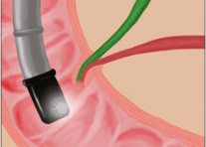
Figure 1 Correct positioning of duodenoscope for bilary cannulation. Visualize the papilla by placing the duodenoscope inferior to the papilla^{[6]}.

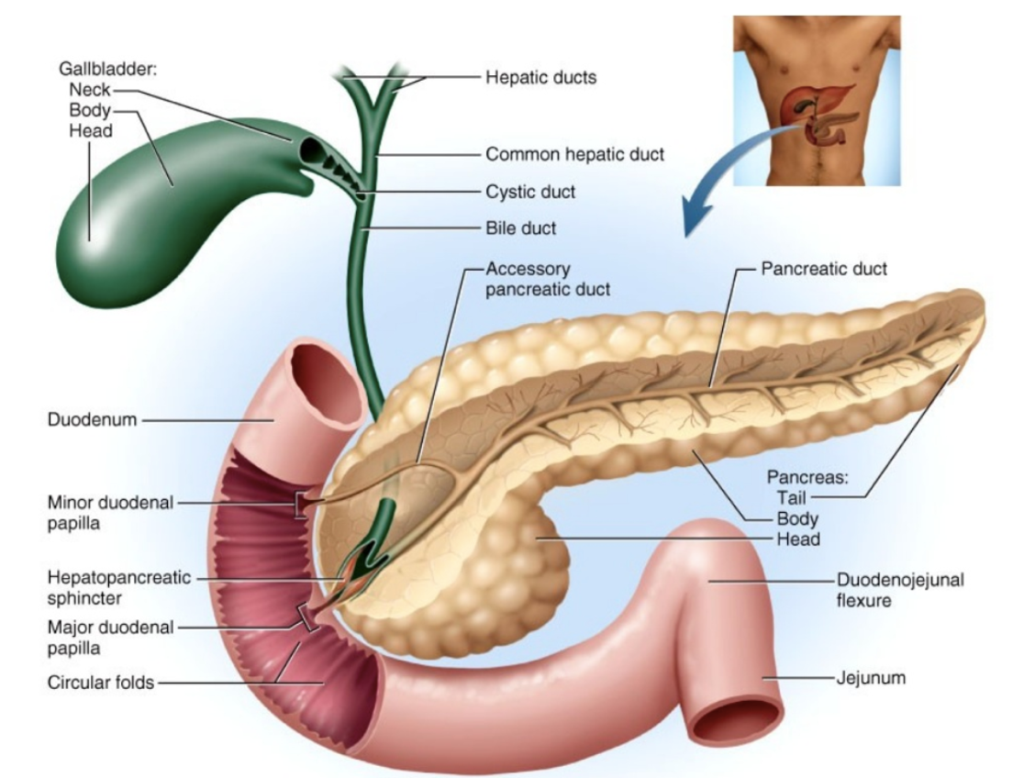

Figure 2 Review of duodenal and pancreatobiliary anatomy. Cross-section of duodenum, with visualization of the minor duodenal papilla, major duodenal papilla, and confluence of the common bile duct and main pancreatic duct to form the hepatopancreatic ampulla^{[26]}.

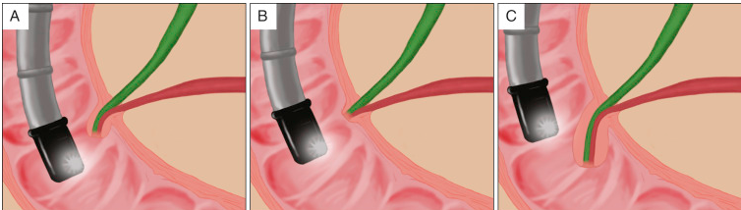
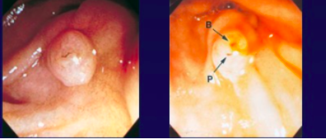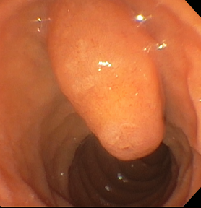

Figure 3 Drawing and corresponding endoscopic view of anatomic variants seen during endoscopic retrograde cholangiopancreatography of the ampulla and major duodenal papilla. A: Normal ampulla and pancreatobiliary junction; B: No common channel; endoscopically, two separate openings (P: Pancreatic duct; and B: Bile duct) may be seen at the papillary tip; C: Large, protuberant, and/or redundant papilla^{[6,7]}.

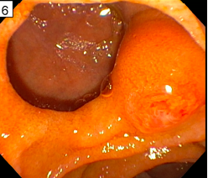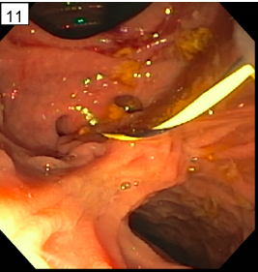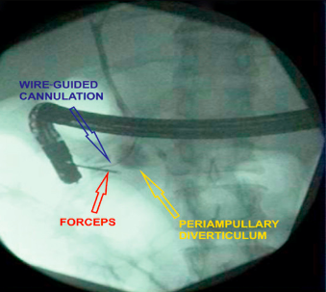
C
B
A
A

Figure 4 Periampullary diverticula. A: Native papilla with large periampullary diverticulum; B: Double periampullary diverticulum (one on each side of the papilla); C: Fluoroscopic visualization of biliary cannulation, using forceps grip, in a case of periampullary diverticulum.

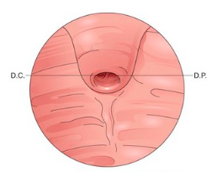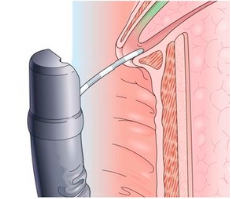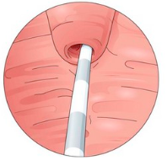

Figure 5 Billroth II anatomy. Inferior view of the major duodenal papilla given the inverted anatomy and thus inverted access approach^{[27]}.

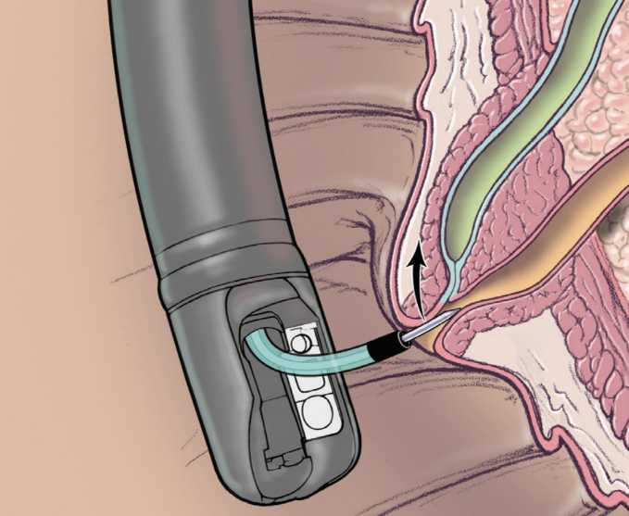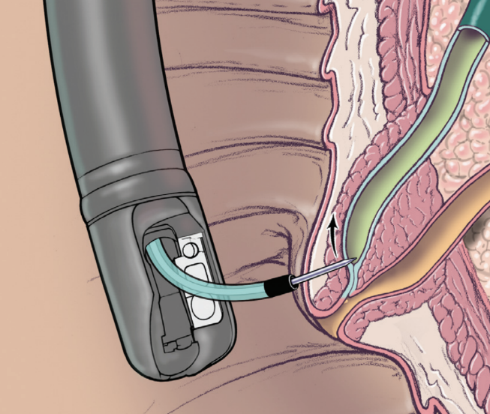
B
A
A
B

Figure 6 Precut techniques. A: Precut papillotomy; B: precut fistulotomy^{[54]}.

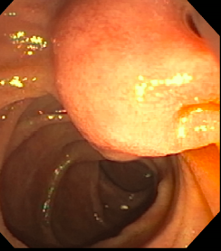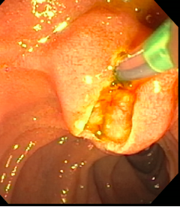
B
A
A
B
Figure 7 Endoscopic view during endoscopic retrograde cholangiopancreatography in a patient with suspected impaction of a gallstone in the ampulla. The major papilla appeared protuberant (A) and felt tense when palpated with a needle knife. Deep biliary cannulation was achieved via suprapapillary fistulotomy (B).

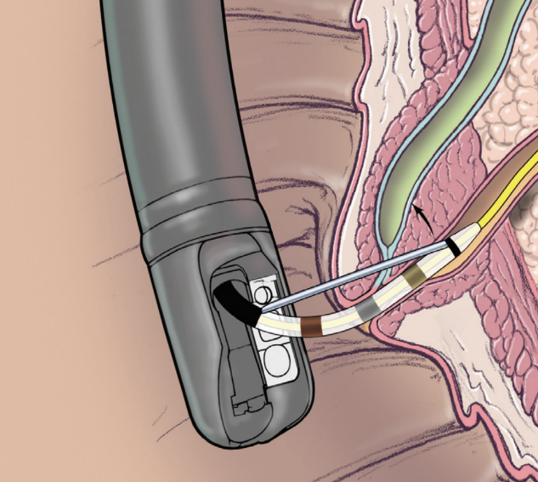
Figure 8 Transpancreatic precut sphincterotomy^{[54]}. Transpancreatic precut sphincterotomy (i.e., septotomy) using a standard sphinctertome oriented toward the common bile duct at the 11 o’clock position and inserted superficially in the main pancreatic duct.

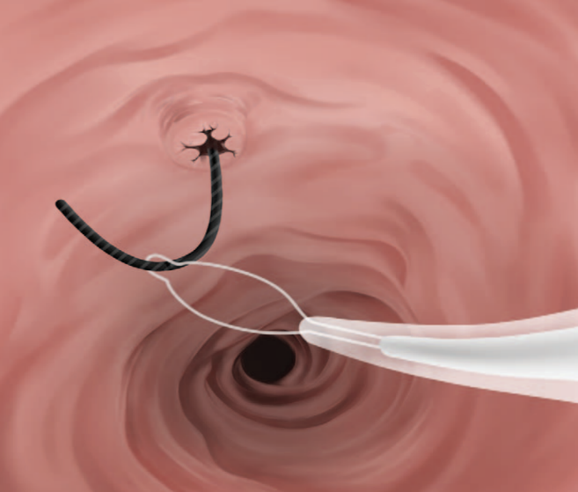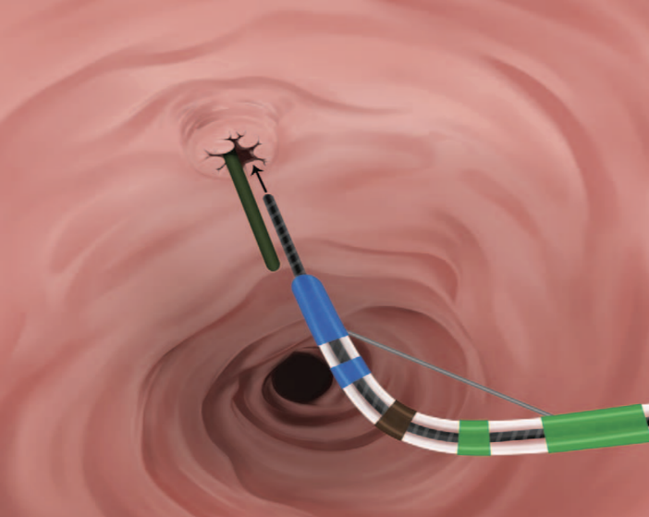
B
A
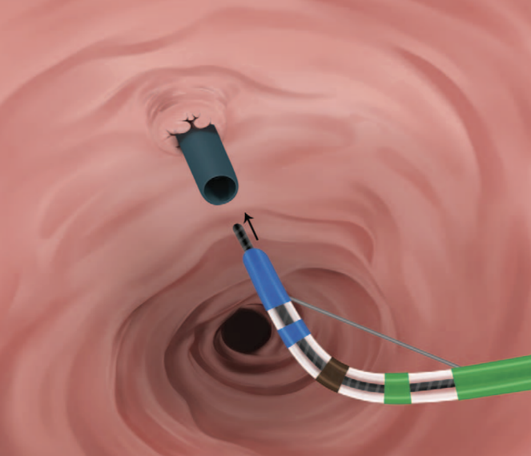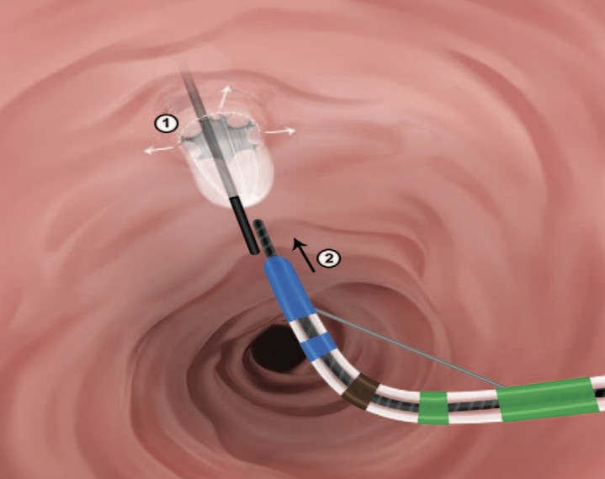
C
D

Figure 9 Rendezvous techniques. Cannulation can either occur (A) over the guidewire after it is pulled into the sphincterotome or (B) in parallel to the guidewire; Adjunctive methods of rendezvous such as (c) the addition of a percutaneous sheath or (d) anterograde balloon dilation of the biliary orifice^{[84]}.

Table 1 Maneuvers to facilitate selective biliary cannulation in difficult cases
Pancreatic guidewire - helps to straighten the intramural segment of the bile duct, reduces accidental MPD cannulation
Double guidewire technique - pancreatic guidewire method in combination with WGC
Wire-guided cannulation over a pancreatic duct stent (WGC-PS) - reduces accidental MPD cannulation
Precut papillotomy - to dissect the major duodenal papilla, used to visualize and cannulate the CBD
Precut fistulotomy - creates a fistula between the duodenal lumen and the CBD
Supra-papillary puncture - creates direct duodenocholedochal access
Supra-papillary puncture in combination with EUS - reduces rates of PEP, but with reasonable rates of perforation
Transpancreatic precut sphincterotomy (TPS) - ST used to perform papillotomy
EUS-guided rendezvous (EUS-RV) - BD punctured under EUS guidance from gastric or duodenal lumen
EUS-guided rendezvous with hybrid rendezvous (EUS-RV/HRV) - re-attempt rendezvous following EUS-cholangiography, uses a dilator to enlarge the needle-tract
Percutaneous rendezvous technique (Perc-RV) - BD access percutaneously, used in variant anatomy cases
Clipping redundant or obscuring folds - in cases of periampullary diverticulum
Using the long scope position – can facilitate better visualization of the major duodenal papilla in some patients and a more stable scope position in patients with a very proximal major papilla.
Change patient position (e.g., go to left lateral decubitus or supine) – may improve orientation and scope stability in some patients.
MPD: Main pancreatic duct; WGC: Wire guided cannulation; CBD: Common bile duct; EUS: Endoscopic ultrasound; PEP: Post-endoscopic retrograde cholangiopancreatography-pancreatitis; ST: Sphincterotome; BD: Biliary duct.

