Name of journal: World Journal of Stem Cells
Manuscript NO: 48245
Manuscript type: ORIGINAL ARTICLE

Basic Study
Generation of induced secretome from adipose-derived stem cells specialized for disease-specific treatment: an experimental mouse model

Kim OH et al. Generation of induced secretome from ASCs

Ok-Hee Kim, Ha-Eun Hong, Haeyeon Seo, Bong Jun Kwak, Ho Joong Choi, Kee-Hwan Kim, Joseph Ahn, Sang Chul Lee, Say-June Kim

Ok-Hee Kim, Ha-Eun Hong, Haeyeon Seo, Kee-Hwan Kim, Sang Chul Lee, Say-June Kim, Catholic Central Laboratory of Surgery, Institute of Biomedical Industry, College of Medicine, the Catholic University of Korea, Seoul 06591, South Korea

Ok-Hee Kim, Ha-Eun Hong, Haeyeon Seo, Bong Jun Kwak, Ho Joong Choi, Joseph Ahn, Say-June Kim, Department of Surgery, Division of Hepato-biliary Pancreatic Surgery, Seoul St. Mary’s Hospital, College of Medicine, the Catholic University of Korea, Seoul 06591, South Korea

Kee-Hwan Kim, Department of Surgery, Uijeongbu St. Mary's Hospital, College of Medicine, the Catholic University of Korea, Seoul 11765, South Korea

Sang Chul Lee, Department of Surgery, Daejeon St. Mary’s Hospital, College of Medicine, The Catholic University of Korea, Seoul 34943, South Korea

ORCID number: Ok-Hee Kim (0000-0002-9204-2587); Ha-Eun Hong (0000-0002-4361-4809); Haeyeon Seo (0000-0003-2992-8112); Bong Jun Kwak (0000-0003-2409-9386); Ho Joong Choi (0000-0002-0862-098X); Kee-Hwan Kim (0000-0001-6219-6027); Joseph Ahn (0000-0001-8528-4919); Sang Chul Lee (0000-0002-8681-7059); Say-June Kim (0000-0001-5171-4837).

Author contributions: All authors contributed to manuscript preparation; Kim SJ designed the research and analyzed data; Kim OH wrote the paper, performed in vitro experiment, and analyzed data; Hong HE and Seo H performed in vitro experiments; Kwak BJ, Choi HJ, Kim KH, Ahn J, and Lee SC performed in vivo experiments and analyzed data.

Supported by National Research Foundation of Korea, No. NRF-2015R1C1A1A02036931

Institutional animal care and use committee statement: Approved by the Animal Care Committee of the Catholic University of Korea, No. CMCDJ-AP-2016-001.

Conflict-of-interest statement: The authors have declared no potential conflicts of interest.

Data sharing statement: Requests for access to data should be addressed to the corresponding author.

ARRIVE guidelines statement: The authors have read the ARRIVE guidelines, and the manuscript was prepared and revised according to the ARRIVE guidelines.

Open-Access: This article is an open-access article that was selected by an in-house editor and fully peer-reviewed by external reviewers. It is distributed in accordance with the Creative Commons Attribution Non Commercial (CC BY-NC 4.0) license, which permits others to distribute, remix, adapt, build upon this work non-commercially, and license their derivative works on different terms, provided the original work is properly cited and the use is non-commercial. See: http://creativecommons.org/licenses/by-nc/4.0/

Manuscript source: Unsolicited manuscript

Corresponding author: Say-June Kim, MD, PhD, Professor, Department of Surgery, Division of Hepato-biliary Pancreatic Surgery, Seoul St. Mary’s Hospital, College of Medicine, the Catholic University of Korea, 222, Banpo-daero, Seocho-gu, Seoul 06591, South Korea. sayjunekim@gmail.com
Telephone: +82-2-22586764
Fax: +82-2-5350070

Received: April 12, 2019
Peer-review started: April 14, 2019
First decision: May 16, 2019
Revised: August 16, 2019
Accepted: September 26, 2019
Article in press: September 26, 2019
Published online: January 26, 2020

Abstract
Background
Recently, the exclusive use of mesenchymal stem cell (MSC)-secreted molecules, named as the secretome, have been evaluated for overcoming the limitations of cell-based therapy while maintaining its advantages.

AIM
to improve cell-free therapy by adding disease-specificity through stimulation of MSCs using disease-causing materials.

METHODS
We collected the secretory materials (named as inducers) released from AML12 hepatocytes that had been pretreated with thioacetamide (TAA) and generated the TAA-induced secretome (TAA-isecretome) after stimulating adipose-derived stem cells with the inducers. The TAA-isecretome was intravenously administered to mice with TAA-induced hepatic failure and those with partial hepatectomy.

RESULTS
TAA-isecretome infusion showed higher therapeutic potential in terms of (1) restoring disorganized hepatic tissue to normal tissue; (2) inhibiting proinflammatory cytokines (interleukin-6 and tumor necrosis factor-α); and (3) reducing abnormally elevated liver enzymes (aspartate aminotransferase and alanine aminotransferase) compared to the naïve secretome infusion in mice with TAA-induced hepatic failure. However, the TAA-isecretome showed inferior therapeutic potential for restoring hepatic function in partially hepatectomized mice. Proteomic analysis of TAA-isecretome identified that antioxidant processes were the most predominant enriched biological networks of the proteins exclusively identified in the TAA-isecretome. In addition, peroxiredoxin-1, a potent antioxidant protein, was found to be one of representative components of TAA-isecretome and played a central role in the protection of TAA-induced hepatic injury.

CONCLUSION
Appropriate stimulation of adipose-derived stem cells with TAA led to the production of a secretome enriched with proteins, especially peroxiredoxin-1, with higher antioxidant activity. Our results suggest that appropriate stimulation of MSCs with pathogenic agents can lead to the production of a secretome specialized for protecting against the pathogen. This approach is expected to open a new way of developing various specific therapeutics based on the high plasticity and responsiveness of MSCs.

Key words: Adipose-derived stem cells; Disease-specificity; Mesenchymal stem cells; Secretome; Peroxiredoxin-1; thioacetamide; Toxic hepatic failure

© The Author(s) 2020. Published by Baishideng Publishing Group Inc. All rights reserved.

Core tip: Appropriate stimulation of adipose-derived stem cells with thioacetamide (TAA) led to the production of a secretome enriched with proteins, especially peroxiredoxin-1, with higher antioxidant activity. Free radicals are principal pathogenic agents in the pathogenesis of TAA-induced hepatic injury. The TAA-induced secretome was superior to the naïve secretome in restoring hepatic function while minimizing inflammatory processes in mice with TAA-induced hepatic failure. However, it was less effective in the mice with partial hepatectomy, suggestive of disease-specificity. Our results suggest that appropriate stimulation of adipose-derived stem cells with pathogenic agents can lead to the production of a secretome specialized for protecting against the pathogen.

Kim OH, Hong HE, Seo H, Kwak BJ, Choi HJ, Kim KH, Ahn J, Lee SC, and Kim SJ. Generation of induced secretome from adipose-derived stem cells specialized for disease-specific treatment: an experimental mouse model. World J Stem Cells
2020; 12(1): 70-86 URL: https://www.wjgnet.com/1948-0210/full/v12/i1/70.htm DOI: https://dx.doi.org/10.4252/wjgo.v12.i1.70

INTROCUCTION
For several decades, numerous efforts have been made to harness the potential of mesenchymal stem cells (MSCs) for biotherapeutic applications. MSCs have a variety of advantages, including high availability, ease of isolation and expansion, functional plasticity, and low immunogenicity^{[1-3]}. Although application of MSCs has shown promising preclinical and clinical outcomes, their clinical applications remain challenging, possibly because of their genetic instability during in vitro expansion, poor growth kinetics, early senescence, and particularly the potential for malignant transformation^{[4-9]}.
Recently, the exclusive use of MSC-secreted molecules rather than the cells alone has gained attention for overcoming the limitations of cell-based therapy while maintaining its advantages. The total set of molecules secreted or surface-shed by cells is generally referred to as the secretome. The secretome includes bioactive peptides, such as cytokines, chemokines, and growth factors^{[10,11]}. Accumulating evidence supports that the principal action mechanism of MSCs is secretome-mediated^{[10,12-14]}. These soluble factors are released from MSCs either alone or in extracellular vesicles (EVs). Therefore, using these cell-free products may indeed represent an alternative to therapies based on cell transplantation.
The composition of the secretome is influenced by various external factors, including the cell source, type of culture media, culturing period, and preconditioning treatment. Therefore, one can use a secretome therapeutically either without manipulation or by manipulating MSCs to release specific secretome components. The latter includes (1) adjustments to the physicochemical environment during secretome preparations; and (2) development of genetically-engineered MSCs. We previously validated the amplified therapeutic potential of adipose-derived stem cell (ASC)-secretome by physicochemically controlling the secretome-obtaining process, such as hypoxic preconditioning^{[15,16]} or using an endotoxin (lipopolysaccharide)^{[17]}.
Interestingly, proteomic analysis of EVs obtained from hepatocytes exposed to liver toxins revealed that they contained higher levels of vital liver-specific proteins, such as carbamoyl phosphate synthetase 1, S-adenosyl methionine synthetase 1, and catechol-O-methyltransferase^{[18,19]}. This suggests that MSCs can be induced to generate a specialized secretome customized to a specific disease. We herein defined induced secretome (isecretome) as the secretome released from MSCs that had been stimulated by disease-causing materials to treat the specific disease. Thioacetamide (TAA) is a well-known hepatotoxin. In this study, we attempted to validate the higher therapeutic effects of the secretome induced by TAA (TAA-isecretome) compared to the naïve secretome, specifically in mice with TAA-induced hepatic failure. If the superiority of an isecretome over a naïve secretome is demonstrated, it could provide a foundation for producing a disease-specific isecretome applicable to specific diseases.

MATERIALS AND METHODS
Cell culture
The AML12 mouse hepatocyte cell line was obtained from American Type Culture Collection (ATCC; Manassas, VA, United States). AML12 cells were maintained in DMEM/F12 (Dulbecco's Modified Eagle Medium/Ham's F-12; Thermo, Carlsbad, CA, United States). The medium was supplemented with 10% FBS (fetal bovine serum; GibcoBRL, Carlsbad, CA, United States), 1% antibiotics (Thermo), 1x ITS supplement (Insulin-Transferrin-Selenium-G supplement; Invitrogen, Carlsbad, CA, United States), and 40 ng/ml dexamethasone (Sigma-Aldrich, St. Louis, MO, United States) at 37 °C. Human ASCs were kindly donated by Hurim BioCell Co. (Seoul, South Korea). ASCs were cultured in MesenPRO RS basal medium (GibcoBRL) supplemented with antibiotics (Penicillin-streptomycin; GibcoBRL) at 37 °C.

Preparation of the secretome released from ASCs
After reaching 70%–80% confluence, ASCs were refed with serum free DMEM low-glucose medium (Thermo Fisher Scientific, Waltham, MA, United States) at 37 °C under 5% CO₂. The conditioned media (CM) obtained from each set of ASCs were concentrated by 25-fold using ultrafiltration units (Amicon Ultra-PL 3; Millipore, Bedford, MA, United States) with a 3-kDa cutoff. The concentrated CM, which had been attained from TAA-untreated, TAA-treated, and pcDNA-HBx^{[20]} transfected culturing conditions, was named as CM (or control secretome), TAA-induced CM (TAA-iCM, representing the TAA-isecretome), and HBx-induced CM (HBx-iCM), respectively.

Cell proliferation assay
Cell proliferation was evaluated with 2-(4-iodophenyl)-3-(4-nitrophenyl)-5-(2,4-disulfophenyl)-2H-tetrazolium (water soluble tetrazolium salt, WST-1) assay using EZ-Cytox Cell Proliferation Assay kit (Itsbio, Seoul, South Korea) according to the manufacturer’s instruction. Absorbance was measured at 450 nm using the microplate reader (model 680; Bio-Rad, Hercules, CA, United States)^{[16]}.

Western blot analysis
AML12 cells and liver specimens obtained from mice were lysed using the EzRIPA Lysis kit (ATTO Corporation; Tokyo, Japan) and quantified by Bradford reagent (Bio-Rad). Proteins were visualized by western analysis using the following primary antibodies (1:1000 dilution) at 4 °C overnight and then with horseradish (HRP)-conjugated secondary antibodies (1:2000 dilution) for 1 h at 25 °C^{[16]}. From Cell Signaling Technology (Beverly, MA, United States), we obtained primary antibodies against BAX (Bcl-2-like protein 4), BIM (Bcl-2-like protein 11), GPx (glutathione peroxidase), HGF (hepatocyte growth factor), Mcl-1 (myeloid cell leukemia 1), PARP (poly ADP-ribose polymerase), PCNA (proliferating cell nuclear antigen), p-ERK (phosphorylated extracellular signal-regulated kinase), p-STAT3, SOD (superoxide dismutase), STAT3 (signal transducer and activator of transcription 3), VEGF (vascular endothelial growth factor), c-caspase-3 (cleaved caspase 3), fibronectin, F4/80, p-ERK, β-actin, and HRP-conjugated secondary antibody. Specific immune complexes were detected using the Western Blotting Plus Chemiluminescence Reagent (Millipore, Bedford, MA, United States).

Animals and study design
Eight-week-old male BALB/c mice (Damool Science, Daejeon, South Korea) were used in this study. Animal studies were carried out in compliance with the guidelines of the Institute for Laboratory Animal Research, Korea (IRB No: CMCDJ-AP-2016-001). We compared the effects of the TAA-isecretome in an in vivo model of TAA-induced hepatic failure. The in vivo model was generated by subcutaneous injection of TAA (300 mg/kg, 24 h intervals for 2 d) into experimental mice. Subsequently, control mice and TAA-treated mice were intravenously (using tail vein) infused with normal saline (n = 15), CM (n = 15), and TAA-iCM (n = 15). An in vivo model of 70% partial hepatectomy was performed (n = 12)^{[21]}.

Serology test and enzyme-linked immunosorbent assay
Blood samples were collected from each mouse, centrifuged for 10 min at 9500 g, and serum was collected. We measured the concentrations of markers for liver injury and kidney injury, such as aspartate transaminase, alanine transaminase, and creatine, using an IDEXX VetTest Chemistry Analyzer (IDEXX Laboratories, Inc., Westbrook, ME, United States). The concentrations of mouse IL-6 and tumor necrosis factor (TNF)-α were measured by sandwich enzyme-linked immunosorbent (ELISA) assay (Abcam, Cambridge, United Kingdom) according to the manufacturer’s instructions.

Histological assessment of mouse specimens
Mouse livers and kidneys from each group were fixed in 10% buffered formalin, embedded in paraffin, and sectioned at 4 µm thickness. Tissue sections were stained with hematoxylin and eosin. The scores for the severity of liver and kidney injury were as follows: 1 (normal); 2 (mild injury); 3 (moderate injury); and 4 (severe injury). Three liver sections were examined per mouse, and three randomly selected high-power fields (40x) were analyzed for each liver section. The mean score for each animal was determined by summing all scores.

Immunohistochemistry staining
For immunohistochemical analysis, formalin-fixed, paraffin-embedded tissue sections were deparaffinized, rehydrated in an ethanol series, and subjected to epitope retrieval using standard procedures. Antibodies against CD68, PECAM (platelet endothelial cell adhesion molecule), and albumin (Cell Signaling Technology, Danvers, MA, United States) were used for immunochemical staining. The samples were then examined under a laser-scanning microscope (Eclipse TE300; Nikon, Tokyo, Japan) to analyze the expression of CD68, PECAM, and albumin.

Liquid chromatography–mass spectrometry/mass spectrometry on the Q-Exactive Plus mass spectrometry
All digested peptides were separated and identified using online nano liquid chromatography and analyzed by electrospray tandem mass spectrometry. For peptide identification, MS/MS spectra were searched by MASCOT (Matrix science, version 2.41)^{[22]}. The genome sequence of the Uniprot_Human was used as the database for protein identification. To predict affected pathways among the differentially expressed genes, gene ontology (GO) enrichment analysis were performed using DAVID (http://david.abcc.ncifcrf.gov/).

Statistical analysis
Statistical analyses were performed with SPSS 11.0 software (SPSS Inc., Chicago, IL, United States) and SigmaPlot® ver. 12.0 (Systat Software Inc., Chicago, IL, United States). The data are presented as mean ± SD. Statistical comparison among groups was determined using Kruskal–Wallis test followed by Dunnett’s test as the post hoc analysis. Probability values of P < 0.05 were regarded as statistically signiﬁcant.

RESULTS
Generation of an isecretome specialized for recovering TAA-induced toxic hepatic failure
Figure 1A shows the concept of generating the TAA-isecretome for treating TAA-induced hepatic failure. We first determined the TAA concentration required to produce the TAA-isecretome. To achieve this, we investigated AML12 cell proliferation and the expression of proliferation intermediates (PCNA, p-STAT3, and STAT3) in AML12 cells at different TAA concentrations (Figure 1B and 1C). We found that 0.25 mmol/L TAA was appropriate because it moderately increased proliferation intermediates without significantly decreasing cell viability. We named the secretory materials released from TAA-treated AML12 cells as “inducer.”
Next, we examined the dilution rate of inducers that maximizes the expression of the proliferation markers (PCNA, p-ERK, p-STAT, and HGF) in ASCs. Of the tested dilution rates (1:100, 1:500, and 1:1000), 1:1000 maximally induced the expression of these markers (Figure 1D).

Determination of in vitro effects of TAA-isecretome
Next, we evaluated the effects of the TAA-isecretome in an in vitro model of TAA-induced hepatic failure. We found that 50 mM TAA was effective for generating the in vitro model of TAA-induced hepatic failure based on the results of cell viability assay and western blot analyses (Figure 2A and 2B). Briefly, we named the secretome obtained from 48 h of incubation of ASCs as CM (normal conditioned media) and that used to generate the TAA-isecretome as iCM (induced conditioned media). We then treated normal and TAA-treated hepatocytes with CM and iCM, respectively. Cell viability tests showed that iCM-treated hepatocytes had the highest cell viability in both normal and TAA-treated hepatocytes (Figure 2C). Additionally, iCM-treated hepatocytes showed the highest expression of markers reflecting liver regeneration (HGF, VEGF, PCNA, and p-ERK) and lowest expression of markers reflecting apoptosis and inflammation (PARP, BIM, BAX, and F4/80) by western blot analysis (Figure 2D).

Determination of in vivo effects of isecretome and comparison of systemic markers after each treatment
We then compared the effects of the TAA-isecretome in an in vivo model of TAA-induced hepatic failure. The in vivo model was generated by subcutaneous injection of TAA (300 mg/kg, 24-h intervals for 2 d) into experimental mice. Subsequently, control mice and TAA-treated mice were intravenously (using tail vein) infused with normal saline, CM, and iCM (Figure 3A). At 48 h after treatment, the mice were euthanized, and the specimens were investigated. Serologic tests showed that among these groups, iCM administration showed the greatest effects in lowering the serum levels of aspartate transaminase, alanine transaminase, and creatinine in TAA-treated mice (Figure 3B). Similarly, ELISA showed that iCM administration decreased the serum levels of IL-6 and TNF-α in TAA-treated mice more than in the other groups (Figure 3C).

Comparison of markers reflecting liver regeneration and inflammation in liver specimens of each group
We performed western blot analysis to compare the expression of various markers reflecting liver regeneration and inflammation in the liver specimens of each group. iCM infusion caused the highest expression of PCNA, p-ERK, p-STAT, and fibronectin in both control livers and those of TAA-treated mice (Figure 4A). Additional western blot analysis showed that iCM infusion most significantly increased the expression of antioxidant enzymes (SOD, catalase, and GPx), and an antiapoptotic protein (Bcl-xL) and most significantly decreased the expression of proapoptotic proteins (c-caspase-3 and Bax) (Figure 4B and 4C).
iCM infusion most significantly decreased both liver-damage and kidney-damage scores that had been calculated based on hematoxylin and eosin staining (Figure 5A). Further, immunohistochemical staining showed that iCM infusion most significantly decreased the expression of inflammatory markers (CD68 and PECAM) and most significantly increased the expression of albumin (Figure 5B).

Validation of disease-specificity of isecretome and analysis of their contents
To validate disease-specific effectiveness of the TAA-isecretome, we intravenously infused the TAA-isecretome into another model of liver injury, a mouse model of 70% partial hepatectomy. At 2 d after infusion, the mice were euthanized, and the specimens were investigated. Western blot analysis revealed that CM infusion, rather than TAA-iCM infusion, induced higher expression of proliferation markers (p-ERK and PCNA) and an antiapoptotic marker (Mcl-1) as well as lower expression of a proapoptotic marker (Bax). (Figure 6A). Taken altogether, the TAA-isecretome had the best proliferative and anti-inflammatory effects, particularly in TAA-induced hepatic failure, indicating the potential for disease-specific treatment.
Various sets of isecretome specialized for individual diseases can be produced using corresponding disease-causing materials. We additionally generated an HBx-isecretome (HBx-iCM) using hepatitis X antigens as inducer and compared the components of the CM, TAA-iCM, and HBx-iCM using liquid chromatography–mass spectrometry (LC/MS). Of the total proteins identiﬁed in the CM, TAA-iCM, and HBx-iCM, 32 secretory proteins were quite different according to each secretome (Figure 6B). Of them, we further investigated ten proteins that had been identified in TAA-iCM, but not in the CM. To predict affected pathways among the differentially expressed genes of the ten proteins, GO enrichment analysis were performed using DAVID (http://david.abcc.ncifcrf.gov/). GO enrichment analysis identified 19 enriched biological networks of the 10 proteins that had been exclusively identified in TAA-isecretome. Of the 19 enriched biological networks, the two most prominent biological processes were the response to reactive oxygen species and cell redox homeostasis, all of which were related with antioxidant activity. Of the ten proteins, peroxiredoxin-1 (Prdx-1) attracted our attention because it is known to have potent antioxidant activity (Figure 6C).
Prdx-1 exerts its antioxidant activity by catalyzing the reduction of H₂O₂ and alkyl hydroperoxide and thus protects cells from the attack of free radicals. Prdx-1 belongs to the toll-like receptor 4 (TLR4) ligand^{[23]}. We thus compared the expression of a hepatoproliferative marker (p-ERK) according to the expression of Prdx-1 (Figure 6D). After treatment with the TAA-iCM, AML2 hepatocytes showed the higher expression of p-ERK as well as Prdx-1 compared with AML2 cells treated with the CM (P < 0.05). Subsequently, we compared the efficacy of the TAA-iCM after pre-treatment of TAK242, a TLR4 inhibitor. Pre-treatment of TAK242 did not only inhibit the expression of Prdx-1 but also inhibited the expression of p-ERK, the hepatoproliferative marker. Taken altogether, our results suggest that Prdx-1 is one of the essential components in TAA-iCM and plays a central role in the protection of TAA-induced hepatic injury.

DISCUSSION
In this study, we showed that the TAA-isecretome was superior to the naïve secretome in restoring hepatic function while minimizing inflammatory processes in mice with TAA-induced hepatic failure. Specifically, isecretome infusion showed higher therapeutic potential in terms of (1) restoring disorganized hepatic tissue to normal tissue; (2) inhibiting proinflammatory cytokines; and (3) reducing abnormally elevated liver enzymes compared to naïve secretome infusion. The plasticity of MSCs in response to specific toxins may have led to the generation and secretion of protective agents (isecretome) against them. Our proteomic analysis indicated that the secretome components exhibited considerable differences according to the “inducing materials.” We expect that clinical application of this concept would be useful for overcoming a variety of diseases for which therapeutics have not been discovered.
Generally, cells have the propensity to protect themselves after exposure to detrimental stimuli or toxins. Because MSCs are unspecialized cells, they have higher plasticity and responsiveness than other cell types, i.e. they can either differentiate into specialized cells or release responsive materials more proficiently than differentiated cells depending on the external stimuli. Rodríguez-Suárez et al^{[18]} investigated the proteome of EVs secreted by primary hepatocytes after exposure to well-known liver toxins (galactosamine and Escherichia coli-derived lipopolysaccharide). EVs exposed to liver toxins contained higher levels of vital liver-specific proteins, such as carbamoyl phosphate synthetase 1, S-adenosyl methionine synthetase 1, and catechol-O-methyltransferase compared to control EVs. The secretome composition is influenced by a variety of external factors, including the cell source, type of culture media, culturing period, and physicochemical environment. Vizoso et al^{[24]} classified the external stimuli into four major categories: (1) hypoxic preconditioning; (2) pro-inflammatory stimuli, such as TNF-α, lipopolysaccharide, toll-like receptor agonists; (3) three-dimensional growth, such as spheroid culture, which stimulates trophic factor secretion; and (4) microparticle engineering, by which the release of a secretome is manipulated. Using the higher plasticity and responsiveness of MSCs, we induced a specific secretome specialized for treating a specific disease.
Whereas the secretome was obtained by nonspecific stimulation, the isecretome was obtained by using stimuli specific for individual diseases, allowing for disease-specific therapy. The isecretome for a specific disease is obtained by stimulating MSCs with specific pathogens involved in the pathogenesis of the disease. This concept is based on the superior responsiveness and plasticity of MSCs compared to host cells, which were exploited in several previous studies^{[25,26]}. Prado et al^{[27]} reported the successful prevention of allergic reaction by intranasal administration of EVs in a murine model of Ole e 1 (the main allergen of olive tree pollen)-allergic sensitization. The EVs were first obtained from bronchoalveolar lavage fluid in mice that had been exposed to Ole e 1. Their favorable results were based on the plasticity of mature respiratory cells. In contrast, our experiment is based on the plasticity of MSCs that are far higher than that of mature cells and demonstrated the increased therapeutic potential.
A prerequisite to obtaining a disease-specific secretome is to determine optimized conditions under which pathogenic materials appropriately induce MSCs to produce protective materials. Too strong or too weak stimulation of MSCs is undesirable because this can lead to either MSC damage or insufficient generation of the isecretome, respectively. To obtain the TAA-isecretome, we first collected the secretory materials from hepatocytes after treating the cells with a TAA, which were named as inducers. We then harnessed ASCs to release the isecretome by treating ASCs with inducers. For this, we determined (1) the concentration of TAA that both maximally stimulated and minimally damaged hepatocytes; and (2) the optimal dilution rate of inducers for harnessing ASCs to release the isecretome with maximal therapeutic potential. We validated this process by western blot analyses of markers reflecting the proliferation and apoptosis of cells.
The hepatotoxic effect of TAA is attributed to its metabolic intermediate, thioacetamide-S-oxide^{[28]}. It is a free radical that binds to hepatic macromolecules, subsequently leading to necrosis of hepatocytes. Silymarin is one of the best known hepatoprotective drugs (the mechanism of action is largely dependent on its antioxidant and free radical scavenging activities)^{[29]}. Throughout LC/MS analysis, we recognized ten proteins that had been exclusively identified in the TAA-iCM but not in the CM. GO enrichment analysis of these proteins found that antioxidant processes were the most predominant enriched biological networks. Of the ten proteins, Prdx-1 attracted our attention because it is known to have potent antioxidant activity.
Prdx-1 is an antioxidant enzyme belonging to the peroxiredoxin family of proteins. It has excellent antioxidant activity by catalyzing the reduction of H₂O₂ and alkyl hydroperoxide and thus protects cells from the attack of free radicals. In an experiment, Prdx-1 knockdown significantly increased the cellular levels of free radicals, while Prdx-1 overexpression reversed them^{[30]}. Binding of Prdx-1 to TLR4 induced the release of numerous cytokines and growth factors, such as IL-6, TNF-α, and VEGF^{[23,31]}. Moreover, we found that the inhibition of TLR4 by TAK242 (a TLR4 inhibitor) led to significant reduction in the expression of p-ERK (a proliferative marker) as well as Prdx-1. Taken altogether, our results suggest that Prdx-1 is one of the representative components released from ASCs that had been induced by TAA and plays a central role in the protection of TAA-induced hepatic injury.
The principle of generating the isecretome is similar to how antibodies against specific antigens are obtained in serotherapy. In serotherapy, introduction of attenuated antigens into the host induces the generation of antibodies against these antigens, which are collected to treat patients suffering from antigen-related disease. Similarly, in isecretome-based therapy, presensitization of MSCs with pathogens induced the generation of the secretome including protective agents against pathogens, which were collected to treat pathogen-causing disease. Because isecretome therapy provides a disease-specific approach, specific therapeutics can be developed based on high plasticity and responsiveness of MSCs. Further studies on the isecretome are expected to identify therapeutic materials by reproducing the pathogenesis of a certain disease within MSCs. There are numerous diseases for which therapeutics have not been developed or are ineffective. We presumed that MSCs can reproduce the repair materials against certain incurable illnesses when encountered during pathogenesis. There are two main clinical applications of the isecretome: 1) direct utilization as therapeutic materials and 2) identification of more specific ingredients as therapeutic materials. The latter is accomplished by proteomic studies of isecretome components. Using isecretome-based technology, we could build “biological drug factories” based on the plasticity of MSCs that produce therapeutic materials from MSCs.
In conclusion, we showed that the TAA-isecretome was superior to the naïve secretome in restoring hepatic function while minimizing inflammatory processes in mice with TAA-induced hepatic failure. However, such superiority was not observed in the mouse model of partial hepatectomy. This suggests that the specific pathogen induces MSCs to release the secretome specialized for the pathogen. Free radicals are principal pathogenic agents in the pathogenesis of TAA-induced hepatic injury. LC/MS analysis and subsequent GO enrichment analysis of TAA-isecretome identified that antioxidant processes were the most predominantly enriched biological networks of the proteins exclusively identified in the TAA-isecretome. In addition, Prdx-1, a potent antioxidant protein, was found to be one of the representative components of the TAA-isecretome and played a central role in the protection of TAA-induced hepatic injury.

Article Highlights
Research background
The exclusive use of mesenchymal stem cell (MSC)-secreted molecules, named as the secretome, rather than stem cells have been evaluated for overcoming the limitations of cell-based therapy while maintaining its advantages. As recent studies have shown that this secretome has therapeutic effects similar to stem cells, the secretome has become the basis of cell-free therapy.

Research motivation
The composition of the secretome is influenced by various external factors, including the cell source, type of culture media, culturing period, and preconditioning treatment. Previous studies suggest that MSCs can be induced to generate a specialized secretome customized to a specific disease. We herein defined induced secretome (isecretome) as the secretome released from MSCs that had been stimulated by disease-causing materials to treat the specific disease.

Research objectives
Thioacetamide (TAA) is a well-known hepatotoxin. We thus attempted to validate the higher therapeutic effects of the secretome induced by TAA (TAA-isecretome) compared to the naïve secretome, specifically in mice with TAA-induced hepatic failure. If the superiority of the isecretome over the naïve secretome is demonstrated, it could provide a foundation for producing a disease-specific isecretome applicable to specific diseases.

Research methods
We collected the secretory materials (named as inducers) released from AML12 hepatocytes that had been pretreated with TAA and generated the TAA-isecretome after stimulating ASCs with the inducers. The TAA-isecretome was intravenously administered to mice with TAA-induced hepatic failure and those with partial hepatectomy. In addition, we generated an HBx-isecretome using hepatitis X antigens as inducers and compared the components of the naïve secretome, TAA-isecretome, and HBx-isecretome using liquid chromatography–mass spectrometry.

Research results
Compared to the naïve secretome infusion, TAA-isecretome infusion showed higher therapeutic potential in terms of (1) restoring disorganized hepatic tissue to normal tissue; (2) inhibiting proinflammatory cytokines (interleukin-6 and tumor necrosis factor-α); and (3) reducing abnormally elevated liver enzymes (aspartate aminotransferase and alanine aminotransferase) in mice with TAA-induced hepatic failure. However, the TAA-isecretome showed inferior therapeutic potential for restoring hepatic function in partially hepatectomized mice. Proteomic analysis of the TAA-isecretome identified that antioxidant processes were the most predominant enriched biological networks of the proteins exclusively identified in the TAA-isecretome. In addition, peroxiredoxin-1, a potent antioxidant protein, was found to be one of the representative components of the TAA-isecretome.

Research conclusions
We showed that the TAA-isecretome was superior to the naïve secretome in restoring hepatic function while minimizing inflammatory processes in mice with TAA-induced hepatic failure. However, such superiority was not observed in the mouse model of partial hepatectomy, suggesting disease-specificity of the TAA-isecretome. Free radicals are principal pathogenic agents in the pathogenesis of TAA-induced hepatic injury. Proteomic analysis of TAA-isecretome identified that antioxidant processes were the most predominantly enriched biological networks of the proteins exclusively identified in the TAA-isecretome. In addition, Prdx-1, a potent antioxidant protein, was found to be one of the representative components of the TAA-isecretome.

Research perspectives
Our results suggest that appropriate stimulation of MSCs with pathogenic agents can lead to the production of a secretome specialized for protecting against the pathogen. This approach is expected to open a new way of developing various specific therapeutics based on the high plasticity and responsiveness of MSCs.

ACKNOWLEDGEMENTS
We would like to thank Drug and Disease Target Team (Ochang), Korea Basic Science Institute for supporting funds for this experiment. We would like to thank Hye-Jung Kim for photoshop work that improved the figure quality. We would like to thank Francis Sahngun Nahm (a professional statistician) for his devoted assistance of statistical analysis. Finally, we would like to thank Hye-Jeong Kim and Ji-Hye Park for data processing and photoshop work.

REFERENCES
1 Lee SK, Lee SC, Kim SJ. A novel cell-free strategy for promoting mouse liver regeneration: utilization of a conditioned medium from adipose-derived stem cells. Hepatol Int 2015; 9: 310-320 [PMID: 25788187 DOI: 10.1007/s12072-014-9599-4]
2 Guglielmi A, Ruzzenente A, Conci S, Valdegamberi A, Iacono C. How much remnant is enough in liver resection? Dig Surg 2012; 29: 6-17 [PMID: 22441614 DOI: 10.1159/000335713]
3 An SY, Jang YJ, Lim HJ, Han J, Lee J, Lee G, Park JY, Park SY, Kim JH, Do BR, Han C, Park HK, Kim OH, Song MJ, Kim SJ, Kim JH. Milk Fat Globule-EGF Factor 8, Secreted by Mesenchymal Stem Cells, Protects Against Liver Fibrosis in Mice. Gastroenterology 2017; 152: 1174-1186 [PMID: 27956229 DOI: 10.1053/j.gastro.2016.12.003]
4 Miura M, Miura Y, Padilla-Nash HM, Molinolo AA, Fu B, Patel V, Seo BM, Sonoyama W, Zheng JJ, Baker CC, Chen W, Ried T, Shi S. Accumulated chromosomal instability in murine bone marrow mesenchymal stem cells leads to malignant transformation. Stem Cells 2006; 24: 1095-1103 [PMID: 16282438 DOI: 10.1634/stemcells.2005-0403]
5 Lapidot T, Sirard C, Vormoor J, Murdoch B, Hoang T, Caceres-Cortes J, Minden M, Paterson B, Caligiuri MA, Dick JE. A cell initiating human acute myeloid leukaemia after transplantation into SCID mice. Nature 1994; 367: 645-648 [PMID: 7509044 DOI: 10.1038/367645a0]
6 Tolar J, Nauta AJ, Osborn MJ, Panoskaltsis Mortari A, McElmurry RT, Bell S, Xia L, Zhou N, Riddle M, Schroeder TM, Westendorf JJ, McIvor RS, Hogendoorn PC, Szuhai K, Oseth L, Hirsch B, Yant SR, Kay MA, Peister A, Prockop DJ, Fibbe WE, Blazar BR. Sarcoma derived from cultured mesenchymal stem cells. Stem Cells 2007; 25: 371-379 [PMID: 17038675 DOI: 10.1634/stemcells.2005-0620]
7 Thomson BM, Bennett J, Dean V, Triffitt J, Meikle MC, Loveridge N. Preliminary characterization of porcine bone marrow stromal cells: skeletogenic potential, colony-forming activity, and response to dexamethasone, transforming growth factor beta, and basic fibroblast growth factor. J Bone Miner Res 1993; 8: 1173-1183 [PMID: 8256654 DOI: 10.1002/jbmr.5650081004]
8 Wang Y, Huso DL, Harrington J, Kellner J, Jeong DK, Turney J, McNiece IK. Outgrowth of a transformed cell population derived from normal human BM mesenchymal stem cell culture. Cytotherapy 2005; 7: 509-519 [PMID: 16306013 DOI: 10.1080/14653240500363216]
9 Le Blanc K, Rasmusson I, Sundberg B, Götherström C, Hassan M, Uzunel M, Ringdén O. Treatment of severe acute graft-versus-host disease with third party haploidentical mesenchymal stem cells. Lancet 2004; 363: 1439-1441 [PMID: 15121408 DOI: 10.1016/S0140-6736(04)16104-7]
10 Baglio SR, Pegtel DM, Baldini N. Mesenchymal stem cell secreted vesicles provide novel opportunities in (stem) cell-free therapy. Front Physiol 2012; 3: 359 [PMID: 22973239 DOI: 10.3389/fphys.2012.00359]
11 Ranganath SH, Levy O, Inamdar MS, Karp JM. Harnessing the mesenchymal stem cell secretome for the treatment of cardiovascular disease. Cell Stem Cell 2012; 10: 244-258 [PMID: 22385653 DOI: 10.1016/j.stem.2012.02.005]
12 Gnecchi M, Zhang Z, Ni A, Dzau VJ. Paracrine mechanisms in adult stem cell signaling and therapy. Circ Res 2008; 103: 1204-1219 [PMID: 19028920 DOI: 10.1161/Circresaha.108.176826]
13 Hoch AI, Binder BY, Genetos DC, Leach JK. Differentiation-dependent secretion of proangiogenic factors by mesenchymal stem cells. PLoS One 2012; 7: e35579 [PMID: 22536411 DOI: 10.1371/journal.pone.0035579]
14 Yang Z, Di Santo S, Kalka C. Current developments in the use of stem cell for therapeutic neovascularisation: is the future therapy "cell-free"? Swiss Med Wkly 2010; 140: w13130 [PMID: 21170763 DOI: 10.4414/smw.2010.13130]
15 Lee SC, Jeong HJ, Lee SK, Kim SJ. Hypoxic Conditioned Medium From Human Adipose-Derived Stem Cells Promotes Mouse Liver Regeneration Through JAK/STAT3 Signaling. Stem Cells Transl Med 2016; 5: 816-825 [PMID: 27102647 DOI: 10.5966/sctm.2015-0191]
16 Lee SC, Kim KH, Kim OH, Lee SK, Hong HE, Won SS, Jeon SJ, Choi BJ, Jeong W, Kim SJ. Determination of optimized oxygen partial pressure to maximize the liver regenerative potential of the secretome obtained from adipose-derived stem cells. Stem Cell Res Ther 2017; 8: 181 [PMID: 28774345 DOI: 10.1186/s13287-017-0635-x]
17 Lee SC, Jeong HJ, Lee SK, Kim SJ. Lipopolysaccharide preconditioning of adipose-derived stem cells improves liver-regenerating activity of the secretome. Stem Cell Res Ther 2015; 6: 75 [PMID: 25890074 DOI: 10.1186/s13287-015-0072-7]
18 Rodríguez-Suárez E, Gonzalez E, Hughes C, Conde-Vancells J, Rudella A, Royo F, Palomo L, Elortza F, Lu SC, Mato JM, Vissers JP, Falcón-Pérez JM. Quantitative proteomic analysis of hepatocyte-secreted extracellular vesicles reveals candidate markers for liver toxicity. J Proteomics 2014; 103: 227-240 [PMID: 24747303 DOI: 10.1016/j.jprot.2014.04.008]
19 Keppler D, Lesch R, Reutter W, Decker K. Experimental hepatitis induced by D-galactosamine. Exp Mol Pathol 1968; 9: 279-290 [PMID: 4952077 DOI: 10.1016/0014-4800(68)90042-7]
20 Chen S, Liu C, Wang X, Li X, Chen Y, Tang N. 15-Deoxy-Δ(12,14)-prostaglandin J2 (15d-PGJ2) promotes apoptosis of HBx-positive liver cells. Chem Biol Interact 2014; 214: 26-32 [PMID: 24582817 DOI: 10.1016/j.cbi.2014.02.009]
21 Galanos C, Lüderitz O, Rietschel ET, Westphal O, Brade H, Brade L, Freudenberg M, Schade U, Imoto M, Yoshimura H. Synthetic and natural Escherichia coli free lipid A express identical endotoxic activities. Eur J Biochem 1985; 148: 1-5 [PMID: 2579812 DOI: 10.1111/j.1432-1033.1985.tb08798.x]
22 Choi CW, Park EC, Yun SH, Lee SY, Lee YG, Hong Y, Park KR, Kim SH, Kim GH, Kim SI. Proteomic characterization of the outer membrane vesicle of Pseudomonas putida KT2440. J Proteome Res 2014; 13: 4298-4309 [PMID: 25198519 DOI: 10.1021/pr500411d]
23 Riddell JR, Wang XY, Minderman H, Gollnick SO. Peroxiredoxin 1 stimulates secretion of proinflammatory cytokines by binding to TLR4. J Immunol 2010; 184: 1022-1030 [PMID: 20018613 DOI: 10.4049/jimmunol.0901945]
24 Vizoso FJ, Eiro N, Cid S, Schneider J, Perez-Fernandez R. Mesenchymal Stem Cell Secretome: Toward Cell-Free Therapeutic Strategies in Regenerative Medicine. Int J Mol Sci 2017; 18: E1852 [PMID: 28841158 DOI: 10.3390/ijms18091852]
25 Zipori D. Mesenchymal stem cells: harnessing cell plasticity to tissue and organ repair. Blood Cells Mol Dis 2004; 33: 211-215 [PMID: 15528133 DOI: 10.1016/j.bcmd.2004.08.019]
26 Jiang Y, Vaessen B, Lenvik T, Blackstad M, Reyes M, Verfaillie CM. Multipotent progenitor cells can be isolated from postnatal murine bone marrow, muscle, and brain. Exp Hematol 2002; 30: 896-904 [PMID: 12160841 DOI: 10.1016/s0301-472x(02)00869-x]
27 Prado N, Marazuela EG, Segura E, Fernández-García H, Villalba M, Théry C, Rodríguez R, Batanero E. Exosomes from bronchoalveolar fluid of tolerized mice prevent allergic reaction. J Immunol 2008; 181: 1519-1525 [PMID: 18606707 DOI: 10.1016/j.ceb.2004.02.003]
28 Staňková P, Kučera O, Lotková H, Roušar T, Endlicher R, Cervinková Z. The toxic effect of thioacetamide on rat liver in vitro. Toxicol In Vitro 2010; 24: 2097-2103 [PMID: 20600801 DOI: 10.1016/j.tiv.2010.06.011]
29 Ghosh S, Sarkar A, Bhattacharyya S, Sil PC. Silymarin Protects Mouse Liver and Kidney from Thioacetamide Induced Toxicity by Scavenging Reactive Oxygen Species and Activating PI3K-Akt Pathway. Front Pharmacol 2016; 7: 481 [PMID: 28018219 DOI: 10.3389/fphar.2016.00481]
30 Chae S, Lee HK, Kim YK, Jung Sim H, Ji Y, Kim C, Ismail T, Park JW, Kwon OS, Kang BS, Lee DS, Bae JS, Kim SH, Min KJ, Kyu Kwon T, Park MJ, Han JK, Kwon T, Park TJ, Lee HS. Peroxiredoxin1, a novel regulator of pronephros development, influences retinoic acid and Wnt signaling by controlling ROS levels. Sci Rep 2017; 7: 8874 [PMID: 28827763 DOI: 10.1038/s41598-017-09262-6]
31 Riddell JR, Bshara W, Moser MT, Spernyak JA, Foster BA, Gollnick SO. Peroxiredoxin 1 controls prostate cancer growth through Toll-like receptor 4-dependent regulation of tumor vasculature. Cancer Res 2011; 71: 1637-1646 [PMID: 21343392 DOI: 10.1158/0008-5472.Can-10-3674]

P-Reviewer: Akiyama Y, Sundararajan V S-Editor: Ma YJ
L-Editor: Filipodia E-Editor: Liu MY
Specialty type: Cell and tissue engineering
Country of origin: South Korea
Peer-review report classification
Grade A (Excellent): A
Grade B (Very good): B
Grade C (Good): 0
Grade D (Fair): 0
Grade E (Poor): 0

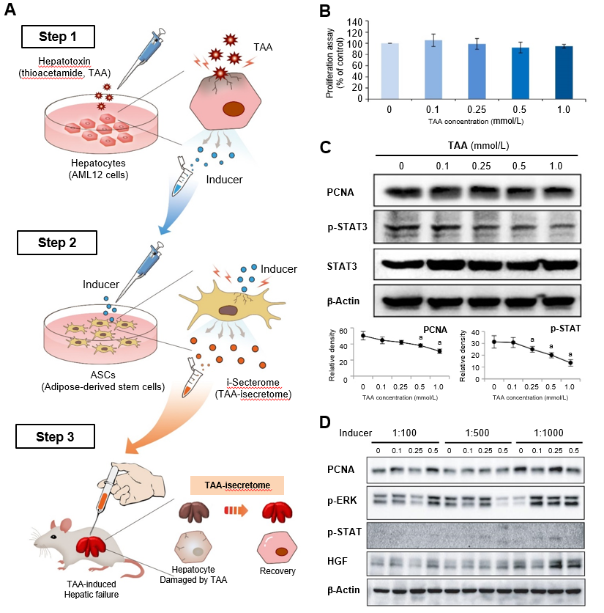
Figure 1 Generation of thioacetamide-induced secretome specialized for thioacetamide-induced toxic hepatic failure. A: Basic concept of induced secretome (isecretome) conditioned media-based therapy. Induced secretome conditioned media therapy utilizes the mesenchymal stem cell ability to generate disease-protecting materials for specific pathogens. After identifying disease-causing materials (TAA), mouse hepatocytes were treated with TAA, and then secretary proteins (inducers) were collected. The inducers were utilized to induce adipose-derived stem cells to release the TAA-induced secretome; B: AML12 cell proliferation assay according to TAA concentrations. No significant changes in the range of tested concentrations were found; C: Western blotting showing the expression of proliferation markers in AML12 cells according to TAA concentrations. We determined that 0.25 mmol/L TAA was an “inducer” of adipose-derived stem cells because it moderately increased proliferation marker expression without reducing proliferation; D: Western blotting to determine dilution rate of inducers that maximized the expression of markers related to liver regeneration in adipose-derived stem cells. A dilution rate of 1000-fold maximally induced marker expression. Values are presented as mean ± sd of three independent experiments. ªP < 0.05. PCNA: proliferating cell nuclear antigen; p-ERK: phosphorylated extracellular signal-regulated kinases; p-STAT3: phosphorylated signal transducer and activator of transcription 3; TAA: thioacetamide; ASCs: adipose-derived stem cells.

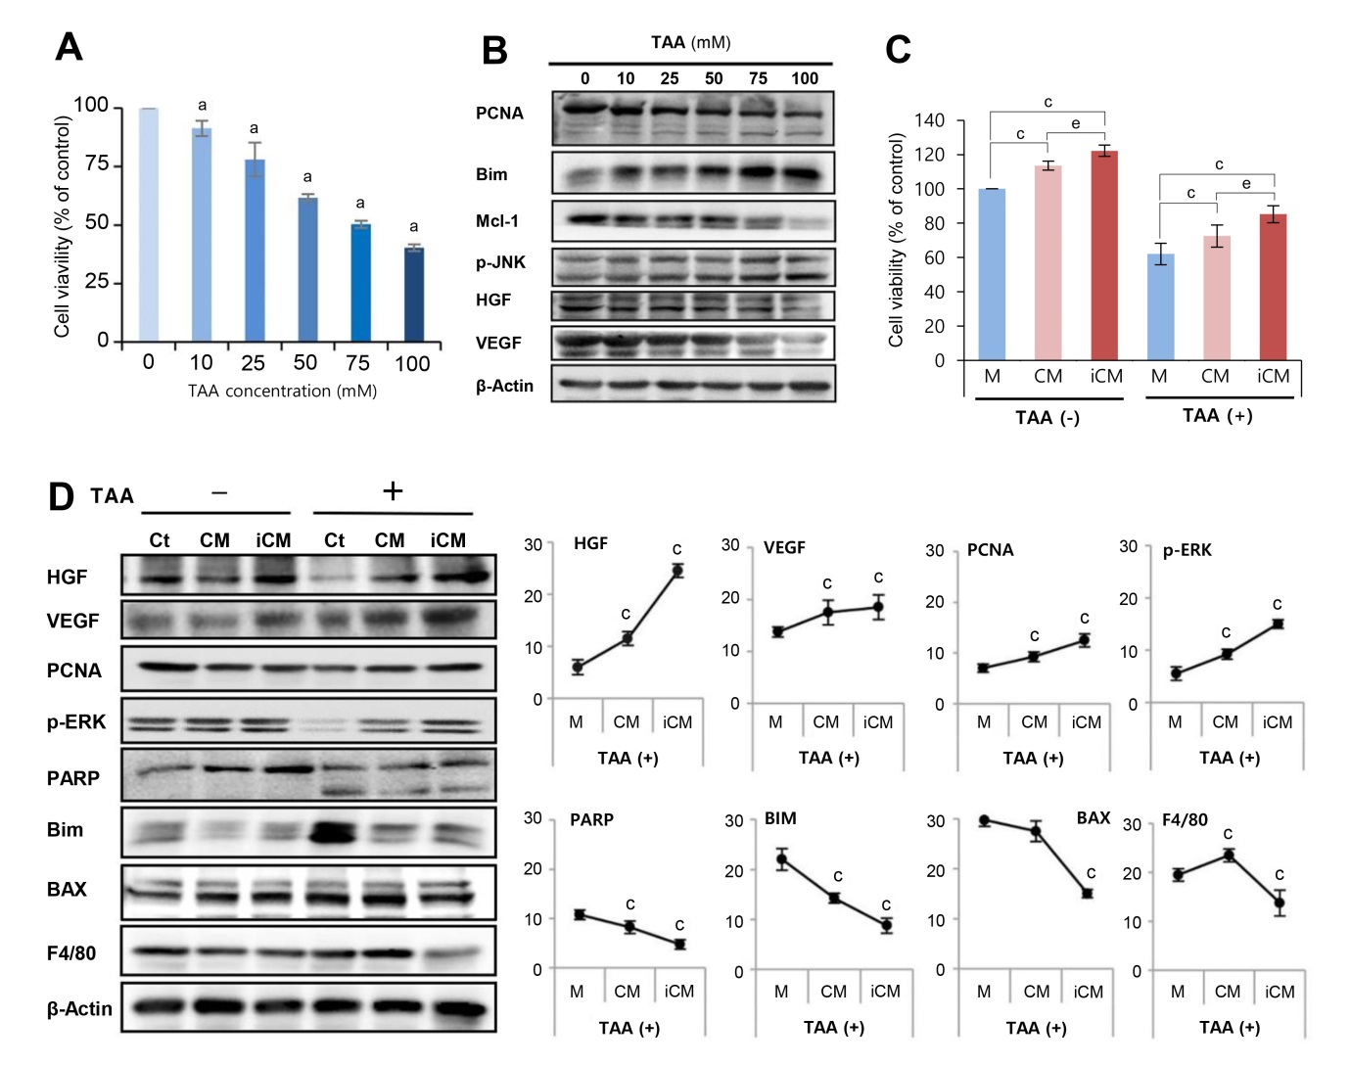
Figure 2 Determination of in vitro effects of thioacetamide-induced secretome. A, B: Cell proliferation test (A) and western blotting (B) of AML12 cells to determine TAA concentration for generating an in vitro model of TAA-induced hepatic failure. A TAA concentration of 50 mM was used for TAA-induced hepatocytes; C, D: Effects of the TAA-induced secretome on the in vitro model of TAA-induced hepatic failure. Cell proliferation test (C) demonstrated that induced conditioned media-treated hepatocytes showed the highest cell proliferation in both normal and TAA-treated hepatocytes. In western blot analysis (D), induced conditioned media-treated hepatocytes showed the highest expression of liver regeneration markers and lowest expression of apoptosis and inflammation markers. Values are presented as mean ± sd of three independent experiments. ªP < 0.05; ^{c}P < 0.05 vs media; ^{e}P < 0.05 between conditioned media and induced conditioned media. Bax: bcl-2-like protein 4; BIM: Bcl-2-like protein 11; Ct: control; iCM: induced secretome group of which components were the TAA-induced secretome; HGF: hepatocyte growth factor; M: media group of which components were commercialized conditioned media; Mcl-1: Myeloid cell leukemia 1; CM: normal conditioned media group of which components were the naïve secretome; PARP: Poly adenosine diphosphate-ribose polymerase; PCNA: proliferating cell nuclear antigen; p-ERK: phosphorylated extracellular signal-regulated kinases; p-JNK: phosphorylated jun n-terminal kinase; TAA: thioacetamide; VEGF: vascular endothelial growth factor.

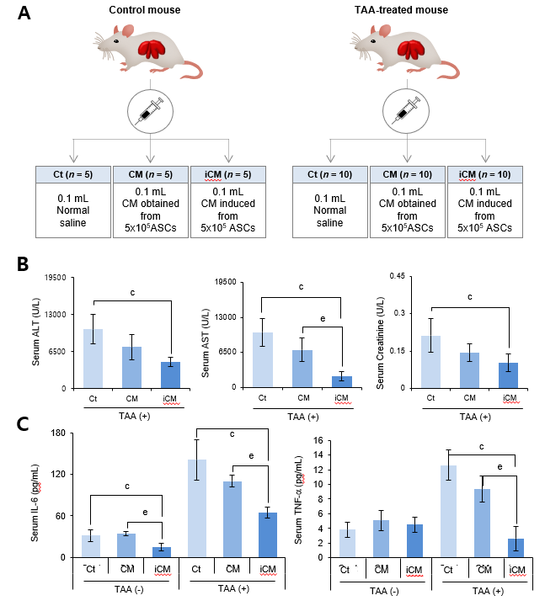
Figure 3 Animal study design and comparison of systemic effects in each group. A: animal study design. Control mice and TAA-treated mice were intravenously (using tail vein) infused with normal saline, conditioned media (CM), and induced CM (iCM); B: Serology tests of aspartate transaminase, alanine transaminase, and creatinine in TAA-treated mice. iCM infusion decreased the serum levels of aspartate transaminase, alanine transaminase, and creatinine to the greatest extent; C: Results of ELISA showing serum levels of inflammatory markers (IL-6 and TNF-α) in each group. iCM administration lowered the serum levels of IL-6 and TNF-α the most in TAA-treated mice. Values are presented as mean ± sd of three independent experiments. ^{c}P < 0.05 vs control (saline); ^{e}P < 0.05 between CM and iCM. ALT: Alanine transaminase; AST: Aspartate transaminase; iCM: Isecretome group of which components were the TAA-induced secretome; NCM: Normal conditioned media group of which components were the naïve secretome; PECAM: Platelet endothelial cell adhesion molecule; TAA: Thioacetamide.

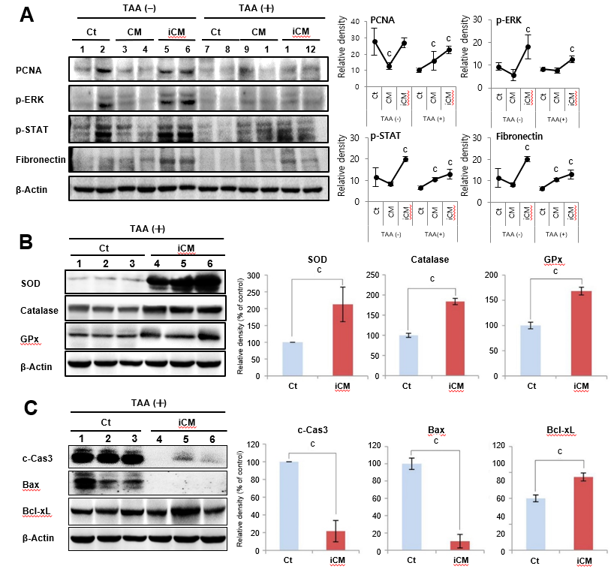
Figure 4 Molecular studies validating effects of thioacetamide-induced secretome in the mouse model of thioacetamide-induced hepatic failure. A: Pro-proliferative actions of the TAA-induced secretome in the mouse model of TAA-induced hepatic failure. Western blot analysis comparing the expression of various markers reflecting liver regeneration and inflammation in liver specimens of each group. TAA-induced conditioned media infusion induced the highest expression of PCNA, p-ERK, p-STAT, and fibronectin in both control livers and those of TAA-treated mice; B: Antioxidant actions of TAA-induced secretome in the mouse model of TAA-induced hepatic failure. Western blot analysis was performed to compare the expression of antioxidant enzymes (SOD, catalase, and GPx) in liver specimens from each group. The TAA-induced conditioned media infusion group showed the higher expression of antioxidant enzymes in the livers of TAA-treated mice compared to in the control group; C: Anti-apoptotic actions of the TAA-induced secretome in the mouse model of TAA-induced hepatic failure. TAA-iCM infusion group showed lower expression of proapoptotic proteins (c-Caspase-3 and Bax) and higher expression of an anti-apoptotic protein (Bcl-xL) in the livers of TAA-treated mice compared to in the control group. Values are presented as mean ± sd of three independent experiments. ^{c}P < 0.05 vs control (saline). Bax: bcl-2-like protein 4; Bcl-xL: B-cell lymphoma-extra large; c-Cas3: cleaved caspase-3; GPx: Glutathione peroxidase; iCM: induced secretome group of which components were the TAA-induced secretome; CM: normal conditioned media group of which components were the naïve secretome; PCNA: proliferating cell nuclear antigen; p-ERK: phosphorylated extracellular signal-regulated kinases; p-STAT3: phosphorylated signal transducer and activator of transcription 3; SOD: Superoxide dismutase; TAA: thioacetamide.

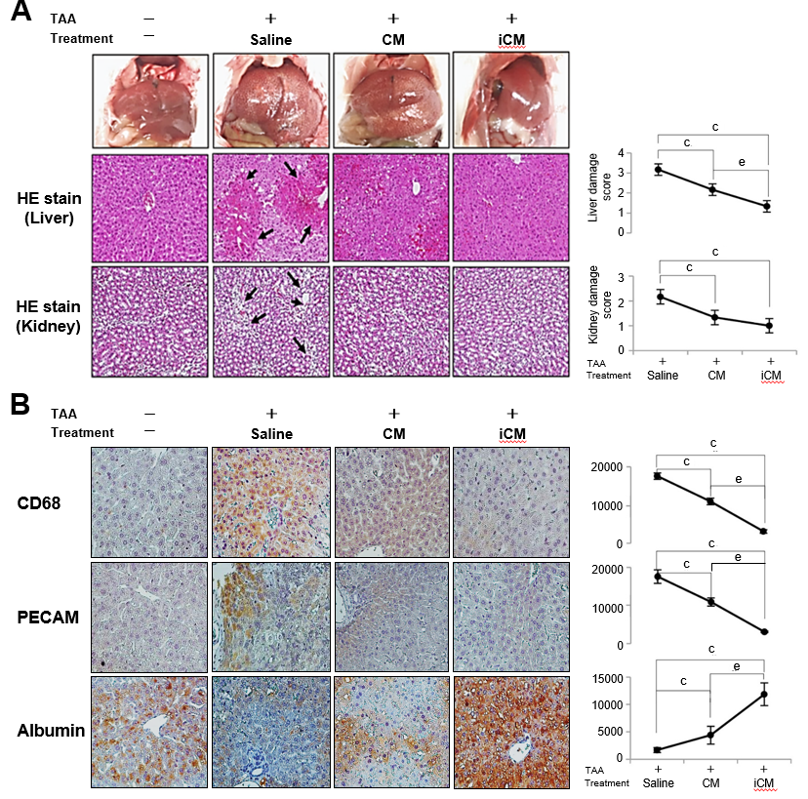
Figure 5 Various stains validating effects of thioacetamide-induced secretome in the mouse model of thioacetamide-induced hepatic failure. A: TAA-induced conditioned media infusion significantly decreased both liver damage and kidney damage scores calculated based on hematoxylin and eosin staining; B: Immunohistochemical staining of liver specimens. Immunohistochemical stains showed that TAA-induced conditioned media infusion significantly decreased the expression of inflammatory markers (CD68 and PECAM) and significantly increased the expression of albumin. Values are presented as mean ± sD of three independent experiments. ^{c}P < 0.05 vs control (saline); ^{e}P < 0.05 between conditioned media and induced conditioned media. iCM: induced secretome group of which components were the TAA-induced secretome; CM: normal conditioned media group of which components were the naïve secretome; TAA: thioacetamide.

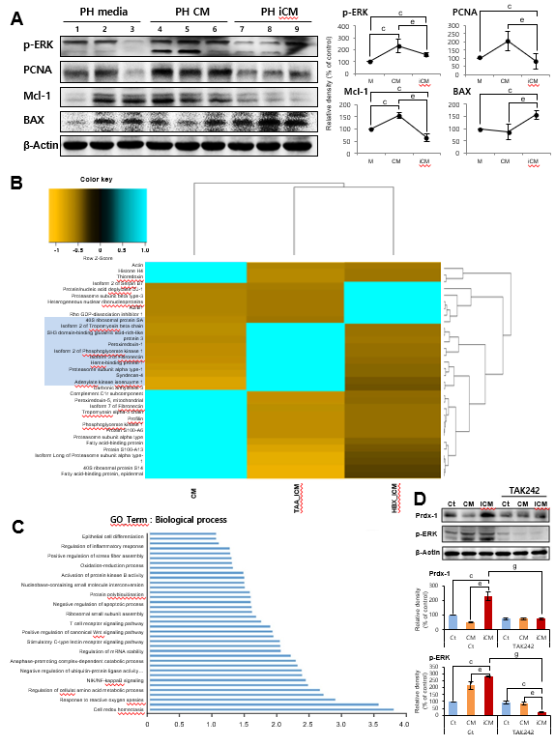
Figure 6 Validation of disease specificity and analysis of secretome components. A: Western blot analysis showing effectiveness of the TAA-induced secretome (isecretome) in partially hepatectomized mice. TAA-induced conditioned media (iCM) infusion was inferior to CM infusion in partially hepatectomized mice, considering the lower expression of proliferation markers (p-ERK and PCNA), and an anti-apoptotic marker (Mcl-1) and higher expression of a proapoptotic marker (Bax) following TAA-iCM infusion; B: Heat map generated from label-free liquid chromatography–mass spectrometry for quantitative proteomics reflecting protein expression values of the secretome, TAA-isecretome, and HBx-isecretome. Samples are arranged in columns and proteins in rows. Red shades indicate increased expression in samples compared to in control samples; green shades indicate reduced expression; black indicates median expression. Each sample for liquid chromatography–mass spectrometry was pooled from three samples of the secretome. The components and concentration of various essential proteins varied widely between iCM and HBx-iCM, validating their specificity. Values are presented as mean ± sD of three independent experiments; C: Gene ontology enrichment analysis of the ten proteins that had been exclusively identified in the TAA-isecretome. Gene ontology enrichment analysis identified the 19 enriched biological networks of the 10 proteins. Of the 19 enriched biological networks, two of the most prominent biological processes were the response to reactive oxygen species and cell redox homeostasis, all of which were related to antioxidant activity; D: Peroxiredoxin-1 (Prdx-1) inhibition test. Prdx-1 is one of the potent antioxidant proteins and was found to be one of ten proteins that had been exclusively identified in the TAA-isecretome. We performed Prdx-1 inhibition test for the determination of the role of Prdx-1 in the hepatic reparative process. Herein, liver regenerative capacity was estimated by the expression of a hepatoproliferative marker (p-ERK). When treated with the TAA-iCM, AML2 hepatocytes showed increased expression of p-ERK as well as Prdx-1 compared with AML2 cells treated with the control CM (P < 0.05). Subsequently, we compared the efficacy of the TAA-iCM after pre-treatment of TAK242, a TLR4 inhibitor. Pre-treatment of TAK242 did not only inhibit the expression of Prdx-1 but also inhibited the expression of p-ERK, the hepatoproliferative marker, suggesting the hepatoprotective role of Prdx-1 in the liver. ^{c}P < 0.05 vs control (saline); ^{e}P < 0.05 between CM and iCM; ^{g}P < 0.05 between iCMs with or without TAK242. BIM: Bcl-2-like protein 11; iCM: isecretome group of which components were the TAA-induced secretome; HBx-iCM: isecretome group of which components were the HBx-induced secretome; Mcl-1: Myeloid cell leukemia 1; CM: normal conditioned media group of which components were the naïve secretome; PCNA: proliferating cell nuclear antigen; Prdx-1: Peroxiredoxin-1.

