Name of Journal: World Journal of Clinical Cases
Manuscript NO: 75364
Manuscript Type: MINIREVIEWS

Application of imaging techniques in pancreaticobiliary maljunction

Wang JY et al. Application of imaging techniques in PBM

Jin-Ye Wang, Pei-Yuan Mu, Ye-Kai Xu, Yuan-Yuan Bai, Dong-Hua Shen

Jin-Ye Wang, Department of Hepatobiliary Surgery, Postgraduate Training Base of Jinzhou Medical University, The PLA Rocket Force Characteristic Medical Center, Beijing 100088, China

Pei-Yuan Mu, Ye-Kai Xu, Yuan-Yuan Bai, Department of Hepatobiliary Surgery, The PLA Rocket Force Characteristic Medical Center, Beijing 100088, China

Dong-Hua Shen, Department of Ultrasound, The PLA Rocket Force Characteristic Medical Center, Beijing 100088, China

Author contributions: Wang JY and Mu PY as the co-first authors contributed equally to this work; Wang JY reviewed and searched the literature, analyzed and interpreted the imaging findings, drafted the manuscript, and gave critical comments; Xu YK, Bai YY, and Shen DH gave critical comments and contributed equally to this work.

Corresponding author: Pei-Yuan Mu, MD, PhD, Chief Physician, Department of Hepatobiliary Surgery, The PLA Rocket Force Characteristic Medical Center, No. 16 Xinjiekouwai Street, Beijing 100088, China. pymu@sina.com

Received: January 30, 2022
Revised: April 19, 2022
Accepted: June 16, 2022
Published online: August 6, 2022

Abstract
Imaging techniques are useful tools in the diagnosis and treatment of pancreaticobiliary maljunction (PBM). PBM is a precancerous lesion often relative to the disease of the pancreas and biliary tract, for example, cholecystolithiasis, protein plugs, and pancreatitis. For patients with PBM, early diagnosis and timely treatment are highly important, which is largely dependent on imaging techniques. The continuous development of imaging techniques, including endoscopic retrograde cholangiopancreatography, magnetic resonance cholangiopancreatography, computed tomography, ultrasound, and intraoperative cholangiography, has provided appropriate diagnostic and therapeutic tools for PBM. Imaging techniques, including non-invasive and invasive, have distinct advantages and disadvantages. The purpose of this paper is to review the application of various imaging techniques in the diagnosis and treatment of PBM.

Key Words: Pancreaticobiliary maljunction; Endoscopic retrograde cholangiopancreatography; Magnetic resonance cholangiopancreatography; Ultrasound; Computed tomography; Intraoperative cholangiography

©The Author(s) 2022. Published by Baishideng Publishing Group Inc. All rights reserved.

Citation: Wang JY, Mu PY, Xu YK, Bai YY, Shen DH. Application of imaging techniques in pancreaticobiliary maljunction. World J Clin Cases 2022; 10(22): 7642-7652
URL: https://www.wjgnet.com/2307-8960/full/v10/i22/7642.htm
DOI: https://dx.doi.org/10.12998/wjcc.v10.i22.7642

Core Tip: Pancreaticobiliary maljunction (PBM) is a congenital structural abnormality, which is one of the risk factors for many pancreaticobiliary diseases such as cholangitis, pancreatitis, cholangiocarcinoma, and gallbladder cancer. Early diagnosis of PBM is a procedure to improve the prognosis of PBM, which is closely related to the development of various imaging techniques. Imaging techniques can achieve the purpose of early diagnosis and timely treatment, which highlights the significance of imaging techniques.
INTRODUCTION
Pancreaticobiliary maljunction (PBM) was first recorded in the early 20th century, and officially named in 1969, which is referred to as congenital malfuntional^{[1]}. The main anatomical feature of PBM is that the bile duct and pancreatic duct join out of the duodenal wall, forming a lengthy common duct (figure 1)^{[2,3]}, often combined with sphincter of Oddi dysplasia. As a result, the pancreatic duct and bile duct lose control, causing reflux^{[4]}. Due to this anatomical abnormality, PBM is often associated with certain diseases, such as cholelithiasis, cholangitis, pancreatitis, and increased risk of cholangiocarcinoma^{[5]}. PBM is often reported in Asian countries and is one of the main reasons for biliary tract cancer. In PBM patients, the pressure in the pancreatic duct is usually higher than that in the bile duct. Pancreatic juice often flows back to the bile duct^{[6]} and mixes with bile to produce cytotoxic substances, such as lysophosphatides. Due to the persistent pancreatic juice reflux to the bile duct, the mucosa of the bile duct and gallbladder is continuously damaged. The repeated repair and damage process of the biliary tract and gallbladder mucosa is related to DNA mutation, thus contributing to various gene mutations. This results in histological variety, for instance, hyperplasia, metaplasia, and dysplasia, and finally leads to biliary and gallbladder carcinogenesis. Kamisawa et al^{[7]} reported that prevalence of biliary tract cancer is 21.6%–42.4% among adult PBM patients^{[8]}. The theory of the hyperplasia-dysplasia-carcinoma sequence seems to explain the carcinogenesis of PBM^{[9]}. This is different from the general principle of carcinogenesis that arises from the adenoma-carcinoma sequence. Rungsakulkij et al^{[10]} set forth that there is evidence that gene mutations are accompanied with carcinogenesis, such as in the K-ras and p53 genes, which are involved in the carcinogenesis of gallbladder cancer in this condition. Thus, patients with PBM have higher rates of stones and tumors within the biliary tract and gallbladder^{[11]}. The characteristic of pathological change seen in PBM patients is epithelial hyperplasia of the gallbladder and biliary tract due to longstanding continuous stasis of the bile intermixed with refluxed pancreatic juice. In summary, PBM is greatly associated with pancreatic biliary disease^{[12]}. The early diagnosis of PBM is very important. The treatment of choice for PBM is prophylactic surgery before malignant changes can take place, which is heavily dependent on imaging techniques. endoscopic retrograde cholangiopancreatography (ERCP) is the most effective way to detect PBM, which could show the connection structure clearly. On ERCP, there is communication between the pancreas and the bile duct despite the contraction of the sphincter, and therefore PBM is diagnosed. Magnetic resonance cholangiopancreatography (MRCP) and computed tomography (CT) can diagnose PBM, based on findings of an abnormal combination between the common bile duct (CBD) and the pancreatic duct, in addition to a long common channel. Thickening of the gallbladder wall and expansion of the bile duct on conventional ultrasound (US) are clues to the diagnosis of PBM. Intraoperative cholangiography (IOC) is used during surgery to observe the anatomy of the pancreaticobiliary system and the function of Oddi sphincter, which therefore has great value in both diagnosis and treatment. For patients with PBM, early diagnosis and timely treatment are highly important, which are largely dependent on imaging techniques. The following imaging features can be used for the diagnosis of PBM: Abnormal long pancreatic bile duct confluence common channel and a morphological anomaly of the confluence^{[13]}. In this paper, we review the current literature about imaging techniques for PBM, in order to help clinicians make early diagnosis and timely treatment of the disease.

DIAGNOSTIC IMAGING TECHNIQUES
ERCP
ERCP is the most effective way to detect PBM, which could show the connection structure clearly. ERCP has been widely applied for the diagnosis of biliary and pancreatic diseases. On ERCP, there is communication between the pancreas and the bile duct despite the contraction of the sphincter, by which PBM is diagnosed (figure 2). ERCP has a sensitivity of 90%-100% in the diagnosis of PBM^{[14]}. ERCP is often referred as the gold standard diagnostic imaging technique for PBM. ERCP can use a side-viewing duodenoscope in order to assess the masses in the distal bile duct and the main pancreatic duct. It plays an important role in detecting biliary tract cancer. Patients with a long common channel in which communication between the pancreatic and bile ducts was maintained in both relaxation and contraction of the sphincter under serial observation during ERCP were diagnosed as having PBM^{[15]}. Whereas, considering that this technique is invasive, other diagnostic imaging techniques are preferred in patients with PBM. Before ERCP, all patients underwent initial tests, including trypsin test, liver function test, US, and MRCP to preliminarily evaluate the basic condition of the patients^{[16]}. If MRCP or US indicates some diseases, such as biliary pancreatitis, obstructive jaundice, cholangitis, CBD dilatation, bile duct stones, or pancreatic obstruction, these diseases will increase the risk of surgery. Therefore, doctors and patients can consider ERCP^{[16]}. Before surgery, ERCP can improve drainage, solve complications, and allow subsequent safe surgery. Post-ERCP pancreatitis was the main complication that was considered^{[17-19]}. Zeng et al^{[16]} reported that it was diagnosed according to the following criteria: Presence of pancreatic pain persisting for at least 24 h and serum amylase level at least 3 times higher than the normal level after ERCP. Weng et al^{[20]} set forth that it is worrisome that ERCP could yield false positive findings (5.35%), with a specificity of 94.65%, when the contrast does not fill the CBD. During ERCP operation, bile can be extracted by fine needle to detect the amylase level in bile. If the bile amylase level is higher than the upper limit of serum amylase, PBR can be suspected after excluding some cases, such as enterobiliary reflux. Enterobiliary reflux (flow of pancreatic juice into the biliary tract) usually occurs in patients with PBM. For these patients, further examination and verification are needed. ERCP is often used as the golden standard for the diagnosis of PBM, but requires anesthesia. For some patients, the procedure is difficult. In addition, Paris et al^{[21]} reported that the incidence of complications after ERCP in children was as high as 13.5%, thus demonstrating a certain risk of complications, for example, pancreatitis and bleeding^{[22]}. The characteristics of invasive examination and postoperative complications mean that we should carefully consider ERCP as a diagnostic examination.

MRCP
MRCP is a noninvasive and low-risk cholangiopancreatography technique, which is widely used in the diagnosis of pancreatic and biliary abnormalities. It was rapidly applied in clinical trials in the 1990s. MRCP can reliably measure the length of the pancreaticobiliary channel^{[23]}. For MRCP, half Fourier acquisition single shot turbo spin echo was used with multilayer thin coronal and axial T2-weighted imaging [repetition time (TR): 1200 ms; echo time (TE): 80 ms; slice thickness: 4 mm]. Oblique thick slabs were acquired in the planes of the CBD and pancreatic duct. For multi-angle imaging, TR was 4500 ms, TE 950 ms, and slice thickness 60 mm. It provides high-resolution three-dimensional images of the CBD and pancreatic duct at multiple locations and angles. MRCP can clearly show the pancreaticobiliary junction. Compared with other imaging techniques (such as US and CT), MRCP can better display the unexpanded pancreatic duct in PBM with common channel protein plug in the case of unclear body and tail of the pancreas. MRCP should be performed on individuals who show gallbladder wall thickening on US for further examination, in order to detect PBM without bile duct dilatation early before the onset of gallbladder cancer. Sometimes, measuring the common channel is difficult to achieve, either because it is too narrow or because the CBD prevents the connection with the pancreatic duct from being evaluated. In addition, in patients with cholangitis, motion artifacts will reduce the imaging quality. Some researchers found that lemon/orange juice can improve the view of the pancreatic duct. When secretin stimulates pancreatic exocrine secretion, dynamic MRCP can observe the backflow of pancreatic juice into the bile duct. Diagnostic accuracy can be upgraded with tridimensional MRCP or dynamic MRCP with secretin stimulation. For common short channels, such as infant PBM imaging, the effect of ordinary MRCP is not as good as that of ERCP, and there are image quality defects such as motion artifacts. The disadvantages of MRCP are the potentially poor definition of the pancreatic duct branch and peripheral biliary tree and the inherent poor spatial resolution compared with ERCP. In some cases, the display of the pancreatic body and tail is not satisfactory^{[24]}. The accuracy of diagnostic MRCP can be increased through using 3D or dynamic MRCP with secretin stimulation. An overwhelming amount of evidence shows that the information provided by MRCP is almost equivalent to that by ERCP. To some extent, MRCP can be used as an image alternative to ERCP. Compared with invasive ERCP, this is a non-invasive imaging technique. When the pancreatic duct and bile duct merge in the duodenal wall to form an abnormally long common channel, the diagnosis of PBM can be made (Figure 3). In a way, this imaging technique allows ducts to be visualized, although the ducts are as narrow as 1 mm in diameter. It also proved to provide other findings not found on ERCP, and the consistency with ERCP was 81%. MRCP allows for a detailed visualization of the CBD and PBM, with detection rates of PBM between 82% and 100%^{[25]}. MRCP plays key role in the early relative accuracy diagnosis and preventive treatment of pancreaticobiliary diseases. Overall, MRCP, as a non-invasive method, has become the first choice for the diagnosis of pancreaticobiliary diseases. This technique has certain limitations, high price, and limited availability, and is related to the subjectivity of long-time exploration and imaging interpretation due to its dependence on operators. Compared with ERCP, MRCP has limitations in the diagnosis of PBM, even if pancreatin is used. However, for diagnosing patients with anatomical maljunction, ERCP remains the gold standard. When ERCP is used as the reference standard, the detectability rate of MRCP for this anomaly has been reported to be 82%^{[26]}.

US
As a safe, rapid, accurate, and economical routine examination tool, US can be used to detect gallbladder wall thickening and intrahepatic and extrahepatic bile duct dilatation (Figure 4A and B). In addition, it can also show pancreatic duct dilatation and other features for the diagnosis of pancreatitis. Although US can observe common pancreaticobiliary channels, this method is limited because it cannot provide accurate measurement of common channels because the coronal plane is not visible. PBM patients without biliary dilatation rarely have some symptoms such as acute abdominal pain and vomiting hyperamylasemia, hyperbilirubinemia, and abnormal liver function (ASD), so most patients are not diagnosed before advanced gallbladder cancer. Kamisawa et al^{[27]} reported that gallbladder wall thickening is a diagnostic clue for PBM patients without bile duct dilatation. US can detect gallbladder wall thickening and bile duct dilatation, so US plays a key role in the pre-diagnosis of PBM. Although gallbladder wall thickening has its own limitations, it is a key factor of PBM. Patients need further examinations, such as MRCP, CT, ERCP, and IOC, to further clarify. In most cases, US is often used as a screening modality. We did not find the literature describing the detection rate of PBM by ultrasound. Endoscopic ultrasound (EUS) is useful for obtaining high-resolution images of pancreaticobiliary diseases. In the normal gallbladder wall, EUS shows a two layered structure consisting of an inner hypoechoic layer composed of the mucosa and the muscular layer, and an outer hyperechoic layer composed of the subserosal layer and the serosa. On EUS, the gallbladder wall of PBM patients showed two layers of thickening, showing epithelial hyperplasia and subserosal fibrosis, or three layers of thickening, one of which was medium and low echo layer, showing hypertrophic muscle layer. In PBM, EUS can detect the confluence of the pancreatic duct and bile duct in the proximal portion of the duodenal wall, the so-called common channel (figure 4C)^{[28]}. However, it is not a routine test, because it requires dedicated endoscopes (e.g., endoscopes for radial and linear EUS). The imaging capability of EUS is generally good, but the technique of EUS imaging is sometimes difficult, and the diagnostic performance of EUS is operator-dependent. In fact, several investigators have reported that EUS could confirm the PBM in 4 (2.9%) of 137 patients who underwent screening US^{[28]}. When ERCP is used as the reference standard, the detectability rate of EUS for this anomaly has been reported to be 88%. Intraductal ultrasonography (IDUS) during ERCP is highly helpful to describe pancreaticobiliary confluence. However, IDUS also has its own limitations, such as weak penetration and poor operability in exploring narrow biliary tract^{[29]}. Increasing the number of ultrasonic examinations is also necessary to facilitate the early diagnosis of pancreaticobiliary diseases. Because most PBM patients without biliary dilatation are not easy to find in the early stage and are in a bad situation once found, a new method for early diagnosis and treatment of PBM should be developed to improve the prognosis. Despite its own limitations, US can raise questions as soon as possible and suggests us to make further diagnosis. Compared with other imaging methods, US has its unique advantages: Noninvasiveness, no radiation, and moderate price. Compared with other imaging techniques, it uses a more comprehensive method to screen all patients with recognized PBM risk factors because it is fast, flexible, and easy to operate^{[30]}.

CT
CT has a higher resolution even than MRCP. CT is widely used in pancreaticobiliary diseases. Traditional examination can observe the relationship between the size of lesion area and surrounding tissues, and further formulate the operation plan. The thickening of the gallbladder wall on US can be used as an indication for further examination of CT. Wall thickening at the stricture site may suggest malignancy because primary ductal stricture lacks wall thickening. Enhanced CT has been strengthened in the diagnosis and treatment of irregular biliary nodules. Postoperative follow-up screening and canceration monitoring have certain value. Because of its own characteristics, CT is more used for the differentiation of pancreaticobiliary diseases than used for PBM. Conventional CT scan is axial scanning, which cannot show the overall shape and cavity of the biliary tract, so it is not satisfied with the observation of the biliary system^{[31]}. Some researchers reported that it is difficult to accurately measure the length of the common channel on CT due to the following reasons: First, the whole process of the common channel is not visible on CT, because in many cases, the common channel part is involved by the area showing less contrast enhancement between the pancreatic head and duodenum. Second, in some cases, the whole process of common channel is not described on the single-layer multiplane reconstructed (MPR) image. Third, public channels are tortuous in some cases. Recent advances in spiral CT techniques, such as multi-detector and sub-second rotation, make it possible to scan the pancreas and pancreas biliary system with a collimation of 1.25 mm and less. This will lead to further improvements, in the mass of multi-plane reformatting (multiplanar reconstruction) due to the high-resolution and MPR images on the z-axis enable us to select the best section to evaluate the pancreas and bile duct and their function confluence. By using high-resolution MPR images, Modified Discrete Cosine Transform (MDCT) allows us to diagnose abnormal pancreaticobiliary connections according to the relationship between catheter confluence and pancreatic parenchyma (figure 5). The sensitivity of MPR images of MDCT in the diagnosis of abnormal pancreaticobiliary confluence was 78%^{[32]}. It has been reported that perfusion cholangiography spiral CT (spiral CT during drip cholangiography; DIC-CT) is used in the diagnosis of PBM^{[33]}. High resolution images were obtained by intravenous hepatobiliary drugs (lipperamide meglumine) and three-dimensional CT. Pancreaticobiliary channels and bidirectional reflux of pancreatic juice and bile were clearly visible. Due to exposure to ionizing radiation, this technique has not been widely used in patients. Another major drawback of DIC-CT is that injection of contrast agents (meglumine iodoacetate) may produce adverse reactions, which occur in 0.8%-3.4% of patients, although the main symptom is rash and usually does not need treatment^{[34]}. At present, it is only used as a second-line diagnostic tool for PBM.

IOC
IOC has become an indispensable technique in hepatobiliary surgery, which provides an intuitive understanding of the anatomy of the biliary system, especially suitable for judging bile duct stenosis, stones and protein embolism, and can safely guide the operation in real time^{[34]}. During the operation, IOC was used to observe the anatomical structure of the pancreaticobiliary system and the function of Oddi sphincter. The diagnosis of PBM can be determined according to the cholangiography results (Figure 6). It can also be used to evaluate the patency of the distal bile duct. IOC is usually divided into intraoperative total cholangiography (ITCP) and intraoperative selective pancreatangiography (ISCP). The method of IOC is chosen according to the patient's condition and the degree of disease development. If the total bile duct cyst is huge, the duodenum is displaced forward. Using ITCP contrast is not easy to show the distal end of the bile duct and bile and pancreatic duct confluence^{[35]}. ITCP can display the intrahepatic and external bile duct and the pancreatic duct, to understand the pathological morphology of all the biliary ducts and pancreatic ducts. ISCP is suitable to focus on the distal intrahepatic or extrahepatic biliary tract and the pancreatic duct. Intraoperative biliary structure shadow combined with preoperative MRCP can reduce the image occlusion of large cyst and is conducive to the imaging of PBM patients with proximal total bile duct stenosis. IOC is a diagnostic and therapeutic method with surgical and anesthetic risks. During IOC, due to the increased pressure in the bile duct, this technique can lead to slight dilatation of the bile duct, which is similar to ERCP^{[36]}. The clinical application of IOC faces several challenges. These challenges include the need for detailed anatomical understanding before IOC, which may be technically difficult (in acute or chronic inflammatory diseases), the need to insert short, thin, or curved cystic duct, and the risk of avulsion when inserting inflammatory cystic duct. In addition, intraoperative cholangiography has some disadvantages, such as being time-consuming, the need for additional equipment and technicians, the risk of radiation exposure to staff and patients, and the need to inject contrast agent into the bile duct, which may increase the risk of bile duct injury^{[37,38]}. Compared with traditional ERCP, MRCP, US, CT, and other imaging techniques, IOC has the advantages of intraoperative navigation, high sensitivity, simple operation, and low price^{[39]}. We firmly believe that this imaging technique provides a new source of real-time anatomical information for hepatobiliary surgery^{[40]}. Intravenous injection of indocyanine green (ICG) has potential advantages over conventional radiographic cholangiography in saving time and avoiding bile duct injury associated with the catheterization required for injection of contrast materials^{[41,42]}. ICG fluorescence imaging has been gradually applied to hepatobiliary surgery, and there are no relevant reports on the application of ICG fluorescence imaging to PBM-related diseases. We can boldly imagine that fluorescence imaging technique will also be suitable for pancreatic bile system anatomy in the near future. We searched the literature for intraoperative cholangiography. Most of the literature was related to endoscopic cholecystectomy, and few were related to PBM. Therefore, the accuracy of intraoperative cholangiography in the diagnosis of PBM could not be retrieved.

TREATMENT OF PBM
PBM can be divided into PBM with biliary dilatation and PBM without^{[43]}. It is agreed that preventive surgery should be performed on PBM patients as soon as possible after diagnosis^{[44]}. For bile duct dilatory PBM, current cholecystectomy, extrahepatic cholbectomy, and hepatic tube-jejunal Roux-en-Y reconstruction is the standard surgical modality. New complications may also occur later, such as narrow anastomosis, reflux cholangitis, intra-hepatic duct stones, and bile duct tumors. There are some PBM patients with obstructive jaundice or acute pancreatitis or other diseases^{[45,46]}. The operation of these patients is considered to increase the postoperative risk. With the continuous progress of imaging techniques, ERCP is not only the standard technique for diagnosing PBM, but also used to improve drainage and solve complications^{[47,48]}. ERCP is also an effective therapeutic option for patients with PBM. ERCP can improve drainage, solve complications, and allow subsequent safe surgery. The indications for ERCP (one case may involve one or more indications) are pancreatitis, pancreaticobiliary calculi, biliary obstruction, and stent displacement. Endoscopic treatments for PBM primarily include endoscopic sphincteropapillotomy (EST), stent insertion, and endoscopic nasobiliary drainage (ENBD)/endoscopic nasal and pancreatic duct drainage (ENPD). If pancreaticobiliary stones or protein plugs are detected, stone removal treatment is required. ERCP needs to be performed under general anesthesia. Two experienced endoscopists intubate the trachea in the prone position and use duodenoscopy. After successful intubation of the CBD, 10 mL of bile samples are taken to measure bile amylase (PBM is indicated when bile amylase level is higher than the upper limit of serum amylase level). EST can help bile and pancreatic juice flow into the duodenum regularly. Endoscopic hemostatic clip is also used to treat high-risk patients with bleeding after EST. Endoscopic papillary balloon dilatation is used if there are large CBD stones. Finally, ENBD/ENPD or endoscopic retrograde cholangiopancreatic drainage is performed when necessary to prevent complications. Jin et al^{[40]} reported that the total effective rate of ERCP in the treatment of PBM was 60.7% (34/56). It is useful to plan the timing and choice of the appropriate surgical procedure.
For PBM patients without biliary dilatation, prophylactic cholecystectomy is recommended to prevent gallbladder cancer. Nevertheless, the risk of developing cancer in the remnant biliary tract is still high, so careful follow-up is needed for such patients in the future. During laparoscopic cholecystectomy, in order to perform accurate resection and prevent bile duct and vascular injury, it is necessary to understand the anatomy of the bile duct and vessels^{[49]}. Laparoscopic ultrasound (LUS) during cholecystectomy allows minimal invasive study of the biliary tract and has excellent ability to identify anatomical structures. LUS, which is cheap, fast and non-irradiated, can be repeated as needed during laparoscopic surgery. Adjacent organs can also be explored^{[49]}. LUS can be a valuable adjunct and can be performed before dissection, and repeated as needed to guide the surgeon. LUS can be performed before Calot’s triangle dissection, which facilitates the mapping of biliary and hilar structures during difficult scenarios such as severe inflammation and fibrosis. Conventional abdominal ultrasound and CT examination are usually performed before operation to provide a reference for operation. To some extent, imaging techniques is also of great value in the treatment of PBM. With the continuous progress of imaging techniques, the relationship between diagnosis and treatment of the disease is becoming closer and more inseparable. In the diagnosis and treatment of PBM, imaging techniques run through the whole process and play an important role in clinical practice.

CONCLUSION
In summary, the clinical features of PBM are atypical and usually characterized by pancreaticobiliary diseases. PBM is one of the pathogenic factors of pancreaticobiliary diseases such as cholangitis, pancreatitis, cholangiocarcinoma, and gallbladder cancer. Early diagnosis and timely treatment are very important. Early diagnosis of PBM can improve the prognosis of PBM, which is closely related to the development of various imaging techniques such as ERCP, MRCP, CT, US, and IOC. If imaging shows that the bile duct and pancreatic duct outside the duodenal wall are connected through a long common tube, a diagnosis of PBM can be made^{[50]}. The imaging techniques mentioned in this paper (ERCP, MRCP, US, CT, and IOC) are valuable for the diagnosis and treatment of PBM patients. ERCP can be used as the gold standard for the diagnosis of PBM and can also be used to alleviate PBM related complications, but this technique is invasive and its application needs careful consideration. As a noninvasive imaging technique, MRCP can clearly show the junction of the pancreaticobiliary duct. It is the first choice for the diagnosis of PBM in most patients. US can be used to detect gallbladder wall thickening and congenital biliary dilatation, which can play a warning role and need further examination. CT has high resolution in the diagnosis of PBM. IOC provides an intuitive understanding of the anatomy of the biliary system and guides the operation in real time. Each imaging technique has its unique advantages and disadvantages. No paper has been found to report the official golden standard. So, further research is needed on golden diagnosing imaging techniques for PBM. Appropriate techniques should be chosen according to the actual situation to achieve the desired effect. The imaging techniques mentioned in this paper guide various diagnostic and treatment procedures, help surgeons accurately perform some surgical operation, and reduce the risk of intraoperative and postoperative complications. They can achieve complete and correct diagnosis and real staging, and help to establish an appropriate treatment attitude. We believe that the imaging technique with all the above characteristics is of great value in the diagnosis and treatment of PBM.
In conclusion, imaging techniques allow us to diagnose an anomalous pancreaticobiliary ductal junction on the basis of findings regarding the relationship between the duct confluence and the pancreatic parenchyma. The detection rates of ERCP, MRCP, EUS, and MDCT for PBM are 90%-100%, 82%-100%, 88%, and 78%^{[51,52]}, respectively. Various imaging techniques also play a great role in the treatment of PBM. In order to achieve the purpose of early diagnosis and timely treatment, imaging techniques for PBM should be used more and more clinically.

REFERENCES
1 López Alza LC, Ramírez Villamila AG, Moreno Gómez LA, Aguilar Velasco D, Fierro Ávila F. Magnetic resonance cholangiopancreatography identification of pancreaticobiliary maljunction in the colombian pediatric population. Cir Pediatr 2020; 33: 177-182 [PMID: 33016657]
2 Cheng L, Tian F, Zhao T, Pang Y, Luo Z, Ren J. Annular pancreas concurrent with pancreaticobiliary maljunction presented with symptoms until adult age: case report with comparative data on pediatric cases. BMC Gastroenterol 2013; 13: 153 [PMID: 24156788 DOI: 10.1186/1471-230X-13-153]
3 Yamanaka T, Araki K, Ishii N, Tsukagoshi M, Igarashi T, Watanabe A, Kubo N, Kuwano H, Shirabe K. Carcinoma of the Papilla of Vater after Diversion Operation for Pancreaticobiliary Maljunction. Case Rep Gastroenterol 2017; 11: 265-270 [PMID: 28626371 DOI: 10.1159/000462967]
4 Kamisawa T, Honda G. Pancreaticobiliary Maljunction: Markedly High Risk for Biliary Cancer. Digestion 2019; 99: 123-125 [PMID: 30179869 DOI: 10.1159/000490816]
5 Yamada K, Ishikawa T, Ohno E, Iida T, Suzuki H, Uetsuki K, Yashika J, Yoshikawa M, Takami H, Inokawa Y, Uchida H, Kawashima H, Fujishiro M. Double common bile duct associated with pancreaticobiliary maljunction. Nagoya J Med Sci 2021; 83: 655-661 [PMID: 34552298 DOI: 10.18999/nagjms.83.3.655]
6 Yamada S, Shimada M, Utsunomiya T, Morine Y, Imura S, Ikemoto T, Mori H, Kanamoto M, Hanaoka J, Iwahashi S, Saito Y, Ishibashi H. Hilar cholangiocarcinoma accompanied by pancreaticobiliary maljunction without bile duct dilatation 20 years after cholecystectomy: report of a case. J Med Invest 2013; 60: 169-173 [PMID: 23614928 DOI: 10.2152/jmi.60.169]
7 Kamisawa T, Ando H, Suyama M, Shimada M, Morine Y, Shimada H; Working Committee of Clinical Practice Guidelines for Pancreaticobiliary Maljunction; Japanese Study Group on Pancreaticobiliary Maljunction. Japanese clinical practice guidelines for pancreaticobiliary maljunction. J Gastroenterol 2012; 47: 731-759 [PMID: 22722902 DOI: 10.1007/s00535-012-0611-2]
8 Lahmar A, Abid SB, Arfa MN, Bayar R, Khalfallah MT, Mzabi-Regaya S. Metachronous cancer of gallbladder and pancreas with pancreatobiliary maljunction. World J Gastrointest Surg 2010; 2: 143-146 [PMID: 21160863 DOI: 10.4240/wjgs.v2.i4.143]
9 Nishi T, Sato Y, Hanaoka T, Takahashi T, Miura H, Takubo K. Synchronous double primary cancers of the extrahepatic bile duct: A case report and literature review. Int J Surg Case Rep 2018; 47: 48-51 [PMID: 29727803 DOI: 10.1016/j.ijscr.2018.04.020]
10 Rungsakulkij N, Boonsakan P. Synchronous gallbladder and pancreatic cancer associated with pancreaticobiliary maljunction. World J Gastroenterol 2014; 20: 14500-14504 [PMID: 25339838 DOI: 10.3748/wjg.v20.i39.14500]
11 Kamisawa T, Kuruma S, Chiba K, Tabata T, Koizumi S, Kikuyama M. Biliary carcinogenesis in pancreaticobiliary maljunction. J Gastroenterol 2017; 52: 158-163 [PMID: 27704265 DOI: 10.1007/s00535-016-1268-z]
12 Morine Y, Shimada M, Takamatsu H, Araida T, Endo I, Kubota M, Toki A, Noda T, Matsumura T, Miyakawa S, Ishibashi H, Kamisawa T, Shimada H. Clinical features of pancreaticobiliary maljunction: update analysis of 2nd Japan-nationwide survey. J Hepatobiliary Pancreat Sci 2013; 20: 472-480 [PMID: 23579999 DOI: 10.1007/s00534-013-0606-2]
13 Saito T, Terui K, Mitsunaga T, Nakata M, Yoshida H. Significance of imaging modalities for preoperative evaluation of the pancreaticobiliary system in surgery for pediatric choledochal cyst. J Hepatobiliary Pancreat Sci 2016; 23: 347-352 [PMID: 26994400 DOI: 10.1002/jhbp.347]
14 Cui GX, Huang HT, Yang JF, Zhang XF. Rare variant of pancreaticobiliary maljunction associated with pancreas divisum in a child diagnosed and treated by endoscopic retrograde cholangiopancreatography: A case report. World J Clin Cases 2019; 7: 1073-1079 [PMID: 31123681 DOI: 10.12998/wjcc.v7.i9.1073]
15 Takuma K, Kamisawa T, Tabata T, Hara S, Kuruma S, Inaba Y, Kurata M, Honda G, Tsuruta K, Horiguchi S, Igarashi Y. Importance of early diagnosis of pancreaticobiliary maljunction without biliary dilatation. World J Gastroenterol 2012; 18: 3409-3414 [PMID: 22807610 DOI: 10.3748/wjg.v18.i26.3409]
16 Zeng JQ, Deng ZH, Yang KH, Zhang TA, Wang WY, Ji JM, Hu YB, Xu CD, Gong B. Endoscopic retrograde cholangiopancreatography in children with symptomatic pancreaticobiliary maljunction: A retrospective multicenter study. World J Gastroenterol 2019; 25: 6107-6115 [PMID: 31686766 DOI: 10.3748/wjg.v25.i40.6107]
17 Attard TM, Grima AM, Thomson M. Pediatric Endoscopic Procedure Complications. Curr Gastroenterol Rep 2018; 20: 48 [PMID: 30173321 DOI: 10.1007/s11894-018-0646-5]
18 Shih HY, Hsu WH, Kuo CH. Postendoscopic retrograde cholangiopancreatography pancreatitis. Kaohsiung J Med Sci 2019; 35: 195-201 [PMID: 30887733 DOI: 10.1002/kjm2.12040]
19 Kamisawa T, Takuma K, Itokawa F, Itoi T. Endoscopic diagnosis of pancreaticobiliary maljunction. World J Gastrointest Endosc 2011; 3: 1-5 [PMID: 21258599 DOI: 10.4253/wjge.v3.i1.1]
20 Weng M, Wang L, Weng H, Gu J, Wang X. Utility of endoscopic retrograde cholangiopancreatography in infant patients with conservational endoscopy. Transl Pediatr 2021; 10: 2506-2513 [PMID: 34765474 DOI: 10.21037/tp-21-406]
21 Paris C, Bejjani J, Beaunoyer M, Ouimet A. Endoscopic retrograde cholangiopancreatography is useful and safe in children. J Pediatr Surg 2010; 45: 938-942 [PMID: 20438931 DOI: 10.1016/j.jpedsurg.2010.02.009]
22 Kamisawa T, Anjiki H, Egawa N, Kurata M, Honda G, Tsuruta K. Diagnosis and clinical implications of pancreatobiliary reflux. World J Gastroenterol 2008; 14: 6622-6626 [PMID: 19034962 DOI: 10.3748/wjg.14.6622]
23 Wang CL, Ding HY, Dai Y, Xie TT, Li YB, Cheng L, Wang B, Tang RH, Nie WX. Magnetic resonance cholangiopancreatography study of pancreaticobiliary maljunction and pancreaticobiliary diseases. World J Gastroenterol 2014; 20: 7005-7010 [PMID: 24944495 DOI: 10.3748/wjg.v20.i22.7005]
24 Guo WL, Huang SG, Wang J, Sheng M, Fang L. Imaging findings in 75 pediatric patients with pancreaticobiliary maljunction: a retrospective case study. Pediatr Surg Int 2012; 28: 983-988 [PMID: 22892909 DOI: 10.1007/s00383-012-3159-6]
25 Ragot E, Mabrut JY, Ouaïssi M, Sauvanet A, Dokmak S, Nuzzo G, Halkic N, Dubois R, Létoublon C, Cherqui D, Azoulay D, Irtan S, Boudjema K, Pruvot FR, Gigot JF, Kianmanesh R; Working Group of the French Surgical Association. Pancreaticobiliary Maljunctions in European Patients with Bile Duct Cysts: Results of the Multicenter Study of the French Surgical Association (AFC). World J Surg 2017; 41: 538-545 [PMID: 27620132 DOI: 10.1007/s00268-016-3684-x]
26 Uchida D, Kato H, Matsumoto K, Ishihara Y, Matsumi A, Saragai Y, Takada S, Yabe S, Muro S, Tomoda T, Horiguchi S, Okada H. Single-session esophagogastroduodenoscopy and endoscopic ultrasound using a forward-viewing radial scan ultrasonic endoscope. BMC Gastroenterol 2019; 19: 220 [PMID: 31852458 DOI: 10.1186/s12876-019-1141-7]
27 Kamisawa T, Takuma K, Anjiki H, Egawa N, Kurata M, Honda G, Tsuruta K, Sasaki T. Pancreaticobiliary maljunction. Clin Gastroenterol Hepatol 2009; 7: S84-S88 [PMID: 19896105 DOI: 10.1016/j.cgh.2009.08.024]
28 Dumonceau JM, Andriulli A, Elmunzer BJ, Mariani A, Meister T, Deviere J, Marek T, Baron TH, Hassan C, Testoni PA, Kapral C; European Society of Gastrointestinal Endoscopy. Prophylaxis of post-ERCP pancreatitis: European Society of Gastrointestinal Endoscopy (ESGE) Guideline - updated June 2014. Endoscopy 2014; 46: 799-815 [PMID: 25148137 DOI: 10.1055/s-0034-1377875]
29 Noda Y, Fujita N, Kobayashi G, Ito K, Horaguchi J, Takazawa O, Obana T, Nakahara K, Ishida K, Suzuki T, Hirasawa D, Sugawara T, Ohira T, Onochi K, Harada Y, Tsuchiya T, Sawai T, Uzuki M, Kariya Y. Intraductal ultrasonography before biliary drainage and transpapillary biopsy in assessment of the longitudinal extent of bile duct cancer. Dig Endosc 2008; 20: 73-78 [DOI: 10.1111/j.1443-1661.2008.00779.x]
30 Donoghue S, Jones RM, Bush A, Srinivas G, Bowling K, Andrews S. Cost effectiveness of intraoperative laparoscopic ultrasound for suspected choledocholithiasis; outcomes from a specialist benign upper gastrointestinal unit. Ann R Coll Surg Engl 2020; 102: 598-600 [PMID: 32538107 DOI: 10.1308/rcsann.2020.0109]
31 Xue HD, Jin ZY, Liao Q, Wang Y, Zhao WM. [Non cholangio-contrast cholangiopancreatography using multi-slice spiral CT]. Zhongguo Yi Xue Ke Xue Yuan Xue Bao 2004; 26: 268-273 [PMID: 15266828]
32 Maguchi H, Osanai M, Katanuma A, Yane K, Takahashi K. [Imaging diagnosis for pancreaticobiliary maljunction]. Nihon Shokakibyo Gakkai Zasshi 2014; 111: 690-698 [PMID: 24769457]
33 Hamada Y, Ando H, Kamisawa T, Itoi T, Urushihara N, Koshinaga T, Saito T, Fujii H, Morotomi Y. Diagnostic criteria for congenital biliary dilatation 2015. J Hepatobiliary Pancreat Sci 2016; 23: 342-346 [PMID: 26996969 DOI: 10.1002/jhbp.346]
34 Nakazawa A, Akamatsu N, Miyata Y, Komagome M, Maki A, Arita J, Ishizawa T, Kaneko J, Beck Y, Hasegawa K. Usefulness of preoperative drip infusion cholangiography with computed tomography for predicting surgical difficulty during laparoscopic cholecystectomy. J Hepatobiliary Pancreat Sci 2020; 27: 315-323 [PMID: 31971340 DOI: 10.1002/jhbp.718]
35 Cirimbei S, Puşcu C, Lucenco L, Brătucu E. The role of intraoperative ultrasound in establishing the surgical strategy regarding hepato-bilio-pancreatic pathology. Chirurgia (Bucur) 2013; 108: 643-651 [PMID: 24157106]
36 Li ZD, Zhao L,Yang LQ, Zhang DR, Li J. Intraoperative Cholangiography for the Diagnosis of Billiary Disease in Children. Zhonghua Xiaoer Waike Zazhi 1997; 18: 277-278 [DOI: 10.3760/cma.j.issn.0253-3006.1997.05.009]
37 Watanabe Y, Kubota H, Honma T, Hosoya T, Yamaguchi K. [Usefulness of helical DIC-CT in pancreaticobiliary maljunction]. Nihon Igaku Hoshasen Gakkai Zasshi 1997; 57: 249-252 [PMID: 9164113]
38 Jamal KN, Smith H, Ratnasingham K, Siddiqui MR, McLachlan G, Belgaumkar AP. Meta-analysis of the diagnostic accuracy of laparoscopic ultrasonography and intraoperative cholangiography in detection of common bile duct stones. Ann R Coll Surg Engl 2016; 98: 244-249 [PMID: 26985813 DOI: 10.1308/rcsann.2016.0068]
39 Wang C, Peng W, Yang J, Li Y, Yang J, Hu X, Xia L, Zhang L, Zhong Y, Qiao L, Pan W. Application of near-infrared fluorescent cholangiography using indocyanine green in laparoscopic cholecystectomy. J Int Med Res 2020; 48: 300060520979224 [PMID: 33334212 DOI: 10.1177/0300060520979224]
40 Jin Z, Bie LK, Tang YP, Ge L, Shen SS, Xu B, Li T, Gong B. Endoscopic therapy for patients with pancreaticobiliary maljunction: a follow-up study. Oncotarget 2017; 8: 44860-44869 [PMID: 28415772 DOI: 10.18632/oncotarget.16228]
41 Aoki T, Murakami M, Yasuda D, Shimizu Y, Kusano T, Matsuda K, Niiya T, Kato H, Murai N, Otsuka K, Kusano M, Kato T. Intraoperative fluorescent imaging using indocyanine green for liver mapping and cholangiography. J Hepatobiliary Pancreat Sci 2010; 17: 590-594 [PMID: 19844652 DOI: 10.1007/s00534-009-0197-0]
42 Ishizawa T, Saiura A, Kokudo N. Clinical application of indocyanine green-fluorescence imaging during hepatectomy. Hepatobiliary Surg Nutr 2016; 5: 322-328 [PMID: 27500144 DOI: 10.21037/hbsn.2015.10.01]
43 Kamisawa T, Kaneko K, Itoi T, Ando H. Pancreaticobiliary maljunction and congenital biliary dilatation. Lancet Gastroenterol Hepatol 2017; 2: 610-618 [PMID: 28691687 DOI: 10.1016/S2468-1253(17)30002-X]
44 Urushihara N, Hamada Y, Kamisawa T, Fujii H, Koshinaga T, Morotomi Y, Saito T, Itoi T, Kaneko K, Fukuzawa H, Ando H. Classification of pancreaticobiliary maljunction and clinical features in children. J Hepatobiliary Pancreat Sci 2017; 24: 449-455 [PMID: 28639336 DOI: 10.1002/jhbp.485]
45 Watanabe M, Midorikawa Y, Yamano T, Mushiake H, Fukuda N, Kirita T, Mizuguchi K, Sugiyama Y. Carcinoma of the papilla of Vater following treatment of pancreaticobiliary maljunction. World J Gastroenterol 2009; 15: 6126-6128 [PMID: 20027689 DOI: 10.3748/wjg.15.6126]
46 Uchida Y, Ome Y, Shimata K, Nagahisa Y, Okabe M, Kawamoto K, Park TB, Itoh T, Ogasahara K. Inflammatory polyp in the common bile duct with pancreaticobiliary maljunction. Case Rep Gastroenterol 2015; 9: 88-92 [PMID: 25969675 DOI: 10.1159/000381306]
47 Ono A, Arizono S, Isoda H, Togashi K. Imaging of Pancreaticobiliary Maljunction. Radiographics 2020; 40: 378-392 [PMID: 31951513 DOI: 10.1148/rg.2020190108]
48 Halász A, Pécsi D, Farkas N, Izbéki F, Gajdán L, Fejes R, Hamvas J, Takács T, Szepes Z, Czakó L, Vincze Á, Gódi S, Szentesi A, Párniczky A, Illés D, Kui B, Varjú P, Márta K, Varga M, Novák J, Szepes A, Bod B, Ihász M, Hegyi P, Hritz I, Erőss B; Hungarian Pancreatic Study Group. Outcomes and timing of endoscopic retrograde cholangiopancreatography for acute biliary pancreatitis. Dig Liver Dis 2019; 51: 1281-1286 [PMID: 31031177 DOI: 10.1016/j.dld.2019.03.018]
49 Matsubayashi H, Matsui T, Sugiura T, Makuuchi R, Kaneko J, Satoh J, Satoh T, Fujie S, Ishiwatari H, Sasaki K, Ono H. A Large Carcinosarcoma of the Gallbladder Accompanied by Pancreaticobiliary Maljunction: A Case with a Six-year Survival. Intern Med 2019; 58: 2809-2817 [PMID: 31243200 DOI: 10.2169/internalmedicine.2783-19]
50 Dili A, Bertrand C. Laparoscopic ultrasonography as an alternative to intraoperative cholangiography during laparoscopic cholecystectomy. World J Gastroenterol 2017; 23: 5438-5450 [PMID: 28839445 DOI: 10.3748/wjg.v23.i29.5438]
51 Itoh S, Fukushima H, Takada A, Suzuki K, Satake H, Ishigaki T. Assessment of anomalous pancreaticobiliary ductal junction with high-resolution multiplanar reformatted images in MDCT. AJR Am J Roentgenol 2006; 187: 668-675 [PMID: 16928928 DOI: 10.2214/AJR.05.0824]
52 Garzón Benavides M, Núñez Ortiz A, López Ruiz T, Cepeda Franco C, Gómez Izquierdo L. Pancreatobiliary maljunction: association with gallbladder cancer. Rev Esp Enferm Dig 2019; 111: 568-570 [PMID: 31215211 DOI: 10.17235/reed.2019.6127/2018]

Footnotes
Conflict-of-interest statement: The authors declare that they have no conflict of interest to disclose.

Open-Access: This article is an open-access article that was selected by an in-house editor and fully peer-reviewed by external reviewers. It is distributed in accordance with the Creative Commons Attribution NonCommercial (CC BY-NC 4.0) license, which permits others to distribute, remix, adapt, build upon this work non-commercially, and license their derivative works on different terms, provided the original work is properly cited and the use is non-commercial. See: https://creativecommons.org/Licenses/by-nc/4.0/

Provenance and peer review: Unsolicited article; Externally peer reviewed.
Peer-review model: Single blind

Peer-review started: January 30, 2022
First decision: April 10, 2022
Article in press: June 16, 2022

Specialty type: Radiology, nuclear medicine and medical imaging
Country/Territory of origin: China
Peer-review report’s scientific quality classification
Grade A (Excellent): 0
Grade B (Very good): B, B
Grade C (Good): C, C
Grade D (Fair): 0
Grade E (Poor): 0

P-Reviewer: Ajiki T, Japan; Kitagawa K, Japan; Manrai M, India; Sugimoto M, Japan A-Editor: Zhu JQ, China S-Editor: Ma YJ L-Editor: Wang TQ P-Editor: Ma YJ
Figure Legends
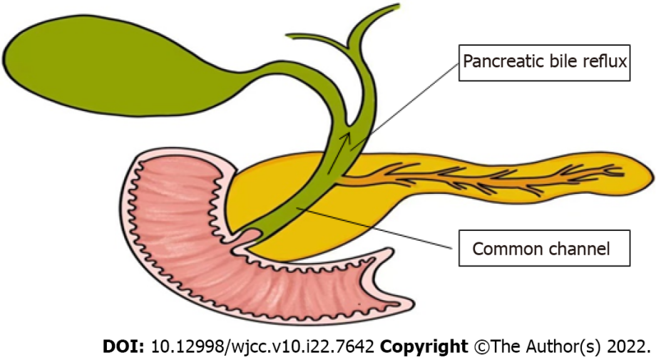
Figure 1 Pathophysiology of pancreaticobiliary maljunction.
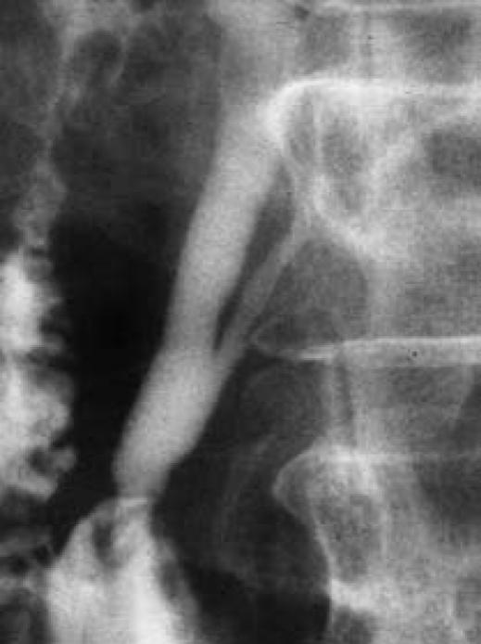
Figure 2 Endoscopic retrograde cholangiopancreatography. Endoscopic retrograde cholangiopancreatography in a patient with pancreaticobiliary maljunction showed a long common channel^{[22]}. Citation: Wang CL, Ding HY, Dai Y, Xie TT, Li YB, Cheng L, Wang B, Tang RH, Nie WX. Magnetic resonance cholangiopancreatography study of pancreaticobiliary maljunction and pancreaticobiliary diseases. World J Gastroenterol 2014; 20: 7005-7010. Copyright © The Authors 2022. Published by Baishideng Publishing Group Inc.
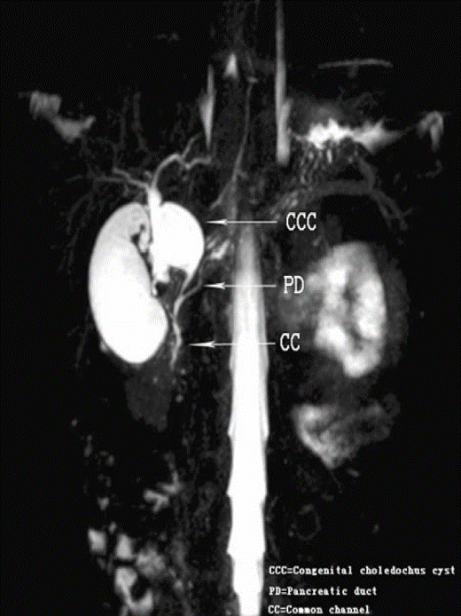
Figure 3 Magnetic resonance cholangiopancreatography. Coronal 4 mm-thick half fourier acquisition single shot turbo spin echo image shows the pancreatic duct joining the common bile duct outside the duodenal wall^{[24]}. Citation: Guo WL, Huang SG, Wang J, Sheng M, Fang L. Imaging findings in 75 pediatric patients with pancreaticobiliary maljunction: a retrospective case study. Pediatr Surg Int 2012; 28: 983-988. Copyright © The Authors 2022. Published by Springer Nature Switzerland AG.
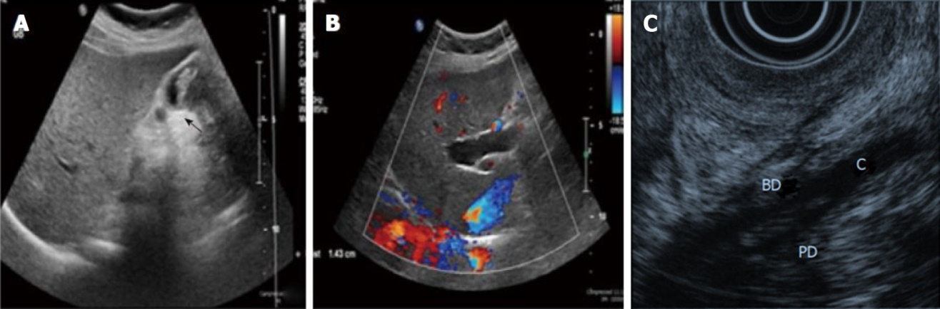
Figure 4 Ultrasound imaging and endoscopic ultrasound. A: Ultrasound showing a thick-walled gallbladder and intraluminal mass (arrow); B: Ultrasound showing intrahepatic bile duct dilation^{[10]}. Citation: Rungsakulkij N, Boonsakan P. Synchronous gallbladder and pancreatic cancer associated with pancreaticobiliary maljunction. World J Gastroenterol 2014; 20: 14500-14504. Copyright © The Authors 2022. Published by Baishideng Publishing Group Inc; C: The confluence of pancreatic duct and bile duct in the proximal portion of the duodenal wall^{[19]}. Citation: Kamisawa T, Takuma K, Itokawa F, Itoi T. Endoscopic diagnosis of pancreaticobiliary maljunction. World J Gastrointest Endosc 2011; 3: 1-5. Copyright © The Authors 2022. Published by Baishideng Publishing Group Inc.
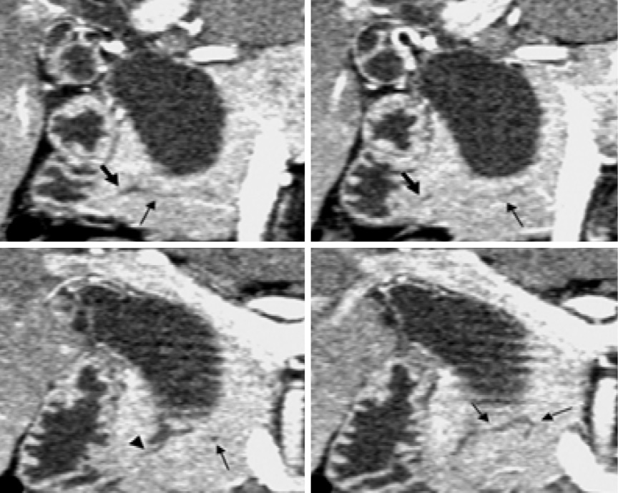
Figure 5 Computed tomography. Coronal images generated from pancreatic phase scanning show that the pancreatic and biliary ducts join within pancreatic parenchyma. Furthermore, these images make it possible to visualize common channel (arrowhead) and ventral pancreatic duct (thin arrows), which is narrow and tortuous. Thick arrows indicate dorsal pancreatic duct^{[51]}. Citation: Itoh S, Fukushima H, Takada A, Suzuki K, Satake H, Ishigaki T. Assessment of anomalous pancreaticobiliary ductal junction with high-resolution multiplanar reformatted images in MDCT. AJR Am J Roentgenol 2006; 187: 668-675. Copyright © The Authors 2022. Published by American Roentgen Ray Society.
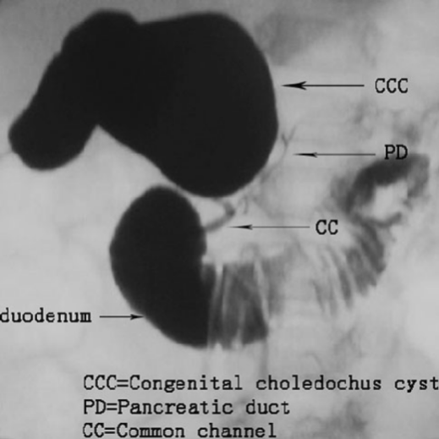
Figure 6 Intraoperative cholangiography. Intraoperative cholangiography shows the junction of the bile and pancreatic ducts located outside the duodenal wall. The common bile duct joins the pancreatic duct^{[24]}. Citation: Guo WL, Huang SG, Wang J, Sheng M, Fang L. Imaging findings in 75 pediatric patients with pancreaticobiliary maljunction: a retrospective case study. Pediatr Surg Int 2012; 28: 983-988. Copyright © The Authors 2022. Published by Springer Nature Switzerland AG.

Published by Baishideng Publishing Group Inc
7041 Koll Center Parkway, Suite 160, Pleasanton, CA 94566, USA
Telephone: +1-925-3991568
E-mail: bpgoffice@wjgnet.com
Help Desk: https://www.f6publishing.com/helpdesk
https://www.wjgnet.com

© 2022 Baishideng Publishing Group Inc. All rights reserved.

