Name of journal: World Journal of Gastroenterology

Manuscript NO: 43205

Manuscript type: ORIGINAL ARTICLE

Retrospective Study
Analysis of intrahepatic sarcomatoid cholangiocarcinoma: Experience from 11 cases within 17 years

Kim DK et al. Analysis of intrahepatic s-CCC

Dong Kyun Kim, Bo Ra Kim, Jin Sook Jeong, Yang Hyun Baek

Dong Kyun Kim, Yang Hyun Baek, Department of Internal Medicine, Dong-A University College of Medicine, Busan 49201, South Korea

Bo Ra Kim, Department of Radiology, Dong-A University College of Medicine, Busan 49201, South Korea

Jin Sook Jeong, Department of Pathology, Dong-A University College of Medicine, Busan 49201, South Korea

ORCID number: Dong Kyun Kim (0000-0003-0463-1582); Bo Ra Kim (0000-0002-8922-5593); Jin Sook Jeong (0000-0001-6474-9772); Yang Hyun Baek (0000-0002-9073-9233).

Author contributions: Kim DK is the first author, designed the study, collected and analyzed the data, and drafted the manuscript; Kim BR helped in analyzing the findings of the imaging studies; Jeong JS helped in analyzing the histopathologic findings of the biopsies; Baek YH designed and supervised the study and revised the manuscript for important intellectual content; All authors have read and approved the final version of the manuscript to be published.

Institutional review board statement: This study was reviewed and approved by the Ethics Committee of the Dong-A University Hospital.

Informed consent statement: Patients were not required to provide an informed consent for the study because the analysis used anonymous clinical data that were obtained after the completion of treatment.

Conflict-of-interest statement: All authors declare no conflicts of interest related to this article.

Data sharing statement: No additional data are available.

Open-Access: This is an open-access article that was selected by an in-house editor and fully peer-reviewed by external reviewers. It is distributed in accordance with the Creative Commons Attribution Non Commercial (CC BY-NC 4.0) license, which permits others to distribute, remix, adapt, build upon this work non-commercially, and license their derivative works on different terms, provided the original work is properly cited and the use is non-commercial. See: http://creativecommons.org/licenses/by-nc/4.0/

Manuscript source: Invited manuscript

Corresponding author: Yang Hyun Baek, MD, PhD, Associate Professor, Department of Internal Medicine, Dong-A University College of Medicine, 26 Daesingongwon-ro, Seo-gu, Busan 49201, South Korea. p100100@dau.ac.kr
Telephone: +82-51-2405678
Fax: +82-51-2401510

Received: October 31, 2018

Peer-review started: October 31, 2018

First decision: December 20, 2018
Revised: January 3, 2019

Accepted: January 14, 2019

Article in press: January 14, 2019

Published online: February 7, 2019

Abstract

BACKGROUND
Intrahepatic sarcomatoid chonalgiocarcinoma (s-CCC) is an extremely rare disease, accounting for less than 1% of hepatobiliary system malignancies, and its pathophysiology is not well known. On the hypothesis that its clinical, serologic, or radiologic diagnosis are not fully understood and its prognosis is poor, we investigated the distinguishing features of s-CCC compared with those of intrahepatic bile duct adenocarcinoma [cholangiocellular carcinoma (CCC)] in patients from a single center.

AIM
To analyze the clinical, serologic, imaging, and histopathologic characteristics of intrahepatic s-CCC patients diagnosed in a single center.

METHODS
The clinical, serologic, imaging, and histopathologic features of 227 patients diagnosed with intrahepatic cholangiocarcinoma (IHCC) in a single medical center during the last 17 years were analyzed. The characteristics of 11 patients with s-CCC were compared with those of 216 patients with intrahepatic bile duct adenocarcinoma CCC.

RESULTS
The number of patients with s-CCC who presented fever and abdominal pain and past history of chronic viral hepatitis or liver cirrhosis (LC) was higher than that of patients with CCC. In imaging studies, patients with s-CCC showed relatively aggressive features. However, no clear distinction was observed between s-CCC and CCC based on other clinical, serologic or radiologic examination results. An accurate diagnosis could be made only via a histopathologic examination through immunohistochemical staining. The clinical course of s-CCC was generally aggressive, and patients had a relatively poor prognosis.

CONCLUSION
In patients with s-CCC, early diagnosis through biopsy and aggressive treatment, including surgical resection, are important.

Key words: Intrahepatic sarcomatoid cholangiocarcinoma; Immunohistochemical staining; Survival; Prognosis; Surgical resection

© The Author(s) 2019. Published by Baishideng Publishing Group Inc. All rights reserved.

Core tip: Intrahepatic sarcomatoid cholangiocarcinoma is rare condition. Patients usually present with an advanced stage of the disease, and they have a poor prognosis. Diagnosis based on histopathologic examination is important because serologic and radiologic examinations cannot help in distinguishing such condition from intrahepatic bile duct adenocarcinoma or other intrahepatic masses. Thus, patients must be diagnosed as early as possible and should receive aggressive treatment, including surgical resection.

Citation:Kim DK, Kim BR, Jeong JS, Baek YH. Analysis of intrahepatic sarcomatoid cholangiocarcinoma: Experience from 11 cases within 17 years. World J Gastroenterol 2019; 25(5): 608-621
URL: https://www.wjgnet.com/1007-9327/full/v25/i5/608.htm
DOI: https://dx.doi.org/10.3748/wjg.v25.i5.608

INTRODUCTION
Epithelial tumors with a sarcomatoid feature can develop in several organs, such as the skin, kidney, esophagus, stomach, gallbladder, thyroid, urinary bladder, uterus, and lungs. However, its pathologic mechanism has not been clearly elucidated^{[1]}. Most malignant tumors in the intrahepatic bile duct are adenocarcinomas which are commonly referred to as cholangiocellular carcinoma (CCC). In contrast, intrahepatic sarcomatoid cholangiocarcinoma (s-CCC) is an extremely rare condition, accounting for less than 1% of hepatobiliary system malignancies, and its pathophysiology is not well known^{[2,3]}. The most common primary hepatic malignancy with a sarcomatoid feature is hepatocellular carcinoma (HCC), and generally, it occurs due to secondary changes in tumor cells after embolization or chemotherapy. However, the relationship between the occurrence of s-CCC and previous treatment has not been clearly understood, and it is often considered as a change according to the natural history of CCC^{[4]}. In some previous studies, the prognosis of s-CCC was reported worse than that of CCC, which was due to a more frequent metastasis to other organs or invasion to adjacent vasculatures, and only few established data about its clinical features, diagnosis, and treatment methods are available^{[5,6]}. In this study, we hypothesized the pathogenesis of s-CCC, investigated the clinical, serologic, imaging, and histopathologic features of s-CCC, and compared with those of CCC in patients from a single center.

MATERIALS AND METHODS

Patients selection
From January 2001 to June 30, 2018, a total of 228 patients with intrahepatic cholangiocarcinoma (IHCC) diagnosed via surgery or ultrasonography (US)-guided liver biopsy at Dong-A University Hospital were screened. Among them, 12 were diagnosed with s-CCC. One patient who was diagnosed with s-CCC via surgery in August 2001 was excluded from the analysis due to the lack of data about the clinical course of the disease and imaging study results. Two patients presented with mixed histopathologic features of HCC and IHCC were included in the study.

Patients assessment
In 11 patients with s-CCC who were enrolled, the admission history, accompanying symptoms or signs, past history of the hepatobiliary system, and findings of serologic examinations, such as liver function tests and tumor marker analysis were assessed. In terms of imaging studies, such as US, computed tomography (CT) scan, and magnetic resonance imaging (MRI), the characteristic features, the size and number of primary masses, distant and lymph node (LN) metastases, and the TNM stage were investigated and compared with those of HCC, IHCC, and other hepatic tumors. Histopathologic examination and immunohistochemical staining of hepatic mass were also conducted. Finally, the types of treatment, consequent clinical course, follow-up results, and survival time were investigated.

Statistical analysis
Data were reported as means ± standard deviation and median value. Data analysis was performed using the Statistical Package for the Social Sciences (SPSS) software version 20.0. Continuous variables were compared using the unpaired student t-test, Mann-Whitney U test, and Kruskal-Wallis test. Categorical variables were compared with the chi-square test and Fisher’s exact test, and they were reported as frequencies and percentages. P < 0.05 were considered statistically significant. Survival curves were obtained using the Kaplan-Meier method and compared using the log-rank test.

RESULTS

Clinical findings
Among the 11 patients diagnosed with s-CCC, 9 (81.8%) were men and 2 (18.2%) were women. The median age of the patients was 61 (range: 45-68) years. During their first visit at the hospital, the patients mainly presented abdominal pain (n = 10, 90.9%), and fever (n = 4, 36.4%), which were more frequent in s-CCC patients compared with CCC patients. Past history of chronic viral hepatitis and liver cirrhosis (LC) were frequent in s-CCC patients: chronic hepatitis B (CHB), n = 3 (27.3%); chronic hepatitis C (CHC), n = 1 (9.1%); LC, n = 5 (45.5%). One of the patients was diagnosed with HCC at another hospital 1 mo before admission and was taking sorafenib. In addition, 1 (9.1%) patient had a previous history of Clonorchis sinensis infection and another (9.1%) patient presented with gallstones at the time of diagnosis. Meanwhile, 3 (27.3%) patients had a history of cholecystectomy. All 11 patients presented with stage IV disease by the TMN stage, of whom 4 (36.4%) had stage IVA and 7 (63.6%) had stage IVB (Tables 1 and 2).

Laboratory findings
The laboratory findings were as follows: serum aspartate aminotransferase (AST) level, 23-80 (median: 34, normal: < 40) U/L; alanine aminotransferase (ALT) level, 10-96 (median: 31, normal: <40) U/L; serum total bilirubin (TB) level, 0.3-1.1 (median: 0.7, normal: < 1.2) mg/dL; and direct bilirubin (DB) level, 0.1-0.8 (median: 0.4, normal: < 0.4) mg/dL. In all patients, the serum alkaline phosphatase (ALP) level was elevated at 252-1520 (median: 757, normal: < 120) U/L. The gamma-glutamyl transferase (GGT) level was measured in only 9 patients, ranging from 32 to 323 (median: 137, normal: < 64) U/L, and it was elevated above the normal limit in 7 patients.
Serum carcinoembryonic antigen (CEA) levels were elevated in only 1 (9.1%) patient, ranging from 0.1 to 12.7 (median: 1.8, normal: < 5) ng/mL. The carbohydrate antigen 19-9 (CA19-9) level ranged from 2.0 to 1809.57 (normal: < 37) U/mL, and it was elevated in 5 patients (45.5%). Alpha-fetoprotein (AFP) level was high in 2 (18.2%) patients (cases 1 and 2), of which 1 patient presented with CHB, LC, and HCC and treated with sorafenib, and the other patient had CHC and LC (Table 3).

Imaging findings
The imaging findings were newly reviewed by a radiologist. The initial radiologic impression obtained via abdominal US and CT scan was very variable as IHCC, HCC, lymphoma, and hepatic abscess. (Table 4, Figure 1). The size of the main tumor lesion on US, CT scan and MRI ranged from 2.5 to 10 (median: 7.5) cm, and the number of intrahepatic tumors was 1 in 6 (54.5%) patients, and multiple tumors were observed in the other 5 (45.5%) patients. All patients had stage IV disease by TNM stage. Multiple LN metastases were observed in all patients, and distant metastases to other organs were observed in 7 (63.6%) patients (Table 1).
All patients had lobulated heterogeneous mass lesions on abdominal US. Hypoechoic features were observed in 3 (27.3%) patients, hyperechoic features in 3 (27.3%) patients, and mixed echoic features in 5 (45.5%) patients. A hypodense mass with heterogeneous, ill-defined, or lobulated features was observed in the CT non-enhanced phase which was performed in only 5 patients. Enhanced CT scans were performed in all 11 patients. In the arterial phase, a hepatic mass presented with irregular rim enhancement (n = 5), peripheral enhancement (n = 5), or diffuse heterogeneous enhancement (n = 1). The CT portal phase showed gradual centripetal enhancement (n = 6), irregular rim enhancement (n = 3), and irregular peripheral enhancement (n = 1). In 1 patient with heterogeneous enhancement of the mass in the arterial phase, the enhancement was more prominent in the portal phase. CT scan in the delayed phase was performed in 4 patients and its findings were not significantly different from those in the portal phase (Table 4). MRI was performed in 3 patients with heterogeneous hyperintensity (n = 3) on the T2-weighted image, gradual centripetal (n = 2) or rim (n = 1) enhancement on the dynamic enhancement scan, and diffusion restriction (n = 3) on diffusion weighted image.

Histopathologic and immunohistochemical findings
Figure 2 shows histopathological findings in case 9. In low-magnified microscopic findings, liver biopsy showed relatively well-demarcated tumor, characterized by poorly differentiated cancer cells without organoid structures, interspersed by stromal tissue, which is associated with necrosis (Figure 2A and B). Individual or clustered cancer cells consisted of enlarged epithelioid cells with pleomorphic and hyperchromatic nuclei and prominent nucleoli, and spindle cells with hyperchromatic and enlarged nuclei (Figure 2A). Occasionally, mucin-secreting cancer cells were observed. Inflammatory cell infiltration was present in the abundant stroma.
IHC study had shown that cancer cells expressed cytokeratin 9 (CK8), cytokeratin 19 (CK19) (Figure 2C), and vimentin (Figure 2D), but not hepatocyte-specific antigen (HSA) (Figure 2E) and AFP. Based on the microscopic findings and immunohistochemical results, this liver tumor was diagnosed as s-CCC. In the remaining 10 patients, cells showing polymorphic and polygonal spindle features were observed on cytopathologic examination. Hepatocellular features were found in 2 patients. Immunochemical staining revealed positive vimentin expression in all patients and CK19 expression in 10 (90.9%) patients. HSA staining was performed in 9 patients, and all patients tested negative. IHC findings are summarized in Table 5.

Treatment and outcome
In this study, all s-CCC patients presented with stage IV disease at the time of diagnosis. Among them, 9 (81.8%) patients died due to disease progression, 1 (9.1%) patient was lost follow-up, and another (9.1%) patient survived. The mean follow-up period of all patients was 93.4 ± 106.3 (median: 47, 14-379) d. The mean survival time of 9 patients who died, from diagnosis to death, was 67.2 ± 53.4 (median: 47, 14-148) d (Table 6).
None of the s-CCC patients could not undergo surgical treatment. Seven (63.6%) of them underwent chemotherapy, all of whom were not treated with anticancer drugs for more than 4 cycles due to rapid disease progression, deterioration of systemic condition, or presence of adverse events. Among the 7 patients with chemotherapy, 1 patient was lost follow-up and the other 6 patients died within 6 months (mean survival time: 92 ± 48.5 d, range: 31-148 d). Three (27.3%) of 11 s-CCC patients who underwent conservative treatment died within 3 wk (mean survival time: 17 ± 3.2 d, 14-20 d) (Table 6). The survival of patients who received chemotherapy was significantly longer than that of patients who only received conservative treatment (P = 0.013). In addition, 1 patient (case 11) with a 5-cm sized single s-CCC with LN and diaphragm metastasis refused chemotherapy and was treated with ABNOBA VISCUM M® (viscum album) via subcutaneous injection as the second option. Despite the advanced stage, the treatment was well tolerated by the patient, and slow progression was observed. He went to regular follow-up for 379 d.

Comparison of intrahepatic s-CCC and intrahepatic bile duct adenocarcinoma
Compared with 216 patients with CCC, abdominal pain (P = 0.011), fever (P = 0.022), past history of LC (P = 0.022), advanced TNM stage (P = 0.018) were more common in patients with s-CCC. The incidence of chronic viral hepatitis, larger mass size, LN metastasis, and distant metastasis tended to be more common in s-CCC patients, although there was no statistical significance. Increased serum CEA (P = 0.029) and CA19-9 (P = 0.098) levels were more common in patients with CCC than in those with s-CCC (Table 2). The initial radiologic impressions were variable, however, there was no patient diagnosed with s-CCC by imaging studies (Table 4).
Thirty-three (15.3%) of the patients with CCC underwent surgical treatment, whereas none of those with s-CCC patients underwent surgery and received chemotherapy or conservative treatment. The mean survival time of patients with s-CCC was significantly shorter than that of patients with CCC (P = 0.001) (Figure 3).

DISCUSSION
Sarcomatoid tumor of the epithelial origin is commonly found in the bladder or lungs, whereas it is rarely observed in the liver or biliary tract and is referred to as “carcinosarcoma”, “sarcomatoid carcinoma”, “carcinoma with sarcomatoid change”, “pseudosarcoma”, “malignant mixed tumor” and “spindle cell carcinoma”^{[3,7,8]}. HCC with sarcomatoid feature accounts for 1.8% of surgically resected HCC and 3.9%-9.4% of autopsy cases. According to some previous reports, it is known to occur due to a secondary change in tumor cells after previous treatment^{[4,8]}. By contrast, s-CCC accounts for 4.5% of bile duct cancer, and has no definite relationship with previous anticancer therapy. Rather, sarcomatoid change is believed due to the natural progression of bile duct cancer^{[4,9,10]}.
The pathogenesis of sarcomatoid changes in cancers including cholangiocarcinoma, has not been elucidated yet, and the following possibilities have been suggested: First, sarcomatoid trans-differentiation or de-differentiation of primary carcinoma cells of epithelial origin, which is also explained as epithelial-mesenchymal transition (EMT) or metaplastic transformation. The EMT is an important mechanism in sarcomatoid changes, and this is a biologic process in which epithelial phenotypes are converted into mesenchymal phenotypes by biochemical changes, including enhanced migratory capacity, invasiveness, elevated resistance to apoptosis, and increased production of extracellular matrix components^{[11]}; Second, biphasic differentiation from pluripotent stem cells to carcinoma or sarcoma in various directions, which is divided into a combination and a collision depending on the type of each tumor growth; Finally, a sarcomatoid re-differentiation of cancer cells with multi-potent differentiation potency derived from carcinoma cells^{[6]}. In this study, underlying CHB, CHC, and LC more common in patient with s-CCC, suggesting that these underlying diseases could have been the causative factors for de-differentiation or biphasic differentiation. This hypothesis about the mechanism of the sarcomatoid change is also an evidence supporting the poor prognosis of s-CCC.
Sarcomatoid combined hepatocellular-cholangiocarcinoma is primary hepatic tumor in which hepatocellular carcinomas and cholangiocarcinomas coexist within the same hepatic tumor components showing distinct tumor pathologic features, and is observed in less than 1% of all patients with liver malignancies^{[12-14]}. In this study, 2 (0.9%) patients presented with mixed histopathologic findings similar to sarcomatoid combined hepatocellular-cholangiocarcinoma (cases 1 and 2). These 2 patients had LC due to CHB and CHC, respectively, and they presented with increased serum AFP levels. At time of diagnoses of these 2 patients, it was difficult to distinguish HCC from IHCC, and the imaging diagnoses were even HCC (Figure 4). These 2 cases can be inferred due to the “sarcomatoid regeneration” of multipotent cancer cells derived from carcinoma cells, which is one of the hypotheses for the mechanism of sarcomatoid cholangiocarcinoma.
s-CCC could be asymptomatic, as is the case with other hepatic tumors, and it may be accompanied by non-specific symptoms or signs such as abdominal pain, nausea, fatigue, fever, and weight loss, of which abdominal pain and fever are more specific. In this study, 10 (90.9%) patients had abdominal pain and 4 (36.4%) patients had fever, which is similar to those reported in the previous articles^{[3,15]}. It can be thought that these clinical features are more common in s-CCC patients because of the mass effect or tumor necrosis caused by relatively large mass size or rapid progression.
According to previously reported cases about s-CCC, serologic tumor markers, such as AFP, CEA, and CA19-9 levels, were negative or low^{[3,8,11,16-22]}. Watanabe et al. investigated the clinical characteristics of operated sarcomatous intrahepatic cholangiocarcinoma and ordinary intrahepatic cholangiocarcinoma, and there was no significant difference in serum CEA and CA19-9 levels between the two groups^{[23]}. By comparison, in this study, CA19-9 level showed an increase in only 45.5% of s-CCC patients and CEA level increased more frequently in CCC patients with statistical significance. AFP levels were with normal range in most cases of s-CCC. Therefore, tumor markers were not helpful in the diagnosis of s-CCC. Additionally, as previously mentioned, two patients with elevated AFP levels were all suspected to be sarcomatoid combined hepatocellular-cholangiocarcinoma via histopathological examination.
A low echogenic liver mass on US, which shows hypo-attenuation and peripheral region enhancement after contrast injection on CT scan, is a commonly known imaging characteristic of s-CCC. In the present study, the hepatic masses showed various echoic, but mainly hypoechoic features on US. CT scan showed heterogeneous, lobulated hypodense hepatic masses with irregular rim or peripheral enhancement. These are similar to those reported in previous studies^{[3,24-26]}. The imaging findings of 11 patients tended to show relatively aggressive features, which included large mass size (mean: 7.3 ± 2.2 cm, median: 7.5 cm), frequent LN and distant metastases, and extensive metastatic lymphadenopathy accompanied by invasion of portal vein or hepatic parenchyma (n = 2). In addition, portal vein thrombosis (n = 1), multiple intrahepatic metastasis (n = 2), and seeding metastasis (n = 1) were aslo observed. However, these findings are also observed in other mass-forming IHCC. Distal intrahepatic ductal dilatation (n = 5), capsular retraction (n = 8), satellite nodule (n=3), peripheral enhancement (n = 10), and gradual centripetal enhancement on dynamic enhancement study are also well-known imaging findings of common mass-forming IHCC. Thus, even though the imaging findings of s-CCC show relatively aggressive features, these are not distinguishing from those of other hepatic tumors, especially IHCC. Indeed, none of the 11 patients were not clearly diagnosed with s-CCC during the first imaging study. Moreover, there were cases of underlying LC (n = 5), mimicking HCC (n = 4), and requirement for differentiation from lymphoma (n = 1), or hepatic abscess (n = 1) (Figure 1). In previous study, there was no meaningful difference in tumor size, number of tumors, and LN metastasis between sarcomatous intrahepatic cholangiocarcinoma and ordinary intrahepatic cholangiocarcinoma^{[23]}. Therefore, it is nearly impossible to identify s-CCC only via imaging studies.
Biopsy is an indispensable test for the final diagnosis. In this study, polymorphic and polygonal cells exhibiting spindle features were commonly observed. In immunohistochemistry, all patients were positive for vimentin, and 10 (90.9%) patients were positive for CK19, and 9 patients who underwent HSA tested negative, which was considerably helpful for the final diagnosis of s-CCC. These results were similar to those of previous studies^{[9,27,28]}.
Although no definitive treatment for s-CCC is available, surgical resection is generally recommended first, and in patients undergoing surgical resection, the survival rate was significantly higher than that of patients who have not undergone surgery^{[3,23,29]}.
Adjuvant chemotherapy along with the combination of gemcitabine and cisplatin has been proposed as a treatment to improve survival^{[10,30]}. Nevertheless, the prognosis of s-CCC is extremely poor compared with that of CCC, and there is no established treatment that can significantly prolong survival after surgery. This is due to the fact that LN or distant metastasis is common at time of diagnosis, and the rate of tumor growth is relatively fast. The tumor is also frequently accompanied by tumor thrombi, and the recurrence rate after treatment is high^{[3,6,10,30,31]}. In addition, several studies have shown that survival prolongation was obtained with iniparib, cisplatin, ifosfamide, dacarbazine, doxorubicin, cyclophosphamide, taxol, thalidomide and paclitaxel treatment as postoperative adjuvant chemotherapy for carcinosarcoma in obstetrics and gynecology patients^{[2,32-34]}, however, there are also some reports on unsuccessful outcomes^{[35,36]}. Among the 11 s-CCC patients of this study, no one could undergo surgical treatment and only seven patients underwent chemotherapy. In the remaining 3 patients with conservative treatment, shortened survival time may be due the lack of the chemotherapy effect, but it is also thought to be due to the higher incidence of deteriorated general condition, old age, or poor performance status, which made the patients die earlier, regardless of cancer progression.
ABNOBA VISCUM M® (viscum album), also called mistletoe, is an extract of a plant that is hemiparasitic to various host plants. This is an immunomodulator and somewhat different from the cytotoxic drugs, target agents, or immune checkpoint inhibitors, and it is mainly, along with chemotherapy or radiation therapy, used to increase the therapeutic effect, decrease side effects, and enhance immunity. In some papers, various positive results regarding the use of viscum album as a palliative therapy in patients with terminal cancer who do not respond to conventional chemotherapy or for those with lung cancer or accompanying malignant pleural effusion and hematologic diseases^{[37-39]}. However, there has been no report about the therapeutic effect of this drug alone for IHCC including s-CCC. Although the patient (case 11) of this study is an unusual case, whether the reason for the good prognosis in this patient is due to the effect of the viscum album or the slow progression of the tumor still remains unclear.
This study has some limitations. First, because only 11 patients with s-CCC were analyzed, some aspects of the comparison between s-CCC and CCC were not statistically significant. Second, a relatively large number of follow-up loss was observed; about 12% of the patients with CCC lost follow-up. This is believed that this study was conducted in a single center, and a large number of patients did not continue with aggressive treatment and wanted conservative treatment only, or to go to another hospital.
In conclusion, intrahepatic s-CCC of the liver is an extremely rare disease, and it is frequently characterized by abdominal pain, fever, and commonly diagnosed at an advanced stage. Its prognosis is extremely poor due to the rapid progression of the disease. Early diagnosis and appropriate treatment are important. Because clinical, serologic, and imaging findings are not helpful in distinguishing s-CCC from CCC, HCC, or other hepatic masses, biopsy should be performed to accurately diagnose and predict prognosis. Although there has been no fully established treatment thus far, surgical resection is usually prioritized, and in some cases, the survival rate can be improved through adjuvant chemotherapy. Further prospective, multicenter studies about the characteristic features, complementary treatment effect of various therapeutic options, and the effect of surgery on the survival rate must be conducted based on the pathogenesis of this disease.

ARTICLE HIGHLIGHTS

Research background
Intrahepatic sarcomatoid chonalgiocarcinoma (s-CCC) is extremely rare, and its pathophysiology is not well known. Because of the poor prognosis, early diagnosis and aggressive treatment is important.

Research motivation
Clinical, serologic, and imaging findings are known to be not helpful to distinguish s-CCC from intrahepatic bile duct adenocarcinoma (CCC) or other hepatic tumors. There is no established treatment option to prolong survival, except surgery.

Research objectives
This study aimed to analyze the distinct characteristics of s-CCC patients for early diagnosis and appropriate treatment.

Research methods
This retrospective study was conducted in a single center of South Korea for assessment of 11 patients with s-CCC diagnosed for 17 years. We analyzed the clinical, serologic, imaging, and histopathologic features of s-CCC patients and compared with those of CCC patients.

Research results
The patients with s-CCC tended to present abdominal pain or fever as the chief complaint and have past history of liver cirrhosis (LC) or chronic viral hepatitis more frequently, compared with the patients with CCC. In addition, s-CCC showed relatively aggressive features on imaging studies. However, no clear distinction in other clinical and serologic, or radiologic examination results between s-CCC and CCC patients. Only a histopathologic examination with immunohistochemical staining was helpful and essential for an accurate differential diagnosis of s-CCC. The clinical course of s-CCC was relatively aggressive, and patients had poor prognoses. Surgery is generally recommended first, however in this study, we could not obtain meaningful results of the surgical treatment or chemotherapy for s-CCC.

Research conclusions
s-CCC is extremely rare disease which presents aggressive clinical course and poor prognosis. Clinical, serologic, and imaging studies are not helpful in diagnosis of s-CCC. In patients with s-CCC, early diagnosis through biopsy and aggressive treatment, including surgical resection, are important.

Research perspectives
Although s-CCC has a poor prognosis, its pathogenesis and the effects of non-surgical treatment are not well established. In addition, there is no definite strategy for differential diagnosis except a histopathological examination. A large-scale, prospective, and multicenter study involving larger number of patients should be conducted in the future.

REFERENCES
1 Lu J, Zhang J, Xiong XZ, Li FY, Ye H, Cheng Y, Zhou RX, Lin YX, Cheng NS. Primary hepatic sarcomatoid carcinoma: clinical features and prognosis of 28 resected cases. J Cancer Res Clin Oncol 2014; 140: 1027-1035 [PMID: 24647927 DOI: 10.1007/s00432-014-1641-3]
2 Okabayashi T, Shima Y, Iwata J, Iiyama T, Sumiyoshi T, Kozuki A, Tokumaru T, Hata Y, Noda Y, Morita M. Surgical outcomes for 131 cases of carcinosarcoma of the hepatobiliary tract. J Gastroenterol 2014; 49: 982-991 [PMID: 24162331 DOI: 10.1007/s00535-013-0882-2]
3 Kaibori M, Kawaguchi Y, Yokoigawa N, Yanagida H, Takai S, Kwon AH, Uemura Y, Kamiyama Y. Intrahepatic sarcomatoid cholangiocarcinoma. J Gastroenterol 2003; 38: 1097-1101 [PMID: 14673730 DOI: 10.1007/s00535-003-1203-y]
4 Chin S, Kim Z. Sarcomatoid combined hepatocellular-cholangiocarcinoma: a case report and review of literature. Int J Clin Exp Pathol 2014; 7: 8290-8294 [PMID: 25550887]
5 Aishima S, Kuroda Y, Asayama Y, Taguchi K, Nishihara Y, Taketomi A, Tsuneyoshi M. Prognostic impact of cholangiocellular and sarcomatous components in combined hepatocellular and cholangiocarcinoma. Hum Pathol 2006; 37: 283-291 [PMID: 16613323 DOI: 10.1016/j.humpath.2005.08.019]
6 Lee DH, Han KH, Ahn SY, Kim SS, Shin HS, Bang KB, Choi JH, Kim SB, Lee WA, Song IH. Sarcomatoid intrahepatic cholangiocarcinoma: a rare case of primary liver cancer. J Liver Cancer 2016; 16: 139-144 [DOI: 10.17998/jlc.16.2.139]
7 Wang QB, Cui BK, Weng JM, Wu QL, Qiu JL, Lin XJ. Clinicopathological characteristics and outcome of primary sarcomatoid carcinoma and carcinosarcoma of the liver. J Gastrointest Surg 2012; 16: 1715-1726 [PMID: 22767081 DOI: 10.1007/s11605-012-1946-y]
8 Jeong BJ, Hyun DH, Lee KW, Ryu ST, Lee JW, Lee JI, Jeong S, Lee DH, Kim PS, Kim HG, Kim YS, Kim JM. [A case of sarcomatoid combined hepatocellular-cholangiocarcinoma]. Korean J Gastroenterol 2004; 43: 56-60 [PMID: 14745254]
9 Nakajima T, Tajima Y, Sugano I, Nagao K, Kondo Y, Wada K. Intrahepatic cholangiocarcinoma with sarcomatous change. Clinicopathologic and immunohistochemical evaluation of seven cases. Cancer 1993; 72: 1872-1877 [PMID: 7689920 DOI: 10.1002/1097-0142(19930915)72:6<1872::AID-CNCR2820720614>3.0.CO;2-N]
10 Malhotra S, Wood J, Mansy T, Singh R, Zaitoun A, Madhusudan S. Intrahepatic sarcomatoid cholangiocarcinoma. J Oncol 2010; 2010: 701476 [PMID: 20454704 DOI: 10.1155/2010/701476]
11 Kim HM, Kim H, Park YN. Sarcomatoid cholangiocarcinoma with osteoclast-like giant cells associated with hepatolithiasis: A case report. Clin Mol Hepatol 2015; 21: 309-313 [PMID: 26523274 DOI: 10.3350/cmh.2015.21.3.309]
12 Murata M, Miyoshi Y, Iwao K, Wada H, Shibata K, Tateishi H, Shimano T, Ohasawa M, Imai Y, Nishikawa M, Kobayashi T, Nakamura Y. Combined hepatocellular/cholangiocellular carcinoma with sarcomatoid features: genetic analysis for histogenesis. Hepatol Res 2001; 21: 220-227 [PMID: 11673107 DOI: 10.1016/S1386-6346(01)00100-0]
13 Goodman ZD, Ishak KG, Langloss JM, Sesterhenn IA, Rabin L. Combined hepatocellular-cholangiocarcinoma. A histologic and immunohistochemical study. Cancer1985; 55: 124-135 [PMID: 2578078 DOI: 10.1002/1097-0142(19850101)55:1<124::AID-CNCR2820550120>3.0.CO;2-Z]
14 Papotti M, Sambataro D, Marchesa P, Negro F. A combined hepatocellular/cholangiocellular carcinoma with sarcomatoid features. Liver 1997; 17: 47-52 [PMID: 9062880 DOI: 10.1111/j.1600-0676.1997.tb00778.x]
15 Eriguchi N, Aoyagi S, Hara M, Okuda K, Fukuda S, Tamae T, Kanazawa N. Malignant sarcomatoid tumor of the liver: report of a case. Surg Today 2001; 31: 170-173 [PMID: 11291715 DOI: 10.1007/s005950170205]
16 Jung GO, Park DE, Youn GJ. Huge subcapsular hematoma caused by intrahepatic sarcomatoid cholangiocarcinoma. Korean J Hepatobiliary Pancreat Surg 2012; 16: 70-74 [PMID: 26388910 DOI: 10.14701/kjhbps.2012.16.2.70]
17 Kim KS, Park JH, Bae BJ, Sohn KR, Shin DG. Sarcomatoid cholangiocarcinoma of the liver; a case study. Korean J Hepatobiliary Pancreat Surg 2004; 8: 54-59
18 Hong KS, Kim IK, Lee JK, Kim JW, Kim H, Hwang JH. A case of intrahepatic sarcomatoid cholangiocarcinoma with huge right ventricular tumor thrombus. Korean J Med 2008; 75: 569-573
19 Kim WS, Kim TH, Hwang JJ, Kim HJ, Jung WT, Lee OJ. A case of intrahepatic sarcomatoid cholangiocarcinoma with rhabdoid transformation. Korean J Med 2011; 80: 453-457
20 Lim JH, Kim JW, Heo SH, Jeong YY, Kang HK. Intrahepatic sarcomatoid cholangiocarcinoma with portal vein thrombosis: a case report. J Korean Soc Radiol 2009; 60: 333-337 [DOI: 10.3348/jksr.2009.60.5.333]
21 Kim MJ, Koo HL, Lee SK, Ro JY, Yu E. A case of combined hepatocellular and cholangiocarcinoma with neuroendocrine differentiation and sarcomatoid transformation: a case report. Korean J Pathol 2005; 39: 125-129
22 Lim BJ, Kim KS, Lim JS, Kim MJ, Park C, Park YN. Rhabdoid cholangiocarcinoma: a variant of cholangiocarcinoma with aggressive behavior. Yonsei Med J 2004; 45: 543-546 [PMID: 15227745 DOI: 10.3349/ymj.2004.45.3.543]
23 Watanabe G, Uchinami H, Yoshioka M, Nanjo H, Yamamoto Y. Prognosis analysis of sarcomatous intrahepatic cholangiocarcinoma from a review of the literature. Int J Clin Oncol 2014; 19: 490-496 [PMID: 23824556 DOI: 10.1007/s10147-013-0586-x]
24 Matsuo S, Shinozaki T, Yamaguchi S, Takami Y, Obata S, Tsuda N, Kanematsu T. Intrahepatic cholangiocarcinoma with extensive sarcomatous change: report of a case. Surg Today 1999; 29: 560-563 [PMID: 10385374 DOI: 10.1007/BF02482354]
25 Imazu H, Ochiai M, Funabiki T. Intrahepatic sarcomatous cholangiocarcinoma. J Gastroenterol 1995; 30: 677-682 [PMID: 8574344 DOI: 10.1007/BF02367798]
26 Sasaki M, Nakanuma Y, Nagai Y, Nonomura A. Intrahepatic cholangiocarcinoma with sarcomatous transformation: an autopsy case. J Clin Gastroenterol 1991; 13: 220-225 [PMID: 1851775 DOI: 10.1097/00004836-199104000-00022]
27 Sung CO, Choi H, Lee KW, Kim SH. Sarcomatoid carcinoma represents a complete phenotype with various pathways of epithelial mesenchymal transition. J Clin Pathol2013; 66: 601-606 [PMID: 23533257 DOI: 10.1136/jclinpath-2012-201271]
28 Leng Q, Xiang XI, Tang Y, Yang Y, Qiu LI. Primary hepatic sarcomatoid carcinoma: A case report. Exp Ther Med 2015; 10: 1145-1148 [PMID: 26622454 DOI: 10.3892/etm.2015.2599]
29 Sumiyoshi S, Kikuyama M, Matsubayashi Y, Kageyama F, Ide Y, Kobayashi Y, Nakamura H. Carcinosarcoma of the liver with mesenchymal differentiation. World J Gastroenterol 2007; 13: 809-812 [PMID: 17278210 DOI: 10.3748/wjg.v13.i5.809]
30 Damiano R, D'Armiento M, Cantiello F, Amorosi A, Tagliaferri P, Sacco R, Venuta S. Gemcitabine and cisplatin following surgical treatment of urinary bladder carcinosarcoma. Tumori 2004; 90: 458-460 [PMID: 15656328 DOI: 10.1177/030089160409000502]
31 Tsou YK, Wu RC, Hung CF, Lee CS. Intrahepatic sarcomatoid cholangiocarcinoma: clinical analysis of seven cases during a 15-year period. Chang Gung Med J 2008; 31: 599-605 [PMID: 19241900]
32 Galaal K, van der Heijden E, Godfrey K, Naik R, Kucukmetin A, Bryant A, Das N, Lopes AD. Adjuvant radiotherapy and/or chemotherapy after surgery for uterine carcinosarcoma. Cochrane Database Syst Rev 2013; : CD006812 [PMID: 23450572 DOI: 10.1002/14651858.CD006812.pub3]
33 Shylasree TS, Bryant A, Athavale R. Chemotherapy and/or radiotherapy in combination with surgery for ovarian carcinosarcoma. Cochrane Database Syst Rev 2013; : CD006246 [PMID: 23450567 DOI: 10.1002/14651858.CD006246.pub2]
34 Einstein MH, Klobocista M, Hou JY, Lee S, Mutyala S, Mehta K, Reimers LL, Kuo DY, Huang GS, Goldberg GL. Phase II trial of adjuvant pelvic radiation "sandwiched" between ifosfamide or ifosfamide plus cisplatin in women with uterine carcinosarcoma. Gynecol Oncol 2012; 124: 26-30 [PMID: 22055846 DOI: 10.1016/j.ygyno.2011.10.008]
35 Aghajanian C, Sill MW, Secord AA, Powell MA, Steinhoff M. Iniparib plus paclitaxel and carboplatin as initial treatment of advanced or recurrent uterine carcinosarcoma: a Gynecologic Oncology Group Study. Gynecol Oncol 2012; 126: 424-427 [PMID: 22634397 DOI: 10.1016/j.ygyno.2012.05.024]
36 McMeekin DS, Sill MW, Darcy KM, Abulafia O, Hanjani P, Pearl ML, Rubin SC, Rose PG, Small L, Benbrook DM. A phase II trial of thalidomide in patients with refractory uterine carcinosarcoma and correlation with biomarkers of angiogenesis: a Gynecologic Oncology Group study. Gynecol Oncol 2012; 127: 356-361 [PMID: 22796461 DOI: 10.1016/j.ygyno.2012.07.095]
37 Thronicke A, Oei SL, Merkle A, Matthes H, Schad F. Clinical Safety of Combined Targeted and Viscum album L. Therapy in Oncological Patients. Medicines (Basel) 2018; 5: [PMID: 30200590 DOI: 10.3390/medicines5030100]
38 Schad F, Thronicke A, Steele ML, Merkle A, Matthes B, Grah C, Matthes H. Overall survival of stage IV non-small cell lung cancer patients treated with Viscum album L. in addition to chemotherapy, a real-world observational multicenter analysis. PLoS One 2018; 13: e0203058 [PMID: 30148853 DOI: 10.1371/journal.pone.0203058]
39 Thronicke A, Steele ML, Grah C, Matthes B, Schad F. Clinical safety of combined therapy of immune checkpoint inhibitors and Viscum album L. therapy in patients with advanced or metastatic cancer. BMC Complement Altern Med 2017; 17: 534 [PMID: 29237435 DOI: 10.1186/s12906-017-2045-0]
P-Reviewer: Bramhall S, Karamouzis MV, Ramia JM, Xiao X
S-Editor: Ma RY L-Editor: A E-Editor: Huang Y
Specialty type: Gastroenterology and hepatology
Country of origin: South Korea
Peer-review report classification
Grade A (Excellent): 0
Grade B (Very good): B
Grade C (Good): C, C
Grade D (Fair): D
Grade E (Poor): 0
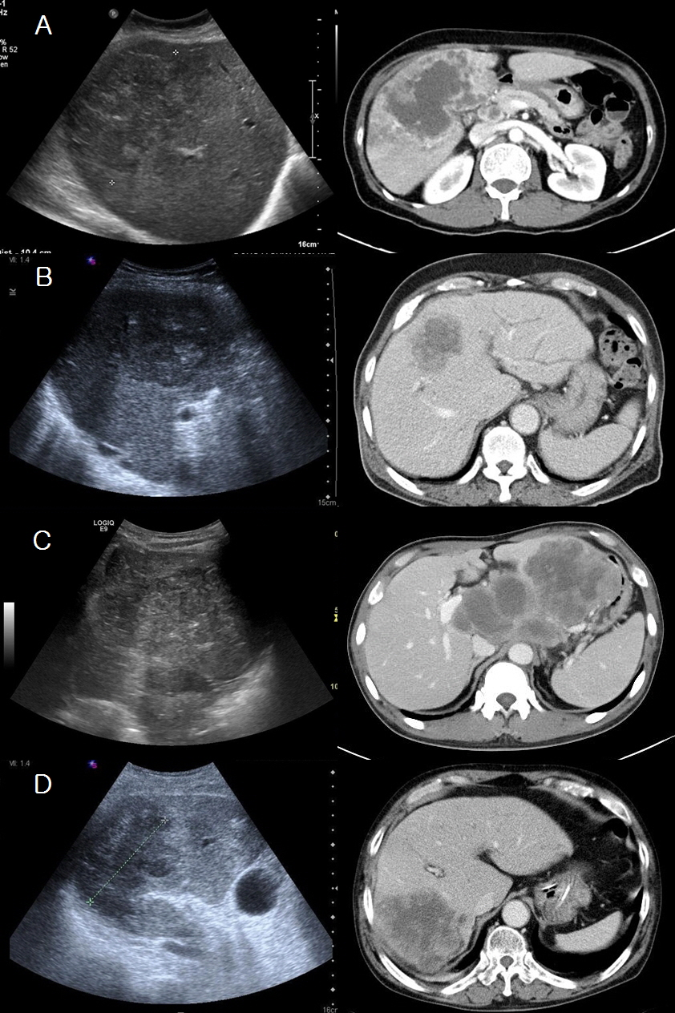
Figure 1 Imaging findings of the patients with various initial diagnosis based on radiologic findings. The initial radiologic impressions were intrahepatic cholangiocarcinoma (A), hepatocellular carcinoma (B), lymphoma (C), and hepatic abscess (D), respectively.
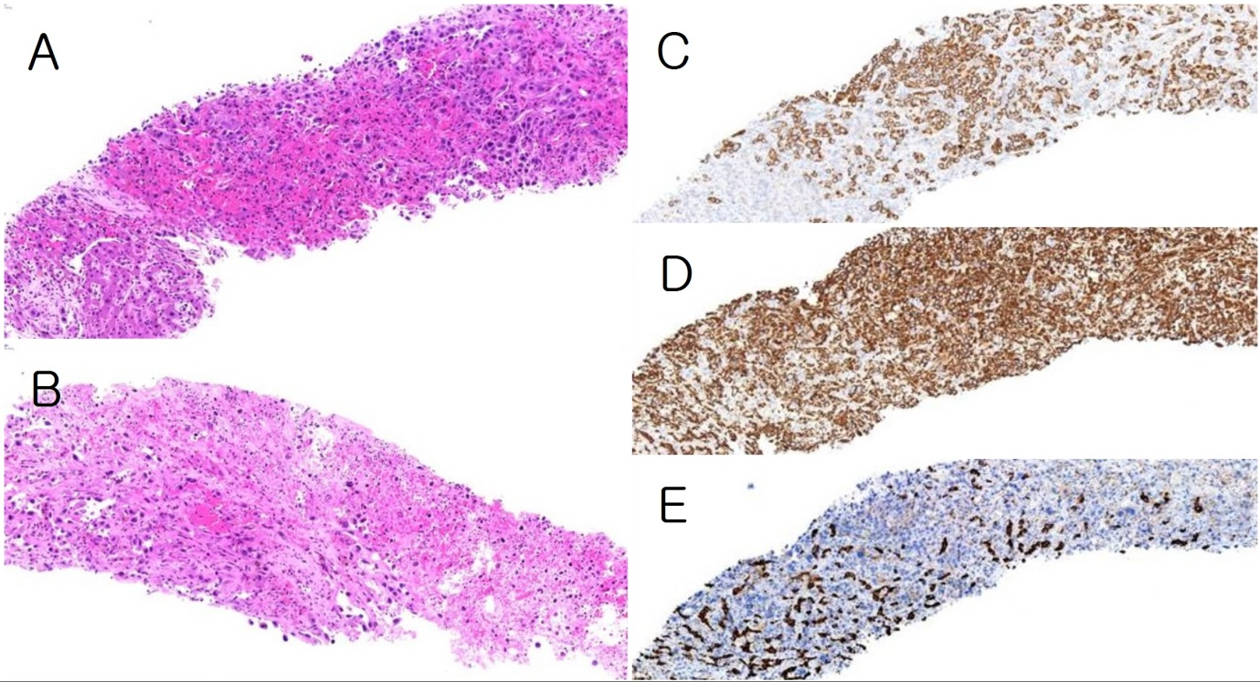
Figure 2 Histologic findings of liver biopsy of case 9. A and B: Hematoxylin and eosin stain, × 100; C-E: Immunohistochemistry, × 50; C: Cytokeratin 19; D: Vimentin; E: Hepatocyte specific antigen. The liver shows a mass composed for proliferating anaplastic tumor cells with ovoid or rather spindle shape and no organoid structures (A), and necrosis (B). The tumor cells express CK19 (C) and vimentin (D), not HSA (E).
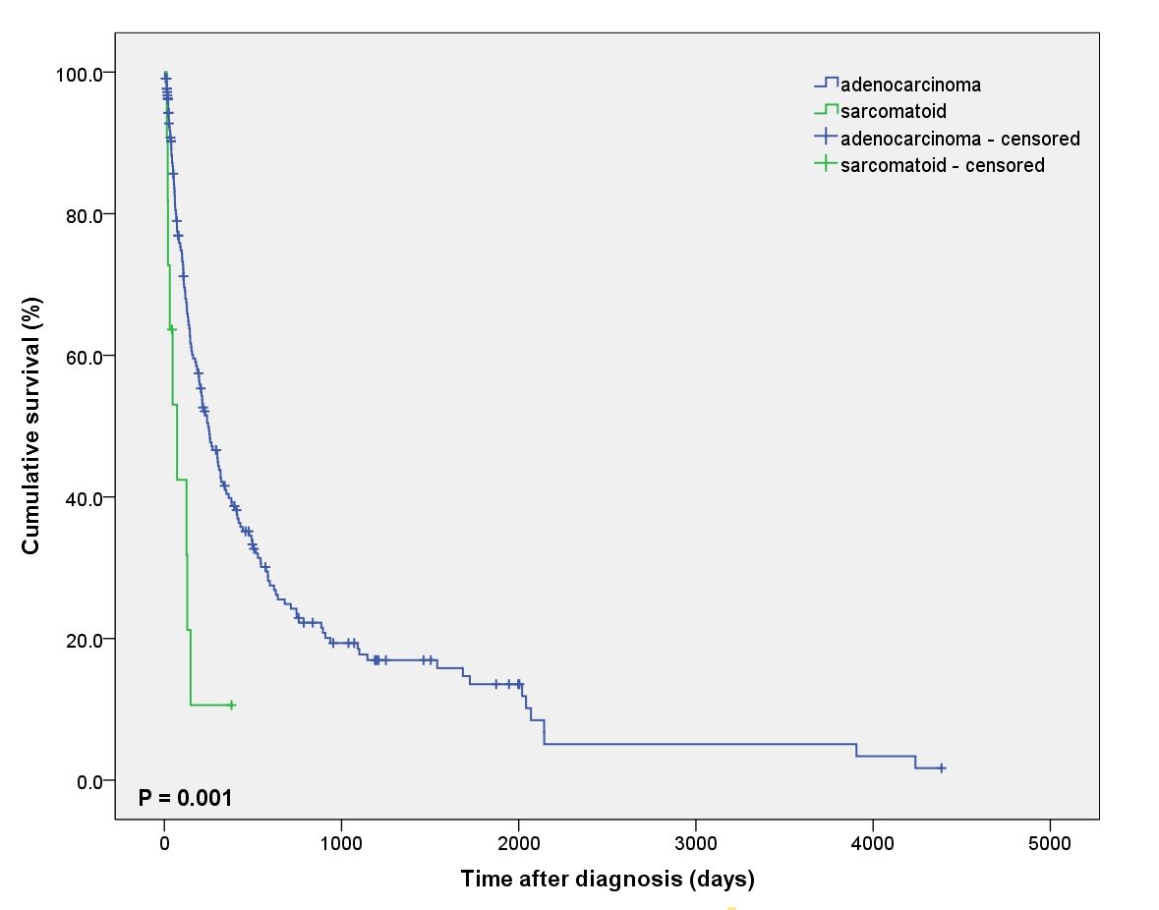
Figure 3 Comparison of cumulative survival rates. Survival rate of intrahepatic bile duct adenocarcinoma group was better than that of sarcomatoid cholangiocarcinoma group.

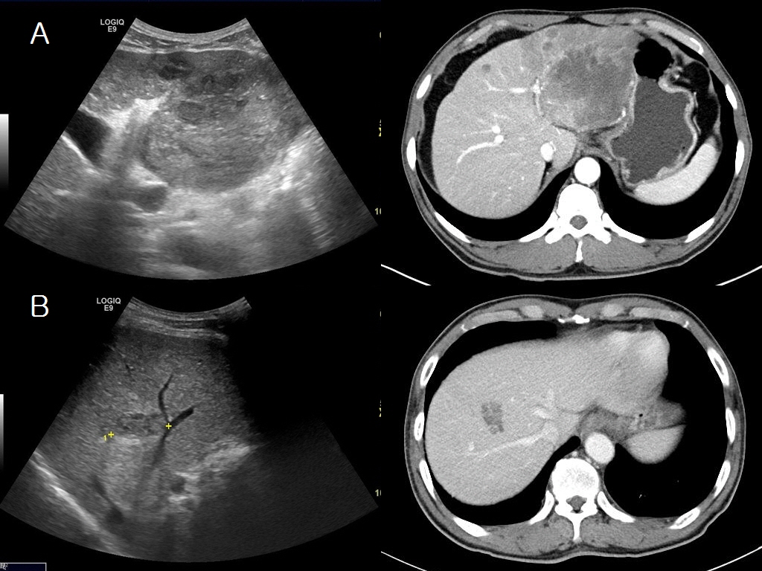
Figure 4 Imaging finding of the patient with mixed pathological findings of hepatocellular carcinoma and intrahepatic cholangiocarcinoma. A: Case 1; B: Case 2.

Table 1 Clinical findings of the patients with intrahepatic sarcomatoid cholangiocarcinoma
Case | Sex | Age | Chief complaint | Stone | CS | Chronic hepatitis | LC | HCC | Tumor size (cm) | Number of mass | Metastasis | Stage (TMN)
1 | M | 45 | RUQ pain | - | - | CHB | + | + | 7.5 | 7 | LN, IH | IVB
2 | M | 67 | Lt. flank pain | - | - | CHC | + | - | 2.5 | 1 | Bone, LN | IVB
3 | M | 55 | RUQ pain, fever | CST | + | - | - | - | 6.5 | 2 | LN | IVA
4 | M | 66 | RUQ pain, fever | GB stone | - | - | - | - | 10.0 | 1 | Lung, LN | IVB
5 | M | 56 | RUQ pain, Fatigue | - | - | CHB | + | - | 8.0 | 1 | Thymus, LN | IVB
6 | F | 66 | RUQ pain | CST | - | - | - | - | 7.5 | 1 | LN | IVB
7 | M | 68 | Wt. loss, Fatigue | CST | - | - | + | - | 6.0 | 1 | Lung, Bone, LN | IVB
8 | F | 55 | RUQ pain, fever | - | - | - | - | - | 8.5 | 3 | LN | IVA
9 | M | 49 | LUQ pain, fever | - | - | CHB | + | - | 9.5 | 3 | LN | IVA
10 | M | 65 | RUQ pain | - | - |  | - | - | 9.5 | 15 | LN, IH | IVA
11 | M | 61 | RUQ pain | - | - |  | - | - | 5.0 | 1 | Diaphragm, LN | IVB
CHB: Chronic hepatitis B; CHC: Chronic hepatitis C; CS: Clonorchis sinensis; CST: Cholecystectomy; GB: Gallbladder; HCC: Hepatocellular carcinoma; IH: Intrahepatic; LC: Liver cirrhosis; LN: Lymph node; LUQ: Left upper quadrant; RUQ: Right upper quadrant.

Table 2 Baseline clinical characteristics of the patients of intrahepatic intrahepatic bile duct adenocarcinoma and sarcomatoid cholangiocarcinoma n (%)
 |  | Adenocarcinoma | Sarcomatoid | P value
Gender | Male | 155 (71.8) | 9 (81.8) | 0.732
 | Female | 61 (28.2) | 2 (18.2)
Age | < 60 | 73 (33.8) | 5 (45.5) | 0.518
 | ≥ 60 | 143(66.2) | 6 (54.5)
Abdominal pain | No | 106 (49.1) | 1 (9.1) | 0.011
 | Pain | 110 (50.9) | 10 (90.9)
Fever | No | 195 (90.3) | 7 (63.6) | 0.022
 | Fever | 21 (9.7) | 4 (36.4)
Jaundice | No | 199 (92.1) | 11 (100.0) | 1.000
 | Jaundice | 17 (7.9) | 0 (0.0)
Weight loss | No | 201 (93.1) | 10 (90.9) | 0.561
 | Weight loss | 15 (6.9) | 1 (9.1)
GB stone | No | 164 (75.9) | 8 (72.7) | 0.730
 | GB stone | 52 (24.1) | 3 (27.3)
Hepatitis | No | 190 (88.0) | 7 (63.6) | 0.063
 | CHB | 21 (9.7) | 3 (27.3)
 | CHC | 5 (2.3) | 1 (9.1)
LC | No | 183 (84.7) | 6 (54.5) | 0.022
 | LC | 33 (15.3) | 5 (45.5)
Serum CEA | < 5 ng/mL | 123 (56.9) | 10 (90.9) | 0.029
 | ≥ 5 ng/mL | 93 (43.1) | 1 (9.1)
Serum CA19-9 | < 37 U/mL | 64 (29.6) | 6 (54.5) | 0.098
 | ≥ 37 U/mL | 152 (70.4) | 5 (45.5)
Main mass | Single | 145 (67.1) | 6 (54.5) | 0.513
 | Multiple | 71 (32.9) | 5 (45.5)
Mass size | < 5 cm | 90 (41.7) | 1 (9.1) | 0.054
 | ≥ 5 cm | 126 (58.3) | 10 (90.9)
LN metastasis | No | 84 (38.9) | 1 (9.1) | 0.057
 | LN meta. | 132 (61.1) | 10 (90.9)
Distant metastasis | No | 140 (64.8) | 4 (36.4) | 0.104
 | Distant meta. | 76 (35.2) | 7 (63.6)
TNM stage | I or II | 76 (35.2) | 0 (0.0) | 0.018
 | III or IV | 140 (64.8) | 11 (100.0)
CA19-9: Carbohydrate antigen 19-9; CEA: Carcinoembryonic antigen; CHB: Chronic hepatitis B; CHC: Chronic hepatitis C; LC: Liver cirrhosis; LN: Lymph node.

Table 3 Laboratory findings of the patients with intrahepatic sarcomatoid cholangiocarcinoma
Case | CEA (ng/mL) | CA19-9 (U/mL) | AFP (ng/mL) | PIVKA-II (mAU/mL) | AST (U/L) | ALT (U/L) | TB (mg/dL) | DB (mg/dL) | ALP (U/L) | GGT (U/L)
1 | 0.74 | > 1200.00 | 131.67 | 69 | 25 | 19 | 1.0 | 0.4 | 387 | 115
2 | 1.45 | 3.38 | 66.45 | 16 | 31 | 10 | 0.7 | 0.2 | 252 | 32
3 | 0.10 | 3.00 | 2.54 | 35 | 54 | 96 | 0.4 | 0.2 | 892 | 137
4 | 2.35 | 1809.57 | 1.73 | N/A | 42 | 30 | 0.9 | 0.6 | 1385 | N/A
5 | 1.81 | 2.33 | 2.31 | 20 | 43 | 57 | 1.0 | 0.6 | 1520 | 203
6 | 12.70 | 710.38 | 3.92 | N/A | 23 | 39 | 0.7 | 0.3 | 1133 | 253
7 | 1.18 | 12.59 | 2.70 | 20 | 23 | 16 | 0.6 | 0.4 | 638 | 224
8 | 3.15 | > 1200.00 | 1.71 | N/A | 30 | 31 | 1.1 | 0.6 | 757 | 323
9 | 1.08 | < 2.00 | 1.52 | N/A | 80 | 30 | 0.7 | 0.5 | 476 | 98
10 | 3.56 | 599.14 | 1.02 | N/A | 37 | 47 | 1.1 | 0.8 | 804 | N/A
11 | 1.81 | 5.77 | 3.02 | 14 | 34 | 36 | 0.3 | 0.1 | 369 | 35
AFP: Alpha-fetoprotein; ALP: Alkaline phosphatase; ALT: Alanine aminotransferase; AST: Aspartate aminotransferase; CA19-9: Carbohydrate antigen 19-9; CEA: Carcinoembryonic antigen; DB: Direct bilirubin; GGT: Gamma-glutamyl transferase; N/A: Not applicable; PIVKA-II: Protein-induced by vitamin K antagonist-II; TB: Total bilirubin.

Table 4 Imaging findings of the patients with intrahepatic sarcomatoid cholangiocarcinoma
Case | US | CT Non-E | CT arterial | CT portal | CT delayed | Initial radiologic impression
1 | Lobulated, heterogeneously hyperechoic | N/A | Thin rim enhancement | Gradual centripetal enhancement | Gradual centripetal enhancement | HCC
2 | Lobulated hypoechoic | Ill-defined hypodense | Minimal to mild heterogeneous enhancement | Progressive heterogeneous enhancement | Progressive heterogeneous enhancement | HCC
3 | Lobulated, heterogeneously hypoechoic  internal hyperechoic | N/A | Non to minimal rim enhancement | Mild irregular rim enhancement | N/A | IHCC
4 | Ill-defined hypoechoic | heterogeneously hypodense | Irregular rim enhancement | Gradual centripetal enhancement | N/A | Hepatic abscess
5 | Lobulated, heterogenoeusly hypo- & hyper-echoic | N/A | Peripheral enhancement | Gradual centripetal enhancement | Gradual centripetal enhancement | HCC
6 | Lobulated hyperechoic | N/A | Irregular rim enhancement | Irregular rim enhancement | N/A | IHCC
7 | Lobulated, heterogeneously hypoechoic internal hyperechoic | Ill-defined hypodense | Irregular peripheral enhancement | Gradual centripetal enhancement | Gradual centripetal enhancement | HCC
8 | Ill-defined heterogenoeusly hypo- & hyper-echoic | Ill-defined hypodense | Irregular peripheral enhancement | Gradual centripetal enhancement | N/A | IHCC
9 | Lobulated, heterogenoeusly hypo- & hyper-echoic | N/A | Irregular peripheral enhancement | Gradual centripetal enhancement | N/A | Lymphoma
10 | Lobulated, heterogeneously hyperecmoic | N/A | Minimal rim enhancement | Rim enhancement | N/A | IHCC
11 | Well-defined, heterogeneously hypoechoic | Lobulated hypodense | Irregular peripheral enhancement | Irregular peripheral enhancement | N/A | IHCC
CT: Computed tomography; HCC: Hepatocellular carcinoma; IHCC: Intrahepatic cholangiocarcinoma; N/A: Not applicable; Non-E: non-enhanced; US: Ultrasonography.

Table 5 Immunohistochemistry of the patients with intrahepatic sarcomatoid cholangiocarcinoma
Case | Specimen | Positive IHC results | Negative IHC results
1 | Needle biopsy | CK19, vimentin | HSA, CD10
2 | Needle biopsy | CK, vimentin, CEA, AFP | CK7, CK19, HSA, c-kit, CD117
3 | Needle biopsy | CK, CK19, vimentin | CK8, Desmin, EMA, CEA, c-kit, S-100
4 | Needle biopsy | CK, CK8, CK19, vimentin, CEA, EMA | HSA, AFP, TTF-1
5 | Needle biopsy | CK, CK8, CK19, vimentin, SMA | HSA, CD5, CD68, HMW-CK
6 | Needle biopsy | CK7, CK8, CK19, vimentin, CEA | HSA
7 | Needle biopsy | CK7, CK8, CK19, vimentin, CD34 | HSA, CEA, HMW-CK
8 | Needle biopsy | CK19, vimentin, CEA, p53 | CD31, CD34
9 | Needle biopsy | CK19, vimentin, CEA | CK7, Desmin, HSA, SMA, c-kit, S-100
10 | Needle biopsy | CK, CK19, vimentin, CEA | HSA, CD31
11 | Needle biopsy | CK7, CK19, vimentin, MUC1 | HSA, CD10
AFP: Alpha-fetoprotein; CD: Cluster of differentiation; CEA: Carcinoembryonic antigen; CK: Cytokeratin; EMA: Epithelial membrane antigen; HMW-CK: High molecular weight cytokeratin; HSA: Hepatocyte specific antigen; IHC: Immunohistochemistry; MUC1: Human mucin-1; SMA: Smooth muscle actin; TTF-1: Thyroid transcription factor-1.
Table 6 Treatment and outcome of the patients with intrahepatic sarcomatoid cholangiocarcinoma
Case | Sex | Age | Tumor size (cm) | Number of mass | Stage (TMN) | Treatment | Outcome | F/U duration (d)
1 | M | 45 | 7.5 | 7 | IVB | Chemotherapy | Died | 47
2 | M | 67 | 2.5 | 1 | IVB | Chemotherapy | Died | 148
3 | M | 55 | 6.5 | 2 | IVA | Chemotherapy | Died | 129
4 | M | 66 | 10.0 | 1 | IVB | Supportive | Died | 20
5 | M | 56 | 8.0 | 1 | IVB | Chemotherapy | Died | 72
6 | F | 66 | 7.5 | 1 | IVB | Chemotherapy | Died | 125
7 | M | 68 | 6.0 | 1 | IVB | Supportive | Died | 19
8 | F | 55 | 8.5 | 3 | IVA | Chemotherapy | Died | 31
9 | M | 49 | 9.5 | 3 | IVA | Chemotherapy | F/U loss | 43
10 | M | 65 | 9.5 | 15 | IVA | Supportive | Died | 14
11 | M | 61 | 5.0 | 1 | IVB | viscum album | Survived | 379
F/U: Follow-up.

