Name of Journal: World Journal of Clinical Cases
Manuscript NO: 53407
Manuscript Type: CASE REPORT

Hepatoid carcinoma of the pancreas: A case report and review of the literature

Zeng SX et al. Hepatoid carcinoma of the pancreas

Shao-Xiong Zeng, Si-Wei Tan, Christ-Jonathan Tsia Hin Fong, Qiong Liang, Bin-Liang Zhao, Ke Liu, Jia-Xiang Guo, Jin Tao

Shao-Xiong Zeng, Si-Wei Tan, Christ-Jonathan Tsia Hin Fong, Ke Liu, Jia-Xiang Guo, Jin Tao, Department of Gastroenterology, the Third Affiliated Hospital of Sun Yat-Sen University, Guangzhou 510630, Guangdong Province, China

Qiong Liang, Department of Pathology, the Third Affiliated Hospital of Sun Yat-Sen University, Guangzhou 510630, Guangdong Province, China

Bin-Liang Zhao, Department of Radiology, the Third Affiliated Hospital of Sun Yat-Sen University, Guangzhou 510630, Guangdong Province, China

Author contributions: Zeng SX and Tao J were the patient’s gastroenterologists; Liang Q performed the pathological diagnosis and contributed to manuscript drafting; Zhao BL performed the radiological diagnosis and contributed to manuscript drafting; Zeng SX, Tan SW, Fong CJTH, Liu K and Guo JX reviewed the literature and contributed to manuscript drafting; Zeng SX, Tan SW, Fong CJTH and Tao J were responsible for the revision of the manuscript for important intellectual content; All authors issued final approval for the version to be submitted.

Supported by the National Natural Science Foundation for Young Scientists of China, No. 81800458; the Science and Technology Planning Project of Guangdong Province, No. 2016A020216014; and the Basic Research Program of Young Teachers’ Training Project of Sun Yat-Sen University, No. 17ykpy52.

Corresponding author: Jin Tao, MD, PhD, Associate Professor, Doctor, Department of Gastroenterology, the Third Affiliated Hospital of Sun Yat-Sen University, No. 600 Tianhe Road, Guangzhou 510630, Guangdong Province, China. taojin3@mail.sysu.edu.cn

Received: December 21, 2019
Revised: February 16, 2020
Accepted: February 28, 2020
Published online: March 26, 2020

Abstract
BACKGROUND
Hepatoid carcinoma (HC) is an extremely rare neoplasm that is morphologically similar to hepatocellular carcinoma. HC has been described in various organs; however, HC of the pancreas is extremely rare. To our knowledge, only 38 cases have been reported. We present a case of HC of the pancreas in a 36-year-old male patient.

CASE SUMMARY
A 36-year-old cachexic man with no significant past medical history was transferred to our hospital with a history of painless jaundice, elevated blood glucose and significant weight loss. Lab tests showed elevated serum transaminases, bilirubin and alpha-fetoprotein levels. Magnetic resonance imaging of the upper abdomen showed a diffusely enlarged pancreas, appearing “sausage-shaped”. Magnetic resonance cholangiopancreatography showed upstream ductal dilation secondary to stricture of the main pancreatic duct and the common bile duct, which were not visible. Immunohistochemistry of biopsied tissue from a percutaneous pancreatic biopsy showed tumor cell positivity for HepPar1, polyclonal carcinoembryonic antigen and CK19, suggestive of HC of the pancreas. The characteristics of 39 patients with HC of the pancreas were reviewed.

CONCLUSION
HC of the pancreas is more prevalent in males, and patients have a median age of 57 years. It is most commonly asymptomatic or presents as abdominal back pain, and the pancreatic tail is the most common location. At the time of diagnosis, liver metastasis is often present.

Key words: Hepatoid carcinoma; Pancreas; Case report; Review

Citation: Zeng SX, Tan SW, Fong CJTH, Liang Q, Zhao BL, Liu K, Guo JX, Tao J. Hepatoid carcinoma of the pancreas: A case report and review of the literature. World J Clin Cases 2020; 8(6): 1116-1128
URL: https://www.wjgnet.com/2307-8960/full/v8/i6/1116.htm
DOI: https://dx.doi.org/10.12998/wjcc.v8.i6.1116

Core tip: Hepatoid carcinoma (HC) of the pancreas is an uncommon tumor with unknown characteristics. To date, there is a lack of definitive criteria for identification, and no defined treatment strategy for patients with HC of the pancreas. This study reviews 39 cases with an emphasis on diagnostic criteria and outcome management. The possibility of HC of the pancreas should be considered for diffuse lesions throughout the pancreas.

INTRODUCTION
Hepatoid carcinoma (HC) is a primary rare tumor that grows outside the liver with similar serological, morphological and immunohistochemistry features to hepatocellular carcinoma (HCC). First described by Ishikura et al^{[1]} in 1985 in the stomach, where it is most commonly found, HC may involve any part of the gastrointestinal tract^{[2-5]}, lungs^{[6]}, and genitourinary tract^{[7-10]}. HC of the pancreas is extremely rare. The clinical features, diagnosis, management and prognosis of HC of the pancreas have yet to be clearly studied because of its rarity and the limited number of case reports in the literature. In this paper, we present a case of hepatoid carcinoma of the pancreas in a 36-year-old cachexic male patient with painless jaundice, elevated blood glucose and weight loss, as well as a review of the current literature focusing on clinical presentation, management and prognosis.

CASE PRESENTATION
Chief complaints
Painless jaundice and emaciation for the past 2 mo.

History of present illness
A 36-year-old man was transferred to the Third Affiliated Hospital of Sun Yat-Sen University with a recent history of painless jaundice, elevated blood glucose and a weight loss of approximately 10 kg for the past 2 mo with no complaints of diarrhea or vomiting.

History of past illnesses
The patient’s past medical and surgical histories were nonsignificant. He was previously diagnosed with autoimmune pancreatitis in another institution and had no response to steroid treatment.

Personal and family history
He had a 10 pack-year history of smoking. He denied any other specific personal or family history of other diseases.

Physical examination upon admission
The patient appeared cachexic and was mildly jaundiced. A nontender epigastric mass of approximately 5 cm was palpable, with a soft nondistended abdomen and normal bowel sounds.

Laboratory examinations
Laboratory tests showed a normal white blood cell count (9.32 × 10E⁹ cells/L), mild anemia (118 g/L) and an elevated platelet count (476 × 10E⁹ cells/L). Liver function tests showed elevated transaminases (ALT 97 U/L and AST 46 U/L), alkaline phosphatase (377 U/L), gamma-GT (337 U/L), total bilirubin (107.6 µmol/L), direct bilirubin (77.64 µmol/L), indirect bilirubin (30.2 µmol/L) and a mild decrease in albumin (31.8 g/L). Autoimmune antibodies such as ANA and rheumatoid factor were negative, and IgG4 (0.333 g/L), amylase and lipase levels were normal; the tumor marker panel showed elevated levels of alpha-fetoprotein (AFP) (475.6 ng/mL) and carbohydrate antigen 125 (77.1 U/mL) but normal serum levels of carcinoembryonic antigen (CEA) (2.2 µg/L) and carbohydrate antigen 19-9 (15.94 U/mL). Markers for hepatitis B and C and human immunodeficiency virus serology were negative.

Imaging examinations
Magnetic resonance imaging of the upper abdomen showed a diffusely enlarged pancreas, appearing “sausage-shaped”, with loss of pancreatic lobular structure; the lesion was isointense to hypointense on the T1-weighted image, isointense to hyperintense on the T2-weighted image, and had a mixed signal on DWI, with central necrosis. In addition, there was a distinct hyperintense rim surrounding the mass, which demonstrated delayed enhancement and a capsule appearance. Magnetic resonance cholangiopancreatography showed upstream ductal dilation secondary to strictures of the main pancreatic duct and common bile duct, which were not visible (Figure 1).

Further diagnostic work-up
A percutaneous pancreatic biopsy was performed under ultrasound guidance.

Pathological examination
Histopathological analysis revealed heteromorphic neoplastic cells arranged in glandular, nested or striped patterns. Immunohistochemistry showed tumor cell positivity for HepPar1 (a hepatocyte-specific antigen), polyclonal CEA and CK19 (Figure 2). The morphological and immunohistochemistry features were suggestive of hepatoid carcinoma of the pancreas.

FINAL DIAGNOSIS
The final diagnosis of the presented case was hepatoid carcinoma of the pancreas.

TREATMENT
The patient finally underwent exploratory laparotomy, during which a large mass of the whole pancreas, approximately 6 cm × 7 cm, was found invading the coeliac trunk, the root of the transverse mesocolon, and the upper mesojejunum. Therefore, no radical surgery was performed, and palliative jejunostomy and cholecystostomy were performed.

OUTCOME AND FOLLOW-UP
At 4 mo after diagnosis and refusing palliative chemotherapy, the patient died of the disease.

DISCUSSION
HC was first described in 1987 by Hruban et al^{[11]}, and we report the 39th case of hepatoid carcinoma of the pancreas diagnosed based on morphological and immunohistochemical features. The demographics and clinical presentation of the 39 cases are summarized in Table 1^{[11-45]}. From the review, we can establish a clear male predominance (69.3%). The ages of patients range from 21 years to 83 years, with a median age of 57 years. The sizes of tumors range from 1 cm to 12 cm, with a median size of 6 cm. HC of the pancreas can be divided into either pure HCC-like (61.54%) or mixed (38.46%) forms with other histological findings, such as neuroendocrine tumors (n = 9), pancreatic ductal adenocarcinoma (n = 3), acinar cell carcinoma (n = 1) and microcytic cystadenoma (n = 2).
Table 2 outlines the main clinical features of HP in the reported literature, with the most common tumor site being the pancreatic tail, accounting for most of the patients who are asymptomatic or complain of abdominal/back pain.
The pathogenesis of hepatoid carcinoma of the pancreas remains to be elucidated. Three theories have been proposed: the ectopic liver tissue theory, in which HC may originate from ectopic pancreatic liver tissue^{[21,22,46]}; the pancreas-to-liver transdifferentiation theory, in which pancreatic cells can transdifferentiate into hepatocytes^{[47,48]}; and the pancreatic multipotent/stem cell theory, in which the liver and pancreas share the same embryonic derivation - the foregut endoderm - and genes controlling hepatocytic differentiation that are normally suppressed in the pancreas may be activated during carcinogenesis^{[12,35]}.
There are currently no standard criteria to establish a diagnosis of hepatoid carcinoma of the pancreas. The differential diagnosis of HC of the pancreas includes HCC or combined hepatocellular-cholangiocarcinoma, metastatic hepatoid carcinoma and other primary pancreatic tumors with eosinophilic cell cytoplasms. Its diagnosis relies on typical morphological features and immunohistochemical staining. Histopathologically, HC consists of medium to large cords of polygonal cells with abundant eosinophilic or clear cytoplasms with centrally located and vesicular nuclei in the sheet-like or trabecular portions. The presence of bile production is a more conclusive finding and is strong evidence of hepatocyte lineage differentiation^{[14,49]}. For immunohistochemistry findings, the hepatoid carcinoma cells show positive staining for immunoreactivity with polyclonal antibodies against AFP, CEA, glypican-3, and HepPar1 (a hepatocyte-specific antigen), as well as albumin mRNA detection by in situ hybridization^{[14,20]}. Cytokeratin 19 positivity plays an important role in differentiating hepatoid tumors from HCC^{[27]}. HC of the pancreas with acinar differentiation should be tested with arginase-1 to exclude acinar cell carcinoma of the pancreas, which also presents with AFP elevation. As seen in our review, serum AFP is often elevated at the time of diagnosis of HC of the pancreas (41.15%), and can be used to monitor therapeutic response and recurrence^{[13,15,18,24]}. Serum protein induced by vitamin K absence or antagonist II, a specific marker used for early diagnosis of HCC, was elevated in some cases, aiding in early diagnosis and indicative of better prognoses^{[18]}. Serum CEA, which was elevated in 28.21% of cases, is a less sensitive diagnostic marker for hepatoid carcinoma of the pancreas.
Due to its rarity, there is currently no standardized treatment for HC of the pancreas. Owing to its aggressive nature and tendency for early liver metastasis, HC of the pancreas warrants surgical resection, if possible. The effect of adjuvant therapy after surgery resection, advocated because of the metastatic potential of the tumor, is still unclear^{[43,44]}. Survival was poor in patients treated with only chemotherapy compared to those treated with surgery and chemotherapy: 5 out of 6 patients treated with chemotherapy succumbed to the disease (after 2.75-14 mo), while 3 out of 9 patients treated with chemotherapy and surgery succumbed to the disease (after 22-102 mo). Variable survival rates of 3 locally unresectable, metastatic or recurrent cases treated with surgery and adjuvant chemotherapy with mFOLFIRINOX, di-amino triazeno-imidazol carboxamide or gemcitabine have been reported in the literature, with one patient dying of the disease at 102 mo and two patients alive at 10 mo and 48 mo^{[14,18,44]}.
The prognosis of hepatoid carcinoma of the pancreas is unclear due to its rarity and possible heterogeneity. HCs of the gastrointestinal tract are associated with an unfavorable prognosis^{[50]} since at the time of diagnosis, liver metastasis is often already present, indicating advanced stage^{[37]}. Survival outcomes mainly depend upon the extent of the disease and the completeness of resection, with greater survival rates after resection and adjuvant chemotherapy, as depicted in Figure 3, with the longest disease-free interval being 107 mo^{[45]}. Owing to the limited data, further studies with long-term follow-up are needed to standardize the treatment and to predict the natural history and prognosis of HC of the pancreas compared to those of the relatively more common gastric hepatoid carcinoma.
Our case was highly challenging due to the clinical presentation of the patient that was inconsistent with the imaging that suggested autoimmune pancreatitis (AIP). AIP commonly presents with obstructive jaundice, abdominal pain, vomiting and weight loss. Type 1 AIP is associated with high serum levels of IgG4 (> 140 mg/dL), IgG4-positive plasma cell infiltration, and sclerosis, while type 2 AIP is often associated with inflammatory bowel disease^{[51]}. The patient may have been previously diagnosed with AIP due to the “sausage-shaped” appearance of the diffusely enlarged pancreas, the presence of a capsule-like rim and ductal stricture on imaging, and the lack of biopsy. Differentiating between AIP and pancreatic malignancy has become a diagnostic challenge for modern gastroenterologists because they often share overlapping clinical and imaging features. The poor response to steroid treatment prior to admission prompted reassessment of the diagnosis. The patient was cachexic, with recent onset of diabetes mellitus (DM), no sign of systemic involvement, negative autoantibodies, and non-elevated amylase and lipase, indicating malignancy. Type 3C DM, as reported in the literature, is difficult to control, requiring at least 1 IU/kg body weight of insulin^{[52]}. The prevalence of DM in patients with pancreatic cancer has been reported to be 40%, with half developing DM within 2 years^{[53]}. Interestingly, DM was reported in only 6 previously reported cases (two of which had an associated neuroendocrine component and increased glucagon levels; the length of DM history was not reported in the remaining 4 cases). In our case, it was attributed to pancreatic islet destruction resulting from advanced-stage hepatoid carcinoma with the absence of a neuroendocrine component on pathology.

CONCLUSION
In summary, this review attempts to summarize the clinical characteristics, diagnostic methods, treatment and prognosis of HC based on the current literature. HC of the pancreas is an extremely rare neoplasm that resembles HCC in terms of morphology and immunohistochemistry findings. Diagnosis is mainly based on histopathological and immunohistochemical features. Elevation of serum AFP and protein induced by vitamin K absence or antagonist II may be a clue leading to the diagnosis of this tumor. Surgical resection is the mainstay of therapy and is more likely to result in long-term survival. Adjuvant chemotherapy has a role in recurrent, residual, unresectable and metastatic disease. Survival outcomes mainly depend upon the extent of the disease at diagnosis. The possibility of hepatoid carcinoma of the pancreas should be considered for diffuse lesions throughout the pancreas.

REFERENCES
1 Ishikura H, Fukasawa Y, Ogasawara K, Natori T, Tsukada Y, Aizawa M. An AFP-producing gastric carcinoma with features of hepatic differentiation. A case report. Cancer 1985; 56: 840-848 [PMID: 2410093 DOI: 10.1002/1097-0142(19850815)56:4<840::aid-cncr2820560423>3.0.co;2-e]
2 Tanigawa H, Kida Y, Kuwao S, Uesugi H, Ojima T, Kobayashi N, Saigenji K, Okayasu I. Hepatoid adenocarcinoma in Barrett's esophagus associated with achalasia: first case report. Pathol Int 2002; 52: 141-146 [PMID: 11940219 DOI: 10.1046/j.1440-1827.2002.01328.x]
3 Gardiner GW, Lajoie G, Keith R. Hepatoid adenocarcinoma of the papilla of Vater. Histopathology 1992; 20: 541-544 [PMID: 1318863 DOI: 10.1111/j.1365-2559.1992.tb01044.x]
4 Yachida S, Fukushima N, Nakanishi Y, Akasu T, Kitamura H, Sakamoto M, Shimoda T. Alpha-fetoprotein-producing carcinoma of the colon: report of a case and review of the literature. Dis Colon Rectum 2003; 46: 826-831 [PMID: 12794586 DOI: 10.1007/s10350-004-6663-5]
5 Hiroshima K, Iyoda A, Toyozaki T, Haga Y, Baba M, Fujisawa T, Ishikura H, Ohwada H. Alpha-fetoprotein-producing lung carcinoma: report of three cases. Pathol Int 2002; 52: 46-53 [PMID: 11940206 DOI: 10.1046/j.1440-1827.2002.01311.x]
6 Nakashima H, Nagafuchi K, Satoh H, Takeda K, Yamasaki T, Yonemasu H, Kishikawa H. Hepatoid adenocarcinoma of the gallbladder. J Hepatobiliary Pancreat Surg 2000; 7: 226-230 [PMID: 10982619 DOI: 10.1007/s005340050181]
7 Ishikura H, Ishiguro T, Enatsu C, Fujii H, Kakuta Y, Kanda M, Yoshiki T. Hepatoid adenocarcinoma of the renal pelvis producing alpha-fetoprotein of hepatic type and bile pigment. Cancer 1991; 67: 3051-3056 [PMID: 1710536 DOI: 10.1002/1097-0142(19910615)67:12<3051::aid-cncr2820671220>3.0.co;2-c]
8 Lopez-Beltran A, Luque RJ, Quintero A, Requena MJ, Montironi R. Hepatoid adenocarcinoma of the urinary bladder. Virchows Arch 2003; 442: 381-387 [PMID: 12715173 DOI: 10.1007/s00428-003-0772-8]
9 Tochigi N, Kishimoto T, Supriatna Y, Nagai Y, Nikaido T, Ishikura H. Hepatoid carcinoma of the ovary: a report of three cases admixed with a common surface epithelial carcinoma. Int J Gynecol Pathol 2003; 22: 266-271 [PMID: 12819394 DOI: 10.1097/01.PGP.0000055173.04957.66]
10 Shintaku M, Kariya M, Shime H, Ishikura H. Adenocarcinoma of the uterine cervix with choriocarcinomatous and hepatoid differentiation: report of a case. Int J Gynecol Pathol 2000; 19: 174-178 [PMID: 10782416 DOI: 10.1097/00004347-200004000-00013]
11 Hruban RH, Molina JM, Reddy MN, Boitnott JK. A neoplasm with pancreatic and hepatocellular differentiation presenting with subcutaneous fat necrosis. Am J Clin Pathol 1987; 88: 639-645 [PMID: 3673946 DOI: 10.1093/ajcp/88.5.639]
12 Tanno S, Obara T, Fujii T, Izawa T, Mizukami Y, Saitoh Y, Ura H, Kohgo Y. alpha-Fetoprotein-producing adenocarcinoma of the pancreas presenting focal hepatoid differentiation. Int J Pancreatol 1999; 26: 43-47 [PMID: 10566157 DOI: 10.1385/IJGC:26:1:43]
13 Yano T, Ishikura H, Wada T, Kishimoto T, Kondo S, Katoh H, Yoshiki T. Hepatoid adenocarcinoma of the pancreas. Histopathology 1999; 35: 90-92 [PMID: 10383723 DOI: 10.1046/j.1365-2559.1999.0728f.x]
14 Paner GP, Thompson KS, Reyes CV. Hepatoid carcinoma of the pancreas. Cancer 2000; 88: 1582-1589 [PMID: 10738216 DOI: 10.1002/(sici)1097-0142(20000401)88:7<1582::aid-cncr12>3.0.co;2-a]
15 Lam K, Lo C, Wat M, Fan ST. Malignant insulinoma with hepatoid differentiation: a unique case with alpha-fetoprotein production. Endocr Pathol 2001; 12: 351-354 [PMID: 11740056 DOI: 10.1385/ep:12:3:351]
16 Cuilliere P, Lazure T, Bui M, Fabre M, Buffet C, Gayral F, Bedossa P. Solid adenoma with exclusive hepatocellular differentiation: a new variant among pancreatic benign neoplasms? Virchows Arch 2002; 441: 519-522 [PMID: 12447684 DOI: 10.1007/s00428-002-0683-0]
17 Hughes K, Kelty S, Martin R. Hepatoid carcinoma of the pancreas. Am Surg 2004; 70: 1030-1033 [PMID: 15586521 DOI: 10.1186/s12957-015-0586-6]
18 Matsueda K, Yamamoto H, Yoshida Y, Notohara K. Hepatoid carcinoma of the pancreas producing protein induced by vitamin K absence or antagonist II (PIVKA-II) and alpha-fetoprotein (AFP). J Gastroenterol 2006; 41: 1011-1019 [PMID: 17096071 DOI: 10.1007/s00535-006-1889-8]
19 Shih NN, Tsung JS, Yang AH, Tsou MH, Cheng TY. A unique pancreatic tumor with exclusive hepatocytic differentiation. Ann Clin Lab Sci 2006; 36: 216-221 [PMID: 16682522 DOI: 10.1097/01.ftd.0000199359.87636.5d]
20 Oh HJ, Cheung DY, Kim TH, Kim SS, Kim MS, Kim JI, Park SH, Han JY, Han NI, Kim JK, Lee YS, Kim EK, Jung ES. [A case of hepatoid carcinoma of the pancreas]. Korean J Gastroenterol 2006; 47: 389-393 [PMID: 16714882]
21 Cardona D, Grobmyer S, Crawford JM, Liu C. Hepatocellular carcinoma arising from ectopic liver tissue in the pancreas. Virchows Arch 2007; 450: 225-229 [PMID: 17216188 DOI: 10.1007/s00428-006-0353-8]
22 Kubota K, Kita J, Rokkaku K, Iwasaki Y, Sawada T, Imura J, Fujimori T. Ectopic hepatocellular carcinoma arising from pancreas: a case report and review of the literature. World J Gastroenterol 2007; 13: 4270-4273 [PMID: 17696261 DOI: 10.3748/wjg.v13.i31.4270]
23 Hameed O, Xu H, Saddeghi S, Maluf H. Hepatoid carcinoma of the pancreas: a case report and literature review of a heterogeneous group of tumors. Am J Surg Pathol 2007; 31: 146-152 [PMID: 17197931 DOI: 10.1097/01.pas.0000213370.79300.e1]
24 Liu CZ, Hu SY, Wang L, Zhi XT, Jin B, Zhu M, Wachtel MS, Frezza EE. Hepatoid carcinoma of the pancreas: a case report. Chin Med J (Engl) 2007; 120: 1850-1852 [PMID: 18028786 DOI: 10.1007/s11805-007-0445-5]
25 Zhang Y, Zhou P, Sun Y. Hepatoid Carcinoma of the Pancreas:a Case Report[J]. Chin J Clin Oncol 2007; 6: 445-447. [DOI:10.1007/s11805-007-0445-5]
26 Jung JY, Kim YJ, Kim HM, Kim HJ, Park SW, Song SY, Chung JB, Kang CM, Pyo JY, Yang WI, Bang S. Hepatoid carcinoma of the pancreas combined with neuroendocrine carcinoma. Gut Liver 2010; 4: 98-102 [PMID: 20479919 DOI: 10.5009/gnl.2010.4.1.98]
27 Petrelli F, Ghilardi M, Colombo S, Stringhi E, Barbara C, Cabiddu M, Elia S, Corti D, Barni S. A rare case of metastatic pancreatic hepatoid carcinoma treated with sorafenib. J Gastrointest Cancer 2012; 43: 97-102 [PMID: 21365478 DOI: 10.1007/s12029-011-9264-2]
28 Kelly PJ, Spence R, Dasari BV, Burt AD, Taylor M, Loughrey MB. Primary hepatocellular carcinoma of the pancreas: a case report and review of the heterogeneous group of pancreatic hepatoid carcinomas. Histopathology 2012; 60: 1012-1015 [PMID: 22320681 DOI: 10.1111/j.1365-2559.2011.04129.x]
29 Kai K, Nakamura J, Ide T, Masuda M, Kitahara K, Miyoshi A, Noshiro H, Tokunaga O. Hepatoid carcinoma of the pancreas penetrating into the gastric cavity: a case report and literature review. Pathol Int 2012; 62: 485-490 [PMID: 22726068 DOI: 10.1111/j.1440-1827.2012.02814.x]
30 Huang SC, Chang HC, Yeh TS, Ng KF, Chen TC. Hepatoid microcarcinoma of the pancreas: a case report and review of the literature. Chang Gung Med J 2012; 35: 285-291 [PMID: 22735061 DOI: 10.4103/2319-4170.106142]
31 Majumder S, Dasanu CA. Hepatoid variant of pancreatic cancer: insights from a case and literature review. JOP 2013; 14: 442-445 [PMID: 23846944 DOI: 10.6092/1590-8577/1476]
32 Steen S, Wolin E, Geller SA, Colquhoun S. Primary hepatocellular carcinoma ("hepatoid" carcinoma) of the pancreas: a case report and review of the literature. Clin Case Rep 2013; 1: 66-71 [PMID: 25356215 DOI: 10.1002/ccr3.26]
33 Xin BB, Li JA, Han X, Zhao J, Ji Y, Lou WH, Xu XF. Successful treatment of a case with pancreatic neuroendocrine carcinoma with focal hepatoid differentiation: a case report and literature review. Int J Clin Exp Med 2014; 7: 3588-3594 [PMID: 25419403]
34 Vanoli A, Argenti F, Vinci A, La Rosa S, Viglio A, Riboni R, Necchi V, Pugliese L, Sessa F, Pietrabissa A, Paulli M. Hepatoid carcinoma of the pancreas with lymphoid stroma: first description of the clinical, morphological, immunohistochemical, and molecular characteristics of an unusual pancreatic carcinoma. Virchows Arch 2015; 467: 237-245 [PMID: 25989715 DOI: 10.1007/s00428-015-1788-6]
35 Soofi Y, Kanehira K, Abbas A, Aranez J, Bain A, Ylagan L. Pancreatic hepatoid carcinoma: a rare form of pancreatic neoplasm. Diagn Cytopathol 2015; 43: 251-256 [PMID: 24965084 DOI: 10.1002/dc.23195]
36 Antonini F, Angelelli L, Rubini C, Macarri G. Endoscopic ultrasound diagnosis of a primary hepatoid carcinoma of the pancreas. Endoscopy 2015; 47: E367-E368 [PMID: 26262449 DOI: 10.1055/s-0034-1392430]
37 Kuo PC, Chen SC, Shyr YM, Kuo YJ, Lee RC, Wang SE. Hepatoid carcinoma of the pancreas. World J Surg Oncol 2015; 13: 185 [PMID: 25986692 DOI: 10.1186/s12957-015-0586-6]
38 Veerankutty FH, Yeldho V, Tu SA, Venugopal B, Manoj KS, Vidhya C. Hepatoid carcinoma of the pancreas combined with serous cystadenoma: a case report and review of the literature. Hepatobiliary Surg Nutr 2015; 4: 354-362 [PMID: 26605284 DOI: 10.3978/j.issn.2304-3881.2015.05.02]
39 Williams NL, Palmer JD, Bar-Ad V, Anné PR, Sama AR, Weinstein JC, Rufail ML, Yeo CJ, Hurwitz MD. Hepatoid Carcinoma of the Pancreas: A Case Report and Review of the Literature. Case Rep Pancreat Cancer 2015; 1: 3-6 [PMID: 30631801 DOI: 10.1089/crpc.2015.29001.nlw]
40 Stamatova D, Theilmann L, Spiegelberg C. A hepatoid carcinoma of the pancreatic head. Surg Case Rep 2016; 2: 78 [PMID: 27488314 DOI: 10.1186/s40792-016-0197-7]
41 Chang JM, Katariya NN, Lam-Himlin DM, Haakinson DJ, Ramanathan RK, Halfdanarson TR, Borad MJ, Pannala R, Faigel D, Moss AA, Mathur AK. Hepatoid Carcinoma of the Pancreas: Case Report, Next-Generation Tumor Profiling, and Literature Review. Case Rep Gastroenterol 2016; 10: 605-612 [PMID: 27920649 DOI: 10.1159/000448064]
42 Akimoto Y, Kato H, Matsumoto K, Harada R, Oda S, Fushimi S, Mizukawa S, Yabe S, Uchida D, Seki H, Tomoda T, Yamamoto N, Horiguchi S, Tsutsumi K, Yagi T, Okada H. Pancreatic Hepatoid Carcinoma Mimicking a Solid Pseudopapillary Neoplasm: A Challenging Case on Endoscopic Ultrasound-guided Fine-needle Aspiration. Intern Med 2016; 55: 2405-2411 [PMID: 27580541 DOI: 10.2169/internalmedicine.55.6741]
43 Pellini Ferreira B, Vasquez J, Carilli A. Metastatic Hepatoid Carcinoma of the Pancreas: First Description of Treatment With Capecitabine and Temozolomide. Am J Med Sci 2017; 353: 610-612 [PMID: 28641727 DOI: 10.1016/j.amjms.2016.12.006]
44 Ma T, Bai X, Li G, Wei S, Liang T. Neoadjuvant modified-FOLFIRINOX followed by surgical resection of both the primary and metastatic tumors of a pancreatic hepatoid carcinoma with synchronous liver metastasis: A case report. Medicine (Baltimore) 2017; 96: e8413 [PMID: 29069039 DOI: 10.1097/MD.0000000000008413]
45 Yang C, Sun L, Lai JZ, Zhou L, Liu Z, Xi Y, Tao Y, Dooley E, Cao D. Primary Hepatoid Carcinoma of the Pancreas: A Clinicopathological Study of 3 Cases With Review of Additional 31 Cases in the Literature. Int J Surg Pathol 2019; 27: 28-42 [PMID: 29961402 DOI: 10.1177/1066896918783468]
46 Collan Y, Hakkiluoto A, Hästbacka J. Ectopic liver. Ann Chir Gynaecol 1978; 67: 27-29 [PMID: 637502]
47 Rao MS, Reddy JK. Hepatic transdifferentiation in the pancreas. Semin Cell Biol 1995; 6: 151-156 [PMID: 7548854 DOI: 10.1006/scel.1995.0021]
48 Shen CN, Horb ME, Slack JM, Tosh D. Transdifferentiation of pancreas to liver. Mech Dev 2003; 120: 107-116 [PMID: 12490301 DOI: 10.1016/s0925-4773(02)00337-4]
49 Marchegiani G, Gareer H, Parisi A, Capelli P, Bassi C, Salvia R. Pancreatic hepatoid carcinoma: a review of the literature. Dig Surg 2013; 30: 425-433 [PMID: 24281319 DOI: 10.1159/000355442]
50 Su JS, Chen YT, Wang RC, Wu CY, Lee SW, Lee TY. Clinicopathological characteristics in the differential diagnosis of hepatoid adenocarcinoma: a literature review. World J Gastroenterol 2013; 19: 321-327 [PMID: 23372352 DOI: 10.3748/wjg.v19.i3.321]
51 Iida T, Wagatsuma K, Hirayama D, Yokoyama Y, Nakase H. The Etiology of Pancreatic Manifestations in Patients with Inflammatory Bowel Disease. J Clin Med 2019; 8: pii: E916 [PMID: 31247968 DOI: 10.3390/jcm8070916]
52 Wynne K, Devereaux B, Dornhorst A. Diabetes of the exocrine pancreas. J Gastroenterol Hepatol 2019; 34: 346-354 [PMID: 30151918 DOI: 10.1111/jgh.14451]
53 Pannala R, Leirness JB, Bamlet WR, Basu A, Petersen GM, Chari ST. Prevalence and clinical profile of pancreatic cancer-associated diabetes mellitus. Gastroenterology 2008; 134: 981-987 [PMID: 18395079 DOI: 10.1053/j.gastro.2008.01.039]

Footnotes
Informed consent statement: The patient and his legal guardian provided informed written consent during the treatment.

Conflict-of-interest statement: The authors declare that they have no conflicts of interest.

CARE Checklist (2016) statement: The authors have read the CARE Checklist (2016), and the manuscript was prepared according to the CARE Checklist (2016).

Open-Access: This article is an open-access article that was selected by an in-house editor and fully peer-reviewed by external reviewers. It is distributed in accordance with the Creative Commons Attribution NonCommercial (CC BY-NC 4.0) license, which permits others to distribute, remix, adapt, build upon this work non-commercially, and license their derivative works on different terms, provided the original work is properly cited and the use is non-commercial. See: http://creativecommons.org/licenses/by-nc/4.0/

Manuscript source: Unsolicited manuscript

Peer-review started: December 21, 2019
First decision: January 12, 2020
Article in press: February 28, 2020

Specialty type: Medicine, research and experimental
Country of origin: China
Peer-review report classification
Grade A (Excellent): 0
Grade B (Very good): 0
Grade C (Good): C, C
Grade D (Fair): 0
Grade E (Poor): 0

P-Reviewer: Ahmad Z, Coskun A S-Editor: Tang JZ L-Editor: Filipodia E-Editor: Liu MY

Figure Legends
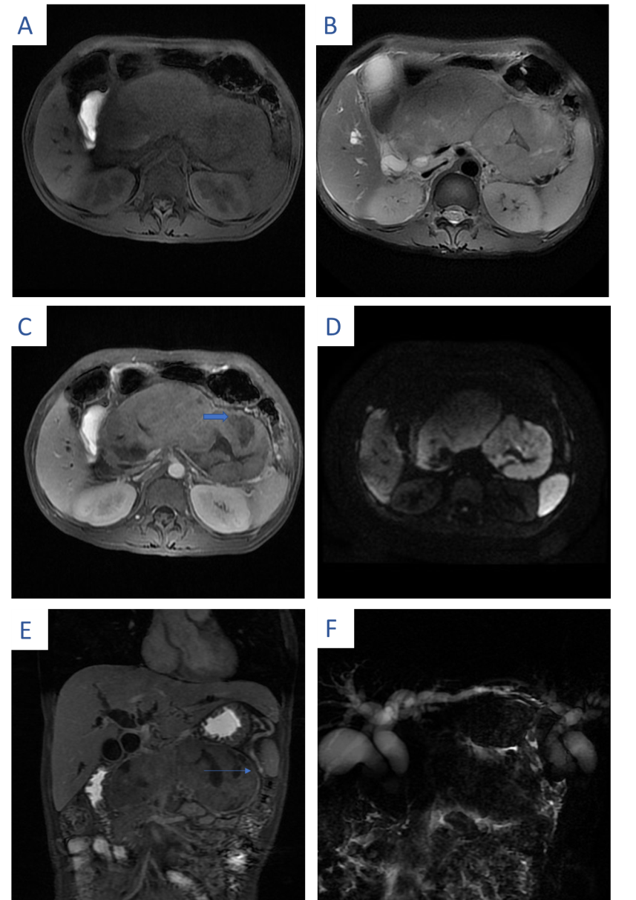
Figure 1 Magnetic resonance imaging of the patient. Magnetic resonance imaging of the upper abdomen shows a diffusely enlarged pancreas, appearing “sausage-shaped”, with loss of pancreatic lobular structure. A: The lesion was isointense to hypointense in the fat-suppressed T1-weighted image; B: The lesion was isointense to hyperintense in the fat-suppressed T2-weighted image; C and D: Central necrosis (see thick arrow) was seen during the contrast-enhanced delayed phase and mixed signal intensity on DWI; E: In addition, there is a distinct hyperintense rim (see the thin arrow) that demonstrated delayed enhancement and a capsule appearance; F: Magnetic resonance cholangiopancreatography showed upstream dilation of the proximal common bile duct and intrahepatic biliary ducts secondary to strictures of the main pancreatic duct and distal common duct.

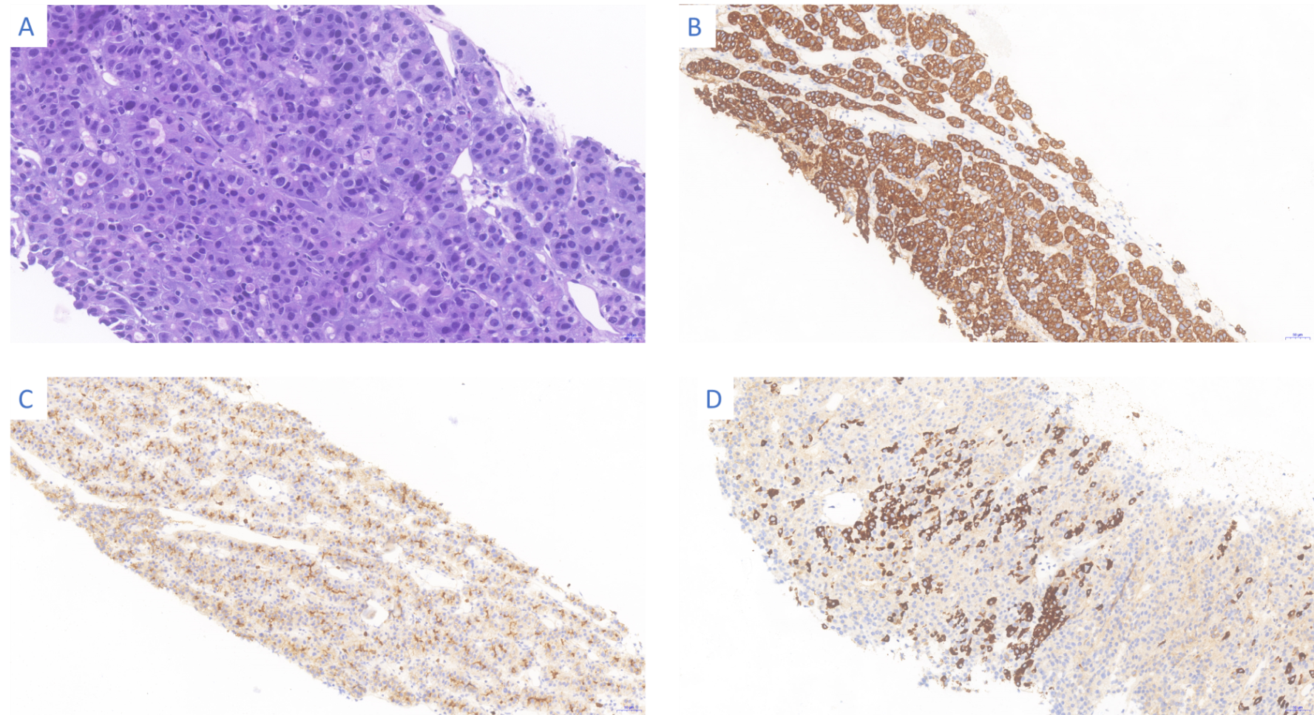
Figure 2 Pathological presentation of the patient. A: Hematoxylin-eosin staining revealed heteromorphic neoplastic cells arranged in glandular, nested or striped patterns (magnification: × 200; scale bar: 20 μm); B: Immunohistochemistry showed tumor cell positivity for CK19 (magnification: × 100; scale bar: 50 μm); C: Immunohistochemistry showed tumor cell positivity for polyclonal carcinoembryonic antigen (magnification: × 100; scale bar: 50 μm); D: Immunohistochemistry showed tumor cell positivity for HepPar1 (magnification: × 200; scale bar: 50 μm).

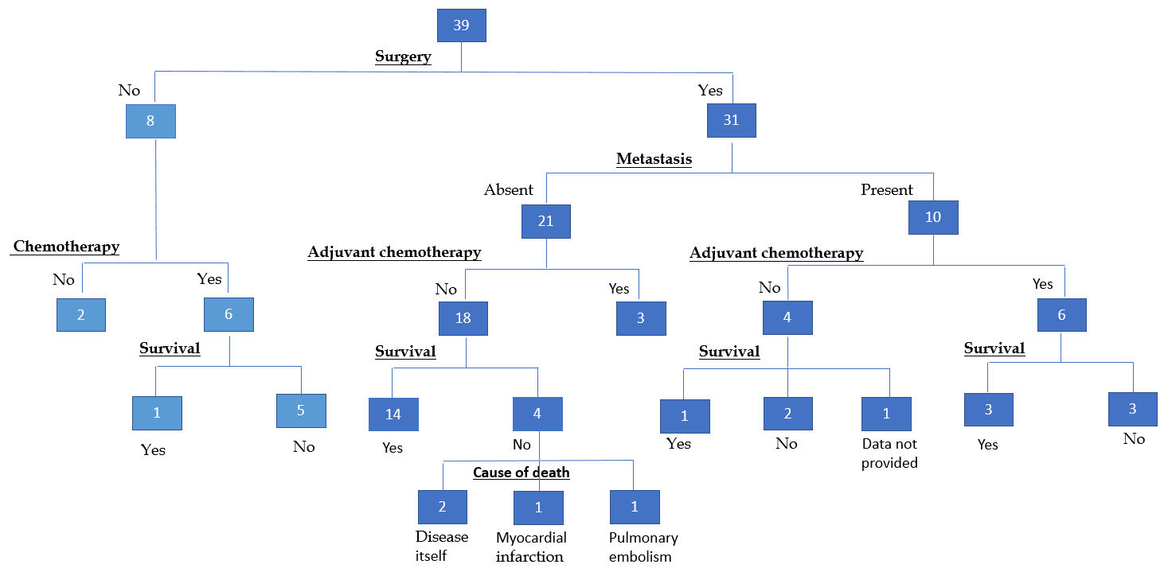
Figure 3 Outcomes of the 39 patients with hepatoid carcinoma of the pancreas reported in the literature.

Table 1 Summary of clinical features of hepatoid carcinomas of the pancreas reported in the English language literature
Ref. | Age | Sex | Clinical presentation | Serum AFP levels at diagnosis | Serum CEA levels at diagnosis | Location | Tumor size in cm | Associated component | Site of metastasis | Treatment | Clinical follow-up in mo
Hruban et al^{[11]}, 1987 | 53 | F | Subcutaneous fat necrosis and polyarthritis | Normal | Not available | Tail | 1 | Acinar cell carcinoma | Liver | chemotherapy (5-FU, Adriamycin) | Died of disease (2.75)
Tanno et al^{[12]}, 1999 | 65 | F | Epigastric and back pain, anorexia, and weight loss | Elevated | Elevated | Body-tail | 6 × 5 | Ductal adenocarcinoma | Liver, right supraclavicular, and para-aortic lymph node | Palliative care | Died of disease (6)
Yano et al^{[13]},  1999 | 57 | M | Jaundice, epigastric pain, vomiting and fever | Elevated | Elevated | Head | 9 × 7 ×5 | Ductal adenocarcinoma | No | Surgery (pancreatoduodenectomy) | Died of disease (3)
Paner et al^{[14]}, 2000 | 28 | M | Severe abdominal and back pain | Elevated | Elevated | Multifocal | 8 × 8 × 6 | Ductal adenocarcinoma | Widespread (gastric, ileal, and colonic mucosa) | Debulking of the tumor plus chemotherapy | Died of disease (14)
Paner et al^{[14]}, 2000 | 57 | M | Vomiting, diarrhea, weight loss, diffuse skin rashes and diabetes mellitus | Elevated | Elevated | Tail | 6 × 4 × 3.5 | Neuroendocrine neoplasms (glucagonoma) | Liver | Surgery (distal pancreatectomy with splenectomy) plus chemotherapy | Died of disease (102)
Lam et al^{[15]}, 2001 | 64 | F | Hypoglycemia and recurrent nocturnal sweating | Elevated | Not available | Tail | 7 × 4 × 4 | Insulinoma | Liver | Distal pancreatectomy with splenectomy plus regional embolization and systemic chemotherapy | Died of disease (22)
Cuilliere et al^{[16]}, 2002 | 70 | M | Incidental (asymptomatic) | Normal | Normal | Body | 3 | Serous microcystic  adenoma | No | Distal pancreatectomy with splenectomy | Alive with no evidence of recurrence (12)
Hughes et al^{[17]}, 2004 | 51 | M | Incidental finding | Normal | Normal | Tail | 6 × 5.5 × 5.5 | No | No | Total pancreatectomy | Alive with no evidence of recurrence (14)
Matsueda et al^{[18]}, 2006 | 49 | F | Weight loss | Elevated | Normal | Widespread | Not  available | No | Liver (detected after 12 mo) | Surgery (total pancreatectomy), chemotherapy (gemcitabine) and liver lobectomy | Alive with no evidence of recurrence (48)
Shih et al^{[19]}, 2006 | 32 | M | Incidental (asymptomatic) | Normal | Elevated | Tail | 7 | No | No | Surgery (distal pancreatectomy with splenectomy) | Alive with no evidence of recurrence (18)
Oh et al^{[20]}, 2006 | 21 | M | Incidental (asymptomatic) | Elevated | Not available | Head | 3 × 3 × 3 | Neuroendocrine neoplasm | No | Surgery (pancreatoduodenectomy) | Alive with no evidence of recurrence (7)
Cardona et al^{[21]}, 2007 | 58 | M | Back and flank pain | Normal | Not available | Body | 3.3 × 2.5 × 2.5 | No | No | Surgery (distal pancreatectomy with splenectomy) | Alive with no evidence of recurrence (15)
Kubota et al^{[22]}, 2007 | 56 | M | Diabetes | Not available | Not available | Tail | 6.3 × 6.2 | No | No | Surgery (distal pancreatectomy with splenectomy) | Alive with no evidence of recurrence (36)
Hameed et al^{[23]}, 2007 | 41 | F | Gastro-esophageal reflux, jaundice, and abdominal pain | Elevated | Elevated | Head | 4.5 × 4 × 3 | Neuroendocrine neoplasm | Liver | Pancreaticoduodenectomy plus Chemotherapy with cisplatin and irinotecan | Died of disease (27)
Liu et al^{[24]}, 2007 | 80 | M | Nausea, diarrhea weight loss and epigastric palpable mass | Normal | Not available | Head | 5 × 5 × 6 | No | Transverse colon | Simple tumorectomy and partial transverse colon resection | Alive with no evidence of recurrence (8)
Zhang et al^{[25]}, 2007 | 37 | F | Upper abdominal pain, anorexia, and emaciation | Elevated | Not available | Widespread | 9 | Neuroendocrine neoplasm | No | Surgery (pancreatoduodenectomy) | Died of disease (3)
Jung et al^{[26]}, 2010 | 46 | M | Dyspepsia and epigastric palpable mass | Elevated | Elevated | Head | 8 × 9 | Neuroendocrine neoplasm | No | Radical pancreatoduodenectomy | Alive with no evidence of recurrence (4)
Petrelli et al^{[27]}, 2012 | 37 | F | Epigastric abdominal mass | Not available | Normal | Body | 11 | No | Liver, mediastinal lymph nodes, and lungs | Chemotherapy with sorafenib | Died of disease (12)
Kelly et al^{[28]}, 2012 | 53 | F | Severe epigastric pain | Elevated | Not available | Body-tail | Not available | No | Liver | Distal pancreatectomy and adjuvant chemotherapy (carboplatin and gemcitabine) | Alive with no evidence of recurrence (22)
Kai et al^{[29]}, 2012 | 79 | F | Incidental (asymptomatic) | Elevated | Elevated | Tail | 7 | No | Stomach, left adrenal gland, and liver | Distal pancreatectomy with splenectomy, combined with resection of the left adrenal gland and total gastrectomy | Died of disease (2)
Huang et al^{[30]}, 2012 | 52 | M | Jaundice, anorexia and epigastric pain | Not available | Elevated | Head | 0.5 nodule | Neuroendocrine tumor | No | Pancreaticoduodenectomy plus chemotherapy with sunitinib | Alive with no evidence of recurrence (16)
Majumder et al^{[31]}, 2013 | 69 | M | Left upper quadrant pain, jaundice and nausea | Normal | Not available | Head | 5.8 × 6.0 | No | Liver | Biliary drainage plus chemotherapy with gemcitabine | Died of disease (3)
Steen et al^{[32]}, 2013 | 61 | F | Incidental (asymptomatic) | Normal | Not available | Tail | 5.3 × 3.5 | No | No | Distal pancreatectomy with splenectomy | Alive with no evidence of recurrence (60)
Xin et al^{[33]}, 2014 | 33 | F | Incidental (asymptomatic) | Elevated | Normal | Head | 2 × 1.4 × 1.8 | Neuroendocrine neoplasm | No | Pancreaticoduodenectomy plus chemotherapy with gemcitabine | Alive with no evidence of recurrence (46)
Vanoli et al^{[34]}, 2015 | 57 | F | Jaundice | Elevated | Elevated | Head | 3.5 × 3 × 3 | No | No | Pancreatoduodenectomy and adjuvant chemotherapy (gemcitabine) | Alive with no evidence of  recurrence (10)
Soofi et al^{[35]}, 2015 | 69 | M | Atypical chest pain | Elevated | Normal | Body and tail | 5.9 | No | No | Distal pancreatectomy with splenectomy | Alive with no evidence of recurrence (4)
Antonini et al^{[36]}, 2015 | 59 | M | Weight loss and abdominal discomfort | Normal | Normal | Body | 6 × 5 | No | No | Chemotherapy with sorafenib | Died of disease (4)
Kuo et al^{[37]}, 2015 | 67 | M | Incidental (asymptomatic) | Normal | Normal | Tail | 2 × 2 | No | No | Distal pancreatectomy with spleen preservation | Alive with no evidence of recurrence (6)
Veerankutty et al^{[38]}, 2015 | 47 | M | Incidental | Not available | Normal | Tail | 3.1 × 2.9 × 2.6 | Serous cystadenoma | No | Distal pancreatectomy with splenectomy (laparoscopic) | Alive with no evidence of recurrence (8)
Williams et al^{[39]}, 2015 | 71 | M | pancreatitis) and melena (oozing ulcer at the ampulla) | Normal | Normal | Head | 5 | No | Duodenal muscularis propria | Pancreaticoduodenectomy and cholecystectomy | Not available
Stamatova et al^{[40]}, 2016 | 78 | M | Incidental (asymptomatic) | Normal | Normal | Head | 8 × 6 | No | No | Pancreaticoduodenectomy | No evidence of recurrence but died of heart attack (2)
Chang et al^{[41]}, 2016 | 61 | M | Incidental (asymptomatic) | Not available | Not available | Body and tail | 1.3 | No | No | Distal pancreatectomy | Alive with no evidence of recurrence (6)
Akimoto et al^{[42]}, 2016 | 59 | M | Incidental (asymptomatic) | Normal | Normal | Body | 5.0 × 3.5 | No | No | Middle pancreatectomy | Alive with no evidence of recurrence (12)
Pellini Ferreira et al^{[43]}, 2017 | 43 | M | Jaundice, epigastric pain, and watery diarrhea | Normal | Normal | Tail | 9.0 | Neuroendocrine neoplasm | Spleen and liver | Chemotherapy with capecitabine and temozolomide | Alive with no evidence of recurrence (16)
Ma et al^{[44]}, 2017 | 75 | M | Weight loss | Elevated | Elevated | Tail | 7.8 | No | Liver | Chemotherapy with mFOLFIRINOX (oxaliplatin + leucovorin + irinotecan + 5-fluorouracil) plus surgery (distal pancreatectomy with splenectomy and wedge resection of the liver) | Alive with no evidence of recurrence (10)
Yang et al^{[45]}, 2018 | 83 | M | Abdominal pain | Not available | Not available | Body | 2.7 × 2.5 × 1.5 | No | No | Laparoscopic distal pancreatectomy and splenectomy | Alive with no evidence of recurrence (107)
Yang et al^{[45]}, 2018 | 72 | M | Severe back pain | Not available | Not available | Tail | 12.0 × 10.5 × 4.5 | No | No | Distal pancreatectomy with splenectomy | Died of pulmonary embolism (1)
Yang et al^{[45]}, 2018 | 54 | M | Incidental (asymptomatic) | Elevated | Normal | Body and tail | 10.0 × 9.0 × 9.0 | No | Adjacent transverse colon | Distal pancreatectomy along with splenectomy and left hemicolectomy | Died of disease (29)
Our case | 36 | M | Progressive jaundice, weight loss and epigastric palpable mass | Elevated | Normal | Widespread | 6.0 × 7.0 | No | Celiac trunk, root of transverse mesocolon, and upper mesojejunum | Palliative care | Died of disease (4)
AFP: Alpha-fetoprotein; CEA: Carcinoembryonic antigen; F: Female; M: Male.

Table 2 Outline of main features characterizing presentation of the 39 cases of hepatoid carcinoma of the pancreas
Variable | n (%) or median (IQR)
Sex
Female | 12 (30.77)
Male | 27 (69.23)
Age in yr
Median (range) | 57 (21-83)
Symptoms
Asymptomatic | 13 (33.33)
Pain: abdominal/back | 13 (33.33)
Gastrointestinal symptoms: vomiting, diarrhea, and dyspepsia | 9 (23.08)
Weight loss | 8 (20.51)
Jaundice | 7 (17.95)
Epigastric mass | 3 ( 7.69 )
Location
Tail | 13 (33.33)
Head | 11 (28.21)
Body | 6 (15.38)
Body and tail | 5 (12.82)
Diffuse or multifocal | 4 (10.26)
Size of longest diameter in cm
Median (range) | 6 ( 1-12 )
Metastasis | 17 (43.59)
Liver metastasis | 12 (30.77)
Associated component: mixed form | 15 (38.46)
Elevated AFP | 18 (46.15)
Elevated CEA | 11 (28.21)
AFP: Alpha-fetoprotein; CEA: Carcinoembryonic antigen; IQR: Interquartile range.

