Name of Journal: World Journal of Respirology
Manuscript NO: 41651
Manuscript Type: REVIEW

Anatomical backgrounds on gas exchange parameters in the lung

Yamaguchi K et al. Structure-function relationships in lung periphery

Kazuhiro Yamaguchi, Takao Tsuji, Kazutetsu Aoshiba, Hiroyuki Nakamura, Shinji Abe

Kazuhiro Yamaguchi, Takao Tsuji, Shinji Abe, Department of Respiratory Medicine, Tokyo Medical University, Tokyo 160-0023, Japan

Kazutetsu Aoshiba, Hiroyuki Nakamura, Department of Respiratory Medicine, Tokyo Medical University, Ibaraki Medical Center, Ibaraki 300-0395, Japan

ORCID number: Kazuhiro Yamaguchi (0000-0002-9135-2161); Takao Tsuji (0000-0002-0501-3543); Kazutetsu Aoshiba (0000-0002-9490-9754); Hiroyuki Nakamura (0000-0003-2821-971X); Shinji Abe (0000-0003-0949-4601).

Author contributions: All authors contributed conception and designation of the study; they contributed acquisition, analysis and interpretation of the data; they expressed the final approval of the version of the article.

Conflict-of-interest statement: The authors have no conflict of interest to declare; there were no supportive foundations to the present study.

Open-Access: This article is an open-access article which was selected by an in-house editor and fully peer-reviewed by external reviewers. It is distributed in accordance with the Creative Commons Attribution Non Commercial (CC BY-NC 4.0) license, which permits others to distribute, remix, adapt, build upon this work non-commercially, and license their derivative works on different terms, provided the original work is properly cited and the use is non-commercial. See: http://creativecommons.org/licenses/by-nc/4.0/

Manuscript source: Invited manuscript

Corresponding author: Kazuhiro Yamaguchi, FCCP, MD, PhD, Guest Professor, Department of Respiratory Medicine, Tokyo Medical University, 6-7-1 Nishi-Shinjuku, Shinjuku-ku, Tokyo 160-0023, Japan. yamaguc@sirius.ocn.ne.jp
Telephone: +81-3-34215402
Fax: +81-3-34215402

Received: September 3, 2018
Peer-review started: September 3, 2018
First decision: Octorber 26, 2018
Revised: November 11, 2018
Accepted: December 16, 2018
Article in press: December 17, 2018
Published online: January 27, 2019

Abstract
Many problems regarding structure-function relationships have remained unsolved in the field of respiratory physiology. In the present review, we highlighted these uncertain issues from a variety of anatomical and physiological viewpoints. Model A of Weibel in which dichotomously branching airways are incorporated should be used for analyzing gas mixing in conducting and acinar airways. Acinus of Loeschcke is taken as anatomical gas-exchange unit. Although it is difficult to define functional gas-exchange unit in a way entirely consistent with anatomical structures, acinus of Aschoff may serve as functional gas-exchange unit in a first approximation. Based on anatomical and physiological perspectives, inert-gas elimination technique (MIGET) is thought to be highly effective for predicting ventilation-perfusion (V_{A}/Q) heterogeneity between acini of Aschoff under steady-state condition. Changes in effective alveolar P_{O2}, the most important parameter in classical gas-exchange theory, are coherent with those in mixed alveolar P_{O2} decided from MIGET. Therefore, effective alveolar-arterial P_{O2} difference (AaDO₂) is considered useful for assessing gas-exchange abnormalities in lung periphery. However, one should be aware that although AaDO₂ sensitively detects moderately low V_{A}⁄Q regions causing hypoxemia, it is insensitive to abnormal gas exchange evoked by very low and high V_{A}⁄Q regions. Pulmonary diffusing capacity for CO (D_{LCO}) and the value corrected for alveolar volume (V_{AV}), i.e., D_{LCO}/V_{AV} (K_{CO}), are thought to be crucial for diagnosing alveolar-wall damages. D_{LCO}-related parameters have higher sensitivity to detecting abnormalities in pulmonary microcirculation than those in alveolocapillary membrane. We would like to recommend four categories derived from combining behaviors of D_{LCO} with those of K_{CO} for differential diagnosis on anatomically morbid states in alveolar walls; type-1 abnormality defined by decrease in both D_{LCO} and K_{CO}, type-2 abnormality by decrease in D_{LCO} but increase in K_{CO}, type-3 abnormality by decrease in D_{LCO} but restricted rise in K_{CO}, and type-4 abnormality by increase in both D_{LCO} and K_{CO}.

Key words: Secondary lobule of miller; Acinus of loeschke; Acinus of Aschoff; Convection; Gas-phase diffusion (stratification); Aqueous-phase diffusion; V_{A}/Q heterogeneity

© The Author(s) 2019. Published by Baishideng Publishing Group Inc. All rights reserved.

Core tip: The anatomical gas-exchange unit is organized into the acinus of Loeschcke, while the functional gas-exchange unit is given by the acinus of Aschoff. The V_{A}/Q distribution in acinar regions is representatively predicted from the inert-gas elimination technique. The effective AaDO₂ plays a vital role in detecting moderately low V_{A}/Q regions eliciting hypoxemia but not very low and high V_{A}/Q regions. The D_{LCO} and K_{CO} are clinically valuable for estimating the impediment of alveolar walls, in which D_{LCO} and K_{CO} are more sensitive to detecting the abnormality of pulmonary microcirculation than that of alveolocapillary membrane.

Citation: Yamaguchi K, Tsuji T, Aoshiba K, Nakamura H, Abe S. Anatomical backgrounds on gas exchange parameters in the lung. World J Respirol 2019; 9(2): 8-29
URL: https://www.wjgnet.com/2218-6255/full/v9/i2/8.htm
DOI: https://dx.doi.org/10.5320/wjr.v9.i2.8

INTRODUCTION
The morphological and physiological aspects of normal and diseased lungs were most actively studied in the era of the 20th century from the 1950’s to 1980’s. The morphological and physiological approaches are both equally important for raising the quality of basic science and of clinical medicine targeting the human lung. Although the lung morphology and the respiratory physiology have evolved in parallel, it is hard to say that the efforts to unite them in a variety of directions by morphologists, physiologists, and clinicians, i.e., the establishment of structure-function relationships, were successful enough. It is of clinical value to have much understanding of the anatomical basis of various functional parameters when physicians should do a pathophysiological decision-making against patients with various types of lung diseases. Based on these historical facts, we try to shed light on the old but new issue, i.e., the elucidation of anatomical backgrounds of various functional parameters that have been used for estimating gas maxing in conducting airways and gas exchange in lung periphery. For accomplishing this purpose, the following five matters were comprehensively addressed in the present review. (1) What is the appropriate anatomical design for understanding gas mixing in conducting airways and gas exchange in lung periphery? (2) Aspects of convective and diffusive gas mixing along peripheral airways in a lung model in which dichotomously branching airways are certainly considered. (3) Is the ventilation-perfusion V_{A}/Q distribution in the lung, which is quantitated in terms of the inert-gas elimination technique (MIGET), indeed supported by the anatomical and physiological facts? (4) Is the effective alveolar-arterial P_{O2} difference (AaDO₂) estimated from the classical gas-exchange theory also supported by the anatomical and physiological facts? (5) What are the anatomical and physiological determinants on the pulmonary diffusing capacity for carbon monoxide (D_{LCO})?

Anatomical design for understanding gas mixing and gas exchange in the lung
Branching of conducting airways: The pattern of airway branching in a normal lung is best studied on resin or silicon rubber casts^{[1-8]} (Figure 1). The lower conducting airways end in clusters that are surrounded by the fibrous connective tissue septa. The cluster is defined as the secondary lobule of Miller^{[9,10]}, which contains lobular (preterminal) bronchioles and terminal bronchioles that supply the gas to or from the acini of Loeschcke^{[10]}.
Although conducting airways are most often described as a symmetric tree that branches off by regular dichotomy, in which all pathways have exactly the same length and each generation of branching is composed of airways uniform in size^{[2,3,11]}, this type of model is in fundamental conflict with the anatomical facts^{[2,12,13]}. A more realistic representation is a tree of irregular, asymmetric dichotomy, where the dimension of conjugate daughter branches differs from that of their parents. The irregular dichotomy includes different branching angle and varied length-to-diameter ratio at a certain airway generation. Weibel^{[2,3]} demonstrated that the pathway length in airways with 1.5-mm diameter varies between 1.5 and 11 mm, with the highest frequency at 3.5-4.0 mm. Similarly, airways of 2.0 mm in diameter (i.e., small airways) are spread out between the 4th and 14th generations of branching tree, with a maximum at the 8th generation. The valuable message emanating from the studies of Weibel is that although conducting airways are correctly modeled by an irregular, asymmetric dichotomous branching tree, the dimensional variation of airway diameters and path lengths assigned to each generation of the tree nearly follows the normal distribution and this variation decreases as the generation progresses. Based on these findings, a simple design called “model A of Weibel”^{[2,3]} or “typical path lung model”^{[4,5,14]} has been developed. This model assumes that in an initial approximation, the asymmetric branching tree can be replaced by the symmetric branching tree using the mean (representative) value estimated from the normal distribution of airway diameters as well as that of path lengths at a given generation (Figure 2), which results in that one can assess gas mixing in the conducting airways with asymmetric branches from the model A of Weibel with simple geometry.

Anatomical definition of lobule and acinus: Different terms have been used for defining the lobule and the acinus during several decades. In 1947, Miller proposed the anatomical concept that is valuable for understanding what the secondary and primary lobules are^{[9]}. As described above, the secondary lobule of Miller is the unit supplied by a lobular bronchiole having dimeter of about 1.0 mm (corresponding to the 12th generation) and surrounded by the fibrous connective tissue septa (i.e., the interlobular septa) (Figure 3). The size of secondary lobules of Miller varies from 1.0 to 2.5 cm, each of which is comprised of varying numbers of acini defined by Loeschcke, ranging from three to 24 depending on the region selected^{[15,16]}. On the other hand, the primary lobule of Miller is expressed by the area governed by an alveolar duct. The secondary lobule proposed by Miller has various advantages from anatomical points of view. Therefore, unless otherwise specified, the simple term of “secondary lobule” is used in the sense of “secondary lobule of Miller” throughout the current review.
In 1958, based on the bronchogram of peripheral airways, Reid^{[17,18]} presented the different definition with regard to the secondary lobule. The secondary lobule of Reid is the unit formed by the structure distal to any bronchiole having a mm-branching pattern. The size of secondary lobule of Reid is fairly constant (approximately 1.0 cm) in comparison with that of Miller and contains three to five acini of Loeschcke. The Reid’s definition is more useful when interpreting the bronchogram.
The acinus of Loeschcke is the unit distal to a terminal bronchiole (Figure 3), in which all alveolated airways engage in gas exchange. The size of acinus of Loeschcke averages 7 to 10 mm in diameter and roughly 80,000 acini configure the lung. An acinus contains alveoli ranging from 3000 to 4000^{[8,19]}, resulting in that the lung consists of 300-million alveoli.
The acinus of Aschoff is defined as the area supplied by a first-order respiratory bronchiole (Figure 3), the size of which is the half of acinus of Loeschcke^{[20]}. All alveolated airways in the acinus of Aschoff participate in gas exchange. The acinus of Loeschke is important when defining the anatomical gas-exchange unit, while the acinus of Aschoff is important when the functional gas exchange is defined.
Similar to conducting airways, intra-acinar, alveolated airways (respiratory bronchioles, alveolar ducts, and alveolar sacs) also show irregular dichotomous branching over an average of nine generations, terminating at between the 6th to 12th generations^{[8,21,22]}. Large acini have more generations and smaller acini have correspondingly fewer. Although the issue of whether the variation of airway diameters and path lengths of each generation in the acinus (Loeschke or Aschoff) follows the normal distribution has not been reliably concluded, Weibel and colleagues^{[2,3,8]} presumed that the geometrically-simple model A of Weibel could be applied for integrating the branches of conducting airways and acinar airways. The features of model A of Weibel (Figure 2), which is also called “trumpet model” or “thumbtack model”, are summarized as follows^{[2,23,24]}: (1) the model consists of the average number of generations over which the airways must terminate in the alveolar sacs corresponding to the 23th generation; (2) the 16th generation defines the terminal bronchiole; (3) the 17th-22th generations correspond to the acinar airways, including the respiratory bronchioles and alveolar ducts; and (4) the number of airways in a particular generation increases tremendously as the generation increases, leading to the exponential increase in the generation-specific total cross-sectional area. Weibel^{[2]} demonstrated that the average diameter of terminal bronchiole, respiratory bronchiole, or alveolar duct is, respectively, 0.50, 0.39, or 0.33 mm, while the average total cross-sectional area of these airways is, respectively, 230, 420, or 2630 cm² (equal to 0.263 m²). The total cross-sectional area including all alveoli amounts to about 130 m² in association with the harmonic mean thickness of alveolocapillary membrane of 1.1 μm^{[25]}.

Anatomical aspects of collateral ventilation: There exist three pathways for collateral ventilation in the acinus, i.e., alveolar pores (pores of Kohn), channels of Lambert, and channels of Martin. Although the typical size of alveolar pores ranges from 2 to 30 μm, there have been many anatomical, physiological, and theoretical studies leading to the conclusion that the alveolar pores are not potent in air-filled lungs^{[26,27]}. These studies indicate that the alveolar pores take no part in maintaining alveolar ventilation.
In 1955, Lambert^{[28]} described accessory communications between bronchioles and alveoli in the normal human lung. The diameter of Lambert channels varies from zero (practically closed) to 30 μm and they are considered to serve as collateral ventilation to adjacent alveoli when airway obstruction occurs at the level of terminal bronchioles^{[27]}. Supporting this consideration, the important role of Lambert channels was identified in patients with pneumoconiosis, in which a striking accumulation of macrophages was found in the Lambert channels and their adjacent alveoli^{[29]}.
In 1966, Martin^{[30]} reported intra-acinar communications at the level of respiratory bronchioles or alveolar ducts in the canine lung. The Martin channels were found in human lungs, as well^{[9,31]}. As the Martin channels have sufficiently low resistance to gas flow, they act as the primary pathway for inducing collateral ventilation in the acinus^{[27]}. Therefore, one can conceive that only the Martin channels, but neither the alveolar pores nor the Lambert channels, serve for equalizing the distribution of alveolar ventilation and the concentration of a certain gas in a particular acinus, though the extent of equalization elicited by collateral ventilation has not been conclusively quantified.

Definition of anatomical gas-exchange unit – importance of acinus of Loeschke: The alveolus cannot be taken as a ventilation unit mostly because each alveolus is not independent of other alveoli. Two adjoining alveoli shares the alveolar wall and each alveolus adjoins several alveoli, some of which are connected to different alveolar ducts. Furthermore, there are communications at the level of respiratory bronchioles or alveolar ducts (Martin channels). On the other hand, the acinus of Loeschke can be taken as an anatomical ventilation unit because it is supplied only by a single conducting airway with no alveoli, i.e., the terminal bronchiole (Figure 3).
There is a serious problem concerning a perfusion unit formed by the pulmonary microcirculation. The dense, intertwined capillary network embedded in the alveolar wall forms a continuum of blood flow that is not partitioned into independent perfusion units, resulting in that the story one likes to present, i.e., the gas-exchange unit is organized into an alveolus associated with a separated capillary network in the alveolar wall, is highly fictitious. The capillary network is supplied by the arteriole that penetrates into the acinus along the acinar airways and is drained into the venule in the acinar periphery. The distance between an arteriole and a venule is of an order between 0.5 and 1.0 mm^{[32]}, resulting in that the perfusion unit given by the area surrounded by an arteriole and a venule extends over several alveoli but it does not cover the whole area of an acinus of Loeschke whose size ranges from 7 to 10 mm^{[25]}. These facts are in accord with the idea that the perfusion unit is not congruent with the ventilation unit so that it gives rise to difficulty in anatomically defining the gas-exchange unit in which the ventilation and perfusion units should be matched. However, König et al^{[33]} found that the whole acinar region of Loeschke is perfused almost homogeneously by colloid gold used as plasma tracer even at rest, indicating that all capillary networks existing in the acinus of Loeschke are connected to each other. Based on the study of König et al^{[33]}, we considered that the anatomical gas-exchange unit is organized approximately into the acinus of Loeschke.

Convective and diffusive gas mixing in conducting and acinar airways
In addition to the convective mixing elicited by ventilation, the diffusive mixing plays an important role in maintaining gas transport along peripheral and acinar airways with large cross-sectional areas (Figure 2). Numerous mathematical attempts have been made to estimate the effect of convection, diffusion, or interactions of both on gas transport in conducting and acinar airways using a model with symmetrically or asymmetrically dichotomous branching of airways^{[24]}. The term of convection is defined as a mass transport resulting from the unidirectional displacement of molecules included in a certain volume. Convective displacement is identical for all molecular species and is, thus, not different for gases with different diffusivity. This indicates that convection (laminar or turbulent flows) occurs along gradients of total pressure but not along those of partial pressure. On the other hand, the term of diffusion is defined as a result from the random motion of molecules due to their thermal energies, depending on their concentration (partial pressure) gradients and diffusivity. Hence, a separation of two gases with different diffusivity occurs during gas transport when diffusive transport constitutes a main limiting process, whereas a separation of two gases is not investigated when gas transport is mainly limited by convection. Diffusive transport in airways and alveoli occurs in axial and radial direction; yet the mechanism of these two directions is the same. Furthermore, the coupling of convection and diffusion occurs under a condition where the contribution of convection and diffusion to gas transport is of similar magnitude, which may occur predominantly in peripheral airways at generations between the 8th and 12^{th[34]}. The magnitude of convection-diffusion coupling under a condition of laminar or turbulent flow is estimated using the dispersion coefficient proposed by Taylor and others^{[35-38]}. However, the Taylor dispersion has been identified to be insignificant for gas transport during normal breathing^{[39-43]}, leading to the conclusion that it is enough to introduce only the convection and diffusion (particularly, axial diffusion), but not the dispersion, as the basic mechanism when assessing the gas transport along conducting and acinar airways.
Introducing both convection and diffusion as the gas mixing mechanism into model A of Weibel that has a simple geometry with trumpet or thumbtack shape, several groups of investigators analyzed the time-dependent change in gas concentration profile of an insoluble gas that is not absorbed into the blood (i.e., no gas exchange) along peripheral conducting airways and acinar airways during normal breathing^{[39,44-50]}. Paiva^{[46]} assumed: (1) no dispersion in airways; (2) no radial diffusion in airways; (3) no axial diffusion in alveolar regions; (4) no convective flow in alveolar regions (i.e., alveoli simply act as a sink for diluting a gas during inspiration while as a reservoir for expelling a gas during expiration); and (5) no collateral ventilation in acinar regions. As the theoretical calculation by Paiva^{[46]} was made under a situation where the tidal volume was set at 500 mL and the functional residual capacity (FRC) at 3000 mL (i.e., the representative lung volume during normal breathing), the end-inspiratory gas concentration in the alveolar region is reduced to 17% of that at the beginning of inspiration. Paiva^{[46]} analyzed gas mixing kinetics along airways constituting the last 13th generations, which correspond closely to the secondary lobule of Miller (Figures 2 and 3). The results emphasized by Paiva^{[46]} are summarized below (Figure 4). (1) On inspiration, the front of a gas, which is expressed by the axial distance at which the concentration of a gas is reduced to 50% of the value at the beginning of inspiration, lags appreciably behind the front of tidal volume. The front of tidal volume attains to the 22th generation of airways (i.e., the alveolar duct), whereas the front of a gas stays at the 17th generation (i.e., the first-order respiratory bronchiole defining the acinus of Aschoff). The gas front is practically stationary, suggesting that the convective advancement of a gas into the periphery is counterbalanced by the diffusion-elicited proximal retreat of a gas. The volume from the airway entrance to the gas front is about 150 mL, which corresponds to the common dead space volume conceptualized in the classical gas-exchange theory. This indicates that the classical, common dead space can be defined as the inspiratory volume decided by the gas front, but not by the front of tidal volume. Furthermore, the classical gas-exchange theory assumes that the front of common dead space has a sharp, all-or-nothing transition boundary as if it is formed only by the ventilation-induced convective flow, implying that the effect of diffusion is converted to the equivalent effect of convection. The region distal to the boundary is the alveolar region in which gas exchange takes place. The definition of dead space specified by Paiva^{[46]} issues an important message as to the way of how to define the functional gas exchange unit in the steady-state V_{A}/Q analysis and classical gas exchange theory, both of which will be argued in the following sections. (2) on expiration, all intrapulmonary concentration gradients of a gas are rapidly faded out, which is mainly caused by the thoracic shrinkage-induced convective flow during expiration. The diffusive process in acinar gas phase imposes a negative impact on gas transport in an early stage, but not in a later stage, of expiration. The aforementioned findings during one respiratory cycle indicate that the stratification (i.e., the concentration gradient of a gas due to diffusion) is evident along acinar airways during inspiration but minimal during expiration. Differing from inspiratory phase, the common dead space formed by the non-alveolated, conducting airways exerts nearly no impact on gas transport in conducting airways during expiratory phase. Instead, the common dead space literally functions as a simple reservoir for diluting the gas expelled from all alveolar regions during expiration.

Quantification of continuous distribution of V_{A}/Q
Definition of functional gas-exchange unit – importance of acinus of Aschoff: In general, the continuous distribution of V_{A}/Q in the lung has been quantitated by means of the multiple inert-gas elimination technique (MIGET). The most important matter in the MIGET is how to define the functional gas-exchange unit in which concentration of a gas should show uniform value. Although the acinus of Loeschke approximates the anatomical gas-exchange unit, it is uncertain as to the issue of whether the acinus of Loeschke concurrently serves as the functional gas-exchange unit. In the acinus of Loeschke, an alveolus adjoins several alveoli and there are communications at the level of respiratory bronchioles or alveolar ducts (Martin channels), both of which tend to equalize gas-concentration difference over the acinus of Loeschke. However, the point of whether the equalization of gas concentration in the acinus of Loeschke is complete has not been surely confirmed. Therefore, it may be fraught with the problem to blindly adopt the acinus of Loeschke as the functional gas-exchange unit. In fact, Paiva et al^{[51]} theoretically suggested that the regions distal to the alveolar duct, which correspond to the primary lobules of Miller, have different gas concentrations at the end of inspiration after single-breath of a non-absorbable gas. However, they^{[51]} also demonstrated that the gas-concentration difference between respective primary lobules of Miller formed during inspiration diminishes rapidly during expiration. Furthermore, caution should be paid against the fact that Paiva et al^{[51]} disregarded the effect of Martin channels-induced collateral ventilation on gas-concentration equalization between the primary lobules of Miller. If the collateral ventilation-elicited equalization effect is taken into consideration, the gas-concentration difference between the primary lobules of Miller is expected to become much smaller. The importance of the acinus of Aschoff given by the region distal to the first-order respiratory bronchiole as the functional gas-exchange unit was implicitly indicated by Paiva^{[46]}. He showed that the “imaginary” boundary separating the alveolar gas-exchange region from the dead space exists in the vicinity of the first-order respiratory bronchiole corresponding to the entrance of the acinus of Aschoff (Figures 3 and 4). As such, the study of Paiva^{[46]} suggests that the functional gas-exchange unit under a steady-state condition is close to the anatomically-defined acinus of Aschoff. This is because the size of the acinus of Aschoff is about half of the acinus of Loeschke such that the gas-concentration variation, if any, is much smaller between the acini of Aschoff than that between the acini of Loeschke. This results in that the acinus of Aschoff satisfies the essential requirement for the functional gas-exchange unit, namely the uniformity of gas concentration over the unit, more precisely than the acinus of Loeshcke does. Hence, we considered that the functional gas-exchange unit should be defined by the acinus of Aschoff whose area is smaller than that of the anatomical gas-exchange unit formed by the acinus of Loeschke, leading to the conclusion that the MIGET argued in this section should be thought to predict the V_{A}/Q heterogeneity between the acini of Aschoff.

Basic rationale for determining V_{A}/Q distribution: Under a steady-state condition in which there is no change in the partial pressure of a gas (P) against the elapsed time (t) at any portion of the lung (i.e., ΔP/Δt = zero), the partial pressure of an inert gas in gas phase (P_{A}) and that in blood phase (P_{c}) of a given functional gas-exchange unit are described by the simple equation in accordance with the law of mass balance^{[19,52-54]}.
P_{A}/P_{v} = P_{c}/P_{v} = λ/(λ + V_{A}/Q) ⋅⋅⋅⋅⋅ eq. 1
Where P_{v} denotes the partial pressure of a given inert gas in mixed venous blood, whereas λ is the blood-gas partition coefficient of a gas, which is decided by its blood solubility (α)^{[19,55]}. The eq. 1 is approved only in a condition where the inspired air does not contain any trace of an inert gas. This holds true when an inert gas is infused through the peripheral vein but not when it is inhaled through the mouth. The eq.1 implies that the partial pressure of an inert gas in the functional gas-exchange unit is simply determined by the ratio of convective flow of ventilation (V_{A}) and that of perfusion (Q) distributed to each functional gas-exchange unit. There are many physiological assumptions that should be addressed for the establishment of eq. 1^{[19,54,56-59]}. They are listed below. (1) The functional gas-exchange unit is in a steady state such that the net transfer rate of an inert gas from capillary blood to alveoli in the functional gas-exchange unit exactly equals the net rate of elimination through expiration. Thus, the amount of an inert gas stored in blood, lung tissue, or alveoli is constant. The condition in which the MIGET is applied meets the steady-state definition. (2) The tidal nature of ventilation is ignored. Namely, the rebreathing of a gas fulfilling the common dead space in previous expiration is not considered. The MIGET assumed the specific, personal dead space connecting to the individual functional gas-exchange unit. Therefore, in a next inspiration, each functional gas-exchange unit inhales the gas from each personal dead space that has the same gas composition as that expelled from each functional gas-exchange unit in previous expiration. This assumption is highly dissociated from the anatomical and physiological facts. However, the volume of common dead space configured by upper and lower conducting airways amounts to 150 mL, which corresponds to only 5% of the lung volume represented by FRC (3000 mL), resulting in that the gas contained in the common dead space is diluted largely when it reaches the gas-exchange units at an early stage of next inspiration. Furthermore, the inspiratory tidal volume is 500 mL so that after inhaling the gas remaining in the dead space (150 mL), which is the averaged mixed alveolar gas exhaled from all functional gas-exchange units during previous expiration, an inspired gas with no inert gas refreshes the gas-exchange units in a later stage of inspiration (350 mL). These considerations suggest that the averaged inert-gas concentration at the entrance of functional gas-exchange unit during inspiration is almost zero under a condition where the MIGET is applied. (3) The pulsatile nature of blood is disregarded so that capillary blood flow is taken to be continuous. Bidani et al^{[60]} analyzed the effect of pulsatile flow (Q_{C}) (and pulsatile capillary blood volume (V_{C}) on equilibration of O₂ between capillary blood and alveolar gas. They found little difference in O₂ equilibration profile between the condition where both Q_{C} and V_{C} are constant and the condition where both Q_{C} and V_{C} have pulsatile natures. Therefore, the assumption of constant blood flow may derive no discernable distortion regarding the steady-state gas exchange^{[61]}. (4) The functional gas-exchange unit is assumed to receive capillary blood flow with the same hematocrit ($Ht$). As first suggested by Brisco^{[62]}, the gas solubility in erythrocytes is different from that in plasma, indicating that variation in Ht between capillaries may affect inert-gas exchange to some extent. However, Young and Wagner^{[63]} demonstrated that although the inert-gas solubility is influenced appreciably by maldistribution of Ht, its effect on inert-gas exchange is small. (5) The inert-gas solubility is taken to be constant irrespective of oxygen saturation with Hb (SO₂) and blood pH. Yamaguchi et al^{[64]} experimentally demonstrated that SO₂ has no impact, while blood pH has a substantial impact, on the inert-gas solubility, including ethane and cyclopropane, both of which are confined to the protein fraction of blood. However, in the same paper, Yamaguchi et al^{[64]} demonstrated that the effect of pH-dependent change in blood solubility of either ethane or cyclopropane on recovered V_{A}/Q distribution is small. (6) Diffusion equilibration is assumed to be complete. This assumption applies both to the diffusion between capillary blood and gas phase through alveolocapillary membrane (aqueous-phase diffusion) and to the diffusion within gas phase [gas-phase diffusion (stratification)]. The blood-gas equilibration is valid for any inert gas that does not combine with Hb^{[52]}. However, this assumption is invalid while analyzing the gas combining with Hb, especially carbon monoxide (CO) and nitric oxide (NO)^{[65]}.
As argued in the previous section, the stratification is evident in inspiration but not in expiration (Figure 4). Since the MIGET analyzes the gas only collected during expiration, the assumption that the stratification has little impact on gas transfer may be approved in the MIGET condition. Furthermore, Yamaguchi et al^{[66]} demonstrated that excepting severe acute respiratory distress syndrome (ARDS), the stratification plays no role during inert-gas elimination under the condition similar to that of the MIGET.
The detailed discussions expanded above identified that most of the physiological assumptions introduced by the MIGET have correct grounds.

Determination of continuous distribution of V_{A}/Q: Saline containing a small quantity of six foreign inert gases with a wide variety of λ, including sulfur hexafluoride (SF₆) (λ= 0.009 mL/mL at 37 °C), ethane (λ = 0.09), cyclopropane (λ = 0.58), halothane (λ = 2.82), diethyl ether (λ = 14.4), and acetone (λ = 304) is infused through the peripheral vein at a constant rate of 2 mL/min^{[54,56]}. After steady state is established (about 30 min after initiating infusion), expired gas, arterial blood, and mixed venous blood are simultaneously sampled and the concentrations of six inert gases in the samples are measured by gas chromatography equipped with flame ionization for hydrocarbons and electron capture for SF₆^{[67]}.
Using the data measured for six inert gases, Wagner and colleagues^{[56,58,59]} established a novel method allowing for predicting a continuous distribution of V_{A}/Q in a representative manner. In this method, they assumed the 50 functional gas-exchange units with a variety of V_{A}/Q values, including the right-to-left shunt with V_{A}/Q of zero (the number of functional gas-exchange unit: 1), the dead space with infinite V_{A}/Q (the number: 50) composed of series (common) and parallel (alveolar) dead space, and the 48 units with finite values of V_{A}/Q ranging from 0.005 to 100, all of which are arranged in parallel and are equally spaced on a logarithmic scale. Applying the least-squares minimization coupled with enforced smoothing under non-negativity constraints for V_{A} and Q, they determined the distribution of V_{A} and/or Q along the logarithmic V_{A}/Q axis. However, it should be noted that the lung model adopted by Wagner et al^{[56,58,59]} consists of unknown variables whose number (n = 50) greatly exceeds the number of measured variables (n = 6) so that no unique solution is generally obtainable^{[68,69]}. In principle, the greater the number of gases, the more detailed and precise is the resultant estimate of the V_{A}/Q distribution. To solve the problem of non-unique solution, Evans and Wagner^{[69-73]} introduced the linear programing approach, in which the upper limit of V_{A} and/or Q distributed to a certain V_{A}/Q unit was examined based on the error of each inert-gas measurement. The linear programming can reliably decide the issue of whether the V_{A}/Q distribution is unimodal or contains more than one mode, i.e., bimodal or trimodal. The mode of V_{A}/Q distribution representatively determined by the least-squares minimization was shown to be qualitatively coincident with that by the linear programming^{[70]} (Figure 5). Furthermore, Wagner and West^{[59,74-76]} analyzed the matching between the measured arterial P_{O2} (P_{aO2}) and that predicted from the representative V_{A}/Q distribution. They found a satisfactory agreement between the two values in patients with COPD and interstitial pneumonias at rest (Figure 6). However, Wagner^{[76]} found that the P_{aO2} predicted from the MIGET is appreciably higher than the measured P_{aO2} in patients with interstitial pneumonias under an excise condition. This indicates that in addition to the V_{A}/Q heterogeneity, the aqueous-phase diffusion limitation through alveolocapillary membrane plays some role in worsening hypoxemia during exercise in patients with interstitial pneumonias.
The representative distributions of V_{A}/Q in a normal subject as well as patients with interstitial pneumonia and COPD are depicted in Figure 7^{[59]}. A normal subject revealed the unimodal distribution of V_{A} and Q along the V_{A}/Q axis, which resembles the sharp normal distribution. A patient with interstitial pneumonia showed the bimodal V_{A}/Q distribution with low V_{A}/Q regions associated with augmented right-to-left shunt. The formation of low V_{A}/Q regions and shunt may be ascribed to the interstitial fibrosis-elicited destruction of acinar structures. A COPD patient with predominant emphysema showed the bimodal V_{A}/Q heterogeneity with high V_{A}/Q regions, which may be attributed to the regional hyperventilation caused by the destruction of alveoli. A patient with predominant bronchiolar involvements revealed the bimodal V_{A}/Q heterogeneity with low V_{A}/Q regions, which may be caused by the destruction and/or obliteration of acinar bronchioles.
Based on the V_{A}/Q-D/Q concept developed by Piiper^{[77]}, in which D denotes the aqueous-phase diffusing capacity for O₂, CO₂, or CO through alveolocapillary membrane, Yamaguchi et al^{[66,78-80]} elaborated a novel method that allows for predicting the continuous distribution of V_{A}/Q and D/Q under a steady-state condition. They^{[66,78-80]} found that in addition to the V_{A}/Q heterogeneity, the D/Q heterogeneity is expanded in patients with interstitial lung diseases but less evident in patients with COPD (Figure 8). Therefore, it is conceived that the heterogeneity of aqueous-phase diffusion plays some role in impeding gas exchange, particularly in lungs with destruction of alveolocapillary membrane or pulmonary microcirculation.

AaDO₂ in classical gas-exchange theory
Determination of alveolar gas composition: About 100 years ago, Krogh et al^{[81]} first described the important principle in the field of respiratory physiology; namely, the gas exchange taking place in any lung region is determined by neither the ventilation nor the blood flow but by the ratio of one another. Shortly after this, Haldane^{[82]} recognized that ventilation-perfusion heterogeneity could cause hypoxemia. These pioneering works led Fenn et al^{[83]}, Riley and Cournand^{[84]}, and others into the establishment of classical gas-exchange theory in a more precise fashion. Rahn^{[85]} proposed the concept of “mean alveolar gas” while Riley et al^{[84,86]} proposed the concept of “ideal alveolar gas”. These two terms are physiologically identical and defined as the intersection of blood and gas R lines, in which R is the respiratory gas-exchange ratio given by the ratio of CO₂ production (V_{CO2}) to O₂ consumption (V_{O2}) of the whole body (Figure 9). As the R is identical at any portion of the body under a steady-state condition, the R values at the level of capillary blood (R_{b}: blood R line) and alveolar gas (R_{g}: gas R line) are the same as that of mixed expired gas. Researches^{[84-86]} theoretically identified that the intersection of R_{b} and R_{g} lines defines the single V_{A}/Q value and the corresponding unique pair of P_{O2} and P_{CO2} in alveolar gas and capillary blood of a certain lung (the O₂-CO₂ diagram or the V_{A}/Q line^{[61,87]}). Although the P_{O2} and P_{CO2} values thus determined satisfactorily meet the metabolic state of the whole body, it does not secure that these P_{O2} and P_{CO2} can work as the representative indicator while analyzing the gas-exchange behavior in the lung. This is because the concept of mean (ideal) alveolar P_{O2} and P_{CO2} is largely lacking in the considerations on complicatedly intertwined lung anatomy and intricate physiological gas-transfer mechanism along the airways and in the lung periphery. Furthermore, to calculate the mean (ideal) alveolar gas, it is necessary to measure P_{O2} and P_{CO2} in mixed venous blood. As this procedure is cumbersome in a clinical setting, Riley et al^{[86]} proposed a new concept of “effective alveolar gas”, in which the mean (ideal) alveolar P_{CO2} is taken to equal the arterial P_{CO2} (P_{aCO2}). Because of the relative flatness of blood CO₂ dissociation curve under a physiological condition, the difference between mean (ideal) P_{CO2} and P_{aCO2} is remarkably small (Figure 9), which indicates that it is not unreasonable to use P_{aCO2} in place of mean (ideal) alveolar P_{CO2}. Therefore, P_{aCO2} is defined as “effective alveolar P_{CO2}” and alveolar P_{O2} estimated therefrom is called “effective alveolar P_{O2}”. As it is not necessary to measure the gas pressures in mixed venous blood, the concept of effective alveolar P_{O2} has got a great deal of support from physicians at bed side, though the anatomical and/or physiological validations on effective alveolar P_{O2} have been lacking. Based on the simplified form of alveolar gas equation, the effective alveolar P_{O2} (effective P_{AO2}) is calculated as
Effective P_{AO2} = P_{IO2} – P_{aCO2}/R ⋅⋅⋅⋅⋅ eq. 2
Where P_{IO2}, P_{aCO2}, and R denote, respectively, inspiratory P_{O2}, arterial P_{CO2}, and respiratory gas-exchange ratio. The R value is taken to be 0.83 in general.
Using eq. 2, one can easily predict the effective alveolar-arterial P_{O2} difference (effective AaDO₂) at bed side as
Effective AaDO₂ = effective P_{AO2} – measured P_{aO2} ⋅⋅⋅⋅⋅ eq. 3
Unless otherwise specified, P_{AO2} and AaDO₂, respectively, indicate effective P_{AO2} and effective AaDO₂ in this review.

Relationships between AaDO₂ and V_{A}/Q distribution decided by MIGET: Differing from the V_{A}/Q theory developed on the basis of the MIGET, the classical gas-exchange theory is not sufficiently warranted by the anatomical and physiological facts. Hence, it is necessary for certifying the issue of whether the effective P_{AO2} indeed functions as the representative P_{O2} in mixed gas exhaled from all functional gas-exchange units. For answering this question, it is indispensable at least to compare the results obtained from the classical gas-exchange theory with those from the MIGET. We first examined what kinds of V_{A}/Q units are sensitively detected by O₂. We calculated P_{AO2} in each V_{A}/Q unit on the assumption that P_{O2} equilibration between alveolar gas and capillary blood is complete (Figure 10). We found that P_{AO2} changes sharply in the units having V_{A}/Q ranging from 0.1 to 1.0, (i.e., the sensitivity of O₂ to V_{A}/Q detection is equivalent to that of cyclopropane) but not in other V_{A}/Q units, resulting in that AaDO₂ reflects gas-exchange behavior in regions with moderately low V_{A}/Q values but is insensitive to gas exchange in regions with very low and high V_{A}/Q values. The finding indicates that the ability of AaDO₂ detecting the V_{A}/Q heterogeneity is substantially limited and does not cover the whole range of V_{A}/Q heterogeneity as the MIGET does. Next, we investigated the coincidence between mixed P_{AO2} estimated from V_{A}/Q distribution recovered from the MIGET and effective P_{AO2} calculated from eq. 2 in patients with interstitial pneumonia or COPD (Figure 11). The coincidence between the two P_{AO2} is satisfactory, indicating that the effective P_{AO2} and, thus, effective AaDO₂ can accordingly change reflecting the formation of moderately low V_{A}/Q regions that is related to the emergence of hypoxemia. Hence, we concluded that effective P_{AO2} and effective AaDO₂ are practically useful in a clinical setting as far as the gas-exchange abnormality elicited by moderately low V_{A}/Q regions is considered.

Pulmonary diffusing capacity for CO (D_{LCO})
General survey on D_{LCO}: The most terminal organization in the lung is alveolocapillary membrane and capillary network embedded in the alveolar wall (septum) (Figure 12). The main mechanism of gas transfer through alveolocapillary membrane and capillary blood is the aqueous-phase diffusion so that the impaired gas transfer there is estimated by measuring the pulmonary diffusing capacity using diffusion-limited gases such as CO and NO, i.e., D_{LCO} and D_{LNO} (Figure 13). About 30 years ago, Guénard et al^{[88]} and Borland and Higginbottom^{[89]} independently elaborated a method for measuring the D_{LNO}. NO has an extremely high affinity with Hb, i.e., 400000 times higher than that of O₂ and 1800 times higher than that of CO^{[65]}, which indicates that the chemical reaction of NO with Hb has virtually no obstacle to NO uptake by erythrocytes (i.e., diffusion limitation but no reaction limitation). Therefore, the partial pressure of NO in pulmonary capillary network is assumed to be practically zero, resulting in that D_{LNO} may be predominantly decided by the diffusive process across alveolocapillary membrane and erythrocytes. However, this does not hold true in the case of D_{LCO,} in which besides the diffusive process across alveolocapillary membrane and erythrocytes, the replacement reaction of CO with HbO₂ causes a substantial resistance to CO transfer, i.e., diffusion limitation plus reaction limitation. In the current review, we will confine ourselves to describe D_{LCO} only. This is simply because D_{LNO} is not measured across the world at present. If readers want to know a more comprehensive discussion on D_{LCO} and D_{LNO,} we suggest them to refer to a more extensive review reported by us^{[65]}.
It has been over 100 years since Krogh^{[90]} developed the method to measure the single-breath CO uptake through alveolocapillary membrane. Since then, the single-breath D_{LCO} has gained a position as the most clinically useful pulmonary function test after spirometry and lung volume examination. The practical method to examine the single-breath D_{LCO} was proposed by Ogilvie et al^{[91]}. On the same time, Roughton et al^{[92]} proposed an important model describing the gas transfer through alveolocapillary membrane and erythrocytes. They^{[92]} assumed that the CO transfer process from alveolocapillary membrane to Hb condensed within erythrocytes could be simplified into the two processes; i.e., (1) the membrane diffusing capacity for CO (D_{MCO}) that reflects the diffusion limitation across alveolocapillary membrane and plasma layer surrounding erythrocytes, and (2) the blood diffusing capacity for CO (D_{BCO}) that is defined as the product of capillary blood volume (V_{C}) and specific gas conductance for CO in the blood (θ_{CO}). The θ_{CO} signifies the diffusive process across erythrocyte membrane and its interior incorporated with the competitive replacement reaction of CO with HbO₂. Since the reciprocals of D_{MCO} and D_{BCO} are the gas-transfer resistances that are connected in series, the total resistance for CO transfer, 1/D_{LCO}, is expressed as
1/D_{LCO} = 1/D_{MCO} + 1/(θ_{CO}⋅V_{C}) ⋅⋅⋅⋅⋅ eq. 4
In addition to the D_{LCO}, the D_{LCO}/V_{AV}, in which V_{AV} denotes the alveolar volume during a single-breath maneuver, is similarly important. This parameter expresses the D_{LCO} per unit alveolar volume, which is equal to the Krogh factor (K_{CO}), i.e., the rate constant of alveolar gas uptake per unit pressure. The relative contribution of 1/D_{MCO} and that of 1/D_{BCO} to overall resistance of CO transfer (1/D_{LCO}) were found to be 23% and 77%, respectively (Figure 14)^{[65,93]}. The finding indicates that D_{LCO} is primarily weighted by D_{BCO}, resulting in that D_{LCO}-associated parameters are more susceptible to the damage of pulmonary microcirculation than that of alveolocapillary membrane.

Factors affecting D_{LCO} and K_{CO}: The D_{LCO} and K_{CO} are the physiological parameters that are useful for diagnosing the pathological changes occurring in alveolocapillary membrane and pulmonary microcirculation. However, there are many matters that should be argued with regard to the D_{LCO}-related parameters as listed below.
Influence of back-pressure of CO from pulmonary capillary blood: The CO back-pressure during D_{LCO} measurement is estimated at about 3% of the alveolar P_{CO} in a nonsmoking subject^{[65]}. Therefore, the effect of CO back-pressure on D_{LCO} can be ignored in a subject with no habitual smoking. However, heavy smokers or repeated measurements of D_{LCO} produce the CO back-pressure that is not disregarded because the CO back-pressure reaches about 16% of the alveolar P_{CO}, which induces a significant error while estimating the overall D_{LCO}.
Influence of functional heterogeneities: The D_{LCO} is influenced by at least three heterogeneities^{[65]}; (1) the distribution of alveolar tidal volume to alveolar volume (V_{AT}/V_{AV}), (2) that of diffusing capacity to alveolar volume (D_{LCO}/V_{AV}, i.e., K_{CO}), and (3) that of alveolar tidal volume in each region to total alveolar tidal volume. Of these, the heterogeneity of K_{CO}, which may be caused by the regional difference in rate constant of CO uptake due to local variations in the thickness of alveolocapillary membrane and plasma layer as well as the density of erythrocytes in microcirculation^{[94]}, is the most important, while other two heterogeneities may be considerably degraded during a breath-holding maneuver. Piiper and Sikand^{[95,96]} theoretically and experimentally analyzed the significance of K_{CO} heterogeneity on overall D_{LCO}, resulting in a larger D_{LCO} value for a shorter breath-hold time. Furthermore, their analysis^{[95,96]} identified that the overall D_{LCO} may be underestimated by 37% in a condition where a serious K_{CO} heterogeneity exists. However, it is impossible to universally apply the value reported by Piiper and Sikand^{[95,96]} to clinical cases having various types of lung diseases, because the extent of K_{CO} heterogeneity differs substantially in respective patients. Therefore, the measured D_{LCO} should be regarded as the “apparent or effective” value that is always underestimated by the K_{CO} heterogeneity to an uncertain extent.
To note, if the diffusing capacity (D) for a certain gas is measured under a steady-state condition, the apparent D value is significantly reduced due to the V_{A}/Q and D/Q heterogeneities. Indeed, Yamaguchi et al^{[80]} identified an appreciable effect of these heterogeneities on apparent D value, particularly in patients with interstitial lung diseases (Figure 8).
Influence of alveolar volume: Declining alveolar volume (V_{AV}) without loss of acini (for instance, post-pneumonectomy and inspiratory muscle insufficiency) accompanies^{[65,97]}; (1) slight decrease in D_{MCO}/V_{AV} but large increase in V_{C}/V_{AV}, (2) decrease in D_{LCO}, and (3) increase in K_{CO}, which indicates the “facilitated” CO transfer per unit lung volume in conditions with declining V_{AV} with no loss of acini. Overall V_{C} remains constant due to the stability of cardiac output (Q), which reinforces the redistribution of pulmonary perfusion during lung volume changes; thus V_{C}/V_{AV} increases with decreasing V_{AV}. Reduced V_{AV} decreases D_{MCO} but does not change V_{C}, leading to decreasing D_{LCO}. Hence, the characteristic of decreased V_{AV} without loss of acini is decreased D_{LCO} in association with increased K_{CO}.
The situation is different in the diminished expansion caused by loss of acini such as interstitial lung diseases. Declining V_{AV} with losing acini elicits^{[65,97]}; (1) decrease in both D_{M} and V_{C} associated with large decrease in D_{LCO}, (2) small increase in V_{C}/V_{AV} accompanied with increased D_{MCO}/V_{AV} (this is attributed to the redistribution of Q), and (3) small change in K_{CO}. The trend of D_{MCO}/V_{AV} is opposite to that without loss of acini. The extent of increased V_{C}/V_{AV} in lungs with loss of acini is less than that without loss of acini, leading to a restricted increase in K_{CO} (i.e., a lesser improvement of CO uptake per unit lung volume) in lungs with losing acini.
Influence of cardiac output: The increased Q (for instance, left-to-right shunt) elicits capillary distension and/or recruitment, leading to the increased surface area of alveolocapillary membrane (rise in D_{MCO} and D_{MCO}/V_{AV}) and the augmented capillary blood volume (rise in V_{C} and V_{C}/V_{AV}), which increase both D_{LCO} and K_{CO}. On the other hand, decreased Q shows the opposite trend^{[98,99]}.
Influence of alveolar hemorrhage: The behaviors of D_{LCO} and K_{CO} in patients with alveolar hemorrhage (for instance, ANCA-associated microscopic polyangiitis) are qualitatively similar to those observed in patients with increased Q. This is because hemorrhage-derived Hb release into the alveolar space absorbs CO before it reaches the capillary blood such that both D_{LCO} and K_{CO} are elevated even under a condition where alveolar walls are significantly injured.

Differential diagnosis based on behaviors of D_{LCO} and K_{CO}: The decrease in both D_{LCO} and K_{CO} is the general feature in lungs with various injuries of alveolocapillary membrane and/or pulmonary microcirculation, because they reduce D_{MCO}, D_{BCO}, or both. We want to define these general behaviors of D_{LCO} and K_{CO} as the type-1 abnormality. However, there are many pathological conditions that do not follow the principle of type-1 abnormality. As discussed above, declining alveolar volume without loss of acini leads to decreased D_{LCO} in association with increased K_{CO}. We define these behaviors of D_{LCO} and K_{CO} as the type-2 abnormality. On the other hand, declining alveolar volume with losing acini elicits decreased D_{LCO} and restricted rise in K_{CO}. We define these aspects of D_{LCO} and K_{CO} as the type-3 abnormality. Increased Q and alveolar hemorrhage increase both D_{LCO} and K_{CO}. We define these increasing aspects of D_{LCO} and K_{CO} as the type-4 abnormality.
In 1951, Austrian et al^{[100]} first proposed the disease concept of “alveolar-capillary (A-C) block”. This classic syndrome originated to describe the interference of gas transfer through alveolocapillary membrane by aqueous-phase diffusion in patients with various kind of interstitial lung diseases^{[101,102]}. However, many physiologists and clinicians have questioned the role of impaired aqueous-phase diffusion as the factor inducing hypoxemia. This is because in addition to alveolar interstitium, acinar airways and pulmonary microcirculation are simultaneously injured in most of the interstitial lung diseases. The impediment of acinar airways and/or microcirculation evokes the V_{A}/Q heterogeneity leading to hypoxemia. In relation to this problem, there has been no direct study credibly addressing the issue of whether the impaired aqueous-phase diffusion across alveolocapillary membrane can indeed evoke hypoxemia. For getting an answer about this question, all gas-exchange parameters, including V_{A}/Q distribution, AaDO₂, D_{LCO}, and K_{CO}, should be simultaneously examined in patients with pathologically-confirmed pure lesion of impaired alveolocapillary membrane but no lesion of acinar airways or pulmonary microcirculation.

CONCLUSION
To answer the questions that have remained unsolved in the field of respiratory physiology, we analyzed the structure-function relationships in the lung from a variety of anatomical and physiological points of view. The important results found therefrom are as follows: (1) The model A of Weibel is useful for estimating gas mixing in peripheral conducting airways; (2) The anatomical gas-exchange unit is organized by the acinus of Loeschcke; (3) Although it is difficult to define the functional gas-exchange unit correctly, the acinus of Aschoff may act as the functional gas-exchange unit in an initial approximation; (4) The inert-gas elimination technique (MIGET) is supported by the anatomical and physiological backgrounds in many respects. Therefore, the MIGET is clinically valuable for predicting the heterogenous V_{A}/Q distribution between the acini of Aschoff under steady-state conditions; (5) The effective AaDO₂ sensitively detects moderately low V_{A}/Q regions causing hypoxemia. Hence, the AaDO₂ is taken as a useful, clinical indicator for predicting impaired gas exchange. However, one should be aware that the AaDO₂ is insensitive to impaired gas exchange caused by very low V_{A}/Q regions and/or high V_{A}/Q regions; (6) The D_{LCO} and K_{CO} (D_{LCO}/V_{AV}) are useful for diagnosing the impediment of alveolar walls, including alveolocapillary membrane and pulmonary microcirculation. However, one should recognize the fact that the effect of regional variations in K_{CO} on overall D_{LCO} could not be totally eliminated; and (7) The clinically useful categorization with regard to behaviors of D_{LCO} and K_{CO} is; the type-1 abnormality: decrease in both D_{LCO} and K_{CO}, the type-2 abnormality: decrease in D_{LCO} but increase in K_{CO}, the type-3 abnormality: decrease in D_{LCO} but restricted rise in K_{CO}, or the type-4 abnormality: increase in both D_{LCO} and K_{CO}. These categories of D_{LCO} and K_{CO} abnormalities allow for precise differential diagnosis concerning the damage in alveolocapillary membrane and that in pulmonary microcirculation.

REFERENCES
1 James DG, Studdy PR. A Color Atlas of Respiratory Diseases, volume 2. London: Wolfe Medical Publications Ltd., 1981: 1-29
2 Weibel ER. Design of airways and blood vessels considered as branching trees. The LUNG Scientific Foundations (second edition). Philadelphia: Lippincott-Raven Publishers, 1997: 1061-1071
3 Gehr P, Bachofen M, Weibel ER. The normal human lung: ultrastructure and morphometric estimation of diffusion capacity. Respir Physiol 1978; 32: 121-140 [PMID: 644146 DOI: 10.1016/0034-5687(78)90104-4]
4 Phalen RF, Yeh HC, Schum GM, Raabe OG. Application of an idealized model to morphometry of the mammalian tracheobronchial tree. Anat Rec 1978; 190: 167-176 [PMID: 629400 DOI: 10.1002/ar.1091900202]
5 Phalen RF, Oldham MJ, Beaucage CB, Crocker TT, Mortensen JD. Postnatal enlargement of human tracheobronchial airways and implications for particle deposition. Anat Rec 1985; 212: 368-380 [PMID: 4073554 DOI: 10.1002/ar.1092120408]
6 Horsfield K, Dart G, Olson DE, Filley GF, Cumming G. Models of the human bronchial tree. J Appl Physiol 1971; 31: 207-217 [PMID: 5558242 DOI: 10.1152/jappl.1971.31.2.207]
7 Horsfield K. Axial pathways compared with complete data in morphological studies of the lung. Respir Physiol 1984; 55: 317-324 [PMID: 6739988 DOI: 10.1016/0034-5687(84)90054-9]
8 Haefeli-Bleuer B, Weibel ER. Morphometry of the human pulmonary acinus. Anat Rec 1988; 220: 401-414 [PMID: 3382030 DOI: 10.1002/ar.1092200410]
9 Raskin SP, Herman PG. Interacinar pathways in the human lung. Am Rev Respir Dis 1975; 111: 489-495 [PMID: 1092234 DOI: 10.1164/arrd.1975.111.4.489]
10 Webb WR. Thin-section CT of the secondary pulmonary lobule: anatomy and the image--the 2004 Fleischner lecture. Radiology 2006; 239: 322-338 [PMID: 16543587 DOI: 10.1148/radiol.2392041968]
11 Weibel ER. Is the lung built reasonably? The 1983 J. Burns Amberson Lecture. Am Rev Respir Dis 1983; 128: 752-760 [PMID: 6414351 DOI: 10.1164/arrd.1983.128.4.752]
12 Horsfield K, Cumming G. Morphology of the bronchial tree in man. J Appl Physiol 1968; 24: 373-383 [PMID: 5640724 DOI: 10.1152/jappl.1968.24.3.373]
13 Hogg JC, Hackett TL. Structure and Function Relationships in Diseases of the Small Airways. Ann Am Thorac Soc 2018; 15: S18-S25 [PMID: 29461883 DOI: 10.1513/AnnalsATS.201710-809KV]
14 Yeh HC, Schum GM. Models of human lung airways and their application to inhaled particle deposition. Bull Math Biol 1980; 42: 461-480 [PMID: 7378614 DOI: 10.1007/BF02460796]
15 Itoh H, Murata K, Konishi J, Nishimura K, Kitaichi M, Izumi T. Diffuse lung disease: pathologic basis for the high-resolution computed tomography findings. J Thorac Imaging 1993; 8: 176-188 [PMID: 8320761]
16 Webb WR, Műller NL, Naidich DP. Illustrated glossy of high-resolution computed tomography. In: High-Resolution CT of the Lung (third edition). Philadelphia: Lippincott Williams & Wilkins, 2001: 599-618
17 Reid L, Simon G. The peripheral pattern in the normal bronchogram and its relation to peripheral pulmonary anatomy. Thorax 1958; 13: 103-109 [PMID: 13569411 DOI: 10.1136/thx.13.2.103]
18 Reid L. The secondary lobule in the adult human lung, with special reference to its appearance in bronchograms. Thorax 1958; 13: 110-115 [PMID: 13569412 DOI: 10.1136/thx.13.2.110]
19 Yamaguchi K. Morphological and biological alterations determining ventilation-perfusion inequality in the lung. Kokyu 1995; 14: 281-287
20 Lee JY, Lee KS, Jung KJ, Han J, Kwon OJ, Kim J, Kim TS. Pulmonary tuberculosis: CT and pathologic correlation. J Comput Assist Tomogr 2000; 24: 691-698 [PMID: 11045687 DOI: 10.1097/00004728-200009000-00005]
21 Hansen JE, Ampaya EP, Bryant GH, Navin JJ. Branching pattern of airways and air spaces of a single human terminal bronchiole. J Appl Physiol 1975; 38: 983-989 [PMID: 1141138 DOI: 10.1152/jappl.1975.38.6.983]
22 Paiva M, Engel LA. Model analysis of gas distribution within human lung acinus. J Appl Physiol Respir Environ Exerc Physiol 1984; 56: 418-425 [PMID: 6706753 DOI: 10.1152/jappl.1984.56.2.418]
23 La Force RC, Lewis BM. Diffusional transport in the human lung. J Appl Physiol 1970; 28: 291-298 [PMID: 5414760 DOI: 10.1152/jappl.1970.28.3.291]
24 Piiper J, Scheid P. Diffusion and convection in intrapulmonary gas mixing. In: Fishman AP, LE Farhi, Tenney SM, Geiger SR. Handbook of Physiology, section 3: The Respiratory System, volume IV. Bethesda Maryland: American Physiological Society, 1987: 51-69
25 Weibel ER. Design and morphometry of the pulmonary gas exchanger. The LUNG Scientific Foundations (second edition). Philadelphia: Lippincott-Raven Publishers, 1997: 1147-1157
26 Schreider JP, Hutchens JO. Morphology of the guinea pig respiratory tract. Anat Rec 1980; 196: 313-321 [PMID: 7406223 DOI: 10.1002/ar.1091960307]
27 Mitzner W. Collateral ventilation. The LUNG Scientific Foundations (second edition). Philadelphia: Lippincott-Raven Publishers, 1997: 1425-1435
28 Lambert MW. Accessory bronchiole-alveolar communications. J Pathol Bacteriol 1955; 70: 311-314 [PMID: 13295905 DOI: 10.1002/path.1700700206]
29 Duguid JB, Lambert MW. The pathogenesis of coal miner’s pneumoconiosis. J Pathol Bacteriol 1964; 88: 389-403 [PMID: 14226413 DOI: 10.1002/path.1700880203]
30 Martin HB. Respiratory bronchioles as the pathway for collateral ventilation. J Appl Physiol 1966; 21: 1443-1447 [PMID: 5923213 DOI: 10.1152/jappl.1966.21.5.1443]
31 Boyden EA. The structure of the pulmonary acinus in a child of six years and eight months. Am J Anat 1971; 132: 275-299 [PMID: 5115520 DOI: 10.1002/aja.1001320302]
32 Sobin SS, Fung YC, Lindal RG, Tremer HM, Clark L. Topology of pulmonary arterioles, capillaries, and venules in the cat. Microvasc Res 1980; 19: 217-233 [PMID: 7382846 DOI: 10.1016/0026-2862(80)90042-4]
33 König MF, Lucocq JM, Weibel ER. Demonstration of pulmonary vascular perfusion by electron and light microscopy. J Appl Physiol (1985) 1993; 75: 1877-1883 [PMID: 8282645 DOI: 10.1152/jappl.1993.75.4.1877]
34 Wilson TA. Design of the bronchial tree. Nature 1967; 213: 668-669 [PMID: 6031769 DOI: 10.1038/213668a0]
35 Al Mukahal FHH, Duffy BR, Wilson SK. Advection and Taylor-Aris dispersion in rivulet flow. Proc Math Phys Eng Sci 2017; 473: 20170524 [PMID: 29225503 DOI: 10.1098/rspa.2017.0524]
36 Berezhkovskii AM, Skvortsov AT. Aris-Taylor dispersion with drift and diffusion of particles on the tube wall. J Chem Phys 2013; 139: 084101 [PMID: 24006968 DOI: 10.1063/1.4818733]
37 Scherer PW, Shendalman LH, Greene NM, Bouhuys A. Measurement of axial diffusivities in a model of the bronchial airways. J Appl Physiol 1975; 38: 719-723 [PMID: 1141102 DOI: 10.1152/jappl.1975.38.4.719]
38 Fredberg JJ. Augmented diffusion in the airways can support pulmonary gas exchange. J Appl Physiol Respir Environ Exerc Physiol 1980; 49: 232-238 [PMID: 7400006 DOI: 10.1152/jappl.1980.49.2.232]
39 Lacquet LM, Van Der Linden LP, Paiva M. Transport of H₂ and SF₆ in the lung. Respir Physiol 1975; 25: 157-173 [PMID: 1202597 DOI: 10.1016/0034-5687(75)90094-8]
40 Chang DB, Lewis SM, Young AC. A theoretical discussion of diffusion and convection in the lung. Math Biosci 1976; 29: 331-349 [DOI: 10.1016/0025-5564(76)90110-3]
41 Pack A, Hooper MB, Nixon W, Taylor JC. A computational model of pulmonary gas transport incorporating effective diffusion. Respir Physiol 1977; 29: 101-123 [PMID: 847307 DOI: 10.1016/0034-5687(77)90121-9]
42 Worth H, Adaro F, Piiper J. Penetration of inhaled He and SF₆ into alveolar space at low tidal volumes. J Appl Physiol Respir Environ Exerc Physiol 1977; 43: 403-408 [PMID: 199565 DOI: 10.1152/jappl.1977.43.3.403]
43 Nixon W, Pack A. Effect of altered gas diffusivity on alveolar gas exchange-a theoretical study. J Appl Physiol Respir Environ Exerc Physiol 1980; 48: 147-153 [PMID: 7353967 DOI: 10.1152/jappl.1980.48.1.147]
44 Cumming G, Horsfield K, Preston SB. Diffusion equilibrium in the lungs examined by nodal analysis. Respir Physiol 1971; 12: 329-345 [PMID: 5136022 DOI: 10.1016/0034-5687(71)90074-0]
45 Scherer PW, Shendalman LH, Greene NM. Simultaneous diffusion and convection in single breath lung washout. Bull Math Biophys 1972; 34: 393-412 [PMID: 4657076 DOI: 10.1007/BF02476450]
46 Paiva M. Gas transport in the human lung. J Appl Physiol 1973; 35: 401-410 [PMID: 4732334 DOI: 10.1152/jappl.1973.35.3.401]
47 Chang HK, Cheng RT, Farhi LE. A model study of gas diffusion in alveolar sacs. Respir Physiol 1973; 18: 386-397 [PMID: 4746962 DOI: 10.1016/0034-5687(73)90100-X]
48 Davidson MR, Fitz-Gerald JM. Transport of O₂ along a model pathway through the respiratory region of the lung. Bull Math Biol 1974; 36: 275-303 [PMID: 4424249 DOI: 10.1007/BF02461329]
49 Davidson MR. Lung gas mixing during expiration following an inspiration of air. Bull Math Biol 1975; 37: 113-126 [PMID: 1156692 DOI: 10.1007/BF02470618]
50 Davidson MR. The influence of gas exchange on lung gas concentrations during air breathing. Bull Math Biol 1977; 39: 73-86 [PMID: 830193 DOI: 10.1007/BF02460682]
51 Paiva M, Engel LA. The anatomical basis for the sloping N₂ plateau. Respir Physiol 1981; 44: 325-337 [PMID: 7268221 DOI: 10.1016/0034-5687(81)90027-X]
52 Kety SS. The theory and applications of the exchange of inert gas at the lungs and tissues. Pharmacol Rev 1951; 3: 1-41 [PMID: 14833874 DOI: 10.1007/BF02432785]
53 Farhi LE. Elimination of inert gas by the lung. Respir Physiol 1967; 3: 1-11 [PMID: 6059100 DOI: 10.1016/0034-5687(67)90018-7]
54 Yamaguchi K, Okada Y. Multi-compartment analysis on ventilation-perfusion inequality in the lungs studied by multiple inert gas washout. Kokyu 1985; 4: 1455-1466
55 Piiper J, Dejours P, Haab P, Rahn H. Concepts and basic quantities in gas exchange physiology. Respir Physiol 1971; 13: 292-304 [PMID: 5158848 DOI: 10.1016/0034-5687(71)90034-X]
56 Wagner PD, Saltzman HA, West JB. Measurement of continuous distributions of ventilation-perfusion ratios: theory. J Appl Physiol 1974; 36: 588-599 [PMID: 4826323 DOI: 10.1152/jappl.1974.36.5.588]
57 Wagner PD, Laravuso RB, Uhl RR, West JB. Continuous distributions of ventilation-perfusion ratios in normal subjects breathing air and 100 per cent O₂. J Clin Invest 1974; 54: 54-68 [PMID: 4601004 DOI: 10.1172/JCI107750]
58 Wagner PD, West JB. Ventilation-perfusion relationships. In: JB West. Pulmonary Gas Exchange. New York: Academic Press, 1980: 219-262
59 West JB, Wagner PD. Ventilation-perfusion relationships. In: RG Crystal, PJ Barns, JB West, ER Weibel. The LUNG Scientific Foundations (second edition). Philadelphia: Lippincott-Raven Publishers, 1997: 1693-1709
60 Bidani A, Flumerfelt RW, Crandall ED. Analysis of the effects of pulsatile capillary blood flow and volume on gas exchange. Respir Physiol 1978; 35: 27-42 [PMID: 734248 DOI: 10.1016/0034-5687(78)90038-5]
61 Yamaguchi K. O₂-CO₂ diagram and its physiological significance. Kokyu 1985; 4: 405-414
62 Briscoe WA. A method for dealing with data concerning uneven ventilation of the lung and its effects on blood gas transfer. J Appl Physiol 1959; 14: 291-298 [PMID: 13654151 DOI: 10.1152/jappl.1959.14.3.291]
63 Young IH, Wagner PD. Effect of intrapulmonary hematocrit maldistribution on O₂, CO₂, and inert gas exchange. J Appl Physiol Respir Environ Exerc Physiol 1979; 46: 240-248 [PMID: 217855 DOI: 10.1152/jappl.1979.46.2.240]
64 Yamaguchi K, Mori M, Kawai A, Asano K, Takasugi T, Umeda A, Kawashiro T, Yokoyama T. Effects of pH and SO₂ on solubility coefficients of inert gases in human whole blood. J Appl Physiol 1993; 74: 643-649 [PMID: 8458779 DOI: 10.1152/jappl.1993.74.2.643]
65 Yamaguchi K, Tsuji T, Aoshiba K, Nakamura H. Simultaneous measurement of pulmonary diffusing capacity for carbon monoxide and nitric oxide. Respir Investig 2018; 56: 100-110 [PMID: 29548647 DOI: 10.1016/j.resinv.2017.12.006]
66 Yamaguchi K, Mori M, Kawai A, Takasugi T, Asano K, Oyamada Y, Aoki T, Fujita H, Suzuki Y, Yamasawa F. Ventilation-perfusion inequality and diffusion impairment in acutely injured lungs. Respir Physiol 1994; 98: 165-177 [PMID: 7817048 DOI: 10.1016/0034-5687(94)00061-1]
67 Wagner PD, Naumann PF, Laravuso RB. Simultaneous measurement of eight foreign gases in blood by gas chromatography. J Appl Physiol 1974; 36: 600-605 [PMID: 4151148 DOI: 10.1152/jappl.1974.36.5.600]
68 Olszowka AJ, Wagner PD. Numerical analysis of gas exchange. In: JB West. Pulmonary Gas Exchange. New York: Academic Press, 1980: 263-306 (chapter 8)
69 Evans JW. Mathematical analysis of compartmental lung models. New York: Academic Press, 1980: 307-334
70 Evans JW, Wagner PD. Limits on V_{A}/Q distributions from analysis of experimental inert gas elimination. J Appl Physiol Respir Environ Exerc Physiol 1977; 42: 889-898 [PMID: 195926 DOI: 10.1152/jappl.1977.42.6.889]
71 Wagner PD. A general approach to the evaluation of ventilation-perfusion ratios in normal and abnormal lungs. Physiologist 1977; 20: 18-25 [PMID: 854533]
72 Wagner PD. Measurement of the distribution of ventilation-perfusion ratios. New York: Academic Press, 1978: 217-260
73 Ratner ER, Wagner PD. Resolution of the multiple inert gas method for estimating V_{A}/Q maldistribution. Respir Physiol 1982; 49: 293-313 [PMID: 6293027 DOI: 10.1016/0034-5687(82)90118-9]
74 Wagner PD, Dantzker DR, Dueck R, de Polo JL, Wasserman K, West JB. Distribution of ventilation-perfusion ratios in patients with interstitial lung disease. Chest 1976; 69: 256-257 [PMID: 1248296 DOI: 10.1378/chest.69.2_Supplement.256]
75 Wagner PD, Dantzker DR, Dueck R, Clausen JL, West JB. Ventilation-perfusion inequality in chronic obstructive pulmonary disease. J Clin Invest 1977; 59: 203-216 [PMID: 833271 DOI: 10.1172/JCI108630]
76 Wagner PD. Ventilation-perfusion inequality and gas exchange during exercise in lung disease. Madison Wisconsin: The University of Wisconsin Press, 1977: 345-356
77 Piiper J. Variations of ventilation and diffusing capacity to perfusion determining the alveolar-arterial O₂ difference: theory. J Appl Physiol 1961; 16: 507-510 [PMID: 13735693 DOI: 10.1152/jappl.1961.16.3.507]
78 Yamaguchi K, Kawai A, Mori M, Asano K, Takasugi T, Umeda A, Yokoyama T. Continuous distributions of ventilation and gas conductance to perfusion in the lungs. Adv Exp Med Biol 1990; 277: 625-636 [PMID: 1965763 DOI: 10.1007/978-1-4684-8181-5_71]
79 Yamaguchi K, Kawai A, Mori M, Asano K, Takasugi T, Umeda A, Kawashiro T, Yokoyama T. Distribution of ventilation and of diffusing capacity to perfusion in the lung. Respir Physiol 1991; 86: 171-187 [PMID: 1780598 DOI: 10.1016/0034-5687(91)90079-X]
80 Yamaguchi K, Mori M, Kawai A, Takasugi T, Oyamada Y, Koda E. Inhomogeneities of ventilation and the diffusing capacity to perfusion in various chronic lung diseases. Am J Respir Crit Care Med 1997; 156: 86-93 [PMID: 9230730 DOI: 10.1164/ajrccm.156.1.9607090]
81 Krogh A, Lindhard J. The volume of the dead space in breathing and the mixing of gases in the lungs of man. J Physiol 1917; 51: 59-90 [PMID: 16993378 DOI: 10.1113/jphysiol.1917.sp001785]
82 Haldane JS. A British Medical Association Lecture on some recent advances in the physiology of respiration, renal secretion, and circulation. Br Med J 1921; 1: 409-413 [PMID: 20770221 DOI: 10.1136/bmj.1.3142.409]
83 Fenn WO, Rahn H, Otis AB. A theoretical study of the composition of the alveolar air at altitude. Am J Physiol 1946; 146: 637-653 [PMID: 20996488 DOI: 10.1152/ajplegacy.1946.146.5.637]
84 Riley RL, Cournand A. Ideal alveolar air and the analysis of ventilation-perfusion relationships in the lungs. J Appl Physiol 1949; 1: 825-847 [PMID: 18145478 DOI: 10.1152/jappl.1949.1.12.825]
85 Rahn H. A concept of mean alveolar air and the ventilation-blood flow relationships during pulmonary gas exchange. Am J Physiol 1949; 158: 21-30 [PMID: 18133090 DOI: 10.1152/ajplegacy.1949.158.1.21]
86 Riley RL, Lilienthal JL Jr. On the determination of the physiologically effective pressures of oxygen and carbon dioxide in alveolar air. Am J Physiol 1946; 147: 191-198 [PMID: 21000736 DOI: 10.1152/ajplegacy.1946.147.1.191]
87 Rahn H, Fenn WO. A Graphical Analysis of the Respiratory Gas Exchange. Washington DC: The American Physiological Society, 1955: 1-41
88 Guenard H, Varene N, Vaida P. Determination of lung capillary blood volume and membrane diffusing capacity in man by the measurements of NO and CO transfer. Respir Physiol 1987; 70: 113-120 [PMID: 3659606 DOI: 10.1016/S0034-5687(87)80036-1]
89 Borland CD, Higenbottam TW. A simultaneous single breath measurement of pulmonary diffusing capacity with nitric oxide and carbon monoxide. Eur Respir J 1989; 2: 56-63 [PMID: 2707403]
90 Krogh M. The diffusion of gases through the lungs of man. J Physiol 1915; 49: 271-300 [PMID: 16993296 DOI: 10.1113/jphysiol.1915.sp001710]
91 Blakemore WS, Forster RE, Morton JW, Ogilvie CM. A standardized breath holding technique for the clinical measurement of the diffusing capacity of the lung for carbon monoxide. J Clin Invest 1957; 36: 1-17 [PMID: 13398477 DOI: 10.1172/JCI103402]
92 Roughton FJ, Forster RE. Relative importance of diffusion and chemical reaction rates in determining rate of exchange of gases in the human lung, with special reference to true diffusing capacity of pulmonary membrane and volume of blood in the lung capillaries. J Appl Physiol 1957; 11: 290-302 [PMID: 13475180 DOI: 10.1152/jappl.1957.11.2.290]
93 Zavorsky GS, Hsia CC, Hughes JM, Borland CD, Guénard H, van der Lee I, Steenbruggen I, Naeije R, Cao J, Dinh-Xuan AT. Standardisation and application of the single-breath determination of nitric oxide uptake in the lung. Eur Respir J 2017; 49 [PMID: 28179436 DOI: 10.1183/13993003.00962-2016]
94 Hlastala MP. Diffusing-capacity heterogeneity. Bethesda Maryland: American Physiological Society, 1987: 217-232
95 Piiper J, Sikand RS. Determination of D_{CO} by the single breath method in inhomogeneous lungs: theory. Respir Physiol 1966; 1: 75-87 [PMID: 5912141 DOI: 10.1016/0034-5687(66)90030-2]
96 Sikand RS, Piiper J. Pulmonary diffusing capacity for CO in dogs by the single breath method. Respir Physiol 1966; 1: 172-192 [PMID: 5911880 DOI: 10.1016/0034-5687(66)90015-6]
97 Hughes JM, Pride NB. Examination of the carbon monoxide diffusing capacity (D_{LCO}) in relation to its K_{CO} and V_{A} components. Am J Respir Crit Care Med 2012; 186: 132-139 [PMID: 22538804 DOI: 10.1164/rccm.201112-2160CI]
98 Magini A, Apostolo A, Salvioni E, Italiano G, Veglia F, Agostoni P. Alveolar-capillary membrane diffusion measurement by nitric oxide inhalation in heart failure. Eur J Prev Cardiol 2015; 22: 206-212 [PMID: 24165475 DOI: 10.1177/2047487313510397]
99 Zavorsky GS, Borland C. Confusion in reporting pulmonary diffusing capacity for nitric oxide and the alveolar-capillary membrane conductance for nitric oxide. Eur J Prev Cardiol 2015; 22: 312-313 [PMID: 24676716 DOI: 10.1177/2047487314528872]
100 Austrian R, Mcclement JH, Renzetti AD Jr, Donald KW, Riley RL, Cournand A. Clinical and physiologic features of some types of pulmonary diseases with impairment of alveolar-capillary diffusion; the syndrome of "alveolar-capillary block". Am J Med 1951; 11: 667-685 [PMID: 14902838 DOI: 10.1016/0002-9343(51)90019-8]
101 West JB. Restrictive diseases. Baltimore: Williams Wilkins, 1982: 92-111
102 Forster RE II, DuBois AB, Briscoe WA, Fisher AB. Diffusion. In: The Lung Physiologic Basis of Pulmonary Function Tests (3rd edition). Chicago: Year Book Medical Publishers, Inc. 1986: 190-222

P-Reviewer: Deng B S-Editor: Cui LJ L-Editor: Filipodia E-Editor: Zhang YL
Specialty type: Respiratory system
Country of origin: Japan
Peer-review report classification
Grade A (Excellent): 0
Grade B (Very good): B
Grade C (Good): 0
Grade D (Fair): 0
Grade E (Poor): 0

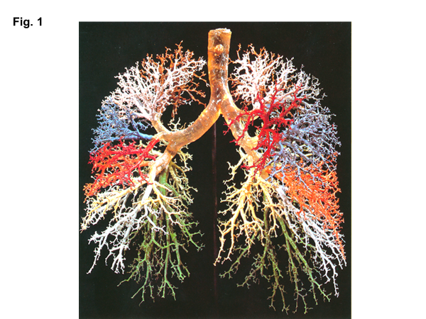

Figure 1 Resin cast of human lung. Complicated dichotomously-branching tree of conducting airways is exhibited. Adopted from ref^{[1]}.

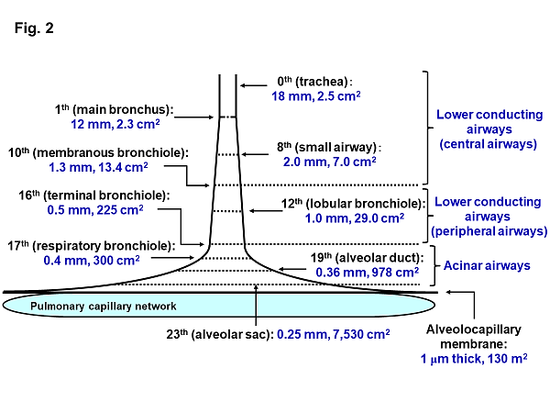
Figure 2 Schematic presentation of effective diameter and cross-sectional area along lower conducting airways and acinar airways (trumpet or thumbtack model). Generation of branching tree and diameter as well as cross-sectional area in each generation are obtained from model A of Weibel^{[2]}. Lower conducting airways are classified into two routes; i.e., central airways [generation from zero (trachea) to 9th] and peripheral airways (generation from 10th to 16th, in which 16th generation corresponds to terminal bronchiole). Peripheral airways are characterized by membrane bronchioles, whereas small airways are defined by their diameters of less than 2.0 mm originating in 8th generation. Airways from 17th generation (respiratory bronchiole) to 23th generation (alveolar sac) are not included in peripheral airways. Instead, they are treated as something else, being defined as acinar (alveolated) airways (acinus indicates that defined by Loeschke). This is because acinar airways have not only the function of carrying gas but also the function of gas exchange. Alveolar sacs end in alveoli formed by alveolar walls containing alveolocapillary membranes and capillary networks. Thickness of alveolocapillary membrane is about 1.0 μm and total cross-sectional area of alveolocapillary membrane and capillary network is about 130 m².

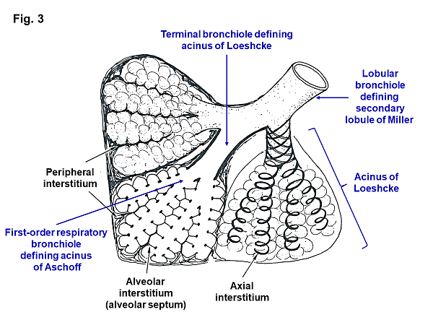
Figure 3 Secondary lobule and acinus. Secondary lobule of Miller is defined by area supplied by a lobular bronchiole while acinus of Loeschke by area supplied by a terminal bronchiole. Acinus of Aschoff is area supplied by a first-order respiratory bronchiole. Secondary lobule of Miller is surrounded by fibrous connective tissue forming interlobular septum. In acini of Loeschke and Aschoff, there are three important interstitial tissues, including peripheral interstitium, alveolar interstitium forming alveolar septum, and axial interstitium spirally surrounding airways, which begins at alveolar duct extending to hilum. Axial interstitium and alveolar interstitium are joined via intra-parenchymal interstitium and all interstitial tissues are in a serial linkage. Modified from ref^{[2]}.

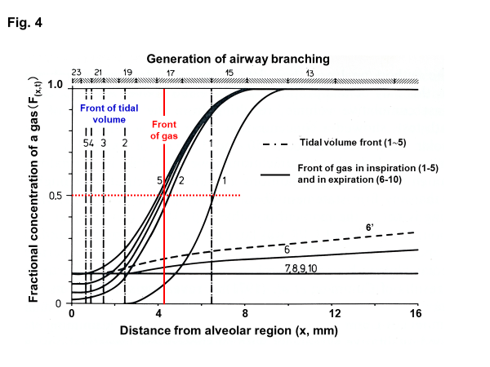
Figure 4 Concentration profiles along peripheral conducting airways and acinar airways during respiratory cycle in thumbtack model. Upper abscissa: generation of airway branching defined in model A of Weibel. Lower abscissa: axial distance from alveolar region. Ordinate: fractional concentration of the test gas. 100% O₂ is inhaled (single breath) into, and then exhaled from, initially O₂-free lung with constant flow (tidal volume: 500 mL) and constant lung volume (FRC: 3000 mL). O₂ is assumed to be not absorbed into capillary blood (i.e., no gas exchange). Solid curves (black) indicate concentration profiles at successive equally timed periods during inspiration (1-5) and expiration (6-10). Dashed dotted lines (1-5) are tidal volume fronts (i.e., concentration fronts of non-diffusible tracer gas) during inspiration. Dashed line (6’) is concentration profile calculated on assumption of no axial diffusion during expiratory phase corresponding to time point of solid line of 6. Red solid line denotes “imaginary” boundary between common dead space and alveolar region conceptualized in classical gas-exchange theory. Boundary is defined by stationary gas front converting diffusional effect into equivalent convectional effect, which is formed at entrance of acinus of Aschoff (17th generation of branching tree). See text for detailed explanation. Modified from ref^{[46]}.

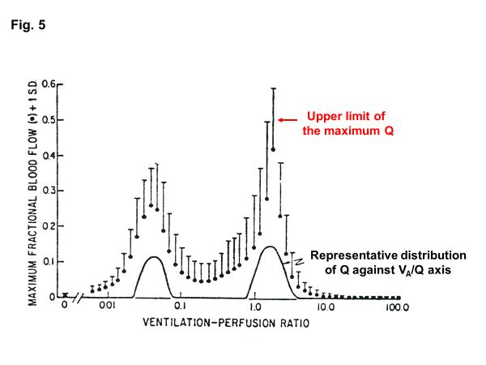
Figure 5 Range of solution for V_{A}/Q distribution recovered from MIGET. Comparison between representative Q distribution obtained from MIGET in terms of least-squares minimization and maximum Q distribution decided by linear programming. Adopted from ref^{[70]}.

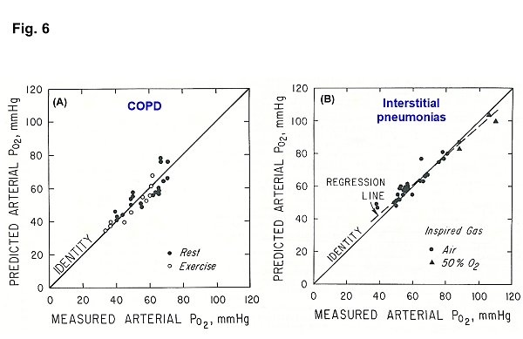
Figure 6 Comparison of predicted P_{aO2} from MIGET and measured P_{aO2.} A: COPD at rest or during exercise; B: Interstitial pneumonias at rest while inspiring gas with 21% O₂ (room air) or 50% O₂. Adopted from ref^{[76]}.

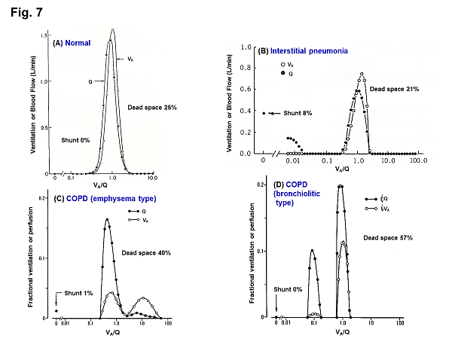
Figure 7 Representative V_{A}/Q distributions predicted from MIGET in various types of lung diseases. A: Young normal subject; B: Patient with interstitial pneumonia; C: COPD patient with predominant emphysema; D: COPD patient with predominant bronchiolitis. See text for detailed explanation. Adopted from ref^{[59]}.

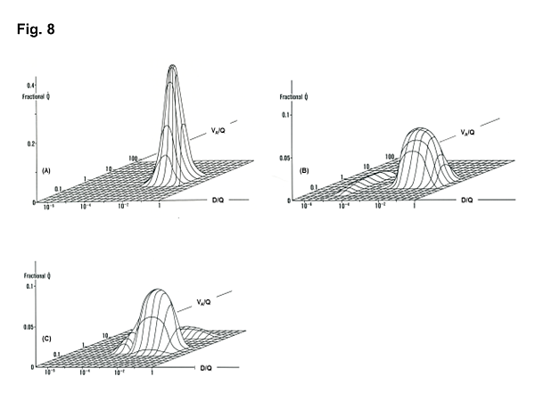
Figure 8 V_{A}/Q-D/Q distributions in normal and diseased lungs. A: V_{A}/Q and D/Q distribution in normal lung; B: that in lung with desquamative interstitial pneumonia (DIP); C: that in lung with COPD characterized by emphysema. Patient with DIP (B) revealed minimal V_{A}/Q heterogeneity but very low D/Q regions that may yield “diffusion shunt” contributing to hypoxemia. Very low D/Q regions may be caused by deceased surface area and/or increased thickness of alveolocapillary membrane. Patient with COPD (C) showed V_{A}/Q heterogeneity with high V_{A}/Q regions but minimal regions with very low D/Q. Modified from ref^{[80]}.

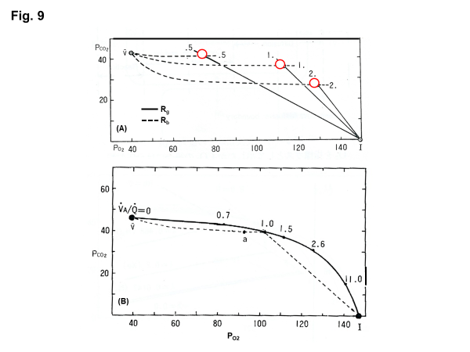
Figure 9 O₂-CO₂ diagram and V_{A}/Q line. A: O₂-CO₂ diagram, in which solid and dotted lines indicate gas R lines (R_{g}) and blood R lines (R_{b}), respectively. Intersect of these two lines denoted by red circle provides single V_{A}/Q value and corresponding unique pair of P_{O2} and P_{CO2}; B: V_{A}/Q line constructed by connecting each intersection of R_{g} and R_{b}. I: Inspired point; a: Arterial point; v: Mixed venous point. See text for further explanation. Adopted from ref^{[87]}.

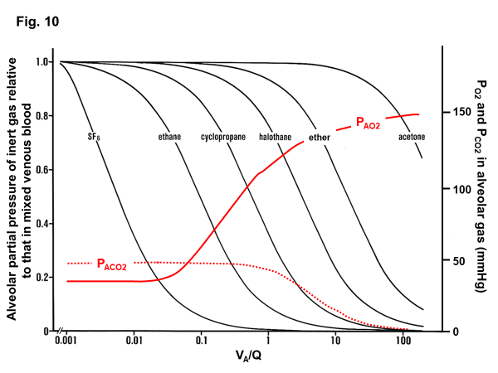
Figure 10 V_{A}/Q regions detected from gas exchange behaviors of O₂, CO₂, and inert gases. Left ordinate: excretion (E) of inert gas defined as P_{A}/P_{v}, where P_{A} is partial pressure of inert gas in each functional gas-exchange unit, while P_{v} is that in mixed venous blood. Right ordinate: P_{AO2} and P_{ACO2} in each functional gas-exchange unit. Abscissa: logarithmic V_{A}/Q value. E of each inert gas sharply changes in a certain range of V_{A}/Q depending on its blood-gas partition coefficient (λ). For instance, sharp change in E for SF₆ is found at V_{A}/Q ranging between 0.001 and 0.01. As such, SF₆ has high sensitivity to detecting gas exchange in regions with very low V_{A}/Q. On the other hand, E for acetone sharply changes at V_{A}/Q ranging from 10 to 100, indicating that acetone is susceptible to gas exchange in regions with very high V_{A}/Q. P_{AO2} changes greatly at V_{A}/Q ranging between 0.1 and 1.0, suggesting that O₂ has sensitivity to detecting gas exchange in regions with moderately low V_{A}/Q (like cyclopropane). Meanwhile, CO₂ is susceptible to gas exchange in regions with moderately high V_{A}/Q ranging from 1.0 to 10 (like halothane).
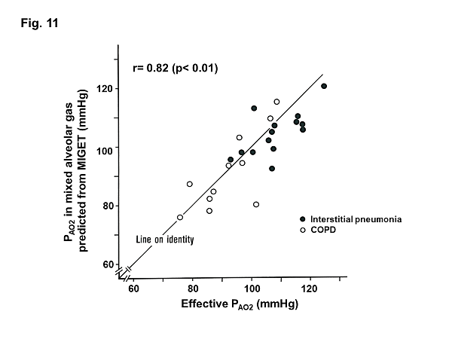
Figure 11 Comparison of effective P_{AO2} and P_{AO2} in mixed alveolar gas estimated from V_{A}/Q distribution decided by MIGET. Effective P_{AO2} and P_{AO2} estimated from MIGET were compared [patients with interstitial pneumonia (n = 14) and COPD (n = 11)]. Coincidence of two P_{AO2} is satisfactory. See text for further explanation.

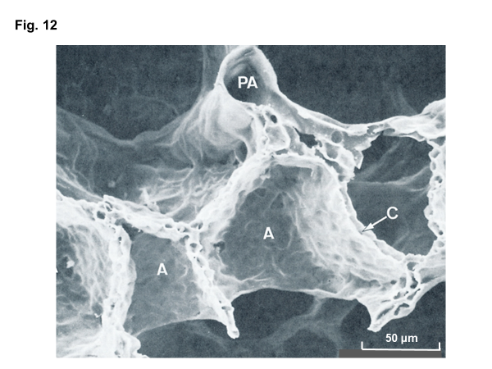
Figure 12 Scanning electron microscopic image of perfusion-fixed alveolar walls. PA: Pulmonary arteriole; A: Alveolar walls, C: Capillary networks embedded in alveolar wall. Adopted from ref^{[25]}.

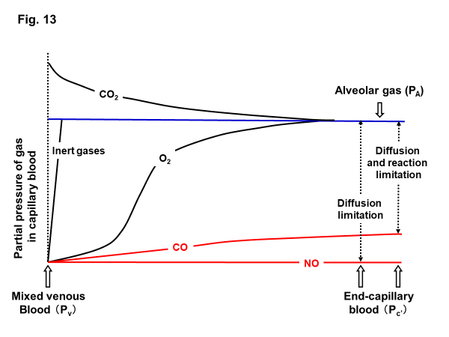
Figure 13 Partial-pressure equilibration of gases between alveolar gas and capillary blood. Inert gases that are not combined with erythrocyte Hb show instantaneous equilibration between alveolar gas and capillary blood. O₂ and CO₂ that have relatively low affinity with Hb need some time for completing equilibration between alveolar gas and capillary blood. CO and NO (red lines) that have very high affinity with Hb prevent rise in their partial pressures in capillary blood. Hence, CO and NO do not reach partial-pressure equilibration between alveolar gas and capillary blood any more even in normal lung. Affinity of NO with Hb is extremely high and chemical reaction of NO with Hb is very rapid such that partial pressure of NO in capillary blood is maintained at negligible level. Therefore, there is no “back-pressure” effect during measurement of D_{LNO}. However, affinity of CO with Hb is lower than that of NO (i.e., 1/1,800 times that of NO). Therefore, partial pressure of CO in capillary blood rises gradually such that “back-pressure” of CO from capillary blood should not be ignored while measuring D_{LCO}.

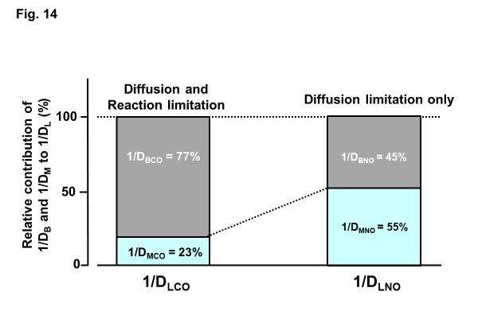
Figure 14 Relative contribution of 1/D_{M} and 1/D_{B} to overall resistance of 1/D_{L}. Difference in membrane diffusing capacity for CO (D_{MCO}) and that for NO (D_{MNO}) is simply attributed to difference in their Krogh diffusion constants defined as (α⋅d), where α is Bunsen solubility coefficient of the gas (mL/mL/atm) and d is gas diffusivity (cm²/sec) in alveolocapillary membrane and plasma layer. D_{MNO}/D_{MCO} is assumed to be 1.97^{[65]}. On the other hand, blood diffusing capacity for CO (D_{BCO}) or NO (D_{BNO}) is defined as alveolar capillary blood volume (V_{C}) multiplied by specific gas conductance of each gas (θ_{CO}, θ_{NO}). θ_{CO} signifies the diffusive process across erythrocyte membrane and its interior incorporated with the competitive, replacement reaction of CO with HbO₂. Therefore, θ_{CO} changes significantly depending on surrounding P_{O2}. On the other hand, θ_{NO} is not influence by chemical reaction with Hb and is decided predominantly by diffusion across erythrocytes, thus resulting in constant θ_{NO} [4.5 mL/min/mmHg/(mL⋅blood)^{[65,93]}. Since the reciprocal of D_{M} and D_{B} are gas-transfer resistance that is connected in series, total resistance for gas transfer, 1/D_{L}, is expressed as 1/D_{L} = 1/D_{M} + 1/D_{B}. Relative contribution of 1/D_{M} and 1/D_{B} to 1/D_{L} was estimated using data obtained from simultaneous measurements of D_{LCO} and D_{LNO}^{[93]}. Conclusions derived therefrom are that contribution of 1/D_{MCO} and 1/D_{BCO} to 1/D_{LCO} is, respectively, 23% and 77%, while that of 1/D_{MNO} and 1/D_{BNO} to 1/D_{LNO} is, respectively, 55% and 45%. These facts suggest that D_{LCO} is primarily governed by both diffusion through alveolocapillary membrane and erythrocytes as well as reaction in erythrocytes (limitation by both diffusion and reaction), whereas D_{LNO} is almost evenly prescribed by diffusion through alveolocapillary membrane and that inside erythrocytes (diffusion limitation only). Important message drawn from this analysis is that D_{LNO} is evenly sensitive to morphological abnormality in alveolocapillary membrane as well as that in pulmonary microcirculation. On the other hand, D_{LCO} is more sensitive to microcirculatory abnormality. Adopted from ref^{[65]}.

