Name of Journal: World Journal of Clinical Cases
Manuscript NO: 75959
Manuscript Type: CASE REPORT

Considerations of single-lung ventilation in neonatal thoracoscopic surgery with cardiac arrest caused by bilateral pneumothorax: A case report

Zhang X et al. Neonatal cardiac arrest caused by pneumothorax

Xu Zhang, Hai-Cheng Song, Kui-Liang Wang, Yue-Yi Ren

Xu Zhang, Hai-Cheng Song, Kui-Liang Wang, Yue-Yi Ren, Department of Heart Center, Women's and Children's Hospital Affiliated to Qingdao University, Qingdao 266034, Shandong Province, China

Author contributions: Zhang X and Ren YY, the patient’s anesthesiologists, acquired the patient consent, and drafted and revised the manuscript; Wang KL and Song HC took responsibility for investigation and data curation; all authors read and approved the final manuscript.

Corresponding author: Yue-Yi Ren, MD, Associate Chief Physician, Associate Professor, Department of Heart Center, Women's and Children's Hospital Affiliated to Qingdao University, No. 217 Liaoyang West Road, Shibei District, Qingdao 266034, Shandong Province, China. xxgmz1173@126.com

Received: February 23, 2022
Revised: March 29, 2022
Accepted: June 18, 2022
Published online: July 26, 2022

Abstract
BACKGROUND
Tension pneumothorax of the contralateral lung during single-lung ventilation (SLV) combined with artificial pneumothorax can cause cardiac arrest due to bilateral pneumothorax. If not rapidly diagnosed and managed, this condition can lead to sudden death. We describe the emergency handling procedures and rapid diagnostic methods for this critical emergency situation.

CASE SUMMARY
We report a case of bilateral pneumothorax in a neonatal patient who underwent thoracoscopic esophageal atresia and tracheoesophageal fistula repair under the combined application of SLV and artificial pneumothorax. The patient suffered sudden cardiac arrest and received emergency treatment to revive her. The recognition of dangerous vital sign parameters, rapid evacuation of the artificial pneumothorax, and initiation of lateral position cardiopulmonary resuscitation while simultaneously removing the endotracheal tube to the main airway are critically important. Moreover, even though the sinus rhythm was restored, the patient’s continued tachycardia, reduced pulse pressure, and depressed pulse oximeter waveform were worrisome. We should highly suspect the possibility of pneumothorax and use rapid diagnostic methods to make judgment calls. Sometimes thoracoscopy can be used for rapid examination; if the mediastinum is observed to be shifted to the right, it may indicate tension pneumothorax. This condition can be immediately relieved by needle thoracentesis, ultimately allowing the safe completion of the surgical procedure.

CONCLUSION
Bilateral pneumothorax during SLV combined with artificial pneumothorax is rare but can occur at any time in neonatal thoracoscopic surgery. Therefore, anesthesiologists should consider this possibility, be alert, and address this rare but critical complication in a timely manner.

Key Words: Neonatal thoracoscopic surgery; Bilateral pneumothorax; Single-lung ventilation; Cardiac arrest; Case report

©The Author(s) 2022. Published by Baishideng Publishing Group Inc. All rights reserved.

Citation: Zhang X, Song HC, Wang KL, Ren YY. Considerations of single-lung ventilation in neonatal thoracoscopic surgery with cardiac arrest caused by bilateral pneumothorax: A case report. World J Clin Cases 2022; 10(21): 7592-7598
URL: https://www.wjgnet.com/2307-8960/full/v10/i21/7592.htm
DOI: https://dx.doi.org/10.12998/wjcc.v10.i21.7592

Core Tip: Tension pneumothorax on the contralateral lung during single-lung ventilation (SLV) combined with artificial pneumothorax can lead to cardiac arrest due to bilateral pneumothorax. If not rapidly diagnosed and managed, it can lead to sudden death. Bilateral pneumothorax during SLV combined with artificial pneumothorax is rare but can occur at any time in neonatal thoracoscopic surgery. We describe the emergency handling procedures and rapid diagnostic methods for this critical emergency situation.

INTRODUCTION
The thoracoscopic repair of esophageal atresia (EA) and tracheoesophageal fistula (TEF) has gained increased acceptance, but it is a highly technical and challenging procedure^{[1]}. To expand the surgical space, the nondependent lung is intentionally collapsed using surgically guided intrathoracic carbon dioxide (CO₂) insufflation (artificial pneumothorax, AP) combined with single-lung ventilation (SLV)^{[2]}. However, for neonates, the combination of these two approaches can potentially pose serious pathophysiological changes. The most common complications of thoracoscopic repair include the development of high airway pressure, hypoxemia and hypercapnia^{[3]}. The present case report details a neonatal patient who underwent thoracoscopic EA/TEF repair using the combination of AP and SLV, which was complicated by the development of bilateral pneumothorax and cardiac arrest.

CASE PRESENTATION
Chief complaints
A preterm female born at 36 wk gestation received nCPAP-assisted ventilation due to dyspnea, during which it was difficult to place an indwelling nasogastric tube.

History of present illness
The neonatal patient was delivered by cesarean section at 36 wk due to intrauterine distress and reduced flow in the umbilical artery. The patient gradually developed dyspnea for 10 min after birth, which was characterized by shortness of breath and cyanosis, and the neonate was then transferred to the Neonatal Intensive Care Unit (NICU). She was given nCPAP-assisted ventilation, during which it was difficult to place an indwelling nasogastric tube. Due to the history of amniotic fluid, EA was not excluded.

History of past illness
The patient had no history of other illnesses.

Personal and family history
The patient had no family history of illness.

Physical examination
The physical examination revealed a premature infant's appearance and poor physical development (height, 40 cm; weight, 1.93 kg), a blood pressure of 75/45 mmHg, a pulse rate of 140 beats per min, and a respiratory rate (RR) of 46 breaths/min. Her oxygen saturation on a pulse oximeter was 93% in room air.

Laboratory examinations
Blood tests showed an Hb level of 14.5 g/dL, hematocrit (Hct) of 75%, platelet count of 187 × 10⁹ cells/L, leukocyte count of 16.83 × 10⁹/L, and C-reactive protein of 5.68 mg/L. Other blood tests showed no significant abnormalities.

Imaging examinations
Upper gastrointestinal radiography (a small amount of contrast agent was injected through the orogastric tube) showed that the middle and upper esophagus was markedly dilated, the proximal blind end of the esophagus was located at the level of the third thoracic vertebra, and there was significantly less physiological gas accumulation in the abdomen (Figure 1). Chest computed tomography suggested neonatal pneumonia and no pleural effusion. Echocardiography showed no obvious abnormalities.

FINAL DIAGNOSIS
She was initially diagnosed with type III EA, which is the most common proximal EA, with a distal TEF.

TREATMENT
The patient underwent surgery on the third day after her birth. In preparation for thoracoscopic repair, the patient first was allowed to continue to spontaneously breathe during general anesthesia with 6% sevoflurane carried by 100% oxygen through a face mask. A 2.8-mm fiberoptic bronchoscope (FOB) was inserted into the airway orally through a swivel adaptor connected to the mask. The fistula was located proximal to the carina and trifurcation (Figure 2A). Then, a bougie was introduced into the left mainstem bronchus under the FOB (Figure 2B), and a 3.0 mm cuffed endotracheal tube (ETT) was positioned into the left mainstem bronchus using the bougie as a guide. We confirmed the SLV by chest auscultation, as the 2.8-mm FOB could not pass through the ETT. One milligram of rocuronium was then administered intravenously, left radial artery cannulation and right internal jugular vein catheterization were performed, and she was placed in the left lateral decubitus position. AP was established by insufflation of CO₂ into the right thoracic cavity at a pressure of 4 mmHg. Mechanical ventilation was conducted with a pressure control of 24 cmH₂O, a RR of 28 breaths/min, and a positive end expiratory pressure 3 cmH₂O.
The end-tidal CO₂ (ETCO₂) level continuously rose during surgery. When the operative procedure started at 1 h, the arterial partial pressure of CO₂ (PaCO₂) was 62 mmHg. The control pressure was gradually increased to 30 mmHg, and the AP pressure was reduced to 2 mmHg to meet the tidal volume requirements. Two hours into the operation, a further increase in the PaCO₂ to 85 mmHg prompted communication with the surgeon. At this time, the fistula was ligated, and the surgeon performed an end-to-end anastomosis during the operation.
The surgeon thought that the distance between the two ends of the esophagus was small, so the success rate of the operation was very high. To increase the tidal volume and RR, manual ventilation with 100% oxygen was instituted, which also washed out the retained CO₂ after two minutes of using recruitment maneuvering techniques. During the establishment of AP and CO₂ insufflation, the patient suffered sudden cardiac arrest, with her heart rate, arterial blood pressure and pulse oximeter suddenly flattening on the monitor.
The CO₂ in the right thoracic cavity was immediately evacuated by opening the trocar, and the surgeon initiated lateral cardiac compressions, with one palm against the child's back and by using two-finger anterior chest compressions. With an intravenous injection of 10 μg of epinephrine, a normal sinus heart rhythm was restored. However, the monitor showed an HR of 180 beats/min, an ABP of 53/47 mmHg with reduced pulse pressure, and a poor pulse oximetry waveform. Thoracoscopy showed that the mediastinal structures were shifted to the right, strongly indicating the presence of a left tension pneumothorax.
We examined the ETT and anesthesia breathing circuit and then removed the ETT from the main airway. Auscultation of bilateral lung breath sounds showed that the breath sounds on the left were weak, while the breath sounds on the right were strong. The right thoracoscopic incision was covered with gauze, and the patient was moved to the supine position. A needle thoracocentesis was performed with a 22 G intravenous indwelling needle in the second left interspace midclavicular line, which caused immediate improvement in the ABP and pulse oximeter waveforms. After approximately 50 mL of gas had been extracted, the indwelling needle was replaced with a standard chest drain. The patient's vital signs then returned to normal, with an ABP of 58/39 mmHg, a HR of 165 beats/min, and a pulse oximeter reading of 93%. With the restoration of stable hemodynamics, the thoracoscopy was converted to thoracotomy and was successfully completed.

OUTCOME AND FOLLOW-UP
After surgery, the patient was immediately transferred to the cardiac intensive care unit under endotracheal intubation. The chest X-ray revealed partial atelectasis of the left lung after the operation (Figure 3A). The patient was treated with positive pressure ventilation. The chest X-ray taken on the first postoperative day revealed good re-expansion of the left lung (Figure 3B). Bedside ultrasonography was performed, and no pleural effusion was found. The ETT was removed on the fifth postoperative day. Because the patient developed recurrent pneumothorax and pulmonary exudation, the air leakage persisted, and the patient's right chest tube was removed on the 12th day after the operation. The chest X-ray taken on the 13th postoperative day showed that a pneumothorax had developed again on the left side (Figure 3C); therefore, the left chest tube was not removed until the 15th postoperative day. Then, she was transferred out of the NICU. Postoperative upper gastrointestinal radiography showed that the surgical effect was good (Figure 3D). The patient had a repeat chest X-ray, which showed marked improvement, and she was subsequently discharged (Figure 3E).

DISCUSSION
Neonatal pneumothorax is an uncommon event during the perioperative period. There are many risk factors for pneumothorax in neonates, such as prematurity, neonatal respiratory distress syndrome, pneumonia and positive pressure ventilation^{[4]}. In the present case, the patient care was complicated by congenital pneumonia, and she received CPAP treatment before surgery. To expand the surgical space, we used a combination of AP and SLV. The methods available for neonatal SLV are limited^{[5]}. The smallest FOB (2.8 mm) available in our hospital was too thick to use the ETT. We chose a compromise method, by using the fiberoptic bronchoscope to guide the bougie into the left main bronchus and then through the bougie into the ETT. It can be more accurate to place the ETT into the left main bronchus in order to avoid the fistula. At the start of surgery, the patient was placed in the left lateral decubitus position with AP in the right lung and left SLV. Unexpectedly, she developed bilateral pneumothorax, which resulted in cardiac arrest. If right-sided AP was not used, the tension pneumothorax on the left may not have led to sudden cardiac arrest. A possible cause of the left pneumothorax was the higher-pressure ventilation from the single bronchus intubation and SLV. Niwas et al^{[6]} reported that neonatal pneumothorax cases mainly occurred on the right side (72.5%), and 67% of these cases were related to endotracheal intubation of the single bronchus. Another potential cause was the use of intraoperative manual ventilation and continuous strong positive pressure ventilation with the consequent rupture of the left pulmonary alveoli, leading to a tension pneumothorax. In previous case reports, many cases of tension pneumothorax during SLV in adults have been associated with barotrauma^{[7]}. During SLV, the use of recruitment maneuvering techniques at high pressures can lead to barotraumatic and even contralateral tension pneumothorax^{[8]}. In addition, another possible cause was the use of an intubation bougie to guide single bronchus intubation. Literature reports have indicated that the use of intubation bougies in neonates may cause a pneumothorax. Kumar and Walker reported a case of pneumothorax as a result of airway perforation by using a bougie^{[9]}. Two other cases of neonatal pneumothorax reported by Parekh et al^{[10]} were suspected to be caused by trauma when a bougie is used to guide endotracheal intubation.
Normally, the clinical manifestations of tension pneumothorax in neonates receiving mechanical ventilation include immediate increased airway pressure, progressively decreased pulse oximeter readings, decreased heart rate, sometimes decreased or disappearing end tidal CO₂ concentrations, and loss of breath sounds of the affected side^{[11]}. However, some findings are generally considered to be reasonable in neonatal thoracoscopy, such as decreased HR, ABP, pulse oximeter readings, and a narrowing of pulse pressure. In this case, the patient developed tension pneumothorax and immediately experienced cardiac arrest. If the situation permits, in addition to auscultation, chest transillumination and lung ultrasound are also fast and effective methods for the diagnosis of pneumothorax^{[12,13]}.
In this case, the blood gas analysis of the patient showed that her PaCO₂ exceeded 85 mmHg and that she developed hypercapnia. By suspending the surgery, we increased the RR and tidal volume to quickly expel CO₂ from the alveolar spaces. Severe acidosis, mainly due to hypercapnia caused by the application of CO₂ to develop an AP, is a common feature and regarded as a significant drawback of neonatal thoracoscopy^{[14,15]}. However, several studies have shown that the decrease in SaO2 and pH and the increase in PaCO₂ are reversible during neonatal thoracoscopy and AP^{[14,15,16]}. The regional cerebral oxygen saturation (rSO₂) remained stable, suggesting no hampering of cerebral oxygenation by thoracoscopic surgery. In one study, further follow-up showed that neurodevelopmental outcomes of these neonates were favorable in the first 24 months^{[14]}. In general, no matter what happens to the other blood gas parameters, maintaining a normal rSO₂ is very important to prevent brain injury.
The cause of cardiac arrest in this patient was mediastinal displacement and compression of the heart and large blood vessels due to bilateral tension pneumothorax. We immediately started chest compressions with the patient in the lateral position and gave the patient an intravenous injection of epinephrine. At the same time, rapid evacuation of CO₂ and removal of the ETT in the main airway were also critically important. Moreover, even though a normal sinus rhythm was restored, the patient’s continued tachycardia, reduced pulse pressure, and depressed pulse oximeter waveform were still worrisome. In these types of cases should highly suspect the possibility of pneumothorax and use rapid diagnostic methods to make judgment calls. Sometimes thoracoscopy can be used for rapid examination; if the mediastinum is observed to have shifted to the right, tension pneumothorax may be present. This condition is immediately relieved by needle thoracentesis, which ultimately allows for safe completion of the surgical procedure.

CONCLUSION
Pneumothorax is rare but can occur at any time during neonatal thoracoscopic surgery. In addition to the common risk factors for neonatal pneumothorax, AP and SLV are two special risk factors that can lead to the possibility of bilateral pneumothorax. Therefore, anesthesiologists should consider and be alert to the occurrence of bilateral pneumothorax in neonatal thoracoscopic surgery. If not found and managed adequately in a rapid manner, the conditions can lead to cardiac arrest and sudden death.

REFERENCES
1 Wu Y, Kuang H, Lv T, Wu C. Comparison of clinical outcomes between open and thoracoscopic repair for esophageal atresia with tracheoesophageal fistula: a systematic review and meta-analysis. Pediatr Surg Int 2017; 33: 1147-1157 [PMID: 28914345 DOI: 10.1007/s00383-017-4153-9]
2 Kashyap L, Nisa N, Chowdhury AR, Khanna P. Safety issues of endobronchial intubation for one-lung ventilation in video-assisted thoracoscopic surgery in neonates: Can we extubate on the table? Saudi J Anaesth 2017; 11: 254-255 [PMID: 28442980 DOI: 10.4103/1658-354X.203058]
3 Zani A, Lamas-Pinheiro R, Paraboschi I, King SK, Wolinska J, Zani-Ruttenstock E, Eaton S, Pierro A. Intraoperative acidosis and hypercapnia during thoracoscopic repair of congenital diaphragmatic hernia and esophageal atresia/tracheoesophageal fistula. Paediatr Anaesth 2017; 27: 841-848 [PMID: 28631351 DOI: 10.1111/pan.13178]
4 Vibede L, Vibede E, Bendtsen M, Pedersen L, Ebbesen F. Neonatal Pneumothorax: A Descriptive Regional Danish Study. Neonatology 2017; 111: 303-308 [PMID: 28013308 DOI: 10.1159/000453029]
5 Schmidt C, Rellensmann G, Van Aken H, Semik M, Bruessel T, Enk D. Single-lung ventilation for pulmonary lobe resection in a newborn. Anesth Analg 2005; 101: 362-364 [PMID: 16037144 DOI: 10.1213/01.ANE.0000156007.97090.DA]
6 Niwas R, Nadroo AM, Sutija VG, Gudavalli M, Narula P. Malposition of endotracheal tube: association with pneumothorax in ventilated neonates. Arch Dis Child Fetal Neonatal Ed 2007; 92: F233-F234 [PMID: 17449860 DOI: 10.1136/adc.2006.106245]
7 Lee SK, Seo KH, Kim YJ, Youn EJ, Lee JS, Park J, Moon HS. Cardiac arrest caused by contralateral tension pneumothorax during one-lung ventilation: - A case report. Anesth Pain Med (Seoul) 2020; 15: 78-82 [PMID: 33329794 DOI: 10.17085/apm.2020.15.1.78]
8 Hoechter DJ, Speck E, Siegl D, Laven H, Zwissler B, Kammerer T. Tension Pneumothorax During One-Lung Ventilation - An Underestimated Complication? J Cardiothorac Vasc Anesth 2018; 32: 1398-1402 [PMID: 29361455 DOI: 10.1053/j.jvca.2017.07.022]
9 Sakhuja P, Ferenc BA, Fierens I, Garg A, Ratnavel N. Association of pneumothorax with use of a bougie for endotracheal intubation in a neonate. J Paediatr Child Health 2019; 55: 376 [PMID: 30828942 DOI: 10.1111/jpc.14383]
10 Parekh UR, Maguire AM, Emery J, Martin PH. Pneumothorax in neonates: Complication during endotracheal intubation, diagnosis, and management. J Anaesthesiol Clin Pharmacol 2016; 32: 397-399 [PMID: 27625498 DOI: 10.4103/0970-9185.188820]
11 Huang TJ, Ahmed A, D'Souza D, Awad H. Delayed diagnosis of contralateral tension pneumothorax during robotic lung wedge resection. J Clin Anesth 2018; 45: 30-31 [PMID: 29272756 DOI: 10.1016/j.jclinane.2017.11.023]
12 Sharma D, Murki S, Pratap T. Point of care in nursery to diagnose pneumothorax in neonates by new use of LED torch. Med Dr. D.Y. Patil Univers 2016; 9: 124-126 [DOI: 10.4103/0975-2870.167973]
13 Fei Q, Lin Y, Yuan TM. Lung Ultrasound, a Better Choice for Neonatal Pneumothorax: A Systematic Review and Meta-analysis. Ultrasound Med Biol 2021; 47: 359-369 [PMID: 33341304 DOI: 10.1016/j.ultrasmedbio.2020.11.011]
14 Bishay M, Giacomello L, Retrosi G, Thyoka M, Garriboli M, Brierley J, Harding L, Scuplak S, Cross KM, Curry JI, Kiely EM, De Coppi P, Eaton S, Pierro A. Hypercapnia and acidosis during open and thoracoscopic repair of congenital diaphragmatic hernia and esophageal atresia: results of a pilot randomized controlled trial. Ann Surg 2013; 258: 895-900 [PMID: 23604057 DOI: 10.1097/SLA.0b013e31828fab55]
15 Costerus S, Vlot J, van Rosmalen J, Wijnen R, Weber F. Effects of Neonatal Thoracoscopic Surgery on Tissue Oxygenation: A Pilot Study on (Neuro-) Monitoring and Outcomes. Eur J Pediatr Surg 2019; 29: 166-172 [PMID: 29270947 DOI: 10.1055/s-0037-1615277]
16 Tytgat SH, van Herwaarden MY, Stolwijk LJ, Keunen K, Benders MJ, de Graaff JC, Milstein DM, van der Zee DC, Lemmers PM. Neonatal brain oxygenation during thoracoscopic correction of esophageal atresia. Surg Endosc 2016; 30: 2811-2817 [PMID: 26490769 DOI: 10.1007/s00464-015-4559-1]

Footnotes
Informed consent statement: Written informed consent was obtained from the patient’s parent or guardian for publication of this case report and any accompanying images.

Conflict-of-interest statement: No conflict of interest exits in the submission of this manuscript, and manuscript is approved by all authors for publication.

CARE Checklist (2016) statement: The authors have read the CARE Checklist (2016), and the manuscript was prepared and revised according to the CARE Checklist (2016).

Open-Access: This article is an open-access article that was selected by an in-house editor and fully peer-reviewed by external reviewers. It is distributed in accordance with the Creative Commons Attribution NonCommercial (CC BY-NC 4.0) license, which permits others to distribute, remix, adapt, build upon this work non-commercially, and license their derivative works on different terms, provided the original work is properly cited and the use is non-commercial. See: https://creativecommons.org/Licenses/by-nc/4.0/

Provenance and peer review: Unsolicited article; Externally peer reviewed.
Peer-review model: Single blind

Peer-review started: February 23, 2022
First decision: March 25, 2022
Article in press: June 18, 2022

Specialty type: Anesthesiology
Country/Territory of origin: China
Peer-review report’s scientific quality classification
Grade A (Excellent): 0
Grade B (Very good): B
Grade C (Good): C
Grade D (Fair): D
Grade E (Poor): 0

P-Reviewer: Lee S, South Korea; Tajiri K, Japan S-Editor: Yan JP L-Editor: A P-Editor: Yan JP

Figure Legends
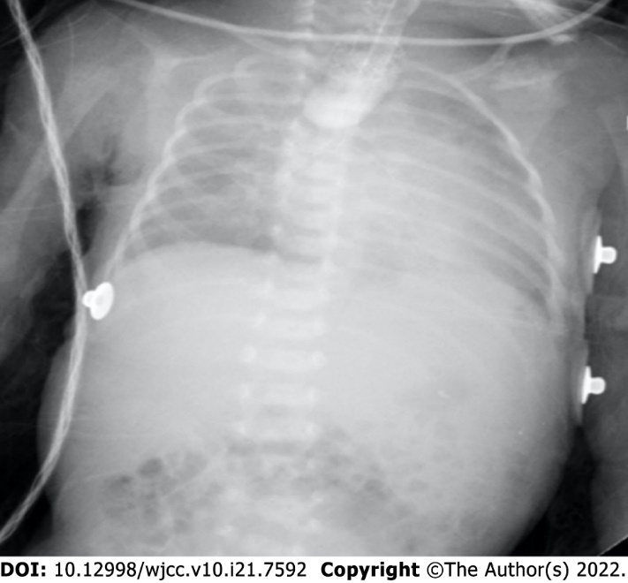

Figure 1 The preoperative upper gastrointestinal radiography.

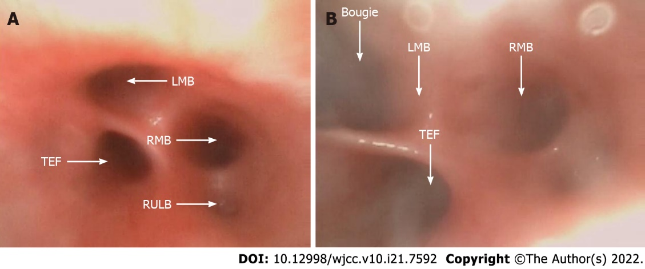

Figure 2 Fiberoptic bronchoscopy. A: The thick fistula was located proximal as a trifurcation at the carina; B: The bougie was introduced into the left mainstem bronchus under fiberoptic bronchoscopy. LMB: Left mainstem bronchus; RMB: Right mainstem bronchus; RULB: Right upper lobe bronchus; TEF: Tracheoesophageal fistula.

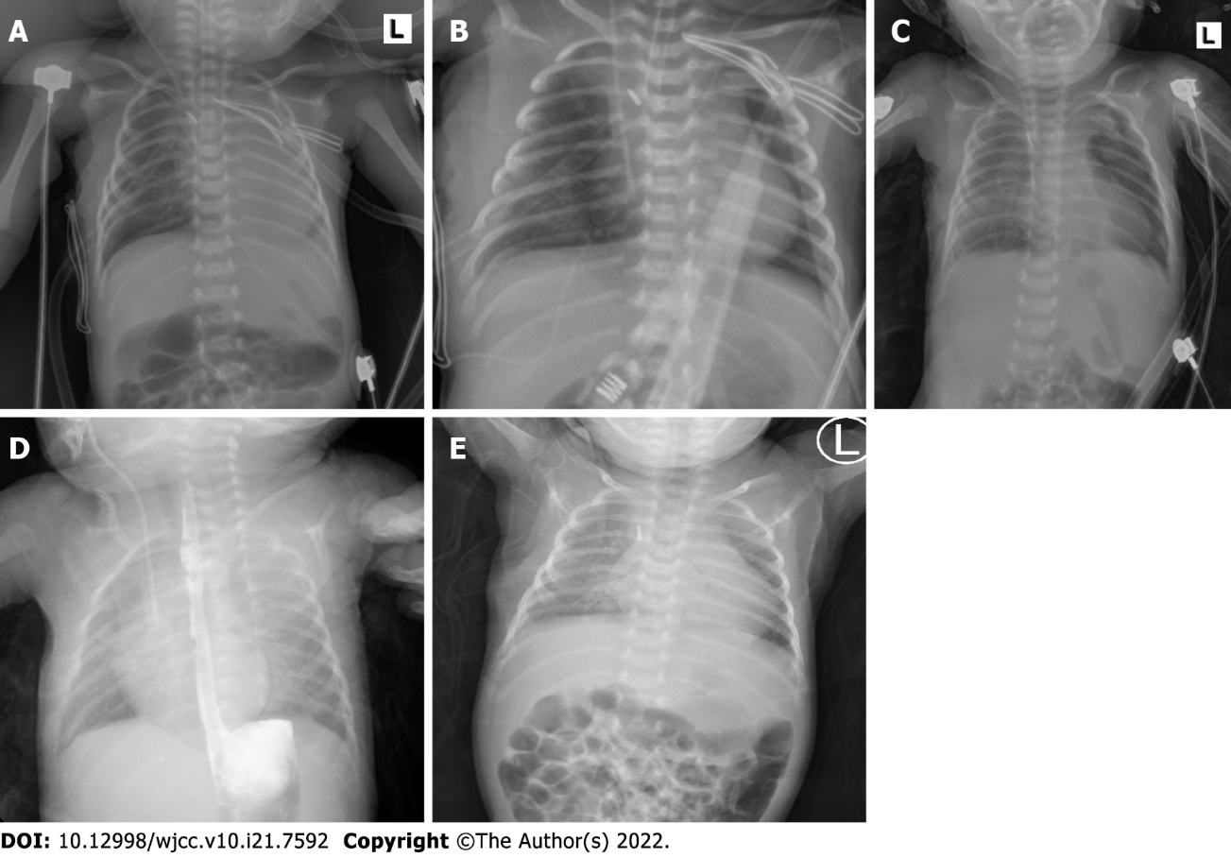
Figure 3 The chest X-ray images. A: The chest X-ray revealed partial atelectasis of the left lung after the operation; B: The chest X-ray taken on the first postoperative day revealed good re-expansion of the left lung; C: The chest X-ray taken on the 13th postoperative day revealed pneumothorax reappearing on the left; D: The postoperative upper gastrointestinal radiography showed that the operation effect was good; E: The chest X-ray before discharge showed marked improvement.

Published by Baishideng Publishing Group Inc
7041 Koll Center Parkway, Suite 160, Pleasanton, CA 94566, USA
Telephone: +1-925-3991568
E-mail: bpgoffice@wjgnet.com
Help Desk: https://www.f6publishing.com/helpdesk
https://www.wjgnet.com

© 2022 Baishideng Publishing Group Inc. All rights reserved.

