Name of Journal: World Journal of Stem Cells
Manuscript NO: 74043
Manuscript Type: LETTER TO THE EDITOR

Skinny people serum factors promote the differentiation of multipotent stem cells into brown adipose tissue

Gu YL et al. Sex hormones influence MSCs differentiation

Yuan-Long Gu, Wei Shen, Zhi-Peng Li, Bo Zhou, Zi-Jun Lin, Lian-Ping He

Yuan-Long Gu, Department of Interventional Oncology, Municipal Hospital Affiliated to Taizhou University, Taizhou 318000, Zhejiang Province, China

Wei Shen, Zhi-Peng Li, Bo Zhou, Zi-Jun Lin, Lian-Ping He, School of Medicine Taizhou University, Taizhou University, Taizhou 318000, Zhejiang Province, China

Author contributions: Shen W and Li ZP conceptualization, formal analysis; Zhou B, Li ZP and He LP writing of the original draft; Gu YL is responsible for writing, reviewing, and editing; all authors participated in drafting the manuscript and all have read, contributed to, and approved the final version of the manuscript.

Corresponding author: Yuan-Long Gu, MD, Resident, Department of Interventional Oncology, Municipal Hospital Affiliated to Taizhou University, No. 381 Zhongshan East Road, Jiaojiang District, Taizhou 318000, Zhejiang Province, China. ylgu@tzc.edu.cn

Received: December 12, 2021
Revised: January 21, 2022
Accepted: March 16, 2022
Published online: April 26, 2022

Abstract
The original study by Alessio et al reported that skinny people (SP) serum can promote the formation of brown adipocytes, but not the differentiation of white adipocytes. This finding may explain why SP do not often become obese, despite consuming more calories than the body needs. More importantly, they demonstrated that circulating factors in SP serum can promote the expression of UCP-1 protein, thereby reducing fat accumulation. In this study, only male serum samples were evaluated to avoid the interference of sex hormones in experiments, but adult males also synthesize estrogen, which is produced by the cells of the testes. At the same time, adult females secrete androgens, and females synthesize androgens that are mainly produced by the adrenal cortex. We believe that the approach of excluding sex hormone interference by sex selection alone may be flawed, so we comment on the article and debate the statistical analysis of the article.

Key Words: Androgen; Cytokine; Estrogen; Gender; Multipotent stem cell; Obesity

©The Author(s) 2022. Published by Baishideng Publishing Group Inc. All rights reserved.

Gu YL, Shen W, Li ZP, Zhou B, Lin ZJ, He LP. Skinny people serum factors promote the differentiation of multipotent stem cells into brown adipose tissue. World J Stem Cells 2022; 14(4): 314-317
URL: https://www.wjgnet.com/1948-0210/full/v14/i4/314.htm
DOI: https://dx.doi.org/10.4252/wjsc.v14.i4.314

Core Tip: Both men and women secrete estrogens and androgens. In females, androgens are mainly derived from the sites of the zona fasciculata and the zona reticularis in the adrenal cortex. In males, estrogens are produced by surrounding tissues, such as the skin, through the conversion of testosterone. Sex hormones in the serum can affect the differentiation and the stereotype of multipotent stem cells.

TO THE EDITOR
We have read with great interest the ingenious article written by Alessio et al^{[1]} published in World Journal of Stem Cells. Their valuable research explains why skinny people (SP) ingest more calories than the body needs while presenting normal body composition. They reasoned that the existence of certain factors in the serum of SP can promote the differentiation of multipotent stem cells (MSCs) towards brown adipocytes. After reading the article, we agreed that several issues are worthy of discussion. Here, we state our views and contribute to the debate.
Studies have shown that sex hormones, including estrogens and androgens, can affect the differentiation and commitment of MSCs^{[2]}. In a previous study, Alrabadi^{[3]} reported that androgen injections could increase aggressiveness, as well as the body weight of rats, indicative of an association between aggressiveness and body weight. Serum androgen levels in men are usually higher than those in women due to testosterone secretion by the cells of the testes. Androgens can affect body weight by affecting MSCs, and testosterone (a type of androgen) can induce skeletal muscle hypertrophy through a variety of mechanisms. For instance, testosterone can regulate the commitment and differentiation of MSCs. Furthermore, testosterone increases lean body mass and reduces fat mass in young men, and the magnitude of these changes is significantly correlated with testosterone concentration^{[4]}. Therefore, we suggest that the interference of androgen itself on MSC commitment and differentiation should be excluded as much as possible when studying cytokine stimulators of MSCs in the sera of adult males.
In men, estrogen exists in the plasma in a form with high biological activity, estradiol. Approximately 15% of the circulating estrogens are derived directly from the cells of the testes, and the remaining estradiol is derived from aromatase catalysis in peripheral tissues^{[5,6]}. Adult males secrete approximately 30-40 micrograms of estradiol per day, and accumulating evidence supports the key roles of this hormone in the regulation of male metabolism. In men, estradiol may be a stronger influencing factor of obesity than testosterone, and even short-term estradiol deprivation can lead to increased fat mass^{[4,6]}. Therefore, it is not ideal to eliminate the influence of sex hormones through gender selection, and we recommend that the authors expand the study by isolating and eliminating the interfering effects of sex hormones.
In the context of the global pandemic, there are no gender differences in overweight and obesity in most regions, except for a few developing areas with gender or ethnic differences^{[7,8]}. We suggest that the authors expand the female sample size and consider the following factors. Androgen synthesis also occurs in women, and androgens are synthesized by the adrenal cortex and ovary. The adrenal cortex is a major contributor of androgen synthesis in women (Figure 1), and the sites of androgen synthesis are the zona fasciculata and the zona reticularis in the adrenal cortex. The adrenal cortex’s ability to secrete androgens is maintained throughout life, with the organ mainly synthesizing dehydroepiandrosterone and androstenedione. Although their biological activity is weak, these hormones are converted into more active forms, where they function in the peripheral blood. More importantly, the active forms of androgens synthesized by the adrenal glands affect MSC commitment and differentiation, which in turn affects body weight and fat metabolism^{[9-11]}.
The study stated that serum samples were collected from 12 adult men with a normal body mass index. The author divided these men into two groups, namely, the SP group and the normal people (NP) group, with six samples in each group. Although the author stated that the daily calorie intake of the SP group exceeded 30%-40% of the body calorie requirement, we recommend that the author provide additional details on the individual diets.
Using the author’s data, we employed Power and Sample Size Calculation software (HyLown Consulting LLC Atlanta, GA, United States) for sample size estimation. We estimated the sample size of triglycerides to a type II error β of 0.2, that is, a power of 0.8 (1-β) and a first type error (α) of 5%. According to the data in Table 1, which reported the clinical parameters, the mean concentrations of triglycerides in NP and SP groups were 79.2 mmol/L and 98.1 mmol/L, respectively, the sample ratio was 1, and the standard deviation(σ) was 22. According to our calculation, the theoretical conservative estimate of the sample size of each group should be at least 22 cases, while the sample size of each group in this study was only 6 cases. Thus, we believe that the statistical power of this study was low, and we suggest that the author expand the study by increasing the sample size.

REFERENCES
1 Alessio N, Squillaro T, Monda V, Peluso G, Monda M, Melone MA, Galderisi U, Di Bernardo G. Circulating factors present in the sera of naturally skinny people may influence cell commitment and adipocyte differentiation of mesenchymal stromal cells. World J Stem Cells 2019; 11: 180-195 [PMID: 30949296 DOI: 10.4252/wjsc.v11.i3.180]
2 Hong L, Sultana H, Paulius K, Zhang G. Steroid regulation of proliferation and osteogenic differentiation of bone marrow stromal cells: a gender difference. J Steroid Biochem Mol Biol 2009; 114: 180-185 [PMID: 19429449 DOI: 10.1016/j.jsbmb.2009.02.001]
3 Alrabadi N, Al-Rabadi GJ, Maraqa R, Sarayrah H, Alzoubi KH, Alqudah M, Al-U'datt DG. Androgen effect on body weight and behaviour of male and female rats: novel insight on the clinical value. Andrologia 2020; 52: e13730 [PMID: 32629528 DOI: 10.1111/and.13730]
4 Herbst KL, Bhasin S. Testosterone action on skeletal muscle. Curr Opin Clin Nutr Metab Care 2004; 7: 271-277 [PMID: 15075918 DOI: 10.1097/00075197-200405000-00006]
5 Nelson LR, Bulun SE. Estrogen production and action. J Am Acad Dermatol 2001; 45: S116-S124 [PMID: 11511861 DOI: 10.1067/mjd.2001.117432]
6 Rubinow KB. Estrogens and Body Weight Regulation in Men. Adv Exp Med Biol 2017; 1043: 285-313 [PMID: 29224100 DOI: 10.1007/978-3-319-70178-3_14]
7 An R, Shen J, Bullard T, Han Y, Qiu D, Wang S. A scoping review on economic globalization in relation to the obesity epidemic. Obes Rev 2020; 21: e12969 [PMID: 31724312 DOI: 10.1111/obr.12969]
8 Chang E, Varghese M, Singer K. Gender and Sex Differences in Adipose Tissue. Curr Diab Rep 2018; 18: 69 [PMID: 30058013 DOI: 10.1007/s11892-018-1031-3]
9 Mauvais-Jarvis F, Clegg DJ, Hevener AL. The role of estrogens in control of energy balance and glucose homeostasis. Endocr Rev 2013; 34: 309-338 [PMID: 23460719 DOI: 10.1210/er.2012-1055]
10 Takao K, Iizuka K, Liu Y, Sakurai T, Kubota S, Kubota-Okamoto S, Imaizumi T, Takahashi Y, Rakhat Y, Komori S, Hirose T, Nonomura K, Kato T, Mizuno M, Suwa T, Horikawa Y, Sone M, Yabe D. Effects of ChREBP deficiency on adrenal lipogenesis and steroidogenesis. J Endocrinol 2021; 248: 317-324 [PMID: 33538705 DOI: 10.1530/JOE-20-0442]
11 Schnabl K, Westermeier J, Li Y, Klingenspor M. Opposing Actions of Adrenocorticotropic Hormone and Glucocorticoids on UCP1-Mediated Respiration in Brown Adipocytes. Front Physiol 2018; 9: 1931 [PMID: 30705635 DOI: 10.3389/fphys.2018.01931]

Footnotes
Conflict-of-interest statement: Each author has reviewed the statement by the Baishideng Publishing Group on conflict of interest, and each author states that there is no commercial, professional, or personal conflict of interest relevant to the study and hereby attests that it complies with the principles of publishing ethics.

Open-Access: This article is an open-access article that was selected by an in-house editor and fully peer-reviewed by external reviewers. It is distributed in accordance with the Creative Commons Attribution NonCommercial (CC BY-NC 4.0) license, which permits others to distribute, remix, adapt, build upon this work non-commercially, and license their derivative works on different terms, provided the original work is properly cited and the use is non-commercial. See: https://creativecommons.org/Licenses/by-nc/4.0/

Provenance and peer review: Invited article; Externally peer reviewed.
Peer-review model: Single blind

Peer-review started: December 12, 2021
First decision: January 12, 2022
Article in press: March 16, 2022

Specialty type: Biochemistry and molecular biology
Country/Territory of origin: China
Peer-review report’s scientific quality classification
Grade A (Excellent): A
Grade B (Very good): B
Grade C (Good): C
Grade D (Fair): D
Grade E (Poor): E

P-Reviewer: Gallone A, Italy; Prasetyo EP, Indonesia; Sallustio F, Italy; Silva-Junior AJD, Brazil; Ventura C, Italy S-Editor: Wu YXJ L-Editor: A P-Editor: Wu YXJ

Figure Legends
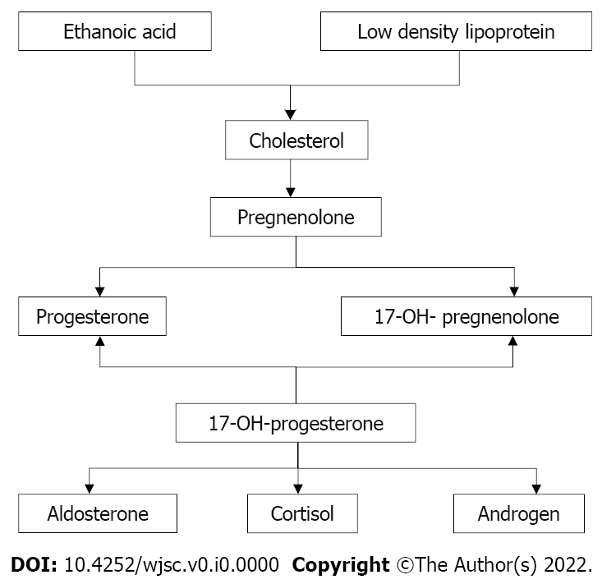
Figure 1 Schematic diagram of the major steps of corticosteroid synthesis in the adrenal glands. Cholesterol is the synthetic raw material for all steroid hormones, including those produced by the adrenal glands. Approximately 80% of the cholesterol that is synthesized is derived from low density lipoprotein (LDL) in the blood, and a small amount is synthesized from acetic acid in cortical cells. After cholesterol binds to the LDL receptor in the cortical cell membrane, it enters the cell and is stored in the form of cholesterol. Under the actions of cholesterol-associating enzymes, cholesterol is decomposed into free cholesterol, which is transported into mitochondria via transporters, converted into pregnenolone by cholesterol side chain lyase, and then further transformed into various cortical stimuli.

Table 1 Normal and skinny patient parameters
 | NP | SP
BMI (kg/m²) | 22.10 ± 1.10 | 20.50 ± 1.30
Glucose (mmol/L) | 84.8 ± 6.20 | 87.0 ± 5.80
Total cholesterol (mmol/L) | 190.6 ± 23.18 | 185.6 ± 20.12
LDL cholesterol (mmol/L) | 127.2 ± 21.10 | 130.6 ± 25.27
HDL cholesterol (mmol/L) | 59.3 ± 8.80 | 62.6 ± 12.14
Triglycerides (mmol/L) | 79.2 ± 22.40 | 98.1 ± 46.42
NP: Normal people; SP: Skinny people; BMI: Body mass index; LDL: Low density lipoprotein; HDL: High density lipoprotein.

Published by Baishideng Publishing Group Inc
7041 Koll Center Parkway, Suite 160, Pleasanton, CA 94566, USA
Telephone: +1-925-3991568
E-mail: bpgoffice@wjgnet.com
Help Desk: https://www.f6publishing.com/helpdesk
https://www.wjgnet.com

© 2022 Baishideng Publishing Group Inc. All rights reserved.

