Name of Journal: World Journal of Gastroenterology
Manuscript No.: 46756
Manuscript Type: OPINION REVIEW

Acute kidney injury spectrum in patients with chronic liver disease: Where do we stand?

Chancharoenthana W et al. AKI in chronic liver disease

Wiwat Chancharoenthana, Asada Leelahavanichkul

Wiwat Chancharoenthana, Immunology Unit, Department of Microbiology, Faculty of Medicine Chulalongkorn University, Bangkok 10330, Thailand

Asada Leelahavanichkul, Translational Research in Inflammation and Immunology Research Unit (TRIRU), Department of Microbiology, Faculty of Medicine Chulalongkorn University, Bangkok 10330, Thailand

ORCID number: Wiwat Chancharoenthana (0000-0002-2965-146X); Asada Leelahavanichkul (0000-0002-5566-6403).

Author contributions: Chancharoenthana W and Leelahavanichkul A searched and reviewed published articles and wrote the manuscript; Chancharoenthana W critically reviewed the article and made revisions to the manuscript; and both authors approved the final version of the article to be published.

Conflict-of-interest statement: All authors have no stated conflicts of interest related to this publication.

Open-Access: This article is an open-access article which was selected by an in-house editor and fully peer-reviewed by external reviewers. It is distributed in accordance with the Creative Commons Attribution Non Commercial (CC BY-NC 4.0) license, which permits others to distribute, remix, adapt, build upon this work non-commercially, and license their derivative works on different terms, provided the original work is properly cited and the use is non-commercial. See: http://creativecommons.org/licenses/by-nc/4.0/

Manuscript source: Invited manuscript

Corresponding author: Asada Leelahavanichkul, MD, PhD, Assistant Professor, Lecturer, Translational Research in Inflammation and Immunology Research Unit (TRIRU), Department of Microbiology, Faculty of Medicine Chulalongkorn University, 1873 Rama IV Road, Bangkok 10330, Thailand. asada.l@chula.ac.th
Telephone: +66-2-2564132
Fax: +66-2-2525952

Received: February 27, 2019
Peer-review started: February 27, 2019
First decision: April 30, 2019
Revised: June 13, 2019
Accepted: July 1, 2019
Article in press: July 3, 2019
Published online: July 28, 2019

Abstract
Acute kidney injury (AKI) is a common complication of liver cirrhosis and is of the utmost clinical and prognostic relevance. Patients with cirrhosis, especially decompensated cirrhosis, are more prone to develop AKI than those without cirrhosis. The hepatorenal syndrome type of AKI (HRS–AKI), a spectrum of disorders in prerenal chronic liver disease, and acute tubular necrosis (ATN) are the two most common causes of AKI in patients with chronic liver disease and cirrhosis. Differentiating these conditions is essential due to the differences in treatment. Prerenal AKI, a more benign disorder, responds well to plasma volume expansion, while ATN requires more specific renal support and is associated with substantial mortality. HRS–AKI is a facet of these two conditions, which are characterized by a dysregulation of the immune response. Recently, there has been progress in better defining this clinical entity, and studies have begun to address optimal care. The present review synopsizes the current diagnostic criteria, pathophysiology, and treatment modalities of HRS–AKI and as well as AKI in other chronic liver diseases (non-HRS–AKI) so that early recognition of HRS–AKI and the appropriate management can be established.

Key words: Acute kidney injury; Acute-on-chronic liver failure; Chronic liver disease; Hepatorenal syndrome; Plasma perfusion and bilirubin adsorption and double plasma molecular absorption system; Fractionated plasma separation and adsorption; Molecular adsorbent recycling system; Single-pass albumin dialysis

© The Author(s) 2019. Published by Baishideng Publishing Group Inc. All rights reserved.

Core tip: Acute kidney injury following advanced liver disease is a very common syndrome in clinical practice. Recent evidence from both basic research on pathophysiology and clinical studies has revealed a complex association between the liver and kidney through the vascular microenvironment and related immune mediators. These connections may play roles in promising new treatments of acute kidney injury on top of chronic liver disease. Furthermore, non-cell-based liver support systems have yielded promising preliminary data on the attenuation of the mortality rate of these conditions of dual organ failure.

Chancharoenthana W, Leelahavanichkul A. Acute kidney injury spectrum in patients with chronic liver disease: Where do we stand? World J Gastroenterol 2019; 25(28): 3684-3703
URL: https://www.wjgnet.com/1007-9327/full/v25/i28/3684.htm
DOI: https://dx.doi.org/10.3748/wjg.v25.i28.3684

INTRODUCTION
Acute kidney injury (AKI) superimposed on chronic liver disease and cirrhosis is common and consists of varying phenotypes. Prerenal renal dysfunction caused by severe hypoalbuminemia is the most common clinical syndrome in patients with advanced liver disease. Although prerenal azotemia seems to be the first phase of AKI, it is difficult to differentiate from hepatorenal syndrome (HRS) and acute tubular necrosis (ATN). Once the onset of AKI occurs in chronic liver disease, a consequence of its complications is an increased morbidity and mortality rate. Accordingly, the characteristics of renal dysfunctions in both noncirrhotic and chronic liver diseases, such as prerenal HRS-ATN, require not only earlier recognition but also precise diagnosis with optimal management. Recently, there have been great advances, including in classification, nomenclature, and pathophysiology, in identifying the connection between chronic liver disease and acute renal dysfunction in patients with cirrhosis. Indeed, acute-on-chronic liver failure (ACLF) was first recognized in the early 2000s as a new classification that represents the distinct characteristics of chronic liver failure (or decompensated cirrhosis) with rapid deterioration leading to hepatic and extrahepatic multiorgan failure^{[1,2]}. Since then, many efforts in natural history and pathophysiology have been made^{[3]}. Substantial advancements have been made not only in the field of hepatology but also in the understanding of the significance of renal dysfunction in chronic liver disease, as suggested by the international guideline that all acute renal dysfunction in patients with cirrhosis requires the same clinician attention as AKI^{[4]}.
Since the first description by Hecker and Sherlock in the 1960s, renal dysfunction in patients with ascites and advanced cirrhosis has typically been called HRS^{[2]}, which refers to a syndrome of decreased renal function mainly resulting from the systemic hemodynamic effects of advanced portal hypertension. However, advanced chronic liver disease can impact renal function with a wide range of complications, including bile acid nephropathy, coagulopathy-induced bleeding from ischemic ATN, related glomerular diseases (e.g., immunoglobulin, a nephropathy, hepatitis B-related glomerulonephritis, hepatitis C-related glomerulonephritis, cryoglobulinemia, membranoproliferative glomerulonephritis), and other comorbid diseases such as inherited cystic diseases. Herein, we review the updated information, including the etiology, pathophysiology, and therapeutic aspects, of renal dysfunction in advanced chronic liver disease.

NOMENCLATURE AND CLASSIFICATION OF ADVANCED LIVER DISEASES
The clinical spectrum of advanced liver disease is currently recognized as follows:

Chronic liver disease
Chronic liver disease is a progressive process of destruction and regeneration of liver parenchyma resulting in fibrosis and cirrhosis over a period of 24 wk (Figure 1) caused by inflammation, infection, abnormal metabolism, or malignancy. The functional classification of chronic liver disease can be divided into compensated and decompensated liver disease.

Acute-on-chronic liver failure
ACLF is liver failure with one or more extrahepatic organ failures, leading to an increased 28-d mortality rate within 3 mo of disease onset^{[5]}. However, there are currently at least 4 different definitions for ACLF in clinical practice: (1) the Asian Pacific Association for the Study of Liver (APASL); (2) the American Association for the Study of Liver Diseases (AASLD); (3) the European Association for the Study of the Liver (EASL) or AASLD-EASL; and (4) the World Gastroenterology Organization (WGO) definition (Table 1).
The first ACLF definition, given by the APASL in 2009, was “acute hepatic insult manifesting as jaundice, and coagulopathy complicated within 4 wk by ascites and/or encephalopathy in a patient with previously diagnosed or undiagnosed chronic liver disease”^{[6]}. Then, in 2014, the revised ACLF definition included the presentation of a high mortality rate within 28 d of disease onset (short-term mortality)^{[7]}. Later, the AASLD-EASL workgroup defined ACLF as “acute deterioration of preexisting chronic liver disease usually related to a precipitating event and associated with increased mortality at 3 mo due to multisystem organ failure”, based on the data from large prospective multicenter studies^{[8,9]}. After that, the WGO workgroup announced an improved ACLF definition: “a syndrome in patients with chronic liver disease with or without previously diagnosed cirrhosis which is characterized by acute hepatic decompensation resulting in liver failure (jaundice and prolonged international normalized ratio) and one or more extrahepatic organ failure that is associated with increased mortality within a period of 28 d and up to 3 mo from onset”^{[5]}. Interestingly, while the timeframe between the onset of acute liver injury and liver failure development (4 wk) is clear in the APASL definition, time intervals are not mentioned in the AASLD-EASL or the WGO definition.
In addition, there are some differences in ACLF definition regarding the underlying liver conditions of the patients. Patients with cirrhosis and non-cirrhosis (i.e., pre-cirrhotic) are included in the APASL and WGO but not in the AASLD-EASL definition. Patients with hepatic decompensation (previously or currently) are not included in the APASL definition, while they are included in the AASLD-EASL definition (which does not include noncirrhotic chronic liver disease). In parallel, the WGO definition includes both cirrhosis (compensated and decompensated) and noncirrhotic chronic liver disease.
Because ACLF can develop from: (1) Noncirrhotic liver disease (e.g., hepatitis B, alcohol-related chronic liver disease, and nonalcoholic fatty liver disease (NAFLD); (2) compensated cirrhosis with precipitating factors; and (3) decompensated cirrhosis, the WGO suggested that all patients with chronic liver disease (no cirrhosis, compensated cirrhosis, or decompensated cirrhosis) should be included in the ACLF definition and divided into types A (noncirrhotic chronic kidney disease), B (compensated cirrhosis), and C (decompensated cirrhosis)^{[5]} (Figure 1).

THE PARADIGM SHIFTS IN THE DEFINITION AND PATHOPHYSIOLOGY OF RENAL DYSFUNCTION IN LIVER DISEASE
The diagnostic criteria of AKI in patients with cirrhosis: an updated definition
Historically, AKI in patients with cirrhosis was often defined as HRS type 1 and type 2. HRS type 1 referred to AKI in cirrhosis with a relatively rapid progressive deterioration of renal function with serum creatinine (SCr) higher than 2.5 mg/dL for more than 2 wk, and HRS type 2 referred to AKI with slowly progressing renal function deterioration in cirrhosis with refractory ascites (SCr level of 1.5-2.5 mg/dL)^{[10]}. Because SCr is a less sensitive biomarker of AKI, with several pathophysiological limitations due to sarcopenia caused by hepatic injury (discussed later), the International Club of Ascites (ICA) recently proposed a new diagnostic criterion for HRS in 2015^{[4]}. Accordingly, the SCr > 2.5 mg/dL criterion was removed along with recommending HRS as another kind of AKI, called HRS–AKI. In addition, the 2-wk threshold for the diagnosis of HRS and its subtypes was removed. The ultimate changes to the diagnostic criteria from HRS to HRS-AKI are now in the context of “cirrhotic patients who develop AKI by detecting a change in absolute SCr level of ≥ 0.3 mg/dL or by an increase in SCr ≥ 50% from baseline within 48 h with a lack of volume expansion response without evidence of shock, recent exposure to nephrotoxic agents or preexisting structural renal disease”^{[4]} (Table 2).
In 2007, the Acute Kidney Injury Network (AKIN) proposed the guidelines for AKI-defining criteria^{[11]}, which were integrated into the ICA and the Acute Dialysis Quality Initiative (ADQI) in 2011^{[12]} (Table 3), because several validation studies on the AKIN criteria show the independent mortality association depending on the stage of renal injury^{[13-16]}. The most recently proposed guideline from Huelin et al^{[17]} suggests that stage 1 AKI should be divided into 2 phases, stage 1A (SCr < 1.5 mg/dL) and stage 1B (SCr > 1.5 mg/dL), because stage 1 AKI with SCr > 1.5 mg/dL shows a similar mortality rate as stage 2 AKI. However, further validation study is needed due to the unclear differences in baseline characteristics between stage 1A and stage 1B AKI, where the more severe liver dysfunction is shown in the latter group.

Hepatorenal syndrome–acute kidney injury: A changing of pathophysiologic definitions
The new definitions of advanced liver disease and AKI improve the understanding of the underlying pathophysiologic mechanisms in the liver and kidneys. HRS is currently not the only form of AKI in chronic liver disease. Indeed, a vast majority of AKI in chronic liver disease is not characterized as HRS, particularly in ACLF (Table 4).

Splanchnic vasodilatation
The progression of advanced chronic liver disease into liver cirrhosis (liver architecture disruption) results from splanchnic vasodilatation in response to increased intrahepatic resistance (portal hypertension) caused by several mediators, including nitric oxides, prostacyclin, carbon monoxide, epoxyeicosatrienoic acids, glucagon, endogenous cannabinoids, and adrenomedullin^{[18-24]}. In advanced cirrhosis, the loss of liver compensation that slows disease progression in the liver is due to progressive splanchnic vasodilatation (loss of the counteract vasoconstriction), leading to a decrease in the effective circulatory volume, reduced renal blood flow and AKI. This phenomenon simulates the renin-angiotensin-aldosterone system (RAAS) and vasopressin, which in turn cause more severe renal vasoconstriction and worsening renal hypoperfusion^{[25]}. Evidence of their functional nature was illustrated by measuring copeptin, a 39-amino-acid glycopeptide released from the neurohypophysis, and arginine vasopressin (AVP). The higher copeptin level is, the greater the risk of AKI and the worse the outcomes of decompensated cirrhosis^{[26]}. In addition, the deterioration of renal perfusion is caused by the alteration of renal blood flow autoregulation^{[27,28]}. Together, the current treatment concepts of HRS-AKI are reversing the physiological responses by improving the hemodynamic vascular bed using volume expansion (such as with albumin) together with splanchnic vasoconstrictors.

Role of inflammation
Systemic inflammation is one of the mechanisms responsible for decompensated cirrhosis because increased inflammatory cytokines are demonstrated in HRS-AKI (the late stage of cirrhosis). Advanced liver disease with spontaneous bacterial peritonitis (SBP) and renal insufficiency is characterized by high tumor necrosis factor (TNF)-α and interleukin (IL)-6 compared with advanced liver disease with normal renal function^{[29]}. Furthermore, patients with acute decompensated cirrhosis and difficult-to-treat HRS-AKI (persistent AKI) demonstrate higher interferon-inducible protein-10 and vascular cell adhesion molecule-1 compared to patients with treatment-responsive HRS-AKI^{[30]}. In addition, the growing evidence afforded by systems biology analysis has demonstrated a similar nature of inflammation in HRS-AKI in comparison with AKI in chronic non-hepatic conditions, such as lupus nephritis^{[30]}.

Adrenal insufficiency
Relative adrenal insufficiency is found in over 25%-30% of decompensated cirrhosis patients. Of note, adrenal insufficiency contributes to cardiomyopathy in cirrhosis patients via the downregulation of β-adrenergic receptors as well as the alteration of catecholamines’ effects on the systemic vascular tone^{[31]}. Furthermore, the presence of adrenal insufficiency in patients with stable decompensated cirrhosis is associated with poorer clinical characteristics, such as circulatory dysfunction, previous history of SBP, and worse survival rate^{[32]}.

Cardiac dysfunction
The impacts of advanced chronic liver disease on cardiac function and the systemic circulatory system are well known. Cirrhotic cardiomyopathy is a diminished cardiac contractile function with electrophysiological abnormalities in response to stress stimuli without preexisting cardiac disease^{[33]}. The emerging data reflect a liver-heart-kidney interaction. Cirrhotic cardiomyopathy arises from sustained portal hypertension, which increases the risk of bacterial translocation and portosystemic shunt. Bacterial translocation stimulates the production of systemic inflammatory cytokines and eventually causes endothelial dysfunction^{[34]}, while an increased portosystemic shunt decreases systemic vascular resistance by increasing nitric oxide, adenosine, bradykinin, and endocannabinoids^{[35]}. In addition, portal hypertension and splanchnic dilation activate the sympathetic nervous system and several neurohormones, including AVP, renin, and angiotensin, which affect heart function by increasing afterload and left ventricular end-diastolic pressure^{[36]}. Decreased cardiac output and increased right atrial pressure cause renal tissue hypoxia and venous congestion, respectively, leading to kidney injury and lower glomerular filtration rate^{[37]}. Accordingly, cardiac dysfunction in advanced chronic liver disease deteriorates renal function in HRS through a liver–heart–kidney connection, which is possibly related to a new model of therapeutic approaches to HRS^{[38]}.

Pathophysiology involved in AKI in other chronic liver diseases (non-HRS-AKI): An update of evidences
Role of inflammation, apoptosis, and cell death: Hepatic inflammation is a novel major component for the initiation and progression of liver injury^{[39]}. In chronic liver disease, hepatic inflammation is activated by several risk factors (i.e., systemic infection, gastrointestinal bleeding, alcohol, viral infection, etc.) resulting in (Figure 1): (1) Hepatocyte damage that delivering several damage-associated molecular patterns (DAMPs) from liver cells; and (2) gut immunity impairment that enhancing the translocation of pathogen-associated molecular pattern (PAMPs) from gut organisms^{[40]}. Subsequently, both DAMPs and PAMPs enhance the more severe liver damage (ALF, ACLF, and liver cirrhosis). Several liver associated DAMPs including IL-1, IL-33, high-mobility group box-1, and bile acid^{[41]} are recognized by several receptors [e.g., toll-like receptors (TLR)-4, TLR-9 and the receptor for advanced glycation end-products] on Kupffer cells (liver macrophages)^{[42]} resulting in the more enhanced hepatic damages (Figure 2).
In addition, the imbalance of inflammatory response in ACLF (a local inflammatory response) contributes to the systemic inflammatory response syndrome (SIRS) in different severity and subsequently turns into the compensatory anti-inflammatory response syndrome (CARS)^{[43]}. While SIRS relates to the excessive liver inflammation and extrahepatic organ dysfunction, CARS is a counter regulatory mechanism against the inappropriate hyper-inflammatory process. Overwhelming of activated monocyte function may contribute to AKI, compatible with those in septic AKI^{[44]}. In addition, Because macrophage polarization is related to pro- versus anti- inflammation, SIRS and CARS in ACLF might be associated with M1 and M2 macrophage polarization, respectively, of Kupffer cells in liver^{[45]}. Moreover, bone marrow-derived macrophage that was recruited into liver by the inflammatory-induced CCL2 and CCR5 chemokine expression might also be important in liver injury^{[45]}. Macrophage polarization and macrophage origin may be beneficial to the understanding in the inflammatory phase of liver injury (i.e., initiation, propagation and resolution)^{[46]}. The inhibition of Kupffer cells, the prevention of monocyte recruitment into liver, and the promotion of proper macrophage polarization might be the novel strategies for liver injury attenuation^{[47]}.
Systemic oxidative stress and several inflammatory cytokines (human nonmercaptalbumin 2, IL-6, and IL-8) are also higher in patients with ACLF compared to non-ACLF conditions^{[48]}. Similarly, the severity of ACLF is associated with apoptosis as determined by the apoptosis index [plasma caspase-cleaved keratin 18 (cK18; an apoptosis biomarker)/keratin 18 (K18; an indicator of total cell death)]^{[49]}, implying the influence of systemic inflammation and apoptosis in ACLF. Indeed, persistent infection (inflammatory activation) is an important risk factor in cirrhotic patients on the basis of the score of chronic liver failure-organ failure. Therefore, AKI superimposed in ACLF is associated with a 20% increase in mortality depending on AKI severity (more severe with SCr > 1.5 mg/dL)^{[9]}.

Role of bile acid: The limited responsiveness of terlipressin plus albumin treatment in HRS type 1 with high serum bilirubin (≥ 10 mg/dL) suggests the influence of bile acid in chronic liver disease^{[50]}. Indeed, the markedly elevated serum bilirubin in chronic liver disease induces bile cast nephropathy, a common renal pathology of AKI with severe liver dysfunction diagnosed from the presentation of intratubular bile casts by Hall histochemical staining, which are associated with irreversible AKI in chronic liver disease^{[51-53]}. In the less severe form of renal injury, bile acid accumulation in cirrhosis induces proximal tubulopathy mimicking Fanconi syndrome (low uric acid, low phosphate but high bile acid in serum) without bile cast nephropathy^{[51-53]}. Although serum bilirubin is an independent predictor of the therapeutic response of HRS, the precise role of bile cast nephropathy is still unclear.

Worsening portal hypertension: Markedly increased intrahepatic resistance is common in progressive ACLF patients and usually results in increased portal hypertension^{[54]}. This, in turn, may potentiate hepatorenal reflex disturbance, causing progressive AKI^{[27]}.

Worsening cardiac output: ACLF worsens cardiac functions through arterial vasodilation in the splanchnic area and peripheral circulation, which can be demonstrated in all stages of liver injury, from the early compensated stage to progressive liver decompensation to the late stage of HRS. The low cardiac output due to excessive vascular dilatation is counteracted by: (1) several vasoconstriction mediators (including the RAAS, vasopressin, and the sympathetic nervous system); and (2) vigorous salt and water balancing from renal homeostasis^{[55]}. Once cardiac function fails to compensate for arterial vasodilation, as determined by the low cardiac output and reduced systolic function, the more severe liver injury condition (late HRS) will develop due to the decreased effective circulating volume^{[56]}.

TREATMENT
General management
As discussed above, the points on the continuum of AKI disease in liver cirrhosis, i.e., prerenal azotemia-HRS-ATN (prerenal-HRS-ATN), are difficult to differentiate clearly. AKI management in a certain setting should focus on early recognition with an understanding of the individual patient’s clinical course (Figure 3). The disturbance of hemodynamics in cirrhosis patients is the principal cause of AKI that is precipitated by infection, abrupt onset of severe hyperbilirubinemia, gastrointestinal bleeding, over-diuresis, or nephrotoxic agents. All of these factors must be immediately identified and corrected in patients with advanced cirrhosis to prevent subsequent renal complications. An intravascular volume status assessment is an initial step for any AKI etiologies. Volume status assessment is challenging, particularly in cirrhosis, because the patients usually also have hyperdynamic circulation between a total-body hypervolemic state and a low effective circulatory volume status. Unfortunately, there is no effective monitoring tool for these patients. Central venous pressure monitoring not only has a poor correlation with the intravascular volume due to confounding effects from ascites but also is too invasive for the coagulopathy that is commonly found in chronic liver disease. Echocardiography for intravascular volume assessment depends solely on the determination of inferior vena cava size and variability, which relies mostly on operator expertise^{[57]}.
Although there is no advantage in mortality attenuation or AKI incidence when comparing albumin and crystalloids^{[58]}, albumin is usually the recommended volume expander in chronic liver disease due to albumin’s pleiotropic effects (anti-inflammatory and antioxidant properties)^{[59,60]}. Hydroxyethyl starch is contraindicated due to its associations with increased AKI and mortality rates^{[61]}. In addition, intravenous albumin administration at 1-1.5 and 1 g/kg on days 1 and 3, respectively, with antibiotics attenuates the mortality of SBP and the AKI incidence^{[62]}. In parallel, SBP prophylaxis with oral quinolones (norfloxacin 400 mg twice a day for 7 d) is recommended in the high-risk group (low protein in ascites fluid and previous history of SBP)^{[63]}, while intravenous ceftriaxone (1 g/d for 7 d) is more proper than oral quinolones in patients with active gastrointestinal bleeding^{[64]}. Further, patients with high serum bilirubin (> 20 mg/dL) (with an abrupt onset or long duration) may develop nephropathy due to jaundice or bile cast induction^{[52,65]}, and selective bilirubin removal might be beneficial^{[66]}.
Intravascular volume depletion due to excessive diuretic treatment (diuretic-induced AKI) is common. Furthermore, electrolyte disturbance, such as hyperkalemia from aldosterone antagonists or other potassium-sparing diuretics, may necessitate urgent renal replacement therapy, particularly in those with renal impairment. Hypokalemia, a precipitating factor of hepatic encephalopathy, is a frequent diuretic complication. Accordingly, diuretic administration should be reserved for patients with a hypervolemic state or marked ascites and should be avoided in those vulnerable to intravascular volume depletion. All nephrotoxic agents, such as radiological contrasts, need to be prescribed with caution. Sepsis is also a common condition that is found with decompensated cirrhosis^{[67]}. Organ failures such as AKI and acute respiratory distress syndrome may be a result of a high production of sepsis-induced proinflammatory cytokine production^{[67]}. Cirrhosis patients with AKI should undergo a full septic workup and be treated with empirical antibiotics. Measuring the appropriate markers for early sepsis might be beneficial, as mentioned in the setting of resuscitation guided by serum lactate^{[68,69]}. However, this approach remains controversial in advanced liver disease because of: (1) The poor lactic acid metabolism in liver diseases; and (2) the weak association between hyperlactatemia and tissue hypoperfusion^{[70]}.
Managements of HRS
If renal function does not improve after adequate volume expansion, HRS-AKI and non-HRS-AKI must be in line with the differential diagnosis and be further assessed with simultaneous treatment. The goal of HRS–AKI treatment is to optimize the cardiac output and mean arterial blood pressure (MAP). Although there was no significant difference in outcomes between targeting the higher MAPs (80-85 mmHg) compared with the lower MAPs (65-75 mmHg) in septic AKI^{[71]}, the most recent study revealed that AKI incidence was lowest among those whose postresuscitation MAP was closest to or higher than their preadmission MAP^{[72]}. Perhaps an individualized target MAP acts as a key marker for HRS-AKI. To increase the MAP and cardiac output, intravenous albumin administration along with systemic vasoconstrictors has shown promising outcomes. A number of systemic vasoconstrictors are used to counter splanchnic vasodilation, including a vasopressin analog (terlipressin)^{[73,74]}, an α-adrenergic agonist (norepinephrine)^{[75,76]}, and a combination of α-adrenergic agonist (midodrine) and somatostatin analog (octreotide)^{[77]}. The most recent meta-analysis demonstrates that: (1) The treatment of HRS type 1 with terlipressin plus albumin attenuates the short-term mortality; and (2) terlipressin plus albumin or noradrenaline plus albumin is superior to triple therapy with midodrine, octreotide and albumin^{[78]}. Regarding AKI outcome, terlipressin infusion gives an earlier and stronger response than noradrenaline, with a higher reversal rate of HRS (40% vs 17%) and a lower rate of renal support requirement (57% vs 80%)^{[79]}. Interestingly, the effectiveness of albumin depends on the cumulative administration dose, as a 100 g increase in cumulative albumin (max dose of 600 g albumin) increases the survival rate with a hazard ratio of 1.15 and a 95% confidence interval of 1.02-1.31^{[80]}. Because most HRS-AKI develops in an ACLF setting and is associated with inflammatory mediators, therapeutic strategies not only for hemodynamic restoration but also for the attenuation of systemic inflammation might represent a paradigm shift in the treatment, as demonstrated by the balancing of monocyte function^{[81]}. Recently, simvastatin, a well-known lipid-lowering agent, has demonstrated beneficial effects in an ACLF rat model with advanced chronic liver disease through the improvement of hepatic hemodynamics, microvascular dysfunction, and endotoxemia^{[82]}.

Roles of extracorporeal support systems
Compared with noncomplicated HRS-AKI, non-HRS-AKI and HRS-AKI in advanced ACLF have more morbidity and mortality because of their poor response to terlipressin and albumin. ACLF with ≥ 2 organ failures (ACLF grade 2-3) is associated with a 60%-75% rate of 28-d mortality^{[9]}, and therapies such as plasmapheresis that potentially ameliorate the ACLF severity by modulating the immune system may be an option. Currently, both renal and liver support in clinical studies have failed to have any survival advantage^{[83,84]}. Regarding the mode of hemodialysis, continuous renal replacement therapy (CRRT) does not improve mortality in comparison with intermittent hemodialysis; however, CRRT might be well tolerated in patients with unstable conditions, including fulminant hepatic failure, as it does not raise intracranial pressure^{[85]}. Indeed, the ADQI group recommends renal support only in cases with acute reversible components. Otherwise, renal support is not recommended in AKI-superimposed chronic liver disease, which is similar to the recommendation of limited utilization of liver support in liver transplantation^{[85]}. However, extracorporeal albumin dialysis may improve outcomes based on the clearance of excess bilirubin, bile acid, inflammatory cytokines, and endotoxins in systemic circulation^{[84]}. The extracorporeal liver support is currently divided into 2 kinds of systems.

Cell-based liver support systems (bioartificial liver support systems): The data on bioartificial liver support systems benefit in patients with ACLF are still limited and from uncontrolled studies with limited numbers of patients.

Non-cell-based liver support systems: There are two major modalities regarding to the non-cell-based liver support systems-plasma therapy and albumin dialysis. Plasma therapy comprises 4 subtypes of techniques: (1) Standard plasma exchange is a simple circuit (Figure 4) that enhances the elimination of inflammatory cytokines and endotoxins by using 1.2 L of plasma as fluid replacement. However, it has so far failed to show a confirmed survival advantage; (2) High-volume plasma exchange (HVP). Unlike standard plasma exchange, the HVP procedure uses a large amount of fresh-frozen plasma (approximately > 10 L of fresh-frozen plasma or 15%-20% of ideal body weight) as replacement fluid. The established technique was first used for immunologically driven disorders in the early 1990s^{[86]}. HVP decreases the vasopressor dose requirement in resuscitation and improves hepatic encephalopathy symptoms by decreasing blood ammonia and urea^{[87]}. A recent prospective, randomized study was conducted in 183 patients with acute liver failure, with approximately 2.4 treatments per patient and 9 h per treatment, and it demonstrated a slightly improved survival by an intention-to-treat analysis (59% vs 48%) and reduced circulating proinflammatory mediators [IL-6, TNF-α, DAMPs^{[88]} and soluble B7 (CD80/CD89)^{[89]}]. Unfortunately, there is no evidence on using HPV in ACLF so far. Further prospective studies are required to confirm these results in patients with acute liver failure and might be extended to patients with ACLF in the near future; (3) Plasma perfusion and bilirubin adsorption system and double plasma molecular absorption system, as shown in Figure 5. The fundamental mechanism in the plasma perfusion and bilirubin adsorption system is the separation of plasma that passes through an anion-exchange column (adsorbent), which has an adsorption effect on specific molecules (such as bilirubin, bile acid, and related similar molecular structures). Data from several studies showed a safe decrease in the plasma bilirubin concentration of approximately 18%-50% from baseline after one session^{[90,91]}. The double plasma molecular absorption system is more sophisticated than plasma perfusion and bilirubin adsorption, combining both with an adsorbent for the reduction in inflammatory mediators, drugs or toxins (Figure 5). Although the rationale for using these systems seems to be that they will improve our understanding of ACLF pathophysiology, most studies on the double plasma molecular absorption system are in patients with hepatitis B-related liver failure^{[92-94]}. In our experience, the double plasma molecular absorption system decreased bilirubin and ammonia 25%-30% from baseline after one treatment session in patients with ACLF and cancer (unpublished data). The reduction in hyperbilirubinemia in patients with sepsis-related ACLF was also demonstrated in our case series (unpublished data); (4) Fractionated plasma separation and adsorption (FPSA) (Prometheus®). FPSA, first introduced in 1999, is fractionated through an albumin-permeable filter with a cutoff of 250 kDa. Albumin and other plasma proteins cross the membrane and pass across 2 columns in a series—an anion-exchange column and a neutral resin adsorber. The cleansed albumin/plasma is returned to the standard blood pool circuit, where it is then treated by conventional high-flux hemodialysis (Figure 6). Clinical studies have evaluated the effect of FPSA in ACLF patients, with favorable outcomes, indicating that the use of FPSA is well tolerated and decreases the circulating levels of serum bilirubin, bile acids, and ammonia^{[95-100]}. However, the improvement of neurological status and hemodynamics following FPSA treatment is controversial^{[96,98]}. A prospective, randomized clinical trial (HELIOS study)^{[100]} conducted in 145 ACLF patients demonstrated that FPSA decreased serum bilirubin with nondifferent 28-d survival rates (66% vs 63%). The secondary endpoint showed a significant improvement in survival in ACLF patients using the cutoff of Model for End-Stage Liver Disease (MELD) score > 30. It should be emphasized that there is no further confirmatory study or any study in an acute liver failure setting so far.
Albumin dialysis has been classified as molecular adsorbent recycling system (MARS) and single plasma albumin dialysis (SPAD). Technically, MARS consists of 3 main circuits of the blood delivery system, albumin flow, and routine hemodialysis system (Figure 7). In the MARS circuit, blood is dialyzed through an albumin-saturated high-flux dialyzer with 20% human albumin (600 mL) and is used as the dialysate for carrying the albumin-bound toxins into the dialysate, where the water-soluble and albumin-bound toxins will be removed from albumin through 2 sequential adsorbent columns containing activated charcoal and anion-exchange resin. Then, the toxin-free albumin will be circulated in the circuit. The high-molecular-weight toxins (> 50 kDa) are not removed by MARS due to the dialyzer pore size limitation. The RELIEF study is the largest randomized trial using MARS in ACLF, with 189 patients from 19 European centers, and it demonstrated that undergoing up to ten 6-h to 8-h sessions of MARS was associated with the improvement of hepatic encephalopathy (from grade 2-4 to grade 0-1; 63% vs 38%, respectively; P = 0.07) without a 28-d survival benefit^{[101]}. Similarly, the FULMAR trial was a randomized controlled study using MARS in 102 patients with acute liver failure fulfilling transplant criteria and demonstrated no significant differences in 6-month survival between the MARS (85%) and standard medical treatment (76%) groups (P = 0.28)^{[102]}. However, the major confounder in the study was the short transplant waiting time [median 16.2 h, mostly within 24 h (75%)], which might be too short to see the benefit of liver support. Interestingly, neither MARS nor FPSA showed significant decreases in inflammatory markers (IL-6, IL-8, IL-10, and TNF-α) after the treatment session in a small study^{[103]}.
In contrast to MARS, SPAD uses a standard CRRT system without any additional columns (Figure 8). After a SPAD cycle is run, water-soluble toxins (ammonia, creatinine, urea, uric acid) are removed almost completely. Blood is dialyzed against a standard dialysis solution with the addition of albumin to the dialysate. The most effective albumin concentration was 3%. A further increase in the albumin concentration to 4% did not lead to a significant increase in the detoxification^{[104]}. However, SPAD increased the detoxification efficiency of albumin-bound substances from 350 mL/h to 700 mL/h (for bilirubin) or 1000 mL/h (for bile acids) of the dialysate flow in SPAD for the first time^{[104]}. Unfortunately, SPAD has been evaluated in a case-control fashion mostly in drug overdose-related liver failure, with controversial outcomes^{[105-107]}.

Roles of liver transplantation
So far, liver transplantation is the only treatment modality for the reversal of either HRS-AKI or non-HRS-AKI in an ACLF setting. Recently, a large retrospective study of liver transplantation in patients with either HRS-AKI or non-HRS-AKI in ACLF demonstrated that 1-year and 5-year survival rates were 91% and 77%, respectively. However, those with a renal injury background of either diabetes or hypertension showed a lower survival rate (1-year and 5-year survival at 87% and 71%, respectively)^{[108]}. Pretransplant AKI severity contributed as an important factor for renal function recovery at 4-6 wk posttransplantation. Thus, simultaneous liver-kidney transplantation should be considered in those with predicted renal recovery longer than 6 wk^{[85]}.

Roles of the novel monocytes and macrophage modulators
Regarding the high rate of mortality and limited treatment options for ACLF and AKI following ACLF; novel, robust therapies are needed.

Targeting liver macrophage: So far, unfortunately, none of proven macrophage-directed therapies has been recommended in ACLF although a number of immunomodulators including N-acetylcysteine, albumin and glucocorticoids are approved for other immune-related liver diseases^{[46]}. The limitation of knowledge is probably due to the limitation in retrieving human liver tissue and the differentiation process for liver macrophage in human^{[46]}.

Targeting inhibition of Kupffer cell activation: Inhibition of progression of the early phase of SIRS in ACLF could be attenuate the signal induction for Kupffer cell activation especially targeting to inhibit released DAMPs. Recent study demonstrated potential beneficial of HMGB-1 blockade treatment in rat with ACLF model through alleviating inflammation in SIRS^{[109]}. Likewise, the blocking responses against of histones (a DAMP) attenuated cytokine production and reduced liver injury severity^{[110]}. In addition, the prevention and treatment of bacterial translocation by appropriate antibiotics is the most effective attenuation of initial innate immune activation leading to the subsequently Kupffer cell inhibition^{[111]}.

Targeting inhibition of monocyte recruitment into the liver: The recruitment of monocytes into liver is mediated mainly through chemokine system including; CCL2-CCR2 and CCL5-CCR5 for the recruitment of monocyte and lymphocyte, respectively^{[112]}. As such, Cenicriviroc, an CCR2/CCR5 inhibitor, in a randomized, double-blind study in 289 patients with NAFLD and hepatic fibrosis demonstrated a reduction on fibrosis in treatment group (n = 145) compares with placebo (n = 144) (20% vs 10%) without the reduction of the primary endpoint (NAFLD activity score)^{[113]} supporting the animal model data^{[112]}.

Targeting promotion of macrophage differentiation: An early promotion of macrophage differentiation from activated macrophages phenotype into a pro-restorative phenotype (such as by corticosteroids) might enhance the resolution of liver injury^{[111]}. However, the data on macrophage differentiation treatment in ACLF is still too less. Corticosteroids might provides some advantages in the early phase of ACLF but possibly augment infectious complications in the late phase^{[114]}.

Roles of the novel granulocyte colony-stimulating factor therapy
ACLF is mainly mediated through immune dysfunction and is also susceptible to the serious infections. Accordingly, treatment by hematopoietic growth factor to induce immune cells seems reasonable to restore immune homeostasis through improving impaired phagocytosis^{[115]} and mobilization of CD34+ progenitor cells into liver^{[116]}. The first randomized placebo-controlled study in 2012 using granulocyte colony-stimulating factor (G-CSF) in patients with ACLF demonstrated an improved 60-d survival rate and a reduction in multiorgan injury on the basis of clinical scores, including those of the MELD and Sequential Organ Failure Assessment (66% vs 26%)^{[117]}. Likewise, G-CSF improved the 90-d mortality rate (78% vs 30%) in a randomized trial on 46 patients with ACLF^{[118]}. The largest study, on 55 patients with hepatitis B-related ACLF randomized to receive standard medical treatment or G-CSF in addition to standard medical treatment, again showed a significant benefit in the 90-d survival rate in the G-CSF-treated group (48% vs 28%)^{[119]}. Interestingly, the most recent randomized study in 32 patients with hepatitis B virus-ACLF showed that 5 μg/kg/day of G-CSF for six consecutive days in addition to the standard treatment, improves survival, facilitates clinical recovery, prevents renal failure and protects from hyponatremia^{[120]}.

CONCLUSION
AKI following advanced liver cirrhosis is a critical condition. The early recognition and rapid diagnosis of AKI in these patients may improve therapeutic outcomes. However, the understanding of the pathogenesis and the quality of the diagnostic tools for the simultaneous injury of the kidney and liver are still limited. A distinct diagnostic criterion for differentiating the points on the prerenal-HRS-ATN spectrum needs robust validation as well as an accurate distinction between HRS-AKI and non-HRS-AKI in ACLF. Inflammation is increasingly recognized as an important driver of AKI, particularly in patients with infection and multiorgan failure. As AKI in chronic liver disease is persistent and rapidly becomes irreversible by medical treatment as the condition prolongs, novel therapies and new approaches for either liver or renal support are required.

REFERENCES
1 Sen S, Williams R, Jalan R. The pathophysiological basis of acute-on-chronic liver failure. Liver 2002; 22 Suppl 2: 5-13 [PMID: 12220296 DOI: 10.1034/j.1600-0676.2002.00001.x]
2 Jalan R, Williams R. Acute-on-chronic liver failure: Pathophysiological basis of therapeutic options. Blood Purif 2002; 20: 252-261 [PMID: 11867872 DOI: 10.1159/000047017]
3 Olson JC, Kamath PS. Acute-on-chronic liver failure: Concept, natural history, and prognosis. Curr Opin Crit Care 2011; 17: 165-169 [PMID: 21326095 DOI: 10.1097/MCC.0b013e328344b42d]
4 Angeli P, Gines P, Wong F, Bernardi M, Boyer TD, Gerbes A, Moreau R, Jalan R, Sarin SK, Piano S, Moore K, Lee SS, Durand F, Salerno F, Caraceni P, Kim WR, Arroyo V, Garcia-Tsao G; International Club of Ascites. Diagnosis and management of acute kidney injury in patients with cirrhosis: Revised consensus recommendations of the International Club of Ascites. Gut 2015; 64: 531-537 [PMID: 25631669 DOI: 10.1136/gutjnl-2014-308874]
5 Jalan R, Yurdaydin C, Bajaj JS, Acharya SK, Arroyo V, Lin HC, Gines P, Kim WR, Kamath PS; World Gastroenterology Organization Working Party. Toward an improved definition of acute-on-chronic liver failure. Gastroenterology 2014; 147: 4-10 [PMID: 24853409 DOI: 10.1053/j.gastro.2014.05.005]
6 Sarin SK, Kumar A, Almeida JA, Chawla YK, Fan ST, Garg H, de Silva HJ, Hamid SS, Jalan R, Komolmit P, Lau GK, Liu Q, Madan K, Mohamed R, Ning Q, Rahman S, Rastogi A, Riordan SM, Sakhuja P, Samuel D, Shah S, Sharma BC, Sharma P, Takikawa Y, Thapa BR, Wai CT, Yuen MF. Acute-on-chronic liver failure: Consensus recommendations of the Asian Pacific Association for the study of the liver (APASL). Hepatol Int 2009; 3: 269-282 [PMID: 19669378 DOI: 10.1007/s12072-008-9106-x]
7 Sarin SK, Kedarisetty CK, Abbas Z, Amarapurkar D, Bihari C, Chan AC, Chawla YK, Dokmeci AK, Garg H, Ghazinyan H, Hamid S, Kim DJ, Komolmit P, Lata S, Lee GH, Lesmana LA, Mahtab M, Maiwall R, Moreau R, Ning Q, Pamecha V, Payawal DA, Rastogi A, Rahman S, Rela M, Saraya A, Samuel D, Saraswat V, Shah S, Shiha G, Sharma BC, Sharma MK, Sharma K, Butt AS, Tan SS, Vashishtha C, Wani ZA, Yuen MF, Yokosuka O; APASL ACLF Working Party. Acute-on-chronic liver failure: Consensus recommendations of the Asian Pacific Association for the Study of the Liver (APASL) 2014. Hepatol Int 2014; 8: 453-471 [PMID: 26202751 DOI: 10.1007/s12072-014-9580-2]
8 Olson JC, Wendon JA, Kramer DJ, Arroyo V, Jalan R, Garcia-Tsao G, Kamath PS. Intensive care of the patient with cirrhosis. Hepatology 2011; 54: 1864-1872 [PMID: 21898477 DOI: 10.1002/hep.24622]
9 Moreau R, Jalan R, Gines P, Pavesi M, Angeli P, Cordoba J, Durand F, Gustot T, Saliba F, Domenicali M, Gerbes A, Wendon J, Alessandria C, Laleman W, Zeuzem S, Trebicka J, Bernardi M, Arroyo V; CANONIC Study Investigators of the EASL–CLIF Consortium. Acute-on-chronic liver failure is a distinct syndrome that develops in patients with acute decompensation of cirrhosis. Gastroenterology 2013; 144: 1426-1437, 1437.e1-1437.e9 [PMID: 23474284 DOI: 10.1053/j.gastro.2013.02.042]
10 Salerno F, Gerbes A, Ginès P, Wong F, Arroyo V. Diagnosis, prevention and treatment of hepatorenal syndrome in cirrhosis. Gut 2007; 56: 1310-1318 [PMID: 17389705 DOI: 10.1136/gut.2006.107789]
11 Mehta RL, Kellum JA, Shah SV, Molitoris BA, Ronco C, Warnock DG, Levin A; Acute Kidney Injury Network. Acute Kidney Injury Network: Report of an initiative to improve outcomes in acute kidney injury. Crit Care 2007; 11: R31 [PMID: 17331245 DOI: 10.1186/cc5713]
12 Wong F, Nadim MK, Kellum JA, Salerno F, Bellomo R, Gerbes A, Angeli P, Moreau R, Davenport A, Jalan R, Ronco C, Genyk Y, Arroyo V. Working Party proposal for a revised classification system of renal dysfunction in patients with cirrhosis. Gut 2011; 60: 702-709 [PMID: 21325171 DOI: 10.1136/gut.2010.236133]
13 Wong F, O'Leary JG, Reddy KR, Patton H, Kamath PS, Fallon MB, Garcia-Tsao G, Subramanian RM, Malik R, Maliakkal B, Thacker LR, Bajaj JS; North American Consortium for Study of End-Stage Liver Disease. New consensus definition of acute kidney injury accurately predicts 30-day mortality in patients with cirrhosis and infection. Gastroenterology 2013; 145: 1280-8.e1 [PMID: 23999172 DOI: 10.1053/j.gastro.2013.08.051]
14 Belcher JM, Garcia-Tsao G, Sanyal AJ, Bhogal H, Lim JK, Ansari N, Coca SG, Parikh CR; TRIBE-AKI Consortium. Association of AKI with mortality and complications in hospitalized patients with cirrhosis. Hepatology 2013; 57: 753-762 [PMID: 22454364 DOI: 10.1002/hep.25735]
15 Piano S, Rosi S, Maresio G, Fasolato S, Cavallin M, Romano A, Morando F, Gola E, Frigo AC, Gatta A, Angeli P. Evaluation of the Acute Kidney Injury Network criteria in hospitalized patients with cirrhosis and ascites. J Hepatol 2013; 59: 482-489 [PMID: 23665185 DOI: 10.1016/j.jhep.2013.03.039]
16 Fagundes C, Barreto R, Guevara M, Garcia E, Solà E, Rodríguez E, Graupera I, Ariza X, Pereira G, Alfaro I, Cárdenas A, Fernández J, Poch E, Ginès P. A modified acute kidney injury classification for diagnosis and risk stratification of impairment of kidney function in cirrhosis. J Hepatol 2013; 59: 474-481 [PMID: 23669284 DOI: 10.1016/j.jhep.2013.04.036]
17 Huelin P, Piano S, Solà E, Stanco M, Solé C, Moreira R, Pose E, Fasolato S, Fabrellas N, de Prada G, Pilutti C, Graupera I, Ariza X, Romano A, Elia C, Cárdenas A, Fernández J, Angeli P, Ginès P. Validation of a Staging System for Acute Kidney Injury in Patients With Cirrhosis and Association With Acute-on-Chronic Liver Failure. Clin Gastroenterol Hepatol 2017; 15: 438-445.e5 [PMID: 27720915 DOI: 10.1016/j.cgh.2016.09.156]
18 Martin PY, Ginès P, Schrier RW. Nitric oxide as a mediator of hemodynamic abnormalities and sodium and water retention in cirrhosis. N Engl J Med 1998; 339: 533-541 [PMID: 9709047 DOI: 10.1056/NEJM199808203390807]
19 Oberti F, Sogni P, Cailmail S, Moreau R, Pipy B, Lebrec D. Role of prostacyclin in hemodynamic alterations in conscious rats with extrahepatic or intrahepatic portal hypertension. Hepatology 1993; 18: 621-627 [PMID: 8359803 DOI: 10.1002/hep.1840180322]
20 De las Heras D, Fernández J, Ginès P, Cárdenas A, Ortega R, Navasa M, Barberá JA, Calahorra B, Guevara M, Bataller R, Jiménez W, Arroyo V, Rodés J. Increased carbon monoxide production in patients with cirrhosis with and without spontaneous bacterial peritonitis. Hepatology 2003; 38: 452-459 [PMID: 12883490 DOI: 10.1053/jhep.2003.50304]
21 Di Pascoli M, Zampieri F, Verardo A, Pesce P, Turato C, Angeli P, Sacerdoti D, Bolognesi M. Inhibition of epoxyeicosatrienoic acid production in rats with cirrhosis has beneficial effects on portal hypertension by reducing splanchnic vasodilation. Hepatology 2016; 64: 923-930 [PMID: 27312119 DOI: 10.1002/hep.28686]
22 Gomis R, Fernández-Alvarez J, Pizcueta P, Fernández M, Casamitjana R, Bosch J, Rodés J. Impaired function of pancreatic islets from rats with portal hypertension resulting from cirrhosis and partial portal vein ligation. Hepatology 1994; 19: 1257-1261 [PMID: 8175150 DOI: 10.1002/hep.1840190526]
23 Domenicali M, Caraceni P, Giannone F, Pertosa AM, Principe A, Zambruni A, Trevisani F, Croci T, Bernardi M. Cannabinoid type 1 receptor antagonism delays ascites formation in rats with cirrhosis. Gastroenterology 2009; 137: 341-349 [PMID: 19208344 DOI: 10.1053/j.gastro.2009.01.004]
24 Kojima H, Tsujimoto T, Uemura M, Takaya A, Okamoto S, Ueda S, Nishio K, Miyamoto S, Kubo A, Minamino N, Kangawa K, Matsuo H, Fukui H. Significance of increased plasma adrenomedullin concentration in patients with cirrhosis. J Hepatol 1998; 28: 840-846 [PMID: 9625320 DOI: 10.1016/S0168-8278(98)80235-3]
25 Solà E, Ginès P. Renal and circulatory dysfunction in cirrhosis: Current management and future perspectives. J Hepatol 2010; 53: 1135-1145 [PMID: 20850887 DOI: 10.1016/j.jhep.2010.08.001]
26 Solà E, Kerbert AJ, Verspaget HW, Moreira R, Pose E, Ruiz P, Cela R, Morales-Ruiz M, López E, Graupera I, Solé C, Huelin P, Navarro AA, Ariza X, Jalan R, Fabrellas N, Benten D, de Prada G, Durand F, Jimenez W, van der Reijden JJ, Fernandez J, van Hoek B, Coenraad MJ, Ginès P. Plasma copeptin as biomarker of disease progression and prognosis in cirrhosis. J Hepatol 2016; 65: 914-920 [PMID: 27422752 DOI: 10.1016/j.jhep.2016.07.003]
27 Stadlbauer V, Wright GA, Banaji M, Mukhopadhya A, Mookerjee RP, Moore K, Jalan R. Relationship between activation of the sympathetic nervous system and renal blood flow autoregulation in cirrhosis. Gastroenterology 2008; 134: 111-119 [PMID: 18166350 DOI: 10.1053/j.gastro.2007.10.055]
28 Snowdon VK, Lachlan NJ, Hoy AM, Hadoke PW, Semple SI, Patel D, Mungall W, Kendall TJ, Thomson A, Lennen RJ, Jansen MA, Moran CM, Pellicoro A, Ramachandran P, Shaw I, Aucott RL, Severin T, Saini R, Pak J, Yates D, Dongre N, Duffield JS, Webb DJ, Iredale JP, Hayes PC, Fallowfield JA. Serelaxin as a potential treatment for renal dysfunction in cirrhosis: Preclinical evaluation and results of a randomized phase 2 trial. PLoS Med 2017; 14: e1002248 [PMID: 28245243 DOI: 10.1371/journal.pmed.1002248]
29 Navasa M, Follo A, Filella X, Jiménez W, Francitorra A, Planas R, Rimola A, Arroyo V, Rodés J. Tumor necrosis factor and interleukin-6 in spontaneous bacterial peritonitis in cirrhosis: Relationship with the development of renal impairment and mortality. Hepatology 1998; 27: 1227-1232 [PMID: 9581675 DOI: 10.1002/hep.510270507]
30 Solé C, Solà E, Huelin P, Carol M, Moreira R, Cereijo U, Mas JM, Graupera I, Pose E, Napoleone L, dePrada G, Juanola A, Fabrellas N, Torres F, Morales-Ruiz M, Farrés J, Jiménez W, Ginès P. Characterization of inflammatory response in hepatorenal syndrome: Relationship with kidney outcome and survival. Liver Int 2018 [PMID: 30597709 DOI: 10.1111/liv.14037]
31 Acevedo J, Fernández J, Prado V, Silva A, Castro M, Pavesi M, Roca D, Jimenez W, Ginès P, Arroyo V. Relative adrenal insufficiency in decompensated cirrhosis: Relationship to short-term risk of severe sepsis, hepatorenal syndrome, and death. Hepatology 2013; 58: 1757-1765 [PMID: 23728792 DOI: 10.1002/hep.26535]
32 Cholongitas E, Goulis I, Pagkalidou E, Haidich AB, Karagiannis AKA, Nakouti T, Pipili C, Oikonomou T, Gerou S, Akriviadis E. Relative Adrenal Insufficiency is Associated with the Clinical Outcome in Patients with Stable Decompensated Cirrhosis. Ann Hepatol 2017; 16: 584-590 [PMID: 28611262 DOI: 10.5604/01.3001.0010.0298]
33 Møller S, Lee SS. Cirrhotic cardiomyopathy. J Hepatol 2018; 69: 958-960 [PMID: 29716752 DOI: 10.1016/j.jhep.2018.01.006]
34 Bellot P, García-Pagán JC, Francés R, Abraldes JG, Navasa M, Pérez-Mateo M, Such J, Bosch J. Bacterial DNA translocation is associated with systemic circulatory abnormalities and intrahepatic endothelial dysfunction in patients with cirrhosis. Hepatology 2010; 52: 2044-2052 [PMID: 20979050 DOI: 10.1002/hep.23918]
35 Iwakiri Y, Shah V, Rockey DC. Vascular pathobiology in chronic liver disease and cirrhosis - current status and future directions. J Hepatol 2014; 61: 912-924 [PMID: 24911462 DOI: 10.1016/j.jhep.2014.05.047]
36 Nazar A, Guevara M, Sitges M, Terra C, Solà E, Guigou C, Arroyo V, Ginès P. LEFT ventricular function assessed by echocardiography in cirrhosis: Relationship to systemic hemodynamics and renal dysfunction. J Hepatol 2013; 58: 51-57 [PMID: 22989573 DOI: 10.1016/j.jhep.2012.08.027]
37 Krag A, Bendtsen F, Henriksen JH, Møller S. Low cardiac output predicts development of hepatorenal syndrome and survival in patients with cirrhosis and ascites. Gut 2010; 59: 105-110 [PMID: 19837678 DOI: 10.1136/gut.2009.180570]
38 Kazory A, Ronco C. Hepatorenal Syndrome or Hepatocardiorenal Syndrome: Revisiting Basic Concepts in View of Emerging Data. Cardiorenal Med 2019; 9: 1-7 [PMID: 30223273 DOI: 10.1159/000492791]
39 Rolando N, Wade J, Davalos M, Wendon J, Philpott-Howard J, Williams R. The systemic inflammatory response syndrome in acute liver failure. Hepatology 2000; 32: 734-739 [PMID: 11003617 DOI: 10.1053/jhep.2000.17687]
40 Strnad P, Tacke F, Koch A, Trautwein C. Liver - guardian, modifier and target of sepsis. Nat Rev Gastroenterol Hepatol 2017; 14: 55-66 [PMID: 27924081 DOI: 10.1038/nrgastro.2016.168]
41 Heymann F, Tacke F. Immunology in the liver--from homeostasis to disease. Nat Rev Gastroenterol Hepatol 2016; 13: 88-110 [PMID: 26758786 DOI: 10.1038/nrgastro.2015.200]
42 Woolbright BL, Jaeschke H. The impact of sterile inflammation in acute liver injury. J Clin Transl Res 2017; 3: 170-188 [PMID: 28670626 DOI: 10.18053/jctres.03.2017S1.003]
43 Albillos A, Lario M, Álvarez-Mon M. Cirrhosis-associated immune dysfunction: Distinctive features and clinical relevance. J Hepatol 2014; 61: 1385-1396 [PMID: 25135860 DOI: 10.1016/j.jhep.2014.08.010]
44 Chousterman BG, Boissonnas A, Poupel L, Baudesson de Chanville C, Adam J, Tabibzadeh N, Licata F, Lukaszewicz AC, Lombès A, Deterre P, Payen D, Combadière C. Ly6Chigh Monocytes Protect against Kidney Damage during Sepsis via a CX3CR1-Dependent Adhesion Mechanism. J Am Soc Nephrol 2016; 27: 792-803 [PMID: 26160897 DOI: 10.1681/ASN.2015010009]
45 Antoniades CG, Khamri W, Abeles RD, Taams LS, Triantafyllou E, Possamai LA, Bernsmeier C, Mitry RR, O'Brien A, Gilroy D, Goldin R, Heneghan M, Heaton N, Jassem W, Bernal W, Vergani D, Ma Y, Quaglia A, Wendon J, Thursz M. Secretory leukocyte protease inhibitor: A pivotal mediator of anti-inflammatory responses in acetaminophen-induced acute liver failure. Hepatology 2014; 59: 1564-1576 [PMID: 24282114 DOI: 10.1002/hep.26933]
46 Krenkel O, Tacke F. Liver macrophages in tissue homeostasis and disease. Nat Rev Immunol 2017; 17: 306-321 [PMID: 28317925 DOI: 10.1038/nri.2017.11]
47 Triantafyllou E, Woollard KJ, McPhail MJW, Antoniades CG, Possamai LA. The Role of Monocytes and Macrophages in Acute and Acute-on-Chronic Liver Failure. Front Immunol 2018; 9: 2948 [PMID: 30619308 DOI: 10.3389/fimmu.2018.02948]
48 Clària J, Stauber RE, Coenraad MJ, Moreau R, Jalan R, Pavesi M, Amorós À, Titos E, Alcaraz-Quiles J, Oettl K, Morales-Ruiz M, Angeli P, Domenicali M, Alessandria C, Gerbes A, Wendon J, Nevens F, Trebicka J, Laleman W, Saliba F, Welzel TM, Albillos A, Gustot T, Benten D, Durand F, Ginès P, Bernardi M, Arroyo V; CANONIC Study Investigators of the EASL-CLIF Consortium and the European Foundation for the Study of Chronic Liver Failure (EF-CLIF). Systemic inflammation in decompensated cirrhosis: Characterization and role in acute-on-chronic liver failure. Hepatology 2016; 64: 1249-1264 [PMID: 27483394 DOI: 10.1002/hep.28740]
49 Macdonald S, Andreola F, Bachtiger P, Amoros A, Pavesi M, Mookerjee R, Zheng YB, Gronbaek H, Gerbes AL, Sola E, Caraceni P, Moreau R, Gines P, Arroyo V, Jalan R. Cell death markers in patients with cirrhosis and acute decompensation. Hepatology 2018; 67: 989-1002 [PMID: 29023872 DOI: 10.1002/hep.29581]
50 Nazar A, Pereira GH, Guevara M, Martín-Llahi M, Pepin MN, Marinelli M, Solá E, Baccaro ME, Terra C, Arroyo V, Ginès P. Predictors of response to therapy with terlipressin and albumin in patients with cirrhosis and type 1 hepatorenal syndrome. Hepatology 2010; 51: 219-226 [PMID: 19877168 DOI: 10.1002/hep.23283]
51 Adebayo D, Morabito V, Davenport A, Jalan R. Renal dysfunction in cirrhosis is not just a vasomotor nephropathy. Kidney Int 2015; 87: 509-515 [PMID: 25296092 DOI: 10.1038/ki.2014.338]
52 van Slambrouck CM, Salem F, Meehan SM, Chang A. Bile cast nephropathy is a common pathologic finding for kidney injury associated with severe liver dysfunction. Kidney Int 2013; 84: 192-197 [PMID: 23486516 DOI: 10.1038/ki.2013.78]
53 Bairaktari E, Liamis G, Tsolas O, Elisaf M. Partially reversible renal tubular damage in patients with obstructive jaundice. Hepatology 2001; 33: 1365-1369 [PMID: 11391524 DOI: 10.1053/jhep.2001.25089]
54 Mehta G, Mookerjee RP, Sharma V, Jalan R. Systemic inflammation is associated with increased intrahepatic resistance and mortality in alcohol-related acute-on-chronic liver failure. Liver Int 2015; 35: 724-734 [PMID: 24703488 DOI: 10.1111/liv.12559]
55 McConnell M, Iwakiri Y. Biology of portal hypertension. Hepatol Int 2018; 12: 11-23 [PMID: 29075990 DOI: 10.1007/s12072-017-9826-x]
56 Møller S, Bendtsen F. The pathophysiology of arterial vasodilatation and hyperdynamic circulation in cirrhosis. Liver Int 2018; 38: 570-580 [PMID: 28921803 DOI: 10.1111/liv.13589]
57 Huggins JT, Doelken P, Walters C, Rockey DC. Point-of-Care Echocardiography Improves Assessment of Volume Status in Cirrhosis and Hepatorenal Syndrome. Am J Med Sci 2016; 351: 550-553 [PMID: 27140719 DOI: 10.1016/j.amjms.2016.02.040]
58 Finfer S, Bellomo R, Boyce N, French J, Myburgh J, Norton R; SAFE Study Investigators. A comparison of albumin and saline for fluid resuscitation in the intensive care unit. N Engl J Med 2004; 350: 2247-2256 [PMID: 15163774 DOI: 10.1056/NEJMoa040232]
59 Valerio C, Theocharidou E, Davenport A, Agarwal B. Human albumin solution for patients with cirrhosis and acute on chronic liver failure: Beyond simple volume expansion. World J Hepatol 2016; 8: 345-354 [PMID: 26981172 DOI: 10.4254/wjh.v8.i7.345]
60 O'Brien AJ, Fullerton JN, Massey KA, Auld G, Sewell G, James S, Newson J, Karra E, Winstanley A, Alazawi W, Garcia-Martinez R, Cordoba J, Nicolaou A, Gilroy DW. Immunosuppression in acutely decompensated cirrhosis is mediated by prostaglandin E2. Nat Med 2014; 20: 518-523 [PMID: 24728410 DOI: 10.1038/nm.3516]
61 Zarychanski R, Abou-Setta AM, Turgeon AF, Houston BL, McIntyre L, Marshall JC, Fergusson DA. Association of hydroxyethyl starch administration with mortality and acute kidney injury in critically ill patients requiring volume resuscitation: A systematic review and meta-analysis. JAMA 2013; 309: 678-688 [PMID: 23423413 DOI: 10.1001/jama.2013.430]
62 Sort P, Navasa M, Arroyo V, Aldeguer X, Planas R, Ruiz-del-Arbol L, Castells L, Vargas V, Soriano G, Guevara M, Ginès P, Rodés J. Effect of intravenous albumin on renal impairment and mortality in patients with cirrhosis and spontaneous bacterial peritonitis. N Engl J Med 1999; 341: 403-409 [PMID: 10432325 DOI: 10.1056/NEJM199908053410603]
63 Ginés P, Rimola A, Planas R, Vargas V, Marco F, Almela M, Forné M, Miranda ML, Llach J, Salmerón JM. Norfloxacin prevents spontaneous bacterial peritonitis recurrence in cirrhosis: Results of a double-blind, placebo-controlled trial. Hepatology 1990; 12: 716-724 [PMID: 2210673 DOI: 10.1002/hep.1840120416]
64 Fernández J, Ruiz del Arbol L, Gómez C, Durandez R, Serradilla R, Guarner C, Planas R, Arroyo V, Navasa M. Norfloxacin vs ceftriaxone in the prophylaxis of infections in patients with advanced cirrhosis and hemorrhage. Gastroenterology 2006; 131: 1049-56; quiz 1285 [PMID: 17030175 DOI: 10.1053/j.gastro.2006.07.010]
65 Betjes MG, Bajema I. The pathology of jaundice-related renal insufficiency: Cholemic nephrosis revisited. J Nephrol 2006; 19: 229-233 [PMID: 16736428 DOI: 10.1089/end.2006.20.223]
66 Esposito P, Rampino T, Sileno G, Dal Canton A. Selective bilirubin removal: A treatment of jaundice-related kidney injury? Kidney Int 2013; 84: 624-625 [PMID: 23989367 DOI: 10.1038/ki.2013.246]
67 Gustot T, Durand F, Lebrec D, Vincent JL, Moreau R. Severe sepsis in cirrhosis. Hepatology 2009; 50: 2022-2033 [PMID: 19885876 DOI: 10.1002/hep.23264]
68 Gu WJ, Zhang Z, Bakker J. Early lactate clearance-guided therapy in patients with sepsis: A meta-analysis with trial sequential analysis of randomized controlled trials. Intensive Care Med 2015; 41: 1862-1863 [PMID: 26154408 DOI: 10.1007/s00134-015-3955-2]
69 Lu Y, Zhang H, Teng F, Xia WJ, Sun GX, Wen AQ. Early Goal-Directed Therapy in Severe Sepsis and Septic Shock: A Meta-Analysis and Trial Sequential Analysis of Randomized Controlled Trials. J Intensive Care Med 2018; 33: 296-309 [PMID: 27756870 DOI: 10.1177/0885066616671710]
70 Casserly B, Phillips GS, Schorr C, Dellinger RP, Townsend SR, Osborn TM, Reinhart K, Selvakumar N, Levy MM. Lactate measurements in sepsis-induced tissue hypoperfusion: Results from the Surviving Sepsis Campaign database. Crit Care Med 2015; 43: 567-573 [PMID: 25479113 DOI: 10.1097/CCM.0000000000000742]
71 Asfar P, Meziani F, Hamel JF, Grelon F, Megarbane B, Anguel N, Mira JP, Dequin PF, Gergaud S, Weiss N, Legay F, Le Tulzo Y, Conrad M, Robert R, Gonzalez F, Guitton C, Tamion F, Tonnelier JM, Guezennec P, Van Der Linden T, Vieillard-Baron A, Mariotte E, Pradel G, Lesieur O, Ricard JD, Hervé F, du Cheyron D, Guerin C, Mercat A, Teboul JL, Radermacher P; SEPSISPAM Investigators. High versus low blood-pressure target in patients with septic shock. N Engl J Med 2014; 370: 1583-1593 [PMID: 24635770 DOI: 10.1056/NEJMoa1312173]
72 Moman RN, Ostby SA, Akhoundi A, Kashyap R, Kashani K. Impact of individualized target mean arterial pressure for septic shock resuscitation on the incidence of acute kidney injury: A retrospective cohort study. Ann Intensive Care 2018; 8: 124 [PMID: 30535664 DOI: 10.1186/s13613-018-0468-5]
73 Boyer TD, Sanyal AJ, Wong F, Frederick RT, Lake JR, O'Leary JG, Ganger D, Jamil K, Pappas SC; REVERSE Study Investigators. Terlipressin Plus Albumin Is More Effective Than Albumin Alone in Improving Renal Function in Patients With Cirrhosis and Hepatorenal Syndrome Type 1. Gastroenterology 2016; 150: 1579-1589.e2 [PMID: 26896734 DOI: 10.1053/j.gastro.2016.02.026]
74 Sanyal AJ, Boyer TD, Frederick RT, Wong F, Rossaro L, Araya V, Vargas HE, Reddy KR, Pappas SC, Teuber P, Escalante S, Jamil K. Reversal of hepatorenal syndrome type 1 with terlipressin plus albumin vs. placebo plus albumin in a pooled analysis of the OT-0401 and REVERSE randomised clinical studies. Aliment Pharmacol Ther 2017; 45: 1390-1402 [PMID: 28370090 DOI: 10.1111/apt.14052]
75 Alessandria C, Ottobrelli A, Debernardi-Venon W, Todros L, Cerenzia MT, Martini S, Balzola F, Morgando A, Rizzetto M, Marzano A. Noradrenalin vs terlipressin in patients with hepatorenal syndrome: A prospective, randomized, unblinded, pilot study. J Hepatol 2007; 47: 499-505 [PMID: 17560680 DOI: 10.1016/j.jhep.2007.04.010]
76 Sharma P, Kumar A, Shrama BC, Sarin SK. An open label, pilot, randomized controlled trial of noradrenaline versus terlipressin in the treatment of type 1 hepatorenal syndrome and predictors of response. Am J Gastroenterol 2008; 103: 1689-1697 [PMID: 18557715 DOI: 10.1111/j.1572-0241.2008.01828.x]
77 Cavallin M, Kamath PS, Merli M, Fasolato S, Toniutto P, Salerno F, Bernardi M, Romanelli RG, Colletta C, Salinas F, Di Giacomo A, Ridola L, Fornasiere E, Caraceni P, Morando F, Piano S, Gatta A, Angeli P; Italian Association for the Study of the Liver Study Group on Hepatorenal Syndrome. Terlipressin plus albumin versus midodrine and octreotide plus albumin in the treatment of hepatorenal syndrome: A randomized trial. Hepatology 2015; 62: 567-574 [PMID: 25644760 DOI: 10.1002/hep.27709]
78 Facciorusso A, Chandar AK, Murad MH, Prokop LJ, Muscatiello N, Kamath PS, Singh S. Comparative efficacy of pharmacological strategies for management of type 1 hepatorenal syndrome: A systematic review and network meta-analysis. Lancet Gastroenterol Hepatol 2017; 2: 94-102 [PMID: 28403995 DOI: 10.1016/S2468-1253(16)30157-1]
79 Arora V, Maiwall R, Rajan V, Jindal A, Muralikrishna Shasthry S, Kumar G, Jain P, Sarin SK. Terlipressin Is Superior to Noradrenaline in the Management of Acute Kidney Injury in Acute on Chronic Liver Failure. Hepatology 2018 [PMID: 30076614 DOI: 10.1002/hep.30208]
80 Salerno F, Navickis RJ, Wilkes MM. Albumin treatment regimen for type 1 hepatorenal syndrome: A dose-response meta-analysis. BMC Gastroenterol 2015; 15: 167 [PMID: 26606982 DOI: 10.1186/s12876-015-0389-9]
81 Korf H, du Plessis J, van Pelt J, De Groote S, Cassiman D, Verbeke L, Ghesquière B, Fendt SM, Bird MJ, Talebi A, Van Haele M, Feio-Azevedo R, Meelberghs L, Roskams T, Mookerjee RP, Mehta G, Jalan R, Gustot T, Laleman W, Nevens F, van der Merwe SW. Inhibition of glutamine synthetase in monocytes from patients with acute-on-chronic liver failure resuscitates their antibacterial and inflammatory capacity. Gut 2018; pii: gutjnl-2018-316888 [PMID: 30580251 DOI: 10.1136/gutjnl-2018-316888]
82 Tripathi DM, Vilaseca M, Lafoz E, Garcia-Calderó H, Viegas Haute G, Fernández-Iglesias A, Rodrigues de Oliveira J, García-Pagán JC, Bosch J, Gracia-Sancho J. Simvastatin Prevents Progression of Acute on Chronic Liver Failure in Rats With Cirrhosis and Portal Hypertension. Gastroenterology 2018; 155: 1564-1577 [PMID: 30055171 DOI: 10.1053/j.gastro.2018.07.022]
83 Gonwa TA, Wadei HM. The challenges of providing renal replacement therapy in decompensated liver cirrhosis. Blood Purif 2012; 33: 144-148 [PMID: 22269395 DOI: 10.1159/000334149]
84 Karvellas CJ, Subramanian RM. Current Evidence for Extracorporeal Liver Support Systems in Acute Liver Failure and Acute-on-Chronic Liver Failure. Crit Care Clin 2016; 32: 439-451 [PMID: 27339682 DOI: 10.1016/j.ccc.2016.03.003]
85 Nadim MK, Kellum JA, Davenport A, Wong F, Davis C, Pannu N, Tolwani A, Bellomo R, Genyk YS; ADQI Workgroup. Hepatorenal syndrome: The 8th International Consensus Conference of the Acute Dialysis Quality Initiative (ADQI) Group. Crit Care 2012; 16: R23 [PMID: 22322077 DOI: 10.1186/cc11188]
86 Kondrup J, Almdal T, Vilstrup H, Tygstrup N. High volume plasma exchange in fulminant hepatic failure. Int J Artif Organs 1992; 15: 669-676 [PMID: 1490760 DOI: 10.1177/039139889201501110]
87 Larsen FS, Ejlersen E, Hansen BA, Mogensen T, Tygstrup N, Secher NH. Systemic vascular resistance during high-volume plasmapheresis in patients with fulminant hepatic failure: Relationship with oxygen consumption. Eur J Gastroenterol Hepatol 1995; 7: 887-892 [PMID: 8574723]
88 Larsen FS, Schmidt LE, Bernsmeier C, Rasmussen A, Isoniemi H, Patel VC, Triantafyllou E, Bernal W, Auzinger G, Shawcross D, Eefsen M, Bjerring PN, Clemmesen JO, Hockerstedt K, Frederiksen HJ, Hansen BA, Antoniades CG, Wendon J. High-volume plasma exchange in patients with acute liver failure: An open randomised controlled trial. J Hepatol 2016; 64: 69-78 [PMID: 26325537 DOI: 10.1016/j.jhep.2015.08.018]
89 Khamri W, Abeles RD, Hou TZ, Anderson AE, El-Masry A, Triantafyllou E, Bernsmeier C, Larsen FS, Singanayagam A, Kudo N, Possamai LA, Lebosse F, Auzinger G, Bernal W, Willars C, Weston CJ, Lombardi G, Wendon J, Thursz M, Antoniades CG. Increased Expression of Cytotoxic T-Lymphocyte-Associated Protein 4 by T Cells, Induced by B7 in Sera, Reduces Adaptive Immunity in Patients With Acute Liver Failure. Gastroenterology 2017; 153: 263-276.e8 [PMID: 28363639 DOI: 10.1053/j.gastro.2017.03.023]
90 Morimoto T, Matsushima M, Sowa N, Ide K, Sawanishi K. Plasma adsorption using bilirubin-adsorbent materials as a treatment for patients with hepatic failure. Artif Organs 1989; 13: 447-452 [PMID: 2803055 DOI: 10.1111/j.1525-1594.1989.tb01556.x]
91 Ott R, Rupprecht H, Born G, Müller V, Reck T, Hohenberger W, Köckerling F. Plasma separation and bilirubin adsorption after complicated liver transplantation: A therapeutic approach to excessive hyperbilirubinemia. Transplantation 1998; 65: 434-437 [PMID: 9484766 DOI: 10.1097/00007890-199802150-00025]
92 Wan YM, Li YH, Xu ZY, Yang J, Yang LH, Xu Y, Yang JH. Therapeutic plasma exchange versus double plasma molecular absorption system in hepatitis B virus-infected acute-on-chronic liver failure treated by entercavir: A prospective study. J Clin Apher 2017; 32: 453-461 [PMID: 28304106 DOI: 10.1002/jca.21535]
93 Fan Z, EnQiang C, Yao DL, LiBo Y, Hong L, Lang B, Ping F, Hong T. Neutrophil-lymphocyte ratio predicts short term mortality in patients with hepatitis B virus-related acute-on-chronic liver failure treated with an artificial liver support system. PLoS One 2017; 12: e0175332 [PMID: 28426800 DOI: 10.1371/journal.pone.0175332]
94 Yao J, Li S, Zhou L, Luo L, Yuan L, Duan Z, Xu J, Chen Y. Therapeutic effect of double plasma molecular adsorption system and sequential half-dose plasma exchange in patients with HBV-related acute-on-chronic liver failure. J Clin Apher 2019 [PMID: 30758886 DOI: 10.1002/jca.21690]
95 Rifai K, Ernst T, Kretschmer U, Bahr MJ, Schneider A, Hafer C, Haller H, Manns MP, Fliser D. Prometheus--a new extracorporeal system for the treatment of liver failure. J Hepatol 2003; 39: 984-990 [PMID: 14642616 DOI: 10.1016/S0168-8278(03)00468-9]
96 Krisper P, Haditsch B, Stauber R, Jung A, Stadlbauer V, Trauner M, Holzer H, Schneditz D. In vivo quantification of liver dialysis: Comparison of albumin dialysis and fractionated plasma separation. J Hepatol 2005; 43: 451-457 [PMID: 16023249 DOI: 10.1016/j.jhep.2005.02.038]
97 Laleman W, Wilmer A, Evenepoel P, Elst IV, Zeegers M, Zaman Z, Verslype C, Fevery J, Nevens F. Effect of the molecular adsorbent recirculating system and Prometheus devices on systemic haemodynamics and vasoactive agents in patients with acute-on-chronic alcoholic liver failure. Crit Care 2006; 10: R108 [PMID: 16859530 DOI: 10.1186/cc4985]
98 Dethloff T, Tofteng F, Frederiksen HJ, Hojskov M, Hansen BA, Larsen FS. Effect of Prometheus liver assist system on systemic hemodynamics in patients with cirrhosis: A randomized controlled study. World J Gastroenterol 2008; 14: 2065-2071 [PMID: 18395908 DOI: 10.3748/wjg.14.2065]
99 Oppert M, Rademacher S, Petrasch K, Jörres A. Extracorporeal liver support therapy with Prometheus in patients with liver failure in the intensive care unit. Ther Apher Dial 2009; 13: 426-430 [PMID: 19788460 DOI: 10.1111/j.1744-9987.2009.00761.x]
100 Kribben A, Gerken G, Haag S, Herget-Rosenthal S, Treichel U, Betz C, Sarrazin C, Hoste E, Van Vlierberghe H, Escorsell A, Hafer C, Schreiner O, Galle PR, Mancini E, Caraceni P, Karvellas CJ, Salmhofer H, Knotek M, Ginès P, Kozik-Jaromin J, Rifai K; HELIOS Study Group. Effects of fractionated plasma separation and adsorption on survival in patients with acute-on-chronic liver failure. Gastroenterology 2012; 142: 782-789.e3 [PMID: 22248661 DOI: 10.1053/j.gastro.2011.12.056]
101 Bañares R, Nevens F, Larsen FS, Jalan R, Albillos A, Dollinger M, Saliba F, Sauerbruch T, Klammt S, Ockenga J, Pares A, Wendon J, Brünnler T, Kramer L, Mathurin P, de la Mata M, Gasbarrini A, Müllhaupt B, Wilmer A, Laleman W, Eefsen M, Sen S, Zipprich A, Tenorio T, Pavesi M, Schmidt HH, Mitzner S, Williams R, Arroyo V; RELIEF study group. Extracorporeal albumin dialysis with the molecular adsorbent recirculating system in acute-on-chronic liver failure: the RELIEF trial. Hepatology 2013; 57: 1153-1162 [PMID: 23213075 DOI: 10.1002/hep.26185]
102 Saliba F, Camus C, Durand F, Mathurin P, Letierce A, Delafosse B, Barange K, Perrigault PF, Belnard M, Ichaï P, Samuel D. Albumin dialysis with a noncell artificial liver support device in patients with acute liver failure: A randomized, controlled trial. Ann Intern Med 2013; 159: 522-531 [PMID: 24126646 DOI: 10.7326/0003-4819-159-8-201310150-00005]
103 Stadlbauer V, Krisper P, Aigner R, Haditsch B, Jung A, Lackner C, Stauber RE. Effect of extracorporeal liver support by MARS and Prometheus on serum cytokines in acute-on-chronic liver failure. Crit Care 2006; 10: R169 [PMID: 17156425 DOI: 10.1186/cc5119]
104 Schmuck RB, Nawrot GH, Fikatas P, Reutzel-Selke A, Pratschke J, Sauer IM. Single Pass Albumin Dialysis-A Dose-Finding Study to Define Optimal Albumin Concentration and Dialysate Flow. Artif Organs 2017; 41: 153-161 [PMID: 27121702 DOI: 10.1111/aor.12736]
105 Karvellas CJ, Bagshaw SM, McDermid RC, Stollery DE, Bain VG, Gibney RT. A case-control study of single-pass albumin dialysis for acetaminophen-induced acute liver failure. Blood Purif 2009; 28: 151-158 [PMID: 19590182 DOI: 10.1159/000227280]
106 Chan WK, Hui WF. Sequential use of hemoperfusion and single-pass albumin dialysis can safely reverse methotrexate nephrotoxicity. Pediatr Nephrol 2016; 31: 1699-1703 [PMID: 27335061 DOI: 10.1007/s00467-016-3389-2]
107 Churchwell MD, Pasko DA, Smoyer WE, Mueller BA. Enhanced clearance of highly protein-bound drugs by albumin-supplemented dialysate during modeled continuous hemodialysis. Nephrol Dial Transplant 2009; 24: 231-238 [PMID: 18723569 DOI: 10.1093/ndt/gfn467]
108 Cannon RM, Jones CM, Davis EG, Eckhoff DE. Effect of Renal Diagnosis on Survival in Simultaneous Liver-Kidney Transplantation. J Am Coll Surg 2019; 228: 536-544.e3 [PMID: 30586642 DOI: 10.1016/j.jamcollsurg.2018.12.003]
109 Li X, Wang LK, Wang LW, Han XQ, Yang F, Gong ZJ. Blockade of high-mobility group box-1 ameliorates acute on chronic liver failure in rats. Inflamm Res 2013; 62: 703-709 [PMID: 23591781 DOI: 10.1007/s00011-013-0624-1]
110 Li X, Gou C, Yao L, Lei Z, Gu T, Ren F, Wen T. Patients with HBV-related acute-on-chronic liver failure have increased concentrations of extracellular histones aggravating cellular damage and systemic inflammation. J Viral Hepat 2017; 24: 59-67 [PMID: 27660136 DOI: 10.1111/jvh.12612]
111 Possamai LA, Thursz MR, Wendon JA, Antoniades CG. Modulation of monocyte/macrophage function: A therapeutic strategy in the treatment of acute liver failure. J Hepatol 2014; 61: 439-445 [PMID: 24703954 DOI: 10.1016/j.jhep.2014.03.031]
112 Mossanen JC, Krenkel O, Ergen C, Govaere O, Liepelt A, Puengel T, Heymann F, Kalthoff S, Lefebvre E, Eulberg D, Luedde T, Marx G, Strassburg CP, Roskams T, Trautwein C, Tacke F. Chemokine (C-C motif) receptor 2-positive monocytes aggravate the early phase of acetaminophen-induced acute liver injury. Hepatology 2016; 64: 1667-1682 [PMID: 27302828 DOI: 10.1002/hep.28682]
113 Friedman SL, Ratziu V, Harrison SA, Abdelmalek MF, Aithal GP, Caballeria J, Francque S, Farrell G, Kowdley KV, Craxi A, Simon K, Fischer L, Melchor-Khan L, Vest J, Wiens BL, Vig P, Seyedkazemi S, Goodman Z, Wong VW, Loomba R, Tacke F, Sanyal A, Lefebvre E. A randomized, placebo-controlled trial of cenicriviroc for treatment of nonalcoholic steatohepatitis with fibrosis. Hepatology 2018; 67: 1754-1767 [PMID: 28833331 DOI: 10.1002/hep.29477]
114 Bernsmeier C, Singanayagam A, Patel VC, Wendon J, Antoniades CG. Immunotherapy in the treatment and prevention of infection in acute-on-chronic liver failure. Immunotherapy 2015; 7: 641-654 [PMID: 26065379 DOI: 10.2217/imt.15.27]
115 Rolando N, Clapperton M, Wade J, Panetsos G, Mufti G, Williams R. Granulocyte colony-stimulating factor improves function of neutrophils from patients with acute liver failure. Eur J Gastroenterol Hepatol 2000; 12: 1135-1140 [PMID: 11057460 DOI: 10.1097/00042737-200012100-00011]
116 Rolando N, Clapperton M, Wade J, Wendon J. Administering granulocyte colony-stimulating factor to acute liver failure patients corrects neutrophil defects. Eur J Gastroenterol Hepatol 2000; 12: 1323-1328 [PMID: 11192322 DOI: 10.1097/00042737-200012120-00010]
117 Garg V, Garg H, Khan A, Trehanpati N, Kumar A, Sharma BC, Sakhuja P, Sarin SK. Granulocyte colony-stimulating factor mobilizes CD34(+) cells and improves survival of patients with acute-on-chronic liver failure. Gastroenterology 2012; 142: 505-512.e1 [PMID: 22119930 DOI: 10.1053/j.gastro.2011.11.027]
118 Singh V, Sharma AK, Narasimhan RL, Bhalla A, Sharma N, Sharma R. Granulocyte colony-stimulating factor in severe alcoholic hepatitis: A randomized pilot study. Am J Gastroenterol 2014; 109: 1417-1423 [PMID: 24935272 DOI: 10.1038/ajg.2014.154]
119 Duan XZ, Liu FF, Tong JJ, Yang HZ, Chen J, Liu XY, Mao YL, Xin SJ, Hu JH. Granulocyte-colony stimulating factor therapy improves survival in patients with hepatitis B virus-associated acute-on-chronic liver failure. World J Gastroenterol 2013; 19: 1104-1110 [PMID: 23467275 DOI: 10.3748/wjg.v19.i7.1104]
120 Saha BK, Mahtab MA, Akbar SMF, Noor-E-Alam SM, Mamun AA, Hossain SMS, Alam MA, Moben AL, Khondaker FA, Chowdhury FI, Raihan R, Rahman S, Choudhury AK; APASL ACLF working party. Therapeutic implications of granulocyte colony stimulating factor in patients with acute-on-chronic liver failure: Increased survival and containment of liver damage. Hepatol Int 2017; 11: 540-546 [PMID: 28840583 DOI: 10.1007/s12072-017-9814-1]
P-Reviewer: Abd-Elsalam S S-Editor: Yan JP
L-Editor: A E-Editor: Zhang YL
Specialty type: Gastroenterology and hepatology
Country of origin: Thailand
Peer-review report classification
Grade A (Excellent): 0
Grade B (Very good): 0
Grade C (Good): C
Grade D (Fair): 0
Grade E (Poor): 0
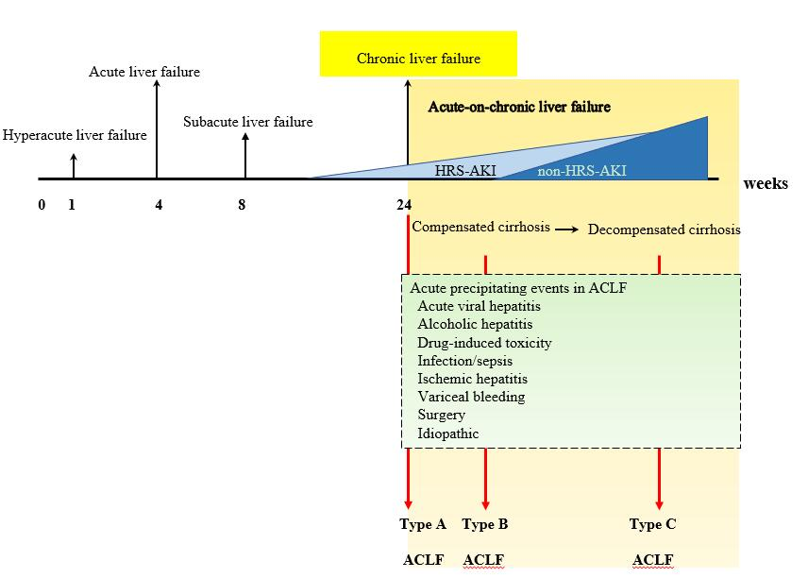
Figure 1 Definition of liver disease terminology according to timing and characteristics. ACLF: Acute-on-chronic liver failure; AKI: Acute kidney injury; HRS: Hepatorenal syndrome.

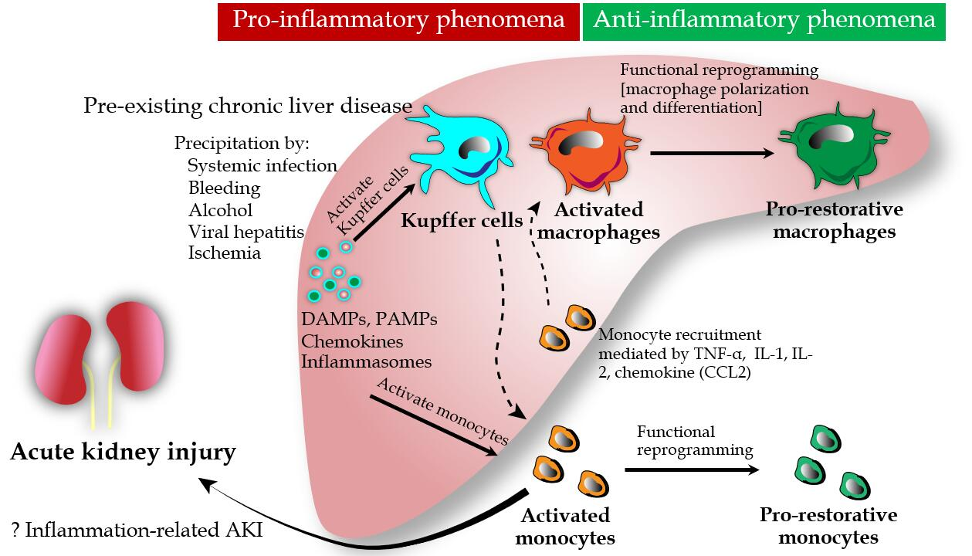

Figure 2 Role of monocytes and macrophages in the immunological aspects of acute-on-chronic liver failure and acute kidney injury. Several risk factors addition to pre-existing chronic liver disease initiate hepatic inflammation which release various types of damage-associated molecular patterns, pathogen-associated molecular pattern, chemokines and inflammasomes. These mediators affect to the inflammatory cascade through monocyte and Kupffer cell activation which subsequently turn on either liver or systemic immunity. While, in the liver, Kupffer cells signal to bone marrow-derived monocytes for recruiting them to the liver, systemic (peripheral) monocytes also become activated monocytes which expanding the pro-inflammatory responses or systemic inflammatory response syndrome (SIRS). Overwhelming of pro-inflammatory cascade is supposed to be the background of acute kidney injury (AKI), similarly septic AKI (inflammation-related AKI). However, the functional reprogramming of both activated macrophages and activated monocytes could attenuate SIRS by differentiating to pro-restorative phenotypes that favors liver tissue resolution and healing. DAMP: Damage-associated molecular pattern; IL: Interleukin; PAMPs: Pathogens-associated molecular patterns; SIRS: Systemic inflammatory response syndrome; TNF-α: Tumor necrosis factor-alpha; AKI: Acute kidney injury.

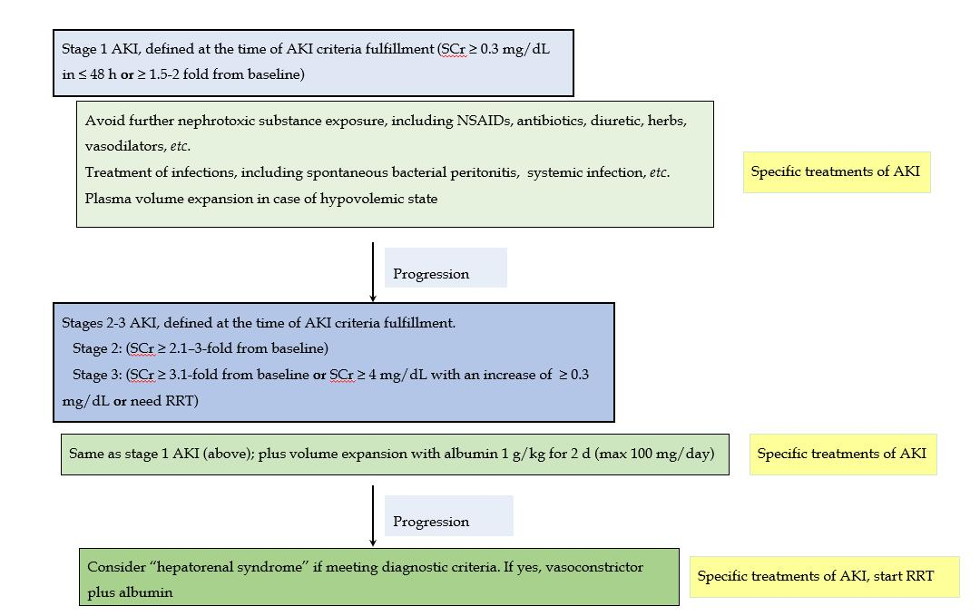

Figure 3 Summarized algorithm for the management of acute kidney injury according to the International Club of Ascites-acute kidney injury classification, which combines Kidney Disease Improving Global Outcomes criteria and conventional criteria in patients with cirrhosis and ascites. NSAIDs: Nonsteroidal anti-inflammatory drugs; SCr: Serum creatinine; RRT: Renal replacement therapy; AKI: Acute kidney injury.

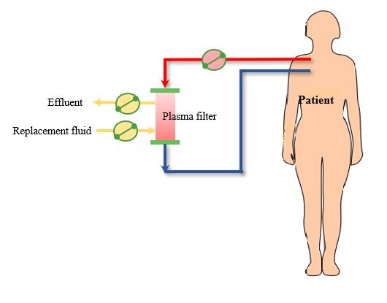

Figure 4 Plasma exchange circuit.

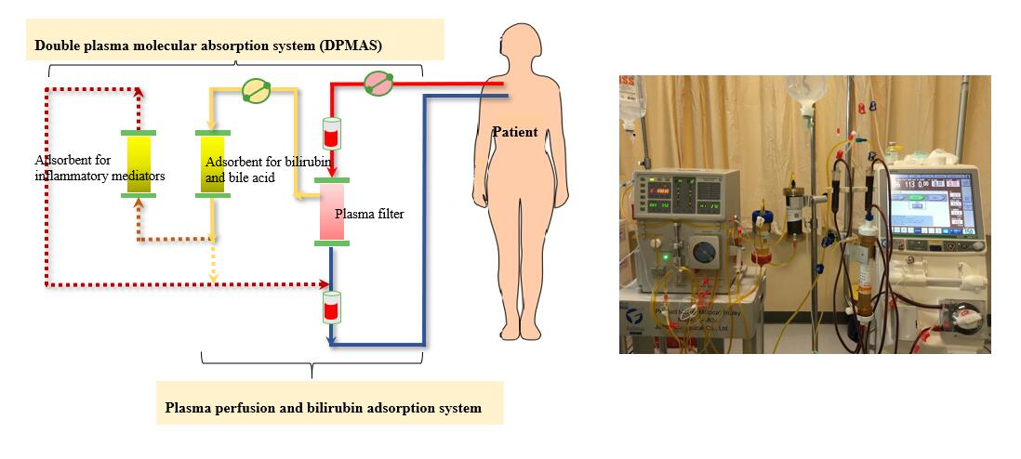

Figure 5 Plasma perfusion and bilirubin adsorption system and double plasma molecular absorption system circuit. DPMAS: double plasma molecular absorption system.

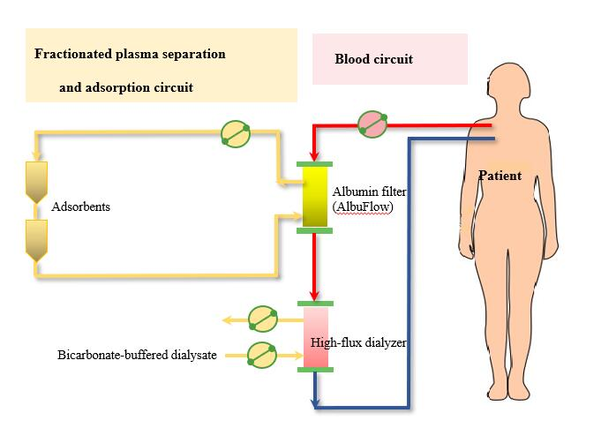

Figure 6 Fractionated plasma separation and adsorption (Prometheus®) circuit.

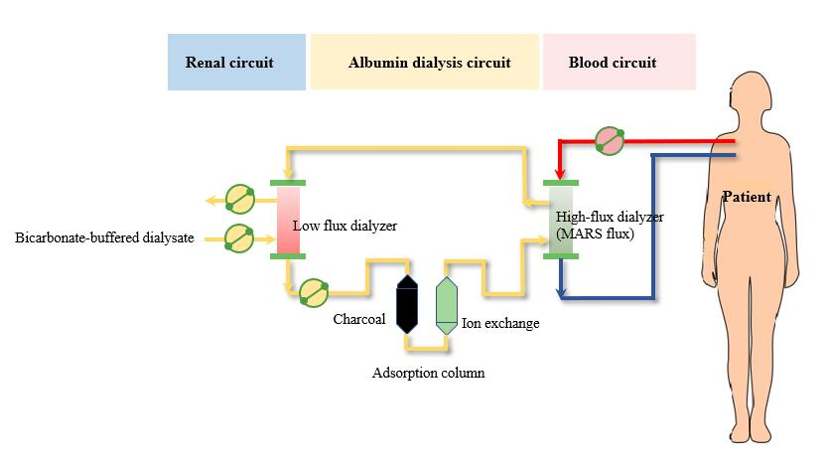

Figure 7 Molecular adsorbent recycling system circuit. MARS: Molecular adsorbent recycling system.

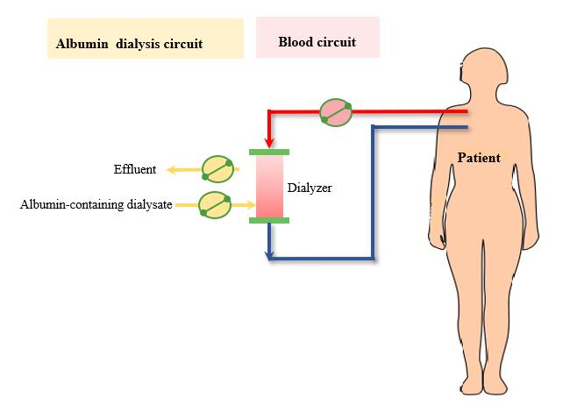

Figure 8 Single-pass albumin dialysis circuit.

Table 1 Comparison of the definitions of acute-on-chronic liver failure from the Asian Pacific Association for the Study of Liver, American Association for the Study of Liver Diseases-European Association for the Study of the Liver, and World Gastroenterology Organization
Criteria | APSAL | AASLD-EASL | WGO
Preexisting or underlying chronic liver disease | Noncirrhotic chronic liver disease, compensated cirrhosis | Cirrhotic chronic liver disease, cirrhosis with prior decompensation | Noncirrhotic chronic liver disease, compensated cirrhosis, decompensated cirrhosis
Precipitating causes | Alcohol, drugs, hepatotropic viruses, surgery, trauma | Alcohol, drugs, hepatotropic viruses, surgery, trauma, variceal bleeding, infection/sepsis | Alcohol, drugs, hepatotropic viruses, surgery, trauma, variceal bleeding, infection/sepsis
Duration between acute liver injury and ACLF | 4 wk | NA | NA
Organ failure | Hepatic failure | Extrahepatic organ failure | Hepatic failure, extrahepatic organ failure
APSAL: Asian Pacific Association for the Study of Liver; AASLD-EASL: American Association for the Study of Liver Diseases-European Association for the Study of the Liver; WGO: World Gastroenterology Organization; NA: Not available.
Table 2 The International Club of Ascites diagnostic criteria for hepatorenal syndrome
International Club of Ascites diagnostic criteria for hepatorenal syndrome
Diagnosis of cirrhosis and ascites
Diagnosis of acute kidney injury (AKI) according to ICA-AKI criteria (Table 3)
No response after 2 consecutive days of diuretic withdrawal and plasma volume expansion administration with albumin at 1 g/kg of body weight
Absence of shock
No current or recent use of nephrotoxic agents
No signs of structural kidney injuries, defined as the following:
Absence of proteinuria (> 500 mg/day or equivalent)
Absence of microscopic hematuria (> 50 red blood cells per high-power field)
Normal findings on renal ultrasonography
AKI: Acute kidney injury; ICA: Ascites diagnostic criteria.

Table 3 The proposed classification system of renal dysfunction in patients with cirrhosis proposed by the Acute Dialysis Quality Initiative and the International Club of Ascites work group^{[12]}
Diagnosis | Definition
Acute kidney injury (AKI) | Rise in serum creatinine (SCr) of ≥ 50% from baseline or a rise in SCr by ≥ 0.3 mg/dL (26.5 μmol/L) in < 48 h. Hepatorenal syndrome (HRS) type 1 is a specific form of AKI  Stage 1: Increase in serum creatinine (SCr) ≥ 0.3 mg/dL (26.5 μmol/L) or an increase in SCr 1.5-fold to 2-fold from baseline  Stage 2: Increase in SCr > 2-fold to 3-fold from baseline  Stage 3: Increase in SCr > 3-fold from baseline or an increase in SCr ≥ 4.0 mg/dL (353.6 μmol/L) with an acute increase ≥ 0.3 mg/dL (26.5 μmol/L) or initiation of renal replacement therapy
Chronic kidney disease (CKD) | Glomerular filtration rate (GFR) of < 60 mL/min for > 3 mo, calculated using the MDRD6 formula. HRS type 2 is a specific form of CKD
Acute-on-chronic kidney disease | Rise in SCr of ≥ 50% from baseline or a rise of SCr by ≥ 0.3 mg/dL (26.5 μmol/L) in < 48 h in a patient with cirrhosis whose GFR is < 60 mL/min for > 3 mo, calculated using the MDRD6 formula
MDRD: Modification in diet of renal disease; GFR: Glomerular filtration rate; CKD: Chronic kidney disease; AKI: Acute kidney injury; SCr: Serum creatinine.

Table 4 Comparison between the main mechanisms of the pathophysiology of hepatorenal syndrome–acute kidney injury and non-hepatorenal syndrome-acute kidney injury
Hepatorenal syndrome | Non-hepatorenal syndrome
Splanchnic vasodilatation  Inflammation  Adrenal insufficiency  Cardiac dysfunction | Acute-on-chronic liver failure  Inflammation  Bacterial translocation  Bile acid  Worsening portal hypertension  Worsening cardiac output

