Name of Journal: World Journal of Gastrointestinal Oncology
Manuscript NO: 80325
Manuscript Type: ORIGINAL ARTICLE

Retrospective Study
Development and validation of a nomogram for predicting metachronous peritoneal metastasis in colorectal cancer: A retrospective study

Ban B et al. Nomogram for predicting m-PM in CRC

Bo Ban, An Shang, Jian Shi

Bo Ban, An Shang, Jian Shi, Department of General Surgery, The Second Hospital of Jilin University, Changchun 130041, Jilin Province, China

Author contributions: Ban B designed and performed the research and wrote the paper; Shi J designed the research and supervised the report; Shang A designed the research and contributed to the analysis.

Supported by the Science and Technology Development Project of Jilin Province, No. 2020SCZT079.

Corresponding author: Jian Shi, MD, PhD, Associate Chief Physician, Associate Professor, Department of General Surgery, The Second Hospital of Jilin University, No. 218 Ziqiang Street, Nanguan District, Changchun 130041, Jilin Province, China. 383888697@qq.com

Received: September 23, 2022
Revised: November 23, 2022
Accepted: December 21, 2022
Published online: January 15, 2023

Abstract
BACKGROUND
Peritoneal metastasis (PM) after primary surgery for colorectal cancer (CRC) has the worst prognosis. Prediction and early detection of metachronous PM (m-PM) have an important role in improving postoperative prognosis of CRC. However, commonly used imaging methods have limited sensitivity to detect PM early. We aimed to establish a nomogram model to evaluate the individual probability of m-PM to facilitate early interventions for high-risk patients.

AIM
To establish and validate a nomogram model for predicting the occurrence of m-PM in CRC within 3 years after surgery.

METHODS
We used the clinical data of 878 patients at the Second Hospital of Jilin University, between January 1, 2014 and January 31, 2019. The patients were randomly divided into training and validation cohorts at a ratio of 2:1. The least absolute shrinkage and selection operator (LASSO) regression was performed to identify the variables with nonzero coefficients to predict the risk of m-PM. Multivariate logistic regression was used to verify the selected variables and to develop the predictive nomogram model. Harrell’s concordance index, receiver operating characteristic curve, Brier score, and decision curve analysis (DCA) were used to evaluate discrimination, distinctiveness, validity, and clinical utility of this nomogram model. The model was verified internally using bootstrapping method and verified externally using validation cohort.

RESULTS
LASSO regression analysis identified six potential risk factors with nonzero coefficients. Multivariate logistic regression confirmed the risk factors to be independent. Based on the results of two regression analyses, a nomogram model was established. The nomogram included six predictors: Tumor site, histological type, pathological T stage, carbohydrate antigen 125, v-raf murine sarcoma viral oncogene homolog B mutation and microsatellite instability status. The model achieved good predictive accuracy on both the training and validation datasets. The C-index, area under the curve, and Brier scores were 0.796, 0.796 [95% confidence interval (CI) 0.735-0.856], and 0.081 for the training cohort and 0.782, 0.782 (95%CI 0.690-0.874), and 0.089 for the validation cohort, respectively. DCA showed that when the threshold probability was between 0.01 and 0.90, using this model to predict m-PM achieved a net clinical benefit.

CONCLUSION
We have established and validated a nomogram model to predict m-PM in patients undergoing curative surgery, which shows good discrimination and high accuracy.

Key Words: Colorectal cancer; Metachronous peritoneal metastasis; Risk factor; Nomogram

©The Author(s) 2023. Published by Baishideng Publishing Group Inc. All rights reserved.

Citation: Ban B, Shang A, Shi J. Development and validation of a nomogram for predicting metachronous peritoneal metastasis in colorectal cancer: A retrospective study. World J Gastrointest Oncol 2023; 15(1): 112-127
URL: https://www.wjgnet.com/1948-5204/full/v15/i1/112.htm
DOI: https://dx.doi.org/10.4251/wjgo.v15.i1.112

Core Tip: The prediction and early detection of metachronous peritoneal metastasis remain a difficult task in clinical practice. Conventional imaging modalities have limited sensitivity for detecting peritoneal nodules < 5 mm in diameter. Second-look surgery may be an alternative means for early detection of PM; however, its invasive nature and surgical complications mean that this approach should only be applied to high-risk patients. The present study aimed to develop a nomogram to help surgeons screen out high-risk patients and select appropriate individualized follow-up and treatment strategies.

INTRODUCTION
Colorectal cancer (CRC) ranks third among global cancers in terms of its mortality with more than 850000 deaths annually and metastasis is one of the most common causes for death in CRC^{[1]}. After the liver, the peritoneum is the second most common metastatic site for CRC spread^{[2,3]}. Approximately 10%-25% of patients with CRC develop peritoneal metastasis (PM) after initial diagnosis^{[4]}. Compared with other CRC metastatic sites, PM is associated with poorer progression-free survival and overall survival^{[5,6]}. As a result, in the 8th edition of the tumor, node, metastasis staging system published by the American Joint Committee on Cancer, PM was classified as M1c since it has a worse prognosis when compared with patients with one distant organ metastasis (M1a) and those with more than one distant organ metastasis (M1b)^{[7]}. PM of CRC can be divided into synchronous and metachronous PM^{[8]}. In m-PM, peritoneal recurrence occurs after primary surgery^{[9,10]}. The prediction and early detection of m-PM have an important role in improving postoperative prognosis of CRC, because surgeons are more likely to achieve complete cytoreduction (CCR-0) in patients with lower peritoneal cancer index (PCI) values^{[11]}. Cytoreduction surgery (CRS) plus hyperthermic intraperitoneal chemotherapy (HIPEC) and systemic treatment have been widely applied in the treatment of early m-PM from CRC, and have markedly improved the oncological outcomes^{[12,13]}.
However, conventional imaging modalities have limited sensitivity for detecting peritoneal nodules < 5 mm in diameter, making it difficult to detect PM early^{[14]}. Second-look surgery may be an alternative means for early detection of PM. However, its invasive nature and surgical complications mean that this approach should only be applied to high-risk patients^{[14,15]}. Previous research has demonstrated that several clinicopathological factors including T4 tumor, mucinous adenocarcinoma and signet-ring cell carcinoma are closely related to m-PM^{[16]}. However, few studies have reported the genetic alterations of m-PM. A reliable and integrated predictive model is needed to evaluate the risk of developing m-PM and improve the management of high-risk patients. A nomogram is a simple and practical scoring system that is mainly used for predicting risk and evaluating prognosis, with good clinical application^{[17]}. The present study aimed to develop a nomogram to help surgeons screen out high-risk patients and select appropriate individualized follow-up and treatment strategies.

MATERIALS AND METHODS
Patients
The study was approved by the Ethics Committee of the Second Hospital of Jilin University and carried out in line with the Declaration of Helsinki. Patients were carefully selected, and finally, 878 patients with CRC undergoing curative-intent resection were considered to be eligible between January 1, 2014 and January 31, 2019, at the Colorectal Center of Jilin University. The inclusion criteria were as follows: Primary CRC confirmed by colonoscopy and biopsy; American Society of Anesthesiologists Grades I-III; no signs of distant metastasis based on imaging examinations as well as intraoperative exploration; no history of other malignancy; patients undergoing curative-intent resection; and patients undergoing tumor kirsten rat sarcoma viral oncogene homolog (KRAS), neuroblastoma RAS viral oncogene homolog (NRAS) and v-raf murine sarcoma viral oncogene homolog B (BRAF) mutation testing as well as microsatellite instability (MSI) analysis. Patients were excluded if they underwent emergency surgery, had synchronous peritoneal metastasis (s-PM) before resection, rectal cancer below the peritoneum, were treated with neoadjuvant chemotherapy or radiotherapy, or had incomplete follow-up data. At present, there is no international consensus concerning the defining time points of s-PM and m-PM^{[10]}. The most common method is to adopt initial surgery as the cutoff point for distinguishing between s-PM and m-PM^{[9,10,18]}, which was adopted in this study.
The preoperative clinical stage was determined by physical examination, chest-abdominal computed tomography (CT), and colonoscopy. The postoperative examination follow-up protocol included an evaluation of serum tumor marker every 3 mo, thoracoabdominal CT every 6 mo, and colonoscopy every 12 mo. The occurrence of m-PM within 3 years after curative surgery was defined as the target event for this predictive model. m-PM was diagnosed by laparoscopic exploration or imaging examination. In the present study, follow-up was terminated if the patients were diagnosed with m-PM and remaining patients were followed up for 3 years. All follow-up was completed on January 31, 2022.

m-PM-related variables
A total of 23 potential risk factors for m-PM were evaluated. These included: Gender; age at the time of surgery (≥ 60 years or < 60 years); body mass index (≥ 25 kg/m² or < 25 kg/m²); preoperative ascites; surgical method (laparoscopic or open); number of examined lymph nodes (≥ 12 or < 12); anastomotic leakage; tumor site (right colon, left colon, or rectum); tumor size (≥ 5 cm or < 5 cm); tumor type (ulcer type, uplift type, or infiltrating type); differentiation (well/moderate or poor/undifferentiated); histological type (adenocarcinoma, mucinous adenocarcinoma, or signet-ring cell carcinoma); pathological T stage; pathological N stage; neural invasion; vascular invasion; preoperative serum tumor marker [carcinoembryonic antigen, carbohydrate antigen 125 (CA125) and carbohydrate antigen 19-9], KRAS, NRAS or BRAF mutation, and MSI status.
All tumors were grouped according to their primary location as right colon (from cecum to transverse colon), left colon (from splenic flexure to sigmoid colon), and rectum. The tumor type was classified into: ulcer type (tumor grew deep into the intestinal wall and infiltrated around it, forming a crater-like ulcer with a raised edge); uplift type (tumor grew into the lumen of the intestine); and infiltrating type (tumor grew invasively within the wall of the intestinal tract, causing stiffness of the intestinal wall). The MSI analysis was performed using the five Bethesda instability markers BAT-25, BAT-26, D5S346, D2S123, and D17S250. Tumors expressing more than one instability marker were classified as high-frequency (MSI-H), those expressing only one instability marker were classified as low frequency (MSI-L), and those which did not express any markers were classified as stable (MSS). The MSI-L and MSS cases were included in the same group (MSI-L/MSS) because no significant difference in treatment outcomes was observed between the two variables in previous studies^{[19]}.

Statistical analysis
All data were analyzed using SPSS version 26.0 and R version 4.0.3. The categorical variables were presented as numbers and percentages. The patients were randomly divided into training and validation cohorts at a ratio of 2:1 using a random split-sample method. The ranked data were analyzed using the Mann-Whitney U test. The c² and Fisher’s exact tests were used to compare the categorical variables. Least absolute shrinkage and selection operator (LASSO) regression was performed to identify the variables with nonzero coefficients to predict the risk of m-PM^{[17,20]}. Based on the results of the LASSO regression, multivariate logistic regression was used to verify the selected variables and to develop the predictive nomogram model. For all statistical tests, P < 0.05 was deemed statistically significant.
Various tests were performed to assess the performance of the developed nomogram. The discriminative performance of the model was evaluated using C-index and AUC. The C-index and AUC range from 0 to 1, and a higher value indicates that the model has a higher differentiation performance^{[21]}. The Brier score was used to determine the predictive validity of the model. A Brier score < 0.25 indicates that the model can correctly predict the occurrence of the target event. When the score of the model is between 0 and 0.25, the closer the score is to 0, the better the model performance^{[22]}. The model was verified internally using a bootstrapping method with 1000 resamples. A calibration plot was used to evaluate the consistency between actual and predicted probability. The performance of the model was validated externally using a validation cohort. Decision curve analysis (DCA) was used to evaluate the clinical utility of the model based on net benefits at different threshold probabilities^{[23]}.

RESULTS
Patient demographics
A total of 1874 patients underwent surgery for CRC between January 1, 2014, and January 31, 2019, at the Second Affiliated Hospital of Jilin University. A total of 1406 patients met the inclusion criteria for further analysis. From this cohort, 528 patients were found to be ineligible for the study because they underwent emergency surgery (n = 87), had rectal cancer below the peritoneum (n = 304), s-PM (n = 39), received preoperative chemotherapy or radiotherapy (n = 54), or had incomplete clinical data (n = 44) (Figure 1). Finally, 878 patients were enrolled in the study. The eligible patients were randomly assigned to the validation (n = 586) and training (n = 292) cohorts. The 3-year cumulative incidence of m-PM was 11.1% (65/586) in the training cohort and 9.9% (29/292) in the validation cohort. However, the difference was not significant (P = 0.600). Correlations between various clinicopathological factors in the two cohorts are summarized in Table 1. Patients’ characteristics did not show any significant difference between the two cohorts.

Feature selection
Among the 23 variables, six potential risk factors with nonzero coefficients were identified by LASSO regression analysis, including tumor site, histological type, pathological T stage, CA125, BRAF mutation, and MSI status (Figure 2). Multivariate logistic regression identified right colon cancer, pT4, histological type of mucinous adenocarcinoma and signet-ring cell carcinoma, elevated CA125, BRAF mutation, and MSI-H as independent risk factors for m-PM (Table 2).

Development and validation of the m-PM predictive nomogram
The m-PM predictive nomogram for CRC patients developed based on the multivariate regression analysis is illustrated in Figure 3. The scores for the tumor site were rectal cancer = 0, left colon cancer = 32, and right colon cancer = 72. For the histological subtype, the scores were adenocarcinoma = 0, mucinous adenocarcinoma = 57, and signet-ring = 97. For pathological T stage, the scores were T1 = 0, T2 = 31, T3 = 43, and T4 = 100. For CA125, the scores were normal level = 0 and elevated level = 40. For BRAF mutation, the scores were wild type = 0 and mutation = 49. For MSI status, the scores were MSI-L/MSS = 0 and MSI-H = 49. We evaluated the scores of all patients and used the receiver operating characteristic curve and Youden index to identify the optimum cutoff value of this model. This cutoff value was 168. All patients were divided into two subgroups: Low-risk group (total score ≤ 168) and high-risk group (total score > 168) (Table 3). Most of the patients (712 cases, 81.1%) were classified into the low-risk group. The percentage of patients developing m-PM in this subgroup was 5.6%. Using this simple grouping mothed, our nomogram model can achieve a high negative predictive rate (94.4%). The calibration curve showed good consistency between the predicted and actual observed outcomes since the bias-corrected curve was close to the ideal curve (Figure 4). The model achieved a good predictive accuracy on both the training and validation datasets. The C-index, AUC and Brier scores were 0.796, 0.796 (95%CI 0.735-0.856) and 0.081, and 0.782, 0.782 (95%CI 0.690-0.874) and 0.089 for the training cohort, respectively (Figure 5). DCA showed that when the threshold probability was between 0.01 and 0.90, using this model to predict m-PM achieved a net clinical benefit (Figure 6).

DISCUSSION
PM is traditionally considered as an end-stage disease in CRC. Although nomograms, statistical models and other risk prediction systems have been widely used for predicting the risk of recurrence in clinical practice, to our knowledge, few studies have constructed predictive models based on the risk factors for developing m-PM. One Swedish group conducted two studies to build a model for predicting m-PM in CRC patients^{[24,25]}. These two studies had a large simple size and showed good internal validity. However, limitations including the use of registry-based data and enrolling patients undergoing R2 resection may limit the wider applicability of their model. Pedrazzani et al^{[26]} conducted an international multicenter study to predict the risk of m-PM. Using easily available clinical and pathological variables, their scoring model achieved good predictive value. In this study, we used LASSO regression analysis to assess the impact of 23 clinical variables on the risk of developing m-PM following CRC surgery. This method can optimize the performance of the model by reducing the influence of multicollinearity between variables and selection bias^{[27]}. Among the 23 clinical variables, six risk factors were screened out by LASSO regression analysis. Multiple logistic regressions further confirmed that right colon cancer, pT4, histological types of mucinous adenocarcinoma and signet-ring cell carcinoma, elevated CA125, BRAF mutation, and MSI-H were independent risk factors for m-PM in CRC. Based on the results of the above two regression analyses, we established a predictive nomogram model to evaluate the risk of m-PM in individuals. The final nomogram model showed good discrimination accuracy, calibration, and reliability in both training and validation cohorts.
The highest scoring variable observed in this predictive model was the T4 stage, which has been widely considered as an independent risk factor for PM in previous studies^{[28,29]}. The “seed and soil” hypothesis is often used to explain the process involved in peritoneal dissemination for CRC^{[30]}. According to this hypothesis, the intraperitoneal free cancer cells which shed from the primary tumor are likened to “seed” and the favorable environment for the proliferation of the cancer cells are likened to “soil”. T4 tumors invade the serosa of the bowel and hence facilitate detachment and implantation of cancer cells into the peritoneum^{[31]}.
Consistent with previous studies, we found that patients with right-sided colon cancer have a higher risk of developing m-PM^{[32,33]}. Compared with left-sided tumors, right-sided tumors tend to be asymptomatic until advanced. Therefore, these patients tend to present with advanced tumors that have already invaded the serosal layer, which facilitates dissemination into the peritoneal cavity^{[34]}. Moreover, differences in embryonic origin between right-sided and left-sided colon cancers may also contribute to this discrepancy^{[35]}. Right-sided tumors tend to be more aggressive as they are more likely to present with hypermethylated phenotypes, BRAF mutated expression profiles, and MSI-H status^{[35,36]}.
The tumor-associated glycoprotein antigen CA125 is expressed in mesothelial cells of the peritoneum, epithelium of the oviduct, endocervix, and endometrium. This antigen is a reliable biomarker for monitoring the development of ovarian and gastrointestinal cancers^{[37,38]}. Previous studies demonstrated its accuracy, sensitivity, and specificity in diagnosing peritoneal dissemination of gastric cancer^{[39,40]}. Huang et al^{[38]} retrospectively analyzed the clinical data of 853 patients and found that CA125 was a reliable clinical markers in the diagnosis of PM for CRC patients. In this study, patients with elevated preoperative serum CA125 Levels were more likely to develop m-PM within 3 years than those with normal levels. We found that the mucinous and signet-ring carcinomas, aggressive subtypes of adenocarcinoma, were also significantly associated with PM, which was in agreement with previous studies^{[41]}.
The expression of specific oncogenes and binding proteins may facilitate the detachment of tumor cells from the primary site and subsequent implantation and proliferation of CRC cells in the peritoneal cavity^{[12]}. Therefore, an in-depth analysis of the genetic and molecular mechanisms is essential to evaluate the risk of developing m-PM. The RAS-RAF-MAPK pathway regulates the signal transduction involved in the growth, proliferation, and differentiation for cell^{[42]}. Mutations in upstream genes regulating this pathway, such as BRAF, may result in continuous abnormal activation of the downstream signal pathway^{[43]}. BRAF mutation occurs in about 12% of CRC patients^{[44]}. Approximately 90% of these mutations result in a V600E substitution^{[42]}. The BRAF V600E mutation has been identified as a biomarker for poor prognosis in CRC patients in several clinical studies^{[45,46]}. This mutation is also significantly associated with PM, and this metastatic pattern may contribute to poor survival^{[47,48]}. Moreover, BRAF mutation occurs more frequently in right-sided tumors and the mucinous/signet ring cell histology subtypes, which may further explain why tumors with those characteristics are more likely to spread in the peritoneum^{[49,50]}. MSI is caused by mutations of the DNA mismatch repair genes, which lead to functional defects in the repair of repetitive sequencing (microsatellite) errors during DNA replication^{[51]}. MSI-H is detected in about 15% of CRC patients^{[52]}. CRC with MSI-H is inclined to present in younger patients, with a predominance in proximal colon^{[53]}. Pathologically, MSI-H is associated with a Crohn’s-disease-like lymphocytic reaction, tumor-infiltrating lymphocytes, and mucinous/signet ring cell histology subtypes^{[53,54]}. From a molecular biology point of view, several studies demonstrated the coexistence of MSI-H and BRAF mutation^{[55,56]}. MSI-H has good and bad clinicopathological features, which may explain the different prognostic implications of MSI-H in different stages of CRC. In nonmetastatic CRC, MSI-H was associated with a good prognosis^{[57,58]}. However, in metastatic CRC, patients with MSI-H had a poor prognosis^{[59,60]}. Consistent with our study, Kim et al^{[61]} demonstrated that MSI-H was significantly associated with more frequent PM than MSI-L/MSS. In the present study, BRAF mutation and MSI-H were identified as significant risk factors for m-PM by LASSO and multivariate analyses, and incorporated in this nomogram. Both factors scored 49 points, effectively predicting the probability of m-PM.
Currently, multidetector-row CT remains the primary means to monitor the occurrence of PM after curative surgery in clinical practice. However, CT has limited accuracy to detect PM and underestimates the extent of disease^{[62]}. Whole-body diffusion-weighted magnetic resonance imaging (WB-DWI/MRI) is reported to have a high sensitivity in detecting PM for CRC, and outperform CT in evaluating both cancer distribution and lesion size^{[63,64]}. Several studies have demonstrated good diagnostic performance for positron emission tomography/CT (PET/CT) in detecting peritoneal metastases^{[65,66]}. However, these imaging methods are relatively expensive and time-consuming and unsuitable for general screening. In future clinical practice, our nomogram could be used to identify high-risk patients (total score > 168) that would benefit from further screening with these aggressive imaging modalities. Then, if a positive result is suspected on the targeted examinations, we could perform second-look surgery using laparoscope to evaluate the extent of disease and obtain pathological evidence. Finally, if m-PM is diagnosed, surgeons are supposed to estimate the PCI score and decide whether aggressive treatment including CRS plus HIPEC should be performed in targeted patient.
This study had some limitations. First, the training and validation cohorts were obtained retrospectively from a single center. Therefore, the nomogram requires further validation in multicenter prospective clinical studies. Second, the diagnosis of m-PM was mainly based on postoperative imaging such as CT. This could have delayed diagnosis because of the limited sensitivity of CT in detecting small peritoneal nodules. However, we believe this limitation was minor because the main purpose of this study was to identify risk factors affecting m-PM within the follow-up period, and establish a predictive model for early detection in future clinical practice. Third, because of the limited follow-up time of the included patients in this study, we could only assess the risk of developing m-PM within 3 years after surgery. Although the typical chronological span of m-PM occurrence was covered, further research is still recommended to investigate the risk factors for m-PM at different times points after primary surgery.

CONCLUSION
We have established and validated a nomogram model to predict m-PM in patients undergoing curative CRC surgery. The model showed good discrimination and high calibration in the training and validation cohorts. Our proposed model could be used clinically to help surgeons identify CRC patients at risk of developing m-PM post-surgery and take timely and effective interventions to improve prognosis of these patients. This may provide a reference for future clinical practice.

ARTICLE HIGHLIGHTS
Research background
The prediction and early detection of metachronous peritoneal metastasis (m-PM) remain a difficult task in clinical practice. Few studies have reported the genetic alterations of m-PM.

Research motivation
To explore risk factors in patients with m-PM after curative-intent colorectal cancer (CRC) surgery.

Research objectives
To establish and validate a nomogram model for predicting the occurrence of m-PM in CRC within 3 years after surgery.

Research methods
We used the clinical data of 878 patients at the Second Hospital of Jilin University, between January 1, 2014 and January 31, 2019. The patients were randomly divided into training and validation cohorts at a ratio of 2:1. All data were analyzed using SPSS version 26.0 and R version 4.0.3.

Research results
The 3-year cumulative incidence of m-PM was 11.1% (65/586) in the training cohort and 9.9% (29/292) in the validation cohort. Least absolute shrinkage and selection operator regression analysis and multiple logistic regressions identified that right colon cancer, pT4, histological types of mucinous adenocarcinoma and signet-ring cell carcinoma, elevated carbohydrate antigen 125 (CA125), v-raf murine sarcoma viral oncogene homolog B (BRAF) mutation, and microsatellite instability-high-frequency (MSI-H) were independent risk factors for m-PM in CRC. These six predictors could be used to establish a nomogram for predicting m-PM. The nomogram model showed good discrimination accuracy, calibration, and reliability in both training and validation cohorts.

Research conclusions
The nomogram model based on six predictors (right colon cancer, pT4, and histological types of mucinous adenocarcinoma and signet-ring cell carcinoma, elevated CA125, BRAF mutation, and MSI-H) showed good discrimination and high accuracy.

Research perspectives
The nomogram requires further validation in multicenter prospective clinical studies.

REFERENCES
1 Biller LH, Schrag D. Diagnosis and Treatment of Metastatic Colorectal Cancer: A Review. JAMA 2021; 325: 669-685 [PMID: 33591350 DOI: 10.1001/jama.2021.0106]
2 van Gestel YR, de Hingh IH, van Herk-Sukel MP, van Erning FN, Beerepoot LV, Wijsman JH, Slooter GD, Rutten HJ, Creemers GJ, Lemmens VE. Patterns of metachronous metastases after curative treatment of colorectal cancer. Cancer Epidemiol 2014; 38: 448-454 [PMID: 24841870 DOI: 10.1016/j.canep.2014.04.004]
3 van der Geest LG, Lam-Boer J, Koopman M, Verhoef C, Elferink MA, de Wilt JH. Nationwide trends in incidence, treatment and survival of colorectal cancer patients with synchronous metastases. Clin Exp Metastasis 2015; 32: 457-465 [PMID: 25899064 DOI: 10.1007/s10585-015-9719-0]
4 Sluiter N, de Cuba E, Kwakman R, Kazemier G, Meijer G, Te Velde EA. Adhesion molecules in peritoneal dissemination: function, prognostic relevance and therapeutic options. Clin Exp Metastasis 2016; 33: 401-416 [PMID: 27074785 DOI: 10.1007/s10585-016-9791-0]
5 Lau JW, Chang HS, Lee KY, Gwee YX, Lee WQ, Chong CS. Survival outcomes following primary tumor resection for patients with incurable metastatic colorectal carcinoma: Experience from a single institution. J Dig Dis 2018; 19: 550-560 [PMID: 30117288 DOI: 10.1111/1751-2980.12657]
6 Arakawa K, Kawai K, Ishihara S, Hata K, Nozawa H, Oba K, Sugihara K, Watanabe T. Prognostic Significance of Peritoneal Metastasis in Stage IV Colorectal Cancer Patients With R0 Resection: A Multicenter, Retrospective Study. Dis Colon Rectum 2017; 60: 1041-1049 [PMID: 28891847 DOI: 10.1097/DCR.0000000000000858]
7 Yang Z, Li Y, Qin X, Lv Z, Wang H, Wu D, Yuan Z, Wang H. Development and Validation of a Prognostic Nomogram for Colorectal Cancer Patients With Synchronous Peritoneal Metastasis. Front Oncol 2021; 11: 615321 [PMID: 34277396 DOI: 10.3389/fonc.2021.615321]
8 Enblad M, Graf W, Birgisson H. Risk factors for appendiceal and colorectal peritoneal metastases. Eur J Surg Oncol 2018; 44: 997-1005 [PMID: 29576463 DOI: 10.1016/j.ejso.2018.02.245]
9 Dietz MV, van Kooten JP, Said I, Brandt-Kerkhof ARM, Verhoef C, Bremers AJA, de Wilt JHW, de Reuver PR, Madsen EVE. Survival Outcomes After Cytoreductive Surgery with Hyperthermic Intraperitoneal Chemotherapy in Patients with Synchronous Versus Metachronous Onset of Peritoneal Metastases of Colorectal Carcinoma. Ann Surg Oncol 2022; 29: 6566-6576 [PMID: 35513588 DOI: 10.1245/s10434-022-11805-9]
10 Hentzen JEKR, Rovers KP, Kuipers H, van der Plas WY, Been LB, Hoogwater FJH, van Ginkel RJ, Hemmer PHJ, van Dam GM, de Hingh IHJT, Kruijff S. Impact of Synchronous Versus Metachronous Onset of Colorectal Peritoneal Metastases on Survival Outcomes After Cytoreductive Surgery (CRS) with Hyperthermic Intraperitoneal Chemotherapy (HIPEC): A Multicenter, Retrospective, Observational Study. Ann Surg Oncol 2019; 26: 2210-2221 [PMID: 30877495 DOI: 10.1245/s10434-019-07294-y]
11 Zhang Y, Qin X, Chen W, Liu D, Luo J, Wang H, Wang H. Risk factors for developing peritoneal metastases after curative surgery for colorectal cancer: A systematic review and meta-analysis. Colorectal Dis 2021; 23: 2846-2858 [PMID: 34411399 DOI: 10.1111/codi.15880]
12 Sánchez-Hidalgo JM, Rodríguez-Ortiz L, Arjona-Sánchez Á, Rufián-Peña S, Casado-Adam Á, Cosano-Álvarez A, Briceño-Delgado J. Colorectal peritoneal metastases: Optimal management review. World J Gastroenterol 2019; 25: 3484-3502 [PMID: 31367152 DOI: 10.3748/wjg.v25.i27.3484]
13 Solaini L, D'Acapito F, Passardi A, Framarini M, Tauceri F, Di Pietrantonio D, Frassineti GL, Casadei Gardini A, Cucchetti A, Cavaliere D, Ercolani G. Cytoreduction plus hyperthermic intraperitoneal chemotherapy for peritoneal carcinomatosis in colorectal cancer patients: a single-center cohort study. World J Surg Oncol 2019; 17: 58 [PMID: 30917826 DOI: 10.1186/s12957-019-1602-z]
14 Elias D, Honoré C, Dumont F, Ducreux M, Boige V, Malka D, Burtin P, Dromain C, Goéré D. Results of systematic second-look surgery plus HIPEC in asymptomatic patients presenting a high risk of developing colorectal peritoneal carcinomatosis. Ann Surg 2011; 254: 289-293 [PMID: 21709543 DOI: 10.1097/SLA.0b013e31822638f6]
15 Goéré D, Glehen O, Quenet F, Guilloit JM, Bereder JM, Lorimier G, Thibaudeau E, Ghouti L, Pinto A, Tuech JJ, Kianmanesh R, Carretier M, Marchal F, Arvieux C, Brigand C, Meeus P, Rat P, Durand-Fontanier S, Mariani P, Lakkis Z, Loi V, Pirro N, Sabbagh C, Texier M, Elias D; BIG-RENAPE group. Second-look surgery plus hyperthermic intraperitoneal chemotherapy versus surveillance in patients at high risk of developing colorectal peritoneal metastases (PROPHYLOCHIP-PRODIGE 15): a randomised, phase 3 study. Lancet Oncol 2020; 21: 1147-1154 [PMID: 32717180 DOI: 10.1016/S1470-2045(20)30322-3]
16 Lurvink RJ, Bakkers C, Rijken A, van Erning FN, Nienhuijs SW, Burger JW, Creemers GJ, Verhoef C, Lemmens VE, De Hingh IH. Increase in the incidence of synchronous and metachronous peritoneal metastases in patients with colorectal cancer: A nationwide study. Eur J Surg Oncol 2021; 47: 1026-1033 [PMID: 33272737 DOI: 10.1016/j.ejso.2020.11.135]
17 Hao M, Li H, Wang K, Liu Y, Liang X, Ding L. Predicting metachronous liver metastasis in patients with colorectal cancer: development and assessment of a new nomogram. World J Surg Oncol 2022; 20: 80 [PMID: 35279173 DOI: 10.1186/s12957-022-02558-6]
18 Nagata H, Ishihara S, Hata K, Murono K, Kaneko M, Yasuda K, Otani K, Nishikawa T, Tanaka T, Kiyomatsu T, Kawai K, Nozawa H, Watanabe T. Survival and Prognostic Factors for Metachronous Peritoneal Metastasis in Patients with Colon Cancer. Ann Surg Oncol 2017; 24: 1269-1280 [PMID: 27995451 DOI: 10.1245/s10434-016-5732-z]
19 Popat S, Hubner R, Houlston RS. Systematic review of microsatellite instability and colorectal cancer prognosis. J Clin Oncol 2005; 23: 609-618 [PMID: 15659508 DOI: 10.1200/JCO.2005.01.086]
20 Wen J, Pan T, Yuan YC, Huang QS, Shen J. Nomogram to predict postoperative infectious complications after surgery for colorectal cancer: a retrospective cohort study in China. World J Surg Oncol 2021; 19: 204 [PMID: 34238303 DOI: 10.1186/s12957-021-02323-1]
21 Pencina MJ, D'Agostino RB. Overall C as a measure of discrimination in survival analysis: model specific population value and confidence interval estimation. Stat Med 2004; 23: 2109-2123 [PMID: 15211606 DOI: 10.1002/sim.1802]
22 Steyerberg EW, Vickers AJ, Cook NR, Gerds T, Gonen M, Obuchowski N, Pencina MJ, Kattan MW. Assessing the performance of prediction models: a framework for traditional and novel measures. Epidemiology 2010; 21: 128-138 [PMID: 20010215 DOI: 10.1097/EDE.0b013e3181c30fb2]
23 Li R, Xue M, Ma Z, Qu C, Wang K, Zhang Y, Yue W, Zhang H, Tian H. Construction and validation of a nomogram for predicting prolonged air leak after minimally invasive pulmonary resection. World J Surg Oncol 2022; 20: 249 [PMID: 35922824 DOI: 10.1186/s12957-022-02716-w]
24 Segelman J, Akre O, Gustafsson UO, Bottai M, Martling A. Individualized prediction of risk of metachronous peritoneal carcinomatosis from colorectal cancer. Colorectal Dis 2014; 16: 359-367 [PMID: 24410859 DOI: 10.1111/codi.12552]
25 Segelman J, Akre O, Gustafsson UO, Bottai M, Martling A. External validation of models predicting the individual risk of metachronous peritoneal carcinomatosis from colon and rectal cancer. Colorectal Dis 2016; 18: 378-385 [PMID: 26588669 DOI: 10.1111/codi.13219]
26 Pedrazzani C, Turri G, Marrelli D, Kim HJ, Park EJ, Spolverato G, Foppa C, Spinelli A, Pucciarelli S, Baik SH, Choi GS. Prediction of Metachronous Peritoneal Metastases After Radical Surgery for Colon Cancer: A Scoring System Obtained from an International Multicenter Cohort. Ann Surg Oncol 2022; 29: 7896-7906 [PMID: 35789302 DOI: 10.1245/s10434-022-12097-9]
27 McEligot AJ, Poynor V, Sharma R, Panangadan A. Logistic LASSO Regression for Dietary Intakes and Breast Cancer. Nutrients 2020; 12 [PMID: 32878103 DOI: 10.3390/nu12092652]
28 Bastiaenen VP, Aalbers AGJ, Arjona-Sánchez A, Bellato V, van der Bilt JDW, D'Hoore AD, Espinosa-Redondo E, Klaver CEL, Nagtegaal ID, van Ramshorst B, van Santvoort HC, Sica GS, Snaebjornsson P, Wasmann KATGM, de Wilt JHW, Wolthuis AM, Tanis PJ. Risk of metachronous peritoneal metastases in patients with pT4a versus pT4b colon cancer: An international multicentre cohort study. Eur J Surg Oncol 2021; 47: 2405-2413 [PMID: 34030920 DOI: 10.1016/j.ejso.2021.05.009]
29 Kim BC, Bae JH, Park SM, Won DY, Lee IK. Is ascites CEA a risk factor for peritoneal carcinomatosis in colorectal cancer?: a long-term follow-up study. Int J Colorectal Dis 2020; 35: 147-155 [PMID: 31802190 DOI: 10.1007/s00384-019-03448-2]
30 Akhtar M, Haider A, Rashid S, Al-Nabet ADMH. Paget's "Seed and Soil" Theory of Cancer Metastasis: An Idea Whose Time has Come. Adv Anat Pathol 2019; 26: 69-74 [PMID: 30339548 DOI: 10.1097/PAP.0000000000000219]
31 Mo S, Dai W, Xiang W, Li Q, Wang R, Cai G. Predictive factors of synchronous colorectal peritoneal metastases: Development of a nomogram and study of its utilities using decision curve analysis. Int J Surg 2018; 54: 149-155 [PMID: 29730071 DOI: 10.1016/j.ijsu.2018.04.051]
32 de Boer NL, Rovers K, Burger JWA, Madsen EVE, Brandt-Kerkhof ARM, Kok NFM, de Wilt JHW, de Reuver PH, Bos A, de Hingh IHJT, Verhoef C. A population-based study on the prognostic impact of primary tumor sidedness in patients with peritoneal metastases from colon cancer. Cancer Med 2020; 9: 5851-5859 [PMID: 32614506 DOI: 10.1002/cam4.3243]
33 Shida D, Inoue M, Tanabe T, Moritani K, Tsukamoto S, Yamauchi S, Sugihara K, Kanemitsu Y. Prognostic impact of primary tumor location in Stage III colorectal cancer-right-sided colon versus left-sided colon versus rectum: a nationwide multicenter retrospective study. J Gastroenterol 2020; 55: 958-968 [PMID: 32651860 DOI: 10.1007/s00535-020-01706-7]
34 Le VH, Thornblade L, Ituarte PHG, Lai LL, Melstrom KA. Metachronous peritoneal metastases following curative resection for colon cancer: Understanding risk factors and patterns of recurrence. J Surg Oncol 2021; 123: 622-629 [PMID: 33616972 DOI: 10.1002/jso.26322]
35 Price TJ, Beeke C, Ullah S, Padbury R, Maddern G, Roder D, Townsend AR, Moore J, Roy A, Tomita Y, Karapetis C. Does the primary site of colorectal cancer impact outcomes for patients with metastatic disease? Cancer 2015; 121: 830-835 [PMID: 25377235 DOI: 10.1002/cncr.29129]
36 Hsu YL, Lin CC, Jiang JK, Lin HH, Lan YT, Wang HS, Yang SH, Chen WS, Lin TC, Lin JK, Lin PC, Chang SC. Clinicopathological and molecular differences in colorectal cancer according to location. Int J Biol Markers 2019; 34: 47-53 [PMID: 30854932 DOI: 10.1177/1724600818807164]
37 Bafna S, Kaur S, Batra SK. Membrane-bound mucins: the mechanistic basis for alterations in the growth and survival of cancer cells. Oncogene 2010; 29: 2893-2904 [PMID: 20348949 DOI: 10.1038/onc.2010.87]
38 Huang CJ, Jiang JK, Chang SC, Lin JK, Yang SH. Serum CA125 concentration as a predictor of peritoneal dissemination of colorectal cancer in men and women. Medicine (Baltimore) 2016; 95: e5177 [PMID: 27893659 DOI: 10.1097/MD.0000000000005177]
39 Huang C, Liu Z, Xiao L, Xia Y, Huang J, Luo H, Zong Z, Zhu Z. Clinical Significance of Serum CA125, CA19-9, CA72-4, and Fibrinogen-to-Lymphocyte Ratio in Gastric Cancer With Peritoneal Dissemination. Front Oncol 2019; 9: 1159 [PMID: 31750248 DOI: 10.3389/fonc.2019.01159]
40 Yang C, Yang Y, Huang X, Li H, Cheng H, Tong S, Zheng Y. A Nomogram Based on Clinicopathologic Features and Preoperative Hematology Parameters to Predict Occult Peritoneal Metastasis of Gastric Cancer: A Single-Center Retrospective Study. Dis Markers 2020; 2020: 1418978 [PMID: 33376558 DOI: 10.1155/2020/1418978]
41 Kermanshahi TR, Magge D, Choudry H, Ramalingam L, Zhu B, Pingpank J, Ahrendt S, Holtzman M, Zeh H, Bartlett D, Zureikat A, Pai RK. Mucinous and Signet Ring Cell Differentiation Affect Patterns of Metastasis in Colorectal Carcinoma and Influence Survival. Int J Surg Pathol 2017; 25: 108-117 [PMID: 27571790 DOI: 10.1177/1066896916664990]
42 Afrăsânie VA, Marinca MV, Alexa-Stratulat T, Gafton B, Păduraru M, Adavidoaiei AM, Miron L, Rusu C. KRAS, NRAS, BRAF, HER2 and microsatellite instability in metastatic colorectal cancer - practical implications for the clinician. Radiol Oncol 2019; 53: 265-274 [PMID: 31553708 DOI: 10.2478/raon-2019-0033]
43 Wan XB, Wang AQ, Cao J, Dong ZC, Li N, Yang S, Sun MM, Li Z, Luo SX. Relationships among KRAS mutation status, expression of RAS pathway signaling molecules, and clinicopathological features and prognosis of patients with colorectal cancer. World J Gastroenterol 2019; 25: 808-823 [PMID: 30809081 DOI: 10.3748/wjg.v25.i7.808]
44 Grothey A, Fakih M, Tabernero J. Management of BRAF-mutant metastatic colorectal cancer: a review of treatment options and evidence-based guidelines. Ann Oncol 2021; 32: 959-967 [PMID: 33836264 DOI: 10.1016/j.annonc.2021.03.206]
45 Price TJ, Hardingham JE, Lee CK, Weickhardt A, Townsend AR, Wrin JW, Chua A, Shivasami A, Cummins MM, Murone C, Tebbutt NC. Impact of KRAS and BRAF Gene Mutation Status on Outcomes From the Phase III AGITG MAX Trial of Capecitabine Alone or in Combination With Bevacizumab and Mitomycin in Advanced Colorectal Cancer. J Clin Oncol 2011; 29: 2675-2682 [PMID: 21646616 DOI: 10.1200/JCO.2010.34.5520]
46 Venderbosch S, Nagtegaal ID, Maughan TS, Smith CG, Cheadle JP, Fisher D, Kaplan R, Quirke P, Seymour MT, Richman SD, Meijer GA, Ylstra B, Heideman DA, de Haan AF, Punt CJ, Koopman M. Mismatch repair status and BRAF mutation status in metastatic colorectal cancer patients: a pooled analysis of the CAIRO, CAIRO2, COIN, and FOCUS studies. Clin Cancer Res 2014; 20: 5322-5330 [PMID: 25139339 DOI: 10.1158/1078-0432.CCR-14-0332]
47 Prasanna T, Karapetis CS, Roder D, Tie J, Padbury R, Price T, Wong R, Shapiro J, Nott L, Lee M, Chua YJ, Craft P, Piantadosi C, Sorich M, Gibbs P, Yip D. The survival outcome of patients with metastatic colorectal cancer based on the site of metastases and the impact of molecular markers and site of primary cancer on metastatic pattern. Acta Oncol 2018; 57: 1438-1444 [PMID: 30035653 DOI: 10.1080/0284186X.2018.1487581]
48 Lipsyc M, Yaeger R. Impact of somatic mutations on patterns of metastasis in colorectal cancer. J Gastrointest Oncol 2015; 6: 645-649 [PMID: 26697197 DOI: 10.3978/j.issn.2078-6891.2015.045]
49 Yokota T, Ura T, Shibata N, Takahari D, Shitara K, Nomura M, Kondo C, Mizota A, Utsunomiya S, Muro K, Yatabe Y. BRAF mutation is a powerful prognostic factor in advanced and recurrent colorectal cancer. Br J Cancer 2011; 104: 856-862 [PMID: 21285991 DOI: 10.1038/bjc.2011.19]
50 Yalcin S, Onguru O. BRAF mutation in colorectal carcinomas with signet ring cell component. Cancer Biol Med 2017; 14: 287-292 [PMID: 28884045 DOI: 10.20892/j.issn.2095-3941.2017.0053]
51 Sun BL. Current Microsatellite Instability Testing in Management of Colorectal Cancer. Clin Colorectal Cancer 2021; 20: e12-e20 [PMID: 32888812 DOI: 10.1016/j.clcc.2020.08.001]
52 Lochhead P, Kuchiba A, Imamura Y, Liao X, Yamauchi M, Nishihara R, Qian ZR, Morikawa T, Shen J, Meyerhardt JA, Fuchs CS, Ogino S. Microsatellite instability and BRAF mutation testing in colorectal cancer prognostication. J Natl Cancer Inst 2013; 105: 1151-1156 [PMID: 23878352 DOI: 10.1093/jnci/djt173]
53 Gelsomino F, Barbolini M, Spallanzani A, Pugliese G, Cascinu S. The evolving role of microsatellite instability in colorectal cancer: A review. Cancer Treat Rev 2016; 51: 19-26 [PMID: 27838401 DOI: 10.1016/j.ctrv.2016.10.005]
54 Fujiyoshi K, Yamamoto G, Takenoya T, Takahashi A, Arai Y, Yamada M, Kakuta M, Yamaguchi K, Akagi Y, Nishimura Y, Sakamoto H, Akagi K. Metastatic Pattern of Stage IV Colorectal Cancer with High-Frequency Microsatellite Instability as a Prognostic Factor. Anticancer Res 2017; 37: 239-247 [PMID: 28011498 DOI: 10.21873/anticanres.11313]
55 Goldstein J, Tran B, Ensor J, Gibbs P, Wong HL, Wong SF, Vilar E, Tie J, Broaddus R, Kopetz S, Desai J, Overman MJ. Multicenter retrospective analysis of metastatic colorectal cancer (CRC) with high-level microsatellite instability (MSI-H). Ann Oncol 2014; 25: 1032-1038 [PMID: 24585723 DOI: 10.1093/annonc/mdu100]
56 Aasebø KØ, Dragomir A, Sundström M, Mezheyeuski A, Edqvist PH, Eide GE, Ponten F, Pfeiffer P, Glimelius B, Sorbye H. Consequences of a high incidence of microsatellite instability and BRAF-mutated tumors: A population-based cohort of metastatic colorectal cancer patients. Cancer Med 2019; 8: 3623-3635 [PMID: 31070306 DOI: 10.1002/cam4.2205]
57 Ooki A, Akagi K, Yatsuoka T, Asayama M, Hara H, Takahashi A, Kakuta M, Nishimura Y, Yamaguchi K. Combined microsatellite instability and BRAF gene status as biomarkers for adjuvant chemotherapy in stage III colorectal cancer. J Surg Oncol 2014; 110: 982-988 [PMID: 25154726 DOI: 10.1002/jso.23755]
58 Klingbiel D, Saridaki Z, Roth AD, Bosman FT, Delorenzi M, Tejpar S. Prognosis of stage II and III colon cancer treated with adjuvant 5-fluorouracil or FOLFIRI in relation to microsatellite status: results of the PETACC-3 trial. Ann Oncol 2015; 26: 126-132 [PMID: 25361982 DOI: 10.1093/annonc/mdu499]
59 Tran B, Kopetz S, Tie J, Gibbs P, Jiang ZQ, Lieu CH, Agarwal A, Maru DM, Sieber O, Desai J. Impact of BRAF mutation and microsatellite instability on the pattern of metastatic spread and prognosis in metastatic colorectal cancer. Cancer 2011; 117: 4623-4632 [PMID: 21456008 DOI: 10.1002/cncr.26086]
60 Smith CG, Fisher D, Claes B, Maughan TS, Idziaszczyk S, Peuteman G, Harris R, James MD, Meade A, Jasani B, Adams RA, Kenny S, Kaplan R, Lambrechts D, Cheadle JP. Somatic profiling of the epidermal growth factor receptor pathway in tumors from patients with advanced colorectal cancer treated with chemotherapy ± cetuximab. Clin Cancer Res 2013; 19: 4104-4113 [PMID: 23741067 DOI: 10.1158/1078-0432.CCR-12-2581]
61 Kim CG, Ahn JB, Jung M, Beom SH, Kim C, Kim JH, Heo SJ, Park HS, Kim JH, Kim NK, Min BS, Kim H, Koom WS, Shin SJ. Effects of microsatellite instability on recurrence patterns and outcomes in colorectal cancers. Br J Cancer 2016; 115: 25-33 [PMID: 27228287 DOI: 10.1038/bjc.2016.161]
62 Dohan A, Hoeffel C, Soyer P, Jannot AS, Valette PJ, Thivolet A, Passot G, Glehen O, Rousset P. Evaluation of the peritoneal carcinomatosis index with CT and MRI. Br J Surg 2017; 104: 1244-1249 [PMID: 28376270 DOI: 10.1002/bjs.10527]
63 Dresen RC, De Vuysere S, De Keyzer F, Van Cutsem E, Prenen H, Vanslembrouck R, De Hertogh G, Wolthuis A, D'Hoore A, Vandecaveye V. Whole-body diffusion-weighted MRI for operability assessment in patients with colorectal cancer and peritoneal metastases. Cancer Imaging 2019; 19: 1 [PMID: 30616608 DOI: 10.1186/s40644-018-0187-z]
64 Zhang H, Dai W, Fu C, Yan X, Stemmer A, Tong T, Cai G. Diagnostic value of whole-body MRI with diffusion-weighted sequence for detection of peritoneal metastases in colorectal malignancy. Cancer Biol Med 2018; 15: 165-170 [PMID: 29951340 DOI: 10.20892/j.issn.2095-3941.2017.0162]
65 van 't Sant I, Engbersen MP, Bhairosing PA, Lambregts DMJ, Beets-Tan RGH, van Driel WJ, Aalbers AGJ, Kok NFM, Lahaye MJ. Diagnostic performance of imaging for the detection of peritoneal metastases: a meta-analysis. Eur Radiol 2020; 30: 3101-3112 [PMID: 32065287 DOI: 10.1007/s00330-019-06524-x]
66 Honma Y, Terauchi T, Tateishi U, Kano D, Nagashima K, Shoji H, Iwasa S, Takashima A, Kato K, Hamaguchi T, Boku N, Shimada Y, Yamada Y. Imaging peritoneal metastasis of gastric cancer with (18)F-fluorothymidine positron emission tomography/computed tomography: a proof-of-concept study. Br J Radiol 2018; 91: 20180259 [PMID: 29916721 DOI: 10.1259/bjr.20180259]

Footnotes
Institutional review board statement: This study was reviewed and approved by the Ethics Committee of The Second Hospital of Jilin University (Approval No. 2021-003).

Informed consent statement: The informed consent was waived from the patients.

Conflict-of-interest statement: All the authors report no relevant conflicts of interest for this article.

Data sharing statement: No additional data are available.

Open-Access: This article is an open-access article that was selected by an in-house editor and fully peer-reviewed by external reviewers. It is distributed in accordance with the Creative Commons Attribution NonCommercial (CC BY-NC 4.0) license, which permits others to distribute, remix, adapt, build upon this work non-commercially, and license their derivative works on different terms, provided the original work is properly cited and the use is non-commercial. See: https://creativecommons.org/Licenses/by-nc/4.0/

Provenance and peer review: Unsolicited article; Externally peer reviewed.
Peer-review model: Single blind

Peer-review started: September 23, 2022
First decision: November 16, 2022
Article in press: December 21, 2022

Specialty type: Gastroenterology and hepatology
Country/Territory of origin: China
Peer-review report’s scientific quality classification
Grade A (Excellent): 0
Grade B (Very good): B
Grade C (Good): 0
Grade D (Fair): D
Grade E (Poor): 0

P-Reviewer: Amornyotin S, Thailand; Sahin TT, Turkey S-Editor: Chen YL L-Editor: A P-Editor: Chen YL

Figure Legends
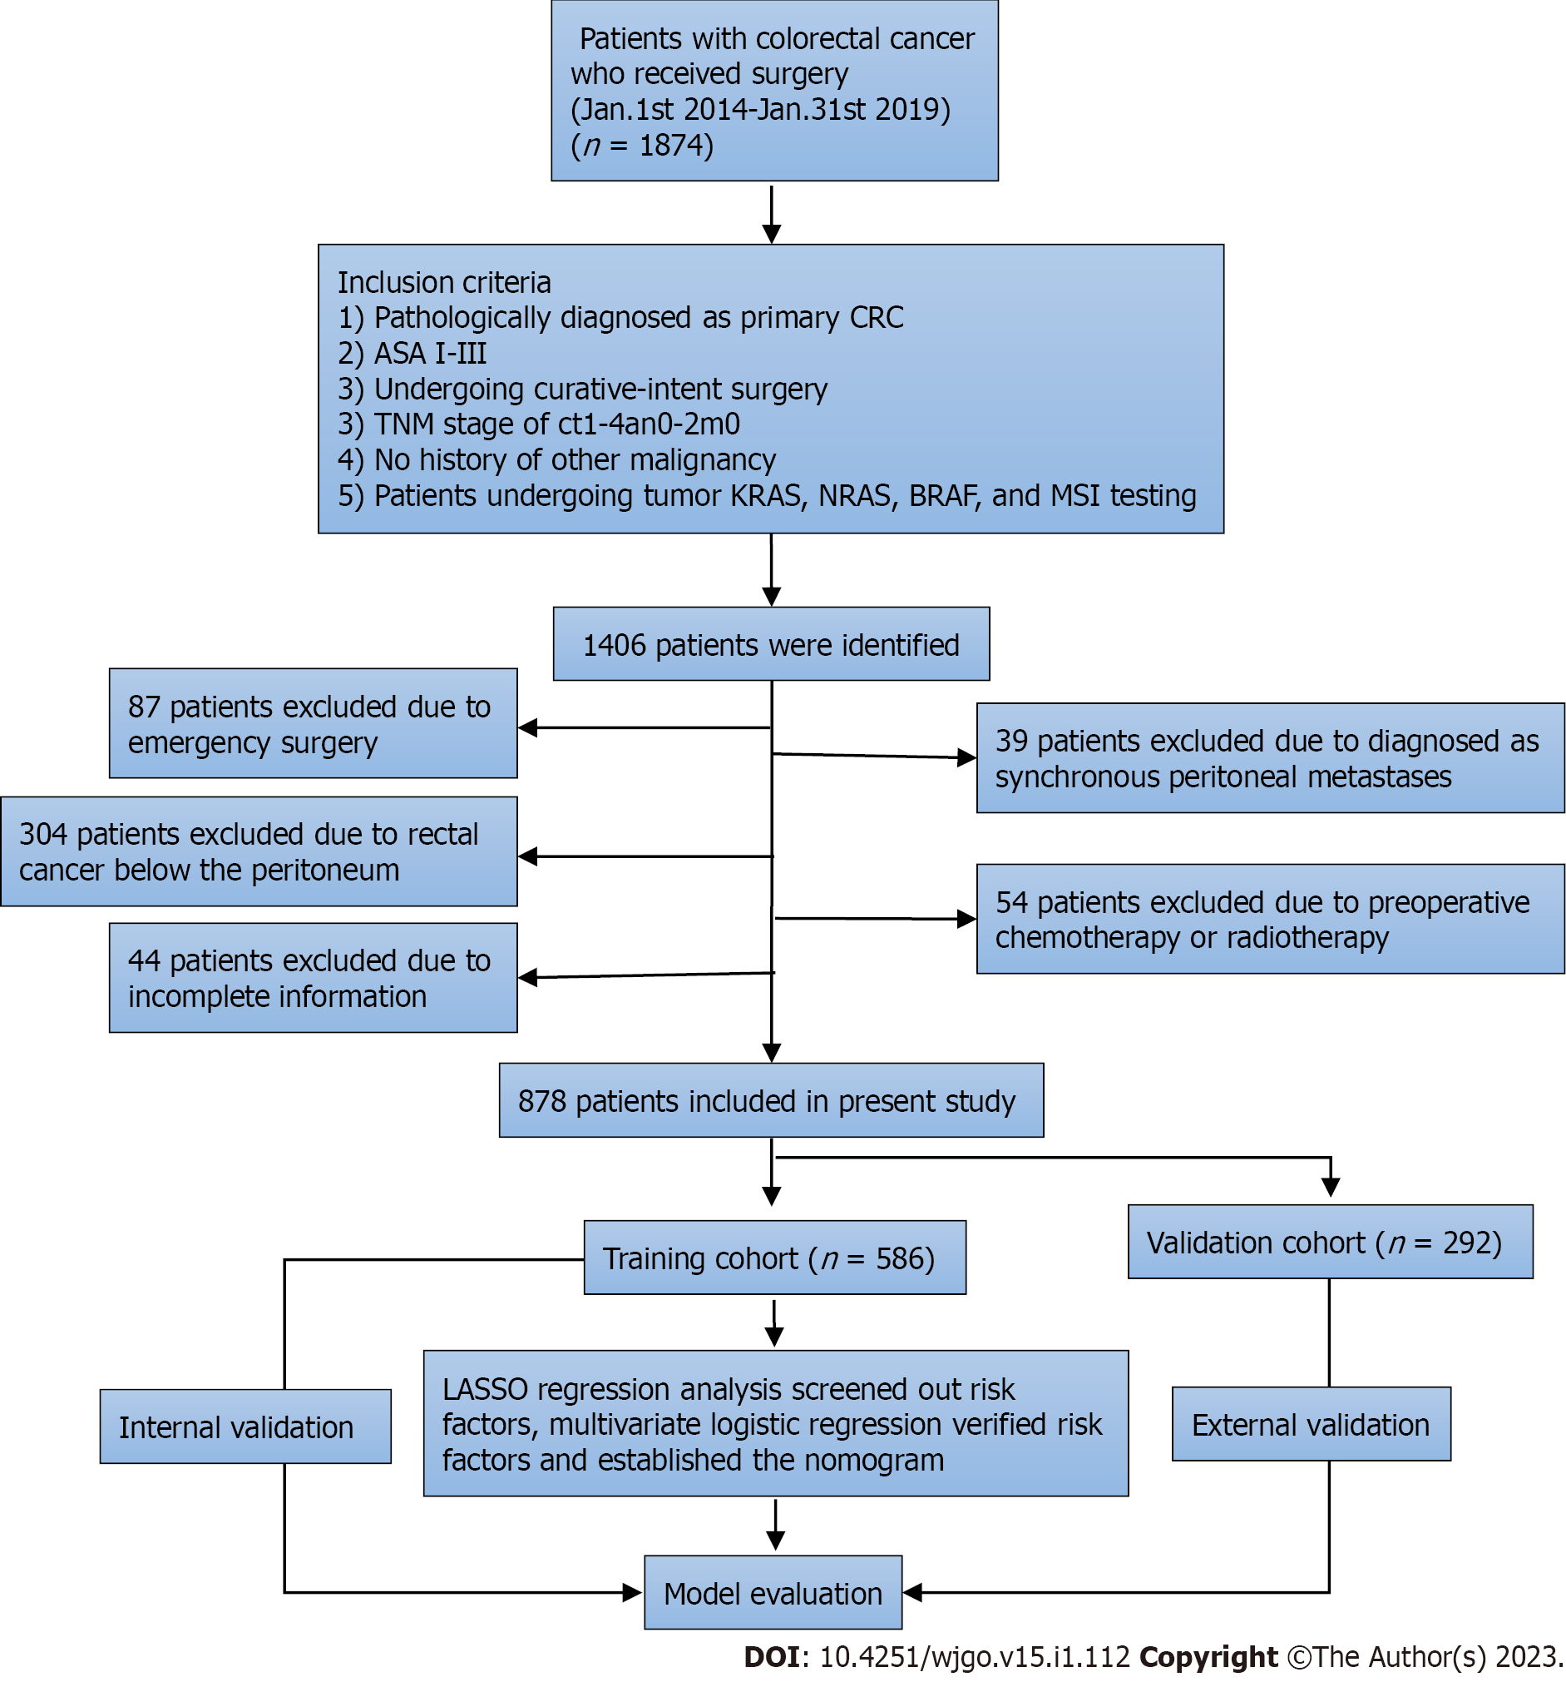
Figure 1 Flow chart of the study. CRC: Colorectal cancer; ASA: American Society of Anesthesiologists; TNM: Tumor-Node-Metastasis; KRAS: Kirsten rat sarcoma viral oncogene homolog; NRAS: Neuroblastoma RAS viral oncogene homolog; BRAF: V-raf murine sarcoma viral oncogene homolog B; MSI: Microsatellite instability; LASSO: Least absolute shrinkage and selection operator.

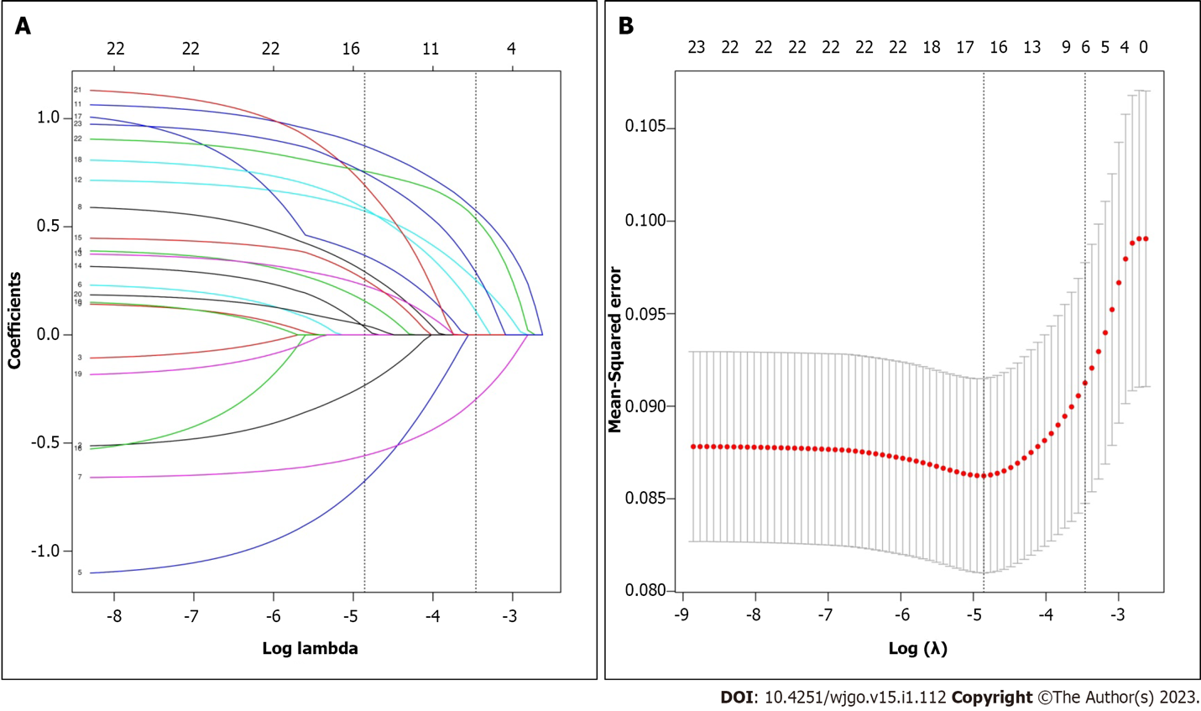
Figure 2 Variables selection using least absolute shrinkage and selection operator binary logistic regression analysis. A: Least absolute shrinkage and selection operator (LASSO) coefficient of the 23 variables associated with metachronous peritoneal metastasis; B: Optimal parameter (λ) was obtained using 10-fold cross-validation and minimum criteria. When the minimum λ was 0.031, six nonzero coefficients were selected by LASSO regression. LASSO: Least absolute shrinkage and selection operator.

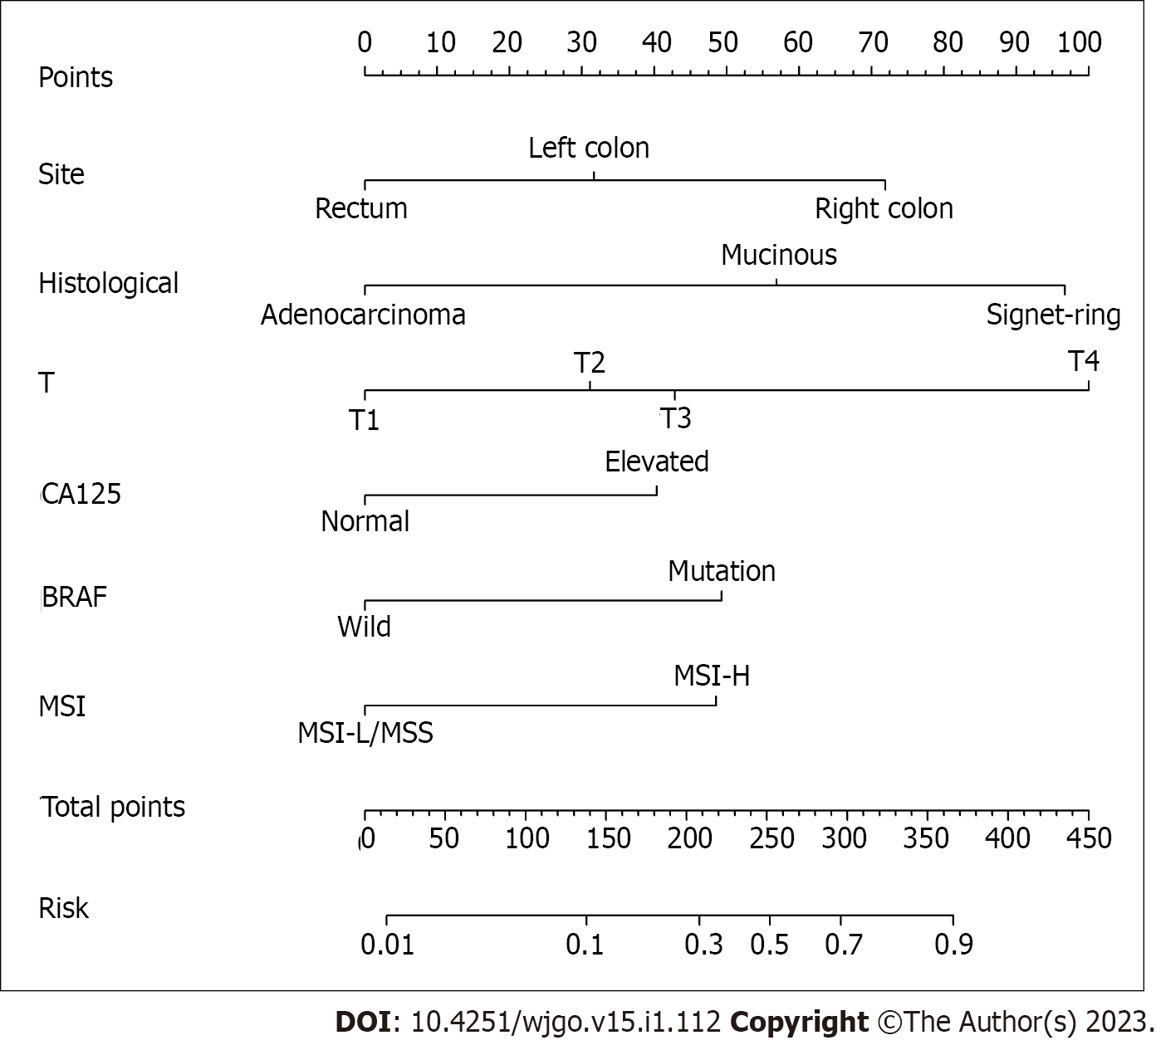
Figure 3 Nomogram for the probability of metachronous peritoneal metastasis based on six factors: Tumor site, histological type, pathological T stage, plasma levels of carbohydrate antigen 125, BRAF mutation, and microsatellite instability status. CA125: Carbohydrate antigen 125; MSI: Microsatellite instability; BRAF: V-raf murine sarcoma viral oncogene homolog B; MSI-L: MSI-Low; MSI-H: MSI-High.

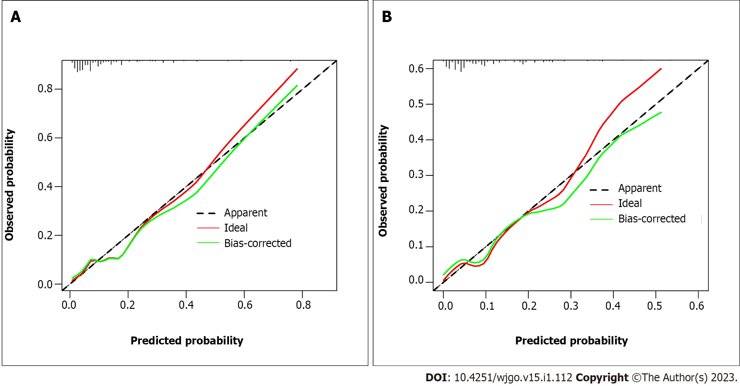
Figure 4 Nomogram calibration curves showed good consistency between actual probability and predicted probability. A: Calibration curve for training cohort; B: Calibration curve for validation cohort.

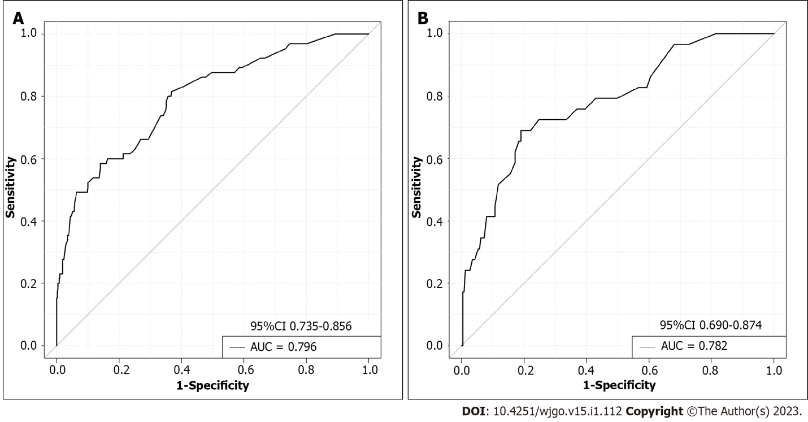
Figure 5 Receiver operating characteristic curves of the nomogram for predicting metachronous peritoneal metastasis. A: The training cohort; B: Validation cohort.

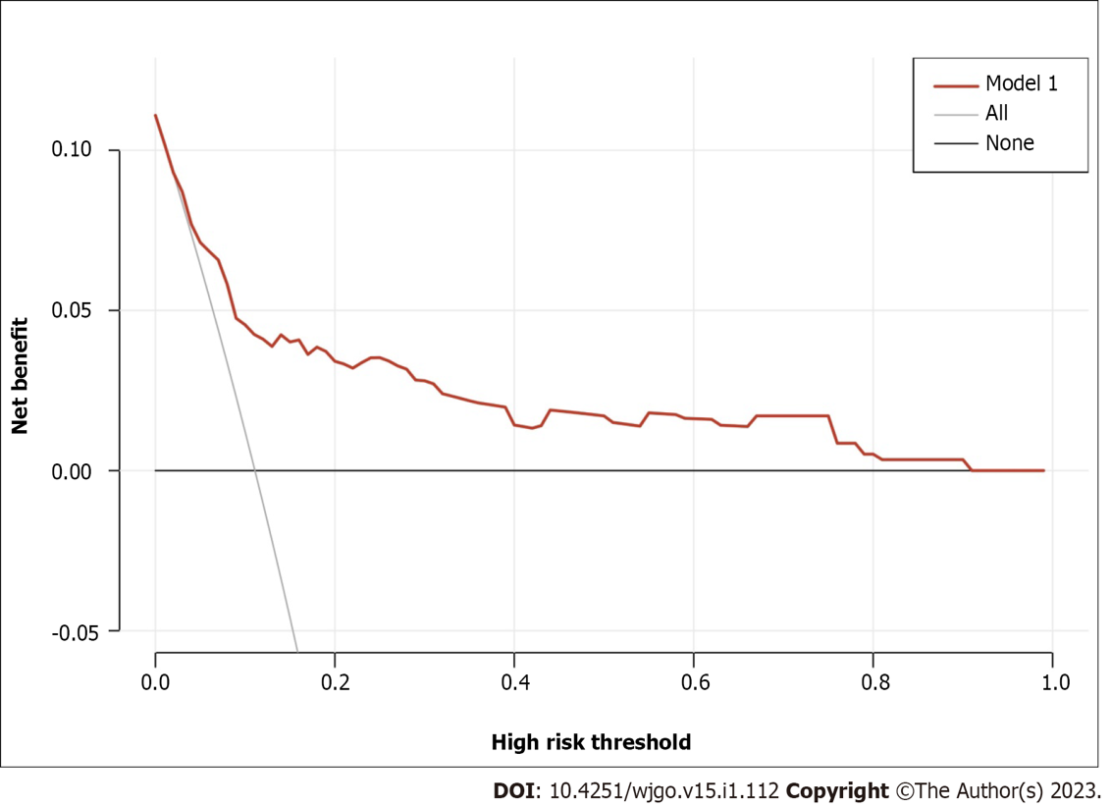
Figure 6 Decision curve analysis for the metachronous peritoneal metastasis nomogram. The blue line represents this nomogram. When the threshold probability is between 1% and 90%, using this nomogram to predict metachronous peritoneal metastasis can achieve net benefit. m-PM: Metachronous peritoneal metastasis.

Table 1 Baseline characteristics of patients (n = 878), n (%)
Variables | Training cohort (n = 586) | Validation cohort (n = 292) | P value
Gender |  |  | 0.777
Male | 321 (54.8) | 157 (53.8)
Female | 265 (45.2) | 135 (46.2)
Age (yr) |  |  | 0.924
≥ 60 | 293 (50.0) | 147 (50.3)
< 60 | 293 (50.0) | 145 (49.7)
BMI (kg/m²) |  |  | 0.683
≥ 25 | 154 (26.3) | 73 (25.0)
< 25 | 432 (73.7) | 219 (75.0)
Preoperative ascites |  |  | 0.794
Yes | 80 (13.7) | 38 (13.0)
No | 506 (86.3) | 254 (87.0)
Operation mode |  |  | 0.228
Open | 183 (31.2) | 103 (35.3)
Laparoscopic | 403 (68.8) | 189 (64.7)
Anastomotic leakage |  |  | 0.585
Yes | 44 (7.5) | 25 (8.6)
No | 542 (92.5) | 267 (91.4)
Tumor site |  |  | 0.767
Right colon | 160 (27.3) | 80 (27.4)
Left colon | 176 (30.0) | 94 (32.2)
Rectum | 250 (42.7) | 118 (40.4)
Tumor size (cm) |  |  | 0.223
≥ 5 | 254 (43.3) | 114 (39.0)
< 5 | 332 (56.7) | 178 (61.0)
Tumor type |  |  | 0.819
Ulcer | 395 (67.4) | 202 (69.2)
Uplift | 152 (25.9) | 70 (24.0)
Infiltrating | 39 (6.7) | 20 (6.8)
Differentiation |  |  | 0.448
Well/moderate | 519 (88.6) | 253 (86.6)
Poor/undifferentiated | 67 (11.4) | 39 (13.4)
Histology |  |  | 0.707
Adenocarcinoma | 497 (84.8) | 245 (83.9)
Mucinous | 69 (11.8) | 39 (13.4)
Signet-ring | 20 (3.4) | 8 (2.7)
T stage |  |  | 0.650
1 | 54 (9.2) | 21 (7.2)
2 | 137 (23.4) | 64 (21.9)
3 | 272 (46.4) | 146 (50.0)
4 | 123 (22.0) | 61 (20.9)
N stage |  |  | 0.976
0 | 263 (44.9) | 129 (44.2)
1 | 168 (28.7) | 84 (28.8)
2 | 155 (26.4) | 79 (27.1)
Examined lymph nodes |  |  | 0.147
≥ 12 | 509 (86.9) | 243 (83.2)
< 12 | 77 (13.1) | 49 (16.8)
Nerve invasion |  |  | 0.985
Yes | 185 (31.6) | 92 (31.5)
No | 401 (68.4) | 200 (68.5)
Vascular invasion |  |  | 0.680
Yes | 213 (36.3) | 102 (34.9)
No | 373 (63.7) | 190 (65.1)
CEA |  |  | 0.535
Normal | 344 (58.7) | 165 (56.5)
Elevated | 242 (41.3) | 127 (43.5)
CA125 |  |  | 0.778
Normal | 349 (59.6) | 171 (58.6)
Elevated | 237 (40.4) | 121 (41.4)
CA199 |  |  | 0.781
Normal | 490 (83.6) | 242 (82.9)
Elevated | 96 (16.4) | 50 (17.1)
KRAS mutation |  |  | 0.971
Wild | 370 (63.1) | 184 (63.0)
Mutation | 216 (36.9) | 108 (37.0)
NRAS mutation |  |  | 0.392
Wild | 561 (95.7) | 283 (96.9)
Mutation | 25 (4.3) | 9 (3.1)
BRAF mutation |  |  | 0.783
Wild | 514 (87.7) | 258 (88.4)
Mutation | 72 (12.3) | 34 (11.6)
MSI status |  |  | 0.612
MSS/MSI-L | 509 (86.9) | 250 (85.6)
MSI-H | 77 (13.1) | 42 (14.4)
Peritoneal metastasis |  |  | 0.600
Yes | 521 (88.9) | 263 (90.1)
No | 65 (11.1) | 29 (9.9)
BMI: Body mass index; CEA: Carcinoembryonic antigen; BRAF: V-raf murine sarcoma viral oncogene homolog B; CA125: Carbohydrate antigen 125; CA19-9: Carbohydrate antigen 19-9; KRAS: Kirsten rat sarcoma viral oncogene homolog; NRAS: Neuroblastoma RAS viral oncogene homolog; BRAF: V-raf murine sarcoma viral oncogene homolog B; MSI: Microsatellite instability; MSI-L: MSI-Low; MSI-H: MSI-High.

Table 2 Risk factors for metachronous peritoneal metastasis in colorectal cancer
Risk factors | Multivariate logistic regression
 | OR | 95%CI | P value
Tumor site
Right colon | 1
Left colon | 0.461 | 0.231-0.917 | 0.027
Rectum | 0.250 | 0.120-0.520 | < 0.001
Histology
Adenocarcinoma | 1
Mucinous | 2.993 | 1.441-6.220 | 0.003
Signet-ring | 6.453 | 2.122-19.625 | 0.001
T stage
T1 | 1
T2 | 1.822 | 0.364-9.103 | 0.465
T3 | 2.284 | 0.498-10.484 | 0.288
T4 | 6.871 | 1.487-31.736 | 0.014
CA125
Normal | 1
Elevated | 2.176 | 1.211-3.912 | 0.009
BRAF mutation
Wild | 1
Mutation | 2.586 | 1.277-5.236 | 0.008
MSI status
MSS/MSI-L | 1
MSI-H | 2.547 | 1.245-5.212 | 0.010
CRC: Colorectal cancer; OR: Odds ratio; CI: Confidence interval; MSI: Microsatellite instability; MSS: Microsatellite stability; MSI-L: MSI-Low; MSI-H: MSI-High.

Table 3 Subgroup analysis of the risk of metachronous peritoneal metastasis, n (%)
 | m-PM |  | P value
 | No | Yes
Low-risk group | 672 (94.4) | 40 (5.6) | < 0.001
High-risk group | 112 (67.5) | 54 (32.5)
m-PM: Metachronous peritoneal metastasis.

Published by Baishideng Publishing Group Inc
7041 Koll Center Parkway, Suite 160, Pleasanton, CA 94566, USA
Telephone: +1-925-3991568
E-mail: bpgoffice@wjgnet.com
Help Desk: https://www.f6publishing.com/helpdesk
https://www.wjgnet.com

© 2023 Baishideng Publishing Group Inc. All rights reserved.

