Name of Journal: World Journal of Clinical Cases
Manuscript NO: 66773
Manuscript Type: CASE REPORT

Acute coronary syndrome with severe atherosclerotic and hyperthyroidism: a case report

Zhu HM et al. ACS with AS and hyperthyroidism

Hai-Mei Zhu, Yi Zhang, Yun Tang, Hua Yuan, Zhen-Xian Li, Yun Long

Hai-Mei Zhu, Department of Pain, The First Hospital of Hunan University of Chinese Medicine, Changsha 410007, Hunan Province, China

Yi Zhang, Zhen-Xian Li, The Graduate School, Hunan University of Chinese Medicine, Changsha 410208, Hunan Province, China

Yun Tang, Hua Yuan, Yun Long, Department of Cardiology, The First Hospital of Hunan University of Chinese Medicine, Changsha 410007, Hunan Province, China

Author contributions: Zhu HM and Zhang Y reviewed the literature and contributed to manuscript drafting; Tang Y was the patient’s cardiovascular doctor and interpreted the imaging findings; Yuan H analyzed and interpreted the imaging findings; Li ZX reviewed the literature; Long Y was responsible for the revision of the manuscript for important intellectual content; all authors issued final approval for the version to be submitted.

Supported by Science and Technology Planning Project of Hunan Province, No. 2018JJ2304; and the Research Foundation of Hunan University of Chinese Medicine, No. 2019XJJJ042.

Corresponding author: Yun Long, MD, PhD, Chief Doctor, Department of Cardiology, The First Hospital of Hunan University of Chinese Medicine, No. 95 Shaoshan Road, Yuhua District, Changsha 410007, Hunan Province, China. wwlyf@126.com

Received: May 9, 2021
Revised: June 16, 2021
Accepted: July 22, 2021
Published online: September 26, 2021

Abstract
BACKGROUND
Acute coronary syndrome (ACS) encompasses a spectrum of cardiovascular emergencies arising from the obstruction of coronary artery blood flow and acute myocardial ischemia. Recent studies have revealed that thyroid function is closely related to ACS. However, only a few reports of thyrotoxicosis-induced ACS with severe atherosclerosis have been reported.

CASE SUMMARY
A 33-year-old man, who had a history of hyperthyroidism without taking any antithyroid drugs and no history of coronary heart disease, experienced neck pain with occasional heart palpitations starting 3 mo prior that were aggravated after an activity. As the symptoms worsened at 21 d prior, he went to a hospital for treatment. The electrocardiogram examination showed a multilead ST segment elevation and pathological Q waves. Based on these findings and his symptoms, the patient was diagnosed with a suspected myocardial infarction and transferred to our hospital on July 2, 2020. He was diagnosed with a rare case of ACS due to coronary artery atherosclerosis in the anterior descending artery complicated by hyperthyroidism. A paclitaxel-coated drug balloon was used for treatment to avoid the use of metal stents, thus reducing the time of antiplatelet therapy and facilitating the continued treatment of hyperthyroidism. The 9-mo follow-up showed favorable results.

CONCLUSION
This case highlights that atherosclerosis is a cause of ACS that cannot be ignored even in a patient with hyperthyroidism.

Key Words: Acute coronary syndrome; Atherosclerosis; Hyperthyroidism; Paclitaxel-coated drug balloon; Case report

©The Author(s) 2021. Published by Baishideng Publishing Group Inc. All rights reserved.

Citation: Zhu HM, Zhang Y, Tang Y, Yuan H, Li ZX, Long Y. Acute coronary syndrome with severe atherosclerotic and hyperthyroidism: A case report. World J Clin Cases 2021; 9(27): 8127-8134
URL: https://www.wjgnet.com/2307-8960/full/v9/i27/8127.htm
DOI: https://dx.doi.org/10.12998/wjcc.v9.i27.8127

Core Tip: We present a case of an acute coronary syndrome due to coronary artery atherosclerosis in the anterior descending artery complicated by hyperthyroidism in a 33-year-old man. Patients with thyrotoxicosis-induced acute coronary syndrome (ACS) are very special, and almost all reported cases have been associated with Graves’ disease. Coronary angiography usually shows zero disease, and coronary artery spasm occupies a large proportion of data, which is contradictory with this case that ACS is accompanied by atherosclerosis. In this case ,we find that intensive drug therapy and implant-free interventional therapy are better options for patients with ACS and hyperthyroidism.

INTRODUCTION
Acute coronary syndrome (ACS) encompasses a spectrum of cardiovascular emergencies arising from the obstruction of coronary artery blood flow and acute myocardial ischemia. Patients with ACS frequently have a poor prognosis, and ACS is a major health and economic burden^{[1,2]}. The symptoms of ACS arise from the functional destruction of the circulatory system. However, the pathogenic factors of ACS often arise from systems outside the circulatory system, and diseases related to endocrine system dysfunction, such as diabetes and hyperthyroidism^{[3]}, have an indispensable role to play. Such factors increase the difficulty in clinical treatment and improvement of patient prognosis. Therefore, in recent years, coronary heart disease (CHD) secondary to hyperthyroidism has gradually received considerable attention^{[4]}. We describe a rare case of ACS due to coronary artery atherosclerosis in the anterior descending artery complicated by hyperthyroidism in a 33-year-old man. We also present relevant literature and discuss the interaction mechanism between complications and CHD to achieve a suitable treatment plan.

CASE PRESENTATION
Chief complaints
ACS encompasses a spectrum of cardiovascular emergencies arising from the obstruction of coronary artery blood flow and acute myocardial ischemia. Patients with ACS frequently have a poor prognosis, and ACS is a major health and economic burden^{[1,2]}. The symptoms of ACS arise from the functional destruction of the circulatory system. However, the pathogenic factors of ACS often arise from systems outside the circulatory system, and diseases related to endocrine system dysfunction, such as diabetes and hyperthyroidism^{[3]}, have an indispensable role to play. Such factors increase the difficulty in clinical treatment and improvement of patient prognosis. Therefore, in recent years, CHD secondary to hyperthyroidism has gradually received considerable attention^{[4]}. We describe a rare case of ACS due to coronary artery atherosclerosis in the anterior descending artery complicated by hyperthyroidism in a 33-year-old man. We also present relevant literature and discuss the interaction mechanism between complications and CHD to achieve a suitable treatment plan.

History of present illness
Three months ago, the patient experienced neck pain with occasional heart palpitations that were aggravated after an activity. As the symptoms worsened 21 d prior, he went to a hospital for treatment. The electrocardiogram examination showed a multilead ST segment elevation and pathological Q waves. Based on the findings and his symptoms, the patient was diagnosed with a suspected myocardial infarction.

History of past illness
The patient had a history of hyperthyroidism for 5 mo, without taking any antithyroid drugs. There was no history of CHD.

Personal and family history
The patient smoked approximately 12 cigarettes a day for 10 years. He denied a family history of related disease.

Physical examination
After hospitalization, the results of the diagnosis-related examinations were as follows: body temperature, 36.6 ºC; breathing, 20 breaths/min; blood pressure, 120/80 mmHg; and heart rate, 110 beats/min. The patient was of sound mind and had a slightly enlarged thyroid with ocular signs. Since the onset of the disease, he has lost 6 kg of weight.

Laboratory examinations
The electrocardiogram results were as follows: sinus rhythm, V1-5 ST segment elevation 0.1-0.4 mv and pathological Q waves (Figure 1).
Although the high-sensitivity troponin T (commonly referred to as TNT-Hs) test result was 29.2 pg/mL on admission and 17.1 pg/mL on day 5 of admission (reference range: 0-0.04 pg/mL), the myocardial enzyme test did not show abnormal results. We also tested the patient’s thyroid function (Tables 1 and 2), blood lipids (Table 3), and coagulation function (Table 4). The thyroid function test showed high levels of free triiodothyronine (commonly referred to as FT3), free thyroxine (commonly referred to as FT4) and thyroid-stimulating hormone receptor antibody (commonly referred to as TRAb), and low level of third-generation thyroid-stimulating hormone (commonly referred to as TSH-3GEN).

Imaging examinations
Cardiac color Doppler ultrasound showed uncoordinated left ventricular wall motion and weakened interventricular septal motion. Thyroid color Doppler ultrasound showed that the bilateral thyroid glands were diffusely enlarged with rich color flow, and bilateral cervical lymph nodes were visible.

FINAL DIAGNOSIS
The final diagnosis of the presented case was ACS due to coronary artery atherosclerosis in the anterior descending artery complicated by hyperthyroidism.

TREATMENT
Preoperative intravascular ultrasound (IVUS) examination showed plaque formation in the middle of the anterior descending branch (Figure 2) and severe lesions in the proximal segment. The lesions were rich in lipids and fibrous plaques. The minimum lumen cross-sectional area (referred to as CSA) was 2.03 mm² (Figure 3), and percutaneous coronary intervention was performed. After the anterior descending branch guide wire was passed, a 2.0 × 20 Abbott Balloon (MINI TREK) 10 atm was administered to predilate the proximal lesion, and a 3.5 × 10 cutting balloon (FlxtomeTM Cutting BalloonTM) was cut twice at 8 atm. Then, a 3.5 × 20 drug-coated balloon (SeQuent; B. Braun Melsungen AG) was expanded at 6 atm for 60 s. Finally, the original narrowest lumen CSA increased to 5.58 mm² by IVUS examination. There was no local dissection or hematoma formation and coronary angiography showed significant relief of the stenosis (Figures 4 and 5). The patient’s condition improved 4 d after the interventional therapy, and he was discharged. The foregoing oral medication regimen was continued after discharge.

OUTCOME AND FOLLOW-UP
The 9 mo follow-up showed that the patient was in good condition. On March 11, 2021, the cardiac ultrasound showed that left ventricular wall movement was roughly coordinated, and systolic function was normal.

DISCUSSION
The thyroid hormone has a significant effect on the metabolism of sugar, fat, and protein^{[5]} and acts on all tissue cells. Recent studies have revealed that thyroid hormone widely affects the physiological and pathological processes of the cardiovascular system^{[4]} and is associated with cardiomyocyte injury^{[6]}, thrombus burden^{[7]}, coronary artery spasm^{[8]}, and coronary atherosclerosis^{[9,10]}. The effects of the thyroid hormone on the cardiovascular system include increased resting heart rate, left ventricular contractility, blood pressure (volume) and decreased systemic vascular resistance.
Thyroid function is closely related to ACS. Coronary atherosclerosis, one of the most important pathogenic factors leading to ACS, is a long-lasting and continuously evolving disease^{[11]}. Patients with thyrotoxicosis-induced ACS are rare, and almost all reported cases have been associated with Graves’ disease. Coronary angiography usually shows zero disease, and coronary artery spasm occupies a large proportion of data^{[8,12,13]}. However, in this case ACS was accompanied by severe atherosclerosis.
In our patient, the main manifestation was neck pain, which is atypical. The patient was diagnosed with hyperthyroidism because he had a goiter and showed ocular protrusion symptoms. ACS was not diagnosed until the electrocardiogram and TNT-Hs test were completed. Patients with hyperthyroidism often exhibit a high metabolic state^{[14]}, and the incidence of diabetes and dyslipidemia in such patients is lower than that in ordinary patients, indicating that the conditions for atherosclerosis are lacking and patients are less likely to have CHD. It is important to understand the factors that caused atherosclerotic plaque in this young male patient with hyperthyroidism. There were several risk factors, including his former work as a courier, a fatty diet, smoking, poor sleep, irregular lifestyle, and stress. During the first half of 2020, the patient had to stay home for several months because of the COVID-19 epidemic, resulting in a lack of physical exercise.
It is possible that severe atherosclerotic plaques already existed in the coronary arteries before the onset of hyperthyroidism, and the environmental risk factors promoted the development of coronary atherosclerosis. It is also possible that newly developed hyperthyroidism induced coronary artery spasm or accelerated the progression of atherosclerosis and subsequent plaque disruption or erosion that led to ACS. Given that IVUS did not accurately reflect the composition of the plaque surface or image the microstructure, optical coherence tomography detection provided a better understanding of the mechanism of ACS onset.
We managed the disease using drug-coated balloon technology. During the treatment, we used the IVUS examination to evaluate the treatment effect of the cutting balloon + drug balloon, which can limit the use of iodine-containing contrast media and reduce the effect of iodine on patients with hyperthyroidism. Patients with hyperthyroidism need to take antithyroid drugs, such as thiourea, for an extended period, which may lead to complications, such as neutropenia. If metal stents were used, the patients may be unable to withstand long-term double antiplatelet therapy because of neutropenia or bleeding. Therefore, we chose the paclitaxel-coated drug balloon as an implant-free interventional therapy to avoid the use of stents, reduce the time of antiplatelet therapy, and facilitate the continued treatment of the patient with subsequent hyperthyroidism.

CONCLUSION
ACS with hyperthyroidism is easy to miss clinically. In addition to coronary spasms, the mechanism of coronary atherosclerosis is a cause of ACS that cannot be ignored. For young patients, the dangers of smoking, a fatty diet, and sedentary lifestyle should be emphasized. In terms of clinical treatment, intensive drug therapy and implant-free interventional therapy are better options for patients with ACS and hyperthyroidism.

REFERENCES
1 O'Gara PT, Kushner FG, Ascheim DD, Casey DE Jr, Chung MK, de Lemos JA, Ettinger SM, Fang JC, Fesmire FM, Franklin BA, Granger CB, Krumholz HM, Linderbaum JA, Morrow DA, Newby LK, Ornato JP, Ou N, Radford MJ, Tamis-Holland JE, Tommaso CL, Tracy CM, Woo YJ, Zhao DX. 2013 ACCF/AHA guideline for the management of ST-elevation myocardial infarction: a report of the American College of Cardiology Foundation/American Heart Association Task Force on Practice Guidelines. J Am Coll Cardiol 2013; 61: e78-e140 [PMID: 23256914 DOI: 10.1016/j.jacc.2012.11.019]
2 Roffi M, Patrono C, Collet JP, Mueller C, Valgimigli M, Andreotti F, Bax JJ, Borger MA, Brotons C, Chew DP, Gencer B, Hasenfuss G, Kjeldsen K, Lancellotti P, Landmesser U, Mehilli J, Mukherjee D, Storey RF, Windecker S; ESC Scientific Document Group . 2015 ESC Guidelines for the management of acute coronary syndromes in patients presenting without persistent ST-segment elevation: Task Force for the Management of Acute Coronary Syndromes in Patients Presenting without Persistent ST-Segment Elevation of the European Society of Cardiology (ESC). Eur Heart J 2016; 37: 267-315 [PMID: 26320110 DOI: 10.1093/eurheartj/ehv320]
3 De Leo S, Lee SY, Braverman LE. Hyperthyroidism. Lancet 2016; 388: 906-918 [PMID: 27038492 DOI: 10.1016/S0140-6736(16)00278-6]
4 Jabbar A, Pingitore A, Pearce SH, Zaman A, Iervasi G, Razvi S. Thyroid hormones and cardiovascular disease. Nat Rev Cardiol 2017; 14: 39-55 [PMID: 27811932 DOI: 10.1038/nrcardio.2016.174]
5 Teixeira PFDS, Dos Santos PB, Pazos-Moura CC. The role of thyroid hormone in metabolism and metabolic syndrome. Ther Adv Endocrinol Metab 2020; 11: 2042018820917869 [PMID: 32489580 DOI: 10.1177/2042018820917869]
6 Kim DH, Choi DH, Kim HW, Choi SW, Kim BB, Chung JW, Koh YY, Chang KS, Hong SP. Prediction of infarct severity from triiodothyronine levels in patients with ST-elevation myocardial infarction. Korean J Intern Med 2014; 29: 454-465 [PMID: 25045293 DOI: 10.3904/kjim.2014.29.4.454]
7 Viswanathan G, Balasubramaniam K, Hardy R, Marshall S, Zaman A, Razvi S. Blood thrombogenicity is independently associated with serum TSH levels in post-non-ST elevation acute coronary syndrome. J Clin Endocrinol Metab 2014; 99: E1050-E1054 [PMID: 24628547 DOI: 10.1210/jc.2013-3062]
8 Masani ND, Northridge DB, Hall RJ. Severe coronary vasospasm associated with hyperthyroidism causing myocardial infarction. Br Heart J 1995; 74: 700-701 [PMID: 8541184 DOI: 10.1136/hrt.74.6.700]
9 Coceani M, Iervasi G, Pingitore A, Carpeggiani C, L'Abbate A. Thyroid hormone and coronary artery disease: from clinical correlations to prognostic implications. Clin Cardiol 2009; 32: 380-385 [PMID: 19609889 DOI: 10.1002/clc.20574]
10 Bai MF, Gao CY, Yang CK, Wang XP, Liu J, Qi DT, Zhang Y, Hao PY, Li MW. Effects of thyroid dysfunction on the severity of coronary artery lesions and its prognosis. J Cardiol 2014; 64: 496-500 [PMID: 24951271 DOI: 10.1016/j.jjcc.2014.03.009]
11 Boudoulas KD, Triposciadis F, Geleris P, Boudoulas H. Coronary Atherosclerosis: Pathophysiologic Basis for Diagnosis and Management. Prog Cardiovasc Dis 2016; 58: 676-692 [PMID: 27091673 DOI: 10.1016/j.pcad.2016.04.003]
12 Wei JY, Genecin A, Greene HL, Achuff SC. Coronary spasm with ventricular fibrillation during thyrotoxicosis: response to attaining euthyroid state. Am J Cardiol 1979; 43: 335-339 [PMID: 104611 DOI: 10.1016/s0002-9149(79)80023-5]
13 Nannaka VB, Lvovsky D. A rare case of gestational thyrotoxicosis as a cause of acute myocardial infarction. Endocrinol Diabetes Metab Case Rep 2016; 2016 [PMID: 27933173 DOI: 10.1530/EDM-16-0063]
14 Singh I, Hershman JM. Pathogenesis of Hyperthyroidism. Compr Physiol 2016; 7: 67-79 [PMID: 28134999 DOI: 10.1002/cphy.c160001]

Footnotes
Informed consent statement: Informed written consent was obtained from the patient for publication of this report and any accompanying images.

Conflict-of-interest statement: The authors declare that they have no conflict of interest.

CARE Checklist (2016) statement: The authors have read the CARE Checklist (2016), and the manuscript was prepared and revised according to the CARE Checklist (2016).

Open-Access: This article is an open-access article that was selected by an in-house editor and fully peer-reviewed by external reviewers. It is distributed in accordance with the Creative Commons Attribution NonCommercial (CC BY-NC 4.0) license, which permits others to distribute, remix, adapt, build upon this work non-commercially, and license their derivative works on different terms, provided the original work is properly cited and the use is non-commercial. See: http://creativecommons.org/Licenses/by-nc/4.0/

Manuscript source: Unsolicited manuscript

Peer-review started: May 9, 2021
First decision: June 5, 2021
Article in press: July 22, 2021

Specialty type: Cardiac and cardiovascular systems
Country/Territory of origin: China
Peer-review report’s scientific quality classification
Grade A (Excellent): 0
Grade B (Very good): 0
Grade C (Good): C
Grade D (Fair): 0
Grade E (Poor): 0

P-Reviewer: Rechciński T S-Editor: Ma YJ L-Editor: A P-Editor: Zhang YL
Figure Legends
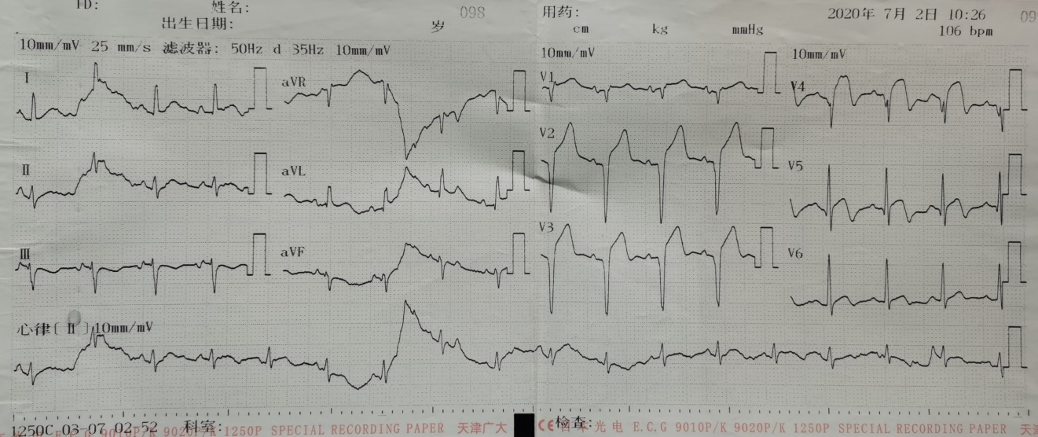
A
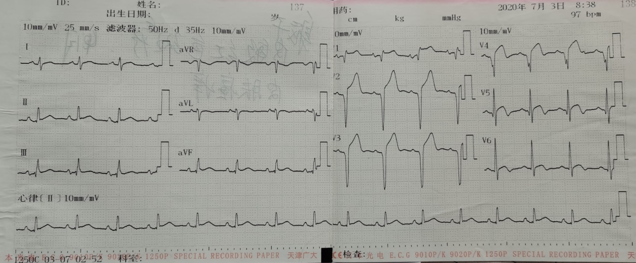
B
Figure 1 Electrocardiogram examination. A: On admission; B: Day after admission.
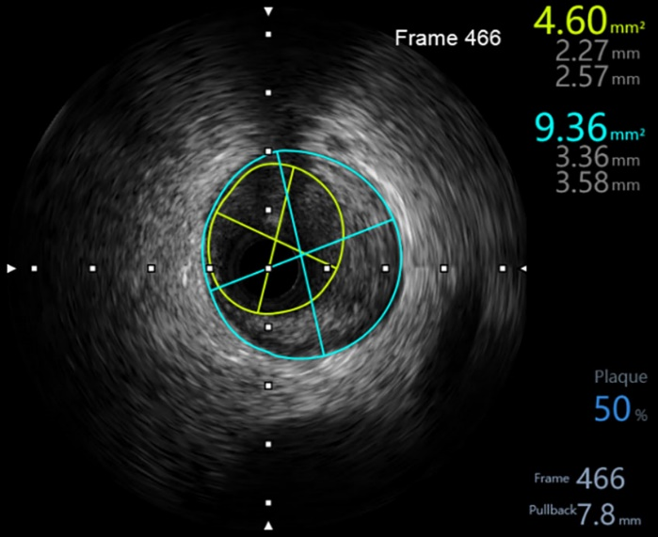
A
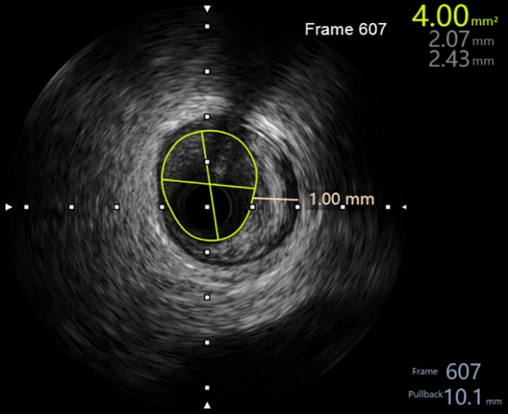
Figure 2 Presence of plaque in the middle of the anterior descending coronary artery. A: Plaque burden was 50%; B: Plaque thickness was 1 mm.
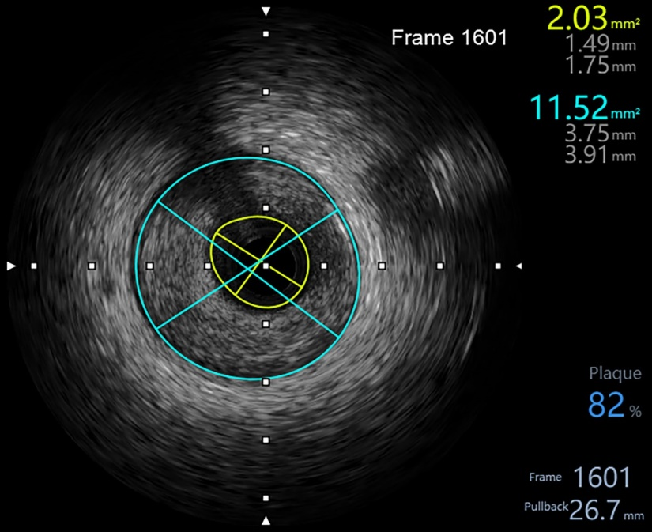
A
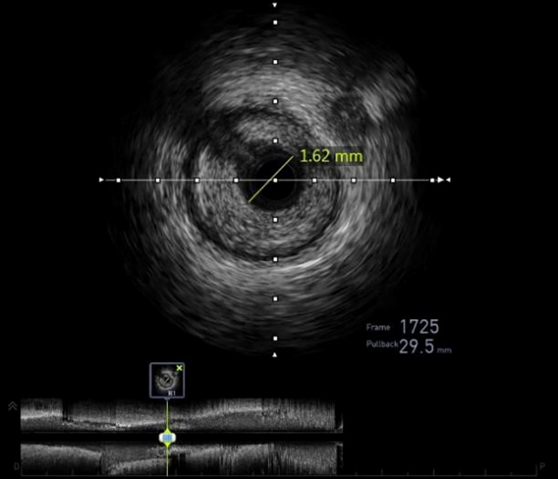
B
Figure 3 Plaque features before interventional treatment of the proximal anterior descending coronary artery. A: Plaque burden was 82%, with minimum lumen cross-sectional area of 2.03 mm²; B: Lumen diameter was 1.62 mm.
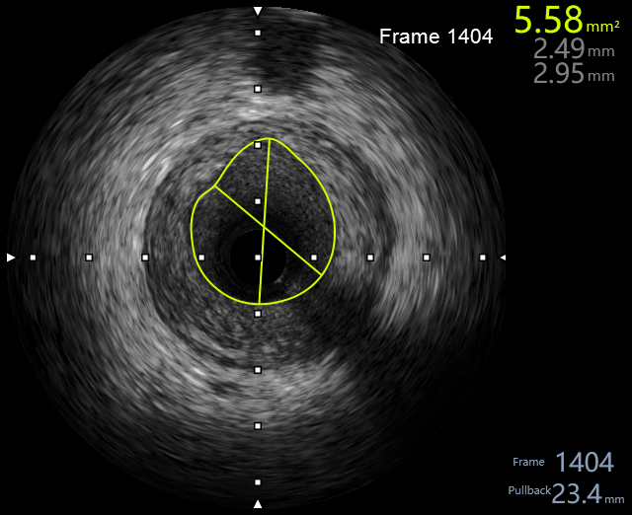
A
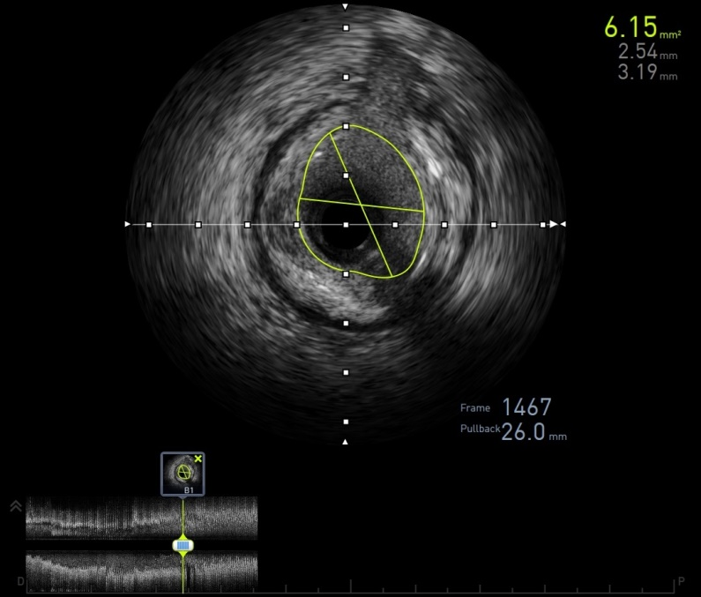
B
Figure 4 Plaque features after interventional treatment of the proximal anterior descending coronary artery. A: Lumen cross-sectional area (CSA) was 5.58 mm²; B: Maximum lumen CSA was 6.15 mm².
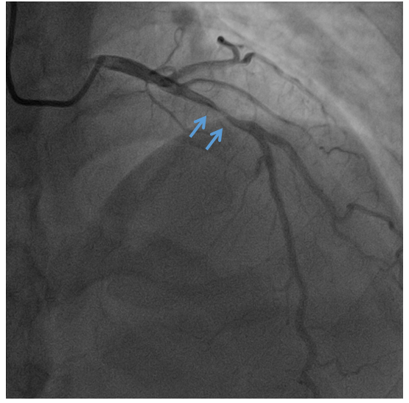
A
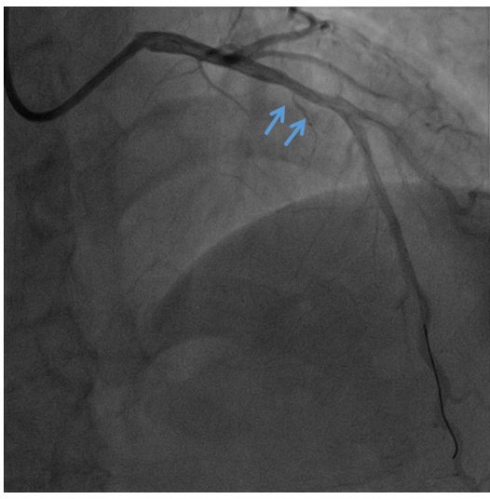
B
Figure 5 Coronary angiography of the proximal anterior descending coronary artery. A: Before interventional treatment, stenosis was 95%; B: After interventional treatment, the stenosis obviously relieved. Orange arrows indicate the narrowest position.
Table 1 Thyroid function test results from time of admission
Item | Result | Reference range | Unit
FT3 | > 30.00 | 1.71-3.71 | pg/mL
FT4 | 3.59 | 0.7-1.48 | ng/dL
TSH-3GEN | 0.0017 | 0.4700-4.6400 | IU/mL
A-TPO | 2.40 | 0-5.61 | IU/mL
A-TG | 0.84 | 0-4.11 | IU/mL
TRAb | 12.56 | < 1.75 | IU/L
A-TPO: Thyroid peroxidase; A-TG: Thyroglobulin; FT3: Free triiodothyronine; FT4: Free thyroxine; TRAb: Thyroid-stimulating hormone receptor antibody; TSH-3GEN: Third-generation thyroid-stimulating hormone.

Table 2 Thyroid function test results from 1 wk after anti-hyperthyroidism treatment
Item | Result | Reference range | Unit
FT3 | 11.85 | 1.71-3.71 | pg/mL
FT4 | 2.85 | 0.70-1.48 | ng/dL
TSH-3GEN | 0.0016 | 0.4700-4.6400 | IU/mL
FT3: Free triiodothyronine; FT4: Thyroxine; TSH-3GEN: Third-generation thyroid-stimulating hormone.

Table 3 Blood lipid test results
Item | Result | Reference range | Unit
CHOL | 3.56 | 2.80-5.17 | mmol/L
TG | 1.16 | 0.56-1.70 | mmol/L
HDL | 0.81 | 0.96-1.15 | mmol/L
LDL | 2.63 | 0-3.10 | mmol/L
CHOL: Cholesterol; HDL: High-density lipoprotein; LDL: Low-density lipoprotein; TG: Triglycerides.

Table 4 Coagulation test results
Item | Result | Reference range | Unit
PT-sec | 13.0 | 11-14 | s
PT-INR | 1.09 | 0.8-1.2 | N/A
APTT | 47.7 | 27-45 | s
FIB | 2.83 | 2-4 | g/L
TT | 18.6 | 0-20 | s
D-Dimer | 0.52 | 0-1 | mg/L
APTT: Activated partial thromboplastin time; FIB: Fibrinogen; N/A: Not applicable; PT-sec: Prothrombin time in seconds; PT-INR: Prothrombin time international normalized ratio; TT: Thrombin time.

Published by Baishideng Publishing Group Inc
7041 Koll Center Parkway, Suite 160, Pleasanton, CA 94566, USA
Telephone: +1-925-3991568
E-mail: bpgoffice@wjgnet.com
Help Desk: https://www.f6publishing.com/helpdesk
https://www.wjgnet.com

© 2021 Baishideng Publishing Group Inc. All rights reserved.

