Name of Journal: World Journal of Clinical Cases
Manuscript NO: 60743
Manuscript Type: CASE REPORT

Madelung disease: A case report

Chen KK et al. Madelung disease

Ke-Ke Chen, Lian-Song Ni, Wei-Hui Yu

Ke-Ke Chen, Lian-Song Ni, Wei-Hui Yu, Department of Endocrinology, The First Affiliated Hospital of Wenzhou Medical University, Wenzhou 325000, Zhejiang Province, China

Author contributions: Chen KK collected clinical data, discussed the details, contributed to the writing; Ni LS contributed to the follow–up of the patient, and modified the manuscript; Yu WH modified the manuscript and was a major contributor in writing the manuscript.

Corresponding author: Wei-Hui Yu, MD, PhD, Attending Doctor, Department of Endocrinology, The First Affiliated Hospital of Wenzhou Medical University, No. 2 Fuxue Alley, Wenzhou 325000, Zhejiang Province, China. shadow1201@163.com

Received: November 16, 2020
Revised: January 3, 2020
Accepted: January 22, 2021
Published online: March 16, 2021

Abstract
BACKGROUND
Madelung disease (MD) is a rare disorder of fat metabolism, resulting in diffuse, symmetrical and painless deposition of adipose tissue in subcutaneous superficial fascial space and/or deep fascia space of the head, neck and shoulders, etc.

CASE SUMMARY
We report a case of MD accompanied by type 2 diabetes in a 61-year-old Chinese male. The patient presented with progressive fat deposition over the mandible, neck, abdomen and elbows. He had a history of smoking and alcohol abuse. Excessive fat deposition was seen in the mandible, elbows and the abdominal area of the patient by ultrasonic examination. Computed tomography showed diffuse and marked soft masses (fat density) in the subcutaneous superficial fascia space of the neck. The patient was diagnosed with MD. He was advised to abstain from alcohol and was followed up regularly.

CONCLUSION
This report discusses the pathogenesis, diagnosis and treatment of MD, and raises the clinician’s awareness of this disease.

Key Words: Madelung disease; Multiple lipomatosis; Diabetes; Case report

©The Author(s) 2021. Published by Baishideng Publishing Group Inc. All rights reserved.

Citation: Chen KK, Ni LS, Yu WH. Madelung disease: A case report. World J Clin Cases 2021; 9(8): 1983-1988
URL: https://www.wjgnet.com/2307-8960/full/v9/i8/1983.htm
DOI: https://dx.doi.org/10.12998/wjcc.v9.i8.1983

Core Tip: Madelung disease (MD) is a rare disorder of fat metabolism, which results in diffuse and symmetrical deposition of adipose tissue in the subcutaneous superficial fascia space and/or deep fascia space in various parts of the body, such as the neck and shoulders, etc. Recently, a case of MD accompanied by type 2 diabetes was diagnosed and treated in our hospital. The clinical characteristics of MD are still under-recognized. Herein we discuss the pathogenesis, diagnosis and treatment of MD in order to improve the clinician’s understanding of the disease.

INTRODUCTION
Madelung disease (MD) is a relatively rare metabolic syndrome with unclear etiology. The main characteristic of the disease is the diffuse, symmetrical, and painless deposition of adipose tissue in the subcutaneous superficial fascial space and/or deep fascia space of the neck, shoulders and proximal extremities, etc^{[1-3]}. It usually occurs in middle-aged men with a history of chronic alcoholism. The disease is more common in the Mediterranean population, and very rare in the Asian population^{[2]}. This report describes a recent case of MD accompanied by type 2 diabetes who was diagnosed and treated in our hospital.

CASE PRESENTATION
Chief complaints
A-61-year-old male of Han ancestry was admitted to our hospital on July 15, 2020 due to a 4-yr history of progressive swollen soft masses at multiple sites.

History of present illness
The patient presented with progressive soft masses over the abdomen for more than four years, swellings in the mandible, back of the neck and elbows also gradually enlarged during these four years.

History of past illness
The patient was a heavy drinker with an average of 500 mL liquor per day for 45 years. He had a smoking history of approximately 20 cigarettes/day for 45 years,. The patient was diagnosed with type 2 diabetes more than 20 years previously, with poorly controlled glucose for many years. He had a history of hypertension for 18 years and did not take any antihypertensive drugs.

Personal and family history
He had no family history of similar diseases and denied previous special drug use.

Physical examination
Physical examination upon admission revealed the following: The patient was conscious; a body mass index of 21.0 kg/m²; subcutaneous masses in the mandible, back of the neck, abdomen and elbows (Figure 1); no signs of moon face, paper skin, hirsutism, or purple stria.

Laboratory examinations
Laboratory tests showed a total cholesterol level of 92.16 mg/dL, low-density lipoprotein cholesterol level of 35.28 mg/dL, high-density lipoprotein cholesterol level of 37.44 mg/dL, triglyceride level of 20.7 mg/dL, hemoglobin A1c of 5.4% and 24 h urinary albumin was 343.5 mg/d. Thyroid function was in the normal range. His basal cortisol level as well as his 1 mg dexamethasone suppression test were normal. Hepatitis B, hepatitis C, human immunodeficiency virus and syphilis were all negative.

Imaging examinations
Ultrasonography showed diffuse lipomatosis and lymph node echo in the neck in January 2018. The thickest part of the mass in the neck was about 28 mm. In July 2020, ultrasonography showed that the thickest part of the mass in the neck was about 44 mm. Ultrasonography of the elbow suggested that there was a hypoechoic mass between the palmaris muscles on both sides of the elbow, with a range of about 51 mm × 15 mm × 34 mm on the left and 46 mm × 14 mm × 35 mm on the right. The boundary was clear and the internal echo was not uniform, with strong echoes of several fiber spacers, similar to the echoes of adipose tissue. Simultaneously, excessive fat deposition was suggested on the mandible and the abdominal area of the patient by ultrasonic examination. Computed tomography showed diffuse and marked fatty deposits in the subcutaneous superficial fascia space of the neck without internal lesions (Figure 2). A breast ultrasound examination showed that both sides of the breast had excessive fat deposition and a flaky strong echo was seen in the deep side of the areola. The left side was about 33 mm × 3 mm × 25 mm and the right side was about 44 mm × 8 mm × 31 mm. The internal lobular structure was disordered, and small hypoechoic areas were seen, but no obvious mass echo and mammary duct expansion was found.

FINAL DIAGNOSIS
The patient was diagnosed with MD according to history taking, clinical features and auxiliary examinations.

TREATMENT
The patient was prescribed glimepiride, metformin, and voglibose to control blood glucose, and losartan potassium to reduce blood pressure and albuminuria. Alcohol abstinence and follow-up were advised. Surgical treatment was not considered at this time.

OUTCOME AND FOLLOW-UP
The patient was in a stable condition at follow-up visit. Alcohol abstinence and follow-up every 3-mo were advised.

DISCUSSION
MD is a disorder of fat metabolism. Patients with MD mainly show diffuse, symmetrical, painless and irreversible deposition of adipose tissue in the subcutaneous superficial fascia space and/or deep fascia space in the neck, shoulder, back and proximal limbs, and is a benign disease^{[1-4]}. The disease is also referred to as benign or multiple symmetrical lipomatosis (MSL), or the Launois-Bensaude syndrome. Previous reports have shown that the disease is more frequent in Mediterranean men, and more common in middle-aged people, aged 30-60 years old, with a male to female ratio of 15:1 to 30:1^{[5]}. The incidence of MD is rare, and it is not difficult to diagnose according to the patient’s history and physical signs. However, if clinicians do not know enough about MD, it is easily missed or misdiagnosed. Based on the anatomical location of adipose tissue, MD can be categorized into two types. Type I is the most common type, and found mainly in males. The adipose tissue is mainly distributed in the upper body, such as upper trunk, cervical region, supraclavicular region and arms. The area of fat in the neck slowly expands, giving it the appearance of a “horse collar”. Patients are admitted to hospital mainly due to "painless neck mass and progressive enlargement”. These patients usually present with concomitant symptoms including weight loss. In contrast, Type II MD, which is often accompanied by weight gain and unrelated to alcoholism, can also occur in females. The fat deposits mainly in the upper back, deltoid muscle area, buttocks and upper thigh, and some patients have upper abdominal fat accumulation^{[6]} and individual cases of pediatric patients have previously been reported^{[7,8]}. The diagnosis of MD is predominantly based on history taking, physical examination and auxiliary examinations. Ultrasound shows symmetric subcutaneous fat layer thickening, involvement of part of the muscle layer, an unclear boundary, irregular shape, often visible cord-like echoes, and the blood supply is not rich. The characteristic findings on CT or MRI play significant roles in the diagnosis and differential diagnosis^{[9]}. Although the pathogenesis is still unclear, MD is considered an autosomal dominant inherited disease^{[10]}. Nisi et al^{[11]} considered that MD is caused by a local defect of lipolysis caused by mitochondrial dysfunction. MD is strongly associated with alcohol consumption, which directly affects mitochondrial activity, causing premature oxidation of mitochondrial DNA or a point mutation in the tRNA-lysine gene of mitochondrial DNA (A8344G)^{[12]}. Musumeci et al^{[13]} confirmed that MSL could be considered, even if rare, a red flag for mitochondrial disorders, even in patients with an apparently isolated MSL. It has also been suggested that it may be related to brown fat hypertrophy caused by functional sympathetic degeneration of adipose tissue, which is the result of an abnormality in the synthesis of intracellular cyclic adenosine monophosphate induced by the stimulation of noradrenaline, the lipogenic, antilipolytic, and decreased lipid oxidative effect of ethanol may play a permissive role in the growth of fat in susceptible individuals^{[14]}. On the other hand, findings have shown that MFN2-related MSL is a novel mitochondrial lipodystrophic syndrome involving both lipomatous masses and lipoatrophy^{[15]}. The development of MD may also be associated with abnormal glucose metabolism, hyperlipidemia, hypothyroidism, peripheral neuropathy of lower limbs, myoclonic epilepsy with ragged-red fibers syndrome and hyperuricemia^{[16,17]}. To date, there is no effective drug therapy for MD. It has been reported that, in a few cases, the fat mass in patients will subside with abstinence and weight loss^{[18]}. Therefore, the general treatment of MD is reduced to palliative treatment, including and diet control. For most patients, discontinuation of alcohol abuse and a bariatric procedure may help control the disease, but has little effect on inhibiting progression of the disease. Surgical resection of the adipose tissue, liposuction, or injection lipolysis is still the most effective treatment, although patients often relapse after treatment^{[11]}. Brea-García et al^{[16]} reported a total postoperative recurrence rate of 63%, nevertheless, up to 95% of patients experienced symptoms relapse after liposuction^{[19]}. Therefore, regular long-term clinical follow-up of patients is recommended.

CONCLUSION
MD, a rare disease that progresses relatively slowly and is known as benign or multiple symmetrical lipomatosis, often coexists with a variety of metabolic disorders. This case introduces the involvement of alcohol abuse in MD pathogenesis. There is currently no effective treatment for the disease; therefore, it is important that patients are regularly followed up. At present, the clinical characteristics of MD are still under-recognized. We hope that this article can contribute to increasing the understanding of MD.

ACKNOWLEDGEMENTS
We are grateful to the patient, who gave his informed consent for publication.

REFERENCES
1 Enzi G, Busetto L, Ceschin E, Coin A, Digito M, Pigozzo S. Multiple symmetric lipomatosis: clinical aspects and outcome in a long-term longitudinal study. Int J Obes Relat Metab Disord 2002; 26: 253-261 [PMID: 11850759 DOI: 10.1038/sj.ijo.0801867]
2 Yeh NC, Yang CY, Chou CW, Yen FC, Lee SY, Tien KJ. Madelung's disease. J Clin Endocrinol Metab 2012; 97: 3012-3013 [PMID: 22701018 DOI: 10.1210/jc.2012-1649]
3 Ardeleanu V, Chicos S, Georgescu C, Tutunaru D. Multiple benign symmetric lipomatosis -- a differential diagnosis of obesity. Chirurgia (Bucur) 2013; 108: 580-583 [PMID: 23958107]
4 Chen CY, Fang QQ, Wang XF, Zhang MX, Zhao WY, Shi BH, Wu LH, Zhang LY, Tan WQ. Madelung's Disease: Lipectomy or Liposuction? Biomed Res Int 2018; 2018: 3975974 [PMID: 29682541 DOI: 10.1155/2018/3975974]
5 Hadjiev B, Stefanova P, Shipkov C, Uchikov A, Mojallal A. Madelung disease: on the morphologic criteria for diagnosis and treatment. Ann Plast Surg 2010; 64: 807-808 [PMID: 20489411 DOI: 10.1097/SAP.0b013e3181d9aa55]
6 Shibasaki ÍI, Shibasaki HI, Nakamoto Tde S, Baccan FS, Raposo LS. Multiple symmetrical lipomatosis (Madelung's disease). Braz J Otorhinolaryngol 2014; 80: 90-91 [PMID: 24626899 DOI: 10.5935/1808-8694.20140018]
7 Shetty C, Avinash KR, Auluck A, Mupparapu M. Multiple symmetric lipomatosis (MSL) of neck in a child (Madelung's disease): report of a rare presentation. Dentomaxillofac Radiol 2007; 36: 51-54 [PMID: 17329589 DOI: 10.1259/dmfr/30388883]
8 Kratz C, Lenard HG, Ruzicka T, Gärtner J. Multiple symmetric lipomatosis: an unusual cause of childhood obesity and mental retardation. Eur J Paediatr Neurol 2000; 4: 63-67 [PMID: 10817486 DOI: 10.1053/ejpn.2000.0264]
9 Szewc M, Sitarz R, Moroz N, Maciejewski R, Wierzbicki R. Madelung's disease - progressive, excessive, and symmetrical deposition of adipose tissue in the subcutaneous layer: case report and literature review. Diabetes Metab Syndr Obes 2018; 11: 819-825 [PMID: 30538518 DOI: 10.2147/DMSO.S181154]
10 Enzi G, Busetto L, Sergi G, Coin A, Inelmen EM, Vindigni V, Bassetto F, Cinti S. Multiple symmetric lipomatosis: a rare disease and its possible links to brown adipose tissue. Nutr Metab Cardiovasc Dis 2015; 25: 347-353 [PMID: 25770761 DOI: 10.1016/j.numecd.2015.01.010]
11 Nisi G, Sisti A. IMAGES IN CLINICAL MEDICINE. Madelung's Disease. N Engl J Med 2016; 374: 572 [PMID: 26863358 DOI: 10.1056/NEJMicm1503861]
12 Gámez J, Playán A, Andreu AL, Bruno C, Navarro C, Cervera C, Arbós MA, Schwartz S, Enriquez JA, Montoya J. Familial multiple symmetric lipomatosis associated with the A8344G mutation of mitochondrial DNA. Neurology 1998; 51: 258-260 [PMID: 9674814 DOI: 10.1212/wnl.51.1.258]
13 Musumeci O, Barca E, Lamperti C, Servidei S, Comi GP, Moggio M, Mongini T, Siciliano G, Filosto M, Pegoraro E, Primiano G, Ronchi D, Vercelli L, Orsucci D, Bello L, Zeviani M, Mancuso M, Toscano A. Lipomatosis Incidence and Characteristics in an Italian Cohort of Mitochondrial Patients. Front Neurol 2019; 10: 160 [PMID: 30873109 DOI: 10.3389/fneur.2019.00160]
14 Kodish ME, Alsever RN, Block MB. Benign symmetric lipomatosis: functional sympathetic denervation of adipose tissue and possible hypertrophy of brown fat. Metabolism 1974; 23: 937-945 [PMID: 4412181 DOI: 10.1016/0026-0495(74)90043-2]
15 Capel E, Vatier C, Cervera P, Stojkovic T, Disse E, Cottereau AS, Auclair M, Verpont MC, Mosbah H, Gourdy P, Barraud S, Miquel A, Züchner S, Bonnefond A, Froguel P, Christin-Maitre S, Delemer B, Fève B, Laville M, Robert J, Tenenbaum F, Lascols O, Vigouroux C, Jéru I. MFN2-associated lipomatosis: Clinical spectrum and impact on adipose tissue. J Clin Lipidol 2018; 12: 1420-1435 [PMID: 30158064 DOI: 10.1016/j.jacl.2018.07.009]
16 Brea-García B, Cameselle-Teijeiro J, Couto-González I, Taboada-Suárez A, González-Álvarez E. Madelung's disease: comorbidities, fatty mass distribution, and response to treatment of 22 patients. Aesthetic Plast Surg 2013; 37: 409-416 [PMID: 23435503 DOI: 10.1007/s00266-012-9874-5]
17 Boozan JA, Maves MD, Schuller DE. Surgical management of massive benign symmetric lipomatosis. Laryngoscope 1992; 102: 94-99 [PMID: 1731165 DOI: 10.1288/00005537-199201000-00019]
18 Prahlow SP, Kosciuk P, Prahlow JA. Multiple Symmetric Lipomatosis. J Forensic Sci 2018; 63: 312-315 [PMID: 28643398 DOI: 10.1111/1556-4029.13536]
19 Jang JH, Lee A, Han SA, Ryu JK, Song JY. Multiple Symmetric Lipomatosis (Madelung's Disease) Presenting as Bilateral Huge Gynecomastia. J Breast Cancer 2014; 17: 397-400 [PMID: 25548590 DOI: 10.4048/jbc.2014.17.4.397]

Footnotes
Informed consent statement: Informed written consent was obtained from the patient for publication of this report and any accompanying images.

Conflict-of-interest statement: The authors declare that they have no conflict of interest.

CARE Checklist (2016) statement: The authors have read the CARE Checklist (2016), and the manuscript was prepared and revised according to the CARE Checklist (2016).

Open-Access: This article is an open-access article that was selected by an in-house editor and fully peer-reviewed by external reviewers. It is distributed in accordance with the Creative Commons Attribution NonCommercial (CC BY-NC 4.0) license, which permits others to distribute, remix, adapt, build upon this work non-commercially, and license their derivative works on different terms, provided the original work is properly cited and the use is non-commercial. See: http://creativecommons.org/Licenses/by-nc/4.0/

Manuscript source: Unsolicited manuscript

Peer-review started: November 16, 2020
First decision: December 13, 2020
Article in press: January 22, 2021

Specialty type: Endocrinology and metabolism
Country/Territory of origin: China
Peer-review report’s scientific quality classification
Grade A (Excellent): 0
Grade B (Very good): 0
Grade C (Good): C
Grade D (Fair): 0
Grade E (Poor): 0

P-Reviewer: Maximiano L S-Editor: Chen XF L-Editor: Webster JR P-Editor: Li JH

Figure Legends
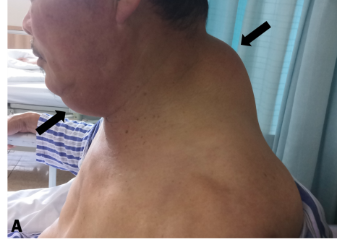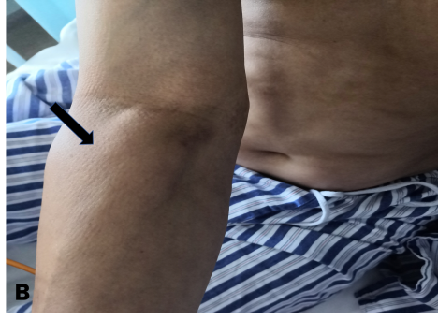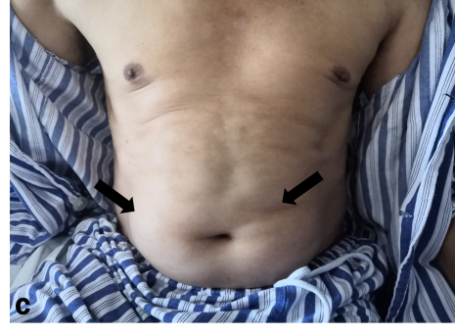
Figure 1 Fat deposition in different parts of the body in a 61-year-old man with Madelung disease. A: Mandible and back of neck; B: Elbow; C: Abdomen.
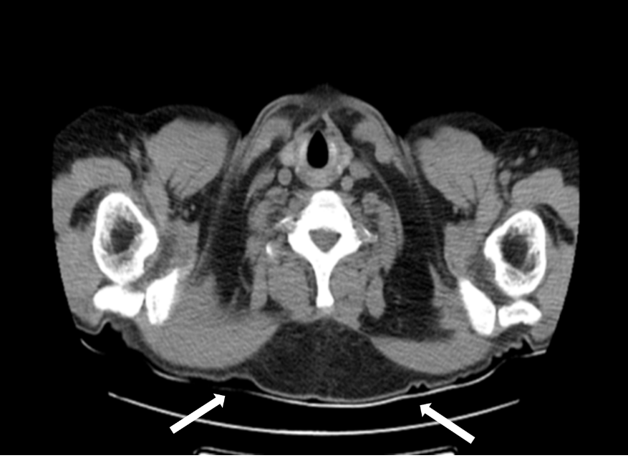
Figure 2 Computed tomography scan shows bilateral fat deposition in the neck (orange arrow).

Published by Baishideng Publishing Group Inc
7041 Koll Center Parkway, Suite 160, Pleasanton, CA 94566, USA
Telephone: +1-925-3991568
E-mail: bpgoffice@wjgnet.com
Help Desk: https://www.f6publishing.com/helpdesk
https://www.wjgnet.com

© 2021 Baishideng Publishing Group Inc. All rights reserved.

