Name of Journal: World Journal of Gastrointestinal Oncology
Manuscript NO: 79536
Manuscript Type: CASE REPORT

Edema of limbs as the primary symptom of gastric signet-ring cell carcinoma: A case report and literature review

Wang B et al. Gastric cancer and lymphedema

Bei Wang, Jing Chen, Ying Wang, Ling-Li Dong, Gui-Fen Shen

Bei Wang, Ling-Li Dong, Gui-Fen Shen, Department of Rheumatology and Immunology, Tongji Hospital, Tongji Medical College, Huazhong University of Science and Technology, Wuhan 430030, Hubei Province, China

Jing Chen, Division of Cardiology, Department of Internal Medicine and Gene Therapy Center, Tongji Hospital, Tongji Medical College, Huazhong University of Science and Technology, Wuhan 430030, Hubei Province, China

Ying Wang, Department of Pathology, Tongji Hospital, Tongji Medical College, Huazhong University of Science and Technology, Wuhan 430030, Hubei Province, China

Author contributions: Wang B wrote the manuscript; Chen J and Wang Y diagnosed and treated the patient; Dong LL collected associated references; Shen GF commented on the manuscript and all authors discussed the results, read and approved the manuscript.

Supported by The National Nature Science Foundation of China, No. 81900363.
Corresponding author: Gui-Fen Shen, MD, PhD, Doctor, Department of Rheumatology and Immunology, Tongji Hospital, Tongji Medical College, Huazhong University of Science and Technology, Jiefang Avenue 1095, Wuhan 430030, Hubei Province, China. guifenshen@126.com

Received: August 26, 2022
Revised: September 17, 2022
Accepted: November 28, 2022
Published online: December15, 2022

Abstract
BACKGROUND
Metastatic skin cancers are relatively rare dermatological malignancies. They usually present as nodules, erythematous lesions, scar-like lesions or other lesion types. Signet-ring cell carcinoma (SRCC) is an uncommon histological type of gastric cancer that usually behaves aggressively and has a poor prognosis. Skin metastasis may be the first sign of clinically silent visceral cancer or recurrence of an internal malignancy.

CASE SUMMARY
Herein we report on the case of a 55-year-old man with edema of a lower extremity as the primary symptom which progressed from local to generalized pitting edema in the year following skin involvement. Pathological evidence from gastroscopic specimens and subcutaneous tissue biopsy showed typical signet-ring cells and gland-like structures. Consistently, immunohistochemical analysis revealed positive pan-cytokeratin expression in tumor cells. A diagnosis of gastric SRCC with skin metastasis was established. Moreover, lymphoscintigraphy showed an obvious accumulation of radiotracer on the anterior and posterior sides of the right leg which indicated lymphedema. We reviewed the relevant literature on subcutaneous metastases of gastric SRCC.

CONCLUSION
This rare case emphasizes the importance of physical examination as it may help elucidate the etiology of edema.

Key Words: Gastric cancer; Signet-ring cell carcinoma; Skin metastasis; Lymphedema; Prognosis; Case report

©The Author(s) 2022. Published by Baishideng Publishing Group Inc. All rights reserved.

Citation: Wang B, Chen J, Wang Y, Dong LL, Shen GF. Edema of limbs as the primary symptom of gastric signet-ring cell carcinoma: A case report and literature review. World J Gastrointest Oncol 2022; 14(12): 2404-2414
URL: https://www.wjgnet.com/1948-5204/full/v14/i12/2404.htm
DOI: https://dx.doi.org/10.4251/wjgo.v14.i12. 2404

Core Tip: Metastatic skin cancers are relatively rare dermatological malignancies. They usually present as nodules, erythematous lesions, scar-like lesions or other lesion types. We report on a case of skin metastases from gastric signet-ring cell carcinoma in which lymphedema of the limbs presented as an initial symptom. This rare case emphasizes the importance of physical examination as it may help elucidate the etiology of edema.

INTRODUCTION
Metastatic skin cancers (MSCs) are relatively rare dermatological malignancies. They constitute 2% of all skin tumors and the reported incidence rates range from 0.7% to 9.0%^{[1]}. MSCs originate most commonly from breast, lung and gastrointestinal tissues and are recognized as having a poor prognosis^{[1,2]}. Furthermore, cutaneous metastases from gastric signet-ring cell carcinoma (SRCC) are uncommon^{[3]}. The clinical presentation of cutaneous metastases from gastric adenocarcinoma is usually single or multiple nodules or erythematous lesions; only 6.4 % to 7.8 % of these cutaneous metastases are the first clinical manifestation^{[4,5]}. Moreover, to the best of our knowledge, there is no report describing edema of the limbs as the primary symptom of MSCs originating from signet-ring cell gastric carcinoma.
The causes of edema vary. Most causes of edema are due to increased capillary filtration overwhelming the normal lymphatic system^{[6]}. Under some conditions, lymphedema occurs when lymph transport capacity is impaired. Lymphedema can be classified into primary and secondary categories^{[7]}. Both primary and secondary forms of lymphedema are often chronic and insidious in nature. Infections such as lymphatic filariasis are a frequent cause of secondary lymphedema in developing countries, whereas in developed countries, a common cause of secondary lymphedema is cancer treatment. Of note, the metastasis or, rarely, direct invasion of active tumor into the lymphatic network can also produce a severe form of lymphedema^{[8]}.
In this study, we present a case of atypical gastric adenocarcinoma with signet-ring cell morphology which presented with cutaneous lymphedema as the primary symptom.

CASE PRESENTATION
Chief complaints
A 55-year-old Chinese male first presented with cutaneous edema of the right lower limb, which developed as systemic edema of all limbs over the course of a year (Figure 1).

History of present illness
In April 2019, the patient developed edema of the right lower limb with an unknown cause. The edema began to spread from the end of the lower extremity to the groin and trunk area. At a local hospital, he was diagnosed with slight renal insufficiency (estimated glomerular filtration rate: 59 mL/min/1.73 m²). Additionally, cardiac insufficiency and hepatic insufficiency was excluded and the patient underwent magnetic resonance imaging of the lower extremity. The results showed obvious swelling of subcutaneous soft tissue in the right thigh, slight edema in the subcutaneous soft tissue of the left thigh and edema of the long and short head of the biceps femoris. One year after skin involvement, the patient presented with newly diagnosed poly-serous effusions (thoracic cavity, abdominal cavity and pericardium).

Personal and family history
The patient had no significant personal history and denied any health issues or genetic problems in his family. There was no obvious weight loss or significant family history.

Physical examination
On admission, the patient’s temperature was 36.0 ℃, heart rate was 91 beats/min, respiratory rate was 20 breaths/min and blood pressure was 143/92 mmHg. No abnormality was found in the heart and the lungs were clear to bilateral auscultation without any wheezes, rales or rhonchi. Furthermore, there was no tenderness or rebound pain in the abdomen. Additionally, there is no sign of associated gastro-intestinal symptoms such as nausea, vomiting, hematemesis or any change in bowel habits. However, he had obvious pitting edema in the right lower limb but not in the left limb. When pressure was applied to the right lower limb, an indentation remained in the soft tissue after the pressure was removed.

Laboratory examinations
The main characteristics of laboratory examinations during the initial 3-mo and 12-mo visits are listed in Table 1. Specifically, the results showed that the patient’s carbohydrate antigen 724 Levels were slightly elevated during the initial (16.41 U/mL, reference value range < 6.9 U/mL), 3-mo (15.51 U/mL) and 12-mo (15.67 U/mL) visit, while serum carcinoembryonic antigen (CEA) and carbohydrate antigen 19-9 Levels were within the normal range. The levels of urea nitrogen (8.97 mmol/L, 12.54 mmol/L, and 12.83 mmol/L for the initial, 3-mo and 12-mo visits, respectively) were slightly elevated. Similarly, creatinine levels (126 μmol/L, 130 μmol/L, and 152 μmol/L for the initial, 3-mo and 12-mo visits, respectively) were also slightly elevated. Kidney function was evaluated as chronic kidney disease (CKD) G3a by calculating the estimated glomerular filtration rate^{[9]}. However, the results were normal for the patient’s kidney, ureter, and bladder on color Doppler ultrasound. Routine urine tests indicated no proteinuria or hematuria. Thyroid function test results were normal.

Imaging examinations
No obvious abnormality was found on computed χ-ray tomography of the chest and abdomen. The 18F-fluorodeoxyglucose (FDG) positron emission tomography was performed. No pathological FDG uptake was detected in the liver, spleen, kidneys, gastrointestinal system, or in either the abdominal or pelvic lymph node groups. Moreover, lymphoscintigraphy labeled with 99^{m}Tc-DX showed an obvious accumulation of radiotracer in the right leg on both the anterior and posterior sides after 3 and 6 h diffusion (Figure 2), indicating lymph angiodysplasia and lymphedema. Color Doppler ultrasound of the heart and blood vessels of both lower limbs showed no abnormality.

Pathological and gastrointestinal endoscopic examination
First, the biopsy of the skin on the lower limb revealed infiltration of the suspicious cells with a signet-ring appearance cells and gland-like structures (Figure 3A-C). Biopsy specimens of the lesions showed reactive epithelial changes [pan-cytokeratin (panCK) positive) (Figure 3C). Because the gastrointestinal tract is the most common source of SRCC, a gastrointestinal endoscopic examination (Figure 3D and E) was subsequently performed. The results showed multiple gastric ulcers without solid neoplasm (Figure 3D and E). However, biopsies of both the body and antrum gastric mucosa showed infiltrating signet ring cell type adenocarcinoma (Figure 3F and G), which were very strongly panCK positive (Figure 3H and I) and CEA positive. Additionally, histopathology showed a less differentiated signet cell ring carcinoma with approximately 20% ki-67 positivity. Taken together, gastrointestinal metastasis was confirmed as the source of the signet-ring cells in skin biopsies. Thus, a diagnosis of metastatic SRCC, most likely from the stomach, was made.

FINAL DIAGNOSIS
Gastric SRCC with skin metastases.

TREATMENT
Surgical intervention is not possible for advanced or metastatic gastric cancer. First-line systemic therapy regimens with 2 cytotoxic drugs are preferred for these patients^{[10]}. The preferred regimens for first-line systemic therapy includes fluoropyrimidine (fluorouracil or capecitabine) combined with either oxaliplatin or cisplatin (category 2B)^{[10]}. Given the renal insufficiency in this patient, oxaliplatin or cisplatin was not suitable^{[11]}. Thus, from August 21 to September 2, 2019, the patient received a combination of chemotherapy with tegafur (a prodrug of 5-fluorouracil, 60 mg/PO/bid), and paclitaxel (second-line systemic therapy; 100 mg/iv/QW). Over the next 5 mo, he received another five cycles of chemotherapy.

OUTCOME AND FOLLOW-UP
At the 3-mo visit, his limb edema had worsened. By the 12-mo visit, edema had spread from the lower limbs to the entire body (Figure 1), and the patient presented with newly diagnosed polyserous effusions (thoracic cavity, abdominal cavity and pericardium). After 6 mo of treatment, the patient declined further chemotherapy and received palliative diuretic therapy.

DISCUSSION
This report describes a rare case in which cutaneous metastasis led to the detection of gastric SRCC. Additionally, this gastric SRCC primarily presented as lymphedema of the limbs after the subcutaneous metastases. The typical sites for metastasis of gastric cancer are the liver, peritoneal cavity and regional lymph nodes^{[12]}. The incidence rate of cutaneous metastasis from gastric SRCC is less than 2%; however, when present, the median survival time is 6.5 mo. Common cutaneous manifestations of gastric SRCC include single or multiple red, violet or hyperpigmented asymptomatic nodules, or more rarely, as cellulitis-like or erysipelas-like erythematous plaques^{[12]}. However, our report presents a case of a patient with gastric SRCC who developed carcinomatous lymphangitis, which is very rare in clinical practice.
Skin metastases from internal tumors are uncommon in clinical practice. In women, the most common origin of skin metastases is adenocarcinoma of the breast, whereas squamous cell carcinoma of the lung is the most common in men. Skin metastases in patients with gastric SRCC are extremely rare. The largest series of patients with skin metastases came from a study by Lookingbill et al^{[3]} with a total of 4020 patients. Current information about skin metastases from cancer of the stomach comes from the publication of small series or case reports. The first thorough review of a cutaneous metastases from gastric cancer was performed in 2014 by Cesaretti et al^{[13]} and included 72 reported patients with cutaneous lesions at various locations on the body surface. However, to the best of our knowledge, skin metastases from gastric SRCC as the first manifestation have not yet been reviewed.
An electronic literature search was conducted using Medline (PubMed) and Google Scholar databases in August 2022 with the terms “gastric SRCC and cutaneous metastases”. The data of publication ranged from 1989 to 2022. There were a total of 30 studies, of which 5 lacked main information; thus, we present a review of 25 studies on cutaneous metastases from gastric signet-ring cell adenocarcinoma (Table 2). The 25 studies included 17 male and 8 female patients with an average age of approximately 58.0-years-old. Although reliable allocation of a skin metastasis to the original tumor is not possible, some preferential associations are obvious. Previous data showed that gastrointestinal and colorectal tumors mainly develop distant skin metastases in the abdomen^{[14]}. In our review, the locations of skin metastases from gastric signet-ring cell adenocarcinoma included the abdomen (10/26, 40.0%)，face (7/25, 28.0%), head (5/25, 20.0%), neck (6/25, 24.0%), back (8/25, 32.0%), chest (3/25, 12.0%), armpits (1/25, 4.0%), groin (2/25, 8.0%), arms (3/25, 12.0%) and limbs (3/25, 12.0%). Only one patient presented with initial symptoms and without any local or general clinical symptoms^{[15]}. In all cases, only seven patients presented with weight loss and gastrointestinal symptoms (such as vomiting, loss of appetite, dyspepsia or abdominal pain)^{[16,17]} as the first manifestation. For the cutaneous manifestations, seven patients presented with skin lesions^{[18-20]} (scar-like or other types of lesions), nine patients with nodules^{[21]} and five with erythema. Ours is a rare case, not only due to dramatic skin metastasis as the first presenting sign but also because the patient presented with obvious edema of the lower limbs. In addition, the prognosis of skin metastases from gastric signet cell carcinoma is poor. In all 25 cases reviewed, only 4 patients survived. Most patients died a few weeks (mean 6.1 wk) later after skin involvement^{[16]}. Currently, the patient in our case is alive, but also has advanced symptoms (systemic edema in all limbs) (Figure 1).
In the review by Cesaretti et al^{[13]} in 2014, 80% of the patients received a management approach ranging from local excision to chemotherapy or chemoradiation therapy to treat their cutaneous metastases. In our review, 16 patients were treated with chemotherapy (11/16), chemoradiation therapy (1/16), surgery (3/16), or radiotherapy (1/16). Chemotherapy is the first choice for the treatment of advanced gastric signet-ring cell adenocarcinoma. In particular, chemotherapy regimens 5-fu/fa/oxaliplatin (5-fluorouracil, folinic acid, and oxaliplatin) and S-1 (tegafur plus cisplatin) were preferred in our review of cutaneous metastases after gastric signet-ring cell adenocarcinoma.
Because carcinomas generally spread preferentially via the lymphatic route and gastrointestinal tumors are known to spread to lymph nodes or lymph-vessels, in this case, it is hypothesized that an aggressive clone of signet cell gastric carcinoma metastasized to the lymph-vessels and then, by making a blockage of lymph-vessels, appeared in the dermis of the skin as an apparently primary skin edema or lymphedema. Lymphedema is a clinical condition characterized by an increased volume of subcutaneous soft tissues due to impairment of the lymphatic system. Lower limb edema is a very common symptom; the most common underlying mechanisms include venous and lymphatic disease, volume overload, increased capillary permeability and decreased oncotic pressure. The most commonly associated diseases are deep vein thrombosis and chronic venous insufficiency, heart failure, hepatic or renal failure hypoproteinemia, idiopathic cyclic edema and drug-induced edema. Lymphedema induced by gastric SRCC is rare and has not been previously reported.
Additionally, the patient’s kidney function was evaluated as CKD G3a by calculating the estimated glomerular filtration rate. Renal dysfunction is classified into nonuremic and uremic stages. Patients with non-uremic renal failure (NURF) are defined as having impaired renal function, but are dependent on their own kidneys. The reason is currently unknown. Recently, owing to the increase in the aged population and the incidence of diabetes mellitus, the number of patients with gastric cancer associated with NURF have been increasing^{[22]}. Whether gastric cancer itself or other factors led to the NURF in this patient remains unclear.

CONCLUSION
We report on a case of skin metastases from gastric SRCC in which lymphedema of the limbs presented as an initial symptom. This case emphasizes the importance of excluding malignancy from the differential diagnosis of edema. Thus, a careful clinical physical examination must be performed on patients with edema to ensure that no information is missing and to obtain further clinical data which could pave the way for further studies.

REFERENCES
1 Wong CY, Helm MA, Helm TN, Zeitouni N. Patterns of skin metastases: A review of 25 years' experience at a single cancer center. Int J Dermatol 2014; 53: 56-60 [PMID: 23432658 DOI: 10.1111/j.1365-4632.2012.05635.x]
2 Disibio G, French SW. Metastatic patterns of cancers: results from a large autopsy study. Arch Pathol Lab Med 2008; 132: 931-939 [PMID: 18517275 DOI: 10.5858/2008-132-931-MPOCRF]
3 Lookingbill DP, Spangler N, Helm KF. Cutaneous metastases in patients with metastatic carcinoma: A retrospective study of 4020 patients. J Am Acad Dermatol 1993; 29: 228-236 [PMID: 8335743 DOI: 10.1016/0190-9622(93)70173-q]
4 Nashan D, Müller ML, Braun-Falco M, Reichenberger S, Szeimies RM, Bruckner-Tuderman L. Cutaneous metastases of visceral tumours: A review. J Cancer Res Clin Oncol 2009; 135: 1-14 [PMID: 18560891 DOI: 10.1007/s00432-008-0432-0]
5 Saeed S, Keehn CA, Morgan MB. Cutaneous metastasis: A clinical, pathological, and immunohistochemical appraisal. J Cutan Pathol 2004; 31: 419-430 [PMID: 15186430 DOI: 10.1111/j.0303-6987.2004.00207.x]
6 Mortimer PS. Managing lymphoedema. Clin Exp Dermatol 1995; 20: 98-106 [PMID: 8565266 DOI: 10.1111/j.1365-2230.1995.tb02665.x]
7 Szuba A, Rockson SG. Lymphedema: Classification, diagnosis and therapy. Vasc Med 1998; 3: 145-156 [PMID: 9796078 DOI: 10.1177/1358836X9800300209]
8 Rockson SG, Keeley V, Kilbreath S, Szuba A, Towers A. Cancer-associated secondary lymphoedema. Nat Rev Dis Primers 2019; 5: 22 [PMID: 30923312 DOI: 10.1038/s41572-019-0072-5]
9 Levin A, Stevens PE. Summary of KDIGO 2012 CKD Guideline: Behind the scenes, need for guidance, and a framework for moving forward. Kidney Int 2014; 85: 49-61 [PMID: 24284513 DOI: 10.1038/ki.2013.444]
10 Ajani JA, D'Amico TA, Bentrem DJ, Chao J, Corvera C, Das P, Denlinger CS, Enzinger PC, Fanta P, Farjah F, Gerdes H, Gibson M, Glasgow RE, Hayman JA, Hochwald S, Hofstetter WL, Ilson DH, Jaroszewski D, Johung KL, Keswani RN, Kleinberg LR, Leong S, Ly QP, Matkowskyj KA, McNamara M, Mulcahy MF, Paluri RK, Park H, Perry KA, Pimiento J, Poultsides GA, Roses R, Strong VE, Wiesner G, Willett CG, Wright CD, McMillian NR, Pluchino LA. Esophageal and Esophagogastric Junction Cancers, Version 2.2019, NCCN Clinical Practice Guidelines in Oncology. J Natl Compr Canc Netw 2019; 17: 855-883 [PMID: 31319389 DOI: 10.6004/jnccn.2019.0033]
11 Taguchi T, Nazneen A, Abid MR, Razzaque MS. Cisplatin-associated nephrotoxicity and pathological events. Contrib Nephrol 2005; 148: 107-121 [PMID: 15912030 DOI: 10.1159/000086055]
12 Liu F, Yan WL, Liu H, Zhang M, Sang H. Cutaneous metastases from gastric adenocarcinoma 15 years after curative gastrectomy. An Bras Dermatol 2015; 90: 46-50 [PMID: 26312672 DOI: 10.1590/abd1806-4841.20153829]
13 Cesaretti M, Malerba M, Basso V, Boccardo C, Santoni R, D'Alessandro G, Weiss A, Campisi C, De Cian F. Cutaneous metastasis from primary gastric cancer: A case report and review of the literature. Cutis 2014; 93: E9-E13 [PMID: 24818191]
14 Rendi MH, Dhar AD. Cutaneous metastasis of rectal adenocarcinoma. Dermatol Nurs 2003; 15: 131-132 [PMID: 12751347]
15 Fekete GL, Cotoi OS, Fekete JE. Multiple nodular cutaneous metastases as the first clinical sign of signet ring cell gastric carcinoma: Case report. Acta Dermatovenerol Croat 2012; 20: 34-37 [PMID: 22507473]
16 Karayiannakis AJ, Bolanaki H, Tsalikidis C, Simopoulos C. Cutaneous metastasis at a surgical drain site after gastric cancer resection. Case Rep Oncol 2010; 3: 495-497 [PMID: 21611104 DOI: 10.1159/000323559]
17 Acikalin MF, Vardareli E, Tel N, Saricam T, Urer S. Erysipelas-like cutaneous metastasis from gastric signet ring cell carcinoma. J Eur Acad Dermatol Venereol 2005; 19: 642-643 [PMID: 16164730 DOI: 10.1111/j.1468-3083.2005.01214.x]
18 Schulmann K, Strate K, Pox CP, Wieland U, Kreuter A. Paraneoplastic acanthosis nigricans with cutaneous and mucosal papillomatosis preceding recurrence of a gastric adenocarcinoma. J Clin Oncol 2012; 30: e325-e326 [PMID: 23008315 DOI: 10.1200/JCO.2012.42.5454]
19 Zadeh VB, Kadyan R, Al-Abdulrazzaq A, Al-Otaibi S, Sarhan A, Najem N. Sister Mary Joseph's nodule: A case of umbilical cutaneous metastasis with signet ring cell histology. Indian J Dermatol Venereol Leprol 2009; 75: 503-505 [PMID: 19736432 DOI: 10.4103/0378-6323.55396]
20 Gündüz Ö, Emeksiz MC, Atasoy P, Kidir M, Yalçin S, Demirkan S. Signet-ring Cells in the Skin: A Case of Late-onset Cutaneous Metastasis of Gastric Carcinoma and a Brief Review of Histological Approach. Dermatol Reports 2016; 8: 6819 [PMID: 28326183 DOI: 10.4081/dr.2016.6819]
21 Essa K, Pervez S, Shah LM, Soomro IN. Signet cell gastric carcinoma presenting as multiple large skin nodules. Australas J Dermatol 2001; 42: 219-220 [PMID: 11510466 DOI: 10.1046/j.1440-0960.2001.00522.x]
22 Mori S, Sawada T, Hamada K, Kita J, Shimoda M, Tagaya N, Kubota K. Gastrectomy for patients with gastric cancer and non-uremic renal failure. World J Gastroenterol 2007; 13: 4589-4592 [PMID: 17729411 DOI: 10.3748/wjg.v13.i34.4589]
23 Bulut E, Taştekin E, Topuz C, Öztürk S, Gökyer A. Exceptional Variant with Distant Cutaneous Metastasis as the First Clinical Sign in Gastric Signet-Ring Carcinoma. J Gastrointest Cancer 2021 [PMID: 34786642 DOI: 10.1007/s12029-021-00747-2]
24 Chen JW, Zheng LZ, Xu DH, Lin W. Extensive cutaneous metastasis of recurrent gastric cancer: A case report. World J Clin Cases 2021; 9: 6575-6581 [PMID: 34435028 DOI: 10.12998/wjcc.v9.i22.6575]
25 Demircioğlu D, Öztürk Durmaz E, Demirkesen C, Şahin S. Livedoid cutaneous metastasis of signet-ring cell gastric carcinoma. J Cutan Pathol 2021; 48: 785-788 [PMID: 33476049 DOI: 10.1111/cup.13969]
26 Souza BDS, Bonamigo RR, Viapiana GL, Cartell A. Signet ring cells in carcinomatous lymphangitis due to gastric adenocarcinoma. An Bras Dermatol 2020; 95: 490-492 [PMID: 32487420 DOI: 10.1016/j.abd.2019.12.004]
27 Cokgezer S, Samanci NS, Bektas M, Kepil N, Demirelli FH. Cutaneous Metastasis of Signet Cell Gastric Carcinoma. Indian J Dermatol 2020; 65: 148-150 [PMID: 32180605 DOI: 10.4103/ijd.IJD_263_18]
28 Matsuoka T, Hosaka S, Inada K, Kawamoto S. [A case of delayed subcutaneous metastases of gastric carcinoma effectively treated with S-1 plus cisplatin chemotherapy]. Gan To Kagaku Ryoho 2013; 40: 2262-2264 [PMID: 24394079]
29 Qiao J, Fang H. Cutaneous nodule in a young man. JAMA 2012; 308: 812-813 [PMID: 22910759 DOI: 10.1001/jama.2012.9637]
30 Alcaraz I, Santonja C, Kutzner H, Requena L. Signet-ring cell gastric adenocarcinoma metastasizing into a primary cutaneous squamous cell carcinoma of the scalp. J Cutan Pathol 2012; 39: 568-569, 570-573 [PMID: 22616597 DOI: 10.1111/j.1600-0560.2012.01928_1.x]
31 Ismaili Z, Dekhay S, Moussaoui A, Jahid A. Primary gastric, duodenal, and rectal signet ring cell carcinoma revealed by cutaneous metastasis. Endoscopy 2011; 43 Suppl 2: E209-E210 [PMID: 21590608 DOI: 10.1055/s-0030-1256399]
32 Kerkeni N, Fazaa B, Ezzine N, Zeglaoui F, Kamoun MR, Jaada N, Khedher MA, Zermani R. Cutaneous metastasis in an old surgical scar revealing gastric linitis. Int J Dermatol 2011; 50: 629-632 [PMID: 21506987 DOI: 10.1111/j.1365-4632.2009.04425.x]
33 Xavier MH, Vergueiro Tde R, Vilar EG, Pinto JM, Issa MC, Pereira GB, Carocha AP. Cutaneous metastasis of gastric adenocarcinoma: An exuberant and unusual clinical presentation. Dermatol Online J 2008; 14: 8 [PMID: 19094846]
34 Müller CS, Pföhler C, Reichrath J, Tilgen W. [Gastric signet ring cell carcinoma presenting. An erysipelas-like cutaneous metastasis of the abdominal skin]. Hautarzt 2008; 59: 992-994 [PMID: 18712325 DOI: 10.1007/s00105-008-1541-z]
35 Kleikamp S, Böhm M, Frosch P, Brinkmeier T. [Acanthosis nigricans, papillomatosis mucosae and "tripe palms" in a patient with metastasized gastric carcinoma]. Dtsch Med Wochenschr 2006; 131: 1209-1213 [PMID: 16721709 DOI: 10.1055/s-2006-941753]
36 Sánchez-Muñoz A, Gravalos Castro C, Colomer Bosch R, García Velasco A, García JP, Cortés-Funes H. [Generalized cutaneous-nodal metastatic spread as initial manifestation of the recurrence of a gastric adenocarcinoma]. Rev Clin Esp 2003; 203: 597-598 [PMID: 14622511 DOI: 10.1157/13053731]
37 Foo KF, Tao M, Tan EH. Gastric carcinoma presenting with cellulitis-like cutaneous metastasis. Singapore Med J 2002; 43: 37-38 [PMID: 12008775]
38 Shibata K, Kitagawa S, Fujimura M, Matsuda T. Chylothorax associated with inflammatory carcinoma. Intern Med 1998; 37: 538-541 [PMID: 9678689 DOI: 10.2169/internalmedicine.37.538]
39 Bajoghli AA, Piselli A, Kemprecos H, Khosravi H, Cardis MA, Noel MS. Gastric carcinoma's primary presentation as multiple cutaneous nodules throughout the body. Cancer Treat Res Commun 2022; 31: 100532 [PMID: 35217487 DOI: 10.1016/j.ctarc.2022.100532]
40 Eckardt AM, Back W. Facial Cutaneous Metastases of Gastric Signet-ring Cell Carcinoma: Resection and Reconstruction as a Palliative Surgical Treatment Option. In Vivo 2022; 36: 1508-1512 [PMID: 35478122 DOI: 10.21873/invivo.12859]

Footnotes
Informed consent statement: Informed written consent was obtained from the patient for the publication of this report and any accompanying images.

Conflict-of-interest statement: All the authors report no relevant conflicts of interest for this article.

CARE Checklist (2016) statement: The authors have read the CARE Checklist (2016), and the manuscript was prepared and revised according to the CARE Checklist (2016).

Open-Access: This article is an open-access article that was selected by an in-house editor and fully peer-reviewed by external reviewers. It is distributed in accordance with the Creative Commons Attribution NonCommercial (CC BY-NC 4.0) license, which permits others to distribute, remix, adapt, build upon this work non-commercially, and license their derivative works on different terms, provided the original work is properly cited and the use is non-commercial. See: https://creativecommons.org/Licenses/by-nc/4.0/

Provenance and peer review: Unsolicited article; Externally peer reviewed.

Peer-review model: Single blind

Peer-review started: August 26, 2022
First decision: September 8, 2022
Article in press: November 28, 2022

Specialty type: Oncology
Country/Territory of origin: China
Peer-review report’s scientific quality classification
Grade A (Excellent): 0
Grade B (Very good): 0
Grade C (Good): C, C, C
Grade D (Fair): 0
Grade E (Poor): 0

P-Reviewer: Brigode WM, United States; Chang A, Thailand S-Editor: Liu XF L-Editor: Filipodia P-Editor: Liu XF

Figure Legends
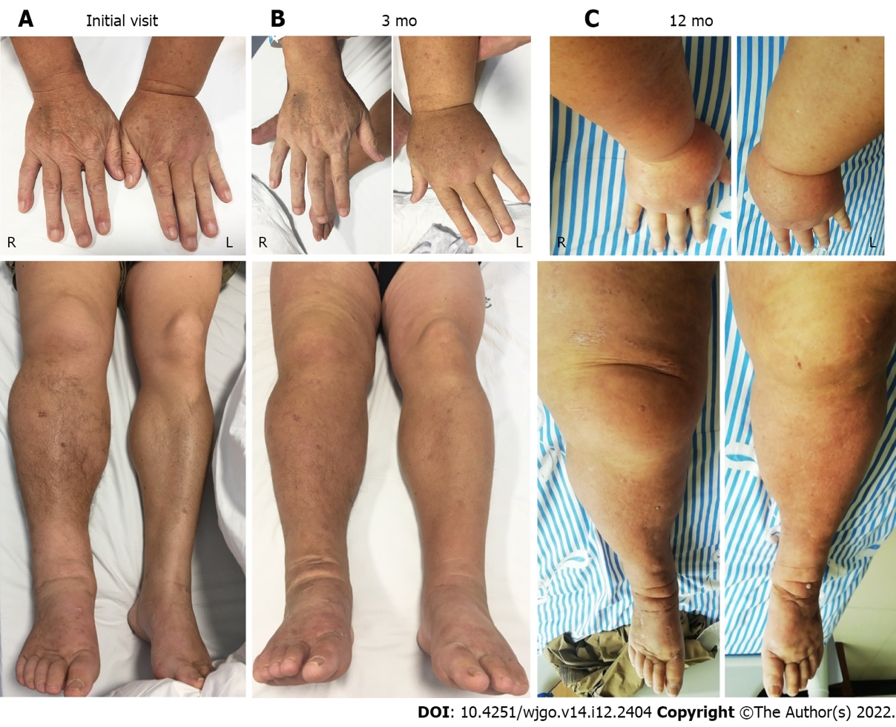
Figure 1 The 55-year-old male patient with systemic edema. A: The images of fingers and legs of this patient at the initial visit; B: The images of fingers and legs of this patient at 3-mo visit; C: The images of fingers and legs of this patient at 12-mo visit.
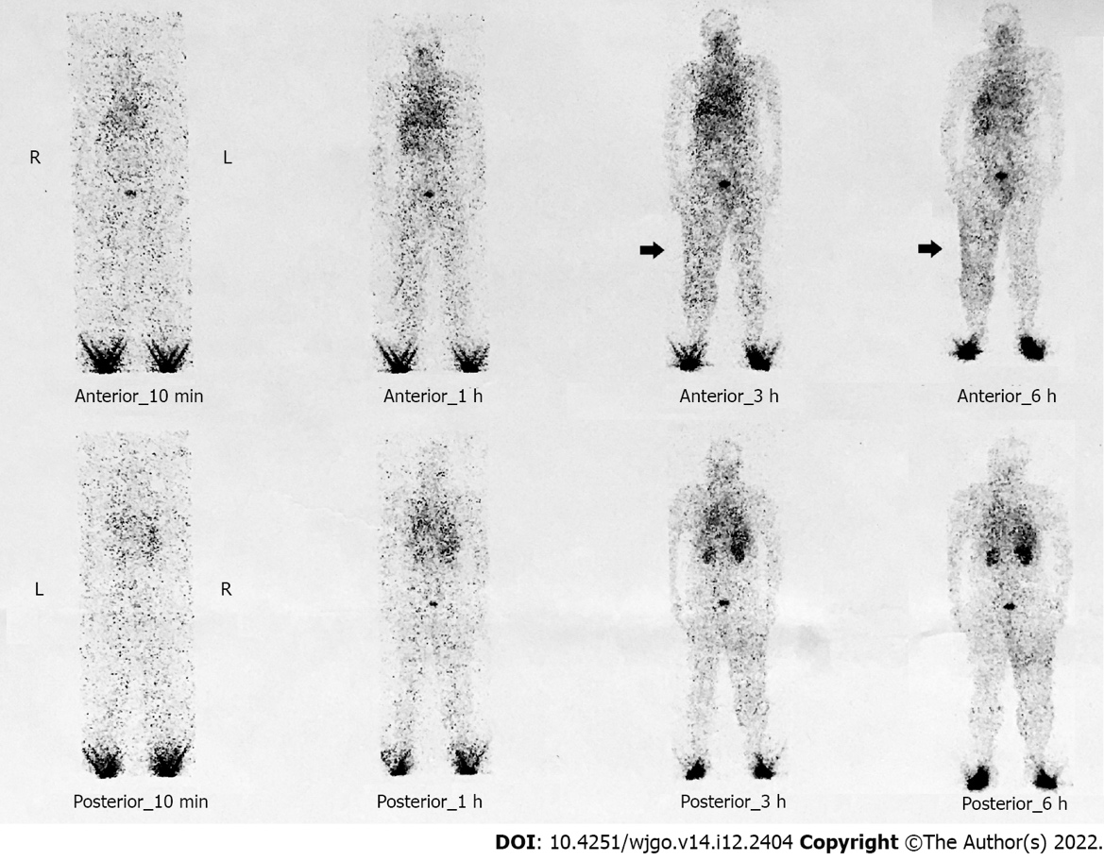
Figure 2 99mTc-DX lymphoscintigraphy. Images were recorded 10 min, 1h, 3h, and 6h after infusion with the 99mTc-DX indicators at both feet. Lymphoscintigraphy showed an obvious accumulation of the radiotracer both the anterior and posterior sides of the right leg.
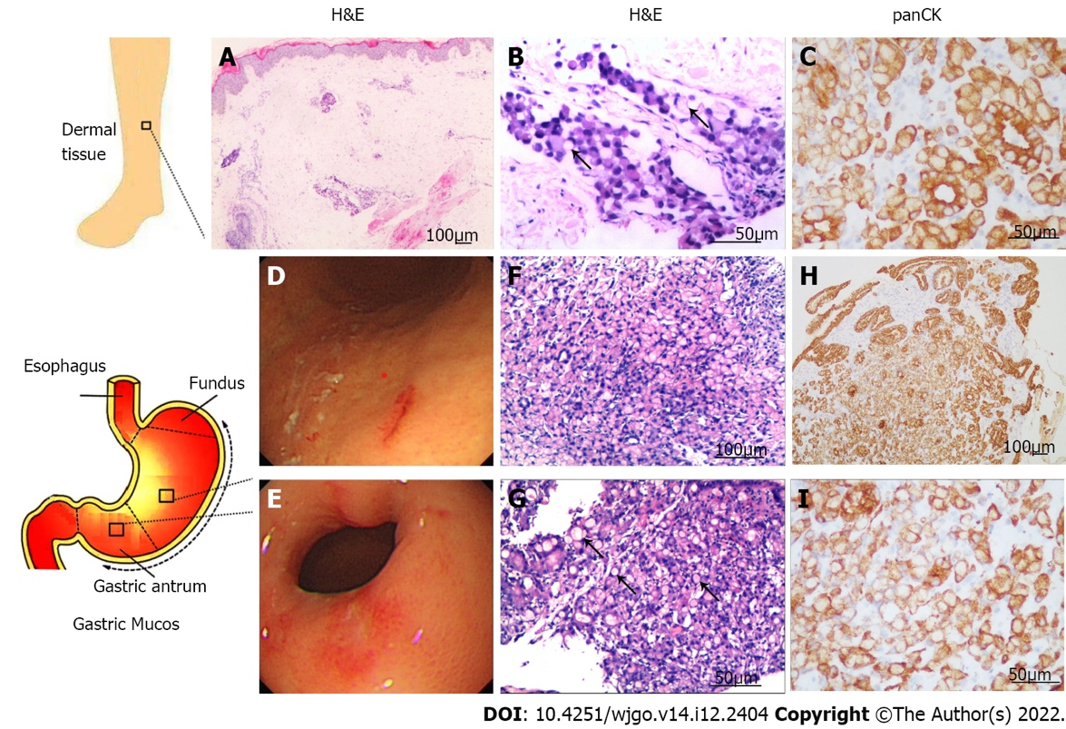
Figure 3 The immunohistochemistry and gastric endoscopy. A: H&E histological samples of the skin tissue on the right lower limb, 10 ×; B: H&E histological samples of the skin tissue on the right lower limb, 20 ×; C: Histological samples of the skin tissue on the right lower limb stained for panCK, 20 ×; D: Images of gastric endoscopy: Gastric body; E: Images of gastric endoscopy: Gastric antrum; F: H&E histological samples of the mucosa in gastric body, 10 ×; G: Gastric antrum, 20 ×; H: Histological samples of the mucosa in gastric body stained for panCK, 20 ×; I: Gastric antrum, 20 ×. Note the abundant signet-ring cells (black arrows) (B) and (G). H&E: Hematoxylin and eosin; panCK: Pan-cytokeratin.

Table 1 Characteristics of laboratory examinations
Parameter | Initial visit | 3 mo | 12 mo | Reference value range
Full blood count
White cell count as × 10⁹/L | 6.4 | 7.55 | 3.58 | (3.5-9.5)
Neutrophils as × 10⁹/L | 4.51 | 5.56 | 2.25 | (1.8-6.3)
Lymphocytes as × 10⁹/L | 1.3 | 1.32 | 0.68 | (1.1-3.2)
Monocytes as × 10⁹/L | 0.36 | 0.5 | 0.23 | (0.1-0.6)
Platelets as × 10⁹/L | 218 | 223 | 208 | (125-350)
Hemoglobin in g/L | 144 | 136 | 157 | (130-175)
Tumor markers
Carbohydrate antigen 724 in U/mL | 16.41 | 15.51 | 15.67 | (< 6.9)
Carbohydrate antigen 199 in U/mL | 15.88 | 16.84 | 4.43 | (≤ 34)
Carcinoembryonic antigen in ng/mL) | 2.81 | 2.86 | 0.78 | (≤ 5)
Blood biochemical indicators
Alanine aminotransferase in U/L | 16 | 11 | 14 | (≤ 41)
Aspartate aminotransferase in U/L | 13 | 13 | 15 | (≤ 41)
Globulin in g/L | 28.9 | 25.5 | 19 | (64-83)
Albumin in g/L | 38.2 | 32.2 | 25 | (35-52)
Creatine kinase in U/L | 93 | 56 | 24 | (≤ 190)
Lactic dehydrogenase in U/L | 163 | 156 | 202 | (135-225)
Urea nitrogen in mmol/L | 8.97 | 12.54 | 12.83 | (3.1-8.0)
Creatinine in μmol/L | 126 | 130 | 152 | (59-104)
Estimated glomerular filtration rate in mL/min/1.73 m² | 55 | 52.9 | 49.5 | (> 90)
Random blood glucose in mmol/L | 6.22 | 5.39 | 6.12 | (< 11.1)
Serum potassium in mmol/L | 4.2 | 3.88 | 3.89 | (3.5-5.1)
Serum sodium in mmol/L | 141.5 | 141 | 142 | (136-145)
Cardiac troponin T in pg/mL | 2.2 | 2.5 | 2.7 | (≤ 34.2)
N terminal pro B type natriuretic peptide in pg/mL | 53 | 45 | 59 | (< 161)
Fibrinogen in g/L | 4.31 | 5.03 | 5.88 | (2-4)
D-Dimer in μg/mL FEU | 1.36 | 1.05 | 7.19 | (< 0.5)
Other indicators
Antinuclear antibodies | 1:100 | 1:100 | Not available | (negative)
Immunoglobulin IgG in g/L | 9.31 | 8.57 | 9.27 | (7-16)
Complement C3 in g/L | 1.46 | 1.32 | 1.39 | (0.8-1.8)
Complement C4 in g/L | 0.67 | 0.39 | 0.51 | (0.1-0.4)
Erythrocyte sedimentation rate in mm/h | 20 | 21 | 25 | (0-15)
High sensitivity C-reactive protein in mg/L | 5.52 | 6.43 | 6.83 | (0-5)
Interleukin 6 in pg/mL | 2.72 | 3.56 | 2.98 | (0.1-2.9)
Tumor necrosis factor α in pg/mL | 2.07 | 2.97 | 3.12 | (0.1-23)
T lymphocyte (CD3 + CD19 -) as /μL | 830 | 977 | 780 | (955-2860)
B lymphocyte (CD3 + CD19 -), as /μL | 62 | 84 | 52 | (90-560)
Proteinuria | negative | negative | negative | (negative)
Antineutrophil cytoplasmic antibody | negative | negative | negative | (negative)
Procalcitonin | < 0.05 | < 0.05 | < 0.05 | (< 0.05)

Table 2 Gastric signet ring cell adenocarcinoma
Patients | Sex/age | Sites of skin involvement | Initial present symptoms | Stage | Follow-up | Management | Ref.
1 | Male/67 | Nodular lesions on his eyelid, cheeks, scalp, and back | Weight loss of 8 kg within 1 mo | Not available | DOD 3 mo after skin | XELOX chemotherapy (oxaliplatin and capecitabine) | [23]
2 | Male/69 | On forehead, back, neck, and arms | Dysphagia from eating and multiple cutaneous nodules | Not available | DOD 1 mo after skin | Surgery | [24]
3 | Female/53 | On abdomen and thighs | Livedo reticularis | Not available | DOD 7 mo after skin | Chemoradiation | [25]
4 | Female/72 | Skin infiltration in the lower limbs, abdomen, and root of the upper limbs | Lymphangitis | Stage IIIa | DOD 5 mo after skin | Adjuvant chemotherapy with capecitabine + oxaliplatin | [26]
5 | Female/75 | On the abdomen | Indurated scar-like lesions on the epigastric area | Stage IIIa (T4aN1M0) | DOD 3 mo after skin | Chemotherapy (5-fluorouracil, infusional folinic acid, and oxaliplatin) | [27]
6 | Female/57 | On the abdomen | With growing lesions on skin | Stage IIIa (T3N2M0) | Not available | Adjuvant chemotherapy [infusional folinic acid + 5-fluorouracil] and radiotherapy, a second round of chemotherapy | [20]
7 | Female/45 | On head and the back | The cutaneous metastases disappeared |  | Survival | Chemotherapy with S-1 (Tegafur) plus cisplatin | [28]
8 | Male/52 | Armpits, axillae, groin, and neck folds | Progressive dermal, mucosal, and perianal lesions, weight loss | T3N2M1 | Not available | N/A | [18]
9 | Male/21 | Cutaneous nodule on his chest | Cutaneous nodule | Stage IV | Survival | Chemotherapy with oxaliplatin (day 1) and S-1 | [29]
10 | Male/85 | A lesion of the right occipital scalp | Abdominal pain, malaise | T4N1M0 | DOD 5 mo after skin | Not available | [30]
11 | Male/35 | Cutaneous nodules on the upper chest, abdomen and left scapular region | Without any local or general clinical symptoms | Not available | Not available | Not available | [15]
12 | Male/76 | Skin ulcer on right hypochondrium | Hematemesis, weight loss and loss of appetite | T4N2M0 | DOD 1 mo after skin | Chemotherapy with irinotecan and oxaliplatin | [16]
13 | Female/50 | Large erythematous plaque on the left side of the neck; and an erythematous lesion in the perineal region | Bowel habit and weight loss | Not available | DOD 0.5 mo after skin | Not available | [31]
14 | Male/59 | Painless nodule of the left flank | Painless nodule of the left flank | Not available | DOD 0.5 mo after skin | Metastatic infiltration of a 32-yr-old surgical scar | [32]
15 | Male/50 | The umbilical area | With a single asymptomatic skin lesion | Not available | Not available | Not available | [19]
16 | Male/69 | Asymptomatic indurated scar-like lesion | Asymptomatic indurated scar-like lesion | Stage IV | DOD 10 mo after skin | Chemotherapy with cisplatin, Taxotere, and xeloda | [33]
17 | Female/71 | Limited cyan erythema on the right side of the middle and lower abdomen | Abdominal skin | Not available | DOD 12 mo after skin | Chemotherapy (unknown medication) | [34]
18 | Male/48 | Bracelet bracelet ("tripe palm"); and hyperkeratosis of fingers | Skin edema with pigmentation | Not available | DOD 36 mo after skin | Chemotherapy with cisplatin, 5-fluorouracil and folic acid | [35]
19 | Male/44 | Multiple cutaneous eruptions on face and neck | Vomiting and weight loss | Not available | N/A | Not available | [17]
20 | Male/51 | Abdominal and back | Without any symptom | Not available | DOD 2 mo after skin | Surgery | [36]
21 | Male/67 | Diffuse erythematous and warm induration over his right cheek and neck | Dyspepsia | Stage IV | DOD 0.75 mo after skin | Radiotherapy | [37]
22 | Male/55 | Lower part of face and neck | With multiple itchy nodules | Not available | DOD 7~8 mo after skin | Not available | [21]
23 | Female/58 | Right inguinal erythema with itching | With chylothorax | Not available | DOD 4 mo after skin | Not available | [38]
24 | Male/44 | On the face, trunk, and upper extremities | Multiple cutaneous nodules | Stage IV | Survival | Chemotherapy with an oxaliplatin-based regimen and denosumab | [39]
25 | Male/68 | Right chin region and on the left forehead | Erythematous skin lesion, nodular skin lesion | T4N0M0 | Not available | Surgical treatment | [40]
DOD: Dead of disease; N/A: Not applicable.

Published by Baishideng Publishing Group Inc
7041 Koll Center Parkway, Suite 160, Pleasanton, CA 94566, USA
Telephone: +1-925-3991568
E-mail: bpgoffice@wjgnet.com
Help Desk: https://www.f6publishing.com/helpdesk
https://www.wjgnet.com

© 2022 Baishideng Publishing Group Inc. All rights reserved.

