Name of Journal: World Journal of Gastroenterology
Manuscript NO: 57689
Manuscript Type: ORIGINAL ARTICLE

Retrospective Cohort Study
Role of doublecortin-like kinase 1 and leucine-rich repeat-containing G-protein-coupled receptor 5 in patients with stage II/III colorectal cancer: Cancer progression and prognosis

Kang XL et al. Role of DCLK1 and Lgr5 in CRC

Xue-Ling Kang, Li-Rui He, Yao-Li Chen, Shu-Bin Wang

Xue-Ling Kang, Department of Oncology, Peking University Shenzhen Hospital, Peking University-Hong Kong University of Science and Technology Medical Center, Shenzhen 518036, Guangdong Province, China

Li-Rui He, Department of Gastrointestinal Surgery, Peking University Shenzhen Hospital, Shenzhen 518036, Guangdong Province, China

Yao-Li Chen, Department of Pathology, Peking University Shenzhen Hospital, Shenzhen 518036, Guangdong Province, China

Shu-Bin Wang, Department of Oncology, Peking University Shenzhen Hospital, Shenzhen Key Laboratory of Gastrointestinal Cancer Translational Research, China Cancer Institute of Shenzhen-Peking University-Hong Kong University of Science and Technology Medical Center, Shenzhen 518036, Guangdong Province, China

Author contributions: Kang XL was responsible for the statistical analysis and preparation of manuscript; He LR provided information of the surgical patients; Chen YL provided the patient's pathological and immunohistochemical staining sections; Wang SB is the guarantor of this work and as such, has full access to all the data in the study and takes responsibility for the integrity of the data.

Supported by Sanming Project of Shenzhen, No. SZSM201612041; Shenzhen Science and Technology Innovation Commission Project, No. GJHZ20180420180754917 and No. ZDSYS20190902092855097; and Postdoctoral Science Foundation of China, No. 2018M633095.

Corresponding author: Shu-Bin Wang, MD, PhD, Chief Doctor, Department of Oncology, Peking University Shenzhen Hospital, Shenzhen Key Laboratory of Gastrointestinal Cancer Translational Research, China Cancer Institute of Shenzhen-Peking University-Hong Kong University of Science and Technology Medical Center, No. 1120 Lianhua Road, Futian District, Shenzhen 518036, Guangdong Province, China. shubinwang2013@163.com

Received: June 19, 2020
Revised: September 29, 2020
Accepted: October 19, 2020
Published online: November 21, 2020

Abstract
BACKGROUND
Cancer stem cells (CSCs) are a subpopulation of cancer cells with the potential of self-renewal and differentiation. CSCs play critical roles in tumorigenesis, recurrence, metastasis, radiation tolerance and chemoresistance.

AIM
To assess the expression patterns and clinical potential of doublecortin-like kinase 1 (DCLK1) and leucine-rich repeat-containing G-protein-coupled receptor 5 (Lgr5), as prognostic CSC markers of colorectal cancer (CRC).

METHODS
The expression of DCLK1 and Lgr5 in CRC tissue sections from 92 patients was determined by immunohistochemistry. Each case was evaluated using a combined scoring method based on signal intensity staining (scored 0-3) and the proportion of positively stained cancer cells (scored 0-3). The final staining score was calculated as the intensity score multiplied by the proportion score. Low expression of DCLK1 and Lgr5 was defined as a score of 0-3; high expression of DCLK1 and Lgr5 was defined as a score of ≥ 4. Specimens were categorized as either high or low expression, and the correlation between the expression of DCLK1 or Lgr5 and clinicopathological factors was investigated.

RESULTS
DCLK1 and Lgr5 expression levels were significantly positively correlated. CRC patients with high DCLK1, Lgr5 and DCLK1/Lgr5expressions had poorer progression-free survival and overall survival. Moreover, high expression of DCLK1 was an independent prognostic factor for recurrence and overall survival in patients with CRC by multivariate analysis (P = 0.026 and P = 0.049, respectively).

CONCLUSION
DCLK1 may be a potential CSC marker for the recurrence and survival of CRC patients.

Key Words: Colorectal cancer; Cancer stem cells; Doublecortin-like kinase 1; Leucine-rich repeat-containing G-protein-coupled receptor 5; Cancer prognosis; Cancer progression

Citation: Kang XL, He LR, Chen YL, Wang SB. Role of doublecortin-like kinase 1 and leucine-rich repeat-containing G-protein-coupled receptor 5 in patients with stage II/III colorectal cancer: Cancer progression and prognosis. World J Gastroenterol 2020; 26(43): 6853-6866
URL: https://www.wjgnet.com/1007-9327/full/v26/i43/6853.htm
DOI: https://dx.doi.org/10.3748/wjg.v26.i43.6853

Core Tip: The role of doublecortin-like kinase 1 (DCLK1) and leucine-rich repeat-containing G-protein-coupled receptor 5 (Lgr5) in patients with stage II/III colorectal cancer (CRC)remains uncertain. In this study, we found a positive correlation between the expression of DCLK1 and Lgr5, suggesting that DCLK1 and Lgr5 were involved in the malignant pathological development of CRC. High DCLK1 expression could predict the risk of recurrence and survival in CRC patients after surgery, which may be used as a potential cancer stem cells marker for the recurrence and survival of stage II/III CRC patients.
INTRODUCTION
Colorectal cancer (CRC) is the third most common malignant tumor worldwide, with 1.8 million new cases annually. In China, CRC has caused more than 800 000 deaths, and its incidence is increasing every year^{[1,2]}. Despite significant improvements in the management of CRC, distant metastases and relapse remain the major causes of patient mortality. Cancer stem cells (CSCs) are a subpopulation of cancer cells with the potential of self-renewal and differentiation. CSCs play critical roles in tumorigenesis, recurrence, metastasis, radiation tolerance and chemoresistance.
Doublecortin-like kinase 1 (DCLK1), a microtubule-associated protein, has been regarded as a CSC marker receiving considerable attention. Nakanishi et al^{[3]} showed that DCLK1-positive CRC cells mark a subset of tumor cells with higher potential for tumor initiation, sphere formation and in vivo tumorigenicity. DCLK1 distinguishes CSCs from normal stem cells in CRC. Combination treatment with fluorouracil (5-FU) and the DCLK1 inhibitor, LRRK2-IN-1 (LRRK), decreased 5-FU-induced phosphorylation of Chk1 and canceled 5-FU-induced cell-cycle arrest at the S phase. Suehiro et al^{[4]} suggested that a combination of 5-FU and LRRK may be an effective, novel approach for the treatment of CRC. DCLK1-positive tumor cells exhibited spheroid formation and tumorigenesis in mouse pancreas^{[5]}. Targeting DCLK1-expressing cells in hepatocellular and pancreatic carcinoma revealed that this marker may be a reliable molecule in targeted therapeutic strategies^{[6,7]}. However, contradictory observations have been reported in which patients with CRC exhibiting high DCLK1 expression had longer survival times than patients with low DCLK1 expression^{[8]}. Further study may be needed to define the role of DCLK1 in CRC development and progression.
Leucine-rich repeat-containing G-protein-coupled receptor 5 (Lgr5) belongs to the family of G-protein-coupled receptors, which contain 17 Leucine-rich repeats and a transmembrane domain containing an α-helix. Lgr5 is a marker of normal intestinal stem cells and colorectal CSCs^{[9,10]}. Lgr5 plays an important role in the pathogenesis of gastric cancer and CRC^{[11-13]}, and Lgr5 expression is closely related to tumorigenesis, chemotherapy resistance and recurrence of gastric cancer and CRC^{[14,15]}. High Lgr5 expression is associated with a poor prognosis in stage IV CRC^{[16]}. Therefore, Lgr5 is considered an indicator of poor outcome and is a potential target of CRC; however, other reports have shown increased Lgr5 expression in well-differentiated and early-stage gastric carcinomas^{[17,18]}.
Designing novel targeting drugs based on specific CSC markers is the goal of CSC therapy. Due to the lack of clear understanding of the potency of DCLK1 in CRC in previous studies, its expression and clinical significance were determined in an extensive collection of CRC samples. Additionally, we evaluated the potential CSC marker, Lgr5, in the same series of CRC samples, considering the possible similarities between gastric cancer and CRC. The aim of this study was to identify the relationship between DCLK1 and Lgr5 in CRC, determine their clinical significance as CSC markers for the recurrence and survival of stage II/III CRC patients, and lay the foundation for further study on the role of DCLK1 and Lgr5 in CRC stem cells. To our knowledge, this is the first study to investigate the relationship between clinicopathological parameters and the prognostic value of these CSC markers in CRC.

MATERIALS AND METHODS
Clinical data
In total, 92 patients with CRC from Peking University, Shenzhen Hospital, from August 2007 to February 2016 were studied. All patients were pathologically confirmed to have stage II/III CRC and had surgical tumor or nontumor tissues stored before therapy. Clinicopathological parameters, including age, gender, and depth of penetration, lymph node metastasis, pathological tumor-node-metastasis (TNM) stage, tumor differentiation, and primary tumor site were documented in a database and were fully anonymous throughout the study (Table 1). We excluded patients if they had previous chemoradiotherapy treatment or metachronous or synchronous cancers. Patients’ clinical data were retrospectively obtained from their medical records, and the last follow-up was in March 2019.

Immunohistochemistry
A total of 92 formalin-fixed, paraffin-embedded samples were cut into sections 5-μm thick and stained using a standard-chain polymer-conjugated technique. The tissue sections were dewaxed, antigens were retrieved in an autoclave for 10 min, and the sections were then cooled to room temperature. Endogenous peroxidases were blocked by incubating the sections in 3% hydrogen peroxide (kit-0014, Maxim, Fuzhou, China). The sections were then incubated overnight at 4 °C with the following primary antibodies: Rabbit polyclonal anti-DCLK1 (1:100 dilution, ab31704; Abcam, United Kingdom) and rabbit polyclonal anti-Lgr5 (1:50 dilution, ab75732; Abcam, United Kingdom). The slides were stained and visualized with a standard immunohistochemistry kit (kit-0014, Maxim, Fuzhou, China). Colorectal cancer tissues with intense immunoreactivity to DCLK1 and Lgr5 were used as positive controls; in the negative control, the primary antibody was replaced with phosphate-buffered saline (PBS).

Scoring system
DCLK1 and Lgr5 staining was evaluated using a coded semiquantitative scoring system, and the evaluator was blinded to the clinical and pathological parameters^{[19]}. A pathologist diagnosed the samples, and two observers scored the immunostained slides semiquantitatively after examining a series on a double-headed microscope. A pathologist also confirmed the results to provide a comprehensive review of section staining. Initially, the slides were scanned at 10 × magnification to obtain a general impression of the overall tumor cell distribution^{[20]}. Positive cells were then assessed semiquantitatively at higher magnifications, and the final scores were determined. DCLK1 and Lgr5 expression levels in CRC were assessed using three scoring methods: Staining intensity, proportion of positive cells and final score. The immunostaining intensity was divided into four categories: 0 (no immunostaining), 1 (weak immunostaining), 2 (moderate immunostaining) and 3 (strong immunostaining). Using the proportion of positive cells, the protein expression levels were semiquantitated and scored from 0 to 3 as follows: 0 (positive cells < 5%), 1 (positive cells 5%-30%), 2 (positive cells 31%-60%), and 3 (positive cells > 60%). The final staining score was calculated as the intensity score multiplied by the proportion score, and a score of 0, 1, 2, 3, 4, 6 and 9 was given^{[21]}. Low expression of DCLK1 and Lgr5 was defined as a score of 0–3; high expression of DCLK1 and Lgr5 was defined as a score of ≥ 4.

Statistical analysis
The software SPSS (version 16, United States) was used to analyze the findings. Pearson’s Chi-square and Spearman’s correlation tests were applied to evaluate the correlation between DCLK1 and Lgr5 expression and clinicopathological parameters. Cumulative survival of the patients was estimated using the Kaplan-Meier method, and the significance of the survival differences was tested using the log rank test. Multivariate analysis was performed using a Cox proportional hazards regression model to examine the interaction between DCLK1 and Lgr5 expression and other clinicopathological variables and to estimate the independent prognostic effect of DCLK1 and Lgr5 on survival by adjusting for confounding factors. A difference of P < 0.05 between the groups was considered statistically significant.

RESULTS
Patient and clinicopathological characteristics
The mean age of the 92 CRC patients was 49 years (range 15-79 years). Fifty-two patients were male (57%). Eighteen CRC patients (20%) showed T3 depth of penetration, whereas 74 patients (80%) showed T4. For the patients with available regional lymph node metastasis, 38 (41%) were category N0, 41 (45%) were N1, and 13 (14%) were N2. Based on tumor distant metastasis staging, 38 CRC cases (41%) were stage II and 54 (59%) were stage III. In terms of tumor differentiation, 66 (72%) and 26 (28%) cases had well/moderate and poor/mucinous differentiation, respectively. Forty-two tumors (46%) were in the left colon, 17 (18%) were in the right colon, and 33 (36%) were in the rectum. Table 1 summarizes the clinicopathological characteristics of these patients. The relationships between preoperative CEA/CA19-9/adjuvant chemotherapy/MSI/recurrence/lung metastases/liver metastases and DCLK1/Lgr5 are shown in Tables 1 and 2.

DCLK1 and Lgr5 expression and association with clinicopathological parameters
Immunohistochemical findings showed that DCLK1 expression was mainly localized in the membranous area of CRC cells. Low DCLK1 expression was found in 48 cases (52%), while high DCLK1 expression was seen in 44 cases (48%) (Figure 1). DCLK1 expression and clinicopathological parameters were not significantly correlated (Table 1). Immunodetection of Lgr5 expression showed that it was generally localized in the cytoplasmic area of tumor cells. In the light of the final score, 67% of cases (62/92) displayed low Lgr5 expression (score of 0-3), and 33% showed high Lgr5 expression (Figure 1). Our analysis indicated that patients with primary tumor in the left colon had higher Lgr5 expression levels (P = 0.032) (Table 1). Lgr5 expression and other clinicopathological parameters were not significantly correlated (Table 1).

Combined analysis of DCLK1 and Lgr5 expression in CRC
A comparison of the expression patterns of DCLK1 and Lgr5 markers showed that these two markers had reciprocal significant correlation in the same series of CRC samples (P < 0.001, Figure 2). Among the 92 CRC samples, 41 (44%) showed the DCLK1^{Low}/Lgr5^{Low} phenotype, 7 (8%) showed the DCLK1^{Low}/Lgr5^{High} phenotype, 21 (23%) showed the DCLK1^{High}/Lgr5^{Low} phenotype, and 23 (25%) showed the DCLK1^{High}/Lgr5^{High} phenotype (Table 2). One-way analysis of variance (ANOVA) and Tukey’s post hoc analysis were used to calculate the correlation between DCLK1/Lgr5 phenotypic expression and clinicopathological parameters. It was found that the DCLK1/Lgr5 phenotypic expression was not significantly associated with clinicopathological variables (Table 2).

Progression-free and overall survival analysis in CRC patients
Progression-free survival (PFS) and overall survival (OS) differed significantly according to the immunoreactivity of DCLK1 and Lgr5 expression levels. Analysis using the Kaplan-Meier method and log-rank tests showed a lower survival rate in the DCLK1^{High} group compared with the DCLK1^{Low} group (PFS: P = 0.003, OS: P = 0.003, Figure 3A and B). The prognostic impact of Lgr5 expression in CRC was similar to that of DCLK1 (PFS: P = 0.037, OS: P = 0.036, Figure 3C and D). Moreover, patients with co-expression of DCLK1^{High}/Lgr5^{High} had a poorer prognosis than the other groups (PFS: P = 0.003, OS: P = 0.008, Figure 3E and F), including the DCLK1^{Low}/Lgr5^{Low}, DCLK1^{Low}/Lgr5^{High}, and DCLK1^{High}/Lgr5^{Low} phenotypes.

Predictive value of DCLK1 and Lgr5 expression levels for recurrence and survival
A Cox proportional hazards model was used to estimate the effect of DCLK1 and Lgr5 expression on recurrence and survival. Univariate analysis showed that the following factors were significantly related to postoperative recurrence and OS: Tumor stage, differentiation, CEA, CA19-9, DCLK1, Lgr5 and DCLK1/Lgr5 expression level (P = 0.022, 0.037, 0.001, 0.002, 0.006, 0.044, and 0.006 for recurrence, P = 0.017, 0.031, 0.002, 0.005, 0.006, 0.043, and 0.012 for OS, respectively). Multivariate analysis confirmed that DCLK1 expression level was an independent predictor of recurrence and OS in patients with CRC (hazard ratio = 4.656, 95% confidence interval = 1.207-17.956, P = 0.026 for recurrence, hazard ratio = 4.272, 95% confidence interval = 1.005-18.167, P = 0.049 for OS; Tables 3 and 4).

DISCUSSION
Few studies have reported the correlation between DCLK1 and Lgr5 in CRC. The results of this study showed that DCLK1 and Lgr5 immunoreactivity was observed in 53% and 41% of CRC cases, respectively, using standard immunostaining. DCLK1 and Lgr5 expression were positively correlated in CRC tissues. Therefore, DCLK1 may affect Lgr5 expression via an unknown mechanism^{[3,22,23]}, and the two complement each other to participate in CRC development, invasion and metastasis^{[3,24,25]}. It was found that patients with DCLK1^{High}, Lgr5^{High} and DCLK1^{High}/Lgr5^{High} expression had poorer PFS and OS, which implied that high DCLK1 and Lgr5 expression may specifically predict the most aggressive and fatal types of primary CRC in cases with stage II/III disease^{[12,26-29]}. DCLK1 and Lgr5 are targets of Wnt signaling, which has emerged as a critical regulator of stem cells, and its pathway is integral in both stem cell and cancer cell maintenance and growth^{[30,31]}. Gastric cancer patients with high DCLK1 expression were shown to have significantly shorter PFS and OS^{[26]}. Uchida confirmed that Lgr5 was observed in both early and late events in colorectal tumorigenesis^{[12]}. DCLK1 may be associated with Lgr5 during CRC development. Conversely, contradictory evidence has shown that DCLK1 overexpression is significantly associated with better PFS and OS^{[32]}, and increased Lgr5 expression in well-differentiated and early-stage gastric carcinomas^{[17,18]}. The exact regulatory mechanism between DCLK1 and Lgr5 requires further exploration.
Despite no association between DCLK1 expression and TNM stage or degree of tissue differentiation being found, DCLK1 was shown to be a potential predictor of tumor recurrence and survival in patients with stage II/III CRC by univariate and multivariate Cox regression analyses, reflecting a more invasive tumor phenotype^{[23,33]}. The discovery of CSCs suggests intratumoral heterogeneity^{[34]}. High DCLK1 expression levels indicate more invasive CRC, resulting in recurrence and metastasis, which may be related to the CSC characteristics of some cancer cells ^{[35]}. Other candidate CSC markers, such as Lgr5, ALDH1, and Musashi-1, also suggest a correlation between tumor expression and poor prognosis in CRC^{[36-38]}. The present study results are based only on immunohistochemical analysis, which does not quantify RNA or protein expression. Therefore, future studies should quantitatively evaluate DCLK1 using reverse transcriptase polymerase chain reaction or fluorescence-activated cell sorting in both normal and CRC tissues.
Although several putative CRC stem cell markers have been identified, how these markers can be used clinically remains unclear. One study applied nanoparticle-based DCLK1 small interfering RNA in colorectal tumor xenografts, which inhibited tumor growth and downregulated c-Myc and Notch1 expression^{[24]}. Sureban found that small interfering RNA blockage of DCLK1 reduced in vivo tumorigenic potential in CRC. This function was mediated by reducing the primary transcript of MIRLET7 and increasing c-Myc expression, both of which are related to the loss of epithelial differentiation^{[39]}. CSCs are widely chemoresistant and radioresistant, which is a key factor in treatment resistance and cancer recurrence^{[40-42]}. These studies suggest that DCLK1 may be a CSC marker with a functional role and thus may be an important therapeutic target.

CONCLUSION
In summary, this study found a positive correlation between the expression of DCLK1 and Lgr5, suggesting that DCLK1 and Lgr5 are involved in the malignant pathological development of CRC. DCLK1^{High}, Lgr5^{High} and DCLK1^{High}/Lgr5^{High} expression resulted in poorer PFS and OS in patients with stage II/III CRC. High DCLK1 expression could predict the risk of recurrence and survival in CRC patients after surgery, which may be used as a potential CSC marker for the recurrence and survival of stage II/III CRC patients. However, further analysis is required to investigate the CSC marker, DCLK1, as a potential early diagnostic and therapeutic target for CRC.

ARTICLE HIGHLIGHTS
Research background
The role of doublecortin-like kinase 1 (DCLK1) and leucine-rich repeat-containing G-protein-coupled receptor 5 (Lgr5) in patients with stage II/III colorectal cancer (CRC) remains uncertain.

Research motivation
Designing novel targeting drugs based on specific cancer stem cell (CSC) markers is the goal of CSC therapy. Due to the lack of clear understanding of the potency of DCLK1 in CRC in previous studies, its expression and clinical significance were determined in an extensive collection of CRC samples.

Research objectives
We determined the clinical significance of DCLK1 and Lgr5 as CSC markers for the recurrence and survival of stage II/III CRC patients.

Research methods
The expression of DCLK1 and Lgr5 in CRC tissue sections from 92 patients was detected by immunohistochemistry.

Research results
In this study, we have found a positive correlation between the expression of DCLK1 and Lgr5, suggesting that DCLK1 and Lgr5 are involved in the malignant pathological development of CRC. High DCLK1 expression could predict the risk of recurrence and survival in CRC patients after surgery.

Research conclusions
DCLK1 may be a potential CSC marker for the recurrence and survival of CRC patients.

Research perspectives
Our research raises the possibility that treatments targeting DCLK1 could be beneficial in CRC patients.

REFERENCES
1 Li J, Qin S, Xu RH, Shen L, Xu J, Bai Y, Yang L, Deng Y, Chen ZD, Zhong H, Pan H, Guo W, Shu Y, Yuan Y, Zhou J, Xu N, Liu T, Ma D, Wu C, Cheng Y, Chen D, Li W, Sun S, Yu Z, Cao P, Chen H, Wang J, Wang S, Wang H, Fan S, Hua Y, Su W. Effect of Fruquintinib vs Placebo on Overall Survival in Patients With Previously Treated Metastatic Colorectal Cancer: The FRESCO Randomized Clinical Trial. JAMA 2018; 319: 2486-2496 [PMID: 29946728 DOI: 10.1001/jama.2018.7855]
2 Chen W, Zheng R, Baade PD, Zhang S, Zeng H, Bray F, Jemal A, Yu XQ, He J. Cancer statistics in China, 2015. CA Cancer J Clin 2016; 66: 115-132 [PMID: 26808342 DOI: 10.3322/caac.21338]
3 Nakanishi Y, Seno H, Fukuoka A, Ueo T, Yamaga Y, Maruno T, Nakanishi N, Kanda K, Komekado H, Kawada M, Isomura A, Kawada K, Sakai Y, Yanagita M, Kageyama R, Kawaguchi Y, Taketo MM, Yonehara S, Chiba T. Dclk1 distinguishes between tumor and normal stem cells in the intestine. Nat Genet 2013; 45: 98-103 [PMID: 23202126 DOI: 10.1038/ng.2481]
4 Suehiro Y, Takemoto Y, Nishimoto A, Ueno K, Shirasawa B, Tanaka T, Kugimiya N, Suga A, Harada E, Hamano K. Dclk1 Inhibition Cancels 5-FU-induced Cell-cycle Arrest and Decreases Cell Survival in Colorectal Cancer. Anticancer Res 2018; 38: 6225-6230 [PMID: 30396941 DOI: 10.21873/anticanres.12977]
5 May R, Sureban SM, Lightfoot SA, Hoskins AB, Brackett DJ, Postier RG, Ramanujam R, Rao CV, Wyche JH, Anant S, Houchen CW. Identification of a novel putative pancreatic stem/progenitor cell marker DCAMKL-1 in normal mouse pancreas. Am J Physiol Gastrointest Liver Physiol 2010; 299: G303-G310 [PMID: 20522640 DOI: 10.1152/ajpgi.00146.2010]
6 Wang W, Zhang H, Wang L, Zhang S, Tang M. miR-613 inhibits the growth and invasiveness of human hepatocellular carcinoma via targeting DCLK1. Biochem Biophys Res Commun 2016; 473: 987-992 [PMID: 27049311 DOI: 10.1016/j.bbrc.2016.04.003]
7 Sureban SM, May R, Weygant N, Qu D, Chandrakesan P, Bannerman-Menson E, Ali N, Pantazis P, Westphalen CB, Wang TC, Houchen CW. XMD8-92 inhibits pancreatic tumor xenograft growth via a DCLK1-dependent mechanism. Cancer Lett 2014; 351: 151-161 [PMID: 24880079 DOI: 10.1016/j.canlet.2014.05.011]
8 Dai T, Hu Y, Lv F, Ozawa T, Sun X, Huang J, Han X, Kishi H, Muraguchi A, Jin A. Analysis of the clinical significance of DCLK1⁺ colorectal cancer using novel monoclonal antibodies against DCLK1. Onco Targets Ther 2018; 11: 5047-5057 [PMID: 30174443 DOI: 10.2147/OTT.S169928]
9 Beumer J, Clevers H. Regulation and plasticity of intestinal stem cells during homeostasis and regeneration. Development 2016; 143: 3639-3649 [PMID: 27802133 DOI: 10.1242/dev.133132]
10 He S, Zhou H, Zhu X, Hu S, Fei M, Wan D, Gu W, Yang X, Shi D, Zhou J, Zhou J, Zhu Z, Wang L, Li D, Zhang Y. Expression of Lgr5, a marker of intestinal stem cells, in colorectal cancer and its clinicopathological significance. Biomed Pharmacother 2014; 68: 507-513 [PMID: 24751002 DOI: 10.1016/j.biopha.2014.03.016]
11 Yamanoi K, Fukuma M, Uchida H, Kushima R, Yamazaki K, Katai H, Kanai Y, Sakamoto M. Overexpression of leucine-rich repeat-containing G protein-coupled receptor 5 in gastric cancer. Pathol Int 2013; 63: 13-19 [PMID: 23356221 DOI: 10.1111/pin.12013]
12 Uchida H, Yamazaki K, Fukuma M, Yamada T, Hayashida T, Hasegawa H, Kitajima M, Kitagawa Y, Sakamoto M. Overexpression of leucine-rich repeat-containing G protein-coupled receptor 5 in colorectal cancer. Cancer Sci 2010; 101: 1731-1737 [PMID: 20384634 DOI: 10.1111/j.1349-7006.2010.01571.x]
13 Xi HQ, Cai AZ, Wu XS, Cui JX, Shen WS, Bian SB, Wang N, Li JY, Lu CR, Song Z, Wei B, Chen L. Leucine-rich repeat-containing G-protein-coupled receptor 5 is associated with invasion, metastasis, and could be a potential therapeutic target in human gastric cancer. Br J Cancer 2014; 110: 2011-2020 [PMID: 24594994 DOI: 10.1038/bjc.2014.112]
14 Hsu HC, Liu YS, Tseng KC, Hsu CL, Liang Y, Yang TS, Chen JS, Tang RP, Chen SJ, Chen HC. Overexpression of Lgr5 correlates with resistance to 5-FU-based chemotherapy in colorectal cancer. Int J Colorectal Dis 2013; 28: 1535-1546 [PMID: 23784051 DOI: 10.1007/s00384-013-1721-x]
15 Xi HQ, Cui JX, Shen WS, Wu XS, Bian SB, Li JY, Song Z, Wei B, Chen L. Increased expression of Lgr5 is associated with chemotherapy resistance in human gastric cancer. Oncol Rep 2014; 32: 181-188 [PMID: 24859092 DOI: 10.3892/or.2014.3207]
16 Wu W, Cao J, Ji Z, Wang J, Jiang T, Ding H. Co-expression of Lgr5 and CXCR4 characterizes cancer stem-like cells of colorectal cancer. Oncotarget 2016; 7: 81144-81155 [PMID: 27835894 DOI: 10.18632/oncotarget.13214]
17 Wu C, Xie Y, Gao F, Wang Y, Guo Y, Tian H, Li Y, Fan W. Lgr5 expression as stem cell marker in human gastric gland and its relatedness with other putative cancer stem cell markers. Gene 2013; 525: 18-25 [PMID: 23664892 DOI: 10.1016/j.gene.2013.04.067]
18 Becker L, Huang Q, Mashimo H. Immunostaining of Lgr5, an intestinal stem cell marker, in normal and premalignant human gastrointestinal tissue. ScientificWorldJournal 2008; 8: 1168-1176 [PMID: 19030762 DOI: 10.1100/tsw.2008.148]
19 Taeb J, Asgari M, Abolhasani M, Farajollahi MM, Madjd Z. Expression of prostate stem cell antigen (PSCA) in prostate cancer: a tissue microarray study of Iranian patients. Pathol Res Pract 2014; 210: 18-23 [PMID: 24183365 DOI: 10.1016/j.prp.2013.09.012]
20 Gagliardi G, Goswami M, Passera R, Bellows CF. DCLK1 immunoreactivity in colorectal neoplasia. Clin Exp Gastroenterol 2012; 5: 35-42 [PMID: 22557932 DOI: 10.2147/CEG.S30281]
21 Gao T, Wang M, Xu L, Wen T, Liu J, An G. DCLK1 is up-regulated and associated with metastasis and prognosis in colorectal cancer. J Cancer Res Clin Oncol 2016; 142: 2131-2140 [PMID: 27520310 DOI: 10.1007/s00432-016-2218-0]
22 Yamaga Y, Fukuda A, Nakanishi Y, Goto N, Matsumoto Y, Yoshioka T, Maruno T, Chiba T, Seno H. Gene expression profile of Dclk1⁺ cells in intestinal tumors. Dig Liver Dis 2018; 50: 1353-1361 [PMID: 30001952 DOI: 10.1016/j.dld.2018.06.011]
23 Chandrakesan P, Yao J, Qu D, May R, Weygant N, Ge Y, Ali N, Sureban SM, Gude M, Vega K, Bannerman-Menson E, Xia L, Bronze M, An G, Houchen CW. Dclk1, a tumor stem cell marker, regulates pro-survival signaling and self-renewal of intestinal tumor cells. Mol Cancer 2017; 16: 30 [PMID: 28148261 DOI: 10.1186/s12943-017-0594-y]
24 Sureban SM, May R, Mondalek FG, Qu D, Ponnurangam S, Pantazis P, Anant S, Ramanujam RP, Houchen CW. Nanoparticle-based delivery of siDCAMKL-1 increases microRNA-144 and inhibits colorectal cancer tumor growth via a Notch-1 dependent mechanism. J Nanobiotechnology 2011; 9: 40 [PMID: 21929751 DOI: 10.1186/1477-3155-9-40]
25 Kleist B, Xu L, Li G, Kersten C. Expression of the adult intestinal stem cell marker Lgr5 in the metastatic cascade of colorectal cancer. Int J Clin Exp Pathol 2011; 4: 327-335 [PMID: 21577318]
26 Meng QB, Yu JC, Kang WM, Ma ZQ, Zhou WX, Li J, Zhou L, Cao ZJ, Tian SB. [Expression of doublecortin-like kinase 1 in human gastric cancer and its correlation with prognosis]. Zhongguo Yi Xue Ke Xue Yuan Xue Bao 2013; 35: 639-644 [PMID: 24382242 DOI: 10.3881/j.issn.1000-503X.2013.06.010]
27 Powrózek T, Krawczyk P, Nicoś M, Kuźnar-Kamińska B, Batura-Gabryel H, Milanowski J. Methylation of the DCLK1 promoter region in circulating free DNA and its prognostic value in lung cancer patients. Clin Transl Oncol 2016; 18: 398-404 [PMID: 26311076 DOI: 10.1007/s12094-015-1382-z]
28 O'Connell MR, Sarkar S, Luthra GK, Okugawa Y, Toiyama Y, Gajjar AH, Qiu S, Goel A, Singh P. Epigenetic changes and alternate promoter usage by human colon cancers for expressing DCLK1-isoforms: Clinical Implications. Sci Rep 2015; 5: 14983 [PMID: 26447334 DOI: 10.1038/srep14983]
29 Barker N, Ridgway RA, van Es JH, van de Wetering M, Begthel H, van den Born M, Danenberg E, Clarke AR, Sansom OJ, Clevers H. Crypt stem cells as the cells-of-origin of intestinal cancer. Nature 2009; 457: 608-611 [PMID: 19092804 DOI: 10.1038/nature07602]
30 Reya T, Clevers H. Wnt signalling in stem cells and cancer. Nature 2005; 434: 843-850 [PMID: 15829953 DOI: 10.1038/nature03319]
31 Park SY, Kim JY, Choi JH, Kim JH, Lee CJ, Singh P, Sarkar S, Baek JH, Nam JS. Inhibition of LEF1-Mediated DCLK1 by Niclosamide Attenuates Colorectal Cancer Stemness. Clin Cancer Res 2019; 25: 1415-1429 [PMID: 30446587 DOI: 10.1158/1078-0432.CCR-18-1232]
32 Liu YH, Tsang JY, Ni YB, Hlaing T, Chan SK, Chan KF, Ko CW, Mujtaba SS, Tse GM. Doublecortin-like kinase 1 expression associates with breast cancer with neuroendocrine differentiation. Oncotarget 2016; 7: 1464-1476 [PMID: 26621833 DOI: 10.18632/oncotarget.6386]
33 Kadletz L, Aumayr K, Heiduschka G, Schneider S, Enzenhofer E, Lill C. Overexpression of DCLK1 is predictive for recurrent disease in major salivary gland malignancies. Eur Arch Otorhinolaryngol 2017; 274: 467-475 [PMID: 27470117 DOI: 10.1007/s00405-016-4227-7]
34 Izumi D, Ishimoto T, Miyake K, Eto T, Arima K, Kiyozumi Y, Uchihara T, Kurashige J, Iwatsuki M, Baba Y, Sakamoto Y, Miyamoto Y, Yoshida N, Watanabe M, Goel A, Tan P, Baba H. Colorectal Cancer Stem Cells Acquire Chemoresistance Through the Upregulation of F-Box/WD Repeat-Containing Protein 7 and the Consequent Degradation of c-Myc. Stem Cells 2017; 35: 2027-2036 [PMID: 28699179 DOI: 10.1002/stem.2668]
35 Merlos-Suárez A, Barriga FM, Jung P, Iglesias M, Céspedes MV, Rossell D, Sevillano M, Hernando-Momblona X, da Silva-Diz V, Muñoz P, Clevers H, Sancho E, Mangues R, Batlle E. The intestinal stem cell signature identifies colorectal cancer stem cells and predicts disease relapse. Cell Stem Cell 2011; 8: 511-524 [PMID: 21419747 DOI: 10.1016/j.stem.2011.02.020]
36 Takahashi H, Ishii H, Nishida N, Takemasa I, Mizushima T, Ikeda M, Yokobori T, Mimori K, Yamamoto H, Sekimoto M, Doki Y, Mori M. Significance of Lgr5(+ve) cancer stem cells in the colon and rectum. Ann Surg Oncol 2011; 18: 1166-1174 [PMID: 21125339 DOI: 10.1245/s10434-010-1373-9]
37 Deng Y, Zhou J, Fang L, Cai Y, Ke J, Xie X, Huang Y, Huang M, Wang J. ALDH1 is an independent prognostic factor for patients with stages II-III rectal cancer after receiving radiochemotherapy. Br J Cancer 2014; 110: 430-434 [PMID: 24327017 DOI: 10.1038/bjc.2013.767]
38 Li D, Peng X, Yan D, Tang H, Huang F, Yang Y, Peng Z. Msi-1 is a predictor of survival and a novel therapeutic target in colon cancer. Ann Surg Oncol 2011; 18: 2074-2083 [PMID: 21442350 DOI: 10.1245/s10434-011-1567-9]
39 Sureban SM, May R, Ramalingam S, Subramaniam D, Natarajan G, Anant S, Houchen CW. Selective blockade of DCAMKL-1 results in tumor growth arrest by a Let-7a MicroRNA-dependent mechanism. Gastroenterology 2009; 137: 649-659, 659.e1-659.e2 [PMID: 19445940 DOI: 10.1053/j.gastro.2009.05.004]
40 Toden S, Tran HM, Tovar-Camargo OA, Okugawa Y, Goel A. Epigallocatechin-3-gallate targets cancer stem-like cells and enhances 5-fluorouracil chemosensitivity in colorectal cancer. Oncotarget 2016; 7: 16158-16171 [PMID: 26930714 DOI: 10.18632/oncotarget.7567]
41 Li F, Zhou K, Gao L, Zhang B, Li W, Yan W, Song X, Yu H, Wang S, Yu N, Jiang Q. Radiation induces the generation of cancer stem cells: A novel mechanism for cancer radioresistance. Oncol Lett 2016; 12: 3059-3065 [PMID: 27899964 DOI: 10.3892/ol.2016.5124]
42 Su YK, Shih PH, Lee WH, Bamodu OA, Wu ATH, Huang CC, Tzeng YM, Hsiao M, Yeh CT, Lin CM. Antrodia cinnamomea sensitizes radio-/chemo-therapy of cancer stem-like cells by modulating microRNA expression. J Ethnopharmacol 2017; 207: 47-56 [PMID: 28602756 DOI: 10.1016/j.jep.2017.06.004]

Footnotes
Institutional review board statement: The study was reviewed and approved by the Peking University Shenzhen Hospital Institutional Review Board.

Informed consent statement: All study participants, or their legal guardian, provided informed written consent prior to study enrollment.

Conflict-of-interest statement: The authors declare that they have no conflicts of interest.

Data sharing statement: Dataset available from the corresponding author at shubingwang2013@163.com. Participants gave informed consent for data sharing.

STROBE statement: The authors have read the STROBE Statement-checklist of items, and the manuscript was prepared and revised according to the STROBE Statement-checklist of items.

Open-Access: This article is an open-access article that was selected by an in-house editor and fully peer-reviewed by external reviewers. It is distributed in accordance with the Creative Commons Attribution NonCommercial (CC BY-NC 4.0) license, which permits others to distribute, remix, adapt, build upon this work non-commercially, and license their derivative works on different terms, provided the original work is properly cited and the use is non-commercial. See: http://creativecommons.org/Licenses/by-nc/4.0/

Manuscript source: Unsolicited manuscript

Peer-review started: June 19, 2020
First decision: September 12, 2020
Article in press: October 19, 2020

Specialty type: Gastroenterology and hepatology
Country/Territory of origin: China
Peer-review report’s scientific quality classification
Grade A (Excellent): 0
Grade B (Very good): B
Grade C (Good): C
Grade D (Fair): 0
Grade E (Poor): 0

P-Reviewer: Lee CL, Nakano H S-Editor: Gao CC L-Editor: MedE-Ma JY P-Editor: Li JH

Figure Legends
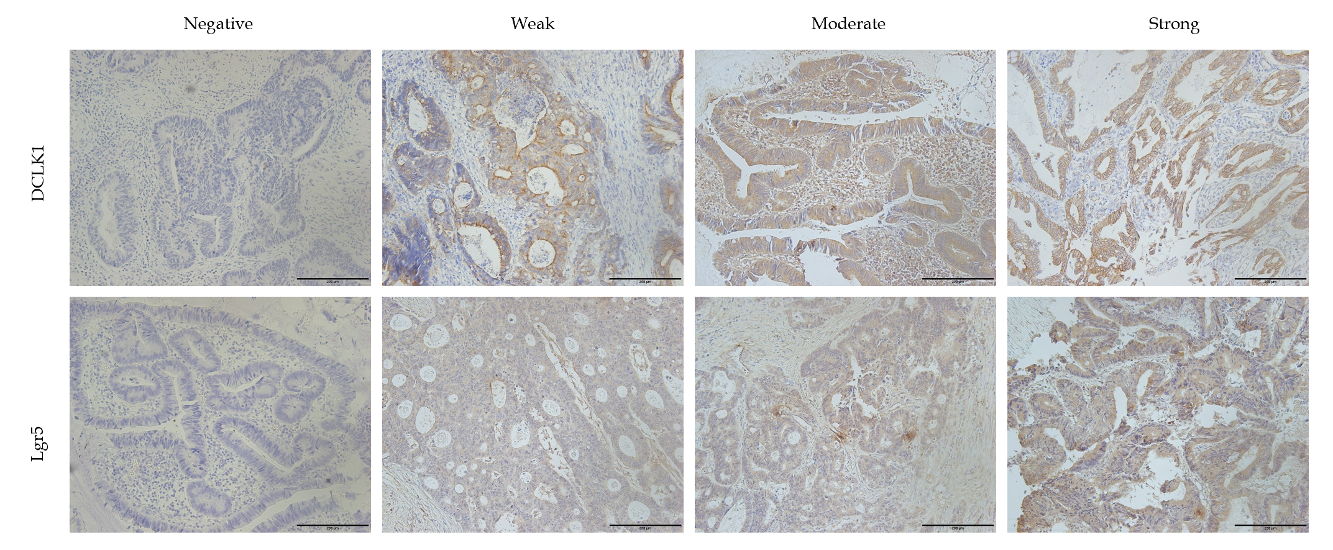
Figure 1 Representative doublecortin-like kinase 1 and leucine-rich repeat-containing G-protein-coupled receptor 5 immunohistochemical staining in colorectal cancer samples. Doublecortin-like kinase 1 (DCLK1) was expressed at the membrane, and leucine-rich repeat-containing G-protein-coupled receptor 5 (Lgr5) was expressed in the cytoplasm of colorectal cancer cells. Expression levels of DCLK1 and Lgr5 were scored as negative (0), weak (1), moderate (2), or strong (3) staining intensity (original magnification 200 ×). DCLK1: Doublecortin-like kinase 1; Lgr5: Leucine-rich repeat-containing G-protein-coupled receptor 5.
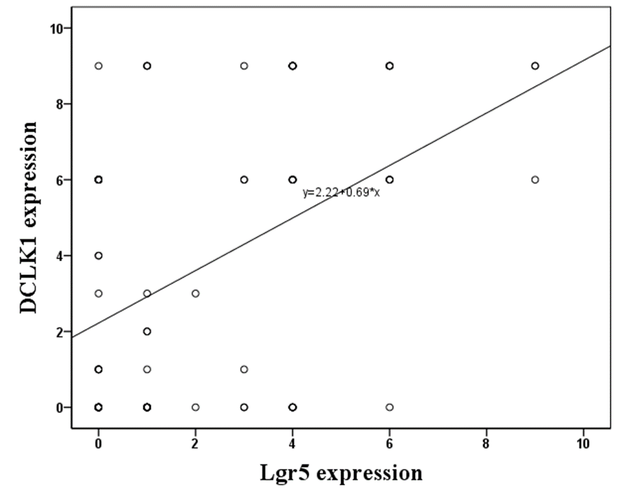
Figure 2 Correlation between doublecortin-like kinase 1 and leucine-rich repeat-containing G-protein-coupled receptor 5 immunohistochemical expression in colorectal cancer specimens. Doublecortin-like kinase 1 (DCLK1) and leucine-rich repeat-containing G-protein-coupled receptor 5 expression were positively significantly correlated (r = 0.206, P < 0.001). DCLK1: Doublecortin-like kinase 1; Lgr5: Leucine-rich repeat-containing G-protein-coupled receptor 5.
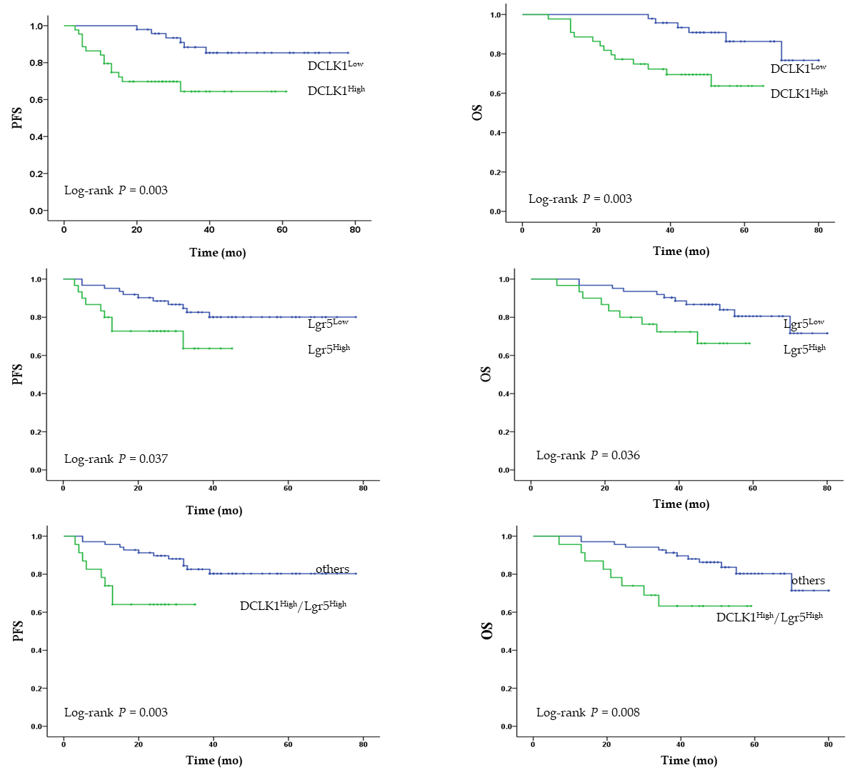
Figure 3 High expression of doublecortin-like kinase 1 and leucine-rich repeat-containing G-protein-coupled receptor 5 was significantly associated with poorer progression-free survival and overall survival in patients with colorectal cancer. Cumulative progression-free survival and overall survival of colorectal cancer patients in different groups were compared. A and B: Doublecortin-like kinase 1 (DCLK1)^{High} and DCLK1^{Low}; C and D: Leucine-rich repeat-containing G-protein-coupled receptor 5 (Lgr5)^{High} and Lgr5^{Low}; E and F: DCLK1^{High}/Lgr5^{High} and others. DCLK1: Doublecortin-like kinase 1; Lgr5: Leucine-rich repeat-containing G-protein-coupled receptor 5; PFS: Progression-free survival; OS: Overall survival.
Table 1 Correlation of immunoreactivity of doublecortin-like kinase 1 and leucine-rich repeat-containing G-protein-coupled receptor 5 with clinicopathological features

Clinicopathologic characteristics | n (%) | DCLK1 |  | P value | Lgr5 |  | P value
 |  | Low  (n = 48) | High  (n = 44) |  | Low  (n = 62) | High  (n = 30)
Age (yr)
≤ 49 | 49 (53) | 26 (53) | 23 (47) | 0.856 | 33 (67) | 16 (33) | 0.992
> 49 | 43 (47) | 22 (51) | 21 (49) |  | 29 (67) | 14 (33)
Gender
Male | 52 (57) | 29 (56) | 23 (44) | 0.431 | 37 (71) | 15 (29) | 0.380
Female | 40 (43) | 19 (47) | 21 (53) |  | 25 (63) | 15 (37)
Depth of penetration
T3 | 18 (20) | 6 (33) | 12 (67) | 0.074 | 13 (72) | 5 (28) | 0.626
T4 | 74 (80) | 42 (57) | 32 (43) |  | 49 (66) | 25 (34)
Lymph node
N0 | 38 (41) | 20 (53) | 18 (47) | 0.892 | 27 (71) | 11 (29) | 0.787
N1 | 41 (45) | 22 (54) | 19 (46) |  | 27 (66) | 14 (34)
N2 | 13 (14) | 6 (12) | 7 (16) |  | 8 (62) | 5 (38)
Tumor stage (TNM)
II | 38 (41) | 20 (55) | 18 (45) | 0.941 | 27 (71) | 11 (29) | 0.530
III | 54 (59) | 28 (52) | 26 (48) |  | 35 (65) | 19 (35)
Differentiation
Well/moderate | 66 (72) | 37 (56) | 29 (44) | 0.234 | 48 (73) | 18 (27) | 0.082
Poor/mucinous | 26 (28) | 11 (42) | 15 (58) |  | 14 (54) | 12 (46)
Tumor site
Left | 42 (46) | 24 (57) | 18 (43) | 0.537 | 32 (76) | 10 (24) | 0.032
Right | 17 (18) | 7 (41) | 10 (59) |  | 7 (41) | 10 (59)
Rectum | 33 (36) | 17 (52) | 16 (48) |  | 23 (70) | 10 (30)
Postoperative adjuvant chemotherapy
Xeloda monotherapy | 7 (7) | 4 (57) | 3 (43) | 0.783 | 5 (71) | 2 (29) | 0.763
FOLFOX regimen | 32 (35) | 18 (56) | 14 (44) |  | 20 (63) | 12 (37)
XELOX regimen | 53 (58) | 26 (49) | 27 (51) |  | 37 (70) | 16 (30)
CEA
Normal | 68 (74) | 38 (56) | 30 (44) | 0.231 | 45 (66) | 23 (34) | 0.676
High | 24 (26) | 10 (42) | 14 (58) |  | 17 (71) | 7 (29)
CA19-9
Normal | 66 (72) | 35 (53) | 31 (47) | 0.793 | 45 (68) | 21 (32) | 0.797
High | 26 (28) | 13 (50) | 13 (50) |  | 17 (67) | 9 (33)
MSI
MSS | 89 (97) | 46 (52) | 43 (48) | 0.609 | 60 (67) | 29 (33) | 0.978
MSI | 3 (3) | 2 (67) | 1 (33) |  | 2 (67) | 1 (33)
Recurrence
Absent | 67 (73) | 37 (55) | 30 (45) | 0.338 | 44 (66) | 23 (34) | 0.565
Present | 25 (27) | 11 (44) | 14 (56) |  | 18 (72) | 7 (28)
Lung metastasis
Absent | 80 (87) | 40 (50) | 40 (50) | 0.281 | 52 (65) | 28 (35) | 0.206
Present | 12 (13) | 8 (67) | 4 (33) |  | 10 (83) | 2 (17)
Liver metastasis
Absent | 83 (90) | 42 (51) | 41 (49) | 0.359 | 55 (66) | 28 (34) | 0.484
Present | 9 (10) | 6 (67) | 3 (33) |  | 7 (78) | 2 (22)
DCLK1: Doublecortin-like kinase 1; Lgr5: Leucine-rich repeat-containing G-protein-coupled receptor 5; TNM: Tumor-node-metastasis.
Table 2 Correlation of immunoreactivity of doublecortin-like kinase 1/leucine-rich repeat-containing G-protein-coupled receptor 5 with clinicopathological features

Clinicopathologic characteristics | n (%) | DCLK1/Lgr5 phenotypes |  |  |  | P value
 |  | DCLK1^{Low} /Lgr5^{Low} | DCLK1^{Low} /Lgr5^{High} | DCLK1^{High} /Lgr5^{Low} | DCLK1^{High} /Lgr5^{High}
Age (yr)
≤ 49 | 49 (53) | 23 (47) | 3 (6) | 10 (20) | 13 (27) | 0.890
> 49 | 43 (47) | 18 (42) | 4 (9) | 11 (26) | 10 (23)
Gender
Male | 52 (57) | 25 (48) | 4 (8) | 12 (23) | 11 (21) | 0.348
Female | 40 (43) | 16 (40) | 3 (7) | 9 (23) | 12 (30)
Depth of penetration
T3 | 18 (20) | 5 (28) | 1 (6) | 8 (44) | 4 (22) | 0.223
T4 | 74 (80) | 36 (49) | 6 (8) | 13 (17) | 19 (26)
Lymph node
N0 | 38 (41) | 17 (45) | 3 (8) | 10 (26) | 8 (21) | 0.858
N1 | 41 (45) | 18 (44) | 4 (10) | 9 (22) | 10 (24)
N2 | 13 (14) | 6 (46) | 0 (0) | 2 (15) | 5 (39)
Tumor stage (TNM)
II | 38 (41) | 17 (45) | 3 (8) | 10 (26) | 8 (21) | 0.774
III | 54 (59) | 24 (45) | 4 (7) | 11 (20) | 15 (28)
Differentiation
Well/moderate | 66 (72) | 32 (48) | 5 (8) | 16 (24) | 13 (20) | 0.115
Poor/mucinous | 26 (28) | 9 (35) | 2 (8) | 5 (19) | 10 (38)
Tumour site
Left | 42 (46) | 22 (52) | 2 (5) | 10 (24) | 8 (19) | 0.187
Right | 17 (18) | 4 (23) | 3 (18) | 3 (18) | 7 (41)
Rectum | 33 (36) | 15 (46) | 2 (6) | 8 (24) | 8 (24)
Postoperative adjuvant chemotherapy
Xeloda monotherapy | 7 (7) | 3 (43) | 1 (14) | 21 (29) | 22 (14) | 0.875
FOLFOX regimen | 32 (35) | 15 (47) | 3 (9) | 5 (16) | 9 (28)
XELOX regimen | 53 (58) | 23 (43) | 3 (6) | 14 (26) | 13 (25)
CEA
Normal | 68 (74) | 33 (49) | 5 (7) | 12 (18) | 18 (26) | 0.238
High | 24 (26) | 8 (33) | 2 (8) | 9 (38) | 5 (21)
CA19-9
No14rmal | 66 (72) | 29 (44) | 6 (9) | 16 (24) | 15 (23) | 0.710
High | 26 (28) | 12 (46) | 1 (4) | 5 (19) | 8 (31)
MSI
MSS | 89 (97) | 39 (44) | 7 (8) | 21 (25) | 22 (23) | 0.713
MSI | 3 (3) | 2 (67) | 0 (0) | 0 (0) | 1 (33)
Recurrence
Absent | 67 (73) | 30 (45) | 7 (10) | 14 (21) | 16 (24) | 0.374
Present | 25 (27) | 11 (44) | 0 (0) | 7 (28) | 7 (28)
Lung metastasis
Absent | 80 (87) | 33 (41) | 7 (9) | 19 (24) | 21 (26) | 0.365
Present | 12 (13) | 8 (66) | 0 (0) | 2 (17) | 2 (17)
Liver metastasis
Absent | 83 (90) | 35 (42) | 7 (9) | 20 (24) | 2 (25) | 0.478
Present | 9 (10) | 6 (67) | 0 (0) | 1 (11) | 2 (22)
DCLK1: Doublecortin-like kinase 1; Lgr5: Leucine-rich repeat-containing G-protein-coupled receptor 5; TNM: Tumor-node-metastasis.
Table 3 Prognostic value, univariate and multivariate analyses of potential predictor for recurrence

Variables | HR | 95%CI | P value
Univariate
Age (≤ 49 vs > 49 yr) | 0.742 | 0.303-1.818 | 0.515
Gender (Male vs Female) | 0.758 | 0.302-1.901 | 0.555
Depth of penetration (T3 vs pT4) | 1.310 | 0.383-4.476 | 0.006
Lymph node
N0 | 1 (ref)
N1 | 2.590 | 0.795-8.439 | 0.114
N2 | 7.562 | 2.189-26.115 | 0.001
Tumor stage (TNM) (II vs III) | 3.610 | 1.201-10.849 | 0.022
Differentiation (well/moderate vs poor/mucinous) | 2.561 | 1.058-6.198 | 0.037
Tumor site
Left | 1 (ref)
Right | 0.735 | 0.205-2.636 | 0.637
Rectum | 0.834 | 0.307-2.263 | 0.721
CEA (normal vs high) | 4.722 | 1.933-11.535 | 0.001
CA19-9 (normal vs high) | 3.961 | 1.633-9.606 | 0.002
MSI (MSS vs MSI) | 0.047 | 0.000-1327.112 | 0.559
Lung metastasis (absent vs present)  Liver metastasis (absent vs present) | 2.325  2.351 | 0.844-6.405  0.785-7.038 | 0.103  0.127
DCLK1 (low vs high) | 3.958 | 1.496-10.472 | 0.006
Lgr5 (low vs high) | 2.521 | 1.025-6.199 | 0.044
DCLK1/Lgr5 (others¹ vs high/high) | 3.808 | 1.471-9.854 | 0.006
Multivariate
Tumor stage (TNM) (II vs III) | 6.846 | 1.918-24.445 | 0.003
Differentiation (well/moderate vs poor/mucinous) | 1.864 | 0.699-4.971 | 0.241
CEA (normal vs high)  CA19-9 (normal vs high) | 4.835  4.102 | 1.651-14.154  1.529-11.005 | 0.004  0.005
DCLK1 (low vs high) | 4.656 | 1.207-17.956 | 0.026
Lgr5 (low vs high) | 0.764 | 0.076-7.691 | 0.819
DCLK1/Lgr5 (others¹ vs high/high) | 3.429 | 0.212-55.583 | 0.386
¹Low/low low/high and high/low. HR: Hazard ratio; CI: Confidence interval; DCLK1: Doublecortin-like kinase 1; Lgr5: Leucine-rich repeat-containing G-protein-coupled receptor 5; TNM: Tumor-node-metastasis.
Table 4 Prognostic value, univariate and multivariate analyses of potential predictor for survival

Variables | HR | 95%CI | P value
Univariate
Age (≤ 49 vs > 49 yr) | 0.681 | 0.276-1.684 | 0.406
Gender (Male vs Female) | 0.795 | 0.316-2.001 | 0.626
Depth of penetration (T3 vs pT4) | 0.772 | 0.226-2.640 | 0.680
Lymph node
N0 | 1 (ref)
N1 | 2.774 | 0.839-9.170 | 0.094
N2 | 8.899 | 2.496-31.723 | 0.001
Tumor stage (TNM) (II vs III) | 3.880 | 1.274-11.871 | 0.017
Differentiation (well/moderate vs poor/mucinous) | 0.376 | 0.155-0.913 | 0.031
Tumour site
Left | 1 (ref)
Right | 0.798 | 0.221-2.880 | 0.731
Rectum | 0.872 | 0.319-2.384 | 0.790
CEA (normal vs high) | 0.245 | 0.101-0.595 | 0.002
CA19-9 (normal vs high) | 3.569 | 1.477-8.621 | 0.005
MSI (MSS vs MSI) | 0.047 | 0.000-3055.106 | 0.588
Recurrence (absent vs present) | 8.038 | 3.070-21.050 | 0.001
Lung metastasis (absent vs present)  Liver metastasis (absent vs present) | 2.141  2.216 | 0.776-5.911  0.734-6.689 | 0.142  0.158
DCLK1 (low vs high) | 4.167 | 1.491-11.644 | 0.006
Lgr5 (low vs high) | 2.575 | 1.030-6.438 | 0.043
DCLK1/Lgr5 (others¹ vs high/high) | 3.273 | 1.297-8.262 | 0.012
Multivariate
Tumor stage (TNM) (II vs III) | 6.087 | 1.647-22.499 | 0.007
Differentiation (well/moderate vs poor/mucinous) | 2.706 | 0.989-7.406 | 0.053
CEA (normal vs high) | 4.363 | 1.346-14.136 | 0.014
CA19-9 (normal vs high) | 1.078 | 0.362-3.208 | 0.893
Recurrence (absent vs present) | 12.002 | 3.066-46.988 | 0.001
DCLK1 (low vs high) | 4.272 | 1.005-18.167 | 0.049
Lgr5 (low vs high) | 7.088 | 0.582-86.342 | 0.125
DCLK1/Lgr5 (others¹ vs high/high) | 0.593 | 0.039-9.085 | 0.708
¹Low/low low/high and high/low. HR: Hazard ratio; CI: Confidence interval; DCLK1: Doublecortin-like kinase 1; Lgr5: Leucine-rich repeat-containing G-protein-coupled receptor 5; TNM: Tumor-node-metastasis.

