Name of Journal: World Journal of Stem Cells
Manuscript NO: 63802
Manuscript Type: ORIGINAL ARTICLE

Basic Study
Chondrogenic potential of mesenchymal stem cells from horses using a magnetic 3D cell culture system

Fülber J et al. Chondrogenic potential of horse MSCs

Joice Fülber, Fernanda R Agreste, Sarah R T Seidel, Eric D P Sotelo, Ângela P Barbosa, Yara M Michelacci, Raquel Y A Baccarin

Joice Fülber, Fernanda R Agreste, Sarah R T Seidel, Eric D P Sotelo, Ângela P Barbosa, Raquel Y A Baccarin, Departamento de Clínica Médica, Medicina Veterinária e Zootecnia, Universidade de São Paulo, São Paulo 05506-270, Brazil

Yara M Michelacci, Departamento de Bioquímica, Escola Paulista de Medicina, Universidade Federal de São Paulo, São Paulo 04044-020, Brazil

Author contributions: Fülber J, Michelacci YM, and Baccarin RYA designed the study and wrote the manuscript; Baccarin RYA was responsible for obtaining funds; Fülber J, Agreste FR, Seidel SRT, Sotelo EDP, Barbosa AP collected tissue samples; Fülber J, Michelacci YM, and Baccarin RYA conducted the experimental analysis; Fülber J performed cell culture, chondrogenic differentiation of mesenchymal stem cells and all laboratory tests; all authors read and approved the final manuscript.

Supported by Fundação Coordenação de Aperfeiçoamento de Pessoal de Nível Superior (CAPES), Brazil, No. 001.

Corresponding author: Joice Fülber, PhD, Postdoc, Departamento de Clínica Médica, Medicina Veterinária e Zootecnia, Universidade de São Paulo, Av. Prof. Dr. Orlando Marques de Paiva, 87 Cidade Universitária, São Paulo 05506-270, Brazil. jfulber@usp.br

Received: February 5, 2021
Revised: March 29, 2021
Accepted: June 4, 2021
Published online: June 26, 2021

Abstract
BACKGROUND
Mesenchymal stem cells (MSCs) represent a promising therapy for the treatment of equine joint diseases, studied due to their possible immunomodulatory characteristics and regenerative capacity. However, the source of most suitable MSCs for producing cartilage for regenerative processes in conjunction with biomaterials for an enhanced function is yet to be established.

AIM
To compare the chondrogenicity of MSCs derived from synovial fluid, bone marrow, and adipose tissue of horses, using the aggrecan synthesis.

METHODS
MSCs from ten horses were cultured, phenotypic characterization was done with antibodies CD90, CD44 and CD34 and were differentiated into chondrocytes. The 3D cell culture system in which biocompatible nanoparticles consisting of gold, iron oxide, and poly-L-lysine were added to the cells, and they were forced by magnets to form one microspheroid. The microspheroids were exposed to a commercial culture medium for 4 d, 7 d, 14 d, and 21 d. Proteoglycan extraction was performed, and aggrecan was quantified by enzyme-linked immunosorbent assay. Keratan sulfate and aggrecan in the microspheroids were identified and localized by immunofluorescence.

RESULTS
All cultured cells showed fibroblast-like appearance, the ability to adhere to the plastic surface, and were positive for CD44 and CD90, thus confirming the characteristics and morphology of MSCs. The soluble protein concentrations were higher in the microspheroids derived from adipose tissue. The aggrecan concentration and the ratio of aggrecan to soluble proteins were higher in microspheroids derived from synovial fluid than in those derived from bone marrow, thereby showing chondrogenic superiority. Microspheroids from all sources expressed aggrecan and keratan sulfate when observed using confocal immunofluorescence microscopy. All sources of MSCs can synthesize aggrecan, however, MSCs from synovial fluid and adipose tissue have demonstrated better biocompatibility in a 3D environment, thus suggesting chondrogenic superiority.

CONCLUSION
All sources of MSCs produce hyaline cartilage; however, the use of synovial liquid or adipose tissue should be recommended when it is intended for use with biomaterials or scaffolds.

Key Words: Cellular therapy; Chondrocytes; Aggrecan; Keratan sulfate

©The Author(s) 2021. Published by Baishideng Publishing Group Inc. All rights reserved.

Fülber J, Agreste FR, Seidel SRT, Sotelo EDP, Barbosa ÂP, Michelacci YM, Baccarin RYA. Chondrogenic potential of mesenchymal stem cells from horses using a magnetic 3D cell culture system. World J Stem Cells 2021; 13(6): 645-658 URL: https://www.wjgnet.com/1948-0210/full/v13/i6/645.htm DOI: https://dx.doi.org/10.4252/wjsc.v13.i6.645

Core Tip: As a method no yet studied in equine chondrocytes, chondrogenic differentiation was performed in three-dimensional plate culture, using technology with biocompatible nanoparticles consisting of gold, iron oxide and poly-L-lysine, forming microspheroids. It has been shown that this technique is advantageous, as it allows for aggregation and a lower number of cells, ensuring high cell density, providing an adequate microenvironment for the differentiation and phenotypic expression of chondrocytes.

INTRODUCTION
Equines have excellent athletic abilities, and therefore often suffer injuries related to the musculoskeletal system, which can occur because of several factors, such as physical condition, preexisting individual vulnerability, poor conformation, genetics, inadequate shoeing, nutritional factors, and errors in training programs^{[1]}.
Among all injuries that comprise the musculoskeletal system, those related to the joints are frequent causes of performance loss. This performance loss is due to the mechanical stress caused by excessive loads that exceed physiological joint limits^{[2]} and most often progress quickly to the destruction of the articular cartilage^{[3]}.
Thus, an increasing number of studies focus on therapies that aim the recover of hyaline cartilage integrity. Regenerative medicine can overcome many difficulties or partial failure of the current therapeutic approaches in promoting hyaline cartilage regeneration. The use of cell therapy and mesenchymal stem cells (MSCs) have promising applications^{[4]}.
MSCs offer a strategy for the repair of damaged cartilage because they can differentiate into chondrocytes. These cells emphasize the possibility of cartilage regeneration in target tissues, due to their tropism for inflamed sites after tissue injury, the secretion of multiple bioactive molecules, the inhibition of inflammation, the lack of immunogenicity, and the immunomodulatory effects^{[5]}.
Since there are some niches to obtain MSCs, several factors must be considered, such as ease of collection procedure, the possibility of related morbidity at the time of collection, quantity of cells obtained from different sources, and proliferative capacity and cell differentiation^{[6,7]}. All these factors must be studied and understood to establish a beneficial MSC source, especially when the focus is on the treatment of specific tissues, such as articular cartilage.
The differentiation potential is one of the most discussed features of MSCs, as different sources can directly or indirectly influence the ability to differentiate^{[8]}.
Bone marrow, adipose tissue, and synovial tissue are some of the primary sources of MSCs in regenerative therapy for the treatment of joint diseases; however, there are differences in chondrogenic differentiation and cell proliferation results. Bone marrow has chondrogenic capacity in vivo, and in vitro^{[9–11]}. However, these cells are capable of producing more significant amounts of collagen I, X, and alkaline phosphatase, thus indicating that they may evolve into a hypertrophic cartilage phenotype^{[12]}.
Adipose tissue-derived MSCs in co-culture with human chondrocytes inhibited chondrocyte apoptosis as well as aggrecan and SOX9 expression, with a decrease in hypertrophic chondrocyte markers such as metalloproteinase 13, alkaline phosphatase, and collagen I, III, IV, and X. However, the expression of collagen X decreased, suggesting chondrocyte protection and loss of the hypertrophic phenotype^{[13]}. Moreover, synovial tissue-derived MSCs have better differentiation potential as they form less hypertrophic cartilage compared to that of bone marrow- and adipose tissue-derived MSCs^{[14]}.
This study investigated MSCs isolated from synovial fluid, adipose tissue, and bone marrow for their specific biological activities related to extracellular matrix synthesis after chondrogenic differentiation. Besides, we sought to establish whether such differences could justify preferential use in scaffold applications specific to joint disease treatment.

MATERIALS AND METHODS
Experimental design
Ten clinically healthy horses aged three to five years were included in the experiment after clinical evaluation, as donors of synovial fluid, bone marrow, and adipose tissue.
All collections were performed after sedation of the animals, trichotomy of the anatomical regions, and antisepsis with 2% chlorhexidine digluconate and alcoholic chlorhexidine solution. An anesthetic block was performed with lidocaine hydrochloride without a vasoconstrictor for bone marrow and adipose tissue collections.
Synovial fluid was obtained by arthrocentesis of the tibiotarsal joint, from medial access to the saphenous vein below the tibial malleolus on the dorsomedial face of the tarsal joint, as described previously^{[15]}.
The bone marrow was obtained from the fifth sternum, and the puncture was performed using a Jamshidi 8G needle, 10 cm in the ventrodorsal direction, perpendicular to the skin. The medullary content was obtained using a 20 mL syringe containing 1 mL of heparin^{[16,17]}.
Finally, the adipose tissue was obtained from the lateral region at the base of the tail above the dorsal gluteal muscle. The adipose tissue was removed with scissors and surgical forceps after skin incision^{[18,19]}. The sample was stored in 50 mL conical tubes containing 30 mL of DMEM/F12 culture medium supplemented with 1% penicillin 10000 U/mL, 10 mg/mL streptomycin, and 25 µg/mL amphotericin B (LGC, Biotechnology, Brazil).

Isolation and culture of synovial fluid-derived cells
The synovial fluid was transferred to 25 cm³ culture flasks and cultured in DMEM/F12 medium supplemented with 10% fetal bovine serum, 1% penicillin 10000 U/mL, streptomycin 10 mg/mL, amphotericin B 25 µg/mL, and glutamine 200 mmol/L. The flasks were incubated at 37 °C (98.6 ºF) with relative humidity close to 100% and a gaseous atmosphere of 5% CO₂. After cell adhesion, the culture medium was changed every 48 h, until 70%–80% cellular confluence^{[20]}.

Isolation and culture of bone marrow-derived cells
The medullary fraction was diluted 1:1 in phosphate-buffered saline (PBS) and gently layered onto Ficoll Histopaque® solution 1077 g/mL (Sigma, St. Louis, MO, United States, ref 10771). Then, the sample was centrifuged at 400 r/min for 30 min at 24 °C (75.2 ºF). After centrifugation, the layer containing the mononuclear cell fraction was resuspended in PBS and centrifuged at 720 r/min for 10 min, followed by another washing step under the same conditions. The pellet was resuspended in 25 cm³ culture flasks filled with supplemented DMEM/F12 culture medium and incubated at 37 °C (98.6 ºF) with a relative humidity close to 100% and a gaseous atmosphere of 5% CO₂^{[21]}.

Isolation and culture of adipose tissue-derived cells
The adipose tissue was washed with PBS, fragmented, and incubated overnight in collagenase type I enzyme solution (GIBCO Thermo Fisher ScientificTM, Carlsbad, CA, United States, ref 17100017) at a concentration of 2 mg/mL, diluted in DMEM/F12 culture medium supplemented with 1% penicillin 10000 U/mL, streptomycin 10 mg/mL, and amphotericin B 25 µg/mL, and incubated at 37 °C (98.6 ºF) with a relative humidity close to 100% and a gaseous atmosphere of 5% CO₂. After incubation, the sample was transferred to conical tubes, and the supplemented DMEM/F12 culture medium was added, and the mixture centrifuged for 10 min at 260 r/min. The supernatant containing the fat fraction was removed, and the pellet was resuspended in culture medium and centrifuged twice. After washing and centrifugation, the pellet was resuspended in culture medium and transferred to 25 cm³ culture flasks, incubated at 37 °C (98.6 ºF) with a relative humidity close to 100% and a gaseous atmosphere of 5% CO₂. The culture medium was changed every 48 h until 70%-80% confluency^{[22]}.

Phenotypic characterization of synovial fluid-MSCs, bone marrow-MSCs and adipose tissue-MSCs
The cell samples between the third (P3) and the fourth passage (P4) were washed with a PBS and distributed at 2 × 10⁵ cells by tube. The cells were centrifuged (300 r/min, 5 min) and the pellets were resuspended in PBS containing of the antibodies [mouse anti-rat CD90-phycoerythrin - PE (clone OX-7; BD, San Jose, CA, United States)/mouse anti-horse CD44-fluorescein isothiocyanate - FITC (clone CVS18; AbD Serotec, Oxford, United Kingdom)] and mouse anti-human CD34-FITC (clone 581; BD)]. Anti- IgG1-PE and anti-IgG1-FITC were used as control isotypes to calibrate the cytometer. After 45 min incubation (4 °C, in the dark), the cells were washed with PBS and centrifugated (300 r/min, 5 min). Pellets were resuspended in 300 μL of PBS and tubes analyzed to flow cytometer (FACSCalibur® - Becton Dickinson, San Jose, CA, United States) and Cell-Quest software (Becton Dickin- son, San Jose, CA, United States). The protocols were performed according to the manufacturer’s instructions.

Chondrogenic differentiation
Viable cells in third passage (P3) (1 × 10⁴ cells/well) were plated in microplates (Greiner Bio-One), and 100 µL of supplemented DMEM/F12 was added to 0.3 µL of nanoparticles (NanoshuttleTM Greiner Bio-One). The experiment was performed in triplicate, and the plates were incubated at 37 °C (98.6 ºF) with a relative humidity close to 100% and a gaseous atmosphere of 5% CO₂. After 24 h, the nanoparticles were incorporated into the cell membranes, and the plate was then incubated under a magnet, subjecting the cells to three-dimensional culture. The chondrogenic differentiation process was initiated using a commercial inducing medium (StemPro chondrogenesis kit; GIBCO ThermoFisher CientificTM, Carlsbad, California, United States, ref A1007101), which was changed every 48 h. The formed microspheroids were removed from the culture on days 4, 7, 14, and 21 after the onset of chondrogenic differentiation.

Extraction of proteoglycans
The microspheroids were digested with guanidine hydrochloride (GuHCl) using the methodology as previously described^{[23]}, followed by the extraction of proteoglycans and subsequent evaluation of the extracellular matrix synthesized by chondrocytes.
After chondrogenic differentiation, the microspheroids were incubated with 500 µL of 4 mol/L GuHCl solution in 0.05 mol/L sodium acetate buffer (pH 4.5) and 5 µL protease inhibitor under agitation at 4 °C (39.2 ºF), overnight. Then, the samples were centrifuged for 5 min at 260 r/min, and the supernatant was stored in 15 mL conical tubes and frozen at -20 ºC (-4 ºF). Then, 500 µL of 4 mol/L GuHCl solution in 0.05 mol/L sodium acetate buffer (pH 4.5) and 5 µL of protease inhibitor was added to the pellet and incubated under the same conditions described above. After incubation, the samples were centrifuged for 5 min at 260 r/min, the supernatant was preserved in conical tubes, and the pellet was discarded. The macromolecules present in the supernatant were precipitated by the slow addition of 3 volumes (3 mL) of methanol and incubated at -20 °C (-4°F) overnight. Following incubation, the samples were centrifuged for 15 min at 1500 r/min, the supernatant was discarded, and the precipitate was collected and dried under a vacuum. The samples were resuspended in 50 µL of distilled water to quantify the total soluble proteins and aggrecan. The aggrecan standard was extracted from equine cartilage to measure the concentration of aggrecan at samples.

Soluble protein concentration
The ratio of aggrecan to soluble proteins was established as a correction factor to compensate for possible differences in the weight or size of microspheroids.
The soluble protein concentration was measured using a modified biuret test (Pierce BCA Protein Assay Thermo CientificTM Kit, ref 23225). The reagents were diluted according to the manufacturer’s instructions, and the absorbance was measured at 560 nm on a microplate reader (Versa max microplate reader) using the SoftMax Pro program.

Aggrecan concentration
The aggrecan concentration was measured using an enzyme-linked immunosorbent assay as described previously^{[24–26]}. The standard curve was produced from horse aggrecan extracted from cartilage.
The addition of the primary monoclonal antibody, horse anti-aggrecan (mouse – Immuny, lote14070), diluted 1:1000 in PBS containing 1% BSA, was followed by secondary anti-peroxidase-conjugated mouse IgG (HRP) antibody diluted 1:50000 in PBS containing 1% BSA. The absorbance was measured at 492 nm on a Vermax microplate reader using the SoftMax Pro program.

Immunofluorescence and confocal microscopy
The microspheroids were incubated with 0.1 mol/L glycine solution in PBS for 10 min and incubated for 60 min at 24 °C (75.2 ºF) in a blocking solution composed of 5% fetal bovine serum and 0.1% saponin diluted in PBS. The blocking solution was then removed, and the microspheroids were washed thrice with PBS. Next, the primary anti-aggrecan antibody (mouse - Immuny) diluted 1:200 with 0.1% saponin solution in PBS containing 1% BSA was added and incubated for 60 min at 24 °C (75.2 ºF). The microspheroids were washed thrice with PBS and incubated for 60 min with goat anti-mouse IgG secondary antibody (2 mg/mL) (Alexa Fluor™ 633, Invitrogen) diluted 1:200 with 0.1% saponin solution in PBS containing 1% BSA. The microspheroids were washed with PBS and incubated with 4',6-diamidino-2-phenylindole (DAPI) (diluted 1:10000) in the same dilution solution as the antibodies for 40 min. The microspheroids were washed thrice with PBS, the slides were prepared, and the images were captured using a Leica TCS SP8 confocal microscope. A sample prepared without the primary antibody was used as the control for laser configuration and excitation range of the primary antibody.

RESULTS
Cell culture and phenotypic characterization of MSCs
The cells from all three sources showed fibroblastoid morphology and adhesion to plastic, thus confirming the characteristics and morphology of MSCs.
The MSCs from the synovial fluid began adhering to the plastic within approximately four days of cultivation and reached about 70% confluency within 25.5 ± 3.8 d. The bone marrow cells started adhering to plastic after approximately five days of cultivation and reached approximately 70% confluency within 18.5 ± 1.89 d.
On the other hand, MSCs obtained from adipose tissue showed adherence to plastic one day after culturing and reached 70% confluency within 3.8 ± 0.89 d.
Synovial fluid (SF)-MSCs, bone marrow (BM)-MSCs and adipose tissue (AT)-MSCs were positive for CD44 and CD90, besides, the cells were negative for hematopoietic marker like CD34 (Figure 1 and Table 1).

Chondrogenic differentiation
MSCs from all sources were able to form microspheroids, which showed a three-dimensional shape after two days of chondrogenic induction. After 4 d, 7 d, 14 d, and 21 d, the microspheroids were removed and stored in PBS for analysis.

Analysis of soluble protein and aggrecan concentration
Soluble proteins were obtained from the microspheroids formed from all three sources. The concentrations of soluble proteins in the microspheroids from adipose tissues were higher than those from bone marrow and synovial fluid (P > 0.05) (Figure 2A).
The microspheroids from synovial fluid and adipose tissue showed a higher concentration of aggrecan when compared to those from bone marrow (Figure 2B).
The ratio of aggrecan to soluble proteins was higher in the microspheroids derived from synovial fluid than in those derived from bone marrow (Figure 2C).
The time of differentiation into MSCs from different sources did not interfere with the results of soluble protein, aggrecan concentration, or aggrecan to soluble protein ratio.

Immunofluorescence and confocal microscopy
DAPI staining was performed to observe the cell nucleus in all the microspheroid slides. Aggrecan and keratan sulfate were identified in the microspheroid matrix of all sources of MSCs (SF-MSCs, BM-MSCs, and AT-MSCs) using a confocal immunofluorescence assay. We noticed better tissue quality over time with deposition of extracellular matrix and synthesis of aggrecan and keratan sulfate in the MSCs from synovial fluid than in those from adipose tissue and bone marrow (Figures 3, 4 and 5, respectively).

DISCUSSION
Tissue bioengineering studies have demonstrated the importance of the environment in which MSCs can express their phenotype. The application of MSCs directly to the desired location does not appear to be the best therapeutic method for promoting tissue regeneration, as MSCs can migrate to sites other than the lesion. They have been known to assume immunomodulatory and paracrine roles that are beneficial^{[27]}. Therefore, the use of scaffolds is a suitable method for MSCs because it provides ideal characteristics for avoiding differentiation and favors the permanence of MSCs at the site of the lesion, thereby preventing the migration of cells through the body of the animal.
The magnetic 3D culture technology mimics an environment similar to the scaffolds. MSCs are cultured with biocompatible nanoparticles consisting of gold, iron oxide, and poly-L-lysine, which aids in cell modeling and the formation of microspheroids, which allows high cell density and better aggregation, providing better conditions for the synthesis and secretion of extracellular matrix. Also, the magnetic 3D microplate culture technology is beneficial because the formation of nanoparticles requires fewer cells and allows chondrocytes to express their phenotype by providing the necessary environment for adequate cell differentiation.
Chondrocytes cultured at high density demonstrated a more significant amount of extracellular matrix with proteoglycans and keratan sulfate when compared to cultures at low cell density. In other words, culturing at high density stabilizes the phenotype of chondrocytes, thereby enhancing their function^{[28,29]}. Thus, the importance of high cell density for differentiation into chondrocytes is accounted for by the effect on the morphology and intercellular communication, by cell-cell contact, or through factors secreted by the cells.
This differentiation technique is advantageous because creates the possibility of achieving high cell densities, even with a small number of cells. In this aspect, it differs from the chondrogenic induction technique in conical tubes that requires a larger number of cells and higher energy demand to create a cartilaginous spheroid. The chondrogenic differentiation technique in conical tubes occurs around days 14-21 of chondrogenic induction and compares the results of MSCs extracted from different sources in horses^{[30,31]}.
Chondrogenic differentiation time is another essential feature since we observed synthesis of the extracellular matrix by chondrocytes from day 4 onwards, regardless of the source. MSCs are arbitrarily induced to remain in the three-dimensional culture. The microspheroids demonstrated firm characteristics and synthesis of extracellular matrix earlier than those observed through induction techniques in conical tubes in which the chondrogenic differentiation process was shown on days 7^{[32]}, 14^{[33]}, and 21^{[20,30,31]}.
MSCs have common characteristics; however, they demonstrate distinct properties depending on their origin^{[34–37]}. The chondrogenic potential is one property that represents the differences between various sources of MSCs; therefore, the type of cell used for cartilage engineering is critical for the effective treatment of joint diseases and establishing long-term results.
The chondrogenic potential of equine MSCs has already been reported using simple monolayer cultures^{[38,39]}, 3D cultures with fibrin^{[40]}, and pellet cultures^{[41–44]} with agarose hydrogels with and without transforming growth factor -1 (TGFβ1)^{[45]}, TGFβ3, and bone morphogenic protein-6^{[46]}. Our results indicate that SF-MSCs and AT-MSCs show chondrogenic superiority in comparison to BM-MSCs, as they demonstrated higher synthesis of aggrecan, the main proteoglycan in articular cartilage. During the analysis of the aggrecan to soluble protein ratio, the SF-MSCs demonstrated greater aggrecan synthesis in comparison to BM-MSCs. Still, AT-MSCS showed similar aggrecan synthesis in comparison to BM-MSCs.
The chondrogenic superiority of SF-MSCs corroborates the hypothesis that the metabolic capacity of cells derived from the synovial fluid is better due to differences in the number of ancestral cells. It seems that the chondrogenesis is a consequence of the propensity for these cells to follow a chondrogenic pathway, thus suggesting that the local tissue microenvironment can influence this pre-determined lineage^{[36]}.
In horses, Kisiday et al^{[45]} demonstrated that BM-MSCs had a lower capacity to produce aggrecan in comparison to AT-MSCs. This finding contrasts to the results published by Vidal et al^{[46]} which demonstrated that BM-MSCs have superior chondrogenic potential in comparison to AT-MSCs.
Based on bioengineering and the use of animal models, MSCs derived from synovial tissue encapsulated in scaffolds produced from gels composed of hyaluronic acid, collagen, and fibrinogen demonstrate tissue repair ability similar to hyaline cartilage in osteochondral defects induced in rabbits^{[47]}.
Ichinose et al^{[48]} reported the chondrogenic superiority of SF-MSCs over BM-MSCs after demonstrating greater expression of platelet derived growth factor in human synovial cells. Furthermore, aggrecan expression was extremely low in BM-MSCs when compared with SF-MSCs in humans^{[49]}.
In addition to these results, it was shown that BM-MSCs result in a hypertrophic chondrogenic phenotype in horses, thereby limiting the repair of cartilage by promoting mineralization, as they exhibit less collagen II and aggrecan marking, and increased type X collagen detection and Runx2 signaling pathway in comparison to SF-MSCs^{[50]}.
In contrast to Sakaguchi et al^{[34]} and Shirasawa et al^{[51]} who used histologic appearance along with toluidine blue staining for the evaluation of the extracellular cartilage matrix produced by MSCs from synovial, bone marrow, and human adipose tissue, in this study we used confocal immunofluorescence in accordance to Zayed et al^{[52]}. All sources showed positive expression for aggrecan and keratan sulfate when analyzed by confocal immunofluorescence at four-time points (4 d, 7 d, 14 d, and 21 d), confirming the chondrogenic differentiation and synthesis of an extracellular cartilage matrix.
Confocal immunofluorescence was used for the evaluation of tissue quality. We observed a higher synthesis of aggrecan and keratan sulfate after chondrogenic differentiation of MSCs from synovial fluid, with evident improvement in the expression and filling of the extracellular matrix from day 4 of the formation of the microspheroids with gradual improvement as time increased. MSC microspheroids from adipose tissue exhibited higher synthesis of aggrecan on day 4 of chondrogenic differentiation than MSCs from the bone marrow, which revealed higher expression on day 21. MSCs from adipose tissue and bone marrow showed similarity in the synthesis of keratan sulfate over time, with evident improvement on day 21.
Tissue engineering or scaffold development involves the production of a three-dimensional tissue that functions as a mechanical support to culture cells. Scaffolds formed by chitosan, polylactic acid, and hyaluronic acid show excellent biocompatibility, high stability, and in vitro chondrogenic differentiation, and confirm the ability of chondrocytes to attach to the scaffold. Thus, they can be applied as a therapeutic strategy for improving the regeneration of cartilage tissue^{[53]}. Three-dimensional cell culture technology mimics an environment similar to scaffolds; however, there are no studies that compare the chondrogenic potential of MSCs using a magnetic three-dimensional cell culture system. Most studies have shown that MSCs from bone marrow are superior to adipose tissue for chondrogenic quality. Thus, new therapeutic strategies based on the bone marrow have appeared more and more in the literature, mainly those based on tissue bioengineering and scaffold development. However, our study shows that MSCs from synovial fluid and adipose tissue develop better in the three-dimensional environment, suggesting the feasibility of future in vivo applications, including in the other species and humans. Furthermore, the use of the cell niche associated with scaffolds may favor the differentiation of MSCs into chondrocytes in vivo and contribute to cartilage repair.
In summary, we established a simple three-dimensional culture method that promoted the differentiation of MSCs into chondrocytes capable of synthesizing extracellular matrix compatible with articular cartilage molecules.
There are no studies about differentiation in chondrocytes in vitro using three-dimensional technology with nanoparticles; therefore, these results represent essential tools for choosing the niche of MSCs for future intra-articular treatment, mainly as it relates to biomaterials. Therefore, niches that have shown repair of chondrogenic impairment can be used with scaffolds, biomaterials, or hydrogels.

CONCLUSION
MSCs derived from synovial fluid, bone marrow, and adipose tissue are capable of chondrogenic differentiation and aggrecan synthesis.
MSCs derived from synovial fluid and adipose tissue cultured under three-dimensional technology system conditions demonstrated better biocompatibility, suggesting chondrogenic superiority. The use of MSCs from synovial fluid or adipose tissue should be recommended when it is intended for use in conjunction with biomaterials or scaffolds for intra-articular treatment of joint disease.

ARTICLE HIGHLIGHTS
Research background
Osteoarthritis is the main cause of economic loss in equine industry as its prompt lameness and limits or ends the equine athletic career. Fewer studies involve comparison tests of mesenchymal stem cells (MSCs) for the chondrogenic lineage in order to find a consistent and long-term therapeutic solution.

Research motivation
Nanoparticle’s technology applied in tridimensional cell culture was an innovative method, as it had not yet been studied in MSCs for chondrocyte differentiation.

Research objectives
To study the three sources of MSCs in order to find out which niche has the best commitment with the cartilage lineage, to use them in joint diseases in the future.

Research methods
We investigate the chondrogenic differentiation in vitro with tridimensional technology with cell exposure to the nanoparticles, evaluate and quantified the aggrecan, the main proteoglycan present in the hyaline cartilage, and identified aggrecan and keratan sulfate.

Research results
Cell culture from the three sources exhibited expression of MSC markers and, after chondrocytes differentiation, demonstrated aggrecan and keratan sulfate.

Research conclusions
MSCs derived from synovial fluid and adipose tissue cultured under three-dimensional technology system conditions demonstrated better biocompatibility, suggesting chondrogenic superiority.

Research perspectives
Future tests involve clinical application of MSCs in equine diseases and, in vitro and in vivo test based on the development of biomaterial in conjunction with the MSCs of synovial fluid for the evaluation of in vitro efficacy and in vivo safety.

REFERENCES
1 Barrey E. Biomechanics of locomotion in the athletic horse. In: Hinchcliff K, Kaneps AJ, Geor RJ. Equine Sports Medicine and Surgery Basic and clinical of the equine athlete, New York: Saunders Elsevier, 2014: 189
2 Riggs CM. Osteochondral injury and joint disease in the athletic horse. Equine Vet Educ 2006; 18: 100-112 [DOI: 10.1111/j.2042-3292.2006.tb00426.x]
3 Van Weeren. Joint physiology: responses to exercise and training. In: Hinchcliff K, Kaneps AJ, Geor RJ. Equine Sports Medicine and Surgery Basic and clinical of the equine athlete, New York: Saunders Elsevier, 2014: 213
4 Orth P, Rey-Rico A, Venkatesan JK, Madry H, Cucchiarini M. Current perspectives in stem cell research for knee cartilage repair. Stem Cells Cloning 2014; 7: 1-17 [PMID: 24520197 DOI: 10.2147/SCCAA.S42880]
5 Sharma RR, Pollock K, Hubel A, McKenna D. Mesenchymal stem or stromal cells: a review of clinical applications and manufacturing practices. Transfusion 2014; 54: 1418-1437 [PMID: 24898458 DOI: 10.1111/trf.12421]
6 Frisbie DD, Smith RK. Clinical update on the use of mesenchymal stem cells in equine orthopaedics. Equine Vet J 2010; 42: 86-89 [PMID: 20121921 DOI: 10.2746/042516409X477263]
7 Toupadakis CA, Wong A, Genetos DC, Cheung WK, Borjesson DL, Ferraro GL, Galuppo LD, Leach JK, Owens SD, Yellowley CE. Comparison of the osteogenic potential of equine mesenchymal stem cells from bone marrow, adipose tissue, umbilical cord blood, and umbilical cord tissue. Am J Vet Res 2010; 71: 1237-1245 [PMID: 20919913 DOI: 10.2460/ajvr.71.10.1237]
8 Han Y, Li X, Zhang Y, Han Y, Chang F, Ding J. Mesenchymal Stem Cells for Regenerative Medicine. Cells 2019; 8: 886 [PMID: 31412678 DOI: 10.3390/cells8080886]
9 Park JS, Shim MS, Shim SH, Yang HN, Jeon SY, Woo DG, Lee DR, Yoon TK, Park KH. Chondrogenic potential of stem cells derived from amniotic fluid, adipose tissue, or bone marrow encapsulated in fibrin gels containing TGF-β3. Biomaterials 2011; 32: 8139-8149 [PMID: 21840589 DOI: 10.1016/j.biomaterials.2011.07.043]
10 Pievani A, Scagliotti V, Russo FM, Azario I, Rambaldi B, Sacchetti B, Marzorati S, Erba E, Giudici G, Riminucci M, Biondi A, Vergani P, Serafini M. Comparative analysis of multilineage properties of mesenchymal stromal cells derived from fetal sources shows an advantage of mesenchymal stromal cells isolated from cord blood in chondrogenic differentiation potential. Cytotherapy 2014; 16: 893-905 [PMID: 24794181 DOI: 10.1016/j.jcyt.2014.02.008]
11 Honarpardaz A, Irani S, Pezeshki-Modaress M, Zandi M, Sadeghi A. Enhanced chondrogenic differentiation of bone marrow mesenchymal stem cells on gelatin/glycosaminoglycan electrospun nanofibers with different amount of glycosaminoglycan. J Biomed Mater Res A 2019; 107: 38-48 [PMID: 30408321 DOI: 10.1002/jbm.a.36501]
12 White JL, Walker NJ, Hu JC, Borjesson DL, Athanasiou KA. A Comparison of Bone Marrow and Cord Blood Mesenchymal Stem Cells for Cartilage Self-Assembly. Tissue Eng Part A 2018; 24: 1262-1272 [PMID: 29478385 DOI: 10.1089/ten.TEA.2017.0424]
13 Maumus M, Manferdini C, Toupet K, Peyrafitte JA, Ferreira R, Facchini A, Gabusi E, Bourin P, Jorgensen C, Lisignoli G, Noël D. Adipose mesenchymal stem cells protect chondrocytes from degeneration associated with osteoarthritis. Stem Cell Res 2013; 11: 834-844 [PMID: 23811540 DOI: 10.1016/j.scr.2013.05.008]
14 Fernandes TL, Kimura HA, Pinheiro CCG, Shimomura K, Nakamura N, Ferreira JR, Gomoll AH, Hernandez AJ, Bueno DF. Human Synovial Mesenchymal Stem Cells Good Manufacturing Practices for Articular Cartilage Regeneration. Tissue Eng Part C Methods 2018; 24: 709-716 [PMID: 30412046 DOI: 10.1089/ten.TEC.2018.0219]
15 Moyer W, Schumacher J, Schumacher J. A Guide to equine Joint Injection and Regional Anesthesia. Veterinary Learning Systems, 2007
16 Fortier LA, Smith RK. Regenerative medicine for tendinous and ligamentous injuries of sport horses. Vet Clin North Am Equine Pract 2008; 24: 191-201 [PMID: 18314043 DOI: 10.1016/j.cveq.2007.11.002]
17 Ortved KF, Nixon AJ. Cell-based cartilage repair strategies in the horse. Vet J 2016; 208: 1-12 [PMID: 26702950 DOI: 10.1016/j.tvjl.2015.10.027]
18 Carvalho AM, Alves ALG, De Oliveira PGG, Cisneros Álvarez LE, Amorim RL, Hussni CA, Deffune E. Use of Adipose Tissue-Derived Mesenchymal Stem Cells for Experimental Tendinitis Therapy in Equines. J Equine Vet Sci 2011; 31: 26-34 [DOI: 10.1016/j.jevs.2010.11.014]
19 Alipour F, Parham A, Kazemi Mehrjerdi H, Dehghani H. Equine adipose-derived mesenchymal stem cells: phenotype and growth characteristics, gene expression profile and differentiation potentials. Cell J 2015; 16: 456-465 [PMID: 25685736 DOI: 10.22074/cellj.2015.491]
20 Fülber J, Maria DA, da Silva LC, Massoco CO, Agreste F, Baccarin RY. Comparative study of equine mesenchymal stem cells from healthy and injured synovial tissues: an in vitro assessment. Stem Cell Res Ther 2016; 7: 35 [PMID: 26944403 DOI: 10.1186/s13287-016-0294-3]
21 Smith RK, Korda M, Blunn GW, Goodship AE. Isolation and implantation of autologous equine mesenchymal stem cells from bone marrow into the superficial digital flexor tendon as a potential novel treatment. Equine Vet J 2003; 35: 99-102 [PMID: 12553472 DOI: 10.2746/042516403775467388]
22 de Mattos Carvalho A, Alves AL, Golim MA, Moroz A, Hussni CA, de Oliveira PG, Deffune E. Isolation and immunophenotypic characterization of mesenchymal stem cells derived from equine species adipose tissue. Vet Immunol Immunopathol 2009; 132: 303-306 [PMID: 19647331 DOI: 10.1016/j.vetimm.2009.06.014]
23 Hassell JR, Newsome DA, Hascall VC. Characterization and biosynthesis of proteoglycans of corneal stroma from rhesus monkey. J Biol Chem 1979; 254: 12346-12354 [PMID: 115885]
24 Saxne T, Heinegård D, Wollheim FA. Therapeutic effects on cartilage metabolism in arthritis as measured by release of proteoglycan structures into the synovial fluid. Ann Rheum Dis 1986; 45: 491-497 [PMID: 3729574 DOI: 10.1136/ard.45.6.491]
25 Heinegård D, Inerot S, Wieslander J, Lindblad G. A method for the quantification of cartilage proteoglycan structures liberated to the synovial fluid during developing degenerative joint disease. Scand J Clin Lab Invest 1985; 45: 421-427 [PMID: 4035279 DOI: 10.1080/00365518509155238]
26 Skiöldebrand E, Lorenzo P, Zunino L, Rucklidge GJ, Sandgren B, Carlsten J, Ekman S. Concentration of collagen, aggrecan and cartilage oligomeric matrix protein (COMP) in synovial fluid from equine middle carpal joints. Equine Vet J 2001; 33: 394-402 [PMID: 11469774 DOI: 10.2746/042516401776249480]
27 Santos VHD, Pfeifer JPH, Souza JB, Stievani FC, Hussni CA, Golim MA, Deffune E, Alves ALG. Evaluation of alginate hydrogel encapsulated mesenchymal stem cell migration in horses. Res Vet Sci 2019; 124: 38-45 [PMID: 30826587 DOI: 10.1016/j.rvsc.2019.02.005]
28 Solursh M, Meier S. Effects of cell density on the expression of differentiation by chick embryo chondrocytes. J Exp Zool 1974; 187: 311-322 [PMID: 4274391 DOI: 10.1002/jez.1401870302]
29 Watt FM. Effect of seeding density on stability of the differentiated phenotype of pig articular chondrocytes in culture. J Cell Sci 1988; 89: 373-378 [PMID: 3058725]
30 Burk J, Ribitsch I, Gittel C, Juelke H, Kasper C, Staszyk C, Brehm W. Growth and differentiation characteristics of equine mesenchymal stromal cells derived from different sources. Vet J 2013; 195: 98-106 [PMID: 22841420 DOI: 10.1016/j.tvjl.2012.06.004]
31 Adam EN, Janes J, Lowney R, Lambert J, Thampi P, Stromberg A, MacLeod JN. Chondrogenic differentiation potential of adult and fetal equine cell types. Vet Surg 2019; 48: 375-387 [PMID: 30801754 DOI: 10.1111/vsu.13183]
32 Zubillaga V, Alonso-Varona A, Fernandes SCM, Salaberria AM, Palomares T. Adipose-Derived Mesenchymal Stem Cell Chondrospheroids Cultured in Hypoxia and a 3D Porous Chitosan/Chitin Nanocrystal Scaffold as a Platform for Cartilage Tissue Engineering. Int J Mol Sci 2020; 21: 1004 [PMID: 32028724 DOI: 10.3390/ijms21031004]
33 Sekiya I, Ojima M, Suzuki S, Yamaga M, Horie M, Koga H, Tsuji K, Miyaguchi K, Ogishima S, Tanaka H, Muneta T. Human mesenchymal stem cells in synovial fluid increase in the knee with degenerated cartilage and osteoarthritis. J Orthop Res 2012; 30: 943-949 [PMID: 22147634 DOI: 10.1002/jor.22029]
34 Sakaguchi Y, Sekiya I, Yagishita K, Muneta T. Comparison of human stem cells derived from various mesenchymal tissues: superiority of synovium as a cell source. Arthritis Rheum 2005; 52: 2521-2529 [PMID: 16052568 DOI: 10.1002/art.21212]
35 Mochizuki T, Muneta T, Sakaguchi Y, Nimura A, Yokoyama A, Koga H, Sekiya I. Higher chondrogenic potential of fibrous synovium- and adipose synovium-derived cells compared with subcutaneous fat-derived cells: distinguishing properties of mesenchymal stem cells in humans. Arthritis Rheum 2006; 54: 843-853 [PMID: 16508965 DOI: 10.1002/art.21651]
36 Yoshimura H, Muneta T, Nimura A, Yokoyama A, Koga H, Sekiya I. Comparison of rat mesenchymal stem cells derived from bone marrow, synovium, periosteum, adipose tissue, and muscle. Cell Tissue Res 2007; 327: 449-462 [PMID: 17053900 DOI: 10.1007/s00441-006-0308-z]
37 Koga H, Muneta T, Nagase T, Nimura A, Ju YJ, Mochizuki T, Sekiya I. Comparison of mesenchymal tissues-derived stem cells for in vivo chondrogenesis: suitable conditions for cell therapy of cartilage defects in rabbit. Cell Tissue Res 2008; 333: 207-215 [PMID: 18560897 DOI: 10.1007/s00441-008-0633-5]
38 Fortier LA, Nixon AJ, Williams J, Cable CS. Isolation and chondrocytic differentiation of equine bone marrow-derived mesenchymal stem cells. Am J Vet Res 1998; 59: 1182-1187 [PMID: 9736400]
39 Worster AA, Nixon AJ, Brower-Toland BD, Williams J. Effect of transforming growth factor beta1 on chondrogenic differentiation of cultured equine mesenchymal stem cells. Am J Vet Res 2000; 61: 1003-1010 [PMID: 10976727 DOI: 10.2460/ajvr.2000.61.1003]
40 Worster AA, Brower-Toland BD, Fortier LA, Bent SJ, Williams J, Nixon AJ. Chondrocytic differentiation of mesenchymal stem cells sequentially exposed to transforming growth factor-beta1 in monolayer and insulin-like growth factor-I in a three-dimensional matrix. J Orthop Res 2001; 19: 738-749 [PMID: 11518286 DOI: 10.1016/S0736-0266(00)00054-1]
41 Arnhold SJ, Goletz I, Klein H, Stumpf G, Beluche LA, Rohde C, Addicks K, Litzke LF. Isolation and characterization of bone marrow-derived equine mesenchymal stem cells. Am J Vet Res 2007; 68: 1095-1105 [PMID: 17916017 DOI: 10.2460/ajvr.68.10.1095]
42 Giovannini S, Brehm W, Mainil-Varlet P, Nesic D. Multilineage differentiation potential of equine blood-derived fibroblast-like cells. Differentiation 2008; 76: 118-129 [PMID: 17697129 DOI: 10.1111/j.1432-0436.2007.00207.x]
43 Hegewald AA, Ringe J, Bartel J, Krüger I, Notter M, Barnewitz D, Kaps C, Sittinger M. Hyaluronic acid and autologous synovial fluid induce chondrogenic differentiation of equine mesenchymal stem cells: a preliminary study. Tissue Cell 2004; 36: 431-438 [PMID: 15533458 DOI: 10.1016/j.tice.2004.07.003]
44 Stewart AA, Byron CR, Pondenis H, Stewart MC. Effect of fibroblast growth factor-2 on equine mesenchymal stem cell monolayer expansion and chondrogenesis. Am J Vet Res 2007; 68: 941-945 [PMID: 17764407 DOI: 10.2460/ajvr.68.9.941]
45 Kisiday JD, Kopesky PW, Evans CH, Grodzinsky AJ, McIlwraith CW, Frisbie DD. Evaluation of adult equine bone marrow- and adipose-derived progenitor cell chondrogenesis in hydrogel cultures. J Orthop Res 2008; 26: 322-331 [PMID: 17960654 DOI: 10.1002/jor.20508]
46 Vidal MA, Robinson SO, Lopez MJ, Paulsen DB, Borkhsenious O, Johnson JR, Moore RM, Gimble JM. Comparison of chondrogenic potential in equine mesenchymal stromal cells derived from adipose tissue and bone marrow. Vet Surg 2008; 37: 713-724 [PMID: 19121166 DOI: 10.1111/j.1532-950X.2008.00462.x]
47 Lee JC, Lee SY, Min HJ, Han SA, Jang J, Lee S, Seong SC, Lee MC. Synovium-derived mesenchymal stem cells encapsulated in a novel injectable gel can repair osteochondral defects in a rabbit model. Tissue Eng Part A 2012; 18: 2173-2186 [PMID: 22765885 DOI: 10.1089/ten.TEA.2011.0643]
48 Ichinose S, Muneta T, Koga H, Segawa Y, Tagami M, Tsuji K, Sekiya I. Morphological differences during in vitro chondrogenesis of bone marrow-, synovium-MSCs, and chondrocytes. Lab Invest 2010; 90: 210-221 [PMID: 20010853 DOI: 10.1038/labinvest.2009.125]
49 Morito T, Muneta T, Hara K, Ju YJ, Mochizuki T, Makino H, Umezawa A, Sekiya I. Synovial fluid-derived mesenchymal stem cells increase after intra-articular ligament injury in humans. Rheumatology (Oxford) 2008; 47: 1137-1143 [PMID: 18390894 DOI: 10.1093/rheumatology/ken114]
50 McCarthy HE, Bara JJ, Brakspear K, Singhrao SK, Archer CW. The comparison of equine articular cartilage progenitor cells and bone marrow-derived stromal cells as potential cell sources for cartilage repair in the horse. Vet J 2012; 192: 345-351 [PMID: 21968294 DOI: 10.1016/j.tvjl.2011.08.036]
51 Shirasawa S, Sekiya I, Sakaguchi Y, Yagishita K, Ichinose S, Muneta T. In vitro chondrogenesis of human synovium-derived mesenchymal stem cells: optimal condition and comparison with bone marrow-derived cells. J Cell Biochem 2006; 97: 84-97 [PMID: 16088956 DOI: 10.1002/jcb.20546]
52 Zayed MN, Schumacher J, Misk N, Dhar MS. Effects of pro-inflammatory cytokines on chondrogenesis of equine mesenchymal stromal cells derived from bone marrow or synovial fluid. Vet J 2016; 217: 26-32 [PMID: 27810206 DOI: 10.1016/j.tvjl.2016.05.014]
53 Mallick SP, Rastogi A, Tripathi S, Srivastava P. Strategies on process engineering of chondrocyte culture for cartilage tissue regeneration. Bioprocess Biosyst Eng 2017; 40: 601-610 [PMID: 27995334 DOI: 10.1007/s00449-016-1724-4]

Footnotes
Institutional review board statement: The study was reviewed and approved by Department of Internal Medicine, School of Veterinary Medicine and Animal Science, University of São Paulo (FMVZ/USP).

Institutional animal care and use committee statement: The present work was approved by the Committee for Ethics in Research of the University of São Paulo (CEUA/USP, 1143080617), and it was carried out in accordance with USP guidelines, ARRIVE guidelines, and the EC Directive 2010/63/EU for animal experiments (http://ec.europa.eu/environment/chemicals/Lab_animals/Legislation_en.htm).

Conflict-of-interest statement: Authors of this manuscript have no conflicts of interest to disclose.

Data sharing statement: No additional data are available.

ARRIVE guidelines statement: The authors have read the ARRIVE guidelines, and the manuscript was prepared and revised according to the ARRIVE guidelines.

Open-Access: This article is an open-access article that was selected by an in-house editor and fully peer-reviewed by external reviewers. It is distributed in accordance with the Creative Commons Attribution NonCommercial (CC BY-NC 4.0) license, which permits others to distribute, remix, adapt, build upon this work non-commercially, and license their derivative works on different terms, provided the original work is properly cited and the use is non-commercial. See: http://creativecommons.org/Licenses/by-nc/4.0/

Manuscript source: Invited manuscript

Peer-review started: February 5, 2021
First decision: March 17, 2021
Article in press: June 4, 2021

Specialty type: Orthopedics
Country/Territory of origin: Brazil
Peer-review report’s scientific quality classification
Grade A (Excellent): 0
Grade B (Very good): 0
Grade C (Good): C
Grade D (Fair): 0
Grade E (Poor): 0

P-Reviewer: Gunel-Ozcan A S-Editor: Liu M L-Editor: A P-Editor: Xing YX
Figure Legends
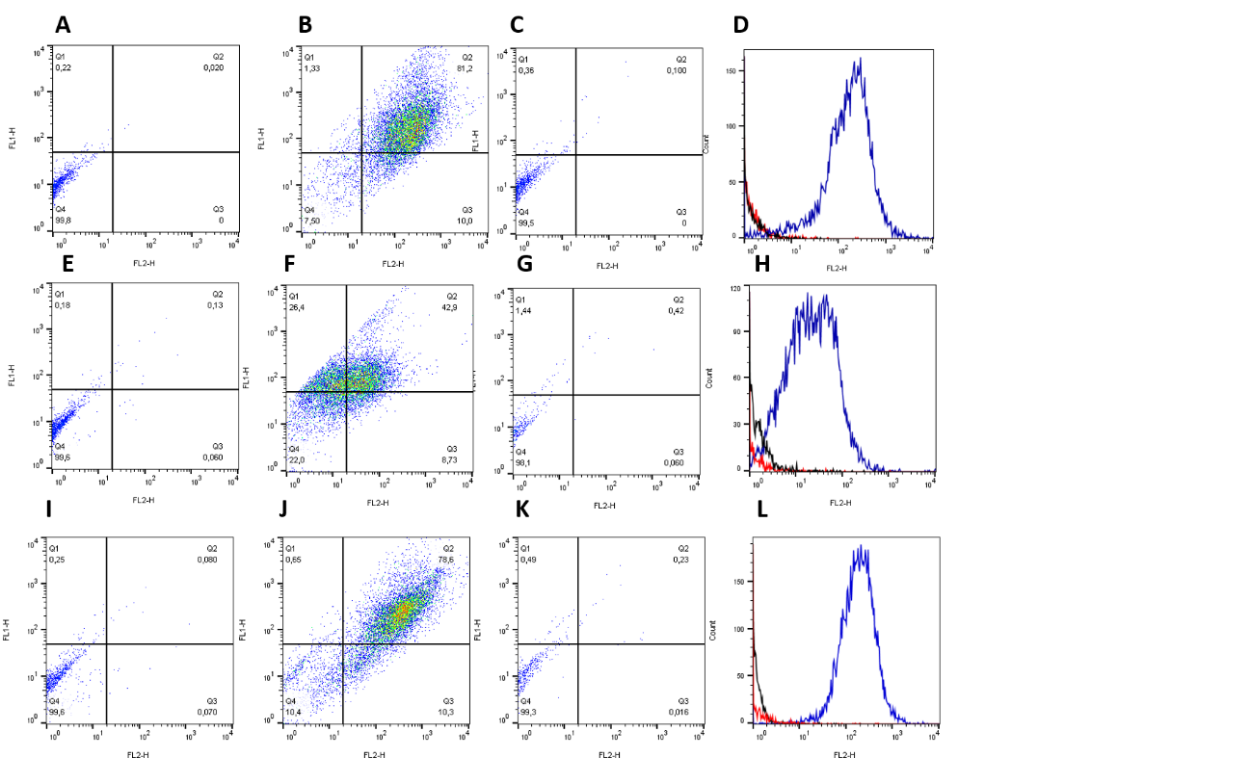
Figure 1 Flow cytometric analysis of the expression of cell surface markers CD90, CD44 and CD34 by mesenchymal stem cells. Representative dot plots and histograms of three sources: Synovial fluid (SF), bone marrow (BM) and adipose tissue (AT). SF, BM and AT. A: SF control; B: SF CD90+CD44+; C: SF CD34+; D: SF histograms control (black line), CD34+ (red line) and CD90+CD44+ (blue line); E: BM control; F: BM CD90+CD44+; G: BM CD34+; H: BM histograms control (black line), CD34+ (red line) and CD90+CD44+ (blue line); I: AT control; J: AT CD90+CD44+; K: AT CD34+; L: AT histograms control (black line), CD34+ (red line) and CD90+CD44+ (blue line).

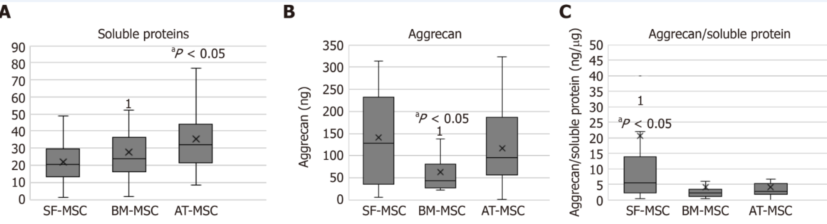
Figure 2 Average and median of the total concentration of soluble proteins, aggrecan, and the ratio of the aggrecan to soluble proteins of the microspheroids from different sources of mesenchymal stem cells. A: Mean concentration (×), median (-), and standard deviation of the concentration of soluble proteins present in microspheroids extracted from samples of synovial fluid-derived mesenchymal stem cells (SF-MSCs), bone marrow-derived mesenchymal stem cells (BM-MSCs), and adipose tissue-derived mesenchymal stem cells (AT-MSCs). ¹ outlier; ªP < 0.05 indicates the statistical difference in relation to BM-MSCs and SF-MSCs; B: Mean concentration (×), median (-), and standard deviation of the concentration of aggrecan from the microspheroids extracted from the samples of SF-MSCs, BM-MSCs, and AT-MSCs. ¹ outlier; ªP < 0.05 indicates the statistical difference in relation to BM-MSCs and SF-MSCs; C: Mean concentration (×), median (-), and standard deviation of the ratio of the concentration of aggrecan to soluble proteins of the microspheroids extracted from the samples of SF-MSCs, BM-MSCs, and AT-MSCs. ¹ outlier; ªP < 0.05 indicates the statistical difference in relation to BM-MSCs. SF-MSCs: Synovial fluid-derived mesenchymal stem cells; BM-MSCs: Bone marrow-derived mesenchymal stem cells; AT-MSCs: Adipose tissue-derived mesenchymal stem cells.
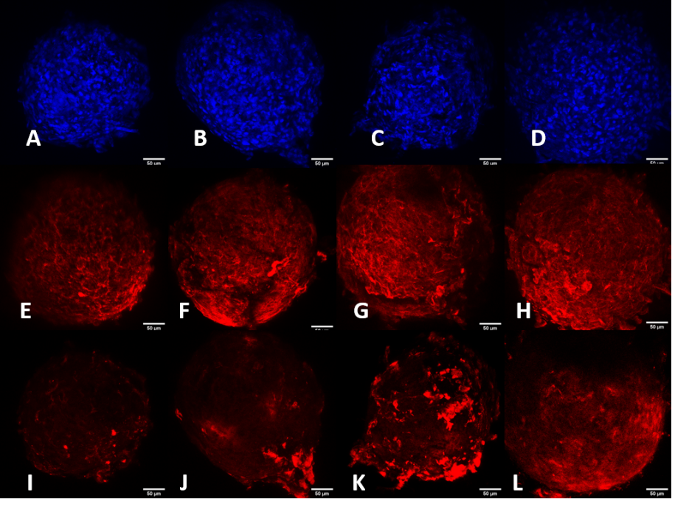
Figure 3 Representative images of 4',6-diamidino-2-phenylindole staining, and aggrecan and keratan sulfate expression in synovial fluid-mesenchymal stem cells using immunofluorescence. A: 4',6-diamidino-2-phenylindole (DAPI) 4 d; B: DAPI 7 d; C: DAPI 14 d; D: DAPI 21 d; E: Aggrecan 4 d; F: Aggrecan 7 d; G: Aggrecan 14 d; H: Aggrecan 21 d; I: Keratan sulfate 4 d; J: Keratan sulfate 7 d; K: Keratan sulfate 14 d; L: Keratan sulfate 21 d.
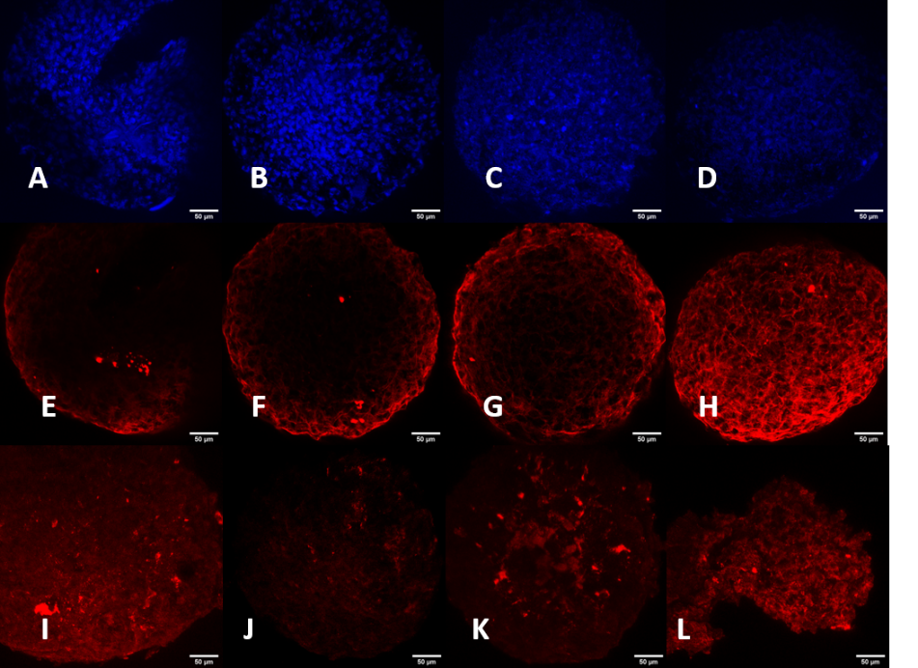
Figure 4 Representative images of 4',6-diamidino-2-phenylindole staining, and aggrecan and keratan sulfate expression in Bone marrow-mesenchymal stem cells using immunofluorescence. A: 4',6-diamidino-2-phenylindole (DAPI) 4 d; B: DAPI 7 d; C: DAPI 14 d; D: DAPI 21 d; E: Aggrecan 4 d; F: Aggrecan 7 d; G: Aggrecan 14 d; H: Aggrecan 21 d; I: Keratan sulfate 4 d; J: Keratan sulfate 7 d; K: Keratan sulfate 14 d; L: Keratan sulfate 21 d.
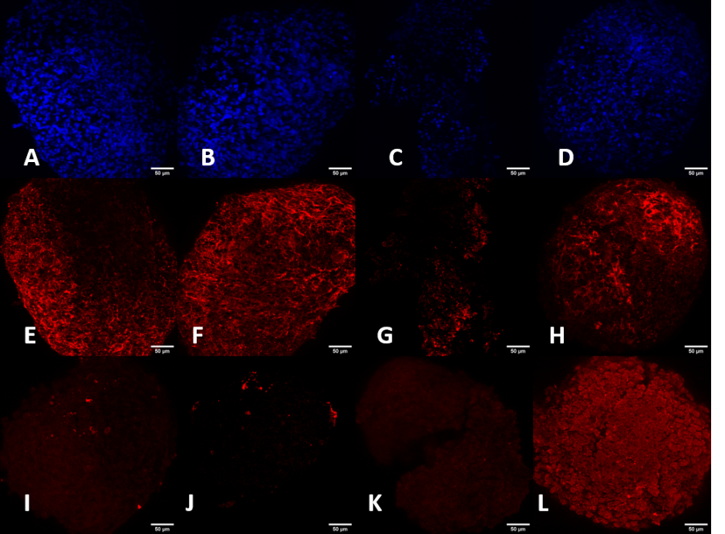
Figure 5 Representative images of 4',6-diamidino-2-phenylindole staining, and aggrecan and keratan sulfate expression in adipose tissue - mesenchymal stem cells using immunofluorescence. A: 4',6-diamidino-2-phenylindole (DAPI) 4 d; B: DAPI 7 d; C: DAPI 14 d; D: DAPI 21 d; E: Aggrecan 4 d; F: Aggrecan 7 d; G: Aggrecan 14 d; H: Aggrecan 21 d; I: Keratan sulfate 4 d; J: Keratan sulfate 7 d; K: Keratan sulfate 14 d; L: Keratan sulfate 21 d.
Table 1 Average percentages of mesenchymal stem cells from synovial fluid, bone marrow and adipose tissue demonstrated positive or negative expression of CD90, CD44 and CD34 markers by flow cytometry
Source | Expression (%)
 | CD44-CD90+ | CD44+CD90- | CD44+CD90+ | CD44-CD90- | CD34+ | CD90+ | CD44+
SF | 21.33 ± 12.89 | 5.12 ± 8.19 | 57.92 ± 11.71 | 15.62 ± 7.10 | 1.49 ± 2.02 | 79.26 ± 9.69 | 63.04 ± 15.16
BM | 19.09 ± 16.38 | 15.80 ± 20.95 | 45.55 ± 26.65 | 23.37 ± 12.92 | 1.98 ± 2.83 | 64.64 ± 27.99 | 61.34 ± 22.13
AT | 19.21 ± 19.50 | 5.32 ± 8.31 | 54.53 ± 21.83 | 20.43 ± 16.26 | 1.90 ± 3.04 | 73.74 ± 21.23 | 59.85 ± 20.26
SF: Synovial fluid; AT: Adipose tissue; BM: Bone marrow

Published by Baishideng Publishing Group Inc
7041 Koll Center Parkway, Suite 160, Pleasanton, CA 94566, USA
Telephone: +1-925-3991568
E-mail: bpgoffice@wjgnet.com
Help Desk: https://www.f6publishing.com/helpdesk
https://www.wjgnet.com

© 2021 Baishideng Publishing Group Inc. All rights reserved.

