Name of Journal: World Journal of Clinical Cases
Manuscript NO: 62079
Manuscript Type: CASE REPORT

Alström syndrome with a novel mutation of ALMS1 and Graves’ hyperthyroidism: A case report and review of the literature

Zhang JJ et al. Alström syndrome with Graves’ hyperthyroidism

Juan-Juan Zhang, Jun-Qi Wang, Man-Qing Sun, De Xu, Yuan Xiao, Wen-Li Lu, Zhi-Ya Dong

Juan-Juan Zhang, Jun-Qi Wang, Man-Qing Sun, De Xu, Yuan Xiao, Wen-Li Lu, Zhi-Ya Dong, Department of Pediatrics, Ruijin Hospital, Shanghai Jiao-Tong University, School of Medicine, Shanghai 200025, China

Author contributions: Zhang JJ and Dong ZY were the patient’s pediatric endocrinologists, reviewed the literature and contributed to manuscript drafting; Wang JQ performed the microbiological analyses and interpretation, and contributed to manuscript drafting; Sun MQ analyzed and interpreted the imaging findings; Xu D reviewed the literature and drafted the manuscript; Xiao Y and Lu WL were responsible for the revision of the manuscript for important intellectual content; all authors issued final approval for the version to be submitted.

Corresponding author: Zhi-Ya Dong, MD, Chief Physician, Department of Pediatrics, Ruijin Hospital, Shanghai Jiao-Tong University, School of Medicine, Ruijin 2nd Road, Shanghai 200025, China. dzy831@126.com

Received: December 30, 2020
Revised: January 21, 2021
Accepted: February 8, 2021
Published online: May 6, 2021

Abstract
BACKGROUND
Alström syndrome (AS, OMIM ID 203800) is a rare disease involving multiple organs in children and is mostly reported in non-Chinese patients. In the Chinese population, there are few reports on the clinical manifestations and pathogenesis of AS. This is the first report on the association between AS and Graves’ hyperthyroidism.

CASE SUMMARY
An 8-year-old Chinese girl was diagnosed with AS. Two years later, Graves’ hyperthyroidism developed with progressive liver dysfunction. The patient's clinical data were collected; DNA from peripheral blood of the proband, parents and sibling was collected for gene mutation detection using the second-generation sequencing method and gene panel for diabetes. The association between the patient's genotype and clinical phenotype was analyzed. She carried the pathogenic compound heterozygous mutation of ALMS1 (c.2296_2299del4 and c.11460C>A). These stop-gain mutations likely caused truncation of the ALMS1 protein.

CONCLUSION
The manifestation of hyperthyroidism may suggest rapid progression of AS.

Key Words: ALMS1; Alström syndrome; Stop-gain mutations; Protein truncation; Graves’ hyperthyroidism; Case report

©The Author(s) 2021. Published by Baishideng Publishing Group Inc. All rights reserved.

Zhang JJ, Wang JQ, Sun MQ, Xu D, Xiao Y, Lu WL, Dong ZY. Alström syndrome with a novel mutation of ALMS1 and Graves’ hyperthyroidism: A case report and review of the literature. World J Clin Cases 2021; 9(13): 3200-3211 URL: https://www.wjgnet.com/2307-8960/full/v9/i13/3200.htm DOI: https://dx.doi.org/10.12998/wjcc.v9.i13.3200

Core Tip: We report the case of an 8-year-old girl who carried two novel mutations in ALMS1 according to the gene panel and developed Graves’ hyperthyroidism 2 years later. To our knowledge, this is the first report on the association between Alström syndrome and Graves’ hyperthyroidism.

INTRODUCTION
Alström syndrome (AS) is a rare ciliopathy characterized by metabolic disorders, such as childhood obesity, insulin resistance, cone retinal dystrophy, and sensorineural hearing loss (SNHL). Type 2 diabetes (T2D) and hypertriglyceridemia usually occur in childhood or adolescence^{[1]}. Dilated cardiomyopathy (DCM) may appear in infancy, and then usually resolves or even disappears within 3 years; however, DCM may recur or appear for the first time in adolescence or adulthood. Other common features of AS include liver, kidney, and lung dysfunction, chronic otitis media in children, spine deformity (scoliosis, kyphosis, or lordosis) in adolescence, short stature in adulthood, and gastrointestinal and neurological diseases (e.g., seizures). AS has a poor prognosis and usually leads to complications-related organ failure and shortened life expectancy under 50 years^{[2]}.
It is estimated that the prevalence of AS is 1-9 cases in 1000000, and 950 cases have been reported to date^{[3]}. This rare autosomal recessive syndrome is caused by a pathogenic variant of ALMS1. This gene, located on chromosome 2p13 and spanning 23 exons, plays a key role in the basal bodies of cilia^{[4,5]}. More than 200 mutations of ALMS1 that cause AS have been identified, most of which are nonsense or frameshift mutations^{[6,7]}. However, the heterogeneity of AS variants and gene expression may lead to a different age of onset and severity of clinical symptoms, which can easily delay diagnosis, especially for those with only certain clinical features^{[8]}. Thus, second-generation sequencing technologies could be useful for an effective and rapid diagnosis of clinically suspected AS^{[9]}.
Here, we describe a Chinese girl who had two novel mutations in ALMS1 according to the gene panel and developed Graves’ hyperthyroidism at 10 years of age. To our knowledge, this is the first report on the association between AS and Graves’ hyperthyroidism.

CASE PRESENTATION
Chief complaints
An 8-year-old Chinese girl presented to the Out-patient Department of our hospital complaining of polydipsia and polyuria.

History of present illness
The patient’s symptoms started 7 mo ago with recurrent episodes of polydipsia and polyuria, which had worsened over the last 48 h.

History of past illness
She presented with retinitis pigmentosa at 8 mo of age, was diagnosed with bilateral congenital macular dysplasia, and then diagnosed with DCM at 1 year of age, At 7 years of age, she had hearing loss and was diagnosed with SNHL.

Personal and family history
She had normal intelligence and body development, with no obvious family history of genetic diseases.

Physical examination
The patient had a rounded face, wide shoulders, a barrel chest, a ‘stocky’ build, and truncal obesity and a remarkable acanthosis nigricans in the neck, with a height of 140 cm (+ 1.14 SD), weight of 43 kg (+ 2.82 SD), and body mass index (BMI) of 22.01 kg/m² (+ 2.53 SD) (Figure 1).

Laboratory examinations
Blood biochemistry, as well as urine analysis revealed increased glycated hemoglobin A1c (HbA1c) level at 8%, abnormal liver function (elevated alanine aminotransferase level (ALT), 61 IU/L; aspartate aminotransferase level (AST), 62 IU/L), and diabetic nephropathy (incipient nephropathy)^{[10]} [urine microalbumin (MA) level, 12.1 mg/dL; urine MA/creatinine ratio, 164 mg/g Cr; 24-h urine protein level, 378 mg/24 h; glomerular filtration rate (GFR), 90 mL/min/1.73m²]. A homeostatic model assessment for insulin resistance (HOMA-IR) index of 16.6 was suggestive of severe insulin resistance (HOMA-IR > 2.6 indicates insulin resistance in adolescence)^{[11]}. No abnormalities were found in her blood lipid levels, renal function, tumor markers, and endocrine hormones, such as thyroxine and epinephrine. The lung function examination revealed obstructive ventilation disorder.

Imaging examinations
The imaging examination revealed scoliosis, thyroid nodules (TI-RADS 2), a right pelvic cyst (7.8 cm × 8.2 cm × 7.5 cm), and hepatosplenomegaly. Her echocardiogram and chest radiograph were normal (Figure 2).

Further diagnostic work-up
The genomic DNA of the proband was extracted from peripheral blood in a tube containing ethylenediaminetetraacetic acid and sequenced using a diabetes panel containing 85 related genes, with an average coverage of 200 ×, covering more than 95% of the target area (including coding and untranslated exons) and including a minimum coverage of 20 ×. All samples were simultaneously analyzed by the NextSeq500 sequencer (Illumina, San Diego, CA, United States) to confirm the sample identity and screen copy number variants and homozygous regions (AmcareLab, Guangzhou, China). Data were filtered to generate “clean reads” by removing adapters and low quality reads (< Q20). Sequences were aligned to the hg19 reference genome by NextGENe software (SoftGenetics, State College, PA, United States) using the recommended standard settings for single-nucleotide variant and insertion/deletion discovery. DNA sequence variations were annotated using the population and literature databases (including 1000 Genomes, dbSNP, GnomAD, Clinvar, HGMD, and OMIM databases). Computational analysis of variants was performed using PolyPhen-2, CADD and MutationTaster. The frequency filter adopted the minor allele frequency > 1% in Asian population. Variants interpretation was manipulated according to the American College of Medical Genetics (ACMG) guidelines^{[12]}. The mutations were validated using the Sanger sequencing method. We identified two pathogenic mutations in ALMS1: chr2, 73675945 (c.2296_2299del4, p.S766Kfs*13) in exon 8 (Figure 3) and chr2, 73800461 (c.11460C>A, p.Y3820*) in exon 16 (Figure 3). These mutations were verified using the Sanger sequencing methods (Figure 3). The results showed that c.2296_2299del4 (p.S766Kfs*13) and c.11460C>A (p.Y3820*) were paternal inheritance and maternal inheritance, respectively. The sister of the proband carried a paternal mutation. These two new mutations in ALMS1 are frameshift and nonsense mutations, respectively. It was predicted that these two mutations are stop-gain mutations that caused truncation of the ALMS1 protein (Figure 4). These two mutations in ALMS1 were considered pathogenic variants according to the ACMG guideline in 2015 (PVS1 + PM2 + PM3 + PP4 for p.S766Kfs*13 and PVS1 + PM2 + PP4 for p.Y3820*)^{[12]}.

ETHICS STATEMENTS
The patient and the patient’s parents and sister all signed an informed consent form. This study was approved by the local ethics committee of Ruijin Hospital affiliated with the Shanghai Jiaotong University School of Medicine.

FINAL DIAGNOSIS
AS was finally diagnosed based on the clinical manifestations, laboratory test results, and genetic sequencing.

TREATMENT
After diagnosis, the patient was treated with metformin combined with insulin detemir to control her blood glucose level, benazepril hydrochloride [angiotensin-converting enzyme inhibitor (ACEI)] (2.5 mg qd) to alleviate urine protein excretion, and polyunsaturated phosphatidylcholine and glutathione for hepatic preservation.

OUTCOME AND FOLLOW-UP
Two years later, the patient was re-admitted because of sustained high-level of liver enzymes and poor control of blood glucose, when she was 10 years old, with a height of 148 cm (+1.34 SD), weight of 44.8 kg (+1.96 SD), BMI of 20.45 kg/m² (+1.74 SD), and pubertal stage of Tanner II. The bone age was 13.5 years old (Figure 5), and the predicted adult height (PAH) was 152 cm (-1.59 SD). Laboratory findings revealed abnormal liver function (ALT, 236 U/L; AST, 117.9 U/L; γ-glutamyl transferase level, 58.3 U/L), diabetes (HbA1c level, 10.0%), Graves’ hyperthyroidism (free T3 level, 10.64 pmol/L; free T4 level, 19.47 pmol/L; thyroid-stimulating hormone level, 0.0082; thyrotropin receptor antibody level, 4.07 IU/L; thyroglobulin antibody and thyrotropin receptor antibody levels, normal), azotemia (blood urea nitrogen level, 7.7 mmol/L), diabetic nephropathy (incipient nephropathy) [urine (MA) level, 8.38 mg/dL; urine MA/creatinine ratio, 108 mg/g Cr; GFR, 119.8 mL/min/1.73 m²; 24-h urine protein level, 318 mg/24 h], hyperlipidemia (triglyceride level, 1.89 mmol/L), and increased HOMA-IR (33.7). The imaging examination revealed disappearance of the right ovarian cyst (after cystectomy), thyroid nodules (TI-RADS 2-3), and gallbladder polyps (Figure 6). Metformin was stopped and intensive treatments, including insulin aspart before three meals and insulin detemir before bedtime (1.8-2 U/kg/d) were initiated. Glutathione, polyunsaturated phosphatidylcholine, bicyclol, and vitamin E were given for hepatic preservation. Oral methimazole (5 mg qd) was prescribed to control hyperthyroidism, and benazepril hydrochloride (5 mg qd) was prescribed to alleviate urine protein excretion.
One month after the treatment, all biochemical indicators were alleviated, and she had normal growth and development comparable to those of children of the same age.

DISCUSSION
ALMS1, composed of 12925 nucleotides, spans 23 exons and encodes the 4168-amino acid protein. ALMS1 is a component of centrosomes, which consist of microtubules, nuclear organelles (comprising mother and daughter cells), and pericentriolar material (a dynamically positioned protein) and are located at the proximal end of the base or cell structure^{[13]}. The roles of ALMS1 in the formation, positioning, and maintenance of primary cilia have been shown, and AS is considered a ciliopathy^{[14-17]}. In addition, ALMS1 plays a role in spermatogenesis, maintenance of pancreatic β-cell numbers, adaptive thermoregulation, and cell cycle arrest of cardiomyocytes^{[18-22]}.
Early studies of AS have shown that mutations in ALMS1 are predominantly around exons 8, 10, and 16^{[23]}. Recent sequencing technology identified novel mutations in exons 5^{[24,25]}, 11, 12, 18, and 20 and intronic mutations in ALMS1^{[13,25-27]}. No mutations have been reported in exons 1-2, 6, 7, 13, and 22-23. The disproportionate clustering of mutations around exons 8, 10, and 16 may be caused by large exon fragments^{[27]}. The mutation that greatly affects the ALMS1 protein is a frameshift or nonsense mutation downstream of exon 7, which leads to the premature termination and a subsequent non-functional protein. Additionally, mutations and deletions at the splice site, an Alu transposon insertion, and a balanced translocation have been identified in ALMS1^{[28]}. More than 268 pathogenic mutations have been found, and race is an important factor in the distribution of genetic variation^{[2]}. For example, c.10539_10557ins(n)19 is more common in French Acadians, c.10775delC in British descents (up to 20%)^{[4,26]}, and IVS8 + 895del1444 in Pakistani individuals^{[29]}. However, most ALMS1 mutations are reported in non-Chinese patients with AS. In the present case, the two compound heterozygous mutations, located in exons 8 and 16, were frameshift and nonsense mutations, respectively, belonging to the regions of hot spot and classic mutations. These mutation sites are reported for the first time.
To date, there are seven published reports of Chinese patients with AS in the PubMed database^{[30-36]}. Frameshift or stop-gain mutations are most common in Chinese patients with AS, and they are all located in hot spots, including our case; there are no spontaneous mutation cases, but the mutation sites and clinical manifestations are different from each other. In 2000, Chen et al^{[31]} reported the first case of AS in an 11-year-old Chinese body, who had typical AS manifestations and developed acute lymphoblastic leukemia during the follow-up. This is the only case of AS with leukemia, and it is unknown whether it is a coincidence or undiscovered manifestation in AS. Liang et al^{[30]} identified seven frameshift mutations and one nonsense mutation in seven probands, and up to 90% of these mutations were firstly reported and different from those in the British and French populations; their mutations were considered due to the haplotype sharing effect in the British population^{[26]}. Xu et al^{[34]} identified 13 null mutations in ALMS1 in 11 probands, and 77% (10/13) were located in the eighth exon characterized by early-onset eye disease, such as Leber congenital amaurosis or severe cone-rod retinal dystrophy; other systemic manifestations were relatively mild, with no DCM or T2D. In another cohort of 21 Chinese patients with AS, the proportion of cognitive impairment and behavioral problems was higher (33%) than that in other populations; c.2084C>A (p.Ser695Ter) was identified in six cases and considered as having Chinese origins. In addition, three new mutations in exons 9, 18, and 19 were identified to be exclusive to Southeast Asians^{[36]}. However, nervous system impairment was not found in the present case.
The clinical phenotype of AS is complex, and it differs greatly even among individuals with the same mutation site^{[13,25-28]}. The underlying mechanism is still unclear. AS is characterized by a complex array of clinical manifestations, including obesity, T2D, retinal dystrophy, hearing loss, liver and kidney dysfunction, short stature, hypothyroidism, neurological and respiratory diseases, male hypogonadism, excess androgen in women, and spine deformity in adolescence^{[37-41]}. Retinal dystrophy usually occurs within a few weeks after birth, and poor vision develops in approximately all children within the first year. About one-third of patients with AS are completely blind by 9 years of age, 50% by 12 years of age, and 90% by 16 years of age^{[8]}. In a study of 21 Chinese patients with AS, 100% of them had poor vision, 19% had nervous system impairment, and 14% had liver and kidney dysfunction by the age of 36 mo, similar to populations in Europe and the United States^{[35,36]}. About two-thirds of patients with AS will develop DCM, and their cardiac function will improve at 3 years of age and remain stable under the “low normal” condition^{[8]}. This explains the phenomenon in our patient who had cardiomyopathy at an early stage but a normal recent echocardiogram. Approximately 89% of patients with AS develop symmetrical SNHL or even worse, with an average age at diagnosis of 7.45 years (range, 1.5-15 years). Approximately 82% of patients with AS are diagnosed with T2D, with a median onset age of 16 years. Obesity usually develops in the first few years after birth, and most infants have a BMI > 95% without weight control^{[42]}. Consistent with previous case reports, the present patient was diagnosed with congenital macular dysplasia at 8 mo of age, DCM at 1 year of age, and SNHL at 7 years of age, but she had an early onset of diabetes (8 years earlier than the median age of onset). Most patients with AS whose height is normal in early childhood, but growth retardation occurs in adolescence, but our proband was taller (+ 1.34 SD). This may have been due to the child’s early puberty (BA 13.5 years old), and the PAH was still impaired. We will continue to follow up to determine if the proband has abnormal growth and development in the middle and late stages of puberty.
This patient developed Graves’ hyperthyroidism 2 years after the diagnosis of AS, which has not been reported previously. Regarding the correlation between AS and the thyroid, most patients have hypothyroidism (11%-36%) and several patients have subclinical hypothyroidism. Until now, there was only one case of a 35-year-old female AS patient with a follicular variant of papillary thyroid carcinoma^{[43]}. It is currently believed that hypothyroidism (central or primary) may be primary or secondary to AS, and 20% of cases are autoimmune-related^{[44]}, while it is not clear that the malignancies represent a true association or a simple coincidence. Only one study reported that two sisters had hyperthyroidism at 30 years of age following a diagnosis of AS at 15 and 20 years, respectively. They were both negative for thyroid autoantibodies and simultaneously developed renal failure; furthermore, they carried the c.8164C>T (p.R2722X) mutation, leading to the premature termination and truncation of the ALMS1 protein at the 2722 amino acid^{[45]} (Table 1). Additionally, their two other sisters without AS developed non-autoimmune hyperthyroidism. In the present case, the patient was still in incipient nephropathy 2 years later, but with azotemia, and she developed a rapid progression of liver dysfunction when she was diagnosed with hyperthyroidism. It was unclear whether the rapid progression of liver dysfunction was associated with the primary manifestation of hyperthyroidism; nevertheless, such a symptom may indicate rapid progression of AS.
Although no specific genotype–phenotype correlation has been found, AS still exhibits genetic heterogeneity. Some studies on the genotype–phenotype association have found that the pathogenic mutation in exon 16 is associated with retinopathy (before 1 year of age), urinary tract abnormality, DCM, and diabetes, and the mutation in exon 8 is related to chronic nephropathy (P = 0.0007). In the present case, the patient carried pathogenic mutations in exons 8 and 16 and experienced progression of early kidney disease with multiple organ involvement, suggesting that the pathogenic mutation in exon 16 may play a major role^{[26,46]}. Compared with the mutation sites, some authors believed that the clinical phenotype of AS may be more related to the variations of the ALMS1 domain and motif, and its residual function^{[47]}. ALMS1 possesses several unique motifs, such as the N-terminal polyglutamine tract, tandem repeat sequence domain, three coiled coil domains, and one ~130-residue long C-terminal. Based on the known amino acid sequence characteristics of ALMS1^{[3]}, this patient was predicted to carry two stop-gain mutations, leading to ALMS1 truncation at positions 780 and 3820, respectively. Compared with nonsense mutations, stop-gain mutations cause greater damage to the ALMS1 protein^{[23]} and have more severe and complex clinical phenotypes, which may help explain the early-onset diabetes, autoimmune hyperthyroidism, and rapidly progressing liver dysfunction.
The treatment for patients with AS is limited to the management of clinical symptoms and improving quality of life^{[41]}. Patients with AS can reduce the photodynamic abnormality by wearing red-orange tinted lenses, improve hearing impairment by undergoing implantation of cochlear hearing aids, and control their body weight gain and blood lipid levels through a healthy low-calorie diet and regular exercise^{[28]}. In addition, rhGH treatment decreased body fat percentage, liver fat, and serum lipid levels, and improved insulin sensitivity and acanthosis nigricans in a small number of patients with AS^{[48]}. An ACEI is usually used for proteinuria and dilated or restrictive cardiomyopathy (beta blockers can also be used for heart failure). When T2D or insulin resistance is present, a large dose of metformin and rosiglitazone is recommended. Moreover, sodium glucose transporter 2 inhibitors (e.g., canagliflozin) are beneficial for some AS patients with chronic kidney disease and heart disease who do not tolerate dipeptidyl peptidase-4 inhibitors. Glucagon-like peptide 1 receptor agonists can be considered if body weight control is urgently needed^{[44]}. A phase 2 clinical trial is currently being conducted in patients with AS, aiming to evaluate the efficacy of PBI-4050 for pathological inflammation and fibrosis^{[49]}. In the present case, the patient exhibited progressive hepatic dysfunction, poor blood glucose control, and Graves’ hyperthyroidism. While providing active treatments for kidney protection and urinary protein reduction by ACEI, it is necessary to balance liver protection and the use of metformin and methimazole. As there is no past empirical reference to refer to, further exploration of this clinical problem is needed. It is also necessary to closely monitor patients’ systemic condition and prevent the failure of major organs. Early diagnosis and intervention may delay progression of the disease and improve the life span and quality of life of patients with AS.

CONCLUSION
In summary, we identified autosomal recessive pathogenic mutations in ALMS1 (c.2296_2299del4 and c.11460C>A) in a Chinese girl with Graves' hyperthyroidism and abnormal liver and kidney function, and predicted that these two mutations are stop-gain mutations that could cause truncation of the ALMS1 protein. To our knowledge, this is the first report on the association between AS and Graves’ hyperthyroidism. Our case suggests that the manifestation of hyperthyroidism may indicate a rapid progression of AS.

ACKNOWLEDGEMENTS
We are grateful for the cooperation of the patient’s family.

REFERENCES
1 Marshall JD, Maffei P, Collin GB, Naggert JK. Alström syndrome: genetics and clinical overview. Curr Genomics 2011; 12: 225-235 [PMID: 22043170 DOI: 10.2174/138920211795677912]
2 Tsai MC, Yu HW, Liu T, Chou YY, Chiou YY, Chen PC. Rare Compound Heterozygous Frameshift Mutations in ALMS1 Gene Identified Through Exome Sequencing in a Taiwanese Patient With Alström Syndrome. Front Genet 2018; 9: 110 [PMID: 29720996 DOI: 10.3389/fgene.2018.00110]
3 Hearn T. ALMS1 and Alström syndrome: a recessive form of metabolic, neurosensory and cardiac deficits. J Mol Med (Berl) 2019; 97: 1-17 [PMID: 30421101 DOI: 10.1007/s00109-018-1714-x]
4 Collin GB, Marshall JD, Ikeda A, So WV, Russell-Eggitt I, Maffei P, Beck S, Boerkoel CF, Sicolo N, Martin M, Nishina PM, Naggert JK. Mutations in ALMS1 cause obesity, type 2 diabetes and neurosensory degeneration in Alström syndrome. Nat Genet 2002; 31: 74-78 [PMID: 11941369 DOI: 10.1038/ng867]
5 Hearn T, Renforth GL, Spalluto C, Hanley NA, Piper K, Brickwood S, White C, Connolly V, Taylor JF, Russell-Eggitt I, Bonneau D, Walker M, Wilson DI. Mutation of ALMS1, a large gene with a tandem repeat encoding 47 amino acids, causes Alström syndrome. Nat Genet 2002; 31: 79-83 [PMID: 11941370 DOI: 10.1038/ng874]
6 Astuti D, Sabir A, Fulton P, Zatyka M, Williams D, Hardy C, Milan G, Favaretto F, Yu-Wai-Man P, Rohayem J, López de Heredia M, Hershey T, Tranebjaerg L, Chen JH, Chaussenot A, Nunes V, Marshall B, McAfferty S, Tillmann V, Maffei P, Paquis-Flucklinger V, Geberhiwot T, Mlynarski W, Parkinson K, Picard V, Bueno GE, Dias R, Arnold A, Richens C, Paisey R, Urano F, Semple R, Sinnott R, Barrett TG. Monogenic diabetes syndromes: Locus-specific databases for Alström, Wolfram, and Thiamine-responsive megaloblastic anemia. Hum Mutat 2017; 38: 764-777 [PMID: 28432734 DOI: 10.1002/humu.23233]
7 Marshall JD, Muller J, Collin GB, Milan G, Kingsmore SF, Dinwiddie D, Farrow EG, Miller NA, Favaretto F, Maffei P, Dollfus H, Vettor R, Naggert JK. Alström Syndrome: Mutation Spectrum of ALMS1. Hum Mutat 2015; 36: 660-668 [PMID: 25846608 DOI: 10.1002/humu.22796]
8 Marshall JD, Beck S, Maffei P, Naggert JK. Alström syndrome. Eur J Hum Genet 2007; 15: 1193-1202 [PMID: 17940554 DOI: 10.1038/sj.ejhg.5201933]
9 Bamshad MJ, Ng SB, Bigham AW, Tabor HK, Emond MJ, Nickerson DA, Shendure J. Exome sequencing as a tool for Mendelian disease gene discovery. Nat Rev Genet 2011; 12: 745-755 [PMID: 21946919 DOI: 10.1038/nrg3031]
10 Haneda M, Utsunomiya K, Koya D, Babazono T, Moriya T, Makino H, Kimura K, Suzuki Y, Wada T, Ogawa S, Inaba M, Kanno Y, Shigematsu T, Masakane I, Tsuchiya K, Honda K, Ichikawa K, Shide K; Joint Committee on Diabetic Nephropathy. A new Classification of Diabetic Nephropathy 2014: a report from Joint Committee on Diabetic Nephropathy. J Diabetes Investig 2015; 6: 242-246 [PMID: 25802733 DOI: 10.1111/jdi.12319]
11 Matthews DR, Hosker JP, Rudenski AS, Naylor BA, Treacher DF, Turner RC. Homeostasis model assessment: insulin resistance and beta-cell function from fasting plasma glucose and insulin concentrations in man. Diabetologia 1985; 28: 412-419 [PMID: 3899825 DOI: 10.1007/bf00280883]
12 Richards S, Aziz N, Bale S, Bick D, Das S, Gastier-Foster J, Grody WW, Hegde M, Lyon E, Spector E, Voelkerding K, Rehm HL; ACMG Laboratory Quality Assurance Committee. Standards and guidelines for the interpretation of sequence variants: a joint consensus recommendation of the American College of Medical Genetics and Genomics and the Association for Molecular Pathology. Genet Med 2015; 17: 405-424 [PMID: 25741868 DOI: 10.1038/gim.2015.30]
13 Sanyoura M, Woudstra C, Halaby G, Baz P, Senée V, Guillausseau PJ, Zalloua P, Julier C. A novel ALMS1 splice mutation in a non-obese juvenile-onset insulin-dependent syndromic diabetic patient. Eur J Hum Genet 2014; 22: 140-143 [PMID: 23652376 DOI: 10.1038/ejhg.2013.87]
14 Jagger D, Collin G, Kelly J, Towers E, Nevill G, Longo-Guess C, Benson J, Halsey K, Dolan D, Marshall J, Naggert J, Forge A. Alström Syndrome protein ALMS1 Localizes to basal bodies of cochlear hair cells and regulates cilium-dependent planar cell polarity. Hum Mol Genet 2011; 20: 466-481 [PMID: 21071598 DOI: 10.1093/hmg/ddq493]
15 Li G, Vega R, Nelms K, Gekakis N, Goodnow C, McNamara P, Wu H, Hong NA, Glynne R. A role for Alström syndrome protein, alms1, in kidney ciliogenesis and cellular quiescence. PLoS Genet 2007; 3: e8 [PMID: 17206865 DOI: 10.1371/journal.pgen.0030008]
16 Heydet D, Chen LX, Larter CZ, Inglis C, Silverman MA, Farrell GC, Leroux MR. A truncating mutation of Alms1 reduces the number of hypothalamic neuronal cilia in obese mice. Dev Neurobiol 2013; 73: 1-13 [PMID: 22581473 DOI: 10.1002/dneu.22031]
17 Graser S, Stierhof YD, Lavoie SB, Gassner OS, Lamla S, Le Clech M, Nigg EA. Cep164, a novel centriole appendage protein required for primary cilium formation. J Cell Biol 2007; 179: 321-330 [PMID: 17954613 DOI: 10.1083/jcb.200707181]
18 Shenje LT, Andersen P, Halushka MK, Lui C, Fernandez L, Collin GB, Amat-Alarcon N, Meschino W, Cutz E, Chang K, Yonescu R, Batista DA, Chen Y, Chelko S, Crosson JE, Scheel J, Vricella L, Craig BD, Marosy BA, Mohr DW, Hetrick KN, Romm JM, Scott AF, Valle D, Naggert JK, Kwon C, Doheny KF, Judge DP. Mutations in Alström protein impair terminal differentiation of cardiomyocytes. Nat Commun 2014; 5: 3416 [PMID: 24595103 DOI: 10.1038/ncomms4416]
19 Louw JJ, Corveleyn A, Jia Y, Iqbal S, Boshoff D, Gewillig M, Peeters H, Moerman P, Devriendt K. Homozygous loss-of-function mutation in ALMS1 causes the lethal disorder mitogenic cardiomyopathy in two siblings. Eur J Med Genet 2014; 57: 532-535 [PMID: 24972238 DOI: 10.1016/j.ejmg.2014.06.004]
20 Lodh S, Hostelley TL, Leitch CC, O'Hare EA, Zaghloul NA. Differential effects on β-cell mass by disruption of Bardet-Biedl syndrome or Alstrom syndrome genes. Hum Mol Genet 2016; 25: 57-68 [PMID: 26494903 DOI: 10.1093/hmg/ddv447]
21 Poekes L, Legry V, Schakman O, Detrembleur C, Bol A, Horsmans Y, Farrell GC, Leclercq IA. Defective adaptive thermogenesis contributes to metabolic syndrome and liver steatosis in obese mice. Clin Sci (Lond) 2017; 131: 285-296 [PMID: 27803297 DOI: 10.1042/CS20160469]
22 Arsov T, Silva DG, O'Bryan MK, Sainsbury A, Lee NJ, Kennedy C, Manji SS, Nelms K, Liu C, Vinuesa CG, de Kretser DM, Goodnow CC, Petrovsky N. Fat aussie--a new Alström syndrome mouse showing a critical role for ALMS1 in obesity, diabetes, and spermatogenesis. Mol Endocrinol 2006; 20: 1610-1622 [PMID: 16513793 DOI: 10.1210/me.2005-0494]
23 Kamal NM, Sahly AN, Banaganapalli B, Rashidi OM, Shetty PJ, Al-Aama JY, Shaik NA, Elango R, Saadah OI. Whole exome sequencing identifies rare biallelic ALMS1 missense and stop gain mutations in familial Alström syndrome patients. Saudi J Biol Sci 2020; 27: 271-278 [PMID: 31889847 DOI: 10.1016/j.sjbs.2019.09.006]
24 Paisey RB, Geberhiwot T, Waterson M, Cramb R, Steeds R, Williams K, White A, Hardy C. Modification of severe insulin resistant diabetes in response to lifestyle changes in Alström syndrome. Eur J Med Genet 2014; 57: 71-75 [PMID: 24462884 DOI: 10.1016/j.ejmg.2013.12.008]
25 Casey J, McGettigan P, Brosnahan D, Curtis E, Treacy E, Ennis S, Lynch SA. Atypical Alstrom syndrome with novel ALMS1 mutations precluded by current diagnostic criteria. Eur J Med Genet 2014; 57: 55-59 [PMID: 24503146 DOI: 10.1016/j.ejmg.2014.01.007]
26 Marshall JD, Hinman EG, Collin GB, Beck S, Cerqueira R, Maffei P, Milan G, Zhang W, Wilson DI, Hearn T, Tavares P, Vettor R, Veronese C, Martin M, So WV, Nishina PM, Naggert JK. Spectrum of ALMS1 variants and evaluation of genotype-phenotype correlations in Alström syndrome. Hum Mutat 2007; 28: 1114-1123 [PMID: 17594715 DOI: 10.1002/humu.20577]
27 Ozantürk A, Marshall JD, Collin GB, Düzenli S, Marshall RP, Candan Ş, Tos T, Esen İ, Taşkesen M, Çayır A, Öztürk Ş, Üstün İ, Ataman E, Karaca E, Özdemir TR, Erol İ, Eroğlu FK, Torun D, Parıltay E, Yılmaz-Güleç E, Karaca E, Atabek ME, Elçioğlu N, Satman İ, Möller C, Muller J, Naggert JK, Özgül RK. The phenotypic and molecular genetic spectrum of Alström syndrome in 44 Turkish kindreds and a literature review of Alström syndrome in Turkey. J Hum Genet 2015; 60: 1-9 [PMID: 25296579 DOI: 10.1038/jhg.2014.85]
28 Geets E, Meuwissen MEC, Van Hul W. Clinical, molecular genetics and therapeutic aspects of syndromic obesity. Clin Genet 2019; 95: 23-40 [PMID: 29700824 DOI: 10.1111/cge.13367]
29 Bond J, Flintoff K, Higgins J, Scott S, Bennet C, Parsons J, Mannon J, Jafri H, Rashid Y, Barrow M, Trembath R, Woodruff G, Rossa E, Lynch S, Sheilds J, Newbury-Ecob R, Falconer A, Holland P, Cockburn D, Karbani G, Malik S, Ahmed M, Roberts E, Taylor G, Woods CG. The importance of seeking ALMS1 mutations in infants with dilated cardiomyopathy. J Med Genet 2005; 42: e10 [PMID: 15689433 DOI: 10.1136/jmg.2004.026617]
30 Liang X, Li H, Li H, Xu F, Dong F, Sui R. Novel ALMS1 mutations in Chinese patients with Alström syndrome. Mol Vis 2013; 19: 1885-1891 [PMID: 24049434]
31 Chen BH, Chiou SS, Tsai RK, Lin YF, Wu JR. Acute lymphoblastic leukemia in one of two siblings with Alstrom syndrome. J Formos Med Assoc 2000; 99: 792-795 [PMID: 11061078]
32 Li M, Xia WB, Jin ZM, Shi H, Meng X, Xing X. [Report of a case with Alstrom syndrome]. Zhonghua Er Ke Za Zhi 2004; 42: 471 [PMID: 15265447]
33 Liu L, Dong B, Chen X, Li J, Li Y. Identification of a novel ALMS1 mutation in a Chinese family with Alström syndrome. Eye (Lond) 2009; 23: 1210-1212 [PMID: 18654604 DOI: 10.1038/eye.2008.235]
34 Xu Y, Guan L, Xiao X, Zhang J, Li S, Jiang H, Jia X, Yin Y, Guo X, Wang J, Zhang Q. ALMS1 null mutations: a common cause of Leber congenital amaurosis and early-onset severe cone-rod dystrophy. Clin Genet 2016; 89: 442-447 [PMID: 26010121 DOI: 10.1111/cge.12617]
35 Yang L, Li Z, Mei M, Fan X, Zhan G, Wang H, Huang G, Wang M, Tian W, Zhou W. Whole genome sequencing identifies a novel ALMS1 gene mutation in two Chinese siblings with Alström syndrome. BMC Med Genet 2017; 18: 75 [PMID: 28724398 DOI: 10.1186/s12881-017-0418-3]
36 Rethanavelu K, Fung JLF, Chau JFT, Pei SLC, Chung CCY, Mak CCY, Luk HM, Chung BHY. Phenotypic and mutational spectrum of 21 Chinese patients with Alström syndrome. Am J Med Genet A 2020; 182: 279-288 [PMID: 31755649 DOI: 10.1002/ajmg.a.61412]
37 Seeger-Nukpezah T, Golemis EA. The extracellular matrix and ciliary signaling. Curr Opin Cell Biol 2012; 24: 652-661 [PMID: 22819513 DOI: 10.1016/j.ceb.2012.06.002]
38 Reiter JF, Leroux MR. Genes and molecular pathways underpinning ciliopathies. Nat Rev Mol Cell Biol 2017; 18: 533-547 [PMID: 28698599 DOI: 10.1038/nrm.2017.60]
39 Guo J, Higginbotham H, Li J, Nichols J, Hirt J, Ghukasyan V, Anton ES. Developmental disruptions underlying brain abnormalities in ciliopathies. Nat Commun 2015; 6: 7857 [PMID: 26206566 DOI: 10.1038/ncomms8857]
40 Spassky N, Meunier A. The development and functions of multiciliated epithelia. Nat Rev Mol Cell Biol 2017; 18: 423-436 [PMID: 28400610 DOI: 10.1038/nrm.2017.21]
41 Grimes DT, Boswell CW, Morante NF, Henkelman RM, Burdine RD, Ciruna B. Zebrafish models of idiopathic scoliosis link cerebrospinal fluid flow defects to spine curvature. Science 2016; 352: 1341-1344 [PMID: 27284198 DOI: 10.1126/science.aaf6419]
42 Shurygina MF, Parker MA, Schlechter CL, Chen R, Li Y, Weleber RG, Yang P, Pennesi ME. A case report of two siblings with Alstrom syndrome without hearing loss associated with two new ALMS1 variants. BMC Ophthalmol 2019; 19: 246 [PMID: 31810438 DOI: 10.1186/s12886-019-1259-y]
43 Papadakis M, Meyer A, Schuster F, Weyerbrock N, Corinth C, Dotzenrath C. Follicular variant of papillary thyroid cancer in Alström syndrome. Fam Cancer 2015; 14: 599-602 [PMID: 26048691 DOI: 10.1007/s10689-015-9816-x]
44 Tahani N, Maffei P, Dollfus H, Paisey R, Valverde D, Milan G, Han JC, Favaretto F, Madathil SC, Dawson C, Armstrong MJ, Warfield AT, Düzenli S, Francomano CA, Gunay-Aygun M, Dassie F, Marion V, Valenti M, Leeson-Beevers K, Chivers A, Steeds R, Barrett T, Geberhiwot T. Consensus clinical management guidelines for Alström syndrome. Orphanet J Rare Dis 2020; 15: 253 [PMID: 32958032 DOI: 10.1186/s13023-020-01468-8]
45 Ozgül RK, Satman I, Collin GB, Hinman EG, Marshall JD, Kocaman O, Tütüncü Y, Yilmaz T, Naggert JK. Molecular analysis and long-term clinical evaluation of three siblings with Alström syndrome. Clin Genet 2007; 72: 351-356 [PMID: 17850632 DOI: 10.1111/j.1399-0004.2007.00848.x]
46 Zmyslowska A, Borowiec M, Antosik K, Ploski R, Ciechanowska M, Iwaniszewska B, Jakubiuk-Tomaszuk A, Janczyk W, Krawczynski M, Salmonowicz B, Stelmach M, Mlynarski W. Genetic evaluation of patients with Alström syndrome in the Polish population. Clin Genet 2016; 89: 448-453 [PMID: 26283575 DOI: 10.1111/cge.12656]
47 Chen JH, Geberhiwot T, Barrett TG, Paisey R, Semple RK. Refining genotype-phenotype correlation in Alström syndrome through study of primary human fibroblasts. Mol Genet Genomic Med 2017; 5: 390-404 [PMID: 28717663 DOI: 10.1002/mgg3.296]
48 Tai TS, Lin SY, Sheu WH. Metabolic effects of growth hormone therapy in an Alström syndrome patient. Horm Res 2003; 60: 297-301 [PMID: 14646408 DOI: 10.1159/000074248]
49 Baig S, Veeranna V, Bolton S, Edwards N, Tomlinson JW, Manolopoulos K, Moran J, Steeds RP, Geberhiwot T. Treatment with PBI-4050 in patients with Alström syndrome: study protocol for a phase 2, single-Centre, single-arm, open-label trial. BMC Endocr Disord 2018; 18: 88 [PMID: 30477455 DOI: 10.1186/s12902-018-0315-6]

Footnotes
Informed consent statement: Informed written consent was obtained from the patient for publication of this report and any accompanying images.

Conflict-of-interest statement: The authors declare that they have no conflict of interest.

CARE Checklist (2016) statement: The authors have read the CARE Checklist (2016), and the manuscript was prepared and revised according to the CARE Checklist (2016).

Open-Access: This article is an open-access article that was selected by an in-house editor and fully peer-reviewed by external reviewers. It is distributed in accordance with the Creative Commons Attribution NonCommercial (CC BY-NC 4.0) license, which permits others to distribute, remix, adapt, build upon this work non-commercially, and license their derivative works on different terms, provided the original work is properly cited and the use is non-commercial. See: http://creativecommons.org/Licenses/by-nc/4.0/

Manuscript source: Unsolicited manuscript

Peer-review started: December 30, 2020
First decision: January 10, 2021
Article in press:

Specialty type: Endocrinology and metabolism
Country/Territory of origin: China
Peer-review report’s scientific quality classification
Grade A (Excellent): 0
Grade B (Very good): B
Grade C (Good): C
Grade D (Fair): D
Grade E (Poor): 0

P-Reviewer: Cuevas-Covarrubias SA, Papadakis M, Yang W S-Editor: Zhang H L-Editor: Webster JR P-Editor:

Figure Legends
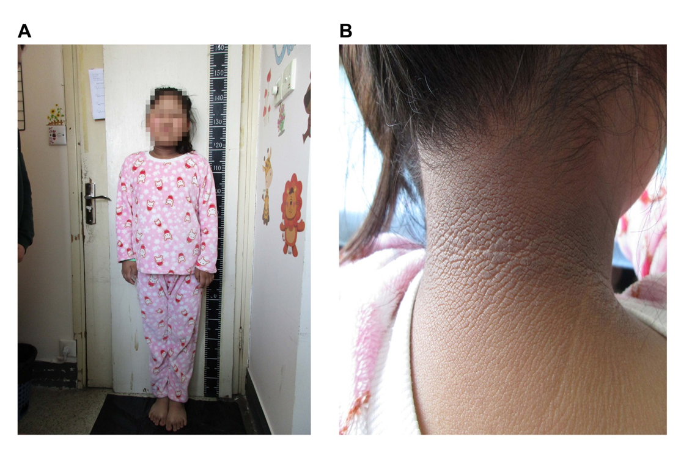
Figure 1 Clinical photographs of the proband reported in this case. A: A rounded face, wide shoulders, a barrel chest, a ‘stocky’ build, and truncal obesity; B: A remarkable acanthosis nigricans in the neck.
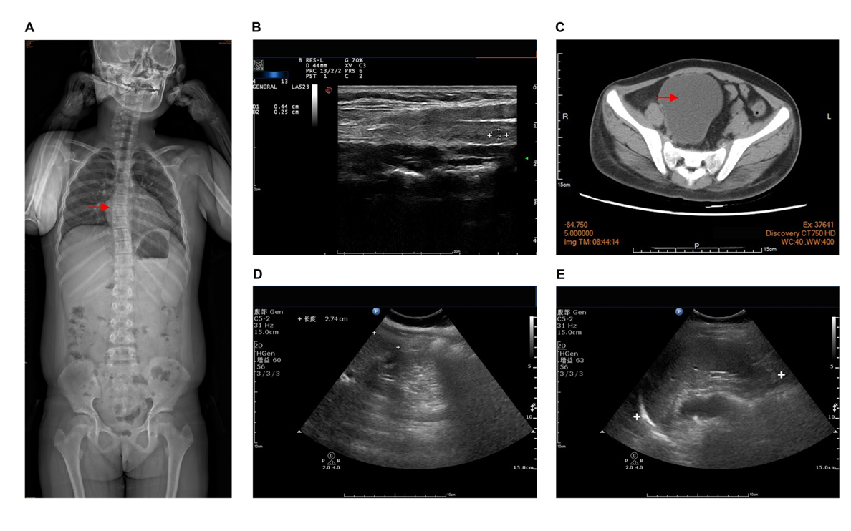
Figure 2 Pre-treatment imaging examinations of the proband. A: Scoliosis; B: Thyroid nodules (TI-RADS2); C: Right pelvic cyst (7.8 cm × 8.2 cm × 7.5 cm); D: Enlarged liver; E: Enlarged spleen.
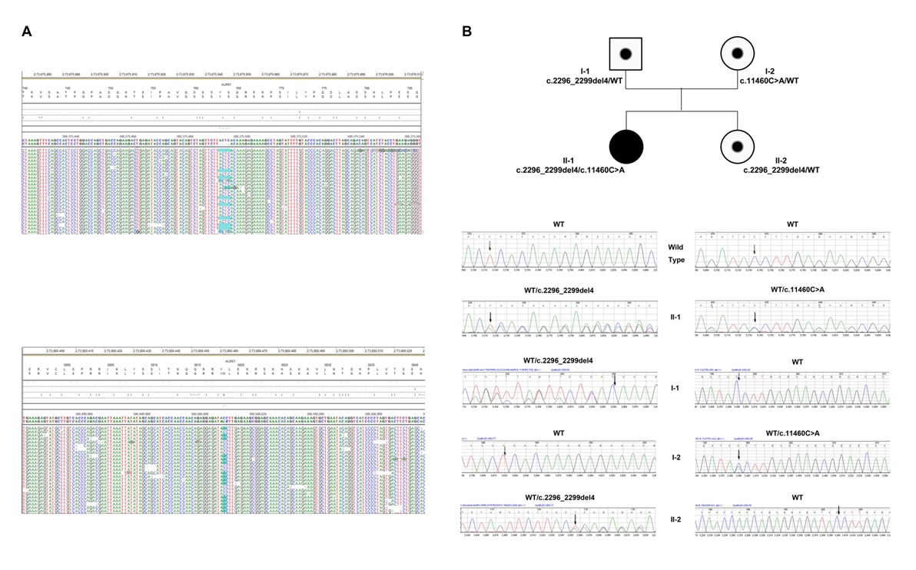
Figure 3 Pedigree and mutation analysis of the family. A: Alignment of exome sequences showing a frameshift mutation of 4-base pair deletion (upper panel) and a nonsense mutation (lower panel) in ALMS1; B: The proband (II-1) carried compound heterozygous mutations: c.2296_2299del4 inherited from her father (I-1) and c.11460C>A from her mother (I-2). The proband’s younger sister (II-2) also carried c.2296_2299del4 from her father. WT: Wild type.
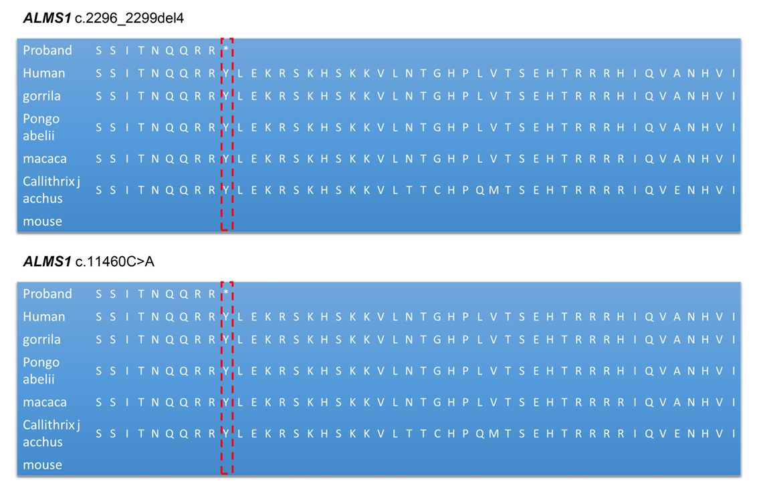
Figure 4 Predicted truncated ALMS1 caused by the frameshift mutation (upper panel) and nonsense mutation (lower panel) identified in this proband.
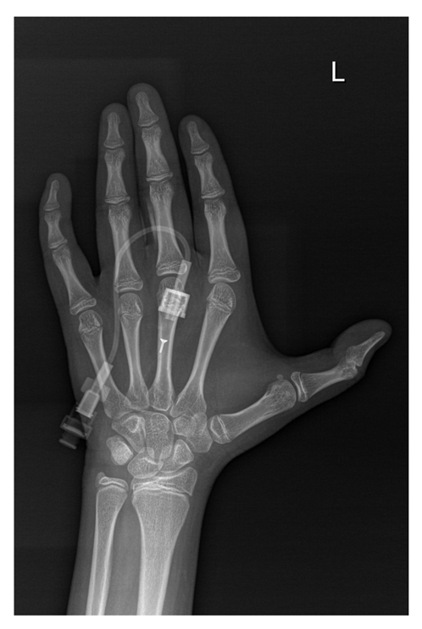
Figure 5 Bone age of the proband, at 2 years post-treatment.
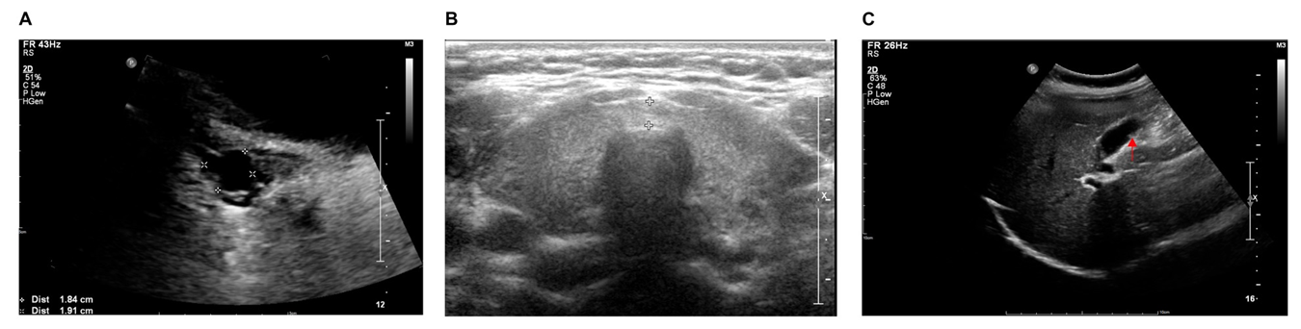
Figure 6 Follow-up imaging examinations of the proband, at 2 years post-treatment. A: Disappearance of the right ovarian cyst; B: Thyroid nodules (TI-RADS 2-3); C: Gallbladder polyps.
Table 1 Genetic and clinical characteristics of Alström syndrome patients with hyperthyroidism
 | Current case | Ozgül et al^{[45]} cases
Year of publication | 2020 | 2007
Race | Chinese | Turkish
Number of patients (sex) | 1 (female) | 3 (females)
Genetics
Inheritance pattern | Compound heterozygous | Homozygote
Location | Exons 8 and 16 | Exon 10
cDNA change | c.2296_2299del4, c.11460C>A | c.8164C>T
Protein change | p.S766Kfs*13, p.Y3820* | p.R2722X
Function prediction | Stop-gain mutation | Stop-gain mutation
Clinical manifestations
Retinal malnutrition (100%) | + | +
SNHL (89%) | + | +
Infant cardiomyopathy (40%) | +
Endocrine-related findings
Short stature (50%) |  | +
Hypothyroidism (11%-36%) |  | +
Hyperthyroidism | + (TRAb elevation) | + (TRAb reduction)
Metabolism-related findings
Childhood obesity | + | +
Insulin resistance (100%) | + | +
Type 2 diabetes (82%) | + | +
Dyslipidemia (High TG level and low HDL level) | + | +
Urinary system (14%)
Chronic kidney disease | +
Renal failure |  | +
Non-alcoholic steatohepatitis | +
Restrictive lung ventilation | + | +
Epilepsy, reflection delay (20%) |  | +
Spinal deformity (68%) | +
Androgen excess in women | + | +
AS: Alström syndrome; cDNA: complementary DNA; SNHL: Sensorineural hearing loss; TG: Triglyceride; HDL: High-density lipoprotein; TRAb: Thyrotropin receptor antibody.

Published by Baishideng Publishing Group Inc
7041 Koll Center Parkway, Suite 160, Pleasanton, CA 94566, USA
Telephone: +1-925-3991568
E-mail: bpgoffice@wjgnet.com
Help Desk: https://www.f6publishing.com/helpdesk
https://www.wjgnet.com

© 2021 Baishideng Publishing Group Inc. All rights reserved.

