Name of Journal: World Journal of Clinical Pediatrics
Manuscript NO: 66283
Manuscript Type: CASE REPORT

Pediatric case with vaccine-related poliovirus infection: A case report

Taherkhani R et al. Vaccine-related poliovirus infection

Reza Taherkhani, Fatemeh Farshadpour

Reza Taherkhani, Fatemeh Farshadpour, Department of Virology, School of Medicine, Bushehr University of Medical Sciences, Bushehr 7514633341, Iran

Author contributions: Farshadpour F and Taherkhani R designed and performed the study; Farshadpour F drafted and edited the manuscript; all authors approved the final draft of the manuscript.

Supported by Deputy Research and Affairs of Bushehr University of Medical Sciences, Bushehr, Iran, No. 4359.

Corresponding author: Fatemeh Farshadpour, PhD, Associate Professor, Department of Virology, School of Medicine, Bushehr University of Medical Sciences, Moallem Street, Bushehr 7514633341, Iran. f.farshadpour@bpums.ac.ir

Received: March 24, 2021
Revised: April 29, 2021
Accepted: July 2, 2021
Published online: September 9, 2021

Abstract
BACKGROUND
As long as oral poliovirus vaccine (OPV) is used, the potential risk for the emergence of vaccine-related polioviruses remains.

CASE SUMMARY
We report a case of Sabin-like type 1 poliovirus infection in an immunocompetent 17-mo-old child after receiving four scheduled doses of OPV. Somehow, the four doses did not confer full protection, possibly because of interference created by other enteroviruses.

CONCLUSION
The surveillance of vaccine-related polioviruses has important implications for improving health policies and vaccination strategies. Missed cases of vaccine-related poliovirus infection might pose a potential risk to global poliovirus eradication. Therefore, the global withdrawal of OPV and a shift to the inclusion of only inactivated poliovirus vaccine in the vaccination schedule is the main objective of the polio eradication program.

Key Words: Poliovirus; Oral poliovirus vaccine; Vaccine-associated paralytic poliomyelitis; Case report

©The Author(s) 2021. Published by Baishideng Publishing Group Inc. All rights reserved.

Citation: Taherkhani R, Farshadpour F. Pediatric case with vaccine-related poliovirus infection: A case report. World J Clin Pediatr 2021; 10(5): 106-111
URL: https://www.wjgnet.com/2219-2808/full/v10/i5/106.htm
DOI: https://dx.doi.org/10.5409/wjcp.v10.i5.106

Core Tip: In this study, we report an unusual case of Sabin-like type 1 poliovirus infection in an immunocompetent 17-mo-old child after receiving four scheduled doses of oral poliovirus vaccine (OPV). Somehow, the four doses did not confer full protection, which may have been caused by interference created by the other enteroviruses. The surveillance of vaccine-related polioviruses (VRPVs) has important implications for improving health policies and vaccination strategies. Missed cases of VRPV infection might pose a potential risk to global poliovirus eradication. Therefore, the global withdrawal of OPV and a shift to including only inactivated poliovirus vaccine in the vaccination schedule is the main objective of the polio eradication program.

INTRODUCTION
The extensive use of trivalent oral poliovirus vaccine (tOPV) in routine and supplementary immunization schedules has led to the control and eradication of wild poliomyelitis in almost all parts of the world^{[1]}. Despite inducing durable mucosal and humoral immunity, conferring immunity to unvaccinated individuals as well as low cost and easy oral administration, oral poliovirus vaccine (OPV) strains are genetically unstable^{[2]}. On rare occasions, OPV might revert toward virulent strains by recombination with other enteroviruses in the human gut or reversion mutations under tropical conditions and with poor sanitation, hygiene and water quality, or under conditions of low vaccination coverage and poor population immunity^{[1,3]}. Vaccine-related polioviruses (VRPVs) can cause vaccine-associated paralytic poliomyelitis (VAPP) in normal and immunodeficient vaccine recipients or their close contacts. However, the risk is much higher in immunodeficient individuals^{[4,5]}.
The emergence and spread of VRPVs are the biggest threats to the global poliovirus eradication program. A switch from live-attenuated OPV to inactivated poliovirus vaccine (IPV) seems to be the best option to eliminate the risk of VAPP emergence. However, in reality, OPV cessation is not feasible as long as global polio eradication is not achieved^{[5-7]}. In polio-endemic regions or neighboring countries at risk of wild poliovirus importation and spread, OPV remains the vaccine of choice to block wild polio infection and transmission caused by induction of prolonged intestinal immunity even beyond its recipients^{[5,8]}. Currently, we are on the horns of a dilemma. In these circumstances, timely detection and response to VRPVs need to be emphasized in countries using OPV to prevent paralysis development and community spread^{[6,9]}. Here, we report a pediatric case of Sabin-like type 1 poliovirus infection at 17 mo of age after receiving four doses of tOPV.

CASE PRESENTATION
Chief complaints
A 17-mo-old girl from Bushehr city was admitted to Shohadaie Khalij-Fars Hospital with symptoms of fever (38.5°C-40°C), drowsiness, irritability, cough, rhinorrhea, vomiting, and generalized weakness.

History of present illness
On history, the child was immunocompetent and had no known illness. The immunization history revealed that the child was vaccinated with four scheduled doses of tOPV, one dose at birth and three doses at 2, 4, and 6 mo of age. Approximately, 11 mo after receiving the fourth dose of tOPV at her local public health center, febrile enteritis along with anorexia and vomiting developed, and she was hospitalized a few days later.

History of past illness
The child had no history of prior illness.

Personal and family history
The child was immunocompetent and had no known illness.

Physical examination
A lumbar puncture (LP) was performed and antibiotic therapy with empiric antibiotics including vancomycin and ceftriaxone was initiated immediately. On the fourth day of hospitalization, her condition deteriorated, and the pediatrician referred her to the Pediatric Clinic of Namazi Hospital in Shiraz for further evaluation. On examination, reduced strength in all limbs, most notably in her lower extremities, and regression in her ability to sit and walk were noted. High-grade fever and conjunctivitis were the other clinical symptoms. An LP was repeated and cerebrospinal fluid (CSF) pleocytosis was reported.

Laboratory examinations
CSF analysis showed a clear appearance, lymphocytic pleocytosis, normal glucose, and a mild increase of protein levels. CSF bacterial culture was negative; viral culture and molecular assays were not performed. The diagnosis was aseptic meningitis.

Imaging examinations
There were no imaging examinations.

Further diagnostic workup
About 2 years after this event, a regional survey supported by Bushehr University of Medical Sciences (grant number 4359), was performed on leftover CSF samples of patients with a diagnosis of primary aseptic meningitis. The study was approved by the Ethical Committee of Bushehr University of Medical Sciences (reference number bpums.rec.1394.29). Sabin-like type 1 poliovirus was isolated from the CSF specimen of this patient by enterovirus reverse transcriptase-polymerase chain reaction assay (RT-PCR), targeting the 5’ untranslated region (5’ UTR) of the genome, followed by sequencing (Figure 1). The nucleotide sequence isolated from the CSF sample of this case was submitted to the GenBank sequence database (accession number: KX011400.10).
The nucleotide sequence of this case (KX011400.1) and the nucleotide sequences of wild-type poliovirus (human poliovirus 1 Mahoney), vaccine-derived poliovirus, and vaccine-strain poliovirus (Sabin type 1) were aligned by the ClustalW program in MEGA software version 4.0 (Biodesign Institute, Tempe, AZ, United States). A change of an A to a G was shown at position 480 of the 5’ UTR of the isolated sequence (Figure 2). The CSF sample was negative for nonpolio enteroviruses, mumps, herpes simplex virus types 1 and 2, cytomegalovirus, and varicella-zoster virus.

FINAL DIAGNOSIS
We present a case of Sabin-like type 1 poliovirus infection that was initially consistent with the diagnosis of aseptic meningitis. On further evaluation, a diagnosis of Kawasaki disease was presumed. However, that diagnosis is unlikely, given that the high-grade fever persisted despite intravenous immune globulin (IVIG) therapy. This was a probable case of VRPV infection, and is supported by isolation of Sabin-like type 1 poliovirus from CSF specimen. The nucleotide sequence isolated from the CSF sample of this case had G at nucleotide position 480 of the 5’ UTR, which differentiates it from the wild-type poliovirus with A-480^{[10,11]}. The probability of nonpolio enteroviral infections was ruled out by the negative RT-PCR enterovirus assay results on the CSF specimen.

TREATMENT
As Kawasaki disease was suspected, a single high-dose (2 g/kg) intravenous administration of immunoglobulin (IVIG) was given. However, the high-grade fever was not responsive to IVIG and persisted for approximately 8 d. Subsequently, the clinical symptoms were gradually improved. It is unclear whether immunoglobulin therapy facilitated the improvement of the clinical symptoms, or they improved spontaneously.

OUTCOME AND FOLLOW-UP
Following clinical improvement, the child was discharged from the hospital, but she had a mild fever, muscular weakness, and difficulty using her lower limbs for approximately 2 mo. At a 1-year follow-up, cardiac complications were not reported, and the strength of all her limbs was completely restored.

DISCUSSION
This is an unusual case of VRPV, as the child was immunocompetent and had received four doses of tOPV. Somehow, the four doses had not conferred full protection, possibly because of interference created by other enteroviruses. Of note, the child lives in a tropical area, where diarrheal diseases frequently occur. Neurovirulent reversion of OPV in the child’s gut is a possibility. However, the long interval between administration of the fourth dose of tOPV and onset of clinical symptoms, as well as the child’s immunocompetency make that unlikely. Other possibilities include the presence of a prolonged poliovirus excreter or the existence of circulating VRPVs in the environment. However, that is unlikely possibility given that no secondary cases were reported southern Iran before or after this event. She was a close contact of other OPV-vaccinated children in a crowded nursery, and therefore exposure of this patient to VRPVs originating from the other children is another possibility. Overall, the evidence is insufficient to trace the source of this strain. This case was detected through a regional survey to reveal the molecular epidemiology of viral causes of aseptic meningitis. This case was missed by routine surveillance of acute flaccid paralysis because the patient was not paralyzed at the time of admission and was evaluated following a misdiagnosis.
The VRPV surveillance has important implications for improving health policies and vaccination strategies. However, most cases of VRPV infection are captured through the acute flaccid paralysis surveillance system. Recognition of VRPVs remains an important challenge. Missed cases of VRPV infection pose a potential risk to global poliovirus eradication. As long as OPV is used, the potential risk of emergence of VRPVs remains^{[6]}. VRPVs are clinically indistinguishable from wild polioviruses and are capable of causing paralytic poliomyelitis and circulating in society whenever the immunity coverage is reduced^{[2,6]}. The emergence of VAPP is a health dilemma as devastating as wild polio. Therefore, the global withdrawal of OPV and shift toward the all-IPV schedule is the main objective of the polio eradication program^{[3]}.

CONCLUSION
In this study, we report an unusual case of Sabin-like type 1 poliovirus infection in an immunocompetent 17-mo-old child after receiving four scheduled doses of OPV. Somehow, the four doses did not confer full protection, possibly because of interference created by other enteroviruses. The surveillance and notification of VRPVs has important implications for improving health policies and vaccination strategies.

REFERENCES
1 Cassemiro KM, Burlandy FM, Barbosa MR, Chen Q, Jorba J, Hachich EM, Sato MI, Burns CC, da Silva EE. Molecular and Phenotypic Characterization of a Highly Evolved Type 2 Vaccine-Derived Poliovirus Isolated from Seawater in Brazil, 2014. PLoS One 2016; 11: e0152251 [PMID: 27019095 DOI: 10.1371/journal.pone.0152251]
2 Burns CC, Diop OM, Sutter RW, Kew OM. Vaccine-derived polioviruses. J Infect Dis 2014; 210 Suppl 1: S283-S293 [PMID: 25316847 DOI: 10.1093/infdis/jiu295]
3 Pons-Salort M, Burns CC, Lyons H, Blake IM, Jafari H, Oberste MS, Kew OM, Grassly NC. Preventing Vaccine-Derived Poliovirus Emergence during the Polio Endgame. PLoS Pathog 2016; 12: e1005728 [PMID: 27384947 DOI: 10.1371/journal.ppat.1005728]
4 Shahmahmoodi S, Mamishi S, Aghamohammadi A, Aghazadeh N, Tabatabaie H, Gooya MM, Zahraei SM, Mousavi T, Yousefi M, Farrokhi K, Mohammadpour M, Ashrafi MR, Nategh R, Parvaneh N. Vaccine-associated paralytic poliomyelitis in immunodeficient children, Iran, 1995-2008. Emerg Infect Dis 2010; 16: 1133-1136 [PMID: 20587188 DOI: 10.3201/eid1607.091606]
5 Foiadelli T, Savasta S, Battistone A, Kota M, Passera C, Fiore S, Bino S, Amato C, Lozza A, Marseglia GL, Fiore L. Nucleotide variation in Sabin type 3 poliovirus from an Albanian infant with agammaglobulinemia and vaccine associated poliomyelitis. BMC Infect Dis 2016; 16: 277 [PMID: 27287521 DOI: 10.1186/s12879-016-1587-y]
6 Li L, Ivanova O, Driss N, Tiongco-Recto M, da Silva R, Shahmahmoodi S, Sazzad HM, Mach O, Kahn AL, Sutter RW. Poliovirus excretion among persons with primary immune deficiency disorders: summary of a seven-country study series. J Infect Dis 2014; 210 Suppl 1: S368-S372 [PMID: 25316857 DOI: 10.1093/infdis/jiu065]
7 Aylward B, Yamada T. The polio endgame. N Engl J Med 2011; 364: 2273-2275 [PMID: 21675884 DOI: 10.1056/NEJMp1104329]
8 Orenstein WA; Committee on Infectious Diseases. Eradicating polio: how the world's pediatricians can help stop this crippling illness forever. Pediatrics 2015; 135: 196-202 [PMID: 25548328 DOI: 10.1542/peds.2014-3163]
9 Farshadpour F, Taherkhani R. Molecular epidemiology of enteroviruses and predominance of echovirus 30 in an Iranian population with aseptic meningitis. J Neurovirol 2021 [PMID: 33788142 DOI: 10.1007/s13365-021-00973-1]
10 McGoldrick A, Macadam AJ, Dunn G, Rowe A, Burlison J, Minor PD, Meredith J, Evans DJ, Almond JW. Role of mutations G-480 and C-6203 in the attenuation phenotype of Sabin type 1 poliovirus. J Virol 1995; 69: 7601-7605 [PMID: 7494267 DOI: 10.1128/JVI.69.12.7601-7605.1995]
11 Georgescu MM, Balanant J, Macadam A, Otelea D, Combiescu M, Combiescu AA, Crainic R, Delpeyroux F. Evolution of the Sabin type 1 poliovirus in humans: characterization of strains isolated from patients with vaccine-associated paralytic poliomyelitis. J Virol 1997; 71: 7758-7768 [PMID: 9311861 DOI: 10.1128/JVI.71.10.7758-7768.1997]

Footnotes
Informed consent statement: Written informed consent was obtained from the patient’s legal guardian for publication of this case report.

Conflict-of-interest statement: The authors of this paper declare that they have no competing interests.

CARE Checklist (2016) statement: The authors have read the CARE Checklist (2016), and the manuscript was prepared and revised according to the CARE Checklist (2016).

Open-Access: This article is an open-access article that was selected by an in-house editor and fully peer-reviewed by external reviewers. It is distributed in accordance with the Creative Commons Attribution NonCommercial (CC BY-NC 4.0) license, which permits others to distribute, remix, adapt, build upon this work non-commercially, and license their derivative works on different terms, provided the original work is properly cited and the use is non-commercial. See: http://creativecommons.org/Licenses/by-nc/4.0/

Manuscript source: Invited manuscript

Peer-review started: March 24, 2021
First decision: April 29, 2021
Article in press: July 2, 2021

Specialty type: Virology
Country/Territory of origin: Iran
Peer-review report’s scientific quality classification
Grade A (Excellent): 0
Grade B (Very good): B
Grade C (Good): 0
Grade D (Fair): 0
Grade E (Poor): 0

P-Reviewer: Laassri M S-Editor: Wu YXJ L-Editor: Filipodia P-Editor: Yuan YY

Figure Legends
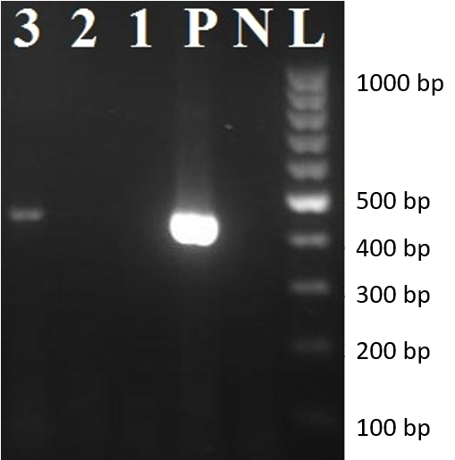
Figure 1 Reverse transcriptase-polymerase chain reaction assay amplification of Sabin-like type 1 poliovirus RNA isolated from cerebrospinal fluid samples of this case. 3: Amplified product (approximately 438 bp) on 2% agarose gel electrophoresis; L: 100 bp DNA ladder; N: Negative control; P: Positive control.

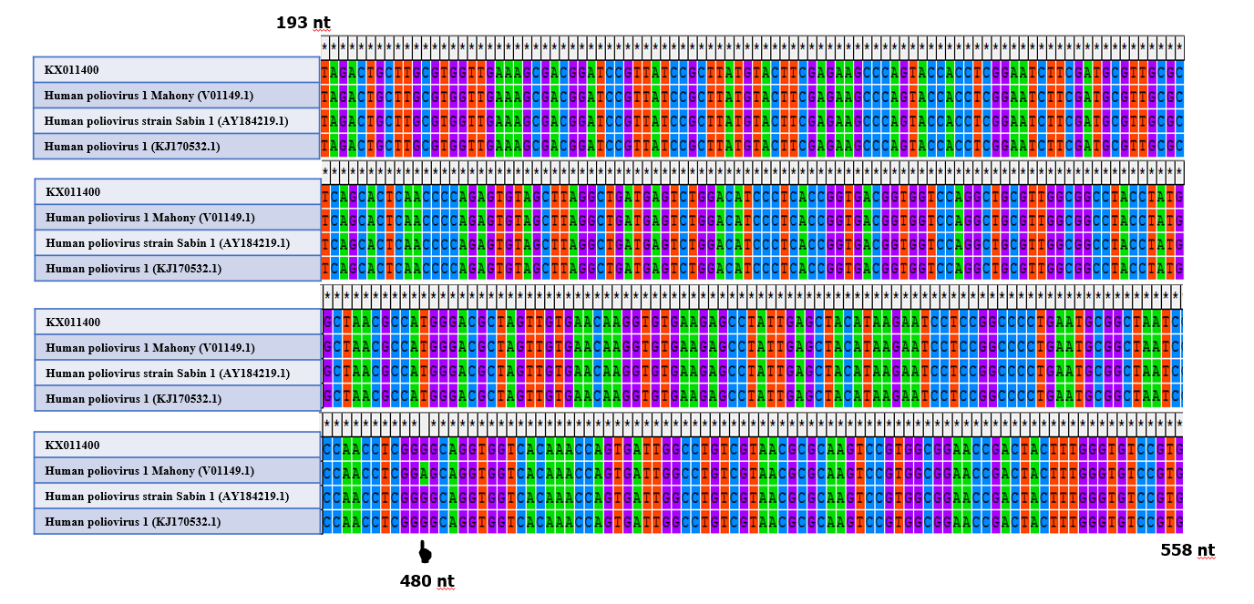
Figure 2 Alignment of the partial nucleotide sequences (193 nt to 558 nt) of this case (KX011400). Wild-type poliovirus (V01149.1), vaccine-strain poliovirus (AY184219.1), and vaccine-derived poliovirus (KJ170532.1) by MEGA software version 4.0 (Biodesign Institute, Tempe, AZ, United States) and appearance of a nucleotide difference at position 480 of the 5’ untranslated region. A denotes wild-type poliovirus and G denotes vaccine-strain poliovirus.

Published by Baishideng Publishing Group Inc
7041 Koll Center Parkway, Suite 160, Pleasanton, CA 94566, USA
Telephone: +1-925-3991568
E-mail: bpgoffice@wjgnet.com
Help Desk: https://www.f6publishing.com/helpdesk
https://www.wjgnet.com

© 2021 Baishideng Publishing Group Inc. All rights reserved.

