Name of Journal: World Journal of Clinical Cases
Manuscript NO: 80091
Manuscript Type: CASE REPORT

Synchronous early gastric and intestinal mucosa-associated lymphoid tissue lymphoma in a Helicobacter pylori-negative patient: A case report

Lu SN et al. Synchronous early gastrointestinal MALT lymphomas

Sheng-Nian Lu, Cheng Huang, Ling-Li Li, Lian-Jun Di, Jin Yao, Bi-Guang Tuo, Rui Xie

Sheng-Nian Lu, Cheng Huang, Ling-Li Li, Lian-Jun Di, Bi-Guang Tuo, Rui Xie, Department of Gastroenterology, Digestive Disease Hospital, Affiliated Hospital of Zunyi Medical University, Zunyi 563003, Guizhou Province, China

Jin Yao, Pathology Department, Affiliated Hospital of Zunyi Medical University, Zunyi 563003, Guizhou Province, China

Author contributions: Lu SN wrote the manuscript; Huang C, Di LJ and Li LL diagnosed the patient and contributed to the endoscopic; Yao J contributed to pathological diagnosis and provided the pathological images; Tuo BG and Xie R performed the treatment and revised the manuscript; and all authors have read and approve the final manuscript.

Supported by Master' s Start-up Fund of the Affiliated Hospital of Zunyi Medical College, No. [2015]34; Basic Research Projects of Science and Technology Department of Guizhou Province, No. Qian Ke He-zk[2022]-646; and Collaborative Innovation Center of Chinese Ministry of Education, No. 2020-39.

Corresponding author: Rui Xie, PhD, Full Professor, Department of Gastroenterology, Digestive Disease Hospital, Affiliated Hospital of Zunyi Medical University, No. 149 Dalian Road, Zunyi 563003, Guizhou Province, China. xr19841029@aliyun.com

Received: September 16, 2022
Revised: October 3, 2022
Accepted: October 31, 2022
Published online: November 26, 2022

Abstract
BACKGROUND
Mucosa-associated lymphoid tissue (MALT) lymphoma occurs largely in the digestive tract, with the stomach being the most commonly affected organ, followed by the small intestine, large intestine, and esophagus. It is rarely found in both the stomach and colon. Helicobacter pylori (H. pylori) infection is strongly associated with gastric MALT lymphoma, although there is a small number of H. pylori-negative gastric MALT lymphomas. Diagnosis of MALT lymphoma is challenging because of nonspecific symptoms and diverse presentations of endoscopic findings.

CASE SUMMARY
We report a case of an asymptomatic patient who during screening endoscopy and was found to have stromal tumor-like submucosal uplift lesions in the stomach body and polypoid lesions in the rectum. After endoscopic resection, the patient was diagnosed with multiple early simultaneous gastrointestinal MALT lymphomas.

CONCLUSION
This study may help improve our understanding of MALT lymphomas and multifocal lesions treated using early endoscopy.

Key Words: Mucosa-associated lymphoid tissue lymphoma; Endoscopy; Synchronous; Helicobacter pylori; Negative; Case report

©The Author(s) 2022. Published by Baishideng Publishing Group Inc. All rights reserved.

Citation: Lu SN, Huang C, Li LL, Di LJ, Yao J, Tuo BG, Xie R. Synchronous early gastric and intestinal mucosa-associated lymphoid tissue lymphoma in a Helicobacter pylori-negative patient: A case report. World J Clin Cases 2022; 10(33): 12447-12454
URL: https://www.wjgnet.com/2307-8960/full/v10/i33/12447.htm
DOI: https://dx.doi.org/10.12998/wjcc.v10.i33.12447

Core Tip: Mucosa-associated lymphoid tissue (MALT) lymphoma is a subtype of non-Hodgkin’s lymphoma that is rarely found in both the stomach and colon. Diagnosis of MALT lymphoma is challenging because of nonspecific symptoms and diverse presentations of endoscopic findings. Helicobacter pylori (H. pylori) infection is the initial event in gastric MALT lymphoma. We report a case of H. pylori-negative gastric MALT lymphoma mimicking a gastric stromal tumor, together with a rectal presentation of intestinal MALT with a polyp-like appearance, which were treated endoscopically with complete remission.
INTRODUCTION
Mucosa-associated lymphoid tissue (MALT) lymphoma is a subtype of non-Hodgkin’s lymphoma classified by the World Health Organization as an extranodal marginal zone B-cell lymphoma, which accounts for approximately 5% of non-Hodgkin’s lymphomas and has a good long-term prognosis with a 10-year survival rate > 90%. MALT lymphoma can occur at many sites, including the salivary glands, thyroid, orbits, lungs, breast, kidneys, skin, liver, and prostate, and most often involves the gastrointestinal tract. The lack of specificity in the endoscopic presentation of MALT lymphoma of the gastrointestinal tract, especially in its early stages, presents a significant risk of underdiagnosis and misdiagnosis, posing a clinical diagnostic challenge.
Helicobacter pylori (H. pylori) infection is the initial event in gastric MALT lymphoma. There are a variety of clinical approaches for diagnosing H. pylori infection, usually combining noninvasive and invasive methods as well as the need to exclude false-negative results caused by antacids^{[1]}. Most gastric MALT lymphomas are H. pylori positive and sensitive to eradication therapy. However, recent studies have found that the pathogenesis of H. pylori-negative gastric MALT lymphoma is increasing annually and may be related to genetics, autoimmunity, or other microorganisms. The clinical features and endoscopic presentation lack specificity, and the occurrence of simultaneous MALT lymphoma in the stomach and intestine in an H. pylori-negative background has rarely been reported^{[2]}.
Here, we report a case of H. pylori-negative gastric MALT lymphoma mimicking a gastric stromal tumor, together with a rectal presentation of intestinal MALT with a polyp-like appearance, which were treated endoscopically with complete remission.

CASE PRESENTATION
Chief complaints
A 46-year-old woman presented with a gastric submucosal uplift by screening endoscopy. She was admitted to our hospital for a further diagnose without any symptoms.

History of present illness
One week ago, the patient presented to the hospital for a screening endoscopy and gastroscopy revealed a submucosal bulge in the upper anterior wall of the gastric body. The possibility of a stromal tumor was considered, and rectal polyps were found by colonoscopy; therefore, the patient was admitted for further endoscopic treatment. The patient was lack of bowel habits change and other alarm symptoms.

History of past illness
The patient had no history of H. pylori infection or chronic infection.

Personal and family history
The patient denied any family history of malignant tumor.

Physical examination
There were no obvious abnormalities during physical examination.

Laboratory examinations
Carbon-14 breath test results were negative, and antibodies against H. pylori types I and II were negative, indicating that the patient had no history of H. pylori infection. Routine blood examination showed normal white blood cells, lymphocytes, hemoglobin and platelets, normal liver and renal functions and electrolytes, and a negative fecal occult blood test.

Imaging examinations
Esophagogastroduodenoscopy revealed an isolated submucosal protrusion in the upper anterior wall of the gastric body, about 4 mm × 5 mm in size, and the surface was slightly faded. The blood vessels were slightly dilated, elongated, and thickened (Figure 1A). Narrow-band imaging (NBI) revealed elongated and dilated marginal crypt epithelium and widened intervening space, similar to the pyloric gland structure, elongated and thickened blood vessels, and slightly thickened radial vessels around the area (Figure 1B). The possibility of gastric fundus gland cancer could not be ruled out using endoscopy. To further characterize this suspicious lesion, endoscopic ultrasonography was performed, which showed thickening of the musculature of the mucosa and homogeneous hypoechoic changes in the lesion of the gastric body (Figure 1C), and leiomyoma was suspected. At this point, the nature of the lesion examined by endoscopy and endoscopic ultrasonography remained controversial. Therefore, diagnostic endoscopic submucosal dissection was performed after communicating with the patient, but no intact tumor was found during the dissection. Therefore, the lesion was removed via endoscopic mucosal resection and sent for pathological examination. Results of hematoxylin and eosin staining showed massive lymphocytic infiltration (Figure 2A). Immunohistochemistry was positive for CD20 (Figure 2B) and MUM1. CD21 (Figure 2C) showed expansion and destruction of follicular dendritic cells. Immunohistochemistry was negative for (Figure 2D-F) CD3, CD10, Bcl-6, CK, cyclin-D and P53. The Ki-67 proliferation index was < 10%. Gene detection revealed clonal rearrangement of the IgH gene in B cells (Figure 3), and Giemsa staining confirmed the absence of H. pylori infection. Therefore, H. pylori-negative gastric MALT lymphoma was diagnosed. Rectal polypoid lesions were observed by colonoscopy (Figure 4A), and electrosurgical treatment was performed. Lymphocyte sheet infiltration was observed on hematoxylin and eosin staining (Figure 4B). Immunohistochemistry was positive for CD20 (Figure 4C). CD21 (Figure 4D) showed expansion and destruction of follicular dendritic cells. It was negative for Bcl-2 (Figure 4E), Bcl-6 and MUM1. Therefore, rectal MALT lymphoma was considered. Systemic positron emission tomography/computed tomography showed no abnormal uptake in the stomach and other areas of the body.

FINAL DIAGNOSIS
The patient was diagnosed with synchronous gastrointestinal MALT lymphoma (stage I).

TREATMENT
The patient was referred to the Department of Hematology because of multiple simultaneous MALT lymphomas in the gastrointestinal tract. After a multidisciplinary discussion, the clinical manifestations of MALT lymphoma were considered to be indolent and H. pylori negative, and complete endoscopic resection was performed. Close follow-up monitoring was then performed.

OUTCOME AND FOLLOW-UP
Five months later, gastroenteroscopy showed no residual or recurrent MALT lymphoma. Currently, the patient is undergoing regular follow-up.

DISCUSSION
MALT lymphoma can occur anywhere in the gastrointestinal tract, but most cases occur in the stomach. Colorectal MALT lymphomas are rare, accounting for < 1% of malignant tumors of the large intestine. The clinical presentation of gastrointestinal lymphoma varies and lacks specificity. Common symptoms include abdominal pain, bloating, nausea, vomiting, loss of appetite, and diarrhea. A few patients present with acute abdomen, such as gastrointestinal perforation, intestinal obstruction, or gastrointestinal bleeding, but approximately one third of patients have no alarming symptoms; therefore, the diagnosis is often incidental, especially in the early stages. Histologically, the disease is characterized by a heterogeneous small B-cell infiltrate that usually shows lymphoepithelial lesions or follicular colonization and a typical immunophenotype of CD20(+), CD5(-), CD10(-) and cyclin D1(-), in marginal zone B cells. Restriction molecular techniques have revealed immunoglobulin light chain restriction or clonal IgH rearrangement.
In this case, the patient was diagnosed with H. pylori-negative, early MALT lymphoma with gastrointestinal co-occurrence. We conducted a literature review based on the characteristics of this case. Recent studies have confirmed that the occurrence and development of most gastric MALT lymphomas are associated with H. pylori infection^{[3]}, and the main pathogenic mechanism may be that H. pylori leads to chronic inflammation and proliferation of T and B cells in the gastric mucosa. Long-term inflammation causes gastric mucosa without lymphoid tissue to produce MALT, which can lead to genetic abnormalities and malignant transformation, namely MALT lymphoma. However, recent studies have found that H. pylori-negative gastric MALT lymphoma is on the rise, and it is believed to be closely related to genes, autoimmunity, or other bacterial and viral infections. In a recent study of genetic alterations and somatic mutations in 57 patients with H. pylori-negative gastric MALT lymphoma, Kiesewetter et al^{[4]} reported t(11;18)(q21;q21)/BiRC3-MALT1 mutations in 22 patients and nuclear factor-kappa B signaling molecule mutations in 14 patients. Autoimmune diseases such as Sjogren’s syndrome, IgG4-related diseases, and obesity also increase the risk of primary MALT lymphoma^{[5]}. Another possibility is infection with bacteria other than H. pylori, which could explain why the eradication of H. pylori can treat some H. pylori-negative MALT lymphomas^{[6]}.
Currently, there is no unified conclusion regarding the etiology of simultaneous gastrointestinal or multisite lymphomas. Clinical reports of simultaneous gastrointestinal MALT lymphoma are rare. We reviewed nine cases of simultaneous gastrointestinal MALT lymphoma reported in the literature (Table 1), and the analysis of the clinical characteristics of these cases showed that the incidence in males was higher than in females, which was consistent with the overall sex characteristics of MALT lymphoma. The median age of onset was 70 years (57-85 years), which is higher than that of single-site lymphoma (50-60 years)^{[15]}. H. pylori infection was present in seven of the nine cases, but six failed to eradicate H. pylori infection, which was lower than the previously reported effective eradication rate of 70%-80%^{[16]}. Most patients (5/9) presented with large tumor-like lesions associated with ulceration with lymphoma other than in the stomach and colon, and 3/9 patients had underlying diseases, including diabetes mellitus, celiac disease, and early gastric cancer. Analysis of the above clinical characteristics suggests that the therapeutic effect of H. pylori eradication in patients with homologous gastrointestinal lymphoma may be less than that in patients with a single site tumor, and most cases may be accompanied by lymphoma at other sites. Only one of the nine cases reported a relationship with t(11;18)(q21;q21) API2 MALT1 chimeric gene associated with translocation^{[12]}. Therefore, it may not be representative and should be explored further. In the present case, the patient had no H. pylori infection, other bacterial infection, or underlying disease, and the examination was good. No lymphoma was found in other parts of the stomach or large intestine, suggesting an early stage of the tumor. Endoscopic biopsy is the gold standard method for the diagnosis of lymphoma. The endoscopic manifestations of lymphoma are diverse, ranging from normal gastric mucosa to ulceration or masses. Studies have shown that superficial lesions are more common^{[15,17]}, similar to erosion, multifocal gastritis, and other malignant tumors, and are often indistinguishable from gastric cancer or gastritis. Nakamura et al^{[18]} found that H. pylori-negative cases were more often located proximal to the stomach, invading the submucosa but rarely presenting with the common superficial type, and H. pylori-negative gastric MALT lymphomas were often clinically advanced. The endoscopic appearance of NBI magnifying glasses is characterized by a tree-like appearance^{[19]}. This is helpful for the endoscopist’s judgment in guiding the biopsy. In our case, the gastric lesion appeared in the upper third of the gastric body, was confined to the submucosa, and appeared as a small submucosal bulge. No typical dendritic vascular manifestations were observed under NBI, which was different from the endoscopic features of gastric MALT lymphoma reported in the past, and may provide a reference to endoscopists when similar cases are encountered in future. Colorectal MALT lymphoma is rare, and there is no consensus regarding colonic MALT lymphoma. A flat, raised, polypoid, or semi-pedicled appearance can be observed during endoscopy. In the rectum, polypoid lesions are more common, the tumors vary in size, with a median diameter of 20 mm^{[20]}. In our case, since the diameter of the lesion was only 5 mm, it was difficult to recognize that it was lymphoma before pathology.
This case was found incidentally in an H. pylori-negative setting, confined to the site that had been endoscopically resected, with no other organ metastases; therefore, we did not opt for further treatment, and no recurrence or progression of the lesion was detected during follow-up. There is no consensus or recommendation for H. pylori-negative gastric MALT lymphoma or intestinal MALT lymphoma. However, because of the low malignancy and slow progression of MALT lymphoma, endoscopic resection as a local treatment method has achieved ideal results.

CONCLUSION
In this case report, we have described the endoscopic presentation of early gastrointestinal MALT lymphoma in the asymptomatic stage, where endoscopic presentation is rare and easily misdiagnosed. The patient in this case was treated using endoscopic resection.

REFERENCES
1 Bordin DS, Voynovan IN, Andreev DN, Maev IV. Current Helicobacter pylori Diagnostics. Diagnostics (Basel) 2021; 11 [PMID: 34441392 DOI: 10.3390/diagnostics11081458]
2 Nakagawara M, Kajimura M, Hanai H, Shimizu S, Kobayashi H, Kaneko E. Simultaneous mucosa-associated lymphoid tissue lymphoma of the stomach and colon. Gastrointest Endosc 1999; 50: 414-415 [PMID: 10462668 DOI: 10.1053/ge.1999.v50.97947]
3 Wotherspoon AC, Doglioni C, Diss TC, Pan L, Moschini A, de Boni M, Isaacson PG. Regression of primary low-grade B-cell gastric lymphoma of mucosa-associated lymphoid tissue type after eradication of Helicobacter pylori. Lancet 1993; 342: 575-577 [PMID: 8102719 DOI: 10.1016/0140-6736(93)91409-f]
4 Kiesewetter B, Copie-Bergman C, Levy M, Wu F, Dupuis J, Barau C, Arcaini L, Paulli M, Lucioni M, Bonometti A, Salar A, Fernández-Rodriguez C, Piris MA, Cucco F, Dobson R, Li Y, Chen Z, Robe C, Simonitsch-Klupp I, Wotherspoon A, Raderer M, Du MQ. Genetic Characterization and Clinical Features of Helicobacter pylori Negative Gastric Mucosa-Associated Lymphoid Tissue Lymphoma. Cancers (Basel) 2021; 13 [PMID: 34203889 DOI: 10.3390/cancers13122993]
5 Mai B, Friscia M, Elzamly S, Thomas-Ogunniyi J, Wahed A, Nguyen A, Hu Z, Cai Z, Chen L. Obesity Is a Risk Factor Associated with H. pylori-negative MALT Lymphoma of Stomach. Ann Clin Lab Sci 2021; 51: 609-614 [PMID: 34686502]
6 Kuo SH, Yeh KH, Lin CW, Liou JM, Wu MS, Chen LT, Cheng AL. Current Status of the Spectrum and Therapeutics of Helicobacter pylori-Negative Mucosa-Associated Lymphoid Tissue Lymphoma. Cancers (Basel) 2022; 14 [PMID: 35205754 DOI: 10.3390/cancers14041005]
7 Isomoto H, Yamasaki J, Kusakari C, Ohba K, Nishida Y, Kohno S. Simultaneous MALT lymphoma of stomach, duodenum, and colon. Gastrointest Endosc 2003; 58: 251-252 [PMID: 12872097 DOI: 10.1067/mge.2003.334]
8 Arakura N, Hasebe O, Umino J, Imai Y, Nagata A, Hosaka N, Akamatsu T. Simultaneous mucosa-associated lymphoid tissue lymphoma of the stomach, jejunum, and colon. Nihon Shokakibyo Gakkai Zasshi 2005; 102: 1286-1292 [PMID: 16262160]
9 Fares MD, Abbas OM, Jamaleddine GW. Extranodal marginal zone lymphoma of MALT involving the lungs, the stomach, and the colon. Lung Cancer 2006; 54: 427-429 [PMID: 16959369 DOI: 10.1016/j.lungcan.2006.07.008]
10 Tursi A, Inchingolo CD. Synchronous gastric and colonic MALT-lymphoma in coeliac disease: a long-term follow-up on gluten-free diet. Dig Liver Dis 2007; 39: 1035-1038 [PMID: 16971196 DOI: 10.1016/j.dld.2006.07.016]
11 Venizelos J, Tamiolakis D, Nikolaidou S, Lambropoulou M, Alexiadis G, Papadopoulos N. Concurrent low grade B-cell non-Hodgkin's lymphoma of MALT type arising in the large intestine, small intestine and stomach. Chirurgia (Bucur) 2007; 102: 99-101 [PMID: 17410739]
12 Sahara K, Tabata T, Arakawa T, Fujiwara T, Egashira H, Fujiwara J, Momma K, Hishima T, Koizumi K, Kamisawa T. A case of MALT lymphoma of the colon, stomach, and small intestine. Nihon Shokakibyo Gakkai Zasshi 2015; 112: 270-277 [PMID: 25748153 DOI: 10.11405/nisshoshi.112.270]
13 McFarlane M, Wong JL, Paneesha S, Rudzki Z, Arasaradnam R, Nwokolo C. Synchronous Upper and Lower Gastrointestinal Mucosa-Associated Lymphoid Tissue Lymphomas. Case Rep Gastroenterol 2016; 10: 241-247 [PMID: 27462192 DOI: 10.1159/000446576]
14 Singh K, Gandhi S, Doratotaj B. Synchronous MALT lymphoma of the colon and stomach and regression after eradication of Strongyloides stercoralis and Helicobacter pylori. BMJ Case Rep 2018; 2018 [PMID: 29970607 DOI: 10.1136/bcr-2018-224795]
15 Gong EJ, Ahn JY, Jung HY, Park H, Ko YB, Na HK, Jung KW, Kim do H, Lee JH, Choi KD, Song HJ, Lee GH, Kim JH. Helicobacter pylori Eradication Therapy Is Effective as the Initial Treatment for Patients with H. pylori-Negative and Disseminated Gastric Mucosa-Associated Lymphoid Tissue Lymphoma. Gut Liver 2016; 10: 706-713 [PMID: 27114423 DOI: 10.5009/gnl15510]
16 Takigawa H, Yuge R, Masaki S, Otani R, Kadota H, Naito T, Hayashi R, Urabe Y, Oka S, Tanaka S, Chayama K, Kitadai Y. Involvement of non-Helicobacter pylori helicobacter infections in Helicobacter pylori-negative gastric MALT lymphoma pathogenesis and efficacy of eradication therapy. Gastric Cancer 2021; 24: 937-945 [PMID: 33638751 DOI: 10.1007/s10120-021-01172-x]
17 Ishikawa E, Nakamura M, Satou A, Shimada K, Nakamura S. Mucosa-Associated Lymphoid Tissue (MALT) Lymphoma in the Gastrointestinal Tract in the Modern Era. Cancers (Basel) 2022; 14 [PMID: 35053607 DOI: 10.3390/cancers14020446]
18 Nakamura S, Matsumoto T, Ye H, Nakamura S, Suekane H, Matsumoto H, Yao T, Tsuneyoshi M, Du MQ, Iida M. Helicobacter pylori-negative gastric mucosa-associated lymphoid tissue lymphoma: a clinicopathologic and molecular study with reference to antibiotic treatment. Cancer 2006; 107: 2770-2778 [PMID: 17099876 DOI: 10.1002/cncr.22326]
19 Nonaka K, Ishikawa K, Shimizu M, Sakurai T, Nakai Y, Nakao M, Yoshino K, Arai S, Kita H. Education and Imaging. Gastrointestinal: gastric mucosa-associated lymphoma presented with unique vascular features on magnified endoscopy combined with narrow-band imaging. J Gastroenterol Hepatol 2009; 24: 1697 [PMID: 19788610 DOI: 10.1111/j.1440-1746.2009.06030.x]
20 Won JH, Kim SM, Kim JW, Park JH, Kim JY. Clinical features, treatment and outcomes of colorectal mucosa-associated lymphoid tissue (MALT) lymphoma: literature reviews published in English between 1993 and 2017. Cancer Manag Res 2019; 11: 8577-8587 [PMID: 31572011 DOI: 10.2147/CMAR.S214197]

Footnotes
Informed consent statement: Informed written consent was obtained from the patient for publication of this report and any accompanying images.

Conflict-of-interest statement: The authors declare that they have no conflict of interest to disclose.

CARE Checklist (2016) statement: The authors have read the CARE Checklist (2016), and the manuscript was prepared and revised according to the CARE Checklist (2016).

Open-Access: This article is an open-access article that was selected by an in-house editor and fully peer-reviewed by external reviewers. It is distributed in accordance with the Creative Commons Attribution NonCommercial (CC BY-NC 4.0) license, which permits others to distribute, remix, adapt, build upon this work non-commercially, and license their derivative works on different terms, provided the original work is properly cited and the use is non-commercial. See: https://creativecommons.org/Licenses/by-nc/4.0/

Provenance and peer review: Unsolicited article; Externally peer reviewed.
Peer-review model: Single blind

Peer-review started: September 16, 2022
First decision: September 27, 2022
Article in press: October 31, 2022

Specialty type: Oncology
Country/Territory of origin: China
Peer-review report’s scientific quality classification
Grade A (Excellent): A
Grade B (Very good): 0
Grade C (Good): C
Grade D (Fair): 0
Grade E (Poor): 0

P-Reviewer: Agrawal P, United States; Tieranu CG, Romania S-Editor: Wang JL L-Editor: A P-Editor: Wang JL

Figure Legends
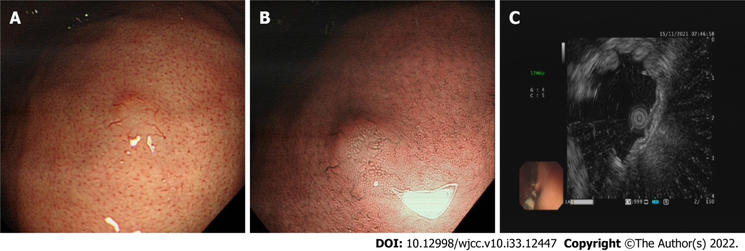
Figure 1 Endoscopic images of the gastric lesion. A: A solitary submucosal eminence was observed; B: Narrow-band imaging appearance of gastric pit pattern elongates and expands, with appearance of irregular abnormal vessels; C: Endoscopic ultrasonography showed thickening of muscularis mucosa with a hypoechoic lesion 2 mm × 5 mm in size.
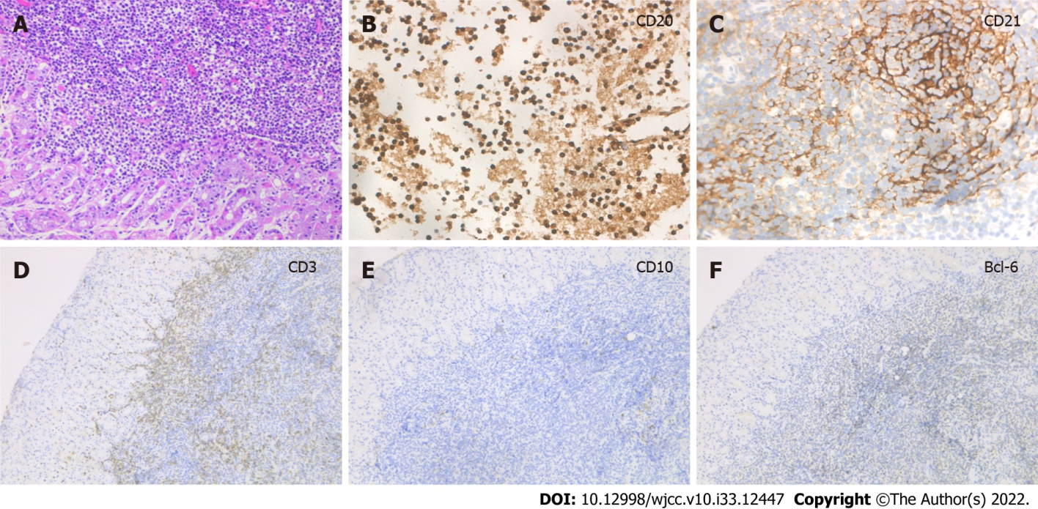
Figure 2 Immunohistochemical results of the gastric mucosa-associated lymphoid tissue lymphoma. A: Hematoxylin-eosin staining of extensive lymphocytic infiltration (200×); B: Immunohistochemistry showed that the lymphoid cells were diffusely positive for CD20 (400×); C: CD21 showed expansion and destruction of follicular dendritic cells (400×); D: Immunohistochemical stains showed CD3 negative (100×); E: CD10 was negative (100×); F: Bcl-6 was negative (100×).
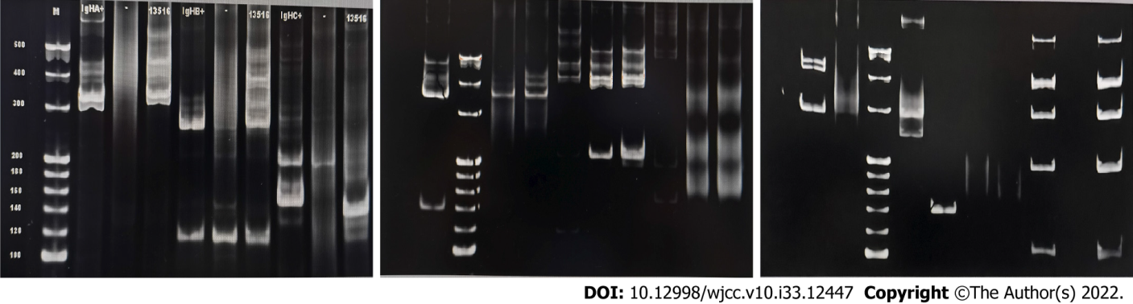
Figure 3 Gene detection revealed clonal rearrangement of the IgH gene in B cells.
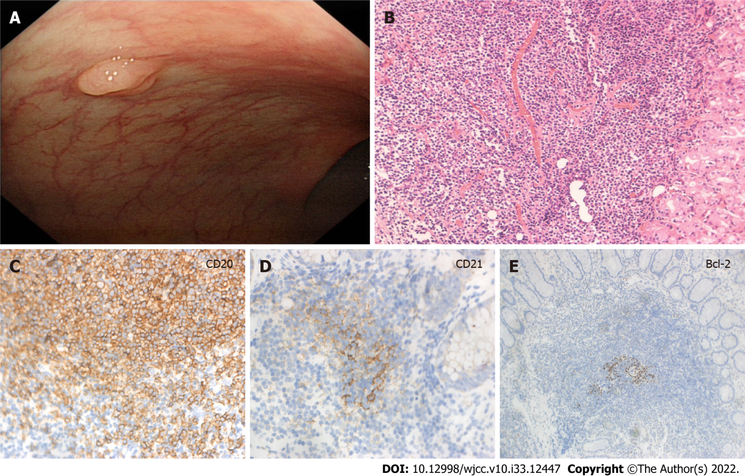
Figure 4 Endoscopic images and immunohistochemical results of colon mucosa-associated lymphoid tissue lymphoma. A: Endoscopic images showing a single 5mm polypoid lesion; B: Hematoxylin-eosin staining of lymphocytic infiltration (200×); C: Immunohistochemistry showed that the lymphoid cells were diffusely positive for B cell marker CD20 (400×); D: CD21 showed expansion and destruction of follicular dendritic cells (400×); E: Immunohistochemical stains showed Bcl-2 negative (100×).
Table 1 Summary of co-occurring gastric and colon mucosa-associated lymphoid tissue lymphoma case reports
Ref. | Sex | Age (yr) | Gastric | Colon | H. pylori | HPE | Other
Nakagawara et al^{[2]} | M | 50 | Enlarged folds | A polypoid tumor | Negative | ND | No
Isomoto et al^{[7]} | F | 67 | Multiple ulcer | Ulcer | Positive | Invalid | Duodenum MALT
Arakura et al^{[8]} | M | 65 | Red and swollen | Submucosal tumor (> 50mm) | Positive | Invalid | Small intestine MALT
Fares et al^{[9]} | M | 70 | An ulcer on top of a polypoid mass | Multiple polyps | Positive | Invalid | Lungs MALT
Tursi et al^{[10]} | M | 57 | Ulcer | Irregular area | ND | ND | Coeliac disease
Venizelos et al^{[11]} | F | 70 | Nodular pattern | Mucosal thicken | Positive | Invalid | Small intestine MALT
Sahara et al^{[12]} | M | 85 | Petechial | Low protuberant lesion (> 20 mm) | Positive | Invalid | Early gastric cancer/small intestine MALT
McFarlane et al^{[13]} | M | 73 | Spherical mass (> 30 mm) with ulceration | Polypoidal sigmoid (> 50 mm) | Positive | Invalid | Diabetes mellitus
Singh et al^{[14]} | M | 60 | Erythematous areas | Diffusely friable, nodular and erythematous mucosa | Positive | Effective | Strongyloides stercoralis
ND: Non-descried; H. pylori: Helicobacter pylori; HPE: Helicobacter pylori eradication.

Published by Baishideng Publishing Group Inc
7041 Koll Center Parkway, Suite 160, Pleasanton, CA 94566, USA
Telephone: +1-925-3991568
E-mail: bpgoffice@wjgnet.com
Help Desk: https://www.f6publishing.com/helpdesk
https://www.wjgnet.com

© 2022 Baishideng Publishing Group Inc. All rights reserved.

