Name of Journal: World Journal of Clinical Cases
Manuscript NO: 41239
Manuscript Type: CASE REPORT

Vertebrobasilar artery dissection manifesting as Millard-Gubler syndrome in a young ischemic stroke patient: A case report

Li et al. MGS with VAD

Xuan-Ting Li, Jun-Liang Yuan, Wen-Li Hu

Xuan-Ting Li, Jun-Liang Yuan, Wen-Li Hu, Department of Neurology, Beijing Chaoyang Hospital, Capital Medical University, Beijing 100020, China

ORCID number: Xuan-Ting Li (0000-0002-4874-3554); Jun-Liang Yuan (0000-0002-9443-9203); Wen-Li Hu (0000-0001-6532-5410).

Author contributions: Li XT and Yuan JL are joint first authors. Hu WL designed the research; Li XT and Yuan JL collected the data; Li XT and Yuan JL wrote the paper.

Supported by the National Natural Science Foundation of China, No. 81301016; and the Beijing Municipal Administration of Hospitals’ Youth Programme, No. QML20150303.

Informed consent statement: Written informed consent was obtained from the patient.

Conflict-of-interest statement: The authors declare no conflict of interest.

CARE Checklist (2016) statement: The authors have read the CARE Checklist (2016), and the manuscript was prepared and revised according to the CARE Checklist (2016).

Open-Access: This article is an open-access article which was selected by an in-house editor and fully peer-reviewed by external reviewers. It is distributed in accordance with the Creative Commons Attribution Non Commercial (CC BY-NC 4.0) license, which permits others to distribute, remix, adapt, build upon this work non-commercially, and license their derivative works on different terms, provided the original work is properly cited and the use is non-commercial. See: http://creativecommons.org/licenses/by-nc/4.0/

Manuscript source: Unsolicited manuscript

Corresponding author: Wen-Li Hu, MD, Director, Doctor, Department of Neurology, Beijing Chaoyang Hospital, Capital Medical University, No. 8, South Gongti Road, Chaoyang District, Beijing 100020, China. wenlihu3366@126.com
Telephone: +86-10-85231370
Fax: +86-10-85232985

Received: July 11, 2018
Peer-review started: July 11, 2018
First decision: August 3, 2018
Revised: August 7, 2018
Accepted: November 30, 2018
Article in press: December 1, 2018
Published online: January 6, 2019

Abstract
BACKGROUND
Millard-Gubler syndrome (MGS) is caused by a lesion in the brainstem at the level of the facial nerve nucleus, and it is also a rare ventral pontine syndrome. Vertebrobasilar artery dissection (VAD) is an uncommon cause of ischemic stroke. To the best of our knowledge, this is the first case report on the coexistence of MGS and VAD in a young acute ischemic stroke patient.

CASE SUMMARY
We herein describe an unusual case of young acute ischemic stroke patient, presenting with acute right peripheral facial palsy, right abducens palsy, and contralateral hemihypesthesia, manifesting as MGS. After receiving dual antiplatelet therapy with aspirin and clopidogrel, as well as rosuvastatin, the patient recovered significantly. The high-resolution magnetic resonance imaging (MRI) indicated a diagnosis of VAD.

CONCLUSION
Our finding further demonstrated that high-resolution MRI is a useful technique to early detect underlying dissection in posterior circulation ischemic stroke.

Key words: Millard-Gubler syndrome; Vertebrobasilar artery dissection; Ischemic stroke; Case report

© The Author(s) 2019. Published by Baishideng Publishing Group Inc. All rights reserved.

Core tip: Millard-Gubler syndrome (MGS) is caused by a lesion in the brainstem at the level of facial nerve nucleus, and it is also a rare ventral pontine syndrome. We herein describe an unusual case of young acute ischemic stroke patient presenting with MGS. The high-resolution magnetic resonance imaging (MRI) indicated a diagnosis of vertebrobasilar artery dissection (VAD). This is the first case report on the coexistence of MGS and VAD in a young acute ischemic troke patient. Our finding further demonstrated that high-resolution MRI is a useful technique to early detect underlying dissection in posterior circulation ischemic stroke.

Citation: Li XT, Yuan JL, Hu WL. Vertebrobasilar artery dissection manifesting as Millard-Gubler syndrome in a young ischemic stroke patient: A case report. World J Clin Cases 2019; 7(1): 73-78
URL: https://www.wjgnet.com/2307-8960/full/v7/i1/73.htm
DOI: https://dx.doi.org/10.12998/wjcc.v7.i1.73

INTRODUCTION
Millard-Gubler syndrome (MGS) is one of uncommon pontine-crossed syndromes, and it involves the facial nerve nucleus, abducent nerve, and the corticospinal tract. It is characterized by paralysis affecting the face and the abducent nerve on the side of the lesion and central hemiplegia on the opposite side^{[1]}. It has been reported that MGS could be found in patients with brainstem tumor such as cavernous angioma^{[2-4]}, rimary meningeal hemangiopericytoma^{[5]}, neurocysticercosis^{[6]}. As far as we know, only five cases of MGS caused by cerebral infarction have been reported^{[1,7-10]}. Vertebrobasilar artery dissection (VAD) is an uncommon cause of ischemic stroke, especially in posterior circulation ischemic stroke^{[11]}. To the best of our knowledge, this is the first report on the coexistence of MGS and VAD in a young acute ischemic stroke patient, using the technique of high-resolution magnetic resonance imaging (MRI). Herein, we describe an unusual case of posterior circulation ischemic stroke manifesting as MGS caused by VAD.

CASE PRESENTATION
Chief complaints
A 49-year-old male presented with dizziness and slurred speech for two days.

History of present illness
Two days before admission, the patient experienced sudden dizziness and nausea, followed by slurred speech, dysphagia, and choking. Before the onset of the illness, he did not suffer from fever or cervical pain.

History of past illness
He suffered from hypertension for seven years. There was no other vascular risk factor or family history.

Physical examination
On admission, his neurological examination revealed right peripheral facial palsy, right abducens palsy, and left hemihypesthesia, suggesting the presence of MGS. Besides, dysarthria, absent gag reflex, and positive bilateral Babinski’s signs were also detected. The other cranial nerves and motor exam were normal. On admission, his blood pressure was 141/85 mmHg.

Laboratory testing
The laboratory tests showed elevated plasm cholesterol (7.83 mmol/L), glycosylated hemoglobin (9.0%), and homocysteine (15 μmol/L), and normal low density lipoprotein (1.4 mmol/L). For the routine blood test, his white blood cell was mildly elevated (10.63 × 10⁹/L) and other items were normal.

Imaging examination
The chest X-ray film showed mild pneumonia. The parameters of MRI examination using a 3-Tesla system (Discovery MR750, GE Medical Systems, Milwaukee, Wis., United States) were as follows: MR angiography (MRA) (repetition time 21 ms; echo time 3.4 ms; slice thickness 0.9 mm), axial T2-weighted (repetition time 5838.7 ms; echo time 107.3 ms), axial T1-weighted imaging (repetition time 1800 ms; echo time 27.7 ms), axial diffusion weighted imaging (DWI) (repetition time 3000 ms; echo time 65.3 ms, b value 1000), and coronal fluid-attenuated inversion recovery sequences (repetition time 7500 ms; echo time 121.1 ms). Brain MRI revealed acute multifocal infarctions in the pons, ventral medulla oblongata, right middle cerebellar peduncle, and left occipital lobe (Figure 1A-C). Brain MRA without contrast agent indicated the occlusion of the left vertebral artery and severe stenosis of the proximal right vertebral artery (Figure 1D). The high-resolution MRI with contrast enhancement showed luminal irregularities with eccentric periluminal hematoma, indicating the dissection of the basilar artery and left vertebral artery (Figure 2).

FINAL DIAGNOSIS
According to the typical symptoms, physical examination, and imaging findings, this patient was diagnosed with acute ischemic stroke presenting as MGS caused by VAD.

TREATMENT
The patient was given dual antiplatelet therapy with aspirin and clopidogrel, as well as rosuvastatin.

OUTCOME AND FOLLOW-UP
Nine days after his admission, he recovered significantly and was discharged from our department with mild residual right facial palsy and left hemihypesthesia.

DISCUSSION
MGS is caused by a lesion in the pons at the level of the facial nerve nucleus. This lesion involves the facial nerve nucleus, the abducent nerve, and the corticospinal tract. Clinical features include ipsilateral peripheral facial palsy, ipsilateral abducens paralysis, contralateral hemidysesthesia, and central hemiplegia caused by the lesion of the ventrolateral pons. To date, there are only five case reports of MGS due to cerebral infarction^{[1,7-10]} (Table 1). One case was a 56-year-old male who presented with left lower facial paralysis and hemiparesthesia on the right side, and brain MRI revealed an acute infarct in the left ventral pons^{[1]}. Another case was a 63-year-old man who presented with left hemiparesis and right facial paralysis involving the lower facial muscles and the orbicularis oculi but sparing the frontalis muscle. DWI indicated acute infarction in ventro-medial aspect of the medulla^{[7]}.

VAD has been found more frequently in patients with posterior circulation ischemic stroke^{[12]}. MRA, a non-invasive technique for dynamic assessment of the cranial circulation, is routinely used in stroke work-up to detect arterial occlusion. In addition, high-resolution MRI has been used to explore vascular diseases, with good advantages in the diagnosis of the dissection, and it can help to give more information about the etiology of cerebral infarction^{[13,14]}. By using the combined high-resolution MRI, we speculated that the acute multifocal infarctions were caused by the dissection of the basilar artery and left vertebral artery.
To the best of our knowledge, this is the first report on the coexistence of MGS and VAD in a young acute ischemic stroke patient. Our case raises the importance that the utility of high-resolution MRI with fat saturation might be a useful tool to early detect the dissection in posterior circulation ischemic stroke, especially in young patients.

CONCLUSION
For acute ischemic stroke in a young patient, artery dissection should be considered in clinical work. High-resolution MRI with fat saturation is an important and useful tool to early detect the dissection, especially in posterior circulation ischemic stroke. Further studies are needed to warrant the potential findings and applications of high-resolution MRI, black blood T2-weighted MRI (angiitis, branch disease, etc.), and fat-saturation MRI (dissections) in stroke differential diagnosis and follow-up.

REFERENCES
1 Onbas O, Kantarci M, Alper F, Karaca L, Okur A. Millard-Gubler syndrome: MR findings. Neuroradiology 2005; 47: 35-37 [PMID: 15647948 DOI: 10.1007/s00234-004-1312-1]
2 Dourado Leite R, Freitas C, Guimaraes S. Vertical muscle transposition with silicone band belting in VI nerve palsy. BMJ Case Rep 2016; 2016: [PMID: 27974341 DOI: 10.1136/bcr-2016-216722]
3 Kesikburun S, Safaz I, Alaca R. Pontine cavernoma hemorrhage leading to Millard-Gubler syndrome. Am J Phys Med Rehabil 2011; 90: 263 [PMID: 20531153 DOI: 10.1097/PHM.0b013e3181e29e8e]
4 Kuhn J, Brümmendorf TH, Brassat U, Lehnhardt FG, Chung BD, Harnier S, Bewermeyer H, Harzheim A, Assheuer J, Netzer C. Novel KRIT1 mutation and no molecular evidence of anticipation in a family with cerebral and spinal cavernous malformations. Eur Neurol 2009; 61: 154-158 [PMID: 19092252 DOI: 10.1159/000186506]
5 Ben Nsir A, Badri M, Kassar AZ, Hammouda KB, Jemel H. Hemangiopericytoma of the Cerebellopontine Angle: A Wolf in Sheep's Clothing. Brain Tumor Res Treat 2016; 4: 8-12 [PMID: 27195255 DOI: 10.14791/btrt.2016.4.1.8]
6 Prasad R, Kapoor K, Srivastava A, Mishra O. Neurocysticercosis presenting as Millard Gubler syndrome. J Neurosci Rural Pract 2012; 3: 375-377 [PMID: 23189006 DOI: 10.4103/0976-3147.102634]
7 Ahdab R, Saade HS, Kikano R, Ferzli J, Tarcha W, Riachi N. Pure ipsilateral central facial palsy and contralateral hemiparesis secondary to ventro-medial medullary stroke. J Neurol Sci 2013; 332: 154-155 [PMID: 23849262 DOI: 10.1016/j.jns.2013.06.028]
8 Matlis A, Kleinman Y, Korn-Lubetzki I. Millard-Gubler syndrome. AJNR Am J Neuroradiol 1994; 15: 179-181 [PMID: 8141053]
9 Yasuda Y, Matsuda I, Sakagami T, Kobayashi H, Kameyama M. Pontine infarction with pure Millard-Gubler syndrome: precise localization with magnetic resonance imaging. Eur Neurol 1993; 33: 331-334 [PMID: 8348923]
10 Rose DZ, Parra-Herran C, Petito CK, Post MJ. Restricted Diffusion of Pus in the Subarachnoid Space: MRSA Meningo-Vasculitis and Progressive Brainstem Ischemic Strokes - A Case Report. Case Rep Neurol 2010; 2: 101-110 [PMID: 21045937 DOI: 10.1159/000319691]
11 Ahn SS, Kim BM, Suh SH, Kim DJ, Kim DI, Shin YS, Ha SY, Kwon YS. Spontaneous symptomatic intracranial vertebrobasilar dissection: initial and follow-up imaging findings. Radiology 2012; 264: 196-202 [PMID: 22550310 DOI: 10.1148/radiol.12112331]
12 Chien C, Chang FC, Huang HC, Tsai JY, Chung CP. Characteristics and Outcomes of Vertebrobasilar Artery Dissection with Accompanied Atherosclerosis. Cerebrovasc Dis Extra 2017; 7: 165-172 [PMID: 29040971 DOI: 10.1159/000480523]
13 Zhang X, Jing J, Dong K, Wang Y, Wang Y. Teaching NeuroImages: Vertebrobasilar dolichoectasia with dissection manifested as infarct and subarachnoid hemorrhage. Neurology 2018; 90: e990-e991 [PMID: 29530968 DOI: 10.1212/WNL.0000000000005119]
14 Jung SC, Kim HS, Choi CG, Kim SJ, Lee DH, Suh DC, Kwon SU, Kang DW, Kim JS. Quantitative Analysis Using High-Resolution 3T MRI in Acute Intracranial Artery Dissection. J Neuroimaging 2016; 26: 612-617 [PMID: 27173143 DOI: 10.1111/jon.12357]

P-Reviewer: Sijens PE, Sergi C, Kai K, Gonzalez-Moreno EI, Elgafy H, Anand A
S-Editor: Dou Y L-Editor: Wang TQ E-Editor: Bian YN

Specialty type: Medicine, research and experimental
Country of origin: China
Peer-review report classification
Grade A (Excellent): 0
Grade B (Very good): B, B, B
Grade C (Good): C
Grade D (Fair): D, D
Grade E (Poor): 0

Table 1 Characteristics of Millard-Gubler syndrome cases caused by cerebral ischemic stroke in the prior literature
Author | Time | Age, yr | Sex | Medical history | Physical examination | MRI | MRA | Others
Yasuda Y et al^{[9]} | 1993 | 60 | Male | NA | Right peripheral facial nerve palsy, left hemiparesis, tongue deviated to the left, exaggerated deep tendon reflex, and equivocal left Babinski’s reflex | Cerebral infarction in the right ventral pons | Occlusion of both vertebral arteries
Matlis A et al^{[8]} | 1994 | 76 | Male | Hypertension, ischemic heart disease, and type II diabetes mellitus | Slight dysarthria, peripheral right facial palsy, flaccid left hemiparesis, brisk left deep tendon reflexes, and positive left Babinski’s reflex | Cerebral infarction in the right anteromedial pons | NA
Onbas O et al^{[1]} | 2005 | 56 | Male | NA | Left facial paralysis, right hemiparesthesia, and exaggerated deep tendon reflexes | Acute cerebral infarction in the left ventral part of the pons | Stenosis of the basilar artery
Rose DZ et al^{[10]} | 2010 | 45 | Male | HIV | Horizontal diplopia, left facial paralysis, and right hemiparesis | Acute cerebral infarction in the left pons | Unremarkable | MRSA meningo-vasculitis caused by the restricted diffusion of pus in the subarachnoid space
Ahdab R et al^{[7]} | 2013 | 63 | Male | Diabetic and hypertensive | Right facial palsy involving the lower facial muscles and the orbicularis oculi but sparing the frontalis muscle and left hemiparesis | Acute cerebral infarction in the ventro-medial aspect of the medulla and limited to the right  pyramid | Diffuse atherosclerotic changes of the basilar trunk  with mild to moderate multisegmental narrowing, especially in the  distal third
MRI: Magnetic resonance imaging; MRA: Magnetic resonance angiography; NA: Not available; HIV: Human immunodeficiency virus; MRSA: Methicillin-resistant Staphylococcus aureus.
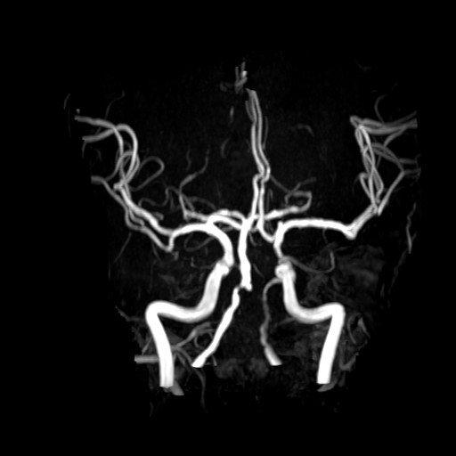
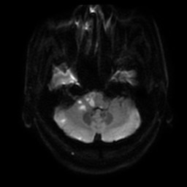
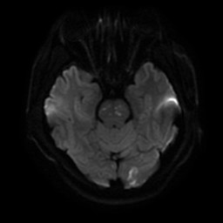
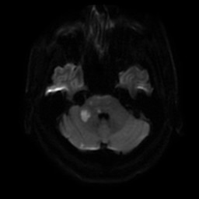
A
B
C
D

Figure 1 Brain magnetic resonance imaging and magnetic resonance angiography show multiple infarctions and occlusion and stenosis of the vertebral artery. A-C: Diffusion weighted imaging shows acute multifocal infarctions in the pons, ventral medulla oblongata, cerebellopontine angle, and left occipital lobe; D: Brain magnetic resonance angiography indicates the occlusion of the left vertebral artery and severe stenosis of the proximal right vertebral artery.

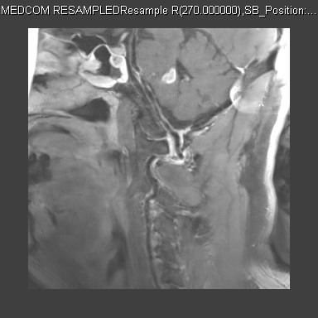
A
C
B
D

Figure 2 High–resolution magnetic resonance imaging shows the dissection of the basilar artery and left vertebral artery. A, B: The eccentric periluminal hematoma of the basilar artery; C, D: The eccentric periluminal hematoma of the left vertebral artery.

