Name of Journal: World Journal of Gastrointestinal Oncology
Manuscript NO: 76064
Manuscript Type: ORIGINAL ARTICLE

Observational Study
Clinical implications of interleukins-31, 32, and 33 in gastric cancer

Liu QH et al. Clinical implications of three ILs in GC

Qing-Hua Liu, Ji-Wei Zhang, Lei Xia, Steven G Wise, Brett David Hambly, Kun Tao, Shi-San Bao

Qing-Hua Liu, Lei Xia, Department of Pathology, Xuzhou Medical University, Xuzhou 221004, Jiangsu Province, China

Ji-Wei Zhang, Department of Surgery, The Central Hospital of Songjiang District, Shanghai Jiaotong University, Shanghai 201699, Shanghai, China

Steven G Wise, Faculty of Medicine and Health, School of Medical Sciences, University of Sydney, Sydney 2006, NSW, Australia

Brett David Hambly, Kun Tao, Shi-San Bao, Department of Pathology, Tongren Hospital, Shanghai 200336, China

Author contributions: Liu QH collected the samples, performed the histopathological and immunohistochemical examinations, analysed the data, and wrote the paper; Zhang JW collected the samples, analysed the data, and wrote the paper; Liu QH and Zhang JW contributed equally to the study; Xia L performed ELISA and data analysis; Wise SG provided intellectual input; Hambly BD and Tao K revised the manuscript and provided intellectual input; Bao SS designed the experiment and revised the manuscript.

Supported by the National Natural Science Foundation of China, No. 81502030.

Corresponding author: Shi-San Bao, MD, PhD, Academic Fellow, Department of Pathology, Tongren Hospital, No. 1111 Xianxia Road, Changning District, Shanghai 200336, China. profbao@hotmail.com

Received: February 28, 2022
Revised: April 21, 2022
Accepted: July 31, 2022
Published online: September 15, 2022

Abstract
BACKGROUND
Gastric cancer (GC) is one of the most common malignancies in China with a high morbidity and mortality.

AIM
To determine whether interleukin (IL)-31, IL-32, and IL-33 can be used as biomarkers for the detection of GC, via evaluating the correlations between their expression and clinicopathological parameters of GC patients.

METHODS
Tissue array (n = 180) gastric specimens were utilised. IL-31, IL-32, and IL-33 expression in GC and non-GC tissues was detected immunohistochemically. The correlations between IL-31, IL-32, and IL-33 expression in GC and severity of clinicopathological parameters were evaluated. Survival curves were plotted using the Kaplan-Meier method/Cox regression. Circulating IL-31, IL-32, and IL-33 were detected by ELISA.

RESULTS
We found that the expression levels of IL-31, IL-32, and IL-33 were all lower in GC than in adjacent non-GC gastric tissues (P < 0.05). IL-33 in peripheral blood of GC patients was significantly lower than that of healthy individuals (1.50 ± 1.11 vs 9.61 ± 8.00 ng/mL, P <0.05). Decreased IL-31, IL-32, and IL-33 in GC were observed in younger patients (< 60 years), and IL-32 and IL-33 were lower in female patients (P < 0.05). Higher IL-32 correlated with a longer survival in two GC subgroups: T4 invasion depth and TNM I-II stage. Univariate/multivariate analysis revealed that IL-32 was an independent prognostic factor for GC in the T4 stage subgroup. Circulating IL-33 was significantly lower in GC patients at TNM stage IV than in healthy people (P < 0.05).

CONCLUSION
Our findings may provide new insights into the roles of IL-31, IL-32, and IL-33 in the carcinogenesis of GC and demonstrate their relative usefulness as prognostic markers for GC. The underlying mechanism of IL-31, IL-32, and IL-33 actions in GC should be further explored.

Key Words: Diagnosis and therapy; Gastric cancer; Immune cell interactions; Interleukin-31; Interleukin-32; Interleukin-33

©The Author(s) 2022. Published by Baishideng Publishing Group Inc. All rights reserved.

Citation: Liu QH, Zhang JW, Xia L, Wise SG, Hambly BD, Tao K, Bao SS. Clinical implications of interleukins-31, 32, and 33 in gastric cancer. World J Gastrointest Oncol 2022; 14(9): 1808-1822
URL: https://www.wjgnet.com/1948-5204/full/v14/i9/1808.htm
DOI: https://dx.doi.org/10.4251/wjgo.v14.i9.1808

Core Tip: Gastric cancer (GC) is one of the most common malignancies in China with a high morbidity and mortality. This study aimed to determine whether interleukin (IL)-31, IL-32, and IL-33 can be used as biomarkers for the detection of GC, via evaluating the correlations between their expression and clinicopathological parameters of GC patients. IL-31, IL-32, and IL-33 expression in GC was correlated with the severity of clinicopathological parameters. Circulating IL-33 was significantly low in GC patients. Our findings may provide new insights into the roles of IL-31, IL-32, and IL-33 in the carcinogenesis of GC.

INTRODUCTION
Gastric cancer (GC) is one of the most common malignancies in China with a high morbidity (approximately 24%) and mortality (approximately 17%)^{[1]} and is ranked third amongst malignant tumours^{[2]}. Despite the more widespread use of recently developed diagnostic techniques, including endoscopic examination, many GC patients are diagnosed at advanced stages, resulting in a poor 5-year survival rate (< 20%). This emphasises the critical need for development of a reliable biomarker(s)^{[3]} with high specificity and sensitivity, to improve the prediction of prognosis for more successful outcomes for GC patients. Endoscopic examination provides a useful approach in the early detection of GC and in reducing cancer-related mortality.
Immunity is critically important in inhibiting the development of malignancy^{[4]}, but the precise underlying mechanism concerning how host defence is involved in the oncogenesis of GC remains to be explored^{[5]}. The role of pro-inflammatory and anti-inflammatory responses during the development of malignancy has been well established to be able to either stimulate or inhibit the growth of a cancer^{[4,6]}. The actions of the immune checkpoint molecules PD-1 and CTLA-4 have been elegantly demonstrated^{[7]} to inhibit anti-cancer immunity during oncogenesis^{[8]}. In addition, the molecular basis of carcinogenesis has also been studied within the gastrointestinal system^{[9]}. Furthermore, a new classification of GC has recently been proposed based on subtype pathway clustering^{[10]}.
Helicobacter pylori (H. pylori), a spiral Gram-negative rod that infects and colonizes the human stomach in 50% of the human population, is a definite human oncogenic agent^{[11]}. In addition, it has been suggested that H. pylori contributes to > 60% of all GCs, although the precise underlying mechanisms are complex^{[12]}. It has been well illustrated by the Nobel laureate Barry Marshal that chronic gastric ulceration is caused by H. pylori infection, which can be eliminated by a cocktail of antibiotics^{[13]}. It has been reported that the constitutive levels of interleukin 32 (IL-32) in both the gastric mucosa and GC tissue is upregulated in H. pylori infection^{[14]}. Thus, it is reasonable to speculate that host immunity plays a critical role during the development of GC.
The cell-mediated immune response is extremely important in defence against tumour development, since compromised host immunity is known to contribute to the establishment, proliferation, and metastasis of malignant tumours^{[15]}. Although high host inflammatory status has been reported in the tumour microenvironment, an incompetent inflammatory/immune response will lead to tumour progression^{[16]}.
IL-31, an immunoregulatory cytokine secreted mainly by activated Th2 cells, plays a major role in the process of chronic inflammation^{[17]}. However, the involvement of IL-31 in the pathogenesis of cancer is unclear. Recent studies have shown that malignant T-cells produce IL-31, with an associated increase in serum levels of IL-31^{[18]}. Additionally, in the advanced stages of cutaneous T cell lymphoma, improved pruritus in patients correlates with lower levels of IL-31^{[19]}.
IL-32, a pro-inflammatory cytokine, is highly produced in several autoimmune diseases, e.g., rheumatoid arthritis, inflammatory bowel disease, and atopic dermatitis^{[20,21]}. However, by contrast with autoimmune and inflammatory diseases, the role of IL-32 appears to differ amongst different forms of cancer, e.g., IL-32 exhibits anti-tumour effects in human colon cancer and leukaemia^{[22,23]}, however, it promotes tumorigenesis in human pancreatic cancers^{[24]}. The role of IL-32 in GC is controversial, i.e., one study found that IL-32 expression is elevated in GC compared with normal stomach tissue^{[14]}, while another study reported that there is no significant difference between GC and normal stomach tissue^{[25]}. The precise role of IL-32 in tumorigenesis of GC and other malignancies remains to be fully explored. An additional controversial finding, however, has also reported that there is substantially reduced IL-32 expression in the GC tissue of patients with the diffuse type of GC^{[26]}. These divergent observations concerning IL-32 expression in GC may be due to different races and/or different tumour micro-environments.
IL-33, a member of the IL-1 family, regulates innate and adaptive immunity as a potent inducer of pro-inflammatory cytokines. The involvement of IL-33 in non-small cell lung cancer is controversial, i.e., high IL-33 has been found to be of diagnostic and prognostic value^{[27]}, but another group has reported no significant associations^{[28]}. The possible role of IL-33 in GC remains to be explored. IL-33 promotes GC invasion and migration via stimulating production of MMP-3 and IL-6 in vitro, using the ST2-ERK1/2 pathway^{[29]}, which has been confirmed in a GC animal model by ablation of the cognate IL-33 receptor ST2^{[30]}. IL-33 mRNA expression is significantly higher in GC tissue compared to that of non-cancer tissue^{[31]}, suggesting that IL-33 promotes the development of GC. However, another controversial report failed to demonstrate an association between IL-33 and the overall 5-year survival rate^{[32]}.
In this study, we specifically assessed the relationships among IL-31, IL-32, and IL-33 in GC utilising the same cohort of patients. We aimed to identify the expression of IL-31, IL-32, and IL-33 in GC and assess their inter-correlations and clinical significance. Our data may provide useful information for both basic understanding of tumour immunology and/or therapeutic targets for GC patients.

MATERIALS AND METHODS
Patients and samples
GC tissues and adjacent histologically normal gastric tissues (control) were obtained from 180 GC patients undergoing subtotal gastrectomy at the Affiliated Hospital, Xuzhou Medical University, China between 2015 and 2020. None of these patients had a total gastrectomy. These GC patients were comprised of 140 males and 40 females, aged from 23 to 85 years. No chemotherapy was administered to these patients prior to subtotal gastrectomy. There were no cases of local recurrences within the stomach after subtotal gastrectomy among the 180 GC patients included in the study. Non-cancer tissues were also collected (n = 159), but did not include cases without a mucosal layer present under microscopic examination (n = 21). This study was approved by the Human Ethical Committee, the Institutional Review Boards of Affiliated Hospitals of Xuzhou Medical University.

Immunohistochemistry
Sections (5 µm) from tissue microarray blocks were labelled with three antibodies, as described previously^{[33]}. The antibodies used are: Rabbit anti-IL-31 polyclonal antibody (22859-1-AP, Proteintech, China), rabbit anti-IL-32 polyclonal antibody (11079-1-AP, Proteintech), and rabbit anti-IL-33 polyclonal antibody (12372-1-AP, Proteintech, China). The dilution for all three antibodies was 1:100. A horseradish peroxidase-conjugated secondary antibody (12127A07, Beijing Sequoia Jinqiao Biological Technology Co., Ltd.) was used. The specific target(s) were visualized with a DAB detection kit (Beijing Sequoia Jinqiao Biological Technology Co., Ltd.) and counterstained with hematoxylin.
Photomicrographs from each of the tissue arrays were taken with a fixed exposure time and colour balance to ensure consistency. IL-31, IL-32, and IL-33 production was quantified using ImagePro Plus9.1 (Media Cybernetic, Silver Spring, MD, United States), as described previously^{[34]}.

ELISA for IL-31, IL-32, and IL-33
To determine if there was a correlation between GC and circulating IL-31, IL-32, and IL-33, we enrolled prospectively ten GC patients prior to preoperative chemotherapy in the Affiliated Hospital, Xuzhou Medical University, China. Blood from ten healthy age and sex matched persons presenting for a routine health check-up were collected as controls. Consent was obtained from both GC patients and healthy controls. The circulating cytokine study was also approved by the Human Ethical Committee, the Institutional Review Boards of the Affiliated Hospitals of Xuzhou Medical University. Plasma samples were collected from subjects and stored at -80 °C until analysis. The concentrations of IL-31, IL-32, and IL-33 were determined using an ELISA instrument (Bio-Rad 550, United States) at 450 nm, following the manufacturers’ instructions for human IL-31 (KGEHC141, KeyGEN BioTECH, Nanjing, Jiangsu Province, China), IL-32 (SEB802Hu, Cloud-Clone Corp, Wuhan, Hubei Province, China) and IL-33 (KGEHC151, KeyGEN BioTECH). All samples were tested in duplicate.

Statistical analysis
GraphPad Prism 6.0 and SPSS 16.0 statistical software packages were used for the statistical analysis of the results of immunohistochemistry and ELISA. Comparison between two groups was performed via the Mann-Whitney U-test. Comparisons among multi-groups were performed via the Kruskal-Wallis test. Low and high cut-off values for cytokine expression were defined by receiver operating characteristic (ROC) curve analysis. Survival curves were plotted by the Kaplan-Meier method and compared by the log-rank test. Cox proportional hazards model was used to identify the prognostic factors that influenced survival. P < 0.05 was considered statistically significant^{[35]}.

RESULTS
Baseline characteristics of patients
The detailed patients’ information is presented in Table 1. Notably, there were four early GC patients, specifically stage T1 patients, among the 180 GC patients involved (Table 1). The management of patients after gastric resection uniformly followed the 2018 Chinese guidelines for diagnosis and treatment of GC, the National Health Commission of The People's Republic of China^{[36]}. All patients had complete clinical information. Among them, 77 had follow-up until their death or until their most recent contact. The other patients were lost to follow-up (Figure 1). There were 42 cancer-related deaths among the 77 patients (54.5%). Thus, amongst the 77 cases, 6 were stage I, and 32 were stage II.

Local expression of IL-31, IL-32, and IL-33 in GC tissue and in peripheral blood of GC patients
The expression levels of IL-31 (Figure 2A and B), IL-32 (Figure 2E and F), and IL-33 (Figure 1I and J) in GC tissue were investigated using immunohistochemistry. The densities of IL-31 (Figure 1C), IL-32 (Figure 2G), and IL-33 (Figure 2K) are presented as box plots, including medians and 25th and 75th percentiles. IL-31, IL-32, and IL-33 were decreased by 9.4%, 28.2% and 27.5%, respectively, in GC compared to histologically normal adjacent gastric tissues (P < 0.05).
There was no significant difference in IL-31 (Figure 2D) or IL-32 (Figure 2H) concentration in the peripheral blood between GC patients and heathy controls. However, the mean value for IL-33 levels in peripheral blood of GC patients was 1.50 ± 1.11 ng/mL, which was significantly lower than that of healthy individuals (9.61 ± 8.00 ng/mL; P < 0.05) (Figure 2L).

Correlation between IL-31, IL-32, and IL-33 expression in GC and clinicopathological parameters
Associations between clinicopathological parameters and IL-31, IL-32, and IL-33 expression are listed in Table 1, Figures 3 and 4, and Supplementary Figures 1 and 2. All three ILs were associated with the age of GC patients (Figure 3A-D, IL-31; Figure 3E-H, IL-32; Figure 3I-L, IL-33). There was significantly lower expression of IL-31, IL-32, and IL-33 in the group of GC patients aged ≤ 60 years compared to the patients aged > 60 (P < 0.05). Significantly lower IL-32 (Figure 4A-D) and IL-33 (Figure 4E-H) expression was also observed in female GC patients compared to male GC patients (P < 0.05). However, no significant difference was observed in IL-31 expression when GC patients were stratified by sex (Supplementary Figure 2). Additionally, there were no correlations observed among IL-31, IL-32, and IL-33 and other parameters, such as tumour size, lymph node metastasis, tumour differentiation, tumour invasion depth (Supplementary Figure 1), and TNM stage (Supplementary Figure 2) of GC.

Prognostic cytokines for overall survival of GC patients
To evaluate whether decreased IL-31, IL-32, and IL-33 correlate with survival of GC patients, low and high cut-off points for IL-31 (Figure 5A), IL-32 (Figure 5B), and IL-33 (Figure 5C) were defined by ROC curve analysis (Figure 5). The cut-off values for the three ILs were determined to be: IL-31, 1486000 AU; IL-32, 64893 AU; IL-33, 166291 AU. Kaplan-Meier survival curves were constructed to compare the survival of GC patient with high and low expression of IL-31 (Figure 5D), IL-32 (Figure 5E), and IL-33 (Figure 5F). The data revealed that there were no correlations between IL-31, IL-32, and IL-33 expression and the prognosis of GC patients (Figure 4). However, Kaplan-Meier analysis was applied to further compare overall survival according to IL-31 (Figure 5G), IL-32 (Figure 5H), and IL-33 (Figure 5I) expression in different subgroups of GC (Figure 5). Figure 4 shows that decreased IL-32 staining correlated with a significantly worse survival of patients in the TNM I-II stage subgroup (P = 0.006) (Figure 5K) and in the tumour invasion depth T4 subgroup (P = 0.004). There were no significant differences in the other clinicopathological subgroups of GC for IL-31, IL-32, and IL-33 (Supplementary Figures 3-5). Furthermore, there was no significant differences in the combination of IL-31, IL-32, and IL-33 expression for the prognosis of GC patients (Supplementary Figure 6).

Correlation of IL-32 with overall survival in subgroups of GC patients
Univariate and multivariate Cox regression analyses were used to examine whether IL-32 is an independent prognostic marker for subgroups of GC patients, including IL-32 expression level, age, sex, tumour differentiation, lymph node invasion, tumour size, depth of tumour invasion, and TNM stage.
Data from patients within the T4 stage subgroup, analysed by univariate analysis, exhibited a correlation between the survival of GC patients and IL-32 expression and TNM stage. In multivariate analysis, IL-32 expression and TNM stage remained as significant independent prognostic factors for survival of GC patients (Table 2).
Furthermore, decreased survival of GC patients in the TNM I-II stage subgroup was found to correlate with lymph node metastasis and tumour size on univariate analysis, but not on multivariate analysis. However, both univariate and multivariate analyses revealed no significant correlations between decreased IL-32 expression and survival of GC patients in the TNM I-II stage subgroup of GC patients (Table 3).

DISCUSSION
The current study demonstrated that the levels of expression of IL-31, IL-32, and IL-33 were all decreased in GC tissue compared to adjacent non-cancer gastric tissue and that the extent of these reductions in expression was higher in younger patients below the age of 60 years. Additionally, in the case of IL-32 and IL-33, their expression was found to be lower in females compared to males. However, the levels of expression of all three ILs amongst all the GC patients as a group did not correlate with a survival benefit, although subgroup analysis did reveal a survival benefit associated with higher levels of expression of IL-32 in the T4 stage and the TNM I-II stage subgroups.
H. pylori, a spiral Gram-negative rod that infects the human stomach in 50% of humans, is a definite human oncogenic agent^{[11]}, consistent with the previous finding that H. pylori contributed to > 60% of all GCs^{[12]}. It has been clearly demonstrated by the Nobel laureate Barry Marshal that chronic gastric ulceration is caused by H. pylori infection^{[13]}. The constitutive level of IL-32 is upregulated in both the gastric mucosa and GC tissue infected with H. pylori^{[14]}. The cell-mediated immune response is extremely important in defence against tumour development, since compromised host immunity contributes to the establishment, proliferation, and metastasis of malignant tumours^{[15]}, a concept that is further supported by others who have shown that incompetent inflammation/immunity leads to tumour progression^{[16]}.
IL-31, an immunoregulatory cytokine secreted mainly by activated Th2 cells, plays a major role in the process of chronic inflammation^{[17]}. However, the involvement of IL-31 in the pathogenesis of cancer is unclear. Malignant T-cells produce IL-31, consistent with increased circulating IL-31^{[18]}. Additionally, in the advanced stages of cutaneous T cell lymphoma, improved pruritus in patients correlates with lower levels of IL-31^{[19]}.
We found decreased IL-31 in GC patients, particularly in younger patients. Our data are consistent with other studies that have shown that younger patients are more likely to have more poorly differentiated tumours compared to older patients with GC, suggesting that younger GC patients have more malignant types of GC^{[37]}. The activity of IL-31 is mediated through the IL-31 receptor A (IL-31RA) and the oncostatin M receptor^{[38,39]}. The two different isoforms of the IL-31RA consist of either long (745 residues) or short (560 residues) isoforms which may induce contrary functions^{[40]}. Proliferation of follicular lymphoma is enhanced via the long IL-31RA isoform, whereas germinal centre-derived B-cell malignancy is inhibited via the short IL-31RA isoform^{[41]}. There is no direct evidence available that identifies which isoform/s of IL-31RA are activated in GC via the IL-31 signalling pathway. However, our data are consistent with the hypothesis that IL-31 mediates an anti-cancer role in GC through the short IL-31RA isoform.
The involvement of IL-33 in non-small cell lung cancer is controversial, i.e., high IL-33 has been found to be of diagnostic and prognostic value^{[27]}, but another report shows no significant associations^{[28]} between IL-33 and the overall 5-year survival rate^{[32]}. IL-33 promotes GC invasion/migration via stimulating MMP-3 and IL-6 in vitro^{[29]}, which has been confirmed in a GC animal model by ablation of the cognate IL-33 receptor ST2^{[30]}. IL-33 mRNA is significantly higher in GC tissue compared to that of non-cancer tissue^{[31]}, suggesting that IL-33 promotes the development of GC.
We observed similar levels of expression of IL-31 and IL-33 in GC, with decreased IL-33 in both younger GC patients and in female GC patients, which is consistent with data from others, who have shown that female sex is a significant factor for predicting a higher likelihood of lymph node metastasis in mucosa-confined, poorly differentiated GC^{[42]}. IL-33 is a multifunctional cytokine that can bind to the IL-33 receptor (ST2), to regulate immunity via activating Th1 cells, Th2 cells, CD8⁺ T cells, and NK cells^{[43,44]}. There are two forms of ST2: The transmembrane form ST2L that when bound to IL-33, is able to activate target cells^{[45]}, and the soluble, secreted form of ST2 (sST2) that acts as a decoy receptor and negatively regulates IL-33 signalling^{[46]}. The possible role of IL-33 in carcinogenesis has been demonstrated in an IL-33 transgenic mouse metastasis model, demonstrating inhibition of the growth and metastasis of B16 melanoma and Lewis lung carcinoma cells, via activating CD8⁺ T cells and NK cells^{[47]}. Thus, these data may be useful for future therapeutic design, utilising the anti-cancer role of IL-33 in GC.
IL-32, a proinflammatory cytokine, is highly expressed in several autoimmune diseases, e.g., rheumatoid arthritis, inflammatory bowel disease, and atopic dermatitis^{[20,21]}. However, the role of IL-32 appears to vary amongst different forms of cancer, e.g., IL-32 has been reported to inhibit colon cancer and leukaemia^{[22,23]}, but promotes pancreatic cancer^{[24]}. The role of IL-32 in GC is also controversial, i.e., IL-32 is elevated in GC compared with normal stomach tissue^{[14]}, but other groups have found either substantially reduced IL-32 expression in GC for the diffuse type of GC^{[26]}, or no significant difference has been observed between GC and normal stomach tissue^{[25]}. These divergent observations concerning IL-32 expression in GC may be due to different races and/or different tumour micro-environments.
We found that the expression of IL-32 was decreased in both younger patients and in female patients with GC, consistent with more severe forms of GC in younger and female patients, suggesting that IL-32 may mediate host defence against the development of GC. Furthermore, we found that high IL-32 expression correlated with a longer survival of GC patients, in the T4 stage and TNM I-II stage subgroups and that IL-32 was an independent prognostic factor for survival in the T4 stage subgroup. Interestingly, the IL-32 positive rate in GC (12%) has been reported to be much lower than the rate in oesophageal squamous cell carcinoma (60%), but no comparison to non-cancerous tissues has been made^{[48,49]}. Thus, we propose a hypothesis for the possible mechanism of IL-32 involvement in carcinogenesis as follows: Because IL-32 contributes to the host defence via enhancing differentiation of monocytes into macrophages^{[50]}, decreased IL-32 in GC tissue, seen particularly amongst the younger or female patients, may compromise host innate immunity, and subsequently contribute to poorly controlled development of cancer. Notably, macrophages are classified as either classical M1 macrophages that promote the inflammatory response against microorganism invasion and are thought to inhibit carcinogenesis, or as M2 macrophages that regulate host immunity and are thought to promote carcinogenesis^{[51]}. It remains to be clarified whether tumour-associated macrophages in GC are derived from one subset or the other, which either promote the development of cancer (M2) or suppress cancer growth (M1), which is perhaps dependent on the tumour microenvironment^{[52]}. For example, IL-32 can induce cell death in thyroid cancer cells through the induction of IL-8 and caspase-8^{[53]}, subsequently up-regulating the proinflammatory response.
IL-32 may also be able to inhibit tumour growth indirectly, hence it may be efficacious as a clinical anti-cancer therapy^{[54]}. For example, the application of siRNA to inhibit IL-32 enhances angiogenesis in HUVECs^{[55]} via up-regulation of VEGF and PDGF. Our current findings showed an inverse correlation between IL-32 and the development of GC, suggesting that IL-32 inhibits the development of cancer directly and/or indirectly, which will be further investigated in future experiments.
Finally, the levels of circulating IL-31, IL-32, and IL-33 were found to be consistent with their respective expression levels in GC tissue, further supporting the relevance of the potential role for these cytokines in mediating tumour-related immunity. However, we hypothesise that the host systemic and/or local inflammatory/immune response may be insufficient to inhibit the development of GC, among the GC cohorts studied, leading to tumour progression^{[16]}.
Unfortunately, no correlation with survival of GC patients was observed among any combination of IL-31, IL-32, and IL-33 expression, a similar result that we have reported previously for the relationship with IL-34 in GC^{[35]}. The current observations are consistent with others, showing that there is no significant correlation between IL-33 expression and overall survival^{[32]}. However, the advantage of our current data is the analysis for the combined IL-31, IL-32, and IL-33 data, to determine the correlation with GC patients from the same cohort. It remains to be explored why there is a discrepancy among IL-31, IL-32, IL-33, and IL-34 during the development of GC, which may be due to different receptors and/or signalling pathways, which will be clarified in the conditioning knockout mice in future studies.
There are some limitations for the current study. First, the number of GC patients and normal individuals who were sampled was rather small for the evaluation of circulating cytokines, using ELISA. However, this pilot study was undertaken to simply provide proof of concept that a systemic response is involved compared to only local cytokine expression in the affected gastric tissues, as well as to support our immunohistochemistry findings. A study with a larger sample size and a range of different backgrounds will be performed in the future.
Second, the stomach tissue of normal healthy people would be the ideal control for GC for comparison, and would offer more convincing evidence. However, we were unable to collect any normal healthy stomach tissue due to ethical issues. We are applying for human ethics approval for the collection of normal healthy stomach tissue from organ donors in the future.
The GC patient cohort recruited for this study was initially set at a reasonable size, i.e., 180 in total, to establish sufficient power to detect clinically relevant differences in the expression levels of the ILs that we examined. Regrettably, more than half of the patients were lost to follow-up during the course of the study, and only 77 GC patients had complete follow-up data (Figure 5). The data in relation to expression levels were based on all 180 patient samples that were initially recruited to ensure that the study was sufficiently powered to detect the potential role of IL-31, IL-32, and IL-33 during the development of GC. If we had only selected the 77 GC patients with complete follow-up data for all aspects of this study, we would be highly likely to lose some important information and/or statistical power in exploring the correlation of these cytokines with clinical presentations. However, the survival analysis could only be performed on the adequately followed sub-cohort of 77 patients. We are currently collecting more samples with a full history and complete follow-up data in collaboration with other institutes, i.e., a larger number of samples for more convincing information for our future studies.
Because there was no local recurrence of GC within the current cohort, we cannot explore the potential role of these cytokines in the prediction of local recurrence of GC. We are currently searching for both primary and recurrent GC cases for future study.

CONCLUSION
In summary, our data demonstrate that IL-31, IL-32, and IL-33 expression in GC is all decreased, which correlates with younger age of the GC patients. IL-32 and IL-33 also correlate with the sex of the GC patients. Decreased IL-32 correlates with a poorer survival of GC patients in the T4 stage and TNM I-II stage subgroups. Downregulation of IL-32 is an independent prognostic factor for survival of T4 GC patients. Finally, low IL-33 in peripheral blood may be considered as an objective predictive marker for the development of GC. However, further studies are required to investigate the mechanism of action of these ILs in GC.

ARTICLE HIGHLIGHTS
Research background
Gastric cancer (GC) is one of the most common malignancies in China with a high morbidity and mortality. Despite the more widespread use of recent diagnostic techniques, including endoscopic examination, many GC patients are diagnosed at advanced stages, resulting in a poor 5-year survival rate, emphasizing the critical need for development of a reliable biomarker(s) with high specificity and sensitivity to improve the prediction of prognosis for more successful outcomes for GC patients. Endoscopic examination provides a useful approach in the early detection of GC, and in reducing cancer-related mortality.

Research motivation
The cell-mediated immune response is extremely important in defence against tumour development, since compromised host immunity is known to contribute to the establishment, proliferation, and metastasis of malignant tumours. Although high host inflammatory status has been reported in the tumour microenvironment, an incompetent inflammatory/immune response will lead to tumour progression.

Research objectives
We aimed to identify the expression of interleukin (IL)-31, IL-32, and IL-33 in GC and assess their inter-correlation and clinical significance.

Research methods
GC tissues were obtained from patients without local recurrences for immunohistochemistry to determine the expression of IL-31, IL-32, and IL-33. Additionally, circulating levels of IL-31, 32, 33 were determined using ELISA. The Mann-Whitney U test or the Kruskal-Wallis test was used for statistical analysis.

Research results
IL-31, IL-32, and IL-33 expression was all lower in GC than in adjacent non-cancer gastric tissues (P < 0.05). IL-33 level in peripheral blood of GC patients was significantly lower than that of healthy individuals (1.50 ± 1.11 vs 9.61 ± 8.00 ng/mL, (P < 0.05). Decreased IL-31, IL-32, and IL-33 expression in GC was observed in younger patients (< 60 years), and IL-32 and IL-33 expression was lower in female patients (P < 0.05). Higher IL-32 expression correlated with a longer survival in two GC subgroups: T4 invasion depth and TNM stage I-II. Univariate/multivariate analysis revealed that IL-32 was an independent prognostic factor for GC in the T4 stage subgroup. Circulating IL-33 was significantly lower in GC patients at TNM stage IV than in healthy people (P < 0.05).

Research conclusions
IL-31, IL-32, and IL-33 expression in GC is all decreased, which correlates with younger age of the GC patients. IL-32 and IL-33 expression also correlates with the sex of the GC patients. Decreased IL-32 correlates with a poorer survival of GC patients in the T4 stage and TNM stage I-II subgroups. Down-regulation of IL-32 is an independent prognostic factor for survival of T4 GC patients. Finally, low IL-33 in peripheral blood may be considered as an objective predictive marker for the development of GC.

Research perspectives
Further studies are required to investigate the mechanism of action of these ILs in GC.

ACKNOWLEDGEMENTS
We acknowledge the staff from the Department of Pathology, Xuzhou Medical University for their support.

REFERENCES
1 Zheng R, Zeng H, Zhang S, Chen W. Estimates of cancer incidence and mortality in China, 2013. Chin J Cancer 2017; 36: 66 [PMID: 28818111 DOI: 10.1186/s40880-017-0234-3]
2 Fock KM. Review article: the epidemiology and prevention of gastric cancer. Aliment Pharmacol Ther 2014; 40: 250-260 [PMID: 24912650 DOI: 10.1111/apt.12814]
3 Yoon H, Kim N. Diagnosis and management of high risk group for gastric cancer. Gut Liver 2015; 9: 5-17 [PMID: 25547086 DOI: 10.5009/gnl14118]
4 Calì B, Molon B, Viola A. Tuning cancer fate: the unremitting role of host immunity. Open Biol 2017; 7 [PMID: 28404796 DOI: 10.1098/rsob.170006]
5 Kwak Y, Seo AN, Lee HE, Lee HS. Tumor immune response and immunotherapy in gastric cancer. J Pathol Transl Med 2020; 54: 20-33 [PMID: 31674166 DOI: 10.4132/jptm.2019.10.08]
6 Mager LF, Wasmer MH, Rau TT, Krebs P. Cytokine-Induced Modulation of Colorectal Cancer. Front Oncol 2016; 6: 96 [PMID: 27148488 DOI: 10.3389/fonc.2016.00096]
7 Zang X. 2018 Nobel Prize in medicine awarded to cancer immunotherapy: Immune checkpoint blockade - A personal account. Genes Dis 2018; 5: 302-303 [PMID: 30591930 DOI: 10.1016/j.gendis.2018.10.003]
8 Siegel R, Desantis C, Jemal A. Colorectal cancer statistics, 2014. CA Cancer J Clin 2014; 64: 104-117 [PMID: 24639052 DOI: 10.3322/caac.21220]
9 Tan P, Yeoh KG. Genetics and Molecular Pathogenesis of Gastric Adenocarcinoma. Gastroenterology 2015; 149: 1153-1162.e3 [PMID: 26073375 DOI: 10.1053/j.gastro.2015.05.059]
10 Li L, Wang X. Identification of gastric cancer subtypes based on pathway clustering. NPJ Precis Oncol 2021; 5: 46 [PMID: 34079012 DOI: 10.1038/s41698-021-00186-z]
11 IARC working group on the evaluation of carcinogenic risks to humans: some industrial chemicals. Lyon, 15-22 February 1994. IARC Monogr Eval Carcinog Risks Hum 1994; 60: 1-560 [PMID: 7869568]
12 Holmes L Jr, Rios J, Berice B, Benson J, Bafford N, Parson K, Halloran D. Predictive Effect of Helicobacter pylori in Gastric Carcinoma Development: Systematic Review and Quantitative Evidence Synthesis. Medicines (Basel) 2021; 8 [PMID: 33466356 DOI: 10.3390/medicines8010001]
13 Marshall BJ, Warren JR. Unidentified curved bacilli in the stomach of patients with gastritis and peptic ulceration. Lancet 1984; 1: 1311-1315 [PMID: 6145023 DOI: 10.1016/s0140-6736(84)91816-6]
14 Sakitani K, Hirata Y, Hayakawa Y, Serizawa T, Nakata W, Takahashi R, Kinoshita H, Sakamoto K, Nakagawa H, Akanuma M, Yoshida H, Maeda S, Koike K. Role of interleukin-32 in Helicobacter pylori-induced gastric inflammation. Infect Immun 2012; 80: 3795-3803 [PMID: 22890997 DOI: 10.1128/IAI.00637-12]
15 de Visser KE, Eichten A, Coussens LM. Paradoxical roles of the immune system during cancer development. Nat Rev Cancer 2006; 6: 24-37 [PMID: 16397525 DOI: 10.1038/nrc1782]
16 Viers BR, Boorjian SA, Frank I, Tarrell RF, Thapa P, Karnes RJ, Thompson RH, Tollefson MK. Pretreatment neutrophil-to-lymphocyte ratio is associated with advanced pathologic tumor stage and increased cancer-specific mortality among patients with urothelial carcinoma of the bladder undergoing radical cystectomy. Eur Urol 2014; 66: 1157-1164 [PMID: 24630414 DOI: 10.1016/j.eururo.2014.02.042]
17 Di Salvo E, Ventura-Spagnolo E, Casciaro M, Navarra M, Gangemi S. IL-33/IL-31 Axis: A Potential Inflammatory Pathway. Mediators Inflamm 2018; 2018: 3858032 [PMID: 29713240 DOI: 10.1155/2018/3858032]
18 Singer EM, Shin DB, Nattkemper LA, Benoit BM, Klein RS, Didigu CA, Loren AW, Dentchev T, Wysocka M, Yosipovitch G, Rook AH. IL-31 is produced by the malignant T-cell population in cutaneous T-Cell lymphoma and correlates with CTCL pruritus. J Invest Dermatol 2013; 133: 2783-2785 [PMID: 23698099 DOI: 10.1038/jid.2013.227]
19 Cedeno-Laurent F, Singer EM, Wysocka M, Benoit BM, Vittorio CC, Kim EJ, Yosipovitch G, Rook AH. Improved pruritus correlates with lower levels of IL-31 in CTCL patients under different therapeutic modalities. Clin Immunol 2015; 158: 1-7 [PMID: 25762519 DOI: 10.1016/j.clim.2015.02.014]
20 Joosten LA, Netea MG, Kim SH, Yoon DY, Oppers-Walgreen B, Radstake TR, Barrera P, van de Loo FA, Dinarello CA, van den Berg WB. IL-32, a proinflammatory cytokine in rheumatoid arthritis. Proc Natl Acad Sci U S A 2006; 103: 3298-3303 [PMID: 16492735 DOI: 10.1073/pnas.0511233103]
21 Heinhuis B, Koenders MI, van Riel PL, van de Loo FA, Dinarello CA, Netea MG, van den Berg WB, Joosten LA. Tumour necrosis factor alpha-driven IL-32 expression in rheumatoid arthritis synovial tissue amplifies an inflammatory cascade. Ann Rheum Dis 2011; 70: 660-667 [PMID: 21187297 DOI: 10.1136/ard.2010.139196]
22 Marcondes AM, Mhyre AJ, Stirewalt DL, Kim SH, Dinarello CA, Deeg HJ. Dysregulation of IL-32 in myelodysplastic syndrome and chronic myelomonocytic leukemia modulates apoptosis and impairs NK function. Proc Natl Acad Sci U S A 2008; 105: 2865-2870 [PMID: 18287021 DOI: 10.1073/pnas.0712391105]
23 Oh JH, Cho MC, Kim JH, Lee SY, Kim HJ, Park ES, Ban JO, Kang JW, Lee DH, Shim JH, Han SB, Moon DC, Park YH, Yu DY, Kim JM, Kim SH, Yoon DY, Hong JT. IL-32γ inhibits cancer cell growth through inactivation of NF-κB and STAT3 signals. Oncogene 2011; 30: 3345-3359 [PMID: 21423208 DOI: 10.1038/onc.2011.52]
24 Nishida A, Andoh A, Inatomi O, Fujiyama Y. Interleukin-32 expression in the pancreas. J Biol Chem 2009; 284: 17868-17876 [PMID: 19386602 DOI: 10.1074/jbc.M900368200]
25 Gonzalez-Hormazabal P, Musleh M, Bustamante M, Stambuk J, Escandar S, Valladares H, Lanzarini E, Chiong H, Rojas J, Castro VG, Rubio-Reyes C, Jara L, Berger Z. Role of cytokine gene polymorphisms in gastric cancer risk in Chile. Anticancer Res 2014; 34: 3523-3530 [PMID: 24982364 DOI: 10.1186/1477-7819-12-198]
26 Pavlovic M, Gajovic N, Jurisevic M, Mitrovic S, Radosavljevic G, Pantic J, Arsenijevic N, Jovanovic I. Diverse Expression of IL-32 in Diffuse and Intestinal Types of Gastric Cancer. Gastroenterol Res Pract 2018; 2018: 6578273 [PMID: 30402092 DOI: 10.1155/2018/6578273]
27 Hu LA, Fu Y, Zhang DN, Zhang J. Serum IL-33 as a diagnostic and prognostic marker in non- small cell lung cancer. Asian Pac J Cancer Prev 2013; 14: 2563-2566 [PMID: 23725175 DOI: 10.7314/apjcp.2013.14.4.2563]
28 Naumnik W, Naumnik B, Niewiarowska K, Ossolinska M, Chyczewska E. Novel cytokines: IL-27, IL-29, IL-31 and IL-33. Can they be useful in clinical practice at the time diagnosis of lung cancer? Exp Oncol 2012; 34: 348-353 [PMID: 23302994]
29 Yu XX, Hu Z, Shen X, Dong LY, Zhou WZ, Hu WH. IL-33 Promotes Gastric Cancer Cell Invasion and Migration Via ST2-ERK1/2 Pathway. Dig Dis Sci 2015; 60: 1265-1272 [PMID: 25655003 DOI: 10.1007/s10620-014-3463-1]
30 Eissmann MF, Dijkstra C, Jarnicki A, Phesse T, Brunnberg J, Poh AR, Etemadi N, Tsantikos E, Thiem S, Huntington ND, Hibbs ML, Boussioutas A, Grimbaldeston MA, Buchert M, O'Donoghue RJJ, Masson F, Ernst M. IL-33-mediated mast cell activation promotes gastric cancer through macrophage mobilization. Nat Commun 2019; 10: 2735 [PMID: 31227713 DOI: 10.1038/s41467-019-10676-1]
31 Deng K, Wang H, Shan T, Chen Y, Zhou H, Zhao Q, Xia J. Tristetraprolin inhibits gastric cancer progression through suppression of IL-33. Sci Rep 2016; 6: 24505 [PMID: 27074834 DOI: 10.1038/srep24505]
32 Hu W, Li X, Li Q, Tan Y, Xu B, Xie Q, Deng X, Lu B, Jiang J, Wu C. Interleukin-33 Expression does not Correlate with Survival of Gastric Cancer Patients. Pathol Oncol Res 2017; 23: 615-619 [PMID: 28000059 DOI: 10.1007/s12253-016-0167-1]
33 Liu QH, Shi ML, Bai J, Zheng JN. Identification of ANXA1 as a lymphatic metastasis and poor prognostic factor in pancreatic ductal adenocarcinoma. Asian Pac J Cancer Prev 2015; 16: 2719-2724 [PMID: 25854353 DOI: 10.7314/apjcp.2015.16.7.2719]
34 Chen F, Qu M, Zhang F, Tan Z, Xia Q, Hambly BD, Bao S, Tao K. IL-36 s in the colorectal cancer: is interleukin 36 good or bad for the development of colorectal cancer? BMC Cancer 2020; 20: 92 [PMID: 32013927 DOI: 10.1186/s12885-020-6587-z]
35 Liu Q, Zhang Y, Zhang J, Tao K, Hambly BD, Bao S. Inverse correlation between Interleukin-34 and gastric cancer, a potential biomarker for prognosis. Cell Biosci 2020; 10: 94 [PMID: 32765828 DOI: 10.1186/s13578-020-00454-8]
36 National Health Commission Of The People's Republic Of China. Chinese guidelines for diagnosis and treatment of gastric cancer 2018 (English version). Chin J Cancer Res 2019; 31: 707-737 [PMID: 31814675 DOI: 10.21147/j.issn.1000-9604.2019.05.01]
37 Nakamura T, Yao T, Niho Y, Tsuneyoshi M. A clinicopathological study in young patients with gastric carcinoma. J Surg Oncol 1999; 71: 214-219 [PMID: 10440758 DOI: 10.1002/(sici)1096-9098(199908)71:4<214::aid-jso2>3.0.co;2-d]
38 Diveu C, Lelièvre E, Perret D, Lak-Hal AH, Froger J, Guillet C, Chevalier S, Rousseau F, Wesa A, Preisser L, Chabbert M, Gauchat JF, Galy A, Gascan H, Morel A. GPL, a novel cytokine receptor related to GP130 and leukemia inhibitory factor receptor. J Biol Chem 2003; 278: 49850-49859 [PMID: 14504285 DOI: 10.1074/jbc.M307286200]
39 Zhang Q, Putheti P, Zhou Q, Liu Q, Gao W. Structures and biological functions of IL-31 and IL-31 receptors. Cytokine Growth Factor Rev 2008; 19: 347-356 [PMID: 18926762 DOI: 10.1016/j.cytogfr.2008.08.003]
40 Diveu C, Lak-Hal AH, Froger J, Ravon E, Grimaud L, Barbier F, Hermann J, Gascan H, Chevalier S. Predominant expression of the long isoform of GP130-like (GPL) receptor is required for interleukin-31 signaling. Eur Cytokine Netw 2004; 15: 291-302 [PMID: 15627637 DOI: 10.1038/sj.embor.7400225]
41 Ferretti E, Tripodo C, Pagnan G, Guarnotta C, Marimpietri D, Corrias MV, Ribatti D, Zupo S, Fraternali-Orcioni G, Ravetti JL, Pistoia V, Corcione A. The interleukin (IL)-31/IL-31R axis contributes to tumor growth in human follicular lymphoma. Leukemia 2015; 29: 958-967 [PMID: 25283844 DOI: 10.1038/leu.2014.291]
42 Pyo JH, Lee H, Min BH, Lee JH, Choi MG, Lee JH, Sohn TS, Bae JM, Kim KM, Ahn HS, Jung SH, Kim S, Kim JJ. A Risk Prediction Model Based on Lymph-Node Metastasis in Poorly Differentiated-Type Intramucosal Gastric Cancer. PLoS One 2016; 11: e0156207 [PMID: 27228258 DOI: 10.1371/journal.pone.0156207]
43 Bonilla WV, Fröhlich A, Senn K, Kallert S, Fernandez M, Johnson S, Kreutzfeldt M, Hegazy AN, Schrick C, Fallon PG, Klemenz R, Nakae S, Adler H, Merkler D, Löhning M, Pinschewer DD. The alarmin interleukin-33 drives protective antiviral CD8⁺ T cell responses. Science 2012; 335: 984-989 [PMID: 22323740 DOI: 10.1126/science.1215418]
44 Liew FY, Pitman NI, McInnes IB. Disease-associated functions of IL-33: the new kid in the IL-1 family. Nat Rev Immunol 2010; 10: 103-110 [PMID: 20081870 DOI: 10.1038/nri2692]
45 Chackerian AA, Oldham ER, Murphy EE, Schmitz J, Pflanz S, Kastelein RA. IL-1 receptor accessory protein and ST2 comprise the IL-33 receptor complex. J Immunol 2007; 179: 2551-2555 [PMID: 17675517 DOI: 10.4049/jimmunol.179.4.2551]
46 Hayakawa H, Hayakawa M, Kume A, Tominaga S. Soluble ST2 blocks interleukin-33 signaling in allergic airway inflammation. J Biol Chem 2007; 282: 26369-26380 [PMID: 17623648 DOI: 10.1074/jbc.M704916200]
47 Gao K, Li X, Zhang L, Bai L, Dong W, Gao K, Shi G, Xia X, Wu L, Zhang L. Transgenic expression of IL-33 activates CD8(+) T cells and NK cells and inhibits tumor growth and metastasis in mice. Cancer Lett 2013; 335: 463-471 [PMID: 23499895 DOI: 10.1016/j.canlet.2013.03.002]
48 Ishigami S, Arigami T, Uchikado Y, Setoyama T, Kita Y, Sasaki K, Okumura H, Kurahara H, Kijima Y, Harada A, Ueno S, Natsugoe S. IL-32 expression is an independent prognostic marker for gastric cancer. Med Oncol 2013; 30: 472 [PMID: 23479179 DOI: 10.1007/s12032-013-0472-4]
49 Nabeki B, Ishigami S, Uchikado Y, Sasaki K, Kita Y, Okumura H, Arigami T, Kijima Y, Kurahara H, Maemura K, Natsugoe S. Interleukin-32 expression and Treg infiltration in esophageal squamous cell carcinoma. Anticancer Res 2015; 35: 2941-2947 [PMID: 25964580]
50 Netea MG, Lewis EC, Azam T, Joosten LA, Jaekal J, Bae SY, Dinarello CA, Kim SH. Interleukin-32 induces the differentiation of monocytes into macrophage-like cells. Proc Natl Acad Sci U S A 2008; 105: 3515-3520 [PMID: 18296636 DOI: 10.1073/pnas.0712381105]
51 Ley K. M1 Means Kill; M2 Means Heal. J Immunol 2017; 199: 2191-2193 [PMID: 28923980 DOI: 10.4049/jimmunol.1701135]
52 Bao S, Hu R, Hambly BD. IL-34, IL-36 and IL-38 in colorectal cancer-key immunoregulators of carcinogenesis. Biophys Rev 2020; 12: 925-930 [PMID: 32638330 DOI: 10.1007/s12551-020-00726-0]
53 Heinhuis B, Plantinga TS, Semango G, Küsters B, Netea MG, Dinarello CA, Smit JWA, Netea-Maier RT, Joosten LAB. Alternatively spliced isoforms of IL-32 differentially influence cell death pathways in cancer cell lines. Carcinogenesis 2016; 37: 197-205 [PMID: 26678222 DOI: 10.1093/carcin/bgv172]
54 Yun HM, Oh JH, Shim JH, Ban JO, Park KR, Kim JH, Lee DH, Kang JW, Park YH, Yu D, Kim Y, Han SB, Yoon DY, Hong JT. Antitumor activity of IL-32β through the activation of lymphocytes, and the inactivation of NF-κB and STAT3 signals. Cell Death Dis 2013; 4: e640 [PMID: 23703385 DOI: 10.1038/cddis.2013.166]
55 Meyer N, Christoph J, Makrinioti H, Indermitte P, Rhyner C, Soyka M, Eiwegger T, Chalubinski M, Wanke K, Fujita H, Wawrzyniak P, Bürgler S, Zhang S, Akdis M, Menz G, Akdis C. Inhibition of angiogenesis by IL-32: possible role in asthma. J Allergy Clin Immunol 2012; 129: 964-73.e7 [PMID: 22336080 DOI: 10.1016/j.jaci.2011.12.1002]

Footnotes
Institutional review board statement: This study was approved by the Human Ethics Committee, the Institutional Review Boards of Affiliated Hospital of Xuzhou Medical University and conducted in accordance with the Declaration of Helsinki.

Informed consent statement: Patients were not required to give informed consent to the study because the analysis used anonymous clinical data that were obtained after each patient agreed to treatment by written consent.

Conflict-of-interest statement: The authors declare that no financial or other conflict of interest exists in relation to the content of the article.

Data sharing statement: The data can be available upon request.

STROBE statement: The authors have read the STROBE Statement—checklist of items, and the manuscript was prepared and revised according to the STROBE Statement—checklist of items.

Open-Access: This article is an open-access article that was selected by an in-house editor and fully peer-reviewed by external reviewers. It is distributed in accordance with the Creative Commons Attribution Non Commercial (CC BY-NC 4.0) license, which permits others to distribute, remix, adapt, build upon this work non-commercially, and license their derivative works on different terms, provided the original work is properly cited and the use is non-commercial. See: https://creativecommons.org/Licenses/by-nc/4.0/

Provenance and peer review: Unsolicited article; Externally peer reviewed.
Peer-review model: Single blind

Peer-review started: February 28, 2022
First decision: April 17, 2022
Article in press: July 31, 2022

Specialty type: Gastroenterology and hepatology
Country/Territory of origin: China
Peer-review report’s scientific quality classification
Grade A (Excellent): 0
Grade B (Very good): 0
Grade C (Good): C, C
Grade D (Fair): D
Grade E (Poor): 0

P-Reviewer: Kawabata H, Japan; Yakar M, Turkey S-Editor: Yan JP L-Editor: Wang TQ P-Editor: Li X

Figure Legends
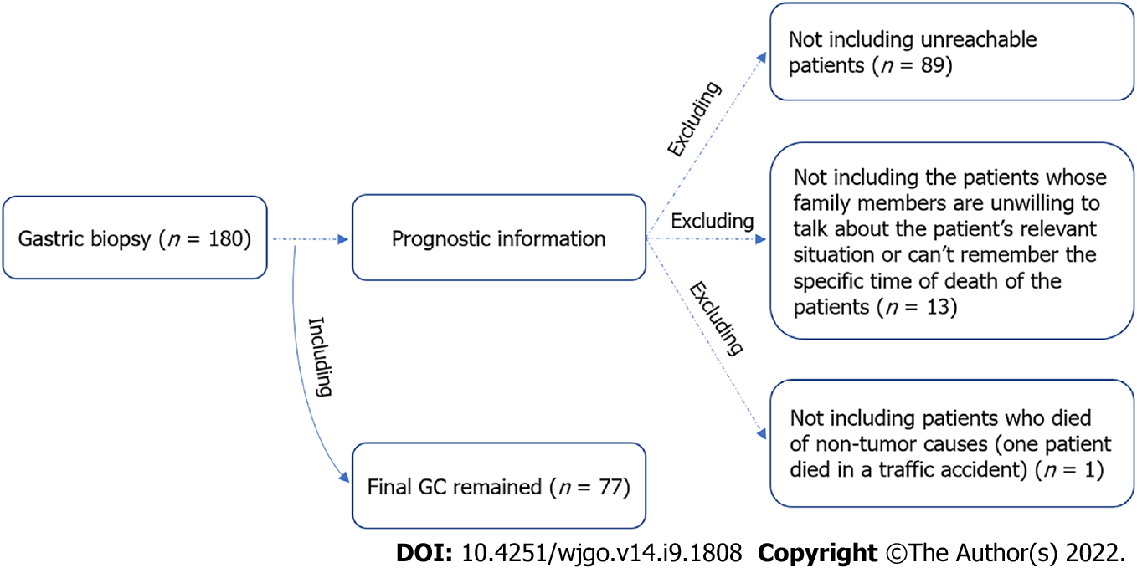
Figure 1 Flow chart for recruitment of gastric cancer patients. GC: Gastric cancer.

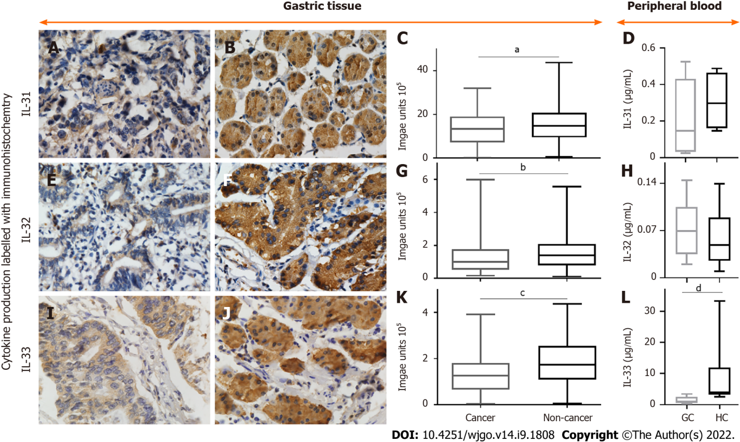
Figure 2 Representative images of immunohistochemical staining for interleukin-31, interleukin-32, and interleukin-33 and their densities in non-cancerous and gastric cancer tissues, as well as their levels in peripheral blood of gastric cancer patients and healthy individuals. A-C: Positive (brown) interleukin (IL)-31 expression in gastric cancer (A) and noncancerous tissues (B) and quantified data (C); D, H, and L: IL-31 (D), IL-32 (H), and IL-33 (L) levels in peripheral blood from gastric cancer (GC) patients and healthy controls (HC); E-G: Positive IL-32 expression in gastric cancer (E) and noncancerous tissues (F) and quantified data (G); I-K: Positive IL-33 expression in gastric cancer (I) and noncancerous tissues (J) and quantified data (K). The densities of IL-31 and IL-33 were all decreased in GC compared to tumour-adjacent normal gastric tissues. Magnification, 600 ×. ªP < 0.05; ^{b}P < 0.01; ^{c}P < 0.0001; ^{d}P < 0.05. GC: Gastric cancer; IL: Interleukin.

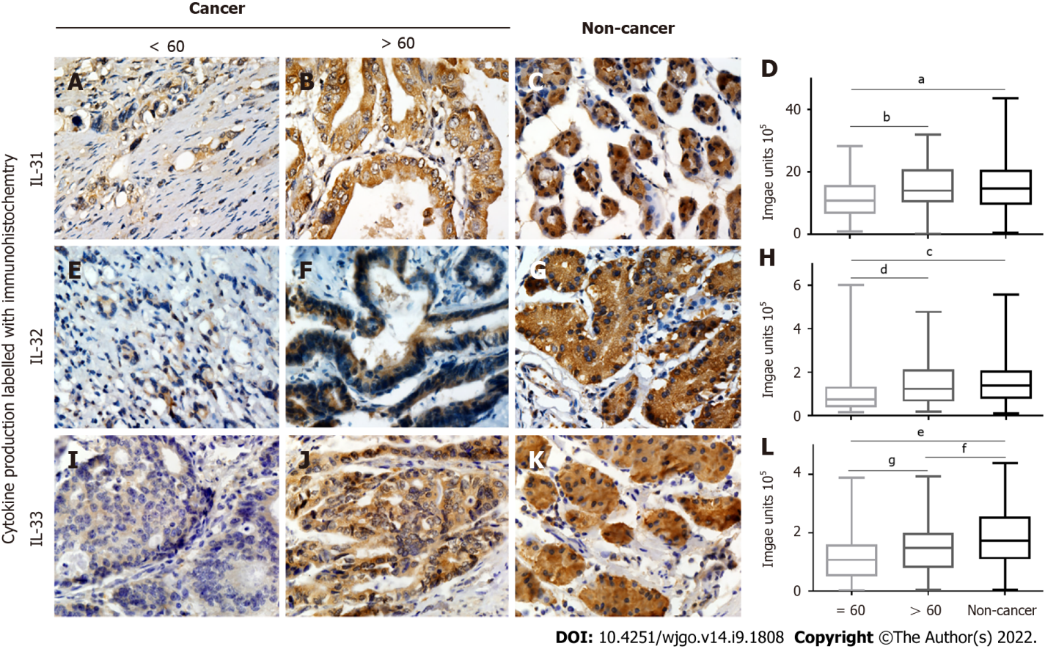
Figure 3 Correlation of interleukin-31, interleukin-32, and interleukin-33 expression with age. A-D: Positive (brown) interleukin (IL)-31 expression in gastric cancer tissues from patients aged < 60 (A) vs > 60 (B) years and noncancerous tissues (C) plus quantified data (D); E-H: Positive (brown) IL-32 expression in gastric cancer tissues from patients aged < 60 (E) vs > 60 (F) years and noncancerous tissues (G), and quantified data (H); I-L: Positive (brown) IL-33 expression in gastric cancer tissues from patients aged < 60 (I) vs > 60 (J) years and noncancerous tissues (K) plus quantified data (L). IL-32 and IL-33 were all decreased in the group of gastric cancer patients aged less than or equal to 60 years. ªP < 0.01; ^{b}P < 0.01; ^{c}P < 0.0001; ^{d}P < 0.01; ^{e}P < 0.0001; ^{f}P < 0.05; ^{g}P < 0.05. IL: Interleukin.

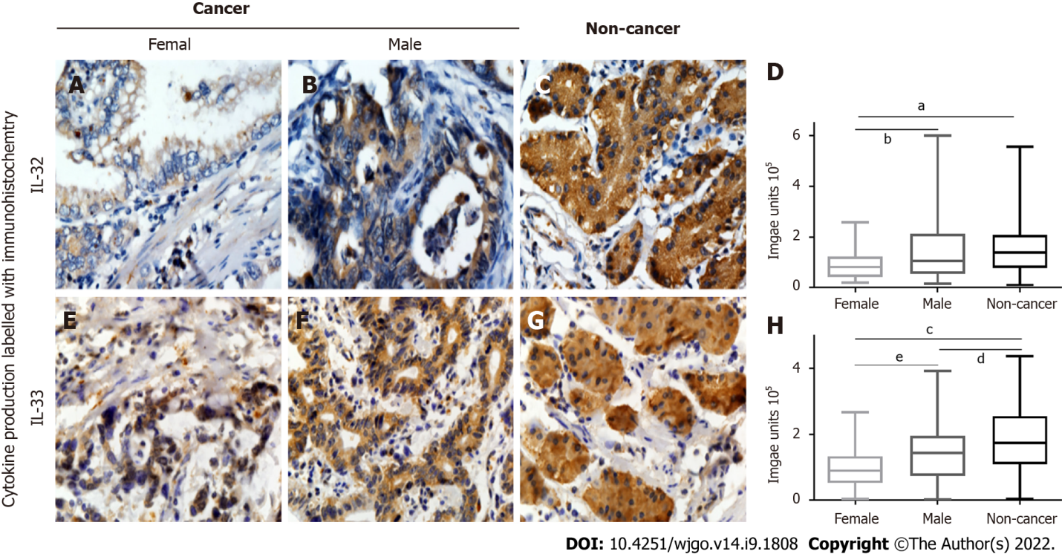
Figure 4 Correlation of interleukin-32 and interleukin-33 expression with sex. A-D: Positive (brown) interleukin (IL)-32 expression in gastric cancer tissues from female (A) vs male (B) patients and noncancerous tissues (C) plus quantified data (D); E-H: Positive (brown) IL-33 expression in gastric cancer tissues from female (E) vs male (F) patients and noncancerous tissues (G) plus quantified data (H). IL-32 and IL-33 both decreased in female patients with gastric cancer. ªP < 0.001; ^{b}P < 0.05; ^{c}P < 0.0001; ^{d}P < 0.01; ^{e}P < 0.05. IL: Interleukin.

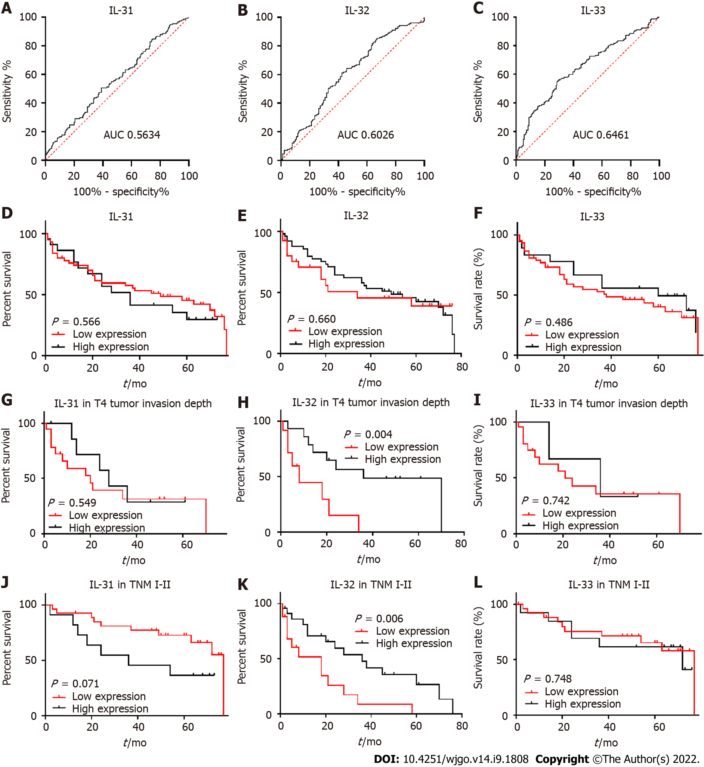
Figure 5 Receiver operating characteristic curves, correlation of interleukin-31, interleukin-32, and interleukin-33 with prognosis of gastric cancer, and subgroup analysis for patients at T4 stage and TNM stage I-II. A-C: The specificity (X-axis) vs sensitivity (Y-axis) of interleukin (IL)-31 (A), IL-32 (B), and IL-33 (C); D-F: Comparison of 5-year survival rate between patients with high and low IL-31 (D), IL-32 (E), and IL-33 (F) expression; G-I: Comparison of 5-year survival rate between patients with high and low IL-31 (G), IL-32 (H), and IL-33 (I) expression in the T4 subgroup; J-L: Comparison of 5-year survival rate between patients with high and low IL-31 (J), IL-32 (K), abd IL-33 (L) expression in the TNM stage 2 subgroup. ROC curves analysis displayed the poor diagnostic potential of IL-31, IL-32, and IL-33 expression for GC. The cut-off point and area under the curve were: IL-31: 1.486 × 10⁶, area under the curve (AUC) = 0.563; IL-32: 64893, AUC = 0.603; IL-33: 166291, AUC = 0.646. Kaplan-Meier survival analysis of GC patients showed that decreased IL-32 expression correlated with a poor survival of GC patients in the T4 and TNM I-II subgroups. IL: Interleukin; AUC: Area under the curve.

Table 1 Correlations between interleukin-31, interleukin-32, and interleukin-33 expression and clinical/pathological features in patients with gastric cancer (n = 180)
Characteristic | Patient number | IL-31 median | P value | IL-32 median | P value | IL-33 median | P value
All cancer | 180 | 1.333 × 10⁶ |  | 99245 |  | 125998
Noncancer (non) | 159 | 1.472 × 10⁶ | 0.043 | 138164 | 0.001 | 173818 | < 0.0001

Gender
Male | 140 | 1.344 × 10⁶ |  | 106075 |  | 143830
Female | 40 | 1.208 × 10⁶ | 0.329 | 81009 | 0.040 | 89697 | 0.029

Age
≤ 60 | 79 | 1.082 × 10⁶ |  | 74098 |  | 106857
> 60 | 101 | 1.404 × 10⁶ | 0.007 | 122682 | 0.001 | 148615 | 0.026

Tumour size (diameter)
< 5 cm | 87 | 1.325 × 10⁶ |  | 98583 |  | 122572
≥ 5 cm | 93 | 1.335 × 10⁶ | > 0.999 | 101583 | > 0.999 | 126415 | > 0.999

Lymph node metastasis
No | 75 | 1.404 × 10⁶ |  | 106075 |  | 143359
Yes | 105 | 1.267 × 10⁶ | 0.284 | 93196 | 0.671 | 113657 | 0.3

Differentiation
High | 14 | 1.609 × 10⁶ | H/M > 1 | 114379 | H/M > 1 | 171038 | H/M: > 0.999
Moderate | 78 | 1.393 × 10⁶ | H/L: 0.6 | 113024 | H/L> 1 | 142850 | H/L: 0.2
Low | 88 | 1.146 × 10⁶ | M/L: 0.3 | 91551 | M/L: 0.4 | 104570 | M/L: 0.1

Invasion depth
T1 | 4 | 2.072 × 10⁶ |  | 218529 | T1/T3: 0.5, T1/T4: 0.6 | 156096
T2 | 27 | 1.600 × 10⁶ |  | 110353 |  | 143582
T3 | 75 | 1.208 × 10⁶ |  | 98367 |  | 116081
T4 | 74 | 1.318 × 10⁶ | All > 1 | 96542 | T1/T2, T2/T3, T2/T4, T3/T4, all > 1 | 125941 | All > 1

TNM
I | 12 | 1.355 × 10⁶ |  | 98583 |  | 142117 | I/IV: 0.8
II | 70 | 1.414 × 10⁶ |  | 113560 | II/ IV: 0.6 | 147031 | II/III: 0.3, II/IV: 0.1
III | 92 | 1.288 × 10⁶ |  | 87667 |  | 107919 | III/IV: 0.7
IV | 6 | 0.950 × 10⁶ | All > 1 | 54851 | I/II, I/III, I/IV, II/ III, III/IV, all > 1 | 52195 | I/II, I/III>1
IL: Interleukin.

Table 2 Univariate and multivariate analyses of clinicopathological factors affecting survival of patients with gastric cancer at T4 stage
Variables analysis | Univariate HR (95%CI) | P value | Multivariate HR (95%CI) | P value
IL-32 (low/high) | 4.338 (1.450-12.980) | 0.009 | 3.287 (1.024-10.555) | 0.046
Tumour differentiation (low/moderate) | 0.710 (0.225-2.237) | 0.559
TNM |  | 0.008 |  | 0.037
IV (reference) | 1 |  | 1
II | 0.034 (0.003-0.423) | 0.008 | 0.069 (0.005-0.946) | 0.045
III | 0.203 (0.018-0.464) | 0.004 | 0.127 (0.025-0.646) | 0.013
Lymph node metastasis (no/yes) | 0.441 (0.098-1.982) | 0.285
Diameter (< 5/≥ 5, cm) | 0.475 (0.161-1.404) | 0.178
Female/male | 0.912 (0.323-2.573) | 0.862
Age (≤ 60/> 60) | 1.950 (0.688-5.529) | 0.209

Table 3 Univariate and multivariate analyses of clinicopathological factors affecting survival of patients with gastric cancer in TNM I-II stage
Variable | Univariate HR (95%CI) | P value | Multivariate HR (95%CI) | P value
IL-32 (low/high) | 0.180 (0.024-1.370) | 0.098
Tumour differentiation |  | 0.947
Low (reference) | 1
High | 1.259 (0.258-6.133) | 0.776
Moderate | 0.964 (0.324-2.871) | 0.947
Tumour invasion depth |  | 0.546
T4 (reference) | 1
T2 | 0.567 (0.059-5.491) | 0.624
T3 | 1.460 (0.187-11.379) | 0.718
Lymph node metastasis (no/yes) | 0.307 (0.108-0.868) | 0.026 | 0.490 (0.152-1.578) | 0.232
Diameter (< 5/≥ 5, cm) | 0.259 (0.092-731) | 0.011 | 0.368 (0.112-1.165) | 0.088
Female/male | 0.522 (0.116-2.340) | 0.396
Age (≤ 60/> 60) | 0.562 (0.192-1.646) | 0.293

Published by Baishideng Publishing Group Inc
7041 Koll Center Parkway, Suite 160, Pleasanton, CA 94566, USA
Telephone: +1-925-3991568
E-mail: bpgoffice@wjgnet.com
Help Desk: https://www.f6publishing.com/helpdesk
https://www.wjgnet.com

© 2022 Baishideng Publishing Group Inc. All rights reserved.

