Name of Journal: World Journal of Clinical Cases
Manuscript NO: 48191
Manuscript Type: ORIGINAL ARTICLE

Retrospective Study
HER2 heterogeneity is a poor prognosticator for HER2 positive gastric cancer

Kaito A et al. HER2 heterogeneity in gastric cancer

Akio Kaito, Takeshi Kuwata, Masanori Tokunaga, Kohei Shitara, Reo Sato, Tetsuo Akimoto, Takahiro Kinoshita

Akio Kaito, Masanori Tokunaga, Reo Sato, Takahiro Kinoshita, Department of Gastric Surgery, National Cancer Center Hospital East, Kashiwa 277-8577, Japan

Akio Kaito, Takeshi Kuwata, Department of Pathology and Clinical Laboratories, National Cancer Center Hospital East, Kashiwa 277-8577, Japan

Takeshi Kuwata, Kohei Shitara, Exploratory Oncology Research & Clinical Trial Center (EPOC), National Cancer Center Hospital East, Kashiwa 277-8577, Japan

Akio Kaito, Kohei Shitara, Department of Gastrointestinal Oncology, National Cancer Center Hospital East, Kashiwa 277-8577, Japan

Tetsuo Akimoto, Juntendo University graduate School of Medicine, Tokyo 163-8001, Japan

Tetsuo Akimoto, Department of Radiation Oncology, National Cancer Center Hospital East, Kashiwa 277-8577, Japan

ORCID number: Akio Kaito (0000-0003-0839-5695); Takeshi Kuwata (0000-0003-0044-953X); Masanori Tokunaga (0000-0002-3183-349X); Kohei Shitara (0000-0001-5196-3630); Reo Sato (0000-0002-2841-0728); Tetsuo Akimoto (0000-0003-0881-1345); Takahiro Kinoshita (0000-0001-7365-8733).

Author contributions: Kaito A and Kuwata T contributed equally to this work; i.e., study concepts, study design, data acquisition, quality control of data and algorithms, and data analysis and interpretation; Kaito A contributed to statistical analysis and manuscript preparation; All authors contributed equally to manuscript editing and manuscript review.

Institutional review board statement: This study was approved by the Institutional Review Board of the National Cancer Center, Japan, No. 2017-164, approval date: Oct. 11, 2017.

Informed consent statement: Comprehensive informed consent including publication without personally identifiable information was obtained from all of the subjects prior to study enrollment, thus specified informed consent for this study is not required. The public document of this study was published on our website: https://www.ncc.go.jp/jp/about/research_promotion/study/list/2017-164.pdf. Informed consent statement could not be obtained because most of the participants were died.

Conflict-of-interest statement: The authors have no conflict of interest to declare.

Open-Access: This article is an open-access article which was selected by an in-house editor and fully peer-reviewed by external reviewers. It is distributed in accordance with the Creative Commons Attribution Non Commercial (CC BY-NC 4.0) license, which permits others to distribute, remix, adapt, build upon this work non-commercially, and license their derivative works on different terms, provided the original work is properly cited and the use is non-commercial. See: http://creativecommons.org/licenses/by-nc/4.0/

Manuscript source: Invited manuscript

Corresponding author: Takeshi Kuwata, MD, PhD, Doctor, Department of Pathology and Clinical Laboratories, National Cancer Center Hospital East, 6-5-1, Kashiwanoha, Kashiwa 277-8577, Japan. tkuwata@east.ncc.go.jp
Telephone: +81-4-71331111
Fax: +81-4-71300190

Received: April 13, 2019
Peer-review started: April 15, 2019
First decision: May 16, 2019
Revised: June 16, 2019
Accepted: June 26, 2019
Article in press: June 26, 2019
Published online: August 6, 2019

Abstract
BACKGROUND
The clinical significance of intratumoral human epidermal growth factor receptor 2 (HER2) heterogeneity is unclear for HER2 positive gastric cancer, although it has been reported to be a significant prognosticator for HER2 positive breast cancer which has received trastuzumab-based chemotherapy.

AIM
To clarify the clinical significance of intratumoral HER2 heterogeneity for HER2 positive gastric cancer which has received trastuzumab-based chemotherapy.

METHODS
Patients with HER2 positive unresectable or metastatic gastric cancer who received trastuzumab-based chemotherapy as a first line treatment were included. The patients were classified into two groups according to their intratumoral HER2 heterogeneity status examined by immunohistochemistry (IHC) on endoscopic biopsy specimens before treatment, and their clinical response to chemotherapy and survival were compared.

RESULTS
A total of 88 patients were included in this study, and HER2 heterogeneity was observed in 23 (26%) patients (Hetero group). The overall response rate was significantly better in the patients without HER2 heterogeneity (Homo group) (Homo vs Hetero: 79.5% vs 35.7%, P = 0.002). Progression free survival of trastuzumab-based chemotherapy was significantly better in the Homo group (median, 7.9 vs 2.5 mo, HR: 1.905, 95%CI: 1.109-3.268). Overall survival was also significantly better in the Homo group (MST, 25.7 vs 12.5 mo, HR: 2.430, 95%CI: 1.389-4.273). Multivariate analysis revealed IHC HER2 heterogeneity as one of the independent poor prognostic factors (HR: 3.115, 95%CI: 1.610-6.024).

CONCLUSION
IHC HER2 heterogeneity is the pivotal predictor to trastuzumab-based chemotherapy, thus HER2 heterogeneity should be considered for assessment of HER2 expression.

Key words: Human epidermal growth factor receptor 2; Heterogeneity; Trastuzumab; Gastric cancer

© The Author(s) 2019. Published by Baishideng Publishing Group Inc. All rights reserved.

Core tip: Although intratumoral human epidermal growth factor receptor 2 (HER2) heterogeneity was reported as important predictor to trastuzumab-based chemotherapy for HER2 positive breast cancer, the clinical significance of HER2 heterogeneity for gastric cancer had been unclear. We defined intratumoral HER2 heterogeneity as biopsy specimens which were taken from two or more different portion of the tumor showed different immunohistochemistry HER2 positivity, and HER2 heterogeneity based on this definition was pivotal poor predictor of tumor shrinkage and poor prognosticator. Thus, intratumoral HER2 heterogeneity should be included to assessment of HER2 positivity.

Citation: Kaito A, Kuwata T, Tokunaga M, Shitara K, Sato R, Akimoto T, Kinoshita T. HER2 heterogeneity is a poor prognosticator for HER2 positive gastric cancer. World J Clin Cases 2019; 7(15):1964-1977
URL: https://www.wjgnet.com/2307-8960/full/v7/i15/1964.htm
DOI: https://dx.doi.org/10.12998/wjcc.v7.i15.1964

INTRODUCTION
Human epidermal growth factor receptor 2 (HER2) was introduced as a predictive biomarker for the treatment of gastric cancer along with trastuzumab^{[1]}, and subsequently trastuzumab was recommended to be administered for HER2 positive gastric cancer as a molecular target drug^{[2,3]}. Assessment of HER2 expression was performed by immunohistochemistry (IHC) and in-situ hybridization (ISH), where positive for HER2 was defined as 3+ on IHC or 2+ on IHC with ISH positive^{[4]}. The strong HER2 intensity of IHC 3+ was reported as a better prognostic factor for HER2 positive gastric cancer treated with trastuzumab-based chemotherapy^{[1]}.
The frequency of intratumoral HER2 heterogeneity was reported as 45%-79% by IHC and 23%-54% by ISH for HER2 positive gastric cancers^{[5-8]}, which were more frequent than that with HER2 positive breast cancers^{[9]}. Although intratumoral HER2 heterogeneity was reported to be one of the poor predictors for the treatment response and poor prognosticator for patients with HER2 positive breast cancer who received trastuzumab-based chemotherapy^{[10,11]}, the clinical significance of intratumoral HER2 heterogeneity for HER2 positive gastric cancer treated with trastuzumab has not been well investigated. Recently, Wakatsuki et al^{[12]} reported that intratumoral HER2 heterogeneity had negative survival benefit for the patients with surgically resected HER2 positive gastric cancer. However, HER2 assessment before treatment is usually based on the endoscopic biopsy specimen for metastatic gastric cancer, and the clinical significance of intratumoral HER2 heterogeneity for biopsy specimen is still unknown.
The aim of this study was to clarify the clinical significance of intratumoral HER2 heterogeneity for HER2 positive gastric cancer treated with trastuzumab-based chemotherapy by evaluation of biopsy specimens.

MATERIALS AND METHODS
Patients and data collection
Patients with histologically confirmed HER2 positive metastatic or unresectable adenocarcinoma of the stomach or gastro-oesophageal junction cancer who received trastuzumab-based chemotherapy as first-line treatment at our hospital between July 2011 and December 2017 were included in this study. The patients were classified into two groups according to intratumoral HER2 heterogeneity, and their clinicopathological findings, clinical responses, progression free survival (PFS) and overall survival (OS) were compared between both groups. Furthermore, the predictive factor for clinical response and prognostic factor were analyzed using multivariable analyses. We extracted clinicopathological findings such as age, sex, tumor diameter, tumor location, macroscopic tumor type, tumor markers, Eastern Cooperative Oncology Group performance score, TNM stage, metastatic site, chemotherapy regimen, histological type of endoscopic biopsy specimen, HER2 positivity, survival outcomes from our prospectively collected database and medical records. Biopsied specimens stained by IHC were reviewed and assessed for their intratumoral HER2 heterogeneity by two pathologists (A.K. and T.K.).
Those patients who received gastrectomy prior to chemotherapy and patients who received chemotherapy without trastuzumab were excluded. Clinical response was evaluated according to new response evaluation criteria in solid tumors (RECIST guideline ver. 1.1) for the patients with measurable metastatic lesions^{[13]}. The onset of PFS was defined as the start of chemotherapy and tumor progression was evaluated by imaging techniques and physical examination. Tumor progression dates for the patients who received radical gastrectomy after good clinical response to chemotherapy were defined as the date of first recurrence after surgery. Tumor staging of gastric and EGJ type III tumor was followed by the Union for International Cancer Control TNM classification of 7th edition for gastric cancer and tumor staging of EGJ type II tumor was followed by that for esophageal cancer^{[14]}. Tumor histology was assessed according to the Japanese Classification of Gastric Carcinoma^{[15]}, with well and moderately differentiated adenocarcinoma and papillary adenocarcinoma classified as differentiated type, and poorly differentiated adenocarcinoma, signet ring cell carcinoma, and mucinous carcinoma classified as undifferentiated type.

Treatment schedules
Chemotherapy regimens were capecitabine or 5-fluorouracil plus cisplatin with trastuzumab (XPT/FPT) before Sep, 2015 and S-1 plus oxaliplatin with trastuzumab (SOXT) after Oct, 2015. XPT or FPT regimens were followed as ToGA study regimen^{[1]}. SOXT regimen was followed as G-SOX study regimen in combination with trastuzumab; oxaliplatin was administered intravenously 100 mg/m² on day 1, while S-1 was administered orally 80 mg/ m² for 14 d followed by a 7-d rest. This schedule was repeated every 3 wk. Trastuzumab was given by intravenous infusion at a dose of 8 mg/kg on day 1 of the first cycle, followed by 6 mg/kg every 3 wk until disease progression^{[16]}.

HER2 immunohistochemistry and fluorescence in situ hybridization
All endoscopic biopsy samples were fixed in neutral buffered 10% formalin. Formalin-fixed paraffin-embedded tumor samples were examined for HER2 using IHC and fluorescence in situ hybridization (FISH) in case of HER2 score 2+.
HER2 IHC analyses were performed using the PATHWAY anti-HER-2/neu (4B5) rabbit monoclonal primary antibody (Ventana Medical Systems, Tucson, AZ, United States). IHC HER2 scoring by biopsy specimen was adopted as ToGA study^{[1]}. In brief, tumor cell clusters of at least 5 positive cells with complete basolateral or lateral membranous reactivity was HER2 positive for endoscopic biopsy samples irrespective of percentage of tumor cells stained. Tumor cells with strong membranous reactivity were scored 3+ and those with moderate reactivity were scored 2+. HER2 FISH analyses were performed at SRL (Tokyo, Japan) using the Path Vysion HER2 DNA Probe kit (Vysis, Downers Grove, IL, United States). When the ratio of HER2 signals to chromosome 17 centromere signals was 2.0 or greater, the gene was considered as amplified (i.e., FISH positive). HER2 positivity was defined as IHC score 3+ or IHC score 2+ and FISH positivity, because these criteria were considered to be indications for using trastuzumab by a subset analysis of the ToGA trial^{[1,3]}.

Assessment of intratumoral HER2 heterogeneity
Assessment of intratumoral HER2 heterogeneity was conducted on patients who underwent assessment of HER2 positivity from two or more different portions of the same tumor, and three or more biopsy specimens were obtained from each portion. Those patients whose HER2 assessment was performed from only one portion were excluded for further examination. Intratumoral HER2 homogeneity was defined as every portion being HER2 positive by IHC, and any portion of the tumor showing HER2 negative defined as intratumoral HER2 heterogeneity (Figure 1).

Statistical analysis
The baseline characteristics of each group were compared using the χ² test or the Fisher’s exact test for categorical data and P < 0.05 was considered statistically significant. The median OS rate and PFS rate were estimated by the Kaplan-Meier method. Independent prognostic factors for OS and PFS were evaluated by univariate and multivariable analysis of Cox proportional hazard model and presented as hazard ratio and 95% confidence interval (CI). Evaluated factors in multivariable analysis were those factors which were significant by univariate analysis. Data were censored on May 31, 2019. All statistical analyses were performed using SPSS Statistics 20 (SPSS Inc., Chicago, IL, United States).
This study was approved by the Institutional Review Board of the National Cancer Center, Japan (IRB file No. 2017-164, approval date: Oct. 11, 2017).

RESULTS
A total of 776 patients with metastatic or unresectable adenocarcinoma of the stomach or gastro-oesophageal junction were treated in this study period, and HER2 positivity was observed in 127 (16.3%). Of these, patients who received upfront gastrectomy before chemotherapy (n = 5) or chemotherapy without trastuzumab (n = 21), and patients who underwent HER2 assessment from one portion of tumor (n = 13) were excluded (Figure 2). Finally, a group of 88 patients were evaluated for their intratumoral HER2 heterogeneity, in which HER2 homogeneity was observed in 65 (Homo group) and HER2 heterogeneity was observed in 23 (Hetero group) patients, respectively.
Patients’ backgrounds are shown in Table 1. Intratumoral HER2 heterogeneity was significantly more frequently observed in macroscopically type 3 and type 4 patients than other types, and patients with IHC 2+ than IHC 3+. Other background characteristics such as age, sex, performance status, TNM stage, metastatic site and chemotherapeutic regimens were not significantly different between both groups. Besides, the number of biopsy site for HER2 assessment were not significantly different, i.e., those numbers more than three was 46% for Homo group and 57% for Hetero group (P = 0.393). Waterfall plot for tumor shrinkage and clinical responses for the patients with measurable metastatic lesions (n = 58) of both groups were shown in Figure 3. Overall response rate (complete response and partial response) was 79.5% in the Homo group, which was considerably better than that in the Hetero group (35.7%, P = 0.002). Kaplan-Meier curves of OS and PFS in both groups were shown in Figure 4. At time of the analysis, the median follow-up was 18.5 mo (range, 4.7-88.0 mo). Median survival time in the Hetero group was 12.5 mo, which was considerably worse than that in the Homo group (25.7 mo, HR; 2.430, 95%CI: 1.389-4.273). Median PFS time in the Hetero group was 2.9 mo, which was also significantly worse than that in the Homo group (7.9 mo, HR: 2.000, 95%CI: 1.203-3.333). Multivariate analysis revealed IHC HER2 heterogeneity as one of the independent poor prognostic factors for OS (HR: 3.115, 95%CI: 1.610-6.024) and PFS (HR: 2.123, 95%CI: 1.225-3.676) (Table 2). Undifferentiated histological type (HR: 2.612, 95%CI: 1.388-4.916), number of non-curative factors (HR: 2.252, 95%CI: 1.113-4.553), clinical nodal status (HR: 2.119, 95%CI: 1.165-3.855), hepatic metastasis (HR: 2.084, 95%CI: 1.076-4.036) and HER2 score (2+) (HR: 2.008, 95%CI: 1.094-3.690) were also extracted as independent poor prognostic factors for OS. We compared survival results by the combination of each HER2 score (2+ or 3+) and HER2 heterogeneity (homogeneity or heterogeneity). MST for the Homo group with HER2 3+ was longest (28.2 mo), followed by Hetero group with 3+ (14.6 mo) and Homo group with 2+ (12.9 mo). Hetero group with 2+ had the worst prognosis (MST: 7.2 mo) (Figure 5).

DISCUSSION
In this study, we examined the effect of intratumoral HER2 heterogeneity by IHC for HER2 positive advanced gastric cancer treated with trastuzumab-based chemotherapy on their therapeutic responses and survival. Intratumoral HER2 heterogeneity by IHC evaluated by biopsy specimen before treatment was one of the independent poor predictive factors for tumor shrinkage, and a poor prognosticator.
The definition of intratumoral HER2 heterogeneity for HER2 positive gastric cancer has not been well established. The cut-off value between HER2 homogeneity and heterogeneity of HER2 positive tumor cells varies 50% to 100% for surgically resected specimens^{[5,6,12,17]} and 30% to 100% for endoscopic biopsy specimens^{[7,8,18]}. The clinical significance of intratumoral HER2 heterogeneity for HER2 positive gastric cancer treated with trastuzumab also has not been well investigated and there have been only a few studies conducted so far. Wakatsuki et al^{[12]} defined the cut-off value of HER2 heterogeneity as 100%, and reported that HER2 homogeneity group had significantly longer PFS (HR: 0.11, 95%CI: 0.03-0.41) and OS (HR: 0.18, 95%CI: 0.06-0.72). However, their study included only 28 patients who received trastuzumab-based chemotherapy after upfront gastrectomy for resectable gastric cancer, not metastatic cancer.
In post hoc exploratory analyses of ToGA trial, the proportion of HER2 positive tumor cells in more than 30% of biopsy specimens could not be extracted as a predictive factor for good response to trastuzumab-based chemotherapy^{[18]}. Recently Yagi et al^{[8]} reported intratumoral HER2 heterogeneity was a poor predictor for trastuzumab-based chemotherapy and a poor prognosticator with the cut-off value of 100% from the median number of four biopsy specimens. Our current study selected the patients in whom HER2 positivity could be assessed from more than two different portions of the tumor, and we defined HER2 heterogeneity as any of those portions of the tumor that did not show HER2 positivity. The number of biopsy specimens examined for each patient in our current study was more than six (i.e., each of the three fragments were obtained from two or more different portions). Although Yagi et al^{[8]} adopted the overall proportion of HER2 positive tumor cells to evaluate intratumoral HER2 heterogeneity, we employed standard criteria of HER2 positivity generally performed in clinical diagnosis, i.e., tumor cell cluster of at least 5 positive cells with complete basolateral or lateral membranous reactivity. According to our simple definition of intratumoral HER2 heterogeneity, the treatment outcomes were definitively different between the HER2 homogeneity group and heterogeneity group.
The stain intensity for IHC was reported as a significant prognostic factor for HER2 positive gastric cancer in ToGA trial. The OS was significantly longer in IHC 3+ patients than IHC 2+ patients (MST: 17.9 and 12.3 mo)^{[1]}. Assessment of HER2 positivity for endoscopic biopsy specimen in ToGA trial was established without consideration of intratumor HER2 heterogeneity, which is now commonly adopted worldwide^{[4]}. Prognostic significance of stain intensity for IHC was also explored in combination with heterogeneity for IHC in our current study. MST of Homo-IHC 3+ patients was 28.2 mo, which was much better than MST of IHC 3+ patients (17.9 mo) in ToGA trial. Hetero-IHC 3+ and Homo-IHC 2+ patients had comparable survival (14.6 and 12.9 mo), on the other hand Hetero-IHC 2+ patients had poorer survival (7.2 mo) compared to IHC 2+ patients (12.3 mo) in ToGA trial. These results suggest that intratumoral HER2 heterogeneity should be included in the assessment of HER2 positivity in addition to the stain intensity for IHC, and patients with Homo-IHC 3+ might be the most effective to further anti-HER2 agents. The survival benefits for anti-HER2 drugs such as lapatinib or pertuzumab in combination with trastuzumab and adjuvant therapy of trastuzumab or trastuzumab beyond progression were proven for breast cancers^{[19-22]}. However, the efficacy of those anti-HER2 agents had not been proven for gastric cancers and intratumoral HER2 heterogeneity may be considered as one of the reasons for the difference of these results between breast and gastric cancers^{[23,24]}.
Although intrinsic mechanism of the correlation between HER2 heterogeneity and poor efficacy for trastuzumab-based chemotherapy is still unclear, chemo-resistance can be one of the main reasons for the treatment failure. Fabi et al^{[25]} reported the discordances of HER2 positivity between primary and metastatic lesions may be a possible cause of chemo-resistance of trastuzumab for metastatic breast cancers. Park et al^{[26]} reported these discordances between primary and metastatic lesions could often be observed also in HER2 positive gastric cancers, and HER2 heterogeneity of primary lesions was existed in such cases with discordances of HER2 positivity. Another explanation for the poor efficacy for trastuzumab might be genomic alterations. Pietrantonio et al^{[27]} reported chemo-resistances for trastuzumab were more frequently observed in patients with genomic alternations including EGFR/MET/KRAS/PI3K/PTEN mutations than those without. They stated such genomic mutations were correlated with IHC 2+, i.e., the existence of HER2 heterogeneity.
Our study has several limitations. The first, concordance of intratumoral HER2 heterogeneity between endoscopic biopsy specimen and whole tumor tissues has not been investigated in the current study. The concordance of HER2 positivity between biopsy specimens and surgically resected specimens was reported to be 80%-91% for IHC 3+ and 25%-57% for IHC 2+ patients^{[28-30]}, thus the interpretation of HER2 heterogeneity for IHC 2+ patients must be made with care. In breast cancer, similar results are also reported comparing core needle biopsy specimens and surgically resected specimens^{[31]}, and repeat testing or reflex testing using an alternative assay (IHC or ISH) are recommended for IHC equivocal cases^{[32]}. Secondly, there was no common standard of adequate numbers and portions for the assessment of intratumoral HER2 heterogeneity. In this study, the assessment of intratumoral HER2 heterogeneity was performed from at least two portions of the tumor. Ohno, et al. reported that HER2 positivity was different from the portion of tumor^{[33]}, i.e., the frequency of HER2 positivity of biopsy specimen from the superficial spreading portion, ulcer mound, and mass portion was as high as 90% to 100%, while these from ulcer bed was only 45% due to the presence of concomitant necrotic tissues and associated inflammation^{[34]}. These results suggest that the assessment of HER2 heterogeneity should be based on biopsy specimens taken from the adequate portion of tumor. Thirdly, this study did not include the intratumoral heterogeneity of HER2 gene amplification. Intratumoral heterogeneity of HER2 gene amplification was reported to be one of the significant prognostic factors for metastatic or resectable advanced breast cancers^{[9,11]}. The significance of intratumoral heterogeneity of HER2 gene amplification should also be clarified by further investigations.
In conclusion, intratumoral HER2 heterogeneity by IHC was a significant predictor of clinical response and a poor prognosticator for trastuzumab-based chemotherapy, thus intratumoral HER2 heterogeneity would be useful to further stratify patients with HER2 positive gastric cancer, and thus should be taken into account in future clinical trials.

Article Highlights
Research background
Human epidermal growth factor receptor 2 (HER2) was introduced as a predictive biomarker for the treatment of gastric cancer along with trastuzumab, and the strong HER2 intensity of immunohistochemistry (IHC) 3+ was reported as a better prognostic factor for HER2 positive gastric cancer treated with trastuzumab-based chemotherapy. The frequency of intratumoral HER2 heterogeneity for HER2 positive gastric cancers were reported to be more frequent than that with HER2 positive breast cancers. Although intratumoral HER2 heterogeneity was reported to be one of the poor predictors for the treatment response and poor prognosticator for patients with HER2 positive breast cancer who received trastuzumab-based chemotherapy, the clinical significance of intratumoral HER2 heterogeneity for HER2 positive gastric cancer treated with trastuzumab has not been well investigated. Furthermore, even the definitions of HER2 heterogeneity for HER2 positive gastric cancer had not been established so far. In this study, we were trying to establish the definition of intratumoral HER2 heterogeneity, and clarify the clinical significance of HER2 heterogeneity for HER2 positive gastric cancer based on the definition.

Research motivation
HER2 heterogeneity may be a pivotal predictor for the efficacy of trastuzumab based chemotherapy. Previously, some authors reported that intratumoral HER2 heterogeneity had negative survival benefit for the patients with surgically resected HER2 positive gastric cancer. However, HER2 assessment before treatment is usually based on the endoscopic biopsy specimen for metastatic gastric cancer, and the clinical significance of intratumoral HER2 heterogeneity for biopsy specimen is still unknown. If these clinical significances are clarified, HER2 heterogeneity might be introduced to assessment of HER2 positivity for gastric cancer in the future.

Research objectives
The aim of this study was to clarify the clinical significance of intratumoral HER2 heterogeneity for HER2 positive gastric cancer treated with trastuzumab-based chemotherapy by evaluation of biopsy specimens.

Research methods
Patients with HER2 positive metastatic or unresectable adenocarcinoma of the stomach or gastro-oesophageal junction who received trastuzumab-based chemotherapy as first-line treatment at our hospital were included. The patients were classified into two groups (Homo- and Hetero- group) according to intratumoral HER2 heterogeneity, and their clinicopathological findings, clinical responses, progression free survival (PFS) and overall survival (OS) were compared between both groups. Furthermore, the predictive factor for clinical response and prognostic factor were analyzed using multivariable analyses. Assessment of intratumoral HER2 heterogeneity was conducted on patients who underwent assessment of HER2 positivity from two or more different portions of the same tumor, and three or more biopsy specimens were obtained from each portion. Those patients whose HER2 assessment was performed from only one portion were excludedon. We introduced the new definition, that is to say intratumoral HER2 homogeneity was defined as every portion being HER2 positive by IHC, and any portion of the tumor showing HER2 negative defined as intratumoral HER2 heterogeneity.

Research results
A total of 776 patients with metastatic or unresectable adenocarcinoma of the stomach or gastro-oesophageal junction were treated in the study period, and HER2 positivity was observed in 127 (16.3%). Intratumoral HER2 heterogeneity was significantly more frequently observed in macroscopically type 3 and type 4 patients than other types, and patients with IHC 2+ than IHC 3+. Tumor shrinkage and clinical responses for the patients with measurable metastatic lesions were evaluated, and overall response rate (complete response and partial response) was considerably better in the Homo group than that in the Hetero group. Median survival time in the Hetero group was 12.5 mo, which was considerably worse than that in the Homo group (25.7 mo, HR; 2.430, 95%CI: 1.389-4.273). Median PFS time in the Hetero group was 2.9 mo, which was also significantly worse than that in the Homo group (7.9 mo, HR: 2.000, 95%CI: 1.203-3.333). Multivariate analysis revealed IHC HER2 heterogeneity as one of the independent poor prognostic factors for OS (HR: 3.115, 95%CI: 1.610-6.024) and PFS (HR: 2.123, 95%CI: 1.225-3.676).

Research conclusions
In this study, we examined the effect of intratumoral HER2 heterogeneity by IHC for HER2 positive advanced gastric cancer treated with trastuzumab-based chemotherapy on their therapeutic responses and survival. Intratumoral HER2 heterogeneity by IHC evaluated by biopsy specimen before treatment was one of the independent poor predictive factors for tumor shrinkage, and a poor prognosticator. Our current study selected the patients in whom HER2 positivity could be assessed from more than two different portions of the tumor, and we newly defined HER2 heterogeneity as any of those portions of the tumor that did not show HER2 positivity. We employed standard criteria of HER2 positivity generally performed in clinical diagnosis, i.e., tumor cell cluster of at least 5 positive cells with complete basolateral or lateral membranous reactivity. According to our simple definition of intratumoral HER2 heterogeneity, the treatment outcomes were definitively different between the HER2 homogeneity group and heterogeneity group. Assessment of HER2 positivity for endoscopic biopsy specimen in ToGA trial was established without consideration of intratumor HER2 heterogeneity. Our current study suggested the combination with heterogeneity for IHC might be beneficial to predict the efficacy of trastuzumab based chemotherapy.

Research perspectives
HER2 heterogeneity was a pivotal predictor for the efficacy of HER2 positive gastric cancers. However, there would be some problems should be solved in the future. The first, concordance of intratumoral HER2 heterogeneity between endoscopic biopsy specimen and whole tumor tissues has not been investigated in the current study. Secondly, there was no common standard of adequate numbers and portions for the assessment of intratumoral HER2 heterogeneity. Thirdly, this study did not include the intratumoral heterogeneity of HER2 gene amplification. Intratumoral heterogeneity of HER2 gene amplification was reported to be one of the significant prognostic factors for metastatic or resectable advanced breast cancers. The significance of intratumoral heterogeneity of HER2 gene amplification should also be clarified by further investigations. The survival benefits for anti-HER2 drugs such as lapatinib or pertuzumab in combination with trastuzumab and adjuvant therapy of trastuzumab or trastuzumab beyond progression were proven for breast cancers. However, the efficacy of those anti-HER2 agents had not been proven for gastric cancers and intratumoral HER2 heterogeneity may be considered as one of the reasons for the difference of these results between breast and gastric cancers. If more detailed clinical significance of intratumoral HER2 heterogeneity is solved in the future, anti-HER2 drugs other than trastuzumab would be adopted and treatment outcomes of HER2 positive gastric cancers would be improved.

REFERENCES
1 Bang YJ, Van Cutsem E, Feyereislova A, Chung HC, Shen L, Sawaki A, Lordick F, Ohtsu A, Omuro Y, Satoh T, Aprile G, Kulikov E, Hill J, Lehle M, Rüschoff J, Kang YK; ToGA Trial Investigators. Trastuzumab in combination with chemotherapy versus chemotherapy alone for treatment of HER2-positive advanced gastric or gastro-oesophageal junction cancer (ToGA): a phase 3, open-label, randomised controlled trial. Lancet 2010; 376: 687-697 [PMID: 20728210 DOI: 10.1016/S0140-6736(10)61121-X]
2 Japanese Gastric Cancer Association. Japanese gastric cancer treatment guidelines 2014 (ver. 4). Gastric Cancer 2017; 20: 1-19 [PMID: 27342689 DOI: 10.1007/s10120-016-0622-4]
3 Ajani JA, D'Amico TA, Almhanna K, Bentrem DJ, Chao J, Das P, Denlinger CS, Fanta P, Farjah F, Fuchs CS, Gerdes H, Gibson M, Glasgow RE, Hayman JA, Hochwald S, Hofstetter WL, Ilson DH, Jaroszewski D, Johung KL, Keswani RN, Kleinberg LR, Korn WM, Leong S, Linn C, Lockhart AC, Ly QP, Mulcahy MF, Orringer MB, Perry KA, Poultsides GA, Scott WJ, Strong VE, Washington MK, Weksler B, Willett CG, Wright CD, Zelman D, McMillian N, Sundar H. Gastric Cancer, Version 3.2016, NCCN Clinical Practice Guidelines in Oncology. J Natl Compr Canc Netw 2016; 14: 1286-1312 [PMID: 27697982]
4 Bartley AN, Washington MK, Colasacco C, Ventura CB, Ismaila N, Benson AB 3rd, Carrato A, Gulley ML, Jain D, Kakar S, Mackay HJ, Streutker C, Tang L, Troxell M, Ajani JA. HER2 Testing and Clinical Decision Making in Gastroesophageal Adenocarcinoma: Guideline From the College of American Pathologists, American Society for Clinical Pathology, and the American Society of Clinical Oncology. J Clin Oncol 2017; 35: 446-464 [PMID: 28129524 DOI: 10.1200/JCO.2016.69.4836]
5 Lee HE, Park KU, Yoo SB, Nam SK, Park DJ, Kim HH, Lee HS. Clinical significance of intratumoral HER2 heterogeneity in gastric cancer. Eur J Cancer 2013; 49: 1448-1457 [PMID: 23146959 DOI: 10.1016/j.ejca.2012.10.018]
6 Kurokawa Y, Matsuura N, Kimura Y, Adachi S, Fujita J, Imamura H, Kobayashi K, Yokoyama Y, Shaker MN, Takiguchi S, Mori M, Doki Y. Multicenter large-scale study of prognostic impact of HER2 expression in patients with resectable gastric cancer. Gastric Cancer 2015; 18: 691-697 [PMID: 25224659 DOI: 10.1007/s10120-014-0430-7]
7 Ahn S, Ahn S, Van Vrancken M, Lee M, Ha SY, Lee H, Min BH, Lee JH, Kim JJ, Choi S, Jung SH, Choi MG, Lee JH, Sohn TS, Bae JM, Kim S, Kim KM. Ideal number of biopsy tumor fragments for predicting HER2 status in gastric carcinoma resection specimens. Oncotarget 2015; 6: 38372-38380 [PMID: 26460823 DOI: 10.18632/oncotarget.5368]
8 Yagi S, Wakatsuki T, Yamamoto N, Chin K, Takahari D, Ogura M, Ichimura T, Nakayama I, Osumi H, Shinozaki E, Suenaga M, Fujisaki J, Ishikawa Y, Yamaguchi K, Namikawa K, Horiuchi Y. Clinical significance of intratumoral HER2 heterogeneity on trastuzumab efficacy using endoscopic biopsy specimens in patients with advanced HER2 positive gastric cancer. Gastric Cancer 2019; 22: 518-525 [PMID: 30328533 DOI: 10.1007/s10120-018-0887-x]
9 Lee HJ, Kim JY, Park SY, Park IA, Song IH, Yu JH, Ahn JH, Gong G. Clinicopathologic Significance of the Intratumoral Heterogeneity of HER2 Gene Amplification in HER2-Positive Breast Cancer Patients Treated With Adjuvant Trastuzumab. Am J Clin Pathol 2015; 144: 570-578 [PMID: 26386078 DOI: 10.1309/AJCP51HCGPOPWSCY]
10 Seol H, Lee HJ, Choi Y, Lee HE, Kim YJ, Kim JH, Kang E, Kim SW, Park SY. Intratumoral heterogeneity of HER2 gene amplification in breast cancer: its clinicopathological significance. Mod Pathol 2012; 25: 938-948 [PMID: 22388760 DOI: 10.1038/modpathol.2012.36]
11 Lee HJ, Seo AN, Kim EJ, Jang MH, Suh KJ, Ryu HS, Kim YJ, Kim JH, Im SA, Gong G, Jung KH, Park IA, Park SY. HER2 heterogeneity affects trastuzumab responses and survival in patients with HER2-positive metastatic breast cancer. Am J Clin Pathol 2014; 142: 755-766 [PMID: 25389328 DOI: 10.1309/AJCPIRL4GUVGK3YX]
12 Wakatsuki T, Yamamoto N, Sano T, Chin K, Kawachi H, Takahari D, Ogura M, Ichimura T, Nakayama I, Osumi H, Matsushima T, Suenaga M, Shinozaki E, Hiki N, Ishikawa Y, Yamaguchi K. Clinical impact of intratumoral HER2 heterogeneity on trastuzumab efficacy in patients with HER2-positive gastric cancer. J Gastroenterol 2018; 53: 1186-1195 [PMID: 29633013 DOI: 10.1007/s00535-018-1464-0]
13 Eisenhauer EA, Therasse P, Bogaerts J, Schwartz LH, Sargent D, Ford R, Dancey J, Arbuck S, Gwyther S, Mooney M, Rubinstein L, Shankar L, Dodd L, Kaplan R, Lacombe D, Verweij J. New response evaluation criteria in solid tumours: revised RECIST guideline (version 1.1). Eur J Cancer 2009; 45: 228-247 [PMID: 19097774 DOI: 10.1016/j.ejca.2008.10.026]
14 Sobin LH, Gospodarowicz MK, Wittekind C. TNM classification of malignant tumors, 7th ed. Wiley-Blackwell, A John Wiley & Sons, Ltd., 2009
15 Japanese Gastric Cancer Association. Japanese classification of gastric carcinoma: 3rd English edition. Gastric Cancer 2011; 14: 101-112 [PMID: 21573743 DOI: 10.1007/s10120-011-0041-5]
16 Koizumi W, Takiuchi H, Yamada Y, Boku N, Fuse N, Muro K, Komatsu Y, Tsuburaya A. Phase II study of oxaliplatin plus S-1 as first-line treatment for advanced gastric cancer (G-SOX study). Ann Oncol 2010; 21: 1001-1005 [PMID: 19875759 DOI: 10.1093/annonc/mdp464]
17 Motoshima S, Yonemoto K, Kamei H, Morita M, Yamaguchi R. Prognostic implications of HER2 heterogeneity in gastric cancer. Oncotarget 2018; 9: 9262-9272 [PMID: 29507688 DOI: 10.18632/oncotarget.24265]
18 Van Cutsem E, Bang YJ, Feng-Yi F, Xu JM, Lee KW, Jiao SC, Chong JL, López-Sanchez RI, Price T, Gladkov O, Stoss O, Hill J, Ng V, Lehle M, Thomas M, Kiermaier A, Rüschoff J. HER2 screening data from ToGA: targeting HER2 in gastric and gastroesophageal junction cancer. Gastric Cancer 2015; 18: 476-484 [PMID: 25038874 DOI: 10.1007/s10120-014-0402-y]
19 Johnston SRD, Hegg R, Im SA, Park IH, Burdaeva O, Kurteva G, Press MF, Tjulandin S, Iwata H, Simon SD, Kenny S, Sarp S, Izquierdo MA, Williams LS, Gradishar WJ. Phase III, Randomized Study of Dual Human Epidermal Growth Factor Receptor 2 (HER2) Blockade With Lapatinib Plus Trastuzumab in Combination With an Aromatase Inhibitor in Postmenopausal Women With HER2-Positive, Hormone Receptor-Positive Metastatic Breast Cancer: ALTERNATIVE. J Clin Oncol 2018; 36: 741-748 [PMID: 29244528 DOI: 10.1200/JCO.2017.74.7824.]
20 Swain SM, Baselga J, Kim SB, Ro J, Semiglazov V, Campone M, Ciruelos E, Ferrero JM, Schneeweiss A, Heeson S, Clark E, Ross G, Benyunes MC, Cortés J; CLEOPATRA Study Group. Pertuzumab, trastuzumab, and docetaxel in HER2-positive metastatic breast cancer. N Engl J Med 2015; 372: 724-734 [PMID: 25693012 DOI: 10.1056/NEJMoa1413513]
21 Gianni L, Eiermann W, Semiglazov V, Lluch A, Tjulandin S, Zambetti M, Moliterni A, Vazquez F, Byakhov MJ, Lichinitser M, Climent MA, Ciruelos E, Ojeda B, Mansutti M, Bozhok A, Magazzù D, Heinzmann D, Steinseifer J, Valagussa P, Baselga J. Neoadjuvant and adjuvant trastuzumab in patients with HER2-positive locally advanced breast cancer (NOAH): follow-up of a randomised controlled superiority trial with a parallel HER2-negative cohort. Lancet Oncol 2014; 15: 640-647 [PMID: 24657003 DOI: 10.1016/S1470-2045(14)70080-4]
22 von Minckwitz G, du Bois A, Schmidt M, Maass N, Cufer T, de Jongh FE, Maartense E, Zielinski C, Kaufmann M, Bauer W, Baumann KH, Clemens MR, Duerr R, Uleer C, Andersson M, Stein RC, Nekljudova V, Loibl S. Trastuzumab beyond progression in human epidermal growth factor receptor 2-positive advanced breast cancer: a german breast group 26/breast international group 03-05 study. J Clin Oncol 2009; 27: 1999-2006 [PMID: 19289619 DOI: 10.1200/JCO.2008.19.6618]
23 Tabernero J, Hoff PM, Shen L, Ohtsu A, Shah MA, Cheng K, Song C, Wu H, Eng-Wong J, Kim K, Kang YK. Pertuzumab plus trastuzumab and chemotherapy for HER2-positive metastatic gastric or gastro-oesophageal junction cancer (JACOB): final analysis of a double-blind, randomised, placebo-controlled phase 3 study. Lancet Oncol 2018; 19: 1372-1384 [PMID: 30217672 DOI: 10.1016/S1470-2045(18)30481-9]
24 Satoh T, Xu RH, Chung HC, Sun GP, Doi T, Xu JM, Tsuji A, Omuro Y, Li J, Wang JW, Miwa H, Qin SK, Chung IJ, Yeh KH, Feng JF, Mukaiyama A, Kobayashi M, Ohtsu A, Bang YJ. Lapatinib plus paclitaxel versus paclitaxel alone in the second-line treatment of HER2-amplified advanced gastric cancer in Asian populations: TyTAN--a randomized, phase III study. J Clin Oncol 2014; 32: 2039-2049 [PMID: 24868024 DOI: 10.1200/JCO.2013.53.6136]
25 Fabi A, Di Benedetto A, Metro G, Perracchio L, Nisticò C, Di Filippo F, Ercolani C, Ferretti G, Melucci E, Buglioni S, Sperduti I, Papaldo P, Cognetti F, Mottolese M. HER2 protein and gene variation between primary and metastatic breast cancer: significance and impact on patient care. Clin Cancer Res 2011; 17: 2055-2064 [PMID: 21307144 DOI: 10.1158/1078-0432.CCR-10-1920]
26 Park SR, Park YS, Ryu MH, Ryoo BY, Woo CG, Jung HY, Lee JH, Lee GH, Kang YK. Extra-gain of HER2-positive cases through HER2 reassessment in primary and metastatic sites in advanced gastric cancer with initially HER2-negative primary tumours: Results of GASTric cancer HER2 reassessment study 1 (GASTHER1). Eur J Cancer 2016; 53: 42-50 [PMID: 26693898 DOI: 10.1016/j.ejca.2015.09.018]
27 Pietrantonio F, Fucà G, Morano F, Gloghini A, Corso S, Aprile G, Perrone F, De Vita F, Tamborini E, Tomasello G, Gualeni AV, Ongaro E, Busico A, Giommoni E, Volpi CC, Laterza MM, Corallo S, Prisciandaro M, Antista M, Pellegrinelli A, Castagnoli L, Pupa SM, Pruneri G, de Braud F, Giordano S, Cremolini C, Di Bartolomeo M. Biomarkers of Primary Resistance to Trastuzumab in HER2-Positive Metastatic Gastric Cancer Patients: the AMNESIA Case-Control Study. Clin Cancer Res 2018; 24: 1082-1089 [PMID: 29208673 DOI: 10.1158/1078-0432.CCR-17-2781]
28 Yoshida H, Yamamoto N, Taniguchi H, Oda I, Katai H, Kushima R, Tsuda H. Comparison of HER2 status between surgically resected specimens and matched biopsy specimens of gastric intestinal-type adenocarcinoma. Virchows Arch 2014; 465: 145-154 [PMID: 24889042 DOI: 10.1007/s00428-014-1597-3]
29 Fazlollahi L, Remotti HE, Iuga A, Yang HM, Lagana SM, Sepulveda AR. HER2 Heterogeneity in Gastroesophageal Cancer Detected by Testing Biopsy and Resection Specimens. Arch Pathol Lab Med 2018; 142: 516-522 [PMID: 28782986 DOI: 10.5858/arpa.2017-0039-OA]
30 Kanayama K, Imai H, Yoneda M, Hirokawa YS, Shiraishi T. Significant intratumoral heterogeneity of human epidermal growth factor receptor 2 status in gastric cancer: A comparative study of immunohistochemistry, FISH, and dual-color in situ hybridization. Cancer Sci 2016; 107: 536-542 [PMID: 26752196 DOI: 10.1111/cas.12886]
31 Tsuda H, Kurosumi M, Umemura S, Yamamoto S, Kobayashi T, Osamura RY. HER2 testing on core needle biopsy specimens from primary breast cancers: interobserver reproducibility and concordance with surgically resected specimens. BMC Cancer 2010; 10: 534 [PMID: 20925963 DOI: 10.1186/1471-2407-10-534]
32 Wolff AC, Hammond ME, Hicks DG, Dowsett M, McShane LM, Allison KH, Allred DC, Bartlett JM, Bilous M, Fitzgibbons P, Hanna W, Jenkins RB, Mangu PB, Paik S, Perez EA, Press MF, Spears PA, Vance GH, Viale G, Hayes DF; American Society of Clinical Oncology; College of American Pathologists. Recommendations for human epidermal growth factor receptor 2 testing in breast cancer: American Society of Clinical Oncology/College of American Pathologists clinical practice guideline update. J Clin Oncol 2013; 31: 3997-4013 [PMID: 24101045 DOI: 10.1200/JCO.2013.50.9984]
33 Oono Y, Kuwata T, Takashima K, Yoda Y, Ikematsu H, Shitara K, Kinoshita T, Yano T. Clinicopathological features and endoscopic findings of HER2-positive gastric cancer. Surg Endosc 2018; 32: 3964-3971 [PMID: 29500656 DOI: 10.1007/s00464-018-6138-8]
34 Gullo I, Grillo F, Molinaro L, Fassan M, De Silvestri A, Tinelli C, Rugge M, Fiocca R, Mastracci L. Minimum biopsy set for HER2 evaluation in gastric and gastro-esophageal junction cancer. Endosc Int Open 2015; 3: E165-E170 [PMID: 26135662 DOI: 10.1055/s-0034-1391359]

P-Reviewer: Chen S, Cao ZF, Cao J S-Editor: Dou Y L-Editor:Filipodia E-Editor: Xing YX

Specialty type: Medicine, Research and Experimental
Country of origin: Japan
Peer-review report classification
Grade A (Excellent): 0
Grade B (Very good): B
Grade C (Good): C
Grade D (Fair): D
Grade E (Poor): 0

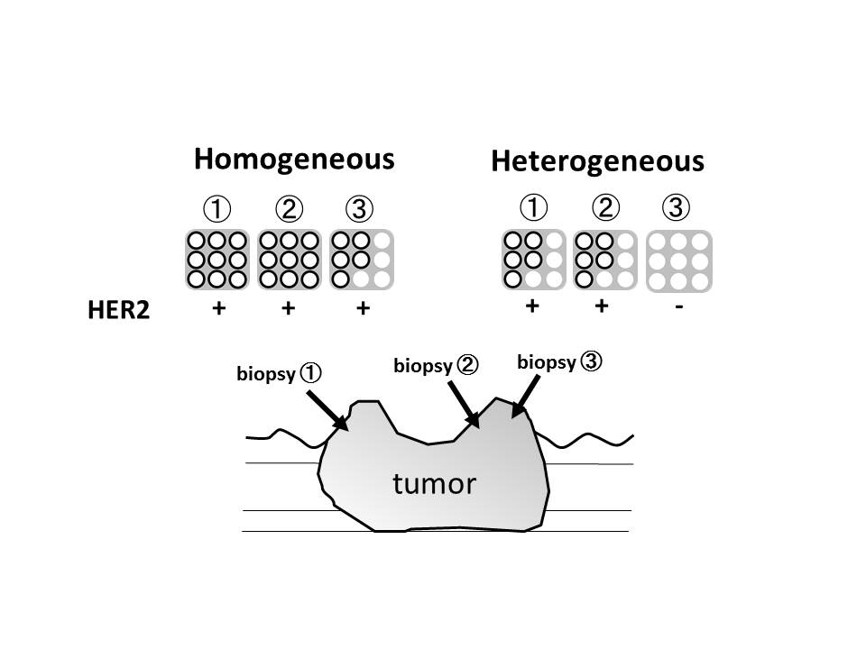Figure 1 Assessment of intratumoral human epidermal growth factor receptor 2 heterogeneity. Assessment of intratumoral human epidermal growth factor receptor 2 (HER2) heterogeneity was conducted from at least two different portion of the same tumor, and more than three biopsy specimens were obtained from each portion. Homogeneity was defined as all assessed portion showed HER2 positivity, and heterogeneity was defined as tumor with any of those portions did not show HER2 positivity. HER2: Human epidermal growth factor receptor 2.

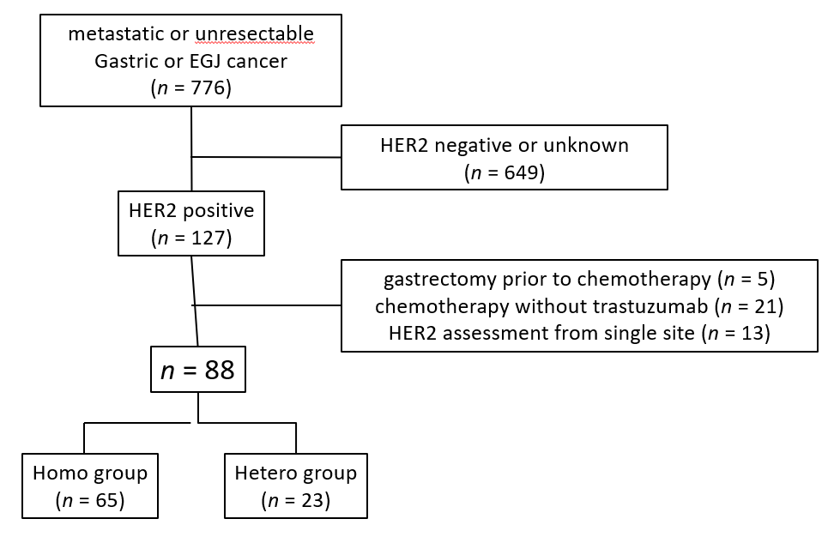
Figure 2 Patient flow chart. Human epidermal growth factor receptor 2 (HER2) positivity was observed in 127 (16.3%) of 776 patients with metastatic or unresectable adenocarcinoma. After exclusion of 39 patients for the listed reasons, HER2 homogeneity was observed in 65 (Homo group) and HER2 heterogeneity was observed in 23 (Hetero group) respectively. HER2: Human epidermal growth factor receptor 2.

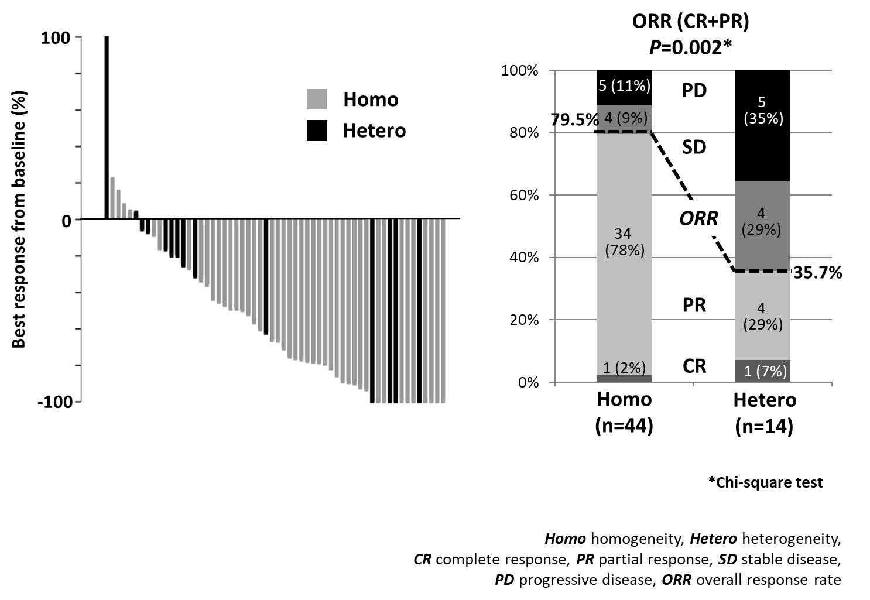
Figure 3 Clinical response for patient with or without intratumoral human epidermal growth factor receptor 2 heterogeneity. Tumor shrinkage (left) and clinical response (right) was evaluated by RECIST ver. 1.1 for 58 patients who have measurable metastatic lesions. Overall response rate was 79.5% in Homo group, which was significantly higher than that in Hetero group (35.7%, P = 0.002). CR: Complete response; PR: Partial response; SD: Stable disease; PD: Progressive disease; ORR: Overall response rate (CR plus PR).

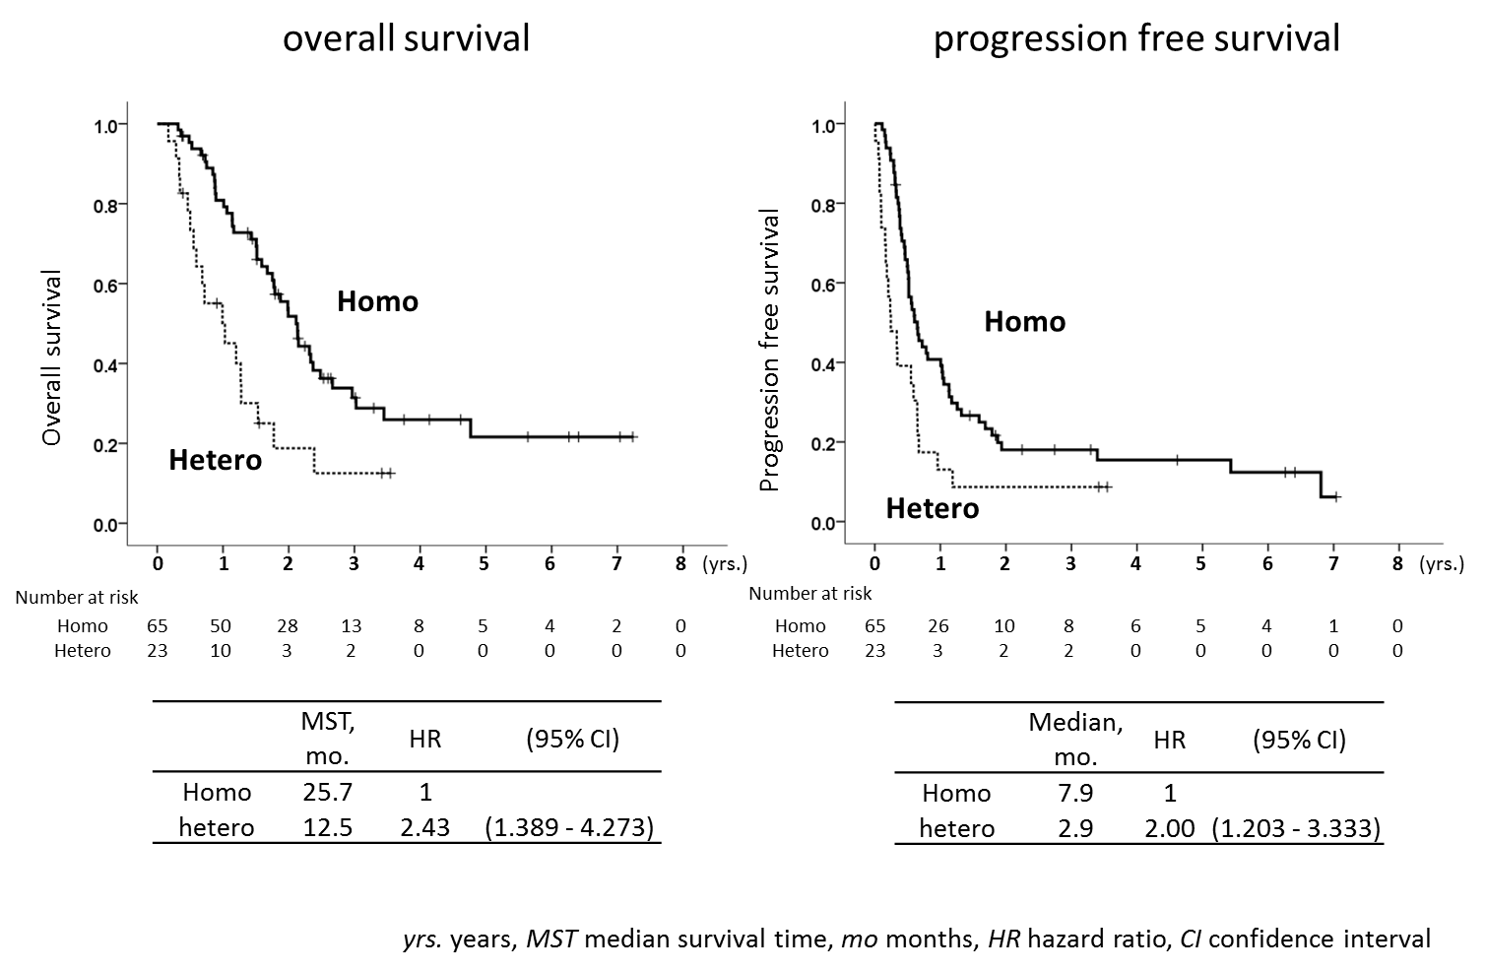
Figure 4 Overall survival and Progression free survival with or without intratumoral human epidermal growth factor receptor 2 heterogeneity. Kaplan-Meier curves of OS (left) and PFS (right) in both groups was shown with the median follow-up of 18.5 mo (range, 4.7-88.0 mo). Median survival time and median progression free survival time in the Hetero group were significantly worse than those in the Homo group. MST: Median survival time; HR: Hazard ratio; CI: Confidence interval.

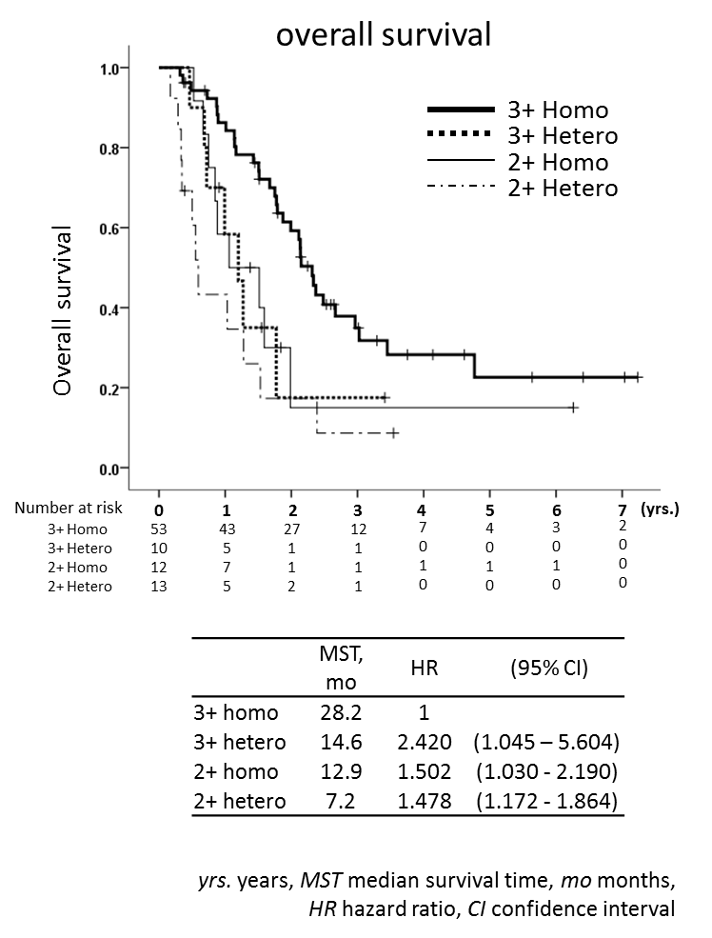
Figure 5 Overall survival of HER2 score and intratumoral human epidermal growth factor receptor 2 heterogeneity. MST for the Homo group with human epidermal growth factor receptor 2 (HER2) 3+ was longest (28.2 mo), followed by Hetero group with 3+ (14.6 mo), Homo group with 2+ (12.9 mo) and Hetero group with 2+ (7.2 mo). MST: Median survival time; HR: Hazard ratio; CI: Confidence interval.

Table 1 Patients’ demographic information
 | Homo (n = 65) | Hetero (n = 23) | P-value
Age, yr | 69 (42-81) | 67.0 (45-82)
< 70 | 34 (52%) | 15 (65%) | 0.284
≥ 70 | 31 (48%) | 8 (35%)
Sex
Male | 43 (66%) | 18 (78%) | 0.279
Female | 22 (34%) | 5 (22%)
ECOG performance status
0 | 61 (94%) | 20 (87%) | 0.152
1 | 2 (3%) | 3 (13%) | (0 vs ≥ 1)
2 | 2 (3%) | 0
Macroscopic type
1 | 7 (11%) | 1 (5%) | 0.008
2 | 28 (43%) | 4 (17%) | (type 1/2 vs 3/4)
3 | 23 (35%) | 16 (69%)
4 | 7 (11%) | 2 (9%)
Tumor location
Upper | 27 (42%) | 11 (48%) | 0.601
Middle / Lower | 38 (58%) | 12 (52%)
Histology
Well differentiated | 48 (74%) | 14 (61%) | 0.31
Poorly differentiated | 15 (23%) | 9 (39%)
Other/unknown | 2 (3%) | 0
T status
cT2 | 2 (3%) | 0 | 0.267
cT3 | 17 (26%) | 4 (17%) | (cT2/3 vs cT4)
cT4 | 46 (71%) | 19 (83%)
N status
cN0 | 5 (8%) | 2 (9%) | 0.748
cN1 | 5 (8%) | 1 (4%) | (≤cN2 vs cN3)
cN2 | 32 (49%) | 11 (48%)
cN3 | 23 (35%) | 9 (39%)
Number of non-curative factor
0 | 1 (1%) | 1 (4%) | 0.404
1 | 32 (49%) | 13 (57%) | (≤1 vs >1)
2 | 29 (45%) | 9 (39%)
>2 | 3 (5%) | 0
Non-curative factor
lymph node | 34 (52%) | 10 (43%)
peritoneal | 22 (34%) | 6 (26%)
hepatic | 27 (42%) | 12 (52%)
other | 9 (14%) | 1 (5%)
Number of HER2 assessment
2 | 35 (54%) | 10 (43%) | 0.393
3 | 27 (42%) | 13 (57%)
>3 | 3 (4%) | 0
HER2 score
3+ | 53 (82%) | 10 (43%) | 0.001
2+ | 12 (18%) | 13 (57%)
Upfront Chemotherapy
SOXT | 33 (50%) | 12 (52%)
XPT | 25 (37%) | 7 (30%)
SPT | 3 (5%) | 2 (9%)
FPT | 1 (2%) | 2 (9%)
FLT | 1 (2%)
PTXT | 1 (2%)
DCST | 1 (2%)
ECOG: Eastern Cooperative Oncology Group; SOXT: S-1 oxaliplatin capecitabine trastuzumab; XPT: capecitabine cisplatin trastuzumab; SPT: S-1 cisplatine trastuzumab; FPT: 5-Fluorouracil cisplatin trastuzumab; FLT: 5-Fluorouracil leucovorin trastuzumab; PTXT: Paclitaxel trastuzumab; DCST: docetaxel cisplatin S-1 trastuzumab.

Table 2 Prognostic factors for overall survival and progression free survival
Covariates | Overall survival |  |  |  | Progression free survival
 | Univariate analysis |  | Multivariable analysis |  | Univariate analysis |  | Multivariable analysis
 | HR (95%CI) | P-value | HR (95%CI) | P-value | HR (95%CI) | P-value | HR (95%CI) | P-value
Age (≥ 80 vs < 80) | 1.31 (0.473-3.625) | 0.604 |  |  | 1.138 (0.492-2.633) | 0.762
Sex (Female vs Male) | 1.057 (0.621-1.798) | 0.838 |  |  | 1.005 (0.615-1.642) | 0.985
Macroscopic type (type 3,4 vs 1,2) | 1.72 (1.027-2.881) | 0.039 |  |  | 1.641 (1.037-2.598) | 0.034
Clinical tumor depth (cT4 vs ≤ cT3) | 1.838(0.992-3.405) | 0.053 |  |  | 1.408 (0.826-2.401) | 0.209
Clinical nodal status (cN3 vs ≤ cN2) | 2.026 (1.184-3.466) | 0.01 | 2.119 (1.165-3.855) | 0.014 | 1.691 (1.056-2.708) | 0.029 | 1.622 (0.951-2.764) | 0.076
Histology (undiff. vs diff.) | 1.884 (1.090-3.255) | 0.023 | 2.612 (1.388-4.916) | 0.003 | 1.643 (1.031-2.618) | 0.037 | 1.902 (1.117-3.237) | 0.018
HER2 score (2+ vs 3+) | 2.331 (1.353-4.016) | 0.002 | 2.008 (1.094-3.690) | 0.024 | 1.828 (1.110-3.012) | 0.018 | 1.612 (0.940-2.770) | 0.083
HER2 heterogeneity (hetero vs homo) | 2.439 (1.389-4.274) | 0.002 | 3.115 (1.610-6.024) | 0.001 | 2 (1.203-3.333) | 0.008 | 2.123 (1.225-3.676) | 0.007
No of non-curative factors (≥ 2 vs 1) | 1.904 (1.138-3.186) | 0.014 | 2.252 (1.113-4.553) | 0.024 | 1.875 (1.185-2.965) | 0.007 | 1.871 (1.023-3.424) | 0.042
M1 (Lym) | 0.687 (0.410-1.150) | 0.154 |  |  | 0.568 (0.358-0.902) | 0.017
M1 (Per) | 1.207 (0.699-2.086) | 0.5 |  |  | 1.327 (0.828-2.127) | 0.24
M1 (Hep) | 1.902 (1.141-3.173) | 0.014 | 2.084 (1.076-4.036) | 0.029 | 1.974 (1.244-3.132) | 0.004 | 2.053 (1.151-3.664) | 0.015
HER2: Human epidermal growth factor receptor 2; HR: Hazard ratio.

