Name of Journal: World Journal of Clinical Cases
Manuscript NO: 74259
Manuscript Type: CASE REPORT

Spontaneous gallbladder perforation and colon fistula in hypertriglyceridemia-related severe acute pancreatitis: A case report

Wang QP et al. Gallbladder perforation in acalculous SAP

Qi-Pu Wang, Yi-Jun Chen, Mei-Xing Sun, Jia-Yuan Dai, Jian Cao, Qiang Xu, Guan-Nan Zhang, Sheng-Yu Zhang

Qi-Pu Wang, Yi-Jun Chen, Mei-Xing Sun, Sheng-Yu Zhang, Department of Gastroenterology, Peking Union Medical College Hospital, Beijing 100730, China

Yi-Jun Chen, School of Medicine, Tsinghua University, Beijing 100084, China

Jia-Yuan Dai, Department of Emergency Medicine, Peking Union Medical College Hospital, Beijing 100730, China

Jian Cao, Department of Radiology, Peking Union Medical College Hospital, Beijing 100730, China

Qiang Xu, Guan-Nan Zhang, Department of General Surgery, Peking Union Medical College Hospital, Beijing 100730, China

Author contributions: Wang QP and Chen YJ were the patient’s gastroenterologists, reviewed the literature, and contributed to manuscript drafting; Sun MX was the patient’s gastroenterologist; Dai JY was the patient’s emergency doctor; Cao J interpreted the imaging findings and performed the percutaneous drainage; Xu Q and Zhang GN performed all surgeries; Zhang SY was the patient’s gastroenterologist and was responsible for the revision of the manuscript for important intellectual content; All authors issued final approval for the version to be submitted.

Supported by Beijing Science and Technology Program, No. Z181100001618013; and Peking Union Medical College Education Reform Program, No. 2019zlgc0116.

Corresponding author: Sheng-Yu Zhang, MD, Doctor, Department of Gastroenterology, Peking Union Medical College Hospital, No. 1 Shuaifuyuan, Wangfujing, Dongcheng District, Beijing 100730, China. pumchzsy@126.com

Received: December 23, 2021
Revised: February 2, 2022
Accepted: April 9, 2022
Published online: June 16, 2022

Abstract
BACKGROUND
Gallbladder perforation and gastrointestinal fistula are rare but serious complications of severe acute pancreatitis (SAP). However, neither spontaneous gallbladder perforation nor cholecysto-colonic fistula has been reported in acalculous acute pancreatitis patients.

CASE SUMMARY
A 31-year-old male presenting with epigastric pain was diagnosed with hypertriglyceridemia-related SAP. He suffered from multiorgan failure and was able to leave the intensive care unit on day 20. Three percutaneous drainage tubes were placed for profound exudation in the peripancreatic region and left paracolic sulcus. He developed spontaneous gallbladder perforation with symptoms of fever and right upper quadrant pain 1 mo after SAP onset and was stabilized by percutaneous drainage. Peripancreatic infection appeared 1 mo later and was treated with antibiotics but without satisfactory results. Then multiple colon fistulas, including a cholecysto-colonic fistula and a descending colon fistula, emerged 3 mo after the onset of SAP. Nephroscopy-assisted peripancreatic debridement and ileostomy were carried out immediately. The fistulas achieved spontaneous closure 7 mo later, and the patient recovered after cholecystectomy and ileostomy reduction. We presume that the causes of gallbladder perforation are poor bile drainage due to external pressure, pancreatic enzyme erosion, and ischemia. The possible causes of colon fistulas are pancreatic enzymes or infected necrosis erosion, ischemia, and iatrogenic injury. According to our experience, localized gallbladder perforation can be stabilized by percutaneous drainage. Pancreatic debridement and proximal colostomy followed by cholecystectomy are feasible and valid treatment options for cholecysto-colonic fistulas.

CONCLUSION
Gallbladder perforation and cholecysto-colonic fistula should be considered in acalculous SAP patients.

Key Words: Acalculous severe acute pancreatitis; Gallbladder perforation; Cholecysto-colonic fistula; Percutaneous drainage; Cholecystectomy; Case report

©The Author(s) 2022. Published by Baishideng Publishing Group Inc. All rights reserved.

Citation: Wang QP, Chen YJ, Sun MX, Dai JY, Cao J, Xu Q, Zhang GN, Zhang SY. Spontaneous gallbladder perforation and colon fistula in hypertriglyceridemia-related severe acute pancreatitis: A case report. World J Clin Cases 2022; 10(17): 5846-5853
URL: https://www.wjgnet.com/2307-8960/full/v10/i17/5846.htm
DOI: https://dx.doi.org/10.12998/wjcc.v10.i17.5846

Core Tip: To the best of our knowledge, this is the first time that spontaneous gallbladder perforation and cholecysto-colonic fistula have been reported in patients with acalculous severe acute pancreatitis. Biliary obstruction due to peripancreatic effusions, pancreatic enzymes or infected necrosis erosion, ischemia, and iatrogenic injury might be related. According to our experience, localized gallbladder perforation can be stabilized by percutaneous drainage. Pancreatic debridement and proximal colostomy followed by cholecystectomy are feasible and valid treatment options for cholecysto-colonic fistulas.

INTRODUCTION
Pancreatic pseudocysts, wall-off necrosis, and peripancreatic abscess are well-known local complications of severe acute pancreatitis (SAP). There are few reports on rare complications of gallbladder perforation^{[1]} or gastrointestinal fistula. Gallbladder perforation occurs in 2%-10% of patients with acute cholecystitis^{[2]}, usually occurs in elderly males^{[3]}, and is mostly associated with calculous cholecystitis^{[4]}. Delays in diagnosis lead to a poor prognosis. One study reported that the morbidity and mortality of gallbladder perforation are 37.5% and 12.5%, respectively^{[4]}. Gastrointestinal fistula most commonly occurs in the colon, with an incidence of 3.3% in acute pancreatitis (AP) and 15% in SAP^{[5]}, which can also involve the duodenum, stomach, and small intestine^{[6]}. Compared with patients without colon complications, SAP patients with colon involvement have significantly higher morbidity and mortality (54% for colonic necrosis)^{[7]}. However, neither gallbladder perforation nor cholecysto-colonic fistula has been recorded in acalculous AP patients. Herein, we present the first case of spontaneous gallbladder perforation and cholecysto-colonic fistula in a patient with acalculous SAP.

CASE PRESENTATION
Chief complaints
A 31-year-old male presented in the emergency room with epigastric pain for 3 d and loss of consciousness for 1 d.

History of present illness
This patient with a body mass index of 29.39 kg/m² was admitted to the local hospital because of epigastric pain for 1 d after a fatty meal. He described the pain as persistent, severe, and radiating to the back, accompanied by nausea and vomiting. Local laboratory examination revealed that the serum amylase level was over 500 U/L (the upper normal limit was 135 U/L), and the triglyceride concentration was 44 mmol/L. The abdominal computed tomography (CT) scan showed pancreatic edema without gallstones. Considering hypertriglyceridemia-related AP, he received lipid-lowering (fenofibrate) and supportive treatment. Two days later, he was transferred to our hospital for worsened situations with loss of consciousness, anuria, and high fever.

History of past illness
The patient reported no remarkable history of past illness.

Personal and family history
The patient liked fatty food, smoked 40 cigarettes per day for 10 years, and drank 500 mL of liquor per day for 10 years. There was no family history of malignant tumors.

Physical examination
The patient’s body temperature was 40 °C, heart rate was 180 beats per min, and respiratory rate was 40 breaths per min. Blood pressure and oxygen saturation could not be measured. Neurological examination revealed loss of light reflection from both pupils, and the Glasgow Coma Scale was E1V1M1. The abdomen was distended, tension was high, and bowel sounds were weak.

Laboratory examinations
The auxiliary examination results at admission are shown in Table 1.

Imaging examinations
An enhanced CT scan showed swelling of the pancreas and profound effusions in the periphery of the pancreas, omental sac, and left paracolic sulcus (Figure 1A).

FINAL DIAGNOSIS
The patient was diagnosed with hypertriglyceridemia-related SAP with multiorgan failure, including shock, respiratory failure, acute renal failure, and rhabdomyolysis.

TREATMENT
After supportive treatment including vasoactive agents, mechanical ventilation, kidney replacement therapy, and early enteral nutrition support the patient was stabilized and admitted to the general ward after spending 20 d in the intensive care units, during which time three percutaneous drainage tubes were placed for possible infection in necrosis collection and fluid effusions in the peripancreatic region and left paracolic sulcus (Figures 1B, 2A and 2B). The drainage fluid culture was negative.
One month after the onset of SAP, the patient developed fever and right upper quadrant pain with elevated conjugated bilirubin and alkaline phosphatase levels of 37.3 μmol/L and 340 U/L, respectively. Contrast-enhanced CT (Figure 2A) and magnetic resonance cholangiopancreatography (Figure 2C) revealed a cystic lesion adjacent to and communicating to a large gallbladder (Figure 2B), and gallbladder perforation was considered. Therefore, another drainage tube was placed into the cystic lesion percutaneously (Figure 2D). The drainage fluid was bile-like with an elevated total bilirubin level of 412 μmol/L.
Two months after the onset of SAP, fever came intermittently when abdominal CT showed gas in the necrotic tissue (Figure 1B), and the peripancreatic drainage fluid gradually turned into pus, which could be readily treated by antibiotics but recurred after antibiotics were ceased. One month later, when the radiologists replaced drainage tubes, feces were withdrawn from the gallbladder fossa and left paracolic sulcus. As indirect evidence of cholecysto-colonic fistula, CT showed gas in the gallbladder lumen (Figure 2E). Then, cholecysto-colonic fistula and descending colon fistula were confirmed via contrast examination. The patient immediately received nephroscopy-assisted debridement of peripancreatic necrosis and ileostomy. Peripancreatic and paracolic drains were changed to larger tubes (Figure 1C), and the abdominal cavity was flushed with normal saline every day. One month after surgery, the patient's body temperature returned to normal, and he was discharged from the hospital.

OUTCOME AND FOLLOW-UP
Six months after the onset of SAP, the patient gradually resumed oral intake with good tolerance, and all drains were removed 1 mo later. Seven months after ileostomy, a colonoscopy revealed spontaneous closure of colon fistulas, and abdominal CT showed the absorption of peripancreatic infectious necrosis (Figure 1D). The patient subsequently underwent cholecystectomy (Figure 2F) and ileostomy reversal. Pathology of the gallbladder suggested chronic inflammation of fibrous connective tissue. Since then, the patient has been symptom free for 5 mo. To illustrate the patient's medical history succinctly and clearly, we briefly summarize it in Table 2.

DISCUSSION
Gallbladder perforation usually occurs days to weeks after acute cholecystitis^{[3]}. It can cause diffuse peritonitis, or it can be surrounded by connective tissue, causing only localized peritonitis^{[2]}. Gallbladder perforation is commonly seen in calculous cholecystitis and sometimes in cancer or trauma^{[8,9]}. On the other hand, acalculous gallbladder perforation in AP is extremely rare. In this case, gallbladder perforation was diagnosed 1 mo after the onset of SAP. Fortunately, the bile was confined to the cystic lesion adjacent to gallbladder without causing generalized biliary peritonitis.
One of the possible mechanisms of gallbladder perforation is that poor bile drainage leads to increased pressure in the gallbladder, causing gallbladder ischemia and necrosis^{[10]}. In this case, pancreatic edema and peripancreatic exudation might have caused biliary obstruction. Second, pancreatic enzymes can erode the adjacent gallbladder^{[3]}. Our patient had profound effusions in the omental sac, which might contribute to damaging the integrity of the gallbladder walls. Third, hypotension will lead to insufficient blood supply to the gallbladder^{[10]}. Our patient developed distributive shock shortly after SAP onset. Moreover, fasting after SAP onset and jejunal nutrition further increased the intraluminal pressure of the gallbladder according to animal models^{[11,12]}.
Colon complications of acute pancreatitis are uncommon and mainly include necrosis, perforation, fistula, and stricture^{[7,13,14]}. Necrosis and perforation appear early in the course of necrotizing pancreatitis, usually within 1 mo, while fistulas and stricture usually occur several months later. In the current case, a cholecysto-colonic fistula, which has not been reported before, and a descending colon fistula were found during drain replacement 3 mo after the onset of SAP and 1 mo after peripancreatic infection.
Similar to gallbladder perforation, erosion of pancreatic enzymes and infectious necrosis, as well as hypotension from shock, can also cause disruption of the colon wall^{[15,16]}. Iatrogenic injury could easily injure the intestine. However, a retrospective study ruled out percutaneous drainage as a risk factor for colon complications^{[13]}. In the present case, it was difficult to fully rule out the possibility of puncture injury.
Local inflammation is prominent when colon fistula forms. Therefore, it is best not to repair the intestinal wall in the early stage. Pancreatic debridement and proximal colostomy are feasible options^{[17,18]}, after which some fistulas can thus be cured^{[7]}. When local inflammation subsided, ostomy reduction was performed a mean of 248.1 d after the initial surgery^{[13]}. Currently, there is no treatment recommendation for patients with gallbladder perforation or fistula in acalculous AP. According to our experience, localized gallbladder perforation can be stabilized by percutaneous drainage instead of urgent surgery. Pancreatic debridement and proximal colostomy followed by cholecystectomy after a period of 7 mo are feasible and valid treatment options for cholecysto-colonic fistulas.

CONCLUSION
Although gallbladder perforation and gastrointestinal fistula are rare complications in acalculous SAP patients, they should be considered for their poor prognosis. Pancreatic debridement and proximal colostomy followed by cholecystectomy after the infection is relieved are feasible and valid treatment options for cholecysto-colonic fistulas.

REFERENCES
1 Perera M, Pham T, Toshniwal S, Lennie Y, Chan S, Houli N. A case of concomitant perforated acute cholecystitis and pancreatitis. Case Rep Surg 2013; 2013: 263046 [PMID: 23956917 DOI: 10.1155/2013/263046]
2 Quiroga-Garza A, Alvarez-Villalobos NA, Angeles-Mar HJ, Garcia-Campa M, Muñoz-Leija MA, Salinas-Alvarez Y, Elizondo-Omaña RE, Guzmán-López S. Localized gallbladder perforation: a systematic review of treatment and prognosis. HPB (Oxford) 2021; 23: 1639-1646 [PMID: 34246546 DOI: 10.1016/j.hpb.2021.06.003]
3 Başara I, Seçil M. Spontaneous asymptomatic gallbladder perforation. Quant Imaging Med Surg 2014; 4: 212-213 [PMID: 24914424 DOI: 10.3978/j.issn.2223-4292.2014.03.03]
4 Derici H, Kara C, Bozdag AD, Nazli O, Tansug T, Akca E. Diagnosis and treatment of gallbladder perforation. World J Gastroenterol 2006; 12: 7832-7836 [PMID: 17203529 DOI: 10.3748/wjg.v12.i48.7832]
5 Dhadlie S, Ratnayake S. A rare case report of ascending colon perforation secondary to acute pancreatitis. Int J Surg Case Rep 2019; 55: 62-65 [PMID: 30690284 DOI: 10.1016/j.ijscr.2018.12.010]
6 Andrew D, Shyam K, Johny J, Beaty S. Elderly male patient with gastrocolic fistula following severe acute necrotising pancreatitis. BMJ Case Rep 2021; 14 [PMID: 33414125 DOI: 10.1136/bcr-2020-240426]
7 Mohamed SR, Siriwardena AK. Understanding the colonic complications of pancreatitis. Pancreatology 2008; 8: 153-158 [PMID: 18382101 DOI: 10.1159/000123607]
8 Zhang J, Shen G, Shi Y, Zhang C, Hong D, Jin L, Yang H, Sun W, Cai H, Hu Z, Wu W. Spontaneous acalculous gallbladder perforation in a man secondary to chemotherapy and radiation: A rare case report. Medicine (Baltimore) 2018; 97: e0674 [PMID: 29742709 DOI: 10.1097/MD.0000000000010674]
9 Katagiri T, Irisawa A, Wakabayashi H, Tsunoda T, Tomoda H, Saito R, Kinuta S. Idiopathic perforation of acalculous gallbladder after insertion of a transpapillary pancreatic stent. Endosc Int Open 2016; 4: E838-E840 [PMID: 27540570 DOI: 10.1055/s-0042-109598]
10 Gunasekaran G, Naik D, Gupta A, Bhandari V, Kuppusamy M, Kumar G, Chishi NS. Gallbladder perforation: a single center experience of 32 cases. Korean J Hepatobiliary Pancreat Surg 2015; 19: 6-10 [PMID: 26155270 DOI: 10.14701/kjhbps.2015.19.1.6]
11 Psáder R, Sterczer A, Pápa K, Harnos A, Szilvási V, Pap A. Effect of enteral feeding on gallbladder function in dogs. Acta Vet Hung 2012; 60: 211-222 [PMID: 22609992 DOI: 10.1556/AVet.2012.018]
12 Ledeboer M, Masclee AA, Biemond I, Lamers CB. Gallbladder motility and cholecystokinin secretion during continuous enteral nutrition. Am J Gastroenterol 1997; 92: 2274-2279 [PMID: 9399769]
13 Maatman TK, Nicolas ME, Roch AM, Lewellen KA, Al-Azzawi HH, Ceppa EP, House MG, Nakeeb A, Schmidt CM, Zyromski NJ. Colon Involvement in Necrotizing Pancreatitis: Incidence, Risk Factors, and Outcomes. Ann Surg 2022; 275: 568-575 [PMID: 32649468 DOI: 10.1097/SLA.0000000000004149]
14 Gondal B, Ogunsua AA, McIntosh L, Shaikh Y, Cave D. Perforation of the descending colon in severe acute pancreatitis: a case report and literature review. Pancreas 2014; 43: 488-490 [PMID: 24622088 DOI: 10.1097/MPA.0000000000000056]
15 Patterson M, Bernstein CN. A Rare Complication of Pancreatitis. Gastroenterology 2021; 160: 1479-1480 [PMID: 33346005 DOI: 10.1053/j.gastro.2020.12.022]
16 Van Minnen LP, Besselink MG, Bosscha K, Van Leeuwen MS, Schipper ME, Gooszen HG. Colonic involvement in acute pancreatitis. A retrospective study of 16 patients. Dig Surg 2004; 21: 33-38; discussion 39-40 [PMID: 14707391 DOI: 10.1159/000075824]
17 Yoshikawa K, Lefor AK, Kubota T. Acute pancreatitis followed by retroperitoneal perforation of the descending colon and a duodenal fistula: Report of a case. Int J Surg Case Rep 2020; 72: 599-602 [PMID: 32698297 DOI: 10.1016/j.ijscr.2020.05.095]
18 Hozaka Y, Kurahara H, Mataki Y, Kawasaki Y, Iino S, Sakoda M, Mori S, Maemura K, Shinchi H, Natsugoe S. Successful treatment for severe pancreatitis with colonic perforation using video-assisted retroperitoneal debridement: A case report. Int J Surg Case Rep 2018; 52: 23-27 [PMID: 30308424 DOI: 10.1016/j.ijscr.2018.09.046]

Footnotes
Informed consent statement: Informed written consent was obtained from the patient for publication of this report and any accompanying images.

Conflict-of-interest statement: Dr. Zhang reports grants from Beijing Science and Technology Program, grants from Peking Union Medical College Education Reform Program, during the conduct of the study.

CARE Checklist (2016) statement: The authors have read the CARE Checklist (2016), and the manuscript was prepared and revised according to the CARE Checklist (2016).

Open-Access: This article is an open-access article that was selected by an in-house editor and fully peer-reviewed by external reviewers. It is distributed in accordance with the Creative Commons Attribution NonCommercial (CC BY-NC 4.0) license, which permits others to distribute, remix, adapt, build upon this work non-commercially, and license their derivative works on different terms, provided the original work is properly cited and the use is non-commercial. See: https://creativecommons.org/Licenses/by-nc/4.0/

Provenance and peer review: Unsolicited article; Externally peer reviewed.
Peer-review model: Single blind

Peer-review started: December 23, 2021
First decision: January 27, 2022
Article in press: April 9, 2022

Specialty type: Medicine, research and experimental
Country/Territory of origin: China
Peer-review report’s scientific quality classification
Grade A (Excellent): 0
Grade B (Very good): 0
Grade C (Good): C
Grade D (Fair): D
Grade E (Poor): 0

P-Reviewer: Hosoya S, Japan; Priyadarshi RN, India S-Editor: Fan JR L-Editor: Filipodia P-Editor: Fan JR

Figure Legends
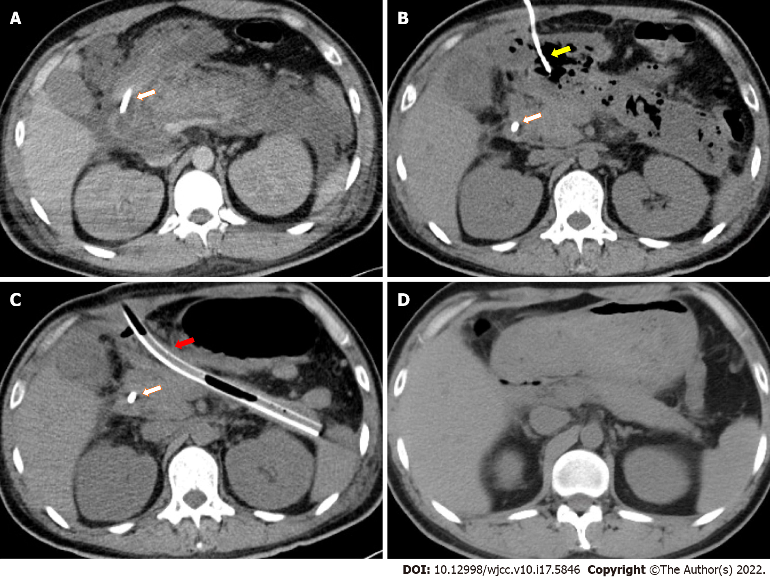
Figure 1 Pancreatic imaging changes during the course of disease. The jejunal feeding tube is marked by a white arrow. The percutaneous drainage tube for the pancreatic head region is marked by a yellow arrow. A: Contrast-enhanced computed tomography (CT) demonstrating pancreatic edema and profound peripancreatic exudation after severe acute pancreatitis (SAP) onset; B: CT demonstrating peripancreatic infected necrosis 2 mo after SAP onset; C: CT after nephroscopy-assisted debridement of peripancreatic necrosis 3 mo after SAP onset. One of the thicker drainage tubes is marked by a red arrow; D: CT demonstrating recovery 10 mo after SAP onset.

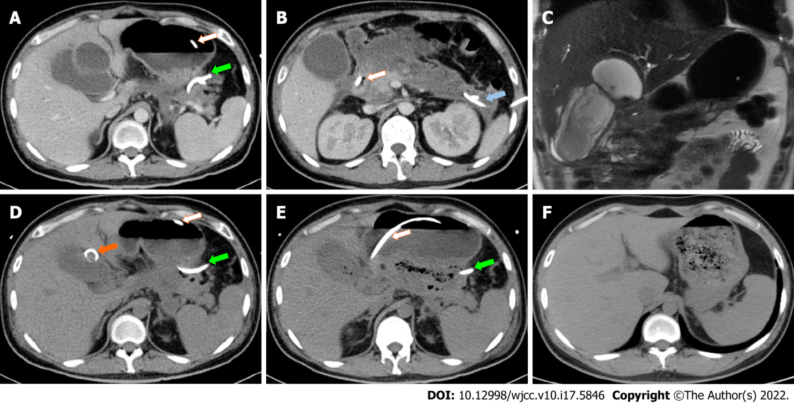
Figure 2 Gallbladder perforation and cholecysto-colonic fistula during the course of disease. The jejunal feeding tube is marked by a white arrow. The percutaneous drainage tube for the pancreatic tail area is marked by a green arrow. The percutaneous drainage tube for the left paracolic sulcus is marked by a blue arrow. A: Contrast-enhanced computed tomography (CT) demonstrating a cystic lesion communicating to the gallbladder 1 mo after severe acute pancreatitis (SAP) onset; B: Contrast-enhanced CT demonstrating a large gallbladder and profound exudation in pancreatic head region 1 mo after SAP onset; C: Magnetic resonance cholangiopancreatography demonstrating a cystic lesion adjacent to the gallbladder 1 mo after SAP onset; D: CT demonstrating adequate drainage of gallbladder perforation 2 mo after SAP onset. The percutaneous drainage tube for the cystic lesion is marked by an orange arrow; E: CT demonstrating gas in the gallbladder lumen as indirect evidence of cholecysto-colonic fistula before debridement surgery; F: CT demonstrating a recovery from cholecystectomy 10 mo after SAP onset.
Table 1 Laboratory examinations at admission
Test item | Test result | Reference range
White blood cell (× 10⁹/L) | 8.7 | 3.5-9.5
Hemoglobin (g/L) | 78 | 120–160
Platelet (× 10⁹/L) | 206 | 100-350
Alanine aminotransferase (U/L) | 230 | 9-50
Alkaline phosphatase (U/L) | 67 | 45-125
Total bilirubin (μmol/L) | 17.1 | 5.1-22.2
Conjugated bilirubin (μmol/L) | 9.9 | 0-6.8
Potassium (mmol/L) | 4.4 | 3.5-5.5
Serum urea (mmol/L) | 19 | 2.78-7.14
Serum creatinine (μmol/L) | 404 | 59-104
Creatine kinase (U/L) | 42853 | 24-195
Myoglobin (μg/L) | 88925 | 10-92
High-sensitivity C-reactive protein (mg/L) | > 250 | < 3.0
Erythrocyte sedimentation rate (mm/h) | > 140 | 0-15
Procalcitonin (ng/mL) | 16 | < 0.25
Blood cultures | Negative | Negative

Table 2 Time course of this case
Time since SAP onset | Clinical events
11 d | Started jejunal nutrition
1 mo | Gallbladder perforation
 | Percutaneous drainage
2 mo | Peripancreatic infection
 | Antibiotics and percutaneous drainage
3 mo | Cholecysto-colonic fistula and descending colon fistula
 | Peripancreatic debridement and ileostomy
4 mo | Normal body temperature
 | Discharged from hospital
6 mo | Started oral intake
7 mo | All drains removed
10 mo | Cholecystectomy and ileostomy reversal
15 mo | Free from the symptoms after surgery
SAP: Severe acute pancreatitis.

Published by Baishideng Publishing Group Inc
7041 Koll Center Parkway, Suite 160, Pleasanton, CA 94566, USA
Telephone: +1-925-3991568
E-mail: bpgoffice@wjgnet.com
Help Desk: https://www.f6publishing.com/helpdesk
https://www.wjgnet.com

© 2022 Baishideng Publishing Group Inc. All rights reserved.

