Name of Journal: World Journal of Gastroenterology
Manuscript NO: 61152
Manuscript Type: ORIGINAL ARTICLE

Basic Study
Huanglian decoction suppresses the growth of hepatocellular carcinoma cells by reducing CCNB1 expression

Li M et al. Effect of Huanglian decoction on HCC

Min Li, Hua Shang, Tao Wang, Shui-Qing Yang, Lei Li

Min Li, Hua Shang, Department of Gastroenterology, Zibo Central Hospital, Zibo 255036, Shandong Province, China

Tao Wang, Department of General Surgery, Zibo Central Hospital, Zibo 255036, Shandong Province, China

Shui-Qing Yang, Lei Li, School of Biological Science and Medical Engineering, Beihang University, Beijing 100191, China

Lei Li, Department of Pathology, University of Otago, Dunedin px806, New Zealand

Author contributions: Li L conceived and performed the experiments and drafted the article; Li M and Shuang H conceived and performed partial experiments; Wang T and Yang SQ designed the study, supervised the experiments, and revised the article; all authors read and approved the final manuscript.

Corresponding author: Lei Li, PhD, Academic Research, Department of Pathology, University of Otago, 270 Great King Street, Dunedin px806, New Zealand. wshililei@buaa.edu.cn

Received: November 26, 2020
Revised: January 3, 2021
Accepted: February 1, 2021
Published online: March 14, 2021

Abstract
BACKGROUND
Hepatocellular carcinoma (HCC) is one of the most prevalent cancers in human populations worldwide. Huanglian decoction is one of the most important Chinese medicine formulas, with the potential to treat cancer.

AIM
To investigate the role and mechanism of Huanglian decoction on HCC cells.

METHODS
To identify differentially expressed genes (DEGs), we downloaded gene expression profile data from The Cancer Genome Atlas Liver Hepatocellular Carcinoma and Gene Expression Omnibus (GSE45436) databases. We obtained phytochemicals of the four herbs of Huanglian decoction from the Traditional Chinese Medicine Systems Pharmacology Database and Analysis Platform. We also established a regulatory network of DEGs and drug target genes and subsequently analyzed key genes using bioinformatics approaches. Furthermore, we conducted in vitro experiments to explore the effect of Huanglian decoction and to verify the predictions. In particular, the CCNB1 gene was knocked down to verify the primary target of this decoction. Through the identification of the expression levels of key proteins, we determined the primary mechanism of Huanglian decoction in HCC.

RESULTS
Based on the results of the network pharmacological analysis, we revealed 5 bioactive compounds in Huanglian decoction that act on HCC. In addition, a protein-protein interaction network analysis of the target genes of these five compounds as well as expression and prognosis analyses were performed in tumors. CCNB1 was confirmed to be the primary gene that may be highly expressed in tumors and was significantly associated with a worse prognosis. We also noted that CCNB1 may serve as an independent prognostic indicator in HCC. Moreover, in vitro experiments demonstrated that Huanglian decoction significantly inhibited the growth, migration, and invasiveness of HCC cells and induced cell apoptosis and G2/M phase arrest. Further analysis showed that the decoction may inhibit the growth of HCC cells by downregulating the CCNB1 expression level. After Huanglian decoction treatment, the expression levels of Bax, caspase 3, caspase 9, p21 and p53 in HCC cells were increased, while the expression of CDK1 and CCNB1 was significantly decreased. The p53 signaling pathway was also found to play an important role in this process.

CONCLUSION
Huanglian decoction has a significant inhibitory effect on HCC cells. CCNB1 is a potential therapeutic target in HCC. Further analysis showed that Huanglian decoction can inhibit HCC cell growth by downregulating the expression of CCNB1 to activate the p53 signaling pathway.

Key Words: Huanglian decoction (Coptidis Rhizoma, Zingiberis Rhizoma, Folium Artemisiae Argyi, Mume Fructus); Hepatocellular carcinoma; The cancer genome atlas; Gene Expression Omnibus; P53 pathway; Cell cycle; Apoptosis

©The Author(s) 2021. Published by Baishideng Publishing Group Inc. All rights reserved.

Citation: Li M, Shang H, Wang T, Yang SQ, Li L. Huanglian decoction suppresses the growth of hepatocellular carcinoma cells by reducing CCNB1 expression. World J Gastroenterol 2021; 27(10): 939-958
URL: https://www.wjgnet.com/1007-9327/full/v27/i10/939.htm
DOI: https://dx.doi.org/10.3748/wjg.v27.i10.939

Core Tip: The purpose of this study was to investigate the role and mechanism of Huanglian decoction on hepatocellular carcinoma (HCC) cells. The results showed that Huanglian decoction has a significant inhibitory effect on the growth of HCC cells. Huanglian decoction can inhibit HCC cell growth by downregulating the expression of CCNB1 to activate the p53 signaling pathway. CCNB1 is a potential therapeutic target for liver cancer.
INTRODUCTION
Hepatocellular carcinoma (HCC) is the most frequent primary malignancy of the liver and the third leading cause of cancer mortality worldwide^{[1-3]}. Current treatment options for liver cancer primarily include surgery, local treatment, biological treatment, and various other methods. Recently, molecular targeted therapy has been used to treat some patients with advanced liver cancer, but because targeted drugs are relatively expensive and induce side effects, they have not been fully utilized^{[4-6]}. In the past few years, there has been growing research attention on traditional Chinese medicine (TCM). Previous studies have established that TCM can improve the clinical symptoms of patients, especially for those with advanced liver cancer by prolonging their survival period, and the cost is relatively inexpensive. In particular, TCM formulation contains a variety of chemical components that act on multiple targets and diseases^{[7-9]}. However, due to the complexity and diversity of TCM components, our understanding of the specific molecular mechanisms of Chinese medicine is still largely unknown. This, therefore, limits the development of Chinese medicine. Nevertheless, the recent development of computer technology has allowed us to analyze the components of these medicines and systematically analyze their effects on diseases through network pharmacology, which has greatly promoted our understanding of the molecular network of Chinese medicines and their nature^{[10-12]}.
Huanglian decoction is a classical Chinese medicine formula that has the effect of clearing heat and treating abdominal pain^{[13,14]}. This formulation was originally recorded in the classic Chinese medicine book “Treatise on Febrile Diseases” (Chinese name: Shang-Han Lun). In this study, we obtained the formula of Huanglian decoction from the ancient Chinese medicine book (Sheng Ji Zong Lu), which contains one of the original recipes. The formula consists of four Chinese herbal medicines: Coptidis Rhizoma, Zingiberis Rhizoma, Folium Artemisiae Argyi, and Mume Fructus. In addition, this decoction plays a pivotal role in the field of TCM due to its various effects, such as treating colds, white diarrhea, and abdominal pain^{[15-17]}. In some Asian-Pacific regions, this decoction is used as an auxiliary medicine for the treatment of liver cancer. Research has demonstrated that this decoction can exert its effects on the liver^{[18-20]}. However, very few studies have investigated the treatment of HCC with this decoction. Thus, in this respect, we aimed to investigate the therapeutic potential of Huanglian decoction as an HCC treatment.
CCNB1 plays a key role in regulating and forming a complex with CDK1 to promote the transition from the G2 phase of the cell cycle to mitosis^{[21]}. Increasing evidence has shown that CCNB1 is overexpressed in certain human cancers, including colorectal, bladder and stomach cancers^{[22-24]}. In addition, the p53 tumor suppressor pathway also plays a key role in mediating the responses of commonly used cancer treatments, and CCNB1 is significantly correlated with the p53 signaling pathway^{[25-29]}. In this study, we explored the main targets of Huanglian decoction in HCC cells. By reducing CCNB1 expression, we studied the effects of Huanglian decoction on the cell cycle and apoptosis, and the potential functional pathways were also explored. The detailed flow chart of this study is depicted in Figure 1. This study provides novel insights into the mechanism of Huanglian decoction treatment in HCC.

MATERIALS AND METHODS
Data collection and cell culture
For this study, we downloaded the gene expression profile data of HCC patients from the Cancer Genome Atlas (TCGA) database (https://portal.gdc.cancer.gov/). This dataset includes 347 tumors and 50 non-tumor samples. Gene Expression Omnibus (GEO) (https://www.ncbi.nlm.nih.gov/geo/) is a public functional genomics data repository. The GSE45436 dataset contained 93 HCC tissue samples and 41 non-cancerous samples. We retrieved data from publicly available databases, hence it was not applicable for additional ethical approval. Then, we selected PLC/PRF/5 and HepG2 cells for the following experiments. Specifically, the cells were purchased from the Chinese National Infrastructure of Cell Line Resource. The culture media used was Dulbecco's Modified Eagle's medium (Thermo Fisher Scientific, Waltham, MA, United States), supplemented with 10% fetal bovine serum (FBS). Finally, the cells were placed in an incubator (37°C; 5% CO₂) as previously described.

Identification of differentially expressed genes
Here, we screened differentially expressed genes (DEGs) between HCC and noncancerous samples using the "limma" R package. The log2FC (fold change) > 1 or < -1 and adjusted P-values < 0.05 were considered statistically significant. To identify the DEGs shared by the TCGA and GEO databases, we used TCGA data in the experimental group, while GEO data were applied in the verification group. Afterward, the intersections were obtained and visualized using the website (http://bioinformatics.psb.ugent.be/webtools/Venn/).

Identification and screening of bioactive components
For this experiment, we retrieved all phytochemicals of the four components of Huanglian decoction from the TCM System Pharmacology Database and Analysis Platform (TCMSP) (http://tcmspw.com/tcmsp.php). Based on the standards recommended by the TCMSP, we selected an oral bioavailability (OB) index ≥ 30% and drug-likeness (DL) index ≥ 0.18 to determine the pharmacological properties of the compound. Notably, compounds that met all these criteria were considered biologically active ingredients^{[30-32]}.

Construction of the network
To comprehensively understand the molecular mechanisms of Huanglian decoction, we collectively analyzed DEGs and active ingredients of the drug. Using Cytoscape version 3.7.2, we constructed Huanglian decoction-compound, compound-target genes, and target gene-disease networks^{[33-35]}. In addition, to further understand the relationship between target genes, we constructed a protein-protein interaction (PPI) network according to the information retrieved from the Search Tool for the Retrieval of Interacting Genes (STRING; https://string-db.org/) online database.

Prognostic analysis of key genes
Key genes in the network were extracted, and survival analyses were performed using R software ("survival" packages) to identify genes associated with prognosis, followed by univariate and multivariate Cox analyses of genes associated with prognosis.

Gene set enrichment analyses
To explore the potential molecular mechanisms of key genes, we performed a Gene Set Enrichment Analysis (GSEA) using the GSEA software version 4.0.3. The number of random sample permutations was set at 1000, while the significance threshold was set at P < 0.05^{[36-39]}.

Preparation of Huanglian decoction aqueous extract
The formula of Huanglian decoction used in this study is different from the previously reported formula. This formulation consisted of 50 g of Coptidis Rhizoma, Zingiberis Rhizoma (25 g), Folium Artemisiae Argyi (25 g), and Mume Fructus (10 g). All the above-mentioned herbs were acquired from the Chinese TongRenTang pharmacy. Briefly, all herbs were mixed and soaked for 30 min, then boiled in a casserole (1000 mL of distilled water) for 2 h. Subsequently, the supernatant was centrifuged at 8000 rpm (4293 × g) for 30 min, at which point the whole procedure was repeated twice and the supernatants were mixed together and then evaporated to dryness. Finally, the precipitate was redissolved in distilled water to a concentration of 10 mg/mL and filtered using a 0.22 μm pore-size filter and stored at 4°C. The active compound of Huanglian Decoction (berberine hydrochloride) was approximately 0.26 mg/mL, which was analyzed by high-performance liquid chromatography (Alliance 2695, Waters, Milford, MA, United States) on an Inertsil ODS-2 C18 analytical column (4.6 mm × 250 mm, 5 μm) with a detection wavelength of 345 nm. It was eluted with acetonitrile-0.05 moL/L phosphoric acid aqueous solution (50:50), the flow rate was 1.0 mL/min, and the column temperature was 30°C.

Wound-healing and transwell invasion assay
For the wound healing assay, we treated cells with different concentrations of Huanglian decoction (50 and 100 μg/mL for PLC/PRF/5 cells, 100 and 200 μg/mL for HepG2 cells) and then analyzed wound healing^{[40-42]}. On the other hand, for transwell invasion assay, we treated HCC cells (1 × 10⁵ cells/well) under different conditions, then fixed them with 4% paraformaldehyde for 2 h, followed by staining the invaded cells with crystal violet solution for 30 min. Finally, we counted the stained cells under an optical microscope.

SiRNA transfection
SiRNA targeting CCNB1 (CCNB1-siRNA, GAAUUCUGCACUAGUUCAA), was designed and synthesized by Nanjing InvivoGene Biotechnology Co., Ltd. (Nanjing, China). When the cells reached 70%-80% confluence, we performed siRNA transfection using Lipofectamine 2000 (Invitrogen, United States) according to the manufacturer's instructions.

Cell apoptosis analysis
To identify apoptotic cells, HCC cells were treated under different conditions. Using an Annexin V-fluorescein isothiocyanate Apoptosis Detection kit (Thermo Fisher Scientific, Waltham, MA, United States) after 48 h, we performed Annexin V and PI staining. Cell apoptosis was detected using a flow cytometer (arachidonyl-2'-chloroethylamide, NovoCyteTM).

Cell cycle analysis
Cells were seeded (4 × 10⁵ cells/well) in 60 mm dishes with 10% FBS and incubated overnight at 37°C in a 5% CO₂ incubator. The HCC cells were then treated under different conditions (48 h). The cells were collected, incubated in ice-cold 70% ethanol, and fixed overnight at 4°C. The cells were then washed twice with poly (butylene succinate) (PBS) and incubated with 20 mg/mL RNase A and 200 mg/mL propidium iodide in PBS at room temperature for 30 min in the dark. Finally, flow cytometry was used for the analysis.

Western blotting analysis
HCC cells in the logarithmic phase were seeded in a 10 cm dish. When the cells occupied 80% of the dish, they were treated with Huanglian decoction for 24 h in culture medium containing 10% FBS. The harvested cells were then disrupted, and the protein concentration was determined using a dye-binding protein assay kit according to the manufacturer’s instruction manual. After centrifugation at 12000 rpm (9660 × g) for 30 min, the supernatants were collected for protein measurement. After the samples were immersed in water at a temperature of 95°C for 10 min, the proteins were separated using gel electrophoresis and transferred to a polyvinylidene fluoride membrane. Thereafter, the membranes were incubated overnight at 4°C with the primary antibody [Rabbit monoclonal (Y106) to Cyclin B1, ab32053, 1/30000 dilution, Abcam, United States] and then further incubated with the secondary antibody (Goat Anti-Rabbit immunoglobulin G H&L (horseradish peroxidase), ab205718, 1/5000 dilution, Abcam, United States). The results were then observed after X-ray exposure, development, and fixation of membranes in a dark environment.

Statistical analysis
Based on three independent experiments, data are expressed as mean ± SEM. All statistical analyses were implemented using R software version 3.5.0 (R Foundation for Statistical Computing, Vienna, Austria) and GraphPad Prism version 8.0.1 (GraphPad Software Inc., United States). If not specified above, a level of P < 0.05 was considered statistically significant.

RESULTS
Identification of DEGs in HCC
We conducted this study as illustrated in the flow chart (Figure 1). To identify the common DEGs in the TCGA and GEO datasets, we performed differential gene analysis on the two datasets. We identified a total of 7667 DEGs at the mRNA level in tumor tissues (n = 374) compared with normal tissues (n = 50) based on the analysis of the TCGA dataset (Figure 2A). On the other hand, we identified a total of 1299 DEGs at the mRNA level in tumor tissues (n = 93) compared with normal tissues (n = 41) according to the GEO dataset analysis (Figure 2B). In summary, these results show an overlap of 838 DEGs (Figure 2C), between the TCGA and GEO datasets.

Identification of bioactive compounds in Huanglian decoction
The four main active ingredients in Huanglian decoction are Coptidis Rhizoma, Zingiberis Rhizoma, Folium Artemisiae Argyi, and Mume Fructus. We retrieved the main chemical constituents of the four components from the TCMSP analytical platform and selected OB ≥ 30% and DL index ≥ 0.18 to determine the druggability of the compounds. Overall, we identified 765 bioactive compounds of the four main herbs, which were reduced to 24 after deleting duplicates (Supplementary Table 1).

Huanglian decoction network analysis and PPI network analysis
To further understand the target genes of Huanglian decoction, we constructed a regulatory network. First, the DEGs of disease and the target gene of Huanglian decoction were subjected to intersection analysis, and 19 common genes were found (Figure 3A and Supplementary Table 2). Then, we constructed the Huanglian decoction-compound, compound-target genes, and target gene-disease networks. As shown in Figure 3B, we uncovered 5 biologically active substances (Quercetin, Stigmasterol, beta-sitosterol, Worenine, and kaempferol) and 19 target genes (HSPB1, CCNB1, CYP1A2, BIRC5, NQO1, CDK1, FOS, CHEK1, TOP2A, E2F1, CHEK2, MAP2, SERPINE1, ADH1C, AKR1C3, IGFBP3, CYP3A4, MMP9, and PARP1). Finally, we constructed a protein interaction network for these 19 genes (Figure 3C) and screened the top 10 genes according to the number of nodes (Figure 3D).

Analysis of the expression levels of hub genes and survival analysis
In all, 10 genes were identified as hub genes. The survival analysis of the hub genes was evaluated using a Kaplan-Meier curve (Figure 4). Overall, we identified 7 genes that were significantly associated with prognosis [E2F1 (P = 0.005), MMP9 (P = 0.014), CDK1 (P = 1.36e-04), CHEK1 (P = 7.838e-04), CCNB1 (P = 0.002), BIRC5 (P = 4.06e-05), and TOP2A (P = 0.001)]. We then analyzed the expression of these genes in tumors and normal tissues and found that all except FOS were highly expressed in tumors.

Identification of key prognostic genes in HCC
To further examine the role of key genes in prognosis, we performed univariate and multivariate Cox analyses of these genes. From the results of the univariate Cox analysis, we noted that CCNB1 [hazard ratio (HR) = 1.467, 95%CI: 1.252-1.719; P < 0.001], CDK1 (HR = 1.421, 95%CI: 1.207-1.673; P < 0.001), CHEK1 (HR = 1.919, 95%CI: 1.436-2.564; P < 0.001), E2F1 (HR = 1.134, 95%CI: 1.083-1.418; P = 0.002), MMP9 (HR = 1.134, 95%CI: 1.023-1.256; P = 0.017), TOP2A (HR = 1.293, 95%CI: 1.133-1.476; P < 0.001), and BIRC5 (HR = 1.342, 95%CI: 1.171-1.538; P < 0.001) were all associated with poorer outcomes (Figure 5A). From the multivariate Cox analysis, we found that only CCNB1 (HR = 1.040, 95%CI: 1.011-1.070; P = 0.007) was associated with a worse prognosis (Figure 5B). These findings revealed that only CCNB1 can serve as an independent prognostic gene. Subsequently, we noted that CCNB1 was associated with tumor development (Figure 5C) and with multiple biological pathways (Table 1 and Figure 5D). Finally, we performed GO (Supplementary Figure 1) and KEGG (Supplementary Figure 2) enrichment analyses on CCNB1 using R software.

Huanglian decoction suppressed HCC cell growth in vitro
Here, we performed cell viability assays on liver cancer cells, the outcomes of which are depicted in Figure 6A. These findings demonstrate that Huanglian decoction exhibited time- and dose-dependent effects on HCC cell viability. The IC₅₀ value of Huanglian decoction after 48 h of treatment was approximately 100 μg/mL for PLC/PRF/5 and 200 μg/mL for HepG2 cells. Moreover, the apoptosis analysis indicated that this decoction can induce apoptosis in both PLC/PRF/5 and HepG2 cells (Figure 6B). Interestingly, further analysis showed that this decoction can reduce the migration and invasion activities of PLC/PRF/5 and HepG2 cells (Figure 6C and D).

Huanglian decoction suppressed HCC cell growth in vitro by inhibiting the expression level of CCNB1 protein
To explore the potential mechanism of Huanglian decoction on HCC cells, we first identified the protein level. Our results highlighted that this decoction can reduce the CCNB1 protein expression levels in both PLC/PRF/5 and HepG2 cells. Furthermore, we noted that after adding this decoction (100 μg/mL for PLC/PRF/5 cells and 200 μg/mL for HepG2 cells) to the si-CCNB1 group, the protein level did not change significantly (Figure 7A and B). Notably, the results of cell proliferation showed that the growth rate of cells was significantly reduced after transfection. Another important finding was that when this decoction was added to the transfected cells, the growth rate of the cells did not change significantly (Figure 7C and D). Remarkably, the findings of cell apoptosis analysis revealed that inhibiting the expression of CCNB1 can promote apoptosis of both PLC/PRF/5 and HepG2 cells, whereas adding Huanglian decoction to the cells after transfection did not significantly promote apoptosis (Figure 7E and F). The cell cycle analysis revealed that Huanglian decoction treatment caused a significant accumulation of cells in G2/M phase in both cell lines (Figure 7G and H), which may be regulated by CCNB1.

Protein expression of CCNB1, Bax, caspase 3, caspase 9, CDK1, p53, and p21 in the different groups by western blot
To further explore the effect of Huanglian decoction on HCC cells, we analyzed the expression levels of several key proteins following treatment of PLC/PRF/5 cells with Huanglian decoction for 48 h (Figure 8A). From the results shown in Figure 8B, we found that the expression levels of apoptosis-related proteins (Bax, caspase 3 and caspase 9) in the Huanglian decoction treatment group and the si-CCNB1 group were upregulated.
Western blotting was performed to examine the expression levels of key regulators responsible for cell cycle regulation (G2/M), including CCNB1, CDK1, and p21. The complex CyclinB1/CDK1 formation is the essential player in G2/M transition, and the decrease of CyclinB1/CDK1 formation will induce G2/M arrest. As shown in Figure 8B, the expression levels of CDK1 and CCNB1 in the Huanglian decoction treatment group and the si-CCNB1 group were both decreased, while the expression level of p21 was significantly increased.
It is well known that the p53 pathway plays an important role in the process of cancer treatment. Jin et al^{[43]} noted that CCNB1 silencing significantly promoted activation of the p53 pathway in HCC cells^{[43]}. We have shown that Huanglian decoction works mainly by inhibiting CCNB1, and thus, we speculate that Huanglian decoction may affect the p53 pathway. We first verified the expression of CDK1, p53, and p21 in the p53 pathway and found that in the Huanglian decoction treatment group and the si-CCNB1 group, the expression of CDK1 was significantly reduced, while the expression of p53 and p21 was greatly increased (Figure 8B).

DISCUSSION
In this study, we found that Huanglian decoction exhibits an effective therapeutic effect on HCC, primarily by inhibiting the expression level of CCNB1. Based on the analysis of TCGA and GEO databases, we identified DEGs in HCC. Subsequently, we also uncovered the main bioactive compounds associated with HCC in Huanglian decoction and key target genes using network pharmacological analysis. Simultaneously, we further screened key genes through PPI network and survival analyses and ultimately, selected 7 genes (E2F1, MMP9, CDK1, CHEK1, CCNB1, BIRC5, and TOP2A) that met the conditions. We then performed univariate and multivariate Cox analyses on these 7 genes. The outcomes indicated that CCNB1 can be used as an independent prognostic indicator. Another important finding is that CCNB1 is involved in the cell cycle, base excision repair, RNA degradation, spliceosome, oocyte meiosis, complement and coagulation cascades, drug metabolism-cytochrome P450, retinol metabolism, primary bile acid biosynthesis, and the tryptophan metabolism signaling pathway of HCC (Figure 5D). Previous studies established that the normal process of cell division occurs through the cell cycle. However, dysregulation of the cell cycle would result in sustained unscheduled cell growth, proliferation, and eventually a hallmark of cancer. Base excision repair is a key genomic maintenance pathway that possesses a tumor-suppressing effect. Therefore, CCNB1 may regulate the development of HCC through these pathways. We also established an in vitro experimental model. Our results show that Huanglian decoction can inhibit the growth of HCC cells in vitro. Further analysis elucidated that this decoction exhibited no obvious inhibitory ability on HCC cells (si-CCNB1). Thus, we speculated that this decoction might inhibit the growth of HCC cells by suppressing the expression of CCNB1.
Induction of apoptosis in cancer cells is a key therapeutic strategy for cancer treatment. Following Huanglian decoction treatment, we found that apoptosis of HCC cells was significantly increased and that the expression of apoptosis-related proteins was increased. The results of the si-CCNB1 group and the si-CCNB1 + Huanglian decoction group showed that Huanglian decoction mainly affected cell apoptosis through CCNB1. The cell cycle is a complex and complicated process. We found that Huanglian decoction can induce G2/M phase arrest. Cyclin B1 plays an important role in G2/M transition and during M phase^{[43,44]}. The cyclin-dependent kinase inhibitor p21 protein plays an important role in G2 phase arrest^{[45]} and has been shown to contribute to cell cycle arrest through transcriptional repression of cell cycle regulatory genes. Therefore, Huanglian decoction may regulate G2/M cell cycle arrest through p21. Our study showed that CCNB1 silencing suppressed the expression of CCNB1 and CDK1 but increased the expression of Bax, caspase 3, caspase 9, p53 and p21. Bax has been reported to be directly activated by p53 in the absence of other proteins to permeabilize mitochondria and initiate the apoptotic program^{[46-48]}. Moreover, p53-induced apoptosis involves triggering the caspase-9 initiator and its downstream caspase-3 executioner. Previous studies have shown that CCNB1 silencing can inhibit cell proliferation and promote cell senescence by activating the p53 signaling pathway in pancreatic cancer^{[21]}. We found that the same phenomenon exists in HCC. Therefore, we speculate that Huanglian decoction can prevent HCC cell progression by inhibiting CCNB1 expression and activating the p53 signaling pathway.
Multiple reports have emphasized that Chinese medicine formula plays an essential role in the treatment of tumors. For instance, Ze-Qi-Tang (ZQT) can inhibit the growth of non-small cell lung cancer cells^{[49]}, whereas Jianpi Jiedu decoction can inhibit the tumorigenesis, metastasis, and angiogenesis of colorectal cancer^{[50]}. In addition, Huanglian Jiedu decoction can induce apoptosis and cell cycle arrest and inhibit the migratory and invasive properties of HCC cells^{[19,51]}. These results further support the idea that TCM formulas are potential complementary and alternative treatments for cancer. Nonetheless, our literature search found that most of the TCM formulas related to Huanglian include Huanglian Jiedu, Huanglian-Wendan, and Huanglian-Renshen decoctions and that studies on Huanglian decoction are scarce. Interestingly, a recent article reported that Huanglian decoction exerts a certain therapeutic effect on diabetes, but the formula source of this decoction is somewhat different from the formula used in this study, and thus, it may not have reference value. However, it is important to note that exploration of the differences among various formulas and their potential medicinal value may be the next step. This is a critical area that should be addressed in future research.
Admittedly, our study had some limitations. First, we did not investigate the mechanism of CCNB1 in HCC. Moreover, it would be better if in vivo experiments were performed to validate our findings.

CONCLUSION
In summary, this study demonstrates that CCNB1 is an independent prognostic indicator in HCC and is significantly associated with a worse prognosis. We confirmed that Huanglian decoction suppressed HCC cell growth in vitro by inhibiting the expression level of the CCNB1 protein. We also explored the mechanism of Huanglian decoction in HCC cells. The results showed that Huanglian decoction can inhibit HCC cell growth by downregulating the expression of CCNB1 to activate the p53 signaling pathway. CCNB1 is a potential therapeutic target for liver cancer. Therefore, this information may help in the development of novel HCC treatments.

ARTICLE HIGHLIGHTS
Research background
Hepatocellular carcinoma (HCC) is the most common primary malignancy of the liver and is the third leading cause of cancer-related mortality worldwide. Huanglian decoction is one of the most important Chinese medicine formulas, with the potential to treat cancer.

Research motivation
In recent years, the application of traditional Chinese medicine in the field of cancer treatment has increased. However, research on Huanglian decoction is still insufficient. We believe that Huanglian decoction may have the potential to treat HCC.

Research objectives
Our research aimed to clarify the effect of Huanglian decoction on HCC cells and to analyze its primary targets and potential functional pathways.

Research methods
In our study, we analyzed the regulatory network of Huanglian decoction and HCC through bioinformatics and network pharmacology and identified key genes. In vitro experiments were performed to verify the effect of Huanglian decoction on HCC cells, and the CCNB1 gene was knocked down to confirm that it is the main target of Huanglian decoction. Determination of the expression levels of key proteins verified the primary mechanism of Huanglian decoction.

Research results
Huanglian decoction can significantly inhibit the growth, migration and invasiveness of HCC cells and can also induce apoptosis and G2/M phase arrest. The results of the network pharmacological analysis showed that the main target of Huanglian decoction in HCC is CCNB1. We verified that Huanglian decoction had an inhibitory effect on liver cancer cells mainly via CCNB1 downregulation. Following Huanglian decoction treatment, the expression levels of Bax, caspase 3, caspase 9, p21 and p53 in HCC cells were increased, while the expression of CDK1 and CCNB1 was significantly decreased. Finally, the p53 signaling pathway plays an important role in this process.

Research conclusions
Huanglian decoction has a significant inhibitory effect on HCC cells. Further analysis showed that Huanglian decoction can inhibit HCC cell growth by downregulating CCNB1 expression to activate the p53 signaling pathway.

Research perspectives
Huanglian decoction has the potential to treat HCC, and CCNB1 is a key therapeutic target in HCC.

ACKNOWLEDGEMENTS
We would like to thank everyone who contributed to this article. We thank Dr. Qin Sun from the Statistics Center of Sichuan Provincial People's Hospital for his assistance in statistical analysis. We thank Dr. Le-Yi Dai from Beijing Foreign Studies University for his assistance in language modification.

REFERENCES
1 El-Serag HB, Rudolph KL. Hepatocellular carcinoma: epidemiology and molecular carcinogenesis. Gastroenterology 2007; 132: 2557-2576 [PMID: 17570226 DOI: 10.1053/j.gastro.2007.04.061]
2 Armengol C, Sarrias MR, Sala M. Hepatocellular carcinoma: Present and future. Med Clin (Barc) 2018; 150: 390-397 [PMID: 29096967 DOI: 10.1016/j.medcli.2017.08.010]
3 Cabrera R, Nelson DR. Review article: the management of hepatocellular carcinoma. Aliment Pharmacol Ther 2010; 31: 461-476 [PMID: 19925500 DOI: 10.1111/j.1365-2036.2009.04200.x]
4 Qi F, Zhao L, Zhou A, Zhang B, Li A, Wang Z, Han J. The advantages of using traditional Chinese medicine as an adjunctive therapy in the whole course of cancer treatment instead of only terminal stage of cancer. Biosci Trends 2015; 9: 16-34 [PMID: 25787906 DOI: 10.5582/bst.2015.01019]
5 Ying J, Zhang M, Qiu X, Lu Y. The potential of herb medicines in the treatment of esophageal cancer. Biomed Pharmacother 2018; 103: 381-390 [PMID: 29674273 DOI: 10.1016/j.biopha.2018.04.088]
6 Yan Z, Lai Z, Lin J. Anticancer Properties of Traditional Chinese Medicine. Comb Chem High Throughput Screen 2017; 20: 423-429 [PMID: 28093974 DOI: 10.2174/1386207320666170116141818]
7 Cheng CS, Chen J, Tan HY, Wang N, Chen Z, Feng Y. Scutellaria baicalensis and Cancer Treatment: Recent Progress and Perspectives in Biomedical and Clinical Studies. Am J Chin Med 2018; 46: 25-54 [PMID: 29316796 DOI: 10.1142/S0192415X18500027]
8 Ming-Hua C, Bao-Hua Z, Lei Y. Mechanisms of Anorexia Cancer Cachexia Syndrome and Potential Benefits of Traditional Medicine and Natural Herbs. Curr Pharm Biotechnol 2016; 17: 1147-1152 [PMID: 27758689 DOI: 10.2174/1389201017666161018123311]
9 Wang SF, Wu MY, Cai CZ, Li M, Lu JH. Autophagy modulators from traditional Chinese medicine: Mechanisms and therapeutic potentials for cancer and neurodegenerative diseases. J Ethnopharmacol 2016; 194: 861-876 [PMID: 27793785 DOI: 10.1016/j.jep.2016.10.069]
10 Hopkins AL. Network pharmacology: the next paradigm in drug discovery. Nat Chem Biol 2008; 4: 682-690 [PMID: 18936753 DOI: 10.1038/nchembio.118]
11 Ye H, Wei J, Tang K, Feuers R, Hong H. Drug Repositioning Through Network Pharmacology. Curr Top Med Chem 2016; 16: 3646-3656 [PMID: 27334200 DOI: 10.2174/1568026616666160530181328]
12 Boezio B, Audouze K, Ducrot P, Taboureau O. Network-based Approaches in Pharmacology. Mol Inform 2017; 36 [PMID: 28692140 DOI: 10.1002/minf.201700048]
13 Pan L, Li Z, Wang Y, Zhang B, Liu G, Liu J. Network pharmacology and metabolomics study on the intervention of traditional Chinese medicine Huanglian Decoction in rats with type 2 diabetes mellitus. J Ethnopharmacol 2020; 258: 112842 [PMID: 32333952 DOI: 10.1016/j.jep.2020.112842]
14 Zhang MQ, Wilkinson B. Drug discovery beyond the 'rule-of-five'. Curr Opin Biotechnol 2007; 18: 478-488 [PMID: 18035532 DOI: 10.1016/j.copbio.2007.10.005]
15 Matter H, Baringhaus KH, Naumann T, Klabunde T, Pirard B. Computational approaches towards the rational design of drug-like compound libraries. Comb Chem High Throughput Screen 2001; 4: 453-475 [PMID: 11562252 DOI: 10.2174/1386207013330896]
16 Tao W, Xu X, Wang X, Li B, Wang Y, Li Y, Yang L. Network pharmacology-based prediction of the active ingredients and potential targets of Chinese herbal Radix Curcumae formula for application to cardiovascular disease. J Ethnopharmacol 2013; 145: 1-10 [PMID: 23142198 DOI: 10.1016/j.jep.2012.09.051]
17 Xie W, Meng X, Zhai Y, Zhou P, Ye T, Wang Z, Sun G, Sun X. Panax Notoginseng Saponins: A Review of Its Mechanisms of Antidepressant or Anxiolytic Effects and Network Analysis on Phytochemistry and Pharmacology. Molecules 2018; 23 [PMID: 29673237 DOI: 10.3390/molecules23040940]
18 Ohta Y, Sasaki E, Nishida K, Hayashi T, Nagata M, Ishiguro I. Preventive effect of oren-gedoku-to (huanglian-jie-du-tang) extract on progression of carbon tetrachloride-induced acute liver injury in rats. Am J Chin Med 1997; 25: 57-68 [PMID: 9166998 DOI: 10.1142/S0192415X97000093]
19 Huang J, Guo W, Cheung F, Tan HY, Wang N, Feng Y. Integrating Network Pharmacology and Experimental Models to Investigate the Efficacy of Coptidis and Scutellaria Containing Huanglian Jiedu Decoction on Hepatocellular Carcinoma. Am J Chin Med 2020; 48: 161-182 [PMID: 31964157 DOI: 10.1142/S0192415X20500093]
20 Jia KK, Ding H, Yu HW, Dong TJ, Pan Y, Kong LD. Huanglian-Wendan Decoction Inhibits NF-κB/NLRP3 Inflammasome Activation in Liver and Brain of Rats Exposed to Chronic Unpredictable Mild Stress. Mediators Inflamm 2018; 2018: 3093516 [PMID: 29853787 DOI: 10.1155/2018/3093516]
21 Zhang H, Zhang X, Li X, Meng WB, Bai ZT, Rui SZ, Wang ZF, Zhou WC, Jin XD. Effect of CCNB1 silencing on cell cycle, senescence, and apoptosis through the p53 signaling pathway in pancreatic cancer. J Cell Physiol 2018; 234: 619-631 [PMID: 30069972 DOI: 10.1002/jcp.26816]
22 Fang Y, Yu H, Liang X, Xu J, Cai X. Chk1-induced CCNB1 overexpression promotes cell proliferation and tumor growth in human colorectal cancer. Cancer Biol Ther 2014; 15: 1268-1279 [PMID: 24971465 DOI: 10.4161/cbt.29691]
23 Liu A, Zeng S, Lu X, Xiong Q, Xue Y, Tong L, Xu W, Sun Y, Zhang Z, Xu C. Overexpression of G2 and S phase-expressed-1 contributes to cell proliferation, migration, and invasion via regulating p53/FoxM1/CCNB1 pathway and predicts poor prognosis in bladder cancer. Int J Biol Macromol 2019; 123: 322-334 [PMID: 30414902 DOI: 10.1016/j.ijbiomac.2018.11.032]
24 Chen EB, Qin X, Peng K, Li Q, Tang C, Wei YC, Yu S, Gan L, Liu TS. HnRNPR-CCNB1/CENPF axis contributes to gastric cancer proliferation and metastasis. Aging (Albany NY) 2019; 11: 7473-7491 [PMID: 31527303 DOI: 10.18632/aging.102254]
25 Kanapathipillai M. Treating p53 Mutant Aggregation-Associated Cancer. Cancers (Basel) 2018; 10 [PMID: 29789497 DOI: 10.3390/cancers10060154]
26 Vieler M, Sanyal S. p53 Isoforms and Their Implications in Cancer. Cancers (Basel) 2018; 10 [PMID: 30149602 DOI: 10.3390/cancers10090288]
27 Taylor WR, Stark GR. Regulation of the G2/M transition by p53. Oncogene 2001; 20: 1803-1815 [PMID: 11313928 DOI: 10.1038/sj.onc.1204252]
28 Zhang J, Huang K, O'Neill KL, Pang X, Luo X. Bax/Bak activation in the absence of Bid, Bim, Puma, and p53. Cell Death Dis 2016; 7: e2266 [PMID: 27310874 DOI: 10.1038/cddis.2016.167]
29 Li Q, Zhang L, Jiang J, Zhang Y, Wang X, Zhang Q, Wang Y, Liu C, Li F. CDK1 and CCNB1 as potential diagnostic markers of rhabdomyosarcoma: validation following bioinformatics analysis. BMC Med Genomics 2019; 12: 198 [PMID: 31870357 DOI: 10.1186/s12920-019-0645-x]
30 Kibble M, Saarinen N, Tang J, Wennerberg K, Mäkelä S, Aittokallio T. Network pharmacology applications to map the unexplored target space and therapeutic potential of natural products. Nat Prod Rep 2015; 32: 1249-1266 [PMID: 26030402 DOI: 10.1039/c5np00005j]
31 Danhof M. Systems pharmacology - Towards the modeling of network interactions. Eur J Pharm Sci 2016; 94: 4-14 [PMID: 27131606 DOI: 10.1016/j.ejps.2016.04.027]
32 Bortolomeazzi M, Keddar MR, Ciccarelli FD, Benedetti L. Identification of non-cancer cells from cancer transcriptomic data. Biochim Biophys Acta Gene Regul Mech 2020; 1863: 194445 [PMID: 31654804 DOI: 10.1016/j.bbagrm.2019.194445]
33 Wu X, Hasan MA, Chen JY. Pathway and network analysis in proteomics. J Theor Biol 2014; 362: 44-52 [PMID: 24911777 DOI: 10.1016/j.jtbi.2014.05.031]
34 Fan Z, Liu H, Xue Y, Lin J, Fu Y, Xia Z, Pan D, Zhang J, Qiao K, Zhang Z, Liao Y. Reversing cold tumors to hot: An immunoadjuvant-functionalized metal-organic framework for multimodal imaging-guided synergistic photo-immunotherapy. Bioact Mater 2021; 6: 312-325 [PMID: 32954050 DOI: 10.1016/j.bioactmat.2020.08.005]
35 Rampersad SN. Multiple applications of Alamar Blue as an indicator of metabolic function and cellular health in cell viability bioassays. Sensors (Basel) 2012; 12: 12347-12360 [PMID: 23112716 DOI: 10.3390/s120912347]
36 Stoddart MJ. Cell viability assays: introduction. Methods Mol Biol 2011; 740: 1-6 [PMID: 21468961 DOI: 10.1007/978-1-61779-108-6_1]
37 Sakata S, Enoki Y, Tomita S, Kohzuki H. In vitro erythropoietin assay based on erythroid colony formation in fetal mouse liver cell culture. Br J Haematol 1985; 61: 293-302 [PMID: 4041373 DOI: 10.1111/j.1365-2141.1985.tb02828.x]
38 Heyworth CM, Dexter TM, Nicholls SE, Whetton AD. Protein kinase C activators can interact synergistically with granulocyte colony-stimulating factor or interleukin-6 to stimulate colony formation from enriched granulocyte-macrophage colony-forming cells. Blood 1993; 81: 894-900 [PMID: 7679006]
39 Eliason JF, Odartchenko N. Colony formation by primitive hemopoietic progenitor cells in serum-free medium. Proc Natl Acad Sci U S A 1985; 82: 775-779 [PMID: 3856231 DOI: 10.1073/pnas.82.3.775]
40 Planz V, Wang J, Windbergs M. Establishment of a cell-based wound healing assay for bio-relevant testing of wound therapeutics. J Pharmacol Toxicol Methods 2018; 89: 19-25 [PMID: 29038019 DOI: 10.1016/j.vascn.2017.10.003]
41 Grada A, Otero-Vinas M, Prieto-Castrillo F, Obagi Z, Falanga V. Research Techniques Made Simple: Analysis of Collective Cell Migration Using the Wound Healing Assay. J Invest Dermatol 2017; 137: e11-e16 [PMID: 28110712 DOI: 10.1016/j.jid.2016.11.020]
42 Luan S, Hao R, Wei Y, Chen D, Fan B, Dong F, Guo W, Wang J, Chen J. A microfabricated 96-well wound-healing assay. Cytometry A 2017; 91: 1192-1199 [PMID: 29156109 DOI: 10.1002/cyto.a.23286]
43 Jin J, Xu H, Li W, Xu X, Liu H, Wei F. LINC00346 Acts as a Competing Endogenous RNA Regulating Development of Hepatocellular Carcinoma via Modulating CDK1/CCNB1 Axis. Front Bioeng Biotechnol 2020; 8: 54 [PMID: 32133348 DOI: 10.3389/fbioe.2020.00054]
44 Xie B, Wang S, Jiang N, Li JJ. Cyclin B1/CDK1-regulated mitochondrial bioenergetics in cell cycle progression and tumor resistance. Cancer Lett 2019; 443: 56-66 [PMID: 30481564 DOI: 10.1016/j.canlet.2018.11.019]
45 Cazzalini O, Scovassi AI, Savio M, Stivala LA, Prosperi E. Multiple roles of the cell cycle inhibitor p21(CDKN1A) in the DNA damage response. Mutat Res 2010; 704: 12-20 [PMID: 20096807 DOI: 10.1016/j.mrrev.2010.01.009]
46 Mirakhor Samani S, Ezazi Bojnordi T, Zarghampour M, Merat S, Fouladi DF. Expression of p53, Bcl-2 and Bax in endometrial carcinoma, endometrial hyperplasia and normal endometrium: a histopathological study. J Obstet Gynaecol 2018; 38: 999-1004 [PMID: 29560769 DOI: 10.1080/01443615.2018.1437717]
47 Kim EM, Jung CH, Kim J, Hwang SG, Park JK, Um HD. The p53/p21 Complex Regulates Cancer Cell Invasion and Apoptosis by Targeting Bcl-2 Family Proteins. Cancer Res 2017; 77: 3092-3100 [PMID: 28377455 DOI: 10.1158/0008-5472.CAN-16-2098]
48 Yao TH, Pataer P, Regmi KP, Gu XW, Li QY, Du JT, Ge SM, Tu JB. Propranolol induces hemangioma endothelial cell apoptosis via a p53-BAX mediated pathway. Mol Med Rep 2018; 18: 684-694 [PMID: 29767244 DOI: 10.3892/mmr.2018.9013]
49 Xu Z, Zhang F, Zhu Y, Liu F, Chen X, Wei L, Zhang N, Zhou Q, Zhong H, Yao C, Zhu X, Gong C, Zhu S, Zou C. Traditional Chinese medicine Ze-Qi-Tang formula inhibit growth of non-small-cell lung cancer cells through the p53 pathway. J Ethnopharmacol 2019; 234: 180-188 [PMID: 30660711 DOI: 10.1016/j.jep.2019.01.007]
50 Peng W, Zhang S, Zhang Z, Xu P, Mao D, Huang S, Chen B, Zhang C, Zhang S. Jianpi Jiedu decoction, a traditional Chinese medicine formula, inhibits tumorigenesis, metastasis, and angiogenesis through the mTOR/HIF-1α/VEGF pathway. J Ethnopharmacol 2018; 224: 140-148 [PMID: 29852266 DOI: 10.1016/j.jep.2018.05.039]
51 Wang N, Feng Y, Tan HY, Cheung F, Hong M, Lao L, Nagamatsu T. Inhibition of eukaryotic elongation factor-2 confers to tumor suppression by a herbal formulation Huanglian-Jiedu decoction in human hepatocellular carcinoma. J Ethnopharmacol 2015; 164: 309-318 [PMID: 25700642 DOI: 10.1016/j.jep.2015.02.025]

Footnotes
Institutional review board statement: Animal and human experiments were not conducted in this study.

Conflict-of-interest statement: The authors declare that there are no competing interests associated with the manuscript.

Data sharing statement: Technical appendix, statistical code, and dataset are available from the corresponding author at [wshililei@buaa.edu.cn].

Open-Access: This article is an open-access article that was selected by an in-house editor and fully peer-reviewed by external reviewers. It is distributed in accordance with the Creative Commons Attribution NonCommercial (CC BY-NC 4.0) license, which permits others to distribute, remix, adapt, build upon this work non-commercially, and license their derivative works on different terms, provided the original work is properly cited and the use is non-commercial. See: http://creativecommons.org/Licenses/by-nc/4.0/

Manuscript source: Unsolicited manuscript

Peer-review started: November 26, 2020
First decision: December 21, 2020
Article in press: February 1, 2021

Specialty type: Gastroenterology and hepatology
Country/Territory of origin: New Zealand
Peer-review report’s scientific quality classification
Grade A (Excellent): 0
Grade B (Very good): B
Grade C (Good): C
Grade D (Fair): D
Grade E (Poor): 0

P-Reviewer: Su SB, Wang L, Xia Q S-Editor: Fan JR L-Editor: Webster JR P-Editor: Liu JH

Figure Legends

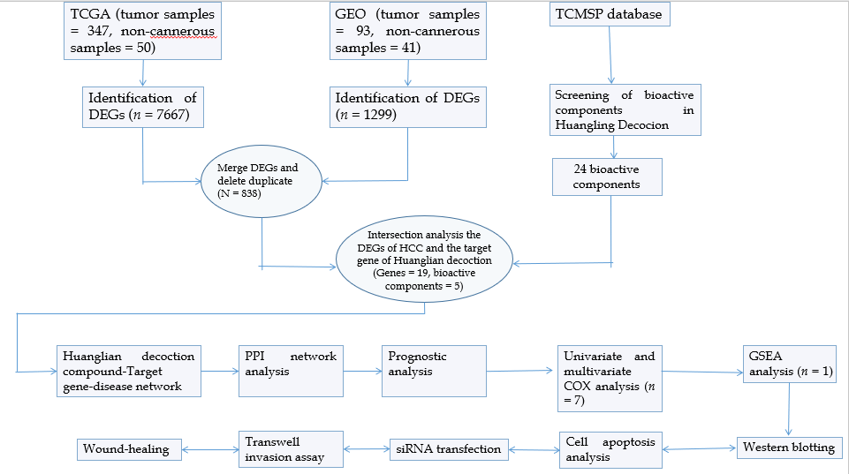
Figure 1 Flow chart. TCGA: The Cancer Genome Atlas; GEO: Gene Expression Omnibus; TCMSP: Traditional Chinese Medicine System Pharmacology Database and Analysis Platform; DEGs: Differentially expressed genes; HCC: Hepatocellular carcinoma; PPI: Protein-protein interaction; GSEA: Gene set enrichment analysis.
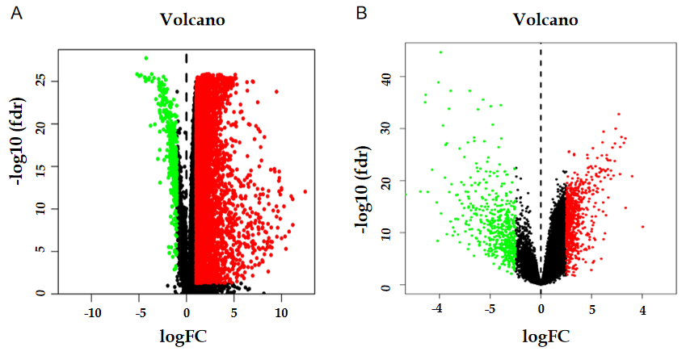
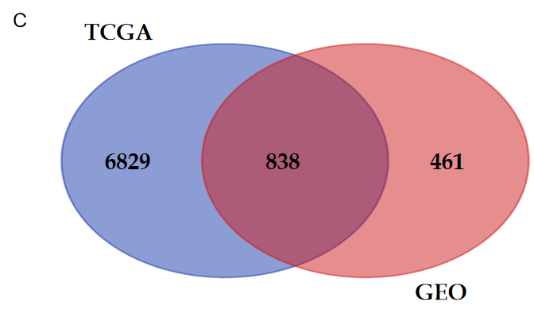
Figure 2 Volcano and Venn diagrams of differentially expressed genes. A: Differential gene analysis of The Cancer Genome Atlas (TCGA) datasets; B: Differential gene analysis of Gene Expression Omnibus (GEO) datasets; C: The TCGA and GEO datasets show an overlap of 838 genes. Upregulated genes are marked in red; downregulated genes are marked in light green. TCGA: The Cancer Genome Atlas; GEO: Gene Expression Omnibus.
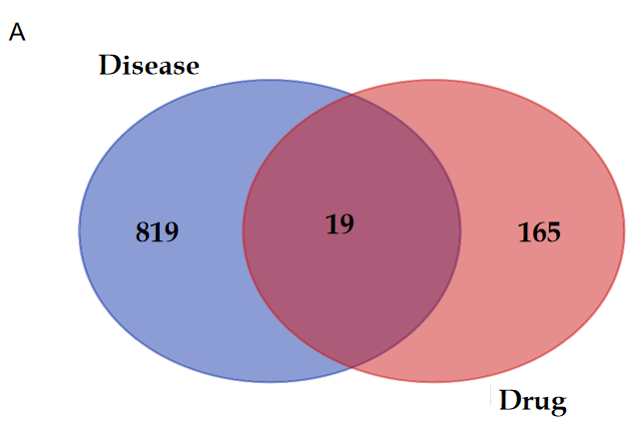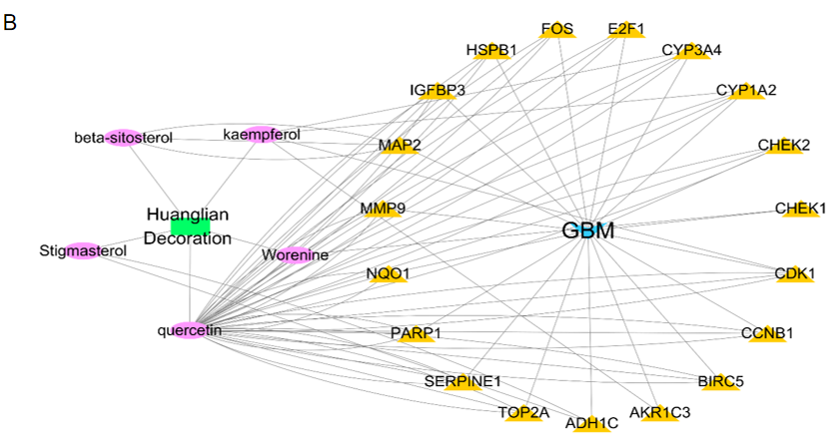
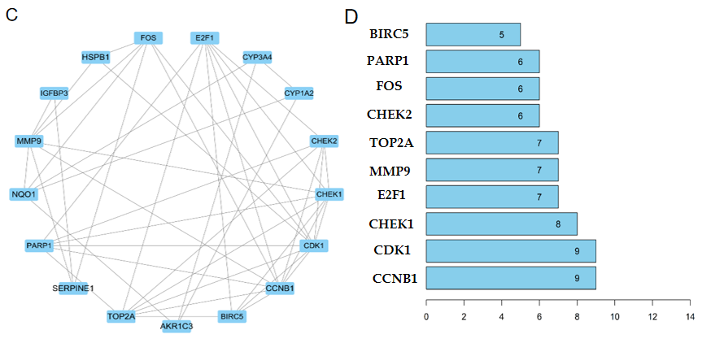
Figure 3 Identification of key genes. A: 19 genes overlap between differentially expressed genes of disease and drug target genes; B: Herb-Compound network of potential bioactive constituents for Huanglian decoction. The circles on the left are the drugs and their bioactive compounds, while the circles on the right are the target genes; C: Protein-protein interaction network for target genes. The edges represent the interaction between them; D: The top 10 genes according to the number of nodes.
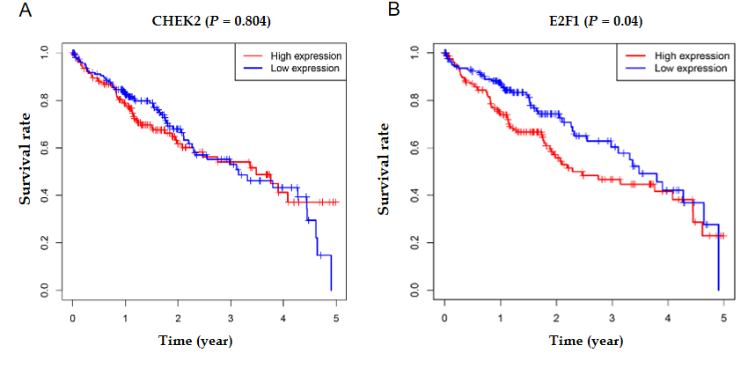
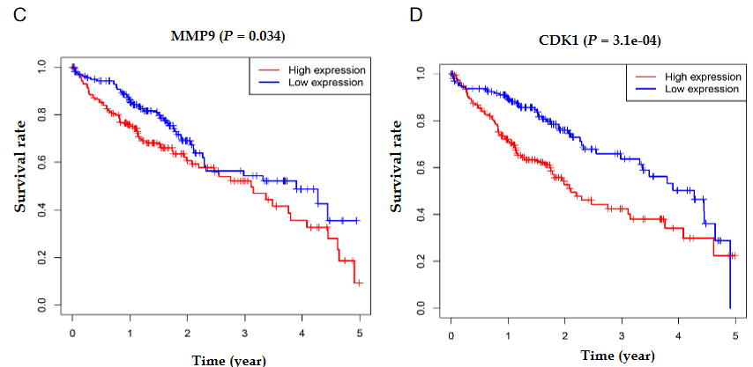

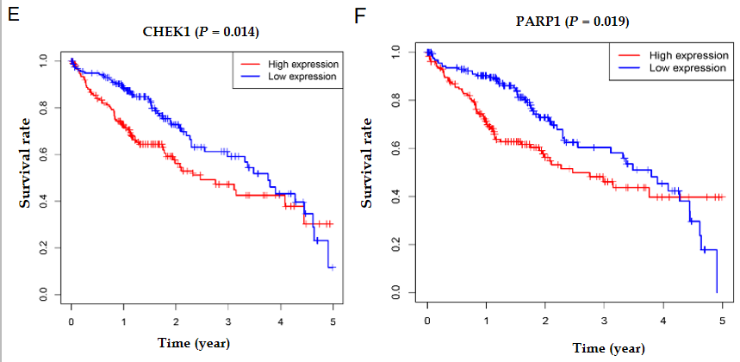
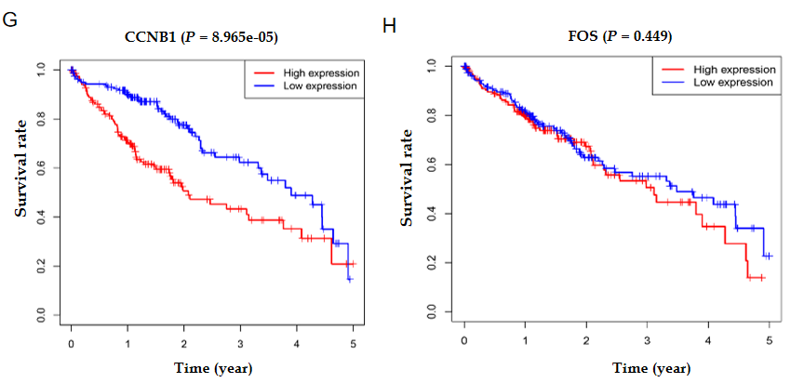
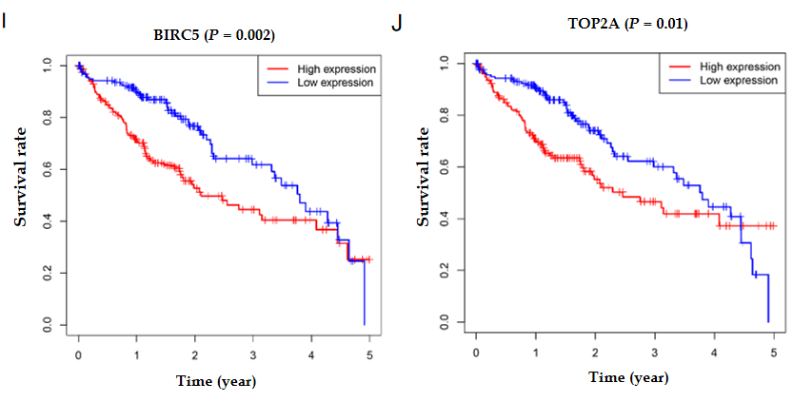
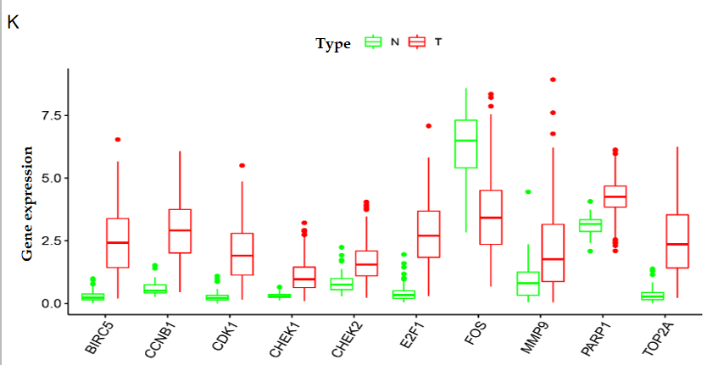
Figure 4 Survival and expression analyses. A-J: Survival analysis of the hub genes; K: Expression analysis of the hub genes. A level of P < 0.05 was considered statistically significant.
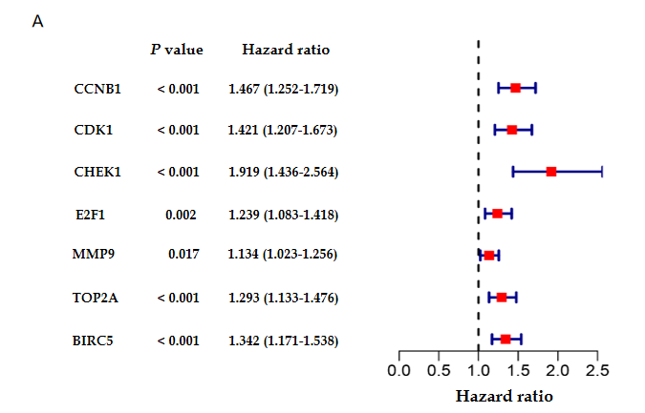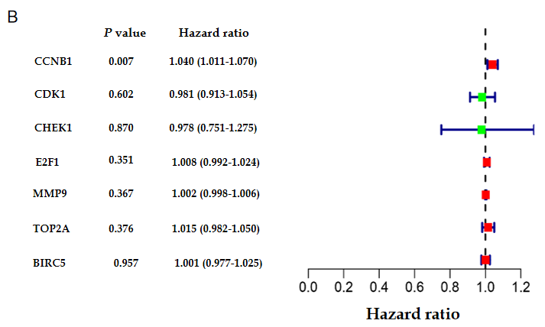
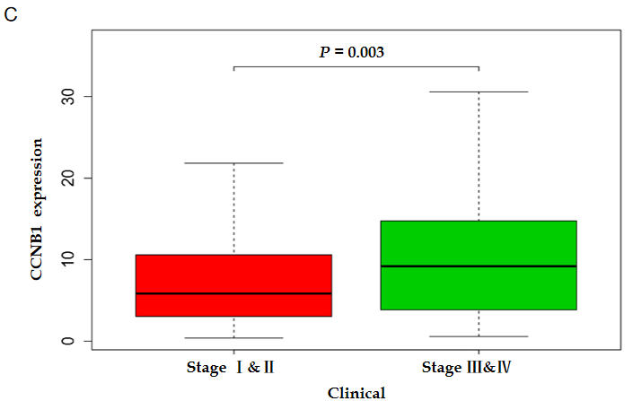
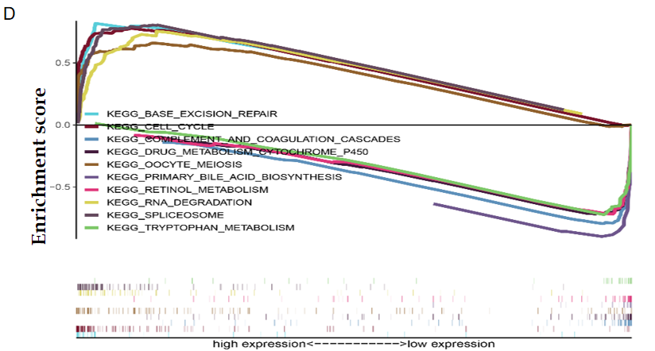
Figure 5 Identification of key prognostic genes in hepatocellular carcinoma. A: Univariate Cox analysis; B: Multivariate Cox analysis; C: CCNB1 found to promote tumor development; D: The Gene Set Enrichment Analysis reveals the biological pathways and processes associated with CCNB1.

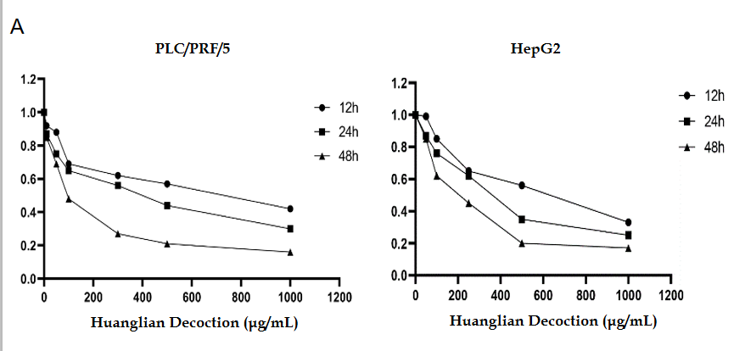
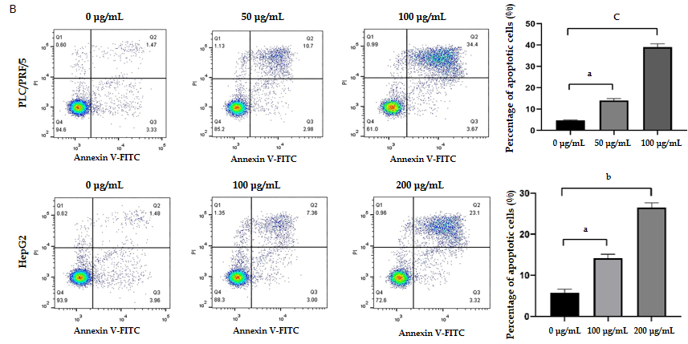
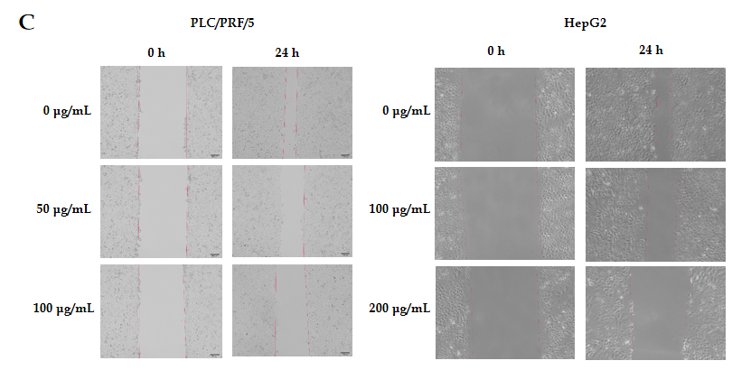
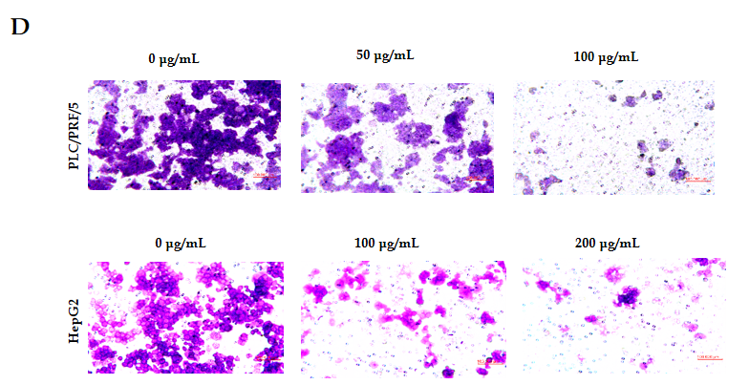
Figure 6 Huanglian decoction suppressed hepatocellular carcinoma cell growth in vitro. A: Time- and dose-dependent effects of Huanglian decoction treatment on the viability of both PLC/PRF/5 and HepG2 cells; B: Huanglian decoction can induce apoptosis of both PLC/PRF/5 and HepG2 cells; C: Huanglian decoction can reduce the migration activity of both PLC/PRF/5 and HepG2 cells; D: Huanglian decoction can reduce the invasion activity of both PLC/PRF/5 and HepG2 cells. ªP < 0.05 vs negative control (NC) group; ^{b}P < 0.01 vs NC group; ^{c}P < 0.001 vs NC group. FITC: Fluorescein isothiocyanate.
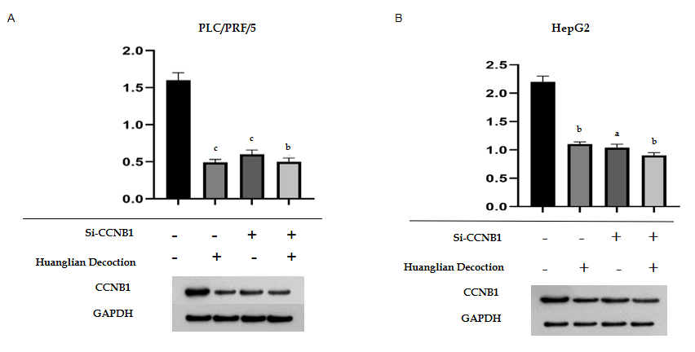
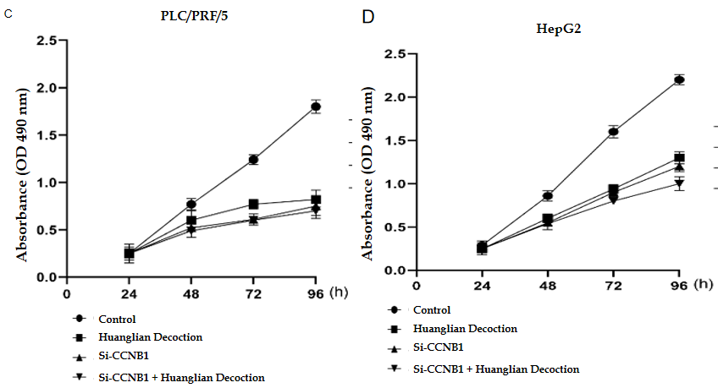
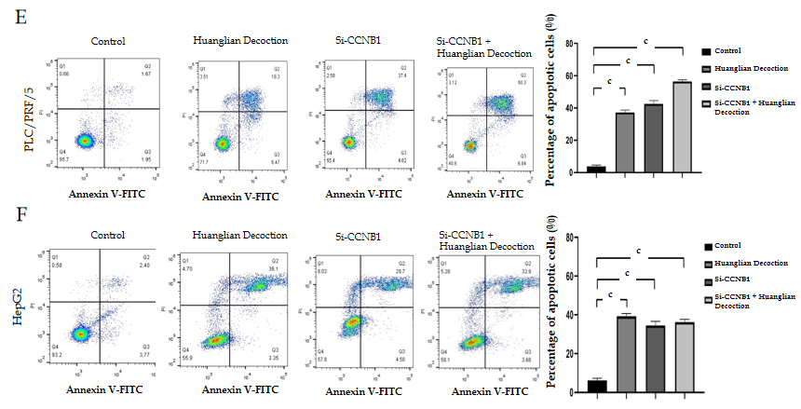
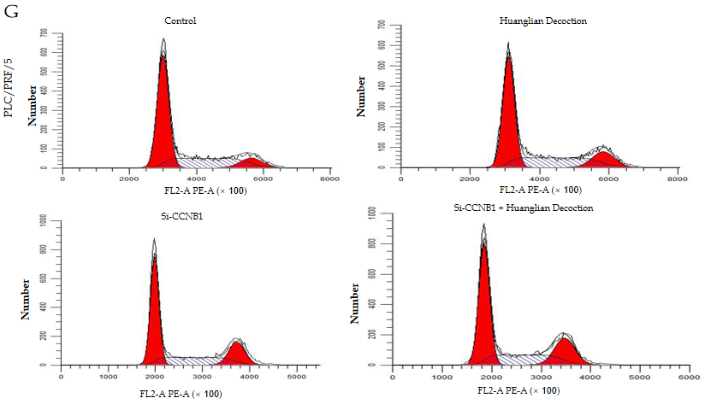

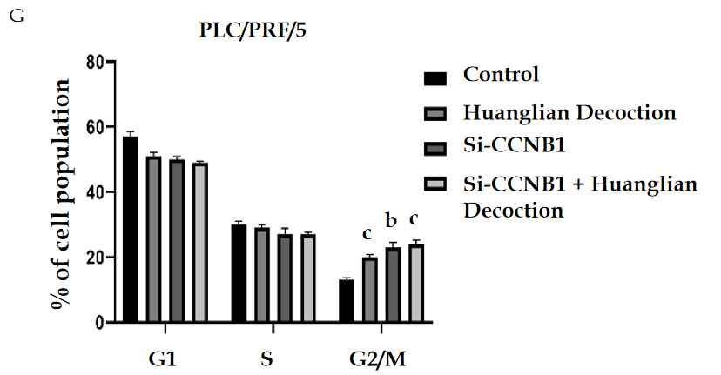
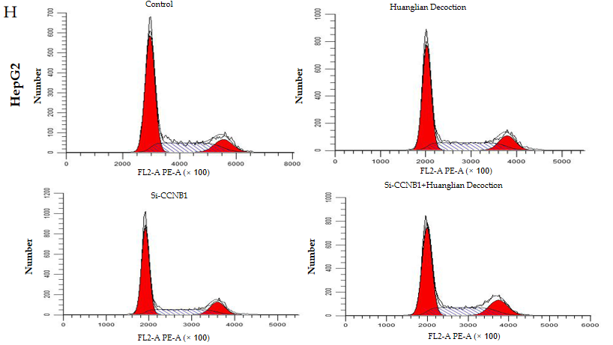

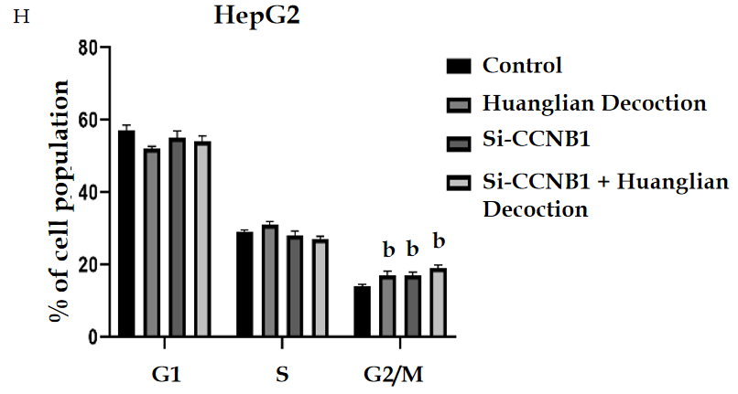
Figure 7 Huanglian decoction suppressed hepatocellular carcinoma cell growth in vitro by inhibiting the expression level of CCNB1 protein. A and B: Huanglian decoction can reduce the expression level of CCNB1 protein in hepatocellular carcinoma cells, but has no significant effect on the transfected cells; C and D: At 24, 48, 72, and 96 h after transfection, cell proliferation was determined using the MTT assay; E and F: The level of cell apoptosis increased significantly after transfection, and Huanglian decoction had no significant effect on the cells after transfection; G and H: Huanglian decoction can induce G2/M phase arrest of PLC/PRF/5 and HepG2 cells. ªP < 0.05 vs negative control (NC) group; ^{b}P < 0.01 vs NC group; ^{c}P < 0.001 vs NC group. FITC: Fluorescein isothiocyanate.
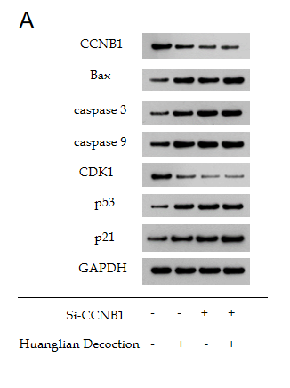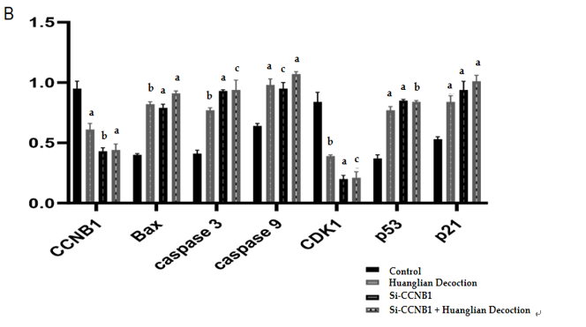
Figure 8 Protein expression of CCNB1, Bax, caspase 3, caspase 9, CDK1, p53, and p21 in the different groups by western blot. A: Western blot analysis results; B: Histogram of protein expression levels. ªP < 0.05 vs negative control (NC) group; ^{b}P < 0.01 vs NC group; ^{c}P < 0.001 vs NC group.
Table 1 Gene set enrichment analysis
Name | ES | NES | NOM P value | FDR q-value
KEGG_CELL_CYCLE | 0.78 | 2.24 | 0.000 | 0.000
KEGG_BASE_EXCISION_REPAIR | 0.82 | 2.23 | 0.000 | 0.000
KEGG_RNA_DEGRADATION | 0.76 | 2.17 | 0.000 | 0.000
KEGG_SPLICEOSOME | 0.81 | 2.16 | 0.000 | 0.000
KEGG_OOCYTE_MEIOSIS | 0.66 | 2.14 | 0.000 | 0.000
KEGG_COMPLEMENT_AND_COAGULATION_CASCADES | -0.80 | -2.27 | 0.000 | 0.000
KEGG_DRUG_METABOLISM_CYTOCHROME_P450 | -0.72 | -2.17 | 0.000 | 0.000
KEGG_RETINOL_METABOLISM | -0.73 | -2.16 | 0.000 | 0.000
KEGG_PRIMARY_BILE_ACID_BIOSYNTHESIS | -0.92 | -2.09 | 0.000 | 0.000
KEGG_TRYPTOPHAN_METABOLISM | 0.73 | -2.09 | 0.000 | 0.000
NOM P value < 0.01 was statistically significant. FDR: False discovery rate.

Published by Baishideng Publishing Group Inc
7041 Koll Center Parkway, Suite 160, Pleasanton, CA 94566, USA
Telephone: +1-925-3991568
E-mail: bpgoffice@wjgnet.com
Help Desk: https://www.f6publishing.com/helpdesk
https://www.wjgnet.com

© 2021 Baishideng Publishing Group Inc. All rights reserved.

