Name of Journal: World Journal of Orthopedics
Manuscript NO: 81029
Manuscript Type: MINIREVIEWS

Surgical strategy of the treatment of atypical femoral fractures

Shim BJ et al. Surgical treatment and surveillance of AFFs

Bum-Jin Shim, Heejae Won, Shin-Yoon Kim, Seung-Hoon Baek

Bum-Jin Shim, Heejae Won, Department of Orthopedic Surgery, Kyungpook National University Chilgok Hospital, Daegu 41404, South Korea

Bum-Jin Shim, Department of Orthopedic Surgery, Kyungpook National University, College of Medincine, Daegu 41944, South Korea

Shin-Yoon Kim, Seung-Hoon Baek, Department of Orthopedic Surgery, Kyungpook National University Hospital, Kyungpook National University, College of Medincine, Daegu 41944, South Korea

Author contributions: Shim BJ performed the majority of the writing, prepared the figures and tables; Won H provided the input in writing the paper; Kim SY performed data accusation and writing; Baek SH designed the outline and coordinated the writing of the paper.

Supported by Korean Fund for Regenerative Medicine (KFRM) grant funded by the Korea Government (the Ministry of Science and ICT, the Ministry of Health & Welfare), No. 22D0801L1 and No. 22C0604L1.

Corresponding author: Seung-Hoon Baek, MD, PhD, Professor, Department of Orthopedic Surgery, Kyungpook National University Hospital, Kyungpook National University, College of Medincine, 130, Dongdeok-ro, Jung-Gu, Daegu 41944, South Korea. insideme@paran.com

Received: December 13, 2022
Revised: February 16, 2023
Accepted: April 19, 2023
Published online: May 18, 2023
Abstract
The atypical femoral fracture (AFF) has been attracting significant attention because of its increasing incidence; additionally, its treatment is challenging from biological and mechanical aspects. Although surgery is often required to manage complete AFFs, clear guidelines for the surgical treatment of AFFs are currently sparse. We reviewed and described the surgical treatment of AFFs and the surveillance of the contralateral femur. For complete AFFs, cephalomedullary intramedullary nailing spanning the entire length of the femur can be used. Various surgical techniques to overcome the femoral bowing common in AFFs include a lateral entry point, external rotation of the nail, and the use of a nail with a small radius of curvature, or a contralateral nail. In the case of a narrow medullary canal, severe femoral bowing, or pre-existing implants, plate fixation may be considered as an alternative. For incomplete AFFs, prophylactic fixation depends on several risk factors, such as a subtrochanteric location, presence of a radiolucent line, functional pain, and condition of the contralateral femur; the same surgical principles as those in complete AFFs can be applied. Finally, once AFF is diagnosed, clinicians should recognize the increased risk of contralateral AFFs, and close surveillance of the contralateral femur is recommended.

Key Words: Atypical femoral fracture; Surgical treatment; Surveillance; Contralateral femur; Femoral bowing

©The Author(s) 2023. Published by Baishideng Publishing Group Inc. All rights reserved.

Citation: Shim BJ, Won H, Kim SY, Baek SH. Surgical strategy of the treatment of atypical femoral fractures. World J Orthop 2023; 14(5): 302-311
URL: https://www.wjgnet.com/2218-5836/full/v14/i5/302.htm
DOI: https://dx.doi.org/10.5312/wjo.v14.i5.302

Core Tip: For complete atypical femoral fractures (AFFs), cephalomedullary intramedullary nailing spanning the entire femur and various surgical techniques to overcome femoral bowing should be considered. For incomplete AFFs, the recognition of impending complete fractures is important. For the contralateral femur, close surveillance is recommended because of the increased risk of contralateral AFF.
INTRODUCTION
The atypical femoral fracture (AFF) has attracted significant attention since Odvina et al^{[1]} first reported non-traumatic subtrochanteric fractures in the femur in nine patients with the prolonged use of bisphosphonate therapy (BP). The treatment of AFFs is challenging, even for skilled orthopedic surgeons. Biologically, long-term use of anti-resorptive agents is associated with reduction of bone turnover and altered biomechanics^{[2]}. The inhibition of the bone remodeling process by reducing the activity of osteoclasts causes changes in the mineral and matrix properties of the bone, consequently increasing the thickness of the bone cortex. As a result, bone strength and stiffness increase, making the bone more brittle and susceptible to fragility fractures. Also, biomechanical analyses indicate that tensile stresses are high in the lateral femoral cortex and these can predispose the AFFs^{[3]}. In addition, it affects primary and secondary bone healing^{[2-4]}, resulting in delayed union or non-union^{[5]}. In addition, AFFs are often encountered in unfavorable mechanical environments, such as anterolateral bowing of the femur^{[6]}, and intramedullary nailing (IMN) may not fit the femur^{[7-9]}. As the incidence of AFF is rising owing to an increase in the aging population^{[4]} and is often associated with the potential risk of poor bone healing, the treatment of AFF has become a major issue in the medical community, leading to convening a task force by the American Society of Bone and Mineral Research^{[10,11]}.
In general, AFF often requires surgical treatment depending on the fracture pattern (complete or incomplete), location (subtrochanter or diaphysis), and presence of symptoms (thigh pain), which is considered the standard treatment for both complete and incomplete fractures. However, as there has been a lack of randomized controlled trials demonstrating the optimal treatment of AFFs, clear guidelines for surgical treatment are currently scarce^{[12,13]}, and treatment for AFF is being performed according to a lack of consensus based on expert opinions.
In the current study, we reviewed the current surgical treatment methods for complete and incomplete AFF and highlighted the specific considerations to be observed in unique situations, such as concurrent severe bowing and surveillance of the contralateral femur. Finally, we summarized the context by providing a management algorithm for AFFs based on contemporary evidence in the literature.

SURGICAL TREATMENT OF COMPLETE FRACTURES
AFFs can be classified into complete and incomplete fractures, and surgical treatment is inevitable for complete fractures^{[14]}. Randomized clinical trials have not yet been conducted to determine the optimal surgical method for complete fractures; however, long cephalomedullary IMN spanning the full length of the femur has been recommended^{[6,10]}.
Biomechanical aspect should be considered for the surgical treatment of AFFs. Previous reports have suggested several reasons why IMN is preferred for plate fixation in AFFs. First, from a mechanical aspect, IMN has advantages, including a better load-sharing capacity and less bending moment owing to its more medial location compared to plate fixation^{[15,16]}. Thus, devices with greater load sharing have an advantage in AFFs in terms of early ambulation in elderly patients. Second, because of decreased bone remodeling and the subsequent poor bone quality, the stress concentration around the end of implants may induce peri-implant stress fractures^{[17]}. While it is difficult to span the full length of the femur with open plating, IMN has the advantage of spanning the whole femur, and therefore, stabile fixation can be achieved without imbalance between tensile force and compressive force of the fracture site and it may be better than plating in reducing subsequent fatigue fractures^{[18]}. Biologically, osteoclastic activity is suppressed by previous anti-resorptive medication in AFF patients, thereby rendering bone remodeling and subsequent direct bone healing difficult^{[1-4]}. Although direct bone healing is important in plate fixation, IMN may induce indirect bone healing by endochondral ossification, and decreased osteoclastic function may affect the fracture healing process lesser compared to other methods^{[19]}. Also, Basically, biological damage can be minimized by avoiding incision and direct manipulation of the fracture site. In addition, Although intramedullary nailing can have detrimental effect on the cortical and the endosteal blood flow, it has important effect for bone healing with increased extraosseous circulation and the bone grafting effect from marrow reaming during IMN may enhance osteosynthesis in AFF patients with reduced fracture healing potential^{[20,21]}. Finally, AFFs often accompany anterolateral bowing of the femur; however, contouring the plate to fit the three-dimensional (3D) curvature of the bowed femur during surgery requires additional time and a large incision for open plating itself in elderly patients^{[9]}. Therefore, IMN has theoretical advantages over plating in terms of mechanical, biological, and practical aspects.
Systematic reviews have shown that a greater proportion of complete AFFs treated with plate fixation required reoperation compared to those individuals treated with IMN^{[11,22]}. Egol et al^{[23]} reported favorable functional outcomes with IMN in the treatment of AFFs. Shkolnikova et al^{[24]} demonstrated that extramedullary fixation, such as plate fixation, resulted in a functional decline in the majority of patients with AFFs. Thus far, studies have shown that IMN provides better radiographic and functional outcomes when compared to plate fixation^{[11,22]}.
The selection of an IMN implant design is important for AFFs. The largest possible nail should be used to avoid distal perforation and iatrogenic fractures caused by IMN^{[25]}. If accompanied by femoral bowing, it is recommended to use a nail with a small radius of curvature (ROC)^{[7,25]}. The conventional standard IMN involves the oblique transverse orientation of the proximal interlocking screws across the proximal femur. However, because these interlocking screws do not cover the femoral neck, there is a potential risk of stress fractures around this unprotected area^{[26]}. As cephalomedullary IMN incorporates one or two large proximal locking screws into the nail and places them in the direction of the femoral head, this method may protect the femoral neck from subsequent fragility fractures. A recent study showed that cephalomedullary IMN reduces the incidence of delayed peri-implant fragility fractures, newly developed AFFs, and non-unions in patients with AFF^{[27]}.
AFFs have been reported to have high complication rates with operative fixation because of their unique properties, including anterolateral bowing of the femur^{[4,28,29]}. Although IMN follows the standard surgical technique for subtrochanteric or shaft fractures, meticulous surgical techniques may be necessary to treat complete AFFs. In AFFs, the lateral cortex of the femur at the fracture site is often thickened, which makes nail passage difficult. To overcome this, the medullary canal can be over-reamed by 2.5 mm to ensure good nail passage, stimulate fracture site healing, and reduce iatrogenic fractures^{[30]}. The quality of fracture reduction is important for determining the healing of AFFs, and mal-alignment is strongly correlated with the healing time and failure rate^{[31,32]}. Moreover, if the IMN straightens the curved femur, this not only affects the healing time but also induces limb length discrepancy (LLD)^{[9]}. A previous study analyzed the factors affecting healing in complete AFFs and reported that IMN without cortical breakage around the fracture site and reduction of the fracture gaps anteriorly and laterally affected the healing of AFFs^{[33]}. Since non-union may occur if there are residual fracture gaps anteriorly and laterally more than 2 mm, it is recommended to attempt narrowing of the gaps using the back-slapping method by applying the angular stable locking system (ASLS®, Synthes GmbH, Oberdorf, Switzerland) for distal interlocking. Another study reported that the quality of fracture reduction was the most important factor for achieving bone union; additionally, the cutoff points for the neck-shaft angle, differences in the neck-shaft angle, and sagittal angulation were 125.6, 4.4, and 5.5°, respectively^{[34]}. If adequate alignment cannot be achieved with traction, particularly in subtrochanteric AFFs associated with strong muscle forces, percutaneous wiring or preliminary plating may be necessary^{[32,33]}. The possible causes of failure include the position of the nail as well as the quality of reduction, and it is important to consider the respective starting points^{[35]}. If loss of reduction occurs during nail passage, repositioning of the starting point should be considered.
IMN in AFF with severe anterolateral bowing is challenging, and various methods have been suggested to overcome this difficulty^{[8]}. First, as mentioned above, if the bowing of the femur is severe, it is recommended to use a nail with as small ROC as possible^{[7,27]}. Second, the entry point lateral to the greater trochanter or piriformis fossa can be used as a site of insertion (Figure 1)^{[36]}. Third, an alternative method is to use the opposite side of the nail (Figure 2)^{[37]}. Some femoral nails have an anterior curve as well as proximal lateral bending, and thus can be aligned with the anatomical axis of the femur with anterolateral bowing by rotating the zig 180° to the opposite side of the nail. The fourth method involves adjusting the alignment by externally rotating the nail. In this method, the anterior curvature of the nail is externally rotated to fit the anterolateral bowing of the femur, and the proximal lateral bending of the nail is matched to the anterior curvature of the femur^{[6]}. However, this method requires the use of a standard nail with proximal screws in the transverse direction instead of the cephalomedullary nail in AFFs and demonstrates concerns related to femoral neck stress fractures. Finally, with the introduction of the minimally invasive plate osteosynthesis (MIPO) technique, which can facilitate indirect bone healing, plate fixation can be considered as an alternative to IMN in AFF with an extremely narrow canal, no nail match with severe femoral bowing, or pre-existing metal implants (Figure 3)^{[38]}. When plate fixation is considered for AFF treatment, spanning the full length of the femur is recommended, and prophylactic screw fixation toward the femoral neck may be necessary to prevent peri-implant or femoral neck fractures (Figure 4)^{[18,39]}.
Delayed union, non-union, or implant failure has been a common complication reported after the surgical treatment of AFFs^{[11,22,40]}. Among them, non-union is the most frequent complication, followed by implant failure. According to a recent systemic review including 348 complete AFFs, reoperation was required in 6 out of 38 (15.7%) extramedullary fixation devices used for treating AFF, whereas revision was required in 20 out of 310 (6.45%) IMNs^{[22]}. This finding is consistent with the results reported by Koh et al^{[11]}; a greater proportion of complete AFFs treated with plate fixation (31.3%) required reoperation than those treated with IMN (12.9%) (P<0.01). With regard to the clinical outcomes, the patients who underwent IMN demonstrated better functional scores^{[40]}. A previous study reported that IMN returned to the baseline function in 64% and pain-free status in 66% of patients at postoperative 12 mo^{[23]}, while another study with a follow-up duration of up to 46 mo demonstrated a functional decline in 64% of the patients, the majority of whom had extramedullary fixation devices^{[24]}. Unlike the increased mortality associated with typical osteoporotic fractures of the femur, a previous study reported that the mortality rate after treating AFFs was lower than that after treating ordinary femoral fractures^{[41]}. Therefore, although the treatment of AFFs is often challenging, orthopedic surgeons may obtain promising outcomes if they choose a proper treatment option according to the individual and pay attention to meticulous surgical techniques.

SURGICAL TREATMENT OF INCOMPLETE FRACTURES
The natural history of incomplete AFFs has not yet been determined; therefore, taking decisions regarding whether or when to perform surgery is difficult^{[42]}. Incomplete AFFs are easily misdiagnosed or undiagnosed before the fracture becomes complete (Figure 1)^{[43]}. Meanwhile, a previous study reported that 10 of 14 (71.4%) incomplete AFFs were eventually treated surgically because of their progression to complete fractures or intractable pain^{[14]}. The purpose of prophylactic surgery in incomplete AFFs is not only to reduce pain, but also to prevent progression to complete fractures, thereby avoiding commonly developed complications after complete AFFs, such as delayed union, non-union, implant failure, and LLD, as described above^{[11,44]}. Therefore, it is important to assess whether the optimal option for treating incomplete AFFs is to perform prophylactic surgery or close observation. Recently, a scoring system was introduced to identify impending fractures among incomplete AFFs according to the fracture location, nature of pain, the extent of the radiolucent line, and condition of the contralateral femur (Table 1)^{[12]}. If the score is equal to or greater than eight points, prophylactic fixation is recommended. Contrastingly, patients with a score of seven or less may be treated conservatively, and the responsible physician should carefully evaluate the patient’s symptoms and radiographic findings to identify the changes during follow-up. In addition, some authors have recommended prophylactic fixation for incomplete AFFs in cases with the “dreaded black line” on radiographs, varus femoral bowing, a history of contralateral AFF, or failure to improve after two or three months of conservative management^{[38,45]}.
The same surgical principles as those for complete AFFs can be applied; thus, cephalomedullary IMN has been proposed as a standard prophylactic fixation for incomplete AFFs^{[46]}. However, for those with severe femoral bowing, which is common in incomplete AFFs, care should be taken because IMN may lead to iatrogenic complete fractures and result in LLD, delayed- or non-union^{[11,46]}. Recently, a report demonstrated that the use of a 3D printing technique could facilitate the reconstruction of severely bowed femurs with incomplete AFF, which were then fixed with a pre-contoured plate using an MIPO technique to match the shape of the femur (Figure 3 and Figure 4)^{[9]}. In this case, additional prophylactic screw fixation toward the femoral neck was required to prevent stress concentration and potential femoral neck fractures.
Although the indications or methods of prophylactic fixation for incomplete AFFs are still controversial, this approach has generally been associated with excellent results^{[23,47]}. A previous study reported that incomplete AFFs treated with surgery showed radiographic healing in 100% and pain-free status in 81% of patients at a mean of 7.1 mo postoperatively^{[23]}. In a systematic review of 109 incomplete AFFs treated with prophylactic fixation (78 fractures with IMN, 12 fractures with plate fixation, and the remaining by unspecified means), 106 fractures (97%) healed radiologically without any revision surgery at an average of 7 mo (range, 1.5–20 mo)^{[11]}.

SURVEILLANCE OF CONTRALATERAL FEMUR
Although the pathogenesis of AFFs remains unclear, patients with unilateral AFF have an increased risk of subsequent contralateral fractures^{[10]}. Previous studies have reported that up to 62.9% of patients with AFFs had bilateral fractures or radiographic abnormalities in the contralateral femur^{[10,48]}. However, as most patients with complete AFFs may have an asymptomatic contralateral femur at initial presentation, it is easy to underestimate the potential AFF in the contralateral femur until the fracture becomes complete (Figure 3)^{[49]}. Several authors have investigated the natural course of the contralateral femur in patients with AFF and reported that up to 88.5% of contralateral femurs eventually progressed to an incomplete or complete fracture within a period of three years^{[50-52]}. This is because reduced weight bearing in the fractured femur may propagate incipient stress fractures in the contralateral femur^{[9]}. A recent report highlighted that the postoperative use of BP might influence the development of contralateral AFF^{[50]}. Therefore, once AFF is diagnosed, a contralateral femur should be evaluated and appropriate medical treatment, including the discontinuation of BPs and initiation of calcium and vitamin D supplementation, must be initiated in addition to endocrine assessments, such as bone turnover markers^{[53]}. When diagnosing a contralateral incomplete AFF, clinicians should decide whether to perform prophylactic surgery or conduct a close observation. As described in the surgical treatment of incomplete fractures, a history of contralateral AFF is a potential risk for an impending complete fracture; thus, the current consensus is that contralateral incomplete AFF may be considered an impending complete fracture^{[12,23,54]}.
In summary, orthopedic surgeons should be aware of the potential risk of contralateral AFF in patients with unilateral AFF and must evaluate the contralateral side. Although the validated guidelines to support the subsequent decision-making processes remain unclear, prophylactic fixation for contralateral incomplete AFF may be recommended in cases where the risk of impending complete AFF is increased (Figure 5)^{[55]}. In the absence of such signs of incomplete AFF, close surveillance of the contralateral femur for at least two years may be required^{[50]}. Once AFF is diagnosed, clinicians should discontinue BPs and provide calcium and vitamin D supplements. The use of bone-forming agents may promote healing and reduce the potential risk of complete AFF on the contralateral side^{[10]}.

CONCLUSION
The incidence of AFFs is increasing, and their treatment is challenging in terms of the biological and mechanical aspects. For complete AFFs, the cephalomedullary IMN spanning the entire length of the femur can be primarily used. The various surgical techniques for IMN to overcome the femoral bowing common in AFFs include over-reaming, use of a lateral entry point, external rotation of the nail, and the use of a nail with a small ROC or contralateral nail. In cases of narrow canals, severe femoral bowing, or pre-existing metal implants, plate fixation may be considered as an alternative. For incomplete AFFs, prophylactic fixation depends on potential risk factors such as subtrochanteric location, the presence of a radiolucent line, functional pain, and condition of the contralateral femur, and the same surgical principles as those in complete AFFs can be applied. Finally, once AFF is diagnosed, the clinicians should recognize the increased risk of contralateral AFF, and close surveillance of the contralateral femur is recommended.

REFERENCES
1 Odvina CV, Zerwekh JE, Rao DS, Maalouf N, Gottschalk FA, Pak CY. Severely suppressed bone turnover: a potential complication of alendronate therapy. J Clin Endocrinol Metab 2005; 90: 1294-1301 [PMID: 15598694 DOI: 10.1210/jc.2004-0952]
2 Geissler JR, Bajaj D, Fritton JC. American Society of Biomechanics Journal of Biomechanics Award 2013: cortical bone tissue mechanical quality and biological mechanisms possibly underlying atypical fractures. J Biomech 2015; 48: 883-894 [PMID: 25683519 DOI: 10.1016/j.jbiomech.2015.01.032]
3 Martelli S, Pivonka P, Ebeling PR. Femoral shaft strains during daily activities: Implications for atypical femoral fractures. Clin Biomech (Bristol, Avon) 2014; 29: 869-876 [PMID: 25156184 DOI: 10.1016/j.clinbiomech.2014.08.001]
4 Kang JS, Won YY, Kim JO, Min BW, Lee KH, Park KK, Song JH, Kim YT, Kim GH. Atypical femoral fractures after anti-osteoporotic medication: a Korean multicenter study. Int Orthop 2014; 38: 1247-1253 [PMID: 24464018 DOI: 10.1007/s00264-013-2259-9]
5 Leighton RK, de Dios Robinson J, Giannoudis PV. Nonunions of Bisphosphonate Fractures of the Femur: Presentation, Etiopathogenesis, Diagnosis, and Operative Treatment. J Orthop Trauma 2019; 33 Suppl 8: S14-S20 [PMID: 31688522 DOI: 10.1097/BOT.0000000000001642]
6 Park YC, Song HK, Zheng XL, Yang KH. Intramedullary Nailing for Atypical Femoral Fracture with Excessive Anterolateral Bowing. J Bone Joint Surg Am 2017; 99: 726-735 [PMID: 28463916 DOI: 10.2106/JBJS.16.00760]
7 Park JH, Lee Y, Shon OJ, Shon HC, Kim JW. Surgical tips of intramedullary nailing in severely bowed femurs in atypical femur fractures: Simulation with 3D printed model. Injury 2016; 47: 1318-1324 [PMID: 26980645 DOI: 10.1016/j.injury.2016.02.026]
8 Lee KJ, Min BW. Surgical Treatment of the Atypical Femoral Fracture: Overcoming Femoral Bowing. Hip Pelvis 2018; 30: 202-209 [PMID: 30534538 DOI: 10.5371/hp.2018.30.4.202]
9 Won H, Baek SH, Kim CH, Kim DH, Yoon JW, Kim SY. Precontoured Plate Fixation for Incomplete Atypical Diaphyseal Fracture of Femur using Three-Dimensional Printing Rapid Prototyping: Two Cases Reports. Orthop Surg 2021; 13: 353-359 [PMID: 33283486 DOI: 10.1111/os.12867]
10 Shane E, Burr D, Abrahamsen B, Adler RA, Brown TD, Cheung AM, Cosman F, Curtis JR, Dell R, Dempster DW, Ebeling PR, Einhorn TA, Genant HK, Geusens P, Klaushofer K, Lane JM, McKiernan F, McKinney R, Ng A, Nieves J, O'Keefe R, Papapoulos S, Howe TS, van der Meulen MC, Weinstein RS, Whyte MP. Atypical subtrochanteric and diaphyseal femoral fractures: second report of a task force of the American Society for Bone and Mineral Research. J Bone Miner Res 2014; 29: 1-23 [PMID: 23712442 DOI: 10.1002/jbmr.1998]
11 Koh A, Guerado E, Giannoudis PV. Atypical femoral fractures related to bisphosphonate treatment: issues and controversies related to their surgical management. Bone Joint J 2017; 99-B: 295-302 [PMID: 28249967 DOI: 10.1302/0301-620X.99B3.BJJ-2016-0276.R2]
12 Min BW, Koo KH, Park YS, Oh CW, Lim SJ, Kim JW, Lee KJ, Lee YK. Scoring System for Identifying Impending Complete Fractures in Incomplete Atypical Femoral Fractures. J Clin Endocrinol Metab 2017; 102: 545-550 [PMID: 27802096 DOI: 10.1210/jc.2016-2787]
13 Githens M, Garner MR, Firoozabadi R. Surgical Management of Atypical Femur Fractures Associated With Bisphosphonate Therapy. J Am Acad Orthop Surg 2018; 26: 864-871 [PMID: 30256339 DOI: 10.5435/JAAOS-D-16-00717]
14 Ha YC, Cho MR, Park KH, Kim SY, Koo KH. Is surgery necessary for femoral insufficiency fractures after long-term bisphosphonate therapy? Clin Orthop Relat Res 2010; 468: 3393-3398 [PMID: 20865463 DOI: 10.1007/s11999-010-1583-2]
15 Eberle S, Gerber C, von Oldenburg G, Hungerer S, Augat P. Type of hip fracture determines load share in intramedullary osteosynthesis. Clin Orthop Relat Res 2009; 467: 1972-1980 [PMID: 19333673 DOI: 10.1007/s11999-009-0800-3]
16 Sedel L, Christel P, Dewas J, de Charentenay FX, Leray J. Comparison of the effects of intramedullary nailing or plating on the mechanical properties of fracture callus. J Biomed Eng 1980; 2: 89-92 [PMID: 7374125 DOI: 10.1016/0141-5425(80)90058-8]
17 Yoo J, Ma X, Lee J, Hwang J. Research Update on Stress Riser Fractures. Indian J Orthop 2021; 55: 560-570 [PMID: 33995860 DOI: 10.1007/s43465-020-00291-4]
18 Lee JY, Soh T, Howe TS, Koh JS, Kwek EB, Chua DT. Bisphosphonate-associated peri-implant fractures: a new clinical entity? A series of 10 patients with 11 fractures. Acta Orthop 2015; 86: 622-626 [PMID: 25817305 DOI: 10.3109/17453674.2015.1036339]
19 Charles-Harris M, Lacroix D, Proubasta I, Planell JA. Intramedullary nails vs osteosynthesis plates for femoral fracture stabilization: A finite element analysis. J Appl Biomater Biomech 2005; 3: 157-167 [PMID: 20799221]
20 Wu CC, Chen WJ. Treatment of femoral shaft aseptic nonunions: comparison between closed and open bone-grafting techniques. J Trauma 1997; 43: 112-116 [PMID: 9253919 DOI: 10.1097/00005373-199707000-00026]
21 Wu CC, Shih CH, Chen WJ, Tai CL. Effect of reaming bone grafting on treating femoral shaft aseptic nonunion after plating. Arch Orthop Trauma Surg 1999; 119: 303-307 [PMID: 10447628 DOI: 10.1007/s004020050415]
22 Ebrahimpour A, Sadighi M, Hoveidaei AH, Chehrassan M, Minaei R, Vahedi H, Mortazavi SJ. Surgical Treatment for Bisphosphonate-related Atypical Femoral Fracture: A Systematic Review. Arch Bone Jt Surg 2021; 9: 283-296 [PMID: 34239955 DOI: 10.22038/abjs.2020.52698.2608]
23 Egol KA, Park JH, Prensky C, Rosenberg ZS, Peck V, Tejwani NC. Surgical treatment improves clinical and functional outcomes for patients who sustain incomplete bisphosphonate-related femur fractures. J Orthop Trauma 2013; 27: 331-335 [PMID: 22986315 DOI: 10.1097/BOT.0b013e31827240ae]
24 Shkolnikova J, Flynn J, Choong P. Burden of bisphosphonate-associated femoral fractures. ANZ J Surg 2013; 83: 175-181 [PMID: 23216704 DOI: 10.1111/ans.12018]
25 Tosounidis TH, Lampropoulou-Adamidou K, Kanakaris NK. Intramedullary nailing of sequential bilateral atypical subtrochanteric fractures and the management of distal femoral intraoperative fracture. J Orthop Trauma 2015 [PMID: 26087454 DOI: 10.1097/BOT.0000000000000370]
26 Patton JT, Cook RE, Adams CI, Robinson CM. Late fracture of the hip after reamed intramedullary nailing of the femur. J Bone Joint Surg Br 2000; 82: 967-971 [PMID: 11041583 DOI: 10.1302/0301-620x.82b7.10518]
27 Oh CW, Kim JW, Park KH, Oh JK, Yoon YC, Chung SH. The importance of reconstruction nailing for diaphyseal atypical femoral fractures: a comparative study with standard nailing. Arch Orthop Trauma Surg 2022; 142: 2677-2683 [PMID: 34244873 DOI: 10.1007/s00402-021-04057-x]
28 Weil YA, Rivkin G, Safran O, Liebergall M, Foldes AJ. The outcome of surgically treated femur fractures associated with long-term bisphosphonate use. J Trauma 2011; 71: 186-190 [PMID: 21610533 DOI: 10.1097/TA.0b013e31821957e3]
29 Grady MK, Watson JT, Cannada LK. Treatment of femoral fracture nonunion after long-term bisphosphonate use. Orthopedics 2012; 35: e991-e995 [PMID: 22691683 DOI: 10.3928/01477447-20120525-51]
30 Abrahamsen B, Eiken P, Eastell R. Cumulative alendronate dose and the long-term absolute risk of subtrochanteric and diaphyseal femur fractures: a register-based national cohort analysis. J Clin Endocrinol Metab 2010; 95: 5258-5265 [PMID: 20843943 DOI: 10.1210/jc.2010-1571]
31 Prasarn ML, Ahn J, Helfet DL, Lane JM, Lorich DG. Bisphosphonate-associated femur fractures have high complication rates with operative fixation. Clin Orthop Relat Res 2012; 470: 2295-2301 [PMID: 22669553 DOI: 10.1007/s11999-012-2412-6]
32 Lee KJ, Yoo JJ, Oh KJ, Yoo JH, Rhyu KH, Nam KW, Suh DH. Surgical outcome of intramedullary nailing in patients with complete atypical femoral fracture: A multicenter retrospective study. Injury 2017; 48: 941-945 [PMID: 28274470 DOI: 10.1016/j.injury.2017.02.036]
33 Lim HS, Kim CK, Park YS, Moon YW, Lim SJ, Kim SM. Factors Associated with Increased Healing Time in Complete Femoral Fractures After Long-Term Bisphosphonate Therapy. J Bone Joint Surg Am 2016; 98: 1978-1987 [PMID: 27926679 DOI: 10.2106/JBJS.15.01422]
34 Cho JW, Oh CW, Leung F, Park KC, Wong MK, Kwek E, Kim HJ, Oh JK. Healing of Atypical Subtrochanteric Femur Fractures After Cephalomedullary Nailing: Which Factors Predict Union? J Orthop Trauma 2017; 31: 138-145 [PMID: 28009615 DOI: 10.1097/BOT.0000000000000743]
35 Murena L, Moretti A, Meo F, Saggioro E, Barbati G, Ratti C, Canton G. Predictors of cut-out after cephalomedullary nail fixation of pertrochanteric fractures: a retrospective study of 813 patients. Arch Orthop Trauma Surg 2018; 138: 351-359 [PMID: 29273922 DOI: 10.1007/s00402-017-2863-z]
36 Kim JW, Kim H, Oh CW, Kim JW, Shon OJ, Byun YS, Kim JJ, Oh HK, Minehara H, Hwang KT, Park KC. Surgical outcomes of intramedullary nailing for diaphyseal atypical femur fractures: is it safe to modify a nail entry in bowed femur? Arch Orthop Trauma Surg 2017; 137: 1515-1522 [PMID: 28770350 DOI: 10.1007/s00402-017-2764-1]
37 Shon OJ, Yoon JY, Kim JW. Clinical outcomes of using contralateral-side laterally bent intramedullary nails in atypical femur fractures with femoral bowing. Arch Orthop Trauma Surg 2021; 141: 1291-1296 [PMID: 32710344 DOI: 10.1007/s00402-020-03524-1]
38 Das De S, Setiobudi T, Shen L, Das De S. A rational approach to management of alendronate-related subtrochanteric fractures. J Bone Joint Surg Br 2010; 92: 679-686 [PMID: 20436006 DOI: 10.1302/0301-620X.92B5.22941]
39 Cho Y, Byun YS, Jo S, Shin J. Plate Fixation for Atypical Fractures of the Femoral Diaphysis. Clin Orthop Surg 2022; 14: 178-183 [PMID: 35685979 DOI: 10.4055/cios21173]
40 Khow KS, Shibu P, Yu SC, Chehade MJ, Visvanathan R. Epidemiology and Postoperative Outcomes of Atypical Femoral Fractures in Older Adults: A Systematic Review. J Nutr Health Aging 2017; 21: 83-91 [PMID: 27999854 DOI: 10.1007/s12603-015-0652-3]
41 Kharazmi M, Hallberg P, Schilcher J, Aspenberg P, Michaëlsson K. Mortality After Atypical Femoral Fractures: A Cohort Study. J Bone Miner Res 2016; 31: 491-497 [PMID: 26676878 DOI: 10.1002/jbmr.2767]
42 Png MA, Mohan PC, Koh JSB, Howe CY, Howe TS. Natural history of incomplete atypical femoral fractures in patients after a prolonged and variable course of bisphosphonate therapy-a long-term radiological follow-up. Osteoporos Int 2019; 30: 2417-2428 [PMID: 31435684 DOI: 10.1007/s00198-019-05067-7]
43 Im GI, Lee SH. Effect of Teriparatide on Healing of Atypical Femoral Fractures: A Systemic Review. J Bone Metab 2015; 22: 183-189 [PMID: 26713309 DOI: 10.11005/jbm.2015.22.4.183]
44 Wang K, Moaveni A, Dowrick A, Liew S. Alendronate-associated femoral insufficiency fractures and femoral stress reactions. J Orthop Surg (Hong Kong) 2011; 19: 89-92 [PMID: 21519086 DOI: 10.1177/230949901101900121]
45 Toro G, Ojeda-Thies C, Calabrò G, Toro G, Moretti A, Guerra GM, Caba-Doussoux P, Iolascon G. Management of atypical femoral fracture: a scoping review and comprehensive algorithm. BMC Musculoskelet Disord 2016; 17: 227 [PMID: 27215972 DOI: 10.1186/s12891-016-1086-8]
46 Starr J, Tay YKD, Shane E. Current Understanding of Epidemiology, Pathophysiology, and Management of Atypical Femur Fractures. Curr Osteoporos Rep 2018; 16: 519-529 [PMID: 29951870 DOI: 10.1007/s11914-018-0464-6]
47 Oh CW, Oh JK, Park KC, Kim JW, Yoon YC. Prophylactic nailing of incomplete atypical femoral fractures. ScientificWorldJournal 2013; 2013: 450148 [PMID: 23365544 DOI: 10.1155/2013/450148]
48 Woo SH, Park KS, Choi IS, Ahn YS, Jeong DM, Yoon TR. Sequential Bilateral Hip Fractures in Elderly Patients. Hip Pelvis 2020; 32: 99-104 [PMID: 32566541 DOI: 10.5371/hp.2020.32.2.99]
49 Schneider PS, Wall M, Brown JP, Cheung AM, Harvey EJ, Morin SN. Atypical femur fractures: a survey of current practices in orthopedic surgery. Osteoporos Int 2017; 28: 3271-3276 [PMID: 28770273 DOI: 10.1007/s00198-017-4155-4]
50 Lee KJ, Min BW, Bae KC, Cho CH, Lee SW, Kim BS. Progression of Asymptomatic Contralateral Femur in Patients with Complete Atypical Femoral Fracture, According to Initial Radiographic Findings. J Bone Joint Surg Am 2021; 103: 123-130 [PMID: 33476100 DOI: 10.2106/JBJS.20.00807]
51 Bogdan Y, Tornetta P 3rd, Einhorn TA, Guy P, Leveille L, Robinson J, Bosse MJ, Haines N, Horwitz D, Jones C, Schemitsch E, Sagi C, Thomas B, Stahl D, Ricci W, Brady M, Sanders D, Kain M, Higgins TF, Collinge C, Kottmeier S, Friess D. Healing Time and Complications in Operatively Treated Atypical Femur Fractures Associated With Bisphosphonate Use: A Multicenter Retrospective Cohort. J Orthop Trauma 2016; 30: 177-181 [PMID: 26709814 DOI: 10.1097/BOT.0000000000000516]
52 Probyn L, Cheung AM, Lang C, Lenchik L, Adachi JD, Khan A, Josse RG, Tomlinson G, Bleakney R. Bilateral atypical femoral fractures: how much symmetry is there on imaging? Skeletal Radiol 2015; 44: 1579-1584 [PMID: 26169723 DOI: 10.1007/s00256-015-2212-7]
53 Eastell R, Rosen CJ, Black DM, Cheung AM, Murad MH, Shoback D. Pharmacological Management of Osteoporosis in Postmenopausal Women: An Endocrine Society* Clinical Practice Guideline. J Clin Endocrinol Metab 2019; 104: 1595-1622 [PMID: 30907953 DOI: 10.1210/jc.2019-00221]
54 Banffy MB, Vrahas MS, Ready JE, Abraham JA. Nonoperative versus prophylactic treatment of bisphosphonate-associated femoral stress fractures. Clin Orthop Relat Res 2011; 469: 2028-2034 [PMID: 21350886 DOI: 10.1007/s11999-011-1828-8]
55 Tornetta P, Ricci WM, Ostrum RF, McQueen MM, McKee MD, Count-Brown CM. Rockwood and Green's fractures in adults: 9th ed. Philadelphia: Lippincott, 2019

Footnotes
Conflict-of-interest statement: There is no conflict of interest associated with any of the senior author or other coauthors contributed their efforts in this manuscript.

Open-Access: This article is an open-access article that was selected by an in-house editor and fully peer-reviewed by external reviewers. It is distributed in accordance with the Creative Commons Attribution NonCommercial (CC BY-NC 4.0) license, which permits others to distribute, remix, adapt, build upon this work non-commercially, and license their derivative works on different terms, provided the original work is properly cited and the use is non-commercial. See: https://creativecommons.org/Licenses/by-nc/4.0/

Provenance and peer review: Invited article; Externally peer reviewed.
Peer-review model: Single blind

Peer-review started: December 13, 2022
First decision: February 8, 2023
Article in press: April 19, 2023

Specialty type: Orthopedics
Country/Territory of origin: South Korea
Peer-review report’s scientific quality classification
Grade A (Excellent): 0
Grade B (Very good): B
Grade C (Good): C
Grade D (Fair): 0
Grade E (Poor): 0

P-Reviewer: Hoveidaei AH, Iran; Wang J, China S-Editor: Wang JL L-Editor: A P-Editor: Zhao S
Figure Legends
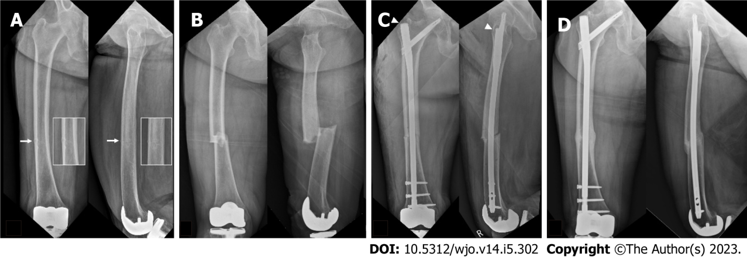
Figure 1 Images of an 80-year-old woman. A: An 80-year-old woman was transferred from a spine clinic because of intractable right thigh pain for three months. Radiographs revealed a transverse radiolucent line (white arrows and insets) on the lateral and anterior cortex of the right femur with 10° of varus. The patient refused prophylactic surgery for incomplete atypical femoral fracture (AFF); however, medical treatment including a switch from bisphosphonate to teriparatide was initiated. According to a scoring system^{[11]}, the risk for impending complete AFF was scored as 10 points; B: Two months later, she visited the emergency department due to progression to a complete AFF; C: She underwent fixation with a long cephalomedullary nail (Trochanteric Fixation Nail-Advanced®, DePuy Synthes, Winterthur, Switzerland) spanning the whole length of the femur. It is to be noted that the entry point of the nail is lateral and anterior to the greater trochanter tip (arrowheads); D: Radiographs taken at 18 mo postoperatively showed healing of the fracture site.
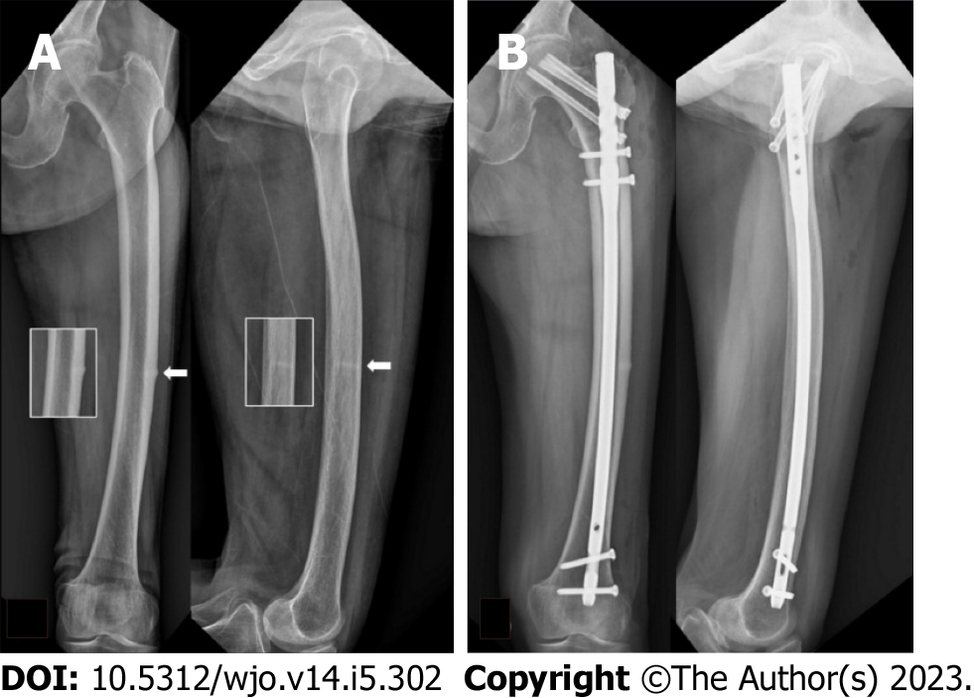
Figure 2 Images of an 81-year-old woman who had taken bisphosphonate for two years. A: An 81-year-old woman who had taken bisphosphonate for two years visited the outpatient clinic complaining of left thigh pain for two months. Radiographs revealed a transverse beak and radiolucent line (white arrows) on the lateral and anterior cortex of the right femur with 10° of varus and 7° of anterior angulation. According to a scoring system^{[11]}, the risk for impending complete atypical femoral fracture was scored as 11 points; B: She underwent fixation with an opposite-side (right side) standard nail (Sirus Femoral Nail®, Zimmer, Warsaw, IN, USA). Prophylactic screw fixation toward the femoral neck on her left femur was performed to prevent potential femoral neck fracture around the nail.
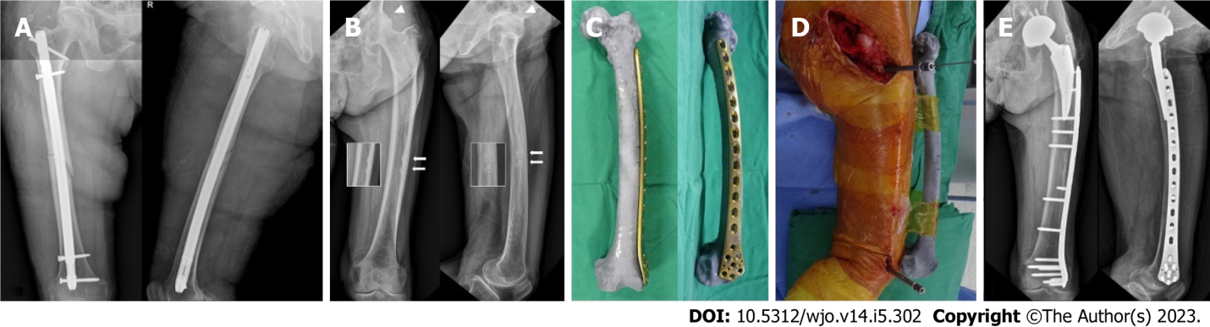
Figure 3 Images of a 75-year-old woman underwent a fixation with a long standard nail. A: A 75-year-old woman underwent a fixation with a long standard nail due to a complete atypical femoral fracture (AFF) on her right femur two years ago at another hospital and kept taking bisphosphonate (BP) until she visited our clinic; B: She reported left groin and thigh pain for six months. Radiographs revealed arthritis on her left hip joint (arrowheads) and transverse beaks with radiolucent lines (“dreaded black line”) on the lateral and anterior cortex of the left femur (white arrows and insets). According to a scoring system^{[11]}, the risk for impending complete AFF was scored as 8 points and BP medication was discontinued; C: Before total hip arthroplasty (THA) to treat hip arthritis, a locking compression plate was pre-contoured along the shape of the bone model with 3D printing rapid prototyping; D: During THA, the sterile 3D-printed model was placed in the same position as that of the femur and used as a surgical navigation. Fixation with the pre-contoured plate via minimally invasive plate osteosynthesis was performed to treat incomplete AFF; E: Radiographs taken three years postoperatively showed complete healing of the AFF without progression of femoral bowing or implant-related complications.
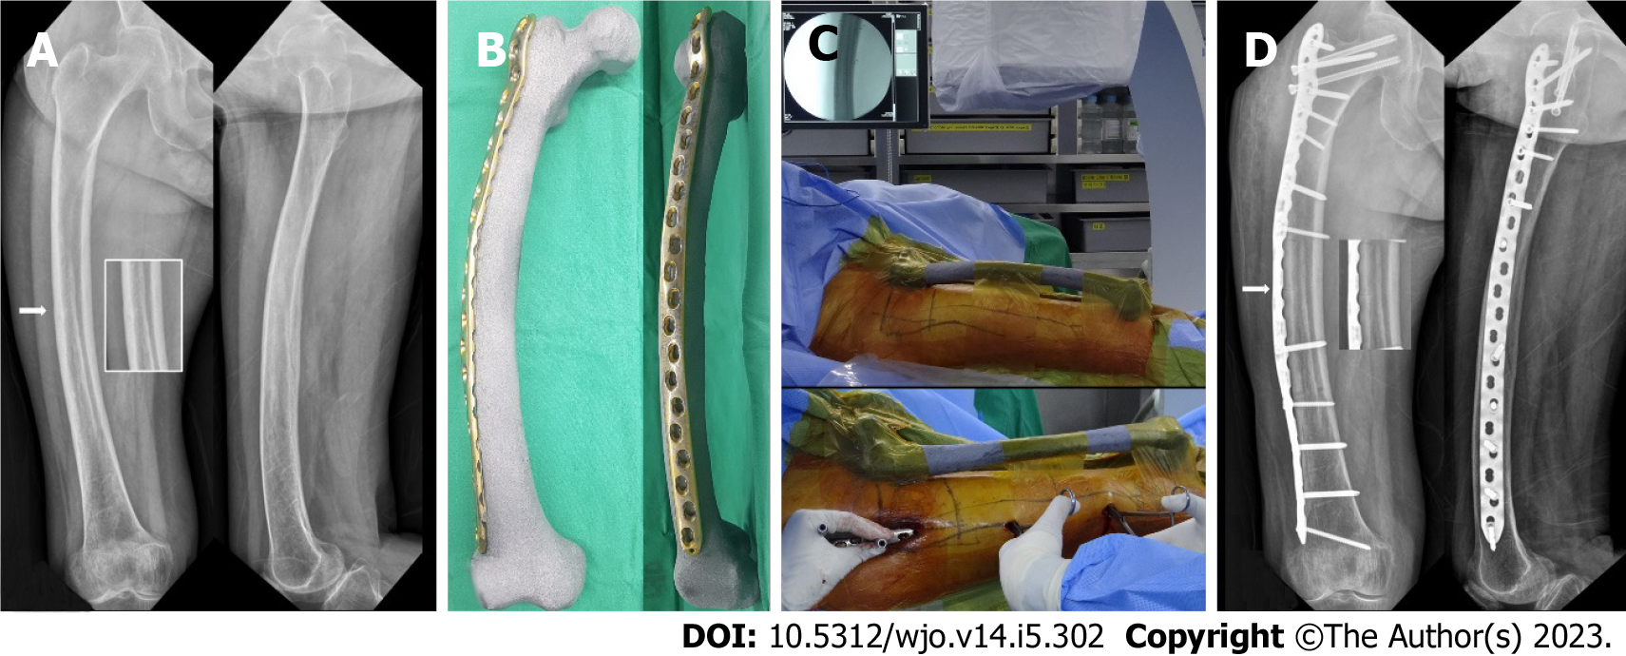
Figure 4 Images of a 75-year-old woman who had taken bisphosphonate. A: A 75-year-old woman who had taken bisphosphonate for a period of four years visited our clinic with right thigh pain for three months. Radiographs showed a transverse radiolucent line (white arrow and inset) on the apex of the lateral cortex of the right femur with 7° of varus. According to a scoring system^{[11]}, the risk for impending complete atypical femoral fracture (AFF) was scored as 9 points; B: Before the surgery, a locking compression plate was pre-contoured along the shape of the bone model with 3D printing rapid prototyping; C: During the surgery, the sterile 3D-printed bone model was placed in the same position as that of the femur and used as a surgical navigation; D: Fixation with pre-contoured plate fixation for incomplete AFF (white arrow and inset) with severe bowing was performed via minimally invasive plate osteosynthesis. It is to be noted that additional prophylactic screw fixation toward the femoral neck was performed to prevent potential femoral neck fractures.
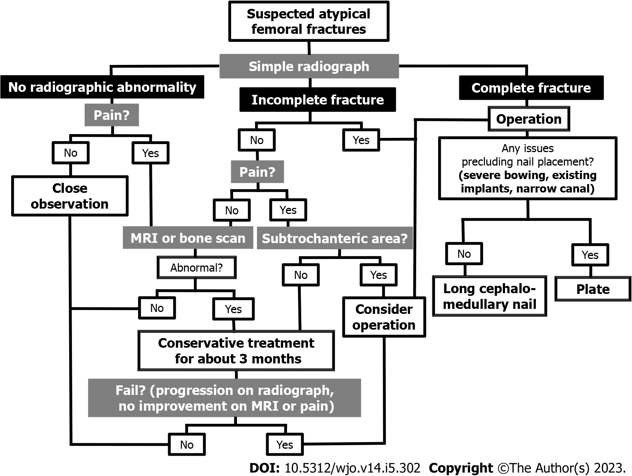
Figure 5 A proposed treatment algorithm for suspected atypical femoral fracture. MRI: Magnetic resonance imaging.
Table 1 A scoring system for the surveillance of impending complete atypical femoral fracture in an incomplete state^{[11]}
Variables | Score
 | 1 | 2 | 3
Pain | None | Mild | Functional
Site | Others | Diaphyseal area | Subtrochanteric area
Contralateral femur | Complete fracture | Incomplete fracture | Intact
Radiolucent line | Focal changes | Less than 1/2 | More than 1/2

Published by Baishideng Publishing Group Inc
7041 Koll Center Parkway, Suite 160, Pleasanton, CA 94566, USA
Telephone: +1-925-3991568
E-mail: bpgoffice@wjgnet.com
Help Desk: https://www.f6publishing.com/helpdesk
https://www.wjgnet.com

© 2023 Baishideng Publishing Group Inc. All rights reserved.

