Name of Journal: World Journal of Orthopedics
Manuscript NO: 64279
Manuscript Type: CASE REPORT

Nuances of oblique lumbar interbody fusion at L5-S1: three case reports

Berry CA. OLIF approaches to L5-S1

Chirag A Berry

Chirag A Berry, Department of Orthopaedics, Cincinnati VA Medical Center, Cincinnati, OH 45220, United States

Author contributions: Berry CA contributed to all aspects of this manuscript, namely, conception, design, data collection and interpretation, literature review, primary surgeon of all patients, drafting, revisions, and final approval.

Corresponding author: Chirag A Berry, MD, Assistant Professor, Department of Orthopaedics, Cincinnati VA Medical Center, 3200 Vine Street, Cincinnati, OH 45220, United States. berrycg@ucmail.uc.edu

Received: February 15, 2021
Revised: May 4, 2021
Accepted: May 27, 2021
Published online: June 18, 2021

Abstract
BACKGROUND
Oblique lumbar interbody fusion is a mini-open retroperitoneal approach that uses a wide corridor between the left psoas muscle and the aorta above L5. This approach avoids the limitations of lateral lumbar interbody fusion, is considered less invasive than anterior lumbar interbody fusion, and is similarly effective for indirect decompression and improving lordosis while maintaining a low complication profile. Including L5-S1, when required, adds to these advantages, as this allows single-position surgery. However, variations in vascular anatomy can affect the ease of access to the L5-S1 disc. The nuances of three different oblique anterolateral techniques to access L5-S1 for interbody fusion, namely, left-sided intra-bifurcation, left-sided pre-psoas, and right-sided pre-psoas approaches, are illustrated using three representative case studies.

CASE SUMMARY
Cases of three patients who underwent multilevel oblique lumbar interbody fusion including L5-S1, using one of the three different techniques, are described. All patients presented with symptomatic degenerative lumbar pathology and failed conservative management prior to surgery. The anatomical considerations that affected the decisions to utilize each approach are discussed. The pros and cons of each approach are also discussed. A parasagittal facet line objectively assesses the relationship between the left common iliac vein and the L5-S1 disc and assists in choosing the approach to L5-S1.

CONCLUSION
Oblique retroperitoneal access to L5-S1 in the lateral decubitus position is possible through three different approaches. The choice of approach to L5-S1 may be individualized based on a patient’s vascular anatomy using preoperative imaging. While most surgeons will rely on their experience and comfort level in choosing the approach, this article elucidates the nuances of each technique.

Key Words: Oblique lumbar interbody fusion; Prepsoas approach; Anterior to psoas; Common iliac vein; Iliolumbar vein; Case report

©The Author(s) 2021. Published by Baishideng Publishing Group Inc. All rights reserved.

Berry CA. Nuances of oblique lumbar interbody fusion at L5-S1: three case reports. World J Orthop 2021; 12(6): 445-455 URL: https://www.wjgnet.com/2218-5836/full/v12/i6/445.htm DOI: https://dx.doi.org/10.5312/wjo.v12.i6.445

Core Tip: Oblique lumbar interbody fusion (OLIF) provides safe retroperitoneal access to nearly all lumbar levels, including L5-S1, thus, allowing single-position surgery. L5-S1 OLIF access may be attempted through three alternative approaches — left intra-bifurcation, left pre-psoas and right pre-psoas approaches — the choice of which can be customized according to the patient’s vascular anatomy.

INTRODUCTION
Oblique pre-psoas retroperitoneal access to the lumbar spine through a mini-open technique has recently gained popularity. The oblique trajectory avoids the iliac crest and lower ribs, which are impediments to lateral lumbar interbody fusion (LLIF)^{[1]}. Staying outside the psoas reduces the risk of lumbar plexus injuries^{[2,3]}, and allows complete muscle relaxation as neuromonitoring is not considered essential for this approach^{[4,5]}. Moreover, a wide anatomic corridor between the left psoas and aorta allows easy access to all lumbar spinal levels above L5^{[6]}, often without the need for any vascular retraction or ligation^{[7]}.
Isolated L5-S1 pathologies can be approached through the anterior lumbar interbody fusion (ALIF) technique in the supine position, taking advantage of the wide corridor between the bifurcated common iliac vessels. However, the ALIF approach requires ligation of the left iliolumbar vein (ILV) and transposition of the great vessels to reach the levels above L5^{[8]}. In contrast, oblique lumbar interbody fusion (OLIF), or anterior to psoas (ATP) approach, performed with the patient in the lateral decubitus position, can address multiple lumbar levels, including L5-S1, with a relatively favorable complication profile^{[4,9]}. The lateral decubitus position takes advantage of gravity-assisted retraction of the peritoneal sac, theoretically reducing the risk of postoperative ileus^{[10]}. OLIF/ATP involves a mini-open muscle-splitting approach through the abdominal oblique and transverse muscles^{[11]}, which may be less traumatic than a midline ALIF approach through the anterior rectus muscle-sheath complex^{[12]}.
Oblique access to L5-S1 is not as straightforward as that for levels above L5. Variations in vascular anatomy create unique situations for which approaches may need to be customized. Oblique anterolateral approaches to L5-S1 have been described in previous studies as staying lateral to^{[4,13]}, or approaching between the bifurcated common iliac vessels^{[7]} (Figure 1A, B). These variations of technique have been found to be safe and feasible in individual studies. However, these studies have not provided adequate guidance regarding the choice of approach. Careful assessment of the vascular anatomy is critical as vascular injuries range from 0.3%-4.3%, especially when L5-S1 is included^{[4,7,12]}. Three representative case studies are presented to describe how the three previously described variations of approaches can be potentially customized based on a patient's anatomy.
All patients in the case studies were operated on in a single institution by a single spine surgeon with assistance from an access surgeon. Imaging and chart review were retrospectively performed. All patients presented with degenerative lumbar pathology and underwent nonsurgical treatment for a minimum of 6-12 wk before being considered for surgical intervention. After careful consideration, each patient elected to proceed with surgery and provided written informed consent.
In the preoperative magnetic resonance imaging (MRI), the location of the left common iliac vein (CIV) in relation to the L5-S1 disc was carefully assessed. We have previously described an imaginary parasagittal line drawn from the medial border of the left L5-S1 facet joint on the MRI axial section through the L5-S1 disc (the facet line)^{[13]} and traced anteriorly to assess its relationship with the left CIV (Figure 1B). MRI axial images through the L5 vertebral body were also carefully evaluated to identify L5 segmental veins or ILV on either side^{[4]} (Figure 1C). Computed tomography was not routinely performed to assess fusion.

Surgical techniques
Left intra-bifurcation approach: The left intra-bifurcation approach has been described by Woods et al^{[7]} and others^{[1,13-15]} and is a modification of the supine ALIF technique. This is performed with the patient in the right lateral decubitus position. Lateral fluoroscopy is performed to mark all target spinal levels on the skin (Figure 2). An oblique 5-6 cm incision in the left lower quadrant of the abdomen is marked 2 fingerbreadths anterior to the anterior iliac crest and extending inferior enough to reach the plane of the sacral slope.
A muscle-splitting approach through the external oblique, internal oblique, and transversus abdominis muscles is performed, and the retroperitoneal space is entered. Blunt dissection is performed to reach the left psoas muscle. The peritoneal sac is then retracted further medially and inferiorly to reach the medial aspect of the left common iliac vessels. Careful blunt dissection is performed to identify the anterior annulus of the L5-S1 disc, which is confirmed with fluoroscopy. The median sacral vessels are identified and ligated (Figure 3A). Blunt dissection may be required to mildly elevate and retract the left CIV laterally to further widen the intra-bifurcation interval. Discectomy and endplate preparation is then performed at L5-S1. Double-bent curettes may be needed to adequately reach the posterior portion of the L5 inferior endplate (Figure 3B). An ALIF cage (width: 32-40 mm; height: 12-20 mm; depth: 24-32 mm; lordosis: 14-20º) packed with bone graft is inserted through an oblique inserter under image guidance. The anteroposterior (AP) fluoroscopy confirms the midline position of the cage. A screw with a washer or a plate is usually placed to cover the cage to prevent dislodgement.

Left pre-psoas approach: The left pre-psoas approach has been described by Tannoury et al^{[4]} and others^{[13,16,17]}, and is an inferior continuation of the pre-psoas OLIF approach to levels above L5. As above, the patient is positioned in the right lateral decubitus position and spinal levels marked on the skin. A 4-5 cm incision is marked along the skin lines about 2 fingerbreadths anterior to the iliac crest, approximately mid-way between the target levels (Figure 2). A muscle-splitting approach through all abdominal wall layers is then performed to reach the retroperitoneal space. The left psoas muscle is identified and the pre-psoas interval is developed and extended inferiorly. The left CIV is identified. The left ILV is often identified inferior to the L4-5 disc, with psoas retraction (Figure 3A). Ligation of this left ILV may be required to allow anteromedial mobilization of the left CIV. This exposes the lateral annulus of the L5-S1 disc. Discectomy and endplate preparation is then performed using specialized instruments that are bent in two planes (Figure 3C, D). An LLIF cage (width: 45-55 mm; height: 10-16 mm; depth: 18-22 mm; lordosis: 6-18º) packed with bone graft is inserted through a lateral inserter under image guidance. Fluoroscopy confirms the coronal position of the cage.

Right pre-psoas approach: The right pre-psoas approach is performed from the right side with the patient in the left lateral decubitus position and has been described by Tannoury et al^{[4]} and others^{[13]}. A transverse incision along the skin lines is made, as above. The procedure is similar to the aforementioned left pre-psoas approach in terms of muscle splitting, entering the retroperitoneal space, and retracting the peritoneal sac anteromedially. The right psoas and IVC are identified, and an interval is created between them. This interval is then traced inferiorly along the right CIV. The right L5 segmental vein, when present, is identified, ligated, and divided (Figure 4A). Next, the right CIV is carefully retracted anteromedially to expose the lateral annulus of the L5-S1 disc. Discectomy, endplate preparation, and placement of an LLIF cage is then performed using bent instruments (Figure 4B), similar to the left pre-psoas approach. While this approach has been found to be safe and feasible by previous studies^{[4,13]}, extensive experience and comfort level is required to work alongside the IVC.

CASE PRESENTATION
Chief complaints
Low back pain.

History of present illness
Case 1: A 58-year-old man [body mass index (BMI): 34 kg/m²] presented with longstanding back and leg pain refractory to conservative treatment.

Case 2: A 69-year-old man (BMI: 31 kg/m²) presented with longstanding back and leg pain refractory to conservative treatment.

Case 3: A 72-year-old man (BMI: 23 kg/m²) presented with longstanding back and leg pain refractory to conservative treatment.

History of past illness
Case 1 had undergone prior laminotomy surgery. Case 2 and Case 3 did not have any relevant past illness.

Personal and family history
None of the 3 patients had any relevant positive personal and family history.

Physical examination
All 3 patients had examination findings consistent with Lumbar degenerative disc disease and stenosis. No neurologic deficit was noted. Case 2, in addition, showed findings consistent with a severe lumbar dextroscoliosis.

Laboratory examinations
None of the 3 patients had any significant laboratory examination findings.

Imaging examinations
Case 1: He was found to have L3-S1 degenerative disc disease and stenosis (Figure 5). A careful review of all the available imaging revealed a wide intra-bifurcation interval between the left and right common iliac vessels in the axial section through the L5-S1 disc. There was an identifiable fat plane between the left CIV and the L5-S1 disc. The medial edge of the left CIV was lateral to the facet line (Figure 5B).

Case 2: He was found to have severe lumbar dextroscoliosis, sagittal imbalance, and multilevel stenosis (Figure 6). An MRI axial cut at the L5-S1 disc showed the left CIV in the midline with no obvious fat plane underneath it (Figure 6D).

Case 3: He was found to have L3-S1 degenerative disc disease with central & foraminal stenosis. L3-S1 OLIF with posterior PPSI was recommended. A thorough evaluation of preoperative imaging was performed (Figure 7). As seen on the L5-S1 disc axial MRI cut, the medial wall of the left CIV was medial to the facet line (Figure 7B). The fat plane was not well-visualized between the left CIV and L5-S1 disc, but a small fat plane was identifiable between the right CIV and L5-S1 disc.

FINAL DIAGNOSIS
Case 1: L3-S1 degenerative disc disease and stenosis.

Case 2: Severe lumbar dextroscoliosis, sagittal imbalance, and multilevel stenosis.

Case 3: L3-S1 degenerative disc disease and stenosis.

TREATMENT
Case 1: L3-S1 OLIF with posterior percutaneous pedicle screw instrumentation (PPSI) was recommended. L5-S1 was approached through the left intra-bifurcation approach, and L3-4 and L4-5 through the left pre-psoas interval, all through the same incision. Minimal retraction and careful protection of the left common iliac vessels was required. Median sacral vessels were ligated. Posterior percutaneous pedicle screw instrumentation was performed in the prone position in the same operative setting. Neuromonitoring was not utilized. Operative time was 358 minutes, and intra-operative blood loss was 100 mL. No vascular injuries and no perioperative blood transfusions were required.

Case 2: Staged L1-S1 OLIF followed by posterior T11-S1 PPSI and iliac fixation on the next day was recommended. A left-sided pre-psoas approach was performed. During the exposure of L5-S1, minimal retraction of the left common iliac artery and no retraction of the CIV were required. The left ILV was not identified and did not interfere with exposure. A single skin incision provided access to 5 spinal segments from L1-S1, taking advantage of the scoliotic concavity on the left side. The patient underwent posterior instrumentation the next day, as planned. Neuromonitoring was used during the second stage only. Operative times for the two stages was 262 min and 294 min, and intra-operative blood loss was 500 mL and 250 mL, respectively. A minor vascular injury in the form of segmental bleed was encountered while exposing the L2-3 disc anterolaterally, which was controlled with ligation. No perioperative blood transfusions were required.

Case 3: L3-S1 OLIF with posterior PPSI was recommended. A right-sided pre-psoas approach was performed with the patient in the left lateral decubitus position. While accessing L5-S1, an L5 segmental vein was encountered, which was ligated with vascular clips and divided. Posterior PPSI was performed with the patient in the prone position at L3-S1 in the same operative setting. Neuromonitoring was not used. Operative time was 278 min, and intra-operative blood loss was 100 mL.

OUTCOME AND FOLLOW-UP
Case 1: The patient recovered well and was discharged home on postoperative day 2. Transient left groin pain was reported but resolved by the 2-wk follow-up. No other approach-related complications were observed. The patient reported excellent clinical improvement at his one year follow up visit. No subsidence or pseudarthrosis was seen.

Case 2: Excellent recovery was seen postoperatively, and the patient was discharged to a rehabilitation facility on day 6. He showed no approach-related complications. The patient reported excellent clinical improvement and radiographic maintenance of alignment at his two year follow up visit. No subsidence, pseudarthrosis, hardware failure, or proximal junctional issues were seen.

Case 3: The patient recovered well and was discharged home on postoperative day 2. There were no approach-related complications reported. The patient reported excellent clinical improvement at his one year follow up visit. No subsidence or pseudarthrosis was seen.

DISCUSSION
Lumbar interbody fusion techniques via anterior approaches (ALIF, OLIF, and LLIF) provide opportunities for indirect decompression^{[18]} and better correction of lordosis than posterior techniques^{[19]}. Among these approaches, OLIF/ATP shows the greatest versatility, allowing exposure of nearly all lumbar levels from T12-S1^{[4]}, and provides distinct advantages over other anterior and posterior approaches with favorable complication profiles^{[9,10]}. Neuromonitoring is not considered essential^{[4,5,18]} as the psoas muscle cushions the lumbar plexus during retraction. Intraoperative muscle relaxation can be employed with favorable effects on abdominal wall musculature compliance, psoas retractability^{[20]}, and intra-abdominal pressure.

Potential complications
Complication rates in OLIF/ATP approaches have been reported between 7.2% and 48.3% in different studies^{[4,21-23]}. The incidence of certain complications may be higher when L5-S1 is included in the OLIF/ATP procedure^{[7,13,23]}. This is especially true for vascular injuries, which can be catastrophic and potentially fatal. In a series of 940 patients, Tannoury et al^{[4]} found vascular injuries in 0.3%. They approached L5-S1 via the left or right pre-psoas approaches. Woods et al^{[7]} reported a 2.9% incidence of vascular injuries in their series of 137 patients. This incidence went up to 4.3% when L5-S1 was included in the approach. They used the intra-bifurcation approach to L5-S1. Our previously published series did not show any differences in incidence of vascular injuries between the three approaches to L5-S1^{[13]}. Approach-related complications like ileus, ipsilateral groin pain, anterior thigh numbness or pain, incisional hernia, or pseudohernia have also been reported with the OLIF/ATP approach^{[4,7,12,23]}. Subsidence may be seen more often with the OLIF approach compared to other anterior approaches for interbody fusion, according to Woods et al^{[7]}

Pros and cons of each approach
The intra-bifurcation left-sided approach is a modification of an ALIF approach to L5-S1, which most spine surgeons are accustomed to. It utilizes an oblique trajectory through an anterolaterally placed incision with the insertion of an ALIF cage. This approach allows broad access to the anterior aspect of L5-S1, which permits near-complete resection of the anterior longitudinal ligament (ALL). Thus, better correction of lordosis can be achieved by utilizing a hyper-lordotic cage. This extensive ALL release may prompt the surgeon to place a plate or washer that covers the cage, to prevent the cage from dislodging anteriorly.
The intra-bifurcation approach may require careful retraction and mobilization of a flat left CIV that may be covering the left half of the L5-S1 disc^{[24]} (Figure 3A). While this approach is similar to the supine ALIF approach, there is a higher likelihood of needing retraction or mobilization of the left CIV than the latter due to the left-sided oblique trajectory. This increases the risk of vascular injury as the medial aspect of the left CIV is often flat and stretched over the anterior osteophytes of the L5-S1 disc^{[13]}. Additionally, in patients with a large sacral slope, a longer oblique incision extending far inferiorly may be required to align with the plane of the L5-S1 disc (Figure 2). In such instances, preparation of the L5 inferior endplate may be blind, requiring extensive help from fluoroscopy^{[15]} (Figure 3B). Such blind endplate preparations might be common to all oblique approaches to L5-S1 and may be a reason for subsidence seen in some patients. Furthermore, due to the lower incision for L5-S1, separate incisions may be required to reach upper lumbar levels in multilevel surgeries. Midline orientation may also be challenging in the initial cases^{[7]}, because of the oblique trajectory of this approach. Lastly, the superior hypogastric sympathetic plexus, which lies anterior to the L5-S1 disc may still be at risk of injury with this approach.
The left and right pre-psoas approaches are an inferior continuation of the pre-psoas approach for levels above L5. Although the common iliac vessels are especially close to the psoas at L5-S1, this interval may be widened by retraction of the psoas and careful mobilization of the CIV, as needed. Being able to put a laterally-placed LLIF cage at L5-S1 reduces the need for longer skin incisions to align with the L5-S1 plane.
The left and right prepsoas approaches may be challenging in patients with large bulky psoas muscles. These approaches require specialized bent intruments and preparation of the L5 inferior endplate is often blind (Figure 3C, D, 4B). A blunt release of the contralateral annulus, which is common for OLIF or LLIF techniques at levels above L5, may not be advisable for the L5-S1 Level because of more laterally located contralateral common iliac vessels that may inadvertently get injured. ALL release is often not possible, however, a blunt ALL rupture may be achievable.
The right prepsoas approach may be useful in patients that may have a favorable indication to approach multiple levels from the right side; for example, in patients with a scoliotic concavity to the right, in those with prior left-sided abdominal surgeries with anticipated scarring, or in those with vascular anomalies^{[25]}. This approach may also be used if the access surgeon believes that L5-S1 can be reached with greater safety than the other approaches^{[4]}. However, this approach needs significant experience as the IVC and right CIV are approached head-on, and the prepsoas interval is much narrower at all levels on the right side.

How to choose the approach
Most patients could possibly undergo L5-S1 OLIF through more than one of the approaches described above. The choice should depend on the access surgeon's comfort level and experience. However, the anatomic relationship of the left CIV to the L5-S1 disc may also be an important consideration. A wide anterior interval between the left and right CIVs, and a more lateral position of the left CIV (Patient 1) may favor an intra-bifurcation approach^{[13,26]}. Although other methods of assessing the relative position of the left CIV to the L5-S1 disc are available^{[26]}, the facet line may be an easy, quick method^{[13]}. If the medial border of the left CIV is medial to this facet line without a distinct fat plane underneath, the intra-bifurcation approach may be challenging, and a pre-psoas approach may be considered (Cases 2, 3). In such cases, the authors personally prefer a right-sided pre-psoas approach for the following reasons. The right CIV is somewhat vertical and is visible throughout its course in a right-sided approach, while the left CIV takes a more horizontal oblique course and is often hidden underneath its accompanying artery in left-sided approaches^{[24]} (Figure 3A, 4A). In the authors’ experience, the more vertical right CIV is far more predictable in its course and easier to retract medially due to its rounded lateral edge, unlike the oblique and flat left CIV (Figure 7B). Moreover, according to Tannoury et al^{[4]}, the right ILV tends to be longer in length and smaller in caliber than the left ILV. The right ILV is hence easier to ligate and divide. Careful assessment of MRI axial images through the L5 vertebral body, may help identify L5 segmental veins or ILV on either side^{[4]} (Figure 1C).
The left pre-psoas approach may be beneficial in anatomy as in Patient 2, where the bifurcation is at a relatively lower vertebral level, such that the left CIV may not need any retraction or mobilization. The left pre-psoas approach can also be potentially used as an intraoperative bailout when an intra-bifurcation approach is unsuccessful due to difficulty retracting the left CIV laterally^{[13]}. However, the right prepsoas approach has to be chosen prior to surgery and cannot be used as an intraoperative bailout.

CONCLUSION
Altogether, L5-S1 can be exposed via an oblique approach using three different techniques, the choice of which may be customized according to a patient’s anatomy. A significant learning curve may be involved, and experience with identifying and ligating venous structures through mini-open exposures is required to safely perform these procedures. The availability of an experienced access surgeon is critical and may be essential for such exposures. While the right-sided pre-psoas approach has been shown to be safe and feasible in some studies, we strongly recommend gaining adequate experience before adopting this technique. In early cases and in patients with challenging vascular anatomy, posterior alternatives may be considered.

REFERENCES
1 Molloy S, Butler JS, Benton A, Malhotra K, Selvadurai S, Agu O. A new extensile anterolateral retroperitoneal approach for lumbar interbody fusion from L1 to S1: a prospective series with clinical outcomes. Spine J 2016; 16: 786-791 [PMID: 27033312 DOI: 10.1016/j.spinee.2016.03.044]
2 Cahill KS, Martinez JL, Wang MY, Vanni S, Levi AD. Motor nerve injuries following the minimally invasive lateral transpsoas approach. J Neurosurg Spine 2012; 17: 227-231 [PMID: 22746272 DOI: 10.3171/2012.5.SPINE1288]
3 Cummock MD, Vanni S, Levi AD, Yu Y, Wang MY. An analysis of postoperative thigh symptoms after minimally invasive transpsoas lumbar interbody fusion. J Neurosurg Spine 2011; 15: 11-18 [PMID: 21476801 DOI: 10.3171/2011.2.SPINE10374]
4 Tannoury T, Kempegowda H, Haddadi K, Tannoury C. Complications Associated With Minimally Invasive Anterior to the Psoas (ATP) Fusion of the Lumbosacral Spine. Spine (Phila Pa 1976) 2019; 44: E1122-E1129 [PMID: 31261275 DOI: 10.1097/BRS.0000000000003071]
5 Lee HJ, Ryu KS, Hur JW, Seong JH, Cho HJ, Kim JS. Safety of Lateral Interbody Fusion Surgery without Intraoperative Monitoring. Turk Neurosurg 2018; 28: 428-433 [PMID: 28593626 DOI: 10.5137/1019-5149.JTN.20103-17.1]
6 Davis TT, Hynes RA, Fung DA, Spann SW, MacMillan M, Kwon B, Liu J, Acosta F, Drochner TE. Retroperitoneal oblique corridor to the L2-S1 intervertebral discs in the lateral position: an anatomic study. J Neurosurg Spine 2014; 21: 785-793 [PMID: 25216400 DOI: 10.3171/2014.7.SPINE13564]
7 Woods KR, Billys JB, Hynes RA. Technical description of oblique lateral interbody fusion at L1-L5 (OLIF25) and at L5-S1 (OLIF51) and evaluation of complication and fusion rates. Spine J 2017; 17: 545-553 [PMID: 27884744 DOI: 10.1016/j.spinee.2016.10.026]
8 Brau SA. Mini-open approach to the spine for anterior lumbar interbody fusion: description of the procedure, results and complications. Spine J 2002; 2: 216-223 [PMID: 14589496 DOI: 10.1016/s1529-9430(02)00184-5]
9 Jin J, Ryu KS, Hur JW, Seong JH, Kim JS, Cho HJ. Comparative Study of the Difference of Perioperative Complication and Radiologic Results: MIS-DLIF (Minimally Invasive Direct Lateral Lumbar Interbody Fusion) Versus MIS-OLIF (Minimally Invasive Oblique Lateral Lumbar Interbody Fusion). Clin Spine Surg 2018; 31: 31-36 [PMID: 28059946 DOI: 10.1097/BSD.0000000000000474]
10 Xi Z, Burch S, Chang C, Ruan H, Eichler CM, Mummaneni PV, Chou D. Anterior lumbar interbody fusion (ALIF) vs oblique lateral interbody fusion (OLIF) at L5-S1: A comparison of two approaches to the lumbosacral junction. Neurosurgery 2019; 66: nyz310_336 [DOI: 10.1093/neuros/nyz310_336]
11 Mayer HM. A new microsurgical technique for minimally invasive anterior lumbar interbody fusion. Spine (Phila Pa 1976) 1997; 22: 691-9; discussion 700 [PMID: 9089943 DOI: 10.1097/00007632-199703150-00023]
12 Silvestre C, Mac-Thiong JM, Hilmi R, Roussouly P. Complications and Morbidities of Mini-open Anterior Retroperitoneal Lumbar Interbody Fusion: Oblique Lumbar Interbody Fusion in 179 Patients. Asian Spine J 2012; 6: 89-97 [PMID: 22708012 DOI: 10.4184/asj.2012.6.2.89]
13 Berry CA, Thawrani DP, Makhoul FR. Inclusion of L5-S1 in oblique lumbar interbody fusion-techniques and early complications-a single center experience. Spine J 2021; 21: 418-429 [PMID: 33091611 DOI: 10.1016/j.spinee.2020.10.016]
14 Kim JS, Sharma SB. How I do it? Oblique lumbar interbody fusion at L5S1(OLIF51). Acta Neurochir (Wien) 2019; 161: 1079-1083 [PMID: 31044276 DOI: 10.1007/s00701-019-03918-0]
15 Pham MH, Jakoi AM, Hsieh PC. Minimally invasive L5-S1 oblique lumbar interbody fusion with anterior plate. Neurosurg Focus 2016; 41 Video Suppl 1: 1 [PMID: 27364428 DOI: 10.3171/2016.2.FocusVid.1692]
16 Zairi F, Sunna TP, Westwick HJ, Weil AG, Wang Z, Boubez G, Shedid D. Mini-open oblique lumbar interbody fusion (OLIF) approach for multi-level discectomy and fusion involving L5-S1: Preliminary experience. Orthop Traumatol Surg Res 2017; 103: 295-299 [PMID: 28089666 DOI: 10.1016/j.otsr.2016.11.016]
17 Chung NS, Jeon CH, Lee HD. Use of an Alternative Surgical Corridor in Oblique Lateral Interbody Fusion at the L5-S1 Segment: A Technical Report. Clin Spine Surg 2018; 31: 293-296 [PMID: 28902743 DOI: 10.1097/BSD.0000000000000584]
18 Fujibayashi S, Hynes RA, Otsuki B, Kimura H, Takemoto M, Matsuda S. Effect of indirect neural decompression through oblique lateral interbody fusion for degenerative lumbar disease. Spine (Phila Pa 1976) 2015; 40: E175-E182 [PMID: 25394317 DOI: 10.1097/BRS.0000000000000703]
19 Champagne PO, Walsh C, Diabira J, Plante MÉ, Wang Z, Boubez G, Shedid D. Sagittal Balance Correction Following Lumbar Interbody Fusion: A Comparison of the Three Approaches. Asian Spine J 2019; 13: 450-458 [PMID: 30909679 DOI: 10.31616/asj.2018.0128]
20 Woods K, Fonseca A, Miller LE. Two-year Outcomes from a Single Surgeon's Learning Curve Experience of Oblique Lateral Interbody Fusion without Intraoperative Neuromonitoring. Cureus 2017; 9: e1980 [PMID: 29492369 DOI: 10.7759/cureus.1980]
21 Abe K, Orita S, Mannoji C, Motegi H, Aramomi M, Ishikawa T, Kotani T, Akazawa T, Morinaga T, Fujiyoshi T, Hasue F, Yamagata M, Hashimoto M, Yamauchi T, Eguchi Y, Suzuki M, Hanaoka E, Inage K, Sato J, Fujimoto K, Shiga Y, Kanamoto H, Yamauchi K, Nakamura J, Suzuki T, Hynes RA, Aoki Y, Takahashi K, Ohtori S. Perioperative Complications in 155 Patients Who Underwent Oblique Lateral Interbody Fusion Surgery: Perspectives and Indications From a Retrospective, Multicenter Survey. Spine (Phila Pa 1976) 2017; 42: 55-62 [PMID: 27116114 DOI: 10.1097/BRS.0000000000001650]
22 Abed Rabbo F, Wang Z, Sunna T, Newman N, Zairi F, Boubez G, Shedid D. Long-term complications of minimally-open anterolateral interbody fusion for L5-S1. Neurochirurgie 2020; 66: 85-90 [PMID: 32197973 DOI: 10.1016/j.neuchi.2019.12.010]
23 Xi Z, Burch S, Mummaneni PV, Mayer RR, Eichler C, Chou D. The effect of obesity on perioperative morbidity in oblique lumbar interbody fusion. J Neurosurg Spine 2020: 1-8 [PMID: 32217805 DOI: 10.3171/2020.1.SPINE191131]
24 Capellades J, Pellisé F, Rovira A, Grivé E, Pedraza S, Villanueva C. Magnetic resonance anatomic study of iliocava junction and left iliac vein positions related to L5-S1 disc. Spine (Phila Pa 1976) 2000; 25: 1695-1700 [PMID: 10870145 DOI: 10.1097/00007632-200007010-00013]
25 Berry CA. Oblique Lumbar Interbody Fusion in Patient with Persistent Left-Sided Inferior Vena Cava: Case Report and Review of Literature. World Neurosurg 2019; 132: 58-62 [PMID: 31479791 DOI: 10.1016/j.wneu.2019.08.176]
26 Chung NS, Jeon CH, Lee HD, Kweon HJ. Preoperative evaluation of left common iliac vein in oblique lateral interbody fusion at L5-S1. Eur Spine J 2017; 26: 2797-2803 [PMID: 28643127 DOI: 10.1007/s00586-017-5176-6]

Footnotes
Informed consent statement: Informed written consent was obtained from each patient for publication of this report and any accompanying images.

Conflict-of-interest statement: The author declares that they have no conflict of interest.

CARE Checklist (2016) statement: The author has read the CARE Checklist (2016), and the manuscript was prepared and revised according to the CARE Checklist (2016).

Open-Access: This article is an open-access article that was selected by an in-house editor and fully peer-reviewed by external reviewers. It is distributed in accordance with the Creative Commons Attribution NonCommercial (CC BY-NC 4.0) license, which permits others to distribute, remix, adapt, build upon this work non-commercially, and license their derivative works on different terms, provided the original work is properly cited and the use is non-commercial. See: http://creativecommons.org/Licenses/by-nc/4.0/

Manuscript source: Unsolicited manuscript

Peer-review started: February 15, 2021
First decision: May 3, 2021
Article in press: May 27, 2021

Specialty type: Orthopedics
Country/Territory of origin: United States
Peer-review report’s scientific quality classification
Grade A (Excellent): 0
Grade B (Very good): B
Grade C (Good): C
Grade D (Fair): 0
Grade E (Poor): 0

P-Reviewer: Liu P, Uçar BY S-Editor: Ma YJ L-Editor: A P-Editor: Yuan YY

Figure Legends
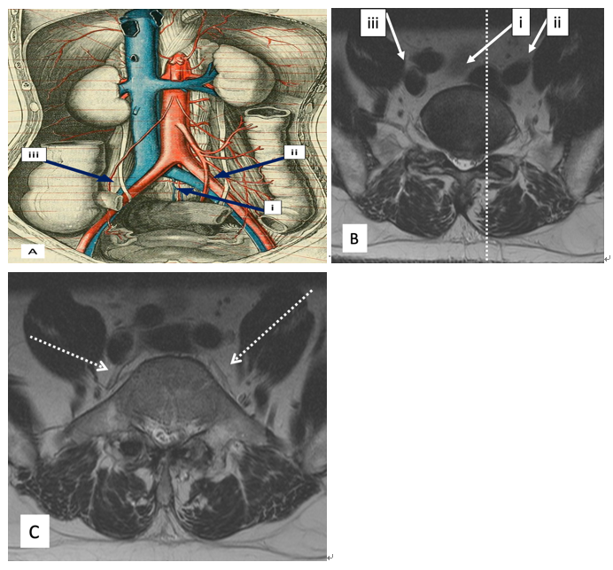
Figure 1 Vascular anatomy as depicted through an illustration showing the frontal aspect (A), and that depicted through magnetic resonance imaging axial sections (B, C). Image B shows magnetic resonance imaging (MRI) axial section through the L5-S1 disc, and the facet line (dotted line) running anteroposteriorly through the medial border of the left L5-S1 facet joint cutting through the left common iliac vein. The three oblique approaches to L5-S1; namely the left intra-bifurcation (i), the left pre-psoas (ii), and the right pre-psoas (iii) are shown in A and B. Image C shows an MRI axial section through mid-L5 vertebral body and shows the left and right ilio-lumbar veins (dotted arrows).
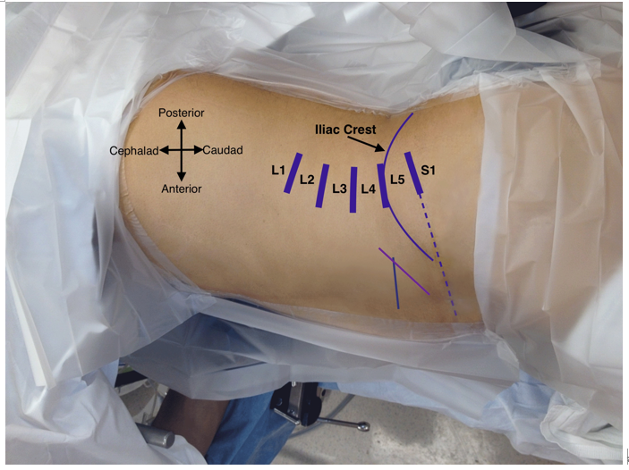
Figure 2 Clinical photograph of a patient in the right lateral decubitus position with superimposed skin markings. Disc levels from L1 to S1 are marked. L5-S1 disc marking is extended anteriorly (dotted line) to guide the incision. A longer oblique line (purple) somewhat parallel to the anterior iliac crest marks the suggested incision for a left intra-bifurcation approach for L3-S1 oblique lumbar interbody fusion (OLIF). The shorter transverse line (green) is the suggested incision (along skin lines) for a left pre-psoas approach for L3-S1 OLIF.
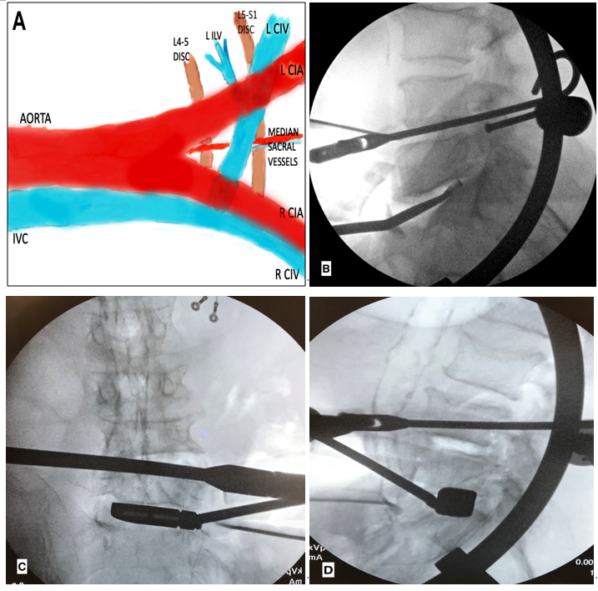
Figure 3 Illustration showing left-sided oblique anterolateral approaches (A), and intraoperative fluoroscopy images (B-D). Image A shows the median sacral vessels that are often encountered in the left intra-bifurcation approach, and the left ilio-lumbar vein (ILV), which may need ligation in a left pre-psoas approach. Image B shows a lateral fluoroscopy image with a double-bent curette which may be helpful in preparing the portions of the L5 inferior endplate that may not be under direct visualization. Images C and D show intraoperative anteroposterior and lateral fluoroscopy images during a left pre-psoas approach with specialized trial instrument bent in two planes. IVC: Inferior vena cava; CIV: Common iliac vein; CIA: Common iliac artery; ILV: Ilio-lumbar vein; R: Right; L: Left.
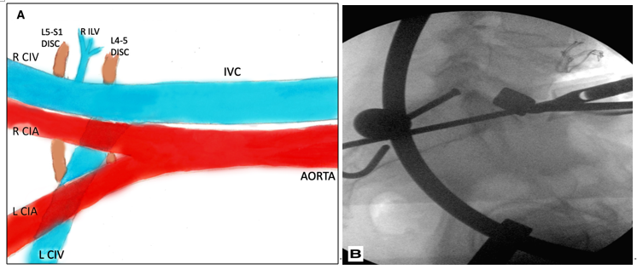
Figure 4 Illustration showing right-sided oblique anterolateral approach (A), and a lateral fluoroscopy image (B) during a right pre-psoas approach. The right ilio-lumbar vein (ILV) is longer in length and smaller in caliber (A) when compared to the left ILV (Figure 3A). Also note that the right common iliac vein (CIV) is visible throughout in the right pre-psoas approach, unlike the left CIV, which for the most part, is covered by the accompanying left common iliac artery. Image B again identifies specialized trial instrument bent in two planes (similar to Figure 3C, D). IVC: Inferior vena cava; CIV: Common iliac vein; CIA: Common iliac artery; ILV: Ilio-lumbar vein; R: Right; L: Left.
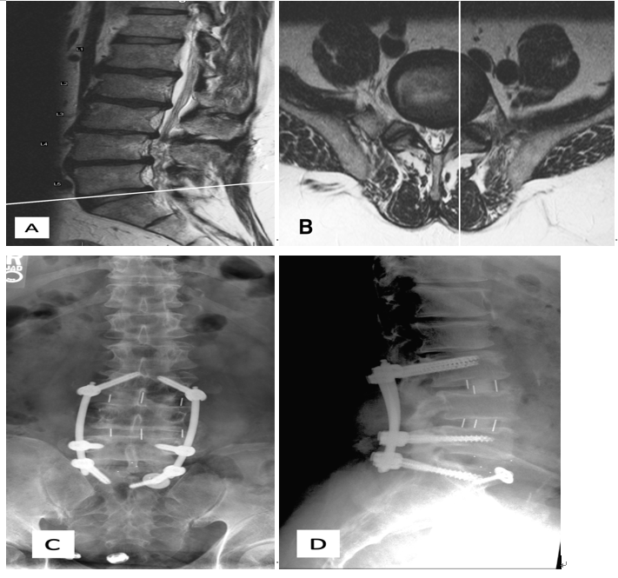
Figure 5 Preoperative magnetic resonance imaging sagittal (A) and axial (B) images and postoperative anteroposterior (C) and lateral (D) upright radiographs for Case 1. Image A shows the scout line corresponding to the axial image B. The anteroposterior facet line through the medial border of the left L5-S1 facet joint runs medial to the medial border of the left CIV (B). CIV: common iliac vein.
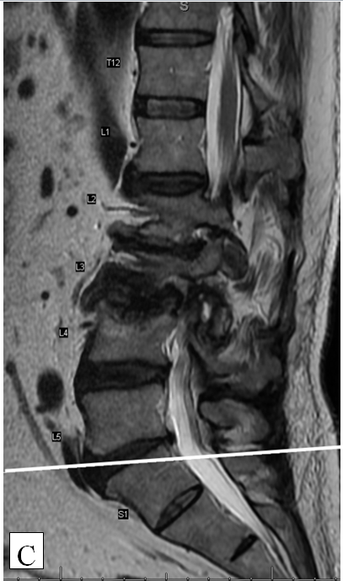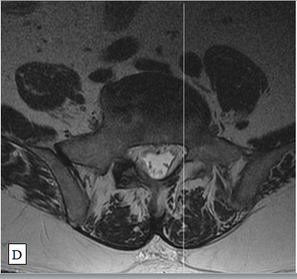
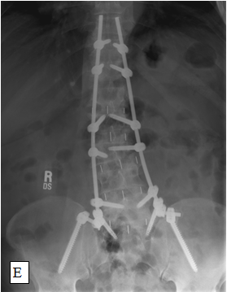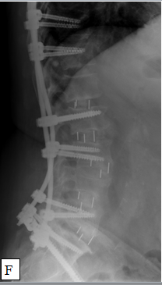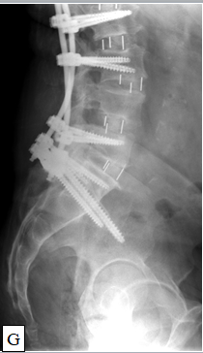
Figure 6 Preoperative upright anteroposterior (A) and lateral (B) radiographs, preoperative magnetic resonance imaging sagittal (C) and axial (D) images, and postoperative anteroposterior (E) and lateral (F, G) upright radiographs for Case 2. Image C shows the scout line corresponding to the axial image D. The left common iliac vein is in the midline medial to the anteroposterior facet line (D). CIV: common iliac vein.
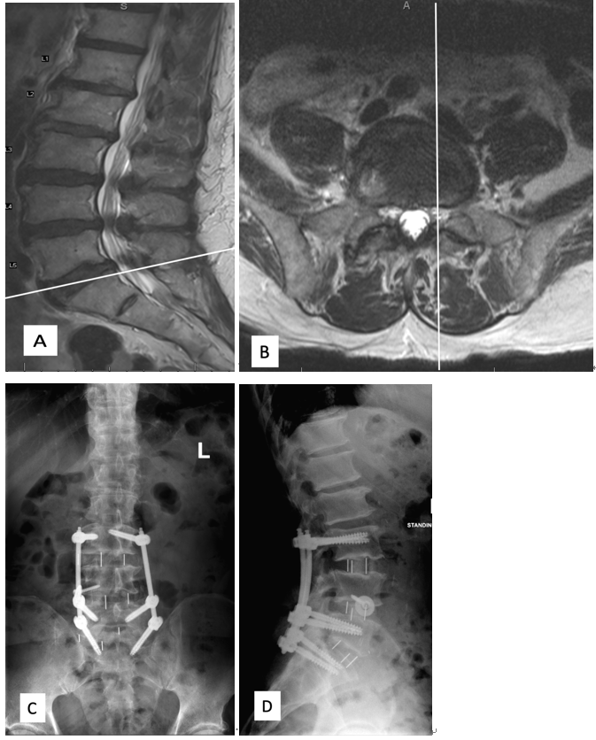
Figure 7 Preoperative magnetic resonance imaging sagittal (A) and axial (B) images and postoperative (C) anteroposterior and (D) lateral upright radiographs for Case 3. Image A shows the scout line corresponding to the axial image B. The anteroposterior facet line through the medial border of the left L5-S1 facet joint runs lateral to the medial border of the left common iliac vein (CIV) (B). The fat plane is better visualized under the right CIV than under the left CIV (B). CIV: common iliac vein.

Published by Baishideng Publishing Group Inc
7041 Koll Center Parkway, Suite 160, Pleasanton, CA 94566, USA
Telephone: +1-925-3991568
E-mail: bpgoffice@wjgnet.com
Help Desk: https://www.f6publishing.com/helpdesk
https://www.wjgnet.com

© 2021 Baishideng Publishing Group Inc. All rights reserved.

