Name of Journal: World Journal of Gastroenterology
Manuscript NO: 62999
Manuscript Type: REVIEW

Open reading frame 3 protein of hepatitis E virus: Multi-function protein with endless potential

Yang YL et al. HEV ORF3 protein

Yong-Lin Yang, Yu-Chen Nan

Yong-Lin Yang, Department of Infectious Diseases, Taizhou People's Hospital, The Fifth Affiliated Hospital of Nantong University, Taizhou 225300, Jiangsu Province, China

Yong-Lin Yang, Department of General Practice, Nanjing First Hospital, Nanjing Medical University, Nanjing 210006, Jiangsu Province, China

Yu-Chen Nan, Department of Preventive Veterinary Medicine, Northwest A&F University, Yangling 712100, Shaanxi Province, China

Author contributions: Yang YL and Nan YC prepared the main body of this manuscript; Nan YC reviewed and revised the manuscript, and designed and prepared the figures; all authors approved the manuscript for publication.

Supported by National Natural Science Foundation of China, No. 31672534; Key Project supported by Medical Science and Technology Development Foundation of Nanjing Department of Health, No. ZKX19026.

Corresponding author: Yu-Chen Nan, PhD, Associate Professor, Department of Preventive Veterinary Medicine, Northwest A&F University, No. 3 Taicheng Road, Yangling Demonstration Zone, Yangling 712100, Shaanxi Province, China. nanyuchen2015@nwsuaf.edu.cn

Received: January 23, 2021
Revised: March 10, 2021
Accepted: April 12, 2021
Published online: May 21, 2021

Abstract
Hepatitis E virus (HEV), a fecal-orally transmitted foodborne viral pathogen, causes acute hepatitis in humans and is responsible for hepatitis E outbreaks worldwide. Since the identification of HEV as a zoonotic agent, this virus has been isolated from a variety of hosts with an ever-expanding host range. HEV-open reading frame (ORF) 3, the smallest ORF in HEV genomes, initially had been perceived as an unremarkable HEV accessory protein. However, as novel HEV-ORF3 function has been discovered that is related to the existence of a putative third virion structural form, referred to as “quasi-enveloped” HEV particles, HEV is challenging the conventional virion structure-based classification scheme, which assigns all viruses to two groups, “enveloped” or “non-enveloped.” In this review, we systematically describe recent progress that has identified multiple pathogenic roles of HEV-ORF3, including roles in HEV virion release, biogenesis of quasi-enveloped virus, regulation of the host innate immune response, and interference with host signaling pathways. In addition, implications of HEV-ORF3-associated quasi-enveloped virions are discussed to guide future development of improved vaccines against zoonotic HEV infection.

Key Words: Hepatitis E virus; Zoonosis; Quasi-enveloped virion; Hepatitis E virus-open reading frame 3; Innate immunity

©The Author(s) 2021. Published by Baishideng Publishing Group Inc. All rights reserved.

Citation: Yang YL, Nan YC. Open reading frame 3 protein of hepatitis E virus: Multi-function protein with endless potential. World J Gastroenterol 2021; 27(20): 2458-2473
URL: https://www.wjgnet.com/1007-9327/full/v27/i20/2458.htm
DOI: https://dx.doi.org/10.3748/wjg.v27.i20.2458

Core Tip: Hepatitis E virus (HEV)-open reading frame (ORF) 3 was originally though as an accessory protein with limited function which is not essential for HEV replication. This view has been challenged by recent discoveries, such as HEV-ORF3-associated “quasi-enveloped” HEV particles, regulation of the host innate immune response, and interference with host signaling pathways. More novel function of HEV-ORF3 will be revealed.

INTRODUCTION
Hepatitis E virus (HEV), a quasi-enveloped, single-stranded positive-sense RNA virus, is classified as a member of the family Hepeviridae^{[1]}. Hepeviridae is a highly diverse family that contains several HEV and HEV-like virus species with zoonotic, anthropotropic, and animal-restricted tropisms^{[2]}. Currently, nearly 3 million symptomatic cases of HEV infection are reported annually, resulting in approximately 70000 deaths and 3000 stillbirths in each year^{[3]}. Generally, mortality of HEV ranges from 0.5% to 3% overall, but HEV mortality rates have approached 30% in pregnant women^{[4,5]}.
The viral genome of HEV is 7.2 kb in length and is an mRNA-like molecule (capped and poly-adenylated at 5' and 3' ends, respectively)^{[6]}. To date, three well-defined open reading frames (ORFs) have been detected in all HEV genotypes studied (Figure 1)^{[7,8]}. HEV-ORF1 protein is translated directly from HEV genome with HEV-ORF2 and-ORF3 proteins translated from subgenomic RNAs^{[9]}. Moreover, ORF4, whose expression is promoted by an atypical internal ribosome entry site (IRES)-like element, completely overlaps with ORF1 and was identified recently only in HEV-1 isolates^{[10]}. In addition to ORFs, HEV genome contains at least four cis-reactive elements (CREs) that are required for viral replication in vivo^{[11-13]}. Two of these CREs, which are located within intergenic-junctional regions between HEV-ORFs, form “stem-loop” structures that act as promoter-like elements for initiation of subgenomic RNA synthesis^{[11,12]}. Conversely, another two CREs within ORF1 and ORF2, function as a scaffold that generates specific signals that trigger recruitment of viral and host factors for a replication complex^{[13]}.
The latest classification system of HEVs includes two genera within the family Hepeviridae, Orthohepevirus (covering all HEV isolates with mammalian and avian origin) and Piscihepevirus (only HEV-like virus with cutthroat trout origin). All four previously characterized HEV genotypes (1-4) that cause human infection are categorized within the species Orthohepevirus A^{[1]}, with Orthohepevirus B, C, and D species encompassing HEV isolates found in other non-human hosts^{[1]}. Within Orthohepevirus A, HEV-1 and HEV-2 isolates are anthropotropic viruses without any animal reservoirs, while HEV-3 and HEV-4 isolates are zoonotic^{[6,14]}. The HEV isolates originally identified from Japanese wild boar, containing unique RNA sequences, are categorized into HEV-5 and 6, whereas camel HEV isolates belong to HEV-7 and HEV-8 genotypes^{[1,15]}. Notably, HEV isolated from a human liver transplant patient has been reported to most closely match camel HEV, suggesting that camel HEVs may be zoonotic as well, although this concept requires further confirmation^{[16]}. In addition to mammalian HEVs, two unique groups of HEV-like viruses that have been isolated from avian species and cutthroat trout (Oncorhynchus clarkia) have been assigned to species Orthohepevirus B and to genus Piscihepevirus (as the only member), respectively.
Initially, HEV was assumed to be solely restricted to humans, in whom it induced self-limiting hepatitis symptoms. However, the emergence of HEV and HEV-like isolates in swine and other animal species supports a much wider HEV host tropism, with some HEV genotypes identified as zoonotic pathogens^{[17]}. Currently, hepatitis E cases have been frequently reported in both developing and developed countries and have occurred in step with increasingly more frequent observations of expanding host ranges^{[18-22]}. Generally, inter-species transmission and infection of zoonotic type of virus from animal to humans is considered to be primary routing of HEV transmission within Western worlds, while fecal-oral transmission appears to be the predominant route of HEV transmission within developing countries^{[23,24]}. Notably, immune serological surveillance data support a high prevalence rate of previous HEV infection in the general population but demonstrate a declining trend in recent years that may be due to undetected endemic HEV circulation^{[25,26]}. Meanwhile, frequent detection of recent cases of chronic HEV, HEV-related acute hepatic failure, and extrahepatic HEV manifestations supports this speculation as well^{[25,27-30]}. Moreover, these observations imply that zoonotic HEV infection is a complicated pathogenic process underlying various forms of HEV-related disease. However, our understanding of HEV remains restricted due to the lack of a robust in vitro HEV cell system. Nevertheless, the HEV genome is known to contain three well-defined ORFs that have been found in all HEV genotypes^{[7,8]}. HEV-ORF3, the smallest ORF found in HEV genomes, encodes a unique protein with multiple indispensable functional roles associated with viral replication and pathogenesis. In this review, we discuss the recent progress toward understanding HEV-ORF3 pathological roles in detail and provide new insights.

PROTEINS ENCODED BY HEV
HEV-ORF1 polyprotein as viral replicase
The HEV-ORF1 protein is the largest protein encoded by the HEV genome and can be directly translated from the mRNA-like genome of HEV^{[8]}. Bioinformatics-based protein homology analysis indicated that at least eight function domains are present within HEV-ORF1 according to similarities to counterparts from other RNA viruses (Figure 2)^{[31]}. These protein domains include methyltransferase domain, the Y domain, papain-like cysteine protease (PCP) domain, a hypervariable region containing previously assigned hypervariable domain and proline-rich domain, the X domain (also named macro-domain), RNA helicase domain, and a RNA polymerase domain (RdRp)^{[2,32]}. The methyltransferase domain and Y domain together are thought to constitute the functional unit of RNA capping enzyme^{[2,32]}. It remains unknown whether HEV-ORF1 protein acts alone to perform all putative viral replicase functions or is cleaved by host protease or viral protease (via PCP domains) to generate independent units resembling viral replicases similar to other positive-sense RNA viruses^{[2,33-35]}. To date, available data suggests that proteolytic cleavage of the HEV-ORF1 product involves PCP domain encoded within HEV-ORF1^{[2,33-35]}. Besides viral replication, another notable characteristic of HEV-ORF1 protein is its flexibility for insertions or deletions within the hypervariable region. The proline-rich domain within the hypervariable region was proposed to act as a linking hinge for the upstream PCP domain and downstream macro-domain, leading to formation of an unstable tertiary structure^{[31,36-38]}. Conversely, the hypervariable region is considered an intrinsically disordered region containing extensive gene segment insertions or deletions and may participate in viral replication^{[39-42]}. As a unique example, one HEV-3 isolate, Kernow-C1 p6 strain, which was originally isolated from an HIV patient chronically infected by HEV as well, contains a 174-nt insertion of a human ribosomal protein S17 sequence originating from the host^{[43]}, which confers ORF1 protein with novel nuclear/nucleolar trafficking capability and may promote viral replication in vitro^{[44,45]}.

HEV-ORF2 encodes viral capsids
HEV-ORF2 encodes the putative capsid protein of HEV virions with a full-size of 660 aa residues, and has a predicted molecular mass of 72 kDa^{[46]}. Notable, the full length ORF2 protein carries N-linked glycans at three putative glycosylation Asn residues at positions 137, 310, and 562, as well as a 15 aa signal peptide at the N-terminus directing full length ORF2 protein to the endoplasmic reticulum (ER)^{[47]}. One notable characteristic of HEV-ORF2 is the existence of various forms of ORF2-derived proteins with multiple functions. Researchers observed very early that multiple processed ORF2-derived products were detected when recombinant ORF2 was expressed in different systems. The mature HEV capsid protein is generated from the full-length ORF2 precursor via proteolytic processing to remove the first N-terminal 111 aa and the last C-terminal 52 aa. However, at least two other forms of HEV-ORF2 have been detected in HEV infected cells and patients^{[48,49]}. The first was a secreted form of ORF2 protein (ORF2s), which utilized an upstream start codon and contained a signal peptide that earmarked ORF2 for subsequent glycosylation and secretion^{[50]}; the second was a capsid-associated truncated form of ORF2 (ORF2c), which was translated beginning at an internal methionine-encoding AUG start codon (aa16 of ORF2)^{[50]}. Meanwhile, a truncated form of ORF2 (ORF2c) detected in HEV-infected cells may be secreted into the extracellular milieu, as is ORF2s^{[49]}.
The mature HEV capsid that lacks N-terminal 111 aa and the last C-terminal 52 aa of full ORF2 can form virus-like particles when expressed in insect cells^{[51,52]}. Genetic analysis of ORF2 sequences of HEV genotypes 1-4 suggests that these proteins share greater than 85% similarity overall, with divergence mainly observed within the first N-terminal 111 aa, which are not incorporated into final virions^{[53]}. A recombinant subunit vaccine using truncated HEV-1 ORF2 protein (HEV239) as major immunogen is licensed in China (Hecolin®)^{[2]}.

A multi-functional protein encoded by HEV-ORF3
ORF3, the smallest ORF among all HEV ORFs, partially overlaps with the N-terminus of ORF2 for about 300 nt and is translated from a different reading frame^{[9]}. It was initially proposed that ORF3 protein contains 123 aa that are encoded by a subgenomic RNA distinct from the RNA encoding ORF2^{[7]}. However, it was later confirmed that ORF3 protein is translated from a bicistronic subgenomic RNA to generate a 114-aa protein with a predicted molecular weight of 13 kDa (vp13), which is actually 9 aa shorter than the initially predicted length^{[9,54]}. Basic sequence analysis of HEV-ORF3 protein indicated that there are two hydrophobic domains and two proline-rich domains present within the N-terminal half and C-terminal portion of HEV-ORF3 proteins, respectively^{[55,56]}, of which the first proline-rich domain contains a mitogen-activated protein kinase (MAPK) phosphorylation site (Ser71)^{[57]}. Furthermore, two presenilin-associated protein (PSAP) motifs within the ORF3 protein were identified in HEV-1 prototype strain Sar55, with the first PSAP motif comprised of aa 86-89 and the second comprised of aa 95-98^{[58]}. Although ORF3 protein is not required for viral RNA replication in vitro^{[59]}, it is irreplaceable for in vivo HEV infection and required for viral particle releasing^{[54,60,61]}. In fact, most studies demonstrated that HEV-ORF3 is indispensable for viral particle egress and biogenesis of lipid membrane-wrapped HEV particles, which is now recognized as quasi-enveloped particles. Moreover, the second PSAP motif within the HEV-ORF3 protein has been shown to be required for the formation of membrane-associated HEV particles, a process that relies on an association of ORF3 with lipids^{[58,62]}. Currently, HEV-ORF3 is thought to form an ion channel that shares key structural features with class I viroporins that are required for virion particle release from cells during infection^{[63]}. This observation aligns with the reported putative role of pORF3^{[61]} and with other evidence indicating that HEV-ORF3 protein interacts with tumor susceptibility gene 101 (TSG101), the key component of host endosomal sorting complex required for transport (ESCRT) pathway, which is mainly employed by enveloped virus for budding and acquiring of viral envelope. Formation of ESCRT complex has been shown to lead to biogenesis of quasi-enveloped HEV particles^{[64-67]}.

HEV-1 specific ORF4
In recent years, a hidden ORF4 from HEV-1 was characterized^{[10]}. Translation of HEV-ORF4 protein is promoted by a novel element located in HEV-ORF1 appearing to be an atypical IRES sequence and works in combination with a suboptimal Kozak sequence^{[10]}. The exact function of HEV-1 specific pORF4 is still unclear. It was demonstrated that pORF4 stimulates ER stress upon HEV replication^{[10]}. It also interacts with multiple ORF1 domains in vitro which are presumably to form a complex further enhancing RdRp activity ^{[10]}. Furthermore, HEV-pORF4 specific antibodies are detectable in HEV-infected patients^{[10]}. Nonetheless, additional investigations are needed to understand functions of the ORF4 product that are unique to genotype 1 HEVs.

REGULATION OF HOST INNATE IMMUNITY AND SIGNALING BY HEV-ORF3 PROTEIN
Initially, HEV-ORF3 protein did not receive much attention, due to its presumed role as an accessory protein involved in regulation of host signaling to promote HEV replication and invasion. This hypothesis was partially evidenced by the fact that ORF3 protein was dispensable for in vitro replication of HEV-RNA^{[59]}. However, subsequent research studies demonstrated that HEV-ORF3-associated putative interference mechanisms acted on multiple host cell signaling pathways, such as those involved in host innate immunity^{[2,68,69]}, indicating that HEV-ORF3 activities ultimately promote viral replication and pathogenesis.
As a multifunctional protein, HEV-ORF3 has been demonstrated to play both positive and negative roles in interferon (IFN) induction. In our previous research, we found that HEV-ORF3 protein could enhance retinoic acid-inducible gene I (RIG-I) activation to subsequently enhance IFN induction^{[68]}. More specifically, HEV-1 ORF3 extended protein half-life of RIG-I and interacted with the RIG-I N-terminal portion to enhance ubiquitination-mediated RIG-I activation triggered by addition of the dsRNA analog poly (I:C)^{[68]} (Figure 3A). Interestingly, it is notable that genotypic differences in HEV-ORF3-associated enhancement of RIG-I-mediated IFN induction were observed. For example, ORF3 proteins from the HEV-1 Sar55 strain and HEV-3 kernowC1 p6 strain could enhance RIG-I activation, while HEV-2 and HEV-4 ORF3 proteins could not^{[68]}, suggesting that HEV-ORF3 participated in genotype-specific HEV virulence and pathogenic effects. Moreover, these results also aligned with results of a more recent report demonstrating HEV-ORF3-associated increases of IFN-α/β and interferon-stimulated gene 15 levels in hepatoma cell line HepG2/C3A^{[70]}. Conversely, other reports have demonstrated that overexpression of HEV-ORF3 downregulated Toll-like receptor (TLR) 3 and TLR7 and their downstream signaling pathways^{[71,72]} (Figure 3B). Meanwhile, another study has demonstrated that ORF3 protein from an HEV-1 strain interacted with signal transducer and activator of transcription (STAT) 1 to block type I IFN-activated pathway^{[73]} (Figure 3C). Furthermore, another study found that ORF3 proteins blocked nuclear translocation of STAT3 to down-regulate STAT3-dependent gene expression, including expression of acute-phase response proteins^{[74]}.
Besides the innate immune response, yeast two-hybrid-based screening detected that binding of ORF3 to Pyst1, a MAPK phosphatase, led to activation of MAPK pathways^{[75]}. Thus, ORF3 appears to regulate host gene expression, as MAPK is related to host gene expression and signaling. Meanwhile, HEV-ORF3 may promote expression of glycolytic pathway enzymes by enhancing phosphorylation and transactivation function of p300/CREB-binding protein as well^{[76]}. Additionally, microarray analysis of Huh7 cells has suggested that liver-specific genes may also be modulated by HEV-ORF3, since it modulated phosphorylation of hepatocyte nuclear factor 4^{[77]}. Moreover, recent research has demonstrated that HEV-ORF3 plays a functional role in virus-cell interactions by influencing expression of integral membrane protein and basement membrane proteins to alter host cell processes associated with apoptosis and lipid metabolism^{[78]}. Taken together, these data suggest that HEV-ORF3 modulates multiple signaling pathways, including those involved in host innate immunity, to ultimately promote HEV pathogenesis.

INVOVEMENT OF HEV-ORF3 PROTEIN IN BIOGENESIS OF QUASI-ENVELOPED HEV PARTICLES
The presence of a lipid layer-based envelope has long been used as the basic criterion for virus classification^{[66]}. The presence of a lipid layer can be assessed through treatment of virus preparations with bile salts, a process that abrogates infectivity of enveloped virions, but not non-enveloped virions, by removing their surface lipid layers^{[66]}. Generally, it is believed that during the virion budding process a viral envelope is formed from membranes of infected cells that contain molecules of at least one membrane-embedded virus-encoded glycoprotein (presented as peplomers). Viral envelopes interact with corresponding virus receptors located on target cells to promote membrane fusion of cellular membrane and viral envelop after initial interactions of virions and corresponding receptors. Meanwhile, surface glycoproteins located in viral envelope serve as antibody-neutralization targets in most cases^{[66]}, while the lipid layer of the virus envelope prevents internal virus antigens, such as nucleocapsid proteins, from serving as viral neutralization targets^{[79]}. Thus, as compared to a non-enveloped virus, a quasi-enveloped virion would be perceived by the host immune system as antigenically distinct from a naked virion. For example, hepatitis A virus (HAV) was the first non-enveloped virus which is confirmed to hijack host cell membrane similar to enveloped virus as an enveloped form^{[80]}. Biogenesis of enveloped HAV particles has been shown to depend on the ESCRT system^{[80,81]}, which is involved in budding of enveloped viruses. Membrane-wrapped or enveloped HAV particles mainly exist in circulation system during acute infection phase of HEV and envelopment confers protection of virus from recognition by neutralizing antibodies, which prevents impairment of virion infectivity^{[80]}. Similar to HAV, HEV was originally classified solely as a non-enveloped virus before membrane-wrapped HEV particles were discovered, with HEV-ORF3 involvement in biogenesis of quasi-enveloped HEV virions confirmed only very recently.
It was observed very early that HEV-ORF3 protein is not required for viral RNA replication in vitro^{[59]}; however, this protein is irreplaceable for HEV replication in vivo and is required for viral particle release from HEV infected cells in vitro^{[54,60,61]}. Meanwhile, antibody-capture assays of HEV virions with or without detergent treatment demonstrated that HEV virion from either serum samples of patients or supernatants of HEV-infected cells were associated with lipid layer and ORF3 protein^{[82]}. Subsequent screening to detect proteins interacting with HEV-ORF3 protein pinpointed the TSG101, a component of the ESCRT complex, as the potential interacting partner of HEV-ORF3^{[62]}. Importantly, the ESCRT complex recognizes and earmarks ubiquitinated proteins for subsequent incorporation into multivesicular bodies (MVBs), an essential step for lysosomal degradation^{[83]}. The ubiquitin E2 variant domain in TSG101 recognizes and interacts with the P(T/S)AP motif present in target proteins to recruit targets to the endosomal membrane^{[84]}.
Many enveloped viruses are equipped with a P(T/S)AP motif within their structural proteins that interact with TSG101 to redirect assembled viral components to cell membrane for virion release from infected cells^{[85]}. Originally, two PSAP motifs comprised of aa 86-89 and aa 95-98 were identified within HEV-ORF3 proteins, the second of which was found to be conserved among HEV genotypes^{[58]}. Replacement of the PSAP motif in HEV-ORF3 proteins with heterologous domain motifs (PPPY, YPDL, and PSAA) or mutated PSAP motifs has been shown to affect HEV virion release from infected cells^{[58,86]}, including avian HEV release^{[87]}. Additionally, HEV-ORF3 expressed in cells was found to associate with the cellular cytoskeleton fraction, with deletion of the N-terminal hydrophobic domain of vp13 abolishing this association^{[57]}. Moreover, a more recent study demonstrated that green fluorescent protein-tagged ORF3 protein interacted with cellular microtubules and modulated microtubule dynamics^{[55]}. This microtubule-like filament of HEV-ORF3 protein indicated that it was potentially involved in a process that promotes virus egress; this process is reminiscent of the process by which the pUL37 protein of herpes virus interacts with dystonin, an important cytoskeleton cross-linker involved in microtubule-based transport of capsids during virion egress^{[88]}. Although HEV was originally defined as a non-enveloped virus, such HEV-ORF3 functions that were formerly attributed only to enveloped viruses may now be related to HEV in its recently discovered “quasi-enveloped” form^{[64-67]}.
Consistent with the aforementioned roles of HEV-ORF3 in virus egress^{[61]}, a recent study found that HEV-ORF3 shares key features with class I viroporins, including its function as an ion channel participating in viral particle egress or release^{[63]}, a function that had been previously demonstrated for the well-characterized viroporin of influenza A virus matrix-2 (M2) protein^{[63]}. Meanwhile, a putative transmembrane region identified in pORF3 may be involved in ER localization of this protein^{[63]}. Since viroporins of other viruses, such as M2 of influenza A virus, are components of virions, these observations imply that HEV-ORF3 is a structural HEV virion protein that exists in a membrane-associated state during the formation of envelope structures of quasi-enveloped HEV virions^{[89]}. Interestingly, palmitoylation of cysteine residues within the N-terminal region of HEV-ORF3 has been shown to participate in its association with the membrane and is also required for infectious particle secretion^{[90]}.
The unique role that HEV-ORF3 plays during biogenesis of quasi-enveloped virus particles makes it a novel target candidate for antiviral drug development. In fact, one study has shown that the addition of a cyclic peptide inhibitor (CPI) to HEV-infected cells interrupted the interaction between the HEV-ORF3 PSAP motif and TSG101^{[85]} and reduced virion release by over 90% when a 50% inhibitory concentration of CPI of 2 μM was used. Thus, HEV-OR3 has potential as a novel candidate for further development as an anti-HEV drug.

POTENTIAL ROLES OF HEV-ORF3 PROTEIN IN HEV HOST TROPSIM
Since the isolation of zoonotic HEV strains from swine HEV and discovery of other HEV-like viral isolates, HEVs have been continually identified from various mammalian hosts. Based on their ability to cause inter-species infection, HEV isolates can be divided three distinct groups: HEV-1 and 2 are only restricted in human; HEV-3, 4, and 7/8 are zoonotic types; while Orthohepevirus C is animal-restricted type. Based on reports in the literature, it implies that either factors or viral determinants contribute to HEV host tropisms and cross-species transmission events.
Among all ORFs, HEV-ORF1 encodes the largest HEV protein and appears to be indispensable for determining HEV host range. An in vitro study demonstrated that swapping of genetic fragment among HEV-1 and HEV-4 infectious clones indicated that chimeric virus formed from an HEV-1 infectious clone bearing surface HEV-4 ORF1 could replicate in porcine kidney cells, while the original HEV-1 virus could not^{[91]}. Meanwhile, chimeric virus containing the junction region between ORF1/2 and the 3' non-coding region (NCR) of HEV-3 or the 3' end of the HEV-1 backbone failed to infect piglets, suggesting that the 5′ NCR and ORF1 are involved in HEV cross-species infection^{[92]}. By contrast, a recent report demonstrated, via genetic fragment swapping of ORF1 regions between HEV-1 and HEV-3 infectious clones, that recombinant chimeric viruses could be generated in vitro. In any case, these chimeric viruses could not infect piglets in vivo^{[93]}, suggesting that ORF1 is not the only determinant that can confer cross-species infectivity of HEV in vivo.
As the viral capsid protein, HEV-ORF2 was initially thought to be an unlikely determinant of host tropism, since it is conserved among all major genotypes infecting humans^{[94]}. However, results of in vivo reverse genetics-based studies that swapped segments between different HEV genotypes indicated that HEV-3 or HEV-4 based chimeric viruses inserting ORF2 from HEV-1 was incapable to cause effective infection in swine^{[95]}. Thus, it appears that HEV-ORF2 is also involved in HEV-interspecies infectivity, in agreement with results of another report demonstrating that replacement of the HEV-3 capsid region spanning aa 456 to 605 (the putative virus receptor-binding region) with corresponding region from HEV-1 prevented chimeric virus from entering and infecting swine cells^{[96]}. Therefore, these data imply that in addition to ORF1, viral capsid proteins also determine host preference. Nevertheless, until cellular receptors for HEV are identified, the link between viral capsid residues and cellular receptor determinants underlying HEV host tropism still requires further investigation.
In addition to ORF1/2, other reports have demonstrated that ORF3 proteins may be involved in determining host range of HEV. Up to date, the literature suggests that HEV-ORF3 protein acting as an ion channel essentially resembles viroporins involved in viral particle release during HEV infection^{[63]}. This viroporin-like function depends on the highly conserved PSAP motif spanning aa 95-98 within Orthohepevirus A, which has been proposed to interact with host TSG101. However, truncation analysis has indicated that the N-terminal 25 aa of HEV-1 ORF3 are required for its association with microtubules as well as virus release^{[55]}. Meanwhile, alignment of ORF3 aa sequences of all eight HEV genotypes indicates that the region containing the M-terminal 25 aa of different HEV-ORF3 proteins are more conserved than the rest of HEV-ORF3. Therefore, the conservation of this region may reflect the conserved role of HEV-ORF3-dependent virion release across all genotypes. Nonetheless, a recent study demonstrated that rat HEV-ORF3 protein possessed the PxYPMP motif in place of the original PSAP motif found in human HEV-ORF3 proteins^{[97]}. Intriguingly, unlike human HEV-ORF3 proteins, rat HEV-ORF3 proteins did not bind to TSG101, but instead utilized MVB-based sorting to achieve virion release; this mechanism differed from the aforementioned TSG101-dependent mechanism for effecting release of human HEV from infected cells^{[97]}. Thus, these results taken together imply that HEV-ORF3 may have an important species-specific function.
Meanwhile, except for the abovementioned conserved motifs, less homology is observed elsewhere in the HEV-ORF3 protein, especially within its C-terminal half (aa 62 to aa 114) (Figure 4), a region that appears to be important for adaptation to various hosts. It is also notable that genomic locations of ORF3-encoding genes vary among species of Orthohepevirus (either of partially or fully overlapping with ORF2, Figure 5)^{[98,99]}, which implies a genotype-specific evolution pattern influencing functions of HEV-ORF3 that affect HEV host tropism. This speculation is in line with a genotype-specific enhancement of IFN induction by HEV-ORF3 proteins observed in our previous report^{[68]}. Therefore, the mechanism by which a genotype-specific function of ORF3 product influences HEV host tropism requires further confirmation, although the accumulating literature indicates that a host-specific function exists that may influence host tropism by HEV-ORF3 proteins.

HEV-ORF PROTEIN AS VACCINE TARGET FOR HEV
Since the discovery of quasi-enveloped virions, researchers have tried to determine if these particles differ from classically enveloped virions, since the outer lipid bilayers of quasi-enveloped particles, such as those of HAV, are devoid of any viral proteins^{[66,80]}, while both HAV virion forms are equally infectious^{[80]}. This apparent paradox raises the question of how membrane-wrapped particles can infect cells in the absence of viral peplomers that are generally thought to be required for enveloped virus infectivity^{[66]}. Nevertheless, HEV appears to differ from HAV, since researchers observed very early before (prior to the identification of quasi-enveloped HEV particles) that HEV-ORF3 protein specific monoclonal antibody (mAb) could capture viral particles from serum samples of HEV patients or cell culture supernatants of HEV infected cells^{[89]}. It is now clear that HEV-ORF3 protein associates with the lipid layer in quasi-enveloped virions produced both in vitro and in vivo, while HEV virions from feces fail to be captured by this mAb due to the lack of the HEV-ORF3-containing envelope^{[89]}. This observation was recently confirmed by electron microscopy showing that immunogold-labeled mAb recognizing HEV-ORF3 proteins bound to quasi-enveloped HEV particles as well^{[100]}. Moreover, although in vitro infectivity appears to be equivalent between quasi-enveloped HAV particles and naked counterparts, quasi-enveloped HEV particles infect fresh cells in a less efficient manner in vitro, as reflected by their need for a longer inoculation time to achieve maximal infectivity^{[67]}. Meanwhile, it appears that cell entry by quasi-enveloped HEV virions depends on endosomal trafficking, which can be abrogated by blocking endosomal acidification^{[67]}. Furthermore, additional investigations have demonstrated that HEV-ORF3 protein acts on ion channel protein and participates in the release of infectious virions from infected cells^{[63]}; this role is similar to that of other well-characterized viroporins such as M2 protein of influenza A virus^{[63]}. It is also notable that two hydrophobic domains located in N-terminal half of HEV-ORF3 demonstrated unique functions, whereby the first one is required associating with microtubules^{[55]}, while the second one contains a putative transmembrane region involved in ER localization^{[63]}. Since viroporins of other viruses, such as M2 protein of influenza A virus, are components of virions, these observations imply that HEV-ORF3 is also a structural component of HEV virions, although it is not known if antibody-based neutralization mechanisms differ between the two types of HEV particles. Nevertheless, since HEV-ORF3 is present within quasi-enveloped HEV virions^{[89]}, it would be an interesting question to be determined if HEV-ORF3-specific antibodies are capable to neutralize quasi-enveloped HEV viral particles since capsid specific antibodies fail to do so.
It remains unclear whether HEV-ORF3 acts as a potential neutralizing target for HEV. A previous report suggested that a recombinant vaccine candidate using HEV-4 ORF3 protein fused with interleukin-1β might confer partial protection against virus challenge^{[101]}. Moreover, similar to vaccines based on HEV-4 ORF3, our research on avian HEV demonstrated that chickens immunized with recombinant avian HEV-ORF3 protein showed partial protection upon challenge and had milder disease symptoms than did controls^{[102]}. However, it is notable that challenge experiments for these vaccines only employed virus stocks obtained from fecal samples which contained only naked viral particles (without envelopes containing HEV-ORF3 protein)^{[102]}. Therefore, it is possible that antibodies induced by current ORF3-based vaccines cannot prevent first-round infection during initial challenge with naked virus, since naked HEV virions cannot be neutralized by antibodies specific for ORF3-HEV. Nevertheless, partial protection observed in both experiments may be due to ORF3-specific antibody-based neutralization of newly synthesized quasi-enveloped HEV virion entering into circulation after initial infection caused by naked HEV virion used for challenging. In any case, these observations raise the interesting question of whether an ORF2-based vaccine could protect hosts from challenge with quasi-enveloped HEV particles, a concept that warrants further investigation.
Up to date, available data indicated that ORF3 proteins (including avian HEV-ORF3) is highly immunogenic to evoke host humoral response, with most B-cell epitopes located at the C-terminal of HEV-ORF3^{[103-106]}. Thus, the C-terminal half (about 60 aa) of HEV-ORF3 proteins appears to be a promising candidate as a recombinant subunit vaccine. However, an obstacle to employing this region for a vaccine candidate is the potential antigen variation issue as predicted by aa sequence alignment of HEV-ORF3s from the four reference strains of HEV-1 to -4 (Figure 4)^{[68]}. Therefore, systematic mapping of antigenic epitopes within HEV-ORF3 proteins of different HEV genotypes may be required before using immunogenic ORF3 epitopes as additional components of HEV subunit vaccines.

CONCLUSION
Although nearly three decades have elapsed since the identification and characterization of the complete genome sequence from the first HEV isolate, the full spectrum of this virus remains unclear and HEV infection now is a public health concern in developed countries as well. Currently, cross-species infection and host tropisms of different HEV genotypes remain elusive, due to the lack of easy-to-handle animal model and a robust in vitro system for studying HEV. Although many details about this virus and its pathology have been revealed in recent years, it is notable that HEV-ORF3 protein, the smallest ORF encoded by HEV, appears to have diverse functions and key roles in HEV virion release, biogenesis of quasi-enveloped virus, regulation of the host innate immune response, and neutralization of quasi-enveloped virus. These advances will guide further studies to reveal the basic biology of HEV, functions of HEV proteins, and HEV pathogenic factors toward the development of effective therapeutics and an improved vaccine.

REFERENCES
1 Smith DB, Simmonds P, Members Of The International Committee On The Taxonomy Of Viruses Study Group, Jameel S, Emerson SU, Harrison TJ, Meng XJ, Okamoto H, Van der Poel WHM, Purdy MA. Consensus proposals for classification of the family Hepeviridae. J Gen Virol 2014; 95: 2223-2232 [PMID: 24989172 DOI: 10.1099/vir.0.068429-0]
2 Nan Y, Zhang YJ. Molecular Biology and Infection of Hepatitis E Virus. Front Microbiol 2016; 7: 1419 [PMID: 27656178 DOI: 10.3389/fmicb.2016.01419]
3 Dalton HR, Saunders M, Woolson KL. Hepatitis E virus in developed countries: one of the most successful zoonotic viral diseases in human history? J Virus Erad 2015; 1: 23-29 [PMID: 27482393]
4 Jameel S. Molecular biology and pathogenesis of hepatitis E virus. Expert Rev Mol Med 1999; 1999: 1-16 [PMID: 14987355 DOI: 10.1017/S1462399499001271]
5 Pillot J, Türkoglu S, Dubreuil P, Cosson A, Lemaigre G, Meng J, Lazizi Y. Cross-reactive immunity against different strains of the hepatitis E virus transferable by simian and human sera. C R Acad Sci III 1995; 318: 1059-1064 [PMID: 8556452]
6 Ahmad I, Holla RP, Jameel S. Molecular virology of hepatitis E virus. Virus Res 2011; 161: 47-58 [PMID: 21345356 DOI: 10.1016/j.virusres.2011.02.011]
7 Tam AW, Smith MM, Guerra ME, Huang CC, Bradley DW, Fry KE, Reyes GR. Hepatitis E virus (HEV): molecular cloning and sequencing of the full-length viral genome. Virology 1991; 185: 120-131 [PMID: 1926770]
8 Tsarev SA, Emerson SU, Reyes GR, Tsareva TS, Legters LJ, Malik IA, Iqbal M, Purcell RH. Characterization of a prototype strain of hepatitis E virus. Proc Natl Acad Sci USA 1992; 89: 559-563 [PMID: 1731327]
9 Graff J, Torian U, Nguyen H, Emerson SU. A bicistronic subgenomic mRNA encodes both the ORF2 and ORF3 proteins of hepatitis E virus. J Virol 2006; 80: 5919-5926 [PMID: 16731930 DOI: 10.1128/JVI.00046-06]
10 Nair VP, Anang S, Subramani C, Madhvi A, Bakshi K, Srivastava A, Shalimar, Nayak B, Ranjith Kumar CT, Surjit M. Endoplasmic Reticulum Stress Induced Synthesis of a Novel Viral Factor Mediates Efficient Replication of Genotype-1 Hepatitis E Virus. PLoS Pathog 2016; 12: e1005521 [PMID: 27035822 DOI: 10.1371/journal.ppat.1005521]
11 Cao D, Huang YW, Meng XJ. The nucleotides on the stem-loop RNA structure in the junction region of the hepatitis E virus genome are critical for virus replication. J Virol 2010; 84: 13040-13044 [PMID: 20943962 DOI: 10.1128/JVI.01475-10]
12 Parvez MK. The intergenic-junction variant (genotype 2 isolate) of hepatitis E virus restores the CREX 'stem-loop' structural integrity, essential for viral life cycle. Gene 2015; 559: 149-154 [PMID: 25597766 DOI: 10.1016/j.gene.2015.01.033]
13 Ju X, Xiang G, Gong M, Yang R, Qin J, Li Y, Nan Y, Yang Y, Zhang QC, Ding Q. Identification of functional cis-acting RNA elements in the hepatitis E virus genome required for viral replication. PLoS Pathog 2020; 16: e1008488 [PMID: 32433693 DOI: 10.1371/journal.ppat.1008488]
14 Meng XJ. Recent advances in Hepatitis E virus. J Viral Hepat 2010; 17: 153-161 [PMID: 20040046 DOI: 10.1111/j.1365-2893.2009.01257.x]
15 Woo PC, Lau SK, Teng JL, Cao KY, Wernery U, Schountz T, Chiu TH, Tsang AK, Wong PC, Wong EY, Yuen KY. New Hepatitis E Virus Genotype in Bactrian Camels, Xinjiang, China, 2013. Emerg Infect Dis 2016; 22: 2219-2221 [PMID: 27869607 DOI: 10.3201/eid2212.160979]
16 Lee GH, Tan BH, Teo EC, Lim SG, Dan YY, Wee A, Aw PP, Zhu Y, Hibberd ML, Tan CK, Purdy MA, Teo CG. Chronic Infection With Camelid Hepatitis E Virus in a Liver Transplant Recipient Who Regularly Consumes Camel Meat and Milk. Gastroenterology 2016; 150: 355-7.e3 [PMID: 26551551 DOI: 10.1053/j.gastro.2015.10.048]
17 Meng XJ. Zoonotic and foodborne transmission of hepatitis E virus. Semin Liver Dis 2013; 33: 41-49 [PMID: 23564388 DOI: 10.1055/s-0033-1338113]
18 Park WJ, Park BJ, Ahn HS, Lee JB, Park SY, Song CS, Lee SW, Yoo HS, Choi IS. Hepatitis E virus as an emerging zoonotic pathogen. J Vet Sci 2016; 17: 1-11 [PMID: 27051334 DOI: 10.4142/jvs.2016.17.1.1]
19 Montesano C, Giovanetti M, Ciotti M, Cella E, Lo Presti A, Grifoni A, Zehender G, Angeletti S, Ciccozzi M. Hepatitis E Virus Circulation in Italy: Phylogenetic and Evolutionary Analysis. Hepat Mon 2016; 16: e31951 [PMID: 27226798 DOI: 10.5812/hepatmon.31951]
20 Anheyer-Behmenburg HE, Szabo K, Schotte U, Binder A, Klein G, Johne R. Hepatitis E Virus in Wild Boars and Spillover Infection in Red and Roe Deer, Germany, 2013-2015. Emerg Infect Dis 2017; 23: 130-133 [PMID: 27983488 DOI: 10.3201/eid2301.161169]
21 Abravanel F, Lhomme S, El Costa H, Schvartz B, Peron JM, Kamar N, Izopet J. Rabbit Hepatitis E Virus Infections in Humans, France. Emerg Infect Dis 2017; 23: 1191-1193 [PMID: 28628452 DOI: 10.3201/eid2307.170318]
22 Doceul V, Bagdassarian E, Demange A, Pavio N. Zoonotic Hepatitis E Virus: Classiﬁcation, Animal Reservoirs and Transmission Routes. Viruses 2016; 8 [PMID: 27706110 DOI: 10.3390/v8100270]
23 Pavio N, Meng XJ, Doceul V. Zoonotic origin of hepatitis E. Curr Opin Virol 2015; 10: 34-41 [PMID: 25588602 DOI: 10.1016/j.coviro.2014.12.006]
24 Salines M, Andraud M, Rose N. From the epidemiology of hepatitis E virus (HEV) within the swine reservoir to public health risk mitigation strategies: a comprehensive review. Vet Res 2017; 48: 31 [PMID: 28545558 DOI: 10.1186/s13567-017-0436-3]
25 Sadik S, van Rijckevorsel GG, van Rooijen MS, Sonder GJ, Bruisten SM. Seroprevalence of hepatitis E virus differs in Dutch and first generation migrant populations in Amsterdam, the Netherlands: a cross-sectional study. BMC Infect Dis 2016; 16: 659 [PMID: 27825308 DOI: 10.1186/s12879-016-2007-z]
26 Teshale EH, Denniston MM, Drobeniuc J, Kamili S, Teo CG, Holmberg SD. Decline in hepatitis E virus antibody prevalence in the United States from 1988-1994 to 2009-2010. J Infect Dis 2015; 211: 366-373 [PMID: 25147277 DOI: 10.1093/infdis/jiu466]
27 Dalton HR, Kamar N, van Eijk JJ, Mclean BN, Cintas P, Bendall RP, Jacobs BC. Hepatitis E virus and neurological injury. Nat Rev Neurol 2016; 12: 77-85 [PMID: 26711839 DOI: 10.1038/nrneurol.2015.234]
28 Geng Y, Zhao C, Huang W, Harrison TJ, Zhang H, Geng K, Wang Y. Detection and assessment of infectivity of hepatitis E virus in urine. J Hepatol 2016; 64: 37-43 [PMID: 26362822 DOI: 10.1016/j.jhep.2015.08.034]
29 Feng Z. Causation by HEV of extrahepatic manifestations remains unproven. Liver Int 2016; 36: 477-479 [PMID: 27005694 DOI: 10.1111/liv.13085]
30 Ripellino P, Pasi E, Melli G, Staedler C, Fraga M, Moradpour D, Sahli R, Aubert V, Martinetti G, Bihl F, Bernasconi E, Terziroli Beretta-Piccoli B, Cerny A, Dalton HR, Zehnder C, Mathis B, Zecca C, Disanto G, Kaelin-Lang A, Gobbi C. Neurologic complications of acute hepatitis E virus infection. Neurol Neuroimmunol Neuroinflamm 2020; 7 [PMID: 31806684 DOI: 10.1212/NXI.0000000000000643]
31 Koonin EV, Gorbalenya AE, Purdy MA, Rozanov MN, Reyes GR, Bradley DW. Computer-assisted assignment of functional domains in the nonstructural polyprotein of hepatitis E virus: delineation of an additional group of positive-strand RNA plant and animal viruses. Proc Natl Acad Sci U S A 1992; 89: 8259-8263 [PMID: 1518855]
32 Ahola T, Karlin DG. Sequence analysis reveals a conserved extension in the capping enzyme of the alphavirus supergroup, and a homologous domain in nodaviruses. Biol Direct 2015; 10: 16 [PMID: 25886938 DOI: 10.1186/s13062-015-0050-0]
33 Parvez MK. Molecular characterization of hepatitis E virus ORF1 gene supports a papain-like cysteine protease (PCP)-domain activity. Virus Res 2013; 178: 553-556 [PMID: 23978667 DOI: 10.1016/j.virusres.2013.07.020]
34 Paliwal D, Panda SK, Kapur N, Varma SPK, Durgapal H. Hepatitis E virus (HEV) protease: a chymotrypsin-like enzyme that processes both non-structural (pORF1) and capsid (pORF2) protein. J Gen Virol 2014; 95: 1689-1700 [PMID: 24795447 DOI: 10.1099/vir.0.066142-0]
35 Parvez MK. The hepatitis E virus nonstructural polyprotein. Future Microbiol 2017; 12: 915-924 [PMID: 28686042 DOI: 10.2217/fmb-2017-0016]
36 Dosztányi Z, Chen J, Dunker AK, Simon I, Tompa P. Disorder and sequence repeats in hub proteins and their implications for network evolution. J Proteome Res 2006; 5: 2985-2995 [PMID: 17081050 DOI: 10.1021/pr060171o]
37 Dunker AK, Oldfield CJ, Meng J, Romero P, Yang JY, Chen JW, Vacic V, Obradovic Z, Uversky VN. The unfoldomics decade: an update on intrinsically disordered proteins. BMC Genomics 2008; 9 Suppl 2: S1 [PMID: 18831774 DOI: 10.1186/1471-2164-9-S2-S1]
38 Tsai CJ, Ma B, Sham YY, Kumar S, Nussinov R. Structured disorder and conformational selection. Proteins 2001; 44: 418-427 [PMID: 11484219]
39 Purdy MA. Evolution of the hepatitis E virus polyproline region: order from disorder. J Virol 2012; 86: 10186-10193 [PMID: 22811526 DOI: 10.1128/JVI.01374-12]
40 Purdy MA, Lara J, Khudyakov YE. The hepatitis E virus polyproline region is involved in viral adaptation. PLoS One 2012; 7: e35974 [PMID: 22545153 DOI: 10.1371/journal.pone.0035974]
41 Pudupakam RS, Huang YW, Opriessnig T, Halbur PG, Pierson FW, Meng XJ. Deletions of the hypervariable region (HVR) in open reading frame 1 of hepatitis E virus do not abolish virus infectivity: evidence for attenuation of HVR deletion mutants in vivo. J Virol 2009; 83: 384-395 [PMID: 18945785 DOI: 10.1128/JVI.01854-08]
42 Pudupakam RS, Kenney SP, Córdoba L, Huang YW, Dryman BA, Leroith T, Pierson FW, Meng XJ. Mutational analysis of the hypervariable region of hepatitis e virus reveals its involvement in the efficiency of viral RNA replication. J Virol 2011; 85: 10031-10040 [PMID: 21775444 DOI: 10.1128/JVI.00763-11]
43 Shukla P, Nguyen HT, Torian U, Engle RE, Faulk K, Dalton HR, Bendall RP, Keane FE, Purcell RH, Emerson SU. Cross-species infections of cultured cells by hepatitis E virus and discovery of an infectious virus-host recombinant. Proc Natl Acad Sci U S A 2011; 108: 2438-2443 [PMID: 21262830 DOI: 10.1073/pnas.1018878108]
44 Kenney SP, Meng XJ. The lysine residues within the human ribosomal protein S17 sequence naturally inserted into the viral nonstructural protein of a unique strain of hepatitis E virus are important for enhanced virus replication. J Virol 2015; 89: 3793-3803 [PMID: 25609799 DOI: 10.1128/JVI.03582-14]
45 Kenney SP, Meng XJ. Identification and fine mapping of nuclear and nucleolar localization signals within the human ribosomal protein S17. PLoS One 2015; 10: e0124396 [PMID: 25853866 DOI: 10.1371/journal.pone.0124396]
46 Robinson RA, Burgess WH, Emerson SU, Leibowitz RS, Sosnovtseva SA, Tsarev S, Purcell RH. Structural characterization of recombinant hepatitis E virus ORF2 proteins in baculovirus-infected insect cells. Protein Expr Purif 1998; 12: 75-84 [PMID: 9473460 DOI: 10.1006/prep.1997.0817]
47 Jameel S, Zafrullah M, Ozdener MH, Panda SK. Expression in animal cells and characterization of the hepatitis E virus structural proteins. J Virol 1996; 70: 207-216 [PMID: 8523527]
48 Ankavay M, Montpellier C, Sayed IM, Saliou JM, Wychowski C, Saas L, Duvet S, Aliouat-Denis CM, Farhat R, de Masson d'Autume V, Meuleman P, Dubuisson J, Cocquerel L. New insights into the ORF2 capsid protein, a key player of the hepatitis E virus lifecycle. Sci Rep 2019; 9: 6243 [PMID: 31000788 DOI: 10.1038/s41598-019-42737-2]
49 Montpellier C, Wychowski C, Sayed IM, Meunier JC, Saliou JM, Ankavay M, Bull A, Pillez A, Abravanel F, Helle F, Brochot E, Drobecq H, Farhat R, Aliouat-Denis CM, Haddad JG, Izopet J, Meuleman P, Goffard A, Dubuisson J, Cocquerel L. Hepatitis E Virus Lifecycle and Identification of 3 Forms of the ORF2 Capsid Protein. Gastroenterology 2018; 154: 211-223.e8 [PMID: 28958858 DOI: 10.1053/j.gastro.2017.09.020]
50 Yin X, Ying D, Lhomme S, Tang Z, Walker CM, Xia N, Zheng Z, Feng Z. Origin, antigenicity, and function of a secreted form of ORF2 in hepatitis E virus infection. Proc Natl Acad Sci U S A 2018; 115: 4773-4778 [PMID: 29669922 DOI: 10.1073/pnas.1721345115]
51 Li TC, Yamakawa Y, Suzuki K, Tatsumi M, Razak MA, Uchida T, Takeda N, Miyamura T. Expression and self-assembly of empty virus-like particles of hepatitis E virus. J Virol 1997; 71: 7207-7213 [PMID: 9311793]
52 Li TC, Takeda N, Miyamura T, Matsuura Y, Wang JC, Engvall H, Hammar L, Xing L, Cheng RH. Essential elements of the capsid protein for self-assembly into empty virus-like particles of hepatitis E virus. J Virol 2005; 79: 12999-13006 [PMID: 16189002 DOI: 10.1128/JVI.79.20.12999-13006.2005]
53 Mori Y, Matsuura Y. Structure of hepatitis E viral particle. Virus Res 2011; 161: 59-64 [PMID: 21440590 DOI: 10.1016/j.virusres.2011.03.015]
54 Huang YW, Opriessnig T, Halbur PG, Meng XJ. Initiation at the third in-frame AUG codon of open reading frame 3 of the hepatitis E virus is essential for viral infectivity in vivo. J Virol 2007; 81: 3018-3026 [PMID: 17202216 DOI: 10.1128/JVI.02259-06]
55 Kannan H, Fan S, Patel D, Bossis I, Zhang YJ. The hepatitis E virus open reading frame 3 product interacts with microtubules and interferes with their dynamics. J Virol 2009; 83: 6375-6382 [PMID: 19369329 DOI: 10.1128/JVI.02571-08]
56 Holla RP, Ahmad I, Ahmad Z, Jameel S. Molecular Virology of Hepatitis E Virus. Semin Liver Dis 2013; 33: 3-14 [PMID: 23564385 DOI: 10.1055/s-0033-1338110]
57 Zafrullah M, Ozdener MH, Panda SK, Jameel S. The ORF3 protein of hepatitis E virus is a phosphoprotein that associates with the cytoskeleton. J Virol 1997; 71: 9045-9053 [PMID: 9371561]
58 Nagashima S, Takahashi M, Jirintai, Tanaka T, Yamada K, Nishizawa T, Okamoto H. A PSAP motif in the ORF3 protein of hepatitis E virus is necessary for virion release from infected cells. J Gen Virol 2011; 92: 269-278 [PMID: 21068219 DOI: 10.1099/vir.0.025791-0]
59 Emerson SU, Nguyen H, Torian U, Purcell RH. ORF3 protein of hepatitis E virus is not required for replication, virion assembly, or infection of hepatoma cells in vitro. J Virol 2006; 80: 10457-10464 [PMID: 16928762 DOI: 10.1128/JVI.00892-06]
60 Graff J, Nguyen H, Yu C, Elkins WR, St Claire M, Purcell RH, Emerson SU. The open reading frame 3 gene of hepatitis E virus contains a cis-reactive element and encodes a protein required for infection of macaques. J Virol 2005; 79: 6680-6689 [PMID: 15890906 DOI: 10.1128/JVI.79.11.6680-6689.2005]
61 Yamada K, Takahashi M, Hoshino Y, Takahashi H, Ichiyama K, Nagashima S, Tanaka T, Okamoto H. ORF3 protein of hepatitis E virus is essential for virion release from infected cells. J Gen Virol 2009; 90: 1880-1891 [PMID: 19339479 DOI: 10.1099/vir.0.010561-0]
62 Nagashima S, Takahashi M, Jirintai S, Tanaka T, Nishizawa T, Yasuda J, Okamoto H. Tumour susceptibility gene 101 and the vacuolar protein sorting pathway are required for the release of hepatitis E virions. J Gen Virol 2011; 92: 2838-2848 [PMID: 21880841 DOI: 10.1099/vir.0.035378-0]
63 Ding Q, Heller B, Capuccino JM, Song B, Nimgaonkar I, Hrebikova G, Contreras JE, Ploss A. Hepatitis E virus ORF3 is a functional ion channel required for release of infectious particles. Proc Natl Acad Sci USA 2017; 114: 1147-1152 [PMID: 28096411 DOI: 10.1073/pnas.1614955114]
64 Nagashima S, Takahashi M, Jirintai S, Tanggis, Kobayashi T, Nishizawa T, Okamoto H. The membrane on the surface of hepatitis E virus particles is derived from the intracellular membrane and contains trans-Golgi network protein 2. Arch Virol 2014; 159: 979-991 [PMID: 24221250 DOI: 10.1007/s00705-013-1912-3]
65 Hurley JH. The ESCRT complexes. Crit Rev Biochem Mol Biol 2010; 45: 463-487 [PMID: 20653365 DOI: 10.3109/10409238.2010.502516]
66 Feng Z, Hirai-Yuki A, McKnight KL, Lemon SM. Naked Viruses That Aren't Always Naked: Quasi-Enveloped Agents of Acute Hepatitis. Annu Rev Virol 2014; 1: 539-560 [PMID: 26958733 DOI: 10.1146/annurev-virology-031413-085359]
67 Yin X, Ambardekar C, Lu Y, Feng Z. Distinct Entry Mechanisms for Nonenveloped and Quasi-Enveloped Hepatitis E Viruses. J Virol 2016; 90: 4232-4242 [PMID: 26865708 DOI: 10.1128/JVI.02804-15]
68 Nan Y, Ma Z, Wang R, Yu Y, Kannan H, Fredericksen B, Zhang YJ. Enhancement of interferon induction by ORF3 product of hepatitis E virus. J Virol 2014; 88: 8696-8705 [PMID: 24850742 DOI: 10.1128/JVI.01228-14]
69 Lhomme S, Migueres M, Abravanel F, Marion O, Kamar N, Izopet J. Hepatitis E Virus: How It Escapes Host Innate Immunity. Vaccines (Basel) 2020; 8 [PMID: 32731452 DOI: 10.3390/vaccines8030422]
70 Wang M, Huang Y, He M, Peng WJ, Tian DY. Effects of hepatitis E virus infection on interferon production via ISG15. World J Gastroenterol 2018; 24: 2173-2180 [PMID: 29853735 DOI: 10.3748/wjg.v24.i20.2173]
71 Lei Q, Li L, Zhang S, Li T, Zhang X, Ding X, Qin B. HEV ORF3 downregulates TLR7 to inhibit the generation of type I interferon via impairment of multiple signaling pathways. Sci Rep 2018; 8: 8585 [PMID: 29872132 DOI: 10.1038/s41598-018-26975-4]
72 He M, Wang M, Huang Y, Peng W, Zheng Z, Xia N, Xu J, Tian D. The ORF3 Protein of Genotype 1 Hepatitis E Virus Suppresses TLR3-induced NF-κB Signaling via TRADD and RIP1. Sci Rep 2016; 6: 27597 [PMID: 27270888 DOI: 10.1038/srep27597]
73 Dong C, Zafrullah M, Mixson-Hayden T, Dai X, Liang J, Meng J, Kamili S. Suppression of interferon-α signaling by hepatitis E virus. Hepatology 2012; 55: 1324-1332 [PMID: 22183878 DOI: 10.1002/hep.25530]
74 Chandra V, Kar-Roy A, Kumari S, Mayor S, Jameel S. The hepatitis E virus ORF3 protein modulates epidermal growth factor receptor trafficking, STAT3 translocation, and the acute-phase response. J Virol 2008; 82: 7100-7110 [PMID: 18448545 DOI: 10.1128/JVI.00403-08]
75 Kar-Roy A, Korkaya H, Oberoi R, Lal SK, Jameel S. The hepatitis E virus open reading frame 3 protein activates ERK through binding and inhibition of the MAPK phosphatase. J Biol Chem 2004; 279: 28345-28357 [PMID: 15096509 DOI: 10.1074/jbc.M400457200]
76 Moin SM, Chandra V, Arya R, Jameel S. The hepatitis E virus ORF3 protein stabilizes HIF-1alpha and enhances HIF-1-mediated transcriptional activity through p300/CBP. Cell Microbiol 2009; 11: 1409-1421 [PMID: 19489936 DOI: 10.1111/j.1462-5822.2009.01340.x]
77 Chandra V, Holla P, Ghosh D, Chakrabarti D, Padigaru M, Jameel S. The hepatitis E virus ORF3 protein regulates the expression of liver-specific genes by modulating localization of hepatocyte nuclear factor 4. PLoS One 2011; 6: e22412 [PMID: 21799848 DOI: 10.1371/journal.pone.0022412]
78 Xu K, Guo S, Zhao T, Zhu H, Jiao H, Shi Q, Pang F, Li Y, Li G, Peng D, Nie X, Cheng Y, Wu K, Du L, Cui K, Zhang W, Wang F. Transcriptome Analysis of HepG2 Cells Expressing ORF3 from Swine Hepatitis E Virus to Determine the Effects of ORF3 on Host Cells. Biomed Res Int 2016; 2016: 1648030 [PMID: 27648443 DOI: 10.1155/2016/1648030]
79 Pütz MM, Midgley CM, Law M, Smith GL. Quantification of antibody responses against multiple antigens of the two infectious forms of Vaccinia virus provides a benchmark for smallpox vaccination. Nat Med 2006; 12: 1310-1315 [PMID: 17086190 DOI: 10.1038/nm1457]
80 Feng Z, Hensley L, McKnight KL, Hu F, Madden V, Ping L, Jeong SH, Walker C, Lanford RE, Lemon SM. A pathogenic picornavirus acquires an envelope by hijacking cellular membranes. Nature 2013; 496: 367-371 [PMID: 23542590 DOI: 10.1038/nature12029]
81 Votteler J, Sundquist WI. Virus budding and the ESCRT pathway. Cell Host Microbe 2013; 14: 232-241 [PMID: 24034610 DOI: 10.1016/j.chom.2013.08.012]
82 Takahashi M, Tanaka T, Takahashi H, Hoshino Y, Nagashima S, Jirintai, Mizuo H, Yazaki Y, Takagi T, Azuma M, Kusano E, Isoda N, Sugano K, Okamoto H. Hepatitis E Virus (HEV) strains in serum samples can replicate efficiently in cultured cells despite the coexistence of HEV antibodies: characterization of HEV virions in blood circulation. J Clin Microbiol 2010; 48: 1112-1125 [PMID: 20107086 DOI: 10.1128/JCM.02002-09]
83 Wen X, He X, Zhang X, Zhang X, Liu L, Guan Y, Zhang Y, Bu Z. Genome sequences derived from pig and dried blood pig feed samples provide important insights into the transmission of African swine fever virus in China in 2018. Emerg Microbes Infect 2019; 8: 303-306 [PMID: 30866784 DOI: 10.1080/22221751.2019.1565915]
84 Neilan JG, Zsak L, Lu Z, Kutish GF, Afonso CL, Rock DL. Novel swine virulence determinant in the left variable region of the African swine fever virus genome. J Virol 2002; 76: 3095-3104 [PMID: 11884534 DOI: 10.1128/jvi.76.7.3095-3104.2002]
85 Wang N, Zhao D, Wang J, Zhang Y, Wang M, Gao Y, Li F, Wang J, Bu Z, Rao Z, Wang X. Architecture of African swine fever virus and implications for viral assembly. Science 2019; 366: 640-644 [PMID: 31624094 DOI: 10.1126/science.aaz1439]
86 Kenney SP, Wentworth JL, Heffron CL, Meng XJ. Replacement of the hepatitis E virus ORF3 protein PxxP motif with heterologous late domain motifs affects virus release via interaction with TSG101. Virology 2015; 486: 198-208 [PMID: 26457367 DOI: 10.1016/j.virol.2015.09.012]
87 Kenney SP, Pudupakam RS, Huang YW, Pierson FW, LeRoith T, Meng XJ. The PSAP motif within the ORF3 protein of an avian strain of the hepatitis E virus is not critical for viral infectivity in vivo but plays a role in virus release. J Virol 2012; 86: 5637-5646 [PMID: 22438540 DOI: 10.1128/JVI.06711-11]
88 Pasdeloup D, McElwee M, Beilstein F, Labetoulle M, Rixon FJ. Herpesvirus tegument protein pUL37 interacts with dystonin/BPAG1 to promote capsid transport on microtubules during egress. J Virol 2013; 87: 2857-2867 [PMID: 23269794 DOI: 10.1128/JVI.02676-12]
89 Takahashi M, Yamada K, Hoshino Y, Takahashi H, Ichiyama K, Tanaka T, Okamoto H. Monoclonal antibodies raised against the ORF3 protein of hepatitis E virus (HEV) can capture HEV particles in culture supernatant and serum but not those in feces. Arch Virol 2008; 153: 1703-1713 [PMID: 18679765 DOI: 10.1007/s00705-008-0179-6]
90 Gouttenoire J, Pollán A, Abrami L, Oechslin N, Mauron J, Matter M, Oppliger J, Szkolnicka D, Dao Thi VL, van der Goot FG, Moradpour D. Palmitoylation mediates membrane association of hepatitis E virus ORF3 protein and is required for infectious particle secretion. PLoS Pathog 2018; 14: e1007471 [PMID: 30532200 DOI: 10.1371/journal.ppat.1007471]
91 Chatterjee SN, Devhare PB, Pingle SY, Paingankar MS, Arankalle VA, Lole KS. Hepatitis E virus (HEV)-1 harbouring HEV-4 non-structural protein (ORF1) replicates in transfected porcine kidney cells. J Gen Virol 2016; 97: 1829-1840 [PMID: 27072797 DOI: 10.1099/jgv.0.000478]
92 Feagins AR, Córdoba L, Sanford BJ, Dryman BA, Huang YW, LeRoith T, Emerson SU, Meng XJ. Intergenotypic chimeric hepatitis E viruses (HEVs) with the genotype 4 human HEV capsid gene in the backbone of genotype 3 swine HEV are infectious in pigs. Virus Res 2011; 156: 141-146 [PMID: 21195119 DOI: 10.1016/j.virusres.2010.12.011]
93 Tian D, Yugo DM, Kenney SP, Lynn Heffron C, Opriessnig T, Karuppannan AK, Bayne J, Halbur PG, Meng XJ. Dissecting the potential role of hepatitis E virus ORF1 nonstructural gene in cross-species infection by using intergenotypic chimeric viruses. J Med Virol 2020 [PMID: 32589758 DOI: 10.1002/jmv.26226]
94 Meng XJ. Expanding Host Range and Cross-Species Infection of Hepatitis E Virus. PLoS Pathog 2016; 12: e1005695 [PMID: 27490119 DOI: 10.1371/journal.ppat.1005695]
95 Córdoba L, Feagins AR, Opriessnig T, Cossaboom CM, Dryman BA, Huang YW, Meng XJ. Rescue of a genotype 4 human hepatitis E virus from cloned cDNA and characterization of intergenotypic chimeric viruses in cultured human liver cells and in pigs. J Gen Virol 2012; 93: 2183-2194 [PMID: 22837416 DOI: 10.1099/vir.0.043711-0]
96 Nguyen HT, Shukla P, Torian U, Faulk K, Emerson SU. Hepatitis E virus genotype 1 infection of swine kidney cells in vitro is inhibited at multiple levels. J Virol 2014; 88: 868-877 [PMID: 24198420 DOI: 10.1128/JVI.02205-13]
97 Li L, Zhang L, Hu Q, Zhao L, Nan Y, Hou G, Chen Y, Han X, Ren X, Zhao Q, Tao H, Sun Z, Zhang G, Wu C, Wang J, Zhou EM. MYH9 Key Amino Acid Residues Identified by the Anti-Idiotypic Antibody to Porcine Reproductive and Respiratory Syndrome Virus Glycoprotein 5 Involve in the Virus Internalization by Porcine Alveolar Macrophages. Viruses 2019; 12 [PMID: 31905776 DOI: 10.3390/v12010040]
98 Zhao D, Liu R, Zhang X, Li F, Wang J, Zhang J, Liu X, Wang L, Zhang J, Wu X, Guan Y, Chen W, Wang X, He X, Bu Z. Replication and virulence in pigs of the first African swine fever virus isolated in China. Emerg Microbes Infect 2019; 8: 438-447 [PMID: 30898043 DOI: 10.1080/22221751.2019.1590128]
99 Wang J, Li J, Wang N, Ji Q, Li M, Nan Y, Zhou EM, Zhang Y, Wu C. The 40 kDa Linear Polyethylenimine Inhibits Porcine Reproductive and Respiratory Syndrome Virus Infection by Blocking Its Attachment to Permissive Cells. Viruses 2019; 11 [PMID: 31546799 DOI: 10.3390/v11090876]
100 Nagashima S, Takahashi M, Kobayashi T; Tanggis, Nishizawa T, Nishiyama T, Primadharsini PP, Okamoto H. Characterization of the Quasi-Enveloped Hepatitis E Virus Particles Released by the Cellular Exosomal Pathway. J Virol 2017; 91 [PMID: 28878075 DOI: 10.1128/JVI.00822-17]
101 Ma H, Song X, Harrison TJ, Li R, Huang G, Zhang H, Kong W, Wang Y. Immunogenicity and efficacy of a bacterially expressed HEV ORF3 peptide, assessed by experimental infection of primates. Arch Virol 2009; 154: 1641-1648 [PMID: 19763777 DOI: 10.1007/s00705-009-0496-4]
102 Syed SF, Sun Y, Du T, Chen Y, Liu B, Wang X, Li H, Nan Y, Zhou EM, Zhao Q. Evaluation of recombinant Chinese avian hepatitis E virus (CaHEV) ORF2 and ORF3 proteins for protection of chickens against CaHEV infection. Vaccine 2017; 35: 3482-3489 [PMID: 28528763 DOI: 10.1016/j.vaccine.2017.05.030]
103 Zhao Q, Sun YN, Hu SB, Wang XJ, Xiao YH, Hsu WH, Xiao SQ, Wang CB, Mu Y, Hiscox JA, Zhou EM. Characterization of antigenic domains and epitopes in the ORF3 protein of a Chinese isolate of avian hepatitis E virus. Vet Microbiol 2013; 167: 242-249 [PMID: 24021883 DOI: 10.1016/j.vetmic.2013.08.006]
104 Semiletov IuA, Dement'evaEV, Iashina TL, Favorov MO, Shibnev VA. [Synthesis and antigenic activity of peptides from the ORF3 protein sequence of hepatitis E virus]. Bioorg Khim 1995; 21: 156-157 [PMID: 7748209]
105 Dement'eva EV, Semiletov IuA, Iashina TL, Shibnev VA. [Analysis of the organization of immunodominant epitopes of hepatitis virus E orf2 and orf3 proteins using synthetic peptides]. Vopr Virusol 1997; 42: 102-105 [PMID: 9297336]
106 Yang Y, Lin S, Nan Y, Ma Z, Yang L, Zhang Y. A Linear Surface Epitope in a Proline-Rich Region of ORF3 Product of Genotype 1 Hepatitis E Virus. Viruses 2016; 8: 227 [PMID: 27548202 DOI: 10.3390/v8080227]

Footnotes
Conflict-of-interest statement: The authors declare no conflict of interests for this article.

Open-Access: This article is an open-access article that was selected by an in-house editor and fully peer-reviewed by external reviewers. It is distributed in accordance with the Creative Commons Attribution NonCommercial (CC BY-NC 4.0) license, which permits others to distribute, remix, adapt, build upon this work non-commercially, and license their derivative works on different terms, provided the original work is properly cited and the use is non-commercial. See: http://creativecommons.org/Licenses/by-nc/4.0/

Manuscript source: Invited manuscript

Peer-review started: January 23, 2021
First decision: February 25, 2021
Article in press: April 12, 2021

Specialty type: Gastroenterology and hepatology
Country/Territory of origin: China
Peer-review report’s scientific quality classification
Grade A (Excellent): A
Grade B (Very good): B, B
Grade C (Good): C
Grade D (Fair): 0
Grade E (Poor): 0

P-Reviewer: Chiu KW, Filipec Kanizaj T, McQuillan GM, Vaughan G S-Editor: Fan JR L-Editor: Wang TQ P-Editor: Liu JH

Figure Legends
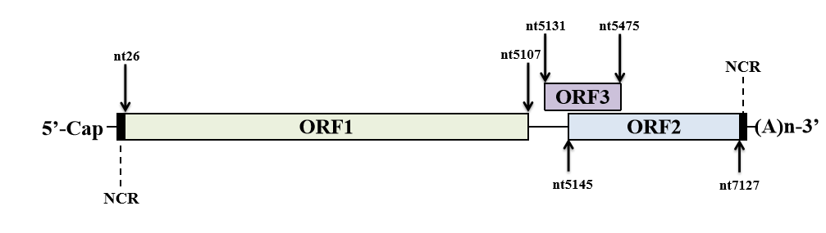
Figure 1 Schematic illustration of hepatitis E virus genome and three well-defined open reading frames. The numbers above or below the RNA boxes indicate nucleotide numbers based on hepatitis E virus-1 prototype Sar55 strain (GenBank accession number AF444002). NCR: Non-coding region; ORF: Open reading frame.
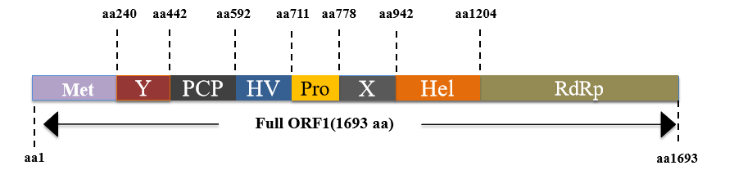
Figure 2 Function domains of hepatitis E virus-open reading frame 1 polyprotein. Putative functional domains of hepatitis E virus (HEV)-open reading frame 1 polyprotein based on HEV-1 prototype Sar55 strain are listed as follows: Methyltransferase domain; Y domain; papain-like cysteine protease; hypervariable region; proline-rich domain; X-domain; Hhelicase; RNA-dependent RNA polymerase. Met: Methyltransferase domain; Y: Y domain; PCP: Papain-like cysteine protease; HV: Hypervariable region; Pro: Proline-rich domain; X: X-domain; Hel: Helicase; RdRp: RNA polymerase; ORF: Open reading frame.
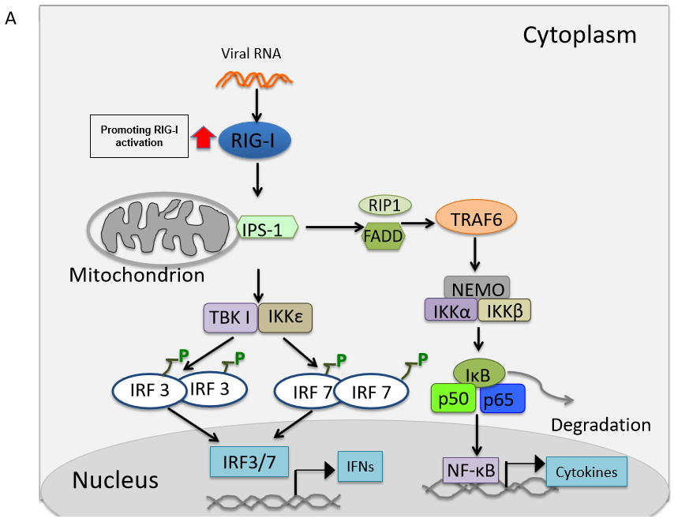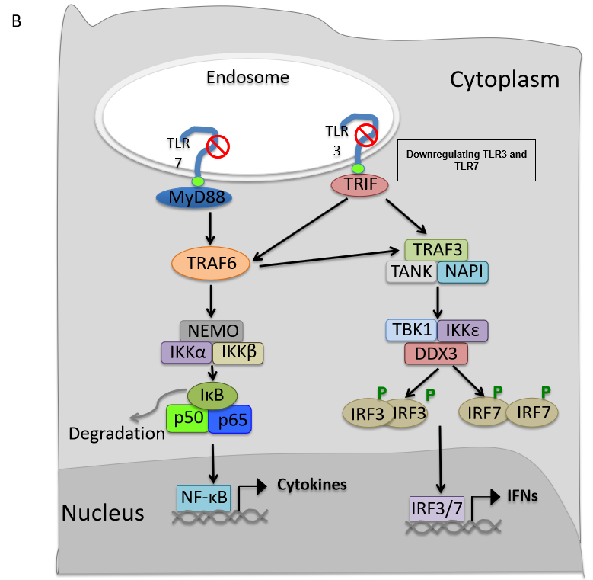
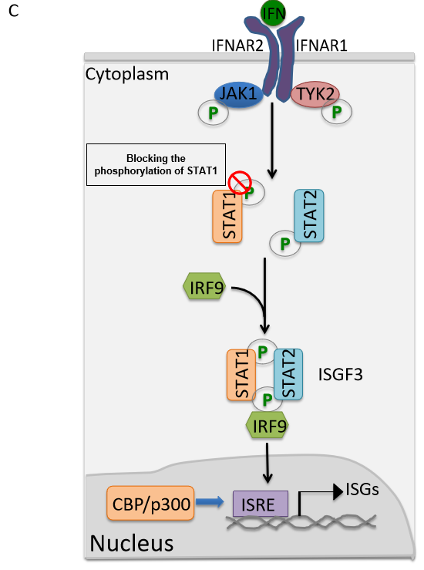
Figure 3 Regulation of host innate immune response by hepatitis E virus-open reading frame 3 proteins. A: Promotion of retinoic acid-inducible gene I mediated activation by hepatitis E virus (HEV)-open reading frame (ORF) 3; B: Inhibition of Toll-like receptor (TLR) 3 and TLR7 by HEV-ORF3; C: Blocking of the phosphorylation of signal transducer and activator of transcription (STAT) 1 to inhibit Janus kinase/STAT signaling. RIG-I: Retinoic acid-inducible gene I; RIP-I: Ribosome-inactivating proteins type I; FADD: Fas-associated protein with death domain; IKK: IkappaB kinase; TBK: Tank-Binding-Kinase; IRF: Interferon regulatory factor; NF-kB: Nuclear factor kB; IFN: Interferon; TLR: Toll-like receptor; TRIF: Toll-interleukin 1 receptor domain-containing adapter inducing interferon-beta; NAPI: Net anthropogenic phosphorus input; IFNAR: Inflammation-the type I interferon receptor; JAK: Janus kinase; TYK: Targeting tyrosine kinase; STAT: Signal transducer and activator of transcription; ISGF: Interferon-stimulated gene factor; ISRE: Interferon-stimulated response element; ISGs: Interferon-stimulated genes; CBP: CREB-binding protein.
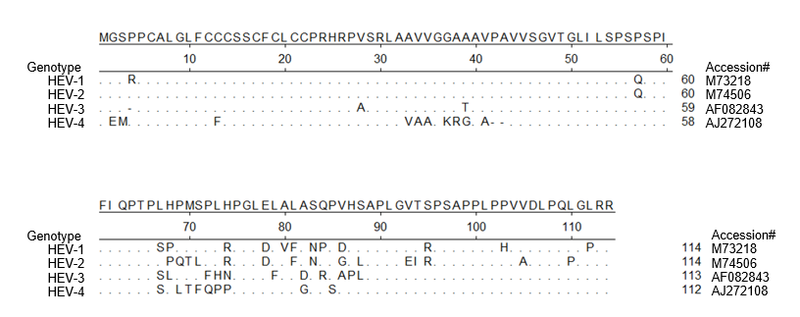
Figure 4 Alignment of amino acid sequence of hepatitis E virus-open reading frame 3 from 4 genotypes in Orthohepevirus A virus. Alignment of amino acid sequence of open reading frame 3 from all seven genotypes classified as Orthohepevirus A virus. Hepatitis E virus (HEV)-1 (reference sequence GenBank accession #M73218), HEV-2 (reference sequence GenBank accession #M74506), HEV-3 (reference sequence GenBank accession #AF082843), and HEV-4 (reference sequence GenBank accession #AJ272108) are shown. Those residues that are the same as consensus sequence are shown as “.”. HEV: Hepatitis E virus.
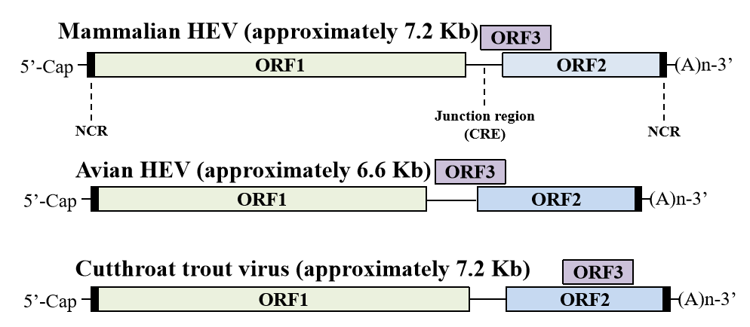
Figure 5 Hepatitis E virus genome organization. Genome location of open reading frame 3 among different hepeviruses. HEV: Hepatitis E virus; NCR: Non-coding region; CRE: Cis-reactive element; ORF: Open reading frame.

Published by Baishideng Publishing Group Inc
7041 Koll Center Parkway, Suite 160, Pleasanton, CA 94566, USA
Telephone: +1-925-3991568
E-mail: bpgoffice@wjgnet.com
Help Desk: https://www.f6publishing.com/helpdesk
https://www.wjgnet.com

© 2021 Baishideng Publishing Group Inc. All rights reserved.

